Main Improvements of SMAT-CE 2.4
28-February, 2024
Main Improvements:
- Fix the bug for “Output Max Design Value” under the “Output Choices-Advanced” input option of Annual PM analysis. The problem is that there are error results in the “Max” file.

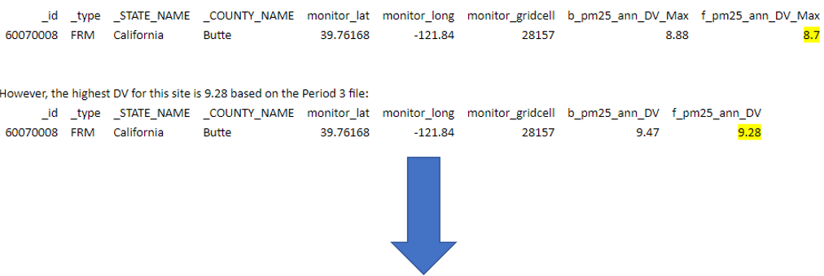
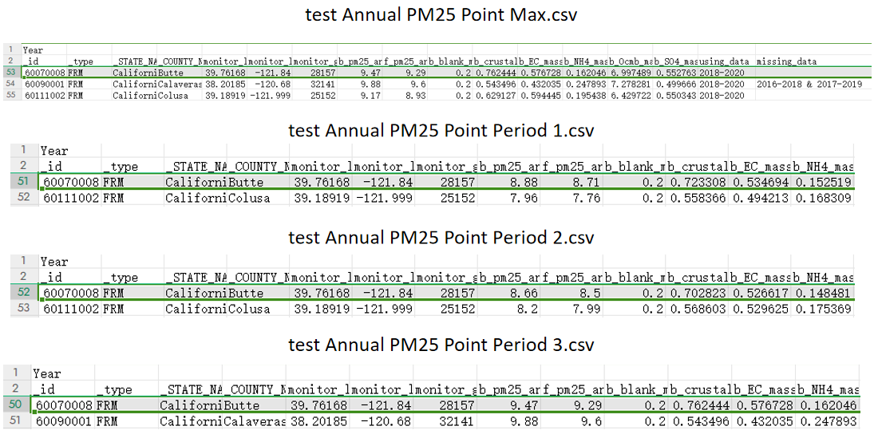
Fig. 1 The updated “Max” file.
- Address the issue with loading old ".proj" files. The current version is compatible with previous projects except those from version 2.3. Projects saved with SMAT-CE 2.3 need to be re-run.

