Main Improvements of Data Fusion 2.2
By SCUT, 2021-10-10

Main Improvements:
We have developed the new “Batch Job” function for DF tool.
Configuration files (*.cfg) are used to define the settings for analyses. There are two ways to export/edit a Configuration File.
- Open a pre-run project, user can modify the analysis options and save current configuration into a single file by clicking the button File – Save Configuration file (*.cfg).
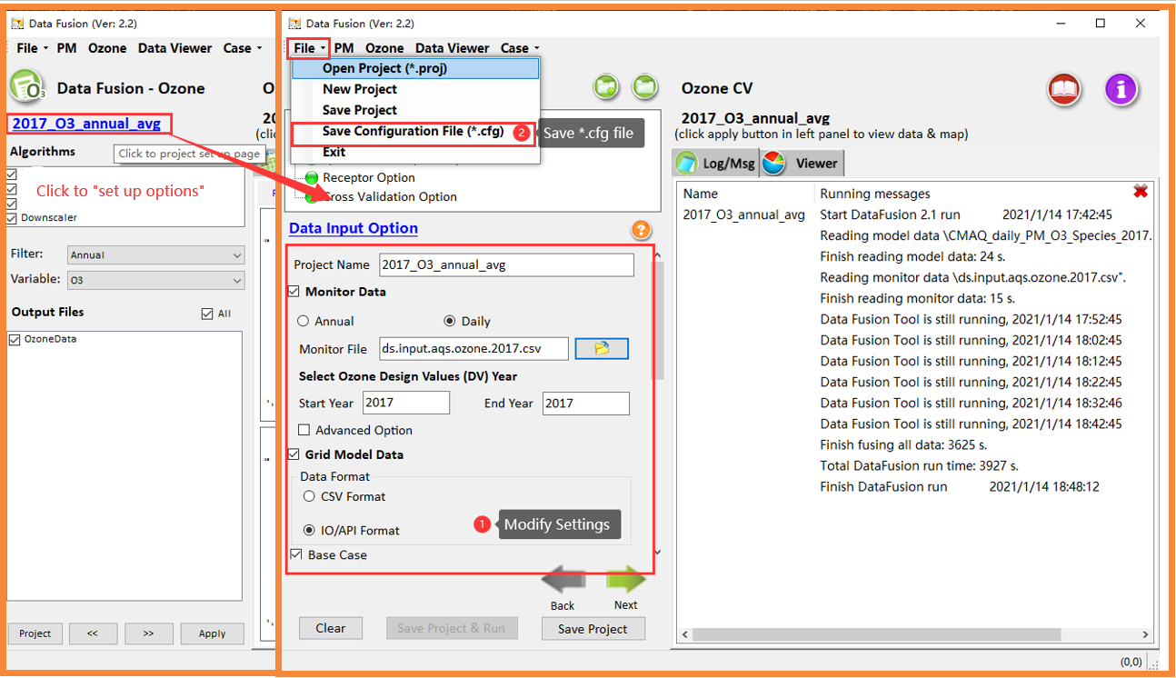
- Open a pre-run project, click “Config/Batch”. Under this page, user can view/edit the project settings and export as *.cfg file.
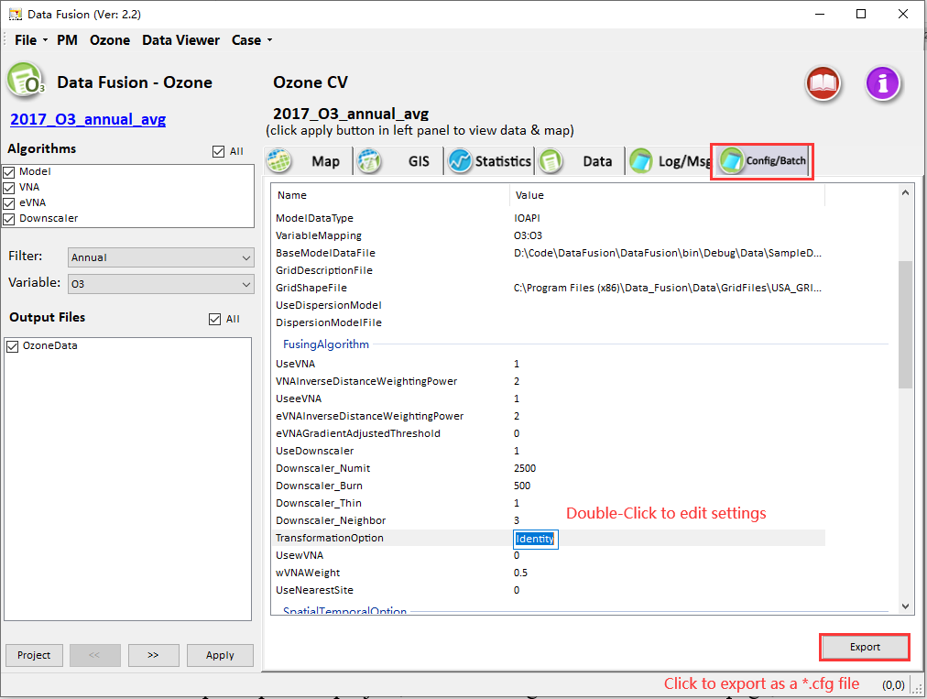
User can use Windows batch scripts (*.bat) to run several Data Fusion analyses in sequence. The batch script can string together a list of *.cfg file to conduct each analysis.
We have provided an example batch script and several configuration files under the path of “My DataFusion Tool\Result\Batchjob\”. The script “batch_examples.bat” includes a list of example cases.
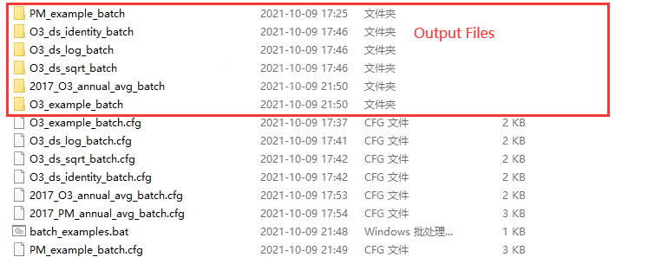
Notes:
  - User can “Right-Click Edit” to view/modify the “batch_examples.bat” file.
  - To run a batch job case, user can add a new line with the same format `start /wait ../../Tool/DataFusion/DataFusion.exe “[Configuration File]”`.
  - The window batch script will skip the lines which start with “::”.
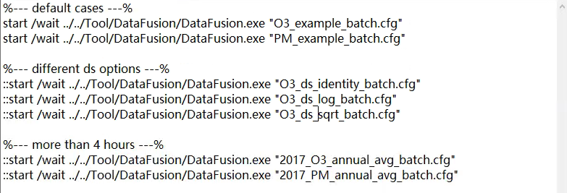
  - After editing the batch script, double-click on the script file to begin analysis.
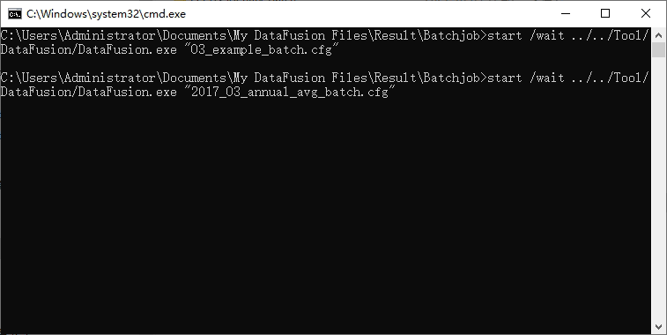
  - The output files of a batch job case are also placed under the directory of “My DataFusion Tool\Result\Batchjob\”.
  - User can open the batch projects and view the results in Data Fusion 2.2.

To Do List:
- Provide more warn/error message for in batch job mode.
- Update the online user guide with new functions.

