Deep learning for predicting ozone variations with emissions and meteorology
Jia Xing^{1,2}, Shuxin Zheng^{3,}*, Siwei Li^{4,}*, Xiaochun Wang^{1,2}, James T. Kelly⁵, Shuxiao Wang^{1,2,}*, Yueqi Jiang^{1,2}, Song Liu^{1,2}, Chang Liu³, Carey Jang⁵, Yun Zhu⁶, Tie-Yan Liu³, Jiming Hao^{1,2}
¹ State Key Joint Laboratory of Environmental Simulation and Pollution Control, School of Environment, Tsinghua University, Beijing 100084, China
² State Environmental Protection Key Laboratory of Sources and Control of Air Pollution Complex, Beijing 100084, China
³ Microsoft Research Asia, Beijing 100080, China
⁴ School of Remote Sensing and Information Engineering, Wuhan University, Wuhan 430079, China
⁵ Office of Air Quality Planning and Standards, U.S. Environmental Protection Agency, Research Triangle Park, NC 27711, USA
⁶ College of Environment and Energy, South China University of Technology, Guangzhou Higher Education Mega Center, Guangzhou 510006, China
*Corresponding Authors: Shuxiao Wang (email: shxwang@tsinghua.edu.cn; phone: +86-10-62771466; fax: +86-10-62773650), Shuxin Zheng (email: Shuxin.Zheng@microsoft.com), Siwei Li (email: siwei.li@whu.edu.cn)

Abstract
Fast and accurate prediction of ambient ozone (O₃) changes with emission and meteorology variation is crucial for understanding the mechanism for O₃ pollution to design effective control strategy. However, existing chemical transport model (CTM)-based methods require massive time and efforts to conduct, resulted in low efficiency which largely limits their usage. Here we proposed a novel method by combining the deep learning technology with CTM (noted as DeepCTM). The well-trained DeepCTM has successfully reproduced the CTM-simulated O₃ concentration with the input features of the precursor emissions, meteorological factors and initial conditions. The advantage of DeepCTM is its high efficiency in identifying the O₃ dominant contributors and quantifying O₃ response to the variation of emissions and meteorology. The DeepCTM application in China suggests that the O₃ suffers large influences from the initialized O₃ and NO₂ concentrations, as well as emission and meteorological factors mostly during daytime when O₃ is formed through photochemical reactions. The variation of meteorological factors such as short-wave radiation can also significantly modulate the O₃ chemistry. The DeepCTM developed in this study exhibits great potentials in dealing with complicated atmospheric system, and can well support the urgent need from policy makers to design effective control strategies to mitigate the O₃ pollution.

Table of Contents Graphic

As one important air pollutant and greenhouse gas, ozone (O₃) gains more and more attentions in China for its challenging the target of “Beautiful China” in air quality attainment ¹. The worsen O₃ pollution in most of Chinese cities raises a lot of concerns, particularly since the Air Pollution Prevention and Control Action Plan taken during 2013-2017 when PM_{2.5} pollution was effectively controlled ². Many studies suggested that the unexpected O₃ increase might be due to both unbalanced precursor (i.e., NO_{x} and VOC) emission controls and unfavorable meteorology conditions for air quality ^{3, 4}. Therefore, design effective control strategy requires an accurate and quick estimation of the O₃ behaviors under the variation of emission and meteorology.
However, predicting O₃ response to emissions and meteorology variations is challenging due to the high nonlinearity associated with atmospheric chemical and physical processes ⁵. Most previous studies ^{6,7} conducted chemical transport model (CTM) with scenario analysis to investigate the influence of meteorology and emission separately, either by reducing emissions with constant meteorological condition or by modulating meteorology but with constant emissions. The nonlinear response of O₃ to emissions has also been explored with advanced CTM-based tools ⁸⁻¹⁴, while most of which has time-consuming issue that significantly limits their usage in exploring the nonlinear response of O₃ to combined variation of emissions and meteorology. More specifically, some studies revealed the challenge of the future climate change for the efforts in continually improving air quality ¹⁵⁻¹⁶. However, the question that how the meteorology impacts on the emission control effectiveness still has not be well addressed. It is an urgent need for an efficient method to quantify the influence of meteorology variation on the O₃ response to emissions.
The deep learning technology such as convolutional neural networks has demonstrated its advantage in linking the complex relations in the atmospheric system¹⁷⁻¹⁹. Our previous studies suggest that the air pollution response to emissions can be inferred from the baseline concentrations of certain indicators determined by the emission and meteorology ²⁰. It is expected that the pollutant concentration is also predictable from emission and meteorology with deep learning method. More important, with the deep learning neural network to represent on the inner-relations of CTM, the efficiency can be substantially enhanced in predicting the O₃ response, thus enable us to accomplish numerous scenarios to examine the O₃ response to emissions and meteorology in a much higher dimensional space than traditional CTM studies. That is an essential task for policy maker to well understand the pollution mechanism and design proper control policies to continually improve the air quality.
The key question remains unknown that how to design a suitable neural network and how well it can replicate the CTM in revealing the inner relations of O₃ to emissions and meteorology. To address above question, here we proposed a novel deep learning neural network structure (noted as DeepCTM) to reproduce the CTM-predicted O₃. The properties of the new DeepCTM will be examined for its ability in revealing the nonlinearity of O₃ response to emissions and meteorology.

Methods
(1) dataset preparation
In this study, we used the Community Multiscale Air Quality Model (CMAQ) which is one of the most commonly used CTM model ²¹ for simulating the air pollutant concentrations to establish the dataset for NN training. The meteorology was derived from the simulating with the Weather Research and Forecasting model (WRF). Their configurations are the same as our previous studies ^{2, 4}. The Carbon Bond 6 and AERO6 were used for gas-phase and particulate matter chemical mechanisms. We use the bottom-up emission inventory with a high spatial and temporal resolution (ABaCAS-EI) ²² developed by Tsinghua University for anthropogenic emissions, and the Model for Emissions of Gases and Aerosols from Nature (MEGAN) ²³ to estimate the biogenic emissions. The performance of model in simulating meteorological variables and air pollutant concentration has been well examined by comparing against with the observations^{2, 4}.
The studied domain covers most of East Asia by total 182 (row) × 232 (column) horizontal grid cells with 27 km × 27 km spatial grid resolutions. Besides the nationwide averages, our analysis also focuses on three key regions in China where suffer the most serious O₃ pollution, including North China Plain, the greater Yangtze-River-Delta, and Southeast China (Figure S1).
(2) NN structure
Although deep learning models are universal approximators ²⁴, it’s quite challenging for them to approximate the complicated atmospheric system. One possible reason is that the performance of neural-based PDE solvers is unsatisfactory ²⁵. To tackle this intractable challenge, it’s necessary to introduce key inductive biases ²⁶ when design the features and the architecture of deep learning model. First, we carefully construct 15 kinds of features that which are sufficient to represent the response relationship between emissions and concentrations. The feature data consists of four emissions including NO_{x} emission at near-surface, within or above planetary boundary layer (PBL), and total VOC emissions; five meteorological factors including PBL height, wind speed, short-wave radiation, convective velocity scale, and 2-meter temperature; three initial concentrations including NO, NO₂ and O₃, and their corresponding transport fluxes which represent the movement between neighbor grid cells following the horizontal wind direction.
Second, we elaborately design a novel deep neural network called DeepCTM. In particular, there is obvious locality pattern between the near emissions, the local meteorology and the concentrations to be predicted. Therefore, we leverage stacked convolutional layers to better extract the exclusive characteristic from the inputs. To stable the procedure of optimization, we employ two key components to smooth the energy landscape, i.e., normalizing the activations from a batch by BN layer ²⁷, and eliminating the annoying singularities by skip connections ²⁸. Besides, unlike traditional convolutional neural networks, the resolutions of all feature maps in DeepCTM remain unchanged to preserve the spatial information as much as possible. The detailed architecture is presented in Figure 1.
The total 15 feature data are concatenated and fed into the residual connection with eight residual blocks ²⁹, which is similar to our previous study ²⁰. The first 3×3 convolutional layer has a large number of channels (i.e., 128) to get expressiveness of the connections among the original 15 features, and the last 3×3 convolutional layer reduced the channels from 128 to 3 to predict the surface concentrations of NO, NO₂ and O₃ for the next time step. The LeakyReLU is chosen as the activation function.
(3) training and testing
We conducted the WRF-CMAQ simulations for the whole year of 2017. The hourly data of the first 20 days in each month (i.e., total 5760 records) are used for training, and the rest of 10 days (i.e., 2880 records) in each month are used for testing. We randomly cropped the indicator maps by the size of 60 for data augmentation to improve the performance of CNN in dealing with the low-level task. The Mean Squared Error loss was used for training, with 5000 epochs. The learning rate starts from 0.001 and linearly decay to zero at the end of training.
We calculated the statistic of model performance using the Root Mean Square Error (RMSE), R-squared (R²), and the Normalized Mean Biases (NMB). The model performance is also thoroughly examined through its ability in dealing with the nonlinear O₃ response to emission and meteorological factors.

Results
(1) Evaluation of the performance in predicting the temporal and spatial O₃ pattern
After 5000 epochs, the trained DeepCTM can well reproduce the CTM-simulated hourly O₃ variation across the whole year. The RMSEs and NMBs in training dataset are within 0.7 and ±1% respectively, and R²s are very close to 1 (see Figure S2). The RMSEs in testing dataset are slight worse than that in training dataset but still within 0.8. Such good performance in both training and testing dataset suggest that the DeepCTM has good generalization capabilities.
The DeepCTM can also well reproduce the spatial distribution of CTM-simulated O₃, as demonstrated by the comparison of two selected typical days from testing dataset (i.e., 21st day in Jan and July which represent winter and summer respectively). The predicted O₃ by DeepCTM for next hour (one step accumulation, Figure 2b) agrees very well with the CTM-simulation, as the RMSEs and NMBs are within 0.8 and ±1% respectively, and R²s are also close to 1 (Figure 2a).
It is also noted that the errors in DeepCTM can quickly accumulate along with the prediction for following steps. The RMSEs will be increased to 2-3 after 6 steps (6h accumulation, Figure 2c), 4-6 after 12-24 steps (12-24h accumulation, Figure 2d-e), 6-7 after 48 steps (Figure 2f). The NMBs are increased continually along with the time accumulation and reach up to 15% after 3 days, with uncontrollable errors appearing at the edge of the simulated domain (Figure 2g). Such accumulation of errors is mostly related to the chaotic of atmospheric system ³⁰. Since the one-step predicted NO, NO₂ and O₃ concentration will be used as the initial condition which is the feature data to be fed in for the next step prediction. A small error in the initial condition can be enlarged in the following prediction, which is a big challenge for any time-series prediction for the atmosphere system. Re-initialization is an effective way to ensure the biases with in certain range. As presented in Figure 2a, with one-time initial once a week, the NMB can be controlled within ±8%. Efforts in reducing the error in a single step can be very helpful for reducing the speed of error accumulation, however, it is still the biggest challenge for long-time prediction with any time-accumulation based method like DeepCTM. To minimize the accumulated errors, our following discussion is only based on the prediction within 1 day (less than 24 steps).
(2) Identification of the factors that dominate O₃ diurnal variation
To examine the influence of individual factor on the diurnal variation of O₃, we conducted a sensitivity analysis by modulating each factor in predicting O₃ response with DeepCTM one by one. The factors of emission, initial condition, and flux transport are set to 0, while other meteorological factors (i.e., PBL height, wind speed, short-wave radiation, convective velocity scale, and 2-meter temperature) are set with a 10% reduction to make the value more realistic than zero (e.g., 0 K is unrealistic in ambient condition).
The 24h DeepCTM prediction results suggest that the initial condition, particularly the initialized O₃ concentration is the dominant factor contributing to the O₃ across a day (Figure 3), while it decays slowly by 10-50% after a day implying the O₃ loss through some sink process like dry deposition. The initial NO₂ concentration is also important in three polluted regions (particularly in Yangtze-River-Delta and Southeast China) and its contribution reaches the maximum at noon time, indicating that NO₂ as one important precursor facilitates the photochemical formation of O₃ at daytime when radiation is the strongest and favorable for photolysis reactions.
The flux transport indicates the O₃ concentration change due to the regional transport. In three polluted regions, the O₃ flux transport acts as a sink during daytime implying the transport of the locally formed O₃ to the downwind area thus reducing the O₃ in the source region. Such phenomena are mostly pronounced in summer and in Yangtze-River-Delta. The NO_{x} flux transport also acts as a sink during summer daytime in Yangtze-River-Delta, indicating that NO_{x} dilution in the polluted region also may mitigate the O₃ formation. However, the NO_{x} flux transport changes to be a weak source in polluted regions, since moving NO_{x} out of the polluted region will reduce the O₃ loss at night (e.g., the NO titration) and enhance the nighttime O₃ concentration. Such detailed chemical behaviors have been well captured by the DeepCTM.
The meteorology factors exert considerable influences on O₃ mostly during daytime when O₃ is formed through photochemical reactions. The 10% reduction in surface short-wave radiation will mitigate O₃ formation at daytime. Similarly, the 10% reduction in 2-meter temperature will reduce O₃ in most of regions for its large influences on the chemical reaction rates. However, the opposite impact of 2-meter temperature on O₃ in North China Plain in winter is probably because the lower temperature leads to snow with higher ground scattering albedo reflecting more radiation back to the atmosphere thus enhancing the O₃ chemical formation. The 10% reduction in PBL height and wind speed will slightly increase the daytime O₃ probably due to the enhancement of precursor concentrations thus promoting the O₃ formation.
The precursor emissions can either be a source and sink for O₃ across a day. The precursor emissions, particularly surface NO_{x} and VOC contributes to the daytime O₃ concentration. While the precursor emissions are mostly a sink for nighttime O₃ probably related to NO_{x} or active VOC species that consume O₃ at night. One thing should be noted that here we conducted the sensitivity analysis in which the emissions of each species are zeroed out individually. Their synergic controls will lead to a more complex O₃ response to the emission changes, which to be discussed in the following text.
(3) Prediction of the nonlinear O₃ response to precursor emission changes
With the DeepCTM, the isopleth of O₃ concentration to precursor emission changes can easily be predicted the same as that derived from the response surface model (RSM) ^{10, 13} (Figure 4). In general, the responses of O₃ to total NO_{x} (combined of NO_{x} emission at surface, within and above PBL) and VOC are quite similar as we found in previous RSM studies. The O₃ chemistry is mostly located in NO_{x}-limited regime in summer and at noon, but in VOC-limited regime is in winter and at night. The jumping at the low VOC conditions in summer might be associated with the rough extrapolation of DeepCTM for such specific cases in which the VOC emissions are too low and beyond the training dataset since there are abundant biogenic VOC emissions in summer which is the most condition of training data.
Beside no requirement of additional CTM simulations, another advantage of the DeepCTM over RSM is its ability in exploring the influence of meteorology variations on O₃ chemistry. We conducted such investigation by using the responsive indicator Peak Ratio ³¹ to represent the O₃ chemistry. The Peak Ratio is the NO_{x} emission ratio (related to baseline=1) corresponding to the maxima O₃ concentration with the baseline VOC emissions. Apparently, O₃ chemistry is located in VOC-limited regime when Peak Ratio < 1, while in NOx-limited regime when Peak Ratio > 1. The influence of meteorology variations on O₃ chemistry is conducted by comparing the Peak Ratio response to the variation of each meteorological factor.
Figure 5 presents the diurnal Peak Ratio across a day under seven levels of short-wave radiation including the baseline (swr_base), 90% reduced (swr0.1), 70% reduced (swr0.3), 30% reduced (swr0.7), 30% increased (swr1.3), 70% increased (swr1.7), and 90% increased (swr1.9). In baseline, the Peak Ratio exhibits strong diurnal variation with the highest at noon and lowest at night, implying that O₃ chemistry is much more likely in NO_{x}-limited regime at noon and in VOC-limited at night. The summertime Peak Ratio is also always higher than that in winter implying the stronger NO_{x}-limited regime in warmer seasons.
The variation of short-wave radiation can significantly modulate the O₃ chemistry across the day in both seasons. In general, the reduced radiation will lower the Peak Ratio leading the O₃ chemistry towards to VOC-limited regime, and increased radiation will enlarge the Peak Ratio and make the O₃ chemistry move to the NO_{x}-limited regime. That is because the stronger short-wave radiation is more favorable for photolysis of NO₂ to form O₃. While, NO₂ can more like consume OH to terminate radical reactions under weaker short-wave radiation thus reducing O₃ formation. The change of O₃ chemistry associated with short-wave radiation is more pronounced in North China Plain / in winter, indicating the north region /colder season (with less baseline radiation) are more sensitive to short-wave radiation than other regions / seasons.
The O₃ chemistry response to other meteorological factors is also investigated. The results suggest that the reduced PBL height (Figure S3) will reduce the Peak Ratio in summer and increase the Peak Ratio in winter (except in southeast China). That might be associated with the enhancement of the precursor (mostly NO_{x}) concentrations due to the reduced PBL, resulted in a more VOC-limited regime. While opposite behavior of Peak ratio response to PBL height is found in winter Yangtze-River-Delta (more complicated in North China Plain) where the baseline is located in strong VOC-limited regime. That might be associated with the reduced NO_{x} for the downwind area to make the regional averaged Peak Ratio increased. The variation of wind speed has little influences on O₃ chemistry in summer, while the reduced wind speed will increase the Peak ratio in winter Yangtze-River-Delta and North China Plain (Figure S4). Similar as that for PBL height, the reason is that the NO_{x} concentration in downwind area will be reduced with smaller wind speed, thus make O₃ chemistry move towards to NO_{x}-limited regime. The lower convective velocity scale will reduce the Peak Ratio since it leads to a more concentrated NO_{x} and stronger VOC-limited regime (Figure S5). The 2-meter temperature (Figure S6) has similar influences on O₃ chemistry as short-wave radiation. The increasing 2-meter temperature leads to a greater Peak Ratio (towards to NO_{x}-limited regime), while reducing 2-meter temperature leads to a smaller Peak Ratio (towards to VOC-limited regime).
(4) Seasonality of meteorological influences on O₃ and O₃ response to emission reductions
The meteorological influences on O₃ include the change in O₃ concentrations as well as the O₃ response to emission reduction. In additional to the previous analysis on the diurnal scale, here we investigate the seasonality of meteorological influences. We conducted this with DeepCTM prediction for each day (re-initial every 24 hours) in 12 months, and grouped daily predictions into monthly averaged level.
We first estimated the O₃ changes due to the variation of meteorological parameters by taking differences of DeepCTM-predicted O₃ under the conditons from 20% increase to 20% decreases of PBL height, wind speed (WS), short-wave radiation (SWR), and convective velocity scale (WSTAR), as well as from +10 K to -10 K of 2-meter temperature (T2), as presented in Figure 6.
In general, the increased PBL height leads to a decreased daily mean O₃ by 1-2 ppb and daily maximum O₃ by 2-5 ppb, with more pronounced influcence in summer and in polluted regions like North China Plain and Yangtze-River-Delta. The increased PBL height may increase wintertime daily mean O₃ by 0.5-1 ppb due to the reduced percurosor concentrations associated with the lower PBL height that increases O₃ under VOC-limited regime. O₃ repsonse to the increase of wind speed is quite similar with that to PBL height, which might be related to the modulation of percurosor concentrations. The increased short-wave radiation leads to an enhanced daily mean O₃ by 2-5 ppb and daily maximum O₃ by 2-7 ppb. The influcence of short-wave radiation on O₃ in North China Plain is larger in winter, while is opposite in Yangtze-River-delta where O₃ is more sensitive to short-wave radiation in summer (rainy season). Simialrly, the increased 2-meter temperature will also enhance O₃ in most of regions except certain months in Southest China. The increased convective velocity scale leads to increased O₃ by 3-5 ppb due to the stronger vertical mixing that transports upper O₃ downward to surface. The O₃ in North China Plain is more sensitive to convective velocity scale in warmer seasons when O₃ formation is highest. While O₃ in Yangtze-River-delta and Southwest China is more sensitive to convective velocity scale in cold seasons probably due to abundant rain in warmer seasons which photochemical reaction is low.
To examine the meteorological influences on O₃ response to emission reduction, we compared the daily O₃ response to emission reduction at different months by taking the 50% NO_{x} control, 50% VOC control and 50% NO_{x} and VOC controls (Figure 7). Results suggest strong seasonality in O₃ response to emissions. In general, NO_{x} control is beneficial for reducing O₃ in summer but dis beneficial or ineffective for reducing O₃ in winter. However, opposite behaviros is found for VOC control which is more effective for reducing O₃ in winter than in summer. Noted that benefits for only controling anthoropegenic VOC in summer will be even smaller since here we considered all VOC emissions to be reduced while there are abundand biogenic VOC emissions in summer are uncontrollable. Such finding is consistent with our previous study ³², demonstrating the strong seasonality of O₃ repsones to emissions due to the meteorological variations. Even in a single month, there are a wide range of O₃ responses to emission changes by 5-10 ppb changing from negative to positive values, implying the meteorological variations can also largely influcence on the control effectiveness even at a small temporal scale like day-to-day variations, which should be well considered in designing effective and meticulous control strategies.

Discussion
In this study, we proposal a deep-learning based air quality simulator (i.e., DeepCTM) which can well reproduce the temporal and spatial pattern of O₃ concentration, as well as its inner correlations with precursor emission and meteorological factors. The well-trained DeepCTM exhibits its ability in accurately and efficiently predicting the O₃ variations with emission and meteorology within certain period of time, which can well support the urgent need from policy makers to design effective control strategies to mitigate the air pollution ³³⁻³⁴. The DeepCTM also successfully identified the dominate factors that contributes to the O₃ diurnal variation, and captured the nonlinearity of O₃ response to emissions under different meteorological conditions. That implies the neural-network-based predictor can dig out the basic physical laws of atmosphere from the raw CTM-simulated data.
This study also reveals the biggest challenge facing in all time-accumulation based method like DeepCTM for long-time prediction. The initial errors can be exponentially enlarged during the accumulation which forbidden its usage for more than 3 days prediction. More accurate representation of the CTM structure will be much help to further improve the accuracy of DeepCTM. For example, in this study we simplified the vertical structure of the atmosphere by only selecting the surface features to represent the atmospheric system. Apparently, such simplification might bring in systemic errors in DeepCTM, and extra efforts can be done through the inclusion of additional features into the neural network. Unfortunately, it is difficult to solve considering the limited computational resources since the training with inclusion of the vertical parameters will take up more than 10 times larger requirement of capacities. Meanwhile, since we only use the baseline CTM simulations for training therefore it has large errors in predicting the conditions that not included in the training set, like the extremely low VOC emissions in summer. Such biases can be simply reduced by bringing in controlled scenarios of CTM into the training. In current DeepCTM design, we did not include the concentration of VOC species due to it complex chemical mechanism in different CTMs. One reason is due to the limited computational resources. Another reason is that bringing in more species will significantly enlarge the influences of initial conditions, resulted in even larger accumulation errors. The above issues are recommended for future studies. Nevertheless, the DeepCTM proposed in this study shows its large advantage and great potentials in dealing with complicated atmospheric system, which can be continually improved with further efforts in both environmental scientific researches and computational technologies.

Author contribution
JX designed the methodology and conducted the NN experiment. SZ & SL provided ideas and designed the NN model. XW, YJ, SL run WRF-CMAQ model. JK, SW, CL, CJ, YZ, TYL and JH helped with the analysis. All authors contribute to writing the paper.

Acknowledgements
This work was supported in part by National Natural Science Foundation of China (41907190), National Key R & D program of China (2018YFC0213805), and MSRA collaborative research project. This work was completed on the “Explorer 100” cluster system of Tsinghua National Laboratory for Information Science and Technology. The views expressed in this manuscript are those of the authors alone and do not necessarily reflect the views and policies of the U.S. Environmental Protection Agency.

Competing interests
The authors declare no competing financial interests.

Reference
- Lu, X.; Zhang, S.; Xing, J.; Wang, Y.; Chen, W.; Ding, D.; ... & Hao, J. Progress of air pollution control in China and its challenges and opportunities in the ecological civilization era. Engineering, 2020.
- Ding, D.; Xing, J.; Wang, S.; Liu, K.; Hao, J. Estimated Contributions of Emissions Controls, Meteorological Factors, Population Growth, and Changes in Baseline Mortality to Reductions in Ambient PM_{2.5} and PM_{2.5} -Related Mortality in China, 2013-2017., Environ Health Perspect. 2019, 127(6):67009.
- Wang, P.; Guo, H.; Hu, J.; Kota, S. H.; Ying, Q.; & Zhang, H. Responses of PM2. 5 and O3 concentrations to changes of meteorology and emissions in China. Science of the Total Environment, 2019, 662, 297-306.
- Ding, D., Xing, J., Wang, S., Chang, X., & Hao, J. Impacts of emissions and meteorological changes on China’s ozone pollution in the warm seasons of 2013 and 2017. Frontiers of Environmental Science & Engineering, 2019, 13(5), 1-9.
- Seinfeld, J.H.; Pandis, S.N. Atmospheric chemistry and physics: from air pollution to climate change. John Wiley & Sons, 2012
- Gilliland, A. B., Hogrefe, C., Pinder, R. W., Godowitch, J. M., Foley, K. L., & Rao, S. T. Dynamic evaluation of regional air quality models: Assessing changes in O3 stemming from changes in emissions and meteorology. Atmospheric Environment, 2008, 42(20), 5110-5123.
- Xing, J.; Zhang, Y.; Wang, S.; Liu, X.; Cheng, S.; Zhang, Q., ... & Wang, W. Modeling study on the air quality impacts from emission reductions and atypical meteorological conditions during the 2008 Beijing Olympics. Atmospheric Environment, 2011, 45(10), 1786-1798.
- Dunker, A. M.; Yarwood, G.; Ortmann, J.P.; Wilson, G.M. Comparison of source apportionment and source sensitivity of ozone in a three-dimensional air quality model, Environmental Science and Technology, 2002, 36, 2953-2964.
- Cohan, D.S.; Hakami, A.; Hu, Y.; Russell, A.G. Nonlinear response of ozone to emissions: source apportionment and sensitivity analysis. Environ. Sci. Technol. 2005, 39, 6739-6748.
- Xing, J.; Wang, S.X.; Jang, C.; Zhu, Y.; Hao, J.M. Nonlinear response of ozone to precursor emission changes in China: a modeling study using response surface methodology. Atmos. Chem. Phys., 2011, 11, 5027-5044.
- Wild, O.; Fiore, A. M.; Shindell, D. T.; Doherty, R. M.; Collins, W. J.; Dentener, F. J.; Schultz, M. G.; Gong, S.; MacKenzie, I. A.; Zeng, G.; Hess, P.; Duncan, B. N.; Bergmann, D. J.; Szopa, S.; Jonson, J. E.; Keating, T. J.; and Zuber, A. Modelling future changes in surface ozone: a parameterized approach, Atmos. Chem. Phys., 2012, 12, 2037-2054, https://doi.org/10.5194/acp-12-2037-2012.
- Kwok, R. H. F.; Baker, K.R.; Napelenok, S.L.; Tonnesen, G.S. Photochemical grid model implementation and application of VOC, NOx, and O3 source apportionment, Geosci. Model Dev., 2015, 8, 99-114.
- Xing, J.; Wang, S.; Zhao, B.; Wu, W.; Ding, D.; Jang, C.; Zhu, Y.; Chang, X.; Wang, J.; Zhang, F.; Hao, J. Quantifying Nonlinear Multiregional Contributions to Ozone and Fine Particles Using an Updated Response Surface Modeling Technique. Environmental science & technology, 2017, 51(20),11788-11798.
- Turnock, S. T.; Wild, O.; Dentener, F. J.; Davila, Y.; Emmons, L. K.; Flemming, J.; Folberth, G. A.; Henze, D. K.; Jonson, J. E.; Keating, T. J.; Kengo, S.; Lin, M.; Lund, M.; Tilmes, S.; and O'Connor, F. M. The impact of future emission policies on tropospheric ozone using a parameterised approach, Atmos. Chem. Phys., 2018, 18, 8953-8978, https://doi.org/10.5194/acp-18-8953-2018.
- Stowell, J. D.; Kim, Y. M.; Gao, Y.; Fu, J. S.; Chang, H. H.; & Liu, Y. The impact of climate change and emissions control on future ozone levels: Implications for human health. Environment international, 2017, 108, 41-50.
- Hong, C.; Zhang, Q.; Zhang, Y.; Davis, S. J.; Tong, D.; Zheng, Y., ... & Schellnhuber, H. J. Impacts of climate change on future air quality and human health in China. Proceedings of the National Academy of Sciences, 2019, 116(35), 17193-17200.
- Gipson, G.L.; Freas, W.P.; Kelly, R.F.; Meyer, E.L. Guideline for use of city-specific EKMA in preparing ozone SIPs. EPA-450/4-80-027, US Environmental Protection Agency, Research Triangle Park, North Carolina, USA, 1981.
- Womack, C. C., et al. An odd oxygen framework for wintertime ammonium nitrate aerosol pollution in urban areas: NOx and VOC control as mitigation strategies. Geophysical Research Letters, 2019, 46(9), 4971-4979.
- Cabaneros, S.M.S.; Calautit, J.K.; Hughes, B.R. A review of artificial neural network models for ambient air pollution prediction. Environmental Modelling & Software, 2019.
- Xing, J.; Zheng, S.; Ding, D.; Kelly, J. T.; Wang, S.; Li, S.; ... & Hao, J. Deep learning for prediction of the air quality response to emission changes. Environmental science & technology, 2020, 54(14), 8589-8600.
- Murphy, B. N., Nolte, C. G., Sidi, F., Bash, J. O., Appel, K. W., Jang, C., ... & Pye, H. O. The Detailed Emissions Scaling, Isolation, and Diagnostic (DESID) module in the Community Multiscale Air Quality (CMAQ) Modeling System version 5.3. Geoscientific Model Development Discussions, 2020, 1-28.
- Xing, J., Lu, X., Wang, S., Wang, T., Ding, D., Yu, S., ... & Hao, J. The quest for improved air quality may push China to continue its CO2 reduction beyond the Paris Commitment. Proceedings of the National Academy of Sciences, 2020, 117(47), 29535-29542.
- Guenther, A. B., Jiang, X., Heald, C. L., Sakulyanontvittaya, T., Duhl, T., Emmons, L. K., & Wang, X. The Model of Emissions of Gases and Aerosols from Nature version 2.1 (MEGAN2. 1): an extended and updated framework for modeling biogenic emissions. Geoscientific Model Development, 5(6), 2012, 1471-1492.
- Csáji B C. Approximation with artificial neural networks. Faculty of Sciences, Etvs Lornd University, Hungary, 2001, 24(48): 7.
- Hsieh J T, Zhao S, Eismann S, et al. Learning Neural PDE Solvers with Convergence Guarantees, International Conference on Learning Representations. 2019.
- Goyal A, Bengio Y. Inductive Biases for Deep Learning of Higher-Level Cognition. arXiv preprint arXiv:2011.15091, 2020.
- Santurkar S, Tsipras D, Ilyas A, et al. How does batch normalization help optimization? Proceedings of the 32nd International Conference on Neural Information Processing Systems. 2018, 2488-2498.
- Orhan E, Pitkow X. Skip Connections Eliminate Singularities, International Conference on Learning Representations. 2018.
- He, K.; Zhang, X.; Ren, S., et al. Deep residual learning for image recognition, Proceedings of the IEEE conference on computer vision and pattern recognition. 2016, 770-778.
- Brasseur, G.P.; Jacob, D.J. Modeling of Atmospheric Chemistry. Cambridge University Press, 2017.
- Xing, J.; Ding, D.; Wang, S.; Dong, Z.; Kelly, J. T.; Jang, C.; Zhu, Y.; Hao, J. Development and application of observable response indicators for design of an effective ozone and fine particle pollution control strategy in China, Atmospheric Chemistry and Physics, 2019, 19(21), 13627-13646.
- Xing, J.; Ding, D.; Wang, S.; Zhao, B.; Jang, C.; Wu, W.; Zhang, F.; Zhu, Y.; Hao, J. Quantification of the enhanced effectiveness of NOx control from simultaneous reductions of VOC and NH3 for reducing air pollution in the Beijing–Tianjin–Hebei region, China, Atmos. Chem. Phys., 2018, 18, 7799-7814.
- Xing, J.; Wang, S.; Jang, C.; Zhu, Y.; Zhao, B.; Ding, D.; Wang, J.; Zhao, L.; Xie, H.; Hao, J. ABaCAS: an overview of the air pollution control cost-benefit and attainment assessment system and its application in China. The Magazine for Environmental Managers - Air & Waste Management Association, 2017, April.
- Xing, J.; Wang, S.; Zhu, Y.; Ding, D.; Long, S.; Tian, H.; Jang, C.; Hao, J. Development and Application of the Scientific Decision Support Platform for Air Pollution Prevention and Control. Research of Environmental Sciences, 2019, 10

Figure 1. The CNN architecture of the DeepCTM for predicting O₃ variations with emissions and meteorology. Conv3x3BN: 3x3 convolution followed by batch normalization; LeakyReLU: leaky rectified linear unit activation function

 | A typical winter day (Jan 21, 2017) |  |  | A typical summer day (July 21, 2017)
(a)
 | DeepCTM | CMAQ |  | DeepCTM | CMAQ
(b)  1h | 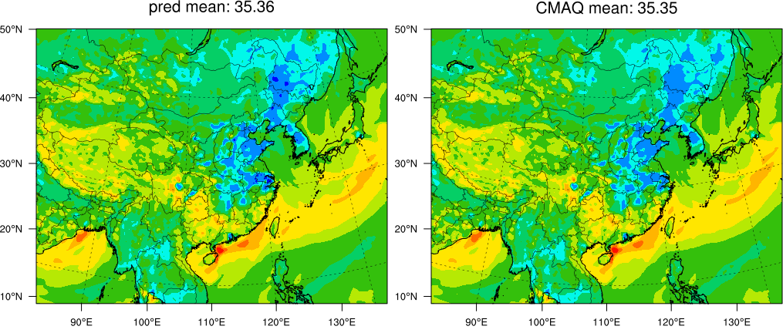 |  | 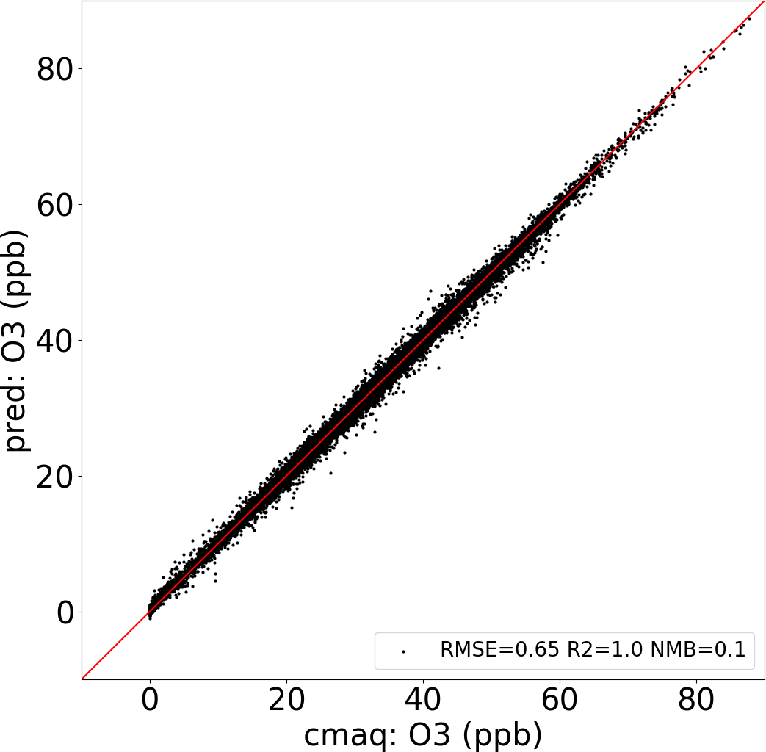 | 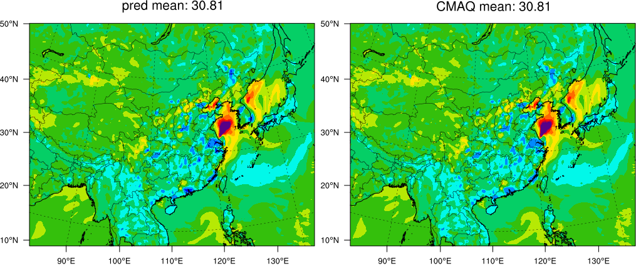 |  | 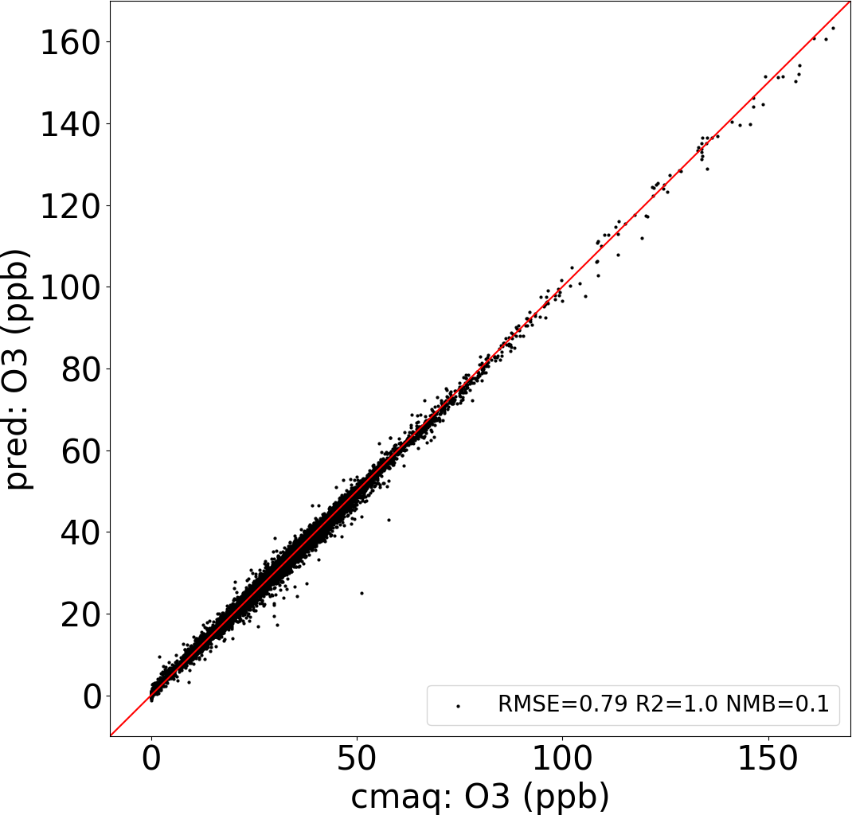
(c)  6h | 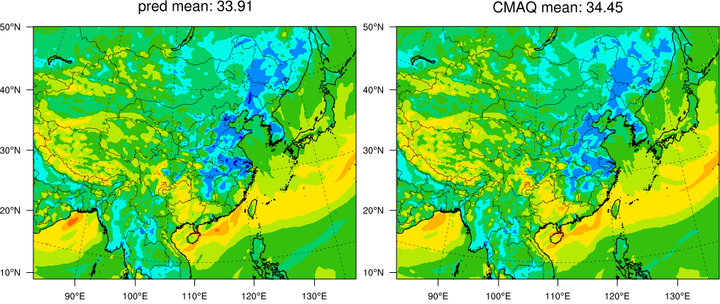 |  | 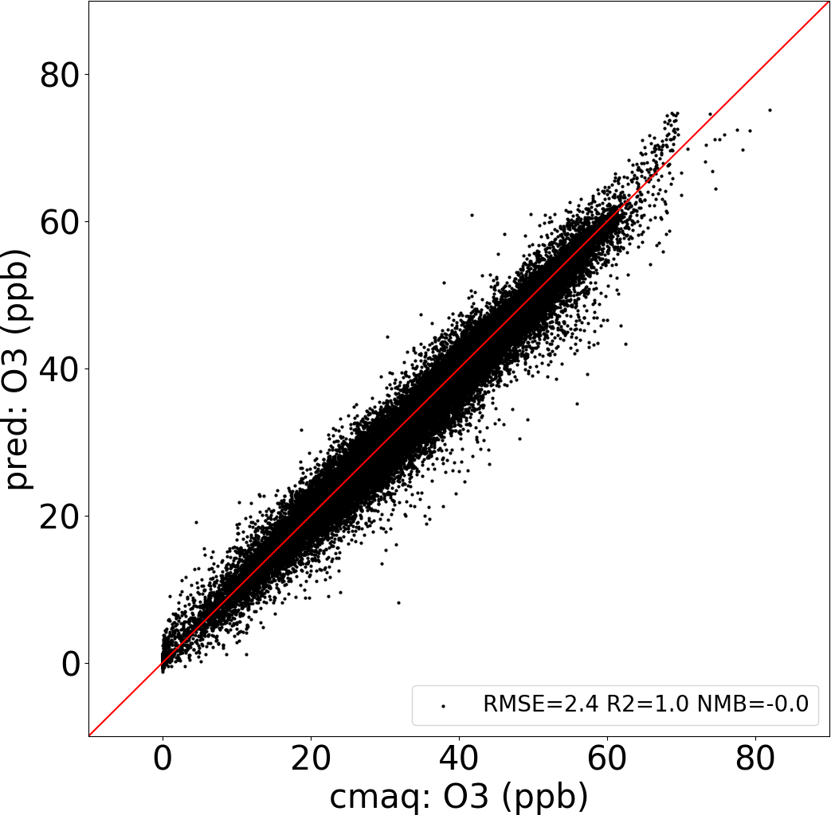 | 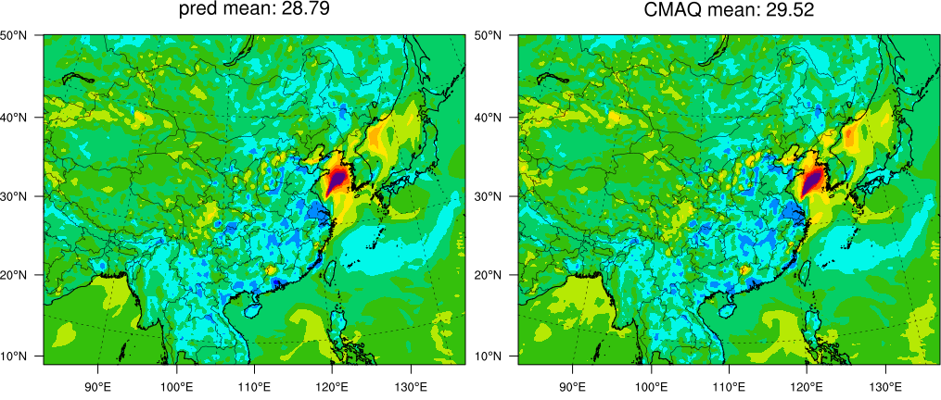 |  | 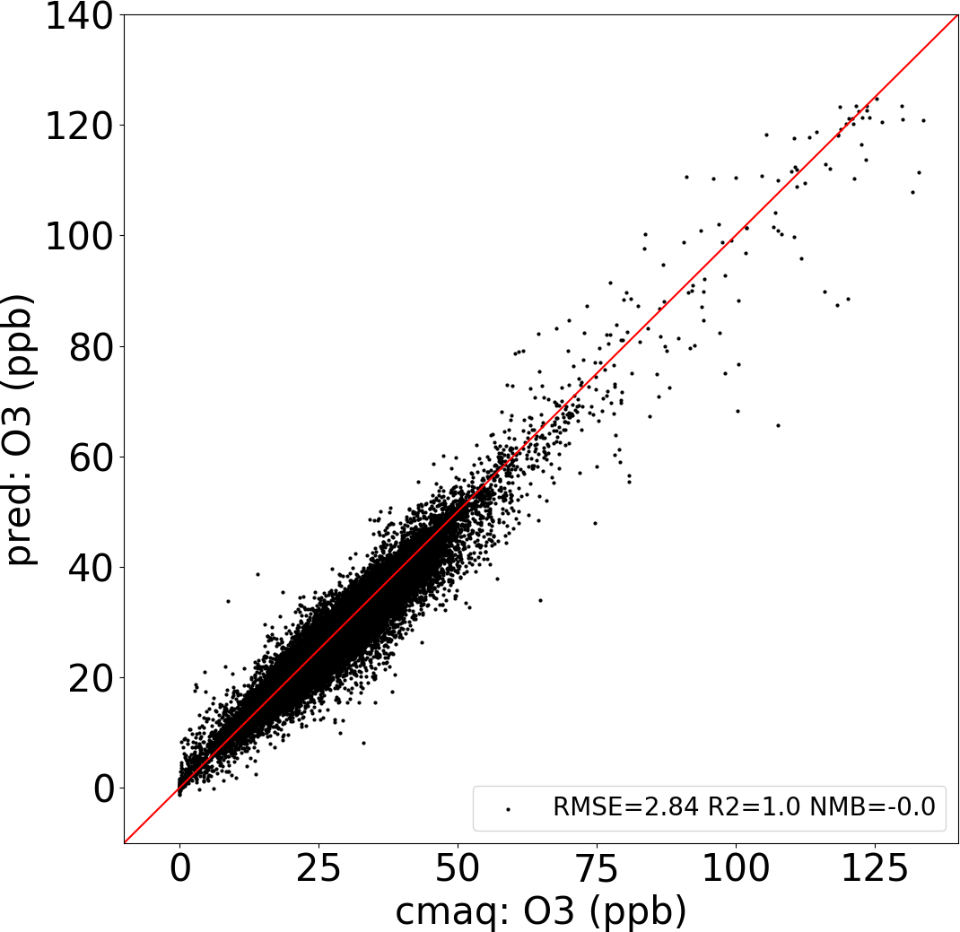
(d)  12h | 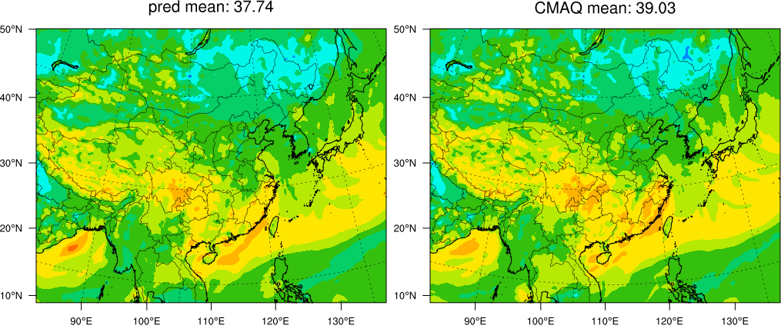 |  | 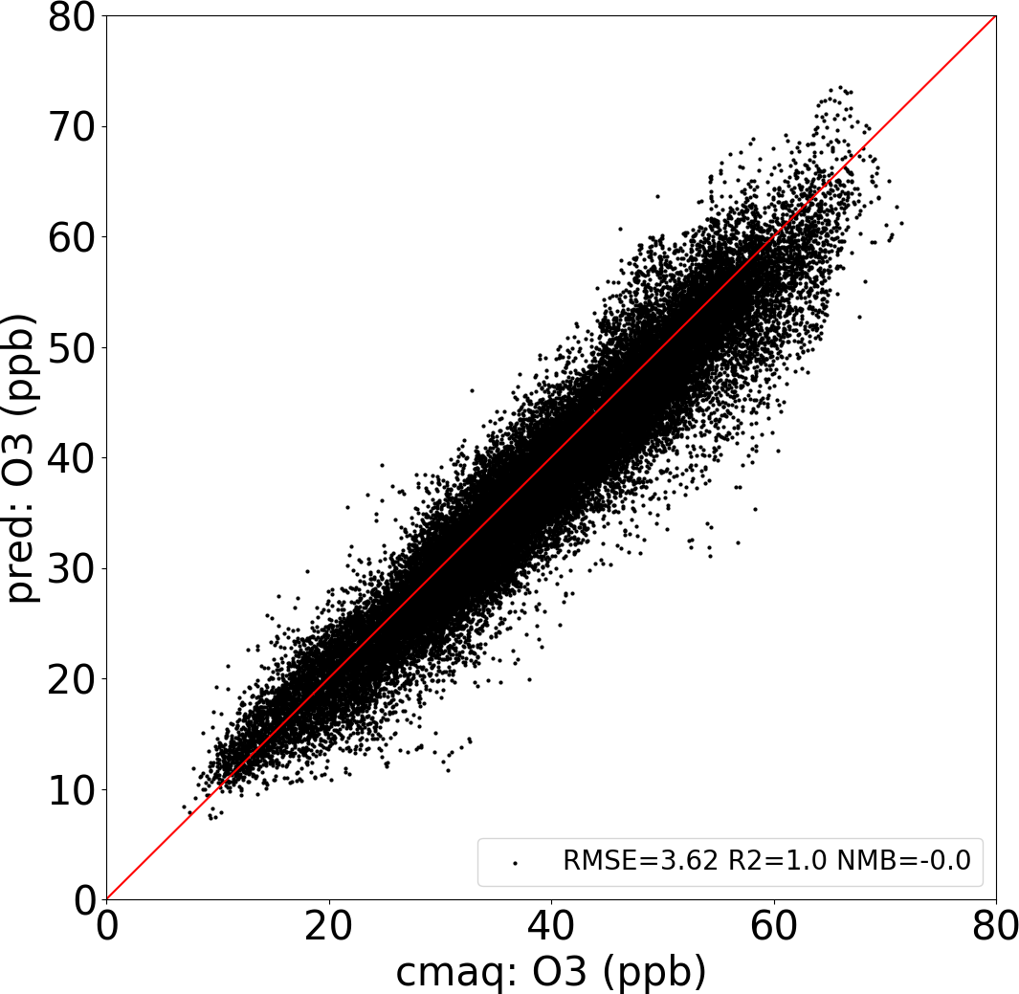 | 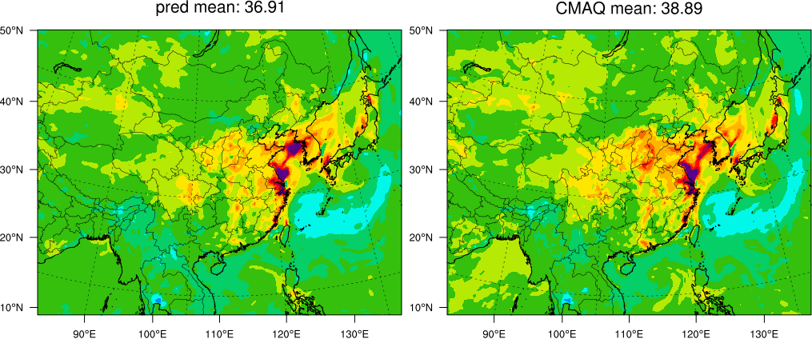 |  | 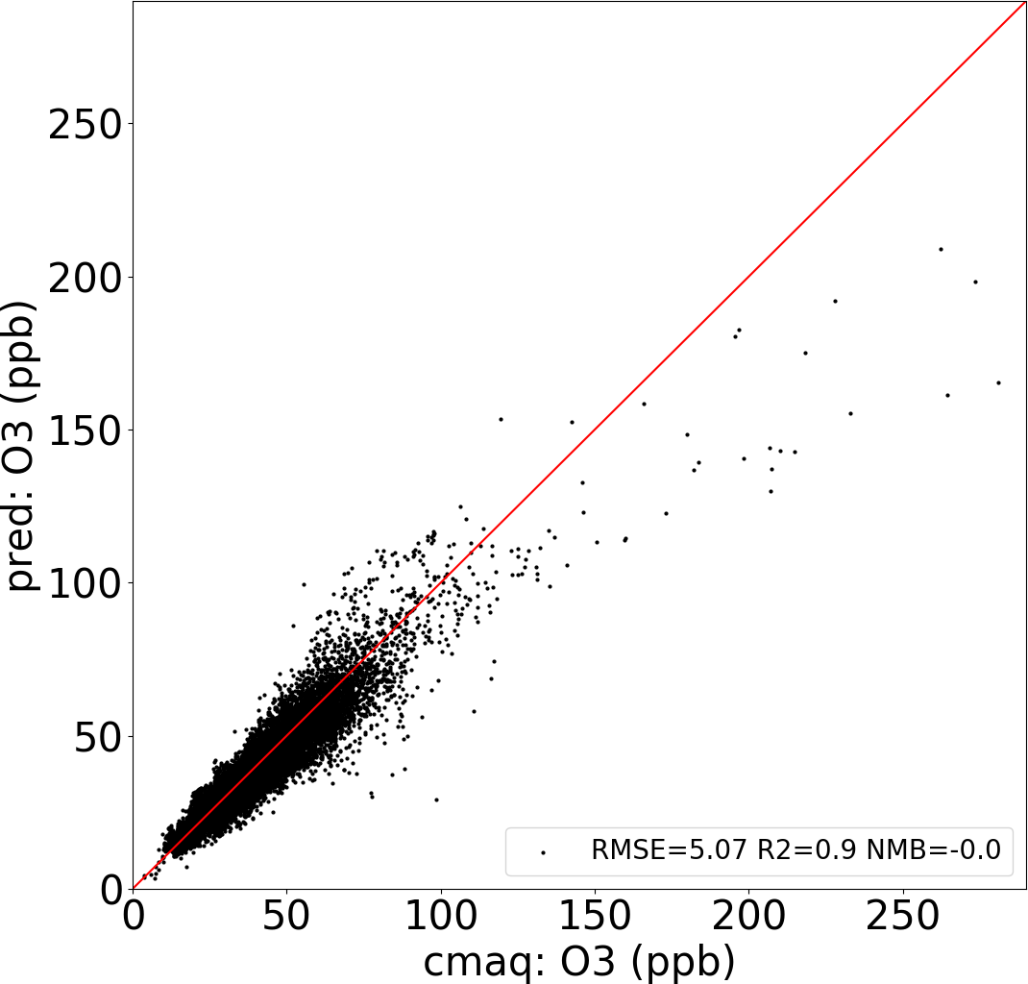
(e)  1d | 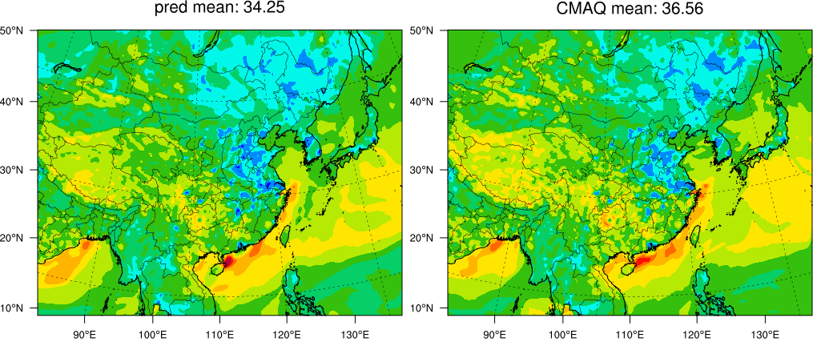 |  | 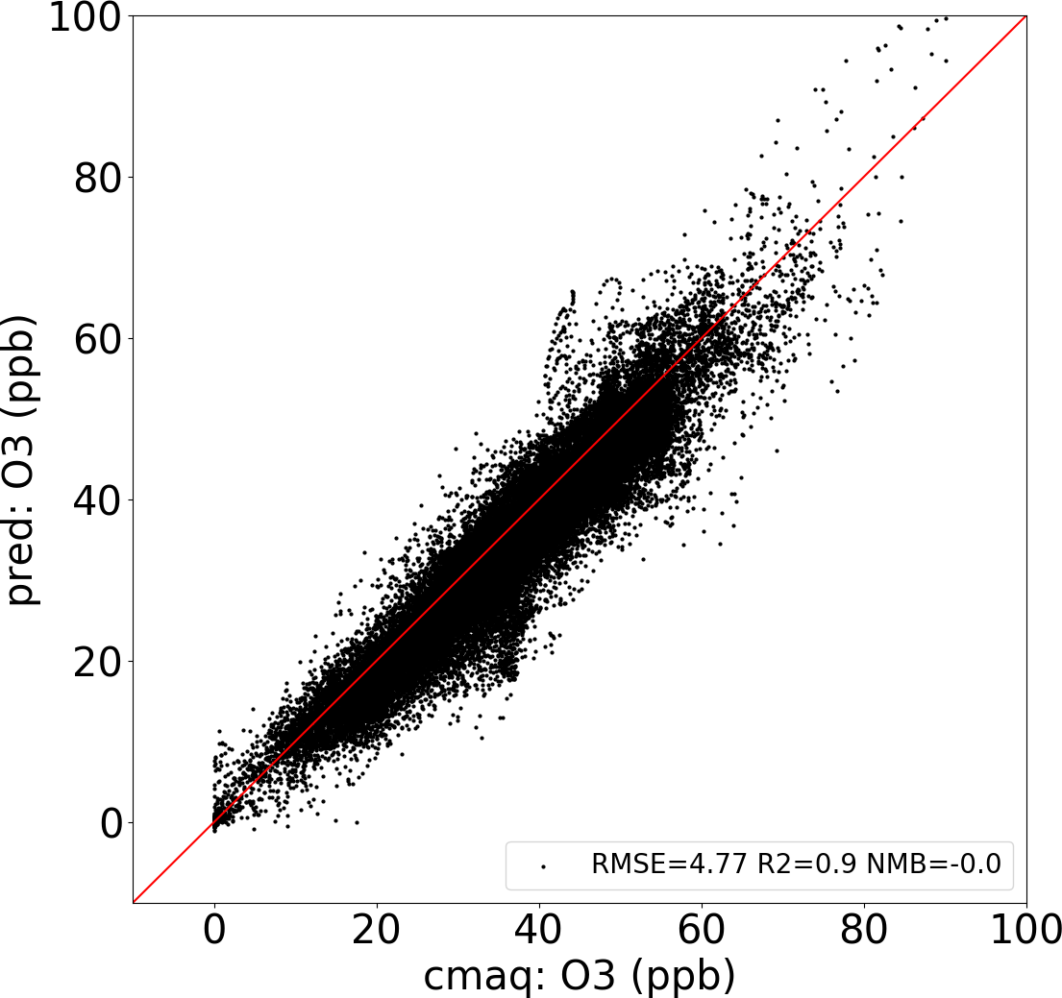 | 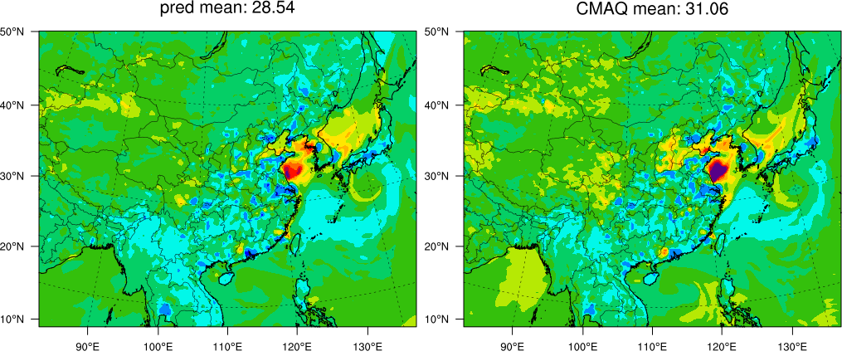 |  | 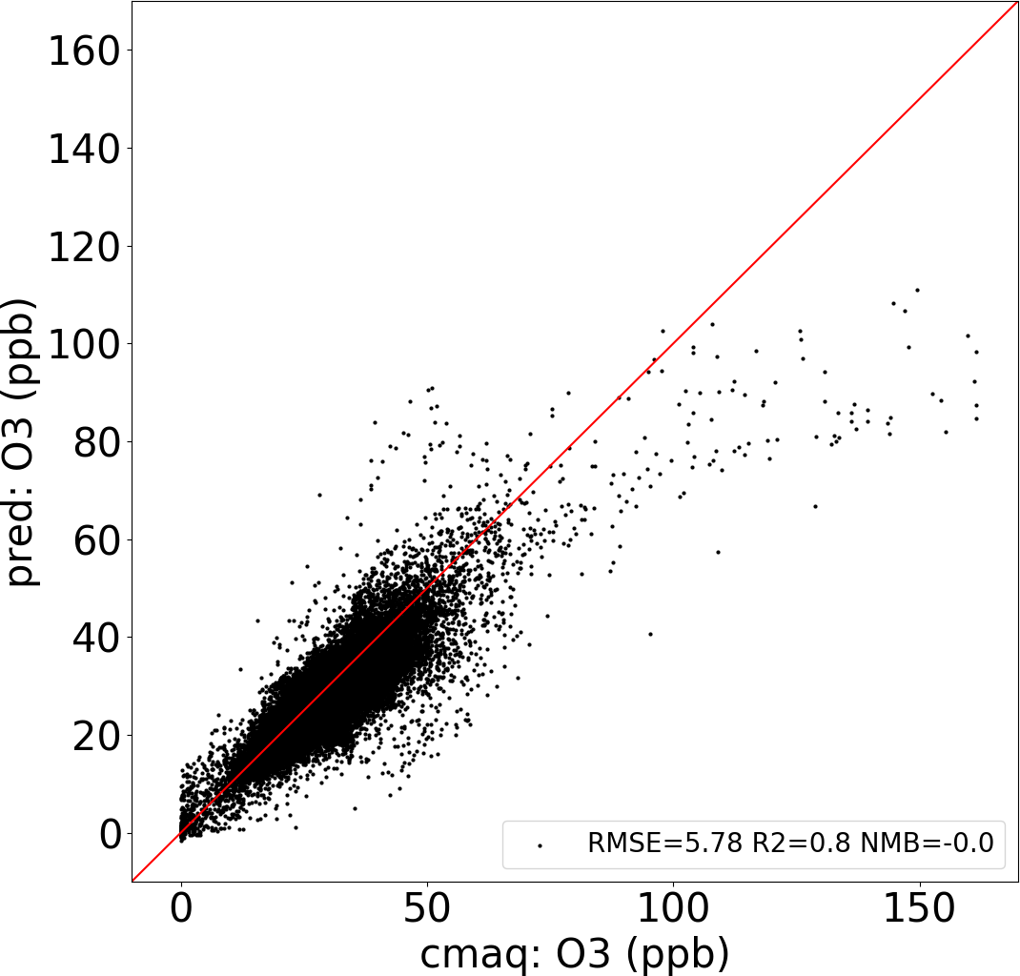
(f)  2d | 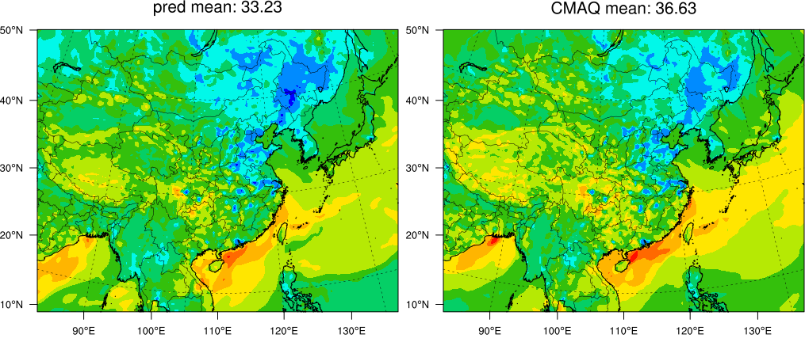 |  | 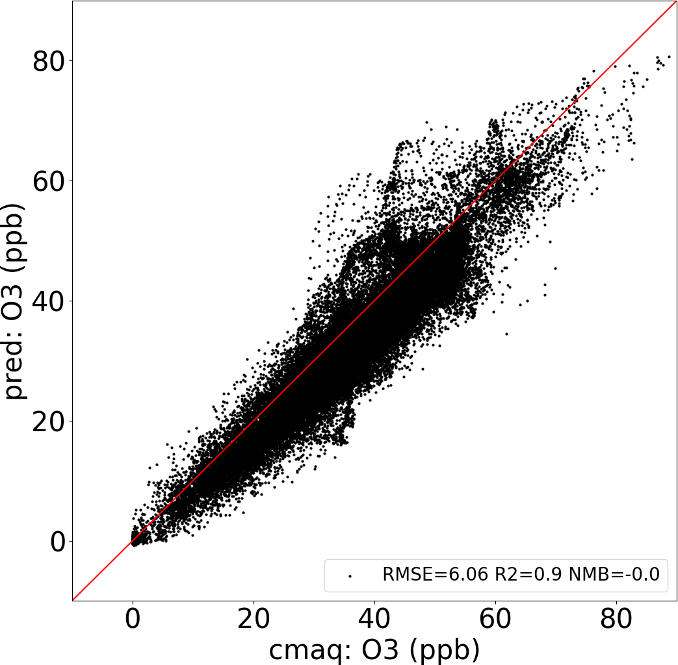 | 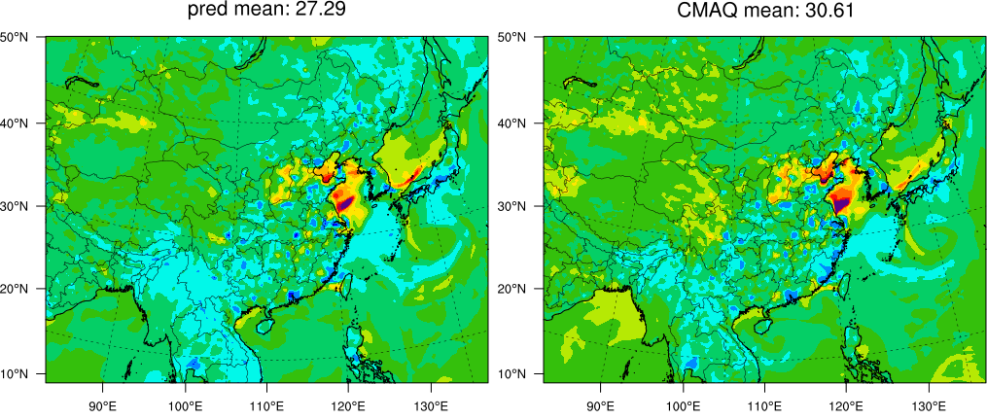 |  | 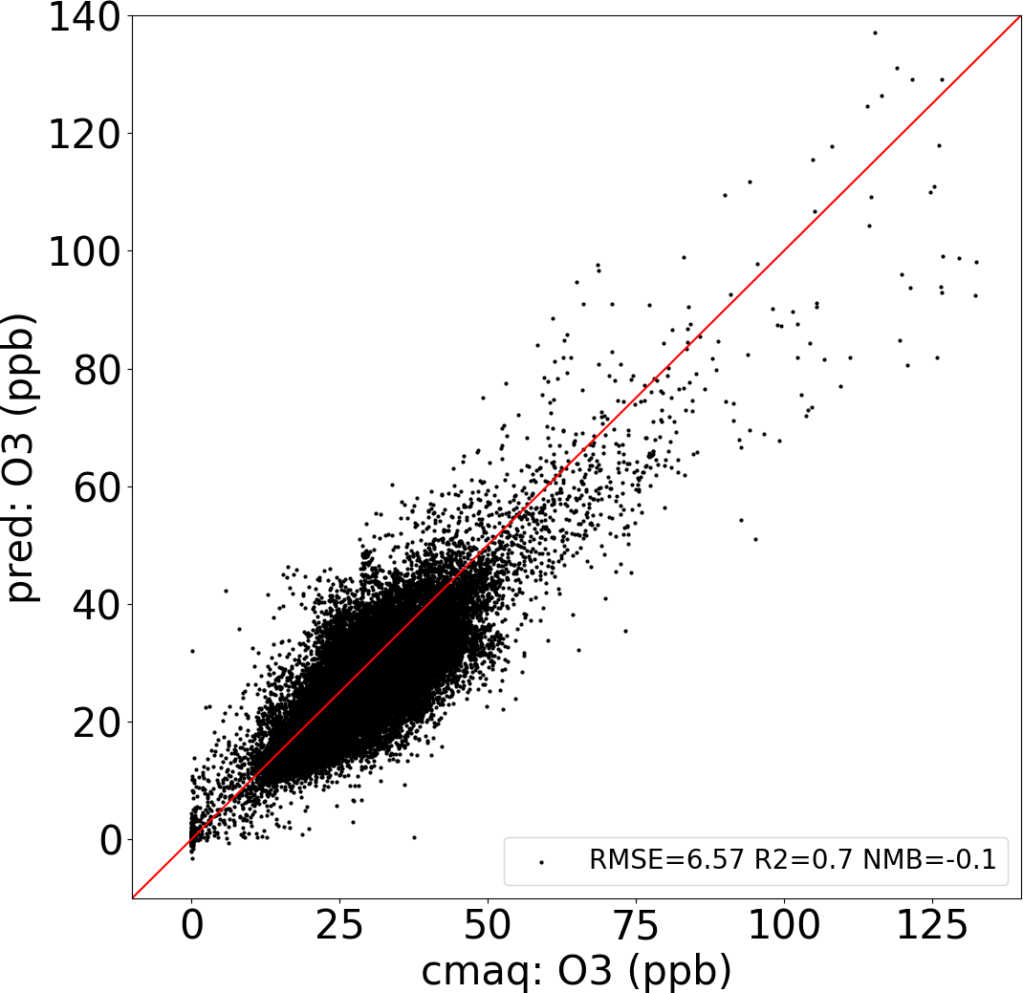
(g)  3d | 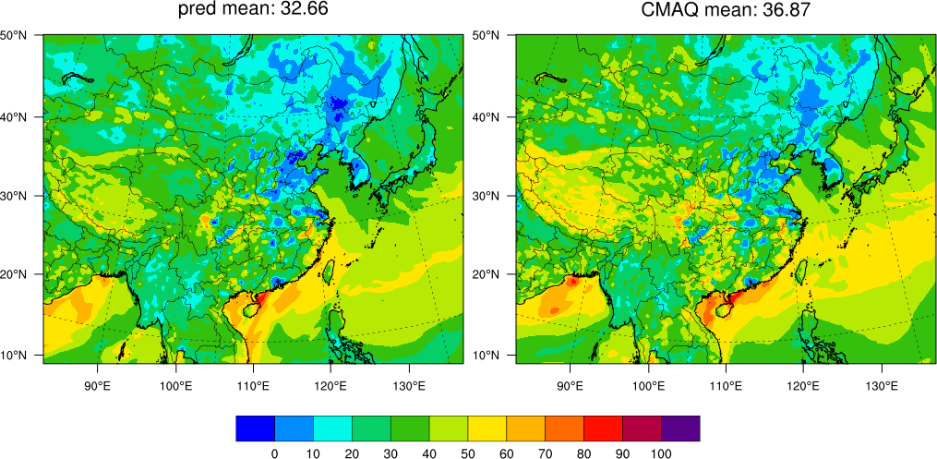 |  | 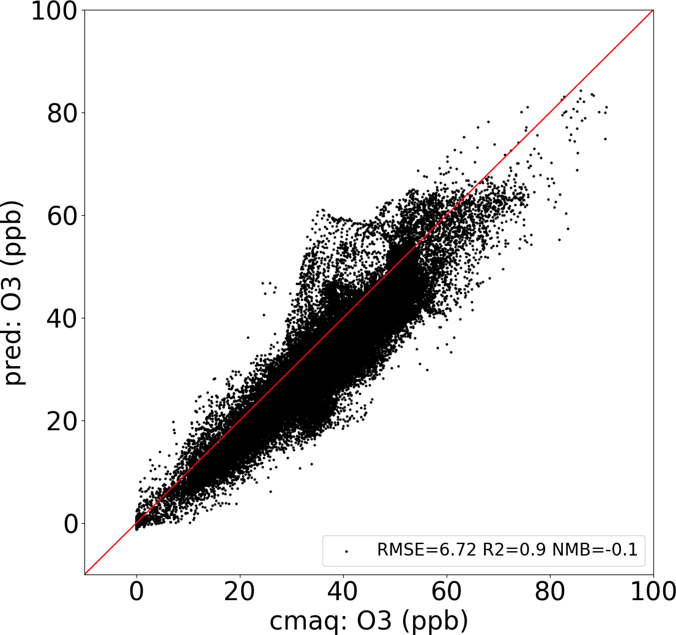 | 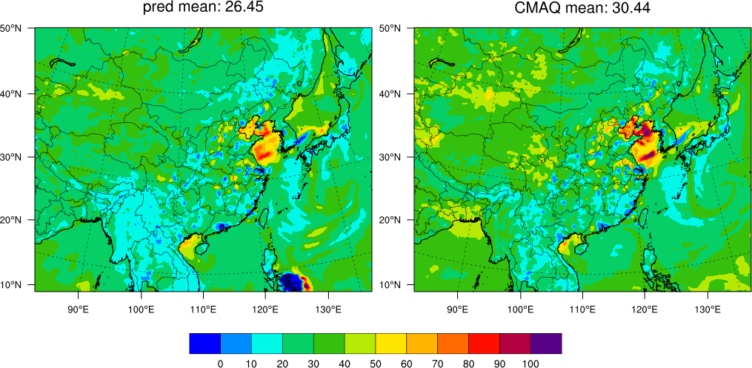 |  | 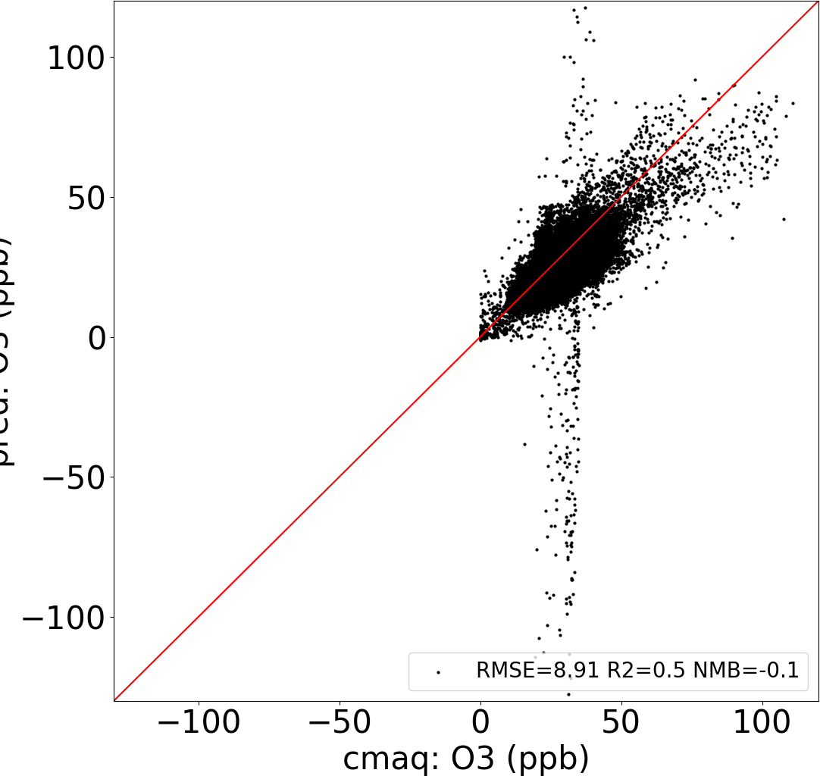
Figure 2. DeepCTM performance in predicing O₃ variations with emissions and meteorology

A typical winter day (Jan 21, 2017) | A typical summer day (July 21, 2017)
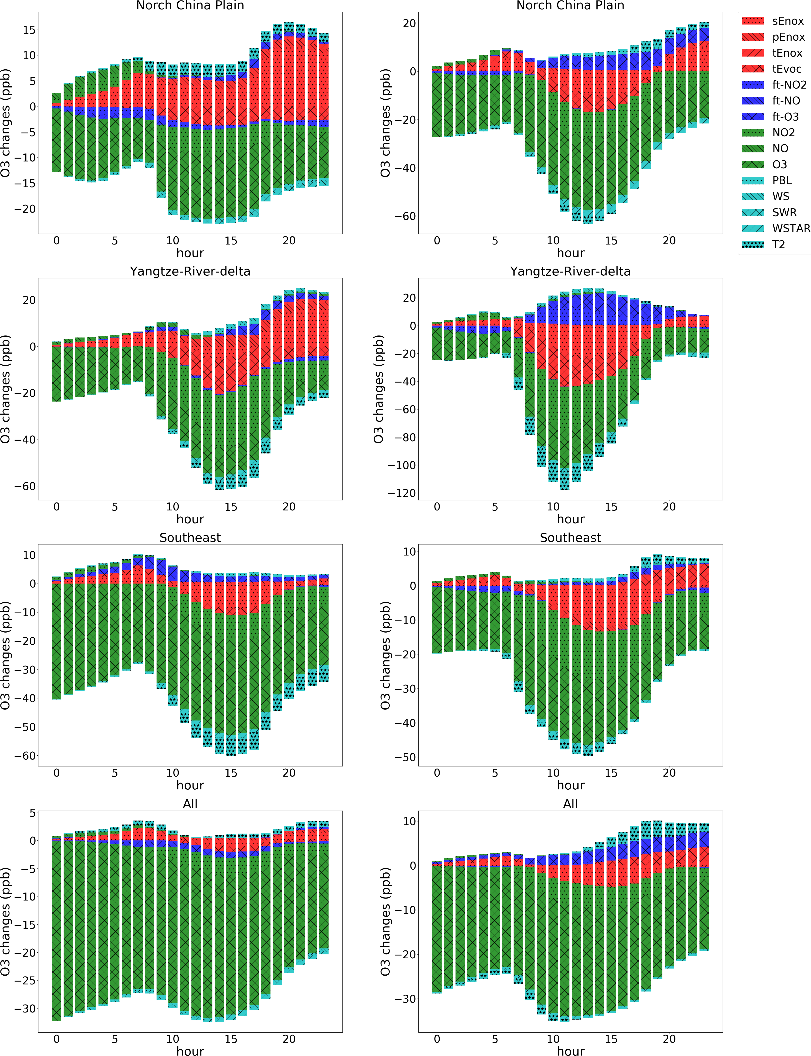
Figure 3. The O₃ sensitivities to the variation of individual factors (emission, initial condition, flux transport, and other meteorological factors are marked as red, green, blue, and cran respectivley; meteorological factors are quantified through a 10% variation, others are quantified through zero-out completely)
A typical winter day (Jan 21, 2017) |  | A typical summer day (July 21, 2017)
Midnight (6 am) | Noon (12 pm) | Midnight (6 am) | Noon (12 pm)
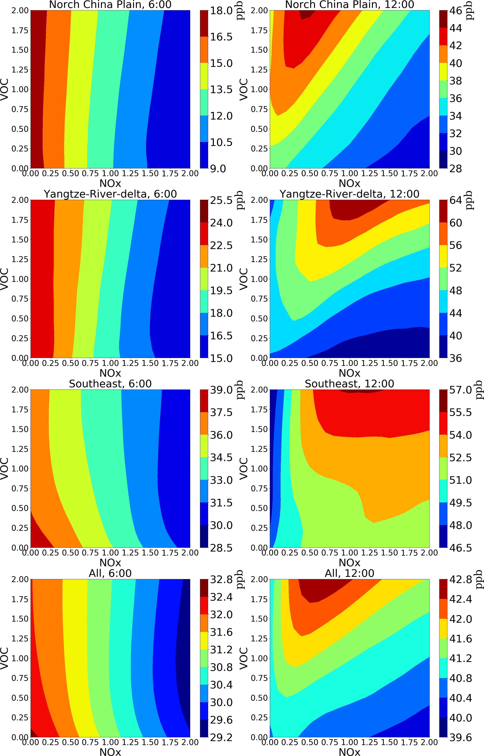 |  | 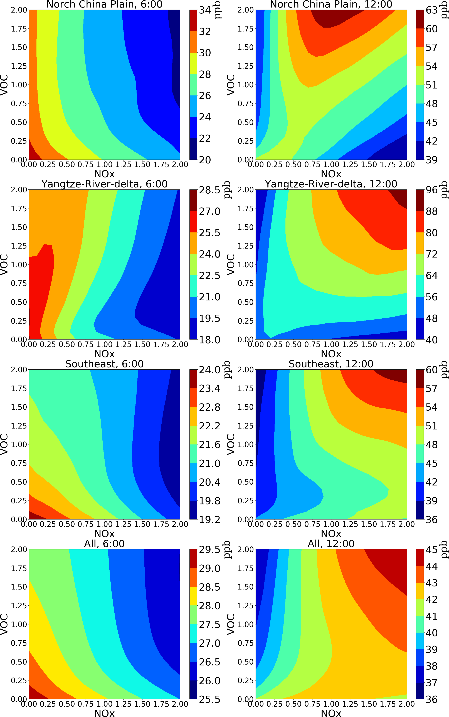

Figure 4. The isopleths of O₃ response to NO_{x}/VOC emission change (baseline = 1) predicted by DeepRSM (the values are averages of all grid cells and days)
A typical winter day (Jan 21, 2017) | A typical summer day (July 21, 2017)
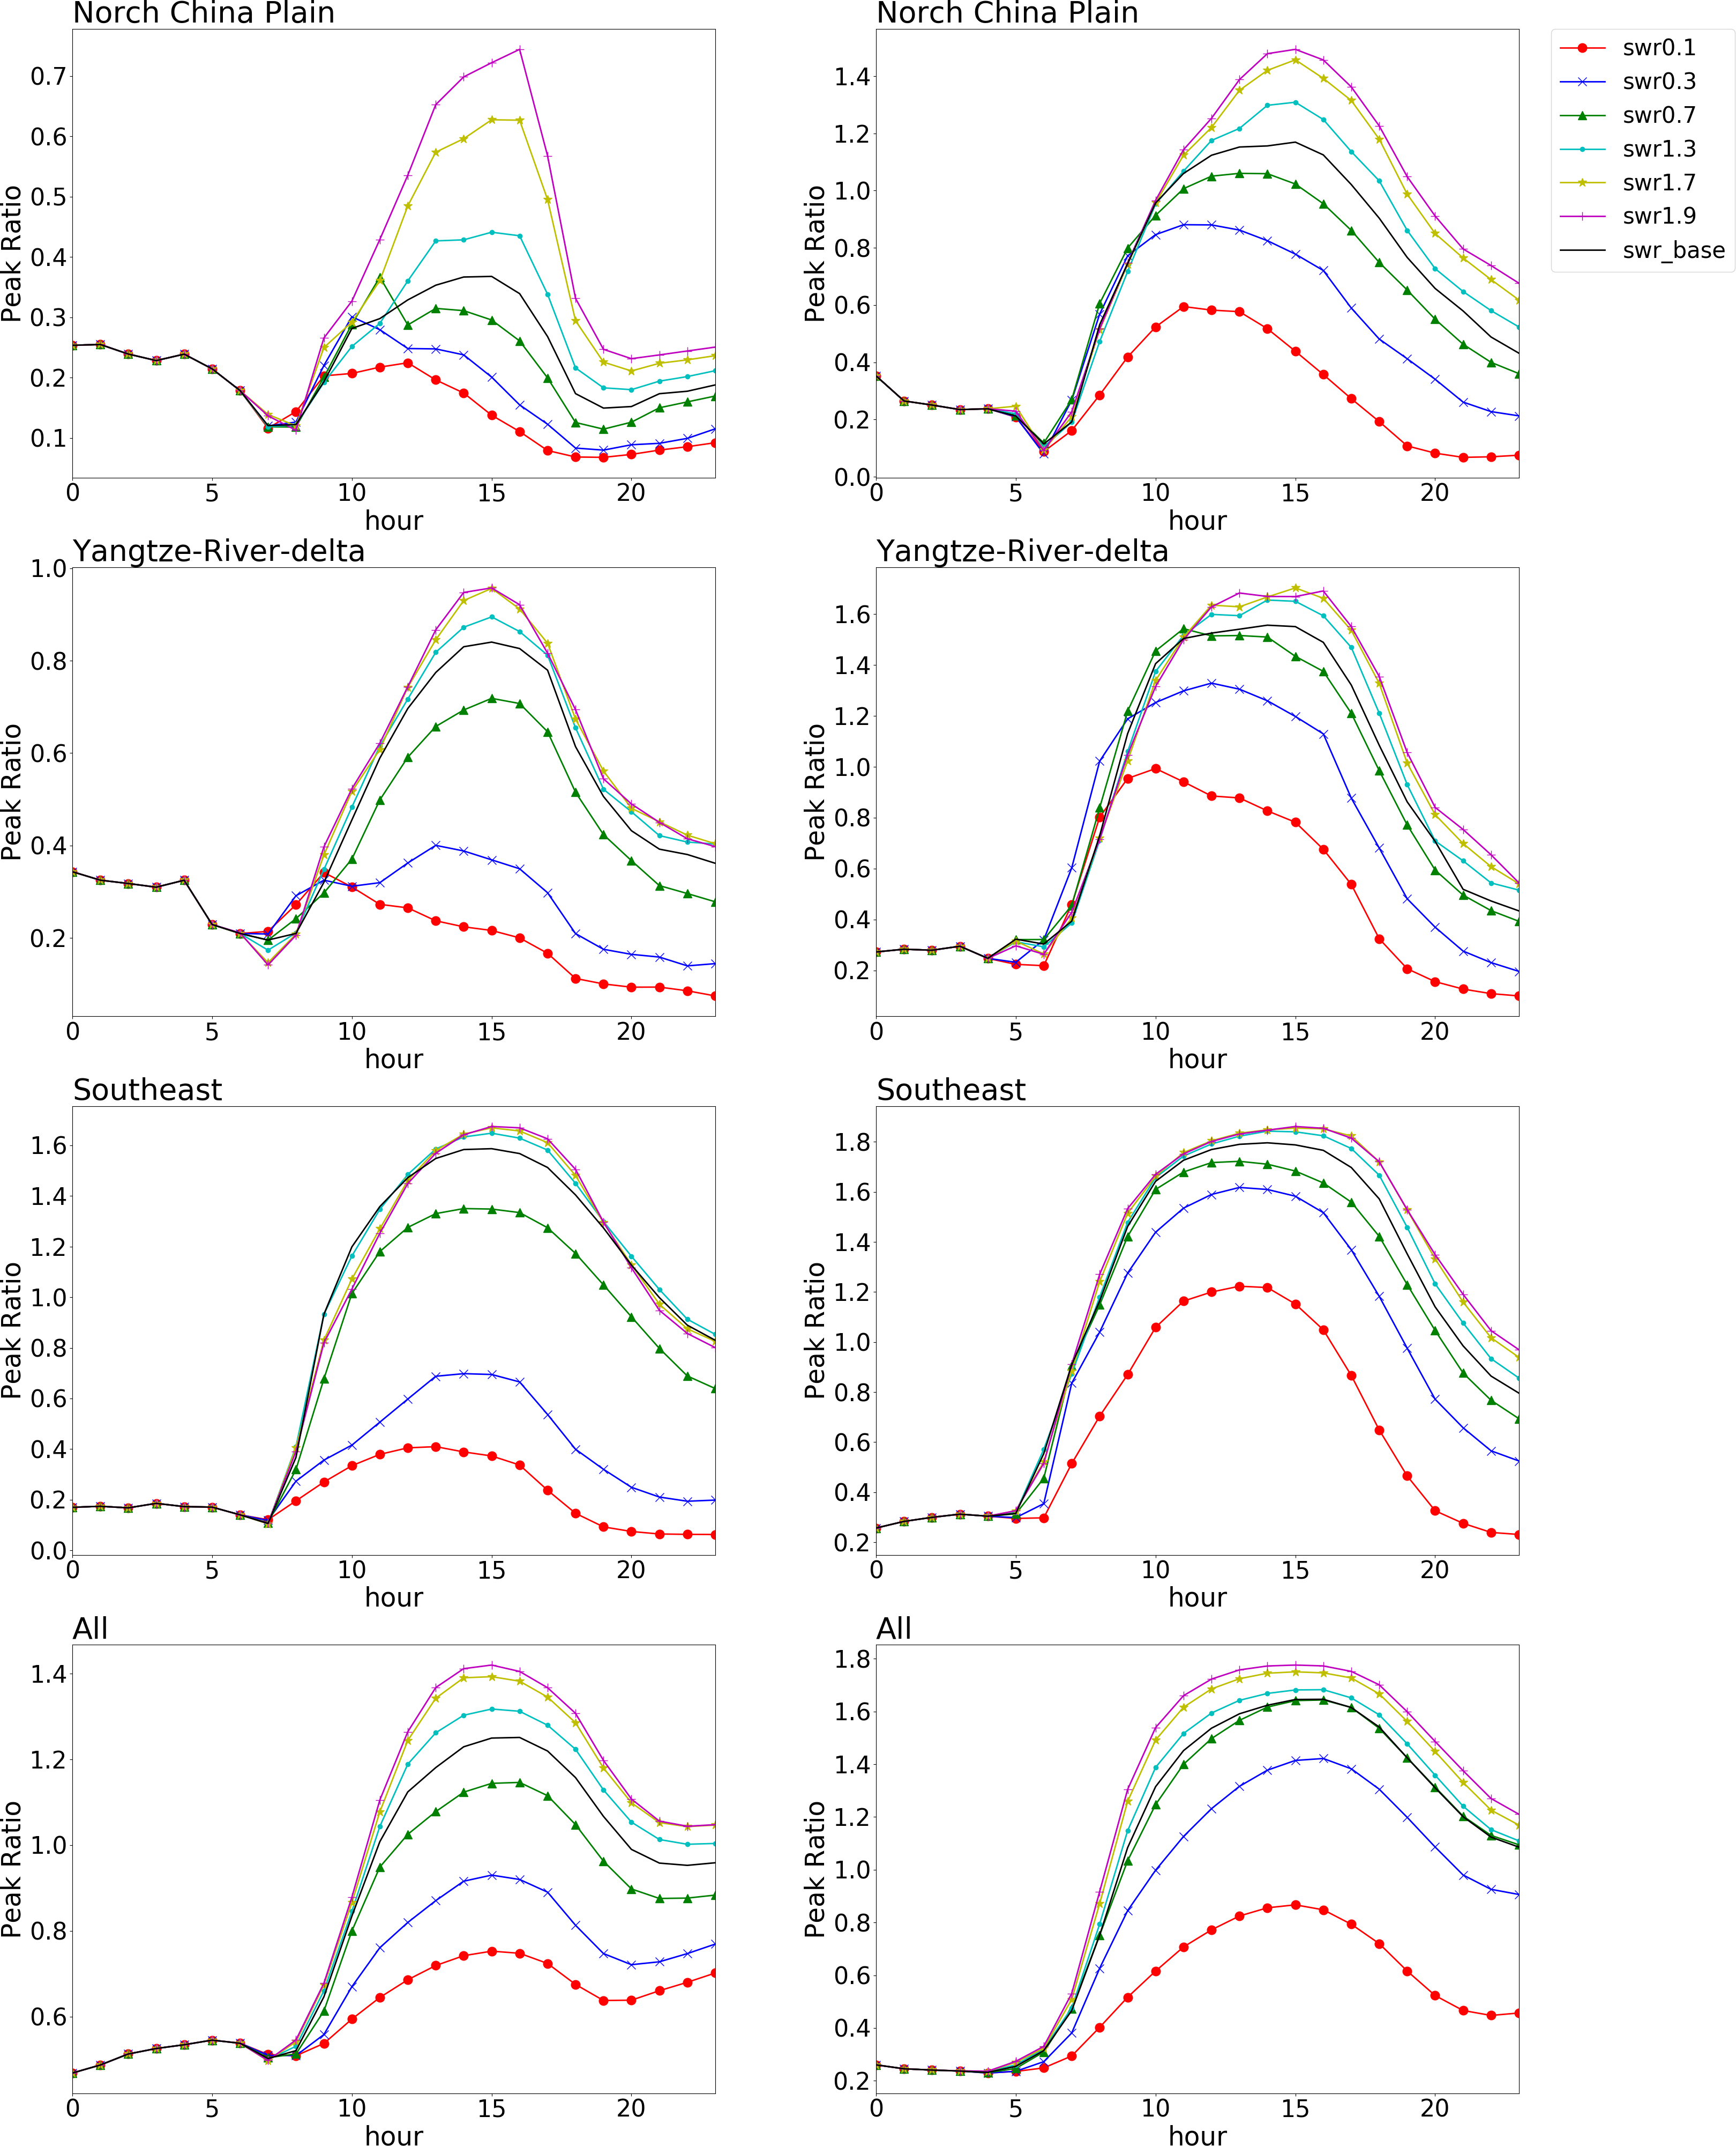
Figure 5. The O₃ chemistry (indicated by the Peak Ratio) response to the variation of short-wave radiation across a day

(a) 24 hour averaged O₃ | (b) 1 hour max O₃
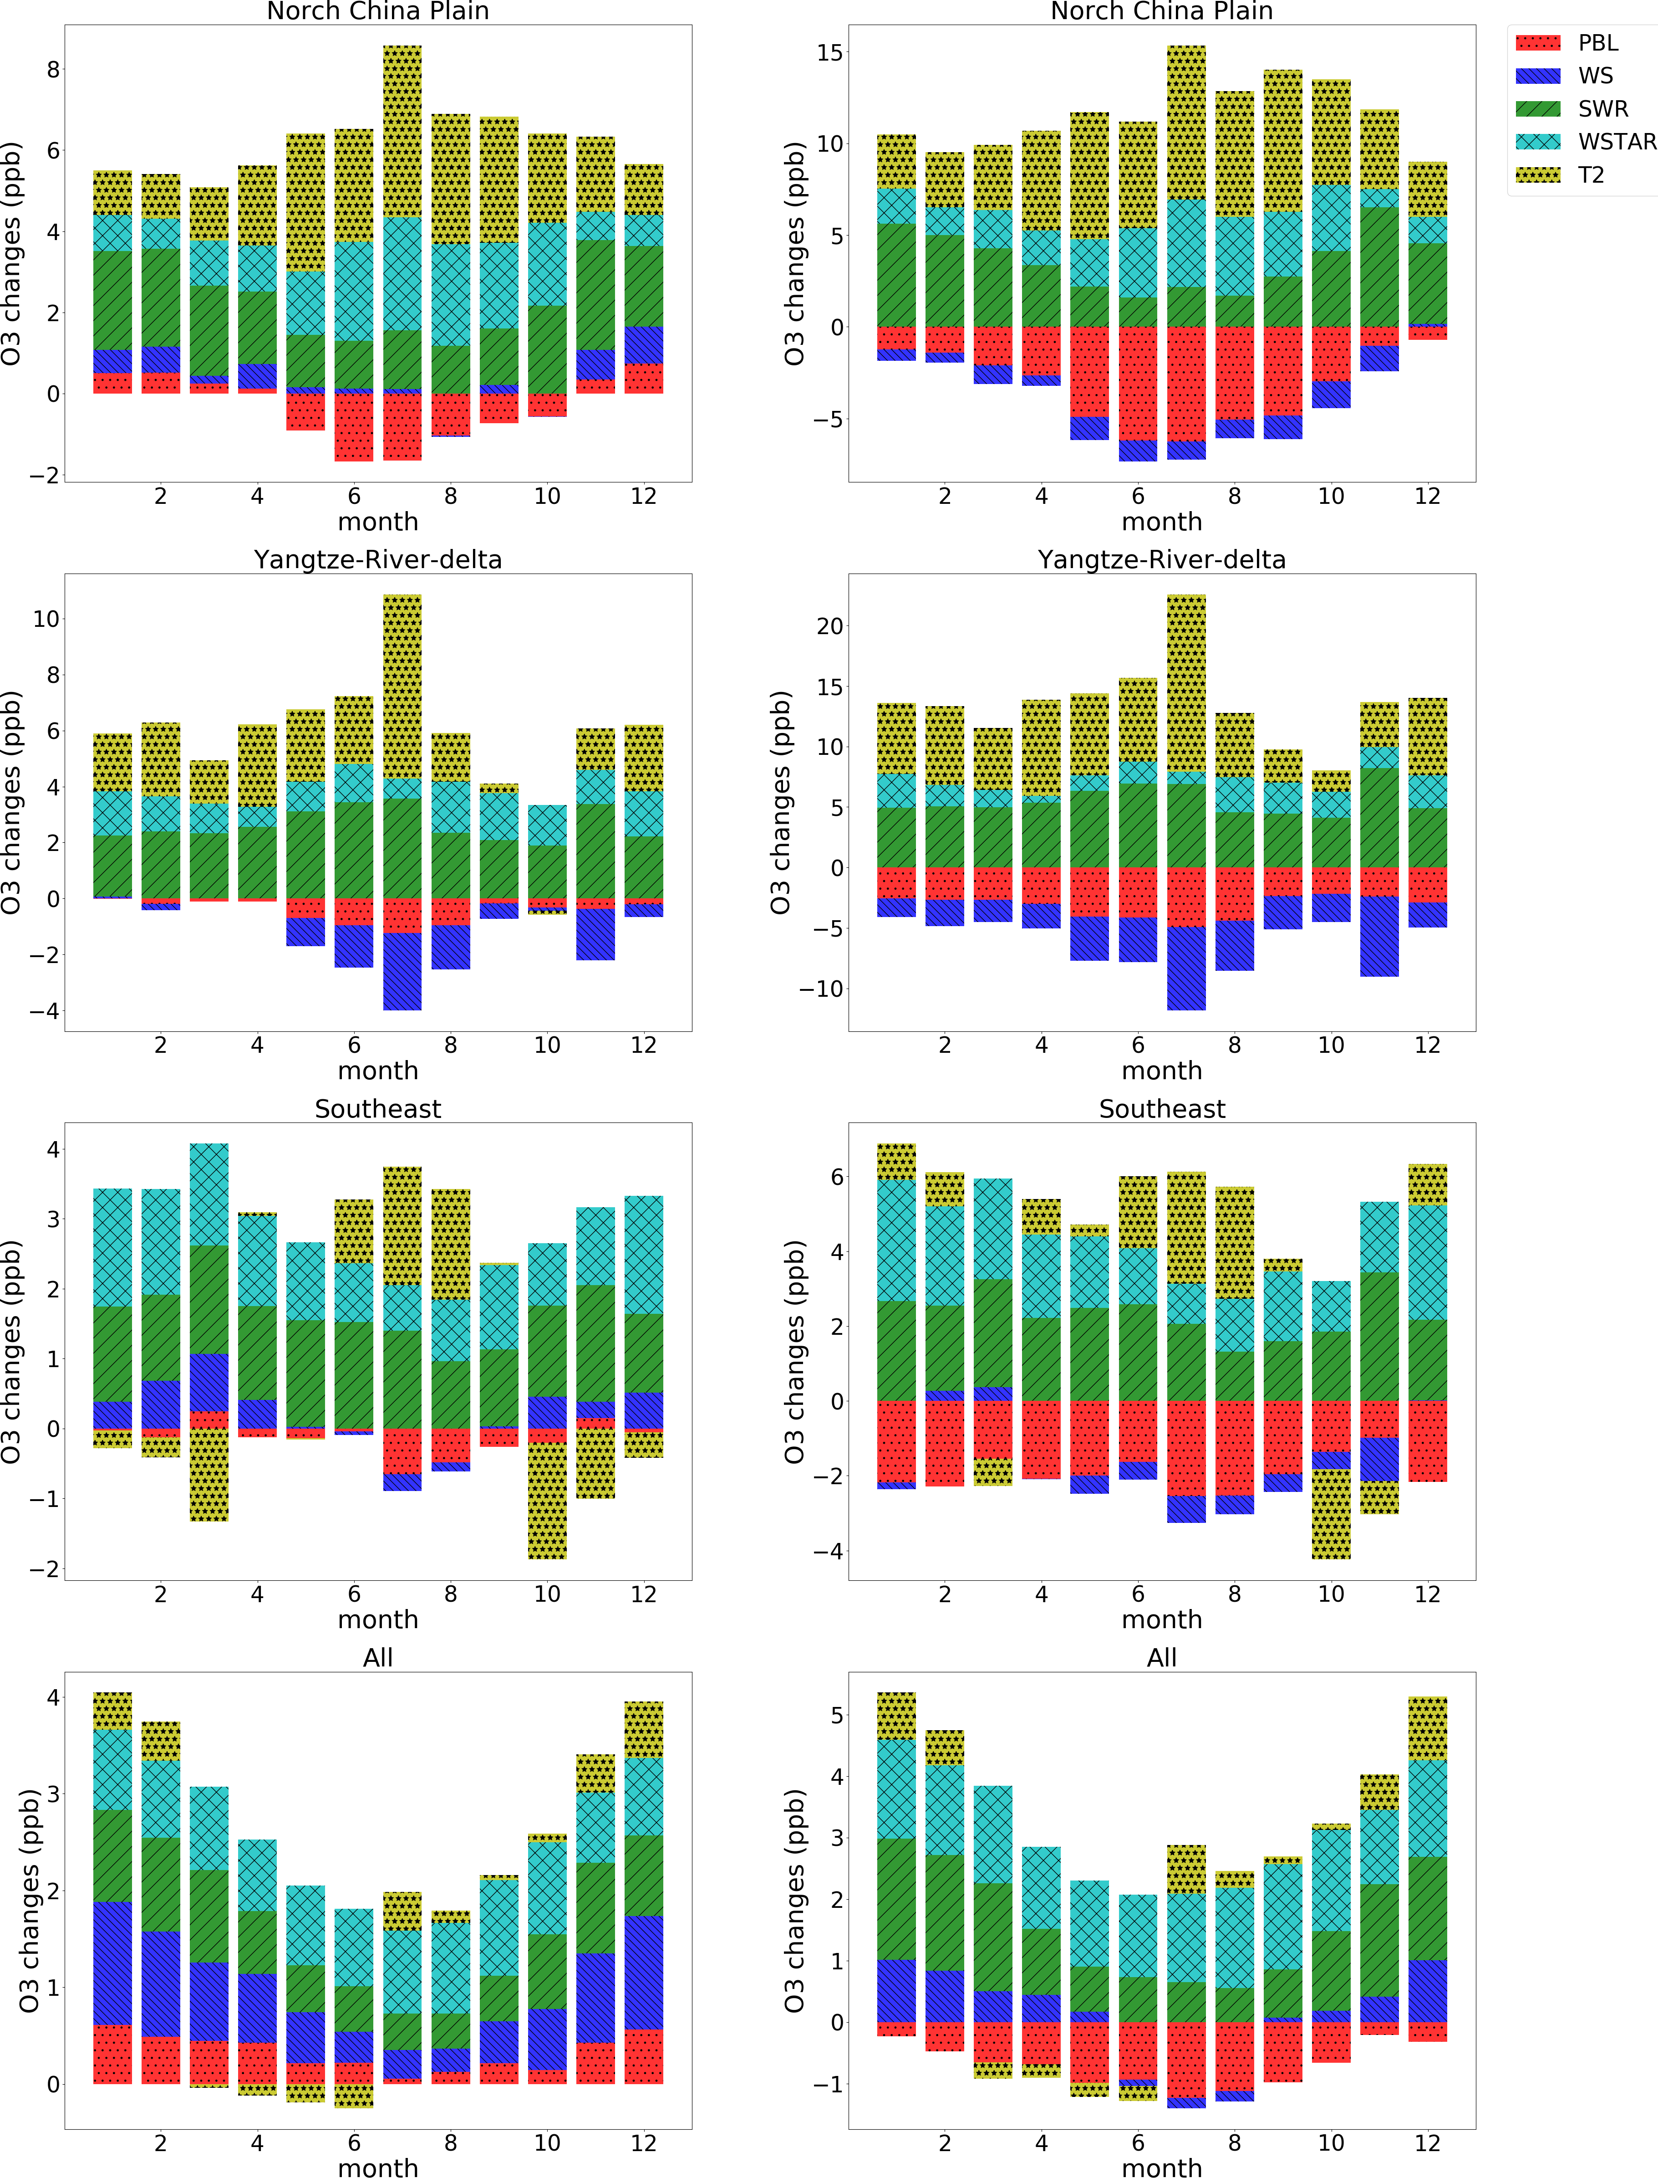
Figure 6.The monthly O₃ changes due to the variation of meteorological parameters by taking differences from 20% increase to 20% decreases of PBL height, wind speed (WS), short-wave radiation (SWR), and convective velocity scale (WSTAR), and differences from +10 K to -10 K of 2-meter temperature (T2) respectively
(a) 24 hour averaged O₃ | (b) 1 hour max O₃
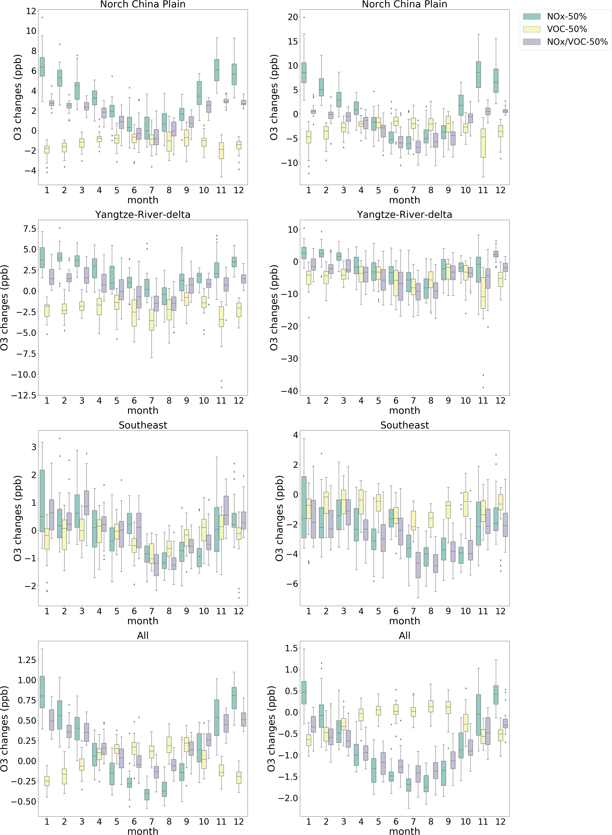

Figure 7.The O₃ changes due to NO_{x} and VOC emission controls under different meteorolgical conditions across a year

Supplementary information for the manuscript Deep learning for predicting ozone variations with emissions and meteorology

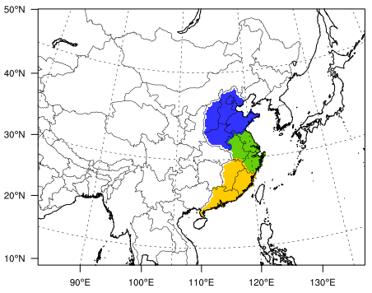
Figure S1.CTM simualtion domain and key selected regions including Norch China Plain (blue), Yangtze-River-delta (green), and Southeast (yellow)

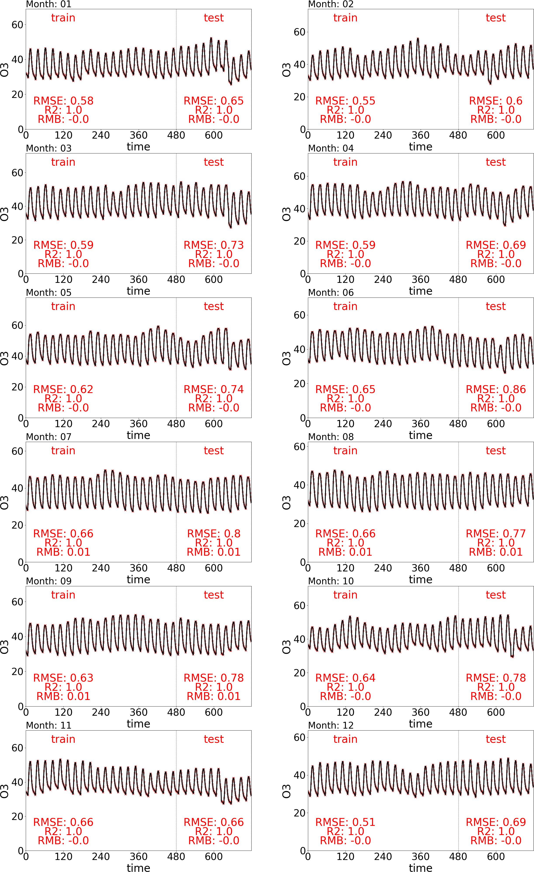
Figure S2.The time-series of DeepCTM-predicted and CMAQ-simulated hourly O₃ concentrations (unit: ppb) and corresponding statistices of DeepCTM-performance

A typical winter day (Jan 21, 2017) | A typical summer day (July 21, 2017)
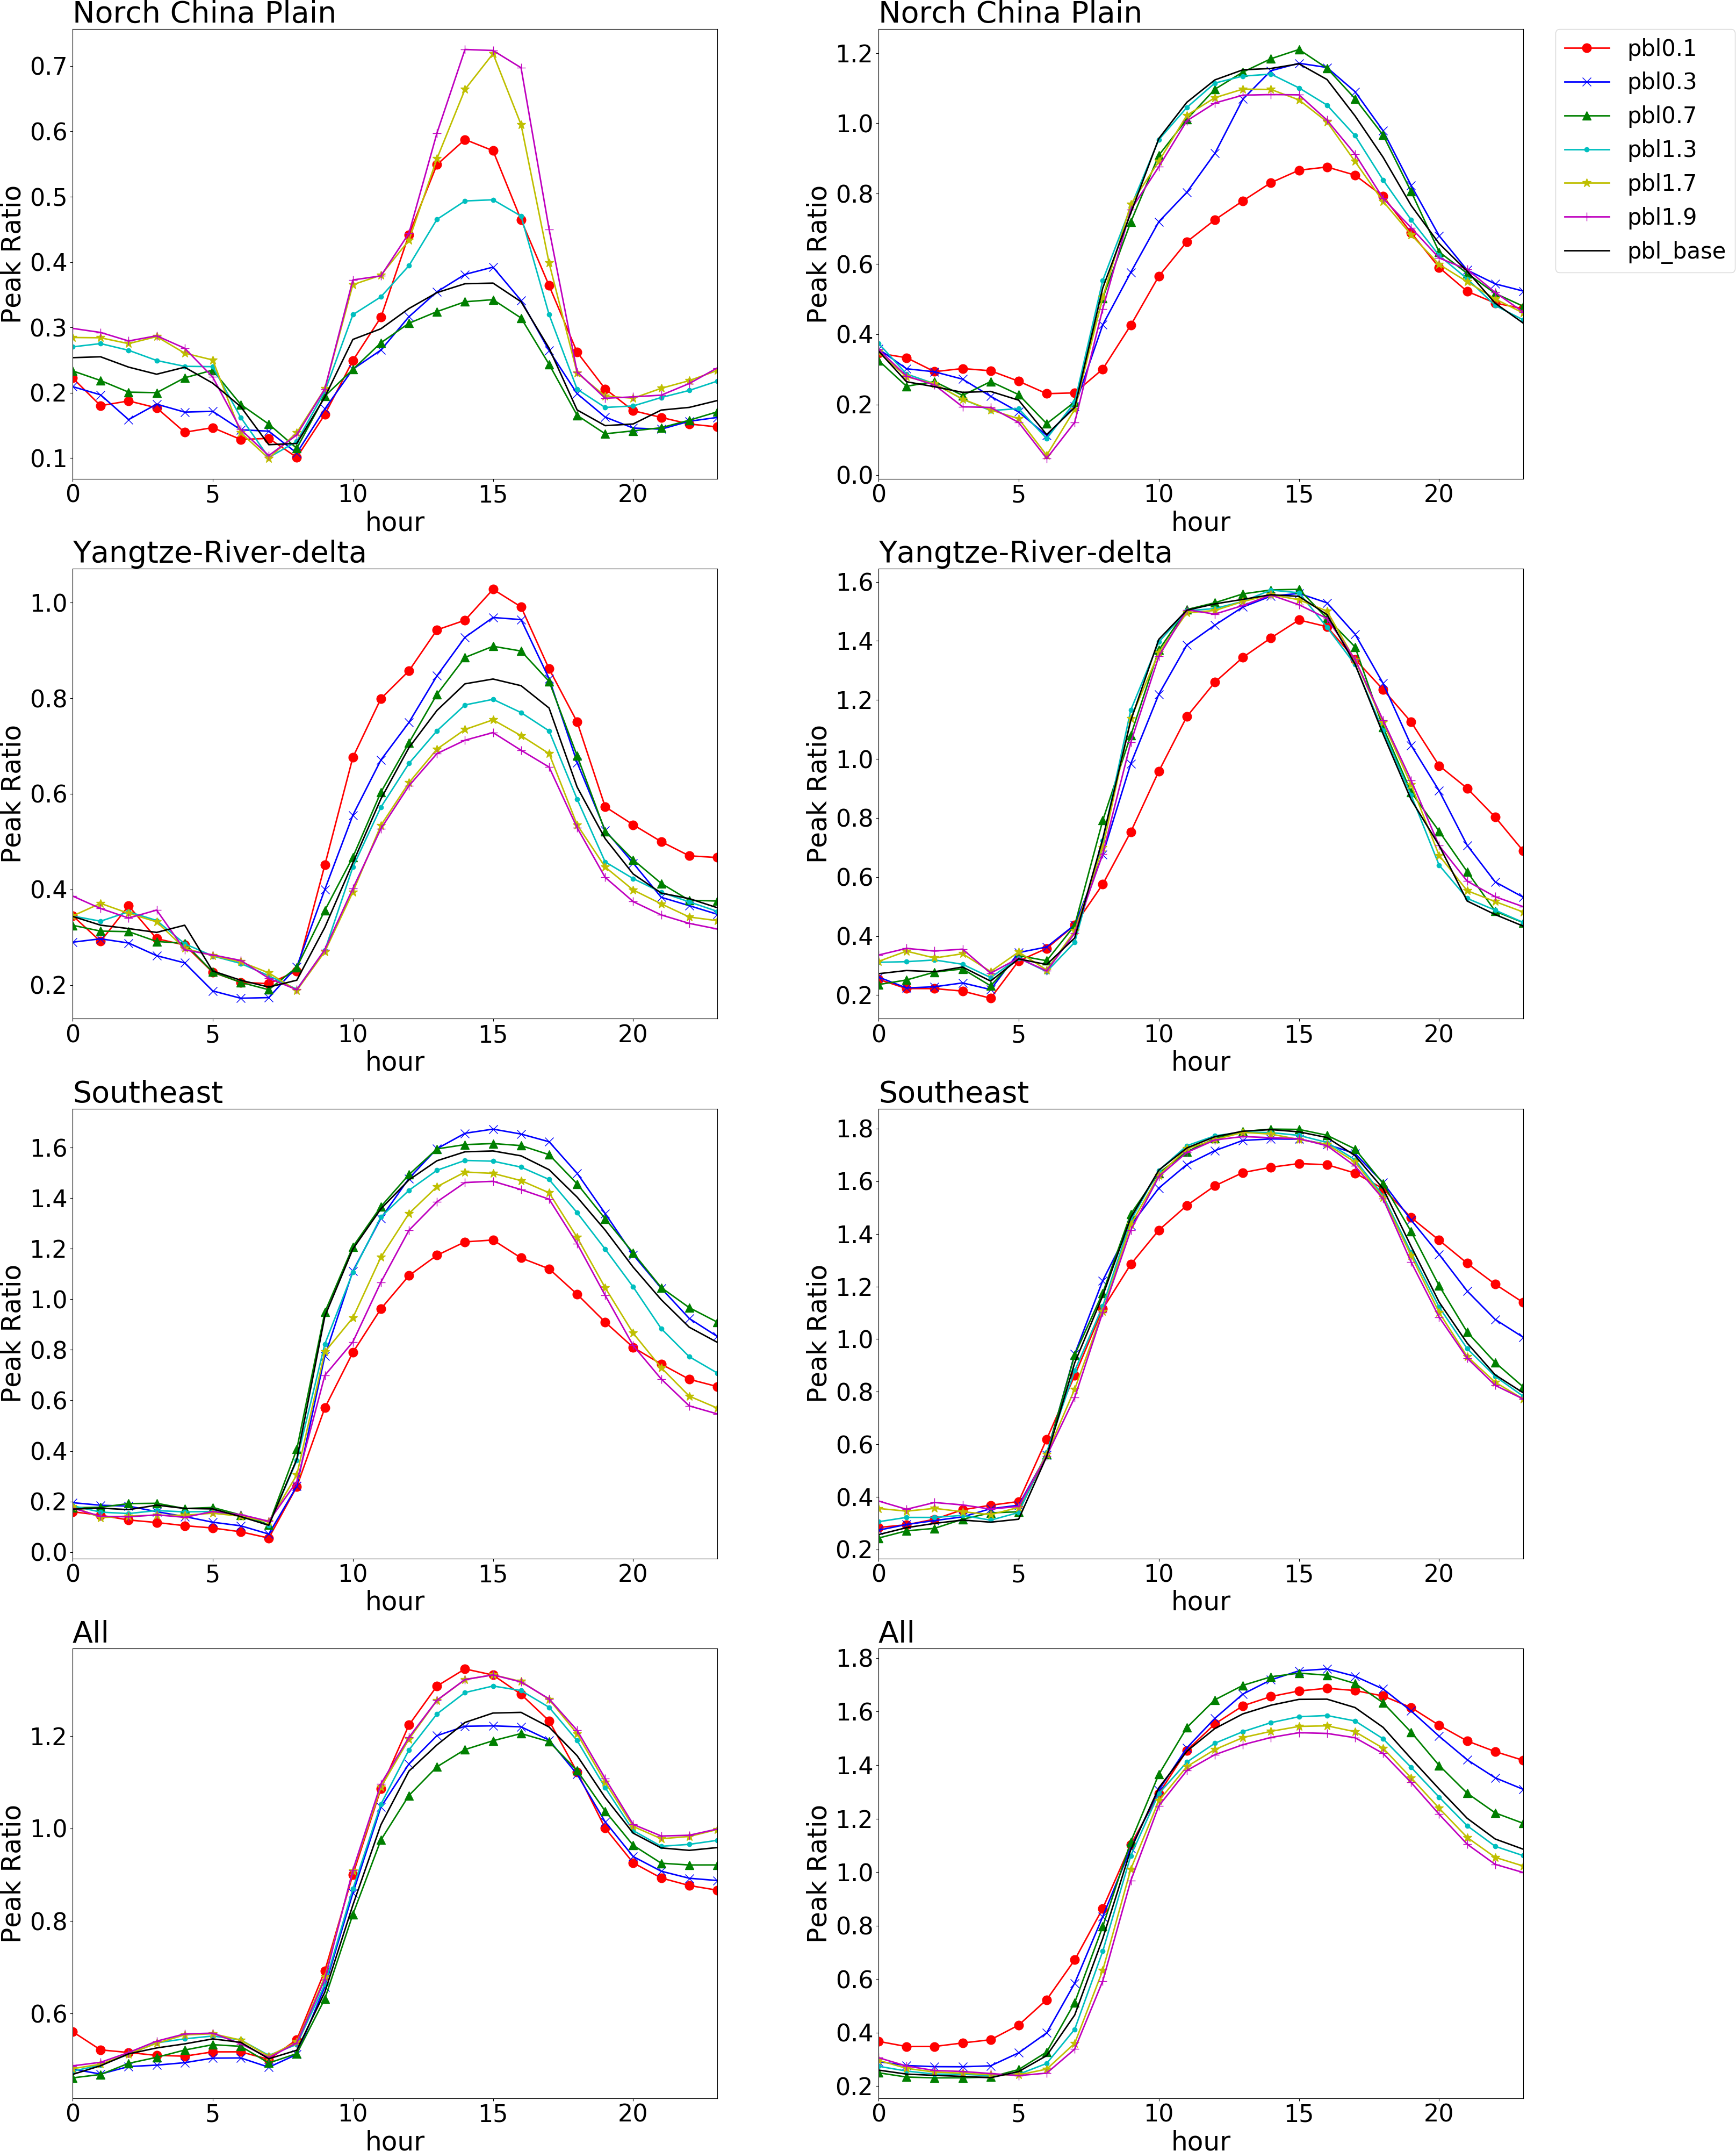
Figure S3. The O₃ chemistry (indicated by the Peak Ratio) response to the variation of PBL height across a day

A typical winter day (Jan 21, 2017) | A typical summer day (July 21, 2017)
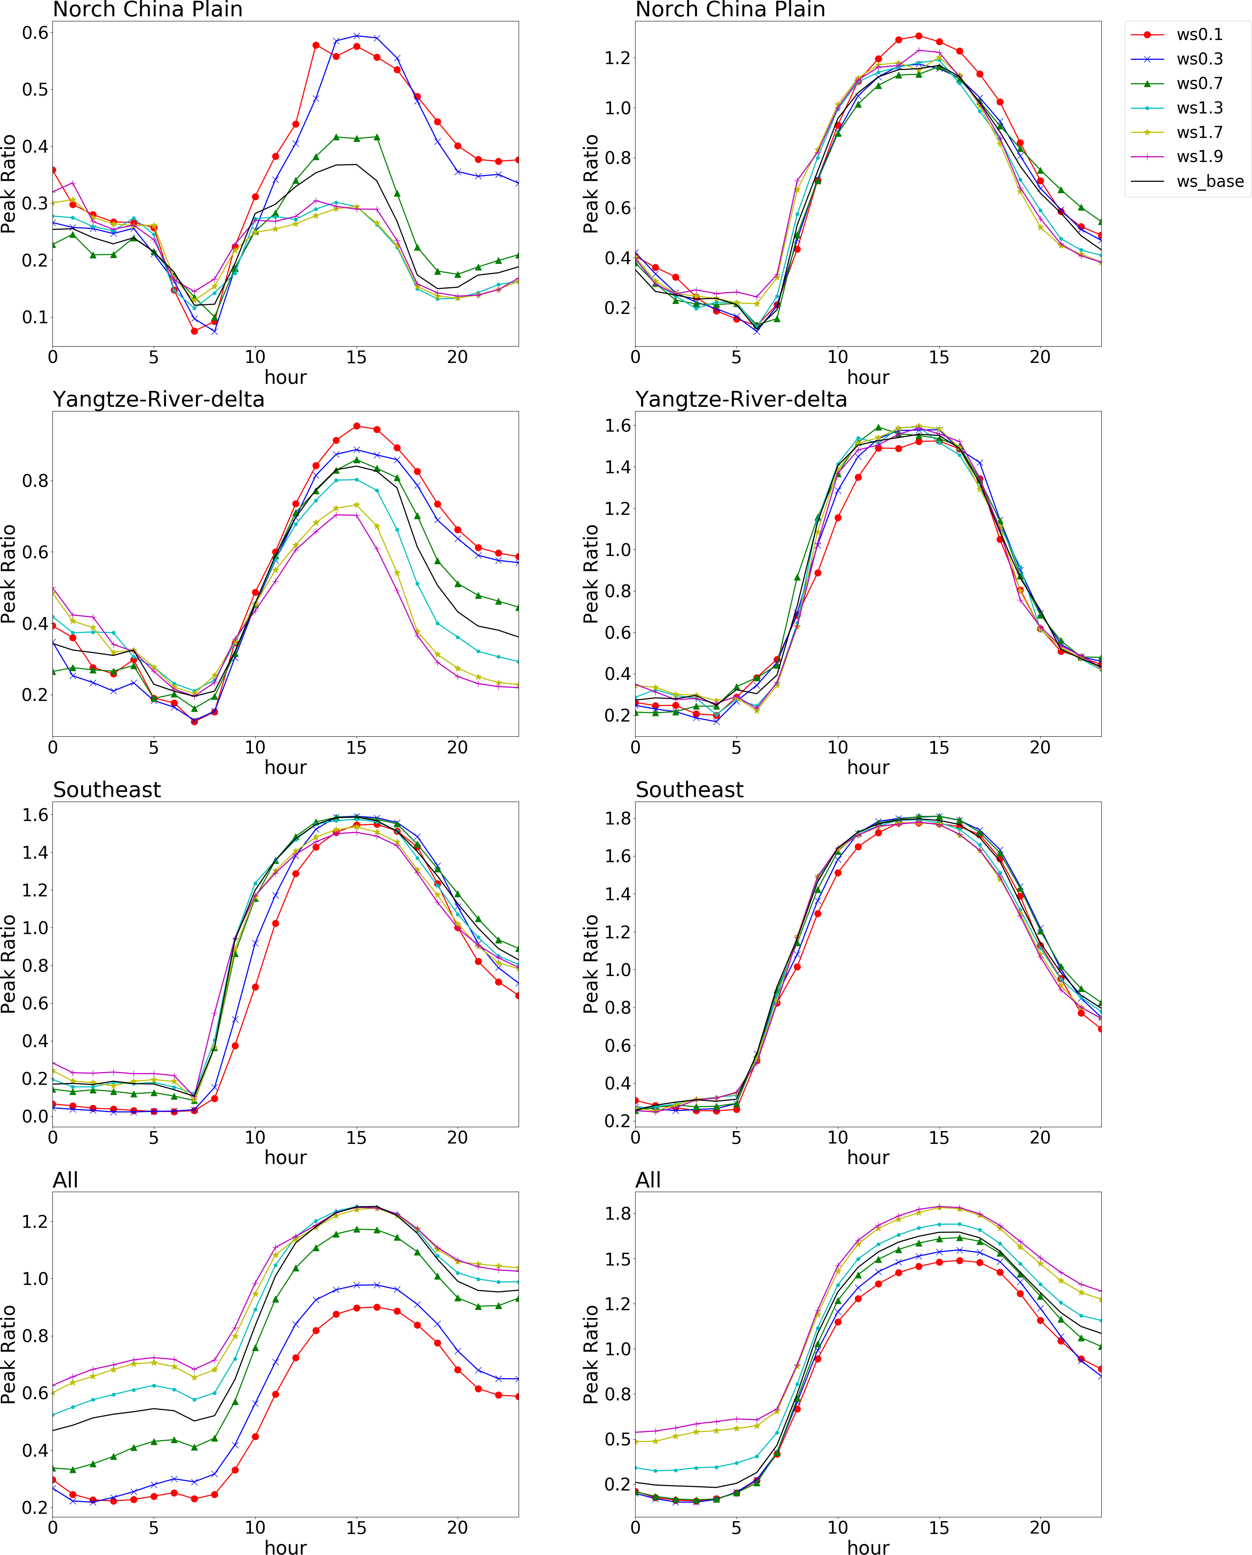
Figure S4. The O₃ chemistry (indicated by the Peak Ratio) response to the variation of wind speed across a day

A typical winter day (Jan 21, 2017) | A typical summer day (July 21, 2017)
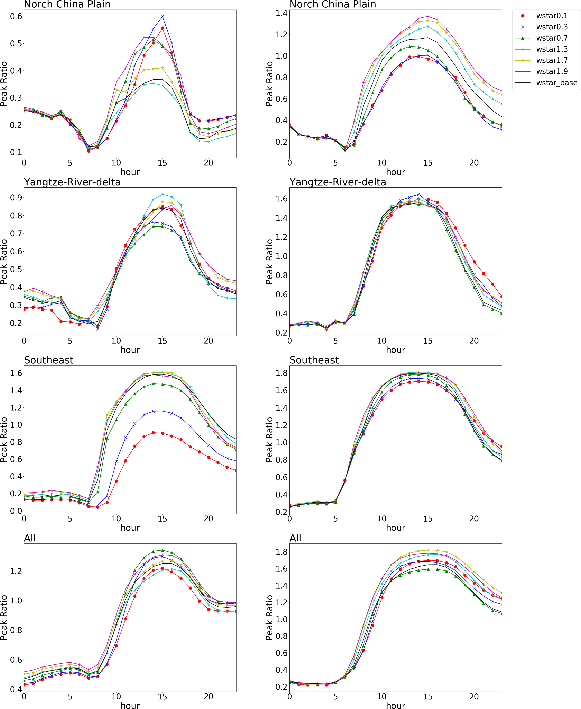

Figure S5. The O₃ chemistry (indicated by the Peak Ratio) response to the variation of convective velocity scale across a day
A typical winter day (Jan 21, 2017) | A typical summer day (July 21, 2017)
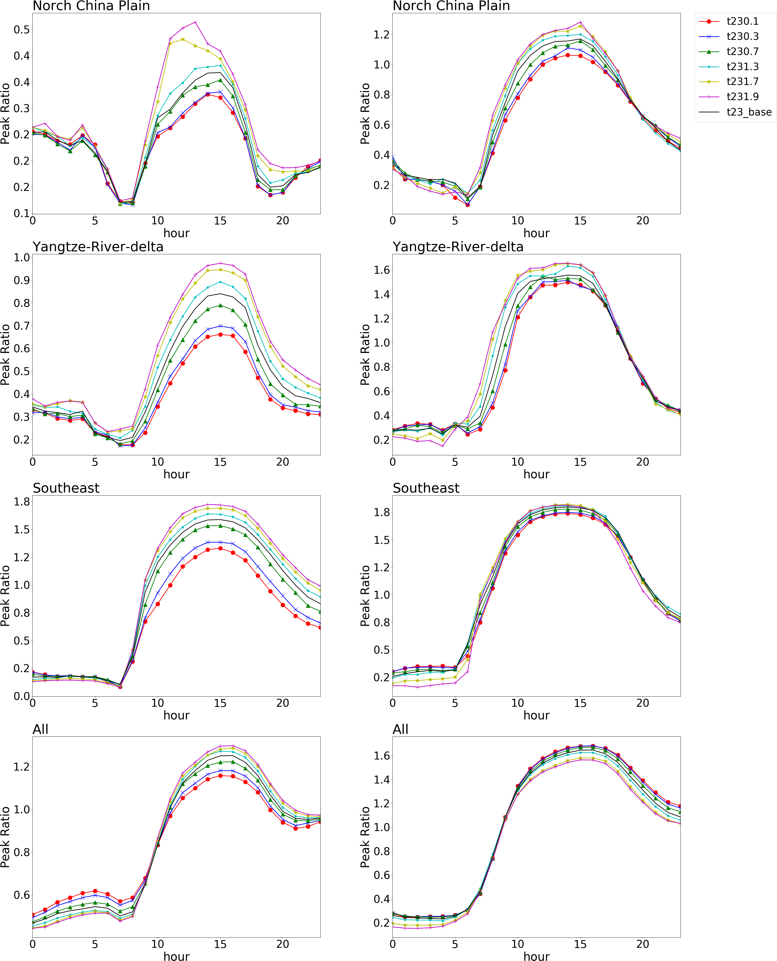

Figure S6. The O₃ chemistry (indicated by the Peak Ratio) response to the variation of 2-meter temperature across a day

