Deep learning for predicting ozone variations with emissions and meteorology
Jia Xing^{1,2}, Shuxin Zheng^{3,}*, Siwei Li^{4,}*, Xiaochun Wang^{1,2}, James T. Kelly⁵, Shuxiao Wang^{1,2,}*, Yueqi Jiang^{1,2}, Song Liu^{1,2}, Chang Liu³, Carey Jang⁵, Yun Zhu⁶, Tie-Yan Liu³, Jiming Hao^{1,2}
¹ State Key Joint Laboratory of Environmental Simulation and Pollution Control, School of Environment, Tsinghua University, Beijing 100084, China
² State Environmental Protection Key Laboratory of Sources and Control of Air Pollution Complex, Beijing 100084, China
³ Microsoft Research Asia, Beijing 100080, China
⁴ School of Remote Sensing and Information Engineering, Wuhan University, Wuhan 430079, China
⁵ Office of Air Quality Planning and Standards, U.S. Environmental Protection Agency, Research Triangle Park, NC 27711, USA
⁶ College of Environment and Energy, South China University of Technology, Guangzhou Higher Education Mega Center, Guangzhou 510006, China
*Corresponding Authors: Shuxiao Wang (email: shxwang@tsinghua.edu.cn; phone: +86-10-62771466; fax: +86-10-62773650), Shuxin Zheng (email: Shuxin.Zheng@microsoft.com), Siwei Li (email: siwei.li@whu.edu.cn)

Abstract
Fast and accurate prediction of ambient ozone (O₃) responses to changes in emissions and meteorology is crucial for understanding the mechanisms of O₃ formation and designing effective control strategies. However, existing chemical transport model (CTM)-based approaches are computationally expensive, and resource burdens limits their usage and effectiveness in air quality management. Here we proposed a novel method (noted as DeepCTM) that combines deep learning to CTM predictions to improve the computational efficiency of photochemical modeling. The well-trained DeepCTM successfully reproduces CTM-simulated O₃ concentration using input features of precursor emissions, meteorological factors, and initial conditions. The advantage of the DeepCTM is its high efficiency in identifying the dominant contributors to O₃ formation and quantifying the O₃ response to variations in emissions and meteorology. The DeepCTM application in China suggests that O₃ concentrations are strongly influenced by the initialized O₃ and NO₂ concentrations, as well as emission and meteorological factors during daytime when O₃ is formed photochemically. The variation of meteorological factors such as short-wave radiation can also significantly modulate the O₃ chemistry. The DeepCTM developed in this study exhibits great potential for efficiently representing the complex atmospheric system, and can provide policymakers with urgently needed information for designing effective control strategies to mitigate O₃ pollution.

Table of Contents Graphic

Ozone (O₃), an important air pollutant and greenhouse gas, has gained increased attention in China recently due to challenges in attaining the “Beautiful China” air quality targets ¹. Worsening O₃ pollution in most Chinese cities in recent years has raised concerns and questions, particularly since PM_{2.5} pollution has been effectively controlled by the Air Pollution Prevention and Control Action Plan implemented during 2013-2017 ². Many studies suggested that the unexpected O₃ increases might be due to both unbalanced precursor (i.e., NO_{x} and VOC) emission controls and meteorological conditions unfavorable for air quality ^{3, 4}. Therefore, the design of effective control strategies requires accurate and quick estimation of the O₃ response to variations in emissions and meteorology.
However, predicting the O₃ response to emissions and meteorology variations is challenging due to the high nonlinearity associated with atmospheric chemical and physical processes ⁵. Most previous studies ^{6,7} performed scenario analysis with chemical transport models (CTMs) to investigate the influence of meteorology and emissions separately, either by reducing emissions under constant meteorological conditions or by modulating meteorology under constant emissions. The nonlinear response of O₃ to emission changes has also been explored with advanced CTM-based tools ⁸⁻¹⁴, but these tools are generally resource intensive and limit the exploration of nonlinear O₃ responses to combined variations in emissions and meteorology. For instance, studies have revealed that future climate change may challenge efforts to continually improve air quality ¹⁵⁻¹⁶. Yet the question of how meteorology influences the effectiveness of emission controls still has not been well addressed. A method to efficiently quantify the influence of meteorological variations on the response of O₃ to emission changes is therefore urgently needed.
Deep learning technology, such as convolutional neural networks (CNNs), has demonstrated skill in representing the highly nonlinear and interactive relationships in the atmospheric system¹⁷⁻¹⁹. Our previous studies suggest that the air pollution response to emission changes can be inferred from the baseline concentrations of certain chemical indicators determined by the emissions and meteorology ²⁰. It is expected that pollutant concentrations are also predictable from emissions and meteorology using deep learning methods. More importantly, deep-learning representations of the inner relations of CTMs can substantially enhance the efficiency of predicting the O₃ response, and thus enable examination of the O₃ response to emissions and meteorology in a much higher dimensional space than traditional CTM studies. Such methods would provide essential information to policymakers to understand air pollution formation mechanisms and design proper control policies to continually improve air quality.
The key remaining questions are how to design a suitable neural network and how well such a network can replicate the CTM in revealing the inner relationships between O₃ and emissions and meteorology. To address these questions, we propose a novel deep learning neural network structure (noted as DeepCTM) to reproduce the CTM-predicted O₃. The properties of the new DeepCTM are examined for its ability to capture the nonlinearity of the O₃ response to emissions and meteorology.

Methods
(1) Dataset preparation
To establish the dataset for NN training, we used the Community Multiscale Air Quality (CMAQ) model, version 5.X, which is one of the most commonly used CTMs ²¹ for simulating the air pollutant concentrations. Meteorological fields were developed from simulations with the Weather Research and Forecasting (WRF) model, version 3.X. The CMAQ and WRF model configurations are the same as in our previous studies ^{2, 4}. The Carbon Bond 6 and AERO6 mechanisms were used to represent gas-phase and particulate matter chemistry, respectively. Anthropogenic emissions are based on the bottom-up ABaCAS-EI ²² inventory developed by Tsinghua University with a high spatial and temporal resolution. Biogenic emissions were based on the Model for Emissions of Gases and Aerosols from Nature (MEGAN) ²³. The performance of WRF and CMAQ for simulating meteorological variables and air pollutant concentrations has been thoroughly evaluated against observations in our previous studies^{2, 4}.
The study domain covers most of East Asia using 182 (row) × 232 (column) horizontal grid cells with 27 km × 27 km resolution. In addition to national averages, our analysis also focuses on three key regions in China that suffer the most serious O₃ pollution, including North China Plain, the greater Yangtze River Delta, and Southeast China (Figure S1).
(2) NN structure
Although deep learning models can represent any nonlinear system ²⁴, it is quite challenging for them to approximate the complicated atmospheric system. The challenges are due in part to unsatisfactory performance in neural-based solvers for partial differential equations ²⁵. To address these challenges, key inductive biases must be introduced ²⁶ when designing the features and architecture of the deep learning model. First, we carefully construct 15 feature maps that are sufficient to represent the response relationship between emissions and O₃ concentrations. The feature data consist of four emission variables including total VOC emissions and NO_{x} emissions at near-surface, within the planetary boundary layer (PBL), and above the PBL; five meteorological variables including PBL height, wind speed, short-wave radiation, convective velocity scale, and 2-meter temperature; three initial concentration fields including NO, NO₂ and O₃, and their corresponding transport fluxes, which represent the movement between neighboring grid cells following the horizontal wind direction.
Second, we carefully design a novel deep neural network called DeepCTM that captures the spatial relationships among local emissions, meteorology and the concentrations to be predicted. Specifically, we use stacked convolutional layers to maintain spatial information through the network and better extract the exclusive characteristics from the inputs. To stabilize the optimization procedure, we employ two key components to smooth the energy landscape: (i) batch normalization of the activations ²⁷ and (ii) skip connections to eliminate the problematic singularities in deep networks ²⁸. Also, unlike traditional CNNs, the resolutions of all feature maps are maintained throughout the network to preserve the spatial information as much as possible in the DeepCTM. The detailed architecture is presented in Figure 1.
The 15 feature maps are concatenated and fed into the residual connection with eight residual blocks ²⁹, similar to our previous study ²⁰. The first 3×3 convolutional layer has a large number of channels (i.e., 128) to achieve expressiveness of the connections among the original 15 features. The channel number reduces from 128 to 3 in the last 3×3 convolutional layer to predict the surface concentrations of NO, NO₂ and O₃ for the next time step. The LeakyReLU (rectified linear unit) is used as the activation function.
(3) Training and testing
We conducted the WRF-CMAQ simulations for the whole year of 2017. The hourly data of the first 20 days in each month (i.e., total 5760 records) are used for training, and the remaining 10 days (i.e., 2880 records) are used for testing. We randomly cropped the indicator maps by the size of 60 for data augmentation to improve the performance of the CNN in dealing with the low-level task. The Mean Squared Error loss was used for training, with 5000 epochs. The learning rate starts from 0.001 and linearly decay to zero at the end of training.
We calculated model performance statistics using the root mean square error (RMSE), R-squared (R²), and the normalized mean bias (NMB). Model performance is also thoroughly examined through its ability to characterize the nonlinear response of O₃ to emission and meteorological factors.

Results
(1) Evaluation of the performance in predicting the temporal and spatial O₃ patterns
After 5000 epochs, the trained DeepCTM can well reproduce the CTM-simulated hourly O₃ variation across the whole year. The RMSEs and NMBs for the training dataset are within 0.7 ppb and ±1% respectively, and R² values are very close to 1 (see Figure S2). The RMSEs for the testing dataset are slightly worse than for the training dataset but are still within 0.8 ppb. Such good performance in both the training and testing dataset suggest that the DeepCTM has good generalization capabilities.
The DeepCTM can also well reproduce the spatial distribution of CTM-simulated O₃, as demonstrated by the comparison of two representative days from the testing dataset (i.e., the 21st day in January and July, which represent winter and summer, respectively). The DeepCTM predictions for O₃ at the next hour (one step accumulation, Figure 2b) agrees very well with the CTM predictions, with RMSEs and NMBs within 0.8 ppb and ±1%, respectively, and R² values close to 1 (Figure 2a).
As the DeepCTM integration proceeds over multiple time steps, the small errors for individual steps can quickly accumulate. The RMSEs increase to 2-3 ppb after 6 time steps (6h accumulation, Figure 2c), 4-6 ppb after 12-24 steps (12-24h accumulation, Figure 2d-e), and 6-7 ppb after 48 steps (Figure 2f). The NMBs also continually increase with the time integration and reach 15% after 3 days, with uncontrollable errors appearing at the edge of the simulation domain (Figure 2g). Such error accumulation is mostly related to the chaotic nature of the atmospheric system ³⁰. The single-step prediction of NO, NO₂ and O₃ concentration is used as the initial condition feature data for the next step of prediction. Thus a small error in the initial condition can be amplified in the subsequent prediction steps, which creates challenges for any time-series prediction for the atmosphere system. Reinitialization of concentration data is an effective way to ensure the biases remain within modest range. As presented in Figure 2a, the NMB can be controlled within ±8% using reinitialization once per week. Efforts to reduce the error in a single step can be very helpful for reducing the rate of error accumulation; however, error accumulation is still the biggest challenge for long-time prediction with any time-accumulation based method like DeepCTM. To minimize the influence of accumulated errors, the following discussion is based on predictions within one day (<24 steps) of initialization.
(2) Identification of the factors that dominate O₃ diurnal variation
To examine the influence of individual factors on the diurnal variation of O₃, we conducted a sensitivity analysis by modulating each factor one-by-one in predicting the O₃ response with DeepCTM. The factors of emission, initial conditions, and flux transport are set to zero, while other meteorological factors (i.e., PBL height, wind speed, short-wave radiation, convective velocity scale, and 2-meter temperature) are set with a 10% reduction to make the values more realistic than zero (e.g., 0 K is unrealistic in ambient conditions).
The 24-h DeepCTM predictions suggest that the initial conditions, particularly the initialized O₃ concentration, is the dominant factor contributing to O₃ across a day (Figure 3). The influence of initial conditions decays slowly by 10-50% after a day due to O₃ loss through sink processes like dry deposition. The initial NO₂ concentration is also important in the three polluted regions (particularly in Yangtze River Delta and Southeast China). Its contribution reaches the maximum at noon, indicating the importance of NO₂ as a precursor that facilitates the photochemical formation of O₃ during daytime when radiation is the strongest and favorable for photolysis reactions.
The flux transport factor influences O₃ concentration changes through regional transport. In the three polluted regions, the O₃ flux transport acts as a sink during daytime. This behavior is due to the transport of locally formed O₃ to downwind areas that reduces O₃ in the source region. Such phenomena are most pronounced in summer and in the Yangtze River Delta. The NO_{x} flux transport also acts as an O₃ sink during summer in daytime in the Yangtze River Delta, indicating that NO_{x} dilution in the polluted region also may mitigate O₃ formation. However, the NO_{x} flux transport is a weak O₃ source in polluted regions at night, since moving NO_{x} out of the polluted region will reduce the O₃ loss at night (e.g., the NO titration) and enhance the nighttime O₃ concentration. Such detailed chemical behaviors are well captured by the DeepCTM.
The meteorology factors exert considerable influence on O₃ mostly during daytime when O₃ is formed through photochemical reactions. The 10% reduction in surface short-wave radiation mitigates O₃ formation during daytime. Similarly, the 10% reduction in 2-meter temperature reduces O₃ in most regions due to its large influence on chemical reaction rates. However, the opposite impact of 2-meter temperature on O₃ occurs in the North China Plain in winter likely because lower temperatures are associated with snow and higher ground scattering albedo. Higher surface albedo reflects more radiation back to the atmosphere and thus enhances photolysis rates and O₃ production. The 10% reduction in PBL height and wind speed slightly increase the daytime O₃ concentrations, probably due to the enhancement of precursor concentrations that promote O₃ formation.
The precursor emissions can either be a source or sink for O₃ across a day. Surface NO_{x} and VOC emissions contribute to daytime O₃ formation but tend to reduce O₃ at night, when NO_{x} or active VOC species consume O₃ through direct reaction. Note that here we conducted the sensitivity analysis with emissions of each species individually zeroed-out. Simultaneous control of the precursors leads to a more complex O₃ response, which is discussed next.
(3) Prediction of the nonlinear O₃ response to precursor emission changes
Using the DeepCTM, the isopleth of O₃ concentration for variations in precursor emissions can easily be predicted as done with response surface models (RSMs) ^{10, 13} (Figure 4). In general, the responses of O₃ to total NO_{x} emissions (i.e., combined NO_{x} emissions from the surface, within PBL, and above PBL) and VOC emissions are quite similar as we found in previous RSM studies. The O₃ chemistry is mostly in a NO_{x}-limited regime in summer and at noon, but in a VOC-limited regime in winter and at night. The jumping in concentrations under low VOC conditions in summer might be associated with the extrapolation of the DeepCTM. This could occur in cases where VOC emissions are low and beyond the range of the training dataset, since there are abundant biogenic VOC emissions in summer which is the primary condition of the training data.
In addition to reduced requirements for CTM simulations for model development, another advantage of the DeepCTM over the RSM is the ability of the DeepCTM to explore the influence of meteorology variations on O₃ chemistry. We conducted such investigation using the Peak Ratio, ³¹ which is an indicator of the chemical regime for the O₃ response to precursor changes. The Peak Ratio is the NO_{x} emission change ratio (range of 0 to 1 for zero-out to baseline emissions) corresponding to the maximum O₃ concentration under conditions of baseline VOC emissions. O₃ chemistry is in the VOC-limited regime when Peak Ratio < 1 and in the NOx-limited regime when Peak Ratio > 1. The influence of meteorology variations on O₃ chemistry is examined by comparing the Peak Ratio response to the variation of each meteorological factor.
Figure 5 presents the diurnal Peak Ratio across a day under seven levels of short-wave radiation, including the baseline (swr_base), 90% reduced (swr0.1), 70% reduced (swr0.3), 30% reduced (swr0.7), 30% increased (swr1.3), 70% increased (swr1.7), and 90% increased (swr1.9) radiation. For baseline conditions, the Peak Ratio exhibits strong diurnal variation with the highest value at noon and lowest value at night. This behavior indicates that O₃ chemistry is much more likely to be in the NO_{x}-limited regime at noon and in the VOC-limited at night. The summertime Peak Ratio is also always higher than that in winter implying the stronger NO_{x}-limited regime in warmer seasons when oxidants are abundant.
The variation of short-wave radiation can significantly modulate the O₃ chemistry across the day in both seasons. In general, reductions in short-wave radiation will lower the Peak Ratio leading the O₃ chemistry toward the VOC-limited regime, and increases in radiation will enlarge the Peak Ratio leading the O₃ chemistry toward the NO_{x}-limited regime. This behavior is because stronger short-wave radiation favors the photolysis of NO₂ to form O₃, whereas the consumption of OH by NO₂ (which terminates radical reactions and thus reduces O₃ formation) is favored under conditions of weaker short-wave radiation. The change in O₃ chemistry associated with short-wave radiation is more pronounced in the North China Plain in winter, indicating that north regions and colder seasons (with less baseline radiation) are more sensitive to short-wave radiation than other regions/seasons.
Meteorological factors in addition to short-wave radiation also influenced the O₃ chemistry. Reductions in PBL height (Figure S3) reduced the Peak Ratio in summer and increased the Peak Ratio in winter (except in southeast China). That relationship might be associated with the enhancement of the precursor (mostly NO_{x}) concentrations due to the reduced mixing height, resulting in a more VOC-limited regime. The opposite Peak Ratio response to changes in PBL height is found in winter in the Yangtze River Delta (more complicated in North China Plain) where baseline conditions are strongly VOC-limited. This behavior could be associated with reduced NO_{x} concentrations in the downwind area that increase the regional average Peak Ratio. The variation of wind speed has little influence on O₃ chemistry in summer, while the reduced wind speed increases the Peak Ratio in winter in the Yangtze River Delta and North China Plain (Figure S4). Similar to the PBL height relationship with O₃, decreases in wind speed move O₃ chemistry toward the NO_{x}-limited regime due to reductions in NO_{x} concentrations in downwind areas. Decreases in the convective velocity scale reduce the Peak Ratio by reducing atmospheric mixing and concentrating NO_{x} to produce a stronger VOC-limited regime (Figure S5). The 2-meter temperature (Figure S6) has a similar influence on O₃ chemistry as short-wave radiation. Increasing the 2-meter temperature leads to a greater Peak Ratio (toward the NO_{x}-limited regime), while reducing the 2-meter temperature leads to a smaller Peak Ratio (toward the VOC-limited regime).
(4) Seasonality of meteorological influences on O₃ and O₃ response to emission reductions
The meteorological influences on O₃ include changes in O₃ concentrations due to transport and mixing as well as the chemistry of the O₃ response to emission reductions. Following our analysis for the diurnal time scale, here we investigate the seasonality of meteorological influences. We conducted this analysis by applying the DeepCTM for each day of 2017 (with re-initialization every 24 hours) and then aggregating daily predictions to the monthly-average level.
We first estimated the O₃ changes due to the variation of meteorological parameters by taking differences of DeepCTM-predicted O₃ for conditons of ±20% changes in PBL height, wind speed (WS), short-wave radiation (SWR), and convective velocity scale (WSTAR), as well as for ±10 K changes in 2-meter temperature (T2), as presented in Figure 6.
In general, the increased PBL height leads to a decreased daily mean O₃ by 1-2 ppb and daily maximum O₃ by 2-5 ppb, with more pronounced influcence in summer and in polluted regions like North China Plain and Yangtze River Delta. The increased PBL height may increase the wintertime daily mean O₃ by 0.5-1 ppb due to the reduced percursor concentrations associated with the higher PBL height that increases O₃ under VOC-limited regime. The O₃ response to increased wind speed is quite similar to that of increased PBL height, which might be related to the modulation of percursor concentrations. Increased short-wave radiation leads to enhanced daily mean O₃ by 2-5 ppb and daily maximum O₃ by 2-7 ppb. The influence of short-wave radiation on O₃ is larger in winter in the North China Plain, but the opposite behavior occurs in the Yangtze River Delta, where O₃ is more sensitive to short-wave radiation in summer (the rainy season). Increases in 2-meter temperature also enhance O₃ in most regions, except for Southwest China in certain months. The increased convective velocity scale leads to increased O₃ by 3-5 ppb due to the stronger vertical mixing that transports upper-level O₃ downward to surface. O₃ in the North China Plain is more sensitive to the convective velocity scale in warmer seasons when O₃ formation is highest. In the Yangtze River Delta and Southwest China, O₃ is more sensitive to the convective velocity scale in cold seasons, probably due to the abundant rain in warmer seasons that reduces photochemical activity.
To examine the meteorological influence on the O₃ response to emission reductions, we compared the daily O₃ response to emission reductions in different months by considering 50% NO_{x} control, 50% VOC control, and 50% NO_{x} and VOC control (Figure 7). Results suggest strong seasonality in the O₃ response to emission changes. In general, NO_{x} control is beneficial for reducing O₃ in summer, but disbeneficial or ineffective for reducing O₃ in winter. However, the opposite behavior is found for VOC control, which is more effective for reducing O₃ in winter than summer. Note that benefits for controlling anthropegenic VOC in summer would be smaller than for the total VOC reductions considered here, because biogenic VOC emissions are abundant in summer and uncontrollable in practice. Such findings are consistent with our previous study ³², demonstrating the strong seasonality of O₃ responses to emission reductions due to the meteorological variations. Even in a single month, there are a wide range of O₃ responses to emission changes, with variations of 5-10 ppb and both negative and positive responses. These results demonstrate that meteorological variations can have a large influence on the control effectiveness even at a small temporal scale (e.g., day-to-day variations), which should be considered in designing effective control strategies.

Discussion
In this study, we proposed a deep-learning based air quality simulator (i.e., DeepCTM) that can well reproduce the temporal and spatial patterns of O₃ concentrations, as well as its inner correlations with precursor emissions and meteorological factors. The well-trained DeepCTM can accurately and efficiently predict the O₃ variations with emissions and meteorology within a certain period of time, which can inform policymakers in designing effective control strategies to mitigate air pollution ³³⁻³⁴. The DeepCTM also successfully identified the dominate factors that contribute to the O₃ diurnal variation and captured the nonlinearity of O₃ response to emissions under different meteorological conditions. These results suggest that the neural-network-based predictor can represent the basic physical and chemical processes of the atmosphere from the raw CTM-simulated data.
This study also reveals the biggest challenge facing time-series based methods like DeepCTM for long-time prediction. The initial errors can grow exponentially during the time integration which precludes its use for more than 3 days of prediction. More accurate representation of the CTM structure would help to further improve the accuracy of DeepCTM. For example, in this study we simplified the vertical structure of the atmosphere by only selecting the surface features to represent the atmospheric system. Apparently, such simplification might lead to systemic errors in DeepCTM predictions, and inclusion of additional features in the neural network could be necessary to address these issues. This is a challenging task since the training with inclusion of the vertical parameters would require >10 times the computational resources. Also, since training is done using the baseline CTM simulation, errors can occur in predicting conditions not included in the training set, like the extremely low VOC emissions in summer. Such biases can be reduced by incorporating CTM simulations for emission control scenarios into the training dataset. In the current DeepCTM design, we did not include the concentration of individual VOC species due to the complex chemical mechanisms for VOCs that vary among CTMs. Incorporating additional species would increase the computational demand for training the DeepCTM and would significantly enlarge the influence of initial conditions and thus the error accumulation. The above issues are recommended for future studies. Nevertheless, the DeepCTM proposed in this study demonstrates its large advantage and potential for addressing the complicated atmospheric system, which can be continually improved with further efforts in both environmental scientific research and computational technologies.

Author contribution
JX designed the methodology and conducted the NN experiment. SZ & SL provided ideas and designed the NN model. XW, YJ, SL run WRF-CMAQ model. JK, SW, CL, CJ, YZ, TYL and JH helped with the analysis. All authors contribute to writing the paper.

Acknowledgements
This work was supported in part by National Natural Science Foundation of China (41907190), National Key R & D program of China (2018YFC0213805), and MSRA collaborative research project. This work was completed on the “Explorer 100” cluster system of Tsinghua National Laboratory for Information Science and Technology. The views expressed in this manuscript are those of the authors alone and do not necessarily reflect the views and policies of the U.S. Environmental Protection Agency.

Competing interests
The authors declare no competing financial interests.

Reference
- Lu, X.; Zhang, S.; Xing, J.; Wang, Y.; Chen, W.; Ding, D.; ... & Hao, J. Progress of air pollution control in China and its challenges and opportunities in the ecological civilization era. Engineering, 2020.
- Ding, D.; Xing, J.; Wang, S.; Liu, K.; Hao, J. Estimated Contributions of Emissions Controls, Meteorological Factors, Population Growth, and Changes in Baseline Mortality to Reductions in Ambient PM_{2.5} and PM_{2.5} -Related Mortality in China, 2013-2017., Environ Health Perspect. 2019, 127(6):67009.
- Wang, P.; Guo, H.; Hu, J.; Kota, S. H.; Ying, Q.; & Zhang, H. Responses of PM2. 5 and O3 concentrations to changes of meteorology and emissions in China. Science of the Total Environment, 2019, 662, 297-306.
- Ding, D., Xing, J., Wang, S., Chang, X., & Hao, J. Impacts of emissions and meteorological changes on China’s ozone pollution in the warm seasons of 2013 and 2017. Frontiers of Environmental Science & Engineering, 2019, 13(5), 1-9.
- Seinfeld, J.H.; Pandis, S.N. Atmospheric chemistry and physics: from air pollution to climate change. John Wiley & Sons, 2012
- Gilliland, A. B., Hogrefe, C., Pinder, R. W., Godowitch, J. M., Foley, K. L., & Rao, S. T. Dynamic evaluation of regional air quality models: Assessing changes in O3 stemming from changes in emissions and meteorology. Atmospheric Environment, 2008, 42(20), 5110-5123.
- Xing, J.; Zhang, Y.; Wang, S.; Liu, X.; Cheng, S.; Zhang, Q., ... & Wang, W. Modeling study on the air quality impacts from emission reductions and atypical meteorological conditions during the 2008 Beijing Olympics. Atmospheric Environment, 2011, 45(10), 1786-1798.
- Dunker, A. M.; Yarwood, G.; Ortmann, J.P.; Wilson, G.M. Comparison of source apportionment and source sensitivity of ozone in a three-dimensional air quality model, Environmental Science and Technology, 2002, 36, 2953-2964.
- Cohan, D.S.; Hakami, A.; Hu, Y.; Russell, A.G. Nonlinear response of ozone to emissions: source apportionment and sensitivity analysis. Environ. Sci. Technol. 2005, 39, 6739-6748.
- Xing, J.; Wang, S.X.; Jang, C.; Zhu, Y.; Hao, J.M. Nonlinear response of ozone to precursor emission changes in China: a modeling study using response surface methodology. Atmos. Chem. Phys., 2011, 11, 5027-5044.
- Wild, O.; Fiore, A. M.; Shindell, D. T.; Doherty, R. M.; Collins, W. J.; Dentener, F. J.; Schultz, M. G.; Gong, S.; MacKenzie, I. A.; Zeng, G.; Hess, P.; Duncan, B. N.; Bergmann, D. J.; Szopa, S.; Jonson, J. E.; Keating, T. J.; and Zuber, A. Modelling future changes in surface ozone: a parameterized approach, Atmos. Chem. Phys., 2012, 12, 2037-2054, https://doi.org/10.5194/acp-12-2037-2012.
- Kwok, R. H. F.; Baker, K.R.; Napelenok, S.L.; Tonnesen, G.S. Photochemical grid model implementation and application of VOC, NOx, and O3 source apportionment, Geosci. Model Dev., 2015, 8, 99-114.
- Xing, J.; Wang, S.; Zhao, B.; Wu, W.; Ding, D.; Jang, C.; Zhu, Y.; Chang, X.; Wang, J.; Zhang, F.; Hao, J. Quantifying Nonlinear Multiregional Contributions to Ozone and Fine Particles Using an Updated Response Surface Modeling Technique. Environmental science & technology, 2017, 51(20),11788-11798.
- Turnock, S. T.; Wild, O.; Dentener, F. J.; Davila, Y.; Emmons, L. K.; Flemming, J.; Folberth, G. A.; Henze, D. K.; Jonson, J. E.; Keating, T. J.; Kengo, S.; Lin, M.; Lund, M.; Tilmes, S.; and O'Connor, F. M. The impact of future emission policies on tropospheric ozone using a parameterised approach, Atmos. Chem. Phys., 2018, 18, 8953-8978, https://doi.org/10.5194/acp-18-8953-2018.
- Stowell, J. D.; Kim, Y. M.; Gao, Y.; Fu, J. S.; Chang, H. H.; & Liu, Y. The impact of climate change and emissions control on future ozone levels: Implications for human health. Environment international, 2017, 108, 41-50.
- Hong, C.; Zhang, Q.; Zhang, Y.; Davis, S. J.; Tong, D.; Zheng, Y., ... & Schellnhuber, H. J. Impacts of climate change on future air quality and human health in China. Proceedings of the National Academy of Sciences, 2019, 116(35), 17193-17200.
- Gipson, G.L.; Freas, W.P.; Kelly, R.F.; Meyer, E.L. Guideline for use of city-specific EKMA in preparing ozone SIPs. EPA-450/4-80-027, US Environmental Protection Agency, Research Triangle Park, North Carolina, USA, 1981.
- Womack, C. C., et al. An odd oxygen framework for wintertime ammonium nitrate aerosol pollution in urban areas: NOx and VOC control as mitigation strategies. Geophysical Research Letters, 2019, 46(9), 4971-4979.
- Cabaneros, S.M.S.; Calautit, J.K.; Hughes, B.R. A review of artificial neural network models for ambient air pollution prediction. Environmental Modelling & Software, 2019.
- Xing, J.; Zheng, S.; Ding, D.; Kelly, J. T.; Wang, S.; Li, S.; ... & Hao, J. Deep learning for prediction of the air quality response to emission changes. Environmental science & technology, 2020, 54(14), 8589-8600.
- Murphy, B. N., Nolte, C. G., Sidi, F., Bash, J. O., Appel, K. W., Jang, C., ... & Pye, H. O. The Detailed Emissions Scaling, Isolation, and Diagnostic (DESID) module in the Community Multiscale Air Quality (CMAQ) Modeling System version 5.3. Geoscientific Model Development Discussions, 2020, 1-28.
- Xing, J., Lu, X., Wang, S., Wang, T., Ding, D., Yu, S., ... & Hao, J. The quest for improved air quality may push China to continue its CO2 reduction beyond the Paris Commitment. Proceedings of the National Academy of Sciences, 2020, 117(47), 29535-29542.
- Guenther, A. B., Jiang, X., Heald, C. L., Sakulyanontvittaya, T., Duhl, T., Emmons, L. K., & Wang, X. The Model of Emissions of Gases and Aerosols from Nature version 2.1 (MEGAN2. 1): an extended and updated framework for modeling biogenic emissions. Geoscientific Model Development, 5(6), 2012, 1471-1492.
- Csáji B C. Approximation with artificial neural networks. Faculty of Sciences, Etvs Lornd University, Hungary, 2001, 24(48): 7.
- Hsieh J T, Zhao S, Eismann S, et al. Learning Neural PDE Solvers with Convergence Guarantees, International Conference on Learning Representations. 2019.
- Goyal A, Bengio Y. Inductive Biases for Deep Learning of Higher-Level Cognition. arXiv preprint arXiv:2011.15091, 2020.
- Santurkar S, Tsipras D, Ilyas A, et al. How does batch normalization help optimization? Proceedings of the 32nd International Conference on Neural Information Processing Systems. 2018, 2488-2498.
- Orhan E, Pitkow X. Skip Connections Eliminate Singularities, International Conference on Learning Representations. 2018.
- He, K.; Zhang, X.; Ren, S., et al. Deep residual learning for image recognition, Proceedings of the IEEE conference on computer vision and pattern recognition. 2016, 770-778.
- Brasseur, G.P.; Jacob, D.J. Modeling of Atmospheric Chemistry. Cambridge University Press, 2017.
- Xing, J.; Ding, D.; Wang, S.; Dong, Z.; Kelly, J. T.; Jang, C.; Zhu, Y.; Hao, J. Development and application of observable response indicators for design of an effective ozone and fine particle pollution control strategy in China, Atmospheric Chemistry and Physics, 2019, 19(21), 13627-13646.
- Xing, J.; Ding, D.; Wang, S.; Zhao, B.; Jang, C.; Wu, W.; Zhang, F.; Zhu, Y.; Hao, J. Quantification of the enhanced effectiveness of NOx control from simultaneous reductions of VOC and NH3 for reducing air pollution in the Beijing–Tianjin–Hebei region, China, Atmos. Chem. Phys., 2018, 18, 7799-7814.
- Xing, J.; Wang, S.; Jang, C.; Zhu, Y.; Zhao, B.; Ding, D.; Wang, J.; Zhao, L.; Xie, H.; Hao, J. ABaCAS: an overview of the air pollution control cost-benefit and attainment assessment system and its application in China. The Magazine for Environmental Managers - Air & Waste Management Association, 2017, April.
- Xing, J.; Wang, S.; Zhu, Y.; Ding, D.; Long, S.; Tian, H.; Jang, C.; Hao, J. Development and Application of the Scientific Decision Support Platform for Air Pollution Prevention and Control. Research of Environmental Sciences, 2019, 10

Figure 1. The CNN architecture of the DeepCTM for predicting O₃ variations with emissions and meteorology. Conv3x3BN: 3x3 convolution followed by batch normalization; LeakyReLU: leaky rectified linear unit activation function

 | A typical winter day (Jan 21, 2017) |  |  | A typical summer day (July 21, 2017)
(a)
 | DeepCTM | CMAQ |  | DeepCTM | CMAQ
(b)  1h | 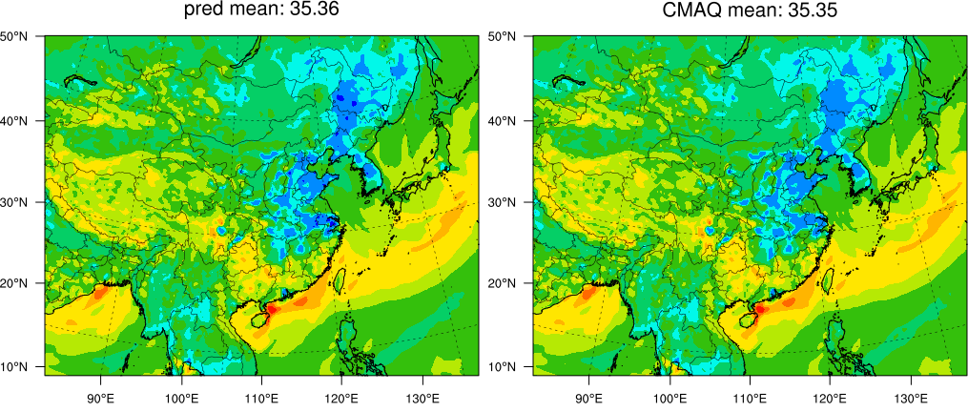 |  | 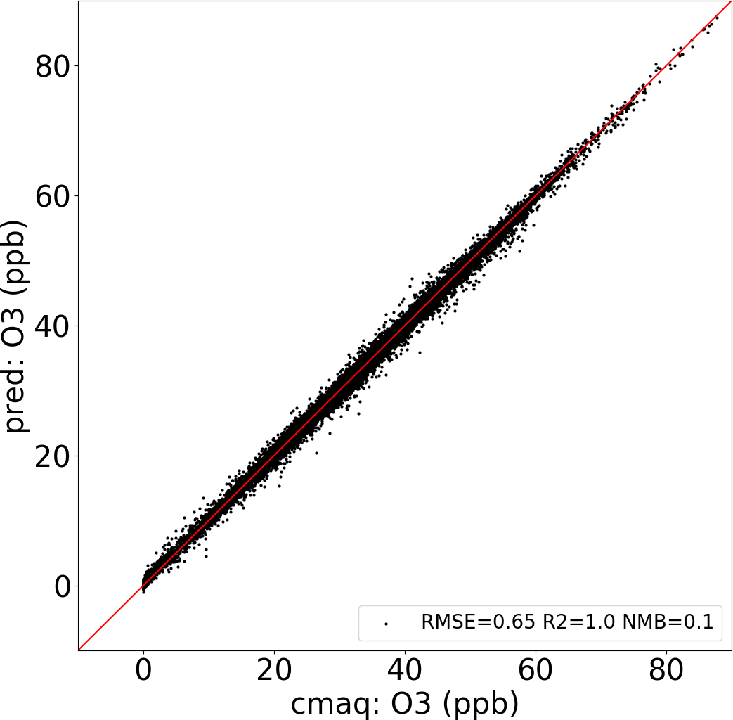 | 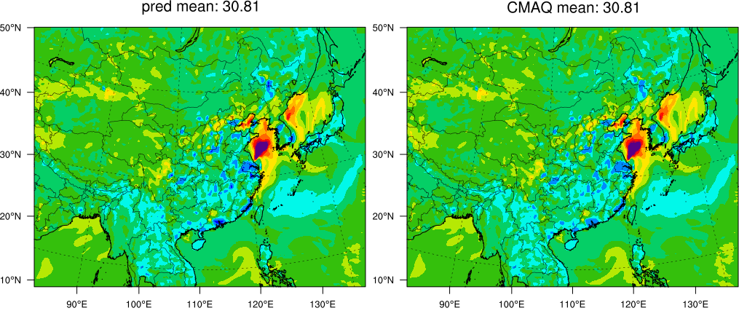 |  | 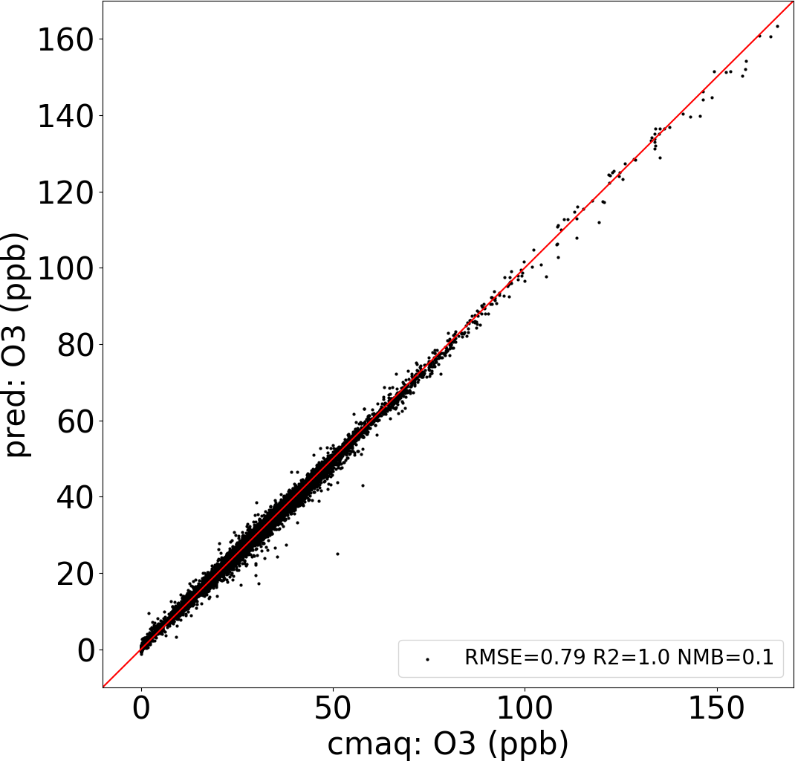
(c)  6h | 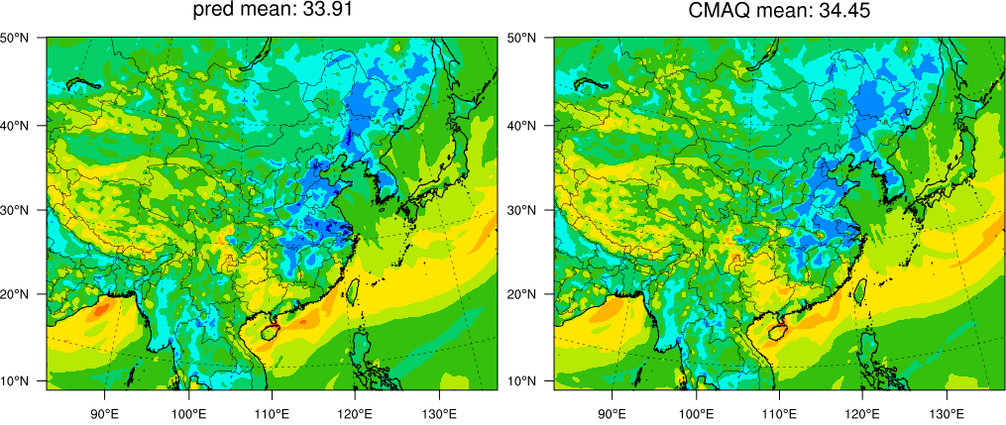 |  | 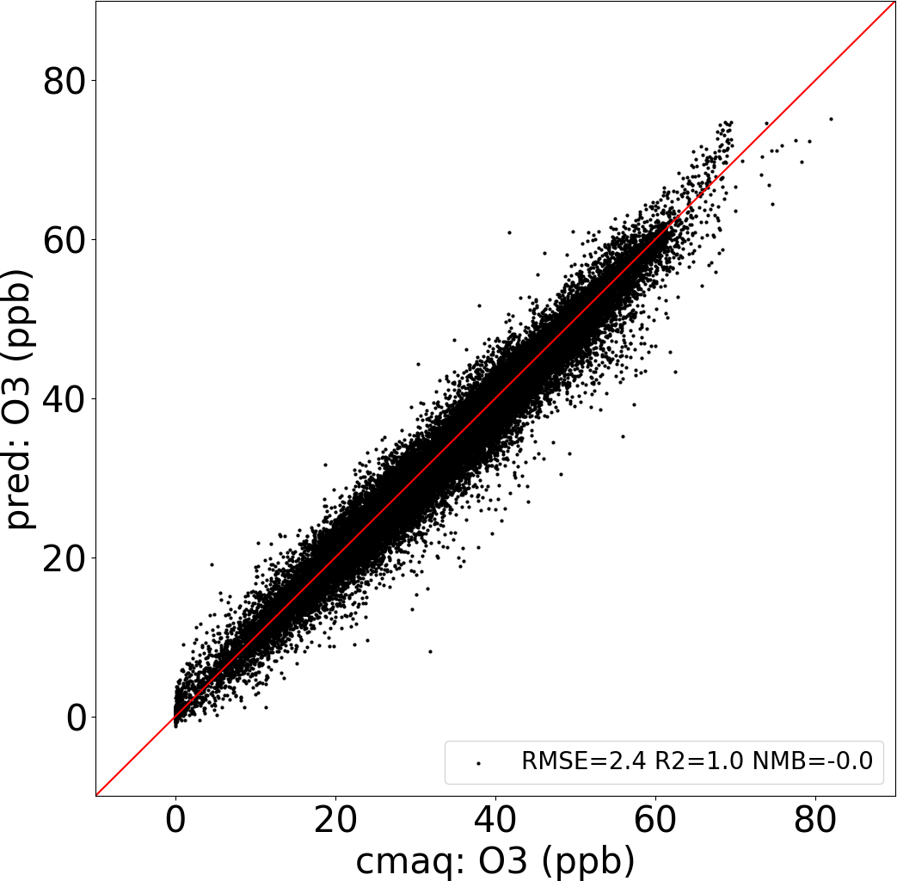 | 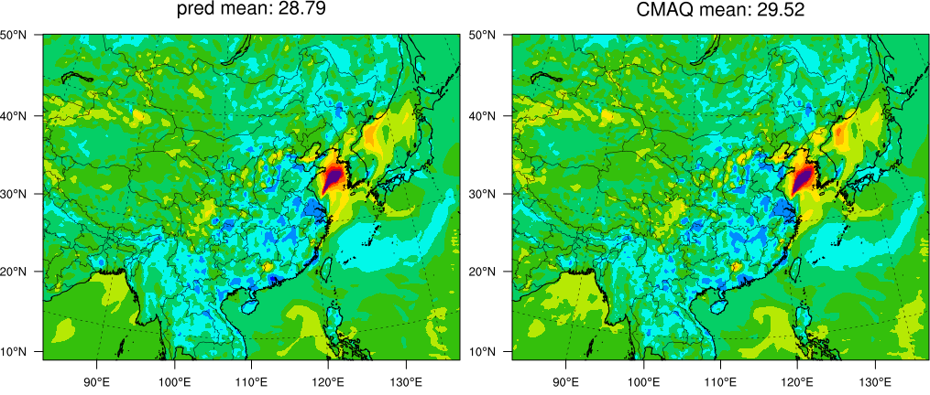 |  | 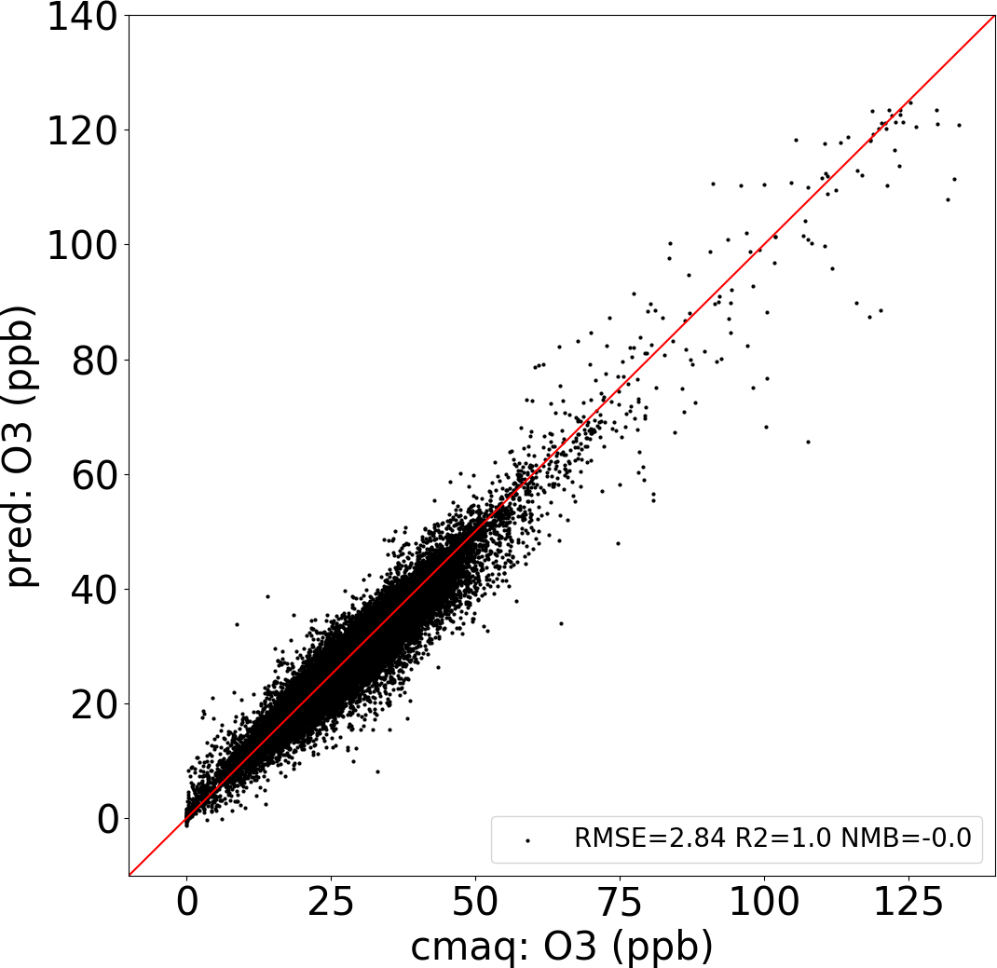
(d)  12h | 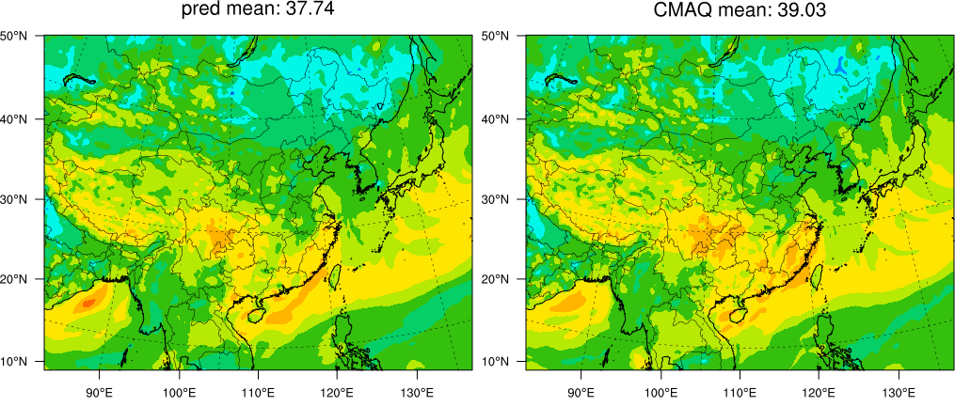 |  | 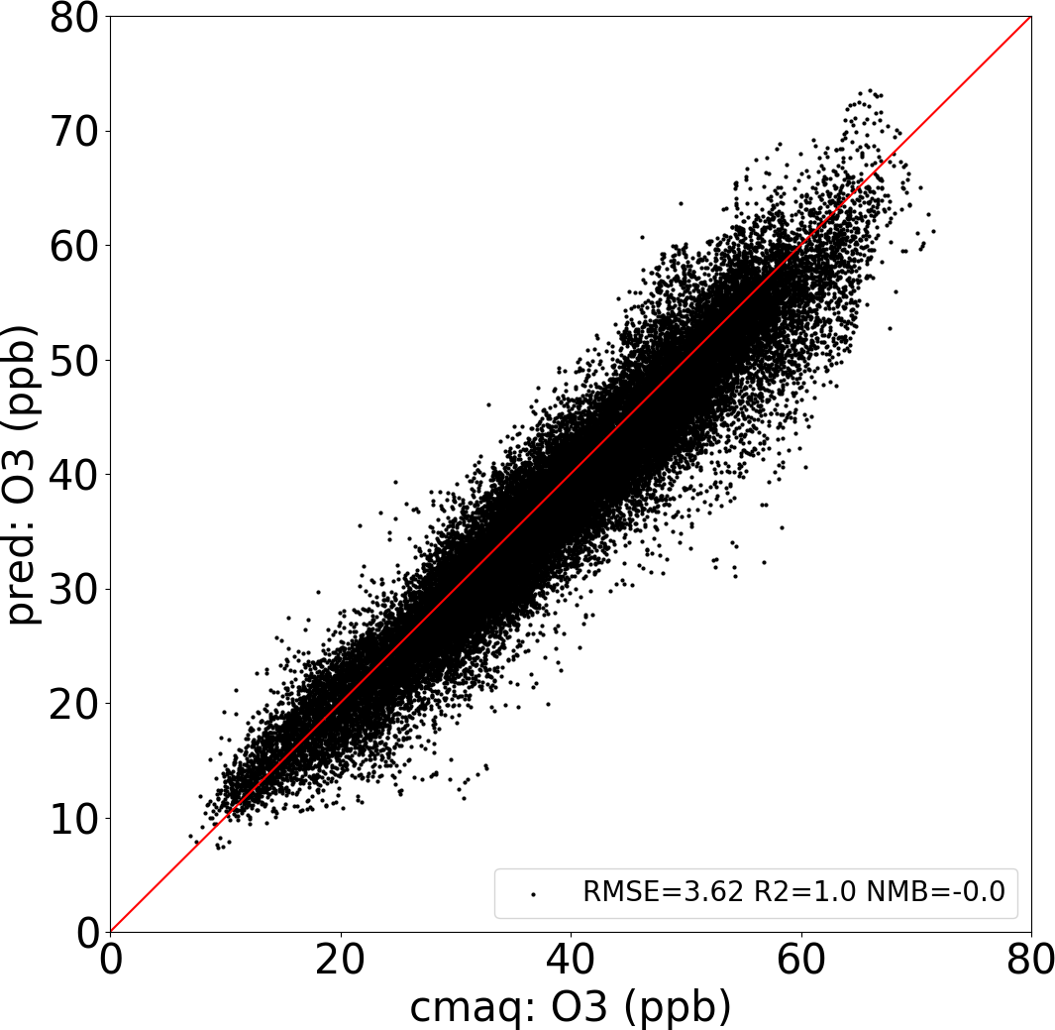 | 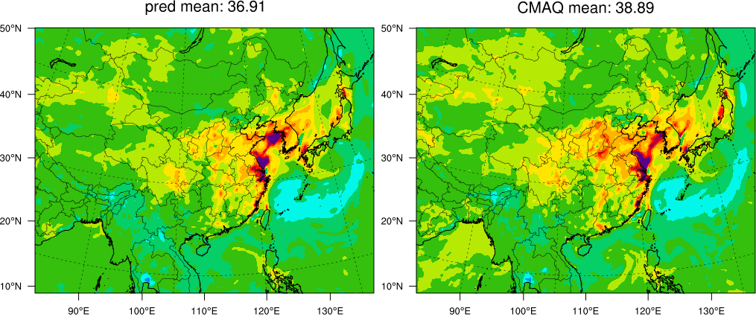 |  | 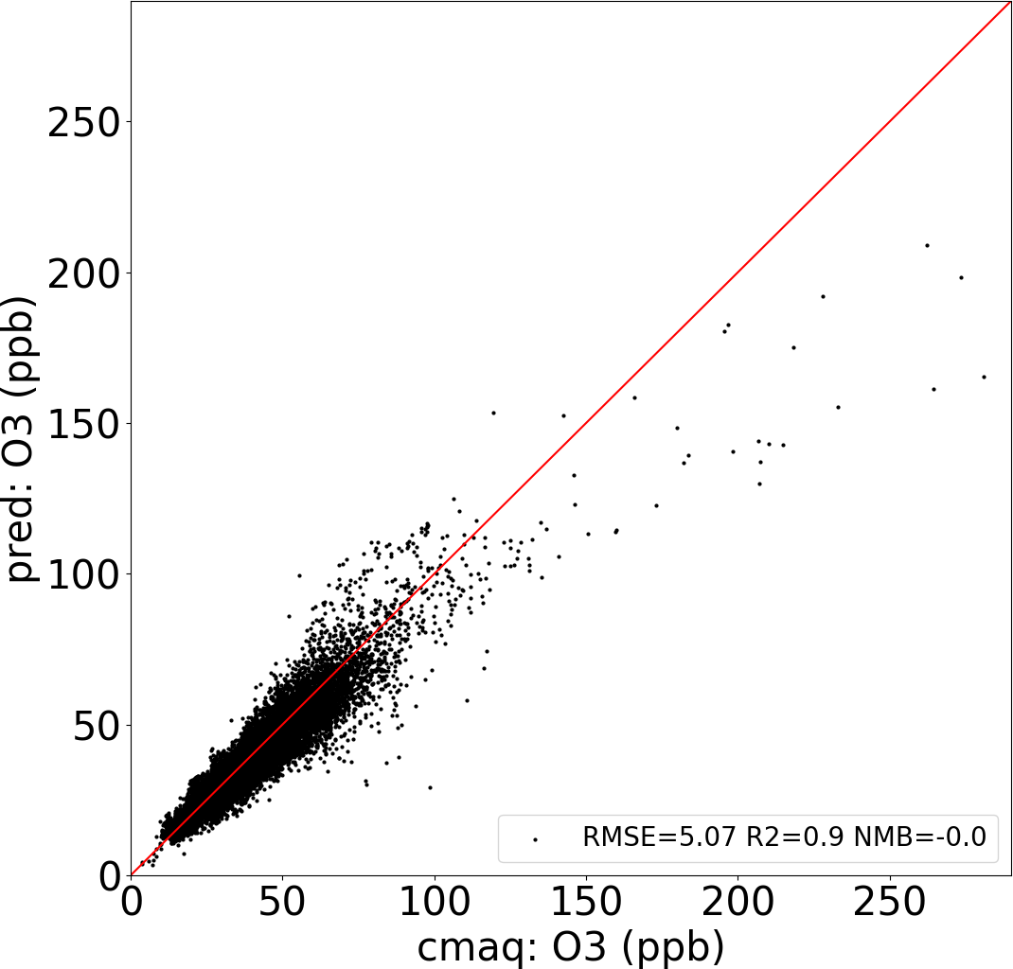
(e)  1d | 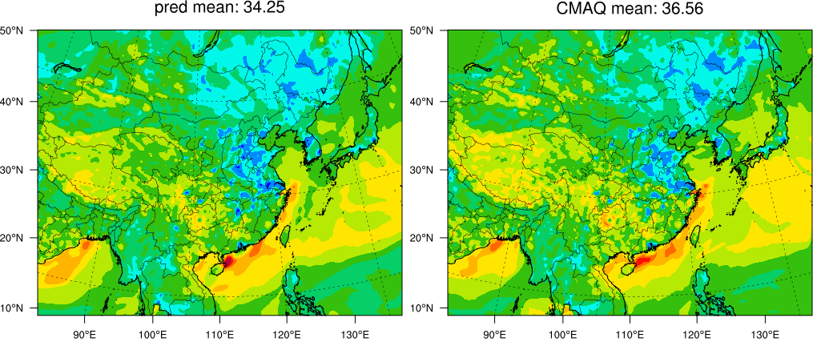 |  | 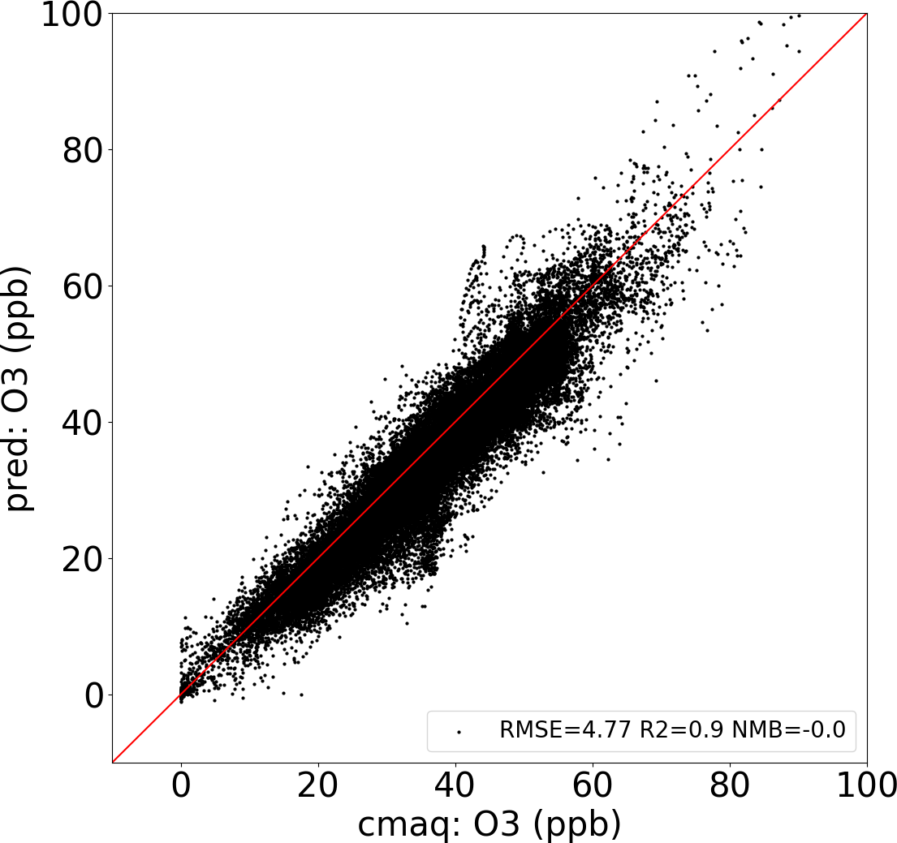 | 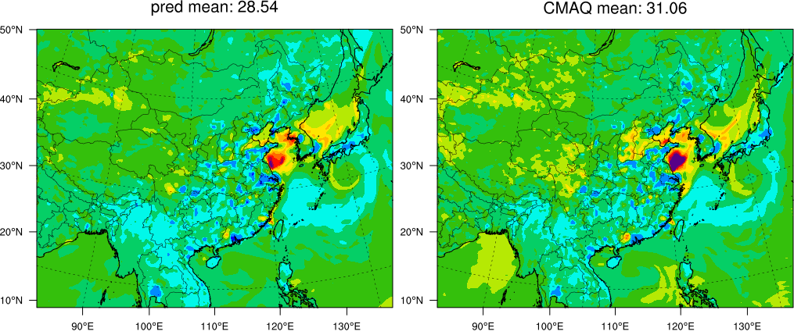 |  | 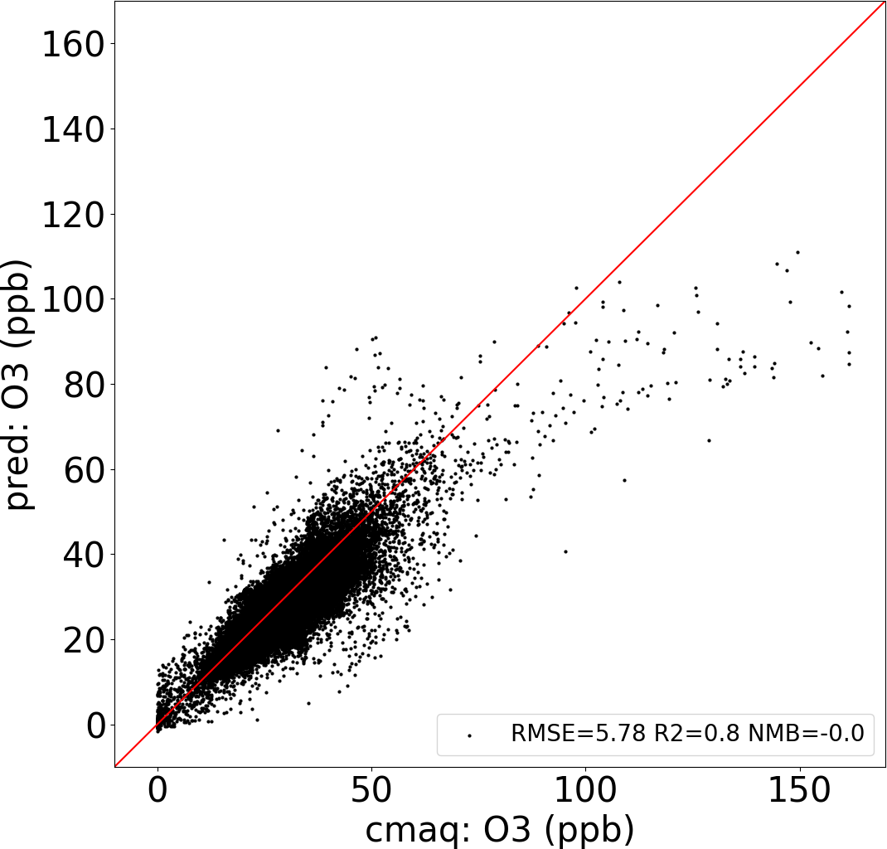
(f)  2d | 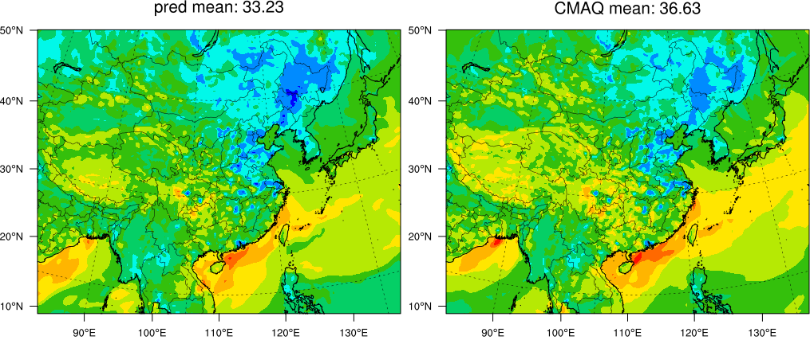 |  | 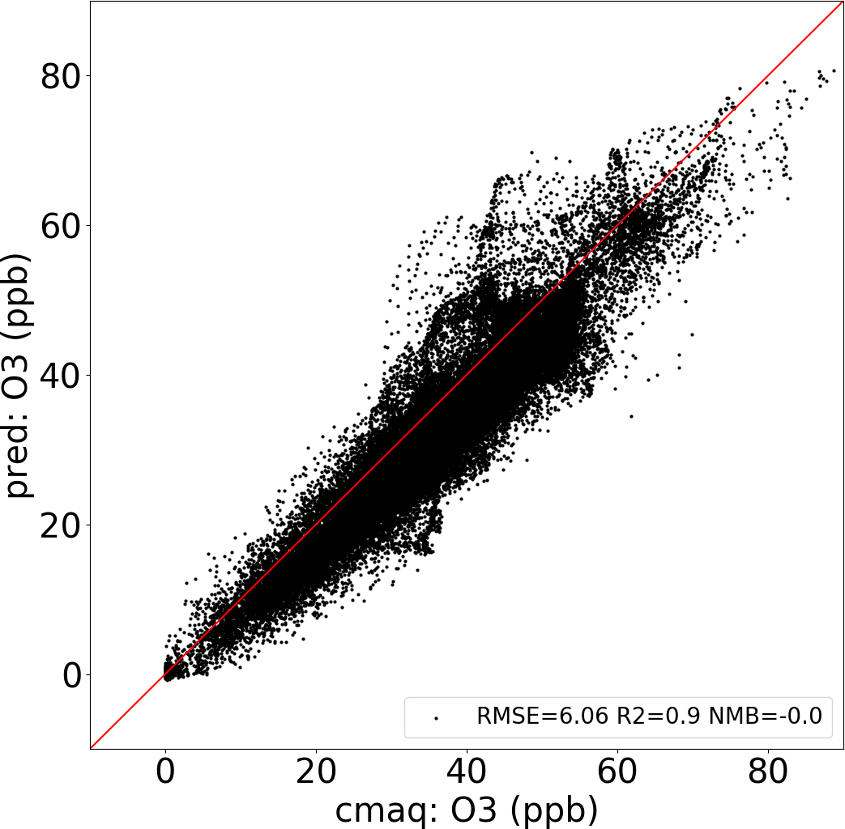 | 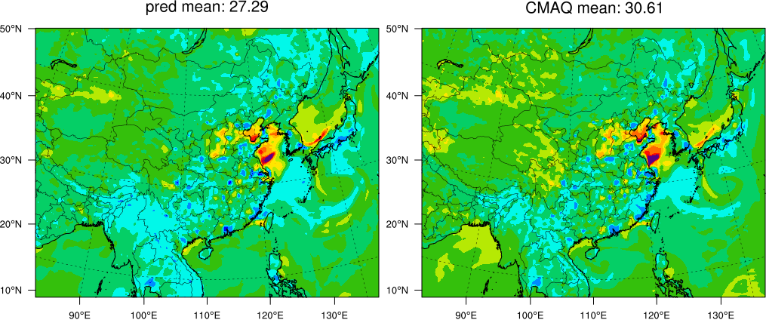 |  | 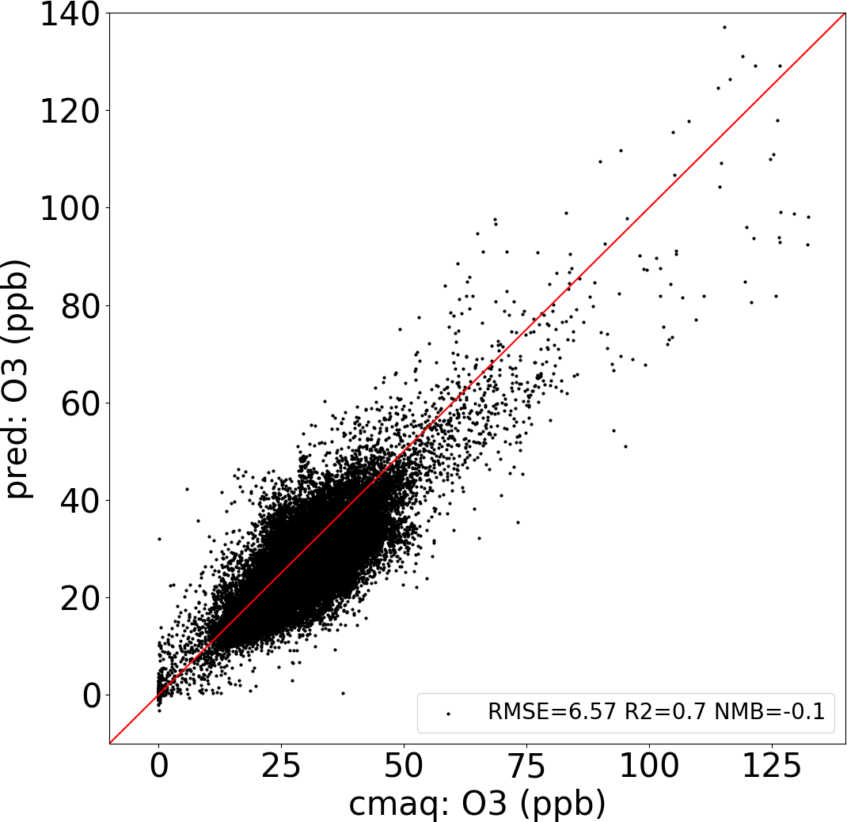
(g)  3d | 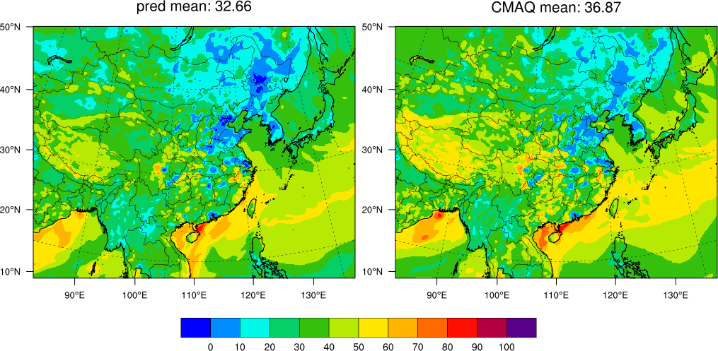 |  | 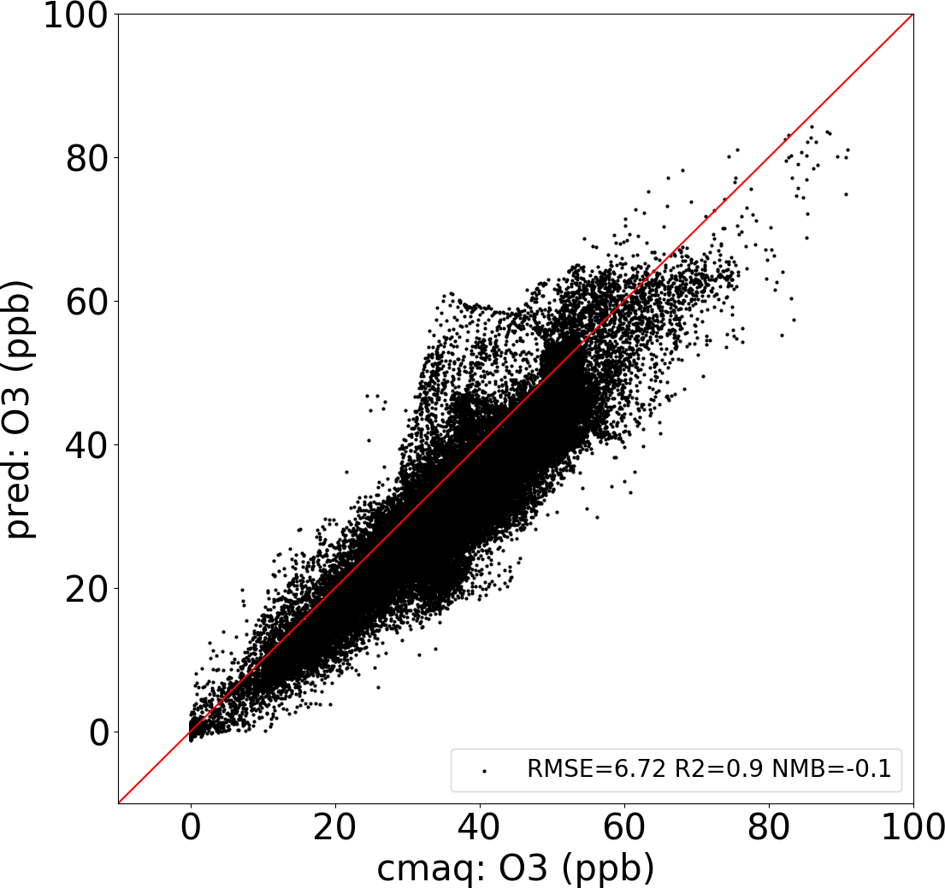 | 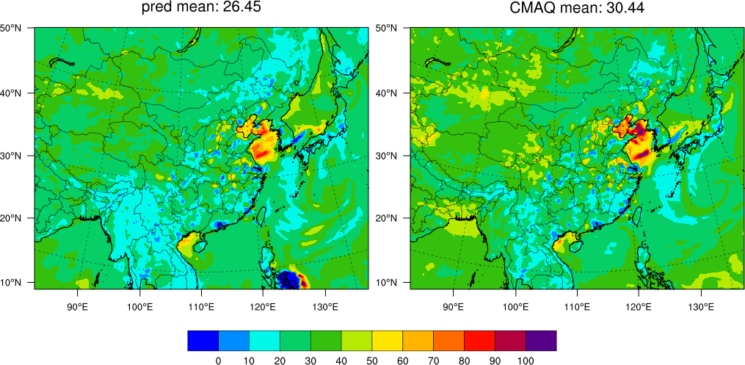 |  | 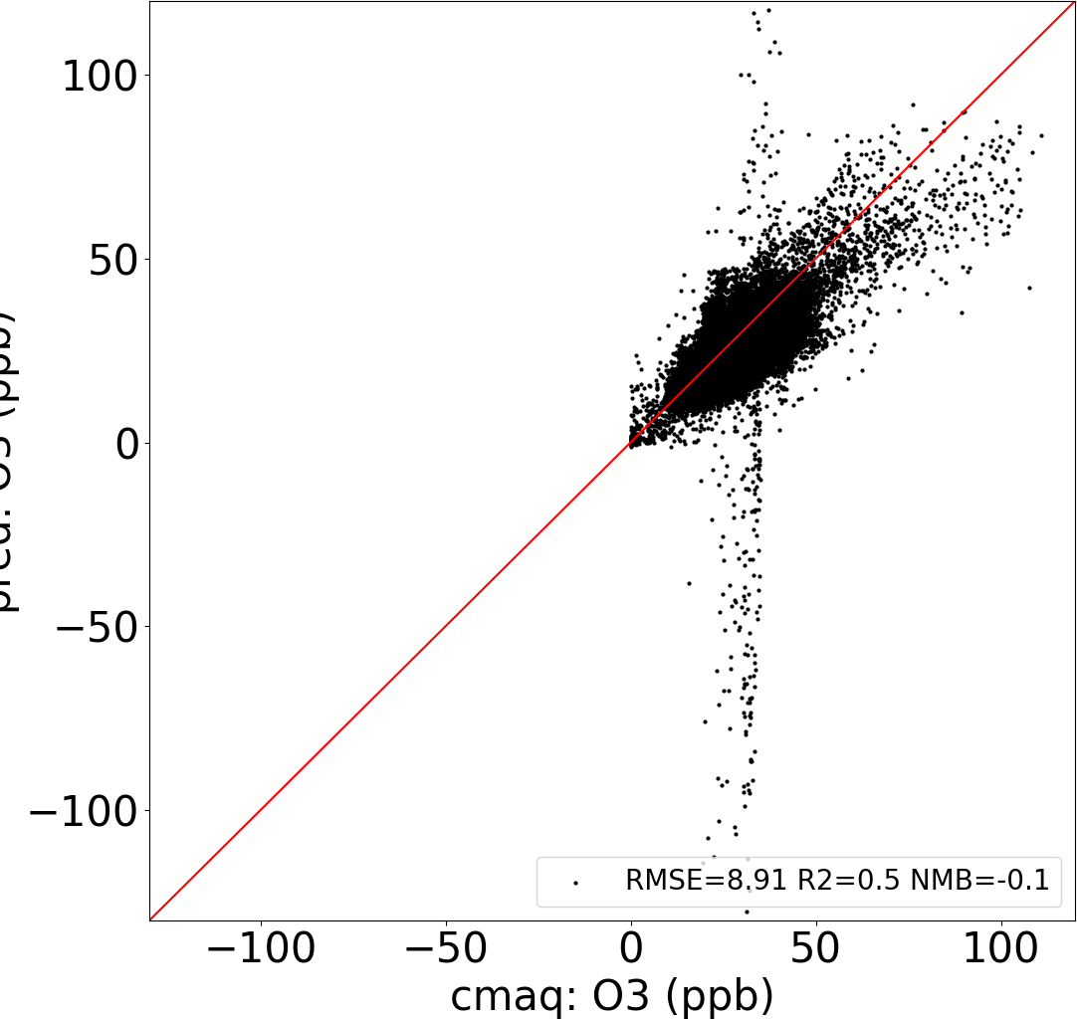
Figure 2. DeepCTM performance in predicing O₃ variations with emissions and meteorology

A typical winter day (Jan 21, 2017) | A typical summer day (July 21, 2017)
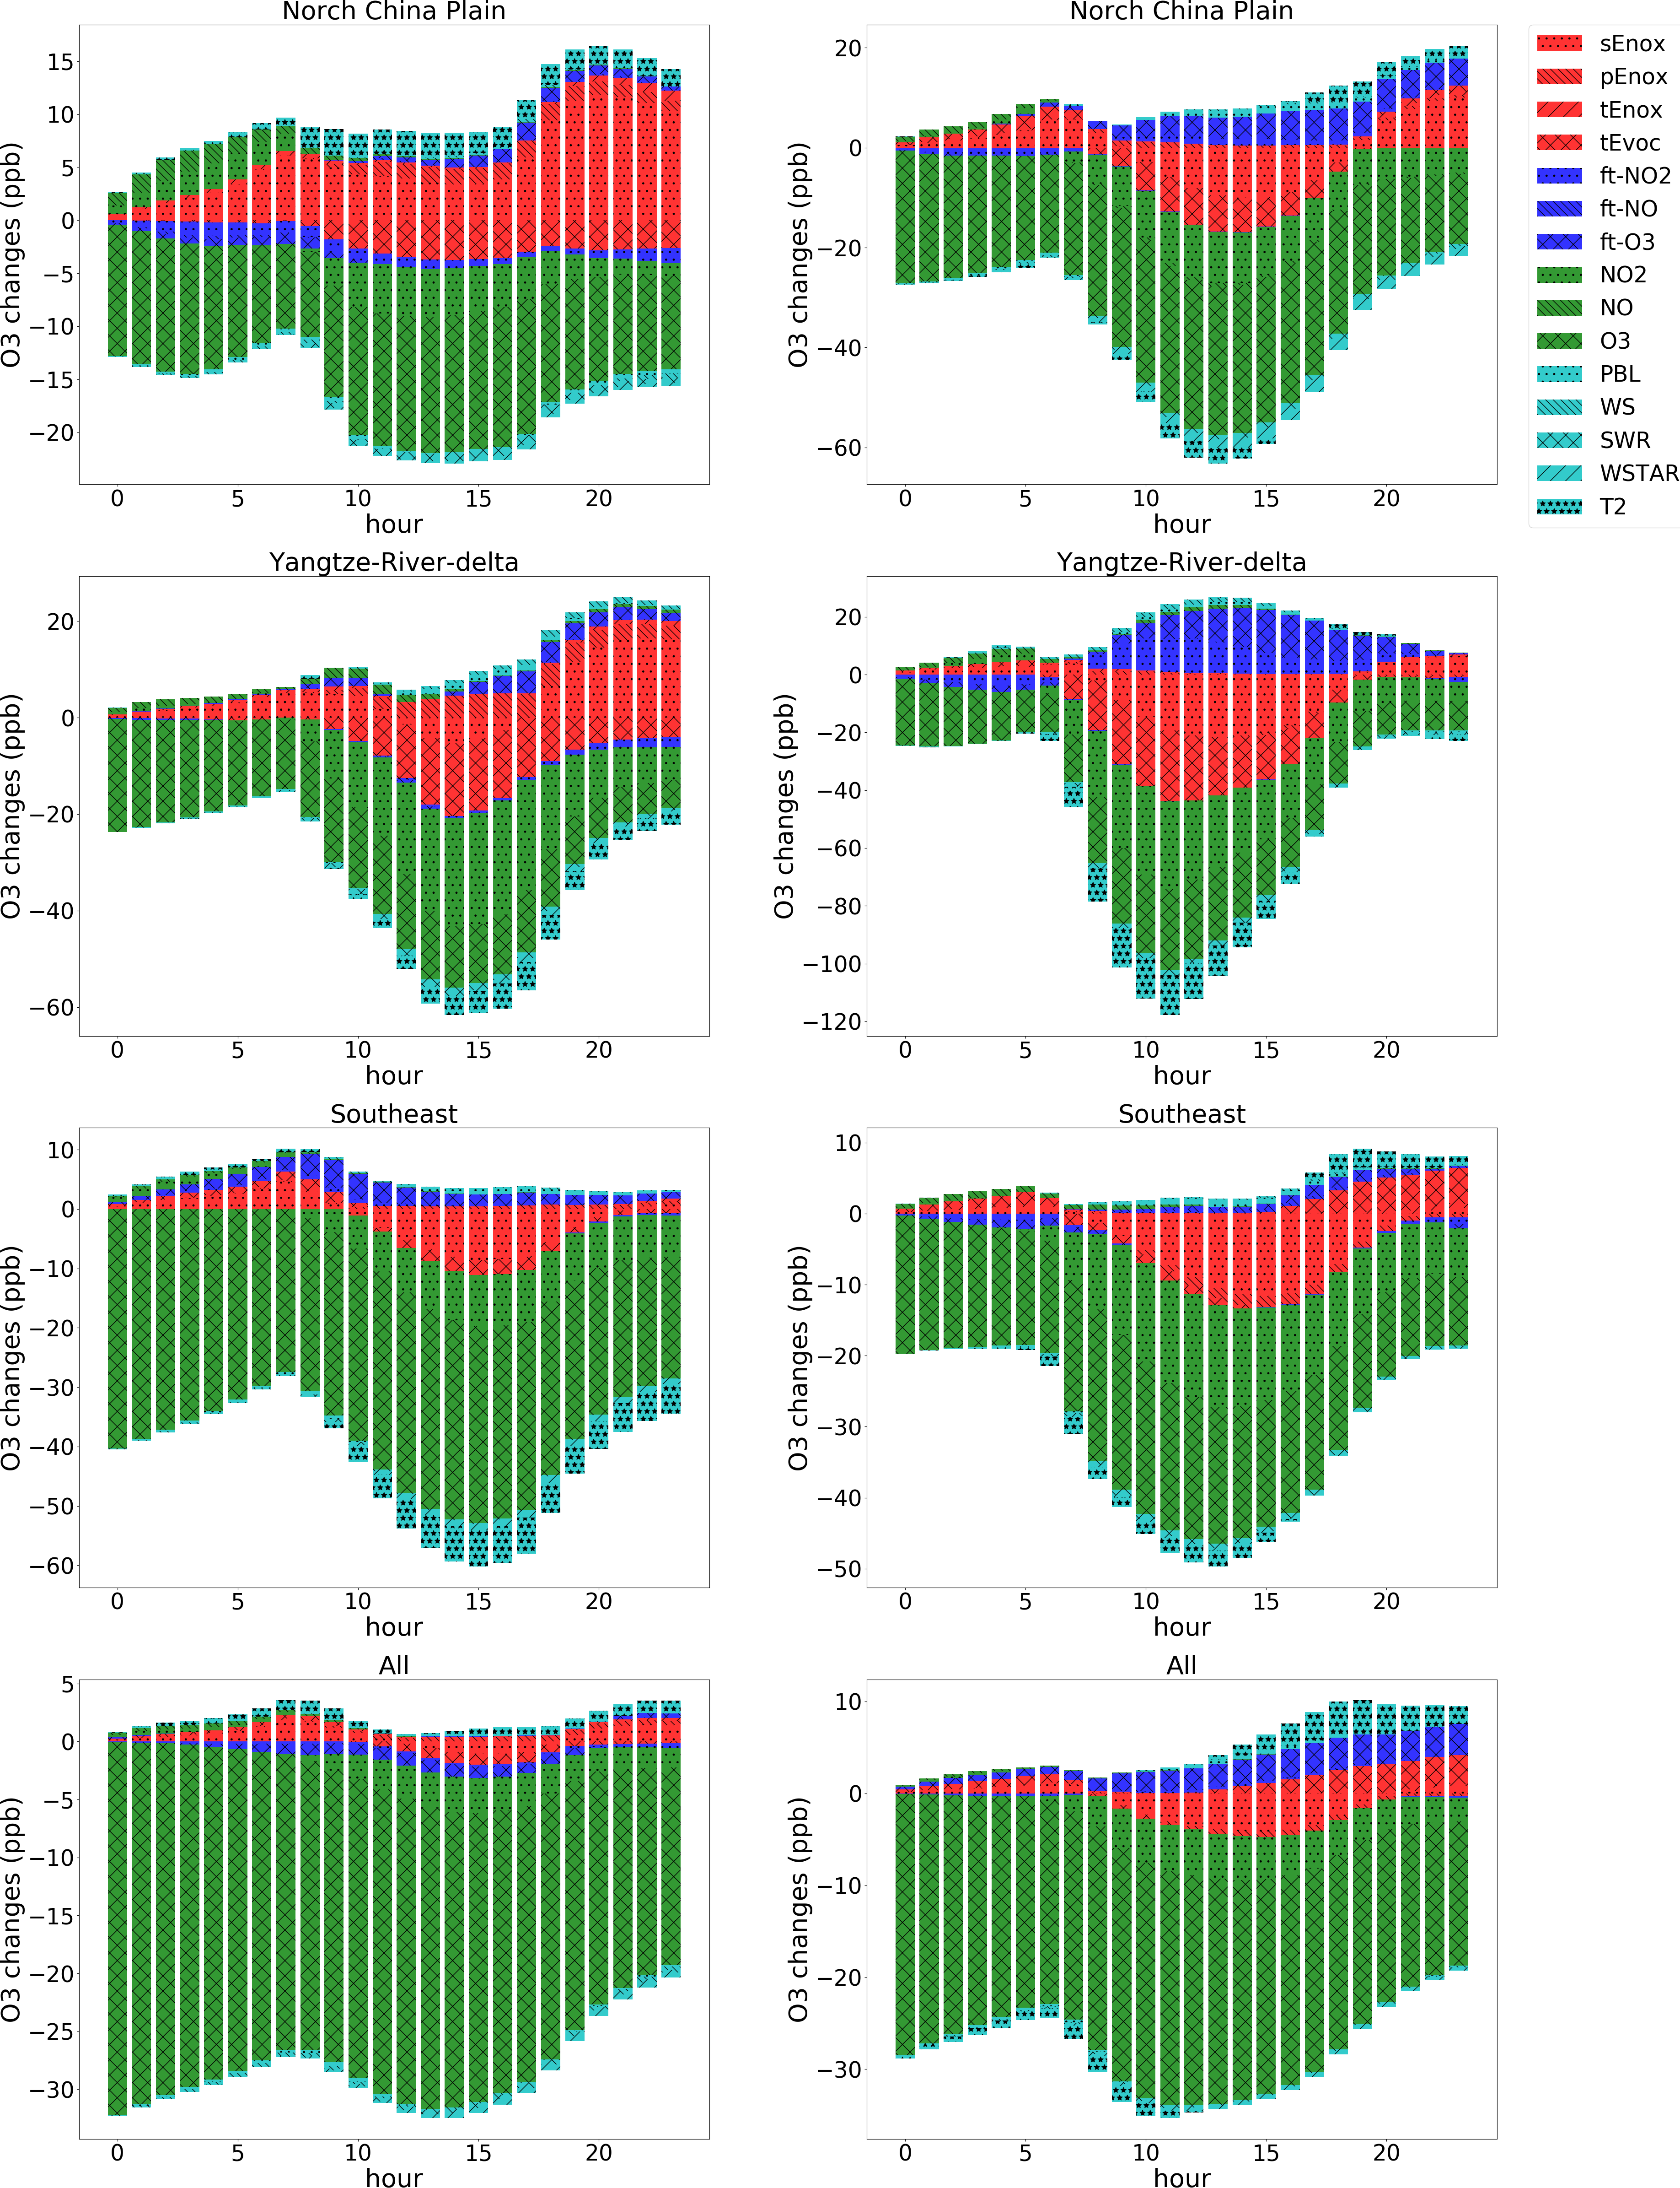
Figure 3. The O₃ sensitivities to the variation of individual factors (emission, initial condition, flux transport, and other meteorological factors are marked as red, green, blue, and cran respectivley; meteorological factors are quantified through a 10% variation, others are quantified through zero-out completely)
A typical winter day (Jan 21, 2017) |  | A typical summer day (July 21, 2017)
Midnight (6 am) | Noon (12 pm) | Midnight (6 am) | Noon (12 pm)
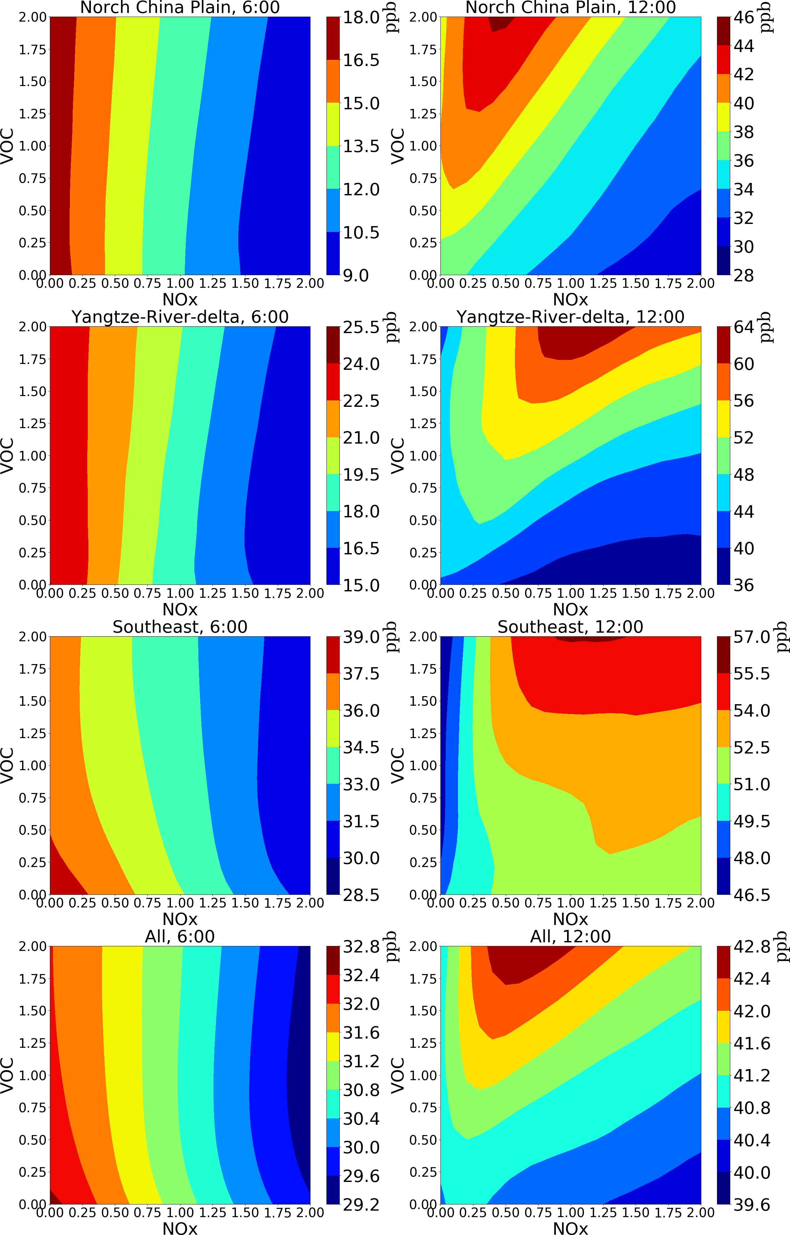 |  | 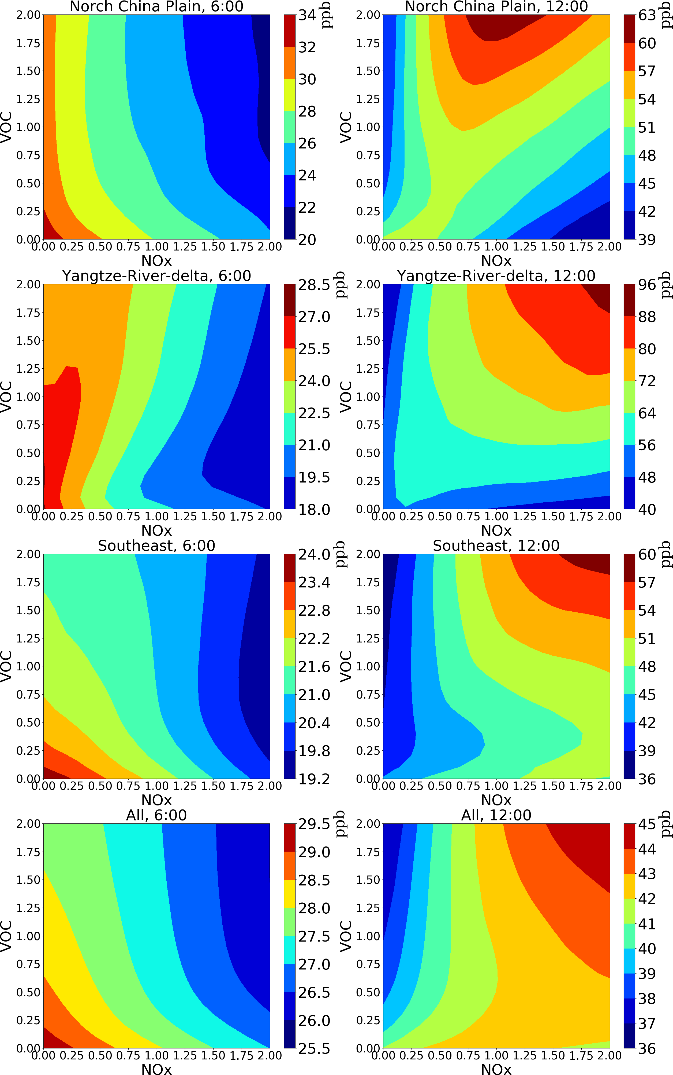

Figure 4. The isopleths of O₃ response to NO_{x}/VOC emission change (baseline = 1) predicted by DeepRSM (the values are averages of all grid cells and days)
A typical winter day (Jan 21, 2017) | A typical summer day (July 21, 2017)
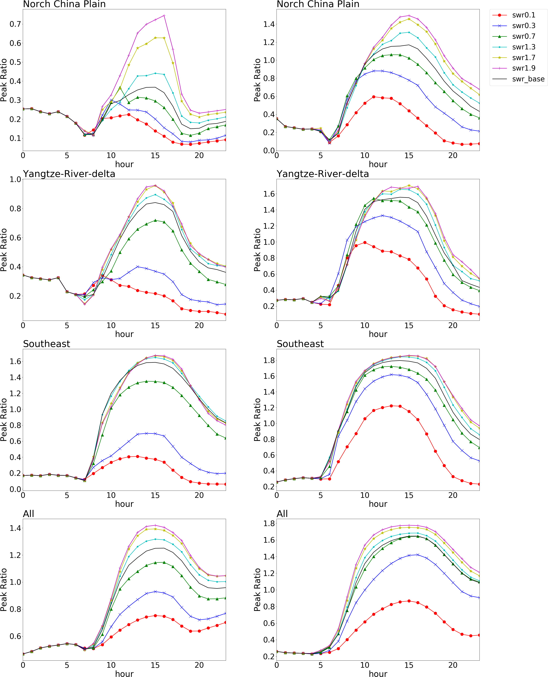
Figure 5. The O₃ chemistry (indicated by the Peak Ratio) response to the variation of short-wave radiation across a day

(a) 24 hour averaged O₃ | (b) 1 hour max O₃
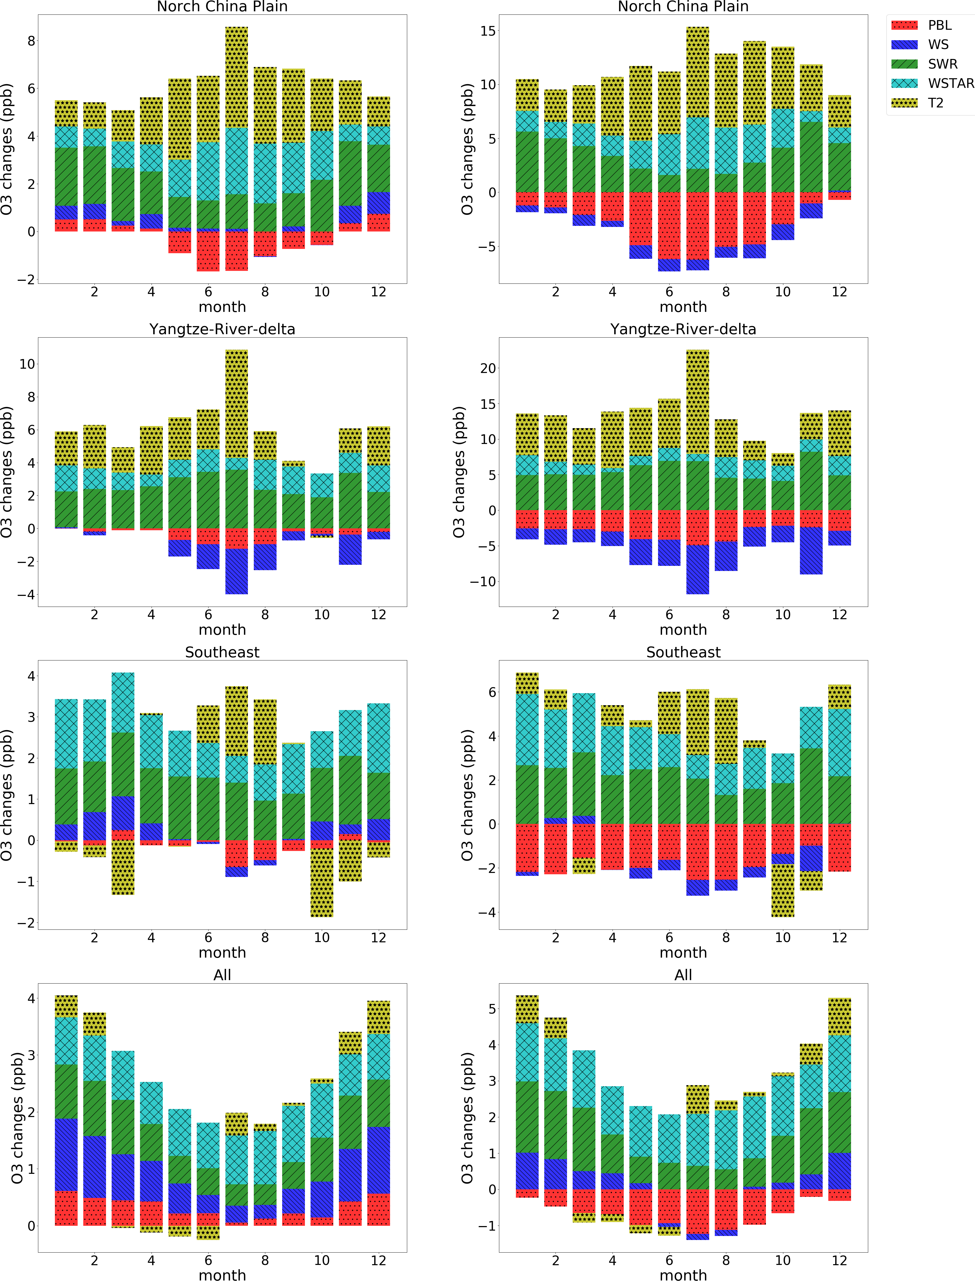
Figure 6.The monthly O₃ changes due to the variation of meteorological parameters by taking differences from 20% increase to 20% decreases of PBL height, wind speed (WS), short-wave radiation (SWR), and convective velocity scale (WSTAR), and differences from +10 K to -10 K of 2-meter temperature (T2) respectively
(a) 24 hour averaged O₃ | (b) 1 hour max O₃
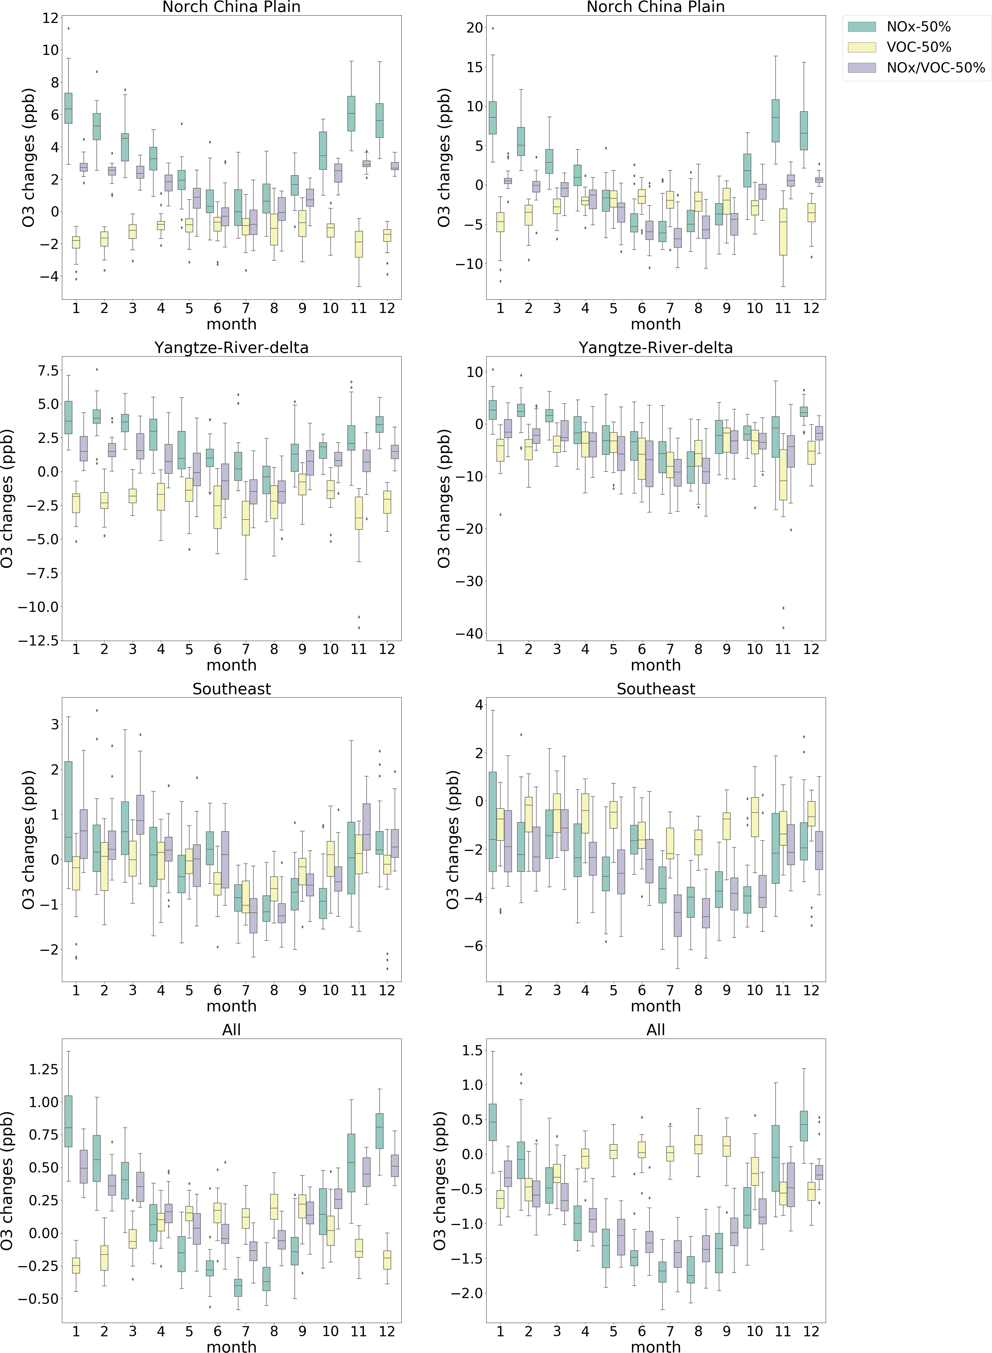

Figure 7.The O₃ changes due to NO_{x} and VOC emission controls under different meteorolgical conditions across a year

Supplementary information for the manuscript Deep learning for predicting ozone variations with emissions and meteorology

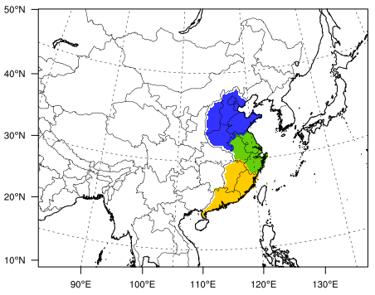
Figure S1.CTM simualtion domain and key selected regions including Norch China Plain (blue), Yangtze-River-delta (green), and Southeast (yellow)

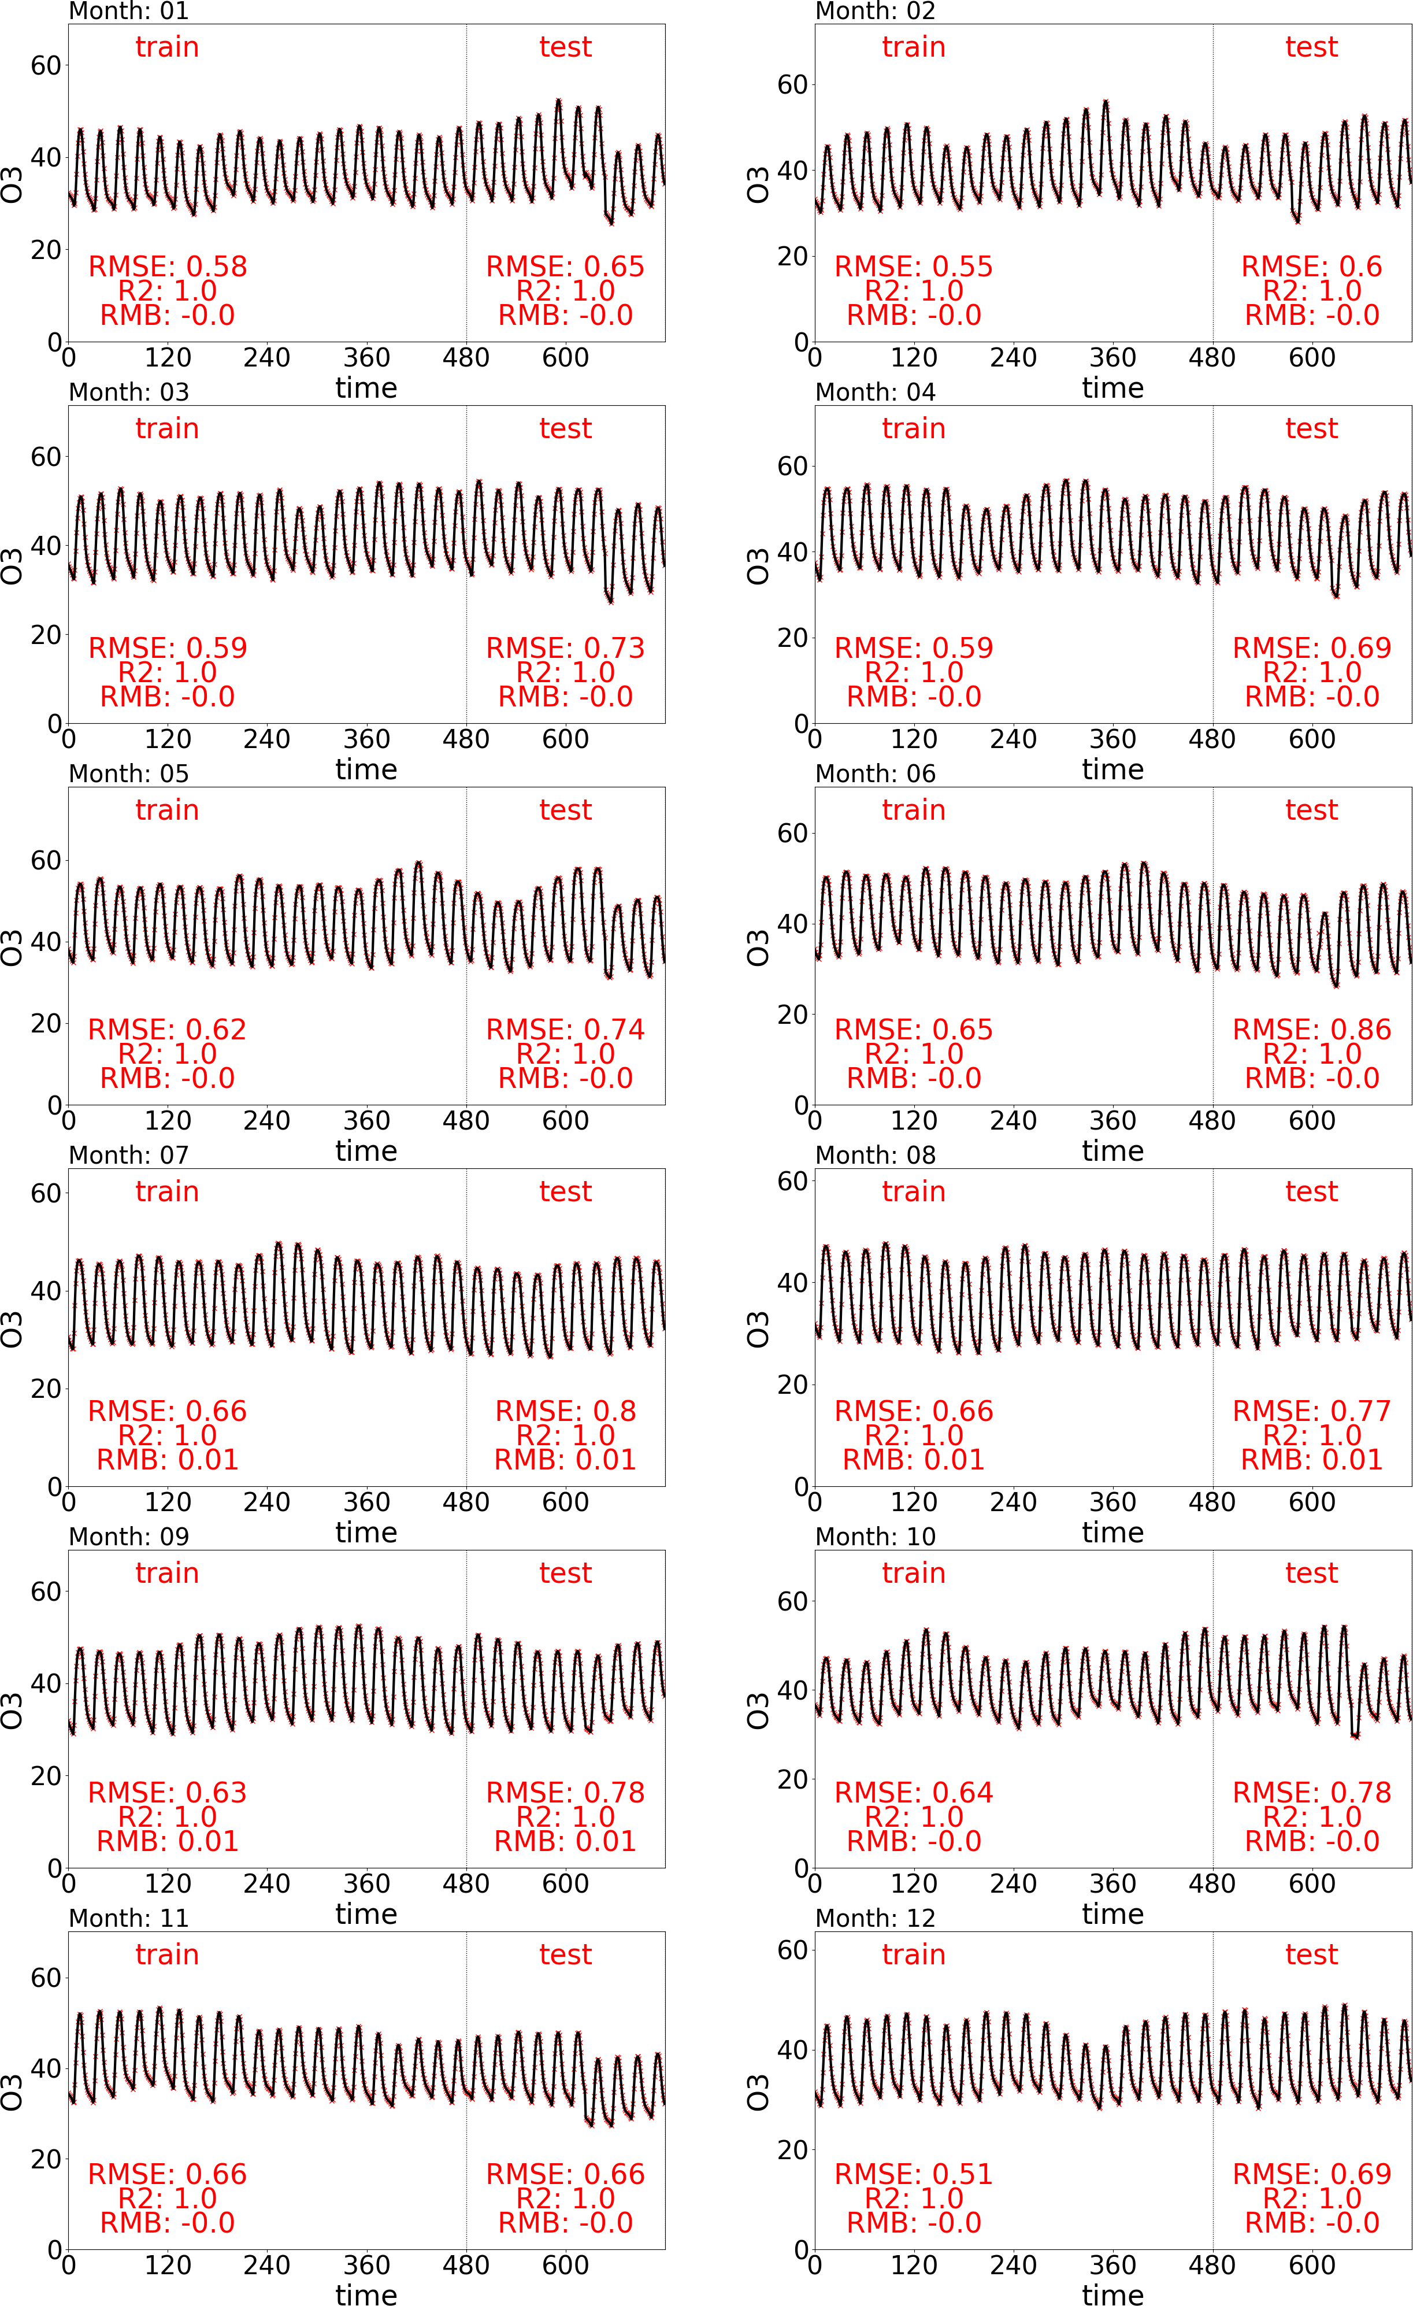
Figure S2.The time-series of DeepCTM-predicted and CMAQ-simulated hourly O₃ concentrations (unit: ppb) and corresponding statistices of DeepCTM-performance

A typical winter day (Jan 21, 2017) | A typical summer day (July 21, 2017)
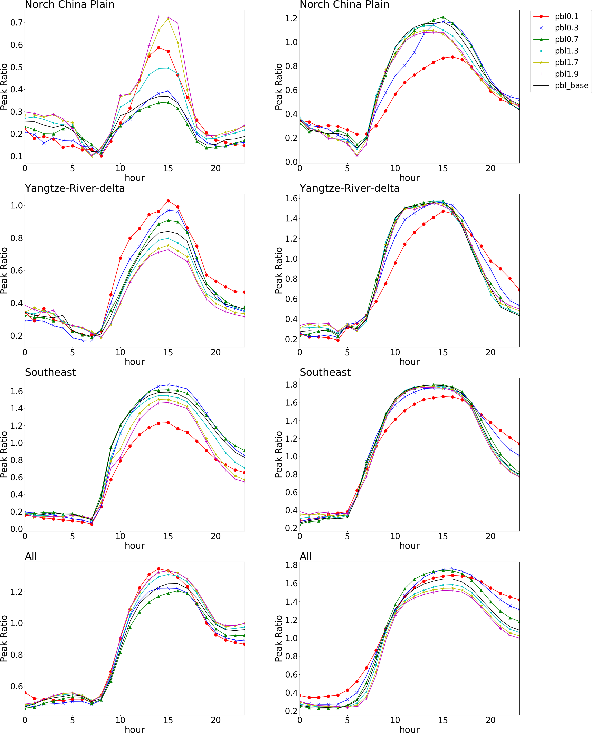
Figure S3. The O₃ chemistry (indicated by the Peak Ratio) response to the variation of PBL height across a day

A typical winter day (Jan 21, 2017) | A typical summer day (July 21, 2017)
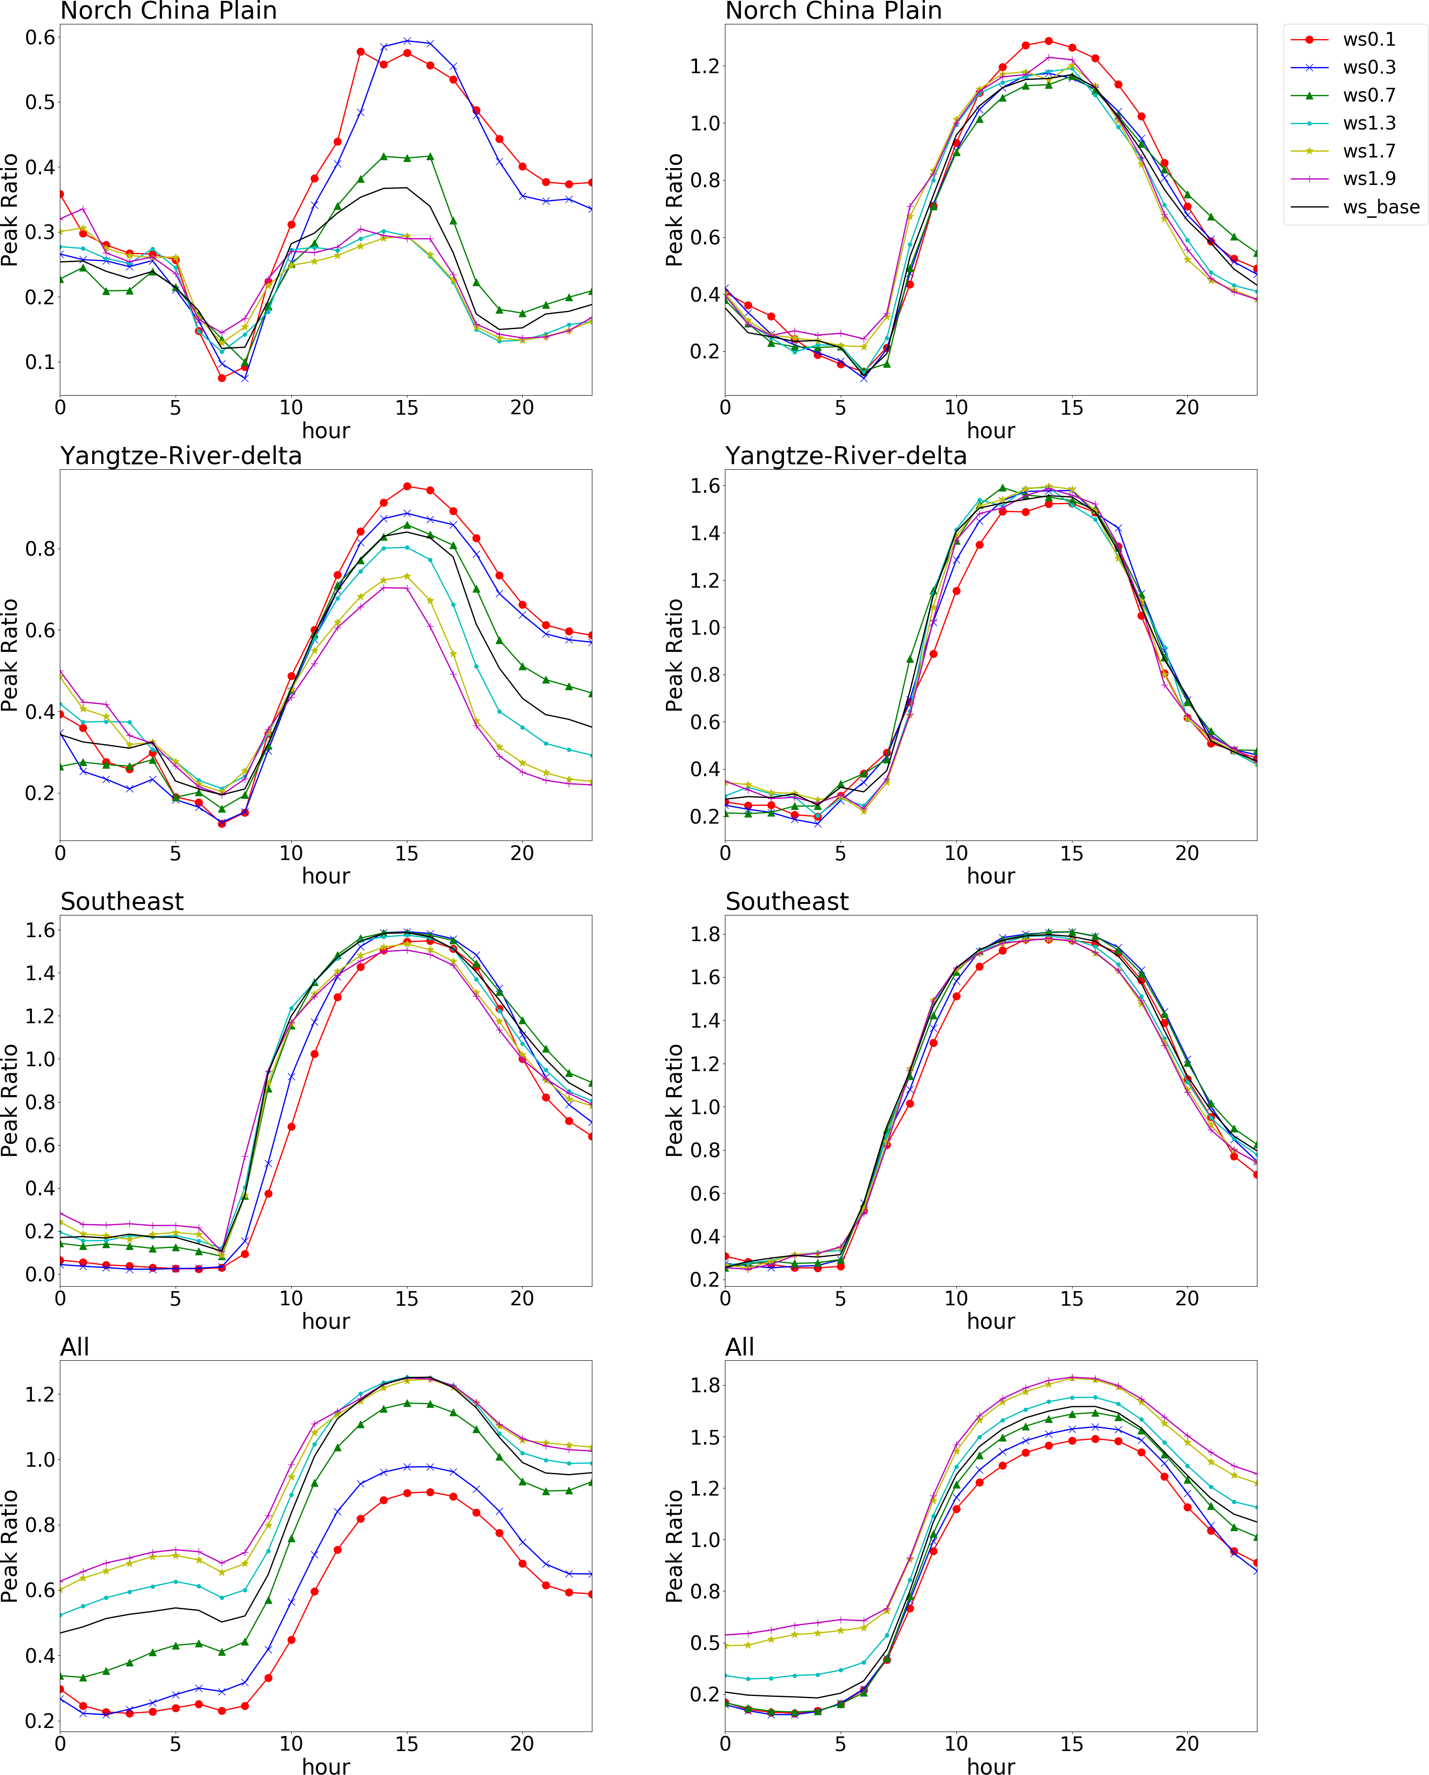
Figure S4. The O₃ chemistry (indicated by the Peak Ratio) response to the variation of wind speed across a day

A typical winter day (Jan 21, 2017) | A typical summer day (July 21, 2017)
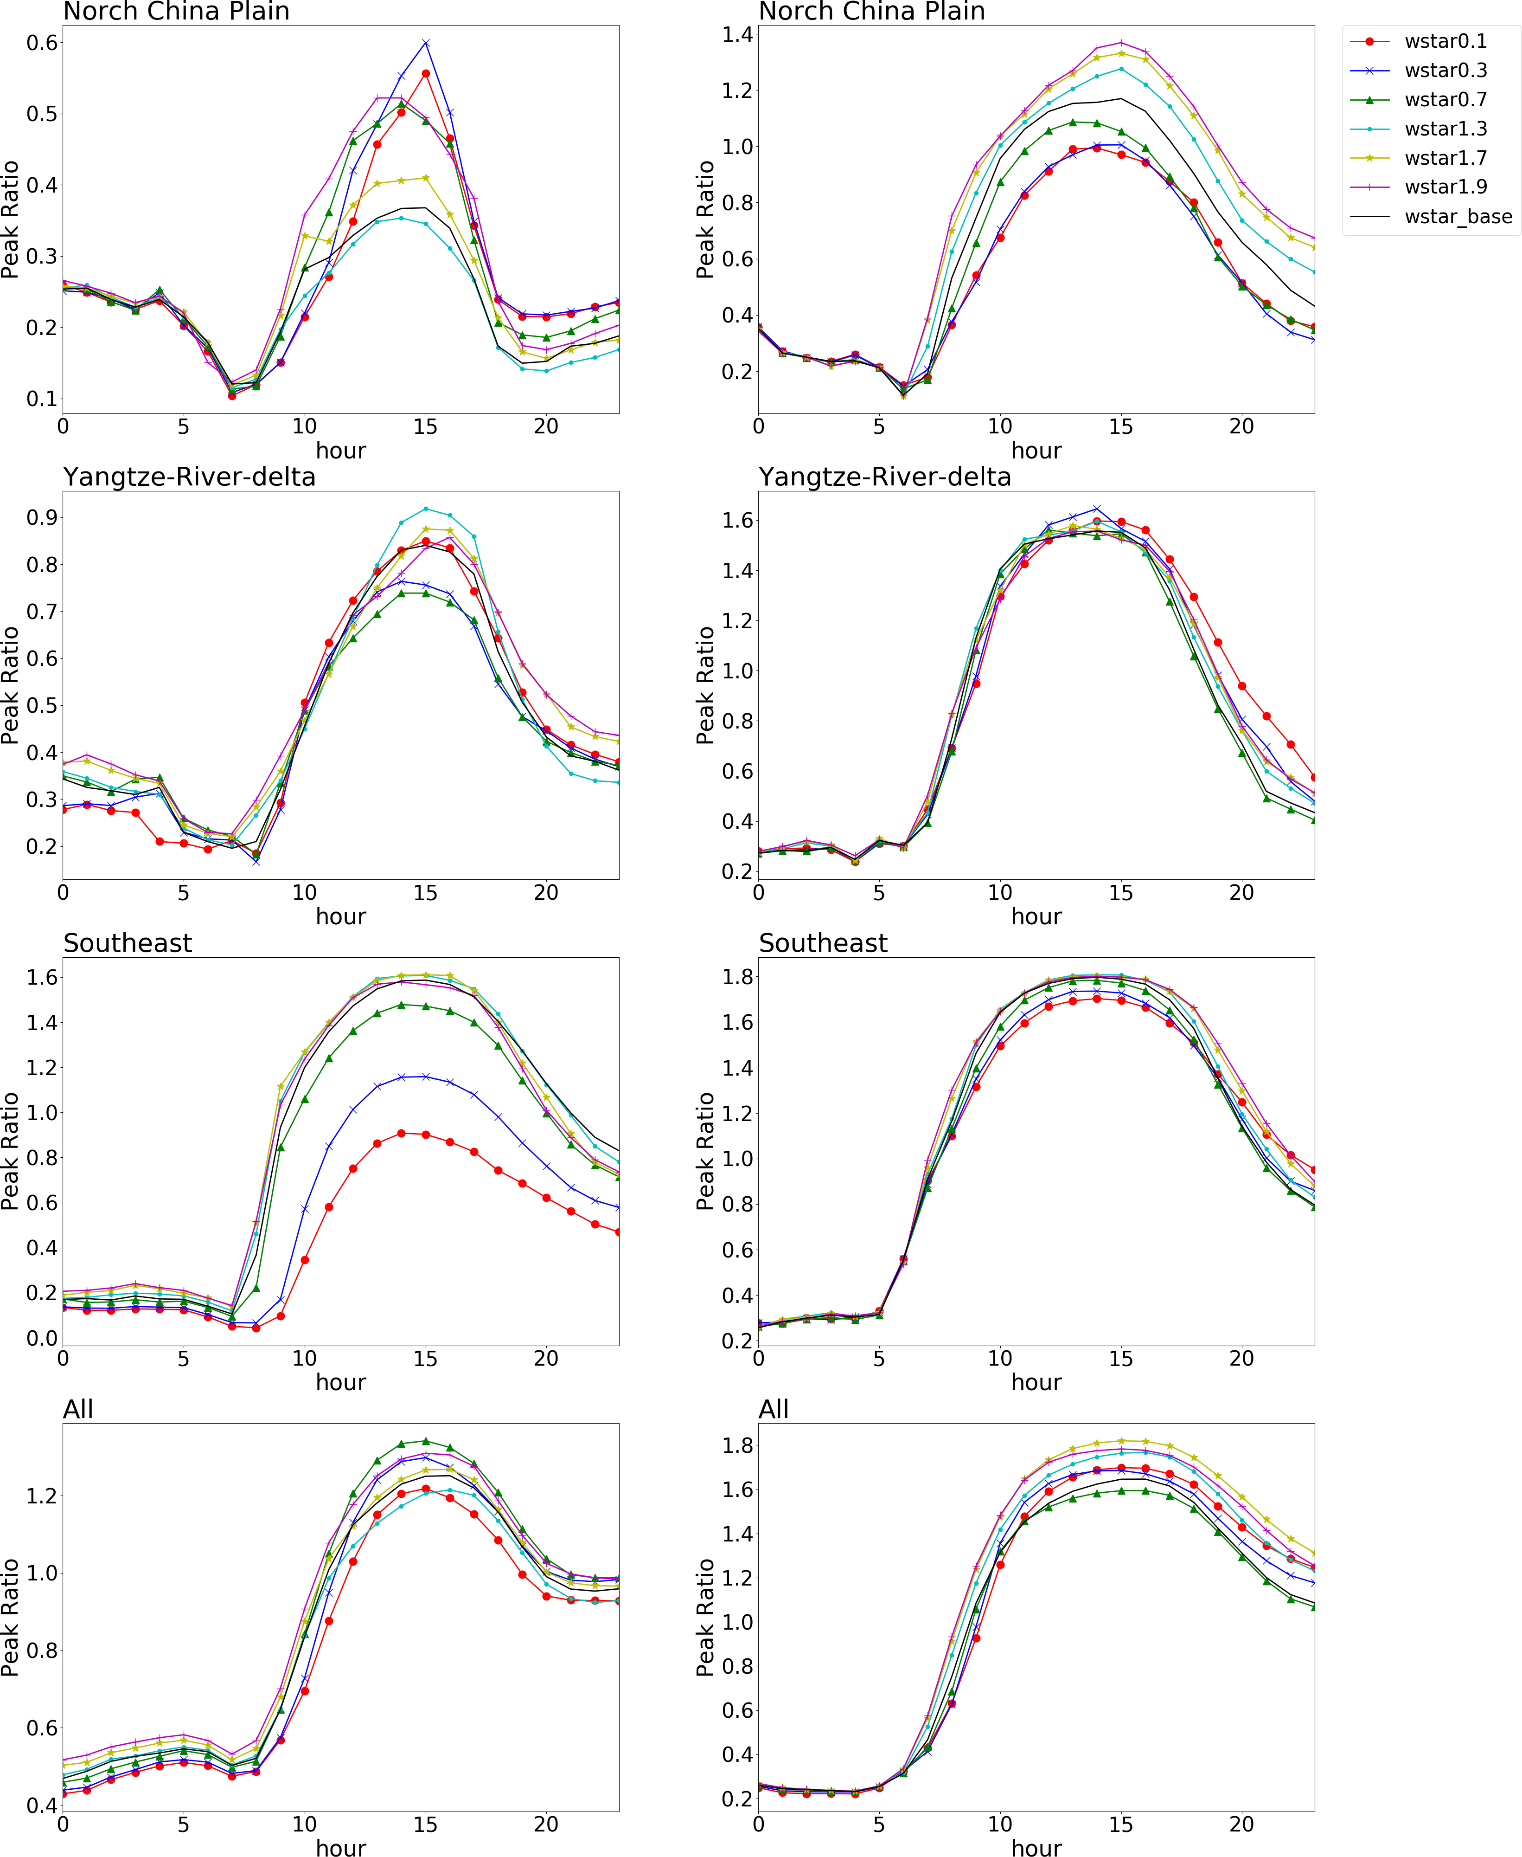

Figure S5. The O₃ chemistry (indicated by the Peak Ratio) response to the variation of convective velocity scale across a day
A typical winter day (Jan 21, 2017) | A typical summer day (July 21, 2017)
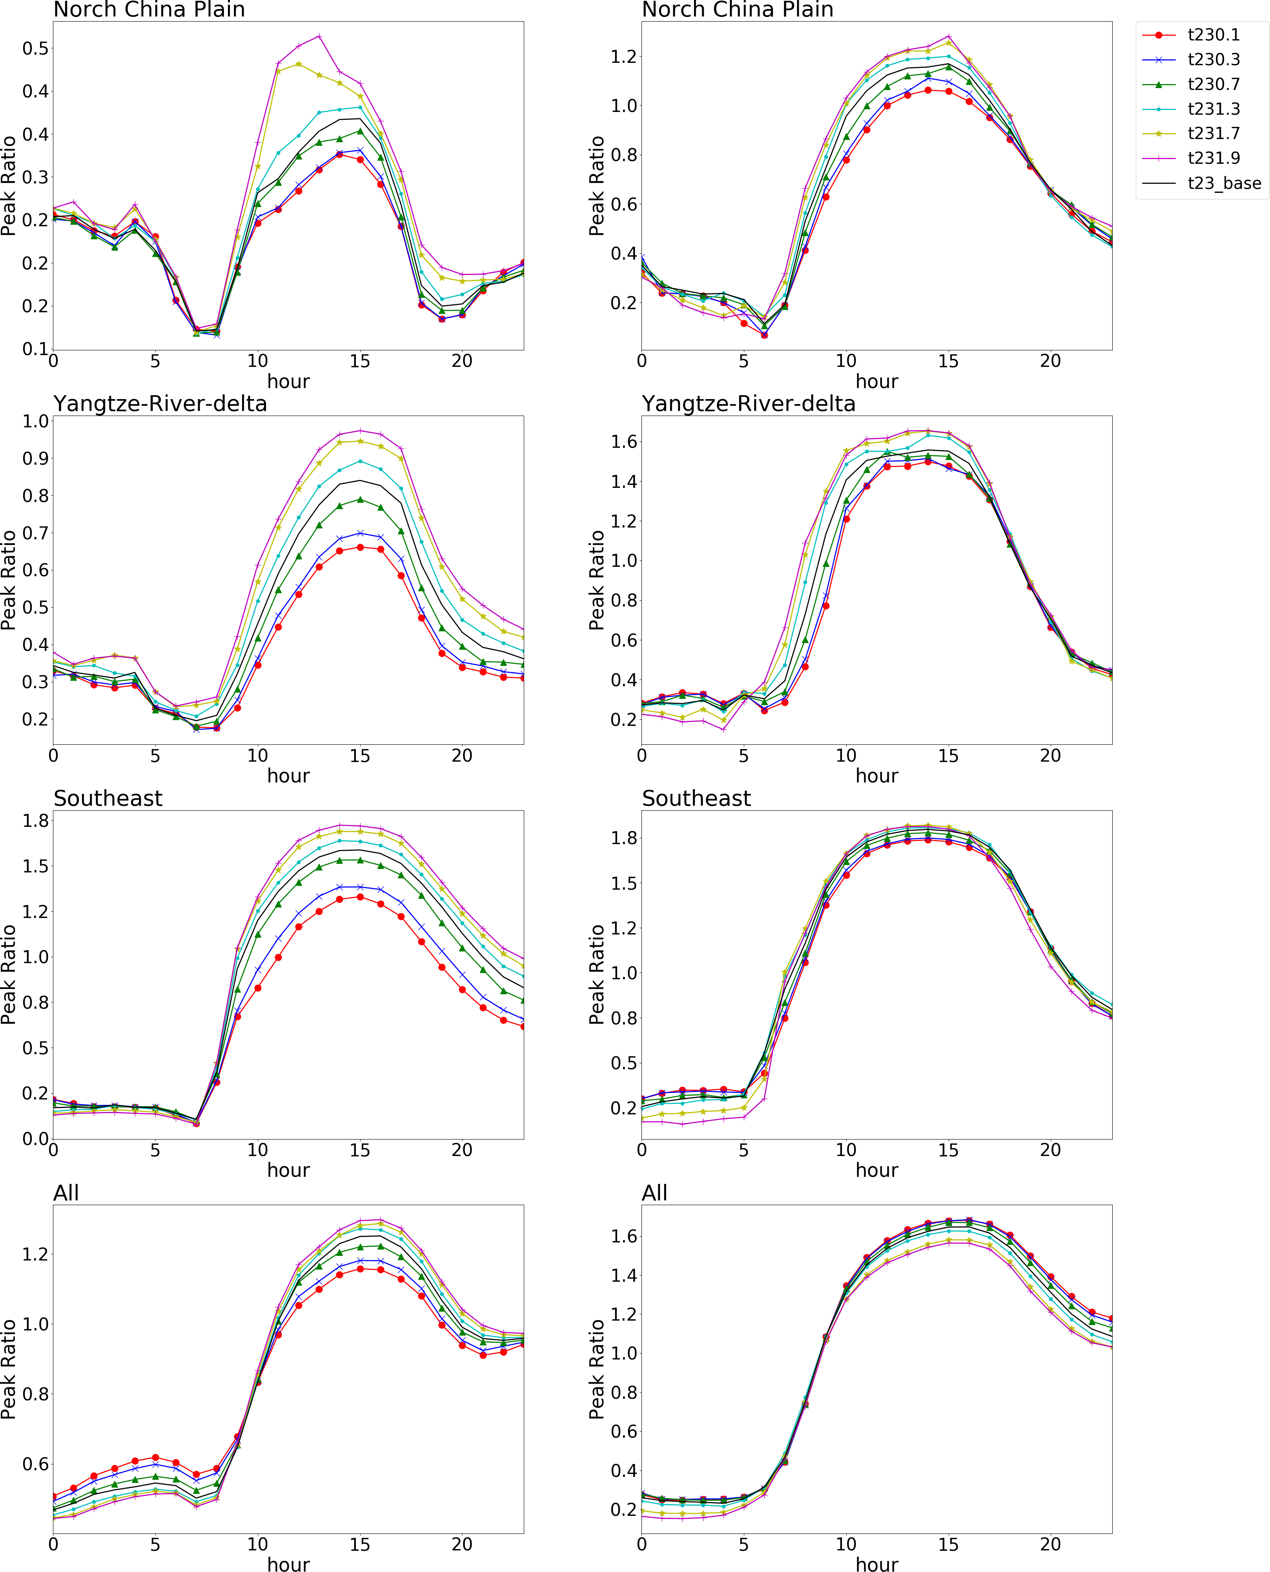

Figure S6. The O₃ chemistry (indicated by the Peak Ratio) response to the variation of 2-meter temperature across a day

