Main Improvements of NEXUS 1.7
By SCUT, 2021-03-26

Main Improvements
- Integrate a new metric “EJ/Demographics” for Data Viewer & Data Query module. The “EJ/Demographics” metrics includes 7 demographic indicators: there are “Demographic index”, “Percent Low-Income”, “Percent Minority”, “Less than high school education”, “Linguistic isolation”, “Individuals under age 5”, “Individuals over age 64”.
- When “EJ/Demographics” is checked, NEXUS will overlap “dark green” diagonal lines for counties > x%
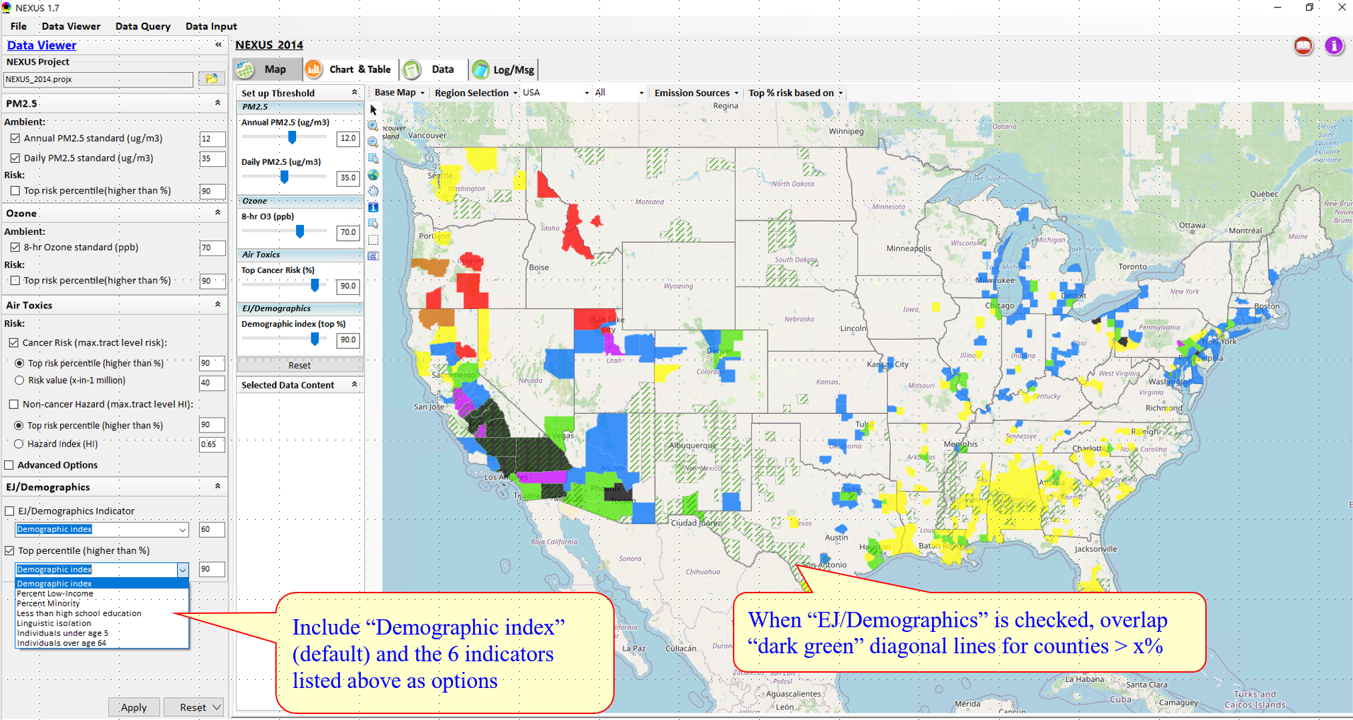
- When a county is selected, the “detail panel” will list out the EJ indicators together with the top percentiles.
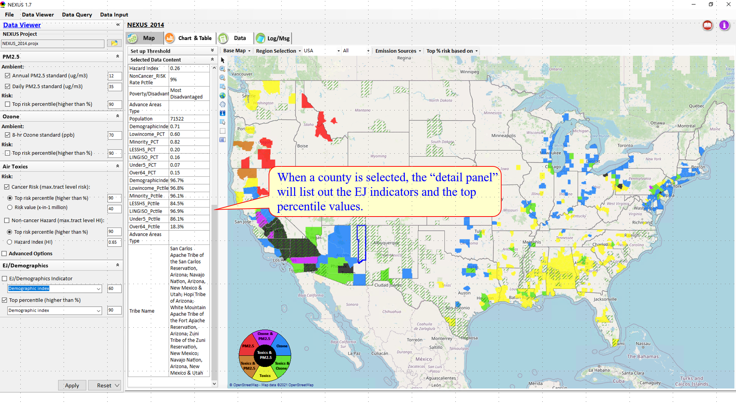
- The “EJ/Demographics” metrics are also available in Data Query Module.
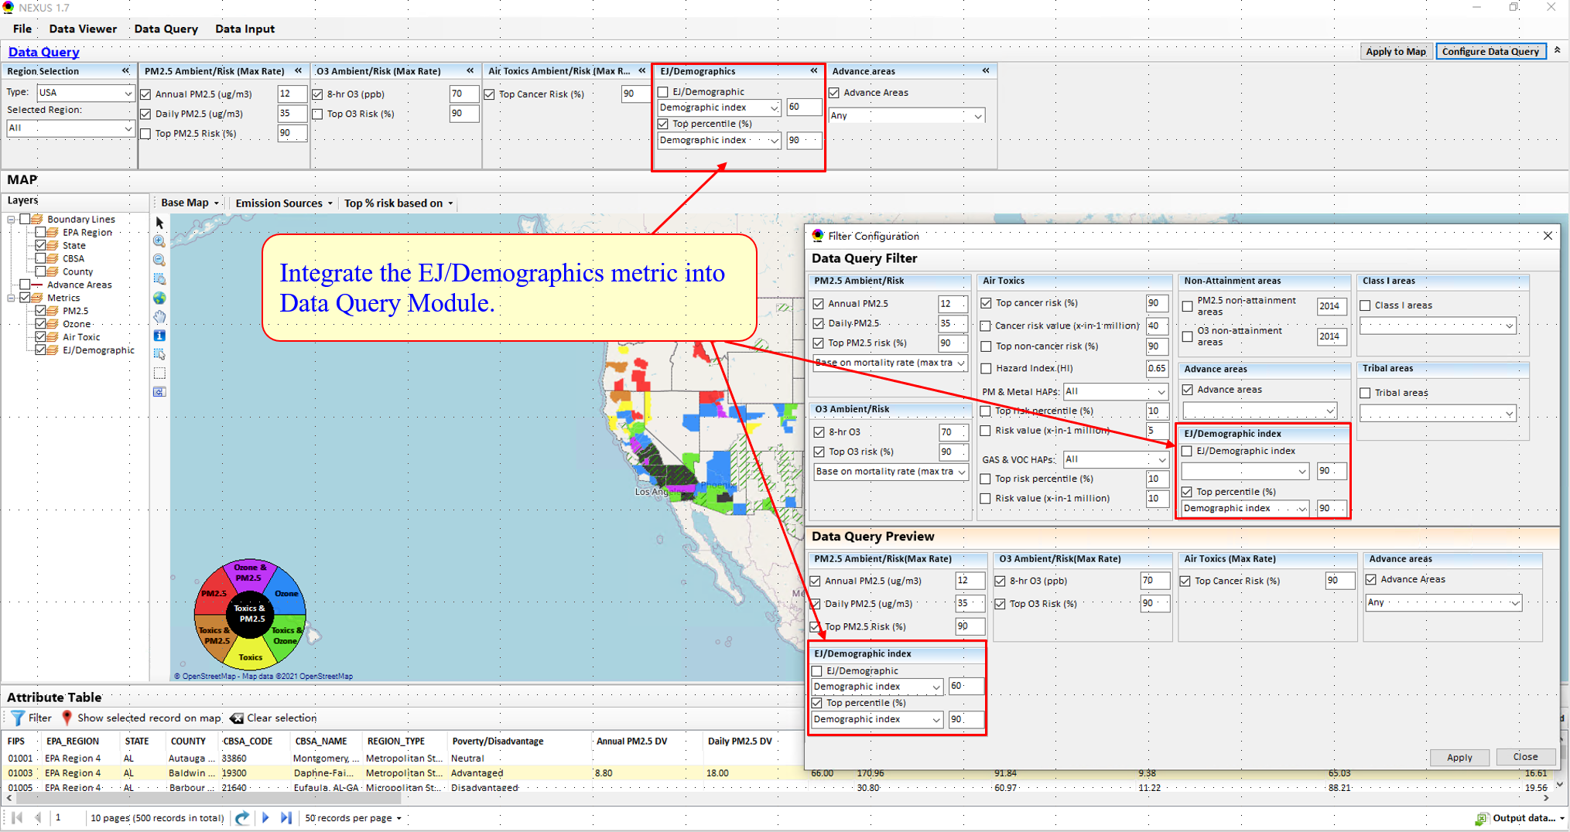
- Under Data Input Module:
  - Change the old “Socio-economic/Demographic data” to “EJ/Demographics data” and replace with “EJSCREEN data (“census block group” level).
  - User can view the original “EJSCREEN” data by clicking the button.

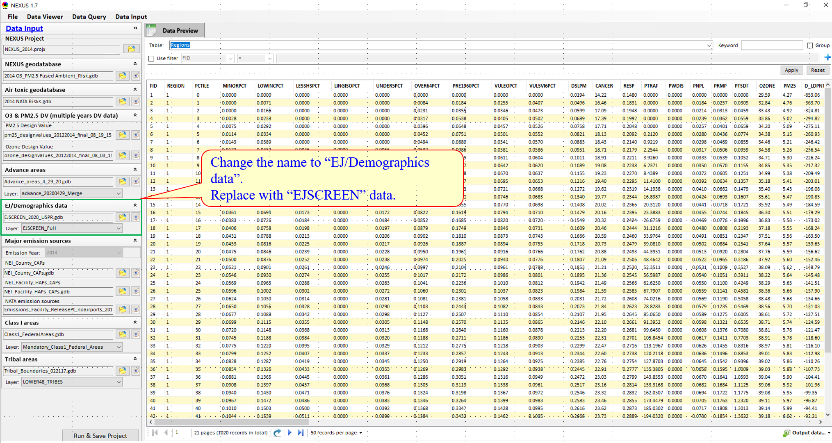
- We also develop the new function to output the facility emissions summary table. User can click “Emission Sources” – “Output Summary Tables”, then the “Export data…” window will pop up. Following steps below shows how to export the summary tables:
  - Select desired pollutants;
  - Select the number for top “X” emissions and top “X” regions;
  - If users want to output those regions defined by themselves, please check to use “User-Customed Regions” and input the region file. Or just skip this step and select regions of interest one by one under the “Available Region” panel.
  - Click to select a region or click to select all regions;
  - Click “OK” to export.
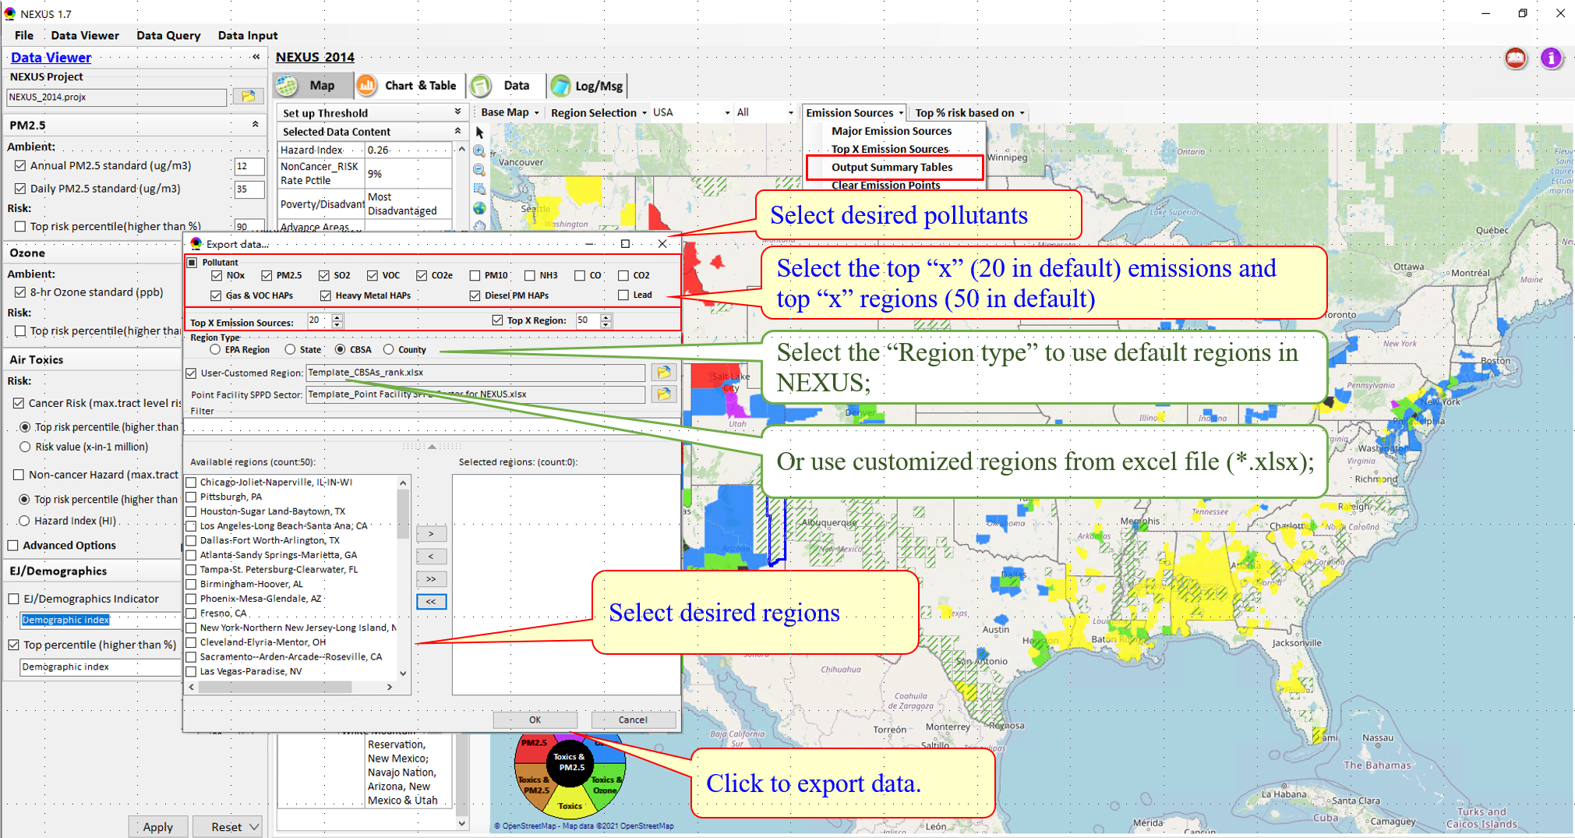
Below shows an example for exported data files:
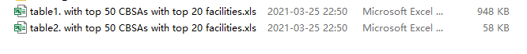

To Do List:
- Support 2017 NEI emission data (for both Data Input and Major emission source module).
- Add a “Major Sector Emissions” to display/rank sector emissions (Point, NonPoint, Road, NonRoad).
- Display/rank CAPs’ sector emissions in the “results” panel under the “Top X Emission Source” module.
- Develop a Proximity-based Risk & EJ Analysis Module:(1) Allow to set a flexible “Radius of Impact” for selected source/facility, (2) Add “Tribal” options Under Major Emission Source module for listing tribal areas (All & individual) and provide a Tribal Analysis module, (3) Include a Sources/Sector Analysis module, (4) Include a EJ Spatial Analysis module, (5) Provide a Tribal Analysis module
- Support to show census tracts level data when “CBSA” or “State” is selected.

