Article
Predicting the Nonlinear Response of PM_{2.5} and Ozone to Precursor Emission Changes with a Response Surface Model
James T. Kelly ^{1,*}, Carey Jang ¹, Yun Zhu ², Shicheng Long ², Jia Xing ^{3,4}, Shuxiao Wang^{3,4}, Benjamin N. Murphy⁵, and Havala O.T. Pye ⁵
Citation: Kelly, J. T..; et al. Predicting the Nonlinear Response of PM_{2.5} and Ozone to Precursor Emission Changes with a Response Surface Model. Atmosphere 2021, 12, x. https://doi.org/10.3390/xxxxx
Received: date
Accepted: date
Published: date
Publisher’s Note: MDPI stays neutral with regard to jurisdictional claims in published maps and institutional affiliations.

Copyright: © 2021 by the authors. Submitted for possible open access publication under the terms and conditions of the Creative Commons Attribution (CC BY) license (http://creativecommons.org/licenses/by/4.0/).
¹ Office of Air Quality Planning and Standards, U.S. Environmental Protection Agency, Research Triangle Park, NC 27711, USA; kelly.james@epa.gov (J.TK.); jang.carey@epa.gov (C.J.)
² College of Environment and Energy, South China University of Technology, Guangzhou Higher Education Mega Center, Guangzhou 510006, China; zhuyun@scut.edu.cn (Y.Z.)
³ State Key Joint Laboratory of Environmental Simulation and Pollution Control, School of Environment, Tsinghua University, Beijing 100084, China; xingjia@tsinghua.edu.cn (J.X.); shxwang@tsinghua.edu.cn (S.W.)
⁴ State Environmental Protection Key Laboratory of Sources and Control of Air Pollution Complex, Beijing 100084, China
⁵ Center for Environmental Measurement and Modeling, U.S. Environmental Protection Agency, Research Triangle Park, NC 27711, USA; murphy.ben@epa.gov (B.N.M.); pye.havala@epa.gov (H.O.T.P.)
* Correspondence: kelly.james@epa.gov (J.T.K.)
Abstract: Reducing PM_{2.5} and ozone concentrations is important to protect human health and the environment. Chemical transport models, such as the Community Multiscale Air Quality (CMAQ) model, are valuable tools for exploring policy options for improving air quality but are computationally expensive. Here we fit an efficient polynomial function-response surface model (pf-RSM) to CMAQ simulations over the eastern U.S. for January and July of 2016. The pf-RSM predictions were evaluated using out-of-sample CMAQ simulations and used to examine the nonlinear response of air quality to emission changes. Predictions of the pf-RSM are in good agreement with the out-of-sample CMAQ simulations, with some exceptions for cases with anthropogenic emission reductions approaching 100%. NO_{x} emission reductions were more effective for reducing PM_{2.5} and ozone concentrations than SO₂, NH₃, or traditional VOC emission reductions. NH₃ emission reductions were effective for reducing nitrate concentrations in January but increased secondary organic aerosol (SOA) concentrations in July. More work is needed on SOA formation under conditions of low NH₃ emissions to verify the responses of SOA to NH₃ emission changes predicted here. Overall, the pf-RSM performs well in the eastern U.S., but next-generation RSMs based on deep learning may be needed to meet the computational requirements of typical regulatory applications.
Keywords: response model; ozone; PM_{2.5}; air quality management

1. Introduction
PM_{2.5} and ozone air pollution leads to harmful effects on human health and the environment [1,2]. Air quality management plans are developed to reduce these criteria pollutant concentrations to meet National Ambient Air Quality Standards (NAAQS) in the U.S. [3-5]. Air quality modeling with comprehensive chemical transport models (CTMs) contributes key information to air quality planning by providing concentration predictions for baseline and policy-relevant emission-control conditions [6].
Air quality modeling is important for effective air quality management because the response of PM_{2.5} and ozone to precursor emissions changes is nonlinear and depends on hundreds chemical reactions. For instance, the response of ozone to NO_{x} emission reduction is to decrease when NO_{x} is the limiting precursor for oxidant formation but to increase under NO_{x}-saturated conditions, where NO_{x} inhibits oxidant production [7]. PM_{2.5} nitrate can also increase or decrease in response to NO_{x} emission reductions depending on oxidant levels and other factors, such as aerosol pH, temperature, and relative humidity [8-12]. Previous studies have individually reported seasonal variations in the nonlinear response of ozone and PM_{2.5} to NO_{x} emission reductions in the U.S. for retrospective periods [13,14]. However, information is limited on the seasonal variation in the simultaneous response in ozone and PM_{2.5} and its components for multiple precursors under recent conditions in the U.S. Consideration of relatively recent conditions is important because NO_{x} emissions declined by 57% and SO₂ emissions by 85% between 2000 and 2017 (gispub.epa.gov/neireport/2017).
A challenge in using CTMs to explore hypothetical policy options is computational expense. The runtime for CTM simulations typically prevents direct modeling of the dozens to hundreds of possible emission scenarios that may be of interest to policymakers [15-17]. As a result, researchers have developed computationally efficient approaches that approximate CTM capabilities [18-27]. Of these approaches, response-surface models (RSMs) are unique in their ability to simulate the nonlinear response of ozone and PM_{2.5} over wide ranges of precursor emission changes. RSMs are developed by statistically fitting the results of multiple CTM simulations with emission changes relative to a baseline simulation.
Early-generation RSMs required large numbers of CTM simulations for fitting to capture the complex pollutant responses simulated by CTMs [21,23,28,29]. To reduce the number of simulations for cases with multiple regions and emission control factors, the extended RSM (ERSM) technique was developed [20,24]. Next, using prior knowledge from ERSM results, a polynomial function-RSM (pf-RSM) approach was developed that further reduced the required number CTM simulations by using polynomial functions to capture the nonlinear response of PM_{2.5} and ozone to emission changes [19]. Recently, the DeepRSM method [22] has been developed to efficiently calculate the polynomial function coefficients using a convolutional neural network trained with chemical indicators [30]. Much of the development of RSM technology has happened through the ABaCAS (Air Benefit and Cost and Attainment Assessment System; www.abacas-dss.com) project, and applications of recent RSMs have been limited to regions in Asia. The performance and applicability of recent RSM methods for the U.S. and other regions needs to be established for these approaches to gain broader use.
In this study, we fit a one-region pf-RSM to CTM simulations over the eastern US for January and July of 2016. We characterize performance of the pf-RSM using 30 out-of-sample (OOS) CTM simulations. We also provide insights on the nonlinear response of air pollution in the eastern U.S. to anthropogenic emission reductions in winter and summer. We focus here on the response of MDA8 ozone, PM_{2.5}, nitrate, sulfate, and organic matter (OM) concentrations to emission changes of NO_{x}, SO₂, NH₃, and volatile organic compound (VOC). The pf-RSM also simulates the response of PM_{2.5} concentrations to primary PM_{2.5} (pPM_{2.5}) emissions and is available for download.

2. Methods

2.1. Base-Case CTM Simulation
CTM simulations were performed for January and July 2016 with version 5.3.1 of the Community Multiscale Air Quality (CMAQ; doi:10.5281/zenodo.3585898) model on a domain covering the eastern U.S. with 12-km grid spacing and 35 vertical layers. Gas-phase chemistry was parameterized according to the Carbon Bond 2006 mechanism (CB6r3) [31], deposition was modeled with the M3DRY parameterization, and aerosol processes were parameterized with the AERO7 module using the non-volatile treatment for primary organic aerosol [32,33]. Chemical boundary conditions were developed from a CMAQ simulation on a larger domain that used boundary conditions from a hemispheric CMAQ simulation [34]. The starting point for the modeled anthropogenic emissions was version 2 of the 2014 National Emissions Inventory; however, many inventory sectors were updated to represent the year 2016 through the incorporation of 2016-specific state and local data along with nationally-applied adjustment methods [35]. Emissions of anthropogenic precursors for secondary organic aerosol (SOA) [36] were not added to the simulation beyond what was captured in the NEI. Therefore, VOC impacts discussed below are due to traditional VOCs alone. Emissions of biogenic compounds were modeled with the Biogenic Emission Inventory System (BEIS) [37], and emissions of sea-spray aerosol [38] were simulated online within CMAQ using 2016 meteorology. Meteorological fields were developed from a simulation with version 3.8 of the Weather Research and Forecasting model as described elsewhere [39].
Model performance for the base-case CTM simulation was evaluated by comparison with available monitoring data for PM_{2.5}, PM_{2.5} components, and maximum daily 8-h average (MDA8) ozone (Text S1, Table S1). The model performance statistics are generally within ranges reported in previous applications [40,41] and support use of the modeling here. However, overpredictions of PM_{2.5} organic carbon concentrations were evident in January, possibly due to issues with emissions or meteorology, and the performance results in Table S1 should be considered in interpreting the RSM predictions. Model performance results here are qualitatively consistent with those of Appel et al. [42], although statistics are calculated for different periods and not directly comparable across studies.

2.2. Sensitivity CTM Simulations and pf-RSM Development
In addition to the base-case simulation, 22 simulations were conducted for model fitting with domain-wide changes in U.S. anthropogenic emissions of NO_{x}, SO₂, VOC, NH₃, and pPM_{2.5} (see Table S2). For 19 of these simulations, emission changes were specified based on Hammersley sampling [43] of emission control ratios between 0 and 1.2 (base case = 1.0). Additionally, one simulation was conducted with 100% reductions in U.S. anthropogenic emissions of NO_{x}, SO₂, NH₃, and VOCs, and two simulations were conducted with 50% and 100% reductions in pPM_{2.5} emissions. Emission-perturbation simulations were implemented in CMAQ using the Detailed Emissions Scaling, Isolation, and Diagnostic (DESID) module [44]. Version 2.5 of the RSM-VAT software was used to implement the Hammersley sampling and generate the emission-control interface files for DESID.
Polynomial functions were fit in each grid cell to provide the nonlinear response of monthly average PM_{2.5}, PM_{2.5} components, and MDA8 ozone to changes in NO_{x}, SO₂, VOC, NH₃, and pPM_{2.5} emissions across the domain. The following optimized polynomial functions were fit using results of the emission reduction simulations in Table S3:

ΔPM_{2.5,spc} = X₁ ΔE_{NOX} + X₂ ΔE_{SO2} + X₃ ΔE_{NH3} + X₄ ΔE_{VOC} + X₅ ΔE_{NOX}² + X₆ ΔE_{SO2}² + X₇ ΔE_{NH3}² + X₈ ΔE_{NOX} ΔE_{VOC} + X₉ ΔE_{NOX}³ + X₁₀ ΔE_{NOX}² ΔE_{VOC} + X₁₁ ΔE_{NOX}² ΔE_{SO2} + X₁₂ ΔE_{NOX}² ΔE_{NH3} (1)

ΔMDA8 O₃ = Y₁ ΔE_{NOX} + Y₂ ΔE_{SO2} + Y₃ ΔE_{NH3} + Y₄ ΔE_{VOC} + Y₅ ΔE_{NOX}² + Y₆ ΔE_{NOX} ΔE_{NH3} + Y₇ ΔE_{NOX}² ΔE_{NH3} (2)

where ΔPM_{2.5,spc} refers to the change from the base case in the concentration of PM_{2.5}, PM_{2.5} nitrate, PM_{2.5} sulfate, or PM_{2.5} organic matter; ΔE refers to the ratio of the difference in emissions between the base and emission perturbation cases to the base emissions (i.e., ΔE_{i} = (E_{i}-E_{Base})/E_{Base}); and X₁₋₁₂ and Y₁₋₇ are the polynomial coefficients determined by least-squares error fitting.
The pf-RSM was evaluated by comparison with 30 OOS CMAQ simulations that were not used in model fitting (Table S4). The OOS simulations included 10 simulations based on Hammersley sampling and 20 simulations corresponding to 20%, 40%, 60%, 80%, and 100% reductions in U.S. anthropogenic NO_{x}, SO₂, NH₃, and VOC emissions.
The strength of the RSM is the ability to conduct interactive exploratory analyses on air quality impacts for an unconstrainted number of emission cases using the RSM-VAT software. Below, we focus on comparisons of pf-RSM and CMAQ OOS predictions to demonstrate performance of the pf-RSM. We also use the OOS simulations to illustrate features of the nonlinear response of ozone and PM_{2.5} and its components in the eastern U.S. in winter and summer. The RSM-VAT software is available with cases preloaded for exploration of additional scenarios.

3. Results
Predictions of the pf-RSM are compared with CMAQ results for the 30 OOS runs in this section. The comparisons illustrate the performance of the pf-RSM as well as the nonlinear response of PM_{2.5} and MDA8 ozone to reductions in U.S. anthropogenic emissions.

3.1. January
The air quality response to emission changes predicted by the pf-RSM and CMAQ are compared for the 30 OOS cases for five species in Figure 1. Overall, there is excellent correlation and little bias between the pf-RSM and CMAQ results. However, some distinct features are evident in the scatterplots due to the specific conditions of the individual OOS simulations. For instance, most points in the MDA8 ozone panel are close to the one-to-one line, but a cluster points above the line indicates some overpredictions by the pf-RSM. These points are associated with the case of 100% NO_{x} emission reductions (see Figure S1 for scatterplots faceted by OOS case). Challenges in simulating pollutant response for cases with extreme emission reductions have been reported in the past and suggest a need for including additional CTM simulations in pf-RSM fitting [19].
pf-RSM predictions of the nitrate response to emission changes also agree well with the OOS CMAQ results, despite some overpredictions of nitrate concentration increases (i.e., disbenefits). These overestimates are associated with cases of SO₂ emission reductions, where disbenefits are overpredicted by up to ~0.4 μg m⁻³ for the case of 100% reduction in anthropogenic SO₂ emissions (Figure S2). For pf-RSM predictions of the sulfate response, the largest deviations from the one-to-one line in Figure 1 are associated with OOS Run 4 and 5 based on Hammersley sampling of emissions (Figure S3). These runs included deep reductions in NO_{x}, VOC, NH₃, and SO₂ emissions (Table S4).
For the OM concentration response, there is good agreement between the pf-RSM and CMAQ predictions in general. However, the pf-RSM predicts some disbenefits for the 100% NO_{x} emission reduction case (Figure S4) that were not predicted by CMAQ. For the total PM_{2.5} concentration response, the scatterplot has a forked shape for concentration decreases larger than 4 μg m⁻³. This pattern results from the combination of underpredictions in response for the pf-RSM in the 100% NH₃ emission reduction case and overpredictions in a case with large NO_{x} reductions (i.e., Run 5 with 97% NO_{x}, 90% SO₂, 24% NH₃, and 81% VOC emission reductions) (Figure S5). This behavior further demonstrates that deviations of the pf-RSM from CMAQ may be relatively large in cases with large emission reductions, and model fitting could be improved by including additional simulations for marginal emission cases.

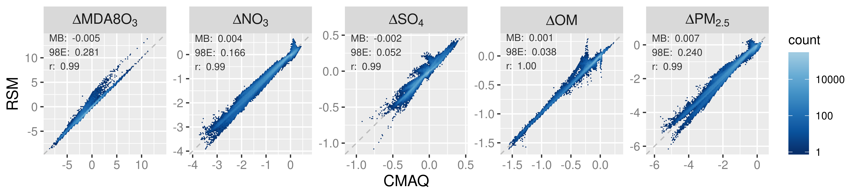
Figure 1. Comparison of changes in mean January concentrations predicted by the pf-RSM and 30 OOS CMAQ simulations. Units: ppb for MDA8 ozone and μg m⁻³ for PM_{2.5} and its components.
In Figure 2, the spatial patterns of concentration responses in January 2016 are compared for CMAQ and the pf-RSM for MDA8 ozone, nitrate, sulfate, and OM for 60% reductions in NH₃, NO_{x}, SO₂, and VOC emissions. The response patterns for the pf-RSM and CMAQ are in good agreement in all cases. NO_{x} emission reductions in January lead to increases in MDA8 ozone over much of the domain (Figure 2a), especially in northern and urban areas (e.g., the mean/max concentration increase above 37˚N is 0.8/7.1 ppb for CMAQ). The ozone disbenefits for NO_{x} emission reductions are consistent with oxidant-limited conditions in NO_{x}-rich areas in winter [14,45,46]. By contrast, MDA8 ozone concentrations decrease in response to NO_{x} emission reductions along the Gulf Coast (except Houston) and over Florida, likely due to the lower NO_{x} emissions and inflow of marine air. For VOC, the 60% emission reductions reduce MDA8 ozone concentrations broadly over the eastern U.S. (CMAQ mean reduction: 1.1 ppb).
The 60% reductions in NH₃ and NO_{x} emissions reduce nitrate concentrations in the northern part of the domain and demonstrate the sensitivity of nitrate to both precursors there (Figure 6b). NH₃ emission reductions in areas of elevated NH₃ concentration [47] can reduce nitrate concentrations by increasing particle acidity (due to removal of the key atmospheric base, NH₃) and thereby reducing the fraction of total nitrate in the particle phase [9,48,49]. NO_{x} emission reductions reduce nitrate through direct removal of the nitrate precursor, which outweighs the effect of increased NO_{x}-to-nitrate conversion efficiency from increased ozone/oxidant concentrations. For reducing nitrate in January, NH₃ emission reductions (mean nitrate reduction: 0.62 μg m⁻³) are more effective than NO_{x} emission reductions (mean nitrate reduction: 0.46 μg m⁻³). SO₂ and VOC emission reductions have relatively small influence on nitrate, with some nitrate disbenefits for SO₂ reductions in the northern part of the domain (likely due to the influence of reduced acidity from lower sulfate on partitioning of total nitrate to the particle phase).
The 60% reductions in NH₃ emissions lead to small decreases sulfate concentrations in the northern part of the domain (Figure 6c). Since sulfate is essentially nonvolatile under atmospheric conditions, NH₃ levels do not affect gas-particle partitioning of sulfate as they do for semi-volatile nitrate. However, in-cloud sulfate production is sensitive to cloud pH, and the reductions in NH₃ concentrations could reduce cloud pH and thereby lower the rate of S(IV) to S(VI) conversion (e.g., due to ozone pathways, [50]). Shah et al. [51] reported that in-cloud oxidation was responsible for about 65% of the conversion of SO₂ to sulfate in the eastern U.S. in winter 2015. NO_{x} emission reductions lead to increases in sulfate in the northern part of the domain due to the increases in ozone and other oxidants that promote conversion of SO₂ to sulfate. SO₂ emission reductions reduce sulfate throughout the domain through direct removal of the sulfate precursor, and VOC reductions reduce sulfate by a small amount by reducing ozone and other oxidants.
The response of OM concentrations to 60% emission reductions is shown in Figure 6d. NO_{x} emission reductions reduce OM concentrations throughout the southeast but increase concentrations slightly in the northeast. In winter, both monoterpene [52] and aromatic [53] oxidation contribute to SOA concentrations. Reductions in NO_{x} emissions lower the concentrations of monoterpene nitrate precursors in the southeast [54] and reduce the oxidation of monoterpenes in areas where ozone and OH decrease [55]. In the northeast, the increases in OM concentrations with NO_{x} emission reductions are consistent with more efficient conversion of SOA precursors to OM due to increased oxidant (e.g., ozone) concentrations. In addition, reducing NO_{x} shifts aromatic oxidation to higher-yield SOA pathways [53].

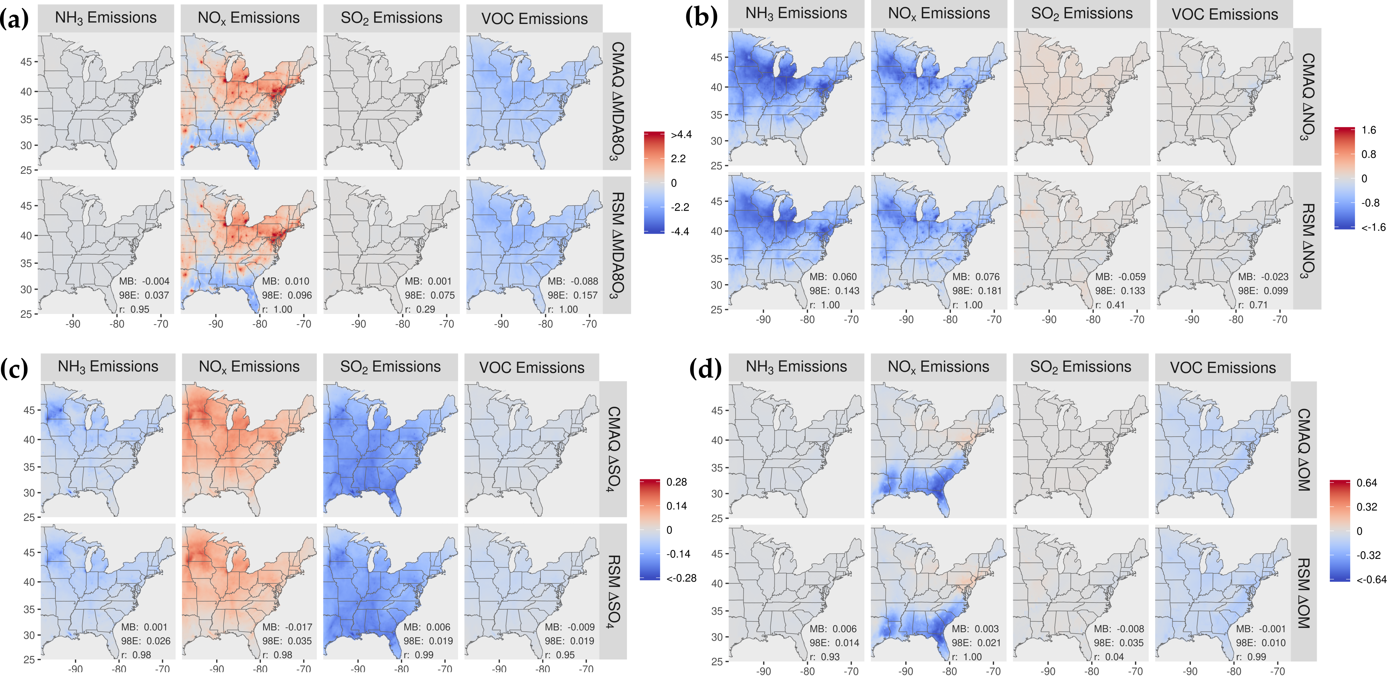

Figure 2. Comparison of the change in average concentration in January 2016 for the pf-RSM and CMAQ for a 60% reduction in anthropogenic emissions of NH₃, NO_{x}, SO₂, and VOC: (a) MDA8 ozone, (b) PM_{2.5} nitrate, (c) PM_{2.5} sulfate, and (d) PM_{2.5} OM. Units: ppb for MDA8 ozone and μg m⁻³ for PM_{2.5} components. Statistics for pf-RSM and CMAQ comparison: MB: mean bias; 98E: 98th percentile of error; r: Pearson correlation coefficient.
In Figure 3, the percent change in concentration is shown for a 60% reduction in emissions for grid cells in four urban core-based statistical areas (CBSAs). Good agreement exists between CMAQ and pf-RSM predictions in the CBSAs. In the CMAQ simulations, reductions in anthropogenic NO_{x} emissions increase MDA8 ozone by 9% (about 2.5 ppb) in NY and Chicago and a smaller amount in Atlanta (4%, 1.4 ppb) and Houston (2%, 0.4 ppb). NO_{x} emission reductions reduce nitrate by 29% (0.6 μg m⁻³) in NY, 39% in Chicago (1.2 μg m⁻³), 52% in Atlanta (0.6 μg m⁻³) and 47% in Houston (0.3 μg m⁻³). Decreases in NH₃ emissions also reduce nitrate in the CBSAs: 51% (1.1 μg m⁻³) in NY, 46% in Chicago (1.4 μg m⁻³), 57% in Atlanta (0.6 μg m⁻³), and 44% in Houston (0.3 μg m⁻³). SO₂ emission reductions reduce sulfate concentrations by 0.11 to 0.18 μg m⁻³ but increase nitrate concentrations by 0.02 to 0.1 μg m⁻³ in the CMAQ simulations. In contrast to the slight nitrate disbenefits predicted by CMAQ, the pf-RSM predicted small nitrate reductions in Atlanta and Houston for the SO₂ emission reductions. NH₃ emission reductions produce the greatest reductions in PM_{2.5} concentrations in January in all CBSAs except Houston.

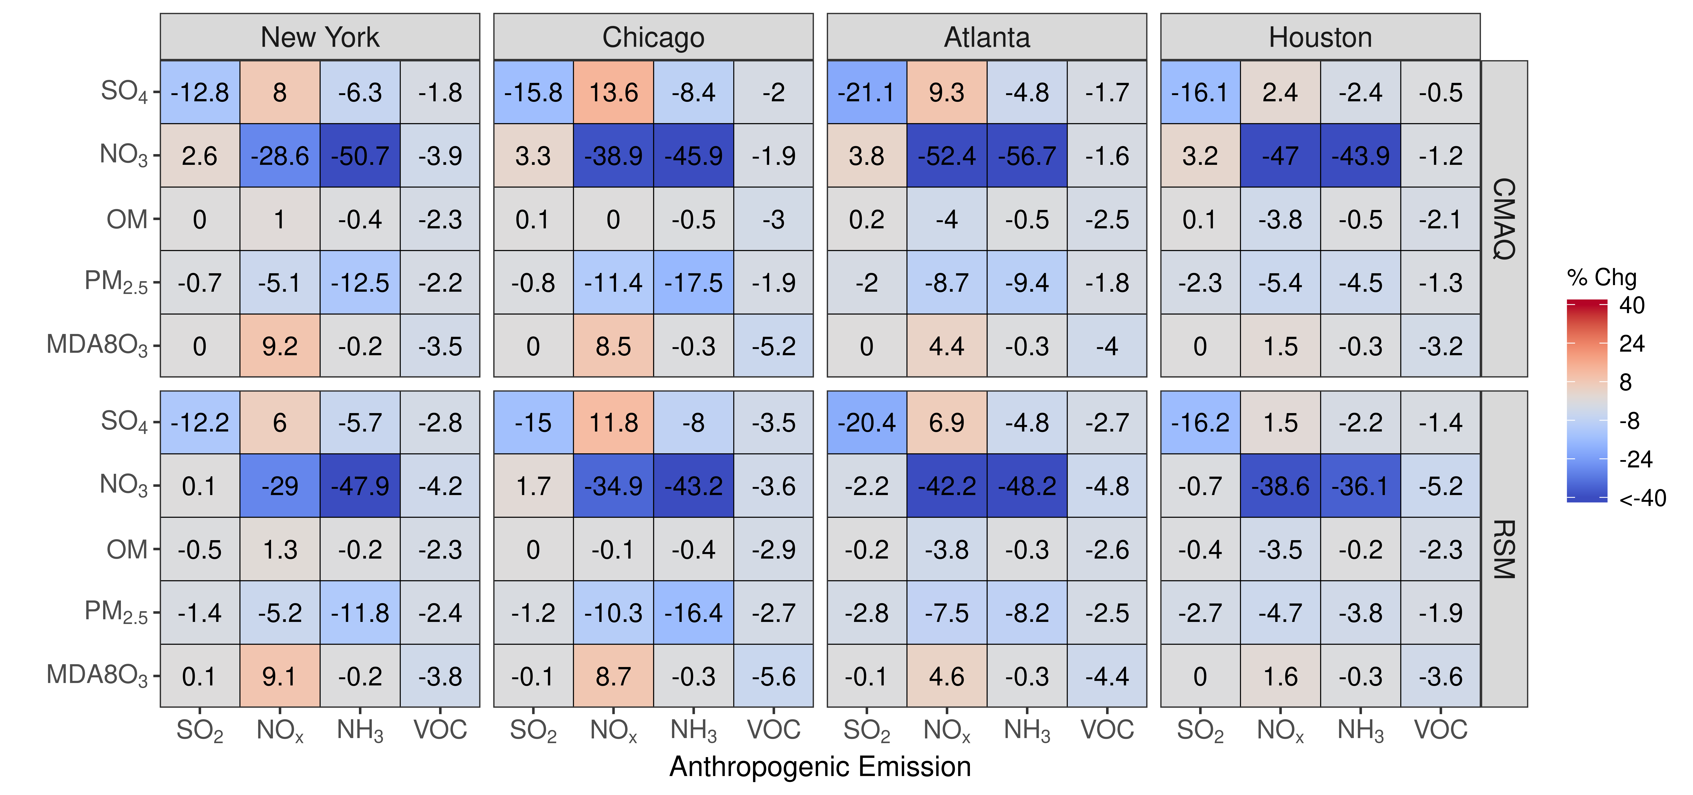
Figure 3. Comparison of the percent change in pollutant concentrations for four urban CBSAs during January 2016 as predicted by the pf-RSM and CMAQ. Units: ppb for MDA8 ozone and μg m⁻³ for PM_{2.5} and its components.
Comparisons of mean absolute concentrations predicted by the pf-RSM and CMAQ over all CBSAs in the domain for 0% to 100% emission reductions in January 2016 are provided Figure 4. The predictions discussed above for the 60% emission reductions are generally reflective of the model response indicated in Figure 4, although the disbenefits in MDA8 ozone for 60% NO_{x} emission reductions transition to benefits for larger reductions. For instance, MDA8 ozone increased over the CBSAs by 0.7 ppb for the 40% NO_{x} emission reduction but decreased by 2.8 ppb for the 100% NO_{x} reduction in the CMAQ simulations.
The trend of increasing sulfate with decreasing NO_{x} emissions (Figure 4) is consistent with Shah, et al. [51], who reported that the SO₂-to-sulfate conversion efficiency increased from 0.11 to 0.18 in winter in the eastern U.S. due to emission reductions during the 2007-2015 period. For CMAQ predictions, the trend of increasing sulfate with decreasing NO_{x} emissions reverses for NO_{x} reductions greater than about 80% but continues for the pf-RSM. pf-RSM performance could be improved for this case by including additional simulations in model fitting [19], although there could also be limitations in the polynomial functions for representing the entire range of concentration response. Nevertheless, the pf-RSM generally captures the CMAQ responses across species and emission changes, including the overall response in PM_{2.5} concentrations. CMAQ predictions of changes in mean PM_{2.5} concentrations over the CBSAs for 100% reductions in anthropogenic emissions are -1.72 μg m⁻³ (-20%, NH₃ emissions); -1.61 μg m⁻³ (-19%, NO_{x} emissions); and -0.19 μg m⁻³ (-2.2%, SO₂ and VOC emissions). The PM_{2.5} concentration reductions associated with 100% NO_{x} emission reductions overcome a 0.07 μg m⁻³ sulfate disbenefit, and the PM_{2.5} concentration reductions for 100% SO₂ emission reductions overcome a 0.15 μg m⁻³ nitrate disbenefit (about 50% of the sulfate reduction in that case).
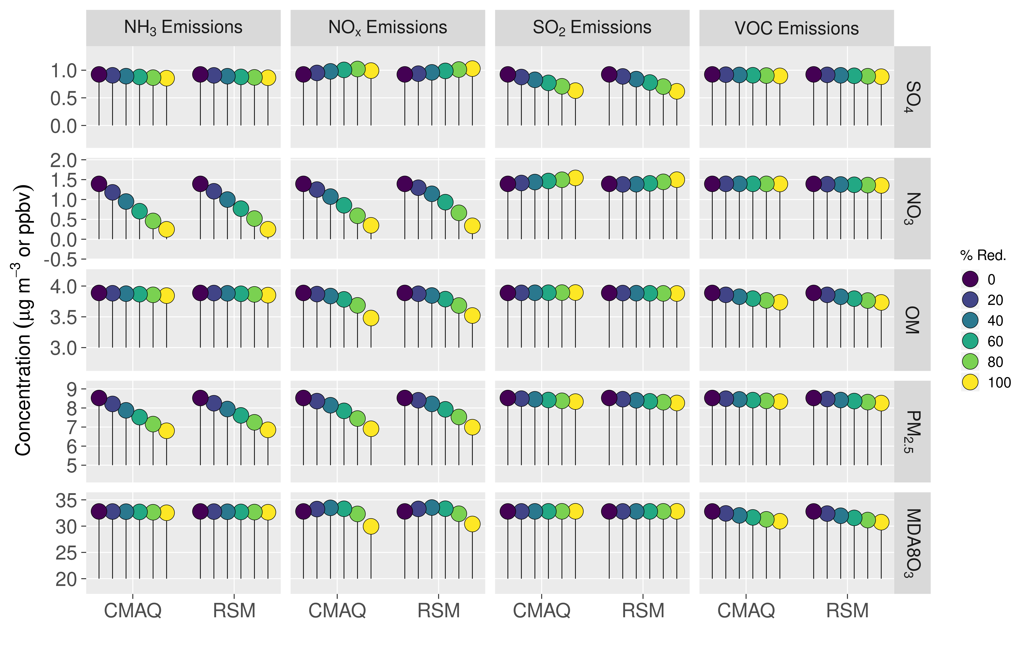
Figure 4. Comparison of the mean absolute concentrations predicted by the pf-RSM and CMAQ over all CBSAs in the domain during January 2016 for U.S. anthropogenic emission changes from 0 to 100%. Units: ppbv for MDA8 ozone and μg m⁻³ for PM_{2.5} and its components.

3.3. July
The mean concentration responses in July 2016 predicted by the pf-RSM and CMAQ are compared for the 30 OOS cases in Figure 5. The pf-RSM predictions for MDA8 ozone agree well with CMAQ results across the full set of OOS simulations, even for the case of 100% NO_{x} emission reductions with large (>30 ppb) MDA8 ozone decreases (Figure S6). Nitrate responses are also in general agreement for the pf-RSM and CMAQ, although the pf-RSM tends to underestimate the magnitude of the disbenefits predicted by CMAQ. These underestimates are associated with the 100% SO₂ emission reduction simulation (Figure S7).
For the sulfate response, a forked pattern exists in the scatterplot for concentration decreases larger than 1 μg m⁻³. This pattern results from pf-RSM underestimates of the CMAQ response for the 100% SO₂ emission reduction case and overestimates for the Run 5 case. The forked pattern for the OM response is due to pf-RSM response overestimates for the 80% and 100% NO_{x} emission reduction cases and slight underestimates for the Run 5 case. Also, the OM disbenefits predicted by CMAQ were underestimated by the pf-RSM for the 100% NH₃ emission reduction case (Figure S9). The forked pattern in the scatterplot for the PM_{2.5} response as well as the pf-RSM underestimate of PM_{2.5} disbenefits follow the behavior for OM (i.e., PM_{2.5} responses are overestimated for the 100% NO_{x} emission reductions and disbenefits are underestimated for 100% NH₃ emission reductions, Figure S10).

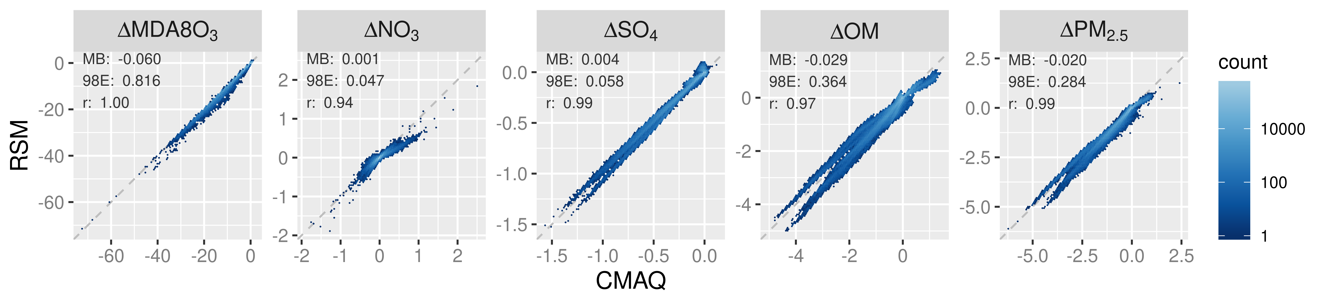
Figure 5. Comparison of changes in mean July concentrations predicted by the pf-RSM and 30 OOS CMAQ simulations. Units: ppb for MDA8 ozone and μg m⁻³ for PM_{2.5} and its components.
In Figure 6, the spatial patterns of concentration responses in July 2016 are compared for CMAQ and the pf-RSM for MDA8 ozone, nitrate, sulfate, and OM for 60% reductions in NH₃, NO_{x}, SO₂, and VOC emissions. The pf-RSM and CMAQ response patterns are generally in good agreement across cases. For MDA8 ozone, the 60% NO_{x} emission reductions lead to large ozone decreases (mean: 7 ppb) throughout the eastern U.S. (Figure 6a), in contrast to the ozone increases predicted in January in northern and urban areas. Emission reductions for other species have a relatively small effect on MDA8 ozone. The 60% reductions in NO_{x} and NH₃ emissions reduce nitrate concentrations through a band of cells from Iowa to Pennsylvania, and NO_{x} emissions reductions also reduce nitrate in parts of Florida (Figure 6b). The SO₂ emission reductions cause increases in nitrate concentrations in some areas, likely due to chemical feedbacks of acidity on gas-particle partitioning of total nitrate. NO_{x} and NH₃ emission reductions lead to small sulfate decreases due to the influence of NO_{x} on oxidant abundance and NH₃ on cloud pH. SO₂ reductions reduce sulfate in the Ohio Valley where large SO2 sources are located (Figure 6c).
The 60% reductions in NH₃ emissions increase OM concentrations along a latitude band between about 32N and 42N. This behavior appears to be associated with biogenic SOA formation from acid-catalyzed uptake of isoprene epoxydiols (IEPOX) and subsequent in-particle reaction involving nucleophile addition to the parent hydrocarbon. This SOA formation pathway is enhanced under conditions of greater acidity and increased nucleophile (water and sulfate) concentration (i.e., eqn. 4 of Pye et al. [56]). The 60% reduction in NH₃ emissions reduces pH by 0.23 on average (up to 0.84) (Figure 7a), which corresponds to a 75% increase in [H+] on average (up to 594%). These increases in acidity rather than changes in nucleophile concentrations explain the OM concentration increases, because sulfate concentrations decrease with decreasing NH₃ emissions (Figure 6c) and aerosol water concentrations also generally decrease, except over a region around WV with small (<9%) increases (Figure 7b).
The 60% reductions in NO_{x} emissions lead to decreases OM concentrations in the southern U.S. where biogenic SOA is relatively high (Figure 6d). Previous work has found that reducing NO_{x} in the southeast U.S. in summer leads to substantial reductions in the organic nitrate fraction of OM and smaller changes for other OM contributors [54]. SO₂ emission reductions reduce OM concentrations with a spatial pattern similar to that previously reported for the SO₂ response of biogenic SOA formed via aerosol water chemistry [57]. As described above, SO₂ emission reductions can reduce particle acidity and nucleophile concentrations and thereby lower biogenic SOA production. Anthropogenic VOC emission reductions lead to small OM concentration reductions in the CMAQ simulations, but the pf-RSM predicts small increases. This behavior did not occur in previous pf-RSM applications in China and should be investigated further in future studies.

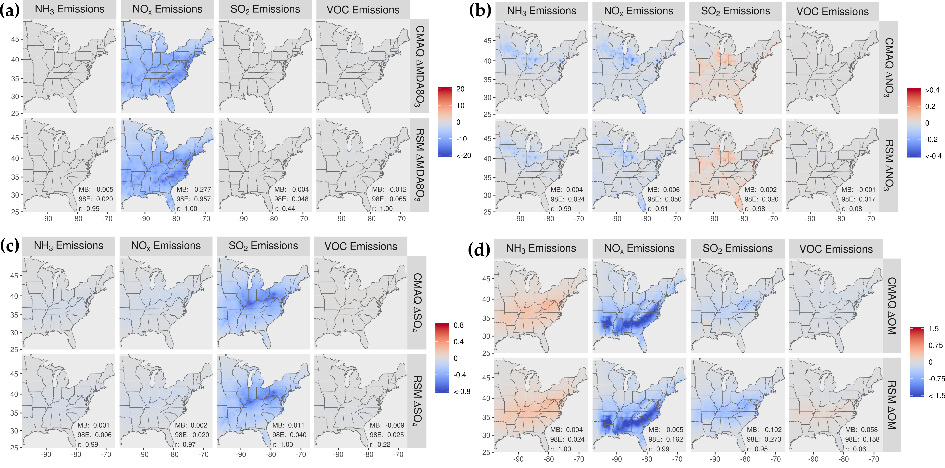
Figure 6. Comparison of the change in average concentration in July 2016 for the pf-RSM and CMAQ for a 60% reduction in anthropogenic emissions of NH₃, NO_{x}, SO₂, and VOC: (a) MDA8 ozone, (b) PM_{2.5} nitrate, (c) PM_{2.5} sulfate, and (d) PM_{2.5} OM. Units: ppb for MDA8 ozone and μg m⁻³ for PM_{2.5} components. Statistics for pf-RSM and CMAQ comparison: MB: mean bias; 98E: 98th percentile of error; r: Pearson correlation coefficient.
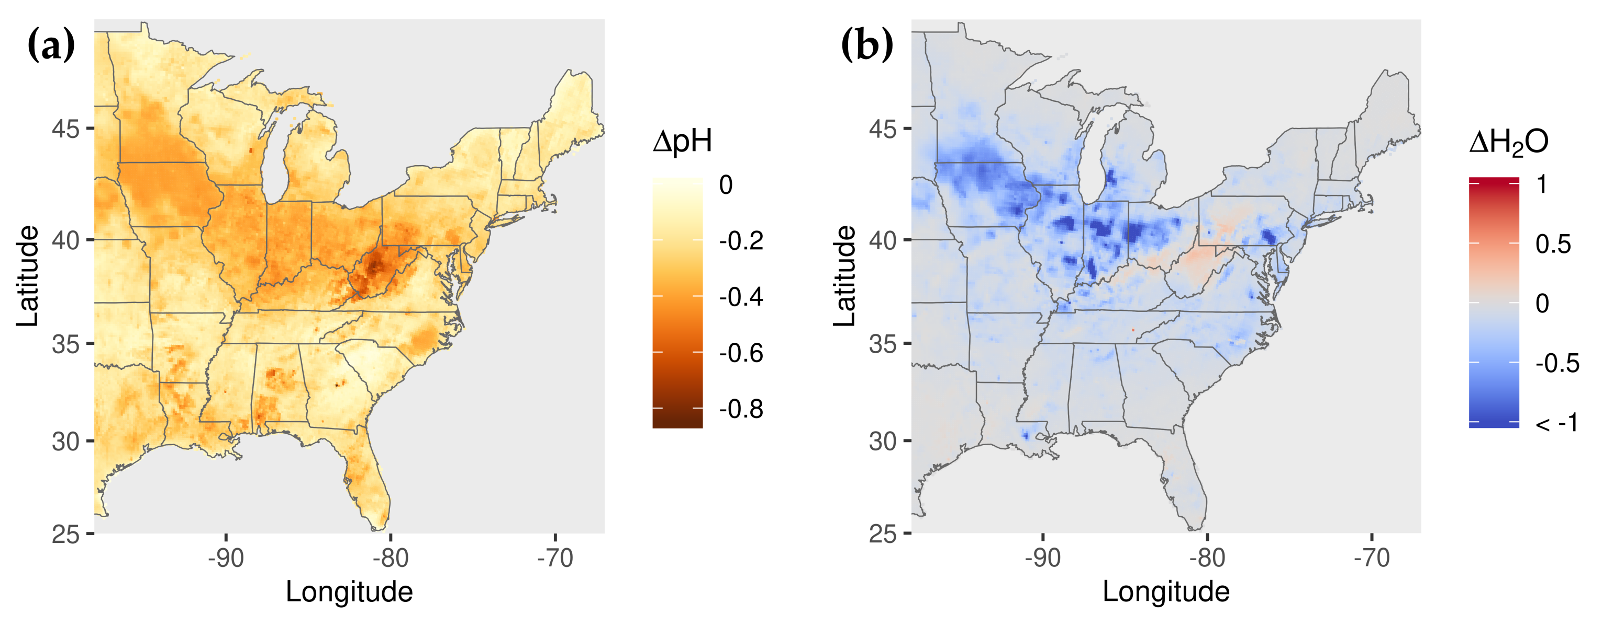
Figure 7. Change in (a) pH and (b) fine-particle water concentration for 60% reduction in NH₃ emissions.
Good agreement exists between pf-RSM and CMAQ predictions of the percent change in concentrations over the four CBSAs in Figure 8 for 60% reductions in precursor emissions in July. In response to the SO₂ emission reductions, sulfate concentrations decreased by 0.1 μg m⁻³ in Houston, 0.25 μg m⁻³ in Atlanta, 0.28 μg m⁻³ in NY, and 0.38 μg m⁻³ in Chicago. In contrast, the SO₂ emission reductions caused some increases in nitrate concentrations, although the effect is small (0.02 μg m⁻³ in Houston and Atlanta, 0.03 μg m⁻³ in NY, and 0.09 μg m⁻³ in Chicago) due to the low nitrate concentrations in summer. In response to 60% NO_{x} emission reductions, MDA8 ozone concentrations decreased from 16% (5 ppb in Houston) to 28% (12 ppb in Atlanta) in the CMAQ simulations. NO_{x} emission reductions also caused decreases in OM concentrations in the CBSAs, with the greatest decrease in Atlanta (18%, 1.5 μg m⁻³), where biogenic SOA is prominent. NO_{x} emission reductions caused large percent reductions in nitrate concentrations (up to 36% in Chicago), but the absolute concentration changes are small (i.e., ≤0.12 μg m⁻³). NH₃ emission reductions lead to decreases in nitrate concentrations and increases in OM concentrations in July. The OM increases are greater than the nitrate decreases in absolute terms (greater by 0.14 μg m⁻³ in NY, 0.03 μg m⁻³ in Chicago, 0.23 μg m⁻³ in Atlanta, 0.02 μg m⁻³ in Houston). Anthropogenic VOC reductions have a small effect on concentrations in July due to the high levels of biogenic VOC.

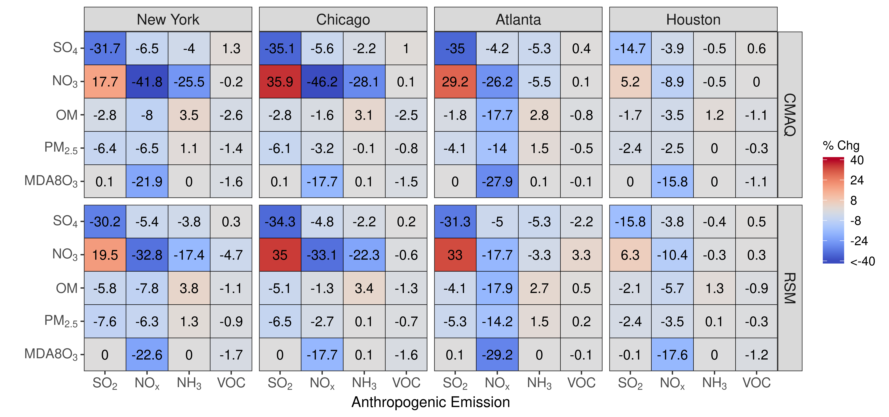
Figure 8. Comparison of the percent change in pollutant concentrations for four urban CBSAs during July 2016 as predicted by the pf-RSM and CMAQ. Units: ppb for MDA8 ozone and μg m⁻³ for PM_{2.5} and its components.
Comparisons of mean absolute concentrations predicted by the pf-RSM and CMAQ over all CBSAs in the domain for 0% to 100% emission reductions in July 2016 are shown in Figure 9. SO₂ emission reductions reduce sulfate (up to 0.42 μg m⁻³) and OM (up to 0.16 μg m⁻³) concentrations but increase nitrate concentrations (up to 0.13 μg m⁻³). In contrast to January, NO_{x} emission reductions reduce MDA8 ozone and sulfate concentrations for all NO_{x} emission reduction levels due to the greater oxidant abundance in July. NO_{x} emission reductions also decrease OM concentrations (up to 0.93 μg m⁻³). NH₃ emission reductions lead to increases in OM concentrations (up to 0.51 μg m⁻³), with increases growing nonlinearly with decreasing emission level. As discussed above, the OM concentration increases with decreasing NH₃ emissions could be related to biogenic SOA formation associated with IEPOX uptake. Additional investigation of this SOA formation pathway under conditions of low NH₃ and SO₂ (and water content) would be worthwhile. Riva, et al. [58] reported that IEPOX organosulfates are highly viscous and likely to lead to phase separation under acidic conditions with low water content. Phase separation becomes more likely as sulfate decreases relative to IEPOX resulting in increased diffusion barriers to further IEPOX uptake and SOA formation. Such behavior, which is not present in the base CMAQ model, could affect the sensitivity of OM to SO₂ and NH₃ emissions.
Predicted changes in PM_{2.5} concentrations for 100% reductions in anthropogenic emissions are -1.09 μg m⁻³ (-15.4%) (NO_{x} emissions); -0.54 μg m⁻³ (-7.67%) (SO₂ emissions); -0.072 μg m⁻³ (-1.02%) (VOC emissions); and +0.30 μg m⁻³ (+4.3%) (NH₃ emissions). The PM_{2.5} concentration decreases associated with 100% NO_{x} emission reductions include a small decrease in sulfate concentration of 0.09 μg m⁻³ (in contrast to January when sulfate concentrations increased with NO_{x} emission reductions). The PM_{2.5} concentration decreases for 100% SO₂ emission reductions overcome a 0.13 μg m⁻³ increase in nitrate concentration (about 30% of the sulfate concentration decrease, 0.42 μg m⁻³). The predicted change in MDA8 ozone concentration for 100% reduction in NO_{x} emissions is -15.0 ppb (38%) and for 100% reduction in VOC emissions is 0.25 ppb.

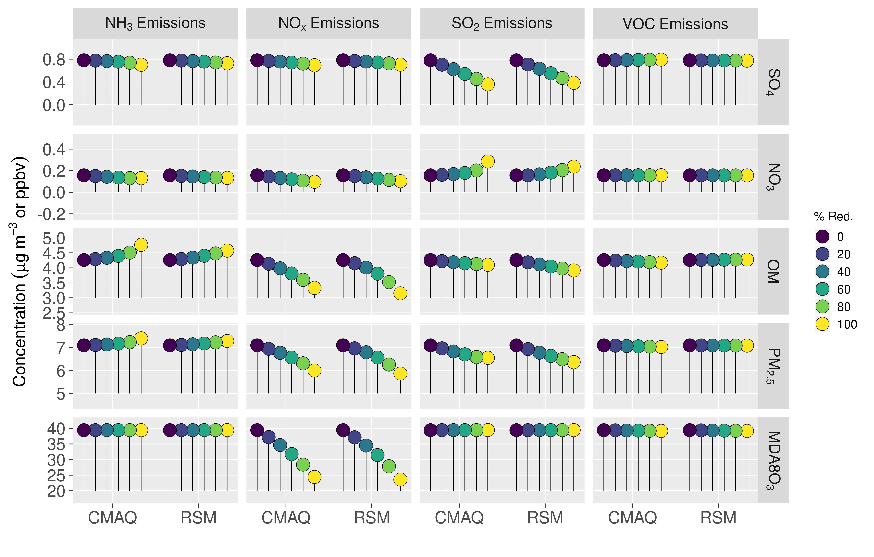
Figure 9. Comparison of the mean absolute concentrations predicted by the pf-RSM and CMAQ over all CBSAs in the domain during July 2016 for U.S. anthropogenic emission changes from 0 to 100%. Units: ppbv for MDA8 ozone and μg m⁻³ for PM_{2.5} and its components.

4. Conclusions
Reducing PM_{2.5} and ozone concentrations is important to protect human health and the environment. CTMs are valuable tools for exploring policy options for improving air quality, but CTMs are computationally expensive and statistical models are therefore developed to approximate CTMs in some applications. Recent developments in RSM technology have reduced the number of CTM simulations needed for model fitting and provide an opportunity to evaluate RSM performance in the U.S.
Predictions of the pf-RSM developed here are in good agreement with OOS CMAQ simulations in the eastern U.S., with some exceptions for cases with anthropogenic emission reductions approaching 100%. Previous work [19] suggests that performance can be improved in these cases by including additional simulations in pf-RSM fitting. Although the pf-RSM required fewer simulations for development than previous-generation RSMs, the one-region, five-emission factor pf-RSM still required about 20 CTM simulations. Therefore, computational expense would present challenges for developing pf-RSMs for multiple regions and emission sectors in typical applications. The recently developed DeepRSM approach [22], which requires fewer CTM simulations for fitting and improves performance compared with the pf-RSM, could facilitate development of more complex RSMs in the future.
NO_{x} emission reductions were more effective for reducing PM_{2.5} concentrations than SO₂, NH₃, and traditional VOC emission reductions. In January, NO_{x} emission reductions decreased nitrate concentrations in the north and OM concentrations in the south. NO_{x} emission reductions did cause some disbenefits for sulfate concentrations in January, but the disbenefits were overcome by decreases in other PM_{2.5} components. In July, NO_{x} emission reductions led to substantial decreases in OM concentrations by reducing biogenic SOA formation in the south. NH₃ emission reductions were effective for reducing nitrate concentrations in January but increased OM concentrations in July. As a result, the effectiveness of NH₃ emission reductions for reducing PM_{2.5} concentrations was less than for NO_{x} emission reductions overall. More work should be done to understand IEPOX SOA formation under conditions of low NH₃ emissions to verify the OM responses predicted here. VOC emission reductions had a smaller effect on PM_{2.5} concentrations than NO_{x} and NH₃ in part due to high levels of biogenic VOC in the eastern U.S. Also, our study did not include emissions of intermediate and semivolatile VOC [36] beyond what is included in the NEI
For MDA8 ozone concentrations, large reductions (> ~80%) in NO_{x} emissions are needed to avoid disbenefits in northern and urban areas in January. In July, all levels of NO_{x} emission reductions are effective for reducing MDA8 ozone due to the abundance of oxidants in summer. VOC emission reductions caused small decreases in MDA8 ozone concentrations in January and had little effect in July due to the high levels of biogenic VOC.
Since our study focused on the nonlinear response of pollutant concentrations, we did not discuss the influence of pPM_{2.5} emissions on PM_{2.5} concentrations. However, PM_{2.5} concentrations are generally more responsive to reductions in pPM_{2.5} emissions than the precursors for secondary PM_{2.5} discussed here. Large reductions in NO_{x} and SO₂ emissions in the eastern U.S. in recent decades have reduced the concentrations of secondary inorganic aerosol and increased the importance of primary PM_{2.5} emissions and organic aerosol. Improved representations of the emissions and chemistry of organic aerosol are increasingly important in this context.
Supplementary Materials: The following are available online at http://www.mdpi.com/, Table S1: CMAQ model performance statistics, Table S2: Definition of statistics used in the CMAQ model performance evaluation, Table S3: Fractional change in U.S. anthropogenic emissions for simulations used in developing the pf-RSM, Table S4: Fractional change in U.S. anthropogenic emissions for 30 OOS simulations used in evaluating the pf-RSM: Figure S1-S5. Comparison of changes in mean January species concentrations predicted by the pf-RSM and 30 OOS CMAQ simulations, Figures S6-S10: Comparison of changes in mean July species concentrations predicted by the pf-RSM and 30 OOS CMAQ simulations.
Author Contributions: Conceptualization, X.X. and Y.Y.; methodology, X.X.; software, X.X.; validation, X.X., Y.Y. and Z.Z.; formal analysis, X.X.; investigation, X.X.; resources, X.X.; data curation, X.X.; writing—original draft preparation, X.X.; writing—review and editing, X.X.; visualization, X.X.; project administration, X.X. All authors have read and agreed to the published version of the manuscript.
Funding: This research received no external funding
Data Availability Statement: Publicly available datasets were analyzed in this study. This data can be found here: ftp://newftp.epa.gov/aqmg/cjang/RSM/RSM-VAT 2.6/
Disclaimer: The views expressed in this manuscript are those of the authors alone and do not necessarily reflect the views and policies of the US Environmental Protection Agency.
Acknowledgments:
Conflicts of Interest: The authors declare no conflict of interest. The funders had no role in the design of the study; in the collection, analyses, or interpretation of data; in the writing of the manuscript, or in the decision to publish the results.

References
1. USEPA. Integrated Science Assessment (ISA) for Particulate Matter (Final Report, 2019). U.S. Environmental Protection Agency, Washington, DC, EPA/600/R-19/188.; 2019.
2. USEPA. Integrated Science Assessment (ISA) for Ozone and Related Photochemical Oxidants (Final Report, Apr 2020). U.S. Environmental Protection Agency, Washington, DC, EPA/600/R-20/012. 2020.
3. SJVAPCD. San Joaquin Valley Air Pollution Control District, 2018 Plan for the 1997, 2006, and 2012 PM2.5 Standards, Available: http://valleyair.org/pmplans/documents/2018/pm-plan-adopted/2018-Plan-for-the-1997-2006-and-2012-PM2.5-Standards.pdf. 2018.
4. ACHD. Allegheny County Health Department. Revision to the Allegheny County Portion of the Pennsylvania State Implementation Plan. Attainment Demonstration for the Allegheny County, PA PM2.5 Nonattainment Area, 2012 NAAQS. Available: https://alleghenycounty.us/uploadedFiles/Allegheny_Home/Health_Department/Programs/Air_Quality/SIPs/90-SIP-PM25-ATTAIN-2012-NAAQS-09-12-2019.pdf. 2019.
5. Bachmann, J. Will the Circle Be Unbroken: A History of the U.S. National Ambient Air Quality Standards. Journal of the Air & Waste Management Association 2007, 57, 652-697, doi:10.3155/1047-3289.57.6.652.
6. USEPA. Modeling Guidance for Demonstrating Attainment of Air Quality Goals for Ozone, PM2.5, and Regional Haze.; EPA -454/B-07-002 U.S. EPA, Office of Air Quality Planning and Standards. Research Triangle Park, NC. EPA 454/R-18-009. Available: https://www3.epa.gov/ttn/scram/guidance/guide/O3-PM-RH-Modeling_Guidance-2018.pdf, 2018.
7. Finlayson-Pitts, B.J.; Pitts, J.N. Chemistry of the Upper and Lower Atmosphere: Theory, Experiments, and Applications; Academic Press: 2000.
8. Ansari, A.S.; Pandis, S.N. Response of Inorganic PM to Precursor Concentrations. Environmental Science & Technology 1998, 32, 2706-2714, doi:10.1021/es971130j.
9. Pye, H.O.T.; Nenes, A.; Alexander, B.; Ault, A.P.; Barth, M.C.; Clegg, S.L.; Collett Jr, J.L.; Fahey, K.M.; Hennigan, C.J.; Herrmann, H., et al. The acidity of atmospheric particles and clouds. Atmos. Chem. Phys. 2020, 20, 4809-4888, doi:10.5194/acp-20-4809-2020.
10. Womack, C.C.; McDuffie, E.E.; Edwards, P.M.; Bares, R.; de Gouw, J.A.; Docherty, K.S.; Dubé, W.P.; Fibiger, D.L.; Franchin, A.; Gilman, J.B., et al. An Odd Oxygen Framework for Wintertime Ammonium Nitrate Aerosol Pollution in Urban Areas: NOx and VOC Control as Mitigation Strategies. Geophysical Research Letters 2019, 46, 4971-4979, doi:https://doi.org/10.1029/2019GL082028.
11. Kleeman, M.J.; Ying, Q.; Kaduwela, A. Control strategies for the reduction of airborne particulate nitrate in California's San Joaquin Valley. Atmospheric Environment 2005, 39, 5325-5341, doi:https://doi.org/10.1016/j.atmosenv.2005.05.044.
12. Thunis, P.; Clappier, A.; Beekmann, M.; Putaud, J.P.; Cuvelier, C.; Madrazo, J.; de Meij, A. Non-linear response of PM2.5 to changes in NOx and NH3 emissions in the Po basin (Italy): consequences for air quality plans. Atmos. Chem. Phys. Discuss. 2021, 2021, 1-26, doi:10.5194/acp-2021-65.
13. West, J.J.; Ansari, A.S.; Pandis, S.N. Marginal PM25: Nonlinear Aerosol Mass Response to Sulfate Reductions in the Eastern United States. Journal of the Air & Waste Management Association 1999, 49, 1415-1424, doi:10.1080/10473289.1999.10463973.
14. Simon, H.; Reff, A.; Wells, B.; Xing, J.; Frank, N. Ozone Trends Across the United States over a Period of Decreasing NOx and VOC Emissions. Environmental Science & Technology 2015, 49, 186-195, doi:10.1021/es504514z.
15. Huang, J.; Zhu, Y.; Kelly, J.T.; Jang, C.; Wang, S.; Xing, J.; Chiang, P.-C.; Fan, S.; Zhao, X.; Yu, L. Large-scale optimization of multi-pollutant control strategies in the Pearl River Delta region of China using a genetic algorithm in machine learning. Science of The Total Environment 2020, 722, 137701, doi:https://doi.org/10.1016/j.scitotenv.2020.137701.
16. Xing, J.; Wang, S.; Jang, C.J.; Zhu, Y.; Zhao, B.; Ding, D.; Wang, J.; Zhao, L.; Xie, H.; Hao, J. An Overview of the Air Pollution Control Cost–Benefit and Attainment Assessment System and Its Application in China. . The Magazine for Environmental Managers 2017, April 2017.
17. Zhang, F.; Xing, J.; Zhou, Y.; Wang, S.; Zhao, B.; Zheng, H.; Zhao, X.; Chang, H.; Jang, C.; Zhu, Y., et al. Estimation of abatement potentials and costs of air pollution emissions in China. Journal of Environmental Management 2020, 260, 110069, doi:https://doi.org/10.1016/j.jenvman.2020.110069.
18. Heo, J.; Adams, P.J.; Gao, H.O. Reduced-form modeling of public health impacts of inorganic PM2.5 and precursor emissions. Atmospheric Environment 2016, 137, 80-89, doi:https://doi.org/10.1016/j.atmosenv.2016.04.026.
19. Xing, J.; Ding, D.; Wang, S.; Zhao, B.; Jang, C.; Wu, W.; Zhang, F.; Zhu, Y.; Hao, J. Quantification of the enhanced effectiveness of NOx control from simultaneous reductions of VOC and NH3 for reducing air pollution in the Beijing–Tianjin–Hebei region, China. Atmos. Chem. Phys. 2018, 18, 7799-7814, doi:10.5194/acp-18-7799-2018.
20. Xing, J.; Wang, S.; Zhao, B.; Wu, W.; Ding, D.; Jang, C.; Zhu, Y.; Chang, X.; Wang, J.; Zhang, F., et al. Quantifying Nonlinear Multiregional Contributions to Ozone and Fine Particles Using an Updated Response Surface Modeling Technique. Environmental Science & Technology 2017, 51, 11788-11798, doi:10.1021/acs.est.7b01975.
21. Xing, J.; Wang, S.X.; Jang, C.; Zhu, Y.; Hao, J.M. Nonlinear response of ozone to precursor emission changes in China: a modeling study using response surface methodology. Atmos. Chem. Phys. 2011, 11, 5027-5044, doi:10.5194/acp-11-5027-2011.
22. Xing, J.; Zheng, S.; Ding, D.; Kelly, J.T.; Wang, S.; Li, S.; Qin, T.; Ma, M.; Dong, Z.; Jang, C., et al. Deep Learning for Prediction of the Air Quality Response to Emission Changes. Environmental Science & Technology 2020, 54, 8589-8600, doi:10.1021/acs.est.0c02923.
23. Wang, S.; Xing, J.; Jang, C.; Zhu, Y.; Fu, J.S.; Hao, J. Impact Assessment of Ammonia Emissions on Inorganic Aerosols in East China Using Response Surface Modeling Technique. Environmental Science & Technology 2011, 45, 9293-9300, doi:10.1021/es2022347.
24. Zhao, B.; Wang, S.X.; Xing, J.; Fu, K.; Fu, J.S.; Jang, C.; Zhu, Y.; Dong, X.Y.; Gao, Y.; Wu, W.J., et al. Assessing the nonlinear response of fine particles to precursor emissions: development and application of an extended response surface modeling technique v1.0. Geosci. Model Dev. 2015, 8, 115-128, doi:10.5194/gmd-8-115-2015.
25. Zhao, B.; Wu, W.; Wang, S.; Xing, J.; Chang, X.; Liou, K.N.; Jiang, J.H.; Gu, Y.; Jang, C.; Fu, J.S., et al. A modeling study of the nonlinear response of fine particles to air pollutant emissions in the Beijing–Tianjin–Hebei region. Atmos. Chem. Phys. 2017, 17, 12031-12050, doi:10.5194/acp-17-12031-2017.
26. Foley, K.M.; Napelenok, S.L.; Jang, C.; Phillips, S.; Hubbell, B.J.; Fulcher, C.M. Two reduced form air quality modeling techniques for rapidly calculating pollutant mitigation potential across many sources, locations and precursor emission types. Atmospheric Environment 2014, 98, 283-289, doi:https://doi.org/10.1016/j.atmosenv.2014.08.046.
27. Tessum, C.W.; Hill, J.D.; Marshall, J.D. InMAP: A model for air pollution interventions. 2017, 12, e0176131. https://doi.org/0176110.0171371/journal.pone.0176131.
28. USEPA. Technical support document for the proposed PM NAAQS rule: Response Surface Modeling, Office of Air Quality Planning and Standards, US Environmental Protection Agency, Research Triangle Park, NC, US, 48. 2006.
29. USEPA. Technical support document for the proposed mobile source air toxics rule: ozone modeling, Office of Air Quality Planning and Standards, US Environmental Protection Agency, Research Triangle Park, NC, US, 49. 2006.
30. Xing, J.; Ding, D.; Wang, S.; Dong, Z.; Kelly, J.T.; Jang, C.; Zhu, Y.; Hao, J. Development and application of observable response indicators for design of an effective ozone and fine-particle pollution control strategy in China. Atmos. Chem. Phys. 2019, 19, 13627-13646, doi:10.5194/acp-19-13627-2019.
31. Emery, C.; Jung, J.; Koo, B.; Yarwood, G. Improvements to CAMx snow cover treatments and Carbon Bond chemical mechanism for winter ozone. Final Report, prepared for Utah Department of Environmental Quality, Salt Lake City, UT. Prepared by Ramboll Environ, Novato, CA, August 2015. ; 2015.
32. Appel, K.W.; Napelenok, S.L.; Foley, K.M.; Pye, H.O.T.; Hogrefe, C.; Luecken, D.J.; Bash, J.O.; Roselle, S.J.; Pleim, J.E.; Foroutan, H., et al. Description and evaluation of the Community Multiscale Air Quality (CMAQ) modeling system version 5.1. Geoscientific Model Development 2017, 10, 1703-1732, doi:10.5194/gmd-10-1703-2017.
33. Simon, H.; Bhave, P.V. Simulating the Degree of Oxidation in Atmospheric Organic Particles. Environmental Science & Technology 2012, 46, 331-339, doi:10.1021/es202361w.
34. Mathur, R.; Xing, J.; Gilliam, R.; Sarwar, G.; Hogrefe, C.; Pleim, J.; Pouliot, G.; Roselle, S.; Spero, T.L.; Wong, D.C., et al. Extending the Community Multiscale Air Quality (CMAQ) modeling system to hemispheric scales: overview of process considerations and initial applications. Atmos. Chem. Phys. 2017, 17, 12449-12474, doi:10.5194/acp-17-12449-2017.
35. USEPA. Technical Support Document (TSD) Preparation of Emissions Inventories for 2016v1 North American Emissions Modeling Platform. Available: https://www.epa.gov/air-emissions-modeling/2016-version-1-technical-support-document 2020.
36. Murphy, B.N.; Woody, M.C.; Jimenez, J.L.; Carlton, A.M.G.; Hayes, P.L.; Liu, S.; Ng, N.L.; Russell, L.M.; Setyan, A.; Xu, L., et al. Semivolatile POA and parameterized total combustion SOA in CMAQv5.2: impacts on source strength and partitioning. Atmos. Chem. Phys. 2017, 17, 11107-11133, doi:10.5194/acp-17-11107-2017.
37. Bash, J.O.; Baker, K.R.; Beaver, M.R. Evaluation of improved land use and canopy representation in BEIS v3.61 with biogenic VOC measurements in California. Geosci. Model Dev. 2016, 9, 2191-2207, doi:10.5194/gmd-9-2191-2016.
38. Gantt, B.; Kelly, J.T.; Bash, J.O. Updating sea spray aerosol emissions in the Community Multiscale Air Quality (CMAQ) model version 5.0.2. Geosci. Model Dev. 2015, 8, 3733-3746, doi:10.5194/gmd-8-3733-2015.
39. USEPA. Meteorological Model Performance for Annual 2016 Simulation WRF v3.8. Available: https://www.epa.gov/sites/production/files/2020-10/documents/met_model_performance-2016_wrf.pdf. 2019.
40. Kelly, J.T.; Koplitz, S.N.; Baker, K.R.; Holder, A.L.; Pye, H.O.T.; Murphy, B.N.; Bash, J.O.; Henderson, B.H.; Possiel, N.C.; Simon, H., et al. Assessing PM2.5 model performance for the conterminous U.S. with comparison to model performance statistics from 2007-2015. Atmospheric Environment 2019, 214, 116872, doi:https://doi.org/10.1016/j.atmosenv.2019.116872.
41. Simon, H.; Baker, K.R.; Phillips, S. Compilation and interpretation of photochemical model performance statistics published between 2006 and 2012. Atmospheric Environment 2012, 61, 124-139, doi:https://doi.org/10.1016/j.atmosenv.2012.07.012.
42. Appel, K.W.; Bash, J.O.; Fahey, K.M.; Foley, K.M.; Gilliam, R.C.; Hogrefe, C.; Hutzell, W.T.; Kang, D.; Mathur, R.; Murphy, B.N., et al. The Community Multiscale Air Quality (CMAQ) Model Versions 5.3 and 5.3.1: System Updates and Evaluation. Geosci. Model Dev. Discuss. 2020, 2020, 1-41, doi:10.5194/gmd-2020-345.
43. Hammersley, J.M. Monte Carlo Methods for Solving Multivariable Problems. Annals of the New York Academy of Sciences 1960, 86, 844-874, doi:https://doi.org/10.1111/j.1749-6632.1960.tb42846.x.
44. Murphy, B.N.; Nolte, C.G.; Sidi, F.; Bash, J.O.; Appel, K.W.; Jang, C.; Kang, D.; Kelly, J.; Mathur, R.; Napelenok, S., et al. The Detailed Emissions Scaling, Isolation, and Diagnostic (DESID) module in the Community Multiscale Air Quality (CMAQ) Modeling System version 5.3. Geosci. Model Dev. Discuss. 2020, 2020, 1-28, doi:10.5194/gmd-2020-361.
45. Jacob, D.J.; Horowitz, L.W.; Munger, J.W.; Heikes, B.G.; Dickerson, R.R.; Artz, R.S.; Keene, W.C. Seasonal transition from NOx- to hydrocarbon-limited conditions for ozone production over the eastern United States in September. Journal of Geophysical Research: Atmospheres 1995, 100, 9315-9324, doi:https://doi.org/10.1029/94JD03125.
46. Martin, R.V.; Fiore, A.M.; Van Donkelaar, A. Space-based diagnosis of surface ozone sensitivity to anthropogenic emissions. Geophysical Research Letters 2004, 31, doi:https://doi.org/10.1029/2004GL019416.
47. Wang, R.; Guo, X.; Pan, D.; Kelly, J.T.; Bash, J.O.; Sun, K.; Paulot, F.; Clarisse, L.; Van Damme, M.; Whitburn, S., et al. Monthly Patterns of Ammonia Over the Contiguous United States at 2-km Resolution. Geophysical Research Letters 2021, 48, e2020GL090579, doi:https://doi.org/10.1029/2020GL090579.
48. Nenes, A.; Pandis, S.N.; Weber, R.J.; Russell, A. Aerosol pH and liquid water content determine when particulate matter is sensitive to ammonia and nitrate availability. Atmos. Chem. Phys. 2020, 20, 3249-3258, doi:10.5194/acp-20-3249-2020.
49. Guo, H.; Sullivan, A.P.; Campuzano-Jost, P.; Schroder, J.C.; Lopez-Hilfiker, F.D.; Dibb, J.E.; Jimenez, J.L.; Thornton, J.A.; Brown, S.S.; Nenes, A., et al. Fine particle pH and the partitioning of nitric acid during winter in the northeastern United States. Journal of Geophysical Research: Atmospheres 2016, 121, 10,355-310,376, doi:https://doi.org/10.1002/2016JD025311.
50. Seinfeld, J.H.; Pandis, S.N. Atmospheric Chemistry and Physics: From Air Pollution to Climate Change, 3rd Edition; John Wiley & Sons, New York, 2016.
51. Shah, V.; Jaeglé, L.; Thornton, J.A.; Lopez-Hilfiker, F.D.; Lee, B.H.; Schroder, J.C.; Campuzano-Jost, P.; Jimenez, J.L.; Guo, H.; Sullivan, A.P., et al. Chemical feedbacks weaken the wintertime response of particulate sulfate and nitrate to emissions reductions over the eastern United States. Proceedings of the National Academy of Sciences 2018, 115, 8110-8115, doi:10.1073/pnas.1803295115.
52. Xu, L.; Pye, H.O.T.; He, J.; Chen, Y.; Murphy, B.N.; Ng, N.L. Experimental and model estimates of the contributions from biogenic monoterpenes and sesquiterpenes to secondary organic aerosol in the southeastern United States. Atmos. Chem. Phys. 2018, 18, 12613-12637, doi:10.5194/acp-18-12613-2018.
53. Henze, D.K.; Seinfeld, J.H.; Ng, N.L.; Kroll, J.H.; Fu, T.M.; Jacob, D.J.; Heald, C.L. Global modeling of secondary organic aerosol formation from aromatic hydrocarbons: high- vs. low-yield pathways. Atmos. Chem. Phys. 2008, 8, 2405-2420, doi:10.5194/acp-8-2405-2008.
54. Pye, H.O.T.; Luecken, D.J.; Xu, L.; Boyd, C.M.; Ng, N.L.; Baker, K.R.; Ayres, B.R.; Bash, J.O.; Baumann, K.; Carter, W.P.L., et al. Modeling the Current and Future Roles of Particulate Organic Nitrates in the Southeastern United States. Environmental Science & Technology 2015, 49, 14195-14203, doi:10.1021/acs.est.5b03738.
55. Pye, H.O.T.; D’Ambro, E.L.; Lee, B.H.; Schobesberger, S.; Takeuchi, M.; Zhao, Y.; Lopez-Hilfiker, F.; Liu, J.; Shilling, J.E.; Xing, J., et al. Anthropogenic enhancements to production of highly oxygenated molecules from autoxidation. Proceedings of the National Academy of Sciences 2019, 116, 6641, doi:10.1073/pnas.1810774116.
56. Pye, H.O.T.; Pinder, R.W.; Piletic, I.R.; Xie, Y.; Capps, S.L.; Lin, Y.-H.; Surratt, J.D.; Zhang, Z.; Gold, A.; Luecken, D.J., et al. Epoxide Pathways Improve Model Predictions of Isoprene Markers and Reveal Key Role of Acidity in Aerosol Formation. Environmental Science & Technology 2013, 47, 11056-11064, doi:10.1021/es402106h.
57. Carlton, A.G.; Pye, H.O.T.; Baker, K.R.; Hennigan, C.J. Additional Benefits of Federal Air-Quality Rules: Model Estimates of Controllable Biogenic Secondary Organic Aerosol. Environmental Science & Technology 2018, 52, 9254-9265, doi:10.1021/acs.est.8b01869.
58. Riva, M.; Chen, Y.; Zhang, Y.; Lei, Z.; Olson, N.E.; Boyer, H.C.; Narayan, S.; Yee, L.D.; Green, H.S.; Cui, T., et al. Increasing Isoprene Epoxydiol-to-Inorganic Sulfate Aerosol Ratio Results in Extensive Conversion of Inorganic Sulfate to Organosulfur Forms: Implications for Aerosol Physicochemical Properties. Environmental Science & Technology 2019, 53, 8682-8694, doi:10.1021/acs.est.9b01019.

