

Air Quality Modeling Assessment Tools (AQMAT) Development
User’s Manual for Model – Visualization and Analysis Tool (Model-VAT) 1.9

Contract No: 68HERD21A0002
Task Order No: 68HERH21F0334
Version: 01

Prepared for: Carey Jang
Task Order Contracting Officer’s Representative
U.S. EPA/OAR/OAQPS/AQAD/AQMG
(Mail Code: C439-01)
109 T.W. Alexander Drive
Research Triangle Park, NC 27711

Prepared by: Yun Zhu, Shicheng Long
College of Environment & Energy
South China University of Technology
Guangzhou, 510006, Guangdong, China

Sarav Arunachalam
Institute for the Environment
The University of North Carolina at Chapel Hill

Date: December 31, 2022
Acknowledgements
In cooperation with the U.S. EPA, the Institute for the Environment at the University of North Carolina at Chapel Hill (UNC-IE) along with the South China University of Technology (SCUT) developed the FAST-CE software. This project was funded by the U.S. EPA under contract 68HERH21F0334 to UNC-IE.

Model-VAT User’s Manual Contents
Table of Figures v
1 Introduction 1
1.1 Overview of Model-VAT 1
1.2 Computer Requirements 1
1.3 Model-VAT Installation Instructions 2
1.3.1 Installing Model-VAT 2
1.3.2 Uninstalling Model-VAT 3
2 Terminology 4
3 Starting Model-VAT 5
3.1 Starting Model-VAT 5
3.1.1 Starting Model-VAT from standalone Model-VAT Software 5
3.1.2 Starting Model-VAT from ABaCAS 5
3.2 Main Window 6
4 Navigating Model-VAT s Main Menu Options 8
4.1 File 8
4.2 Formula 9
4.3 Remote Access 10
4.4 File Converter 13
4.5 R Function 14
4.6 Dispersion/Hybrid Model 18
4.7 GeoPlatform 22
4.8 Help 23
5 Working with Gridded Datasets 25
5.1 Gridded Input File Formats 25
5.1.1 Model Formats 25
5.1.2 Observational Data Formats 25
5.2 Example Datasets 26
5.2.1 Example Datasets from the Model-VAT 26
5.2.2 Example Datasets from the ABaCAS 26
5.3 Adding and Removing a Dataset from a Local File System 27
5.4 Variables List 28
5.5 Domain Panel 29
6 Working with Formulas 31
6.1 Adding and Removing a Formula 31
6.2 Example Formulas 32
6.3 Selecting a Formula for Plotting 32
7 Edit Domain 33
8 Creating Plots 34
8.1 Tile Plot 34
8.1.1 Time Selection and Animation Controls 35
8.1.2 Arrange Window and Select Active Window 36
8.1.3 Layer Selection 37
8.1.4 Add Overlay 37
8.1.5 Add Map Layers 42
8.2 Vertical X-section 46
8.3 Model Evaluation 48
8.3.1 Select plot type from drop-down box 50
8.3.2 Add and select monitor or site compare files/pollutants 51
8.3.3 Add model file and select pollutant 52
8.3.4 Set drawing option and draw plot 52
8.4 Time Series & Box 53
8.4.1 Basic Operation 53
8.4.2 Grid Cell Time Aggregate Statistics 60
8.5 Scatter Plot 62
8.6 3-D Plot 64
8.7 Data Output 65
8.8 Color Map 66
9 Map Transformation and Resolution 69
9.1 Map Projections 69
9.2 Different Plot for Map Transformation 71
9.3 Reset to Default 72
10 Mathematical Functions 73
10.1 Unary Functions 73
10.2 Binary Operators 74
10.3 Boolean Operators 75

Table of Figures
Figure 1.3-1 . Install Model-VAT 3
Figure 3.1-1 . Open Model-VAT on Start Page 5
Figure 3.1-2 . Open Model-VAT on Home Page 5
Figure 3.2-1 . Model-VAT Main Window 6
Figure 4.1-1 . File List 9
Figure 4.3-1 . Remote Access Window 10
Figure 4.3-2 . Add the File to Main Window 11
Figure 4.3-3 . Site Management Window 12
Figure 4.3-4 . Local/Downloaded Files Window 13
Figure 4.4-1 . File Converter Window 14
Figure 4.5-1 . R Function Window 15
Figure 4.5-2 . Density Scatter Plot 16
Figure 4.5-3 . Density Plot 17
Figure 4.5-4 . Bar Chart 1 17
Figure 4.5-5 . Bar Chart 2 18
Figure 4.6-1 . Dispersion/Hybrid Model Window 18
Figure 4.6-2 . AERMOD Window 19
Figure 4.6-3 . AERMOD Plot Window (Coarse-3D Type) 20
Figure 4.6-4 . AERMOD Plot Window (Actual-2D Type) 20
Figure 4.6-5 . SCICHEM Window 20
Figure 4.6-6 . SCICHEM Plot Window 21
Figure 4.6-7 . Model Fusion Plot Window 21
Figure 4.6-8 . Set the Number of Tiles to a Lager One to Make the Plot Look Smoothly 22
Figure 4.7-1 . GeoPlatform Window 23
Figure 4.8-1 . Quick User Guide of Model-VAT Window 24
Figure 4.8-2 . About Model-VAT Window 24
Figure 5.1-1 . Observational File ASCII Format 26
Figure 5.3-1 . Open Dataset File Browser 27
Figure 5.3-2 . Datasets Pane, Domain Pane, and Variables Area 28
Figure 5.4-1 . Right-Click on Variable List 29
Figure 5.5-1 . Dataset Metadata Information 30
Figure 6.1-1 . Adding Multiple Variables on Formula Calculator 31
Figure 7-1 . Edit Domain Dialog Box 34
Figure 7-2 . Create a Plot within Selected Region 35
Figure 8.1-1 . Tile Plot 36
Figure 8.1-2 . BCON File Showed in the Tile Plot 37
Figure 8.1-3 . Arrange Style of Tile Plot Window 38
Figure 8.1-4 . Select an Active Window 39
Figure 8.1-5 . Tile Plot Observation Dialog 40
Figure 8.1-6 . Tile Plot with Observational Data Overlay 41
Figure 8.1-7 . Vector Overlay Dialog Box 42
Figure 8.1-8 . Wind Vector Overlay on an Ozone Tile Plot 42
Figure 8.1-9 . Open Add Wind Rose Plot 43
Figure 8.1-10 . Wind Rose Plot 44
Figure 8.1-11 . Add Layer Window 45
Figure 8.1-12 . Add Layer Window 46
Figure 8.1-13 . Save Layer File as CSV File 46
Figure 8.1-14 . Change Projection 47
Figure 8.1-15 . GIS Layer 49
Figure 8.2-1 . Select a Variable to Add Vertical Cross Section Plot 50
Figure 8.2-2 . Add Vertical Cross Section Plot under Vertical Cross Section Plot Tab Page 51
Figure 8.3-1 . Model Evaluation Window 52
Figure 8.3-2 . The process of drawing map plot 52
Figure 8.3-3 The process of drawing other plots 53
Figure 8.3-4 Choose plot type 54
Figure 8.3-5 Select the monitor files and species 54
Figure 8.3-6 Open Model File Window 55
Figure 8.3-7 set draw option and draw plot 56
Figure 8.4-1 . Select a Grid Cell to Add Time Series Plot 56
Figure 8.4-2 . Select a Variable to Add Time Series Plot 57
Figure 8.4-3 . Add Time Series Plot under Time Series & Box Tab Page 58
Figure 8.4-4 . Smooth Line 59
Figure 8.4-5 . Forward Step Line (left) and Rearward Step Line (right) 59
Figure 8.4-6 . Non-Step Line 60
Figure 8.4-7 . Non-Step Line 60
Figure 8.4-8 . Select a Grid Cell to Add Bar Chart 61
Figure 8.4-9 . Transform Time Series Plot to Bar Chart 61
Figure 8.4-10 . Select a Variable to Add Box Plot 62
Figure 8.4-11 . Transform Time Series Plot to Bar Chart 62
Figure 8.4-12 . Plot Shows All Layers 63
Figure 8.4-13 . Plot Shows Different Stats 64
Figure 8.5-1 . Select a Variable to Add Scatter Plot 65
Figure 8.5-2 . Add Scatter Plot under Scatter Plot Tab Page 66
Figure 8.5-3 Add Density Scatter Plot 66
Figure 8.6-1 . Select a Variable to Add 3-D Plot 67
Figure 8.6-2 . Add 3-D Plot under 3-D Plot Tab Page 68
Figure 8.7-1 . Data Output Tab Page 69
Figure 8.8-1 . Configure Plot, Color Map Tab 70
Figure 9.1-1 . Choose an Active Window to Open Map Transformation 72
Figure 9.1-2 . Choose Target Projection 73
Figure 9.1-3 . Plots before Map Transformation 73
Figure 9.1-4 . Plots after Map Transformation 74
Figure 9.2-1 . Different Plot, Source Projection Plot, and Target Projection Plot 75
Figure 9.3-1 . Reset to Default for Current Window 75

Introduction

Overview of Model-VAT
This manual describes how to use the Model – Visualization and Analysis Tool (Model-VAT). Model-VAT is a flexible and modular visualization software tool that allows users to visualize multivariate gridded environmental datasets created by environmental modeling systems such as the Community Multiscale Air Quality (CMAQ) modeling system and the Weather Research and Forecasting (WRF) modeling system. These modeling systems produce files of gridded concentration, deposition fields, and meteorological parameters that users need to visualize and compare with observational data both spatially and temporally. Model-VAT can facilitate these types of analyses.
This manual is divided into ten chapters that provide the user with instructions on how to use Model-VAT and explain the application of the software showing examples for its use.
Chapter 1: Introduction
Chapter 2: Terminology
Chapter 3: Starting Model-VAT
Chapter 4: Model-VAT main menu and options
Chapter 5: Working with Gridded Datasets
Chapter 6: Working with formulas
Chapter 7: Editing Domain
Chapter 8: Creating plots
Chapter 9: Map transformation and resolution
Chapter 10: Mathematical functions

Computer Requirements
The computer hardware requirements for Model-VAT are typically modest, though this will vary depending on the complexity of the analysis. Model-VAT 1.9 is distributed as an EXE file, as appropriate, for each of the following supported platforms:
- >=32-bit Windows 7
- >=64-bit Windows 7
Model-VAT works best in a 64-bit Windows environment. With a 32-bit installation there are limits on the memory available to the software application; it can utilize no more than 2 GB of RAM. This will impact performance when processing large spatial datasets. A solid-state drive (SSD) has also shown improved performance over hard disk drives (HDD).

Model-VAT Installation Instructions

Installing Model-VAT
Download Model-VAT Software Package from the ABaCAS website. This tool and corresponding example data are available for registered users at this website: http://abacas.see.scut.edu.cn/tools/. The installation of Model-VAT is simple. Double click “Setup.exe” in your installation directory to bring up the setup wizard. Then follow the setup wizard by clicking Next or Finish to complete the installation (Figure 1.3-1).
To install Model-VAT for Windows, unzip the file to a local directory on your Windows 10 computer. If you are unable to install Model-VAT on your computer, please check to see whether your user account is authorized to install software. You may need to request that a user with a computer administrator account install Model-VAT or provide you with an account that has permission to install software. For more information about user account types, click “Start” and select “Control Panel” and then click on the User Account icon.
NOTE: You do not need to install Model-VAT under a Program Files directory or in the root directory on one of your hard disk drives. Therefore, you should not need administrator rights to install Model-VAT. If your system is under strict control from your administrator, you may be able to unzip the Model-VAT distribution under your documents directory; however, you may have problems with a space in your path.
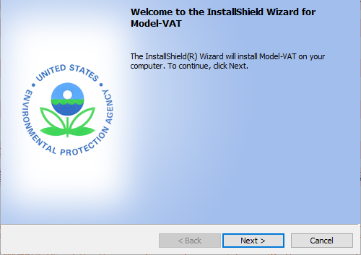
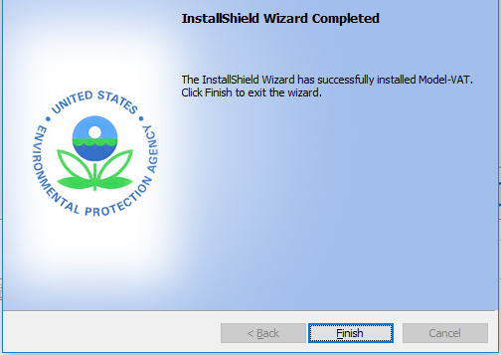
Figure 1.3-1. Install Model-VAT

Uninstalling Model-VAT
To uninstall Model-VAT, go to Control Panel, Programs and Features, and remove Model-VAT. Note that uninstalling Model-VAT does not also remove any results files that you have created with Model-VAT.

Terminology
This chapter explains common terms used in this user’s manual and in the model, and references, where possible, other sections in this manual to find more detailed information.
Community Multi-scale Air Quality (CMAQ) Model: An open-source photochemical grid air quality model that the U.S. EPA and others rely upon to predict levels and changes in pollutant concentrations.
Grid Cell: One of the many geographic, or spatial, components within a Grid Definition. These can be regularly or irregularly shaped.
Lat/Long: Latitude and longitude information to specify the geographic coordinates of a spatial location. The CMAQ model data are usually provided for each grid cell identified by the latitude and longitude of the grid cell's center point. Latitude identifies the north-to-south location of a point on the Earth. Longitude identifies the east-to-west location of a point on the Earth.
Layer: In GIS, a layer represents a logical separation of mapped data usually representing a theme.
Model Data: Pollutant concentration data that are generated by running an air quality model such as CMAQ. This is different from monitor data, which are based upon observed concentrations.
Monitor Data: Pollutant concentration data that are based upon measurements from an air quality monitor. Raw monitor data usually refers to data that are taken directly from measurement networks, with no additional processing of the data. Monitor data are different from model data, which are based upon numerical predictions from an air quality model.
Shapefile: A shapefile is a particular type of GIS file and has a .shp extension. These files are accompanied by companion files with .shx and .dbf extensions and can be used to create Shapefile Grid Definitions. See http://www.esri.com/library/whitepapers/pdfs/shapefile.pdf for more information.

Starting Model-VAT

Starting Model-VAT

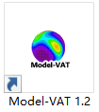
Starting Model-VAT from standalone Model-VAT Software
If you have successfully installed standalone Model-VAT, you can double-click the
icon from your computer desktop to open Model-VAT.

Starting Model-VAT from ABaCAS
If you have installed the ABaCAS software, you can also start Model-VAT from ABaCAS. There are two ways to open it from ABaCAS. One is to open it from ABaCAS Start Page (Figure 3.1-1) and the other one is to open it from ABaCAS Home Page (Figure 3.1-2).
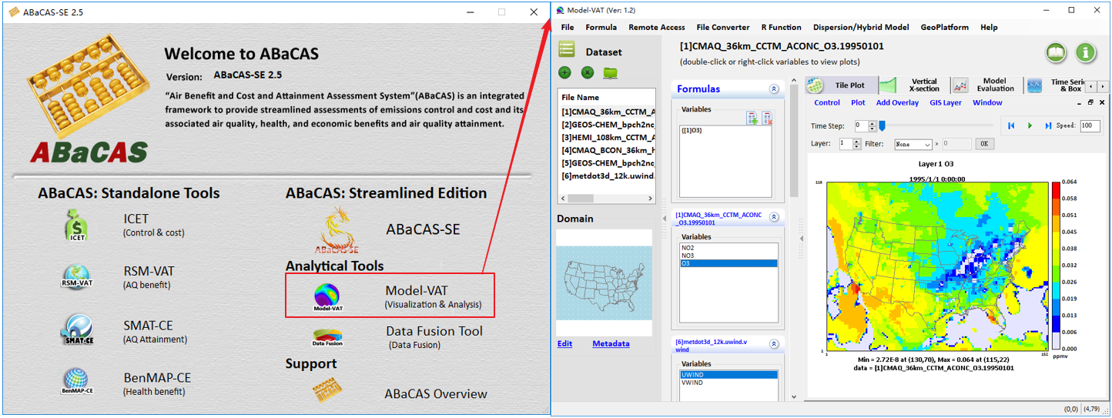
Figure 3.1-1. Open Model-VAT on Start Page

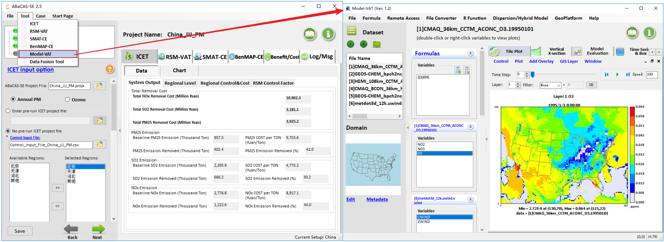
Figure 3.1-2. Open Model-VAT on Home Page

Main Window
When Model-VAT starts, and the main window is displayed (Figure 3.2-1). The top of the main window contains a menu bar with the main window options (File, Formula, Remote Access, File Convertor, R Function, Dispersion/Hybrid Model, GeoPlatform, and Help) (Details shown in Chapter 4).
Below the menu bar, the Model-VAT window is divided into two main areas: a parameters area consisting of Dataset and Domain on the left side and a plots area consisting of Formula (see Chapter 6), Variables and Plot on the right side. You can resize the entire window with your mouse. You can also fold the parameters area by clicking the arrow on the dividing line between the left and right part.

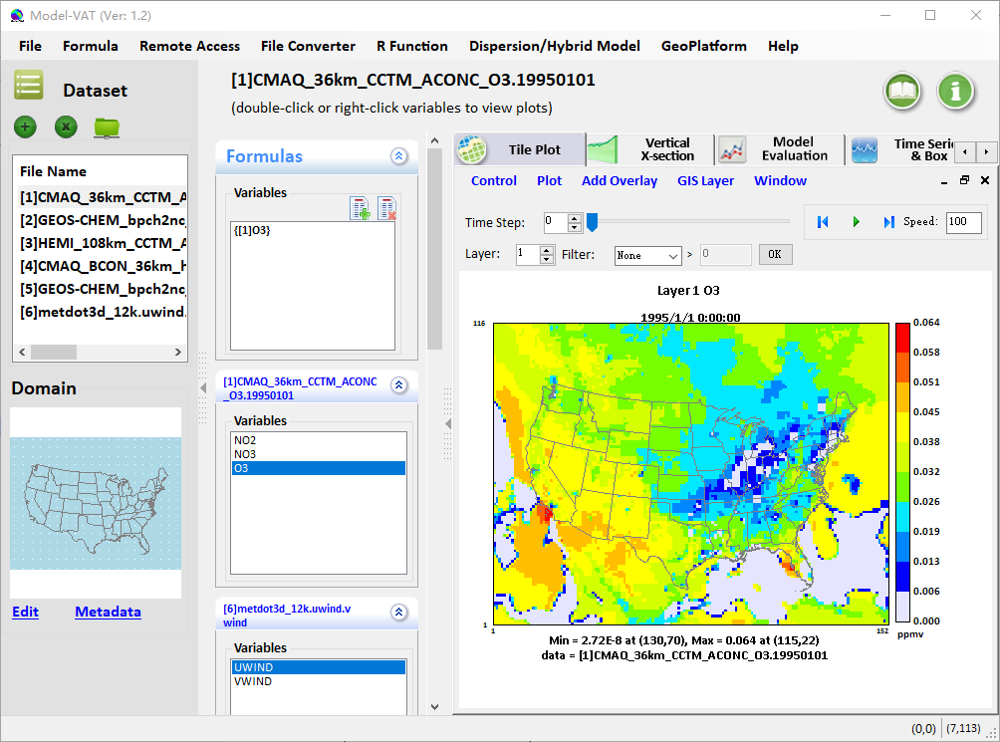
Figure 3.2-1. Model-VAT Main Window
The parameters area contains two parts:
- The Dataset is used to load in the dataset files that you want to work with in this session (see Chapter 5).
- Use the Domain (see Chapter 5) to set the region that the users want to see in Tile Plot.
The plot area contains two parts:
- Formula & Variables:
The Formula is used to create a formula that refers to the variable and the dataset that you are interested in plotting (see Chapter 6). All plots in Model-VAT are generated from formulas. A formula can be as simple as a single variable from one dataset, or it can be an equation that uses variables from one or more datasets.
Once the datasets are loaded, Model-VAT automatically displays the lists of variables that are in the datasets. Variables of each loaded dataset are displayed in the Variables area. Double-click on the name of a variable listed in the variables to add it as a tile plot on the Tile Plot pane.
- The Plot area consists of several plot panes, which are Tile Plot, Vertical X-section, Time Series & Box, Scatter Plot, 3-D Plot, and Data Output. Users can see different kinds of plots according to their need (see Chapter 8).

Navigating Model-VAT s Main Menu Options
Table 4-1 shows the main menu options that are available on the top menu bar in Model-VAT’s main window (Figure 3.2-1). These options are discussed in detail below.
Table 4-1. Model-VAT Main Menu Options
File | Formula | Remote Access | File Converter | R Function | Dispersion/Hybrid Model | GeoPlatform | Help
Open Project |  |  | To CMAQ IO/API |  |  |  | Model-VAT Help
Save Project |  |  | To BenMAP-CE input format |  |  |  | About
New Project |  |  | To SMAT-CE input format
Load demo project
View Script Editor
Options
Exit

File
Click File to open the File list (Figure 4.1-1). Users can select different functions to use from the following five options: Open Project, Save Project, New Project, Load Demo Project, View Script Editor, Options, and Exit.

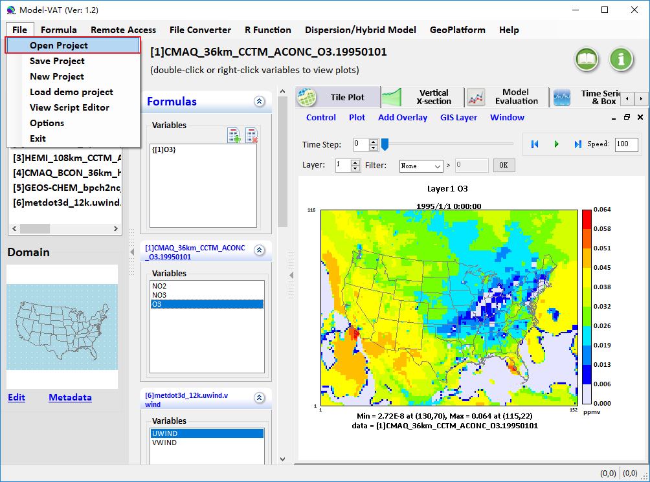
Figure 4.1-1. File List
- Open Project: Open an existing project on the user’s computer.
- Save Project: Overwrite the current project users are opening.
- New Project: Create a new project.
- Load Demo Project: Load the demo project we provided for users to be familiar with Model-VAT.
- View Script Editor: Batch generate graphics in the specified format.
- Options: Choose to show Language, including Chinese and English.
- Exit: Exit Model-VAT.

Formula
Click Formula to open the Formula window. Users can also click to open it (see Chapter 6).

Remote Access

For modeling users, they often need to write scripts to visualize/analysis (V/A) their model output data or download them to local PC from a remote system (e.g., Linux system) for further study. As we know, modeling output data often contain many variables and are usually very large in size. However, what users are interested in is often just one or two variables. Therefore, no matter if it is writing scripts or downloading the whole model output file, especially a large file, can be quite cumbersome and inefficient for data analysis. To address these problems, we developed this module for users to easily extract and visualize/analyze their desired subset of data directly from their remote system.
Click Remote Access to open the Remote Access window (Figure 4.3-1). This part provides three functions: recent sites, site management, and local/download files (Figure 4.3-1).
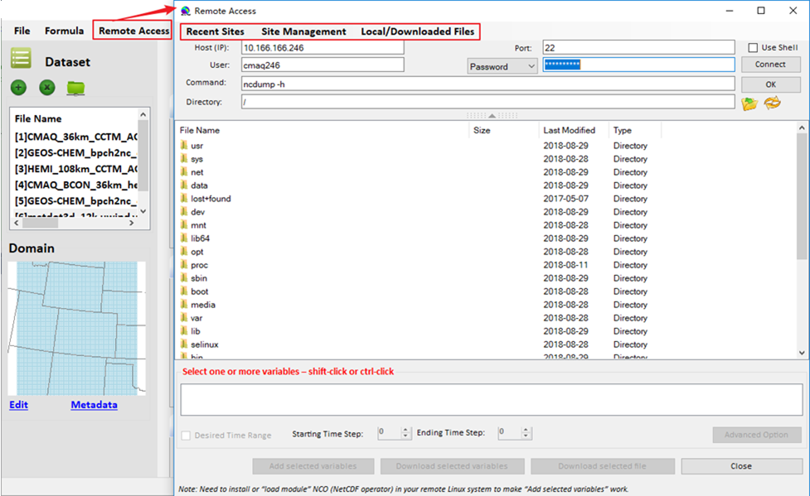
Figure 4.3-1. Remote Access Window
- Recent Sites: Records sites that have been connected and saved.
- Site Management will open when users click Site Management (Figure 4.3-3).
- Local/Downloaded Files will open when users click Local/Downloaded Files (Figure 4.3-4).
- Desired Time Range: Users can select time range when users check this option (Figure 4.3-2).
- Add selected variables: Add selected variables to main window (Figure 4.3-2).
- Download selected variables: Download the variables users are selecting.
- Download selected file: Download and add the file users are selecting to the main window. Users can download multiple files at the same time.
- Close: Close the curent window. After closing, it will remember the previous setup and resume this setup next time when Remote Access is launched again.

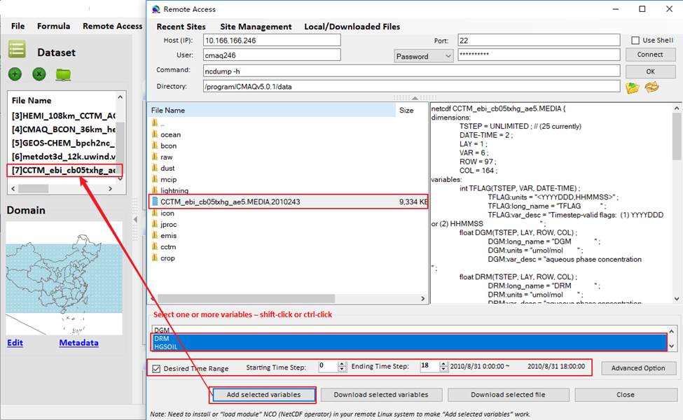
Figure 4.3-2. Add the File to Main Window
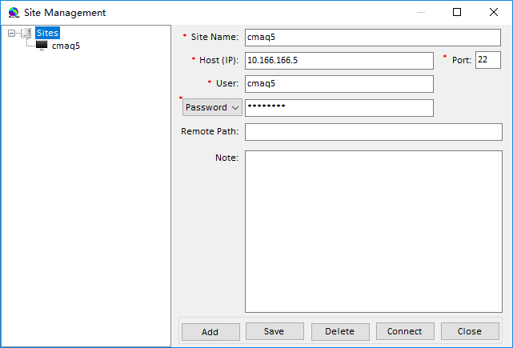
Figure 4.3-3. Site Management Window
- Add: Add a new site.
- Save: Overwrite the old site.
- Delete: Delete the old site.
- Connect: Connect an account.
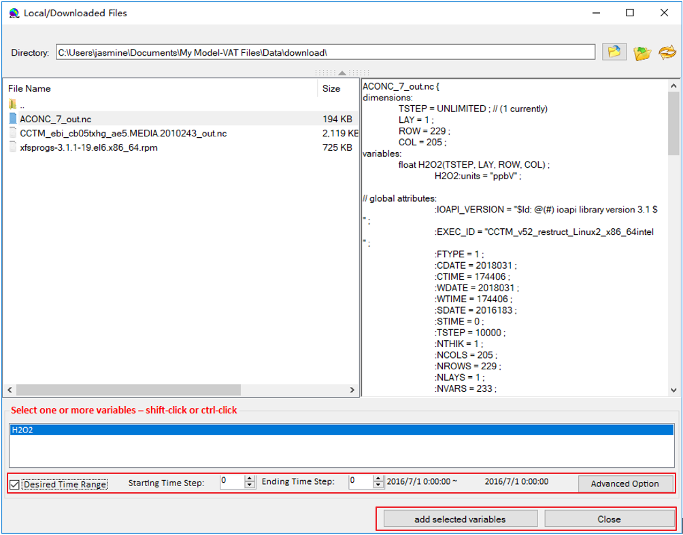
Figure 4.3-4. Local/Downloaded Files Window
- Desired Time Range: Users can select time range when users check this option (Figure 4.3-4).
- Add selected variables: Add the variables users are selecting to the main window (Figure 4.3-4).

File Converter
Click File Converter to open the File Converter window. Users can convert different files to different file output formats as needed.
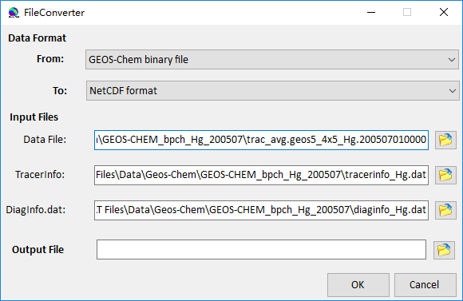
Figure 4.4-1. File Converter Window
Data Format:
Select original format and new format. (This version only supports convert GEOS-Chem binary file to NetCDF (Network Common Data Form) format) (Figure 4.4-1).
Input Files:
Data File: Select the file users want to convert.
TracerInfo: TracerInfo.dat file contains name weight and index information about GEOS-CHEM tracers.
DiagInfo.dat: DiagInfo.dat file contains category names and the offsets which are stored in file tracerinfo.dat.
Output File:
Select converted file path.

R Function
Click R Function to open the R Function window (Figure 4.5-1). After loading an R file or writing an R script, Model-VAT can realize those and execute. And the R plot drawn by R script function can be saved.
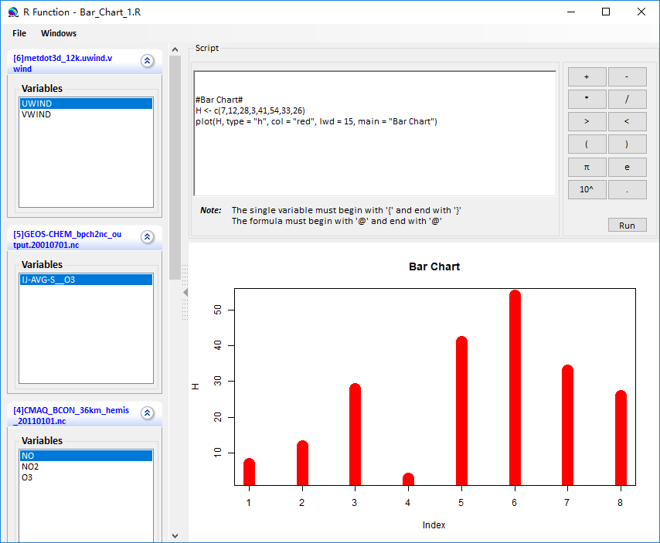
Figure 4.5-1. R Function Window
- Load Demo Project: Load the built-in demo project.
- Open Project: Open an existing project on the user’s computer.
- Load R Script: Load a built-in example script we provided.
- Save R Script: Overwrite the old R script.
- Exit: Exit the R Function.
- Run: Run the R script.
There are some notes and examples to help users to edit the R script:
(1) The single variable must begin with '{' and end with '}'. The formula must begin with '@' and end with '@'. For instance, {[2]IJ-AVG-S__BCPI} is identified as a single variable, @{[2]IJ-AVG-S__BCPI}+{[2]IJ-AVG-S__OCPI}@ is identified as a formula. But if users want to draw a single variable, users should also put it enclosed with @, like this, @ {[2] IJ-AVG-S__BCPI} @.
(2) For drawing bar chart, the strings #Bar Chart#, as a tag, must be written on the first line of the script.
(3) In this version, it can just plot the data of chosen variables in Layer 1 and Time-step 1. But for drawing bar chart, it will draw the Time Series Plot of Layer 1. In the future, we will make it flexible.
Figure 4.5-2, Figure 4.5-3, Figure 4.5-4, and Figure 4.5-5 show some examples of R-function graphics produced by Model-VAT.
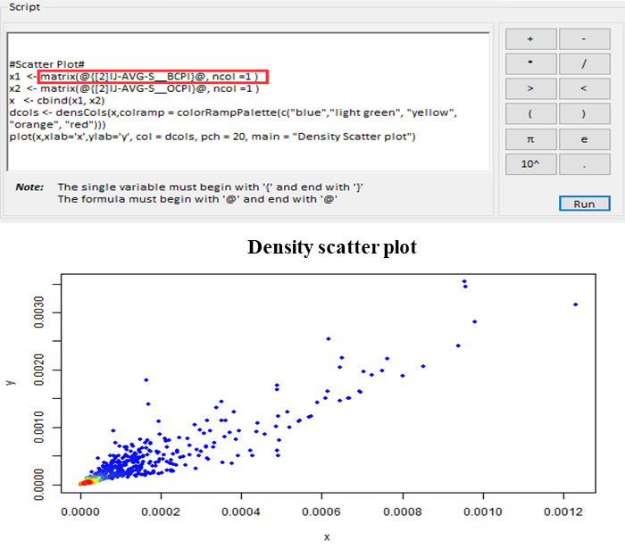
Figure 4.5-2. Density Scatter Plot

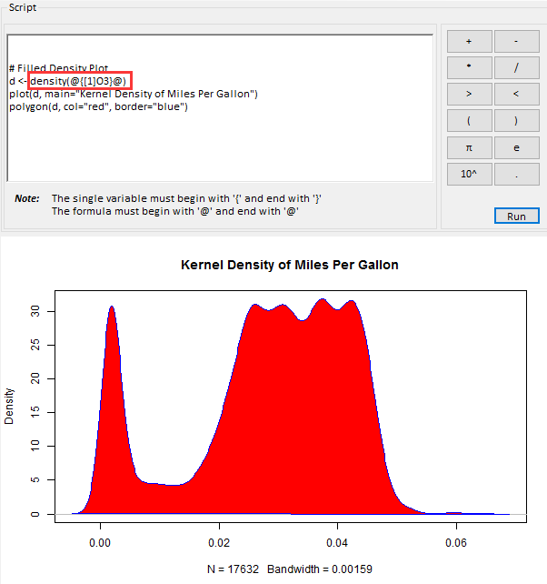
Figure 4.5-3. Density Plot

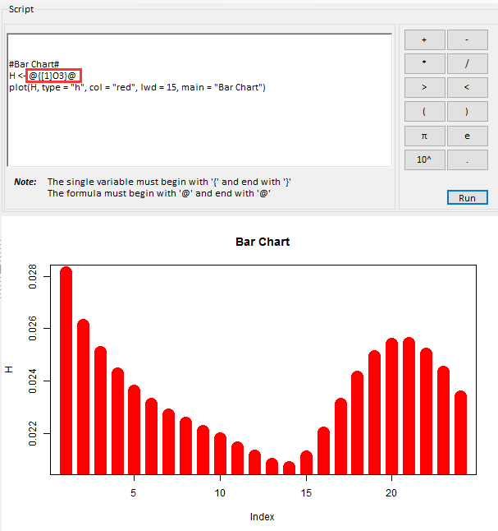
Figure 4.5-4. Bar Chart 1
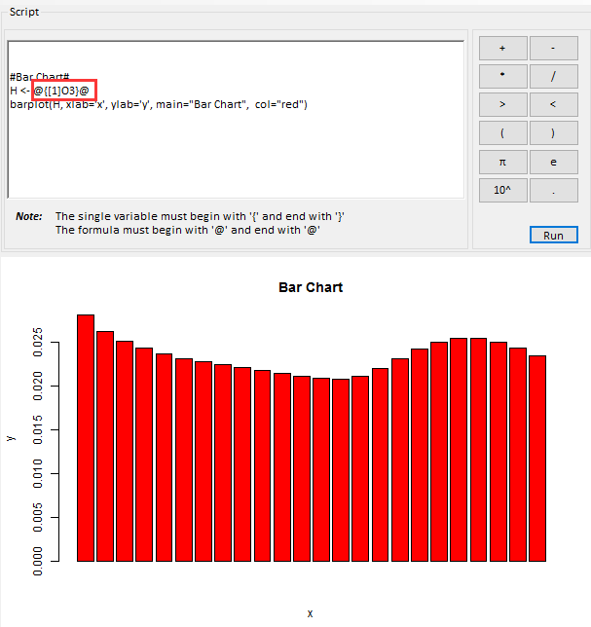
Figure 4.5-5. Bar Chart 2

Dispersion/Hybrid Model
Click Dispersion/Hybrid Model to open the Dispersion/Hybrid Model window. There are three models for users to check: AERMOD (American Meteorological Society/Environmental Protection Agency Regulatory Model), SCICHEM (SCIPUFF with CHEMistry), and AERMOD and CMAQ (Figure 4.6-1). Users can check one of these models, then click Run to draw the responding plot. The Save option is under development.
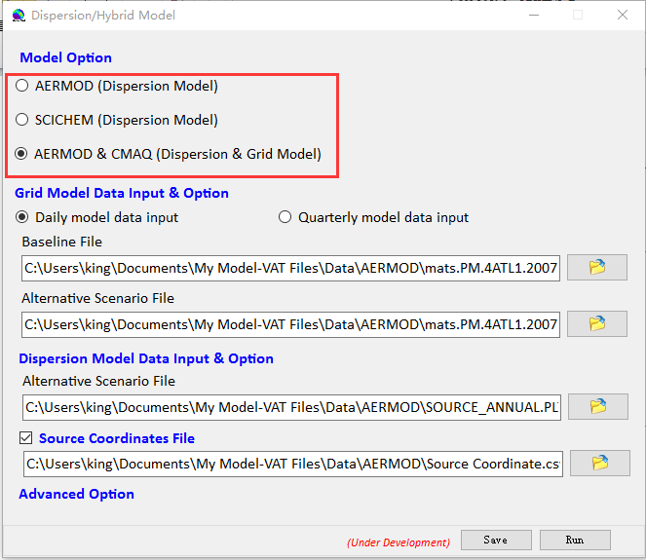
Figure 4.6-1. Dispersion/Hybrid Model Window
AERMOD
When users check the AERMOD, users will see the window as show as Figure 4.6-2, and users can check or uncheck Source Coordinates File.
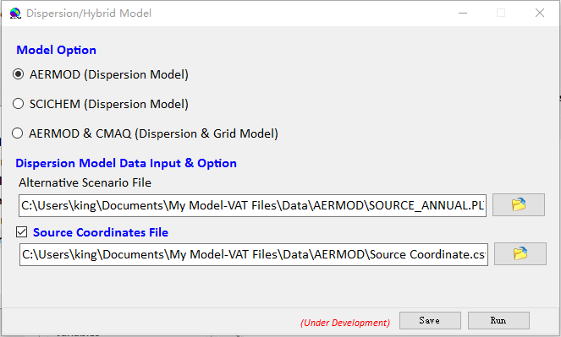
Figure 4.6-2. AERMOD Window
Then click Run to run the model. There is an AERMOD Plot window been opened as show as Figure 4.6-3 and Figure 4.6-4. There are two types of algorithms to draw AERMOD:
Coarse-3D: Using the biggest grid cell.
Actual-2D: Using its actual data (including small and big grid cell), only 2D plot.
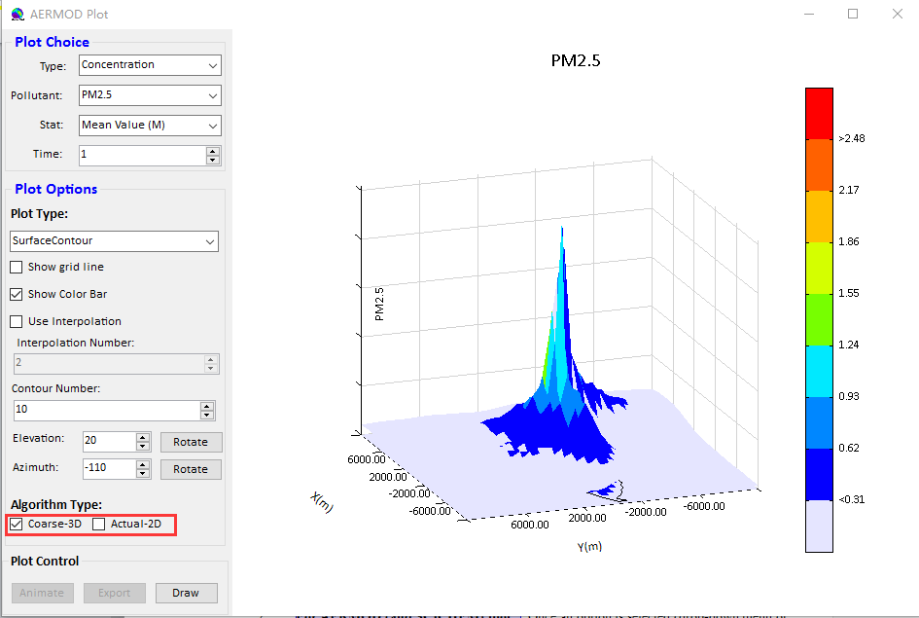
Figure 4.6-3. AERMOD Plot Window (Coarse-3D Type)
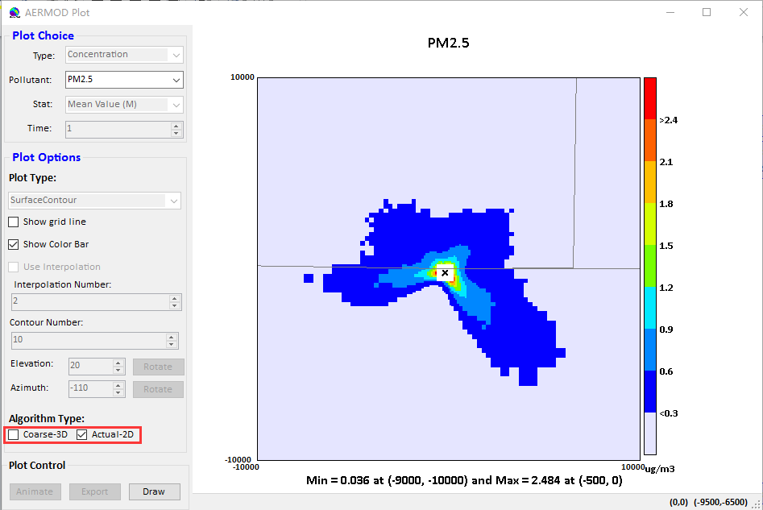
Figure 4.6-4. AERMOD Plot Window (Actual-2D Type)
SCICHEM
When users check the SCICHEM, users will see the window as show as Figure 4.6-5, and Source Coordinate File option will be disenabled.
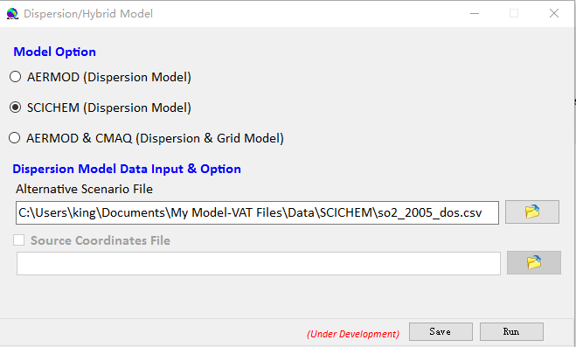
Figure 4.6-5. SCICHEM Window
Then click Run to run the model. There is a SCICHEM Plot window that has been opened as show as Figure 4.6-6.
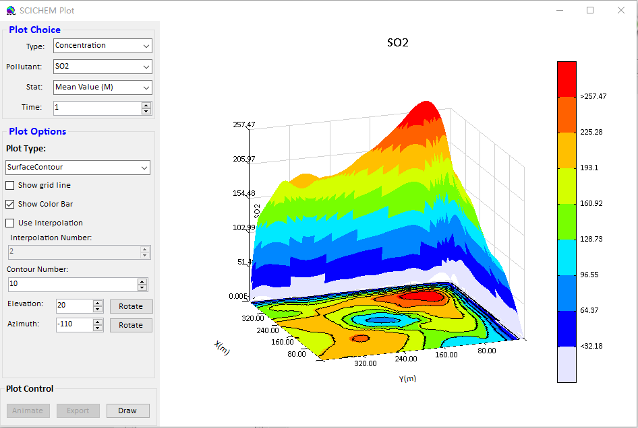
Figure 4.6-6. SCICHEM Plot Window
AERMOD & CMAQ
When users check the AERMOD & CMAQ option, users will see the window as shown in Figure 4.6-1, and users can check or uncheck Source Coordinates File. There are two kinds of grid model data, users can check daily or quarterly.
Then click Run to run the model. There is a Model Fusion Plot window that has been opened as show as Figure 4.6-7.
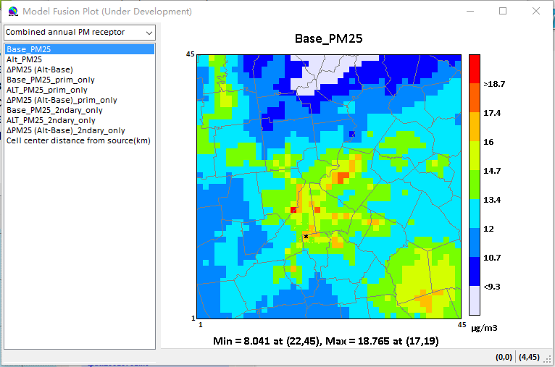
Figure 4.6-7. Model Fusion Plot Window

Note:
- Users could zoom in and zoom out in the AERMOD, SCICHEM, and AERMOD & CMAQ plot.
- Users could make the figure 3D revolve by left clicking and dragging the mouse.
- Users could set the Number of Tiles on Configure Plot to change the smooth of the plot as shown in- Figure 4.6-8.
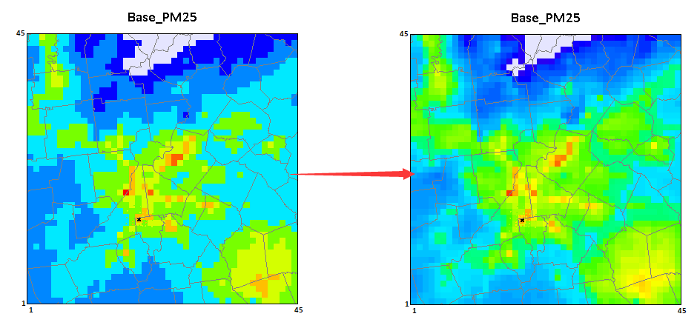
Figure 4.6-8. Set the Number of Tiles to a Lager One to Make the Plot Look Smoothly

GeoPlatform
Click GeoPlatform to open the GeoPlatform window. Users can enter the visual display interface of air model based on online map.
As shown in Figure 4.7-1 of the GeoPlatform window, on the left is the loading model file area. Users can preload different model files, select the pollutant to be displayed, and choose which online map to draw based on.
On the right is the display area, which includes basic GIS features, allowing users to zoom in and out, pan the map, select layers, and so on.
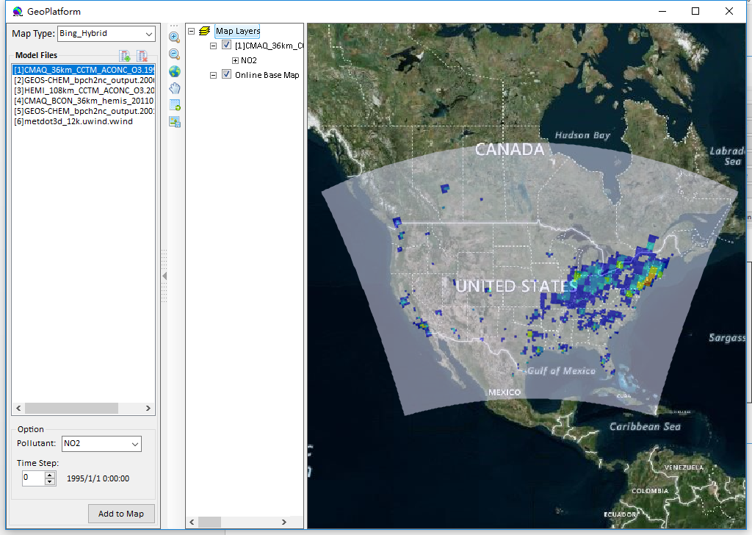
Figure 4.7-1. GeoPlatform Window

Help
Click Help to open the Help list. There are two options under Help.
Model-VAT Help
Users could click Model-VAT Help or the  button to open the Quick User Guide of Model-VAT window as shown in Figure 4.8-1.
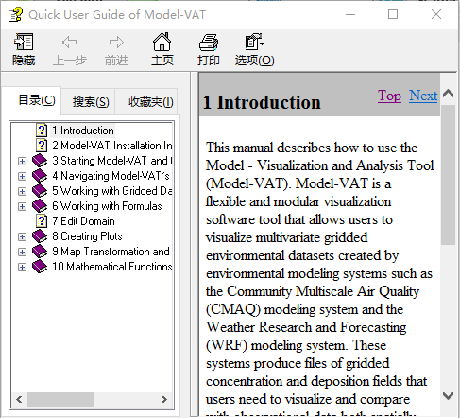
Figure 4.8-1. Quick User Guide of Model-VAT Window

About
Users could click About or the  button to open About Model-VAT window as shown in Figure 4.8-2.
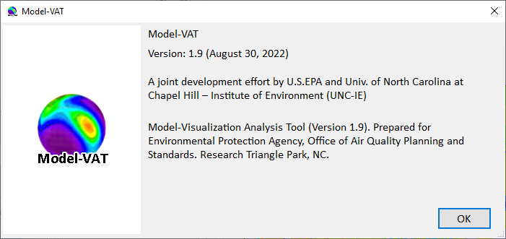
Figure 4.8-2. About Model-VAT Window

Working with Gridded Datasets

Gridded Input File Formats

Model Formats
Model-VAT currently supports visualizing files in the following file format conventions: CMAQ Input/output Applications Programming Interface (I/O API) NetCDF, WRF NetCDF, GEOS-Chem, AERMOD, SCICHEM, and ASCII (American Standard Code for Information Interchange) format (for observational data). In the future, formats of CAMx and (UAM-IV) will be supported.
The CMAQ I/O API was designed as a high-level interface on top of the NetCDF library. (See https://www.cmascenter.org/ioapi/ and http://www.unidata.ucar.edu/software/netcdf/ for further information). The I/O API library provides a comprehensive programming interface to files for the air quality model developer and model-related tool developer. I/O API files are self-describing and include projection information within the gridded dataset.
NetCDF and I/O API files are portable across computing platforms. This means that these files can be read regardless of what computer type or operating system you are using. There are routines available to convert data to these formats or new code can be written and contributed to Model-VAT for use by the community.

Observational Data Formats
Observational data in ASCII format can be obtained from EPA’s Remote Sensing Information Gateway - RSIG (https://www.epa.gov/hesc/rsig-related-downloadable-data-files#input). To use a consistent set of units for the model data and the observational data, you may need to import the ASCII data into an Excel spreadsheet and perform a unit conversion. Model-VAT doesn’t allows the user to use an observational variable to create a formula, so conversions to different units should be done within an Excel spreadsheet. Import the ASCII file that is generated by RSIG into Excel, change the units to match the units found in the gridded model data file, and then save using a tab delimited ASCII file format.
The observational data ASCII format recognized by Model-VAT is an ASCII file with tab-separated columns where the first four columns are provided in the order shown in and one or more additional columns are arbitrary but must have the header format 'name(units)' as shown in Figure 5.1-1. Spreadsheet programs can be used to edit and write the files by choosing ASCII output and tab as the delimiting character (instead of comma). Data within a column must be complete, as empty fields within a column will prevent Model-VAT from reading the observational data. Model-VAT allows the user to specify an alphanumeric value (either numbers and/or letters) for the fourth column (Station ID).
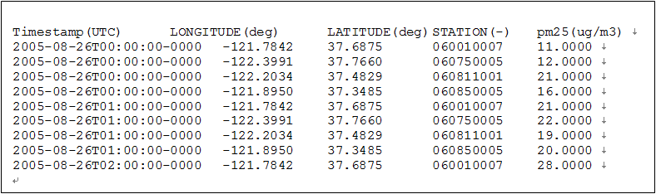
Figure 5.1-1. Observational File ASCII Format

Example Datasets

Example Datasets from the Model-VAT
The example datasets are provided under the Model-VAT installation directory/data directory. For example:
- Windows: \My Model-VAT Files\Tool\Model-VAT\Data

Example Datasets from the ABaCAS
If you have installed the ABaCAS, you can find the example datasets from the ABaCAS installation directory/Model-VAT /data directory. For example:
- Windows: \My Model-VAT Files\Tool\Model-VAT\Data
These datasets may be used to recreate example plots that are provided in this user guide, including a tile plot with observational data overlay in Section 1), and the example datasets for the various dataset projections that Model-VAT supports including LCC, polar stereographic, UTM and Mercator. The data directory currently contains six subdirectories:
- Base_map contains sample coordinates files for region of US, China, and the whole world;
- BC contains sample boundary files;
- CMAQ contains sample WRF and CMAQ I/O API datasets;
- GEOS-Chem contains sample GEOS-Chem files;
- OBS contains an ASCII formatted observational dataset, and an observational dataset of CSV format;
- ShapeFile contains sample shapefiles for US, China, and the whole world.

Adding and Removing a Dataset from a Local File System
To load a data set from a local file system, press the green plus button at the top of the Datasets pane. A file browser (Figure 5.3-1) allows you to select a dataset for use in Model-VAT.
After you select a dataset, Model-VAT will load header information on Dataset pane and display the available variables on Variables area, and domain on Domain pane used by the file (Figure 5.3-2). (The actual model data are not loaded until later, when plots are created.)
Datasets can be removed by highlighting the name of the dataset in the dataset list and pressing the green minus button. Note that although the dataset will be removed, the number that was assigned to that dataset will not be reused by Model-VAT during the current session (unless there had been only one dataset loaded, and it was removed; in that case the next dataset that is loaded will be labeled number 1).
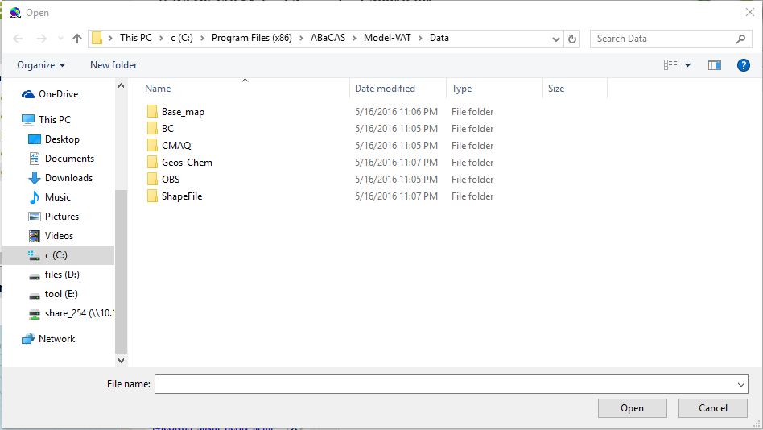
Figure 5.3-1. Open Dataset File Browser
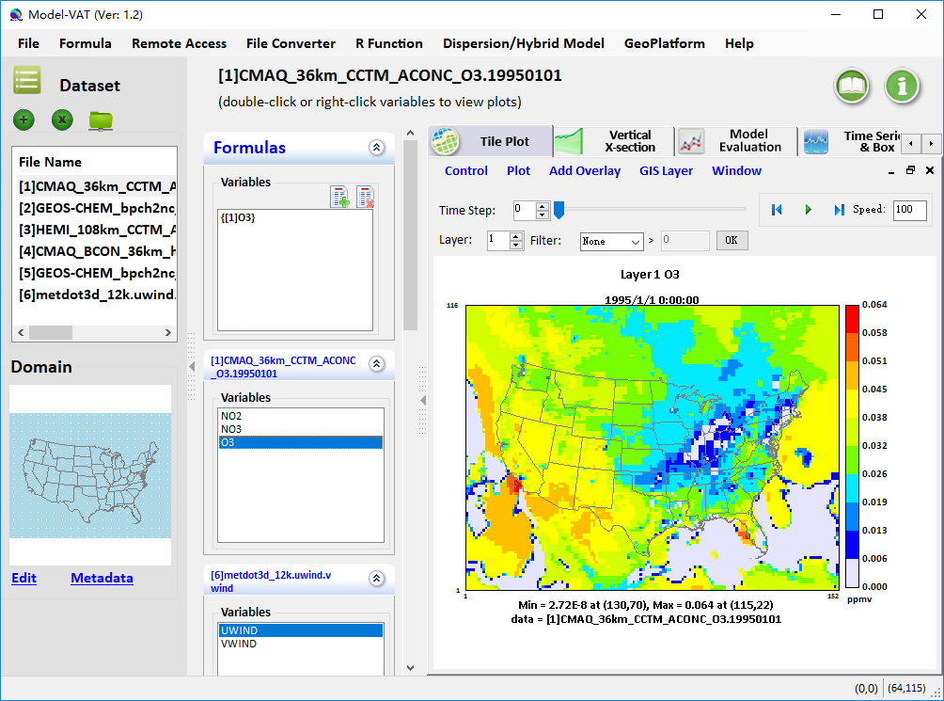
Figure 5.3-2. Datasets Pane, Domain Pane, and Variables Area

Variables List
The variables list shows all of the variables contained in a loaded dataset. Once a Dataset is added, a responding variable list will be added on Variables area. Each of the variables in the list can be used to create a formula in the Formula Pane that can be used to create plots. Model-VAT allows the user to automatically add a formula by double-clicking on the name of a variable. This automatically creates a formula that contains the variable for the loaded dataset and makes it the default formula for making plots. In addition, you may right-click on the name of the variable to show a popup menu as shown in Figure 5.4-1. From this menu you can add one kind of plot from Tile Plot, Vertical X-section, Time Series & Box, Scatter, and 3-D. Formulas are described in more details in Chapter 6 and Plots are introduced in details in Chapter 8.
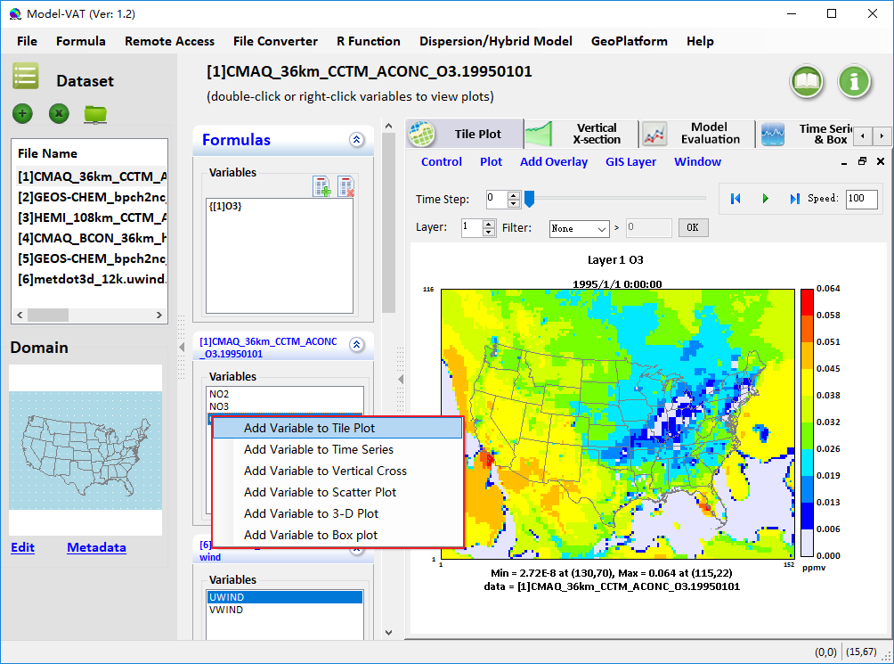
Figure 5.4-1. Right-Click on Variable List

Domain Panel
The domain panel contains an Edit button and a Metadata button. Detailed instructions for using the Edit button are provided in Chapter 7, Edit Domain.
To display the metadata information about a dataset, click on the Metadata button in the Domain panel. A window containing the metadata will appear (Figure 5.5-1). Each dataset includes metadata information that is part of the file header. The metadata provided include the map projection information, dataset dimensions, and dataset global attributes.
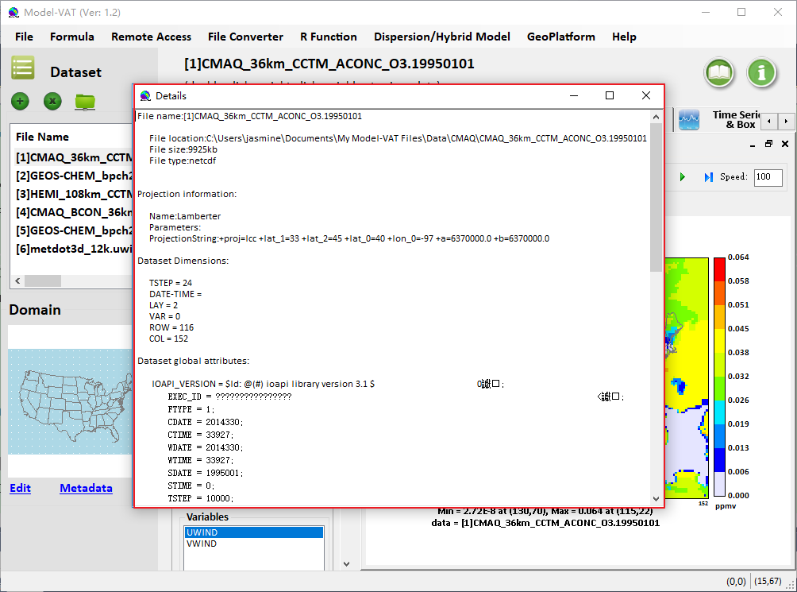
Figure 5.5-1. Dataset Metadata Information

Working with Formulas
All plots in Model-VAT are generated from formulas. A formula is used to compare or manipulate variables in one or more gridded datasets. A formula can be as simple as a single variable from one gridded dataset or it can be an equation that uses variable(s) from one or more gridded datasets. Formulas are used to create visualizations that can assist with model performance evaluations, for example, or that help in comparing model results with observations.

Adding and Removing a Formula
After loading the desired gridded datasets, you can use the variables in them to create formulas. To use a variable to create a simple formula, double click on the name of the variable. This will add the formula {<Dataset Number> [<Variable Name>]} to the formula list in the Formulas pane for example, {[1] O3}. Click the green plus button on Formula Pane or click Formula to open Formula Calculator. Left side of Formula Calculator is all variables of imported datasets. The right side is the Formula Operation. It is divided into three parts: Function, Formula Editor, and Formula (Figure 6.1-1).
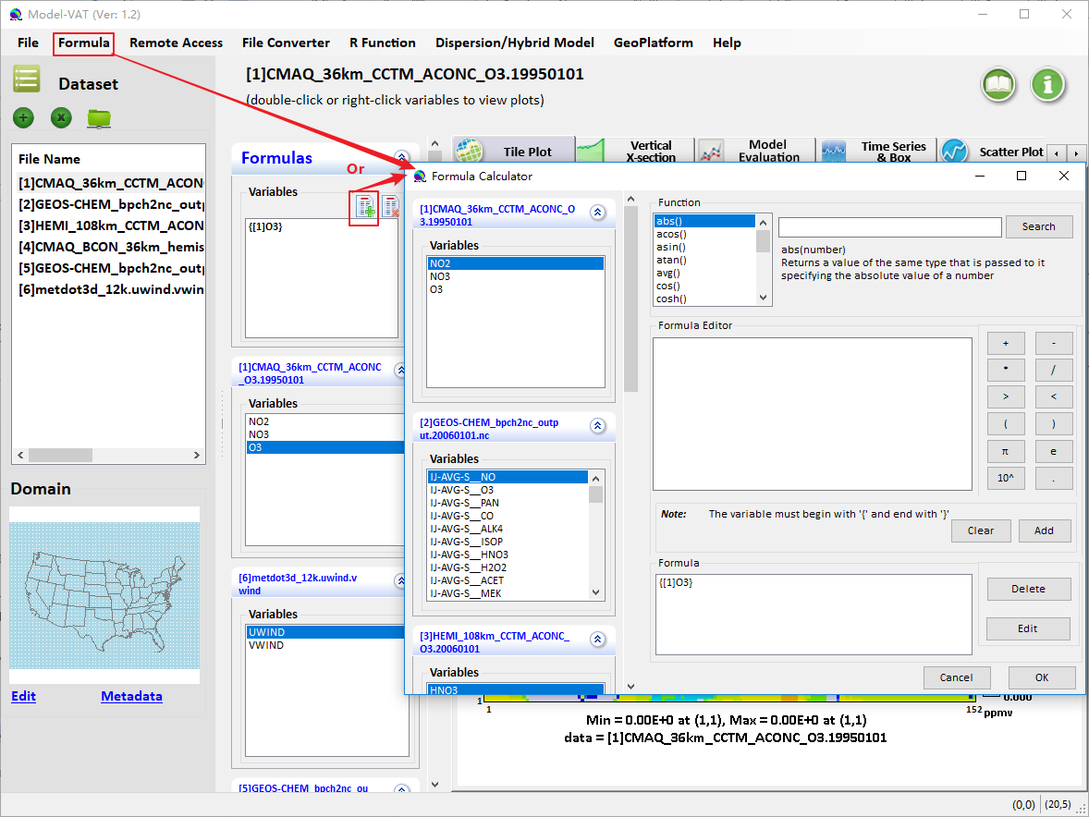
Figure 6.1-1. Adding Multiple Variables on Formula Calculator
Function provides some regular functions for convenience, and you can double-click a function to add it to Formula Editor. To add a variable to the Formula Editor, double click the variable on the left side. Note that every variable must begin with {and end with}. After the variable names are added to the Formula Editor, use the cursor and the keyboard to type in the mathematical operators (double-click an operator) where needed to create a valid formula (see Section 6.2 and Chapter 10). After the formula has been created in the Formula Editor, click the Add button, to place it in the list of formulas available in the Formula. Finally, all formulas created will be stored and displayed on Formula Pane when clicking OK button.
You can edit or delete an added formula by clicking Edit or Delete button on Formula Calculator. You can also delete an added formula by clicking button on Formula Pane. Note that removing a formula from the formula list does not remove plots that were created prior to the deletion of the formula.

Example Formulas
To examine the values of ozone in dataset 1, the formula would be {[1] O3}.
To examine the difference in ozone between datasets 2 and 5, the formula would be {[2] IJ-AVG-S__O3} - {[5] IJ-AVG-S__O3}.
To calculate the percent difference in ozone between datasets 2 and 5, the formula would be ({[2]IJ-AVG-S__O3} - {[5]IJ-AVG-S__O3})*100/({[5]IJ-AVG-S__O3}) .To identify all cells where the ozone concentration exceeds a certain value, you can use the Boolean operators to screen out ranges of your data that are of particular interest. A Boolean expression will evaluate to either True = 1 or False = 0. For example, to plot the cells in which the ozone values in dataset 1 exceed 0.080 ppm, you could use the formula ({[1] O3}>0.080)* {[1] O3}. In the resulting plot, each cell where {[1] O3} exceeds 0.080 will show the value of {[1] O3} for that cell; for all other cells the value shown will be zero.
The notations that can be used in formulas to represent various mathematical functions, and the order of precedence of these functions, are listed in Chapter 10, Mathematical Functions.

Selecting a Formula for Plotting
Before creating a plot, a formula must be selected. Check to see which formula is highlighted in the Formula Pane. By default, Model-VAT designates the most recently added formula as the selected formula. To change the selected formula to a different one in the list, click on a formula in the list on the Formula Pane to highlight it.

Edit Domain
Datasets contain data for cells over a particular geographic area. The Model-VAT program refers to this area as a domain. By default, the entire domain contained in a dataset is used in creating plots. Use the Edit Domain dialog box to select a subset of this domain for plotting.
First, select a dataset on Dataset pane and you will see the whole domain of current dataset on Domain pane. To select a subset of the domain, press the Edit button or click the map. The Edit Domain dialog box then appears (Figure 7-1).
There are two ways to select desired domain, (1) adjust start and end position at the bottom;(2) click to select a starting position and then drag a box around the area of interest; selected cells will appear in red. To clear the selected area, click anywhere on the map. When you are satisfied with the domain subset you have chosen, click the OK button.
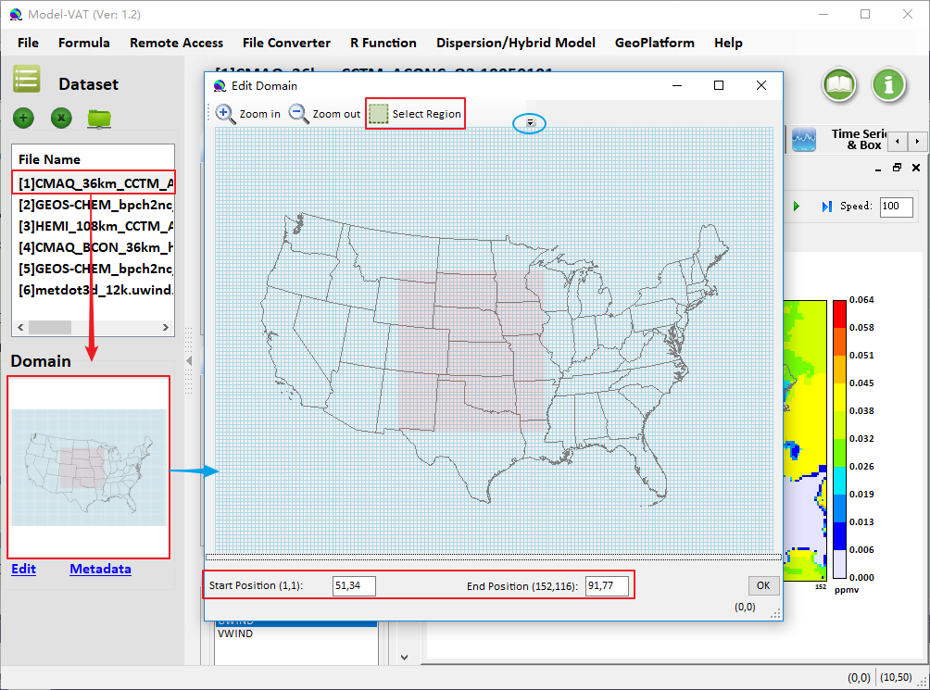
Figure 7-1. Edit Domain Dialog Box
When you finish editing domain, the selected domain will be showed on the map of Domain. Then you can choose a variable to create a tile plot within the selected region (Figure 7-2).
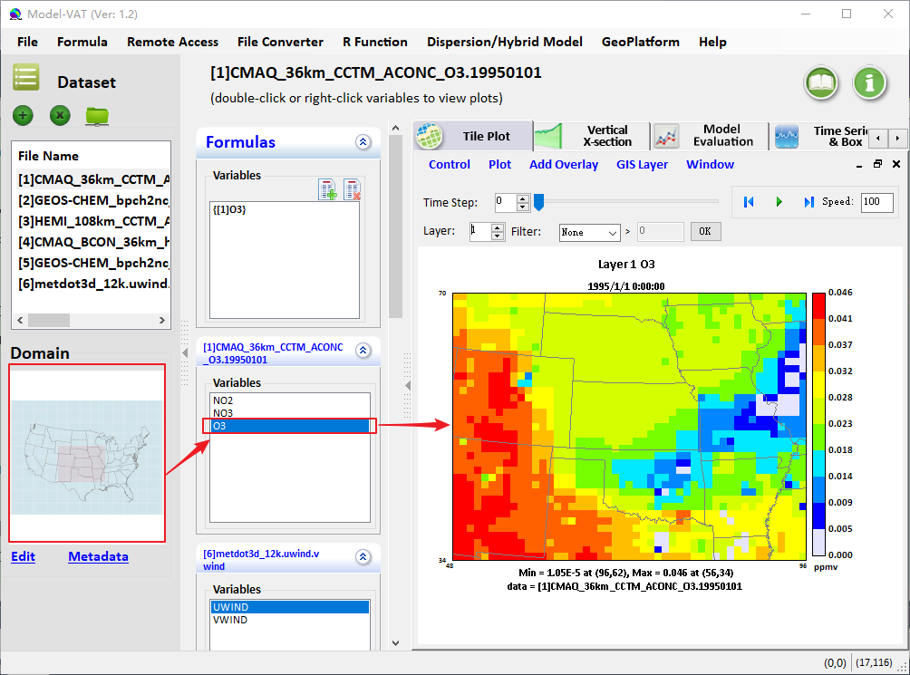
Figure 7-2. Create a Plot within Selected Region
User are also allowed to zoom in domain by clicking mouse button and dragging to the right-low, and go back to previous zoom domain by clicking mouse button and dragging to the left-top or right-clicking or clicking the Control to click the Zoom out to previous domain or Reset to default domain.

Creating Plots
After creating a formula, you are ready to create and view some plots. The available plot types are shown on the Plot Area: Tile Plot, Vertical X-section, Time Series & Box, Scatter Plot, 3-D Plot, and Data Plot. All of these are described in this chapter. Note that not all datasets are appropriate for all plot types.
To generate a plot first highlight a formula in the list of formulas you have created in the Formula Pane or a variable in the list of corresponding Variables area. Next, right click to choose the plot style to generate the plot.
Each plot contains its own menu bar at the top of its window with options for configuring and exploring that type of plot. The menus may include Configure, Controls, Plot, GIS Layers, Add Overlay, and Window.

Tile Plot
The Tile Plot allows the user to display the time steps and vertical layers contained in a gridded dataset and to display grid cell time aggregate statistics. An example of the Tile Plot window is shown in Figure 8.1-1.
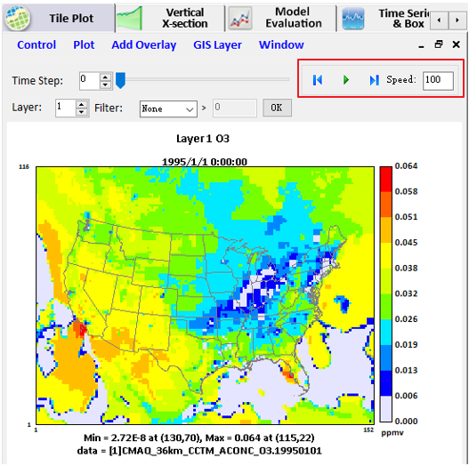
Figure 8.1-1. Tile Plot
There are three ways to add tile plot: Double-clicking a variable in the list box of variable, mouse right clicking a variable in variable list box, and select Add Variable to Tile Plot and double-clicking a variable in the formula list box.
Users can also see the BCON file in the tile plot (Figure 8.1-2).
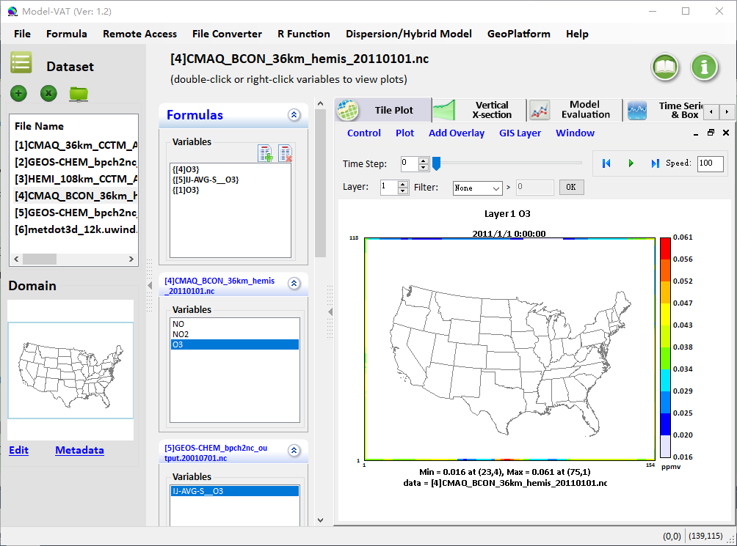
Figure 8.1-2. BCON File Showed in the Tile Plot

Time Selection and Animation Controls
At the top is a track bar and its settings. To change the time step, you can drag the cursor to the position you want on the bar.
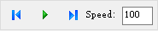 Buttons in the top right corner of the plot allow you to use play/stop, reverse, forward, and speed options to control the animation of the plot (Figure 8.1-1). Control the speed of the animation through the text box labeled Speed; the default delay is 100 milliseconds between frames. If that text box is not visible, expand the plot windows width by clicking with the left mouse button on the right edge of the window and dragging to the right. Enter a number in the box for the length of the delay and then press the Enter key. A larger plot with multiple map layers may require a shorter delay between frames than a small zoomed-in plot with few map layers. There are some kinds of basic statistical functions in the Filter.
User can right-click Probe to use Probe function. When Probe is invoked (display moving + sign), show Column & Row value below when moving mouse over map; When clicked, show cell value (concentrations, etc., below) and record the probed cells; When double-clicked, show a time series of probed cells.

Arrange Window and Select Active Window
Arrange Window:
There are two ways used to arrange tile plot window: Vertical and Cascade (Figure 8.1-3).
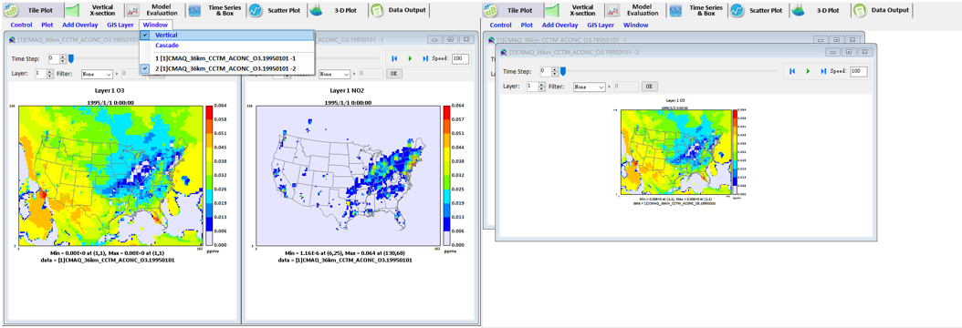
a. Vertical Style b. Cascade Style
Figure 8.1-3. Arrange Style of Tile Plot Window
Select Active Window:
To select an active window, you can click the title of child window or select a child window from the menu named Window under Tile Plot tab page. The checked item is the current active child window (Figure 8.1-4).
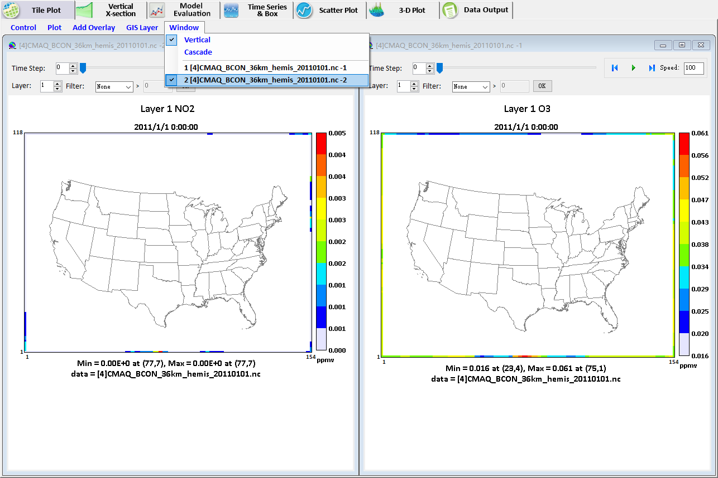
Figure 8.1-4. Select an Active Window

Layer Selection
The Layer displayed for the plot can be controlled by clicking on the up or down arrow for the Layer spin control in the top center of the plot.

Add Overlay
Model-VAT supports two types of overlays observations and vectors. For both types of overlays, you may need to add data from another data file onto that in the underlying plot.
- Observational Data Overlays
It is useful to visually compare the results contained in model output datasets with the data points in observational datasets. You can do this by creating a Tile Plot of the model output and then overlaying it with observational data points. The observational dataset needs to be in a csv or txt observational data format.
Sample observational data are provided in the directory ABaCAS install directory/Model-VAT /data/OBS so you can create a sample Observational Data Overlay Plot. Follow these instructions to create your plot.
- Load a model output dataset to Tile Plot.
- Select a child window as current active window. And then select Add Overlay>Observations from the tile plot s Plot menu to open Add observation data window on a tile plot.
- An Observation dialog box (Figure 8.1-5) appears containing observation datasets to load an observational dataset, and the variables that are available in the observational dataset. Once selecting a dataset, Available Variables list will show all variables of added dataset. Select the observational variable to overlay on the Tile Plot from the Observation Details list. Multiple observational dataset variables can be overlaid on a Tile Plot.
- You can control the appearance of the symbols representing the observational data. The stroke size controls the thickness of the line used to draw the symbols; the shape size controls their diameter. You can use up to six different open-area shapes circle, diamond, square, star, sun, and triangle to distinguish among multiple observational datasets. A circle is the default symbol shape.
- Click OK to overlay the observational data on the tile plot (Figure 8.1-6).
Repeat the above process to add multiple variables. To reset the symbols size, shape, or stroke thickness, reopen the Observation dialog by using Add Overlay>Observations, select the observational variable you want to adjust, and then change its stroke size, shape size, or symbol. You can also remove a variable in the list. When you are finished click the OK button.
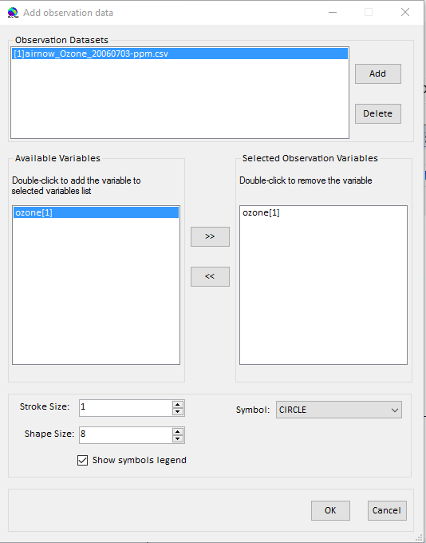
Figure 8.1-5. Tile Plot Observation Dialog
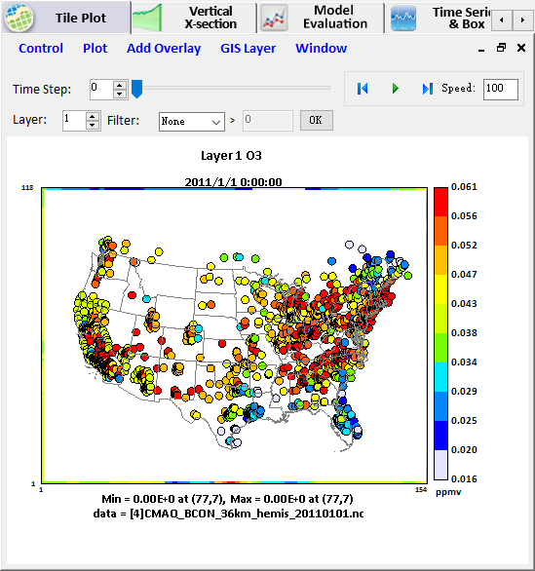
Figure 8.1-6. Tile Plot with Observational Data Overlay
- Vector Overlays
Follow these instructions to add a vector overlay to a tile plot. Typically, these are created to show wind speed and direction on a plot of gridded air quality data. The length of the calculated vectors is proportional to their magnitude.
- Create your Tile Plot.
- Select the Add Overlay>Vectors option from the tile plot s Plot pull-down menu.
- Select the two components of your vector in the Vector Overlay dialog box (Figure 8.1-7).
- Click the Plot button and the vector overlays are displayed on the plot.
NOTE: At this time you cannot control how the vectors are displayed, and there is no option to remove the vectors from the plot. If you need to make a change, you must start again with your Tile Plot.
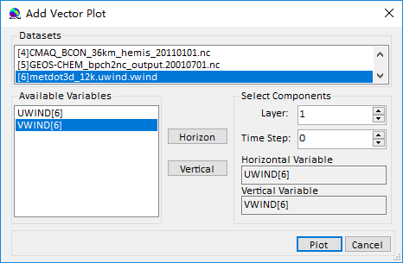
Figure 8.1-7. Vector Overlay Dialog Box
An example of an ozone concentration Tile Plot with a wind vector overlay is shown in Figure 8.1-8. The length of each vector is proportional to its length. The direction of the vector is calculated from the direction and magnitudes of its two components. This figure illustrates how the wind changes speed and direction in this portion of the modeling domain for layer 1, time step 0.
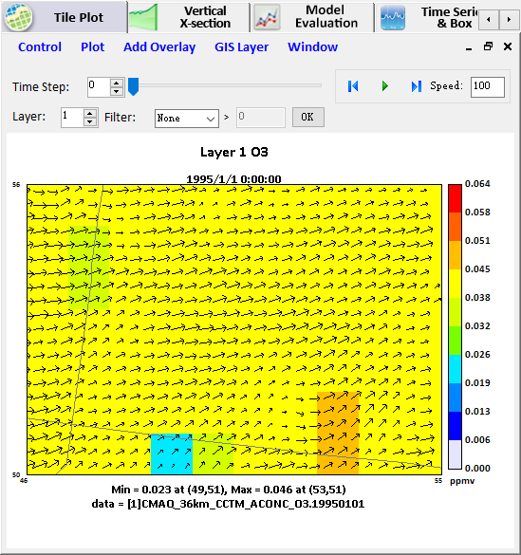
Figure 8.1-8. Wind Vector Overlay on an Ozone Tile Plot

- Draw Wind Rose Plot
We developed the Wind Rose Plot on the basis of Vector File. Follow these instructions to add a Wind Rose Plot to a tile plot.
- Selected the Wind Rose Plot under the right-clicking menu or Plot to open Add Wind Rose Plot dialog box as show as Figure 8.1-9.
- Select the two components of your vector in the Add Wind Rose Plot dialog box (Figure 8.1-9).
- Click the Plot button and the vector overlays are displayed on the plot (Figure 8.1-10).
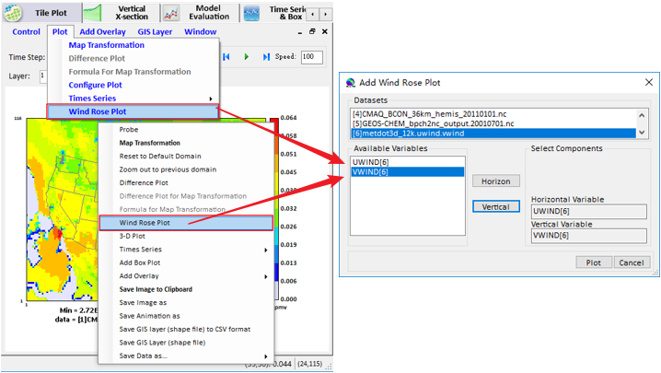
Figure 8.1-9. Open Add Wind Rose Plot

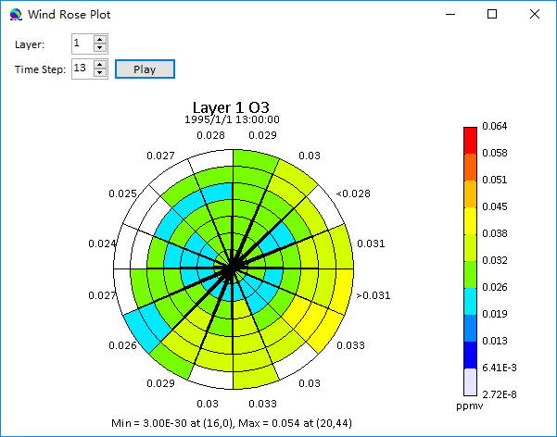
Figure 8.1-10. Wind Rose Plot

Add Map Layers
Use the Configure Layers option in the GIS Layers menu to open Add Layer window to add maps to a Tile Plot (Figure 8.1-11).
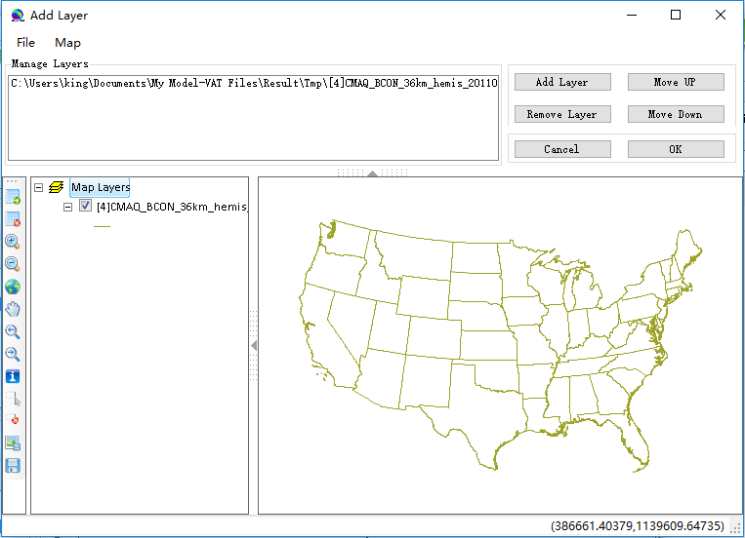
Figure 8.1-11. Add Layer Window
The upper part of the window is used for adding/removing a layer file (Add Layer/ Remove Layer button) or modifying orders of layer files (Move Up/ Move Down button)(Figure 8.1-12). To save layer file as csv format, click to highlight a file in the Manage Layers list, and then mouse right-click it (Figure 8.1-13). The popup save file dialog appears and you can decide a saving path to save it as a csv file.
The lower part of the window is used for displaying all added layers on a map. On the left side is Map Tools, which are used for manipulating the map, e.g., zoom in, zoom out, and full extent (Figure 8.1-12). To change projection, right-click Map Layers to select Projection. On the popup Map Projection window, click Change Projection at the left bottom to enter into Select Projection window. You can select a projection and then click OK to finish changing projection (Figure 8.1-14).
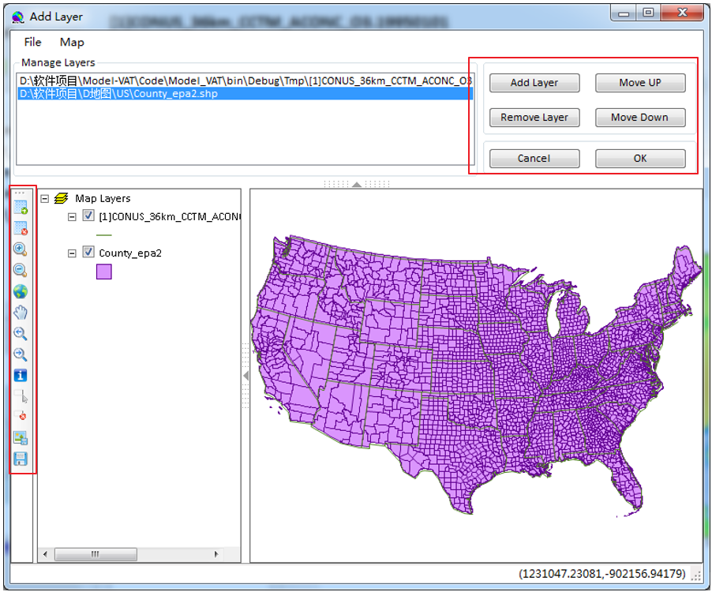
Figure 8.1-12. Add Layer Window
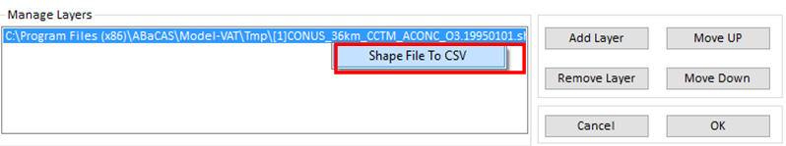
Figure 8.1-13. Save Layer File as CSV File
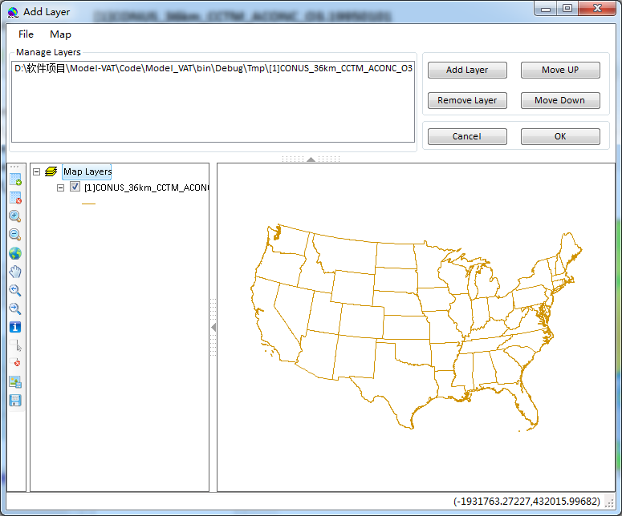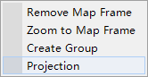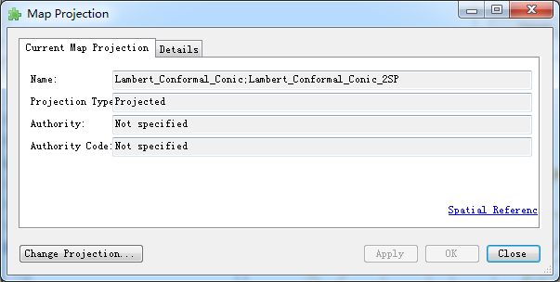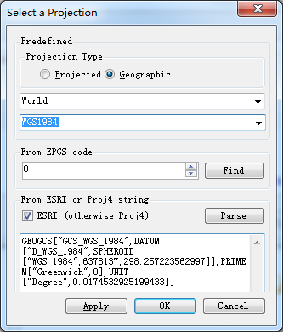
Figure 8.1-14. Change Projection
Use World, USA States, USA Counties, and China Province in the GIS Layer to rich the map as show as Figure 8.1-15.
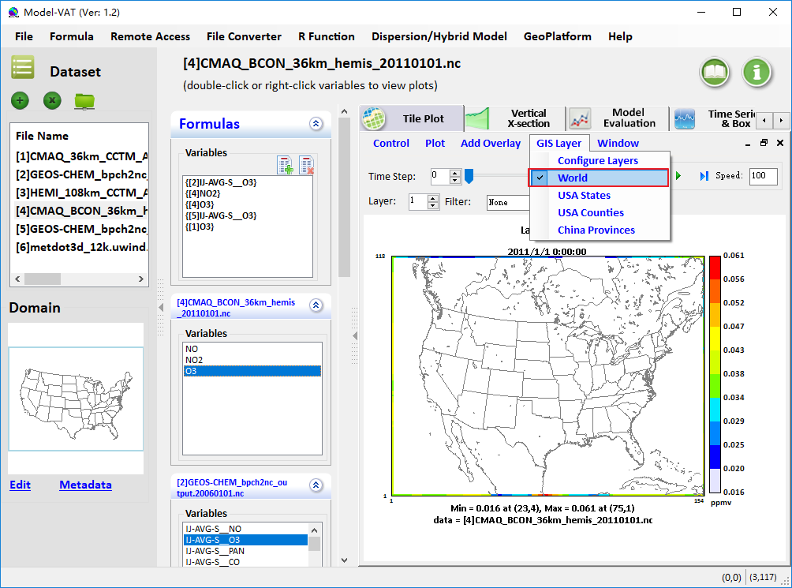
- World
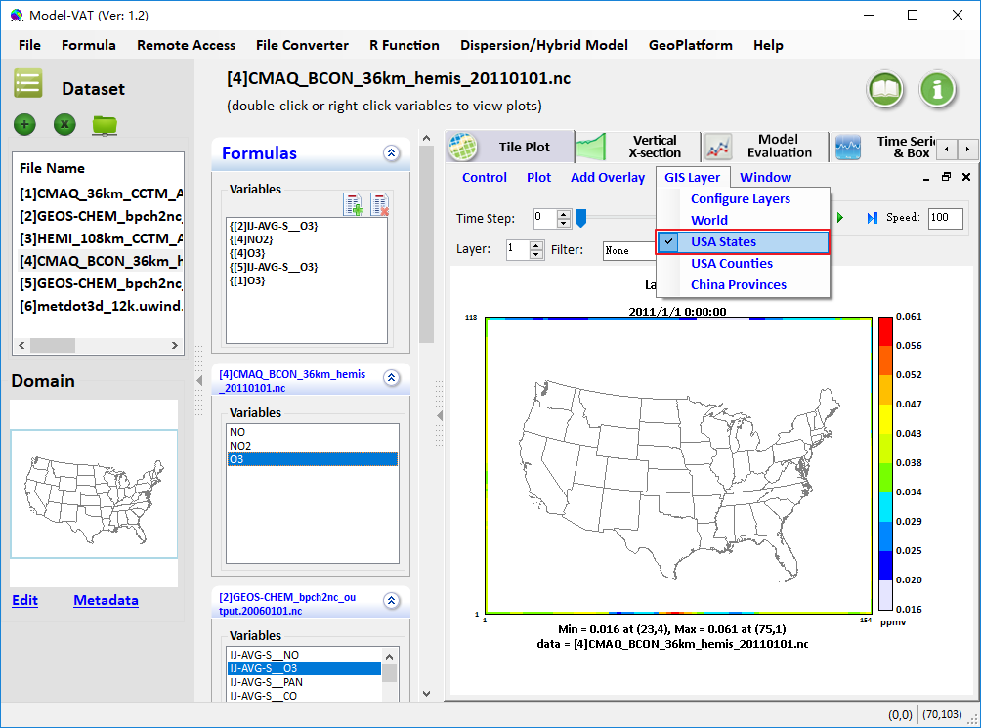
- USA States
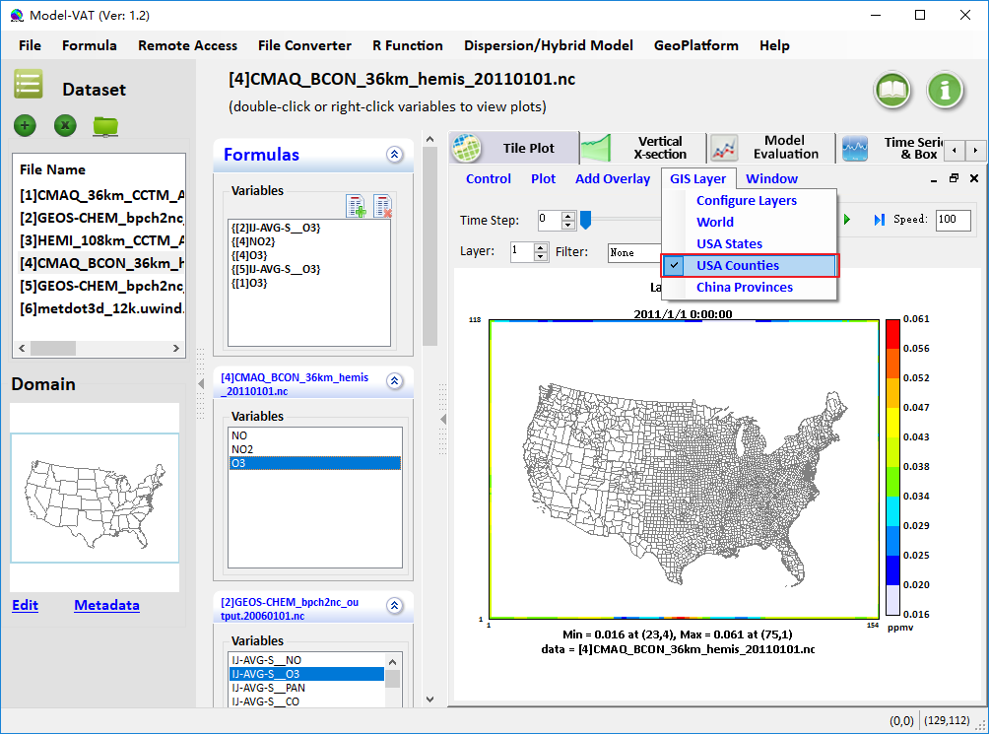
- USA Counties
Figure 8.1-15. GIS Layer

Vertical X-section
The Vertical X-section allows you to show a slice of data. There are two ways to add vertical cross section plot:
1) Mouse right-click a variables in the list box of variable, and select Add Variable to Vertical Cross (Figure 8.2-1).
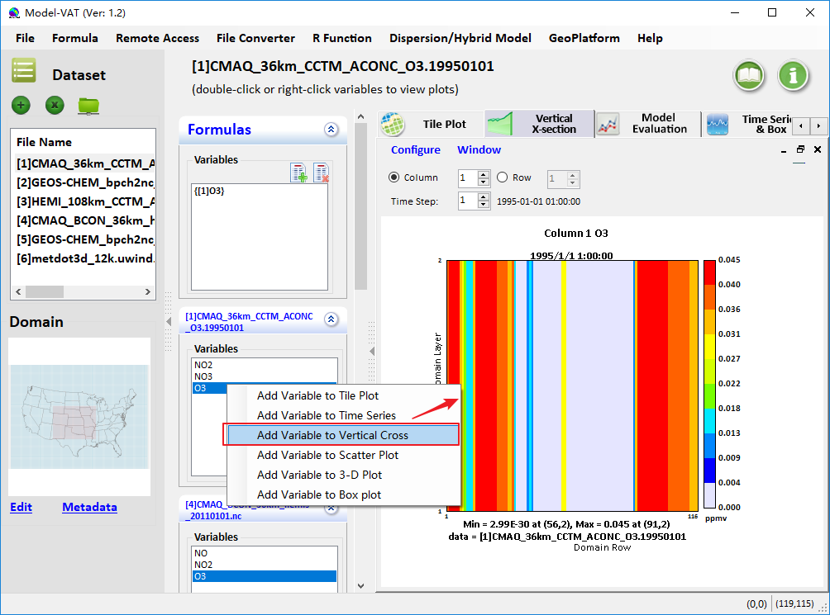
Figure 8.2-1. Select a Variable to Add Vertical Cross Section Plot
2) Switch to Vertical X-section tab page and double-click a variables in the list box of variable (Figure 8.2-2).
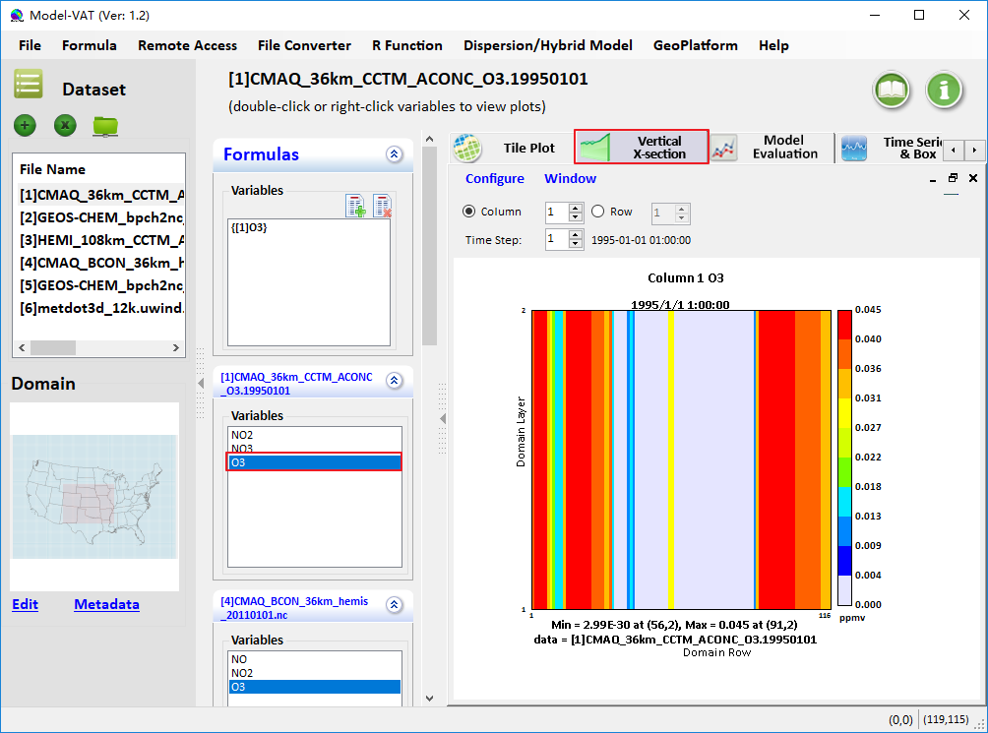
Figure 8.2-2. Add Vertical Cross Section Plot under Vertical Cross Section Plot Tab Page
Enter either The current time step on the plot can be changed. Using the Time Step spinner control above the plot, which also changes the date and time shown in the bottom of the plot. There is also a Column (or Row) spinner control to change the column number (or row number). The column is used for an x-axis cross section and the row is used for a y-axis cross section. The cross-section column number (or row number) is included in the title of the plot and changes as you change the spinner control.

Model Evaluation
The Model Evaluation can verify the reliability of the model simulation results. The comparison between the simulated value and the observed value is generally divided into two aspects. On one hand, the difference between the two values is compared, and on the other hand, the difference between the two trends in the concentration change is compared. Besides, it provides a visualization display of the results in the form of map plots, time series plots, bias table, scatter plots, density scatter plots or box plots. An example of the Model Evaluation window is shown in Figure 8.3-1.
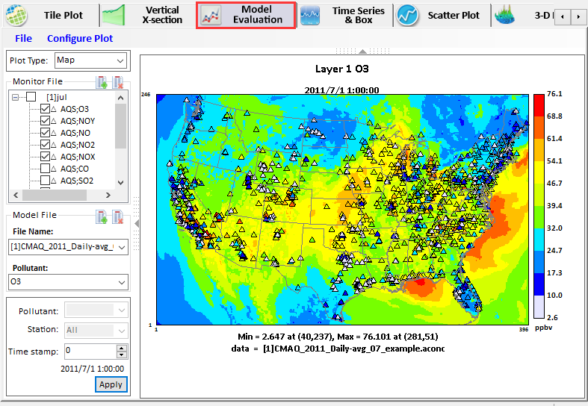
Figure 8.3-1. Model Evaluation Window
There are main 3 steps to draw map plot (Figure 8.3-2):
- Select plot type from drop-down box;
- Add and select monitor or site compare (sitecmp) files/pollutants
- Add model file and select pollutant;
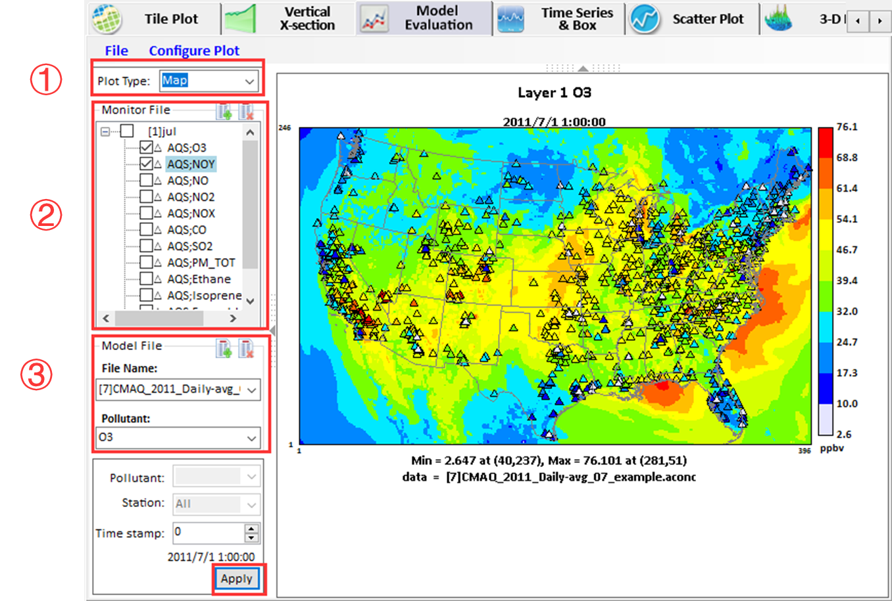
Figure 8.3-2. The process of drawing map plot
There are main 3 steps to draw other plots. (Figure 8.3-3):
- Select plot type from drop-down box;
- Add and select monitor or site compare (sitecmp) files/pollutants
- Set drawing option and draw plot.
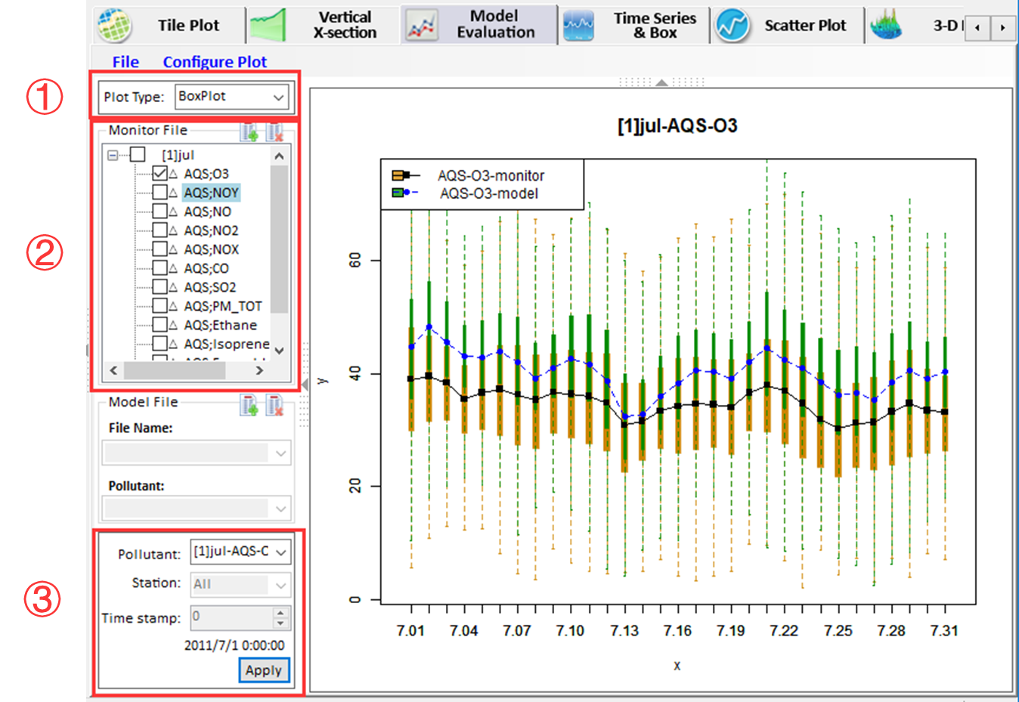
Figure 8.3-3 The process of drawing other plots

Select plot type from drop-down box
Click the drop-down arrow to choose plot type. (Figure 8.3-4).
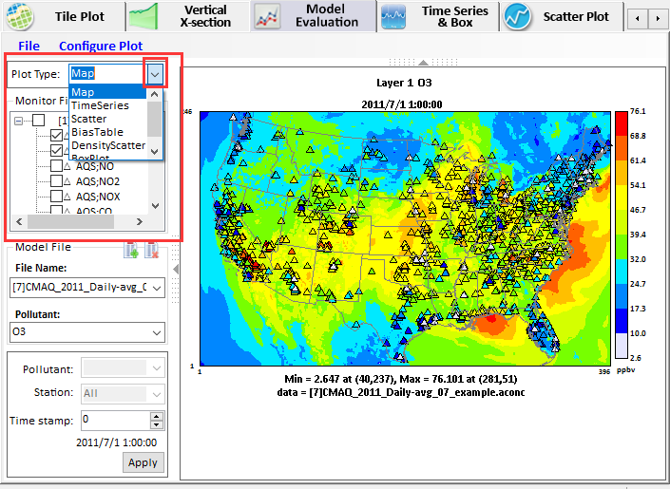
Figure 8.3-4 Choose plot type

Add and select monitor or site compare files/pollutants
Click or click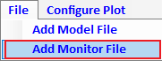 Add Monitor File to open Model Evaluation Input Editor Window to add and select monitor or site compare files/pollutants, and then check the species to analysis (see Figure 8.3-5).
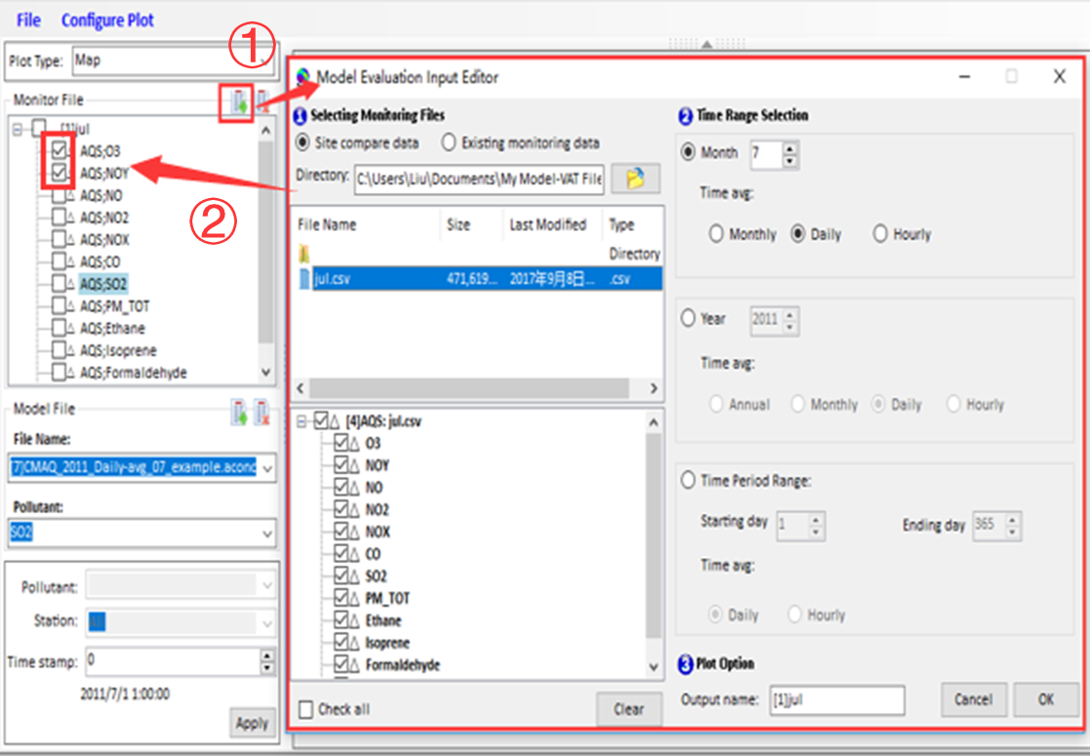
Figure 8.3-5 Select the monitor files and species
Notes:
The initial directory is C:\Users\xxx\Documents\My Model-VAT Files\Data\Sitecmp\AQS.

Add model file and select pollutant
This step is only needed for map plots. Click or click 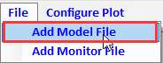 Add Model File to open the Open Model File dialog to add and select model file (see Figure 8.3-6), and select the pollutant to plot.
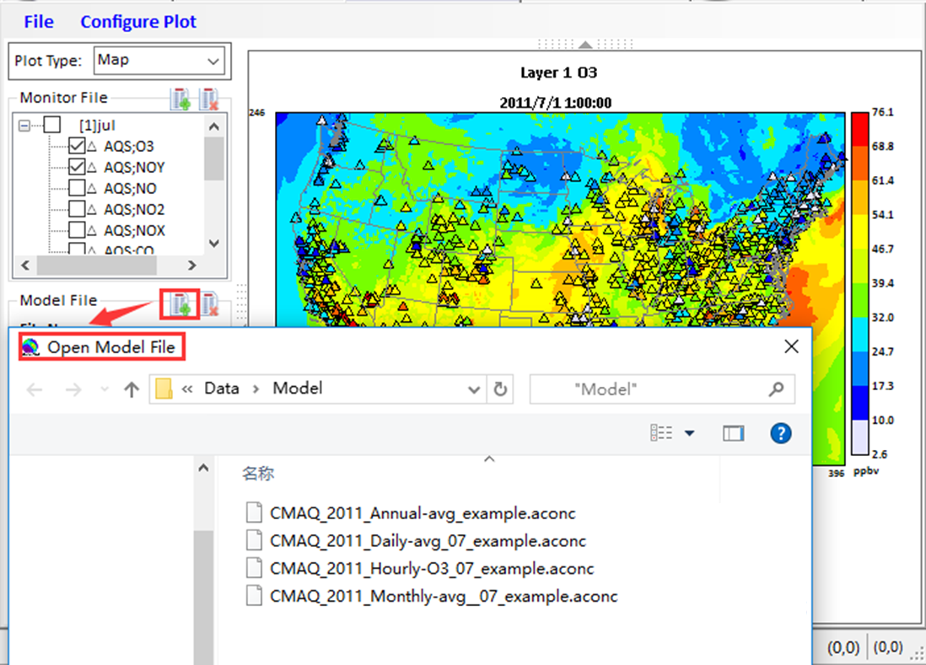
Figure 8.3-6 Open Model File Window

Set drawing option and draw plot
Click drop-down arrow to select the pollutant for analysis and then click Apply button (see Figure 8.3-7).
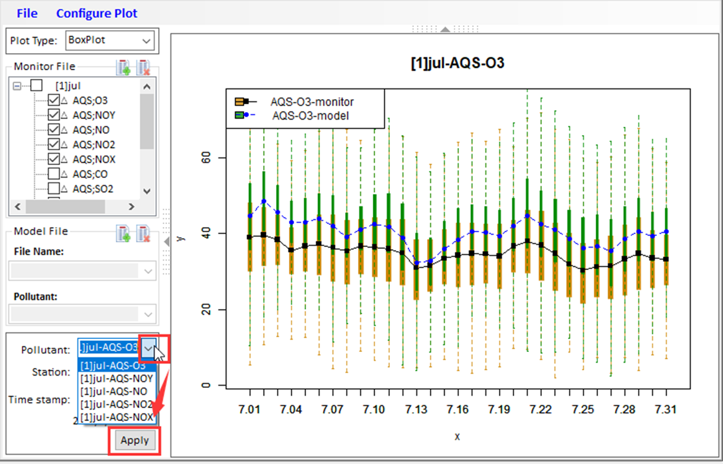
Figure 8.3-7 set draw option and draw plot

Time Series & Box

Basic Operation
The Time Series & Box can show a line graph with the average values over time. The plot is made for the formula s selected domain and layer range. Each time step s data are averaged linearly to produce that time step s data point.
There are three ways to add time series plot:
1) Select a grid cell at the map of Tile Plot and then click Plot Time Series Time Series of Probed Cell(s) (Figure 8.4-1).
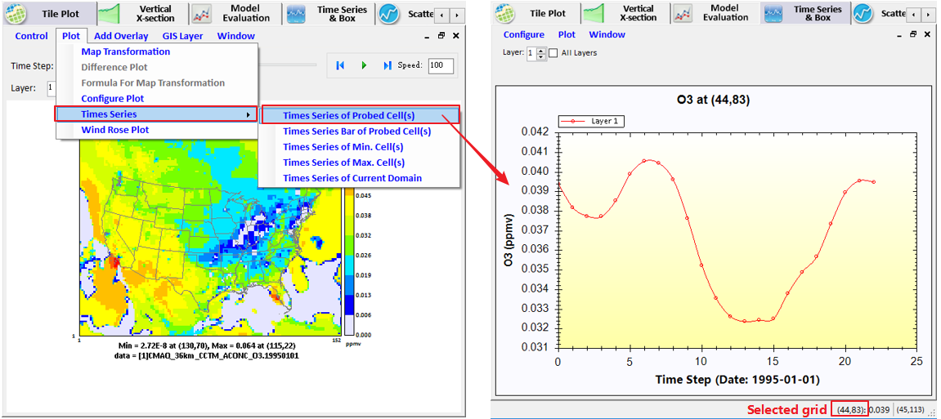
Figure 8.4-1. Select a Grid Cell to Add Time Series Plot
2) Mouse right-click a variable in the list box of variable, and select Add Variable to Time Series (Figure 8.4-2). 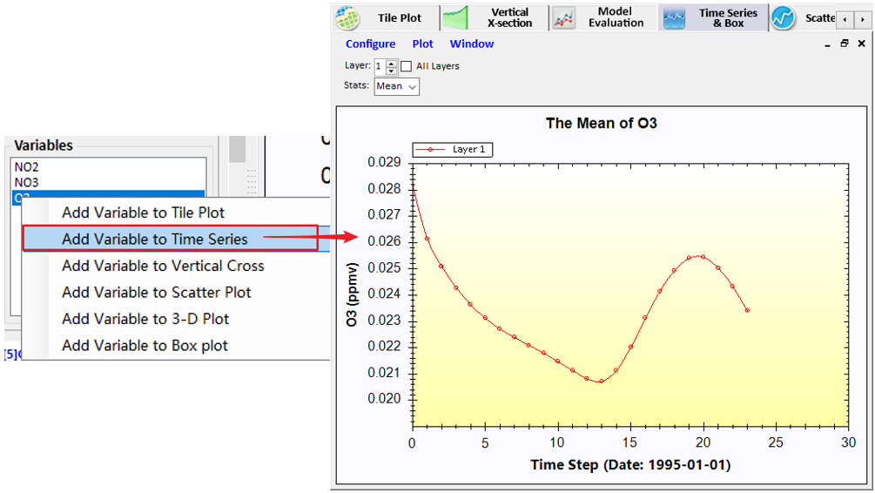
Figure 8.4-2. Select a Variable to Add Time Series Plot
3) Switch to Times Series tab page and double-click a variables in the list box of variable (Figure 8.4-3).
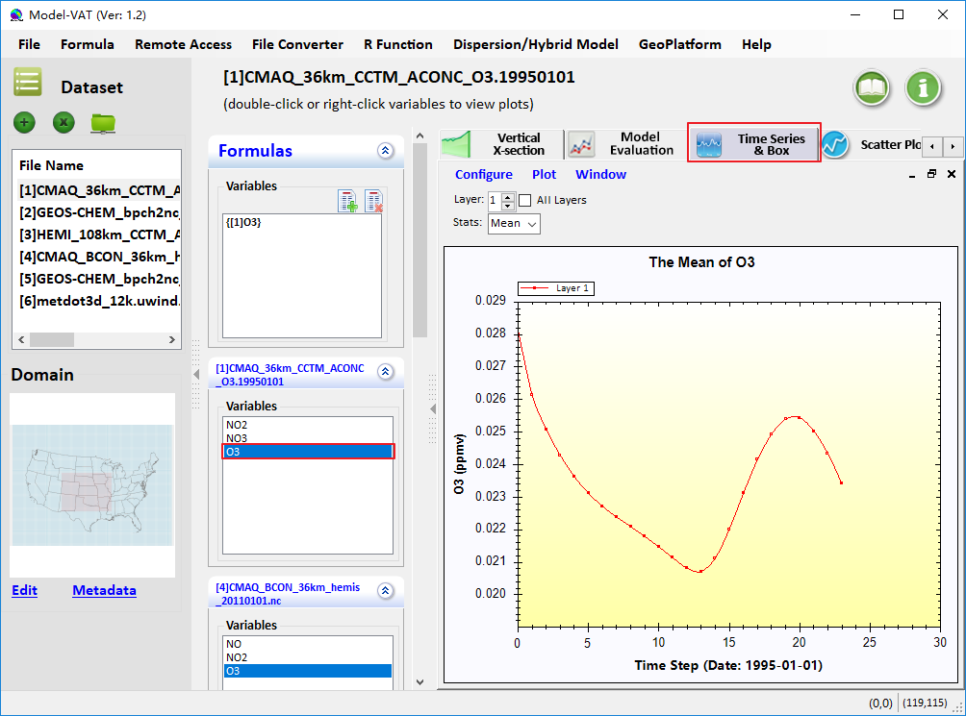
Figure 8.4-3. Add Time Series Plot under Time Series & Box Tab Page
There are four kind of styles of time series plot: smooth line, step line, non-step line, and bar chart. They can be found on the popup menu of Plot menu button at the top.
Smooth Line: Connect points with smooth curve, as shown in Figure 8.4-4.
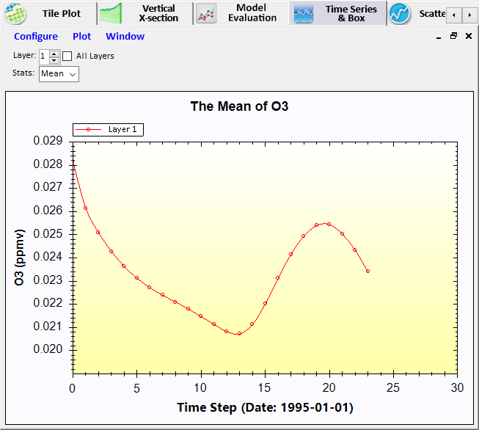
Figure 8.4-4. Smooth Line
Step Line: It is divided into forward step line and rearward step line (Figure 8.4-5).
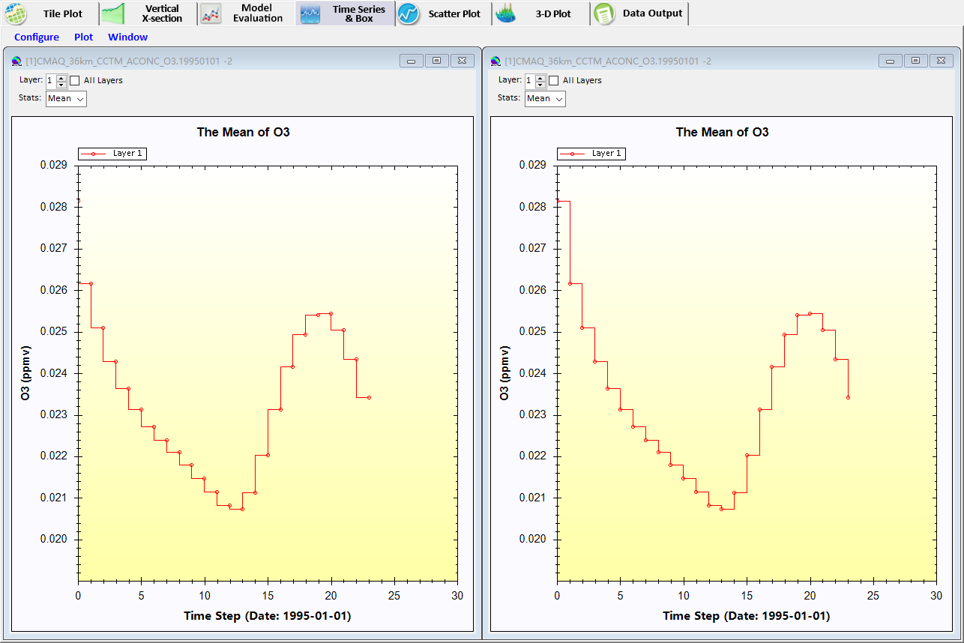
Figure 8.4-5. Forward Step Line (left) and Rearward Step Line (right)
Non-Step Line: Connect points with line, as shown in Figure 8.4-6.
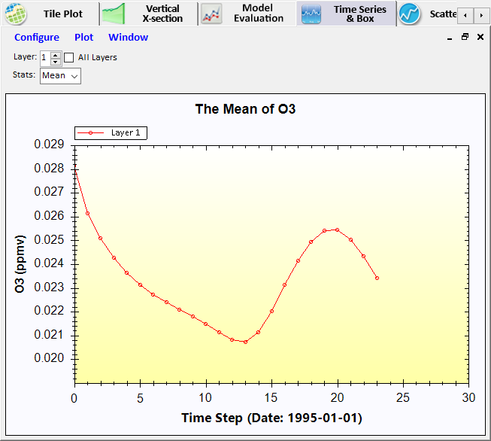
Figure 8.4-6. Non-Step Line
Bar Chart:
The time series bar chart shows average values over time in a bar plot format (Figure 8.4-7) rather than a line format. Other than that, the description of this plot type is the same as for the time series line plot.
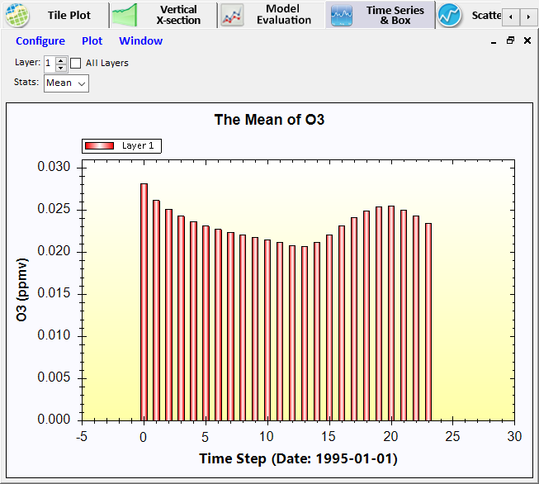
Figure 8.4-7. Non-Step Line

There are two ways to add Box Chart:
1) Select a grid cell at the map of Tile Plot and then click Plot Time Series Time Series Bar of Probed Cell(s) (Figure 8.4-8).
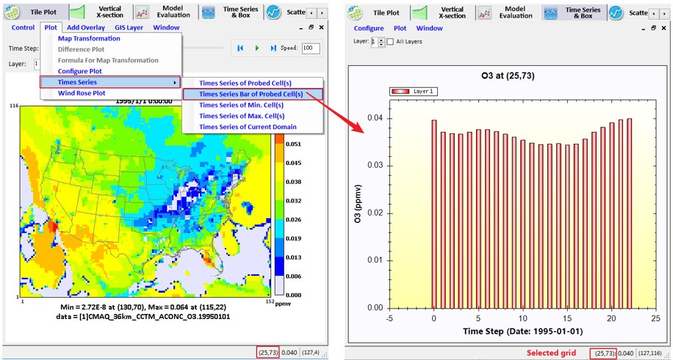
Figure 8.4-8. Select a Grid Cell to Add Bar Chart
2) Transform Time Series Plot to Box Chart by Clicked the Bar Chart under Plot in the Time Series & Box (Figure 8.4-9).
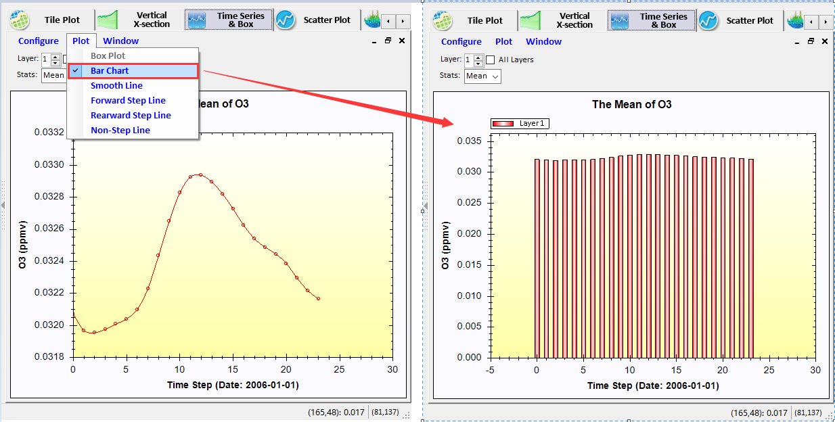
Figure 8.4-9. Transform Time Series Plot to Bar Chart
There are two ways to add Box Plot:
1) Mouse right-click a variable in the list box of variable, and select Add Variable to Box Plot (Figure 8.4-10).
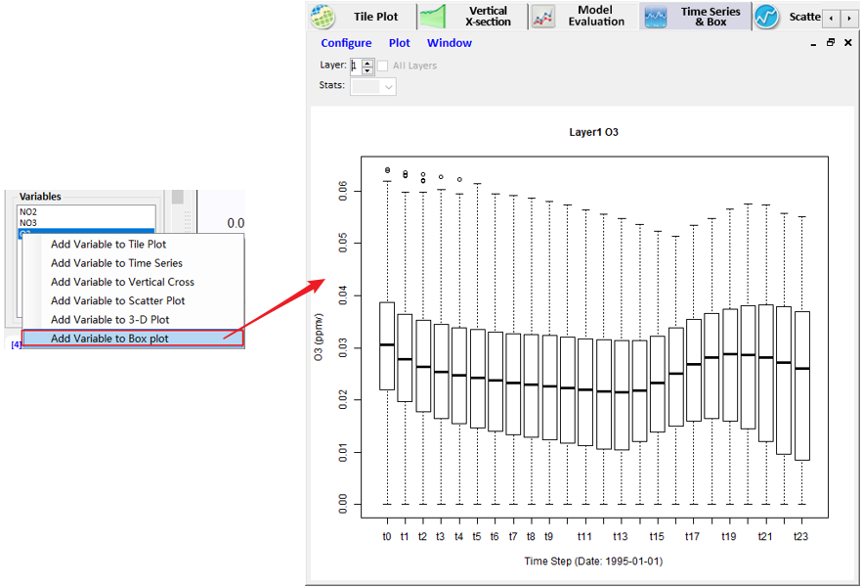
Figure 8.4-10. Select a Variable to Add Box Plot
2) Transform time series plot to box plot by Clicked the Bar Plot under Plot in the Time Series & Box (Figure 8.4-11).
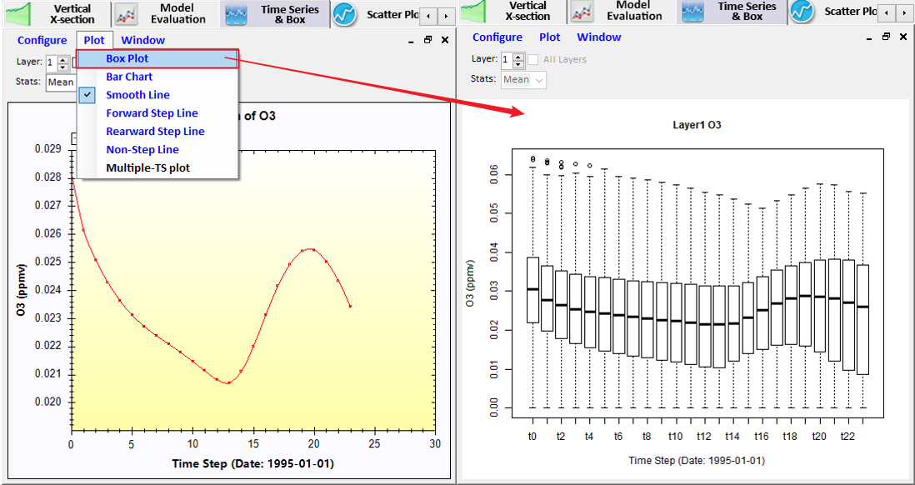
Figure 8.4-11. Transform Time Series Plot to Bar Chart
The current layer can be changed using the Layer spinner control above the plot. The layer value listed in the title is updated when you change the layer. If you want to see all layers plots, you can tick the All Layers (Figure 8.4-12).
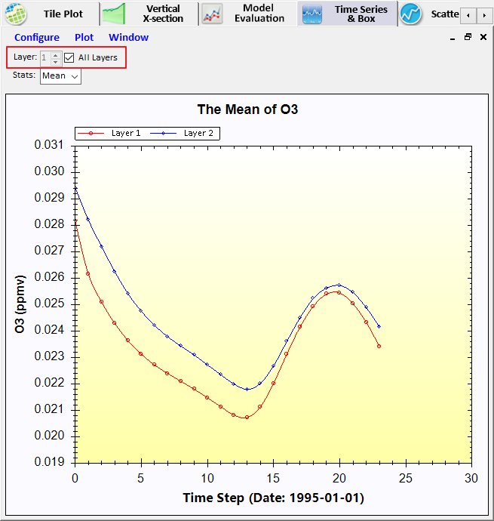
Figure 8.4-12. Plot Shows All Layers

Grid Cell Time Aggregate Statistics
The pull-down menu option labeled Stats provides the option to display grid cell time-aggregate statistics. In this version, the function is only enabled in time series plot (Figure 8.4-13).
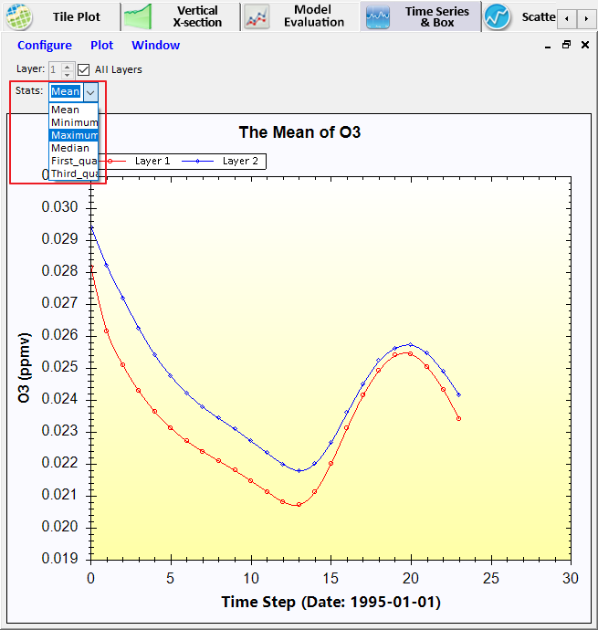
Figure 8.4-13. Plot Shows Different Stats
Model-VAT calculates the grid cell time aggregate statistics as follows: For each cell (i,j,k) in the currently selected domain (independent of neighboring cells), the aggregated statistical value is calculated over the currently selected time steps. In other words, the aggregated statistical value is calculated for the plotted formula for cells (i,j, k,tmin...tmax), with the number of time steps n, where n= (tmax-tmin+1).
- MINIMUM: min (var(i,j,k,tmin), var(i,j,k,tmin+1), ..., var(i,j,k,tmax))
- MAXIMUM: max (var(i,j,k,tmin), var(i,j,k,tmin+1), ..., var(i,j,k,tmax))
- MEAN: SUM / n
- MEDIAN: value at 50th percentile of (sorted {var(i,j,k,tmin), var(i,j,k,tmin+1), ..., var(i,j,k,tmax)})
- FIRST_QUARTILE: value at 25th percentile of(sorted (var(i,j,k,tmin), var(i,j,k,tmin+1), ..., var(i,j,k,tmax)))
- THIRD_QUARTILE: value at 75th percentile of(sorted (var(i,j,k,tmin), var(i,j,k,tmin+1), ..., var(i,j,k,tmax)))

Scatter Plot
The Scatter Plot module shows the relationship between two formulas using dots by scatter plots or density scatter plots.
There are two ways to add a scatter plot:
- Mouse right-click a variable in the list box of variable, and select Add Variable to Scatter Plot (Figure 8.5-1).

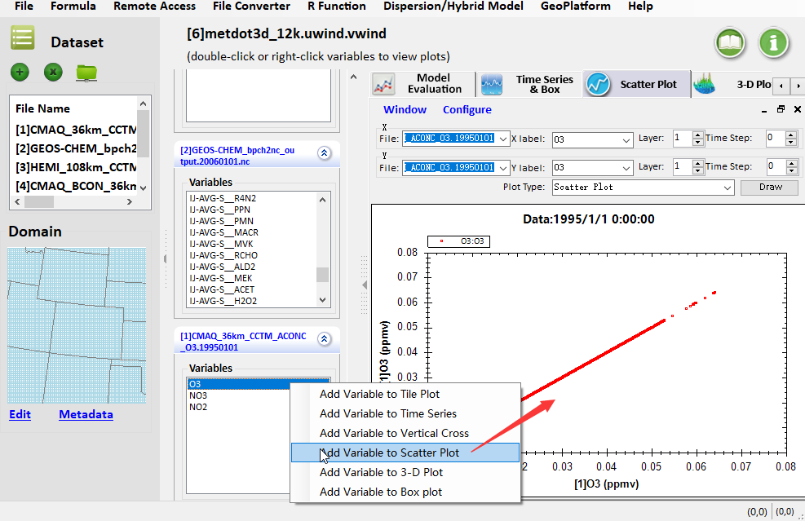
Figure 8.5-1. Select a Variable to Add Scatter Plot
2) Switch to Scatter Plot tab page and double-click a variable in the list box of variable (Figure 8.5-2).
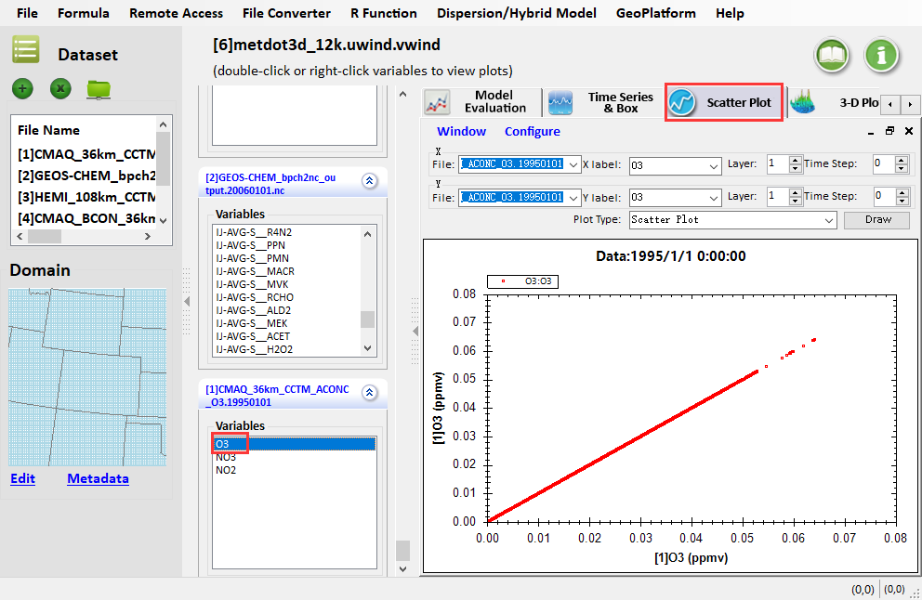
Figure 8.5-2. Add Scatter Plot under Scatter Plot Tab Page
Click drop-down arrow and select Density Scatter Plot to add density scatter plot.
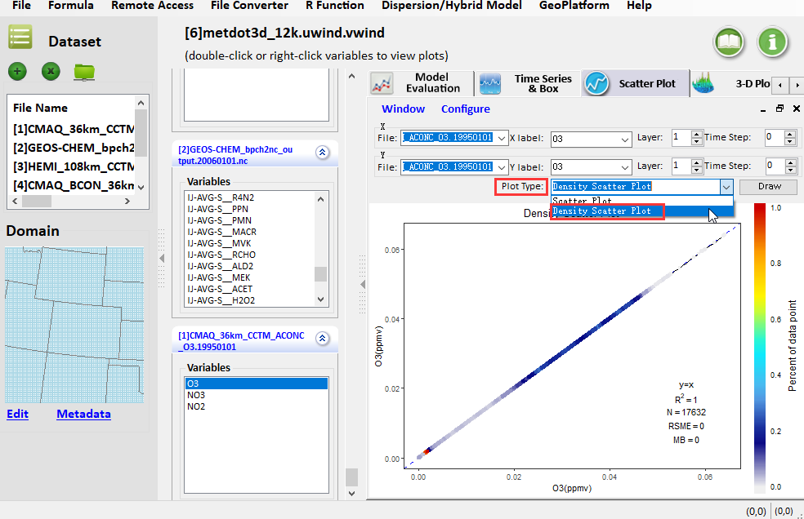
Figure 8.5-3 Add Density Scatter Plot
You can specify X File, Y File, X label, Y label, Layer and Time Step at the top of the plot. The X label (or Y label) can be adjusted by the pull-down menu. The current time step and layer can be adjusted using the spinner controls.

3-D Plot
The 3-D Plot displays the data with stereogram (Figure 8.6-1). There are two ways to add a scatter plot:
1) Mouse right-click a variable in the list box of variables, and select Add Variable to 3-D Plot (Figure 8.6-1).
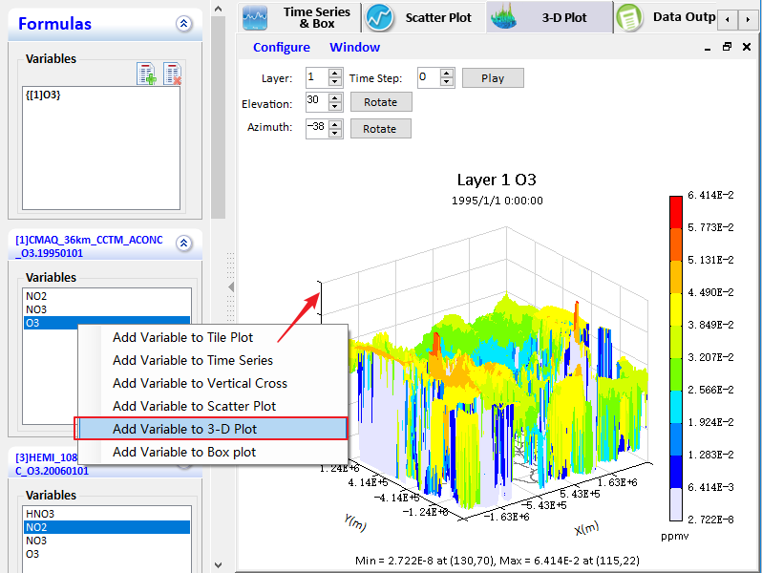
Figure 8.6-1. Select a Variable to Add 3-D Plot
2) Switch to 3-D Plot tab page and double-click a variable in the list box of variable (Figure 8.6-2).
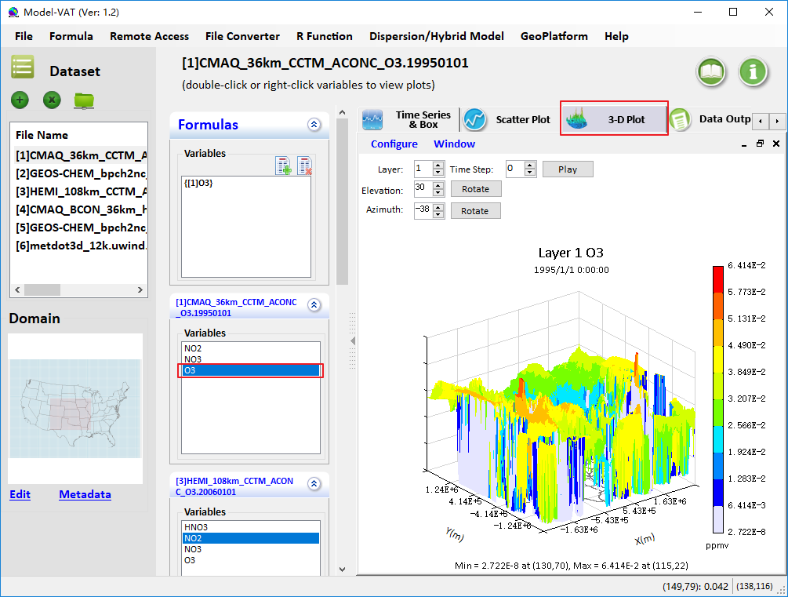
Figure 8.6-2. Add 3-D Plot under 3-D Plot Tab Page

Data Output
The Data Output shows detailed data of variables of selected dataset. In the Data tab page, click a dataset on Dataset pane and its variables will be loaded (Figure 8.7-1). You can check one or more variables and click Apply, and the values of these variables will be shown in the right data table. Time step and layer can be adjusted using spinner controls below the list of variables. Users can export selected data by clicking Export button.
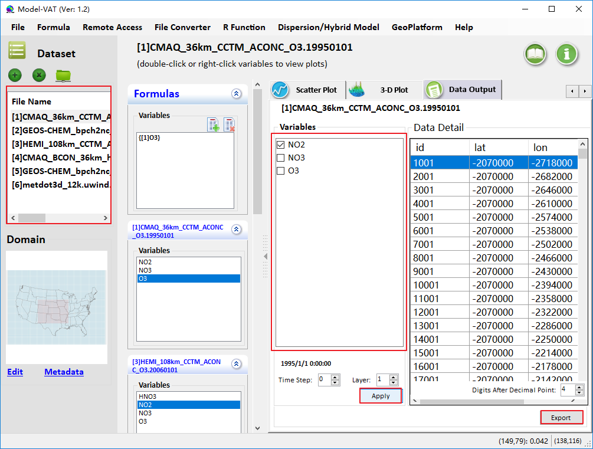
Figure 8.7-1. Data Output Tab Page

Color Map
This tab provides many widgets for you to configure your legend colors, break points, range, etc. Users can select the number of tiles, the palette type to be used, the color interval, the number format, and the scale. Double-click the legend or click the Configure Plot under the plot to open Configure Plot window (Figure 8.8-1).
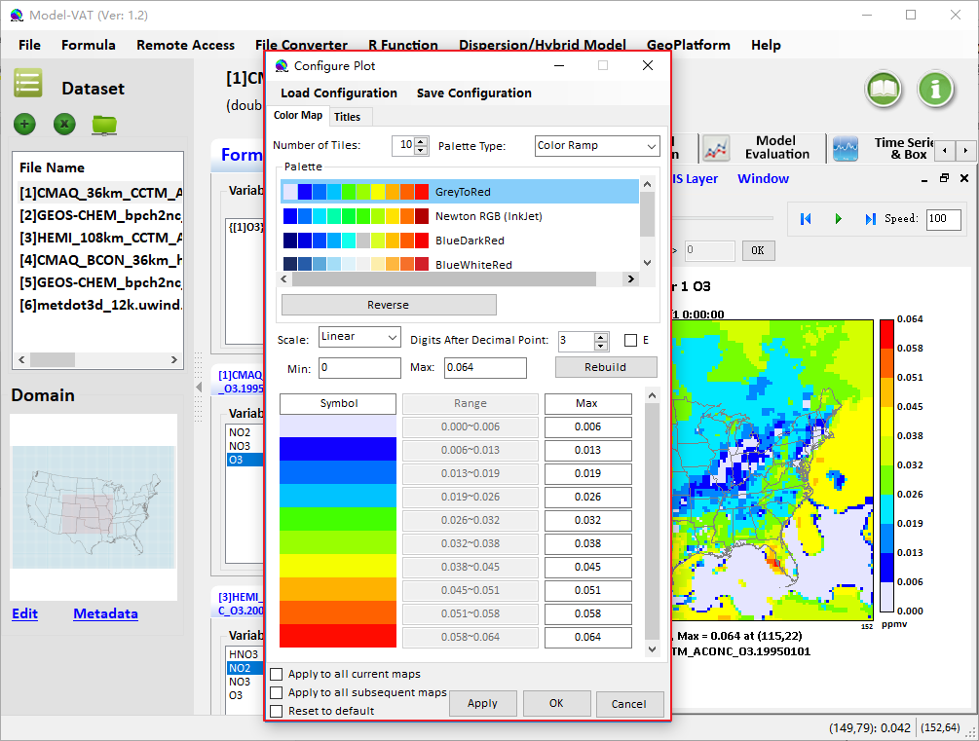
Figure 8.8-1. Configure Plot, Color Map Tab
- Load Configuration: Click to open an existing configuration in user’s computer.
- Save Configuration: Click to overwrite the old configuration.
- Number of Tiles: Start by selecting the number of tiles. Options in some other selections, such as the available palettes and break points, change as you vary the number of tiles.
- Palette Type: Four palette types are available: Color Ramp, Single Sequential, Double Sequential, and R Scale. Color Ramp has a mixture of colors. Single Sequential has a dark color on one end (typically the maximum) with lighter shades of the same color proceeding to the lightest shade at the minimum. Double Sequential has two dark colors at the maximum and minimum of the range and light colors in the middle. R Scale be printed in grayscale and color-blind friendly which are available in an R package. The color palette that is frequently associated with air quality modeling results is one of the Newton RGB palettes of the Sequential type.
- Reverse: The reverse button reverses the order of the colors in the selected palette. For example, if a sequential palette is used, the reverse button changes the color intensities such that the darkest color is at the minimum instead of the maximum of the scale.
- Scale: Select either Linear or Logarithmic. The interval start values are automatically adjusted when you change the scale.
- Digits after Decimal Point: Adjust the digits after decimal point.
- Min and Max: The minimum and the maximum values are computed for the data to be plotted. If you set the Interval to Automatic, you can change the values for the minimum and maximum. Then, press the Rebuild button and the Apply button to see your changes both in the legend and on the map. You cannot edit the minimum or the maximum value if the Interval is set to Custom. Instead, directly edit the Interval Start values; the Interval Start value for the lowest interval is the same as the minimum value.
- Rebuild: The Rebuild button is either active or inactive (i.e., grayed out) depending upon what other widgets are active. If you make changes and the Rebuild button is active, press it before continuing.
- Apply for all maps: Check to apply the old configuration for all maps.

Map Transformation and Resolution
Generally, different air quality models are in different output file formats, grid resolutions, model fields, coordinate systems, etc. It is difficult to make the comparison of the differences between these heterogeneous model data. Different types of air model data must be consistent in these aspects in order to make a comparative analysis. The Map transformation of Model-VAT is developed to convert two or more different model output into the same projection and resolution to make comparison. In this module, it supports to compare with multi-scale models such as CMAQ, H-CMAQ, CAMx, WRF, and GEOS-Chem, and hybrid modeling of CMAQ/AERMOD. Note that those binary model files (e.g., GEOS-Chem) which are not in the Input/output Applications Programming Interface (I/O API) and netCDF format need to be converted to netCDF format first using the File Converter module.

Map Projections
On Tile Plot tab page, you can use Map transformation to unify two or more plots into the same projection and resolution. This contributes to comparison between plots with different projections.
To open map transformation window, there are two ways as follows:
- Choose the active window and then click Plot to select map transformation. (Figure 9.1-1)
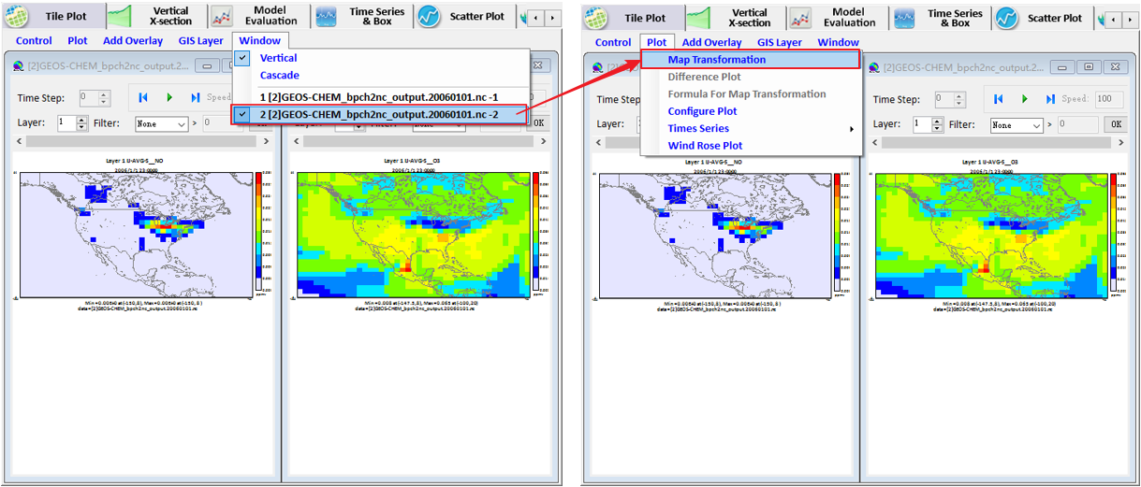
Figure 9.1-1. Choose an Active Window to Open Map Transformation
- You can also right-click a plot and select map transformation.
On the pop-up Map Transformation window, it is divided into Current Projection and Target Projection. Both of them display their grid type, projection name, and details. Choose a target projection and click the OK button (Figure 9.1-2).
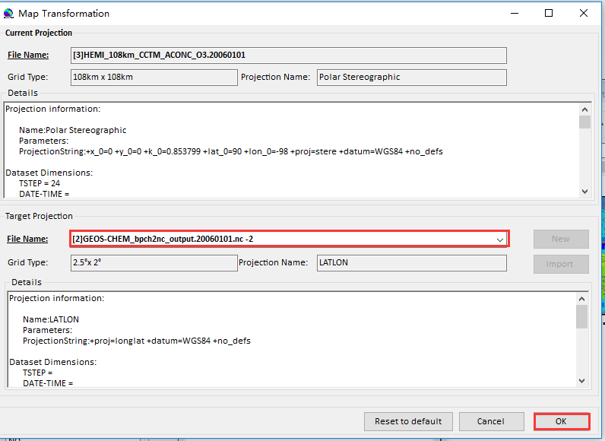
Figure 9.1-2. Choose Target Projection
Figure 9.1-3 and Figure 9.1-4 shows the plots before and after map transformation.
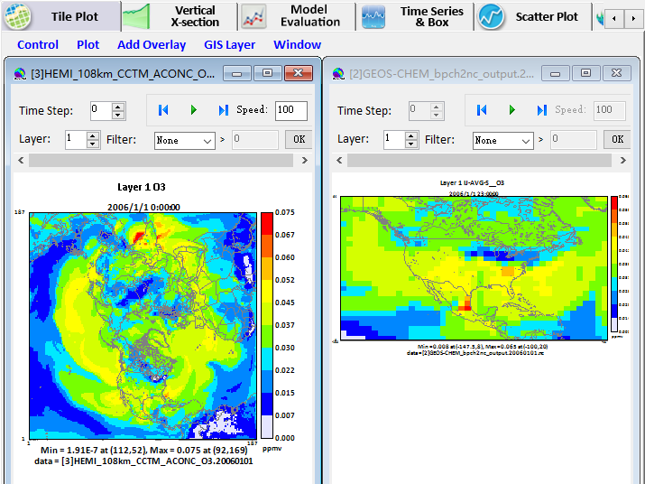
Figure 9.1-3. Plots before Map Transformation
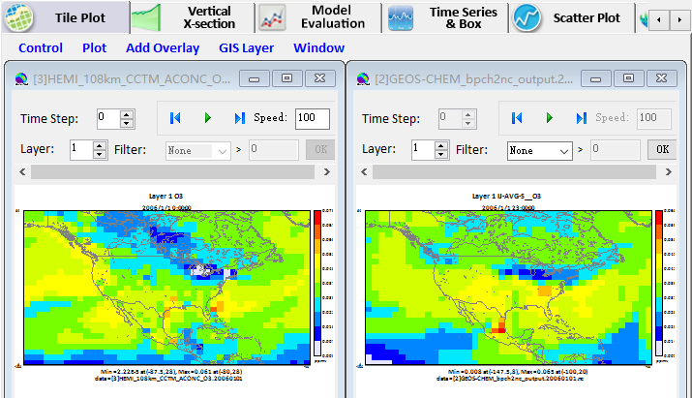
Figure 9.1-4. Plots after Map Transformation

Different Plot for Map Transformation
There are two ways to show different plots for Map Transformation:
1) First select target projection plot as active window and then click Plot to choose Different Plot for Map Transformation.
2) In target projection plot, right click to select Different Plot for Map Transformation.
Figure 9.2-1 shows the differences among different plot, target projection plot, and source projection plot.
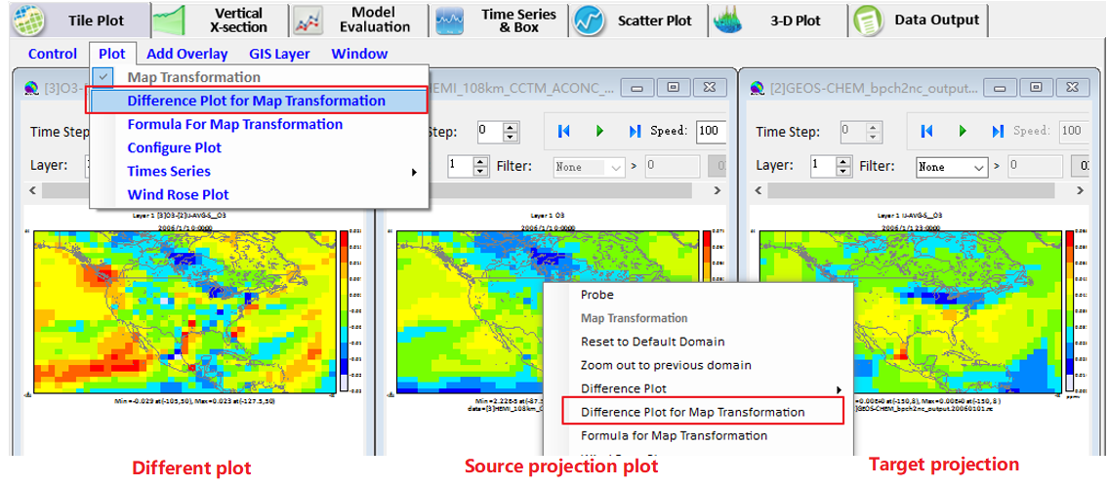
Figure 9.2-1. Different Plot, Source Projection Plot, and Target Projection Plot

Reset to Default
If you want to reset the plot to default projection and resolution, you can use Reset to Default.
You can reset to default domain and grid type in two ways:
- Mouse right-click the transformed plot and select Reset to Default Domain. This way only works for current window (Figure 9.3-1).
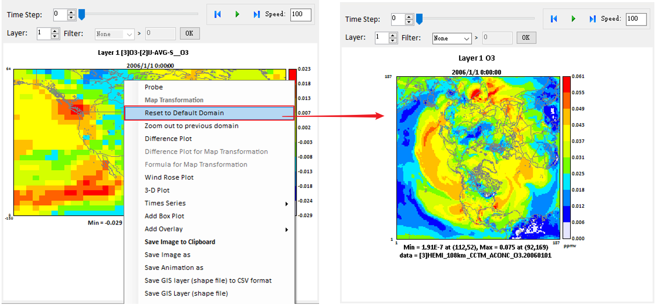
Figure 9.3-1. Reset to Default for Current Window

Mathematical Functions
All Model-VAT visualizations are the result of a formula evaluation. Formulas operate on the variables provided by the datasets. The simplest valid formula consists of a single variable; for example, {[1] O3} is the parameter O3 from current dataset 1. Using infix notation, you can construct more complicated formulas using the mathematical operators and functions listed below.
Listed in order of precedence, the functions and operators are:
- abs, sqrt, exp, log, log10, ln, sin, cos, tan, asin, acos, atan, sinh, cosh, tanh, avg, sum, min, max
- 10^ (power)
- /, *
- +, -
- <, <=, >, >=
- ==, !=
- &&
- ||
Model-VAT also supports the following constants:
- E 2.7182818284590452354
- PI 3.14159265358979323846

Unary Functions
Unary functions are passed a single argument. Depending on the argument and the function type, the function returns a single value or a matrix of data by performing the function on each cell of the arguments array. For example:
- sqrt ({O3 [1]}): Returns a matrix containing the square root of each value in the O3 [1] variable s array.
The following functions return a matrix when passed a dataset variable:
- abs: Returns the absolute value of the argument
- sqrt: Returns the square root of the argument.
- log: Returns the base any logarithm of the argument.
- log10: Returns the base 10 logarithm of the argument.
- exp: Returns Euler s number raised the power of the argument.
- ln: Returns the natural logarithm of the argument.
- sin: Returns the sine of the argument. The argument is in radians.
- cos: Returns the cosine of the argument. The argument is in radians.
- tan: Returns the tangent of the argument. The argument is in radians.
- asin: Returns the arcsine of the argument.
- acos: Returns the arccosine of the argument.
- atan: Returns the arctangent of the argument.
- sinh: Returns the hyperbolic sine of the argument.
- cosh: Returns the hyperbolic cosine of the argument.
- tanh: Returns the hyperbolic tangent of the argument.
The following functions return a single number in all cases when passed a dataset variable:
- avg: Average cell value for all cells in currently selected domain.
- sum: Sum of all cell values in currently selected domain.
- min: For each cell (i,j,k) in the currently selected domain, this calculates the minimum value for that cell over the currently selected time steps. In other words, the minimum value in cells (i,j,k,tmin tmax).
- max: For each cell (i,j,k) in the currently selected domain, this calculates the maximum value for that cell over the currently selected time steps. In other words, the maximum value in cells (i,j,k,tmin tmax).

Binary Operators
Binary operators do not pass a value but operate on the operands to their left and right. Typically, they return a matrix of data by performing the operation on each cell of the operand’s arrays. If both of the operands are single numbers, then these binary operators return a single number. For example:
- {[1]O3} * 2: multiplies each item in the {[1] O3} array by 2 and returns the result.
- {[1]O3} * {[3] O3}: multiplies each item in the {[1] O3} array by the corresponding item in the {[3] O3} array and returns the result. (Note that this assumes that the arrays are of equivalent shape.)
- 3 * 2: multiplies 3 by 2.
The binary operators:
- + Returns the sum of the operands
- - Returns the difference of the operands
- * Returns the product of the operands
- / Returns the ratio of the operands

Boolean Operators
Boolean binary operators return either 1 or 0 in each cell of the resulting matrix. If the operands are single numbers, then a single 1 or 0 is returned. The Boolean binary operators:
- < Returns 1 if the left operand is less than the right operand, else 0
- <= Returns 1 if the left operand is less than or equal to the right operand, else 0
- > Returns 1 if the left operand is greater than the right operand, else 0
- >= Returns 1 if the left operand is greater than or equal to the right operand, else 0
- != Returns 1 if the left operand is not equal to the right operand, else 0
- == Returns 1 if the left operand is equal to the right operand, else 0
- && Returns 1 if both operands are nonzero, else 0
- || Returns 1 if either operand is nonzero, else 0

