BeyondTrust EndPoint Privilege Management Client (EPM)
Quick Guide for Field Ops Users

Summary:
This document is a guide on what Field Ops Users will experience with the new BeyondTrust Endpoint Privilege Management Client (EPM).
The BeyondTrust Endpoint Privilege Management Client (EPM) is an upgrade to the BeyondTrust PowerBroker Client.
The application will give Field Ops Users the ability to run applications that require elevated privileges when needed.
Procedure:
When a member of the Field Ops groups right-click on an application to elevate privileges, the “Run Elevated – Field Ops” option is available.
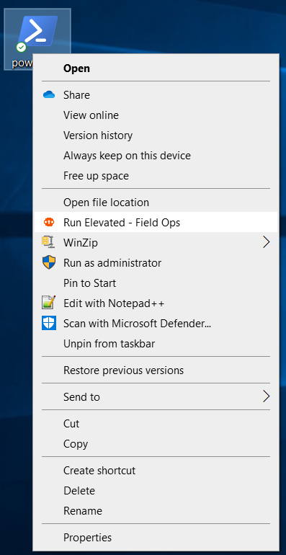

After choosing the “Run Elevate – Field Ops” option, a window with a drop-down menu will appear that will ask to “Please choose a reason” for justifications.
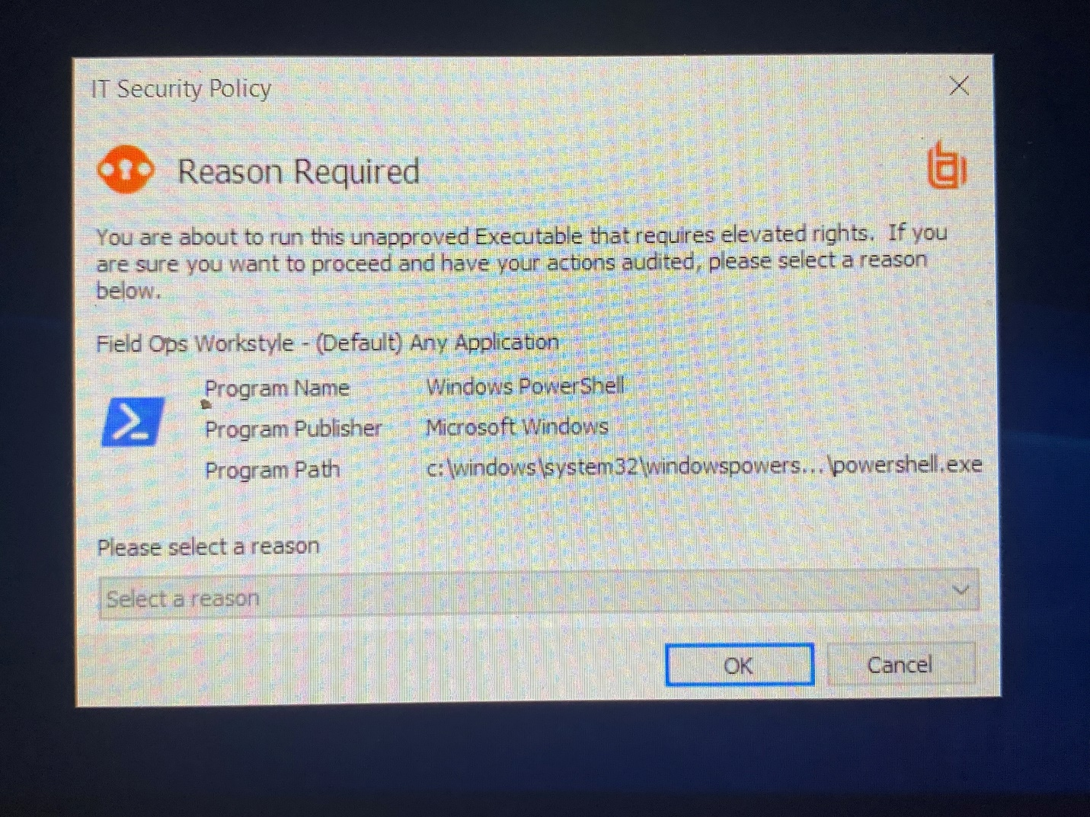

Select a reason and then click OK.
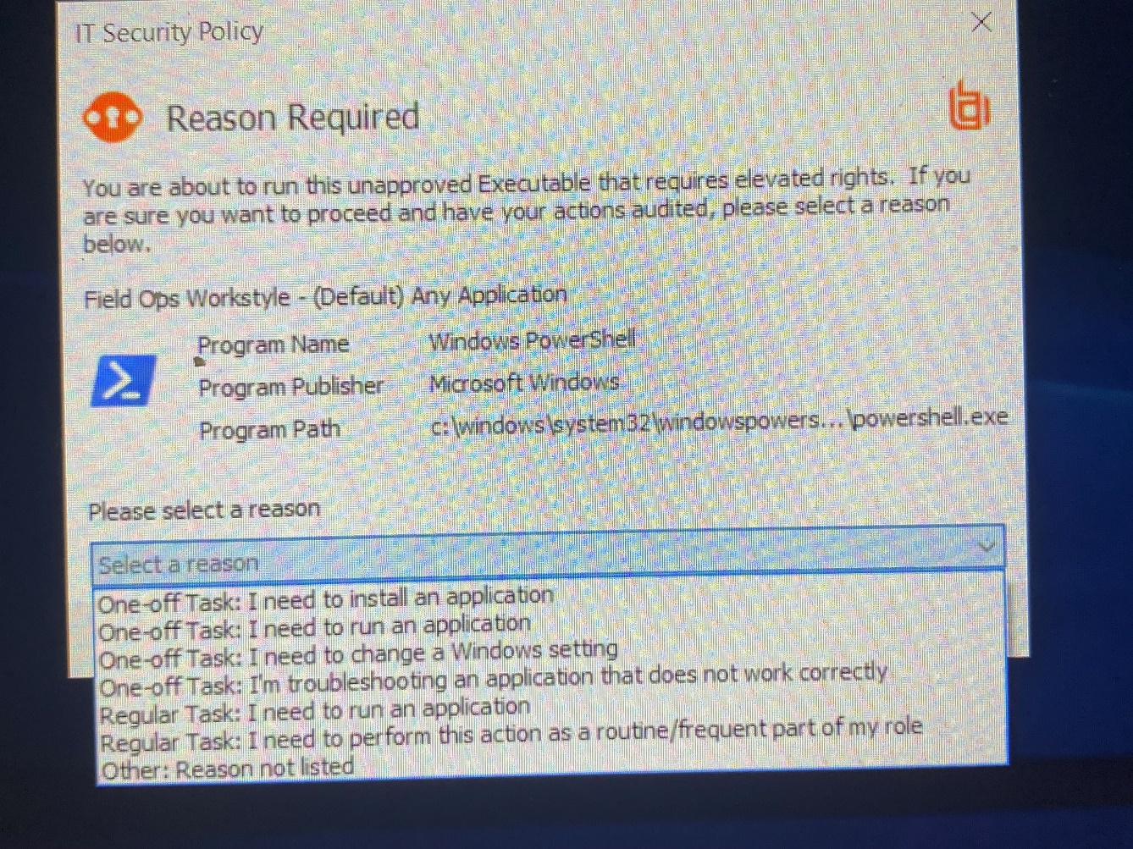

The application will now launch using elevated tokens provided by the BeyondTrust Endpoint Privilege Management Client (EPM).
