NEXUS Multi-Pollutant Screening Tool | - an advanced screening tool for Supporting  - multi-pollutant Air Quality Management & Planning
Multi-Pollutant Background
EPA OAQPS supports a comprehensive, multi-pollutant (MP) approach to our nation’s air quality problems to improve air quality and make more efficient use of available resources. The primary goal of multi-pollutant planning is to identify and evaluate local control strategies targeting emissions of ozone and PM_{2.5} and their precursors, while at the same time reducing air toxics of concern for communities to maximize both air quality improvements and public health benefits. Shifting away from the traditional pollutant-by-pollutant approach, multi-pollutant planning has the potential to reduce costs and increase benefits associated with air quality management.

Tool Motivation
Multi-pollutant air quality issues are complex. EPA has identified the need for a user-friendly tool that integrates multiple data sets to help understand the nature of a MP problem while working effectively with state, local and tribal (SLT) air agencies and/or local communities. NEXUS is being developed to identify geographic areas where health risks related to ozone, PM_{2.5} and air toxics overlap (the NEXUS), inform users about the nature of an area’s multi-pollutant air quality issues, and support EPA efforts with SLT air agencies for developing multi-pollutant control strategies.

NEXUS
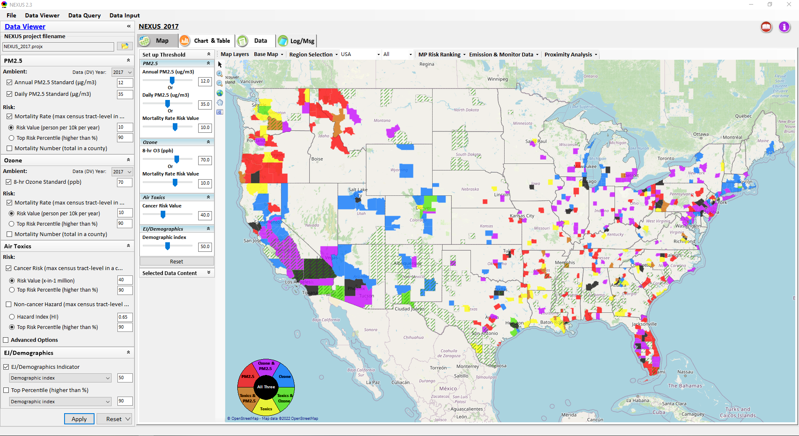
NEXUS is an advanced screening tool with the unique ability to access and display multiple data layers in a single platform, including criteria and toxic pollutant emissions, concentrations, and risk data; criteria and toxic pollutant monitoring data; Environmental Justice (EJ)/demographic and climate change indicators; nonattainment and advance areas, tribal area boundaries, and Class I areas. NEXUS allows flexible selections of air quality metrics for the identification and screening of areas with multipollutant air quality issues (ozone, PM_{2.5} and air toxics) to assist EPA and others in determining whether a multi-pollutant, risk-based approach might be of value for that area to pursue. NEXUS provides maps, charts, and tables to display information about potential issues across a region and allows screening of specific areas to identify viable candidates for which users can pursue more detailed investigations and collaboration(s) with SLT agencies. A proximity screening analysis module was recently developed to facilitate community-level multi-pollutant planning and environmental justice analyses.

Next Steps
OAQPS recently engaged with EPA Regional Offices to share version 2.0 of the NEXUS tool, summarized feedback received, developed a list of prioritized improvements, and convened a group of Regional Beta Testers to guide development and review of NEXUS 3.0. In the coming months, additional climate vulnerability analysis and risk indicators (e.g., heat index, fire, drought, heat stressor, etc.) will be added to NEXUS as they are incorporated into EJSCREEN and other EPA tools.

FAQs

Is NEXUS publicly available?
Currently, NEXUS is only available for download by EPA staff. We are also exploring the potential of developing a “web-based” NEXUS platform to provide an “easy access” (no installation required) and “cross-platform” (not limited to Window-OS) version of the NEXUS tool in the future, dependent on resource availability.

How can I access NEXUS?
On an EPA computer, NEXUS can be self-installed if you have administrator privileges or similar arrangements (e.g., Powerbroker installation privilege). If you are unsure if you have these privileges and your attempt to install fails, you will need to contact EPA IT Support (EISD) and request installation and fill out an EISD Freeware/Shareware Application Request Form. An SharePoint site (internal to EPA only) has been created to download and install the latest version of the NEXUS package (“NEXUS *.* Setup.exe” & “NEXUS *.* Data.exe”) together with NEXUS quick tutorial and User’s Mannual. Both of the “*.exe” files must be downloaded and run to install NEXUS. To confirm proper installation, check “This PC\Documents\My NEXUS files\” to confirm that the NEXUS program and input datasets below were installed successfully.
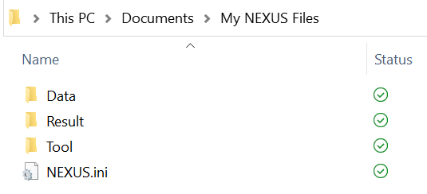
Will NEXUS training be provided?
OAQPS is currently providing briefings and demonstrations for management and EPA regional offices. In addition to live demos, a “User’s Manual” and “Quick Tutorial PPT” is accessible in all versions of NEXUS that explains how to use the tool. In the future, we will explore additional training opportunities such as recorded webinars and online courses.

Will OAQPS help with multi-pollutant projects if we identify an area using NEXUS?
Successful multi-pollutant approaches to air quality management have been demonstrated through a proof-of-concept pilot project in Detroit, in the upstate South Carolina region, and a project currently underway in Louisville. OAQPS is interested in continuing to advance our multi-pollutant work in conjunction with the EPA regions utilizing the NEXUS tool by providing ongoing input and consultation to the regions and SLTs, as typically done for implementation efforts. For this reason, we will also be focusing our initial efforts on training, as mentioned above, that will empower the EPA regions to work directly with their SLT air agencies on multi-pollutant approaches with minimal oversight from OAQPS.

What is the difference between EJSCREEN and NEXUS?
The NEXUS advanced screening tool combines and displays publicly available air quality information to identify geographic areas where health risks related to O₃, PM_{2.5} and air toxics overlap, while EJSCREEN combines environmental and demographic data to highlight areas where vulnerable populations may be disproportionately impacted by pollution. NEXUS incorporates the EJ indicators and data from EJSCREEN, enabling it to overlay these indicators to understand the demographics of areas with multi-pollutant air quality concerns. NEXUS contains the same air pollution environmental indicators provided to EJSCREEN by OAQPS (e.g., O₃ and PM_{2.5} modeled concentration data, AirToxScreen cancer and non-cancer risk, etc.). NEXUS also contains emissions and risk data not available in EJSCREEN (detailed emissions and source characterization, O₃ and PM_{2.5} risk data, AirToxScreen cancer and non-cancer risk by pollutant and source). Recently, proximity screening capabilities similar to EJSCREEN have been incorporated into NEXUS. As additional climate vulnerability analysis and risk indicators (e.g., flood, drought, fire, sea level rise, etc.) are added to EJSCREEN, they will also be incorporated into NEXUS.
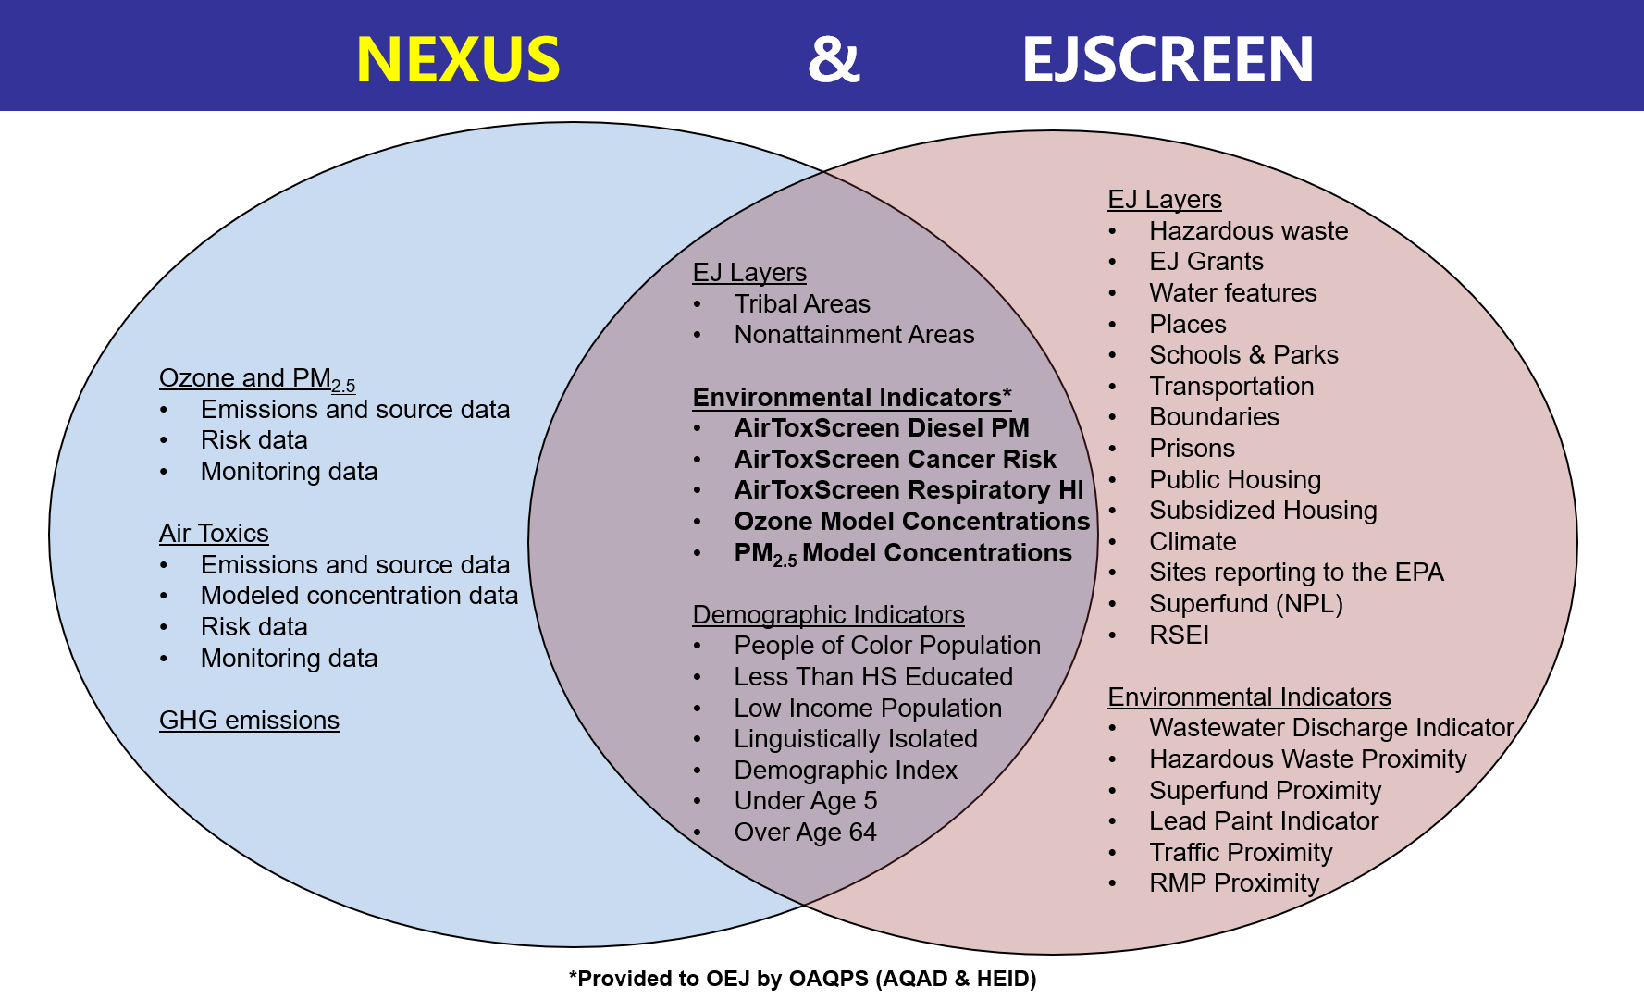

What data are included, where do they come from, what level of detail and version are included, and when will each dataset be updated?
All of the data available in NEXUS is publicly available. The tool consolidates the data into one easily accessible location. The data, source, level, vintage and plans for update/inclusion are included in the table below

Data | Source | Level of Data | Vintage in NEXUS | Plans for Update/Inclusion
O₃ and PM_{2.5} emissions and source data | NEI | County and facility-level | 2017 & 2014 | 2020 (expected summer 2023)
Air Toxics emissions and source data | NEI | County and facility-level | 2017 & 2014 | 2020 (expected summer 2023)
O₃ and PM_{2.5} modeled concentration data | Fused air quality surfaces | County/Census tract level | 2019/2018/2017 & 2014 | 2020 (expected Dec. 2023)
Air Toxics modeled concentration data | Hybrid CMAQ/AERMOD output for toxics | County/Census tract level | 2019/2018/2017 & 2014 | 2020 (expected Dec. 2023)
O₃ and PM_{2.5} risk data | BenMAP | County/Census Tract Level | 2019/2018/2017 & 2014 | 2020 (expected Jan. 2024)
Air Toxics risk data | AirToxScreen | County/Census Tract Level | 2019/2018/2017 & 2014 | 2020 (expected Jan. 2024)
Advance areas | OAQPS/AQPD | County level | 2021
Nonattainment Areas and Design Values (DV) | EPA Greenbook  Air Trends | County level | 2012-2020 | 2021 when data become available
Tribal boundaries | EPA Public Website | County level | 2018 | -
Socio-economic & demographic data | EJSCREEN | County/Census tract level | 2021 | Update to latest EJScreen when available (currently v. 2.1)
O₃ and PM_{2.5} monitoring data (DVs) | OAQPS/AQAD | Site-level | 2002-2020 | 2021 when data become available
Air toxics monitoring data (22 HAPs) | Air Toxics Data Archive | Site-level | 2003-2020 | 2021 when data become available
GHG emissions | NEI & GHG Inventory | County and facility-level | 2017 | NEI 2020 In discussion to harmonize with GHGRP data
Class I areas | EPA Class 1 Federal Areas Website | County level | 2016
CEJST disadvantaged community areas | CEJST data | Census tract level | 2021

How often will the data in NEXUS be updated?
OAQPS will continually update the data based on ongoing internal efforts that generate these data. Beginning in 2023, OAQPS will establish a routine schedule to provide these data based on a multi-pollutant platform such that the data feeding NEXUS will be updated annually (e.g., 2019 vintage in early 2023, 2020 vintage in early 2024, etc)

Will data be provided on a finer resolution for air toxics?
The existing air toxics data, as well as ozone and PM_{2.5}, reflect the “Census Tract–level”, which is consistent with current OAQPS release of annual air toxics data. The NEXUS tool provides the risk data across pollutants at the “County-level” (based on maximum census tract-level in the county). NEXUS’s recently developed “Proximity Analysis” module can provide an area with ability to conduct “community level” screening analysis based on the “Census Tract–level” data. The NEXUS tool will be updated to reflect the latest information once OAQPS transitions to public provision of the air toxics data (annual updates).

What tools are available for more refined analysis after using NEXUS?
NEXUS is an advanced screening tool that can help inform EPA and SLT air quality planners to then conduct a more focused refined assessment for a region or area that would involve the full suite of data/tools/models:
- O₃ and PM_{2.5}: Emissions (NEI, SMOKE/EMF) => Air Quality Models (CMAQ/CAMx) => Health Benefits (BenMAP)
- Air toxics: Emissions (NEI, SPPD rules, SMOKE/EMF) => Air Quality Models (CMAQ and AERMOD) => Risks Assessment (HEM/SaRA*/HAPEM/AirToxScreen)
*SaRA– The Source and Receptor Analysis (SaRA) Tool is in development and will provide actionable risk information for one or more facilities to assess risk and potential EJ concerns at a refined scale.
Who can I contact with questions or feedback regarding NEXUS?
Any questions or comments regarding NEXUS can be sent to the following:
- Carrie Wheeler (MP Team Lead) – wheeler.carrie@epa.gov
- Carey Jang (NEXUS Technical Development Lead) – jang.carey@epa.gov
- Kayla, McCauley (NEXUS Technical coordination Lead) - mcCauley.kayla@epa.gov

