Main Improvements of FAST-CE 3.4
By SCUT, 2023-04-13

Main Improvements:
- Extend to include the DDM/HDDM analysis, user can choose this option under “Source Contribution Method” panel.
  - Under “DDM/HDDM” option, input the “Source Apportionment Data Input File”, “Source Apportionment Mapping File” and “Region File” as required.
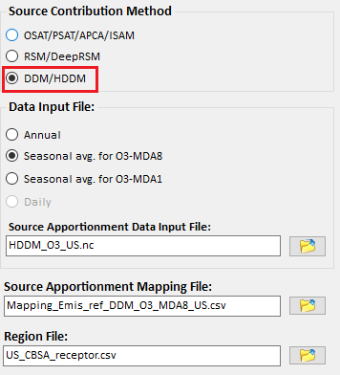
Fig. 1 “DDM/HDDM” option
  - Click the “Next” button, input the cases files.
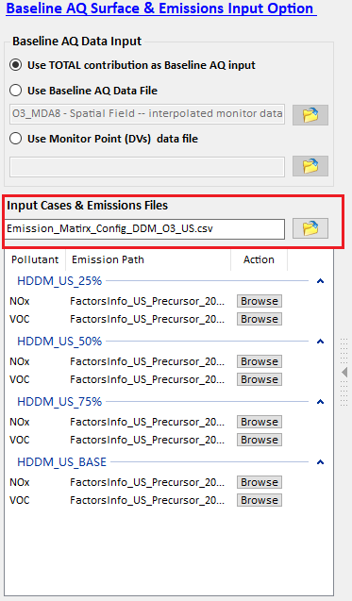
Fig. 2 “Baseline AQ Surface & Emissions Input Files” input option for “DDM/HDDM”
- Extend to include the DeepRSM analysis for “RSM” option under “Source Contribution Method” panel.
- Include two new cases for HDDM (US_HDDM_JUL_O3.proj) and DeepRSM (US_DeepRSM_JUL_O3.proj) option, respectively.
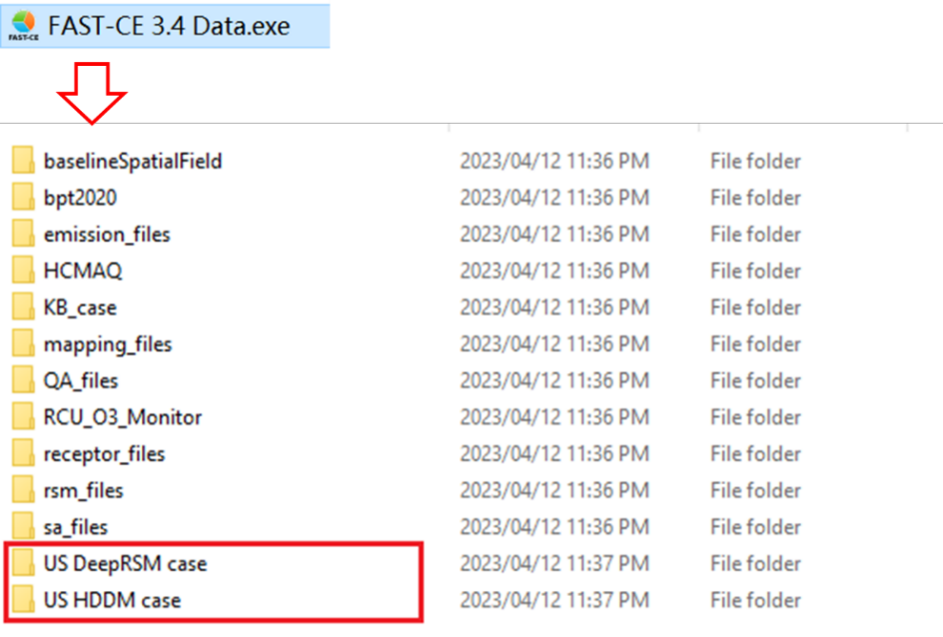
Fig. 3 Data for “DDM/HDDM” and “RSM/DeepRSM” module
- Change the original “Optional Receptor Region File” to “Region File” in “Source Contribution Method Option”, and add a new optional Receptor Region File as the default receptors under “Receptor Analysis” module.
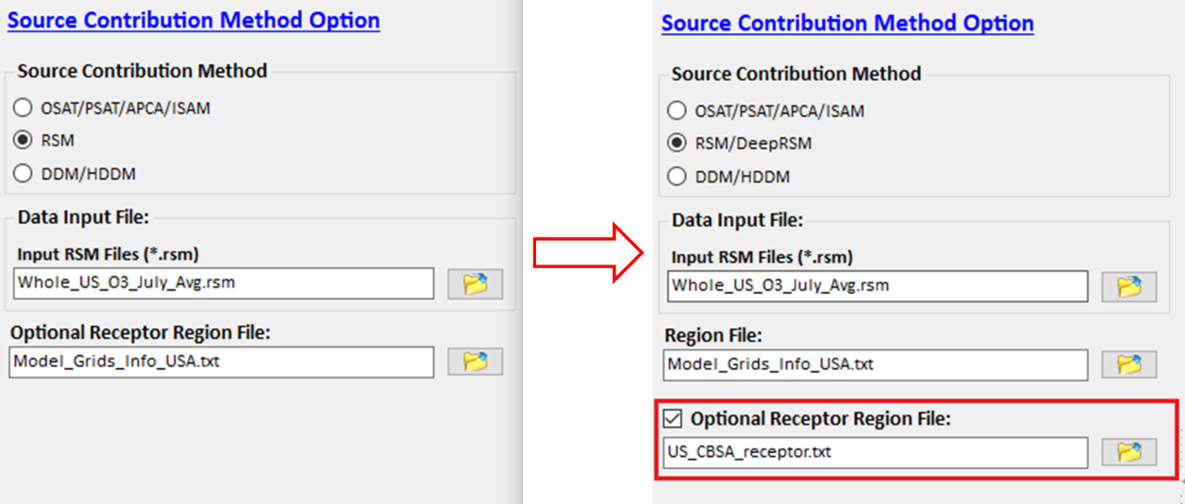
Fig. 4 Update the interface for RSM/DeepRSM analysis
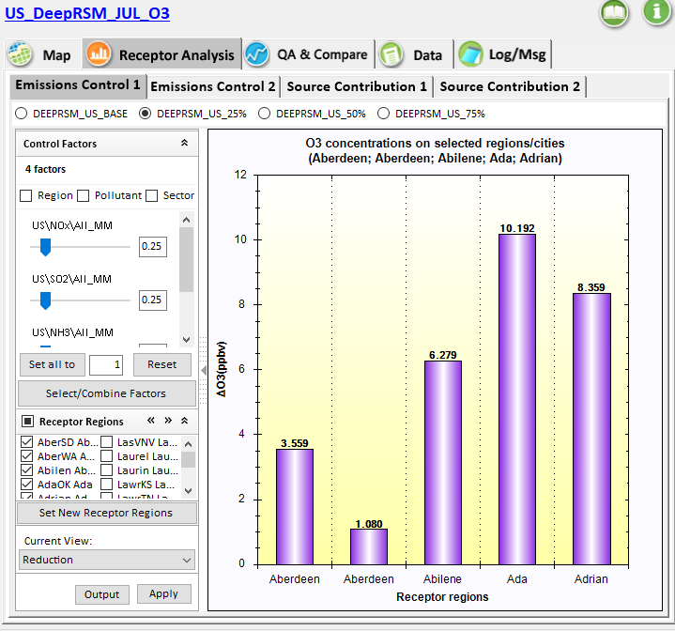
Fig. 5 Use the Optional Receptor Region File in “Receptor Analysis”

To Do List:
- Add the July 2018 US ISAM Case in FAST-CE.
- Develop a multi-method (DeepRSM, ISAM & HDDM) comparison “QA&Compare” module.

