Main Improvements of FAST-CE 3.5
By SCUT, 2023-04-21

Main Improvements:
- Add an option named “Show all tile labels” in configure plot to provide values to all ticks.
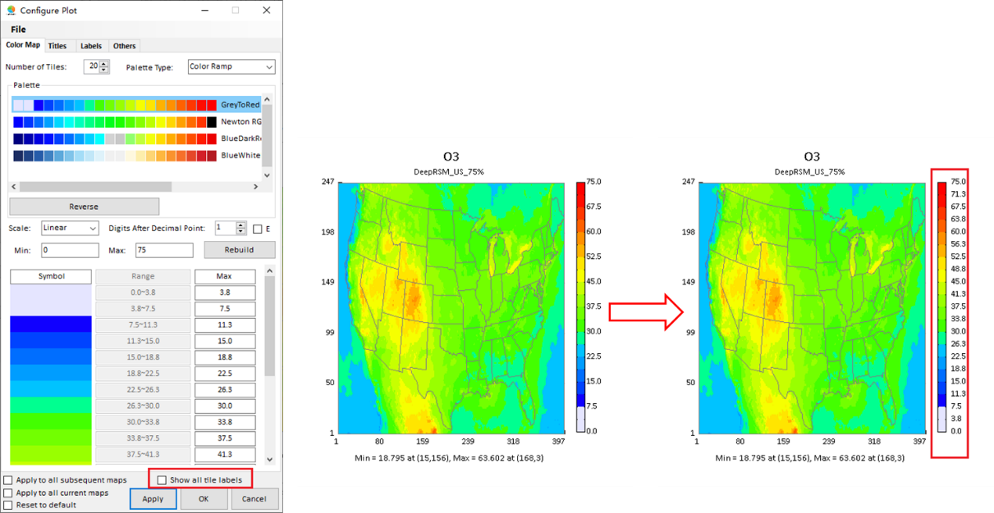
Fig. 1 New “Show all tile labels” checkbox
- Improve the display in “Receptor Analysis”: round the label of bars to 1 decimal place, and change the labels’ angle of x axis and bars when the selected receptor regions over than 10.
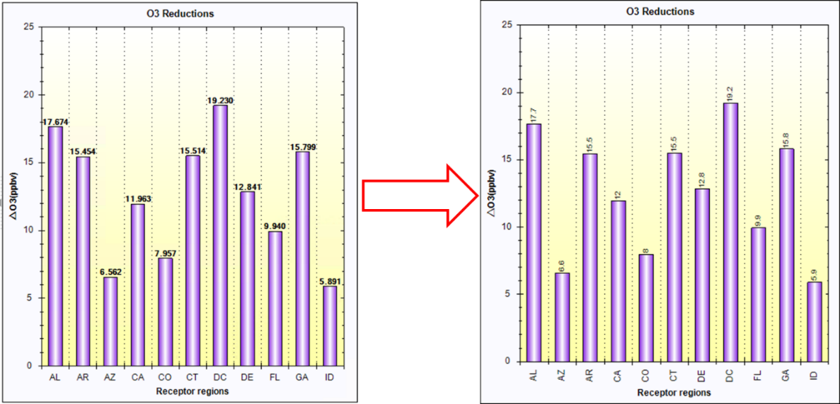
Fig. 2 Improvement of “Receptor Analysis” display
- Change all titles of “DEEPRSM” to “DeepRSM” in US_DeepRSM_JUL_O3 case.
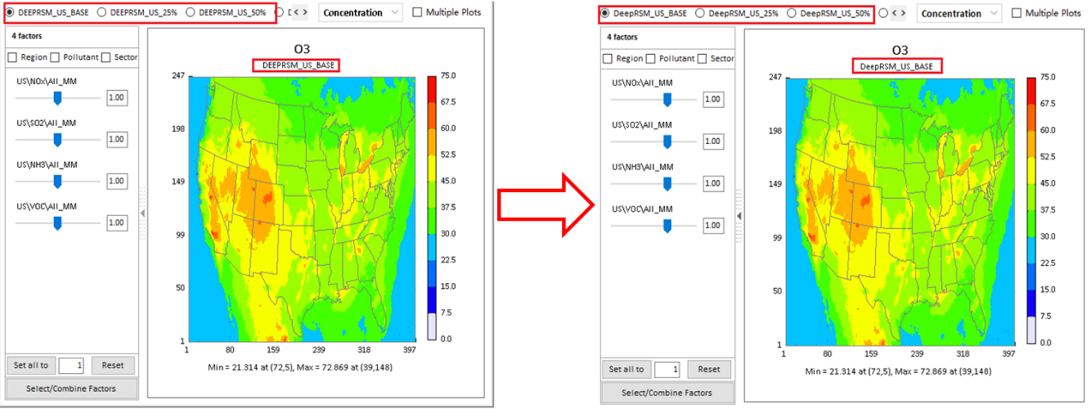
Fig. 3 Correct the “DEEPRSM” to “DeepRSM” in US_DeepRSM_JUL_O3 case
- Change the control value from 0.25 to 0.75 for “DeepRSM_US_25%” case and from 0.75 to 0.25 for “DeepRSM_US_75%” case, respectively. The same changes are made in US_HDDM_JUL_O3 case.
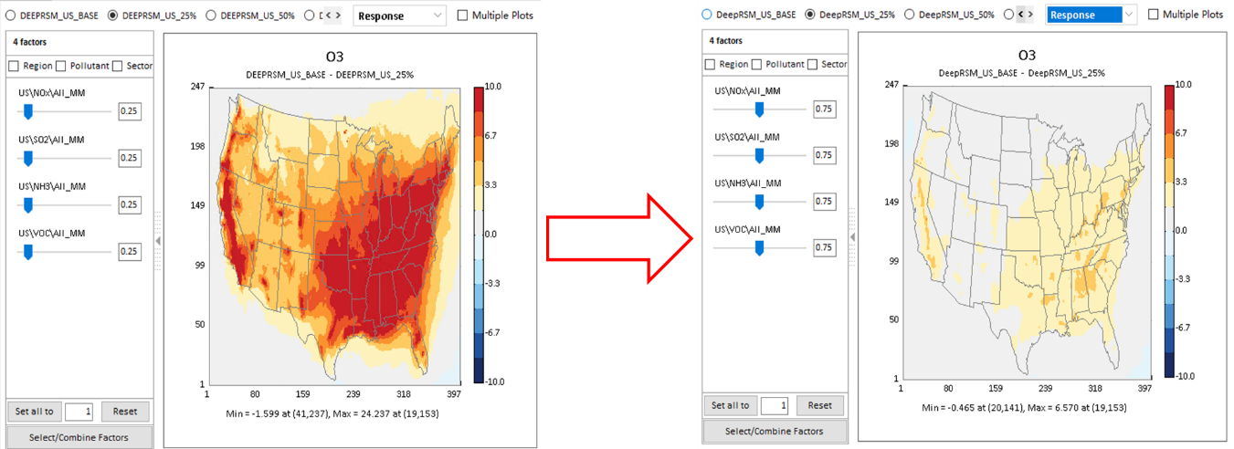
Fig. 4 Correct the control value in DeepRSM and HDDM cases
- Change the default “Response” map scale range to “-10 to +10” and number of tiles to “12” in DeepRSM and HDDM analysis.
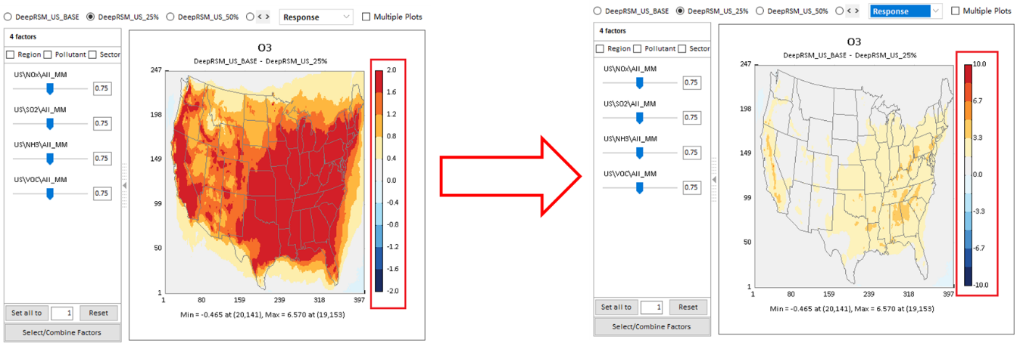
Fig. 5 Change the default map scale range DEEPRSM and HDDM cases
- Use the “US_states”as the default receptor area in US_DeepRSM_JUL_O3 and US_HDDM_JUL_O3 case.
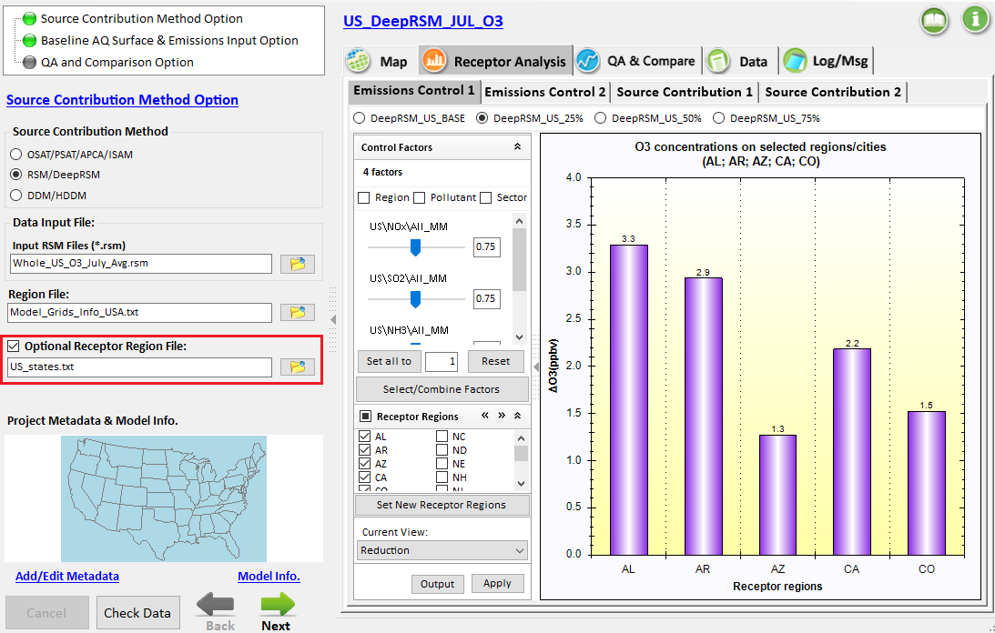
Fig. 6 Change the default receptors

To Do List:
- Add the July 2018 US ISAM Case in FAST-CE.
- Develop a multi-method (DeepRSM, ISAM & HDDM) comparison “QA&Compare” module.

