Main Improvements of FAST-CE 2.9
By SCUT, 2022-04-29

Main Improvements:
- Fix the bug that the project reading would not stop in last version.
- Improve the “EJ/Demographics Data” module:
- Allow to enable the “EJ/Demographics Data” module and choose the data input path in “Startup Option” Plot.
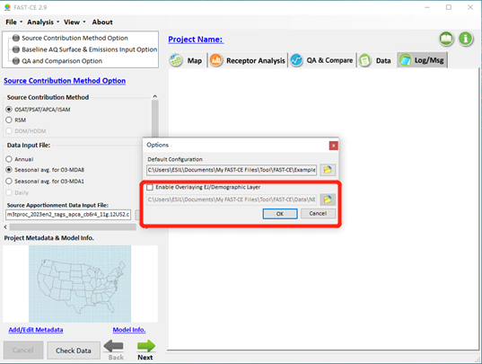
- Add a button “EJ/Demographics Data” to the “Right-click” menu with EJ/ Demographics information layer.
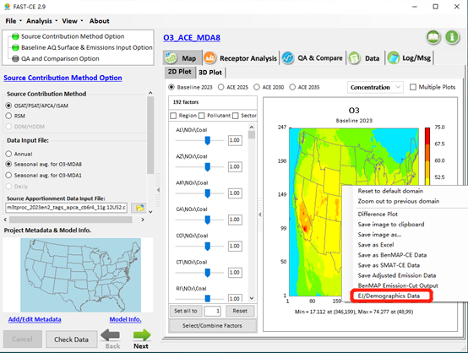
- When right-click the “EJ/Demographics Data”, user will be asked to set the EJ/Demographics Data. The “EJ/Demographics Data” layer will be de displayed.
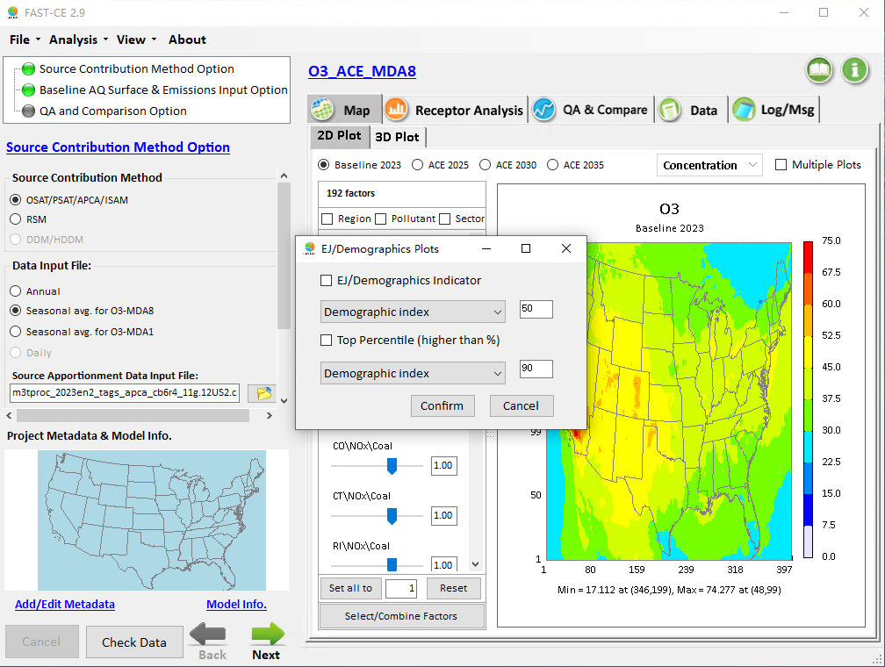
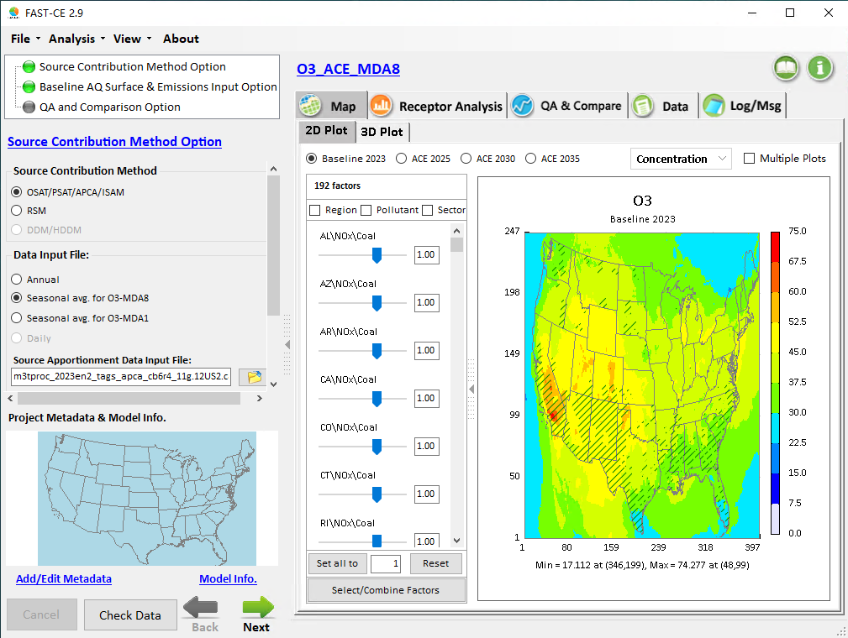

To Do List:
1.Gridding EJ/Demographics Data.

