Main Improvements of NEXUS 0.2
-February, 2020
- Fix the O3 8-hr DV problem:
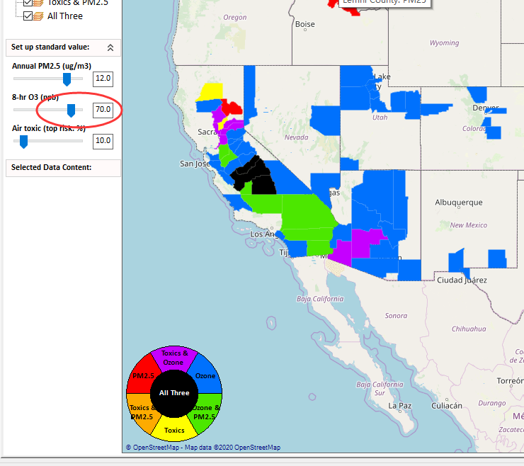
- Change the standard value
  - PM2.5: default = 12, max = 15
  - Ozone: default = 70, max = 80
  - Air Toxic: default = 10;
- Under “Data Input Panel”, change the label to “Annual PM2.5 Standard (ug/m3)”, “8-hr Ozone Standard (ppb)” and “Top Risk percentile (%)”; In next version, we will include “Daily PM2.5” option and update the GUI for this panel as suggested in the last e-mail.
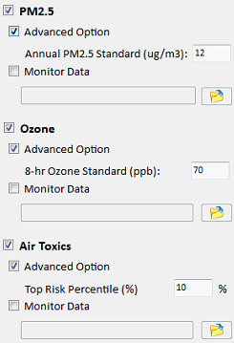
- Fix the bug that after the “File browser” is opened, the “*.gdb” file can not be loaded.
