Web-based NEXUS Publish Wizard
Prepared by SCUT,2023/2/7

The deployment of web-based NEXUS consists of four parts: (1) Geo server, (2) Back-end (server-side code), (3) Front-end (client-side code), and (4) Middleware: Nginx; Below are the details to introduce how to publish each part step by step.

Geo server
The Geo server is an open-source server for sharing geospatial data. In web-based NEXUS, it is used to publish tiles and caches map images from geospatial data (e.g., census tract boundary) to accelerate and optimize map image display.
- Download and install Java (jre1.8.0+). https://www.java.com/en/download/
- Download and install geo server stable release. https://geoserver.org/release/stable/
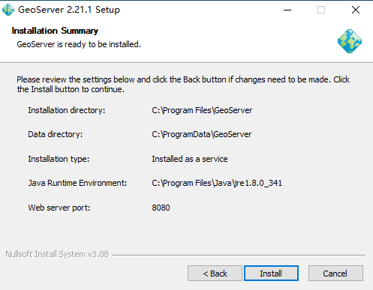
- Note that the default GeoServer Data directory is C:\ProgramData\GeoServer
- Download geo server vector tiles plugin.
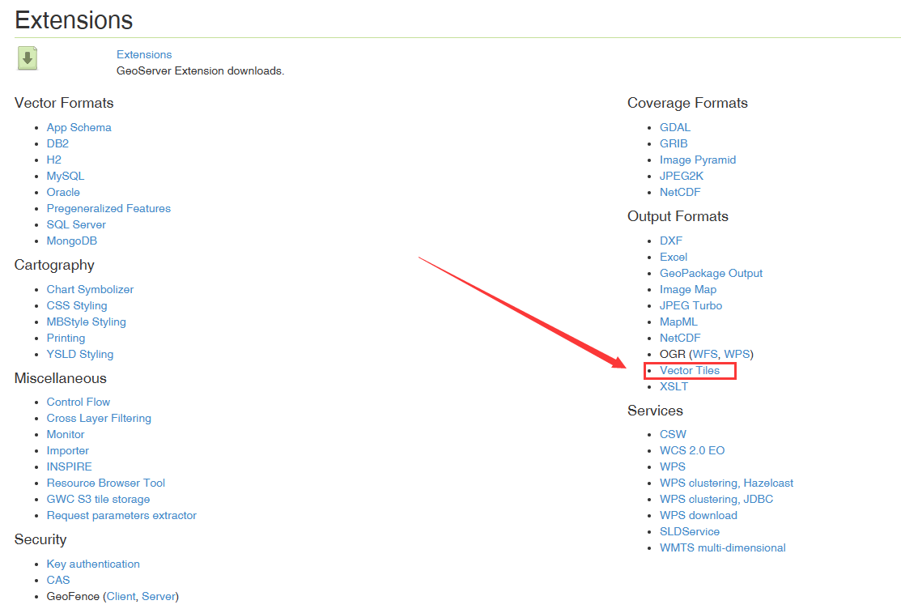
- Unzip vector tiles plugin to directory: C:\Program Files\GeoServer\webapps\geoserver\WEB-INF\lib
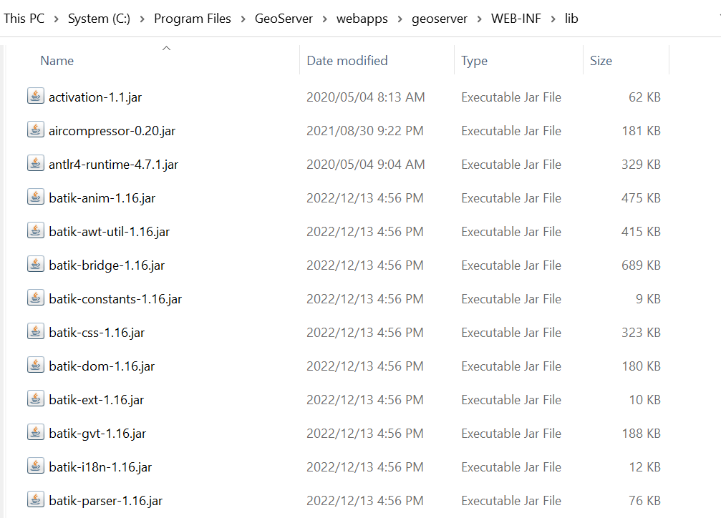
- Restart GeoServer services.
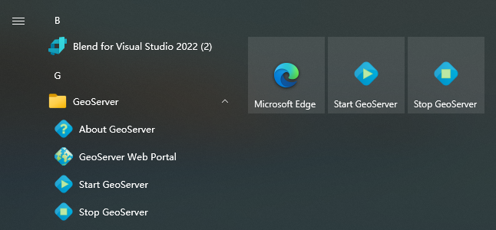
- Open http://localhost:8080/geoserver, login. the default username is admin, default password is geoserver
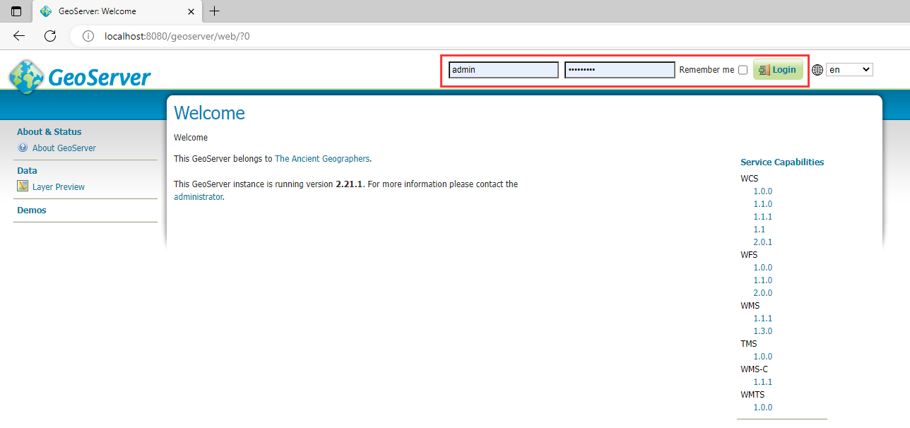
- Add a new workspace: us-boundaries.
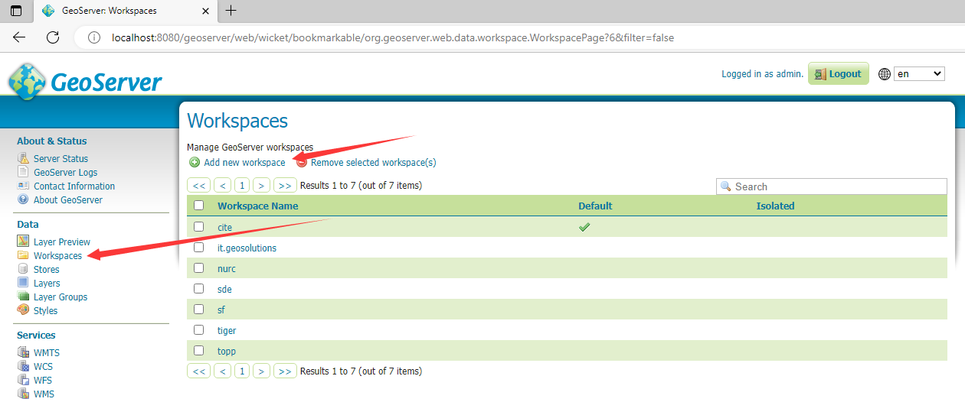
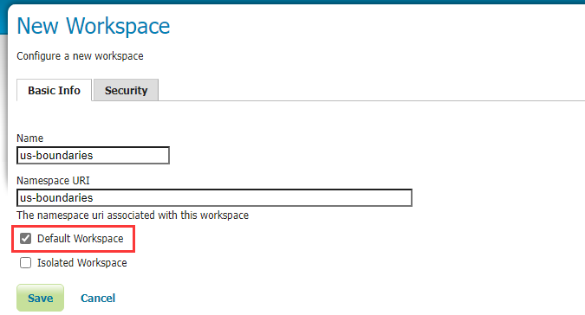
- Unzip us-boundaries.zip to C:\ProgramData\GeoServer\data

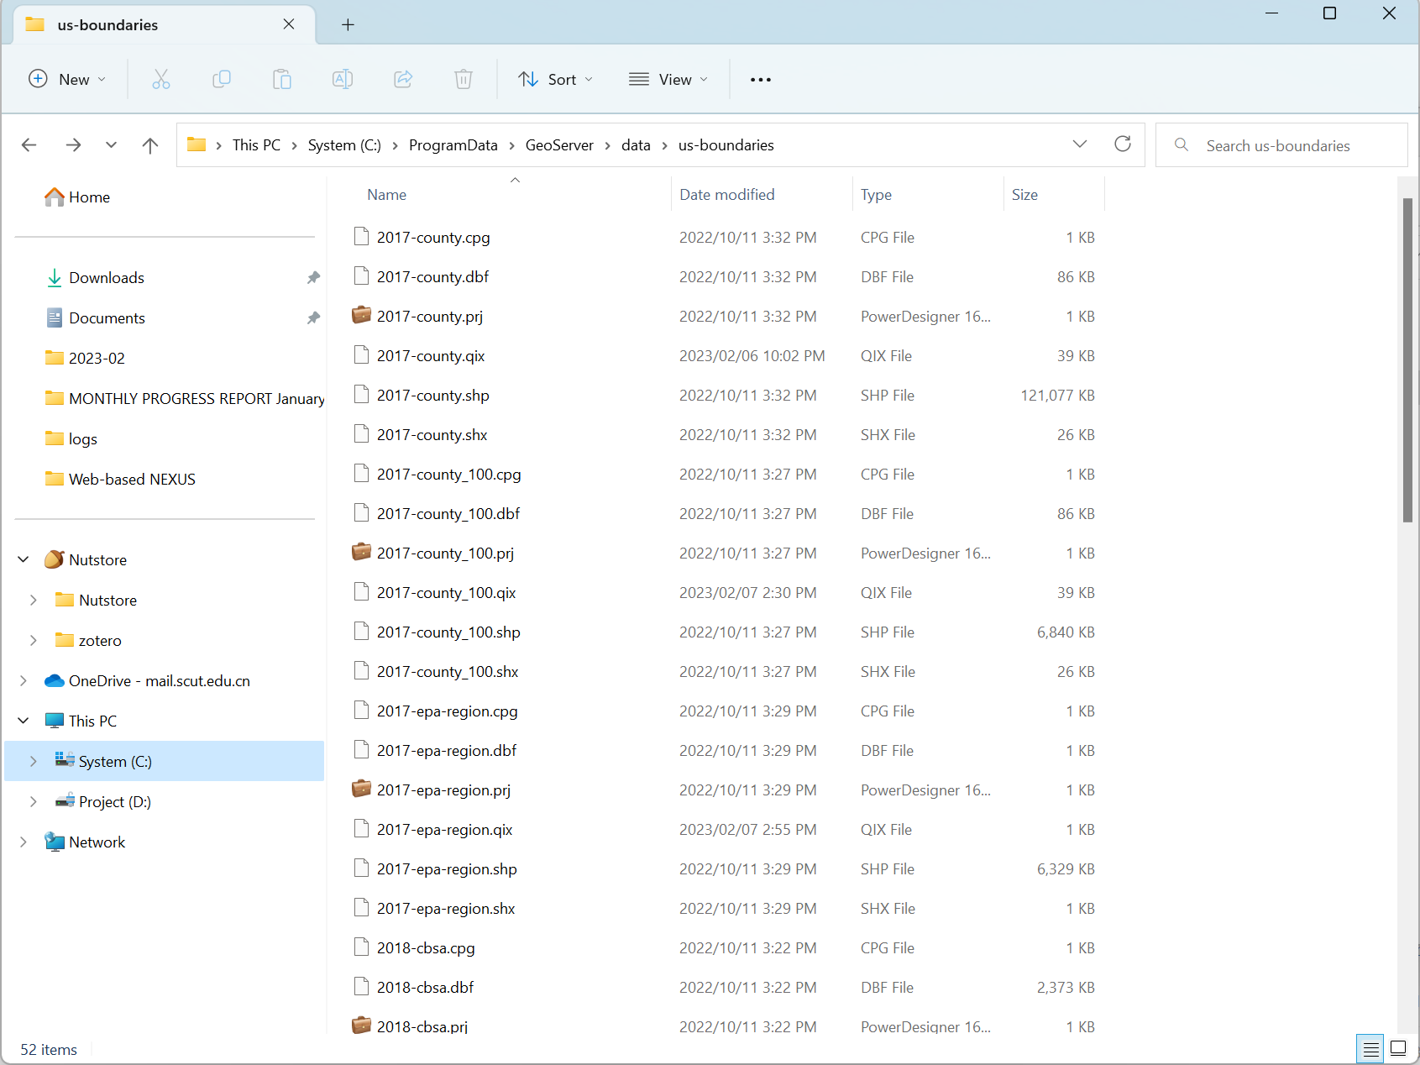
- Add a new data Store.
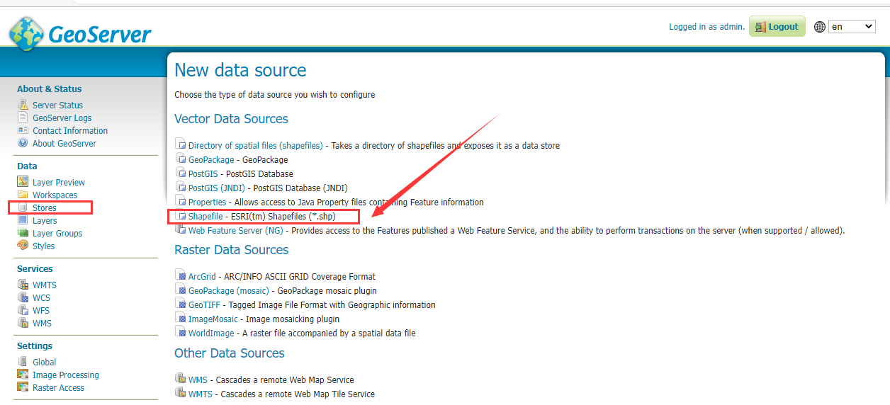
- Add a new vector data source.
- Change DBF charset to UTF-8.
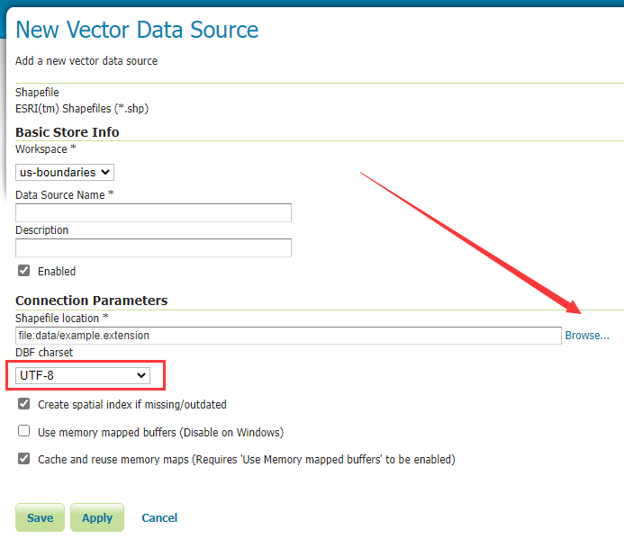
- Browse shapefile location: GeoServer/data/us-boundaries/, select a shapefile in the list.
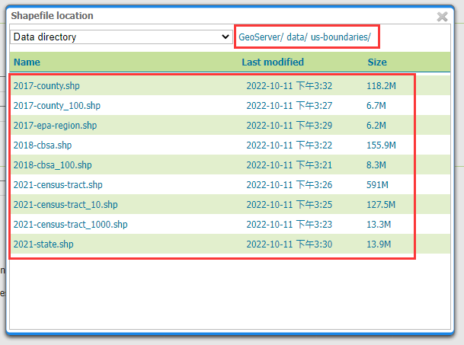
- Set shapefile name to Data Source Name. e.g.
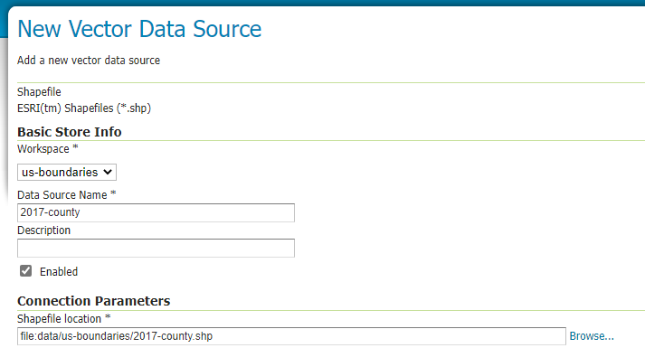
- Click Save, repeat the above steps, select next shapefile in the list, add all vector data source.
- Configure Caching Defaults (Tile Caching→Caching Defaults).
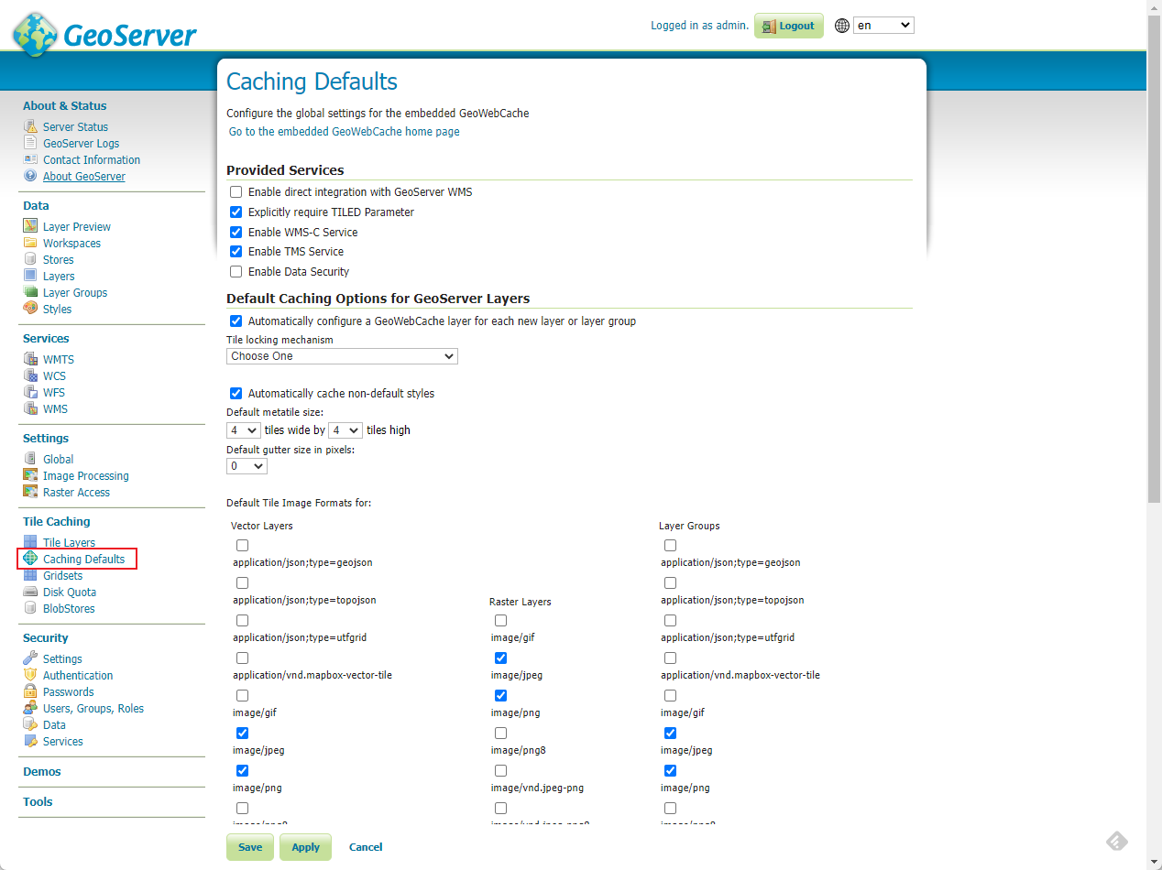
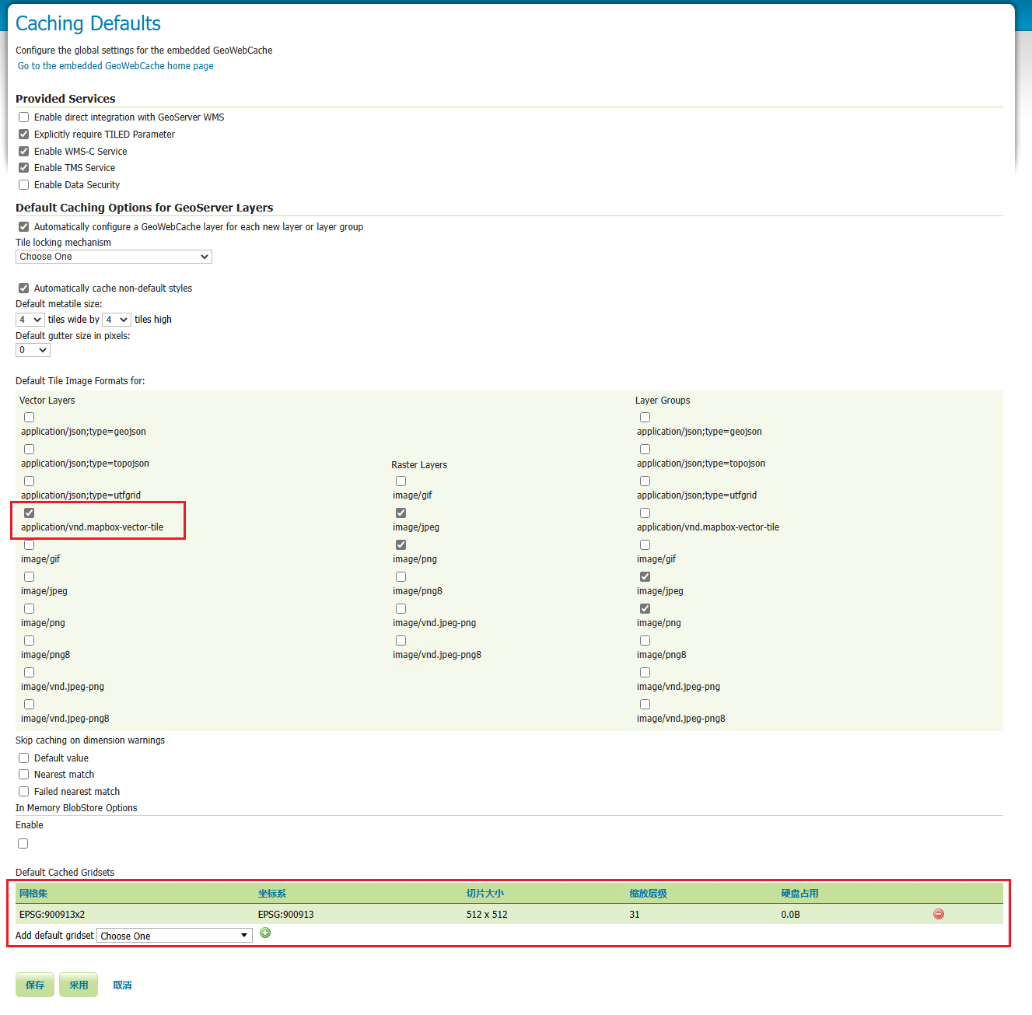
- Add a new layer.
- Select a store under workspace us-boundaries, click publish.
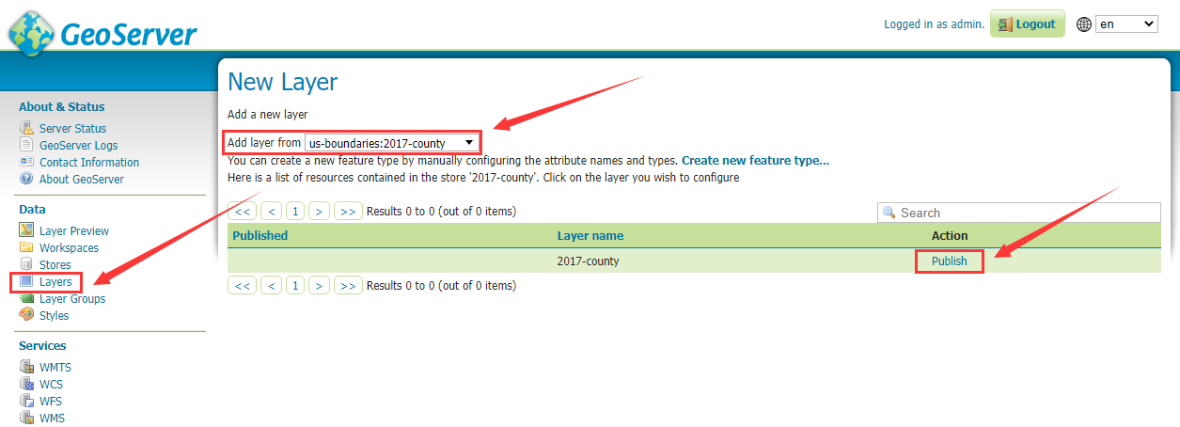
- In Bounding Boxes of Data tab compute bound, click Compute from data and Compute from SRS bounds.
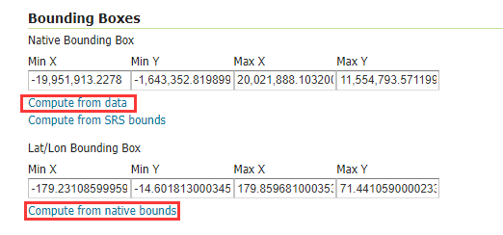
- In Publishing tab, enable Response Cache Headers and set Cache Time to 86400 seconds.
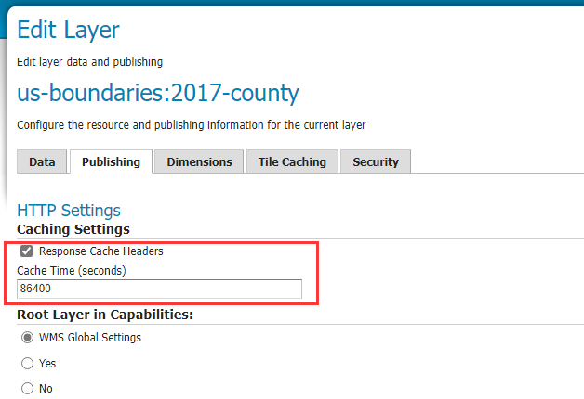
- Click Save, repeat the above steps, add all stores under workspace us-boundaries as new layer and publish.

Back-end (server-side code): Web-Based-NEXUS.WebApi
- Download and install Visual Studio 2022. https://visualstudio.microsoft.com
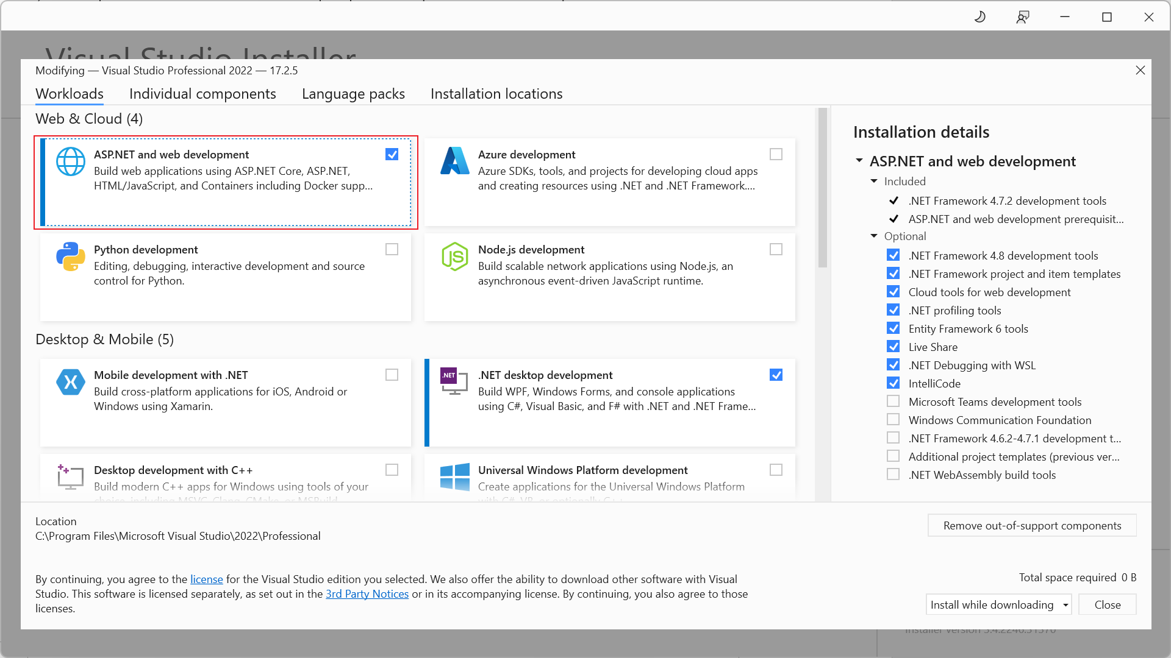
- Unzip Web-Based-NEXUS.WebApi.zip, then open NEXUS.WebApi.sln.
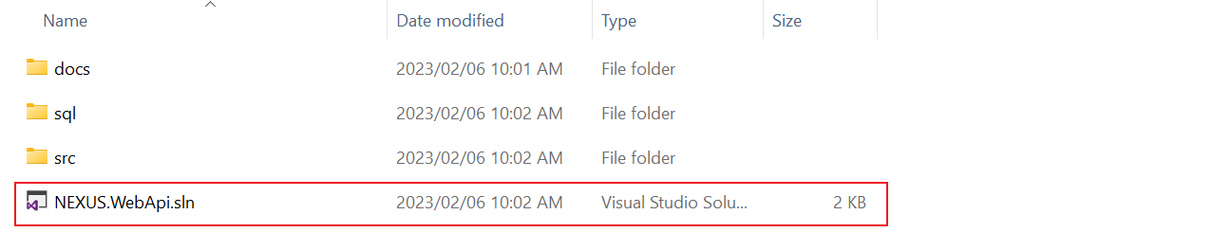
- Right click project NEXUS.WebApi and select Publish to publish to local folder.
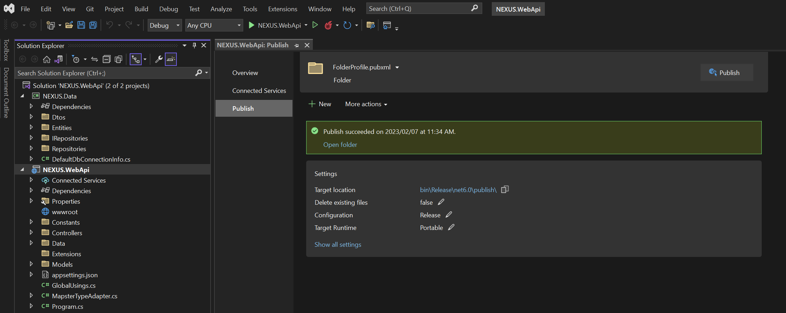
- Get executable program.
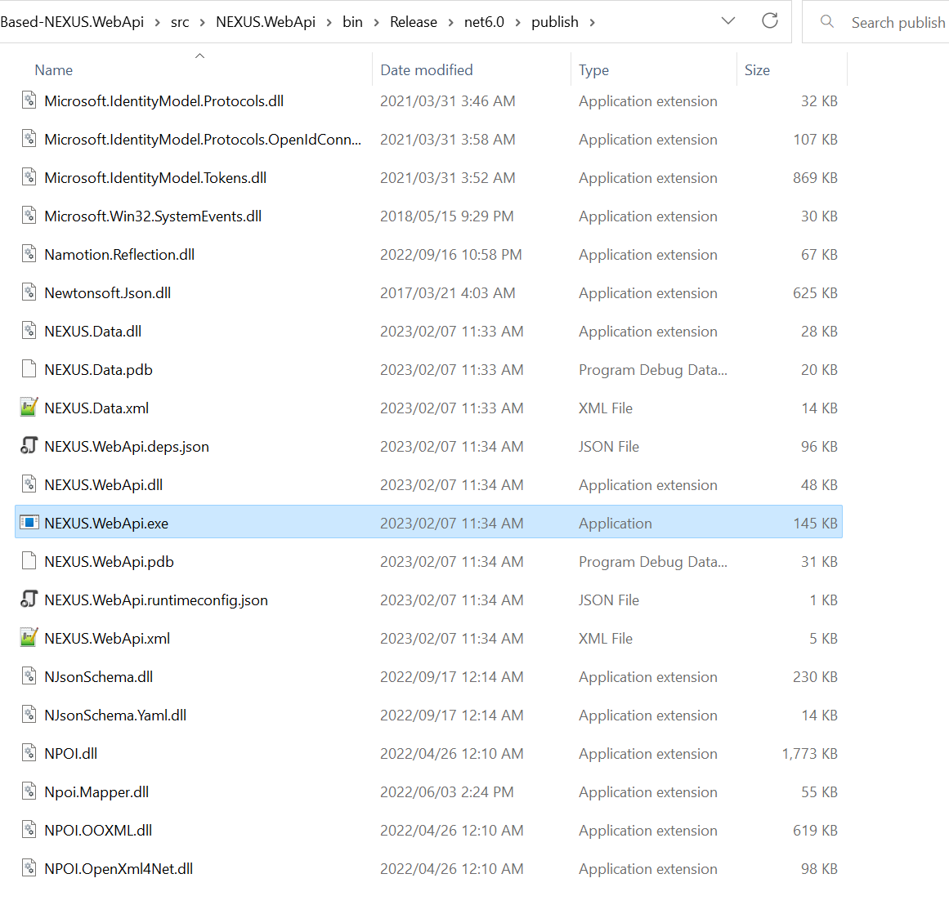

Front-end (client-side code): web-based-nexus.webui
- Download and install Node.js. https://nodejs.org
- Unzip web-based-nexus.webui.zip, then open cmd window, type cd command to web-based-nexus.webui directory, run command: npm i && npm run build
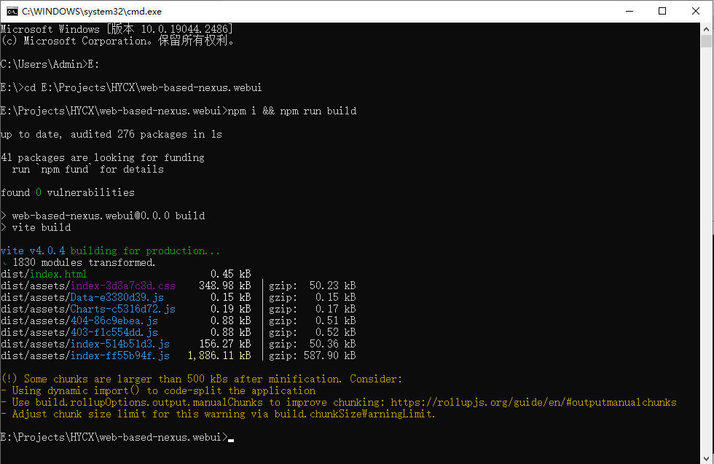
- Get dist folder
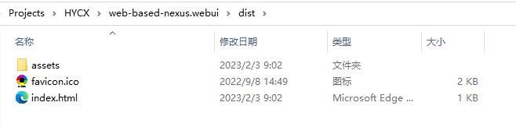
- Create a wwwroot folder under the publish directory. Copy and paste the contents of the dist folder to the wwwroot folder.
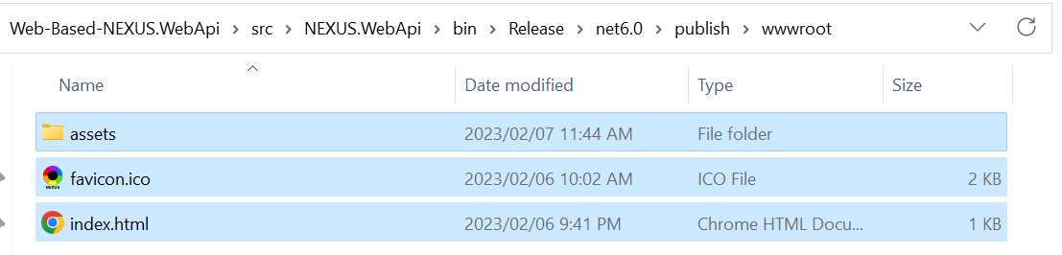

Middleware: Nginx
Nginx is a universal web app server – a lightweight and versatile open-source server that works as a reverse proxy to help improve the performance, reliability, and security of the application.
- Download nginx, and unzip nginx-1.22.1.zip. https://nginx.org/en/download.html
- Edit conf\nginx.conf, insert the following code in server block.
location /nexus/geoserver/ {
proxy_pass http://localhost:8080/geoserver/;
}

location /nexus/ {
proxy_pass http://localhost:8081/nexus/;
}
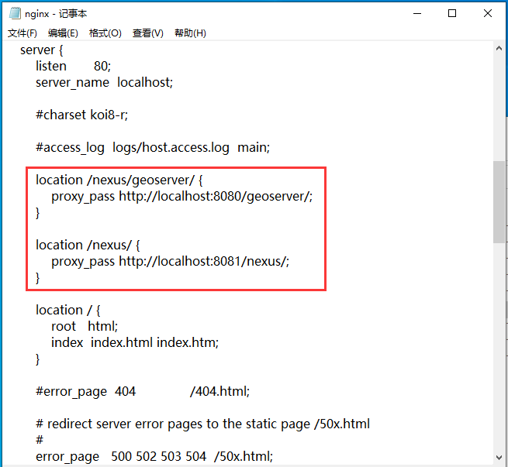
Notes:
If the error.log under logs folder throws a error message like “bind() to 0.0.0.0:80 failed (10013: An attempt was made to access a socket”, it means that the port number of 80 has been occupied by other program, users either could stop the program using the port number of 80 or change the default port number from 80 to other (e.g., 81) under the server block in conf\nginx.conf file.
- Run NEXUS.WebApi.exe
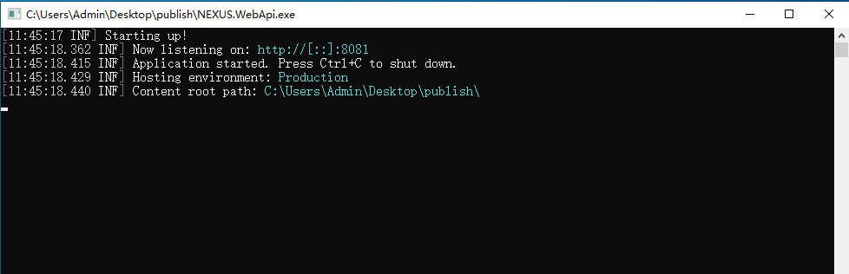
- Run nginx.exe
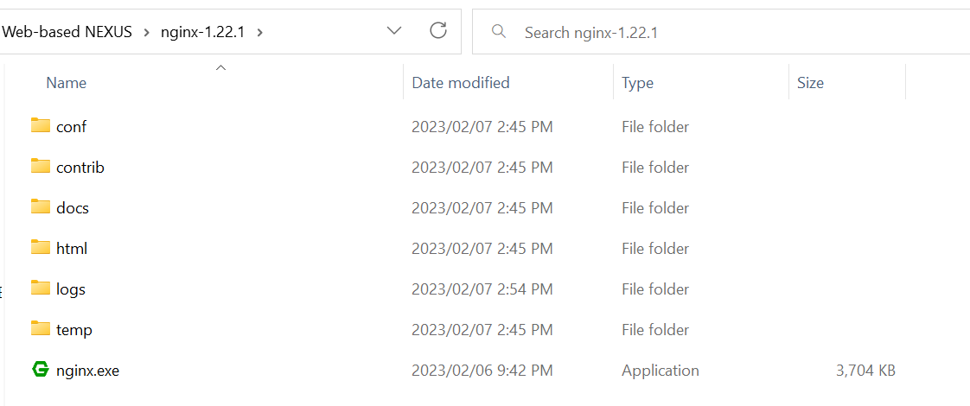
- Open http://localhost/nexus
