EPA multi-pollutant  Partnerships | - AN approach for Expanding  - multi-pollutant Air Quality Management & Planning
The Multi-Pollutant Assessment Process* | 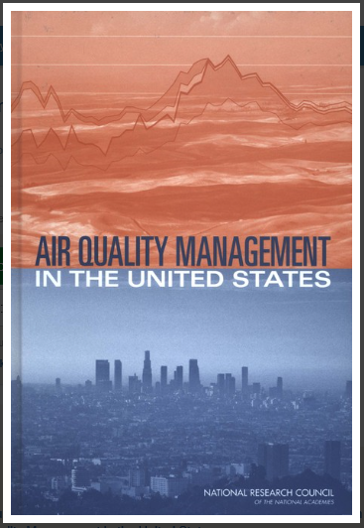  The 2004 National Research Council (NRC) report recommended EPA transition from a pollutant-by-pollutant approach to a multi-pollutant, risk-based approach to managing air quality

Multi-Pollutant Planning
EPA’s OAQPS supports comprehensive, multi-pollutant treatment of our nation’s air quality problems as a means to improve air quality effectively and make the most efficient use of available resources. Shifting away from a pollutant-by-pollutant approach will involve EPA regional support in identifying potential partners and assisting with the 10 steps highlighted above.

How It Works
This approach supports state, local and tribal (SLT) air agencies in developing risk-based multi-pollutant air quality management (AQM) plans and implementing strategies that reduce air pollution emissions and improve public health. EPA Regions, in consultation with OAQPS, provide training, technical support, and access to tools through the partnership; however, the analyses and plan development occur hand-in-hand with SLT experts. The goal is to create a sustainable environment in which EPA Regions and local decision makers are trained and empowered to undertake future multi-pollutant environmental planning and serve as experts, providing peer-to-peer support for other Regions and SLTs interested in implementing a multi-pollutant approach.
Detroit Case Study
Partners: EPA, MDEQ, SEMCOG & LADCO
Goals: Assess and compare two contrasting air quality control strategies
- “Status Quo” approach – controls selected separately to address O₃ & PM nonattainment
- “Multi-pollutant, risk-based” approach – aimed at further reducing population risk from exposure to O₃, PM and select air toxics while still addressing ozone and PM nonattainment
Results showed the multi-pollutant approach:
- Achieved the same or greater reductions of PM and O₃
- Improved air quality regionally and across the Detroit urban core for multiple pollutants
- Produced ~2x greater monetized benefits for PM and O₃
- Reduced non-cancer risk
- Resulted in greater net benefits & was more cost effective
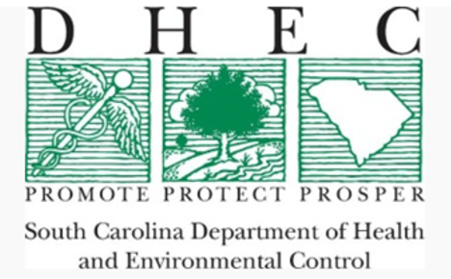    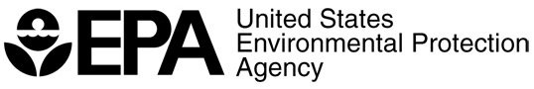 | South Carolina Project  Partners: EPA, SC DHEC & local community and business leaders in 10 upstate South Carolina counties  Goals:  - Develop and analyze a multi-pollutant, risk-based AQM strategy  - To maximize both health benefits and air quality improvements, identify and evaluate a local control strategy targeting emissions of O₃, PM & their precursors while also reducing air toxics of concern for communities  Results demonstrated improving air quality in areas already attaining the NAAQS can yield significant health benefits
Louisville Project

Partners: EPA, Louisville Metro Air Pollution Control District (LMAPCD) & Louisville Metro Department of Public Health and Wellness (LMPHW)
Goals:
- Identify local- and state-level emission reduction measures that address multiple pollutants, with a focus on attainment of the 2015 O₃ NAAQS
- Build a plan to achieve and maintain compliance of all NAAQS
- Demonstrate that the selected strategies can reduce health risk from exposure to O₃, PM and selected air toxics
- Integrate existing health risk-based pollution control programs into a multi-pollutant air quality management plan
- Build institutional capacity among LMAPCD and LMPHW to perform air quality modeling and health benefit analysis projects
Results pending

Next Steps
OAQPS will begin reaching out to individual EPA Regions to discuss and revise this approach and share information regarding potential partners that may be interested and could benefit from a risk-based, multi-pollutant approach to AQM.

