Supporting Information for:

Characterizing the air emissions, transport, and deposition of per- and polyfluoroalkyl substances from a fluoropolymer manufacturing facility
Emma L. D’Ambro^{1,2,*}, Havala O. T. Pye², Jesse O. Bash², James Bowyer³, Chris Allen⁴, Christos Efstathiou⁴, Robert C. Gilliam², Lara Reynolds⁴, Kevin Talgo⁴, Benjamin N. Murphy^{2,*}

¹Oak Ridge Institute for Science Education, Oak Ridge, TN
²Center for Environmental Measurement and Modeling, U.S. EPA, Research Triangle Park, NC
³North Carolina Division of Air Quality, NC DEQ, Raleigh, NC
⁴General Dynamics Information Technology, Research Triangle Park , NC

*Corresponding Authors
Email: dambro.emma@epa.gov, murphy.benjamin@epa.gov

This file includes:
Pages S1 – S38
Tables S1 – S15
Figures S1 – S8
References

PFAS Emission
The Chemours Company Fayetteville Works site reported 109,393 kg yr⁻¹ PFAS emissions for 2017 (https://files.nc.gov/ncdeq/GenX/Data/Chemours-2017-Air-Emissions-Inventory.pdf¹), and these were split among emissions of 53 species emerging from 16 processes. Table S1 shows the annual emissions of each species based on the facility’s calculations along with CAS numbers and assumed structures for each species. Table S9 presents the same species-level annual rates broken down by facility process. The groups in table S9 refer to the same groups (Monomers, IXM, other) in table S11. PFAS emissions were allocated in space and time to best reproduce real emissions from the facility during 2018. The applied emission rates reflect the daily-varying schedule of facility operations as well as emissions controls installed at the facility throughout the year. CMAQ calculates the buoyant rise of emissions given stack parameters (Table S10) and coincident meteorology. PFAS compounds were injected into the atmosphere at a stack height of 25.9 m, consistent with the Chemours Fayetteville Works facility.
There remains uncertainty about the phase of PFAS compounds upon emission due to the variability of species properties and heterogeneous conditions forced by control technologies deployed across various processes. Measurements have identified PFAS in both phases²⁻⁸, and thus previous modeling studies have allocated emissions to the gas^{9, 10} and particle^{3, 11-13} phases. The high C* values for the PFAS species considered here (Table S2) suggest they will partition strongly to the gas phase at ambient conditions, consistent with previous work showing that vapor pressures of PFAS are considerably higher than hydrocarbons of similar size and structure^{14, 15}, and the measurement of PFAS with up to 20 carbons in the gas phase¹⁶. Given the relatively high volatility and relatively low solubility predicted for these PFAS compounds (Table S2), we assume that all explicit species were emitted in the gas-phase except HF which was mapped to the particulate accumulation mode. The phase state of PFAS at the time of emission and downwind from sources is likely dependent on the exact structure of the species and is an open question which we address in section 3.3. Furthermore, an exception to our gas-phase assumption could be in the stack plume near the facility where concentrations are expected to be highest.
Temporal allocation of PFAS emissions may consider variations across months, weeks, days and hours. With limited information, we have assumed for all simulations that the emissions are uniform throughout each day (i.e. flat diurnal profile). For variability throughout the year, we employ records supplied by The Chemours Company of the major relevant processes running every day beginning 20 March 2018. Because we lack data before March 20th, we assume that the records for 1 January to 19 March 2019 are reasonable representative days for the operation schedule in those days of 2018. Table S11 documents the number of days of each month that the emissions inputs assume each major PFAS-emitting process was running for 2018. Processes that do not appear in Table S11 were assumed to emit PFAS every day of 2018; these processes were responsible for minor emission rates.
The Sparse Matrix Operator Kernel Emissions (SMOKE) modeling system¹⁷ was used to allocate HF annual emissions to the Fayetteville Works model grid cell with uniform daily variation to populate emission input files for CMAQ. Emissions of each explicit and lumped PFAS model species (including HF which is not a PFAS) were scaled to these uniform HF emissions online in CMAQ based on their relative annual abundance and temporal distribution. The facility operates production “campaigns” based on demand for commercial products. This results in daily-varying magnitude and speciation of PFAS emissions based on which processes were operating each day. We introduced emissions of PFAS model species consistent with the facility’s operations record (Tables S9 and S11). The facility also reported incremental reductions in emissions from individual processes due to control measures installed at the plant throughout 2018. These controls target a subset of the emitted PFAS that are soluble in water (Table S12). We represented this reduction in CMAQ-PFAS by reducing emissions for those targeted species consistent with levels from stack test characterizations (Table S13: The Chemours Company, Weston Solution Inc., and Test America laboratories Inc., available at: https://deq.nc.gov/news/key-issues/genx-investigation/air-quality-sampling¹.). The daily emissions of each species were allocated temporally using Equations 1-2:
${EF}_{i,j}=\frac{E_{i,j}^{A}}{D_{j}}$ (1)
$E_{i}^{d}=\sum_{j=1}^{Np}{δ_{j}^{d}∙{EF}_{i,j}∙R_{i,j}^{d}}$ (2)
where ${EF}_{i,j}$ is the daily emission factor of species i from process j (lbs day⁻¹), $E_{i,j}^{A}$ is the annual emission rate of species i from process j (kg yr⁻¹), D_{j} is the total number of days process j operated during 2018, $E_{i}^{d}$ is the emission rate of species i on day d (kg day⁻¹), Np is the total number of processes run at the facility, $δ_{j}^{d}$ equals 1 if process j was operating on day d and equals 0 if process j was not operating on day d, and $R_{i,j}^{d}$ is the reduction in emissions of species i from process j on day d due to controls compared to 2017, uncontrolled levels. A uniform constant diel profile was applied to the daily emissions.

WRF Modeling
The Weather Research and Forecasting model (WRF), Advanced Research WRF core (ARW) version 4.1.1¹⁸ was used to prepare meteorological inputs for CMAQ-PFAS. WRF was run at 1 km x 1 km resolution (termed “WRF1” here) for the entire year of 2018 for this work. A 12 km x 12 km run (termed “WRF12” here) for the entire year of 2016 was used as a baseline for WRF1 due to its well documented behavior¹⁹. WRF1 was run over the CMAQ-PFAS Eastern NC domain centered over Fayetteville, NC. The configuration is similar to most US EPA CMAQ applications: the P-X LSM (Pleim-Xu Land Surface Module) and ACM2 PBL (Asymmetric Convective Mixing Planetary Boundary Layer v2) scheme are used for near-surface mixing and surface exchange of heat, moisture and momentum. The sub-grid convective scheme is not activated at the 1km scale (whereas WRF12 utilizes the standard Kain-Fritch scheme). Microphysics, radiation and other general WRF settings are similar or identical to WRF12.
All monthly statistics are based on a common set of meteorology observation sites that lie in the WRF1 domain. There are 33 weather observation sites used to examine model performance (Table S14). For T2 (2-m temperature), the main statistic of importance is root mean square error (RMSE), which measures the accuracy of the model overall. Bias can be deceiving for T2 because sites with negative bias can offset sites with positive bias. WRF1 statistics again are based off the same sites that lie in the 1 km domain. WRF1 predicts T2 very well based on RMSE. In February for example, WRF12 has RMSE of 2.30 K compared to 2.00 K for WRF1. In the summer, WRF12 has errors of 1.6-2.0 K compared to WRF1 RMSEs of 1.4-1.6 K. The average error over the whole year is around 1.7 K in WRF1 and 1.9 K in WRF12.
As with T2, Q2 (2-m water vapor mixing ratio) errors are lower in WRF1 than the benchmark WRF12, and in some cases substantially lower. In the summer for example, WRF1 has RMSEs 1.45 - 1.52 g kg⁻¹ compared to 1.50 – 2.12 g kg⁻¹ for WRF12. Annual average RMSE is about 1.1 g kg⁻¹ for WRF1 compared to 1.3 g kg⁻¹ for WRF12.
The RMSE for WS (10-m wind speed) is generally not significantly different from similarly configured WRF simulations that use Four-Dimensional Data Assimilation (FDDA), which is the case here. WRF1 and WRF12 have the same annual RMSE at 1.46 m s⁻¹. As with WS, WD (10-m wind direction) errors are nearly identical each month and across the year.
Precipitation statistics are based on monthly total precipitation from the WRF model and PRISM observation dataset. For WRF1, precipitation totals are the average total precipitation of a 5x5 grid cell region around the Chemours facility. Monthly precipitation totals can vary a lot over the year and between years. WRF predicts an annual total precipitation of ~1,500 mm, which is a -8% normalized mean bias (NMB) relative to the PRISM OBS total of ~1,650 mm in 2018. Note, this ignores September 2018 where Hurricane Florence resulted in up to 890 mm in areas around Fayetteville, NC. This was ignored because the relatively small WRF domain cannot simulate a major hurricane that does not fit within the domain. For comparison, WRF12 simulated 1,378 mm of precipitation in 2016 which equates to a NMB of -22%. Precipitation is a key meteorological driver of PFAS. WRF1 generally underestimates precipitation, but it is within 10%, which is quite good for a meteorological model. This slight underestimate may be relevant to the modeled concentrations of PFAS.
In conclusion, WRF1 has lower error and uncertainty than WRF12 in just about every metric, indicating good model performance relative to the state of the current science. This evidence suggests that grid reduction from 12 to 1 km does offer benefit.

Model-Measurement Discrepancies
As stated in the main text, reasons for the model/measurement discrepancies in Figure 2 are potentially numerous. The NC DEQ sampling sites are within 1-3 km of each other, which is near the scale of the model horizontal resolution, so small discrepancies between modeled and actual wind velocity and precipitation could impact the differences observed between, for example, the NE and N sampling sites. Standard evaluation of meteorological (Table S14 and S15) and air pollutant metrics (Table S4) indicates that the underlying CMAQ model performs reasonably well for typical comparisons. The magnitude, speciation, and timing of GenX emissions are a source of uncertainty as well. Although stack test measurements informed emission factors for relevant facility processes, much of the calculation of GenX air emissions relied on mass balance assumptions for those processes. The base emissions estimates are from 2017 and scaled to create the 2018 scenario, introducing potential errors in the emissions timing and magnitude. Furthermore, deposition measurements are not available for January-March of 2018, making it challenging to evaluate the breadth of model performance in all seasons. Uncertainties in the OPERA property estimation techniques could lead to biases in gas-particle partitioning calculations. Although, the uncertainties in vapor concentration span 3-5 orders of magnitude (Tables S2-S3), the lowest estimate would still strongly favor the gas phase, therefore our results are likely insensitive to vapor pressure estimates. However, the deposition of acid compounds can be quite sensitive to the estimate of water solubility, as discussed in section 3.3. Finally, it is possible that the sample collection method enhances apparent deposition fluxes²⁰ as dry deposition is measured to surrogate surfaces and modeled to plants, and once bulk samplers contain water they will enhance deposition of water soluble compounds like GenX. Nevertheless, this study successfully demonstrates one of the first direct evaluations of a PFAS-capable, regional-scale chemical transport model with temporally resolved deposition measurements of individual PFAS compounds.

Table S1. PFAS species emitted by Chemours Inc. Fayetteville Works in 2017. CAS-no’s are linked to the compound’s page in EPA’s Comptox Dashboard, where available.
Abbreviation | Name | CAS-no | Structure | Emissions (kg yr⁻¹)
TFE | Tetrafluoroethylene | 116-14-3 | 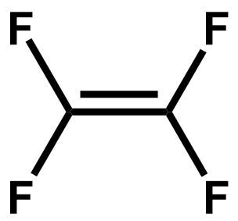 | 40082.1
HFPO | Hexafluoropropylene oxide | 428-59-1 | 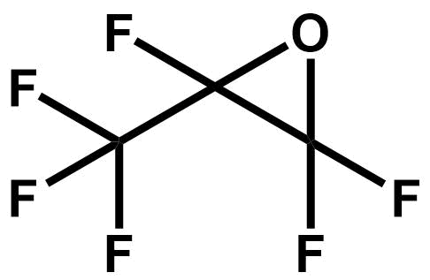 | 27621.5
HFP | Hexafluoropropylene | 116-15-4 | 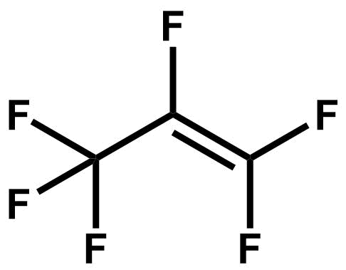 | 22018.3
E2 | 2H-perfluoro(5-methyl-3,6-dioxanonane) | 3330-14-1 | 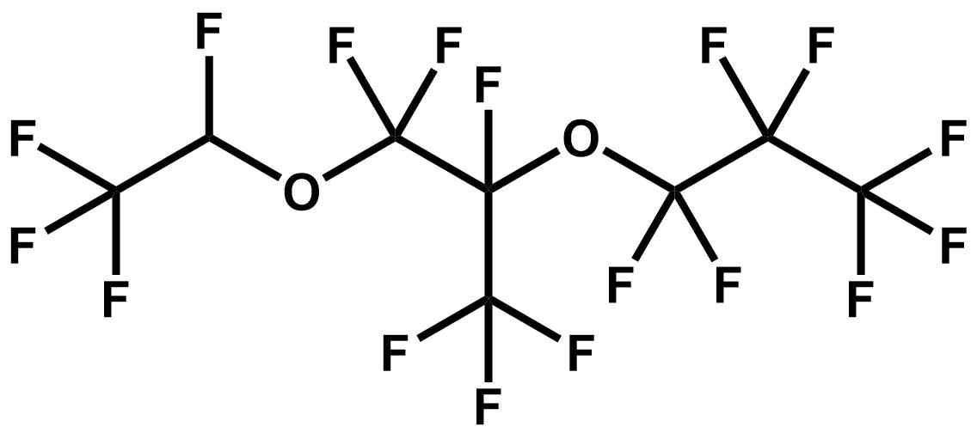 | 4352.3
PSEPVE | perfluoro-2-(2-fluorosulfonylethoxy) propyl vinyl ether | 16090-14-5 | 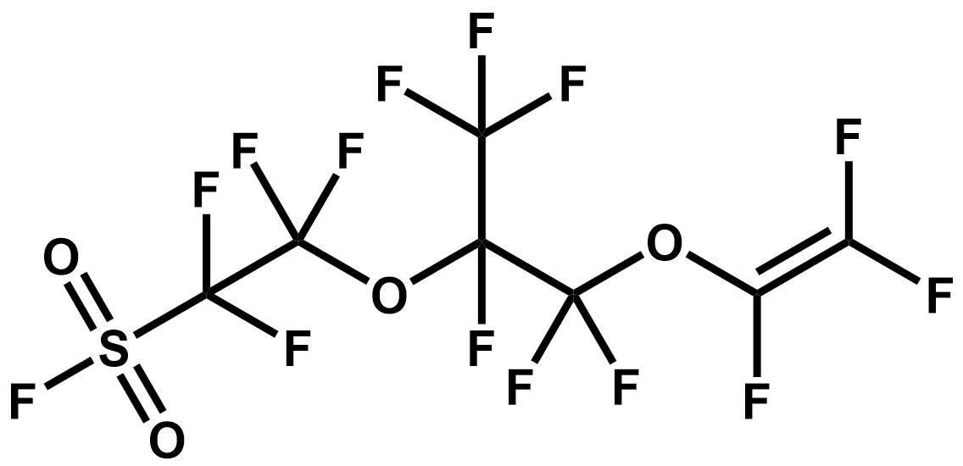 | 2148.3
COF2 | Carbonyl difluoride | 353-50-4 | 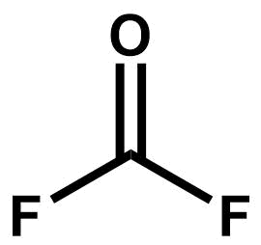 | 1997.5
HF | Hydrofluoric acid | 7664-39-3 | 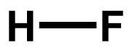 | 1971.3
PAF | Trifluoroacetyl fluoride | 354-34-7 | 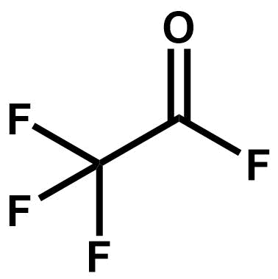 | 1524.1
CH3F | Methyl fluoride | 593-53-3 | 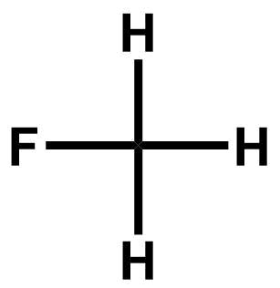 | 1506.6
PPVE | Perfluoropropyl vinyl ether | 1623-05-8 | 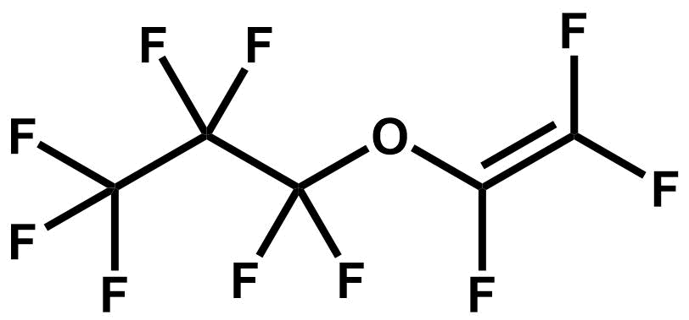 | 1290.7
PMVE | Perfluoromethyl vinyl ether | 1187-93-5 | 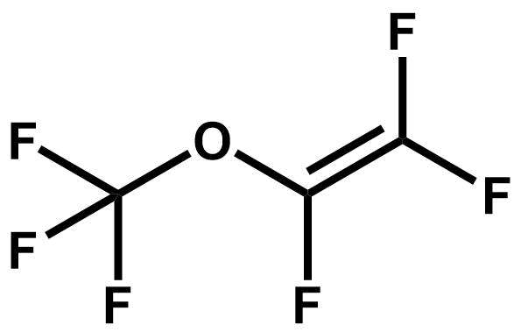 | 1215.0
HFPO-DAF | Perfluoro-2-propoxy propionyl fluoride | 2062-98-8 | 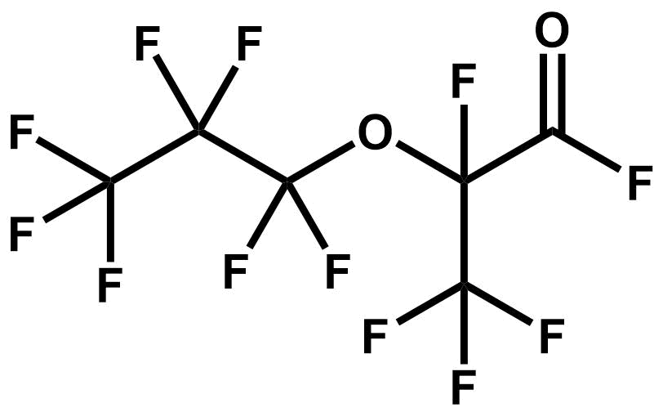 | 725.1
PEVE | Perfluoroethyl vinyl ether | 10493-43-3 | 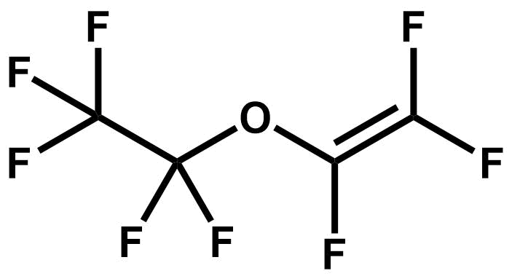 | 696.9
CF3H | Trifluoromethane | 75-46-7 | 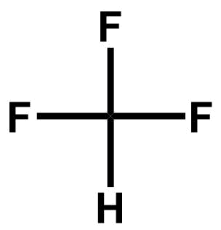 | 455.9
C4 (PFB) | perfluoro-2-butene | 360-89-4 | 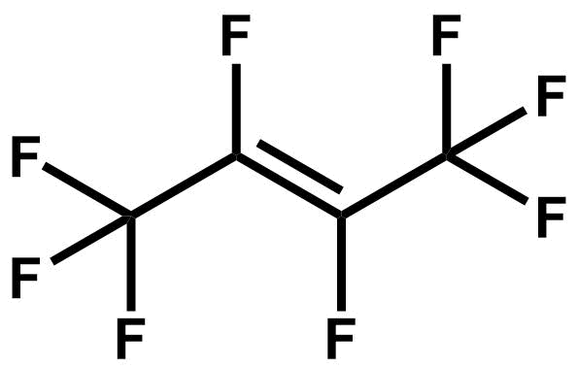 | 446.8
PMPF | Perfluoroacetyl fluoride | 2927-83-5 | 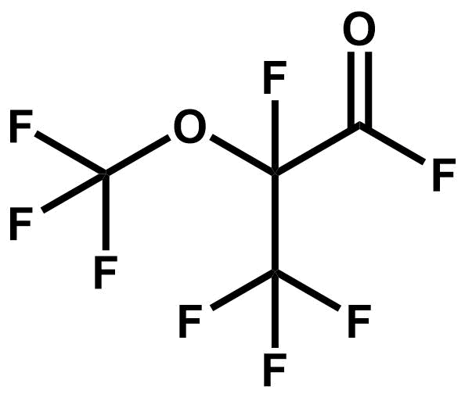 | 425.9
A/F Solvent (n=4 TFF)ª | Carbonofluoridic acid, 1,1,3,3,5,5,7,7,9,9,9-undecafluoro-2,4,6,8-tetraoxanon-1-yl ester | 21703-48-0 | 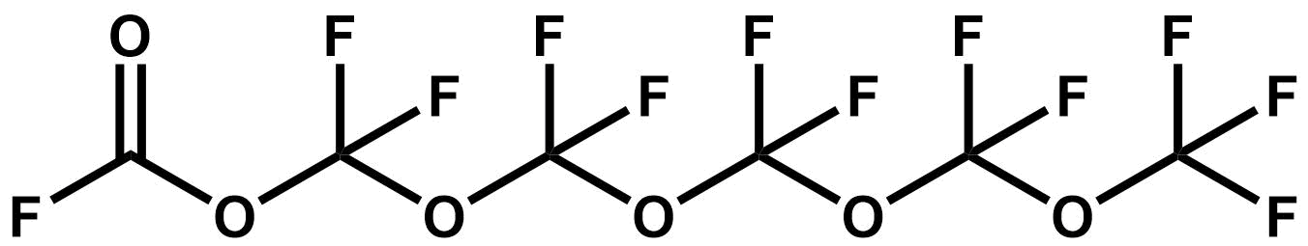 | 393.7
A/F Solvent (n=2 TAF) | perfluoro-3,5,7-trioxaoctanoyl fluoride | 21703-45-7 | 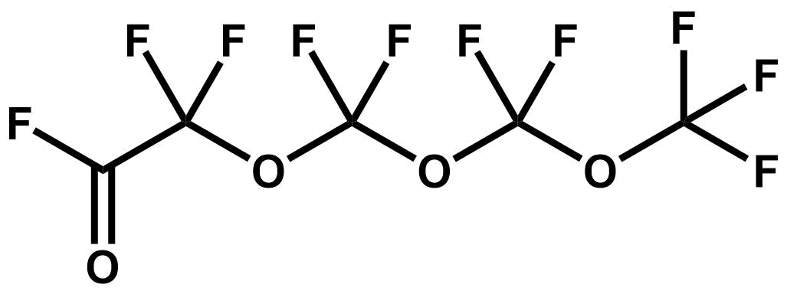 | 382.4
EVE | Propanoic acid, 3-[1-[Difluoro [(trifluoroethenyl oxy] Methyl] -1,2,2,2-Tetrafluoroethoxy]-2,2,3,3-tetrafluoro-, methyl ester | 63863-43-4 | 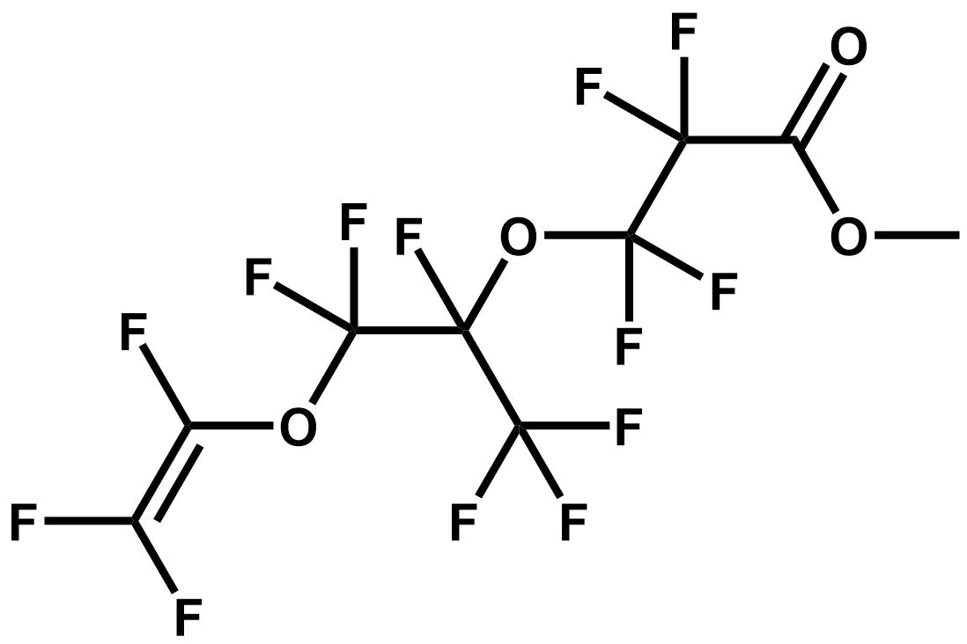 | 376.3
F-113 | Trichloro-1,2,2-trifluoro-1,1,2 Ethane | 76-13-1 | 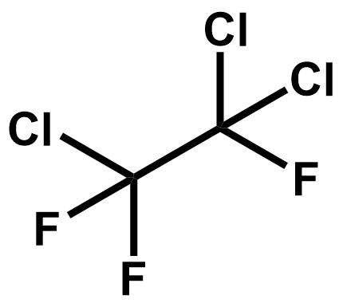 | 361.3
HFPO-DA | 2,3,3,3-tetrafluoro-2-(1,1,2,2,3,3,3-heptafluoropropoxy) propanoic acid | 13252-13-6 | 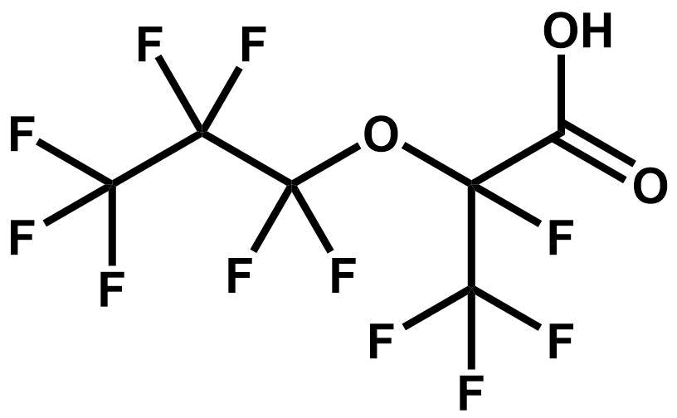 | 304.6
E1 | Propane, 1,1,1,2,2,3,3,-heptafluoro-3-(1,2,2,2-tetrafluoroethoxy)- | 3330-15-2 | 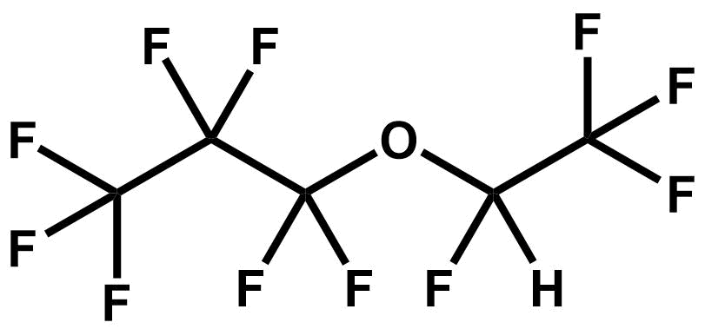 | 243.1
PEPF | Perfluoroethyoxypropionyl fluoride | 1682-78-6 | 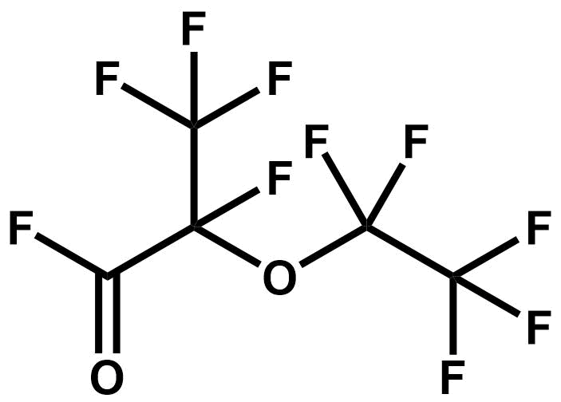 | 177.4
DA | tetrafluoro-2[Hexafluoro-2-(Tetrafluoro-2-{Fluorosulfonyl}Ethoxy) Propoxy Propionyl Fluoride | 4089-58-1 | 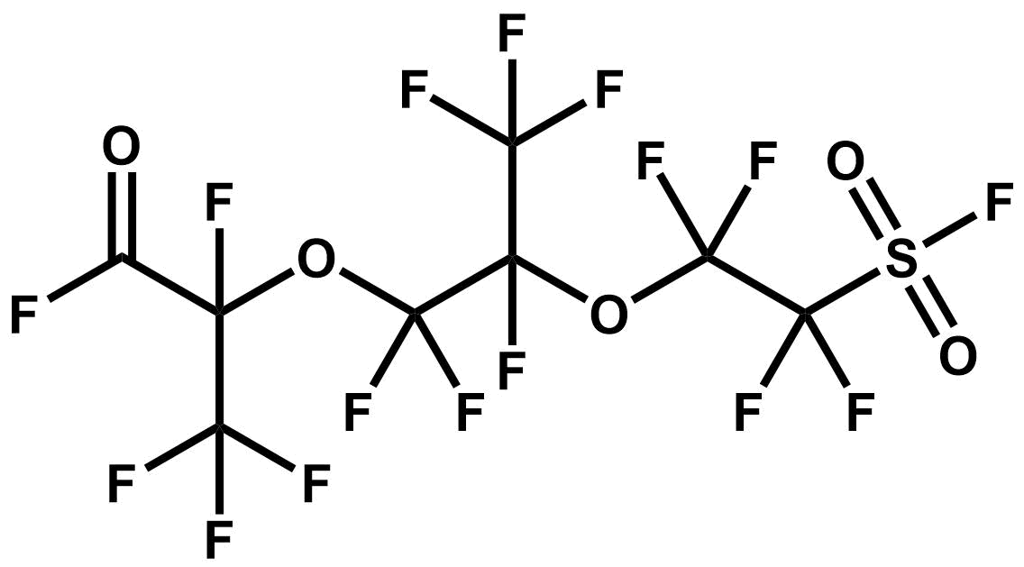 | 131.1
HFPO trimer | Perfluoro-2,5-dimethyl-3,6-dioxanonanoyl | 2641-34-1 | 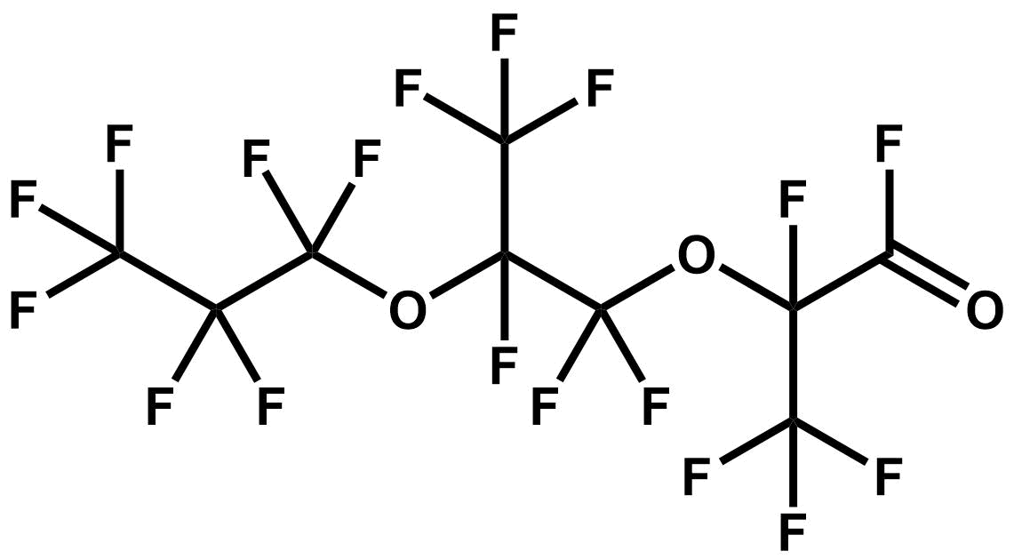 | 127.5
TAF | Trifluoromethyl carbonofluoridate | 3299-24-9 | 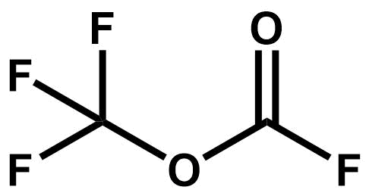 | 126.9
MA | tetrafluoro-2-[tetrafluoro-2-(fluorosulfonyl)Ethoxy]- Propanoyl Fluoride | 4089-57-0 | 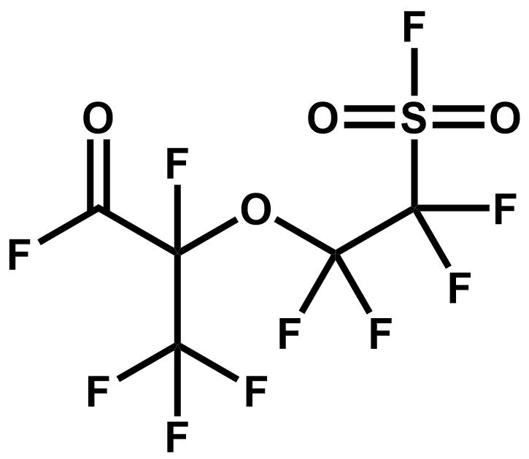 | 58.5
PPF | Perfluoropropionyl fluoride | 422-61-7 | 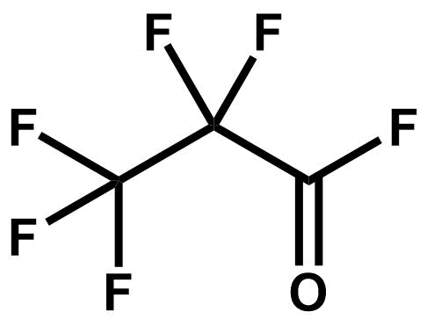 | 35.8
MD | 2,3,3,3,-tetrafluoro-2-[1,1,2,3,3,3-hexafluoro-2-(trifluoromethoxy)propoxy]-propanoyl fluoride | 2479-75-6 | 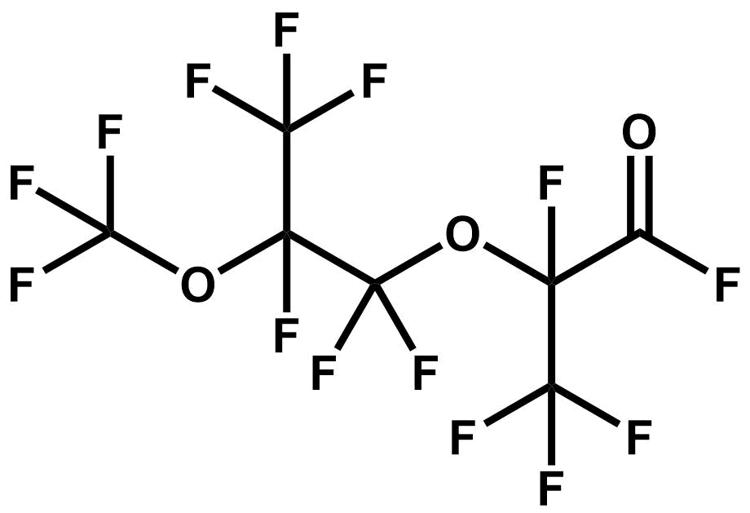 | 32.2
DAE | Methyl perfluoro (8-(Fluoroformyl)-5-methyl-4,7-dioxanonanoate | 69116-73-0 | 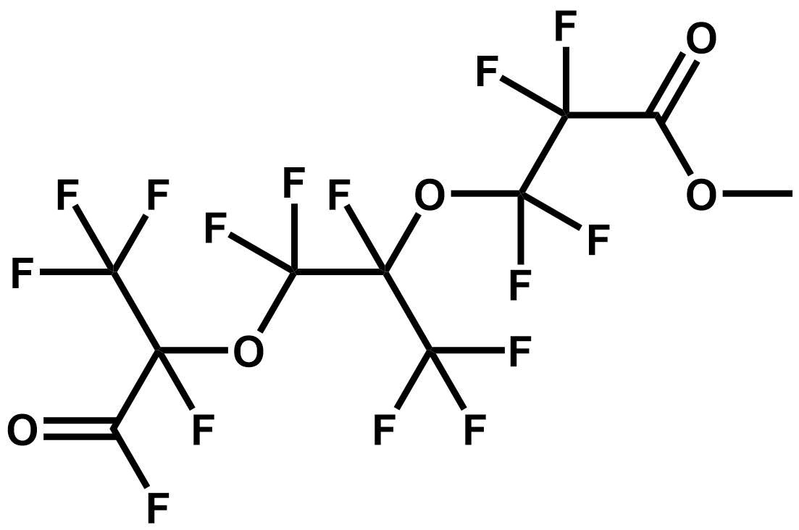 | 24.9
MAE | Methyl perfluoro (5-(fluoroformyl)-4-Oxahexanoate) | 69116-72-9 | 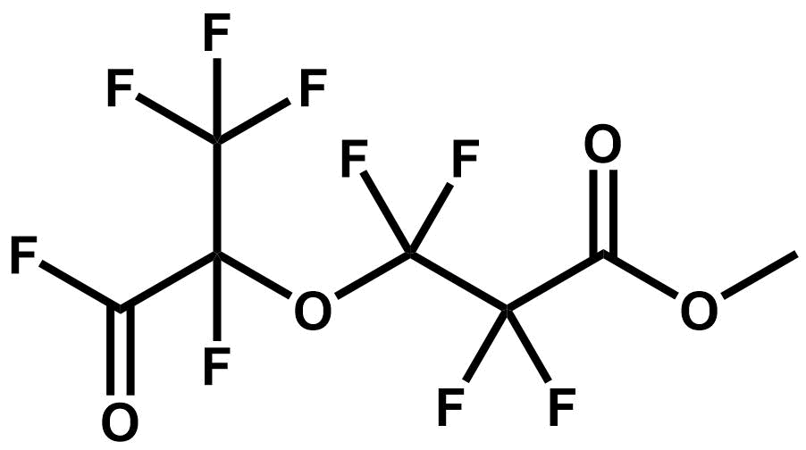 | 16.3
MMF | Propanoic acid, 2,2,3-trifluoro-3-oxo, methyl ester | 69116-71-8 | 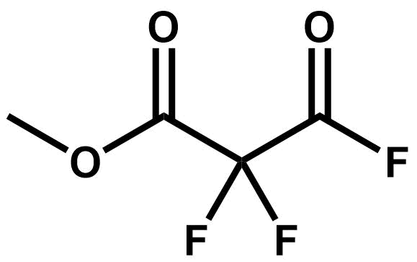 | 25.0
A/F Solvent (n=1 TAF) | Perfluoro-3,5-dioxahexanoyl fluoride | 21703-43-5 | 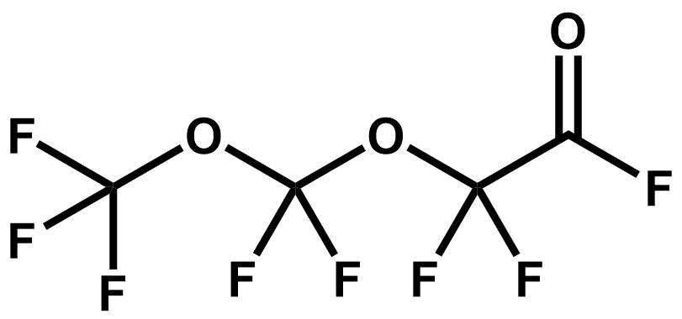 | 12.1
C5 (PFP) | Perfluoropentene | 376-87-4 | 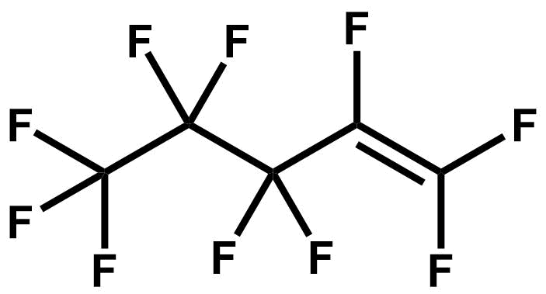 | 8.2
hydro-PEVE | 2,3,3,3-tetrafluoro-2-(pentafluoroethoxy)propanoyl fluoride | 360796-50-5 | 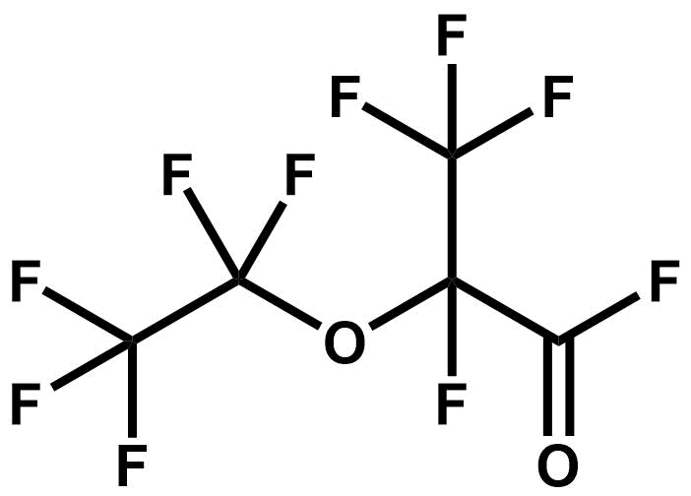 | 6.4
TAª | 2,3,3,3-tetrafluoro-2-[1,1,2,3,3,3-hexafluoro-2-[1,1,2,3,3,3-hexafluoro-2-[1,1,2,2-tetrafluoro-2-(fluorosulfonyl)ethoxy]propoxy]propoxy]propanoyl | 4628-44-8 | 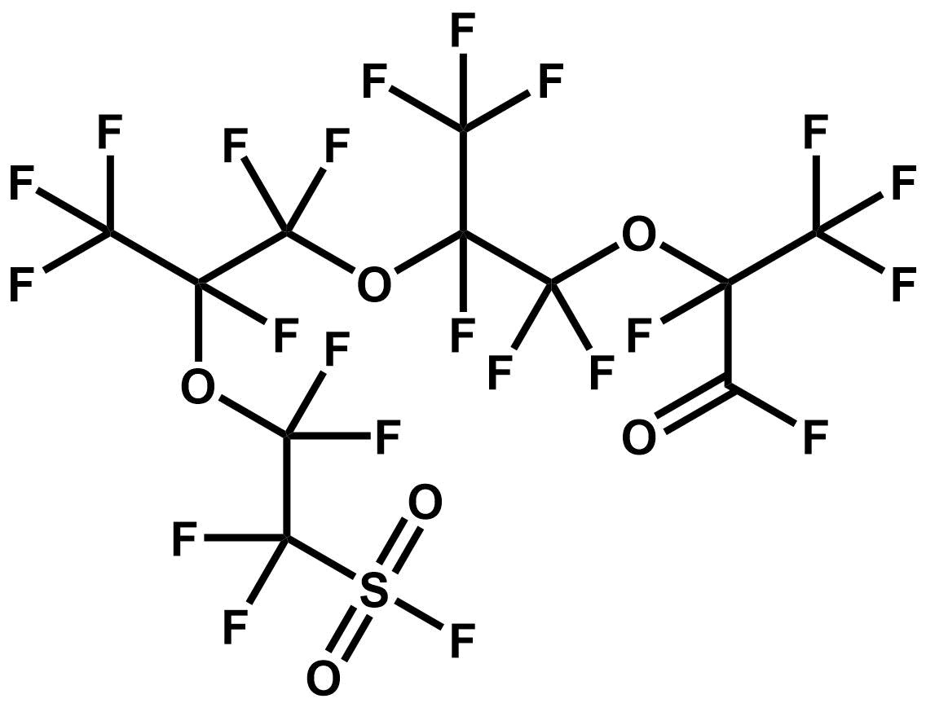 | 5.0
iso-EVE | Methyl perfluoro-6-methyl-4,7-dioxanone-8 eneoate | 73122-14-2 | 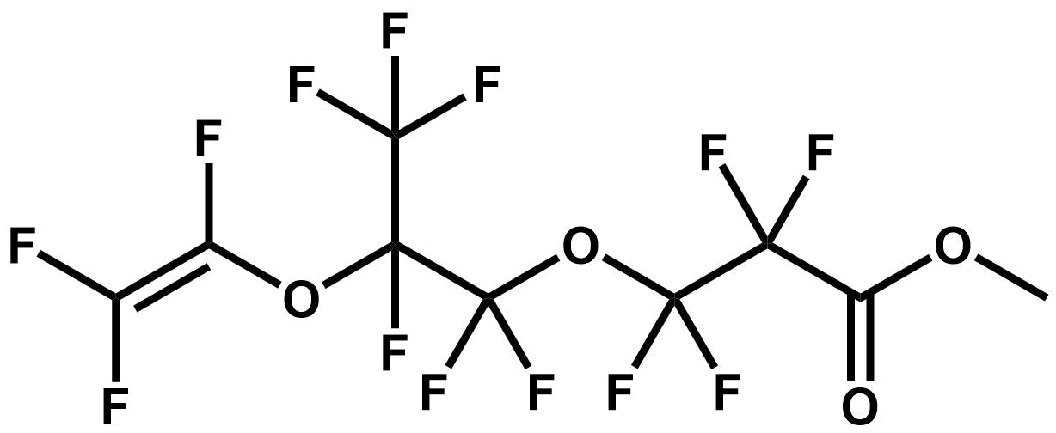 | 4.5
E3 | 2H-perfluoro-5,8-dimethyl-3,6,9-trioxadodecane | 3330-16-3 | 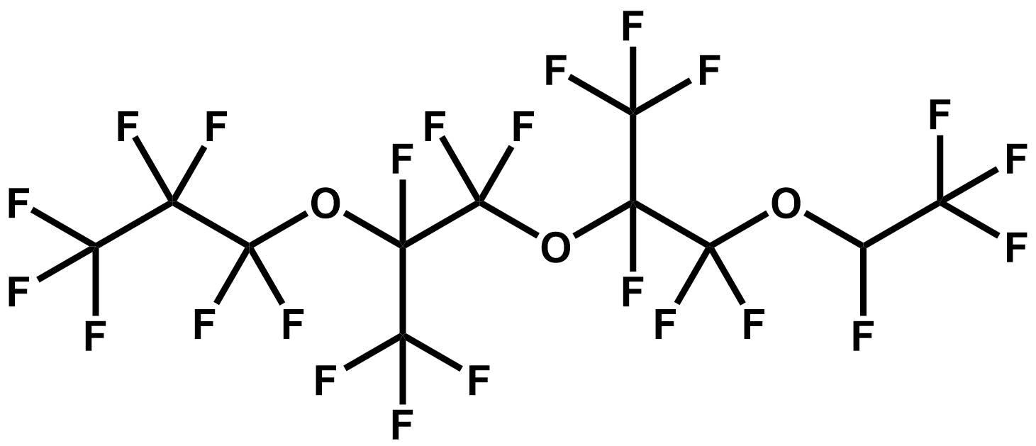 | 4.4
MTFE | 1-methoxy-1,1,2,2-tetrafluoroethane | 425-88-7 | 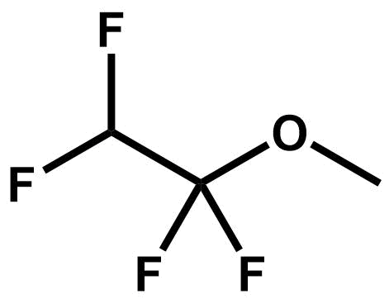 | 3.7
A/F Solvent (n=4 TAF) | Perfluoro-3,5,7,9,11-pentaoxadodecanoyl fluoride | 21703-49-1 | 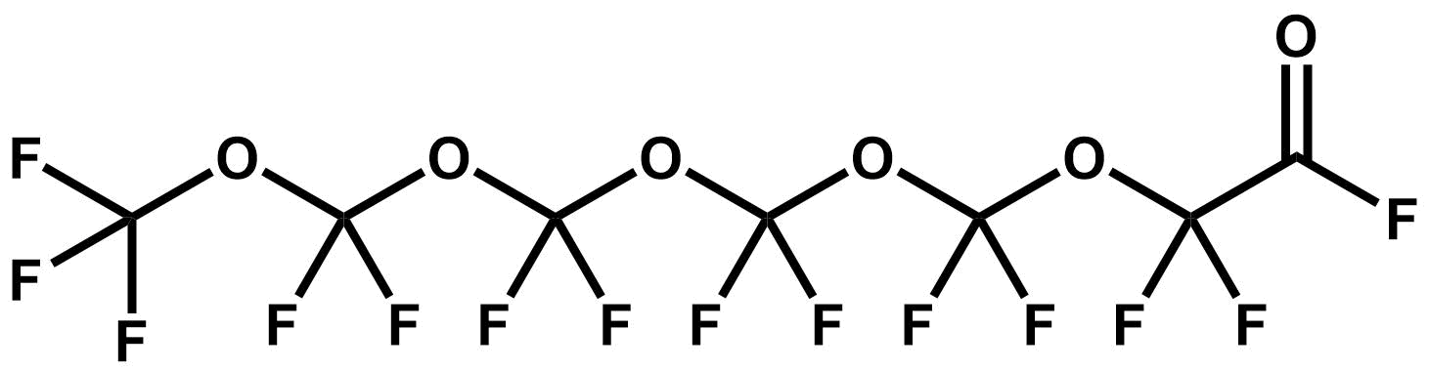 | 3.6
RSU | 2,2-difluoro-2-(fluorosulfonyl)acetyl fluoride | 677-67-8 | 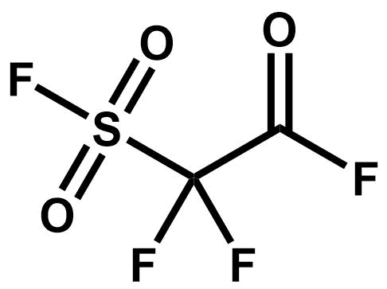 | 3.5
initiator | peroxide, bis[2,3,3,3-tetrafluoro-2-heptafluoropropoxy)-1-oxopropyl] | 56347-79-6 | 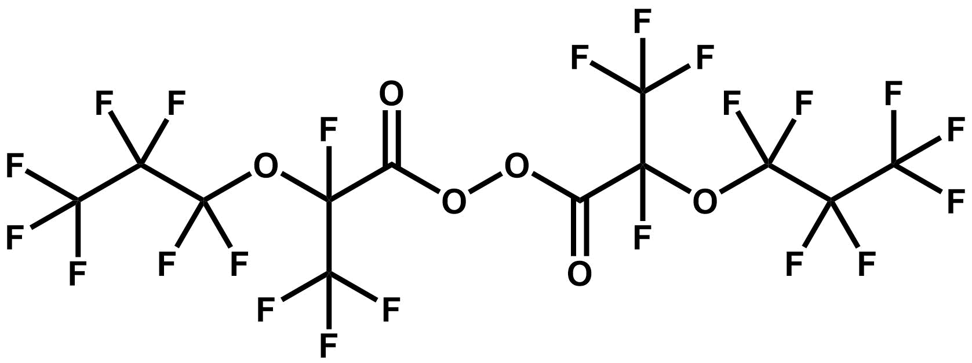 | 3.4
hydro-EVE^{c} | Methyl perfluoro-5-methyl-4,7-dioxanon-8-hydroaneoate | 87483-34-9 |  | 3.2
MTP | Methyl 3-methoxy- | 755-73-7 | 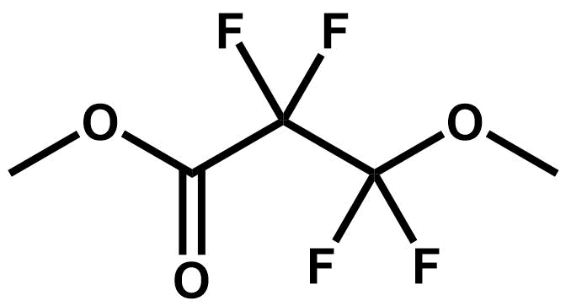 | 3.0
A/F Solvent (n=3 TAF) | 1,1,1,3,3,5,5,7,7,9,9-undecafluoro-2,4,6,8-tetraoxadecan-10-oyl fluoride | 21703-47-9 | 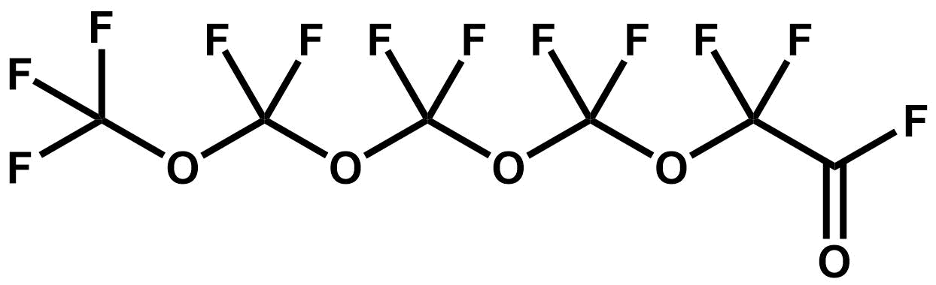 | 2.7
MTVE^{a,d} | methyl trifluorovinyl ether | 3823-94-7 | 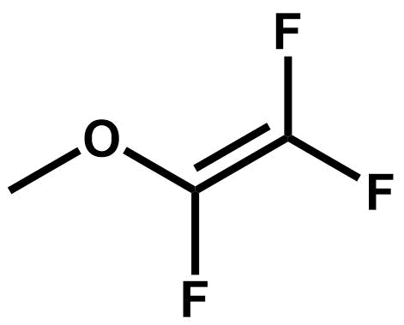 | 2.6
iso-PSEPVEª | Perfluoro-1-methyl-2-(2 fluorosulfonyl ethoxy) ethyl | 34805-58-8 |  | 0.9
TAEª | Methyl perfluoro (13-(fluoroformyl)-5,8-dimethyl-4,7,10-Trioxadodecanoate) | 69116-67-2 |  | 0.9
hydro-PSEPVE | Tetrafluoro-2-[Trifluoro-2-(1,2,2,2-Tetrafluoroethoxy)-1-(Trifluoromethyl) Ethoxy]-Ethane Sulfonyl Fluoride | 75549-02-9 | 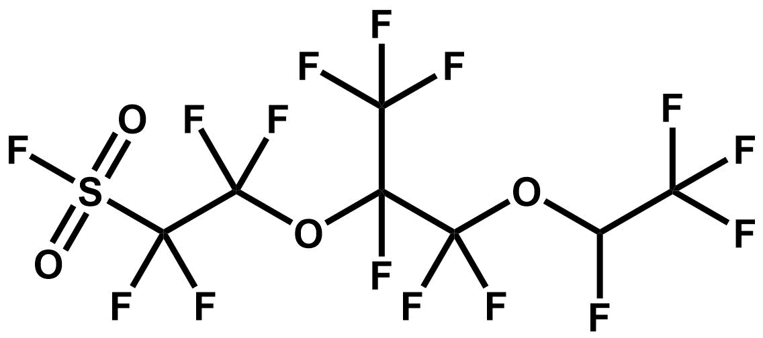 | 0.5
BMTK | Bis(2-methyoxytetrafluoroethyl)ketone | 1422-71-5 | 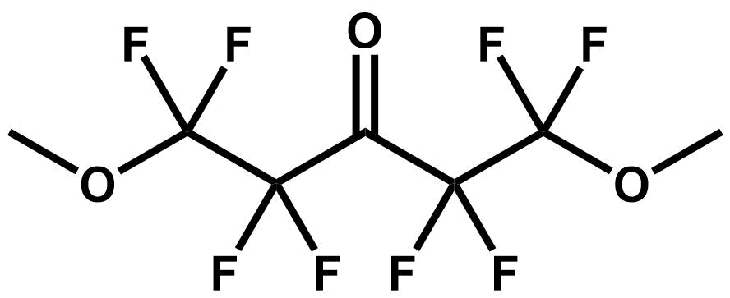 | 0.3
SU | 3,3,4,4-tetrafluoro-1,2-oxathietane 2,2-dioxide | 697-18-7 | 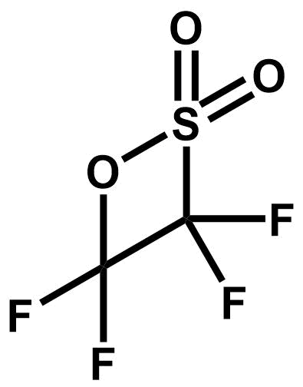 | 0.3
FRD-901 | Poly[oxy[trifluoro(trifluoromethyl)-1,2-ethanediyl]], α-(1-carboxy-1,2,2,2-tetrafluoroethyl)-ω-[tetrafluoro(trifluoromethyl)ethoxy]- | 51798-33-5 |  | 0.1
PMCPª | Perfluoromethylcyclopropane | 379-16-8 | 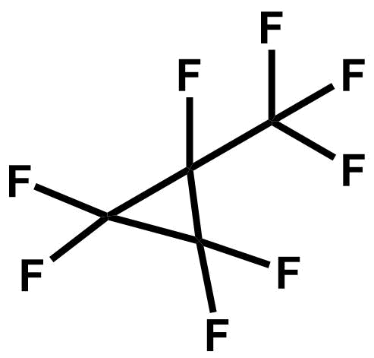 | 0
MTP acidª | 2,2,3,3-Tetrafluoro-3-methoxypropanoic acid | 93449-21-9 | 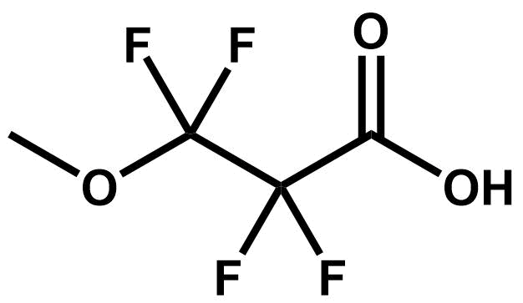 | 0
ªCAS is not in EPA’s Comptox Dashboard
^{b}Abbreviation on emissions report is inconsistent with IUPAC name. The IUPAC name was used to define the model parameters for CMAQ-PFAS.
^{c}CAS in Chemours’ emissions report does not match CAS in EPA’s Comptox Dashboard
^{d}CAS has multiple structures. Structure was chosen based on relevance to the Chemours process from which it was emitted.
Table S2. Physicochemical properties estimated for each emitted PFAS species.
Species | Functional Group | MW  (g mol⁻¹) | Density (g mL⁻¹) | C*  (μg m⁻³) | ΔH_{vap}  (kJ mol⁻¹) | Hº  (M atm⁻¹)
TFE | Terminal | 100.02 | 1.30 | 7.3E+10 | 17.8 | 6.2E+00
HFPO | Terminal | 166.02 | 1.30 | 1.1E+10 | 20.5 | 8.6E-03
HFP | Terminal | 150.02 | 1.58 | 4.0E+10 | 21.5 | 6.5E+00
E2 | Internal | 452.07 | 1.66 | 3.9E+09 | 37.4 | 1.1E+00
PSEPVE | Both | 446.12 | 1.70 | 1.9E+07 | 43.5 | 5.2E+02
COF2 | Terminal | 66.01 | 1.14 | 9.6E+10 | 18.0 | 7.2E-02
HF | n/a | 20.01 | 1.16 |  | 25.5
PAF | Terminal | 116.01 | 1.40 | 4.0E+10 | 25.9 | 2.6E+00
CH3F | None | 34.03 | 1.17 | 8.6E+09 | 17.7 | 6.4E-01
PPVE | Both | 266.04 | 1.53 | 3.0E+09 | 28.3 | 2.1E-01
PMVE | Both | 166.02 | 1.43 | 1.2E+10 | 25.1 | 1.0E+00
HFPO-DAF | Both | 332.04 | 1.30 | 3.1E+09 | 34.5 | 5.0E-02
PEVE | Both | 216.03 | 1.45 | 1.2E+10 | 26.7 | 7.5E-01
CF3H | None | 70.01 | 1.10 | 8.7E+10 | 17.2 | 1.2E-02
C4 (PFB) | Internal | 200.03 | 1.53 | 2.7E+10 | 24.6 | 1.6E+00
PMPF | Both | 232.03 | 1.60 | 4.0E+09 | 29.3 | 1.9E-01
A/F Solvent (n=4 TFF) | Both | 396.04 | 1.80ª | 1.9E+05 | 36.9ª | 1.1E+00
A/F Solvent (n=2 TAF) | Both | 314.04 | 1.60^{b} | 1.1E+08 | 30.0^{c} | 5.1E-02^{d}
EVE | Both | 422.1 | 1.59 | 1.7E+06 | 50.3 | 7.0E+04
F-113 | None | 187.38 | 1.7 | 4.9E+09 | 27.0 | 1.2E-02
HFPO-DA | Both | 330.05 | 1.85 | 9.8E+05 | 46.7 | 4.2E+06
E1 | Internal | 286.04 | 1.54 | 4.4E+09 | 28.3 | 7.8E-02
PEPF | Both | 282.04 | 1.70 | 3.6E+12 | 33.3 | 5.0E-02
DA | Both | 512.12 | 1.80 | 1.1E+07 | 49.6 | 3.2E+04
HFPO trimer | Both | 498.07 | 1.70 | 3.1E+09 | 43.3 | 1.7E+02
TAF | Both | 132.01 | 1.50 | 1.1E+10 | 24.9 | 2.6E-02
MA | Both | 346.1 | 1.80 | 8.4E+08 | 41.8 | 1.3E+02
PPF | Terminal | 166.02 | 1.50 | 3.6E+10 | 25.4 | 6.4E-02
MD | Unknown | 325.69^{d} | 1.59^{d} | 5.0E+09^{d} | 39.0^{d} | 3.7E+04^{d}
DAE | Both | 488.1 | 1.70 | 8.2E+05 | 54.4 | 3.0E+04
MAE | Both | 322.08 | 1.59^{d} | 7.6E+06 | 39.0^{d} | 1.7E+02
MMF | Both | 156.06 | 1.40 | 8.0E+07 | 36.0 | 1.0E+03
A/F Solvent (n=1 TAF) | Both | 248.03 | 1.59^{d} | 2.4E+09 | 39.0^{d} | 1.9E-01
C5 (PFP) | Terminal | 250.04 | 1.60 | 3.8E+10 | 26.5 | 2.2E-01
hydro-PEVE | Both | 236.04 | 1.59^{d} | 5.0E+09 | 39.0^{d} | 3.7E+04
TA | Both | 678.14 | 1.80 | 2.0E+04 | 56.8 | 5.5E+05
iso-EVE | Unknown | 325.69ª | 1.59^{d} | 5.0E+09^{d} | 39.0^{d} | 3.7E+04^{d}
E3 | Internal | 618.09 | 1.72 | 1.0E+09 | 45.2 | 1.8E+02
MTFE | Internal | 132.06 | 1.29 | 1.4E+09 | 24.7 | 1.6E-02
A/F Solvent (n=4 TAF) | Both | 446.05 | 1.80 | 2.1E+05 | 36.9 | 1.9E+02
RSU | Terminal | 180.08 | 1.58 | 6.2E+09 | 34.1 | 1.5E+00
initiator | Internal | 658.09 | 1.80 | 6.6E+05 | 48.9 | 8.2E+04
hydro-EVE | Unknown | 325.69^{d} | 1.59^{d} | 5.0E+09^{d} | 39.0^{d} | 3.7E+04^{d}
MTP | Internal | 190.09 | 1.59^{d} | 1.8E+08 | 39.0^{d} | 2.1E+01
A/F Solvent (n=3 TAF) | Both | 380.04 | 1.59^{d} | 2.1E+06 | 39.0^{d} | 1.1E+00
MTVE | Both | 112.01 | 1.20 | 5.0E+09^{d} | 25.6 | 3.7E+04^{d}
iso-PSEPVE | None | 466.12 | 1.59^{d} | 5.0E+09^{d} | 39.0^{d} | 3.7E+04^{d}
TAE | None | 325.69^{d} | 1.59^{d} | 5.0E+09^{d} | 39.0^{d} | 3.7E+04^{d}
hydro-PSEPVE | Both | 466.12 | 1.80 | 1.9E+07 | 43.4 | 1.8E+02
BMTK | Both | 290.11 | 1.50 | 2.4E+07 | 42.4 | 9.5E-01
SU | Internal | 180.08 | 1.69 | 4.3E+09 | 40.8 | 1.1E-02
FRD-901e | n/a
PMCP^{e} | n/a
MTP acid^{e} | n/a | 176.07 | 1.50 | 4.8E+06 | 43.8 | 2.4E+03
PFASOTHER^{f} |  | 249.09 | 1.57 | 6.3E+05 | 35.6 | 2.1E-01
ªValues for TAF4, a compound of similar structure
^{b}Based on compounds with similar structures (EVE, E1, E2, and HFPOTA)
^{c}Based on compounds with similar carbon numbers and molecular weight (TAF and TAF4)
^{d}Average of other compounds in “PFASOTHER”
^{e}Not included in CMAQ-PFAS. These compounds are exempt from the regulatory definition of VOC and are not required to be reported to EPA, thus it was unclear if they were reported consistently throughout the Chemours report, and were excluded.
^{f} Lumped model species in CMAQ-PFAS representing 24 explicit species as indicated in Table S5

Table S3. Comparison of OPERA saturation vapor concentration predictions to available measurements.
Compound abbreviation | OPERA C*  (µg m⁻³) | Measured C*  (µg m⁻³) | Reference
HFPO | 1.1E+10 | 4.7E+05 | http://www.synquestlabs.com/product/id/52427.html²¹
HFP | 4.0E+10 | 6.9E+03 | http://www.synquestlabs.com/product/id/52426.html²¹
E2 | 3.9E+09 | 7.5E+03 | http://www.synquestlabs.com/product/id/27940.html²¹
PSEPVE | 1.9E+07 | 3.5E+02 | http://www.synquestlabs.com/product/id/27815.html²¹
COF2 | 9.6E+10 | 2.9E+04 | http://www.synquestlabs.com/product/id/52268.html²¹
PAF | 4.0E+10 | 1.4E+04 | http://www.synquestlabs.com/product/id/26419.html²¹
CH3F | 8.6E+09 | 1.0E+04 | http://www.synquestlabs.com/product/id/20878.html²¹
PPVE | 3.0E+09 | 7.6E+04 | http://www.synquestlabs.com/product/id/19309.html²¹
CF3H | 8.7E+10 | 2.4E+04 | http://www.synquestlabs.com/product/id/26876.html²¹
C4 (PFB) | 2.7E+10 | 1.6E+03 | http://www.synquestlabs.com/product/id/23178.html²¹
EVE | 1.7E+06 | 5.7E+02 | http://www.synquestlabs.com/product/id/26279.html²¹
F-113 | 4.9E+09 | 2.9E+04 | https://www.cdc.gov/niosh/npg/npgd0632.html²²

Table S4. CMAQ performance metrics for typically evaluated pollutants using evaluations at sites within the Eastern North Carolina model domain.
Species | Obs Network | Num | Units | Obs Avgª | CMAQ Avg | r^{b} | RMSE^{c} | IOA^{d}
NO_{x} | AQS^{e} | 4635 | ppb | 1.50 | 1.43 | 0.51 | 1.34 | 0.69
O₃ | AQS | 42940 | ppb | 30.19 | 34.17 | 0.82 | 9.54 | 0.86
SO₂ | AQS | 12454 | ppb | 0.79 | 0.24 | 0.18 | 3.91 | 0.09
PM_{2.5} | AQS | 35234 | μg m⁻³ | 7.46 | 9.72 | 0.44 | 6.69 | 0.62
PM_{2.5} | CSN^{f} | 430 | μg m⁻³ | 7.19 | 10.09 | 0.70 | 2.91 | 0.71
ª Observed and CMAQ averages are arithmetic.
^{b} correlation coefficient.
^{c} Root-mean square error
^{d} Index of Agreement
^{e} Air Quality System hourly comparisons
^{f} Chemical Speciation Network comparisons are daily averages measured every third day.

Table S5. Map of emitted PFAS chemical species to CMAQ-PFAS model species.
Species | CMAQ-PFAS Gas Species | CMAQ Aerosol Species
TFE | TFE | ATFEJ
HFPO | HFPO | AHFPOJ
HFP | HFP | AHFPJ
E2 | E2 | AE2J
PSEPVE | PSEPVE | APSEPVEJ
COF2 | COF2 | ACOF2J
HF | --- | AHFJ
PAF | PAF | APAFJ
CH3F | CH3F | ACH3FJ
PPVE | PPVE | APPVEJ
PMVE | PMVE | APMVEJ
HFPO-DAF | HFPODAF | AHFPODAFJ
PEVE | PEVE | APEVEJ
CF3H | CF3H | ACF3HJ
C4 (PFB) | PFB | APFBJ
PMPF | PMPF | APMPFJ
A/F Solvent (n=4 TFF) | TFF4 | ATFF4J
A/F Solvent (n=2 TAF) | TAF2 | ATAF2J
EVE | EVE | AEVEJ
F-113 | F113 | AF113J
HFPO-DA | HFPODA | AHFPODAJ
E1 | E1 | AE1J
PEPF | PEPF | APEPFJ
DA | DA | ADAJ
HFPO trimer | HFPOTA | AHFPOTAJ
TAF | TAF | ATAFJ
MA | MA | AMAJ
PPF | PFASOTHER | APFASOTHERJ
MD | PFASOTHER | APFASOTHERJ
DAE | PFASOTHER | APFASOTHERJ
MAE | PFASOTHER | APFASOTHERJ
MMF | PFASOTHER | APFASOTHERJ
A/F Solvent (n=1 TAF) | PFASOTHER | APFASOTHERJ
C5 (PFP) | PFASOTHER | APFASOTHERJ
hydro-PEVE | PFASOTHER | APFASOTHERJ
TA | PFASOTHER | APFASOTHERJ
iso-EVE | PFASOTHER | APFASOTHERJ
E3 | PFASOTHER | APFASOTHERJ
MTFE | PFASOTHER | APFASOTHERJ
A/F Solvent (n=4 TAF) | PFASOTHER | APFASOTHERJ
RSU | PFASOTHER | APFASOTHERJ
initiator | PFASOTHER | APFASOTHERJ
hydro-EVE | PFASOTHER | APFASOTHERJ
MTP | PFASOTHER | APFASOTHERJ
A/F Solvent (n=3 TAF) | PFASOTHER | APFASOTHERJ
MTVE | PFASOTHER | APFASOTHERJ
iso-PSEPVE | PFASOTHER | APFASOTHERJ
TAE | PFASOTHER | APFASOTHERJ
hydro-PSEPVE | PFASOTHER | APFASOTHERJ
BMTK | PFASOTHER | APFASOTHERJ
SU | PFASOTHER | APFASOTHERJ

Table S6. Water solubility properties for carboxylic acid products of acyl fluoride hydrolysis.
Acyl Fluoride  Species | Carboxylic Acid SMILES | Hº  (M atm⁻¹) | pKa | H^{eff}  (M atm⁻¹)ª
HFPO-DAF | OC(=O)C(F)(OC(F)(F)C(F)(F)C(F)(F)F)C(F)(F)F | 4.2E+06 | -0.73 | 2.3E+10
COF2 | O=C(O)O | 1.0E+04 | 1.10 | 8.0E+05
PAF | O=C(C(F)(F)F)O | 8.1E+03 | 0.72 | 1.5E+06
PMPF | FC(F)(OC(F)(C(F)(F)F)C(O)=O)F | 2.0E+01 | 0.07 | 1.7E+04
TAF2 | OC(C(F)(OC(F)(OC(F)(OC(F)(F)F)F)F)F)=O | 2.0E+00 | -0.22 | 3.4E+03
PEPF | OC(C(OC(F)(C(F)(F)F)F)(C(F)(F)F)F)=O | 3.2E+06 | -0.86 | 2.3E+10
DA | OC(C(F)(OC(F)(C(F)(OC(F)(C(F)(S(=O)(F)=O)F)F)C(F)(F)F)F)C(F)(F)F)=O | 5.9E+07 | -0.009 | 6.0E+10
HFPOTA | OC(C(OC(F)(C(OC(F)(C(F)(C(F)(F)F)F)F)(C(F)(F)F)F)F)(C(F)(F)F)F)=O | 6.4E+06 | -1.29 | 1.2E+11
TAF | OC(OC(F)(F)F)=O | 3.0E+03 | 3.05 | 5.7E+03
MA | OC(C(F)(OC(F)(F)C(F)(S(=O)(F)=O)F)C(F)(F)F)=O | 6.0E+06 | -0.95 | 5.4E+10
ª Effective Henry’s Law constants are calculated for an absorbing media with pH = 3.

Table S7. Weekly total GenX deposition (ng m⁻²) measurements at NC DEQ sampling sites in 2018.
Week | Start Date | End Date | NE,  Wetª  34.859347°  -78.810391° | NE,  Dryª  34.859347°  -78.810391° | N^{b}  34.858974°  -78.828656° | NW^{b}  34.859184°  -78.852599° | SW,  Wetª  34.829306°  -78.865112° | SW,  Dryª  34.829306°  -78.865112° | SE^{b}  34.820316°  -78.850030°
1 | 1/2 | 1/8
2 | 1/9 | 1/15
3 | 1/16 | 1/22
4 | 1/23 | 1/29
5 | 1/30 | 2/5
6 | 2/6 | 2/12
7 | 2/13 | 2/19
8 | 2/20 | 2/26
9 | 2/27 | 3/5
10 | 3/6 | 3/12
11 | 3/13 | 3/19
12 | 3/20 | 3/26 |  |  |  |  |  |  | 1580
13 | 3/27 | 4/2 |  |  | ND |  |  | 427 | 106
14 | 4/3 | 4/9 | 78.5 | 2420 | 1486 |  | 110 | 1717 | 3515
15 | 4/10 | 4/16 | No sample | No sample | 3682 |  | ND | 561 | 1201
16 | 4/17 | 4/23 | ND | ND | 374 |  | 41 | 1090 | 270
17 | 4/24 | 4/30 | No sample | 974 | 654 |  | No sample | ND | 153
18 | 5/1 | 5/7 | 853 | 440 | 3160 |  | ND | ND | 886
19 | 5/8 | 5/14 | ND | ND | 5815 |  | 616 | 1158 | 240
20 | 5/15 | 5/21 | 616 | ND | 2431 |  | ND | ND | ND
21 | 5/22 | 5/28 | ND | ND | ND | 1611 | ND | ND | ND
22 | 5/29 | 6/4 | ND | ND | 4985 | 517 | ND | ND | ND
23 | 6/5 | 6/11 | ND | ND | ND | ND | ND | ND | ND
24 | 6/12 | 6/18 | ND | ND | ND | ND | ND | ND | 761
25 | 6/19 | 6/25 | 369 | ND | 235 | ND | ND | ND | ND
26 | 6/26 | 7/2 | ND | ND | 611 | 954 | 1089 | ND | ND
27 | 7/3 | 7/9 | ND | ND | 472 | ND | ND | ND | 111
28 | 7/10 | 7/16 | ND | ND | ND | ND | ND | ND | ND
29 | 7/17 | 7/23 | ND | ND | 351 | ND | ND | ND | ND
30 | 7/24 | 7/30 | ND | ND | 812 | ND | ND | ND | ND
31 | 7/31 | 8/6 | 663 | ND | 2442 | ND | ND | ND | ND
32 | 8/7 | 8/13 | 568 | 2026 | 345 | 937 | ND | ND | ND
33 | 8/14 | 8/20 | 3837 | 14469 | 463 | ND | ND | ND | 356
34 | 8/21 | 8/27 | ND | ND | 92 | ND | ND | ND | ND
35 | 8/28 | 9/3 | ND | ND | 92 | ND | ND | ND | ND
36 | 9/4 | 9/10 | ND | ND | ND | ND | ND | ND | ND
37 | 9/11 | 9/18 | No collection | No collection | No collection | No collection | No collection | No collection | No collection
38 | 9/19 | 9/26 | No collection | No collection | No collection | No collection | No collection | No collection | No collection
39 | 9/27 | 10/2 | No collection | No collection | No collection | ND | ND | ND | 1200
40 | 10/3 | 10/8 | ND | ND | ND | ND | ND | ND | 111
41 | 10/9 | 10/15 | No collection | No collection | No collection | No collection | No collection | No collection | No collection
42 | 10/16 | 10/22 | ND | ND | ND | ND | ND | ND | ND
43 | 10/23 | 10/29 | ND | ND | ND | ND | ND | ND | ND
44 | 10/30 | 11/5 | ND | ND | 156 | ND | ND | ND | ND
45 | 11/6 | 11/12 | ND | ND | ND | ND | ND | ND | ND
46 | 11/13 | 11/19 | ND | ND | ND | ND | 853 | 820 | 1619
47 | 11/20 | 11/26 | ND | ND | ND | ND | 663 | ND | ND
48 | 11/27 | 12/4 | 474 | 1543 | ND | 2227 | ND | ND | ND
49 | 12/4 | 12/11 | ND | Archived | ND | ND | 3012 | Archived | 5522
50 | 12/12 | 12/27 | ND | ND | 14832 | 1511 | 1563 | ND | Sample error
51 | 12/18 | 12/26 | 374 | ND | 622 | 4392 | 995 | 3762 | 1500
52 | 12/27 | 1/2 | ND | ND | 3000 | 175 | ND | ND | 1326
ªNCON 110 sampler used at these sites
^{b}NCON 120 sampler used at these sites
Table S8. Average annual deposition rate by wet and dry mechanisms for both model runs.
 | Total PFAS, Base | Total PFAS, CarbAcid | GenX, Base | GenX, CarbAcid
Wet (ng m⁻² yr⁻¹)ª | 581.79 | 5,574.45 | 129.86 | 1,026.79
Dry (ng m⁻² yr⁻¹) | 81,600.36 | 93,607.18 | 287.24 | 1,001.07
ªThe total area of the CMAQ-PFAS model domain is 63,440 km²

Table S9. Annual Emissions (kg yr⁻¹) of PFAS emitted by each process at Chemours Fayetteville Works in 2017.
Process | Abbreviation | Group | PFAS Species | Emissions (kg yr⁻¹)
Manufacture of polymer processing aides | PPA | Monomers | Total | 323.0
Manufacture of polymer processing aides |  |  | FRD-901 | 0.1
Manufacture of polymer processing aides |  |  | HFPO-DA | 304.4
Manufacture of polymer processing aides |  |  | HF | 18.5
Manufacture of Hexafluoropropylene Epoxide (HFPO) | HFPO | Other | Total | 37595.1
Manufacture of Hexafluoropropylene Epoxide (HFPO) |  |  | COF2 | 1696.9
Manufacture of Hexafluoropropylene Epoxide (HFPO) |  |  | PAF | 1301.4
Manufacture of Hexafluoropropylene Epoxide (HFPO) |  |  | A/F Solvent (n=4 TFF) | 393.7
Manufacture of Hexafluoropropylene Epoxide (HFPO) |  |  | A/F Solvent (n=1 TAF) | 3.6
Manufacture of Hexafluoropropylene Epoxide (HFPO) |  |  | A/F Solvent (n=2 TAF) | 382.4
 |  |  | A/F Solvent (n=3 TAF) | 2.7
 |  |  | A/F Solvent (n=4 TAF) | 3.6
 |  |  | HFP | 16622.8
 |  |  | HFPO | 15665.3
 |  |  | PMCP | n/a
 |  |  | CF3H | n/a
 |  |  | HF | 1522.7
Vinyl ethers north, EVE process | EVE | Monomers | Total | 275.1
Vinyl ethers north, EVE process |  |  | HFP | 50.3
Vinyl ethers north, EVE process |  |  | HFPO | 55.3
 |  |  | HFPO-DAF | 22.2
 |  |  | EVE | 64.0
 |  |  | TFE | 26.3
 |  |  | MAE | 16.3
 |  |  | DAE | 24.9
 |  |  | TAE | 0.9
 |  |  | hydro-EVE | 3.2
 |  |  | iso-EVE | 4.5
 |  |  | MMF | 3.2
 |  |  | HF | 3.8
Vinyl ethers north, PPVE process | PPVE | Monomers | Total | 10435.1
Vinyl ethers north, PPVE process |  |  | HFP | 3106.2
Vinyl ethers north, PPVE process |  |  | HFPO | 5604.1
 |  |  | HFPO-DAF | 561.5
 |  |  | PPVE | 940.7
 |  |  | PPF | 34.5
 |  |  | TFE | 3.6
 |  |  | C4 (PFB) | 129.7
 |  |  | C5 (PFP) | 7.7
 |  |  | HFPO trimer | 8.6
 |  |  | HF | 38.3
Vinyl ethers north, PSEPVE process | PSEPVE | Monomers | Total | 1560.0
Vinyl ethers north, PSEPVE process |  |  | HFP | 97.5
 |  |  | HFPO | 474.5
 |  |  | HFPO-DAF | 93.0
 |  |  | PSEPVE | 249.5
 |  |  | PPF | 0.9
 |  |  | TFE | 128.8
 |  |  | C4 (PFB) | 308.4
 |  |  | DA | 131.1
 |  |  | hydro-PSEPVE | 0.5
 |  |  | MA | 58.5
 |  |  | HFPO trimer | 3.2
 |  |  | iso-PSEPVE | 0.9
 |  |  | TA | 5.0
 |  |  | RSU | 0.5
 |  |  | HF | 8.8
Vinyl ethers south, PEPM process | VES | Monomers | Total | 2656.9
Vinyl ethers south, PEPM process |  |  | COF2 | 211.8
Vinyl ethers south, PEPM process |  |  | PAF | 176.9
Vinyl ethers south, PEPM process |  |  | PMPF | 83.0
 |  |  | PEPF | 34.5
 |  |  | PMVE | 37.6
 |  |  | PEVE | 0.0
 |  |  | HFP | 1870.6
 |  |  | HFPO | 71.2
 |  |  | HFPO-DAF | 2.7
 |  |  | HF | 168.4
Vinyl ethers south, PPVE process | VES | Monomers | Total | 800.8
Vinyl ethers south, PPVE process |  |  | HFP | 264.9
Vinyl ethers south, PPVE process |  |  | HFPO | 461.8
 |  |  | PPF | 0.5
 |  |  | TFE | 0.5
 |  |  | PPVE | 53.1
 |  |  | C4 (PFB) | 8.6
 |  |  | C5 (PFP) | 0.5
 |  |  | HFPO-DAF | 10.4
 |  |  | HFPO trimer | 0.0
 |  |  | HF | 0.7
Vinyl ethers south, loading HFPO-DAF into ISO tank | VES | Monomers | Total | 0.0
Vinyl ethers south, loading HFPO-DAF into ISO tank |  |  | HFPO-DAF | 0.0
Vinyl ethers south, fugitive emissions | VES | Monomers | Total | 2346.9
Vinyl ethers south, fugitive emissions |  |  | COF2 | 31.3
Vinyl ethers south, fugitive emissions |  |  | PAF | 30.4
Vinyl ethers south, fugitive emissions |  |  | HFP | 6.4
Vinyl ethers south, fugitive emissions |  |  | HFPO | 202.8
 |  |  | PMPF | 342.9
 |  |  | PEPF | 143.3
 |  |  | HFPO-DAF | 0.9
 |  |  | MD | 32.2
 |  |  | hydro-PEVE | 6.4
 |  |  | PPVE | 6.4
 |  |  | PEVE | 682.2
 |  |  | PMVE | 797.0
 |  |  | HF | 64.9
Vinyl ethers south, accidental release | VES | Monomers | Total | 58.5
Vinyl ethers south, accidental release |  |  | HFPO | 24.9
Vinyl ethers south, accidental release |  |  | HFPO-DAF | 31.8
 |  |  | HF | 1.8
RSU process | RSU | IXM | Total | 1496.8
 |  |  | TFE | 1448.9
 |  |  | PAF | 8.9
 |  |  | RSU | 3.0
 |  |  | SU | 0.3
 |  |  | COF2 | 3.1
 |  |  | n=1 TAF | 8.5
 |  |  | HF | 24.0
FPS liquid waste stabilization | Other | Other | Total | 344.9
FPS liquid waste stabilization |  |  | COF2 | 54.4
FPS liquid waste stabilization |  |  | HFPO trimer | 115.7
 |  |  | TAF | 126.9
 |  |  | HF | 47.9
Nafion MMF | MMF | IXM | Total | 1569.8
 |  |  | MTVE | 2.6
 |  |  | MTFE | 3.7
 |  |  | MTP | 3.0
 |  |  | BMTK | 0.3
 |  |  | MTP acid | 0.0
 |  |  | TFE | 28.5
 |  |  | CH3F | 1506.6
 |  |  | MMF | 12.7
 |  |  | HF | 12.4
Resins process | Polymers | IXM | Total | 21176.3
 |  |  | PSEPVE | 1847.9
 |  |  | EVE | 308.0
 |  |  | TFE | 14998.9
 |  |  | E2 | 4018.4
 |  |  | HFPO-DAF | 2.3
 |  |  | F-113 | 0.0
 |  |  | HF | 0.8
IXM membrane process | Products | IXM | Total | 57.2
IXM membrane process |  |  | HF | 57.2
E-Fluids process | E2 | IXM | Total | 488.8
 |  |  | E1 | 243.1
 |  |  | E2 | 241.4
 |  |  | E3 | 4.4
HFA-Hydrate Destruction Reactor system | Other | Other | Total | 455.9
HFA-Hydrate Destruction Reactor system |  |  | CF3H | 455.9
TFE/CO2 separation process | Other | Other | Total | 23413.1
TFE/CO2 separation process |  |  | TFE | 23413.1
HFPO container decontamination | Other | Other | Total | 5061.6
HFPO container decontamination |  |  | HFPO | 5061.6
VEN product container decontamination | Other | Other | Total | 294.9
VEN product container decontamination |  |  | PPVE | 290.5
VEN product container decontamination |  |  | PSEPVE | 0.0
 |  |  | EVE | 4.3
VES product container decontamination | Other | Other | Total | 395.3
VES product container decontamination |  |  | PMVE | 380.4
VES product container decontamination |  |  | PEVE | 14.7
VES product container decontamination |  |  | PPVE | 0.0
 |  |  | HFPO-DAF | 0.2
 |  |  | HF | 0.0
Semiworks 1 | Semiworks | IXM | Total | 549.5
 |  |  | TFE | 33.4
 |  |  | PSEPVE | 50.9
 |  |  | E2 | 92.5
 |  |  | PAF | 6.5
 |  |  | HFPO-DA | 0.2
 |  |  | initiator | 3.4
 |  |  | F-113 | 361.3
 |  |  | HF | 1.1

Table S10. Emissions stack parameters assumed for placement in the model domain and calculation of buoyant plume rise.
Parameter | Value
Latitude | 34.84333
Longitude | -78.83822
Diameter (m) | 0.914
Height (m) | 25.9
Exit Temperature (K) | 297.0
Exit Velocity (m s⁻¹) | 17.7
Exit Flow Rate (m³ s⁻¹) | 0.236

Table S11. Weekly record of number of days each PFAS-emitting process group was running at the Fayetteville Works facility during 2018. January 1 – March 20 were not available, data from 2019 was used as a proxy.
Week | Start Date | End Date | Monomers | IXM | Other
1 | 1/1 | 1/6 | 6 | 6 | 6
2 | 1/7 | 1/13 | 7 | 6 | 7
3 | 1/14 | 1/20 | 7 | 7 | 7
4 | 1/21 | 1/27 | 7 | 7 | 7
5 | 1/28 | 2/3 | 7 | 6 | 7
6 | 2/4 | 2/10 | 6 | 6 | 7
7 | 2/11 | 2/17 | 7 | 7 | 7
8 | 2/18 | 2/24 | 7 | 7 | 7
9 | 2/25 | 3/3 | 7 | 6 | 7
10 | 3/4 | 3/10 | 7 | 7 | 7
11 | 3/11 | 3/17 | 7 | 7 | 7
12 | 3/18 | 3/24 | 7 | 7 | 7
13 | 3/25 | 3/31 | 7 | 7 | 7
14 | 4/1 | 4/7 | 7 | 7 | 7
15 | 4/8 | 4/14 | 7 | 7 | 7
16 | 4/15 | 4/21 | 7 | 7 | 7
17 | 4/22 | 4/28 | 7 | 7 | 7
18 | 4/29 | 5/5 | 7 | 7 | 7
19 | 5/6 | 5/12 | 7 | 7 | 7
20 | 5/13 | 5/19 | 1 | 7 | 7
21 | 5/20 | 5/26 | 3 | 7 | 7
22 | 5/27 | 6/2 | 5 | 7 | 7
23 | 6/3 | 6/9 | 6 | 7 | 7
24 | 6/10 | 6/16 | 7 | 7 | 7
25 | 6/17 | 6/23 | 7 | 7 | 7
26 | 6/24 | 6/30 | 7 | 7 | 7
27 | 7/1 | 7/7 | 7 | 7 | 7
28 | 7/8 | 7/14 | 7 | 7 | 7
29 | 7/15 | 7/21 | 7 | 7 | 7
30 | 7/22 | 7/28 | 7 | 7 | 7
31 | 7/29 | 8/4 | 7 | 7 | 7
32 | 8/5 | 8/11 | 6 | 7 | 7
33 | 8/12 | 8/18 | 7 | 7 | 7
34 | 8/19 | 8/25 | 7 | 7 | 7
35 | 8/26 | 9/1 | 7 | 7 | 7
36 | 9/2 | 9/8 | 7 | 7 | 7
37 | 9/9 | 9/15 | 4 | 5 | 7
38 | 9/16 | 9/22 | 4 | 3 | 7
39 | 9/23 | 9/29 | 7 | 7 | 7
40 | 9/30 | 10/6 | 6 | 7 | 7
41 | 10/7 | 10/13 | 4 | 0 | 7
42 | 10/14 | 10/20 | 0 | 0 | 7
43 | 10/21 | 10/27 | 0 | 0 | 7
44 | 10/28 | 11/3 | 2 | 2 | 7
45 | 11/4 | 11/10 | 6 | 5 | 7
46 | 11/11 | 11/17 | 7 | 7 | 7
47 | 11/18 | 11/24 | 7 | 7 | 7
48 | 11/25 | 12/1 | 7 | 7 | 7
49 | 12/2 | 12/8 | 7 | 7 | 7
50 | 12/9 | 12/15 | 7 | 7 | 7
51 | 12/16 | 12/22 | 7 | 6 | 7
52 | 12/23 | 12/29 | 7 | 7 | 7
53 | 12/30 | 12/31 | 2 | 1 | 2

Table S12. CMAQ-PFAS model species with emissions susceptible to facility controls.
Species
HF
PAF
HFPO-DAF
PMPF
TAF
HFPO-DA
COF2
PEPF
DA
HFPO-TA
MA
PFASOTHER

Table S13. Emission control reduction factors applied for each controlled process throughout 2018.
 | Process
Month | HFPO | PSEPVE | PPVE | PEVE | VES | E2 | MMF | RSU | Products | Polymers | Semi-Works | PPA | Other
Jan | 0.000 | 0.000 | 0.000 | 0.000 | 0.000 | 0.000 | 0.000 | 0.000 | 0.000 | 0.000 | 0.000 | 0.000 | 0.000
Feb | 0.000 | 0.000 | 0.000 | 0.000 | 0.000 | 0.000 | 0.000 | 0.000 | 0.000 | 0.000 | 0.000 | 0.000 | 0.000
Mar | 0.000 | 0.000 | 0.000 | 0.000 | 0.000 | 0.000 | 0.000 | 0.000 | 0.000 | 0.000 | 0.000 | 0.000 | 0.000
Apr | 0.000 | 0.000 | 0.000 | 0.000 | 0.000 | 0.000 | 0.000 | 0.000 | 0.000 | 0.000 | 0.000 | 0.000 | 0.000
May | 0.000 | 0.153 | 0.149 | 0.029 | 0.000 | 0.000 | 0.000 | 0.000 | 0.000 | 0.000 | 0.000 | 0.000 | 0.000
Jun | 0.000 | 0.153 | 0.149 | 0.029 | 0.000 | 0.000 | 0.000 | 0.000 | 0.000 | 0.000 | 0.000 | 0.996 | 0.000
Jul | 0.000 | 0.153 | 0.149 | 0.029 | 0.000 | 0.000 | 0.000 | 0.000 | 0.000 | 0.000 | 0.000 | 0.999 | 0.000
Aug | 0.000 | 0.153 | 0.149 | 0.029 | 0.000 | 0.000 | 0.000 | 0.000 | 0.000 | 0.000 | 0.000 | 0.999 | 0.000
Sep | 0.000 | 0.153 | 0.149 | 0.029 | 0.000 | 0.000 | 0.000 | 0.000 | 0.000 | 0.000 | 0.000 | 0.999 | 0.000
Oct | 0.000 | 0.443 | 0.443 | 0.443 | 0.000 | 0.000 | 0.000 | 0.000 | 0.000 | 0.000 | 0.000 | 0.999 | 0.000
Nov | 0.000 | 0.443 | 0.443 | 0.443 | 0.000 | 0.000 | 0.000 | 0.000 | 0.000 | 0.000 | 0.000 | 0.999 | 0.000
Dec | 0.000 | 0.955 | 0.443 | 0.443 | 0.000 | 0.000 | 0.000 | 0.000 | 0.000 | 0.000 | 0.000 | 0.999 | 0.000
ª0 refers to no reduction. 1 refers to full reduction (i.e. zero emissions).

Table S14. Monthly error statistics for 2-m temperature (T2), 2-m water vapor mixing ratio (Q2), 10-m wind speed (WS), and 10-m wind direction (WD). A: Root Mean Square Error (RMSE), B: bias, and C: Index of Agreement (IOA). Note IOA for wind direction is not available.
A B C

RMSE
Month | T2  (K) | Q2  (g kg⁻¹) | WS  (m s⁻¹) | WD  (ᵒ)
1 | 2.15 | 0.72 | 1.64 | 19
2 | 2.03 | 1.04 | 1.52 | 20
3 | 1.67 | 0.71 | 1.68 | 19
4 | 1.69 | 0.94 | 1.55 | 20
5 | 1.41 | 1.22 | 1.32 | 21
6 | 1.57 | 1.47 | 1.27 | 28
7 | 1.58 | 1.46 | 1.40 | 29
8 | 1.57 | 1.45 | 1.33 | 28
9 | 1.42 | 1.52 | 1.53 | 28
10 | 1.53 | 1.28 | 1.41 | 21
11 | 1.75 | 1.01 | 1.41 | 20
12 | 1.79 | 0.80 | 1.42 | 21

Bias
Month | T2  (K) | Q2  (g kg⁻¹) | WS  (m s⁻¹) | WD  (ᵒ)
1 | -0.24 | -0.21 | 0.61 | 5
2 | -0.48 | -0.28 | 0.37 | 3
3 | -0.15 | -0.20 | 0.57 | 5
4 | -0.34 | -0.14 | 0.37 | 5
5 | -0.16 | -0.20 | 0.41 | 7
6 | 0.24 | -0.15 | 0.17 | 7
7 | 0.23 | -0.22 | 0.28 | 7
8 | 0.32 | -0.42 | 0.37 | 7
9 | 0.05 | -0.56 | 0.18 | 8
10 | -0.44 | -0.63 | 0.43 | 8
11 | -0.44 | -0.42 | 0.45 | 6
12 | -0.43 | -0.21 | 0.38 | 8

IOA
Month | T2  (k) | Q2  (g kg⁻¹) | WS  (m s⁻¹)
1 | 0.96 | 0.98 | 0.78
2 | 0.96 | 0.96 | 0.74
3 | 0.96 | 0.97 | 0.78
4 | 0.96 | 0.94 | 0.77
5 | 0.95 | 0.94 | 0.57
6 | 0.93 | 0.83 | 0.56
7 | 0.91 | 0.83 | 0.55
8 | 0.91 | 0.77 | 0.58
9 | 0.93 | 0.72 | 0.70
10 | 0.98 | 0.97 | 0.70
11 | 0.96 | 0.96 | 0.61
12 | 0.96 | 0.96 | 0.70

Table S15. Total monthly observed (OBS) and modeled (MOD) precipitation for the area encompassing Chemours and the 5 NC DEQ measurement sites, averaged across all grid cells.
Month | OBS (mm) | MOD (mm)
1 | 79 | 49
2 | 49 | 39
3 | 79 | 71
4 | 89 | 70
5 | 117 | 86
6 | 109 | 122
7 | 114 | 133
8 | 138 | 79
9 | 501 | 1313
10 | 52 | 18
11 | 147 | 148
12 | 173 | 192

HFPO-DA
13252-13-6
HFPO-DAF
2062-98-8
Common anion
HFPO-DA ammonium salt
62037-80-3
Figure S1. Structures of HFPO-DA(g), HFPO-DAF, HFPO-DA ammonium salt, and the common anion, HFPO-DA⁻(aq).

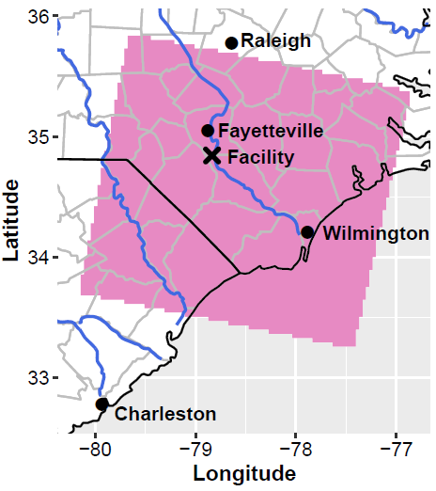
Figure S2. Map of 1 km x 1 km CMAQ-PFAS model domain (pink shaded region).

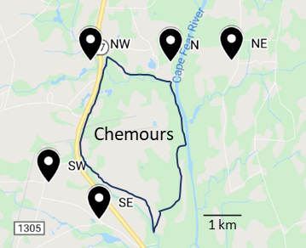
Figure S3. Locations of deposition measurements around the plant, corresponding to locations shown in Figure 2.

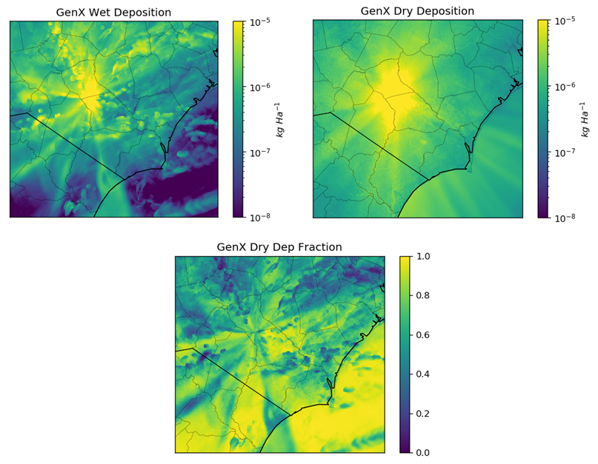
Figure S4. Annual averaged total GenX deposition flux for wet scavenging (top left) and dry pathways (top right). The bottom panel shows the fraction of total deposition attributed to dry pathways.

Figure S5. Histogram of annual average (left) and hourly average (right) total GenX ambient air concentrations predicted by CMAQ-PFAS. Values below 1 pg m⁻³ were removed for the hourly averaged histogram.

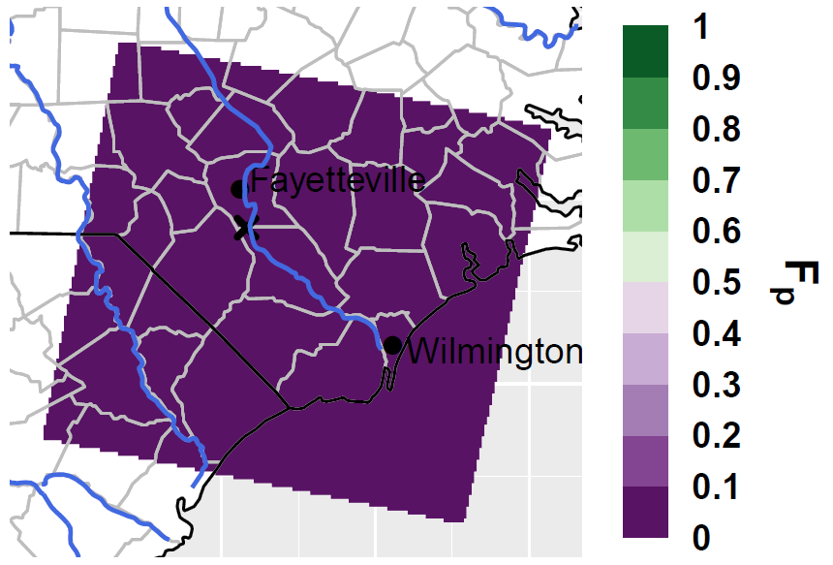
Figure S6. Annually averaged F_{p} for HFPO-DAF across the domain.

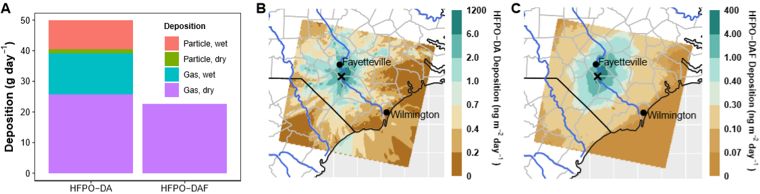
Figure S7. (A) Average domain-wide daily deposition of GenX, colored by the mechanism of deposition. Deposition of HFPO-DA (B) and HFPO-DAF (C). Note the different color axis scales on panels B and C.

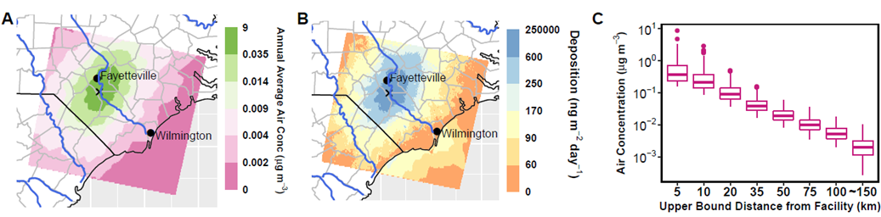
Figure S8. Annually averaged total PFAS air concentration (A) and deposition rate (B). Note the non-linear color scales. (C) The annually averaged air concentration of total PFAS binned as a function of distance from the facility.

References
1. NC DEQ GenX Investigation. 2018. https://deq.nc.gov/news/key-issues/genx-investigation/.
2. Dreyer, A.; Matthias, V.; Temme, C.; Ebinghaus, R., Annual Time Series of Air Concentrations of Polyfluorinated Compounds. Environmental Science & Technology 2009, 43 (11), 4029-4036.
3. Barton, C. A.; Butler, L. E.; Zarzecki, C. J.; Flaherty, J.; Kaiser, M., Characterizing perfluorooctanoate in ambient air near the fence line of a manufacturing facility: Comparing modeled and monitored values. Journal of the Air & Waste Management Association 2006, 56 (1), 48-55.
4. Jahnke, A.; Berger, U.; Ebinghaus, R.; Temme, C., Latitudinal Gradient of Airborne Polyfluorinated Alkyl Substances in the Marine Atmosphere between Germany and South Africa (53° N−33° S). Environmental Science & Technology 2007, 41 (9), 3055-3061.
5. Fang, X.; Wang, Q.; Zhao, Z.; Tang, J.; Tian, C.; Yao, Y.; Yu, J.; Sun, H., Distribution and dry deposition of alternative and legacy perfluoroalkyl and polyfluoroalkyl substances in the air above the Bohai and Yellow Seas, China. Atmospheric Environment 2018, 192, 128-135.
6. Chen, H.; Yao, Y.; Zhao, Z.; Wang, Y.; Wang, Q.; Ren, C.; Wang, B.; Sun, H.; Alder, A. C.; Kannan, K., Multimedia Distribution and Transfer of Per- and Polyfluoroalkyl Substances (PFASs) Surrounding Two Fluorochemical Manufacturing Facilities in Fuxin, China. Environmental Science & Technology 2018, 52 (15), 8263-8271.
7. Yao, Y. M.; Chang, S.; Sun, H. W.; Gan, Z. W.; Hu, H. W.; Zhao, Y. Y.; Zhang, Y. F., Neutral and ionic per- and polyfluoroalkyl substances (PFASs) in atmospheric and dry deposition samples over a source region (Tianjin, China). Environ. Pollut. 2016, 212, 449-456.
8. Yu, N.; Wen, H.; Wang, X.; Yamazaki, E.; Taniyasu, S.; Yamashita, N.; Yu, H.; Wei, S., Nontarget Discovery of Per- and Polyfluoroalkyl Substances in Atmospheric Particulate Matter and Gaseous Phase Using Cryogenic Air Sampler. Environmental Science & Technology 2020, 54 (6), 3103-3113.
9. Yarwood, G.; Kemball-Cook, S.; Keinath, M.; Waterland, R. L.; Korzeniowski, S. H.; Buck, R. C.; Russell, M. H.; Washburn, S. T., High-resolution atmospheric modeling of fluorotelomer alcohols and perfluorocarboxylic acids in the north American troposphere. Environmental Science & Technology 2007, 41 (16), 5756-5762.
10. Wallington, T. J.; Hurley, M. D.; Xia, J.; Wuebbles, D. J.; Sillman, S.; Ito, A.; Penner, J. E.; Ellis, D. A.; Martin, J.; Mabury, S. A.; Nielsen, O. J.; Andersen, M. P. S., Formation of C7F15COOH (PFOA) and other perfluorocarboxylic acids during the atmospheric oxidation of 8 : 2 fluorotelomer alcohol. Environmental Science & Technology 2006, 40 (3), 924-930.
11. Barton, C. A.; Zarzecki, C. J.; Russell, M. H., A Site-Specific Screening Comparison of Modeled and Monitored Air Dispersion and Deposition for Perfluorooctanoate. Journal of the Air & Waste Management Association 2010, 60 (4), 402-411.
12. Shin, H. M.; Vieira, V. M.; Ryan, P. B.; Detwiler, R.; Sanders, B.; Steenland, K.; Bartell, S. M., Environmental Fate and Transport Modeling for Perfluorooctanoic Acid Emitted from the Washington Works Facility in West Virginia. Environmental Science & Technology 2011, 45 (4), 1435-1442.
13. Paustenbach, D. J.; Panko, J. M.; Scott, P. K.; Unice, K. M., A Methodology for Estimating Human Exposure to Perfluorooctanoic Acid (PFOA): A Retrospective Exposure Assessment of a Community (1951–2003). Journal of Toxicology and Environmental Health, Part A 2006, 70 (1), 28-57.
14. Lei, Y. D.; Wania, F.; Mathers, D.; Mabury, S. A., Determination of vapor pressures, octanol-air, and water-air partition coefficients for polyfluorinated sulfonamide, sulfonamidoethanols, and telomer alcohols. Journal of Chemical and Engineering Data 2004, 49 (4), 1013-1022.
15. Daubert, T. E., Physical and Thermodynamic Properties of Pure Chemicals : Data Compilation. Design Institute for Physacal Property Data(DIPPR) 1989.
16. Riedel, T. P.; Lang, J. R.; Strynar, M. J.; Lindstrom, A. B.; Offenberg, J. H., Gas-Phase Detection of Fluorotelomer Alcohols and Other Oxygenated Per- and Polyfluoroalkyl Substances by Chemical Ionization Mass Spectrometry. Environmental Science & Technology Letters 2019, 6 (5), 289-293.
17. Community Modeling and Analysis System (CMAS) Sparse Matrix Operator Kernel Emissions modeling system v4.7, v4.7; 2019.
18. Skamarock, W. C., J. B. Klemp, J. Dudhia, D. O. Gill, Z. Liu, J. Berner, W. Wang, J. G. Powers, M. G. Duda, D. M. Barker, X.-Y. Huang A Description of the Advanced Research WRF Version 4. NCAR Tech. Note NCAR/TN-556+STR; 2019; p 145.
19. Gilliam, R. C.; Herwehe, J. A.; Bullock, O. R., Jr.; Pleim, J. E.; Ran, L.; Campbell, P. C.; Foroutan, H., Establishing the Suitability of the MPAS-A for Global Retrospective Air Quality Modeling. Journal of Geophysical Research, Submitted 2020.
20. Davidson, C. I.; Lindberg, S. E.; Schmidt, J. A.; Cartwright, L. G.; Landis, L. R., DRY DEPOSITION OF SULFATE ONTO SURROGATE SURFACES. J. Geophys. Res.-Atmos. 1985, 90 (ND1), 2123-2130.
21. Synquest Laboratories 2020. http://www.synquestlabs.com/.
22. National Institute for Occupational Safety and Health (NIOSH) 2020. https://www.cdc.gov/niosh/npg/npgd0632.html.

