MONTHLY PROGRESS REPORT

Reporting Period:  Work Assignment Title: | April 2020  ABaCAS enhancement/development
Work Assignment Number: | WA 5-03 Extension (Amendment No. 6)
Contract Number: | ET-D-12-044
Contract Title: | “Air Benefit and Cost and Attainment Assessment System” (ABaCAS) enhancement/development
Prepared by: | Yun Zhu¹, Shuxiao Wang², Shicheng Long³
Company: | - College of Environment &Energy, South China University of Technology, Guangzhou, 510006, China  - School of Environment, Tsinghua University, Beijing, 100084, China  - Guangzhou Urban Environmental Cloud Information Technology R&D Co.ltd, Guangzhou, 510006, China
Prepared for: | Prof. Adel Hanna, PhD and Dr. Sarav Arunachalam  Institute for the Environment/CEMPD  The University of North Carolina at Chapel Hill  Campus Box 1105 (ZIP: 27599-1105)  Europa Center, Suite 490  100 Europa Dr., Chapel Hill, NC 27517

1 Work Performed, Status of Deliverables,
and Issues Needing EPA’s Attention

1.1 Summary of Work Performed

1.1.1 Task 9: Develop a NEXUS Multi-Pollutant Analysis Tool prototype (NEXUS).

Subtask2: As Phase-2 effort, extend the NEXUS tool to allow user to select a region or metropolitan area and provide analysis and visualization functions of air quality and emissions information over the selected (or combined) region or metropolitan area of interest as instructed by EPA

- We (Zhenhua Zhu, Jinying Huang, Ruolin Huang) updated the setting GUI of Data viewer (e.g., included risk percentile options for PM_{2.5} and Ozone, ambient options for air toxic), as shown in Fig. 1.
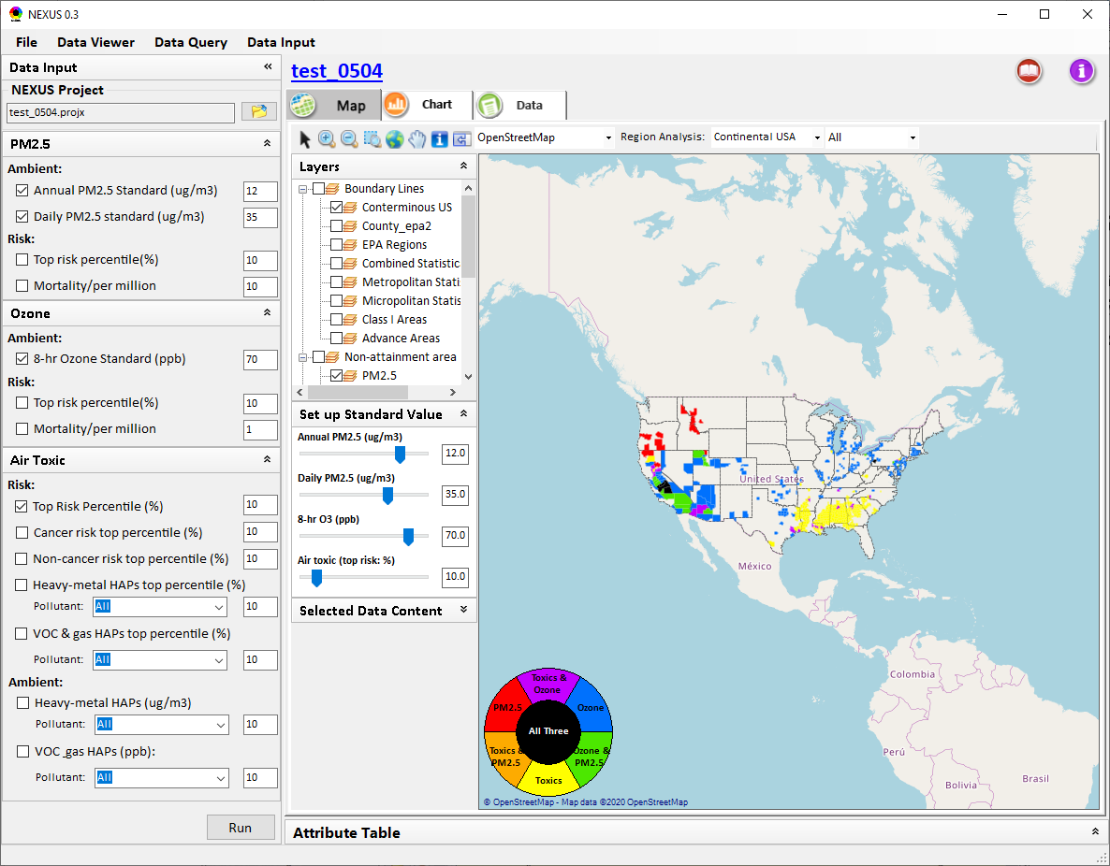
Fig. 1 Updated the setting GUI of Data viewer
- We (Yun Zhu, Yong Tian, Zhifang Li, Ruolin Huang) re-designed the GUI to include two new modules: (1) “Data Input” and (2) “Data Query”, as shown in Fig. 2.
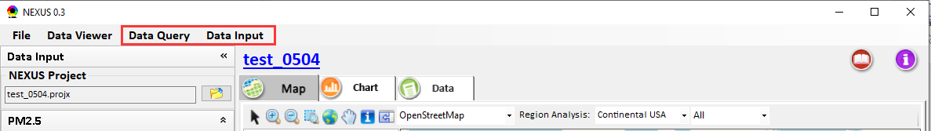
Fig. 2 The two new modules
- Under “Data Input” module (Fig. 3):
- Collected/downloaded all kinds of data needed for NEXUS and designed the GUI to input these data (e.g., NEXUS/Air toxic geodatabase, O₃ and PM_{2.5} DV, Advance areas and Poverty/Disadvantages data, etc.).
- Supported to expand or collapse each type of input data by clicking or .
- Included a “File View” icon for previewing/displaying a viewable data table.
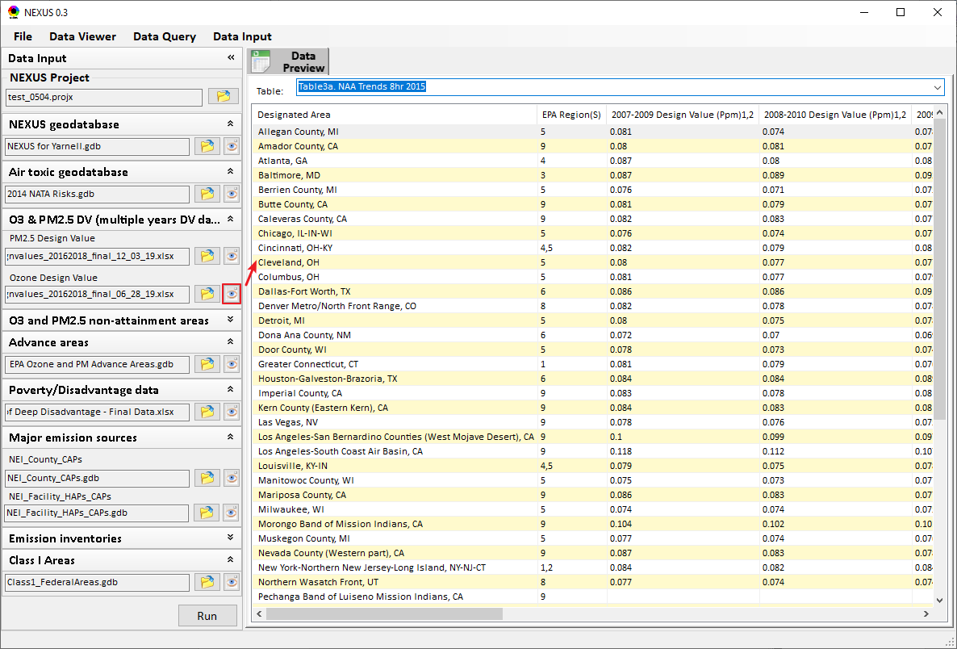
Fig. 3 The“Data Input” module
- Under “Data Query” module:
- Designed a GUI to set up data filters (e.g., set a Continental USA/ EPA Regions/ CBSAs/States, Advance areas, and Poverty/Disadvantage areas, etc.), as shown in Fig. 4.
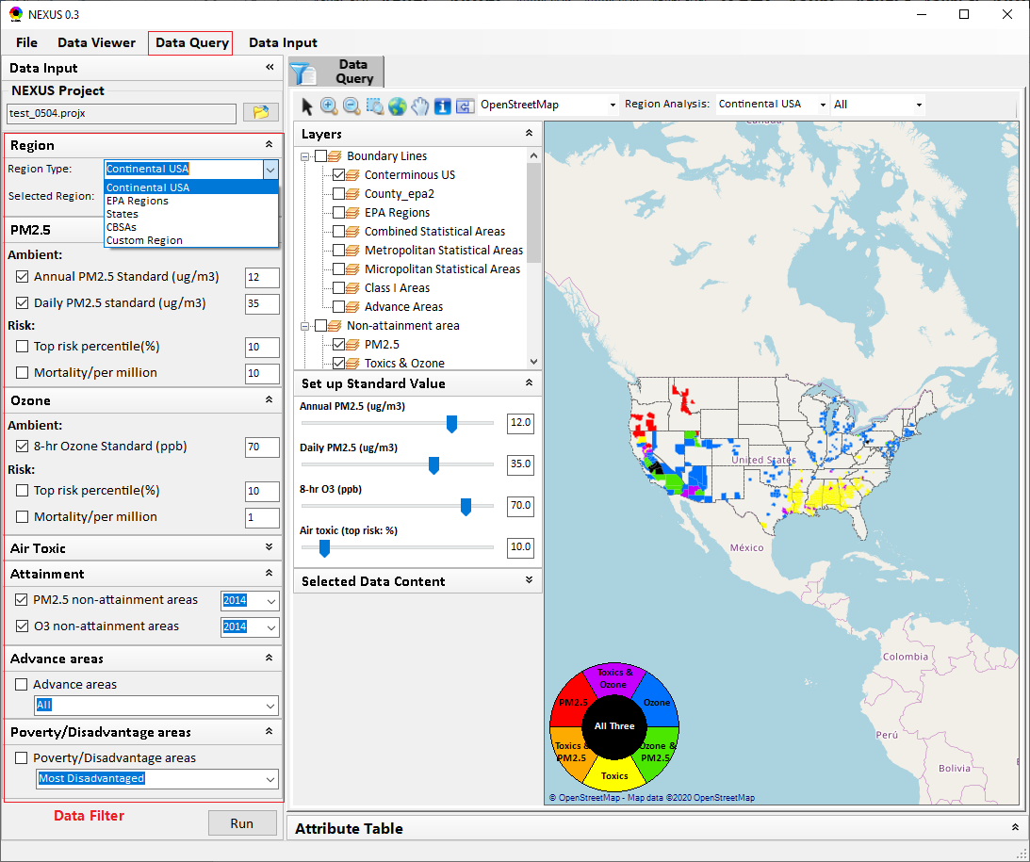
Fig. 4 Designed a GUI to set up data filters
- Designed a GUI for “Region Analysis” menu to provide similar functions (i.e., “select a region to zoom” icon & “identify” icon) to the new “zoom-in” functions (major sources, etc.), as shown in Fig. 5.
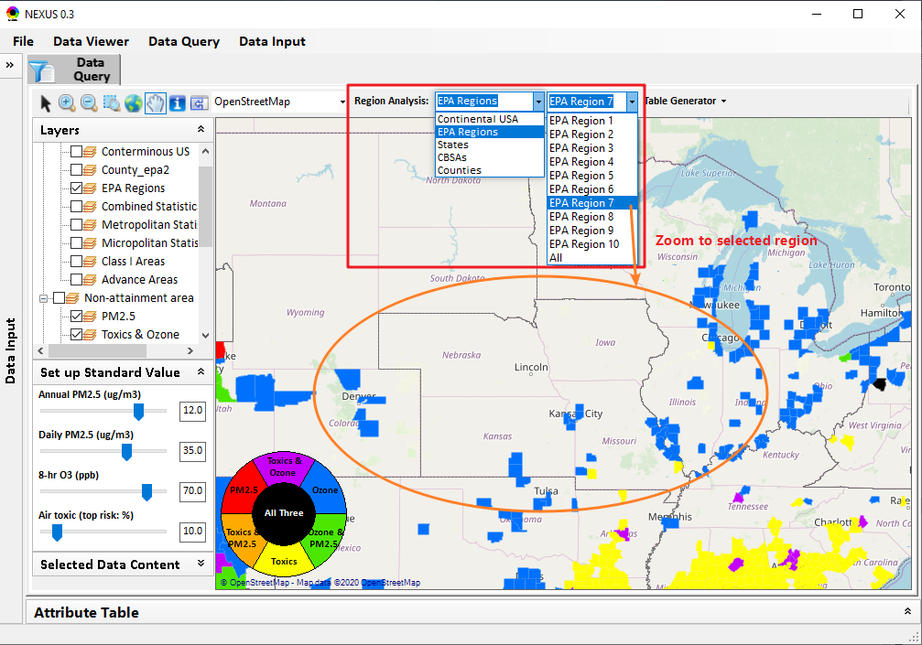
Fig. 5 Designed a GUI for “Region Analysis” menu
- Designed a GUI for “Table Generator” menu to provide functions to automatic generate those tables to list “areas that may have potential multi-pollutant issues” and detailed information, as shown in Fig. 6.
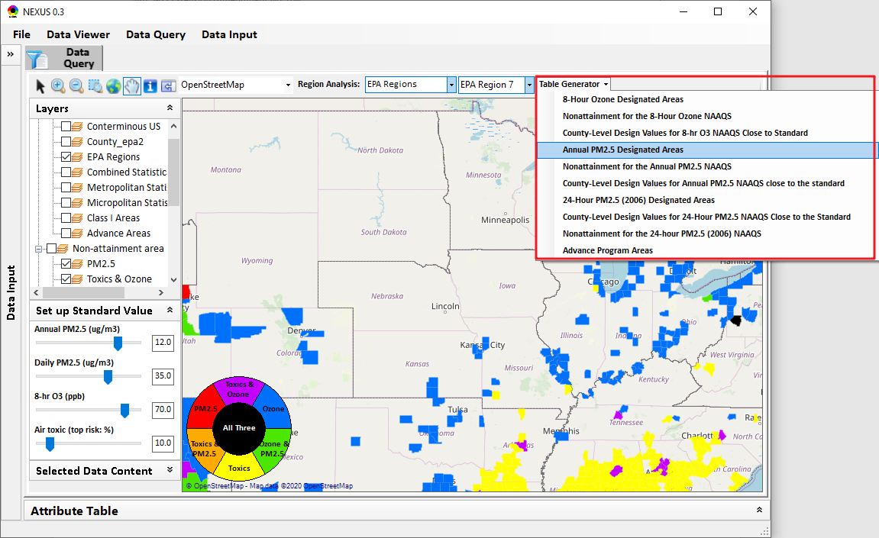
Fig. 6 Designed a GUI for “Table Generator” menu
- Designed a GUI for “Attribute Table” to provide functions to view layers data or data in selected region in a data table, as shown in Fig. 7.

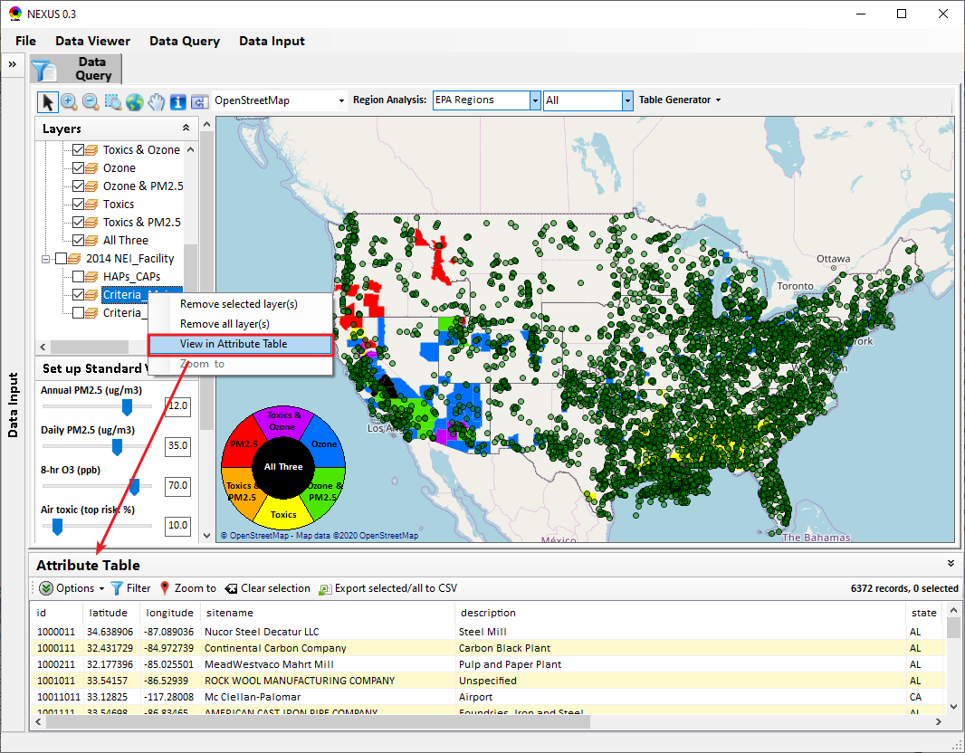
Fig. 7 Designed a GUI for “Attribute Table”

Released Software Tools in This Reporting Period
- NA

Hours Worked This Reporting Period
- Hours worked for each task
Task ID Number | Rate Category (P-level) | Hours Worked | Billing Rate | Dollar Amount
Task 9 | Full Professor/Yun Zhu (P4) | 6 | 120 | $720
Task 9 | Senior Research Associate/Zhenhua Zhu (P3) | 4 | 100 | $400
Task 9 | Senior Research Associate/Yong Tian (P3) | 10 | 100 | $1,000
Task 9 | Research Assistant student/Jinying Huang (P1) | 6 | 35 | $210
Task 9 | Research Assistant student/Zhifang Li (P1) | 18 | 35 | $630
Task 9 | Research Assistant student/Ruolin Huang (P1) | 19 | 35 | $665
Total |  | 63 | / | $3,625

Difficulties Encountered and Remedial Action Taken
- NA

Changes in Personnel
- NA

Deliverables Submitted This Reporting Period
- Delivery of monthly progress reports for April 2020 –May 4, 2020

