MONTHLY PROGRESS REPORT

Reporting Period:  Work Assignment Title: | March 2020  ABaCAS enhancement/development
Work Assignment Number: | WA 5-03 Extension (Amendment No. 6)
Contract Number: | ET-D-12-044
Contract Title: | “Air Benefit and Cost and Attainment Assessment System” (ABaCAS) enhancement/development
Prepared by: | Yun Zhu¹, Shuxiao Wang², Shicheng Long³
Company: | - College of Environment &Energy, South China University of Technology, Guangzhou, 510006, China  - School of Environment, Tsinghua University, Beijing, 100084, China  - Guangzhou Urban Environmental Cloud Information Technology R&D Co.ltd, Guangzhou, 510006, China
Prepared for: | Prof. Adel Hanna, PhD and Dr. Sarav Arunachalam  Institute for the Environment/CEMPD  The University of North Carolina at Chapel Hill  Campus Box 1105 (ZIP: 27599-1105)  Europa Center, Suite 490  100 Europa Dr., Chapel Hill, NC 27517

1 Work Performed, Status of Deliverables,
and Issues Needing EPA’s Attention

1.1 Summary of Work Performed

1.1.1 Task 9: Develop a NEXUS Multi-Pollutant Analysis Tool prototype (NEXUS).

Subtask2: As Phase-2 effort, extend the NEXUS tool to allow user to select a region or metropolitan area and provide analysis and visualization functions of air quality and emissions information over the selected (or combined) region or metropolitan area of interest as instructed by EPA

- We (Shicheng Long, Jinying Huang, Ruolin Huang) updated the GUI and included the “Daily PM_{2.5}” option with a default value of 35 for “Data Input Panel”, as shown in Fig. 1.
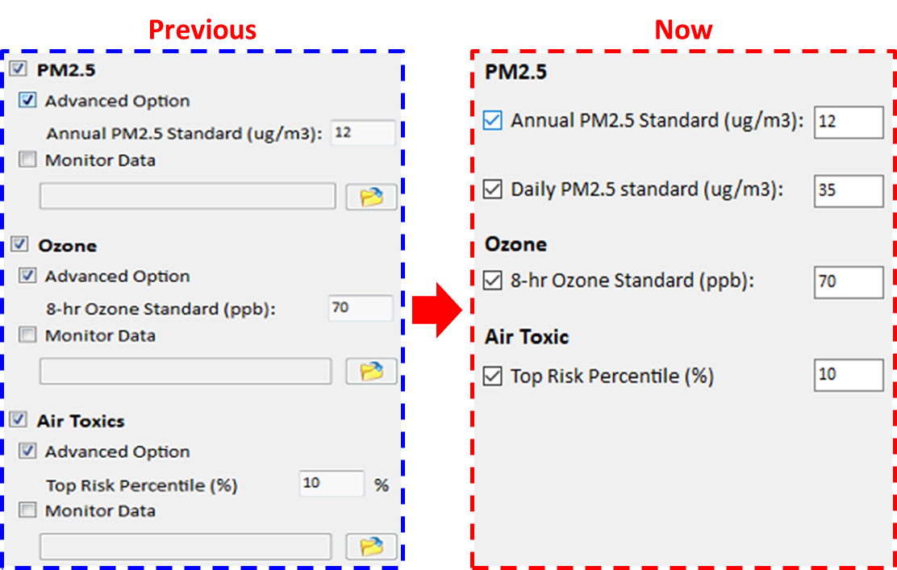
Fig. 1 Updated the GUI for “Data Input Panel”
- In addition, we (Yong Tian, Zhifang Li) also fixed a bug that the program failed to load previous settings while opening a saved project file(*.projx), as shown in Fig. 2.

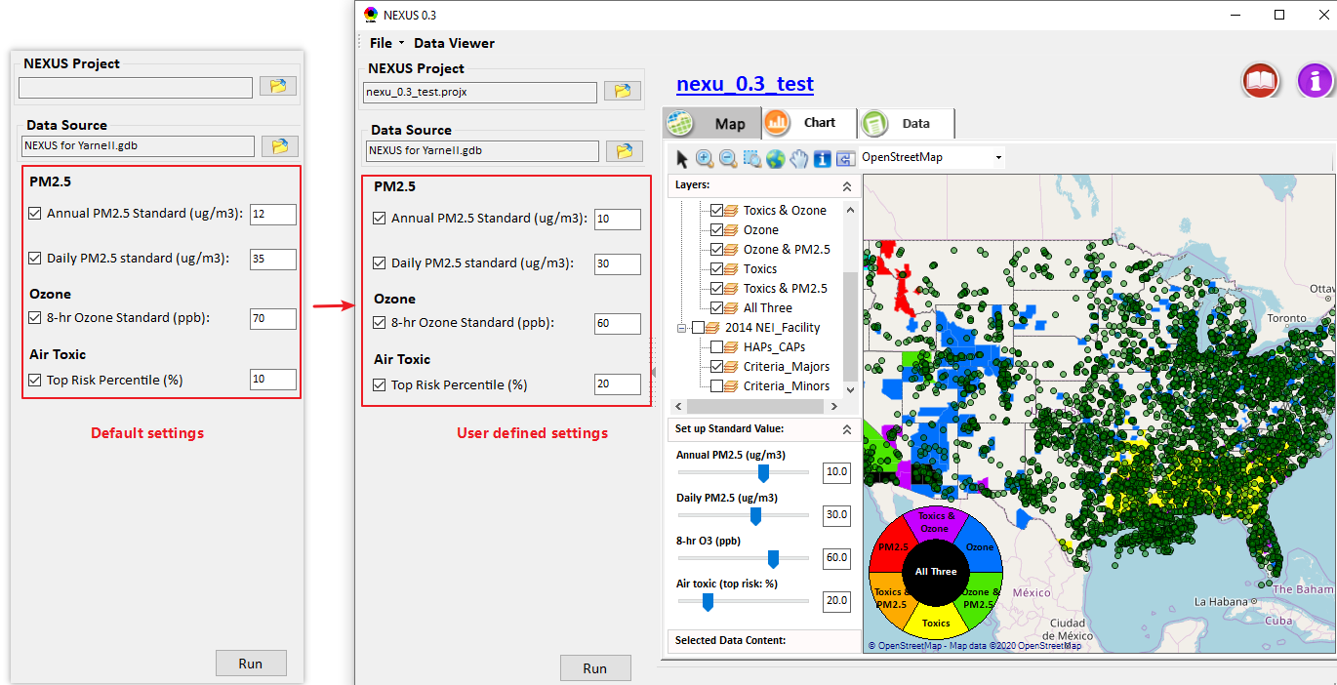
Fig. 2 Update default settings to user defined settings while loading a saved project

- We (Yun Zhu, Zhenhua Zhu, Shicheng Long, Yong Tian, Jinying Huang, Zhifang Li, Xinli Sun, Ruolin Huang) further improved “Map” and “Chart” modules which were listed below:
- Under Map module:
- Added “Daily PM_{2.5}” slide bar to set up standard value for daily PM_{2.5}, as shown in Fig. 3.
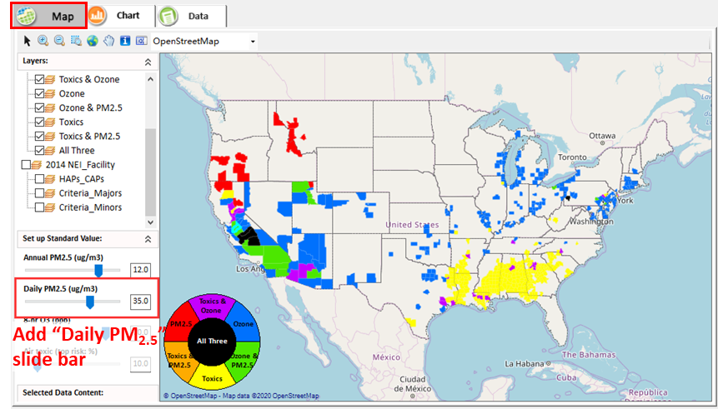
Fig. 3 Added “Daily PM2.5” slide bar
- Included the “2014_NEI_Facility_HAPs_CAPS” data and supported to overlay the NEI points to map, as shown in Fig. 4.
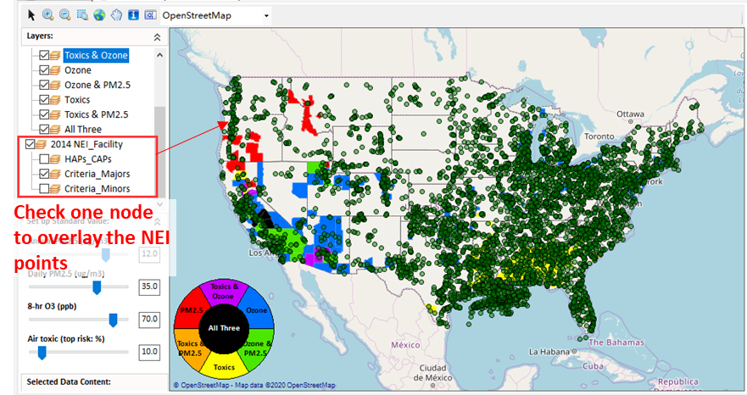
Fig. 4 Overlay the NEI points to map
- Supported to select and zoom a region of interest by using , as shown in Fig. 5.
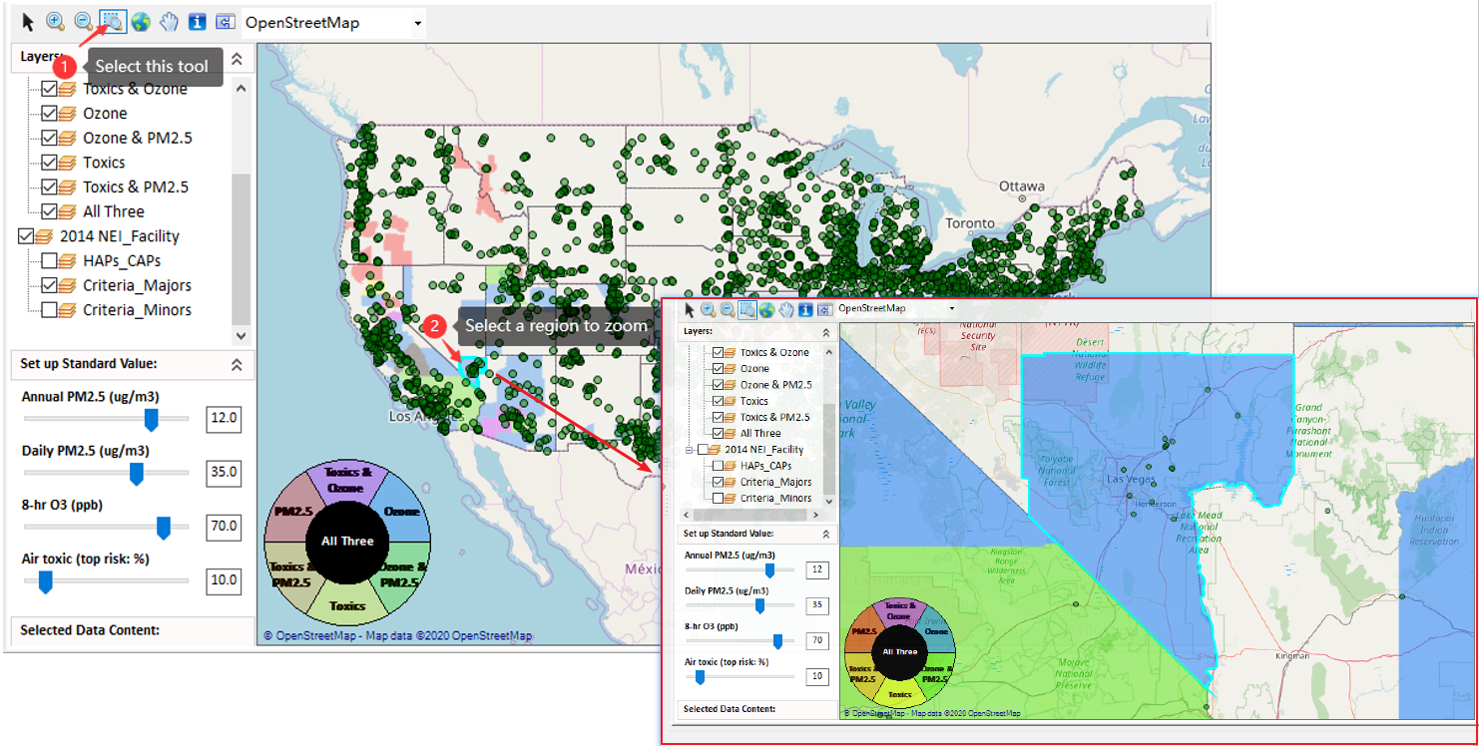
Fig. 5 Selected and zoomed a region of interest
- Supported to show the detail information of the source point highlighted with red outline when the mouse was moving over it, as shown in Fig. 6.
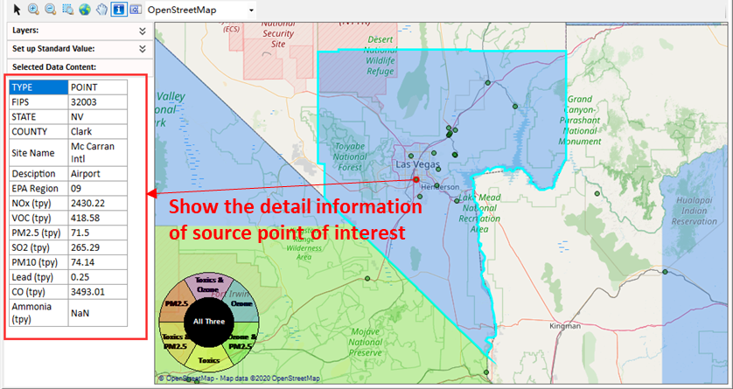
Fig. 6 Showed the detail information of source point
- Supported to switch to “Chart” module to show the top 10 NOx emissions in default within the selected region when right-clicking a region (with blue outline) and then selecting “Show Top 10 Emissions Source”, as shown in Fig. 7.
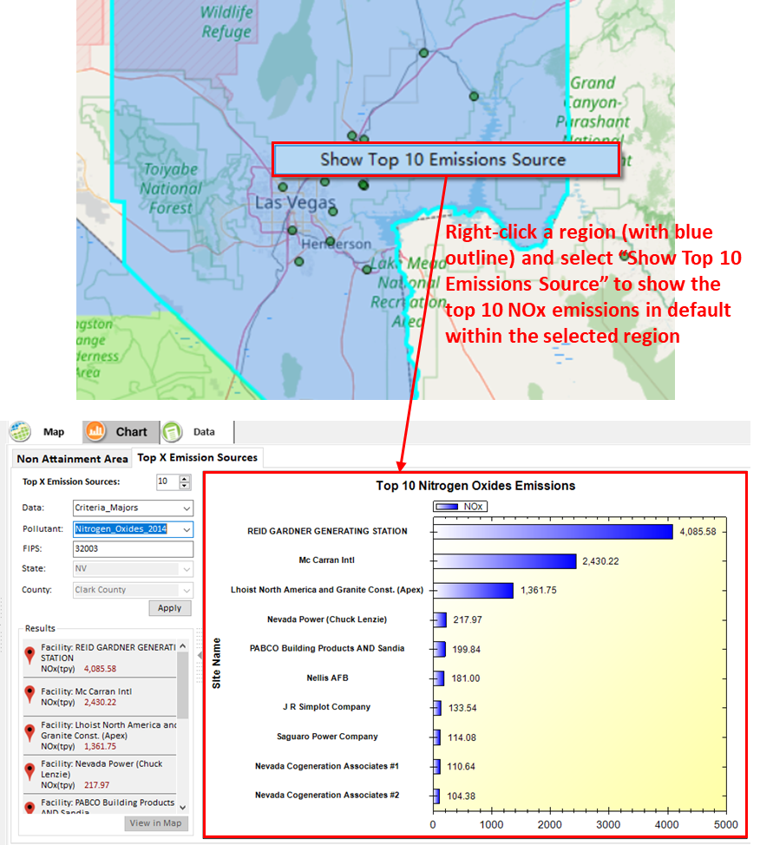
Fig. 7 Showed top 10 emissions source
- Fixed a bug that if users type a value and press “Enter”, the slide bar didn’t match the value in previous version, as shown in Fig. 8.
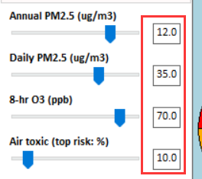
Fig. 8 The slide bar matched the setting value

- Under Chart module:
- Supported to show different combination results of selected pollutant/state/county, as shown in Fig. 9.
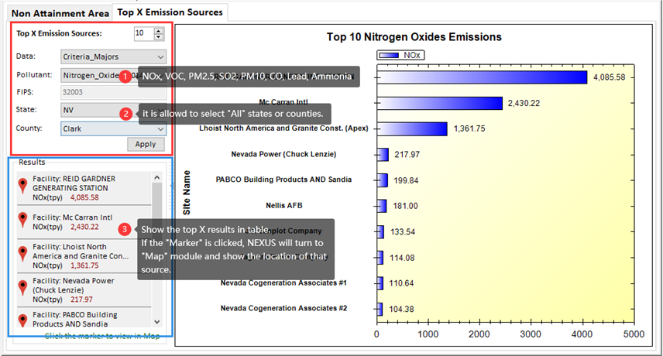
Fig. 9 Displayed different combination results of pollutant/state/county
- Supported to switch back to “Map” module to show the location of clicking source when clicking the “Marker” icon, as shown in Fig. 10.
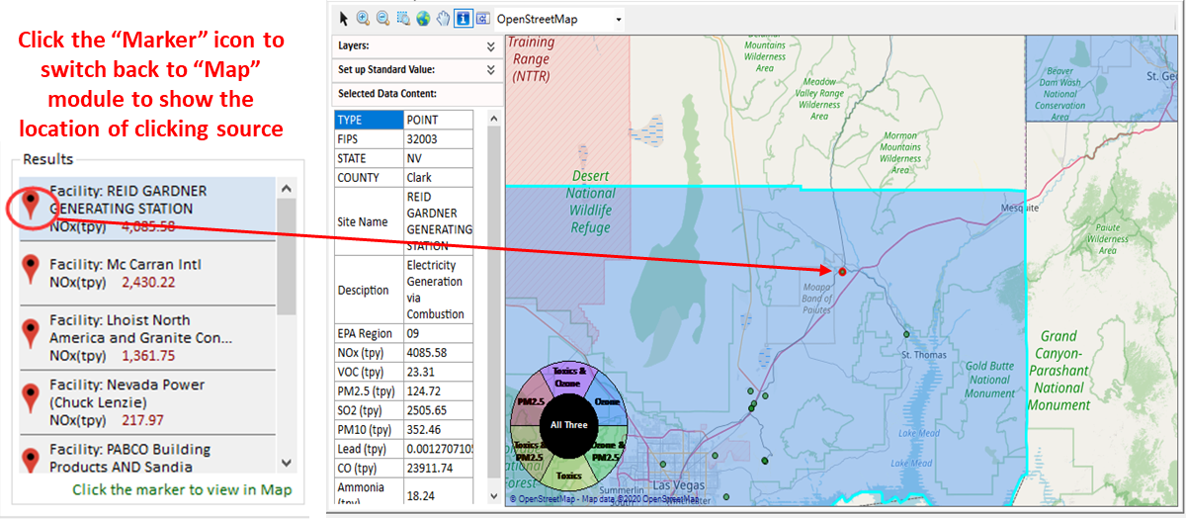
Fig. 10 Showed the location of clicking source
- Added a“Check All” option box to display all areas with O₃ or PM_{2.5} concentrations above user-defined air quality standards or modeled county-level cancer risk estimated from NATA in user-defined top percent, as shown in Fig. 11.
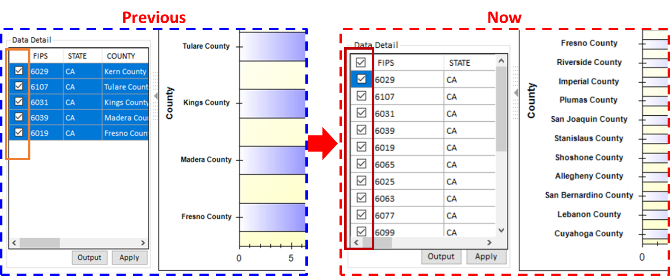
Fig. 11 Added a “Check All” option box

Subtask3: Develop draft on-line User Manual and Quick Start Guide for the NEXUS tool as instructed by EPA

- We (Yun Zhu, Shicheng Long, Jinying Huang, Xinli Sun) developed a draft on-line user manual for NEXUS, as shown in Fig. 12.
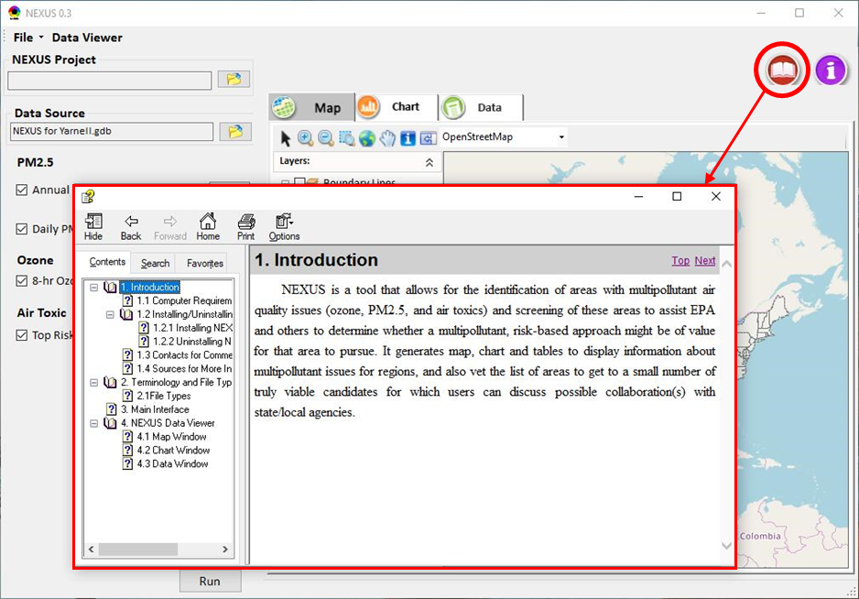
Fig. 12 Draft on-line user manual of NEXUS

Released Software Tools in This Reporting Period
- Task 9：NEXUS enhancement/development, version 0.3 (April 3)

Hours Worked This Reporting Period
- Hours worked for each task
Task ID Number | Rate Category (P-level) | Hours Worked | Billing Rate | Dollar Amount
Task 9 | Full Professor/Yun Zhu (P4) | 21 | 120 | $2,520
Task 9 | Senior Research Associate/Zhenhua Zhu (P3) | 21 | 100 | $2,100
Task 9 | Senior Research Associate/Yong Tian (P3) | 19 | 100 | $1,900
Task 9 | Senior Research Associate/Shicheng Long (P3) | 32 | 100 | $3,200
Task 9 | Research Assistant student/Jinying Huang (P1) | 44 | 35 | $1,540
Task 9 | Research Assistant student/Zhifang Li (P1) | 43 | 35 | $1,505
Task 9 | Research Assistant student/Xinli Sun (P1) | 36 | 35 | $1,260
Task 9 | Research Assistant student/Ruolin Huang (P1) | 32 | 35 | $1,120
Total |  | 248 | / | $15,145

Difficulties Encountered and Remedial Action Taken
- NA

Changes in Personnel
- NA

Deliverables Submitted This Reporting Period
- Delivery of monthly progress reports for March 2020 – April 4, 2020
- Delivery of enhanced/improved NEXUS (Task 9) – April 3, 2020

