Main Improvements of NEXUS 0.5
By SCUT, 2020-07-08

Main Improvements for Data Viewer
  - When starting NEXUS, show “Launching NEXUS” tip, and update all tips from “waiting…” to “Working…”.
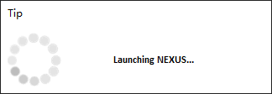
  - Keep Data Viewer setting panel expanded when loading a NEXUS project and update the name of the default project to “NEXUS_Example”.
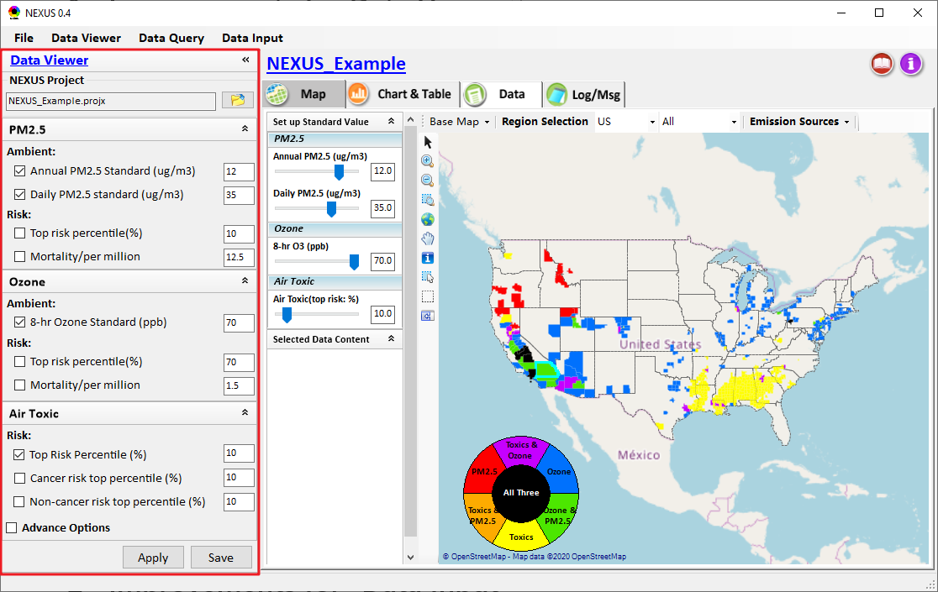
  - Implement the functions of “All” option for Heavy Metal & VOC HAPs.
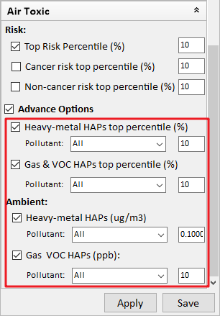
  - Include an “Apply” button to make the options on the left panel take effect and update to Map without saving the project.
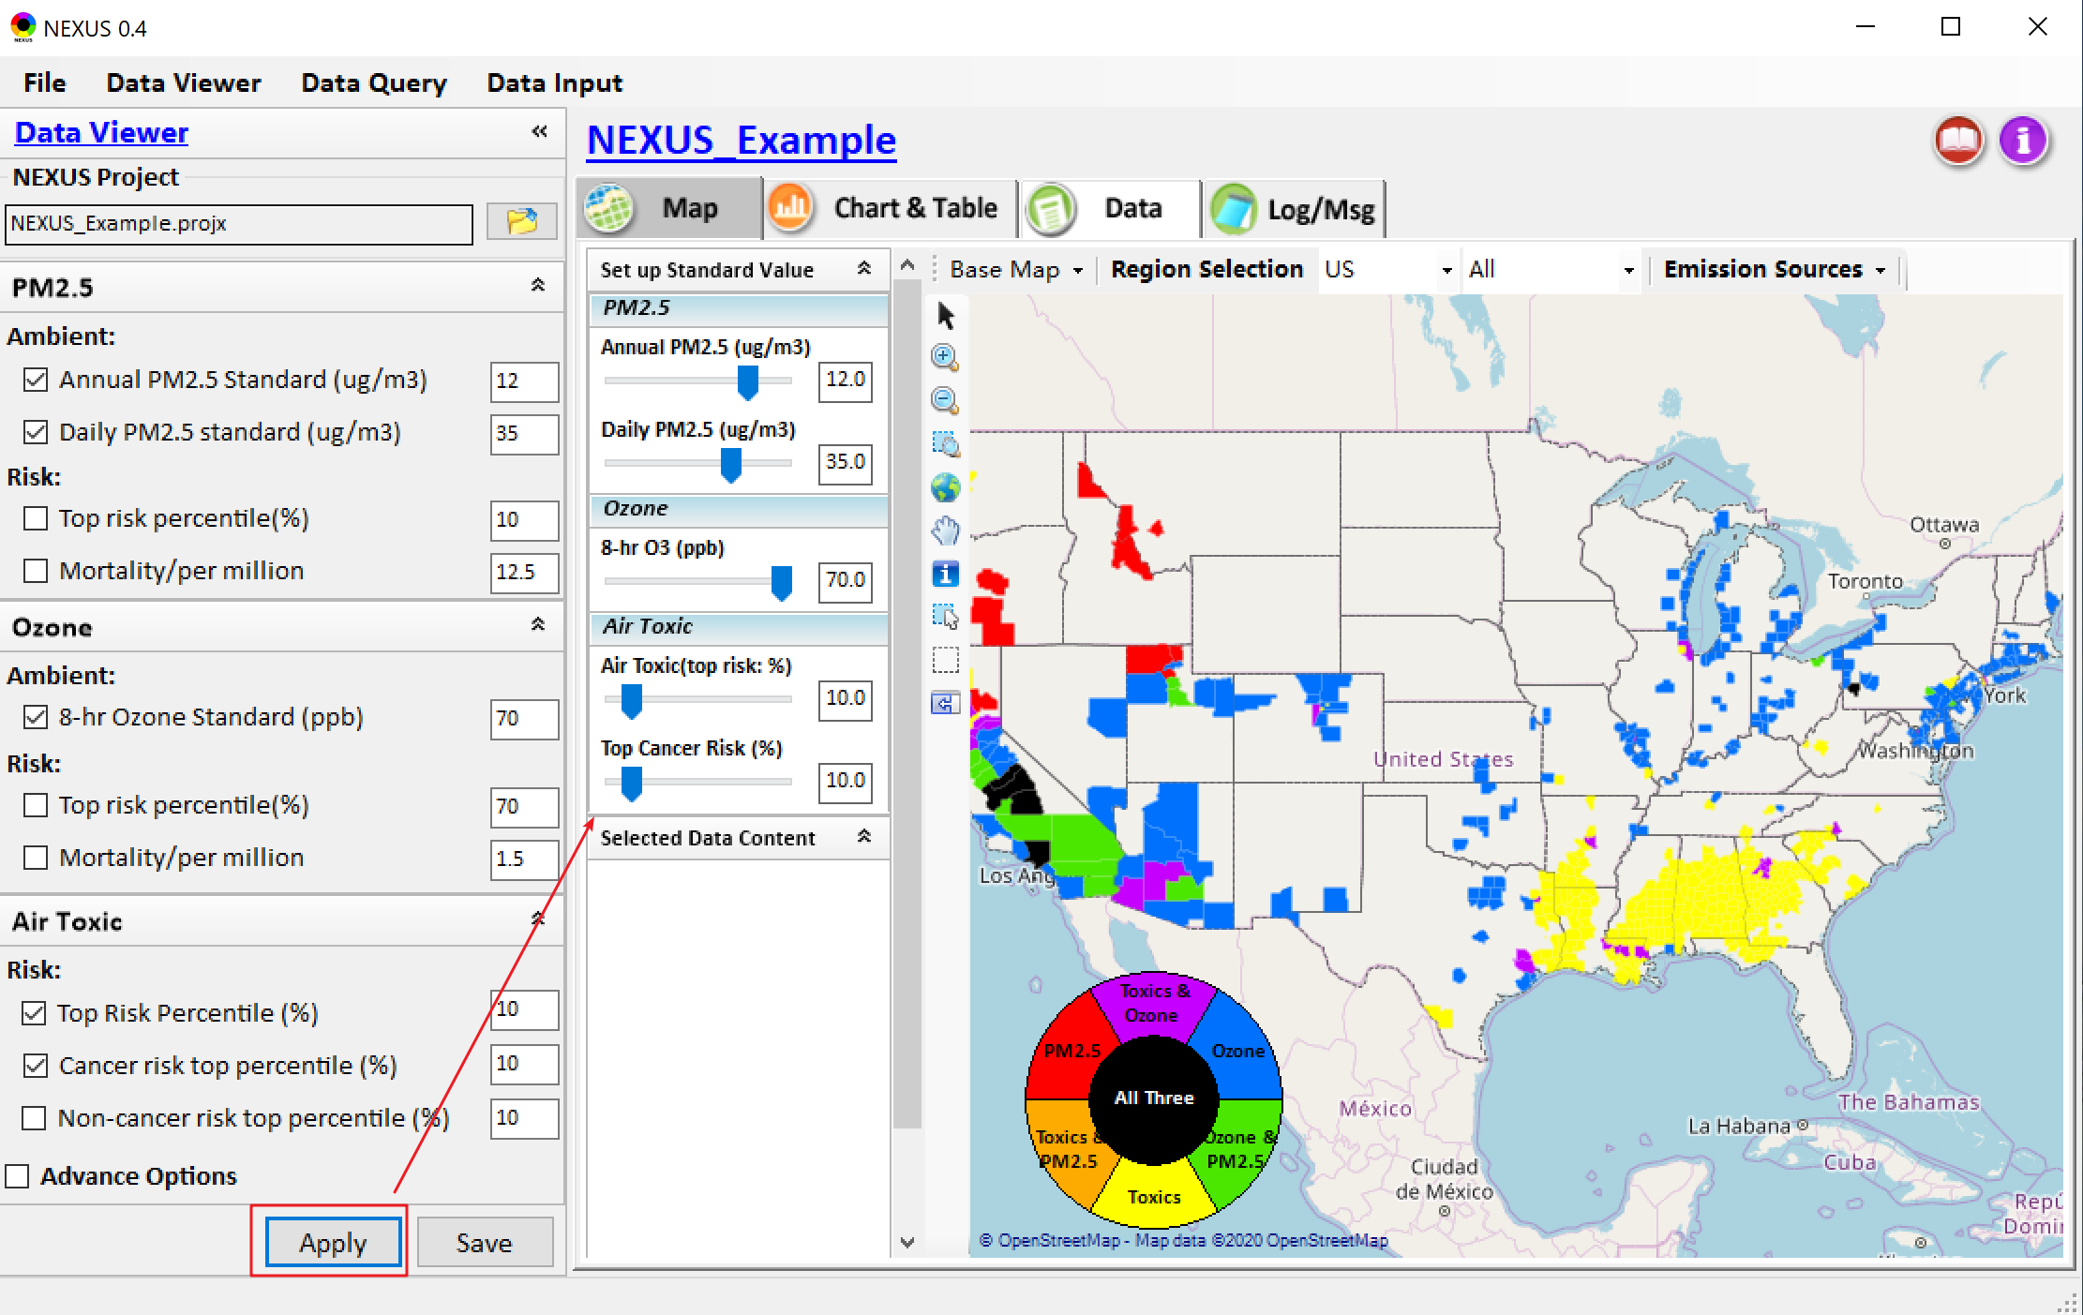
  - Include a Log/Msg module to show the running log message
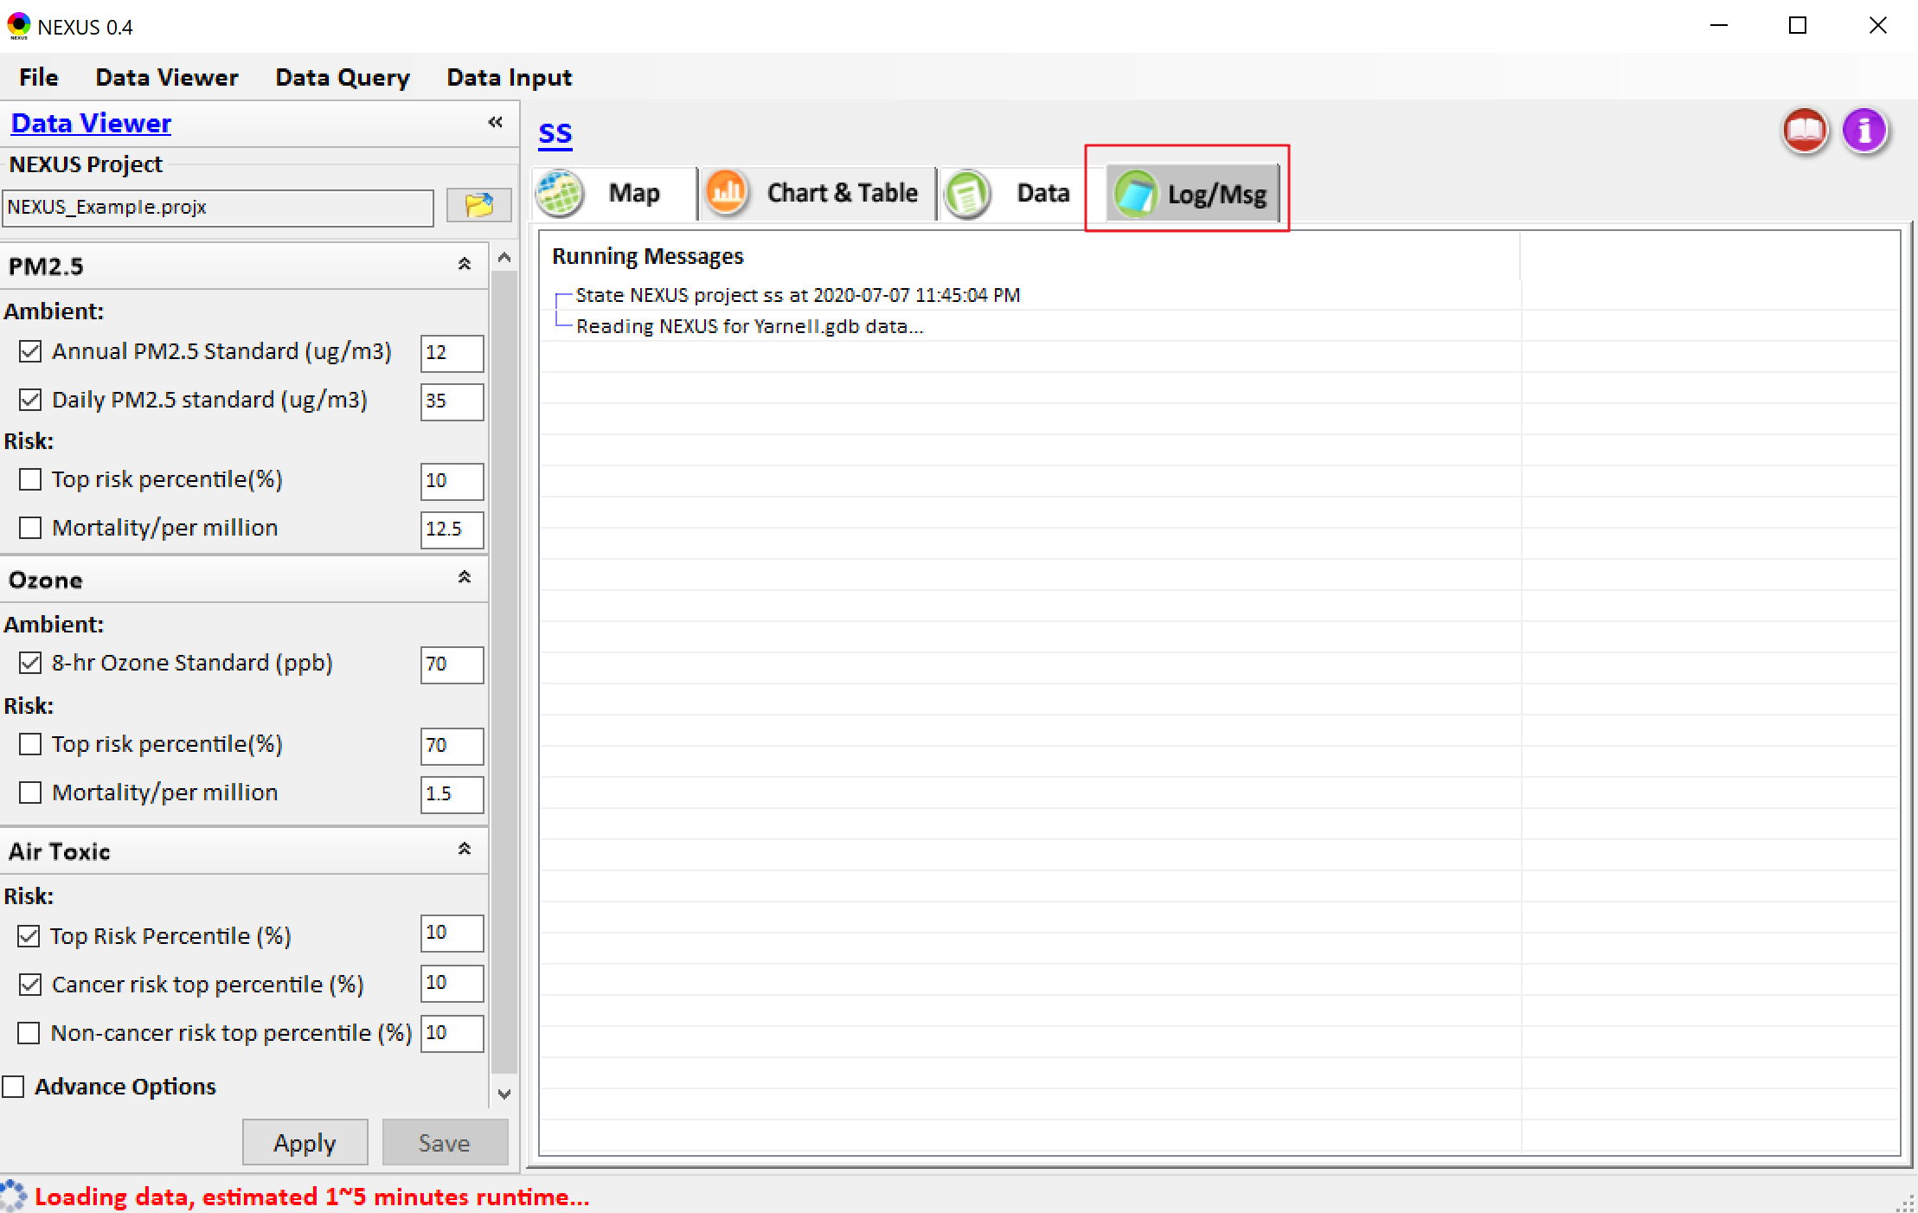
  - Make the titles of “Set up Standard Value” and “Selected Data Content”, and the titles (PM_{2.5}, Ozone, Air toxic) under “Set up Standard Value” panel more prominent and user-friendly by changing the font, title background, etc.
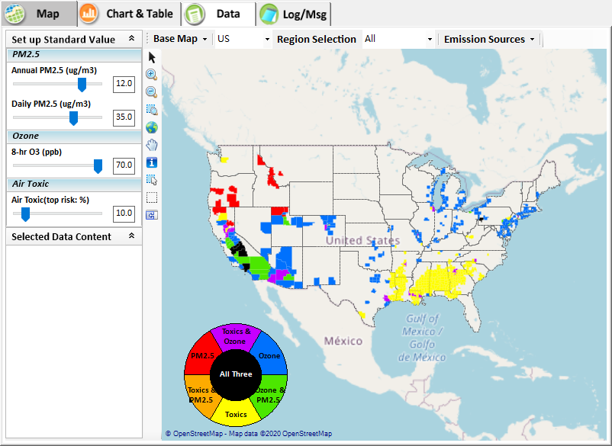
  - Add a “Boundary lines” menu under “Base MAP” and support to overlay with the boundary lines of EPA Regions, States, CBSA, Counties, etc.
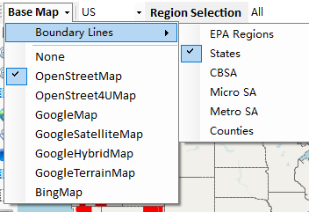
  - Support to drag the map by default without clicking the hand button to enable this function.
  - Arrange EPA Regions, States and CBSA names in alphabetical order. Besides, adjust automatically the width of the drop-down menu of EPA Regions, States and CBSA according to the length of items.
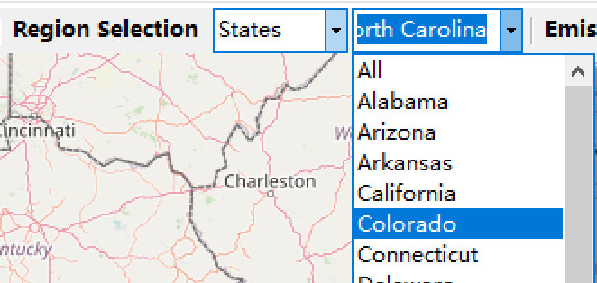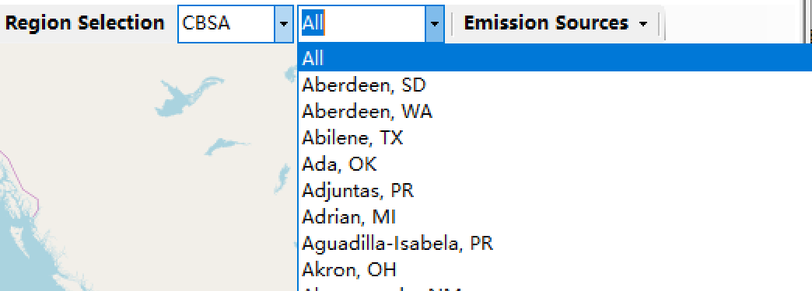
  - Under “Major Emission Sources”：
    - Make the titles (as shown in red box) under “Major Emission Sources” module more prominent user-friendly by updating them to the style of hyperlinks.
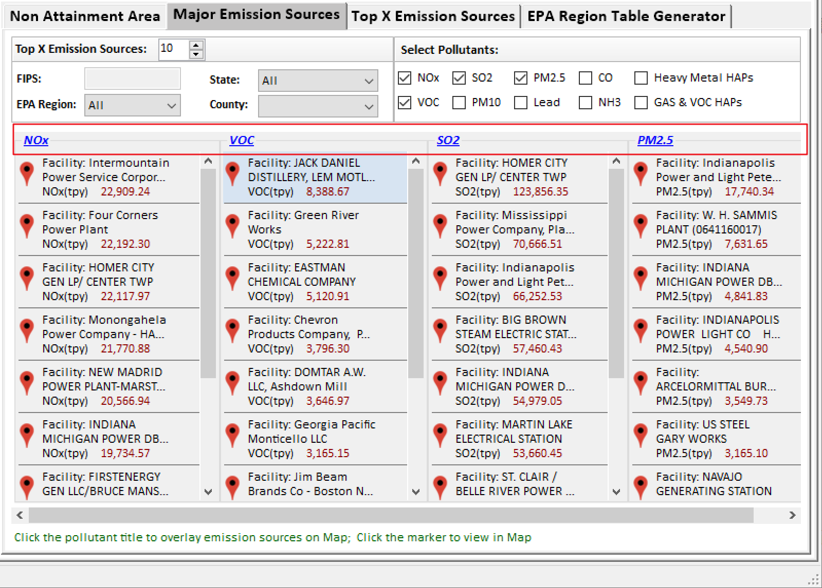
    - Support to click the row or the marker under “Major Emission Sources” to view the selected record on map. And mark an icon  of selected record on map.
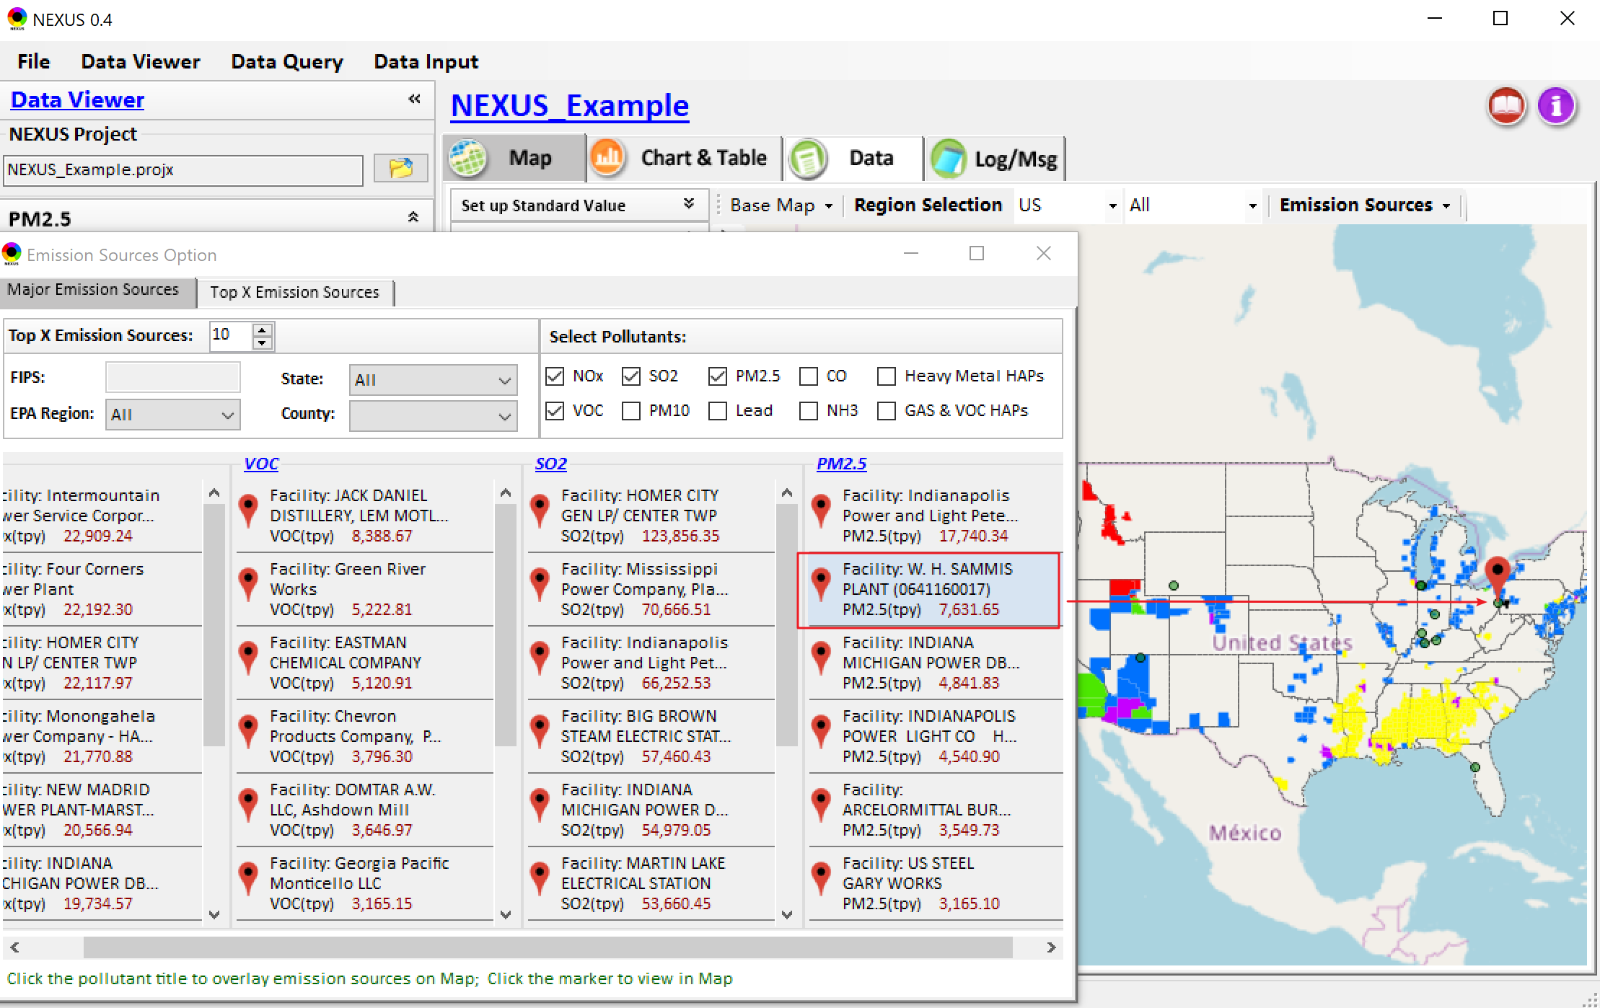
    - Integrate “Heavy Metal HAPs” and “GAS & VOC HAPs” emission sources into “Major Emission Sources” module and also include NATA emission sources data into “Data Input” module.
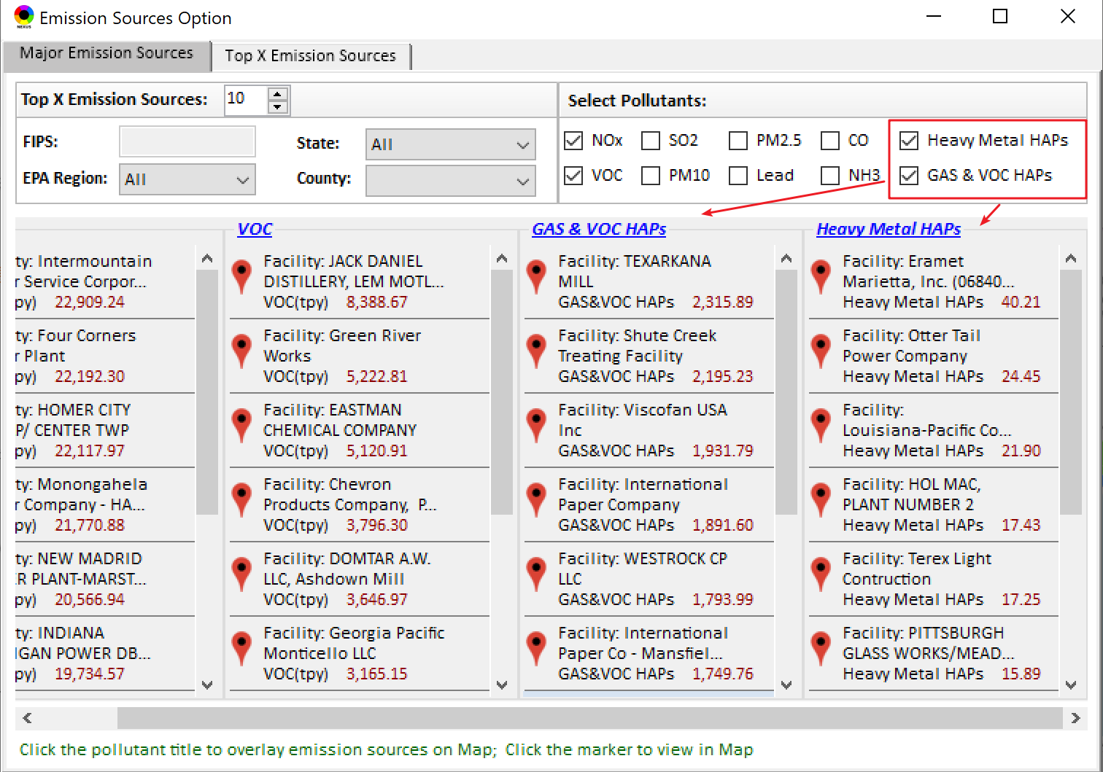
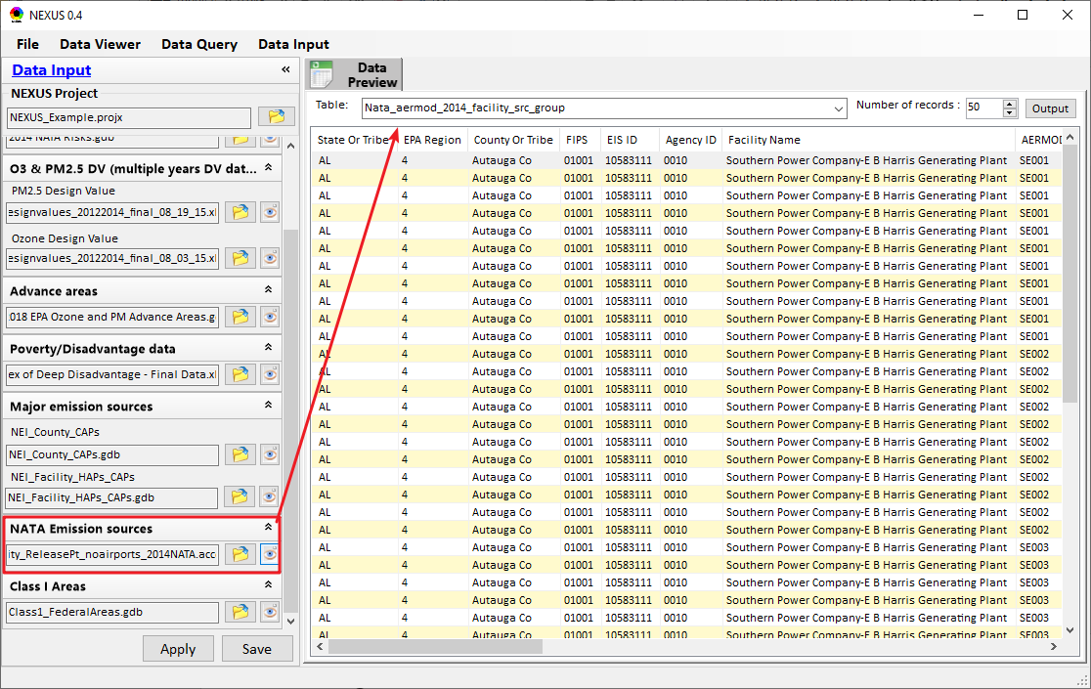

  - We have verified the PM_{2.5} non-attainment results by checking the design values from the files downloaded from EPA website. As shown below, the daily PM_{2.5} value of the “red areas” exceed the 35 ug/m³ standard value.
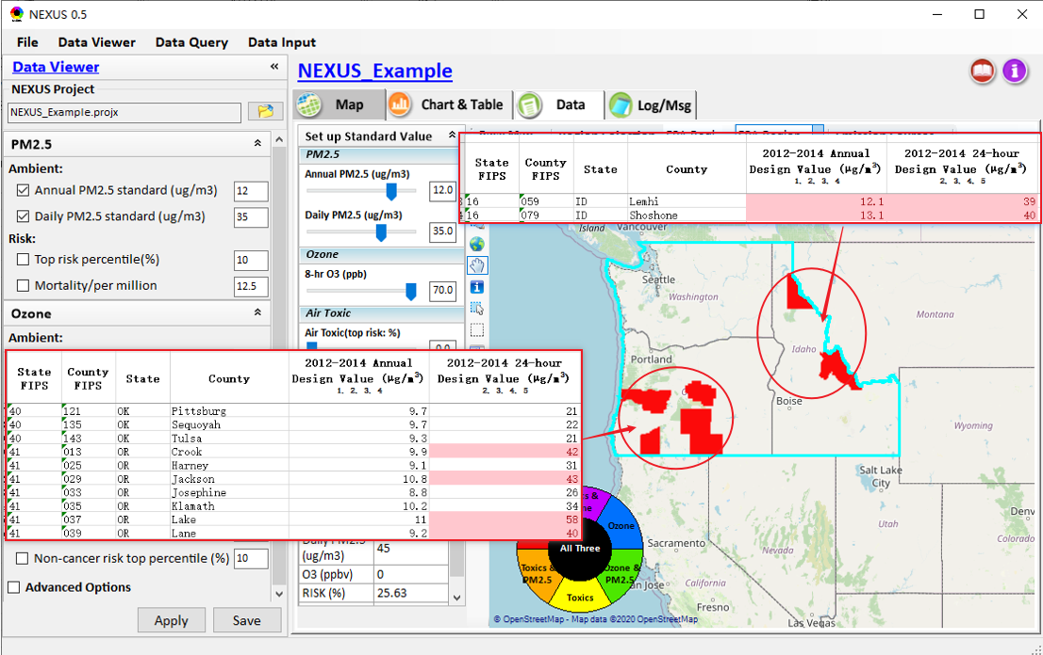

To do list:
  - Support to multi-select regions to combine the data (e.g., emission, mortality) to conduct multi-pollutant “Region Analysis”.
  - Under the Data module, provide a “Summary Table” that includes all kinds of data from “Data Input” module, e.g., join in the current data with Poverty/Disadvantage data.
  - Develop similar function like “EPA Regions” & “States” for “CBSA” under “Region Selection”
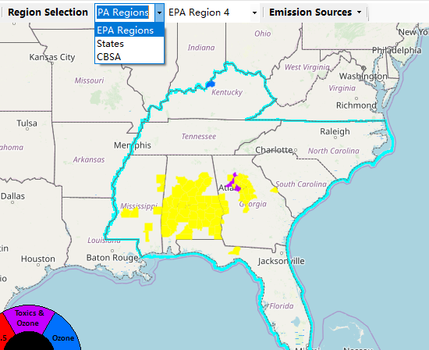
  - Continue to develop the Data Query module
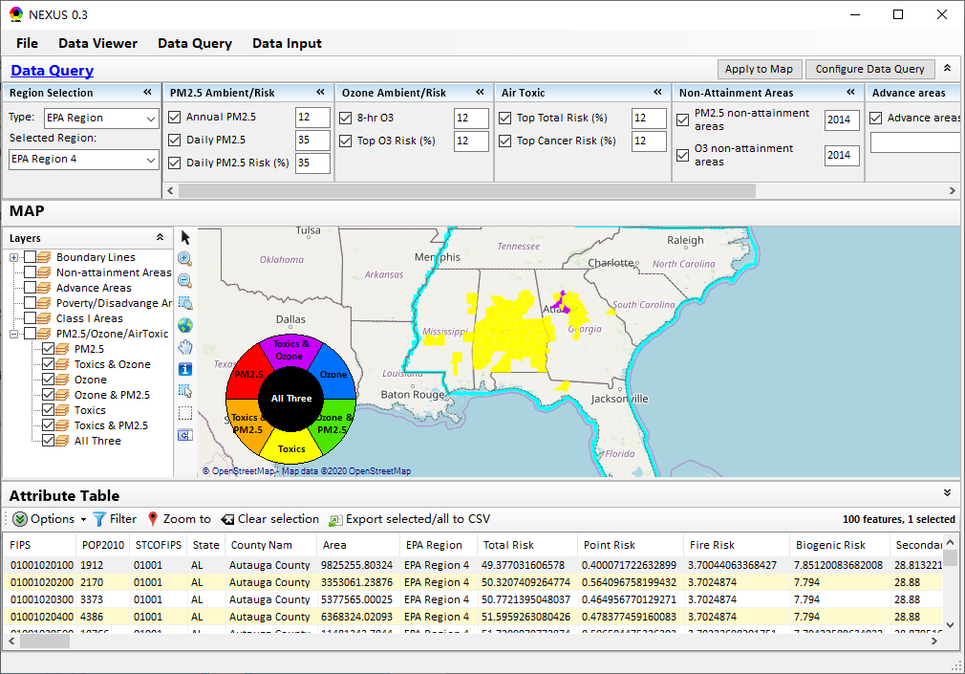
  - Develop the Table Generator module
