Main Improvements of NEXUS 1.3
By SCUT, 2020-09-09

Main Improvements for Data Viewer Module
- Reformat both “PM_{2.5} & O₃ Risk” (Top risk percentile) based on mortality number (person per year) or mortality rate (per 10k per year)
- Reformat both “Air Toxic Risk” (Top risk percentile) based on mortality number (person per year) or mortality rate (per million per year), and apply the selection to all air toxic risk calculations below (include “Advanced Option”)
- Change Heavy Metal HAPS unit to “ng/m3”, change the range to “0 –15” with default “10”;
- Change Gas & VOC HAPS range to “0 – 15” with default “5”;
- Include an updated online user’s manual and provide hot links to “User’s manual’s “Data Viewer” chapter (same for “Data Input” & “Data Query”);
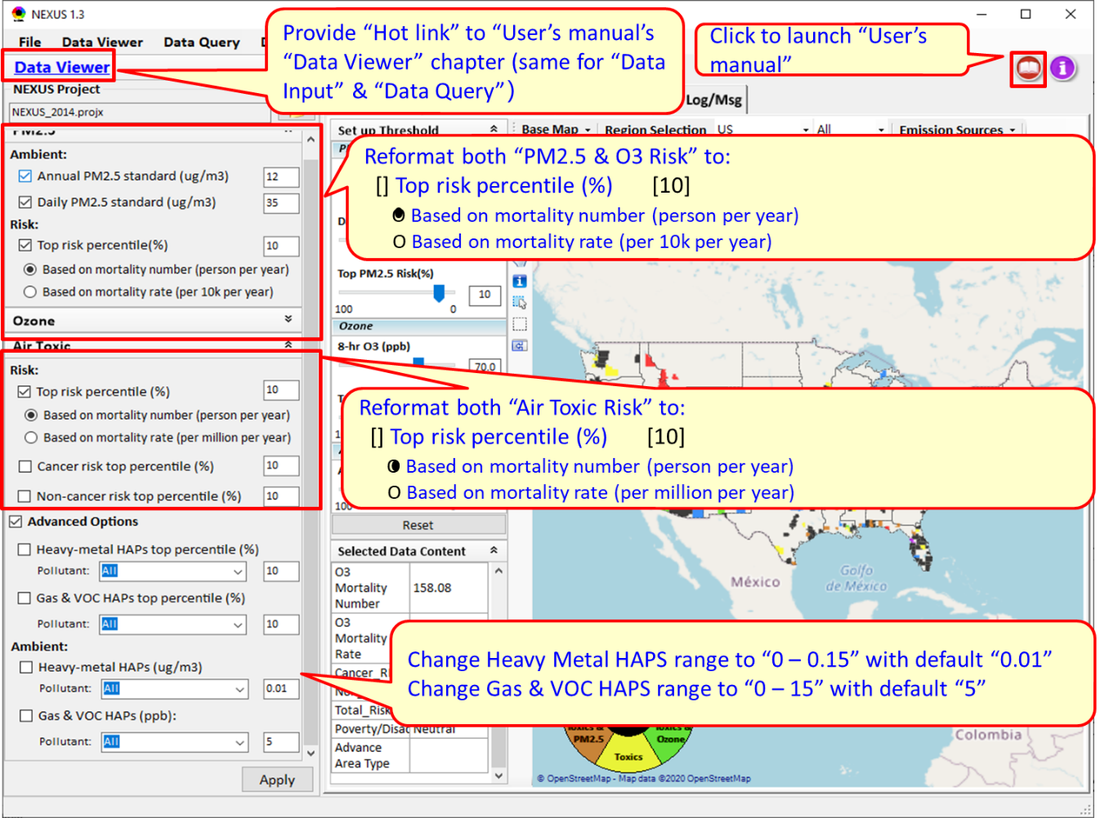
Fig. 1 Main improvements of Data Viewer Module (#1~#5)
- Change “Reset to Default” to “Reset” (box icon) similar to “Apply” below
- Under circle color legend, (1) use “center justified” for “Toxics & PM2.5” to avoid “PM2.5” out of the color legend;(2) slightly shrink the “All Three” “black center circle” to avoid overlapping with any letters.
- Fix the bugs that all top risk bars are not working when “CBSA” selected, and PM2.5 & O3 risk bars are not working when “EPA Region” selected.
- Use no decimal points for all risk bars (i.e., use “10” instead of “10.0)
- “Heavy Metal Risk” & “Gas & VOC Risk” bars are formatted to “100 to 0”
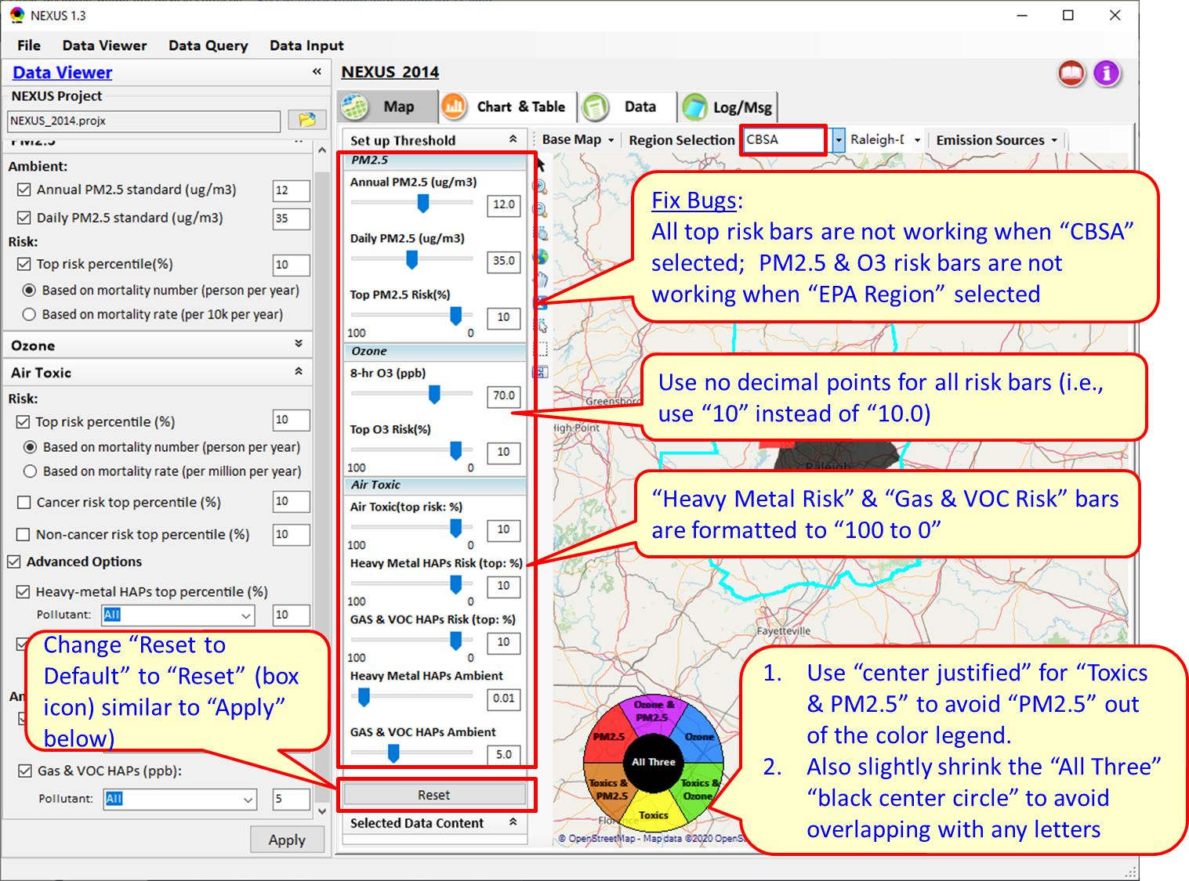
Fig. 2 Main improvements of Data Viewer Module (#6~#10)
- Under “Selected Data Content”, (1)fix a bug in showing incorrect O3 conc;(2) remove all “units”;(3)include both “Mortality number” and “Mortality Rate” and use only 2 decimal points for all data; and (4) clear “Selected Data Content” when “Apply” or “Reset” clicked.
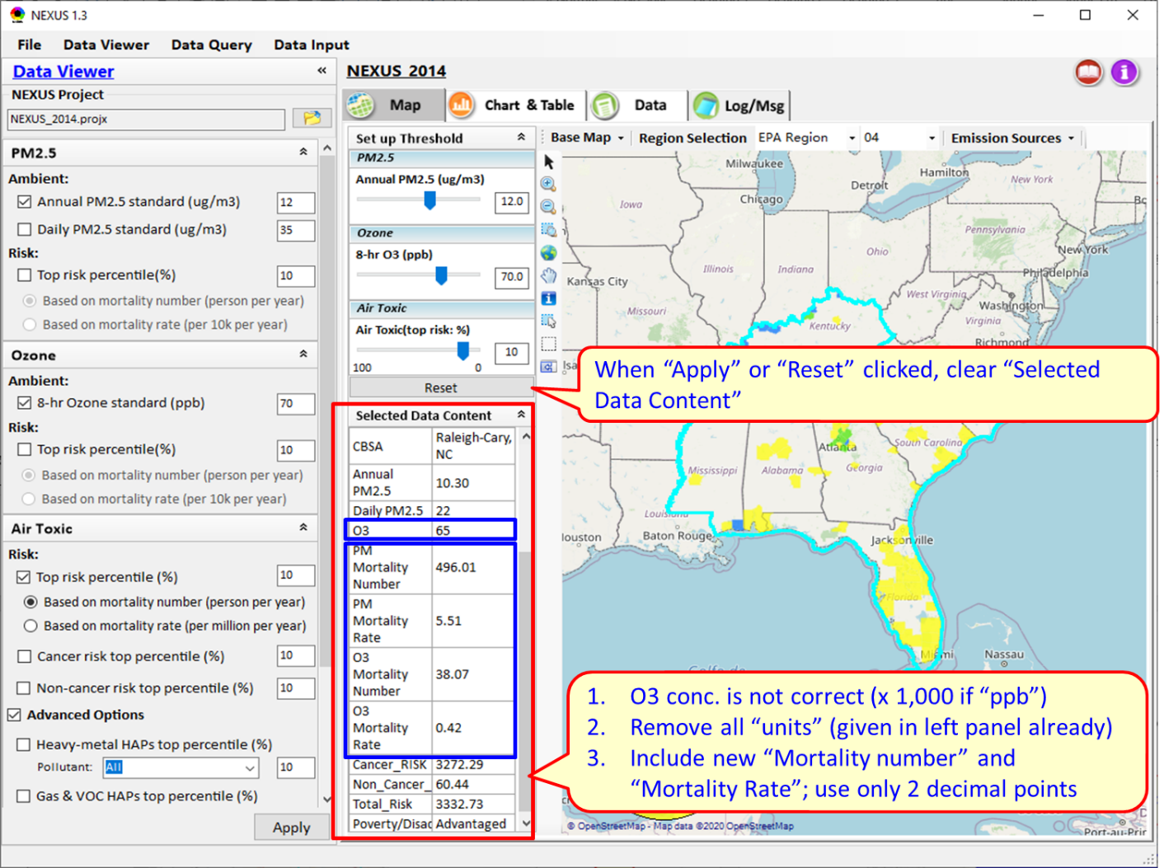
Fig. 3 Update of Selected Data Content module
- Under “Major Emission Sources” or “Top x Emission Source”, (1) don’t let “Map” jump (or move), (2) don’t hide “Set up Threshold” automatically every time when “Emission Sources” (Facility) or “Pollutants” are selected (allow users to control), and (3)support to display “Emissions” data instead of “County’s AQ data” when click the “green circle” of emission points.
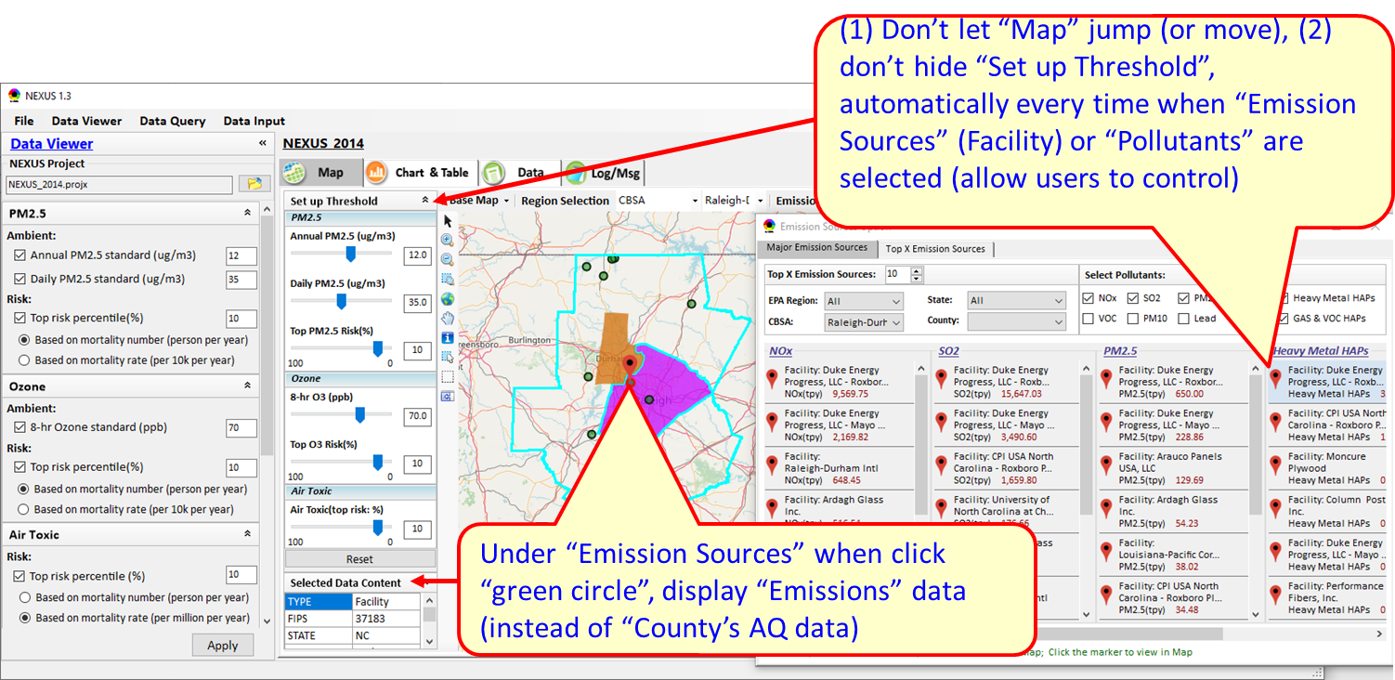
Fig. 4 Update of “Major Emission Sources”
- Under CBSA, fix bugs that (1) the map automatically jumps to whole USA domain (even if both windows have “CBSA” selected already) when “Emission Sources” -> Major Emission Sources” clicked (or “right-click” “Display Major Emission Sources”) and (2)the map sometimes jumps out of selected CBSA into USA domain or other region when click “Facility” or “Pollutants”.
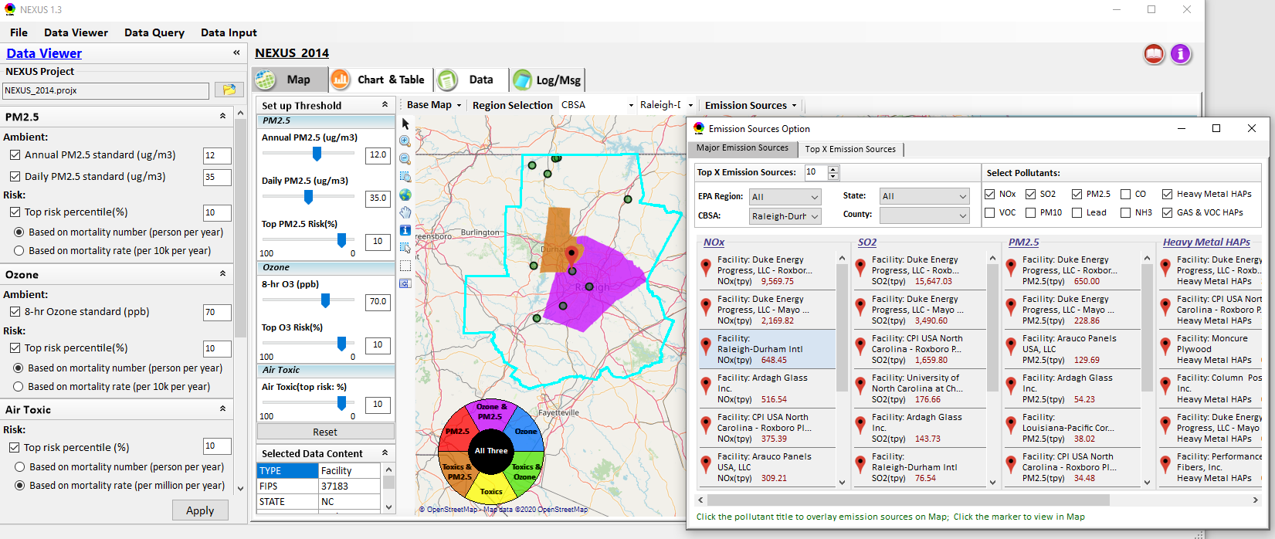
Fig. 5 Fix bugs for CBSA when “Major Emission Sources” clicked.
- Under Data module, (1) fix a bug for only allowing to input up to 12 letters, but need to fully match name,(2) switch button order (“Apply” first), (3) reduce the data decimal points (for all fields) for display (If >1, keep ~2 decimal points, if <1, keep ~4 decimal points), and (4) simplify the column titles (e.g., change “2012-2014 Annul Design Value (mg/m3)” to “Annual PM2.5 DV”) and make the column titles more obvious compared with records below . These changes also are applied to the “Data” for Data Input module and “Attribute table” for Data Query module.
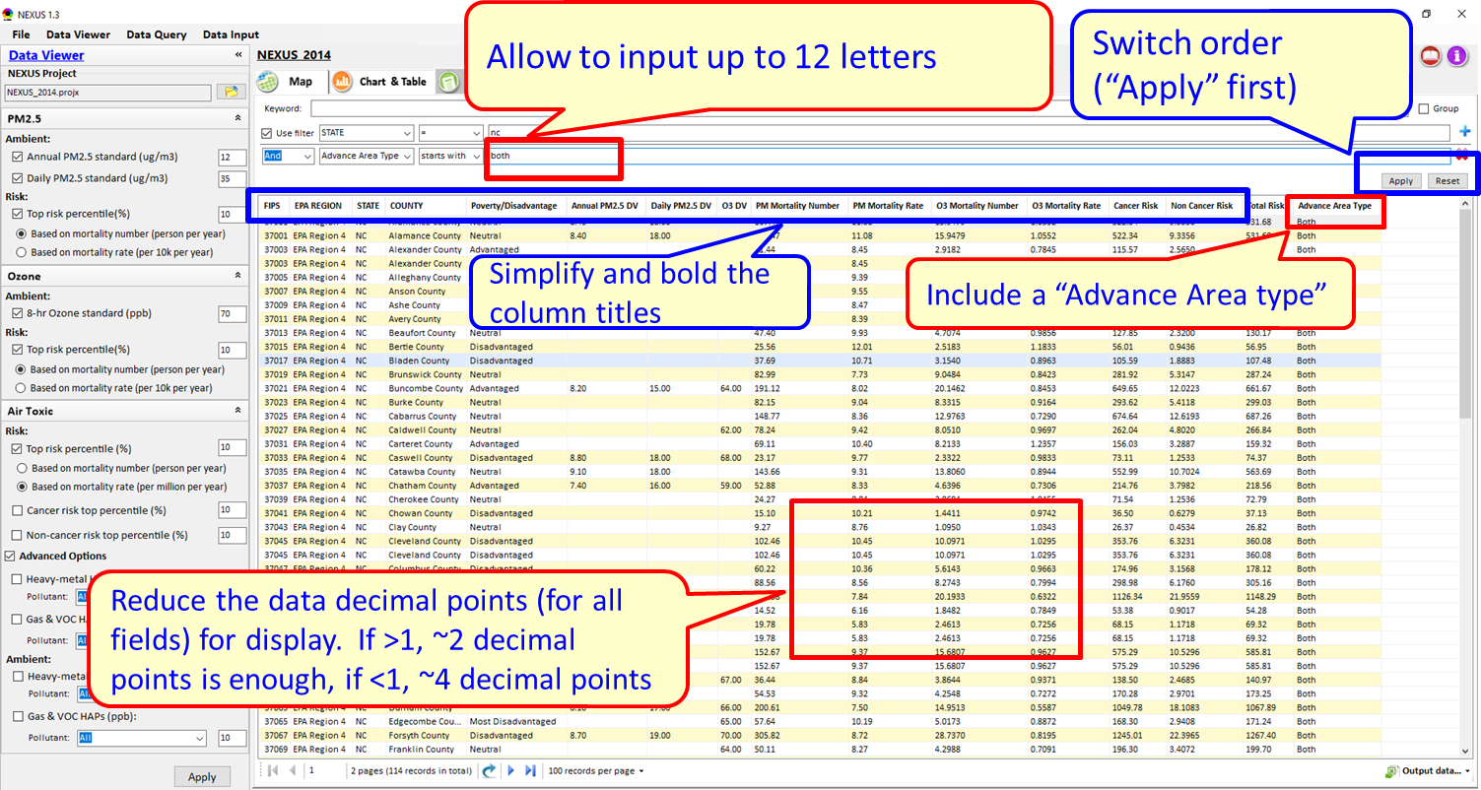
Fig. 6 Update of Data module

Main Improvements for Data Query Module
- Fix a critical bug that “Apply to Map” is not working;
- Use “unchecked” for “Poverty/Disadvantage Area” & “Advance Area” as default options;
- Support to filter Advance area when checking Advance area option on the top of “Data Query” panel.
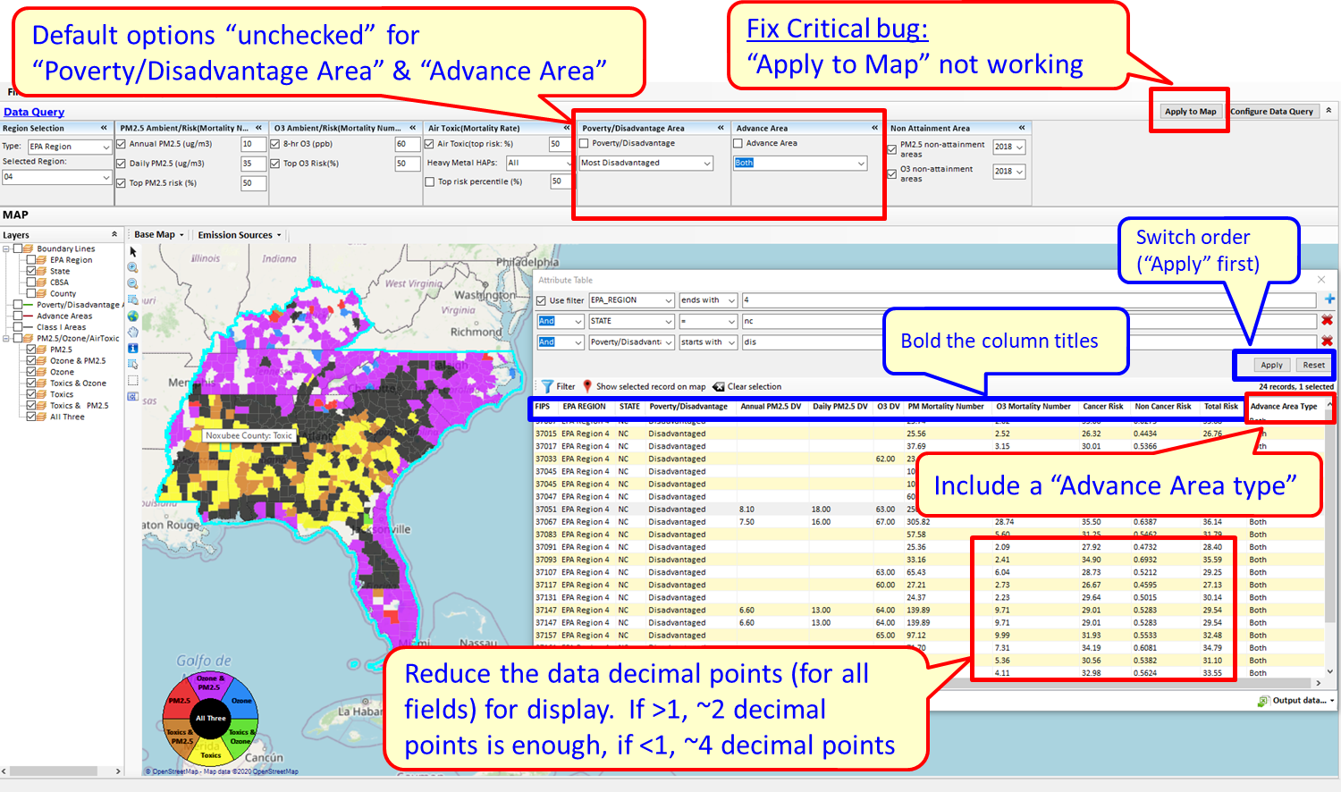
Fig. 7 Update of Data Query module (#1- #3)
- Reformat “PM_{2.5} & O₃ Risk” and “Air Toxic Risk” (Top risk percentile) based on mortality number or mortality rate under Configure Data Query Window.
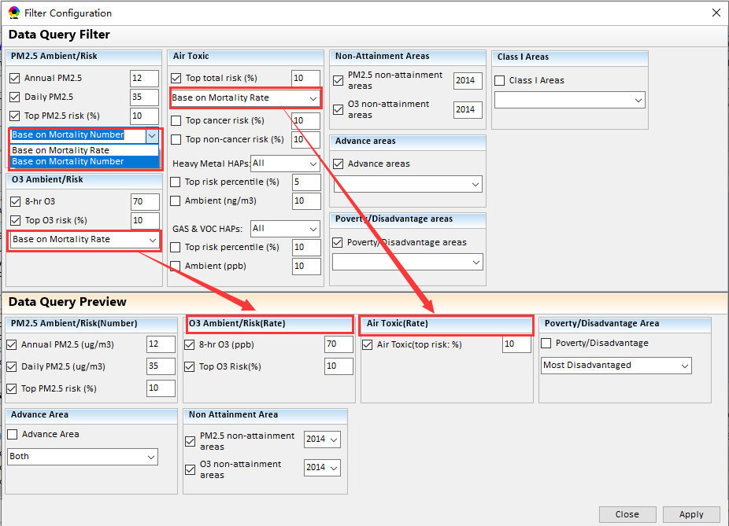
Fig. 8 Update of Data Query filter module

Main Improvements for Data Input Module
- Change NEXUS geodatabase file name from “2014 NEXUS for Yarnell.gdb” to “2014 O3_PM2.5 Fused Ambient_Risk.gdb”.
- Change the button from “Run and Save Project” to “Run & Save Project”
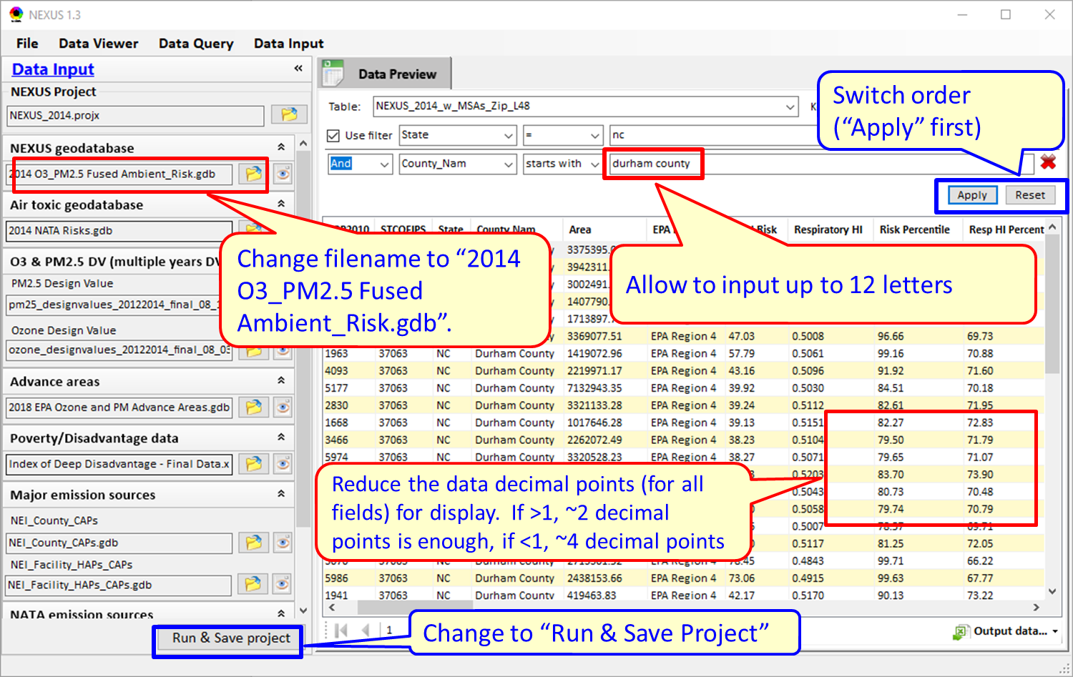
Fig. 9 Update of Data Input module

To Do List:
- Under Data Query Module, remove those layers which locate outside the selected region.
- Complete the Table Generator module.
- Under the Data Module, display the checked data only.
- Support to show census tracts level data when “CBSA” or “State” is selected.

