Main Improvements of NEXUS 1.5
By SCUT, 2020-09-21

Main Improvements for Data Viewer Module
- Change default to “User’s Manual” size to smaller size partial window;
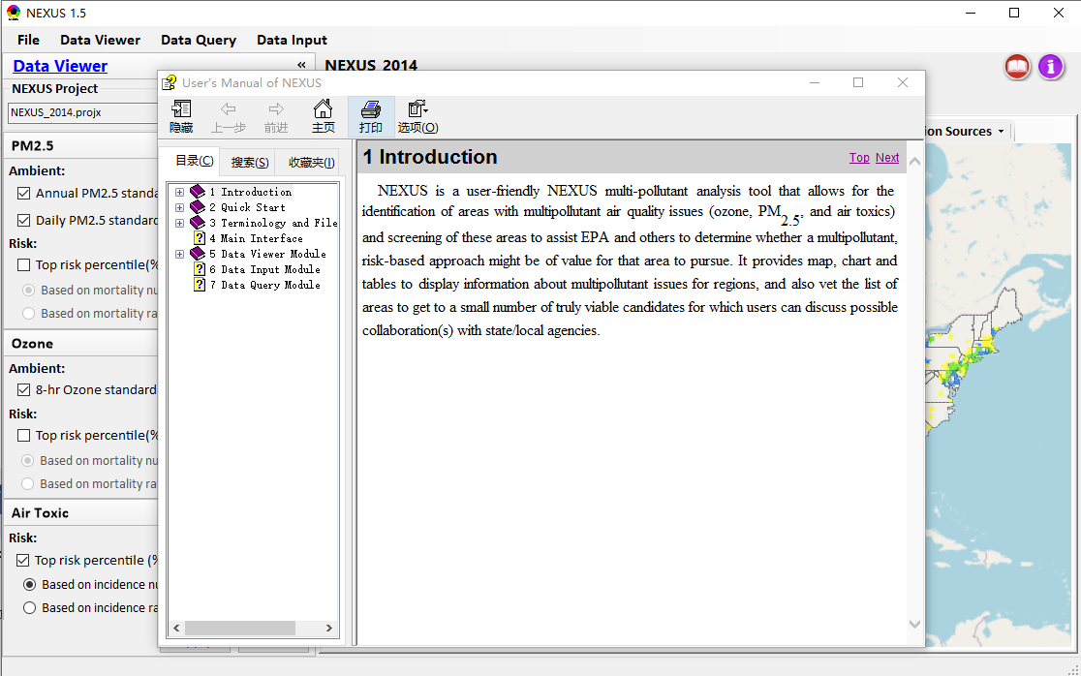
- Support new function of “Save image to clipboard” under the Right-click menu on Map
- For Air Toxic, change “Based on Mortality Rate” to “Based on Incidence Rate” and change “Based on Mortality Number” to “Based on Incidence Number” (also for Data Query Module);
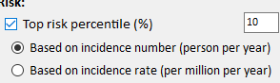
- Under “Top X Emission Sources” chart, change “Data” to include “CAPs” and “HAPs”. For “CAPs”, list only “Pollutants” under current “Criteria_Major”; for “HAPs”, list only “HAPs” pollutants and remove all “CAPs” pollutants.
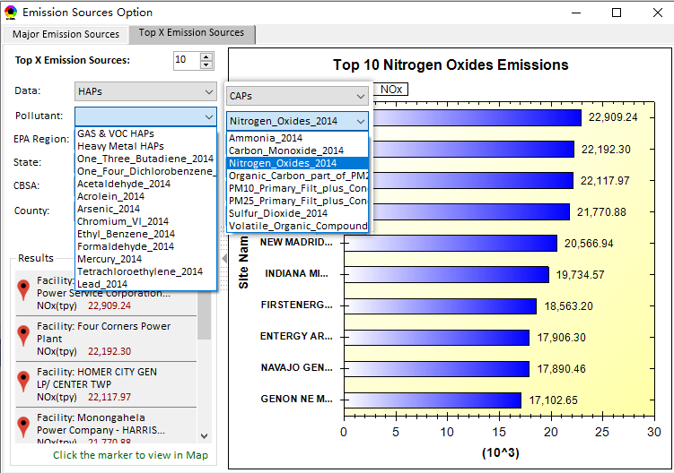
- Use the whole US top x% for USA/EPA Region/State/CBSA region selection (for both Data Viewer and Data Query module) to make sure the results are consistent under different level regions selection.
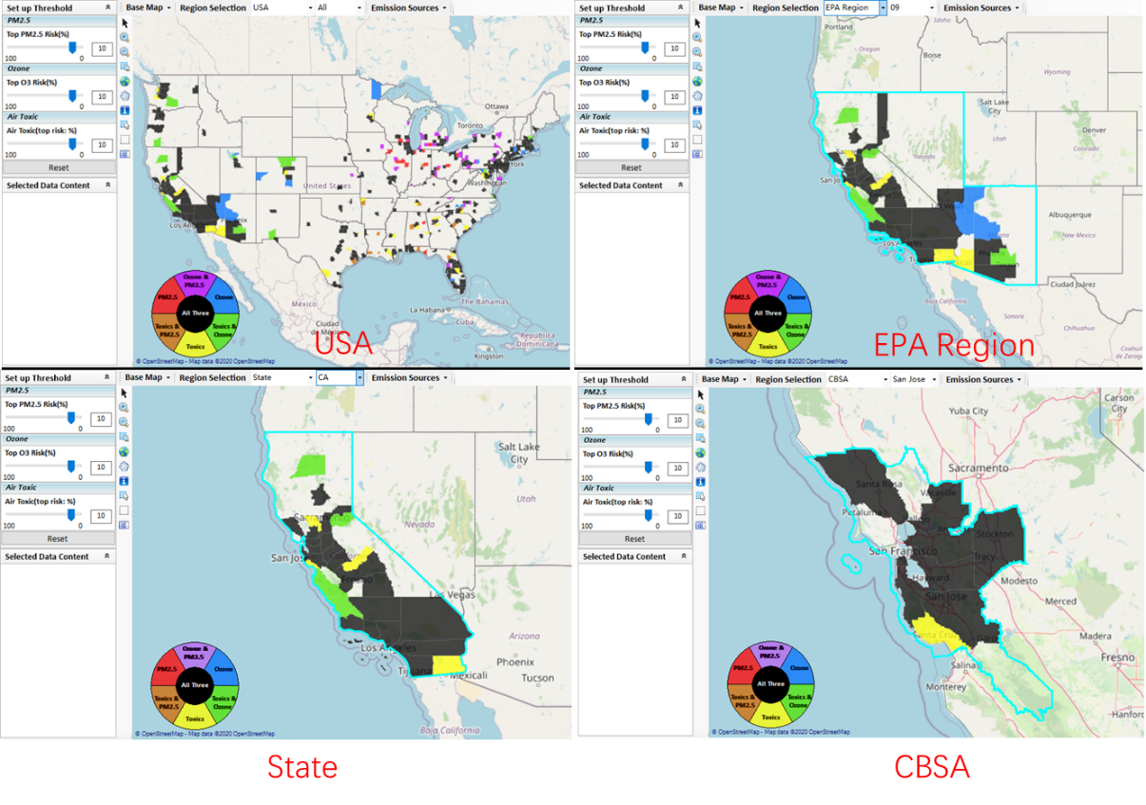

Main Improvements for Data Query Module
- List “Advance Area” first before “Poverty/Disadvantage” Area;
- Change the panel title form “Poverty/Disadvantage” to “Socio-Economic/Demographic”.
- Re-order the nodes on the “Layers” panel;
- Change to user “deep blue” color for the “selected county boundary lines”;
- Remove “boundary lines” outside of the selected region for “Advance”, “Poverty” areas, etc. (to avoid confusion).
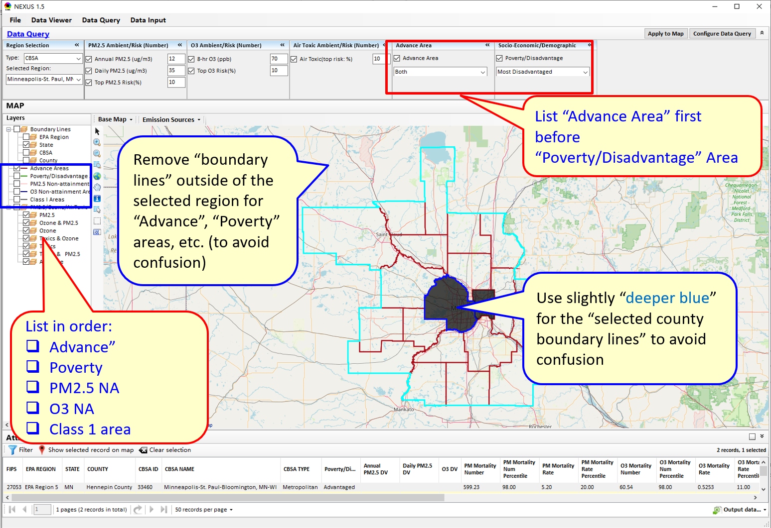

To Do List:
- Include an updated Online-User’s manual
- Complete the Table Generator module.
- Support to show census tracts level data when “CBSA” or “State” is selected.

