Development Plan for NEXUS Tool’s
“Proximity-based Source/Sector Multi-Pollutant Risk and EJ Analysis” Module
AQAD/AQMG, Feb. 18, 2021
Purpose: Develop a new proximity-based source/sector module (i.e., “Proximity-based Risk and EJ Analysis” module) to equip NEXUS with multi-pollutant and climate risks and EJ analysis capabilities for a selected industrial source and its sector group (“zoom-out” to nationwide)
Resources: In-house staff time (Carey, Jim, Shannon, Matt, etc.) with expected OAQPS funding to support this new NEXUS development effort
Data Requirements:
Need to retrieve and/or generate new datasets based on “Census block group” level of resolution (NEXUS’s current datasets are based on “Census tract” level). The datasets required are given below (Table 1).
Table 1. Data requirements
Type of data | Potential source | Level of resolution
Industrial source & sector group emissions data (2017) | EIAG (CAPs) & ATAG (HAPs)? | Point
PM2.5 & O3 risk data (2017) | MP team | Census tract
Air toxics risk data (2017) | NATA team | Block group
Climate risk data (2017) | Climate team? EJSCREEN climate risk indicator? | Block group
Population (Demographic analysis) | Census’ American Community Survey (ACS) | Block group
EJ data (minority group, income group, education, life expectancy, etc.) | EJSCREEN | Block group
Tribal data (boundaries, etc.) | OAQPS public site & CTPG | Block group

Draft Module Design: ”Proximity-based Risk and EJ Analysis” module
- Develop proximity-based multi-pollutant and climate risks and EJ analysis capabilities for a selected industrial source (local) and its sector group (“zoom-out” to nationwide)
- For a selected emission source/facility, allow to set a flexible “Radius of Impact” (e.g., 1 ~ 50 km)
- Create a summary table & chart (example table & chart given below) to cross-examine the potential linkages of
  - Multi-pollutant risks (PM2.5, O3, and Air toxics)
  - EJ and demographic data (population, minority group, income group, etc.)
  - Climate risks (fire, flood, sea level rise, heat, disease, etc.)
  - Expand from the selected source/facility and “zoom out” to its “sector group” nationwide (within the same selected radius of analysis)
(Note: this function could be computationally challenging for both speed & data requirements)
  - Provide plots/charts based on the selected table attributes
- Provide “Spatial analysis” (map) functions for EJ indicators and climate risks
- Include “Tribal areas” to provide similar analysis capabilities
- Also add “EJ” indicators as one of the four key metrics (PM, O3, AT & EJ) in main page

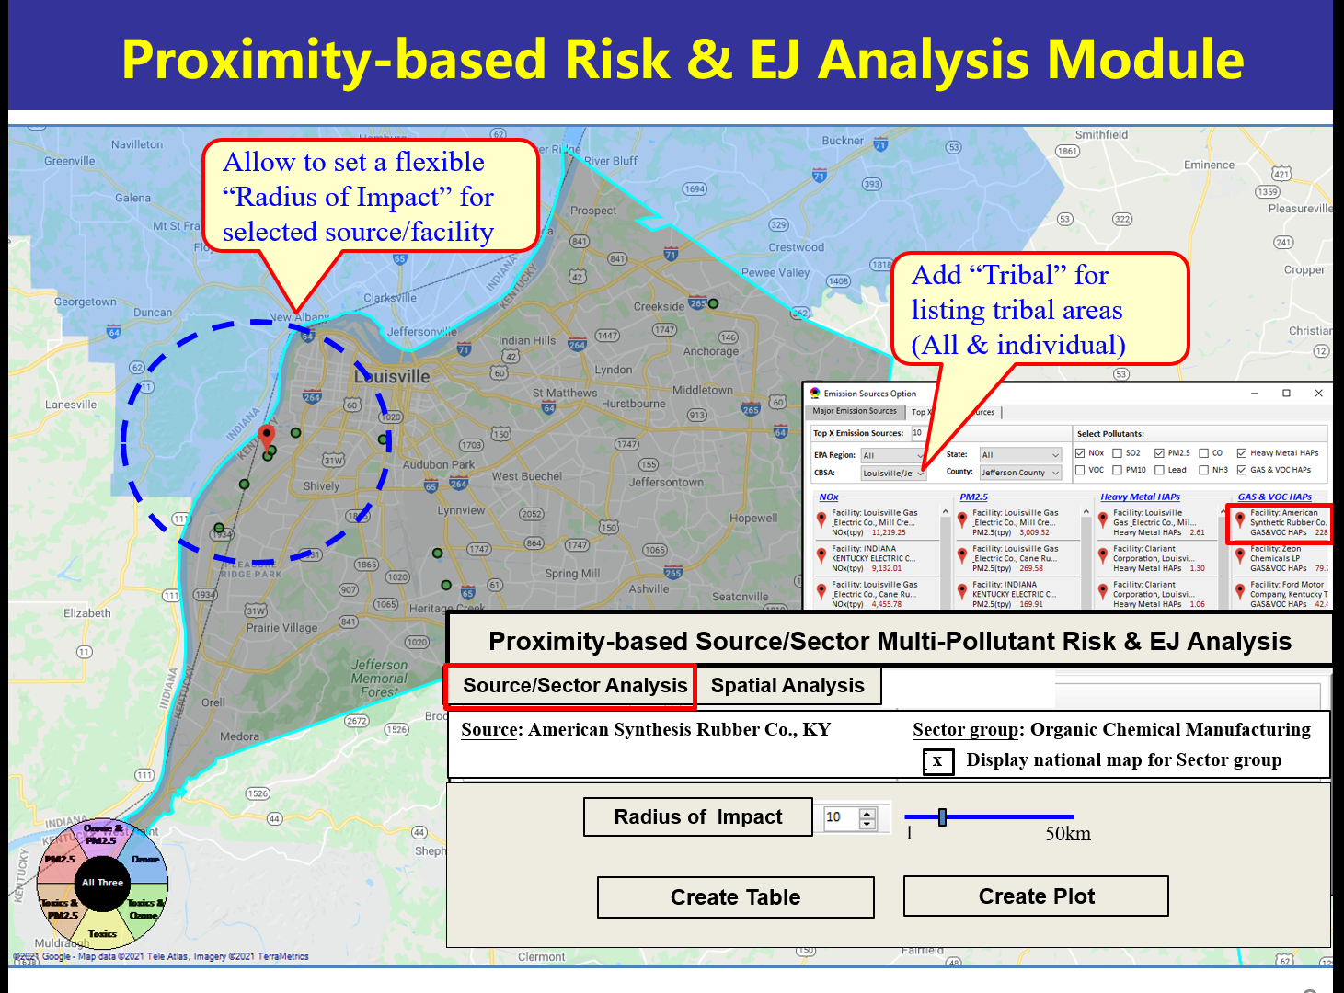

Example Table:

Source Name: American Synthesis Rubber Co., Louisville, KY
Sector Group Name: Organic Chemical Manufacturing
 |  | Within Radius of Source | County Avg. | State Avg. | EPA Region Avg. | Nation Avg. | Sector Group (within radius) National avg. | Sector Group (within radius) Top 25 MSAs
Population total |  | x,xxx | xx,xxx | xxx,xxx | xxx,xxx | 317,xxx,xxx | xxx,xxx | xxx,xxx
PM2.5 risk (%tile) |  | x% | x% | x% | x% | x% | x% | x%
Ozone risk (%tile) |  | x% | x% | x% | x% | x% | x% | x%
Air Toxics:  Cancer risk (%tile) |  | x% | x% | x% | x% | x% | x% | x%
Cancer risk value  (x in-million lifetime) |  | x.x | x.x | x.x | x.x | x.x | x.x | x.x
Non-cancer risk (%tile) |  | x% | x% | x% | x% | x% | x% | x%
Non-cancer risk  (Hazard Index) |  | x.x | x.x | x.x | x.x | x.x | x.x | x.x
Climate risks:  Flood (%tile) |  | x% | x% | x% | x% | x% | x% | x%
Sea level rise (%tile) |  | x% | x% | x% | x% | x% | x% | x%
Fire (%tile) |  | x% | x% | x% | x% | x% | x% | x%
Disease (%tile) |  | x% | x% | x% | x% | x% | x% | x%
EJ:  Minority group (%tile) |  | x% | x% | x% | x% | x% | x% | x%
Low-income group (%tile) |  | x% | x% | x% | x% | x% | x% | x%
Demographic Index (%tile) |  | x% | x% | x% | x% | x% | x% | x%
Linguistic Isolation (%tile) |  | x% | x% | x% | x% | x% |  | x%

Example Chart:
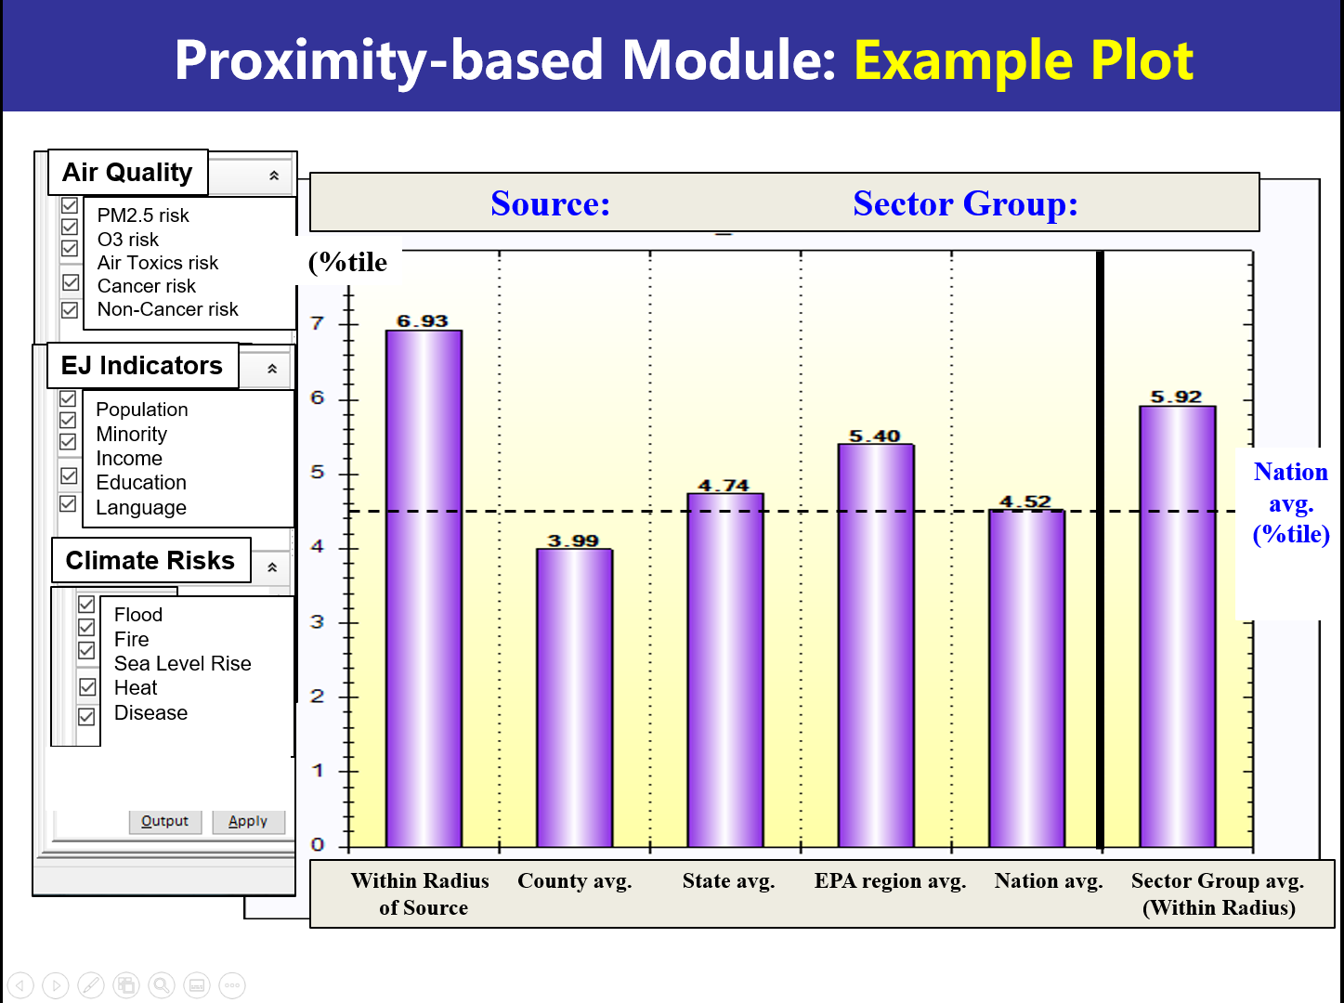

“Spatial Analysis” Function Design
