Development Plan for NEXUS Tool’s
“Proximity-based Source/Sector Multi-Pollutant Risk and EJ Analysis” Module
AQAD/AQMG, March 31, 2021
Purpose: Develop a multi-pollutant proximity analysis capability within the NEXUS tool. This capability can be applied to individual sources/facilities within a specific geographic area or to sector groups at the national level (“zoom-out” to nationwide). This new module will also equip NEXUS with multi-pollutant and climate risks and EJ analysis capabilities.
Resources: In-house staff time (Carey, Jim, Shannon, Matt, etc.) with expected OAQPS funding to support this new NEXUS development effort.
Data Requirements:
Need to retrieve and/or generate new datasets based on “Census block group” level of resolution (NEXUS’s current datasets are based on “Census tract” level). The datasets required are given below (Table 1).

Table 1. Data requirements
Type of data | Potential source | Level of resolution
Industrial source & sector group emissions data (2017) | EIAG (2017 NEI for CAPs/HAPs/GHG) | Point
PM2.5 & O3 conc. data (2017) | AQMG/AQAG | Census tract
PM2.5 & O3 risk data (2017) | MP team/RBG | Census tract
Air toxics risk data (2017) | MP team/ATAG | Block group
Climate risk data (2017) | Climate team & EJSCREEN climate risk indicator | Block group
Population | Census’ American Community Survey (ACS) | Block group
EJ data (minority group, income group, education, demographic index, etc.) | EJSCREEN | Block group
Tribal data (boundaries, etc.) | OAQPS public site & CTPG | Block group

Draft Module Design: ”Proximity-based Multi-pollutant Risk and EJ Analysis” module
- Develop proximity-based multi-pollutant risk and EJ analysis capabilities for a selected industrial source (local) and its sector group (“zoom-out” to nationwide)
- For a selected emission source/facility, allow to set a flexible “Radius of Impact” (e.g., 1 ~ 50 km)
- Create a summary table & chart (example table & chart given below) to cross-examine the potential linkages of
  - Multi-pollutant risks (PM2.5, O3, and Air toxics)
  - Demographic and socio-economic data (population, minority group, low income, etc.)
  - Climate risks (fire, flood, sea level rise, heat, disease, etc.)
By extending the tool to:
  - Provide plots/charts based on the selected table attributes
  - Expand from the selected source/facility and “zoom out” to its “sector group” nationwide (within the same selected radius of analysis)
(Note: this function could be computationally challenging)
  - Link to a national map with all facilities within the same Sector group with point value of MP risks displayed in color scale
- Provide “Spatial analysis” (map) functions for MP risks and EJ indicators
- Include “Tribal areas” to provide similar analysis capabilities
- Include Air toxic “top risk drivers” and “risk threshold” analysis capabilities
- Also add “EJ” indicators as one of the four key metrics (PM, O3, AT & EJ) in main page

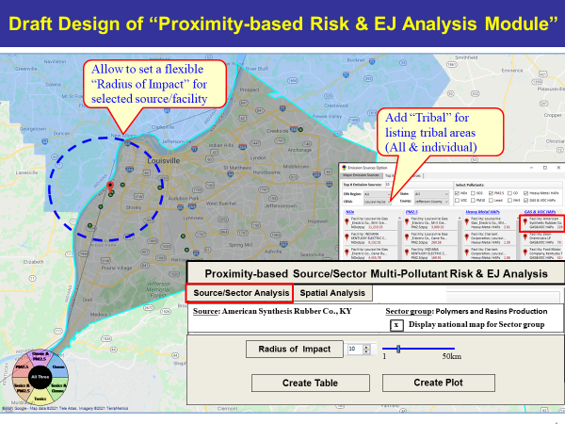
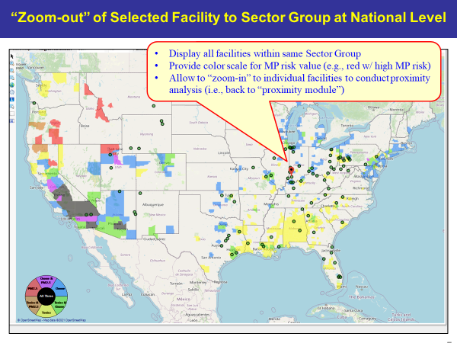
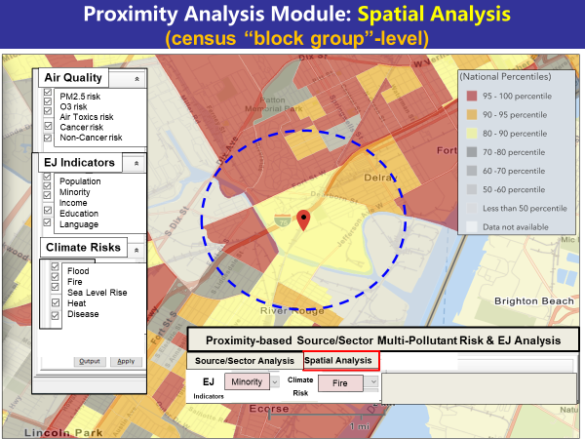
Example Table:

Facility: American Synthesis Rubber Co., Louisville, KY  Sector Group: Polymers and Resins Production  Top Risk Drivers: ETO, Formaldehyde |  |  |  |  | Selected Options:  Radius of Impact: 10km  Number of CBSAs: 25 (top MP risk ranking)  Air Toxics Risk threshold: 10 (“x”-in-a million)
 | Within Radius of Facility | County Avg. | State Avg. | EPA Region Avg. |  | Nation Avg. | Sector Group (within radius) National avg. | Sector Group (within radius) Top 25 CBSAs
Population total | x,xxx | xx,xxx | xxx,xxx | xxx,xxx |  | xxx,xxx | xxx,xxx | xxx,xxx
PM2.5 risk  (pop. weighted conc.) | x | x | x | x |  | x | x | x
Ozone risk  (pop. weighted conc.) | x | x | x | x |  | x | x | x
Air Toxics risk:  Cancer risk value  (“x”-in-a million)) | x.x | x.x | x.x | x.x |  | x.x | x.x | x.x
Cancer risk value above selected threshold  (population) | x,xxx | xx,xxx | xx,xxx | xx,xxx |  | xx,xxx | xx,xxx | xx,xxx
Non-cancer risk  (Hazard Index) | x.x | x.x | x.x | x.x |  | x.x | x.x | x.x
Climate risks:  Flood (%) | x% | x% | x% | x% |  | x% | x% | x%
Sea level rise (%) | x% | x% | x% | x% |  | x% | x% | x%
Fire (%) | x% | x% | x% | x% |  | x% | x% | x%
Disease (%) | x% | x% | x% | x% |  | x% | x% | x%
EJ/Demographics  Minority group (%) | x% | x% | x% | x% |  | x% | x% | x%
Low-income group (%) | x% | x% | x% | x% |  | x% | x% | x%
Demographic Index (%) | x% | x% | x% | x% |  | x% | x% | x%
Linguistic Isolation (%) | x% | x% | x% | x% |  | x% |  | x%

Example Chart:

