Main Improvements of FAST-CE 3.9
By SCUT, 2024-01-26

Main Improvements:
- Develop the Project Comparison Plot module that allows users to compare various cases from different projects:
Step 1: Click the “+” button to select the FAST-CE Projects. Users can also check the “Use BenMap-CE Data” checkbox to load BenMap-CE Data. Cases within the selected project will be listed in the following panel named “Pre-defined Case”;
Step 2: Double-click interested cases or use the Formula Calculator function to define expressions, subsequently they will be added to the "Plot List" panel.
Step 3: Click “Apply” to display results from the “Plot List”.
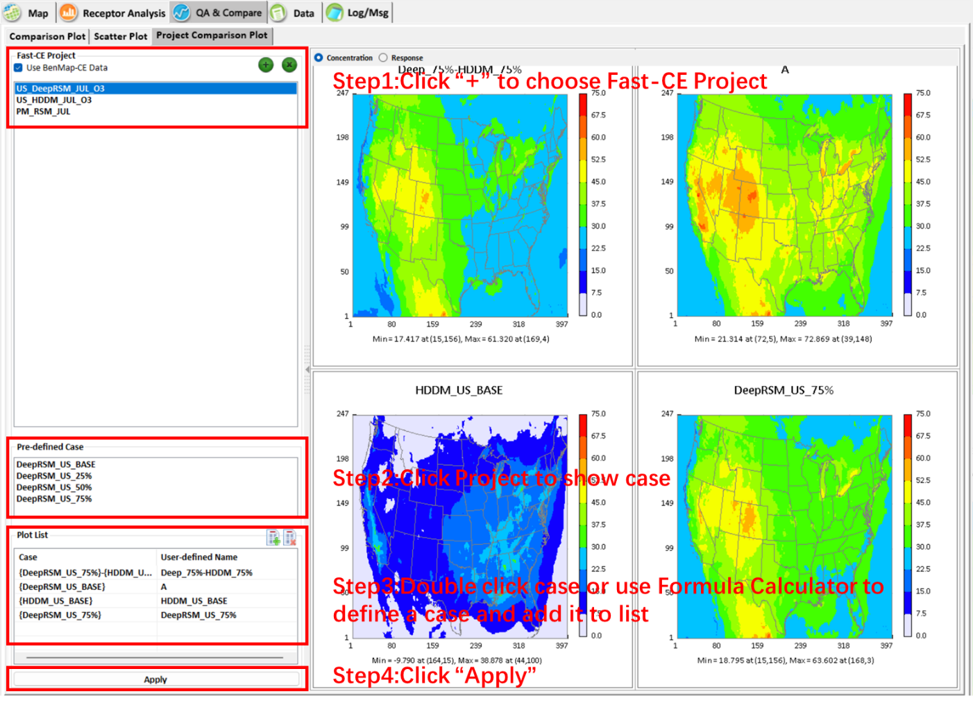
Fig. 1 Develop Project Comparison Plot module
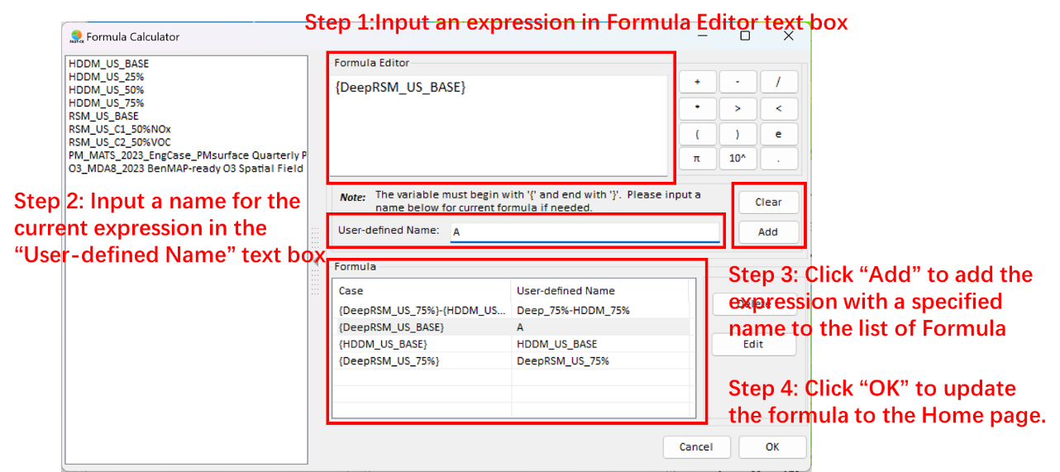
Fig. 2 Formula Calculator for Project Comparison Plot
- Develop the function that allows users to change the baseline case under “Response” option.
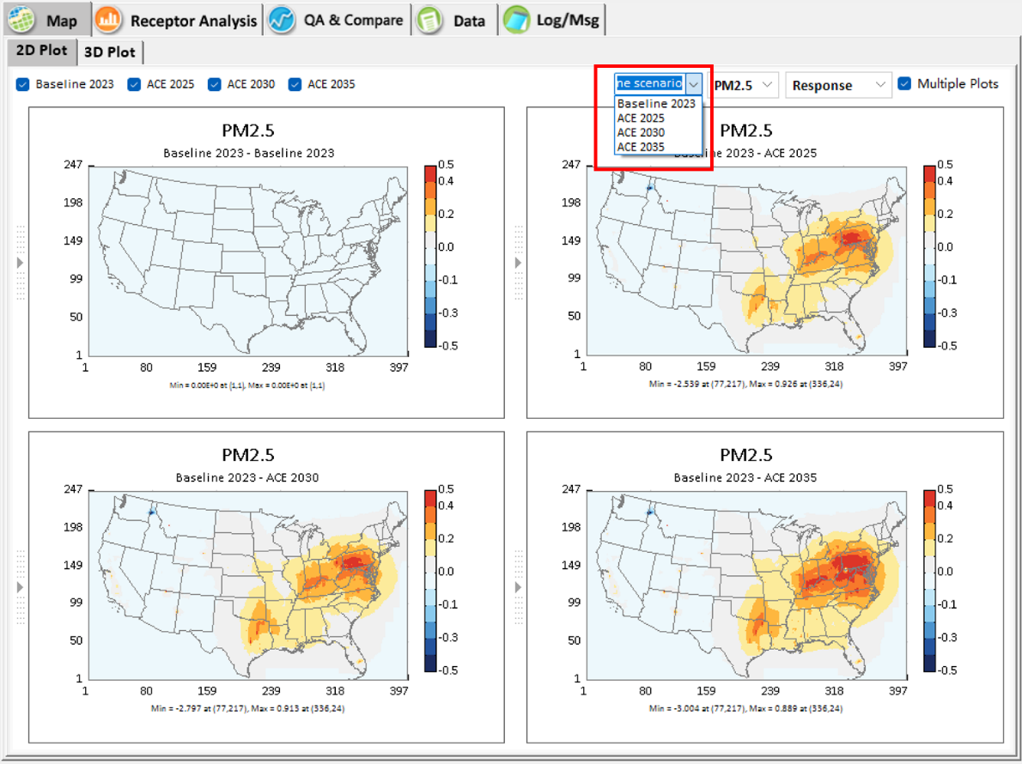
Fig. 3 Set the base case
- Change “Tick” to “Tick: coordinate” and delete the text box in the Configuration Plot form.
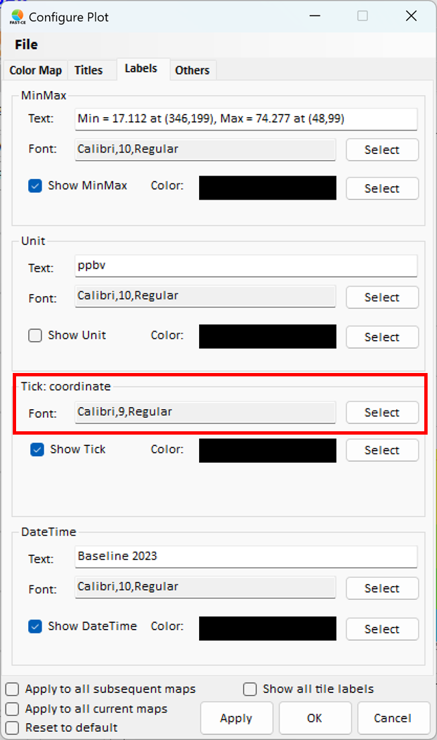
Fig. 4 Adjust Configure Plot
- Add a function to show only one legend bar on the right when checking “Show one legend bar”.
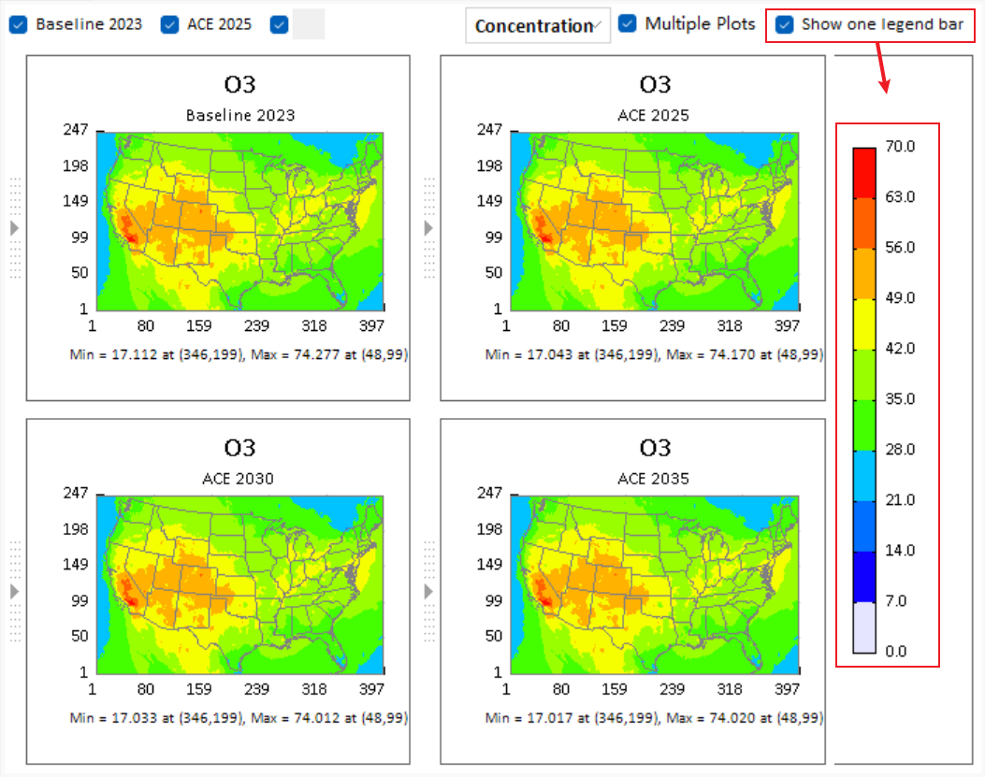
Fig. 5 Show one legend bar
- Add a filtering function in the Data module to support users to filter data based on specified field conditions.
  - Enable the “Use filter” option. To create a set of filter criteria, click the "Add" icon on the right. Alternatively, click the "Remove" icon to remove filter criteria in the current row.
  - Use drop-down menus to set filter expressions.
  - Click “Apply” and the table will show data based on selected filters.
  - To remove all applied filters, click “Reset”.
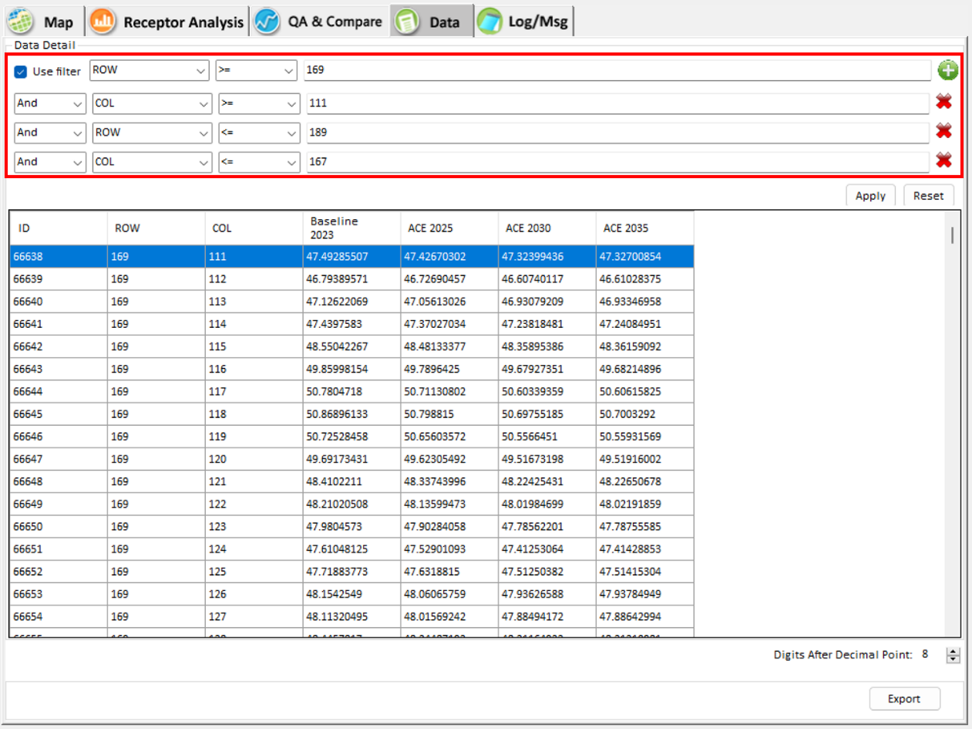
Fig. 6 Data Filter
- Develop a function to display the data from the selected area highlighted in the map.
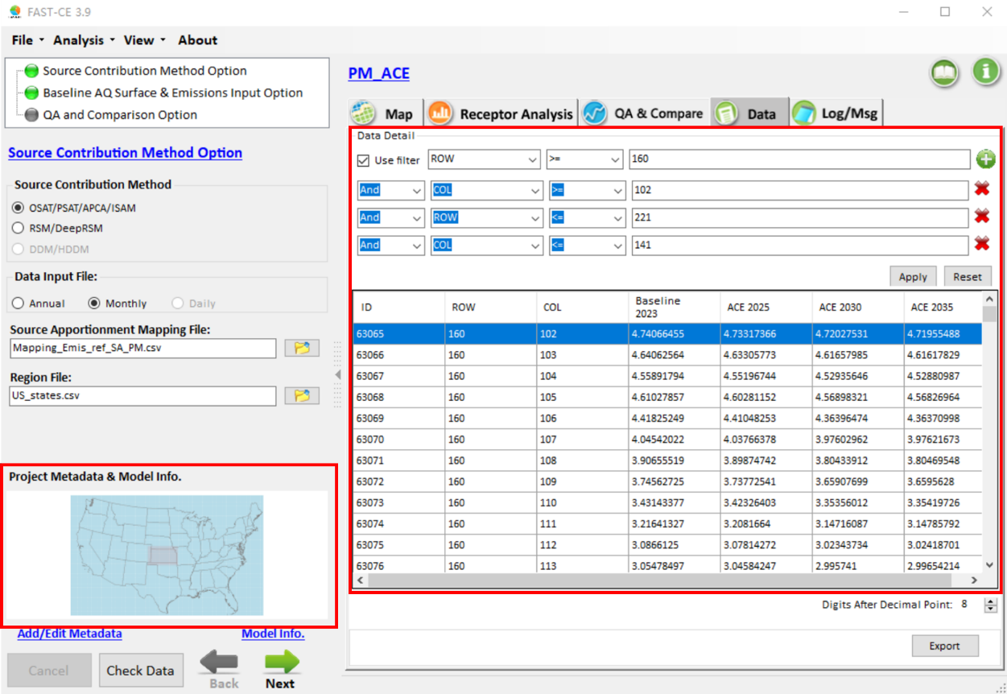
Fig. 7 Show the data in the select area
- Develop a Reigon Emission Combine module that allows users to combine multiple regions and sources. The combined factors are marked with a red asterisk (*). This ensures that the merged regions are treated as a region to calculate the emission factors. The calculation formula is listed below.
$${Factor}_{ReigonA,ReigonB,ReigonC}=\frac{\sum_{ReigonA,ReigonB,ReigonC}{FutureEmissions}}{\sum_{ReigonA,ReigonB,ReigonC}{BaselineEmissions}}$$

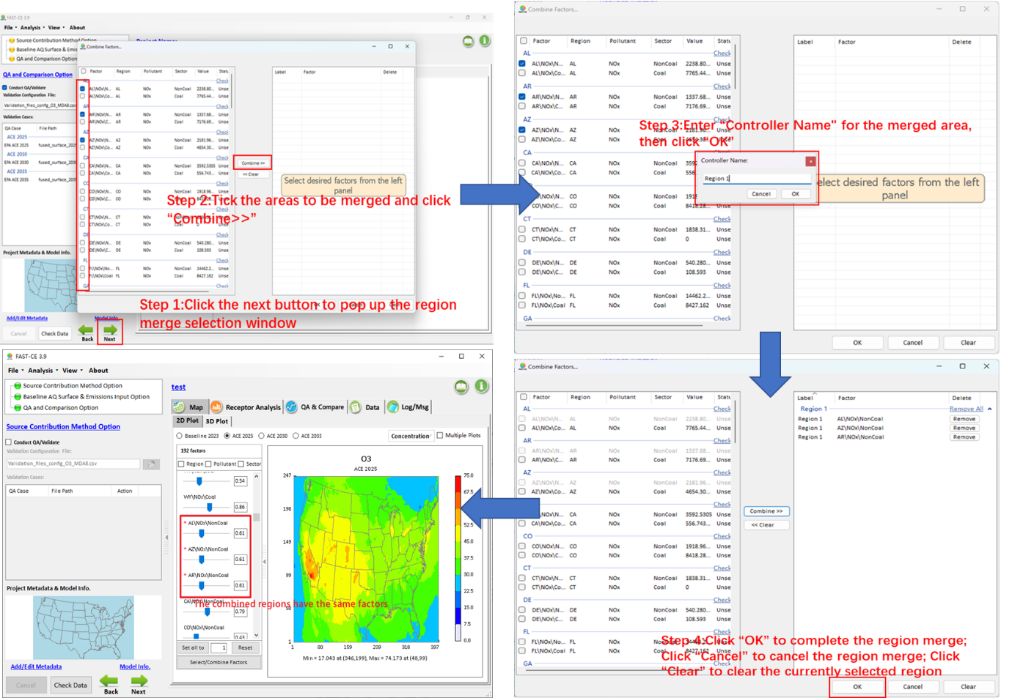
Fig. 8 Region Emission Combine module
- Fix the bug that the case slide button failed to work on the small screen.
- In the PM mapping file, rectified the entries from SO₂ to SO₄ and from NOx to NO₃ in the species and pollutant columns.
- Include an EPA Region receptor file in “../My FAST_CE Files/receptor_files”.

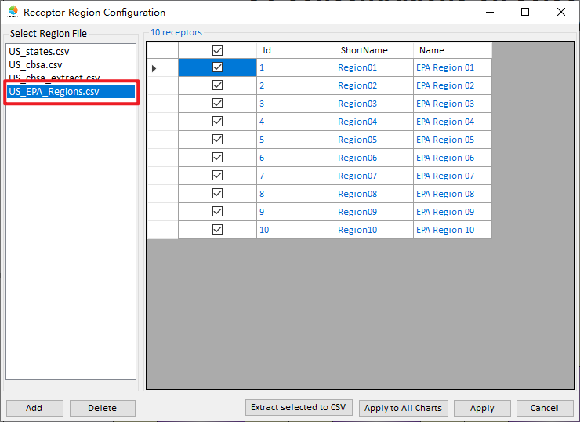
To Do List:
- Develop the multiple plots for PM species.
- Develop the function to show only one legend bar under Project Comparison Plot module

