Main Improvements of Model-VAT 2.3
March 5, 2025
Main Improvements:
- Enhance the remote access functionality to enable access to the EPA Linux system under GSSAPI authentication. Below are the detailed steps to connect to the remote machine:
- Verify SSH Connectivity: Ensure that your computer is authorized to connect to the EPA server via SSH.
- Open the file at: C:\Users\username\.ssh\config and add the following information:
Host atmos2.hesc.epa.gov
User username
GSSAPIAuthentication Yes
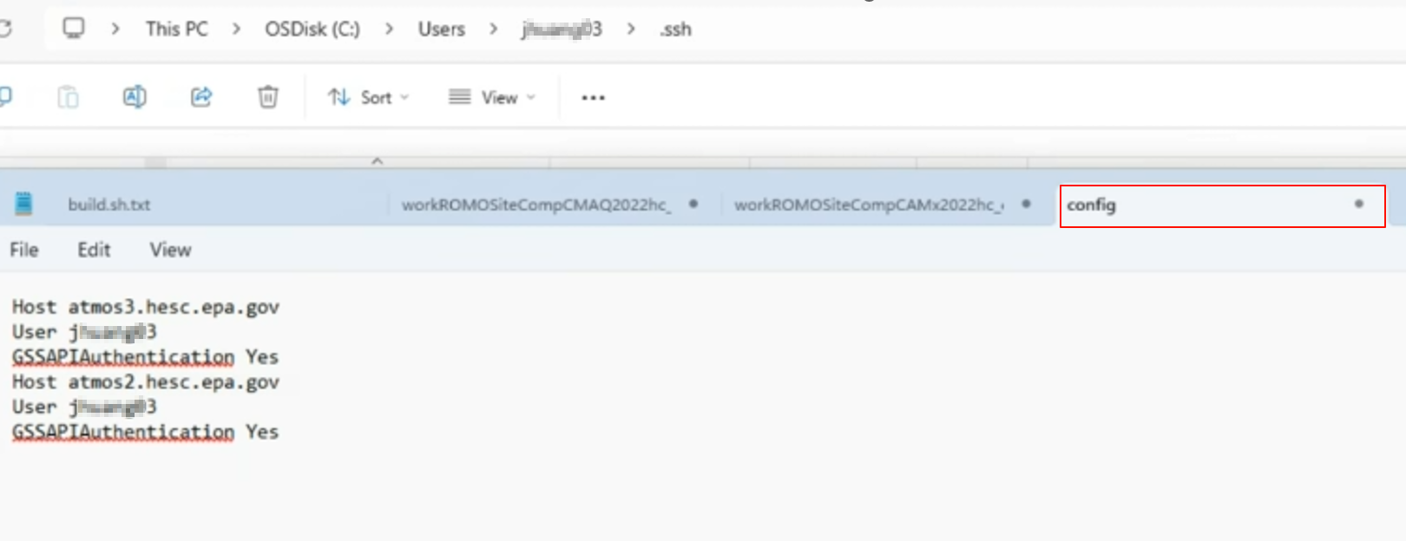
Fig. 1 The screenshot of the config file
- Open a terminal window on your local machine.
- Run the following command:
ssh username@atmos2.hesc.epa.gov
- Enter yes to confirm if this is your first time connecting.
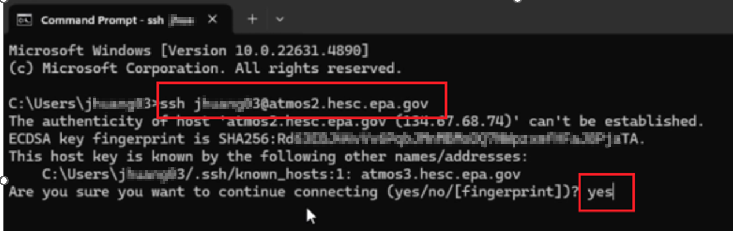
Fig. 2 The screenshot of a terminal window from a Windows laptop illustrates the above process
- Configure Model-VAT: Open Model-VAT, navigate to the remote access module, and select the “GSSAPI” option instead of “Password”.
- Load Module: Load the required modules, including NetCDF, Intel, and NCO libraries, to support specific functions, by entering them in the designated text box. These modules are necessary for functions such as ncdump and ncks. For EPA's ATMOS, you can load: intel/21.4 netcdf nco
- Establish Connection: Click the “Connect” button to initiate the connection to the remote server.
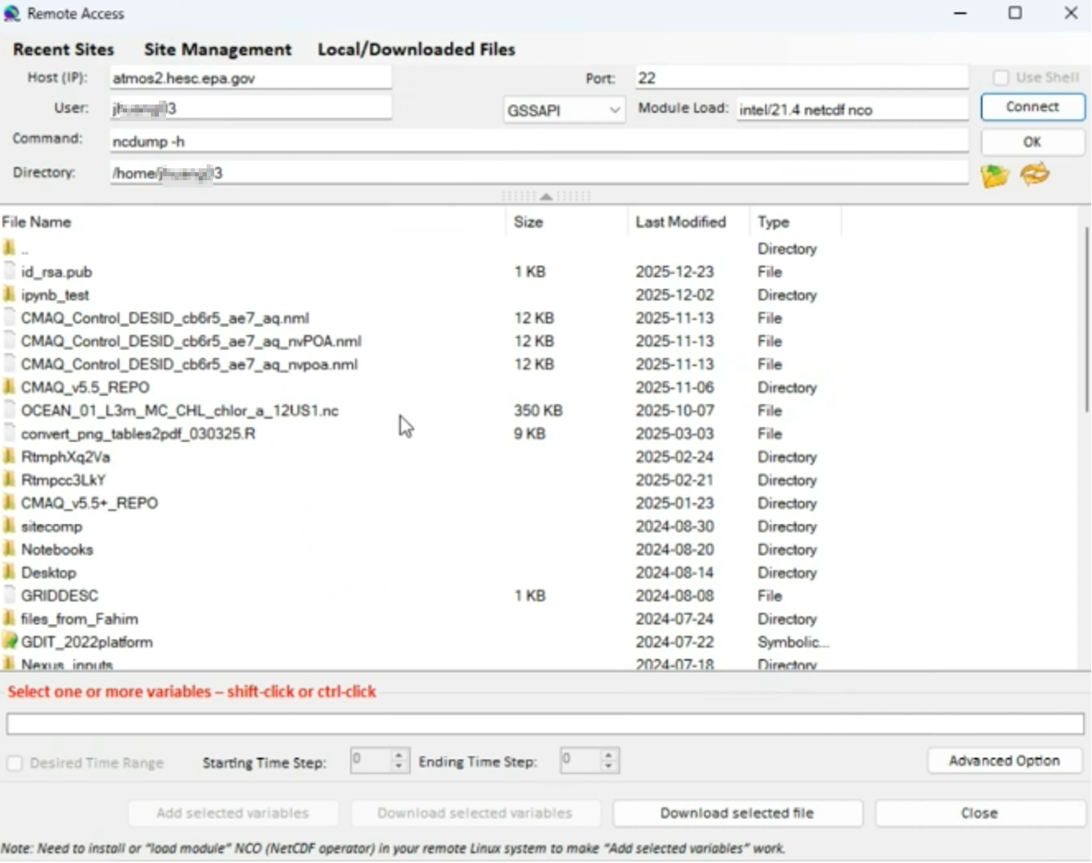
Fig. 3 The Remote Access module of Model-VAT
- Fix the bug in Model-VAT that caused the grid shift.
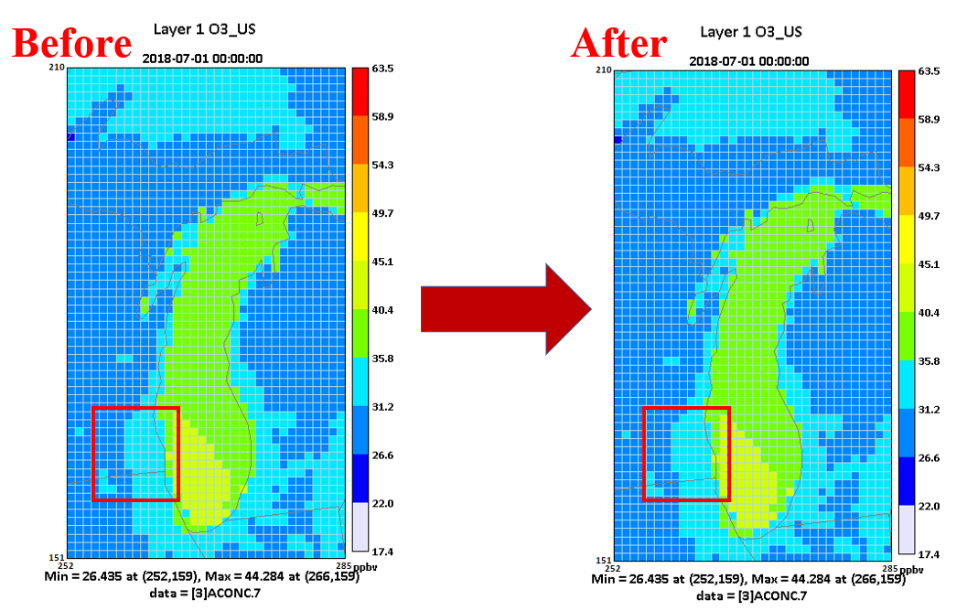
Fig. 4 Fix the grid shift bug in Model-VAT

