Main Improvements of SMAT-CE 2.2
-December, 2023
Main Improvements:
- Fix the bug for “Output Design Value Periods” option under “Output Choices-Advanced” window.
The issue is that the “f_pm25_ann_DV” column in the “Annual_PM25_Point_Period_*.csv” output files is the same as in the “Annual_PM25_Point.csv” output file for the annual test. We fixed it by developing the function to calculate design values for different periods, as shown in Fig. 1.
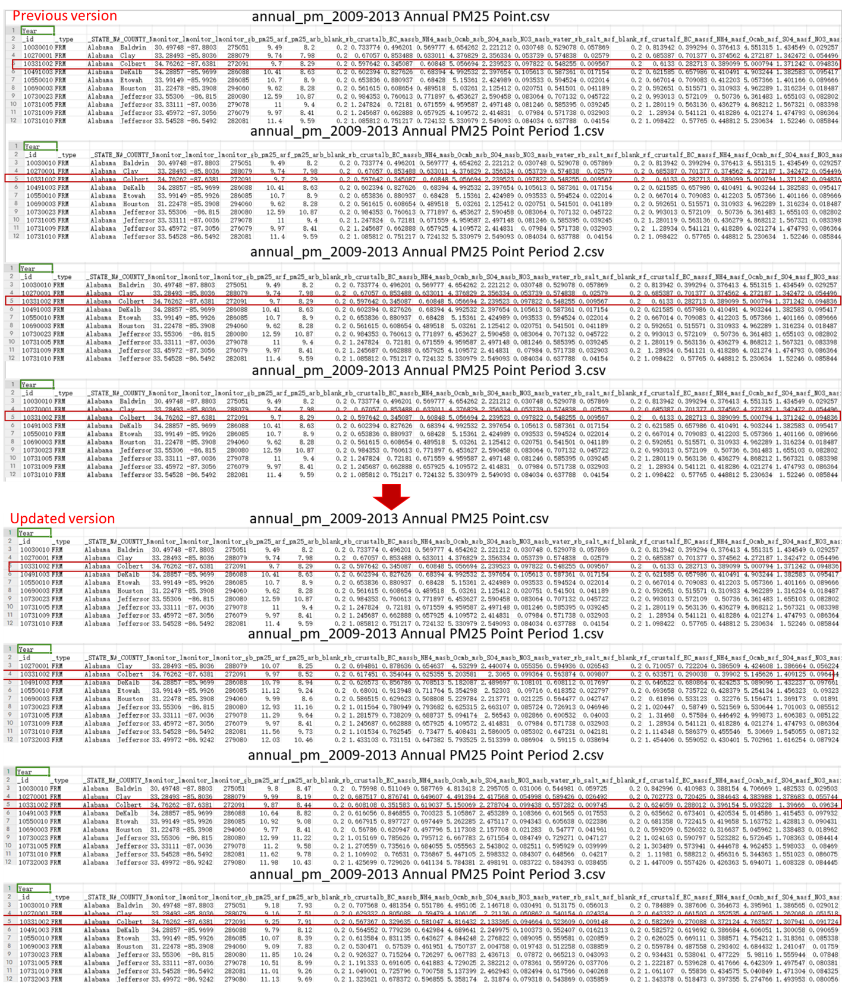
Fig. 1 The results in Annual PM25 Point and Annual PM25 Point Period X file for the default case.
Note:
- Spec Frac Point and Spec Frac Point Period x file are the same for the default case. This is because the calculations for species fractions are based on the data among the years specified under “Species Fraction Option”. In the default case, the year in "Species Fraction Option" is set to 2010-2012 while that in the "PM_{2.5} Calculation Option" is set to 2009-2013. That means the corresponding periods for Spec Frac Point Period x files are 2009-2011, 2010-2012, and 2011-2013, respectively. The periods are different but the species fraction calculations for these three periods are all based on the average data in selected 2010-2012. Therefore, the results for the same FRM sites in Spec Frac Point and Spec Frac Point Period x are identical, as indicated by the red box in the Fig. 2. More details for species fraction calculation can be refereed to Appendix A. Steps for Annual PM2.5 analysis.
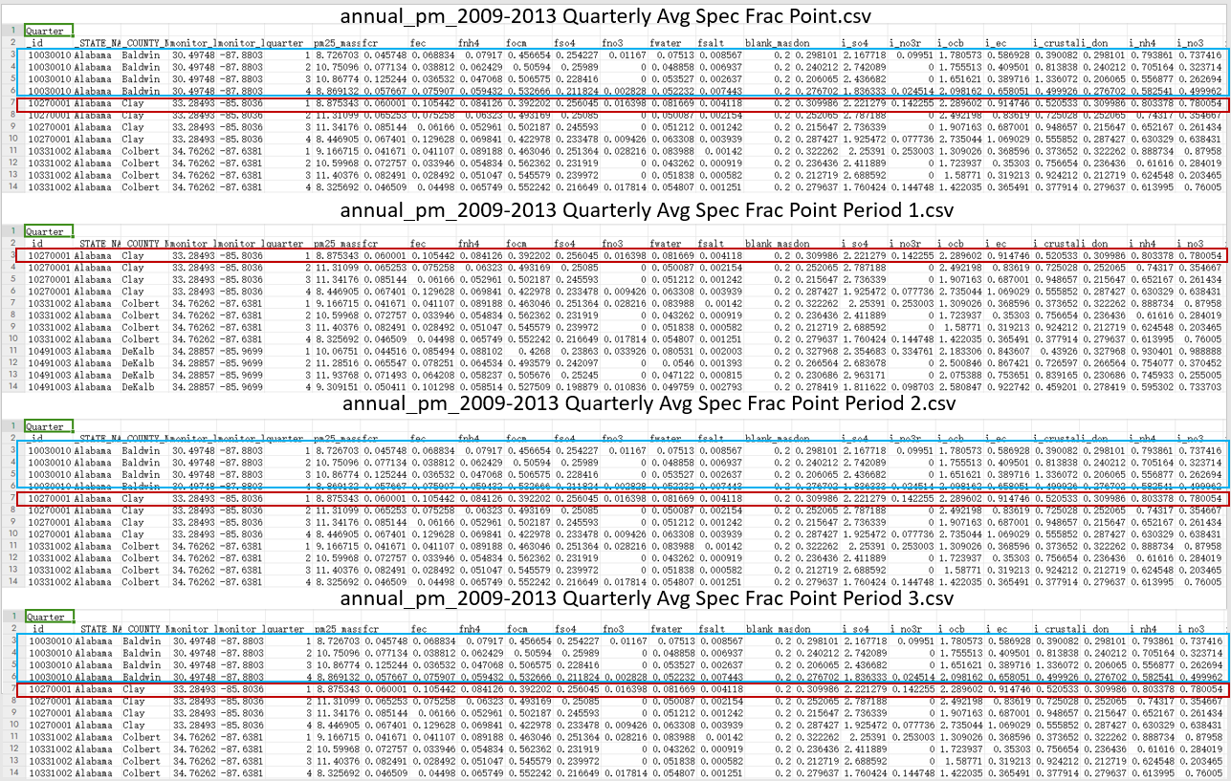
Fig. 2 The results in Spec Frac Point and Spec Frac Point Period x file
- Results in Annual PM25 Point and Annual PM25 Point Period X files are different in default case since they are using average PM_{2.5} values from different periods as baseline design values. The years used in calculating the baseline design values for Annual PM25 Point and Annual PM25 Point Period X are 2009 ~ 2013, 2009 ~ 2011 2010 ~ 2012, and 2011 ~ 2013, respectively. That means that Annual PM25 Point file uses 5-year average values while Annual PM25 Point Period X files employ consecutive 3-year average values as baseline. According to the following equation, the species and PM2.5 values vary in these files although their species fraction are the same, as shown in Fig. 3.
$${Species}_{i, Q,base} ={SpeciesFraction}_{i, Q,base}×({PM}_{2.5,Q,baseline}-BlankMass)$$
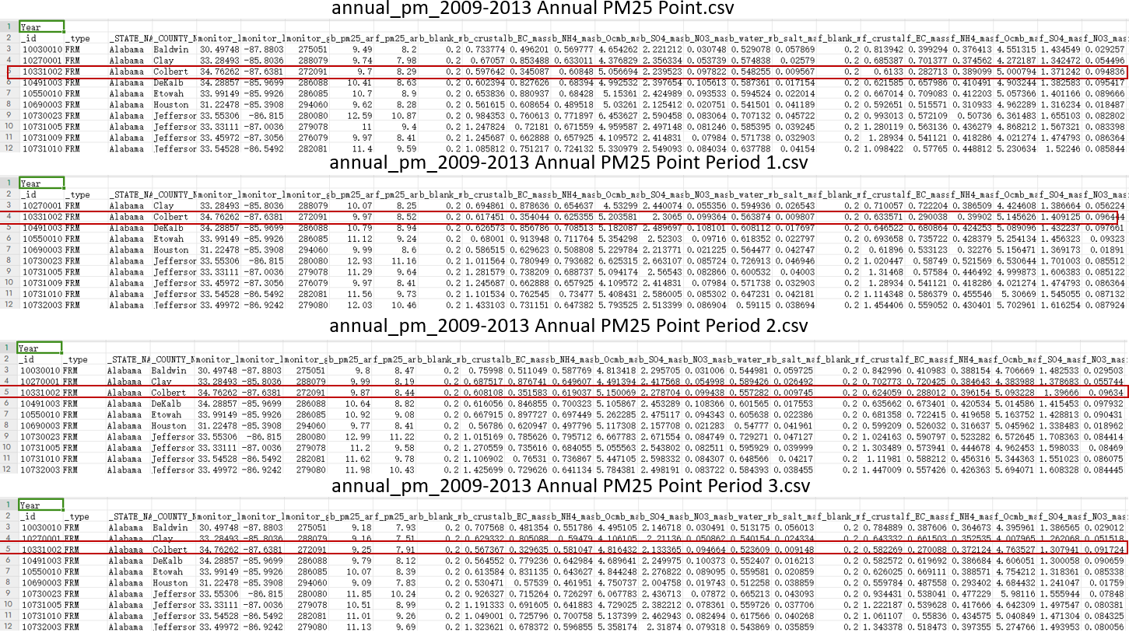
Fig. 3 The results in Annual PM25 Point and Annual PM25 Point Period X file
（3）Number of FRM sites in Annual PM25 Point and Annual PM25 Point Period X vary. This is because the program will remove those sites without data under the different specified period. as shown in Fig. 4.
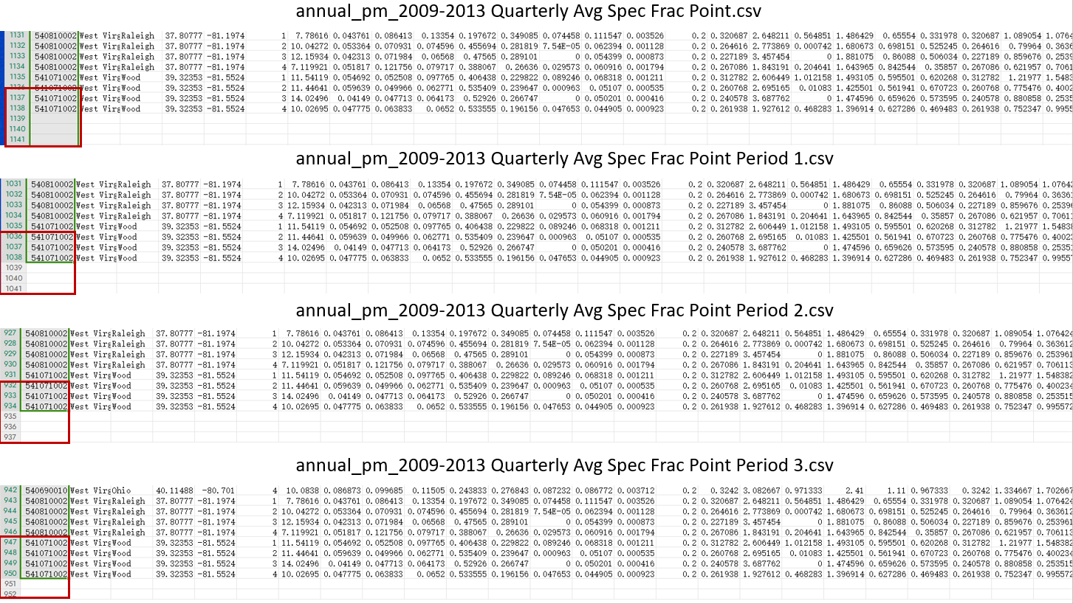
Fig. 4 The end of Spec Frac Point and Spec Frac Point Period X

Appendix A. Steps for Annual PM_{2.5} analysis

Step 1: Baseline Quarterly Average PM_{2.5} Calculation.
This step is to calculate baseline PM_{2.5} levels using the ("official") quarterly average PM_{2.5} file.
$${PM}_{2.5,Q,baseline} = \frac{\sum_{y=1}^{n}{{PM}_{2.5,Q,y}}}{n}$$
Where ${PM}_{2.5,Q,baseline}$ is the n-year quarterly average PM_{2.5} mass from official PM_{2.5} Monitor Data (e.g., official_annual-PM25_allFRM.SmatsInputs.2002thru2020.csv);
${PM}_{2.5,Q,y}$ is the quarterly PM_{2.5} mass for one year.
n is the count of start year and end year. For example, start year=2009, end year=2013 are set, then n=5. It means 5-year averages of consecutive years of data for each quarter will be used as baseline.

Step 2: Baseline Quarterly Average Species Calculation.
This step uses speciated PM_{2.5} monitor data from other monitoring networks, such as STN and IMPROVE, to estimate the PM_{2.5} attributable to the following species: sulfate (SO4), nitrate (NO₃), elemental carbon (EC), organic carbon (OC), crustal matter, particle bound water (PBW), ammonium (NH4), and, data permitting (Blank Mass), salt.
  - Calculate the quarterly interpolated species concentration at FRM sites.
$${InterpolatedSpecies}_{i, Q,base}=VNA({Species}_{i, Q,base})$$

Where ${InterpolatedSpecies}_{i, Q,base}$ is the quarterly average interpolated species (SO4, Crustal, EC, OCb, NO₃, NO₃r, salt, NH4, DON) at FRM sites;
${Species}_{i, Q,base}$ is the quarterly average measured species from species monitoring data ("Species-forfractions-xxxx.csv");
Note that NH4 and DON are interpolated from STN sites since IMPROVE sites have no data for these two species;
  - Calculate the quarterly retained NH4, PWB;
$${NH}_{4r}=\left\{\begin{aligned}DON×{SO}_{4}+0.29×{NO}_{3r} , if using measured pre-calculated DON, \\ SO4, and retained NO3 (NO3r) \\ {DON}_{calculated}×{SO}_{4}+0.29×{NO}_{3r},if using Measured Ammonium\end{aligned}\right.$$
$${DON}_{calculated}=\frac{{NH}_{4, {SO}_{4}}}{{SO}_{4}}$$
$${NH}_{4, {SO}_{4}}={NH}_{4, adjusted}-0.29×{NO}_{3r}$$
$${NH}_{4, adjusted}={NH}_{4, measured}-(PctEvap*0.29*({NO}_{3, measured}-{NO}_{3r}))$$
Where ${SO}_{4} ,{NO}_{3r}$, ${NH}_{4, measured}$, ${NO}_{3, measured}$, DON are the quarterly interpolated species from step 2.1;
$PctEvap$ refers to the percentage of ammonium associated with the volatilized nitrate that is also lost. The default assumption is that no ammonium is volatilized (0 percent).

$$PBW=\left\{\begin{aligned}\left\{\begin{aligned}595.556- 1440.584*S- \\ 1126.488*N+283.907*\left(S**1.5\right)- \\ 13.384*\left(N**1.5\right)- 1486.711*\left(A**1.5\right)+ \\ 764.229*\left(S**2\right)+1501.999*\left(N*S\right)+ \\ 451.873*\left(N**2\right)-185.183*\left(S**2.5\right)- \\ 375.984*\left(S**1.5\right)*N- 16.895*\left(S**3\right)- \\ 65.814*\left(N**1.5\right)*S+96.825*\left(N**2.5\right)+ \\ 83.037*\left(N**1.5\right)*\left(S**1.5\right)-4.419*\left(N**3\right)+ \\ 1720.818*\left(A**1.5\right)*S+ 1220.383*\left(A**1.5\right)*N- \\ 311.496*\left(A**1.5\right)*\left(S**1.5\right)+ 148.771*\left(A**1.5\right)*\left(N**1.5\right)+ \\ 1151.648*\left(A**3\right)\end{aligned}\right\}* \left(SO4+NO3r+NH4r\right) ，if DON<0.225 \\ \left\{\left.\begin{aligned} 202048.975-391494.647 *S- \\ 390912.147 *N+442.435 *\left(S**1.5\right)- \\ 155.335 *\left(N**1.5\right)-293406.827 *\left(A**1.5\right)+ \\ 189277.519 *\left(S**2\right)+ 377992.610 *N*S+ \\ 188636.790 *\left(N**2\right)-447.123 *\left(S**2.5\right)- \\ 507.157 *\left(S**1.5\right)*N- 12.794 *\left(S**3\right)+ \\ 146.221 *\left(N**1.5\right)*S+ 217.197 *\left(N**2.5\right)+ \\ 29.981 *\left(N**1.5\right)*\left(S**1.5\right)-18.649 *\left(N**3\right)+ \\ 216266.951 *\left(A**1.5\right)*S+ 215419.876 *\left(A**1.5\right)*N- \\ 621.843 *\left(A**1.5\right)*\left(S**1.5\right)+ 239.132 *\left(A**1.5\right)*\left(N**1.5\right)+ \\ 95413.122 *(A**3)\end{aligned}\right\}\right. * (SO4+NO3r+NH4r)，if DON≥0.225\end{aligned}\right.$$
$$S = SO4 / (SO4 + NO3r + NH4r)$$
$$N = NO3r / (SO4 + NO3r + NH4r)$$
$$A = NH4r / (SO4 + NO3r + NH4r)$$
Where$DON$ is the quarterly interpolated species. If NH4r calculation uses Measured Ammonium, it uses ${DON}_{calculated}$ from step 2.2 instead;
$NH4r$ is the quarterly adjusted interpolated species from step 2.2;
${SO}_{4} ,{NO}_{3r}$ are the quarterly interpolated species;

  - Calculate the Organic Carbon Mass (${OCM}_{MB}$);

$${OCM}_{MB, Initial} = NonBlankMass-\{SO4 + NO3r+ NH4r+ PBW + Crustal+ EC + \left(Salt\right)\}$$
$${OCM}_{MB, Floor} = Floor*OCb$$
$$NonBlankMass={PM}_{2.5, FractionMass}-Blank Mass$$
$${OCM}_{MB, intermediate} =Max({OCM}_{MB, Floor} ,{OCM}_{MB, Initial})$$
$${OCM}_{MB, Ceiling} =Ceiling*NonBlankMass$$
$${OCM}_{MB, Final} =Min({OCM}_{MB, intermediate} ,{OCM}_{MB, Ceiling})$$

$$Scale=\frac{ NonBlankMass-\{NH4r+ PBW +SO4 + NO3r+ Crustal+ EC+ \left(Salt\right)+{OCM}_{MB, Final}\}}{ \{NH4r+ PBW + SO4 + NO3r+ Crustal+ EC + \left(Salt\right)\}}$$
Where ${PM}_{2.5, FractionMass}$ is the quarterly average PM_{2.5} mass from unofficial Daily PM_{2.5} Monitor Data (e.g., PM25ForFractions2002to2019.csv);
$Blank Mass$typically has a value of between 0.3 and 0.5 ug/m3, which appears to result
from contamination of the FRM filter. a default blank mass value of 0.5 ug/m3 is used;
$Floor$ is a user-adjustable factor to ensure that the OCMMB does not get too small. Set to 1.0 times the interpolated value of blank-adjusted organic carbon (OCb) by default.
$Ceiling$ is a user-adjustable factor to ensure that the value of the floor by itself could not exceed the FRM total PM_{2.5} value. Set to 0.8 or 80% of PM_{2.5} mass ($NonBlankMass$) by default.
$Scale$ is the calculated factor to ensure that the sum of the species just equals the FRM PM_{2.5} value;
$SO4 , NO3r, Crustal, EC,Salt$ are the quarterly interpolated species;
$NH4r, PBW$are the quarterly adjusted interpolated species from step 2.2;

  - Calculate the final adjusted interpolated species concentration

$${InterpolatedSpecies}_{i, Q,base,adjusted}={InterpolatedSpecies}_{i, Q,base}×(1+scale)$$

Where ${InterpolatedSpecies}_{i, Q,base,adjusted}$ is the final quarterly adjusted interpolated species ($SO4 , NO3r, Crustal, EC,Salt, NH4r, PBW$); Note that $NH4r, PBW$ are the adjusted interpolated species from step 2.2;

  - Calculate the species fraction

$${SpeciesFraction}_{i, Q,base}=\frac{{InterpolatedSpecies}_{i, Q,base,adjusted}}{NonBlankMass}$$
Where ${SpeciesFraction}_{i, Q,base}$ is the baseline quarterly species fraction ($SO4 , NO3r, Crustal, EC,Salt, NH4r, PBW$, $NO3$, ${OCM}_{MB}$); Note that $NH4r, PBW$ are the adjusted interpolated species from step 2.2; Note that users are allowed to set a reusable file with species fractions for each FRM monitor under the Species Fraction option. Then the step 2.1-2.5 will be skipped.

  - Calculate the baseline quarterly species concentration at FRM sites

$${Species}_{i, Q,base} ={SpeciesFraction}_{i, Q,base}×({PM}_{2.5,Q,baseline}-BlankMass)$$
Where ${PM}_{2.5,Q,baseline}$ is the n-year quarterly average PM_{2.5} mass from official PM_{2.5} Monitor Data (e.g., official_annual-PM25_allFRM.SmatsInputs.2002thru2020.csv);
${SpeciesFraction}_{i, Q,base}$ is the baseline quarterly species fraction ($SO4 , NO3r, Crustal, EC,Salt, NH4r, PBW$, ${OCM}_{MB}$);
Note that $DON$ uses the value from Step 2.2.

Step 3: Forecasted Quarterly Average Species Calculation
3.1 Calculate the ratio of the modeled forecasted species to the modeled baseline species (called RRFs) for each quarter for each of six species: SO4, NO₃, OCM, EC,
crustal material, and (optionally) NH4.
$${RRF}_{i, Q} =\frac{{Model}_{i,Q, Future}}{{Model}_{i,Q, base}}$$
Where
${Model}_{i,Q, Future}$= Modeled forecasted species “i” average in quarter “Q”;
${Model}_{i,Q, base}$= Modeled baseline species “i” average in quarter “Q”;
${RRF}_{i, Q}$=relative response factor for a species “i” average in quarter “Q”;

3.2 Multiply the baseline weighted quarterly average for each monitor species with the ratio of the modeling data (RRFs) to get forecasted weighted quarterly average species.

${Species}_{i, Q,Future} ={Species}_{i, Q,base}×\frac{{Model}_{i,Q, Future}}{{Model}_{i,Q, base}}={Species}_{i, Q,base}×{RRF}_{i, Q}$
Where
${Species}_{i,Q, Future}$= Estimated forecasted species “i” average in quarter “Q”;
${Species}_{i,Q, base}$= Monitored baseline species “i” average in quarter “Q”;
${Model}_{i,Q, Future}$= Modeled forecasted species “i” average in quarter “Q”;
${Model}_{i,Q, base}$= Modeled baseline species “i” average in quarter “Q”;

Step 4: Forecasted Design Value Calculation
4.1 Get the estimated forecasted quarterly average PM_{2.5} level by adding all forecasted weighted quarterly averages for the species together.
$${PM}_{2.5,Q} = {SO}_{4,Q} + {NO}_{3,Q}+{OCM}_{Q} +{EC}_{Q} +{ Crustal}_{Q} + {NH}_{4, Q}+ {PBW}_{Q}$$
Where
${PM}_{2.5,Q} =$ quarterly average PM_{2.5} design value;
${SO}_{4,Q} , {NO}_{3,Q},{OCM}_{Q} ,{EC}_{Q} ,{ Crustal}_{Q} , {NH}_{4, Q}, {PBW}_{Q}$= Estimated forecasted species “i” average in quarter “Q”;

4.2 Average the four quarterly averages these forecasted quarterly average PM_{2.5}
levels to calculate forecasted design values
$${PM}_{2.5} = \sum_{Q}^{4}{\frac{{PM}_{2.5,Q}}{4}}$$
Where
${PM}_{2.5} =$ annual average PM_{2.5} design value;

