AGRICULTURAL LIVESTOCK

Source Category Description
Animal waste from livestock results in emissions of both NH₃ (ammonia) and Volatile Organic Compounds (VOCs). VOCs emitted by livestock can be defined as any compound of carbon (excluding carbon monoxide, carbon dioxide, carbonic acid, metallic carbides or carbonates, and ammonium carbonate) that may participate in atmospheric photochemical reactions and is emitted by livestock. Livestock are domesticated farm animals raised in an agricultural setting for home use or profit. The following livestock are included in the NEI: beef cattle, dairy cattle, swine, poultry (layers, broilers and turkeys), goats, horses, and sheep.
For this source category, the SCCs in Table 1 were assigned.
Table 1: Livestock Source Classification Codes
SCC | SCC Level 1 | SCC Level 2 | SCC Level 3 | SCC Level 4
2805002000 | Miscellaneous Area Sources | Agriculture Production - Livestock | Beef cattle production composite | Not Elsewhere Classified
2805018000 | Miscellaneous Area Sources | Agriculture Production - Livestock | Dairy cattle composite | Not Elsewhere Classified
2805025000 | Miscellaneous Area Sources | Agriculture Production - Livestock | Swine production composite | Not Elsewhere Classified
2805007100 | Miscellaneous Area Sources | Agriculture Production - Livestock | Poultry production - layers with dry manure management systems | Confinement
2805009100 | Miscellaneous Area Sources | Agriculture Production - Livestock | Poultry production - broilers | Confinement
2805010100 | Miscellaneous Area Sources | Agriculture Production - Livestock | Poultry production - turkeys | Confinement
2805045000 | Miscellaneous Area Sources | Agriculture Production - Livestock | Goats Waste Emissions | Not Elsewhere Classified
2805035000 | Miscellaneous Area Sources | Agriculture Production - Livestock | Horses and Ponies Waste Emissions | Not Elsewhere Classified
2805040000 | Miscellaneous Area Sources | Agriculture Production - Livestock | Sheep and Lambs Waste Emissions | Total

Overview of Calculations
The general approach to calculating NH₃ emissions due to livestock is to multiply the emission factor (in kg per year per animal) by the number of animals in the county. The state-level NH₃ emissions factors are generated using the CMU Ammonia Model [18, 102]. VOC emissions were estimated by multiplying a national VOC/NH₃ emissions ratio by the county-level NH₃ emissions. HAP emissions were estimated by multiplying the county-level VOC emissions by HAP/VOC ratios.

Activity Data
The activity data for this source category is based on livestock counts (average annual number of standing head) and population information by state and county used to develop U.S. EPA’s Greenhouse Gas Inventory [99]. This data set is derived from multiple data sets from the United States Department of Agriculture (USDA), particularly the National Agricultural Statistics Service (NASS) survey and census [100]. The USDA NASS survey dataset, which represents latest available, 2017 national livestock data, is used to obtain the livestock counts for as many counties as possible across the United States. For a full description of the GHG livestock population estimation methodology, refer to the above referenced citation for the EPA’s GHG inventory document.
Generally, counties not specifically included in the NASS survey data set (e.g., due to business confidentially reasons) were gap-filled based on the difference in the reported state total animal counts and the sum of all county-level reported animal counts. State-level data on animal counts from the GHG inventory were distributed to counties based on the proportion of animal counts in those counties from the 2012 NASS census.
$$P_{a,c,2017}=P_{a,s,2017}×r_{a,c,2012}$$
Where:
P_{a,c,2017} = Estimated population of animal type a in county c
P_{a,s,2017} = NASS survey reported state-level population of animal type a in state s
r_{a,c,2012} = Ratio of animal county- to state-level animal counts from the 2012 NASS census for animal type a in county c
.

Allocation Procedure
The USDA survey reports the livestock counts at the county level for many counties, so no allocation is necessary. The procedure for gap-filling missing county-level data using state-level data is described in section C.

Emissions Factors
CMU developed a model to estimate NH₃ emissions from livestock [18, 102]. This model produces daily-resolved, climate level emissions factors for a particular distribution of management practices for each county and animal type, as expressed as emissions/animal. These county level emissions factors are then combined together to create a state level emissions factor for each animal type. For the 2014 NEI v2, these state level emissions factors were back calculated from the CMU model using statewide emissions divided by statewide animal totals. Thus, the CMU model provides a state specific emission factor for each animal type (NH₃ emissions/head).
To develop emissions factors for the 2017 NEI, the CMU model was modified to use hourly meteorological data and two runs were performed using 2014 and 2017 meteorological data. The ratio of the 2017 to 2014 CMU model values were then applied to the 2014 back calculated state-level emissions factors to develop emissions factors for the 2017 NEI. VOC emission factors come from the ratio of NH₃ to VOC emissions in counties which provided an estimate of both pollutants in NEI 2014 v1. There were 106 counties which provided emissions for both pollutants, and the average ratio was 0.08 tons of VOC for every ton of NH₃. This ratio is multiplied by all county level NH₃ emissions in NEI 2017 to estimate VOC emissions for each county. This ratio does not vary by state or animal type.
HAP emissions were estimated by multiplying county-specific VOC emissions by speciation factors that are animal-specific as shown in Table 2 below. All of the HAP VOC fractions were obtained from EPA’s SPECIATE database [101]. As per the availability in SPECIATE, there are total of 6 VOC HAPs estimated for beef cattle, 5 VOC HAPs for dairy cattle, 4 VOC HAPs for swine, and 14 (same) VOC HAPs for layers and broilers (poultry).
Table 2: VOC speciation fractions used to estimate HAP Emissions for the Livestock Sector
SCC | Animal Type | HAP | Fraction of VOC | SPECIATE Profile Number
2805002000 | Beef Cattle | 1,4-Dichlorobenzene | 0.0013 | 95240
2805002000 | Beef Cattle | Methyl isobutyl Ketone | 0.0008 | 95240
2805002000 | Beef Cattle | Toluene | 0.0110 | 95240
2805002000 | Beef Cattle | Chlorobenzene | 0.0001 | 95240
2805002000 | Beef Cattle | Phenol | 0.0006 | 95240
2805002000 | Beef Cattle | Benzene | 0.0001 | 95240
2805007100 | Poultry---Layers | Methyl isobutyl ketone | 0.0169 | 95223
2805007100 | Poultry---Layers | Toluene | 0.0018 | 95223
2805007100 | Poultry---Layers | Phenol | 0.0024 | 95223
2805007100 | Poultry---Layers | N-hexane | 0.0111 | 95223
2805007100 | Poultry---Layers | Chloroform | 0.0025 | 95223
2805007100 | Poultry---Layers | Cresol/Cresylic Acid (mixed isomers) | 0.0048 | 95223
2805007100 | Poultry---Layers | Acetamide | 0.0075 | 95223
2805007100 | Poultry---Layers | Methanol | 0.0608 | 95223
2805007100 | Poultry---Layers | Benzene | 0.0052 | 95223
2805007100 | Poultry---Layers | Ethyl Chloride | 0.0031 | 95223
2805007100 | Poultry---Layers | Acetonitrile | 0.0088 | 95223
2805007100 | Poultry---Layers | Dichloromethane | 0.0002 | 95223
2805007100 | Poultry---Layers | Carbon Disulfide | 0.0034 | 95223
2805007100 | Poultry---Layers | 2-Methyl Napthalene | 0.0006 | 95223
2805009100 | Poultry-Broilers | Methyl isobutyl ketone | 0.0169 | 95223
2805009100 | Poultry-Broilers | Toluene | 0.0018 | 95223
2805009100 | Poultry-Broilers | Phenol | 0.0024 | 95223
2805009100 | Poultry-Broilers | N-hexane | 0.0111 | 95223
2805009100 | Poultry-Broilers | Chloroform | 0.0025 | 95223
2805009100 | Poultry-Broilers | Cresol/Cresylic Acid (mixed isomers) | 0.0048 | 95223
2805009100 | Poultry-Broilers | Acetamide | 0.0075 | 95223
2805009100 | Poultry-Broilers | Methanol | 0.0608 | 95223
2805009100 | Poultry-Broilers | Benzene | 0.0052 | 95223
2805009100 | Poultry-Broilers | Ethyl Chloride | 0.0031 | 95223
2805009100 | Poultry-Broilers | Acetonitrile | 0.0088 | 95223
2805009100 | Poultry-Broilers | Dichloromethane | 0.0002 | 95223
2805009100 | Poultry-Broilers | Carbon Disulfide | 0.0034 | 95223
2805009100 | Poultry-Broilers | 2-Methyl Napthalene | 0.0006 | 95223
2805018000 | Dairy Cattle | Toluene | 0.0018 | 8897
2805018000 | Dairy Cattle | Cresol/Cresylic Acid (mixed isomers) | 0.0276 | 8897
2805018000 | Dairy Cattle | Xylenes (mixed isomers) | 0.0046 | 8897
2805018000 | Dairy Cattle | Methanol | 0.3542 | 8897
2805018000 | Dairy Cattle | Acetaldehyde | 0.0141 | 8897
2805025000 | Swine | Toluene | 0.0047 | 95241
2805025000 | Swine | Phenol (Carbolic Acid) | 0.0179 | 95241
2805025000 | Swine | Benzene | 0.0035 | 95241
2805025000 | Swine | Acetaldehyde | 0.0155 | 95241

For the non-CMU animals (goats, sheep, horses, and turkeys), animal-specific HAP speciation profiles were not available in the literature, so the following assignments were made:
Sheep and Goats | Same HAP fractions as Dairy Cattle
Turkeys | Same HAP fractions as Chicken-Broilers
Horses | Same HAP fractions as Beef Cattle

Meteorological Data Used in Adjusting FEM Emission Factors
The source code provided for FEM model contained weather data for 2014. It did not use standard identifiers (WBAN ID) and was limited to a small number of observations with an unknown source. The FEM weather data used a single monthly value for wind, temperature, and precipitation. FEM interpolated this data to hourly using different techniques. For temperature, a standard deviation was used to raise and lower the mean temperature in the month. For wind speed, the average monthly value was used for all hours. For precipitation, monthly amounts were divided into days (an hours) based upon a parameter defining the frequency of rain in a month.
The source code was modified to accommodate a true hourly processing of the met data. For the years 2014 and 2017, ISD (Integrated Surface Database) files from NOAA were processed into a yearly-hourly data file. Individual weather station files were retrieved from ftp://ftp.ncdc.noaa.gov/pub/data/noaa for all stations in the US.
This is an automated process whereby a year and certain inclusion criteria are set (country codes, missing value limits, etc.) and a direct indexed file is created of all passing stations. In the case of FEM, all stations in the US were included with a maximum of 4000 missing hours for temperature and wind speed and a maximum of 40 consecutive hours without temperature or wind speed. The system automatically fills in missing values using linear interpolation between missing hours.
To determine the weather characteristics for the year, the county centroid is matched to the nearest weather station in the yearly-hourly file. Emissions factors are calculated using every hour of the year for the county location and the model farm types located within the county.
Animal Practice Documentation
The animal practice documentation summarizes the information provided in A. McQulling’s dissertation entitled, “Ammonia emissions from livestock in the United States: from farm-level models to a new national inventory” [102]. This work was funded by EPA grant number RD834549 [103].
Ammonia emissions from livestock depend on two major factors—the management practices employed by the producers (i.e. what housing, storage and application methods are used) and the environmental conditions of location where the farm is situated (i.e. temperatures, wind speeds, precipitation). All of these factors have significant impacts on the conditions of the manure and waste (e.g. water content, total ammoniacal nitrogen concentration) and as a result can enhance or reduce the emissions of ammonia from these sources.
The CMU model requires farm-type inputs which describe the type of animal housing, manure storage and application methods used for a particular location. Each location is expected to have some combination of practices; for example, in a single county, some of the swine farms may use deep-pit housing, lagoon storage, and irrigation application while other farms use shallow-pit housing with lagoon storage and injection application. In order to understand the differences in regional preferences for particular manure management strategies, information was extracted from the most recent National Animal Health Monitoring Surveys done by the USDA. The beef cattle NAHMS was completed in 2007 and feedlot beef in 2011; dairy cattle data was from 2002 and 2007; swine data were collected for 2006 and 2012, and the most recent poultry NAHMS was completed for 2010. The most recent data available had limited spatial resolution (compared to previous work [1], [2]), and so the model is only able to resolve large-scale regional differences in practices. For beef cow-calf systems, the United States was divided into four regions, but only two regions for beef housed on feedlots. For swine, the country was divided into three regions—Midwest, East, and South, and for layers, there were four regions—Northeast, Southeast, Central and West. An additional limitation in the data available for the characterization of the farm practices was that for some of the questions asked by the study, results were only reported in terms of percent of operations which used a particular practice. This may give too much weight to the practices used on smaller farms which have a relatively small contribution to the overall level of ammonia emissions from a particular livestock type or practice. Thus, some uncertainty is expected as a result of the limited quantity of data available regarding manure management practices throughout the country.
As was previously discussed by Pinder et al. [3], one of the factors most limiting to the FEM’s skill is the lack of information about manure managment practices throughout the country. It is unclear whether these uncertainties result in the overprediction or underprediction of total ammonia emissions from livestock in the United States.
Beef
Information regarding beef manure management practices was provided through the USDA National Animal Health Monitoring Study (NAHMS) with a regional distribution of practices. Beef data were provided for beef housed on feedlots as well as those that are a part of cow-calf systems. Cow-calf systems are those in which cattle are left on pasture or rangeland and the cows are kept with their calves, often until the calves are 1-2 years old and ready for sale. Feedlots are a much denser style of production in which large numbers of cattle are housed on concrete or packed earth lots and fed a mixture of corn and grains. Using the information from NAHMS and the animal numbers in the USDA 2012 agriculture census, the fraction of cattle in each state that were housed on feedlots as opposed those raised in a pasture-based farm system was discerned.
The distribution of manure management practices for the states included in the National Animal Health Monitoring System (NAHMS) (as split between feedlots and cow-calf systems) is based on liteature [4]–[8]. The regional distribution of cattle on feed can be seen in the Figure 1 below. There have been relatively few studies that have characterized the emissions from cow-calf or pasture-based systems in the United States, especially compared to the emissions characterization that has been done at a variety of Texas and Oklahoma feedlots. The grazing portion of the beef farm emission model is therefore less constrained and may result in the underprediction of emissions of ammonia from beef not housed on feedlots.
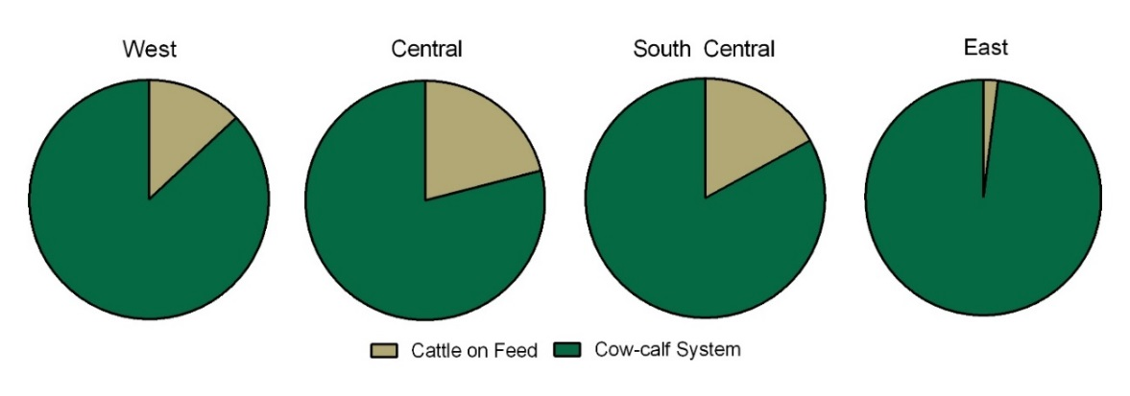
Figure 1. Regional distribution of beef cattle on feed. States in the West include: Arizona, California, Colorado, Idaho, Montana, Nevada, New Mexico, Oregon, Utah, Washington, and Wyoming. The states in the Central region are: Illinois, Indiana, Iowa, Kansas, Michigan, Minnesota, Missouri, Nebraska, North Dakota, South Dakota, and Wisconsin. Texas and Oklahoma are in the South Central region. The remaining states are in the East.
Based on the information provided by NAHMS and the USDA Agricultural census, two manure managment trains (MMTs) are considered. The first is an all grazing system where emissions are affected by the rate of manure infiltration and directly exposed to the elements (temperature, windspeed, precipitation). The alternative is a feedlot system with solid manure storage and broadcast application.
Dairy
The distribution of practices used in dairy cattle is unlikely to have changed substantially in the years following the work of Pinder et al. [1], [2], as seen when comparing the two most recent NAHMS results (from 2002 and 2007) to the 1996 NAHMS data used in the cited work. However, the data available for the 2002 and 2007 NAHMS was less regionally specific than was used in the previous work [9]–[13]. The manure management practice information received at that time included state-specific data, something not available for the current study years. Addtionally, storage and application data for 2002 and 2007 was only available by fraction of surveyed operations rather than by population which may give too much weight to practices employed primarily at smaller dairy farms. Manure management practices can be described regionally as either in the West or East; the distribution of practices is shown below in Figure 2a-b.
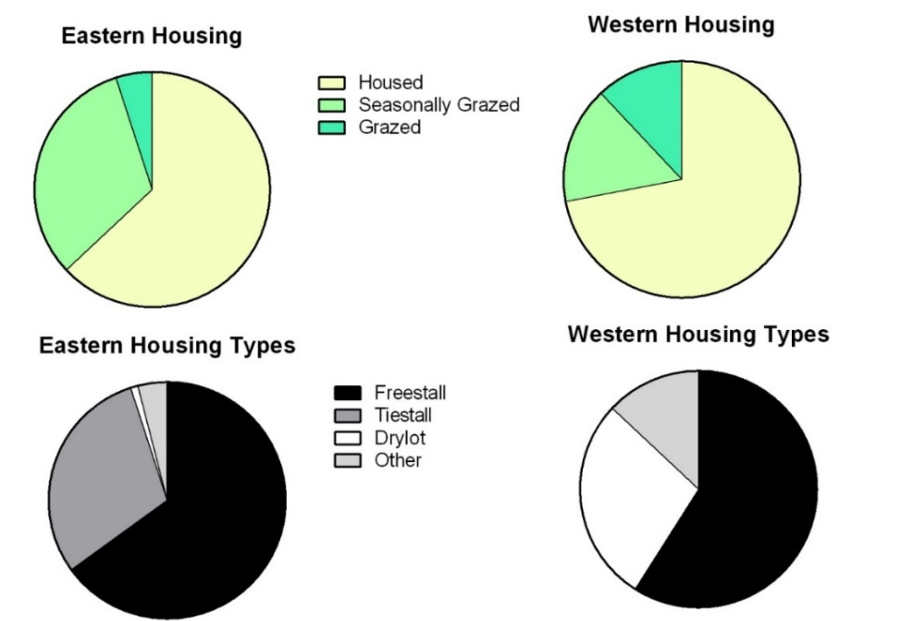
Figure 2a: Regional distribution of dairy housing practices from 2007 NAHMS for Eastern and Western United States. Eastern States include Minnesota, Iowa, Missouri, Arkansas, Louisiana and eastward. Western states are the rest of the continental US.
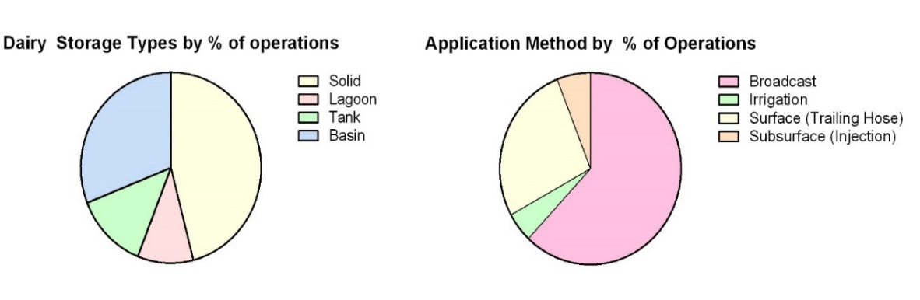
Figure 2b: Distribution of storage and application practices across the US. Regionally separated data was not available from the 2007 NAHMS, and results are presented in terms of percent of farming operations rather than percent of animal population, which may lead to over representation of minor practices.
Swine
There is significant regional variability in the housing types and manure management practices (in terms of storage and application) for swine production in the United States. Some of the management choices made are the result of meteorological limitations (i.e. deep-pit versus shallow-pit housing) while others are chosen for economic reasons (less expensive to use irrigation application rather than injection).
Using the information provided by NAHMS, regional distributions of management practices can be described [14]–[17]. The United States can be broken into three regions based on this data: the South, the Midwest, and the East. Each of these groups of states has a unique distribution of housing, storage, and application practices, seen in Figure 3.
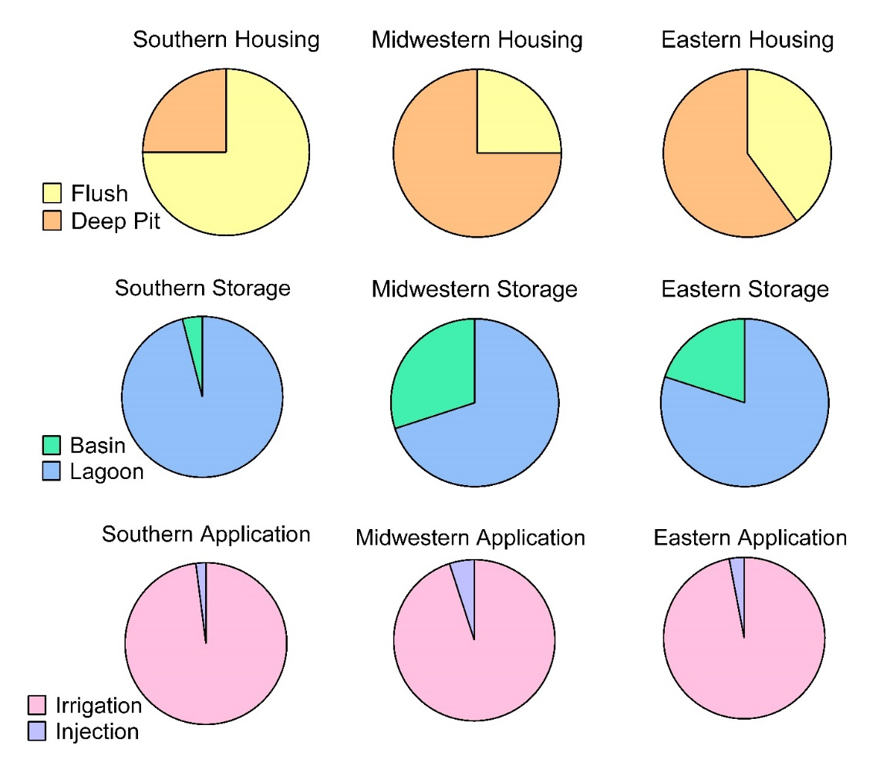
Figure 3: Regional Distribution of swine manure management practices. The Midwest includes: Idaho, Iowa, Minnesota, Montana, North Dakota, Nebraska, South Dakota, Wisconsin and Wyoming. The Eastern states include Connecticut, Delaware, Illinois, Indiana, Maine, Maryland, Massachusetts, Michigan, New Hampshire, New Jersey, New York, Ohio, Pennsylvania, Rhode Island, and Vermont. The remainder of the states are included in the Southern region.
Poultry
Broilers
The major differences in broiler chicken production occur not in terms of farm type, but in the frequency with which barns are entirely cleaned out of their litter material; literature suggests that barns that are cleaned out more frequently have lower emissions than those in which litter material is built up and reused [19]–[22]. Additional factors that may alter the emissions from these facilities include what the bedding or litter material is made up of as well as how long each barn stays empty between flocks. There is not sufficient data to include either bedding material or the time between flocks within the emissions inventory. In fact, much of the variability that might be caused by these factors on a single farm will likely be averaged out as a result of short lifecycle of these birds, which take less than two months to reach market size. Additionally, pasture-raised or organic practices are not included as they make up a very small fraction of total bird population and the emissions from these farms has not been characterized in the literature. The limited data available regarding manure storage and application from broiler housing may result in the underestimation of ammonia emissions from this animal type.
Layers
There are two major housing types used in the production of layer chickens in the United States. These are high-rise layer houses and manure-belt layer houses. The chief difference between these two housing types is the frequency with which manure is removed; in high-rise barns, manure is removed 1-2 times each year, while manure is removed on a daily or weekly basis from manure-belt barns, which results in lower housing emissions and ammonia concentrations but leaves greater quantities in the manure that is headed toward storage and application or processing. High-rise housing operations are more prevalent than manure-belt houses throughout the United States (Figure 4), but manure-belt are somewhat more common in the western and central portions of the United States. There are some limitations on the abiility of the FEM for both the storage and application of poultry manure as there have been few studies to characterize these emissions. The majority of ammonia emissions from poultry are expected to be from housing (particularly for high-rise facilities).
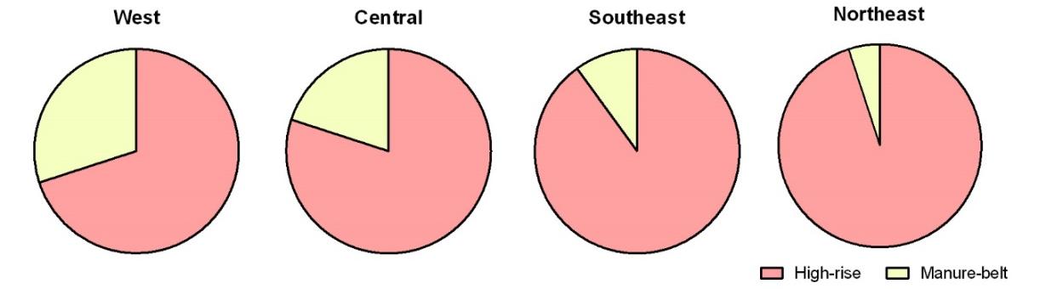

Figure 4. Regional distribution of layer housing types. The West includes: Arizona, California, Colorado, Idaho, Montana, Nevada, New Mexico, Oklahoma, Oregon, Texas, Utah, Washington, and Wyoming. The Central states are: Arkansas, Illinois, Indiana, Iowa, Kansas, Minnesota, Missouri, Nebraska, North Dakota, Ohio, South Dakota, and Wisconsin. Southeastern states are: Alabama, Florida, Georgia, Kentucky, Louisiana, Mississippi, North Carolina, South Carolina, Tennessee, Virginia, West Virginia. The remaining states are considered to be in the Northeast.
Additionally, the most recent NAHMS information does not capture the more recent trend towards cage-free housing or pasture-raised layer chickens [23]–[25]. Cage-free housing is a relatively minor housing practice currently (<10% of all layer chickens are raised on cage free farms, but state-specific data is unavailable so this may vary significantly by state, and this may not represent a similar fraction of total eggs produced), but is poised to grow as a result of concerns about animal health and welfare and the demand for cage-free eggs increases. According to the most recently completed NAHMS, cage-free production occurs at approximately 3% of large layer operations (more than 100,000 layers), and approximately one-quarter of smaller farms. The data provided by NAHMS does not specify the fractions of total layer populations raised at particular farm sizes, but large farms have become increasingly common and it is expected that most eggs are produced from larger farms [25]. Cage-free and organic products are more likely to come from smaller farms whose emissions have not been well-characterized in the literature. Cage-free production is more common in Europe than the United States, so emissions studies from Europe could be used to better characterize cage-free housing emissions [26]–[28].
Model Parameters
The FEM is a tuned-model that applies adjustments to approximate observed data. However, the model evaluation does not reflect the ability of the FEM to predict completely independent measurements but the ability of a relatively simple process-based model, with a single set of mass transfer parameters for each manure management practice, to describe the full range of observed variability.
The NAEMS data and literature data are displayed in Figure 5 below. The range of temperatures studied is most extended for layer hens. With the additional NAEMS data, an apparent inverse relationship between temperature and ammonia emissions is observed, something that was not clear in the prior literature. It has been suggested that this inverse relationship (higher emissions factors for lower temperatures) is related to the drying out of manure in hot barns with high ventilation rates [30]. At lower temperatures, barn ventilation is reduced (to conserve heat) and manure dries slowly, and, therefore more manure urea can be broken down into ammonia, which is then available for volatilization. Additionally, for some practices, particularly for swine storage, emissions factors from NAEMS were uniformly higher than those previously reported in the literature, for both high and low temperatures. As a result of these differences, the FEM’s tuned parameters were adjusted so that model emission factors fell between NAEMS and literature data, weighting the literature studies equally with the NAEMS observations so as not to over-tune to only the literature or NAEMS data. There is significant value in both previously published studies as well as in the values reported by NAEMS, so the re-tuning done is to ensure that this work takes advantage of all available data.
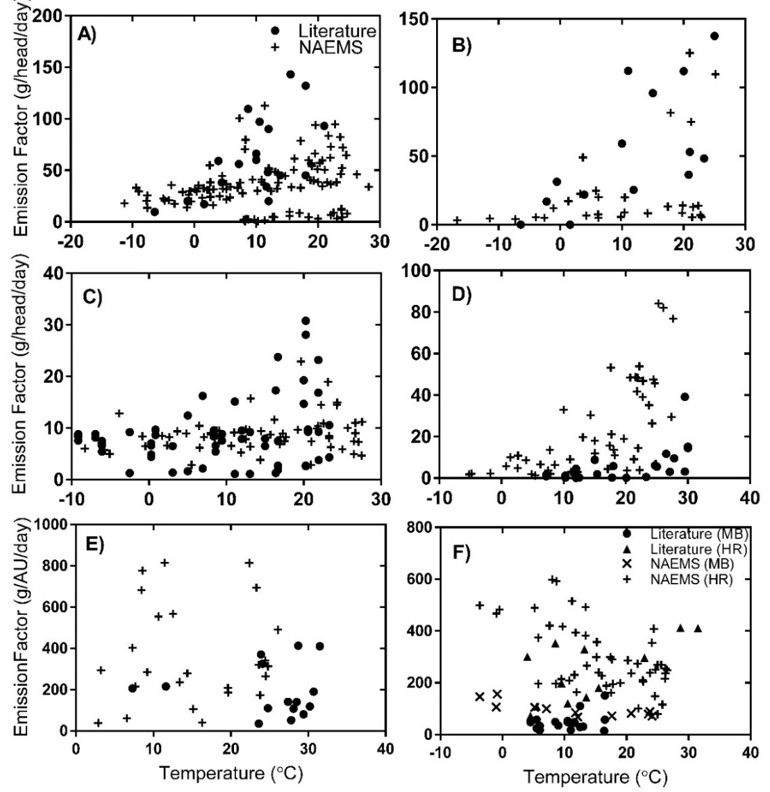
Figure 5: Emission factors as a function of temperature reported in the prior literature and from the National Air Emissions Monitoring Study (NAEMS). Results are displayed by animal type and management stage as follows: a) free-stall dairy housing emissions, b) dairy lagoon storage emissions, c) deep-pit and flush-type swine housing emissions, d) swine lagoon and basin storage emissions, e) litter-based broiler housing emissions, and f) manure-belt (MB) and high-rise (HR) layer housing emissions. (1 AU = animal unit = 500 kg live animal weight)
Manure characteristics
Manure characteristics are important input parameters to the model because they govern the amount of nitrogen available for emission, whether or not the nitrogen present is likely to be volatilized, and how well the waste can infiltrate into the soil during manure application. These parameters have been selected based on information extracted from published literature as well as reports from the National Air Emissions Monitoring study. Table 3 describes the types of parameters and inputs critical to the model and Table 4 presents information about manure volume, nitrogen concentration and pH levels in the waste from each type of animal included in the model.
Table 3. Description and sources of model inputs and parameters
Data Type | Description | Source of input or parameter | Input or Tuned Parameter?
Meteorology | Temperature (°C)  Wind speed (m/s)  Precipitation | From National Climate Data Center, based on farm location | Input value (monthly average for seasonal emissions, daily values for daily model run)
Manure Management Practice | Type of housing, storage, or application | Unique to each farm type; farm types have a unique set of inputs | Input value
Resistance Parameters | Surface mass transfer resistance from manure to atmosphere | Tuned based on literature and NAEMS observations to agree with previous work; constant for a particular management practice (for a particular animal type) | Tuned Parameters

Table 4. Model Input parameters related to manure characteristics
Parameter Name | Animal Type | Range of Values | Value Used in Model | Units | Source
Manure Volume | Beef | 12-17 | 15 | l animal⁻¹ day⁻¹ | [2], [31]
Manure Volume | Dairy |  |  | l animal⁻¹ day⁻¹ | [2]
Manure Volume | Swine | 4-10 | 6 | l animal⁻¹ day⁻¹ | [32]
Manure Volume | Poultry-Layer | 0.088 | 0.088 | l animal⁻¹ day⁻¹ | [33], [34]
Manure Volume | Poultry-Broiler | 4.9 | 4.9 | l finished animal⁻¹ | [33]
Manure Urea Concentration | Beef | 47-70 |  | kg N animal⁻¹ year⁻¹ | [33]
Manure Urea Concentration | Dairy |  |  | kg N animal⁻¹ year⁻¹ | [2]
Manure Urea Concentration | Swine | 11-35 |  | kg N animal⁻¹ year⁻¹ | [34], [35]
Manure Urea Concentration | Poultry-Layer | 0.5-0.6 | 0.55 | kg N animal⁻¹ year⁻¹ | [33]
Manure Urea Concentration | Poultry-Broiler | 0.05-0.06 | 0.055 | kg N finished animal⁻¹ | [33]
Housing pH | Beef | 7.7 | 7.7 |  | [36]
Housing pH | Dairy | 7.5-8.3 | 7.7 |  | [2]
Housing pH | Swine | 6.5-7.5 | 7 |  | [37]
Housing pH | Poultry-Layer | 7.1-7.6 (MB); 8.4-8.7 | 7.3 |  | [38],[39]
Housing pH | Poultry-Broiler | 8 | 8 |  | [40]
Storage pH | Dairy | 7.0-8.0 | 7.5 |  | [1]
Storage pH | Swine | 7.5-8 | 7.7 |  | [35]
Application pH | Beef | 7.5 | 7.5 |  | [41]
Application pH | Dairy | 7.0-7.7 | 7.3 |  | [2]
Application pH | Swine | 7.8-8.2 | 8 |  | [42]
Application pH | Poultry-Layer | 7.2 | 7.2 |  | [43]
Application pH | Poultry-Broiler | 8.8 | 8.8 |  | [44]
Storage pH | Beef | 7.7 | 7.7 |  | [2]
Storage pH | Dairy | 7.5-8.3 | 7.7 |  | [2]

There are a limited number of studies which describe the manure nitrogen and manure pH for each animal type. As a result there is considerable uncertainty in these input values which can result in significant uncertainty in predicted emissions from the model.

Tunable parameters
The FEM is a balance between an empirical approach and first-principles process-based model. A nitrogen mass balance and a process description of ammonia losses are used, but the FEM model parameters are tuned to reproduce measured emissions factors. Model complexity is limited to the most important emissions processes and to inputs that are typically available. The strategy pursued for developing process-based models is guided by the need to build emissions inventories, and the requirements and data limitations associated with this application. Previous measurement campaigns also often sampled emissions from a single part of the production process. This means that information about the emissions process from the start to end of production might be lacking, making nitrogen mass balance in the system difficult. The lack of whole-farm measurements is one gap in much of the literature available and a benefit of the estimates of ammonia emissions produced by the FEM.
There are 2-3 tunable parameters associated with each submodel in the farm emissions model. These tunable parameters allow adjustment of model-predicted emissions and to correct for the unknowns and uncertainties of the input parameters and to ensure that the model-predicted values are consistent with those that have been reported in the literature and in the National Air Emissions monitoring study; they are constant for a particular farm type—tuning is not done for a particular farm—and as a result, there can be significant disagreement between model predictions and the measured emissions for a single farm. The goal of the FEM is not necessarily to capture the emissions of single farms perfectly, but rather to capture the effects of various parameters on emissions on a farm typical of a certain set of practices.
In the FEM, as previously described [29], [45], [46], ammonia emissions are estimated as a function of the nitrogen present in the waste and the mass transfer resistance. This resistance is made up of the following three parts: the aerodynamic (r_{a}), quasi-laminar (r_{b}), and surface resistances (r_{s}) [47]. Aerodynamic and quasi-laminar resistances are used to describe the resistance to transport in the gaseous layer above the animal wastes [45], [48], [49]. These parameters are based on widely used theoretical formulas and are not tuned. The third part of the resistance is the surface resistance from diffusion closest to the gas-liquid (manure) interface. Here, the surface resistance is a function of tuned parameters as well as temperature which ensures the modeled ammonia emission factors are consistent with observations; Table 5 lists which tunable parameters are used for each animal and each submodel.
These values are specific to a particular practice for a particular animal type. This means that a free stall dairy with lagoon storage and injection application would employ the same tuned parameters whether it was located in New York or California. Conversely, two farms in the same location but utilizing different manure management practices would have different tuned parameters in their submodels. The values that have been used for each of these parameters can be found in Table 6.

Table 5. Tuned model parameters for beef, swine, and poultry
Submodel | Animal Type | Description | Tuning/Evaluation Sources
Housing | Cattle: Beef & Dairy  Swine  Poultry: Broiler & Layer | Resistance parameters H₁, H₂ | [50]–[67], [68]–[72], [73]–[78], [79]–[84]
Storage | Dairy Cattle  Swine | Resistance parameters S₁, S₂ | [85]–[90]
Application | Cattle: Beef & Dairy  Swine  Poultry: Broiler & Layer | Resistance parameters A₁,A₂, A₃ | [91], [92], [93]–[95], [96], [97]
Grazing | Cattle: Dairy & Beef | Resistance parameters G₁, G₂ | [98]

Table 6. Tuned Parameter Values by practice and animal type
Submodel | Animal Type | Description | Parameter Values
Housing | Beef cattle | Beef Feedlot | H,=0.1 (s•m⁻¹•°C⁻¹), H₂=-0.01 (s²m⁻²)
Housing | Swine | Swine—shallow pit | H,=0.08(s•m⁻¹⁾, H₂=-0.004(s•m⁻¹•°C⁻¹)
Housing |  | Swine—deep pit | H,=0.1(s•m⁻¹), H₂=-0.008(s•m⁻¹•°C⁻¹)
Housing | Poultry-Layer | Layer—Manure belt | H,=0.3(s•m⁻¹), H₂=-0.015(s•m⁻¹•°C⁻¹)
Housing |  | Layer—High Rise | H,=0.22(s•m⁻¹), H₂=-0.02(s•m⁻¹•°C⁻¹)
Housing | Poultry-Broiler | Broiler | H,=0.15(s•m⁻¹), H₂=-0.035(s•m⁻¹•°C⁻¹)
Storage | Swine | Swine lagoon | S₁=0.20(s•m⁻¹), S₂=4.00(s•m⁻¹•°C⁻¹)
Storage | Swine | Swine basin | S₁=0.11(s•m⁻¹), S₂=2.24(s•m⁻¹•°C⁻¹)
Application | Beef cattle | Beef—broadcast | A,=0.0004, (s•m⁻¹)A₂ =0.88, A₃=-1.4
Application | Swine | Swine—irrigation | A,=0.001(s•m⁻¹), A₂ =-10, A₃=20
Application |  | Swine—injection | A,=0.01(s•m⁻¹), A₂ =-15, A₃=40
Grazing | Beef Cattle | Beef Pasture | G,= 0.12(s•m⁻¹), G₂=5.4

Controls
There are no controls assumed for this category.

Emissions
Back Calculating the 2014 NH₃ Emissions Factors from the CMU Model
The emissions estimates in NEI 2014 v1 came from the CMU model. These emissions were then divided by the model’s animal population figures to estimate the statewide NH₃ emission factor.

$${EF}_{s,a,2014}=E_{s,a,2014}÷ A_{s,a,2014}$$

Where:
EF_{s,a,2014} = 2014 NH₃ emissions factor from the CMU model for animal type a and state s (kg/head)
E_{s,a,2014} = 2014 NH3 emissions from the CMU model for animal type a and state s (kg)
A_{s,a2014} = 2014 animal count for animal type a and state s (head)

Calculating the 2017 NH₃ Emissions Factors
The 2017 NH₃ emissions factors are estimated by multiplying the NH₃ emissions factors from the 2014 NEI CMU model run with the ratio of the 2017 to 2014 CMU model runs performed with the updated hourly metrological data.

$${EF}_{s,a,2017}={EF}_{s,a,2014}× {EF}_{CMU,s,a,2017}÷{EF}_{CMU,s,a,2014}$$

Where:
EF_{s,a,2017} = 2017 NH₃ emissions factor for animal type a and state s (kg/head)
EF_{s,a,2014} = 2014 NH₃ emissions factor from the 2014 NEI CMU model run for animal type a and state s (kg/head)
E_{CMU},_{s,a,2017} = 2017 NH₃ emissions factor from the 2017 CMU model run for animal type a and state s (kg/head)
E_{CMU},_{s,a,2014} = 2014 NH₃ emissions factor from the updated 2014 CMU model run for animal type a and state s (kg/head)

Calculating 2017NH₃ Emissions due to Livestock
Emissions are calculated by multiplying the state specific NH₃ emission factor (in NH₃/head) by the number of animals in a given county in that state.
$$E_{c,a,2017}={EF}_{s,a,2017}× A_{c,a,2017} ×2.2/2000$$

Where:
E_{c,a,2017} = 2017 NH₃ emissions for animal type a and county c (ton)
EF_{s,a,2017} = 2017 NH₃ emissions factor for animal type a and state s in which the county is located (kg/head)
A_{c,a,2017} = 2017 animal count for animal type a and state s (head)
2.2/2000 = conversion factor from kg to tons

Calculating 2017 VOC Emissions due to Livestock
VOC emissions are calculated using the ratio of VOC to NH₃ emissions from livestock. That ratio is 0.08 kg of VOC for every kg of NH₃.
$$E_{VOC,c,a,2017}=V{OC/NH}_{3}× E_{c,a,2017}$$

Where:
E_{VOC,c,a,2017} = 2017 VOC emissions for animal type a and county c (ton)
VOC/NH₃ = 0.08
E_{c,a,2017} = 2017 NH₃ emissions for animal type a and county c (ton)

Calculating 2017 HAP Emissions due to Livestock
HAP emissions are calculated using the ratio of HAP to VOC emissions from livestock. These ratios are derived from the SPECIATE database as discussed above in Section E.
$$E_{HAP,c,a,2017}=\frac{HAP}{VOC}× E_{VOC,c,a,2017} ×2000$$

Where:
E_{HAP,c,a,2017} = 2017 HAP emissions for animal type a and county c (lb)
HAP/VOC = speciation factor derived from the SPECIATE database and listed in Table 2
E_{VOC,c,a,2017} = 2017 VOC emissions for animal type a and county c (ton)
2000 = conversion factor from tons to pounds

Alaska and Hawaii
The CMU model does not cover Alaska or Hawaii (only the lower 48 states); however, the animal counts database does have values for Alaska and Hawaii. To estimate NH₃ (and other pollutant) emissions for Alaska and Hawaii, the state-level emissions factors from Idaho were used as a surrogate for Alaska and state-level emissions factors from Florida were used as a surrogate for Hawaii.

Point Source Subtraction
There are no point source-specific SCCs for livestock; therefore point source subtraction is not performed for this category.

Sample Calculations
Table 7 lists sample calculations to determine NH3, VOC and Toluene emissions from swine production in Cochise County, Arizona.
Table 7. Sample Calculations for NH3, VOC and Toluene emissions from swine in Cochise County, AZ.
Eq. # | Equation | Values for Cochise County, AZ | Result
2 | $${EF}_{s,a,2014}=E_{s,a,2014}÷ A_{s,a,2014}$$ | $=9,370 kg {NH}_{3} ÷ 925$ swine | 10.13 kg NH₃ per head of swine in Cochise County in 2014
3 | $${EF}_{s,a,2017}={EF}_{s,a,2014}× {EF}_{CMU,s,a,2017}÷{EF}_{CMU,s,a,2014}$$ | $$=10.13 kg {NH}_{3} per swine×1.019159$$ | 10.32 kg NH₃ per head of swine in Cochise County in 2017
4 | $$E_{c,a,2017}={EF}_{s,a,2017}× A_{c,a,2017} ×2.2/2000$$ | $$=10.32 kg {NH}_{3}× 30,693 swine ×2.2 /2000$$ | 348.6 tons of NH₃ emissions from swine in Cochise County in 2017
5 | $$E_{VOC,c,a,2017}=V{OC/NH}_{3}× E_{c,a,2017}$$ | $=0.08× 348.6$ tons of NH₃ | 27.89 tons of VOC emissions from swine in Cochise County in 2017
6 | $$E_{HAP,c,a,2017}=\frac{HAP}{VOC}× E_{VOC,c,a,2017} ×2000$$ | $$=0.0047× 27.89 tons VOC ×2000$$ | 262.1 lb of toluene from swine in Cochise County in 2017

Changes from 2014 Methodology
The methodology for estimating county-level animal counts is based on the U.S. EPA’s Greenhouse Gas Inventory. This data set is derived from multiple data sets from the United States Department of Agriculture (USDA), particularly the National Agricultural Statistics Service (NASS) survey and census. In addition, the NH₃ emissions factors were updated to 2017 by growing 2014 emissions factors based on the ratio of 2017 to 2014 emission rates from CMU model runs with updated 2014 and 2017 hourly meteorological data from NOAA.

Puerto Rico and U.S. Virgin Islands Emissions Calculations
Due to the lack of animal counts in Puerto Rico and the U.S. Virgin Islands, emissions are not estimated for these territories.

References

[1] R. W. Pinder, N. J. Pekney, C. I. Davidson, and P. J. Adams, “A process-based model of ammonia emissions from dairy cows: improved temporal and spatial resolution,” Atmos. Environ., vol. 38, no. 9, pp. 1357–1365, Mar. 2004.
[2] R. W. Pinder, R. Strader, C. I. Davidson, and P. J. Adams, “A temporally and spatially resolved ammonia emission inventory for dairy cows in the United States,” Atmos. Environ., vol. 38, no. 23, pp. 3747–3756, Jul. 2004.
[3] R. W. Pinder, P. J. Adams, S. N. Pandis, and A. B. Gilliland, “Temporally resolved ammonia emission inventories: Current estimates, evaluation tools, and measurement needs,” J. Geophys. Res. Atmospheres, vol. 111, no. D16, p. D16310, Aug. 2006.
[4] USDA-APHIS, “Feedlot 2011 -- Part I: Management Practices on US Feedlots with a Capacity of 1000 or More Head,” 2013.
[5] USDA-APHIS, “Feedlot 2011 -- Part II: Management Practices on US Feedlots with a capacity of Fewer than 1000 Head,” 2013.
[6] USDA-APHIS, “Beef 2007-2008 -- Part I: Reference of Beef Cow-calf Management Practices in the United States, 2007-08,” 2009.
[7] USDA-APHIS, “Beef 2007-2008-- Part II: Reference of Beef Cow-calf Management Practices in the United States, 2007-08,” 2009.
[8] USDA-APHIS, “Beef 2007-08 -- Part III: Changes in the US Beef Cow-calf Industry, 1993-2008,” 2009.
[9] USDA-APHIS, “Dairy 2007-- Part V: Changes in Dairy Cattle Health and Management Practices in the United States, 1996-2007,” 2007.
[10] USDA-APHIS, “Dairy 2007-- Part III: Reference of Dairy Cattle Health and Management Practices in the United States, 2007,” 2007.
[11] USDA-APHIS, “Dairy 2007-- Part II: Changes in the US Dairy Cattle Industry, 1991-2007,” 2007.
[12] USDA-APHIS, “Dairy 2002-- Part II: Changes in the United States Dairy Industry, 1991-2002,” 2002.
[13] USDA-APHIS, “Dairy 2002-- Part 1: Reference of Dairy Health and Management in the United States, 2002,” 2002.
[14] USDA-APHIS, “Swine 2006 -- Part I: Reference of Swine Health and Management Practices in the United States, 2006,” 2007.
[15] USDA-APHIS, “Swine 2006 -- Part II: Reference of Swine Health and Health Management Practices in the United States, 2006,” 2008.
[16] USDA-APHIS, “Swine 2006 -- Part III: Reference of Swine Health, Productivity, and General Management in the United States, 2006,” 2008.
[17] USDA-APHIS, “Swine 2006 -- Part IV: Changes in the US Pork Industry, 1990-2006,” 2008.
[18] A. M. McQuilling and P. J. Adams, “Semi-empirical process-based models for ammonia emissions from beef, swine, and poultry operations in the United States,” Atmos. Environ., vol. 120, pp. 127–136, Nov. 2015.
[19] USDA-APHIS, “Poultry ’04 -- Part II: Reference of Health and Management of Gamefowl Breeder Flocks in the United States, 2004,” 2005.
[20] USDA-APHIS, “Poultry ’04 -- Part III: Reference of Management Practices in Live-Poultry Markets in the United States, 2004,” 2005.
[21] USDA-APHIS, “Poultry 2010 -- Reference of Health and Management Practices on Breeder Chicken Farms in the United States, 2010,” 2005.
[22] USDA-APHIS, “Poultry 2010: Structure of the US Poultry Industry, 2010,” 2011.
[23] USDA-APHIS, “Part II: Reference of 1999 Table Egg Layer Management in the US,” 2000.
[24] USDA-APHIS, “Layers 2013--Part 1: Reference of Health and Management Practices on Table-Egg Farms in the United States 2013,” 2014.
[25] USDA-APHIS, “Layers 2013 -- Part III: Trends in Health and Management Practices on Table-Egg Farms in the United States, 1999-2013,” 2014.
[26] T. Shepherd, Y. Zhao, H. Li, J. Stinn, M. Hayes, and H. Xin, “Environmental assessment of three egg production systems--Part II. Ammonia, greenhouse gas, and particulate matter emissions,” Poult. Sci., vol. 94 (3), pp. 534–543, 2015.
[27] D. Charles, “Most U.S. Egg Producers Are Now Choosing Cage-Free Houses,” the salt (NPR), 2016. [Online]. Available: http://www.npr.org/sections/thesalt/2016/01/15/463190984/most-new-hen-houses-are-now-cage-free.
[28] Y. Zhao, T. Shepherd, H. Li, and H. Xin, “Environmental assessment of three egg production systems--Part I: Monitoring system and indoor air quality,” Poult. Sci., vol. 94 (3), pp. 518–533, 2015.
[29] A. M. McQuilling and P. J. Adams, “Semi-empirical process-based models for ammonia emissions from beef, swine, and poultry operations in the United States,” Atmos. Environ., vol. 120, pp. 127–136, Nov. 2015.
[30] R. Morgan, D. Wood, and B. Van Heyst, “The development of seasonal emission factors from a Canadian commercial laying hen facility,” Atmos. Environ., vol. 86, pp. 1–8, 2014.
[31] H. Van Horn, “Factors affecting manure quantity, quality, and use,” in Texas Animal Nutrition Council, Texas, USA, 1998.
[32] J. P. Chastain, J. J. Camberato, J. E. Albrecht, and J. Adams, “Swine Manure Production and Nutrient Content.” .
[33] ASAE, “ASAE D384.1 FEB03: Manure Production and Characteristics,” 01-Feb-2003. [Online]. Available: http://large.stanford.edu/publications/coal/references/docs/ASAEStandard.pdf. [Accessed: 10-Oct-2016].
[34] A. D. Visscher et al., “Ammonia Emissions from Anaerobic Swine Lagoons: Model Development,” J. Appl. Meteorol., vol. 41, no. 4, pp. 426–433, Apr. 2002.
[35] J. Arogo, P. W. Westerman, and A. J. Heber, “A Review of Ammonia Emissions from Confined Swine Feeding Operations,” Trans. ASAE, vol. 46, no. 3, 2003.
[36] N. A. Cole, A. M. Mason, R. W. Todd, M. Rhoades, and D. B. Parker, “Chemical Composition of Pen Surface Layers of Beef Cattle Feedyards1,” Prof. Anim. Sci., vol. 25, no. 5, pp. 541–552, Oct. 2009.
[37] T.-T. Lim, A. J. Heber, J.-Q. Ni, D. C. Kendall, and B. R. Richert, “Effects of Manure Removal Strategies on Odor and Gas Emission from Swine Finishing,” 2002.
[38] N. S. Bolan, A. A. Szogi, T. Chuasavathi, B. Seshadri, M. J. Rothrock, and P. Panneerselvam, “Uses and management of poultry litter,” Worlds Poult. Sci. J., vol. 66, no. 4, pp. 673–698, Dec. 2010.
[39] Y. Liang et al., “Ammonia Emissoins from U.S. Laying Hen Houses in Iowa and Pennsylvania,” Trans. ASAE, vol. 48, no. 5, pp. 1927–1941, 2005.
[40] N. S. Ferguson et al., “The effect of dietary protein and phosphorus on ammonia concentration and litter composition in broilers,” Poult. Sci., vol. 77, no. 8, pp. 1085–1093, Aug. 1998.
[41] C. A. Rotz and J. Oenema, “Predicting Management Effects on Ammonia Emissions from Dairy and Beef Farms,” Trans. ASABE, vol. 49, no. 4, pp. 1139–1149, 2006.
[42] L. M. Safley, J. C. Barker, and P. W. Westerman, “Loss of nitrogen during sprinkler irrigation of swine lagoon liquid,” Bioresour. Technol., vol. 40, no. 1, pp. 7–15, Jan. 1992.
[43] S. G. Sommer and N. J. Hutchings, “Ammonia emission from field applied manure and its reduction—invited paper,” Eur. J. Agron., vol. 15, no. 1, pp. 1–15, Sep. 2001.
[44] C. D. Coufal, C. Chavez, P. R. Niemeyer, and J. B. Carey, “Measurement of broiler litter production rates and nutrient content using recycled litter,” Poult. Sci., vol. 85, no. 3, pp. 398–403, Mar. 2006.
[45] N. Hutchings, S. Sommer, and S. Jarvis, “A model of ammonia volatilization from a grazing livestock farm,” Atmos. Environ., vol. 30.4, pp. 589–599, 1996.
[46] R. Pinder, N. Pekney, C. Davidson, and P. Adams, “A process-based model of ammonia emissions from dairy cows: improved temporal and spatial resolution,” Atmos. Environ., vol. 38.9, pp. 1357–1365, 2004.
[47] M. Wesely and B. Hicks, “Some factors that affect the deposition rates of sulfur dioxide and similar gases on vegetation,” J. Air Pollut. Control Assoc., vol. 27.11, pp. 1110–1116, 1977.
[48] S. Sommer and N. Hutchings, “Ammonia emission from field applied manure and its reduction—invited paper,” Eur. J. Agron., vol. 15.1, pp. 1–15, 2001.
[49] J. Olesen and S. Sommer, “Modelling effects of wind speed and surface cover on ammonia volatilization from stored pig slurry,” Atmos. Environ., vol. 27.16, pp. 2567–2574, 1993.
[50] N. Cole, P. Defoor, M. Galyean, G. Duff, and J. Gleghorn, “Effects of phase-feeding of crude protein on performance, carcass characteristics, serum urea nitrogen concentrations, and manure nitrogen of finishing beef steers,” J. Anim. Sci., vol. 84.12, pp. 3421–3432, 2006.
[51] A. Hristov et al., “Review: Ammonia emissions from dairy farms and beef feedlots,” Can. J. Anim. Sci., vol. 91, no. 1, pp. 1–35, 2011.
[52] T. Klopfenstein and G. Erickson, “Effects of manipulating protein and phosphorus nutrition of feedlot cattle on nutrient management and the environment,” J. Anim. Sci., vol. 80, pp. E106–E114, 2002.
[53] R. Todd, N. Cole, and L. Harper, “Ammonia and gaseous nitrogen emissions from a commercial beef cattle feedyard estimated using the flux-gradient method and N: P ratio analysis,” in Proceedings of State of the Science: Animal Manure and Waste Management, 2005, pp. 1–8.
[54] R. Todd, N. Cole, R. Clark, T. Flesch, L. Harper, and B. Baek, “Ammonia emissions from a beef cattle feedyard on the southern High Plains,” Atmos. Environ., vol. 42.28, pp. 6797–6805, 2008.
[55] R. Todd, N. Cole, and R. Clark, “Ammonia emissions from open lot beef cattle feedyards on the southern High Plains,” in Proc. 16th Annual International Emissions Inventory Conference--Emission Inventories: Integration, Analysis, Communication, 2007, pp. 1–19.
[56] R. Todd, N. Cole, M. Rhoades, D. Parker, and K. Casey, “Daily, monthly, seasonal, and annual ammonia emissions from southern High Plains cattle feedyards,” J. Environ. Qual., vol. 40.4, pp. 1090–1095, 2011.
[57] R. Todd, N. Cole, and R. Clark, “Reducing crude protein in beef cattle diet reduces ammonia emissions from artificial feedyard surfaces,” J. Environ. Qual., vol. 35.2, pp. 404–411, 2006.
[58] E. L. Cortus, L. D. Jacobson, B. Hetchler, and A. J. Heber, “Emission Monitoring Methodology at a NAEMS Dairy Site, with an Assessment of the Uncertainty of Measured Ventilation Rates,” in Proceedings of the IX International Livestock Environment Symposium (ILES IX), 2012.
[59] B. Bogan, A. Chandrasekar, S. McGlynn, C. Gooch, and A. J. Heber, “National air emissions monitoring study: data from Dairy Freestall Barn and Milking Center in New York, Site NY5B,” Purdue University, West Lafayette, IN, Jul. 2010.
[60] Y. Zhao et al., “National Air Emissions Monitoring Study: Data from Two Dairy Freestall Barns in California - Site CA5B,” Purdue University, West Lafayette, IN, Final Report, 2010.
[61] J. Ramirez-Dorronsoro, H. Joo, P. M. Ndegwa, and A. J. Heber, “National Air Emissions Monitoring Study: Data from Two Dairy Freestall Barns in Washington WA5B,” Purdue University, West Lafayette, IN, Final Report, 2010.
[62] T. T. Lim, Y. Jin, J. Ha, and A. J. Heber, “National Air Emissions Monitoring Study: Emissions data from Two Freestall Barns and a Milking Center at a Dairy Farm in Indiana - Site IN5B,” Purdue University, West Lafayette, IN, Final Report, 2010.
[63] H. Joo et al., “Ammonia and Hydrogen Sulfide Concentrations and Emissions for Naturally Ventilated Freestall Dairy Barns,” Trans. ASABE, pp. 1321–1331, Oct. 2015.
[64] B. Bogan, K. Wang, W. Robarge, J. Kang, and A. Heber, “National Air Emissions Monitoring Study: Emissions Data from Three Swine Finishing Barns in North Carolina - Site NC3B,” Purdue University, West Lafayette, IN, Technical Report, 2010.
[65] A. J. Heber, “Emission Data from Four Swine Finishing Rooms in India,” Final Report, 2010.
[66] A. J. Heber, “Emissions Data from Two SOW Barns and One Swine Farrowing Room in Oklahoma,” Final Report, 2010.
[67] W. Robarge, K. Wang, B. Bogan, J. Kang, and A. J. Heber, “National Air Emissions Monitoring Study: Emissions Data from Two Sow Gestation Barns and One Farrowing Room in North Carolina- Site NC4B,” Purdue University, West Lafayette, IN, Final Report, 2010.
[68] A. Aarnink, A. Keen, and J. Metz, “Ammonia emission patterns during the growing periods of pigs housed on partially slatted floors,” J. Agric. Eng., vol. 62.2, pp. 105–116, 1995.
[69] J. Arogo, P. Westerman, and A. Heber, “A review of ammonia emissions from confined swine feeding operations,” Trans. ASAE, vol. 46, no. 3, pp. 805–817, 2003.
[70] A. Heber et al., “Effect of a manure additive on ammonia emission from swine finishing buildings,” Trans. ASAE, vol. 43.6, pp. 1895–1902, 2000.
[71] S. Hoff et al., “Emissions of ammonia, hydrogen sulfide, and odor before, during, and after slurry removal from a deep-pit swine finisher,” J. Air Waste Manag. Assoc., vol. 56.5, pp. 581–590, 2006.
[72] L. Jacobson, B. Hetchler, V. Johnson, R. Nicolai, and D. Schmidt, “Seasonal variations in NH3, H2S and PM10 emissions from pig and poultry buildings from a multi-state project,” in Symposium on the State of the Science of Animal Manure and Waste Management. American Society of Agricultural Engineers, 2005, pp. 1–6.
[73] C. Fabbri, L. Valli, M. Guarino, A. Costa, and V. Mazzotta, “Ammonia, methane, nitrous oxide and particulate matter emissions from two different buildings for laying hens,” Biosyst. Eng., vol. 97.4, pp. 441–455, 2007.
[74] Y. Liang et al., “Ammonia emissions from US laying hen houses in Iowa and Pennsylvania,” Trans. ASAE, vol. 48.5, pp. 1927–1941, 2005.
[75] K. Nahm, “Evaluation of the nitrogen content in poultry manure,” Worlds Poult. Sci. J., vol. 59.1, pp. 77–88, 2003.
[76] F. Nicholson, B. Chambers, and A. Walker, “Ammonia emissions from broiler litter and laying hen manure management systems,” Biosyst. Eng., vol. 89.2, pp. 175–185, 2004.
[77] E. L. Cortus, X. Lin, R. Zhang, and A. J. Heber, “National Air Emissiosn Monitoring Study: Emissions Data form Two Broiler Chicken Houses in California - Site CA1B,” Purdue University, West Lafayette, IN, Final Report, 2010.
[78] X. J. Lin, E. L. Cortus, R. Zhang, S. Jiang, and A. J. Heber, “Air Emissions from Broiler Houses in California,” Trans. ASABE, vol. 55, no. 5, pp. 1895–1908, 2012.
[79] K. Casey et al., “Ammonia emissions from broiler houses in Kentucky during winter,” in International Symposium on Gaseous and Odour Emissions from Animal Production Facilities, 2003, pp. 1–10.
[80] R. Gates, K. Casey, E. Wheeler, H. Xin, and A. Pescatore, “US broiler housing ammonia emissions inventory,” Atmos. Environ., vol. 42.14, pp. 3342–3350, 2008.
[81] C. Coufal, C. Chavez, P. Niemeyer, and J. Carey, “Measurement of broiler litter production rates and nutrient content using recycled litter,” Poult. Sci., vol. 85.3, pp. 398–403, 2006.
[82] R. Lacey, J. Redwine, and C. Parnell, “Particulate matter and ammonia emission factors for tunnel-ventilated broiler production houses in the southern US,” Trans. ASAE, vol. 46.4, pp. 1203–1214, 2003.
[83] J. Q. Ni et al., “National Air Emissions Monitoring Study: Emissions data from Two Manure Belt Layer Houses in Indiana - Site IN2B,” Purdue University, West Lafayette, IN, Final Report, 2010.
[84] J.-Q. Ni et al., “Characteristics of ammonia, hydrogen sulfide, carbon dioxide, and particulate matter concentrations in high-rise and manure-belt layer hen houses,” Atmos. Environ., vol. 57, pp. 165–174, Sep. 2012.
[85] L. Harper and R. Sharpe, “Ammonia emissions from swine waste lagoons in the southeastern US coastal plains,” Raleigh, NC, 1998.
[86] T. Lim, A. Heber, J. Ni, A. Sutton, and P. Shao, “Odor and gas release from anaerobic treatment lagoons for swine manure,” J. Environ. Qual., vol. 32.3, pp. 406–416, 2003.
[87] T. Osada, K. Kuroda, and M. Yonaga, “Determination of nitrous oxide, methane, and ammonia emissions from a swine waste composting process,” J. Mater. Cycles Waste Manag., vol. 2.1, pp. 51–56, 2000.
[88] S. Portejoie, J. Martinez, F. Guiziou, and C. Coste, “Effect of covering pig slurry stores on the ammonia emission processes,” Bioresour. Technol., vol. 87.3, pp. 199–207, 2003.
[89] A. Visscher et al., “Ammonia emissions from anaerobic swine lagoons: Model development,” J. Appl. Meteorol., vol. 41.4, pp. 426–433, 2002.
[90] J. Zahn, J. Hatfield, Y. Do, and A. DiSpirito, “Air pollution from swine production facilities differing in waste management practice,” Proc. Water Environ. Fed., vol. 3, pp. 609–634, 2000.
[91] K. James, “The development of US ammonia emission factors for use in process based modeling,” North Carolina State University, 2008.
[92] S. McGinn and S. Sommer, “Ammonia emissions from land-applied beef cattle manure,” Can. J. Soil Sci., vol. 87.3, pp. 345–352, 2007.
[93] M. Chantigny, D. Angers, P. Rochette, G. Belanger, and D. Cote, “Gaseous nitrogen emissions and forage nitrogen uptake on soils fertilized with raw and treated swine manure,” J. Environ. Qual., vol. 36.6, pp. 1864–1872, 2007.
[94] R. Sharpe and L. Harper, “Ammonia and nitrous oxide emissions from sprinkler irrigation applications of swine effluent,” J. Environ. Qual., vol. 26.6, pp. 1703–1706, 1997.
[95] P. Westerman, R. Huffman, and J. Barker, “Environmental and agronomic evaluation of applying swine lagoon effluent to coastal bermudagrass for intensive grazing and hay,” in Proc. of the 7th Int. Symp. on Agricultural and Food Processing Wastes, 1995, pp. 18–20.
[96] N. Pelletier, “Environmental performance in the US broiler poultry sector: Life cycle energy use and greenhouse gas, ozone depleting, acidifying and eutrophying emissions,” Agric. Syst., vol. 98.2, pp. 67–73, 2008.
[97] J. Redwine, R. Lacey, S. Mukhtar, and J. Carey, “Concentration and emissions of ammonia and particulate matter in tunnel-ventilated broiler houses under summer conditions in Texas,” Trans. ASAE, vol. 45.4, pp. 1101–1109, 2002.
[98] D. Hatch, S. Jarvis, and G. Dollard, “Measurements of ammonia emission from grazed grassland,” Environ. Pollut., vol. 65.4, pp. 333–346, 1990.
[99] U.S. EPA. 2018. Inventory of Greenhouse Gas Emissions and Sinks, 1990-2016. Chapter 5.2, Manure Management. EPA 430-R-18-003.
[100] United States Department of Agriculture National Agricultural Statistics Service Quick Stats. https://quickstats.nass.usda.gov/
[101] EPA’s SPECIATE Database, 2016, available at: https://www.epa.gov/air-emissions-modeling/speciate-version-45-through-40
[102] A. McQuilling, 2016, Ammonia Emissions from Livestock in the United States: From Farm-Level Models to a New National Inventory, Thesis, Carnegie Mellon University, available at: https://kilthub.cmu.edu/articles/Ammonia_Emissions_from_Livestock_in_the_United_States_From_Farm-Level_Models_to_a_New_National_Inventory/6714665
[103] EPA Grant Number RD834549, https://cfpub.epa.gov/ncer_abstracts/index.cfm/fuseaction/display.abstractDetail/abstract/9117/report/F

