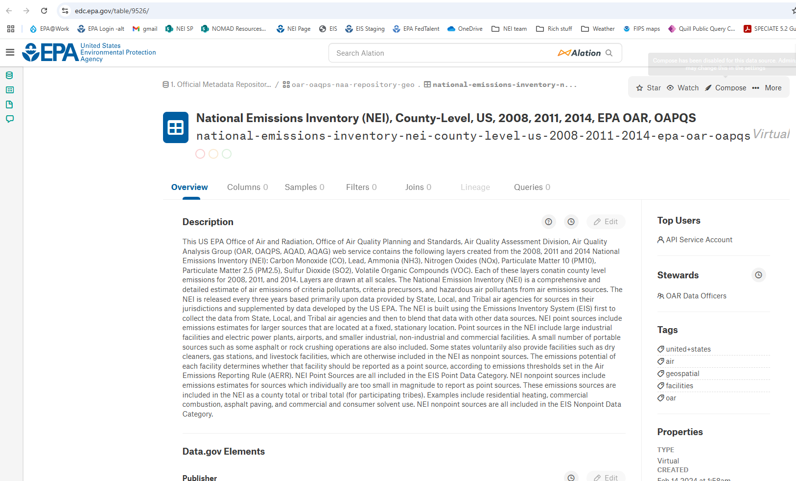
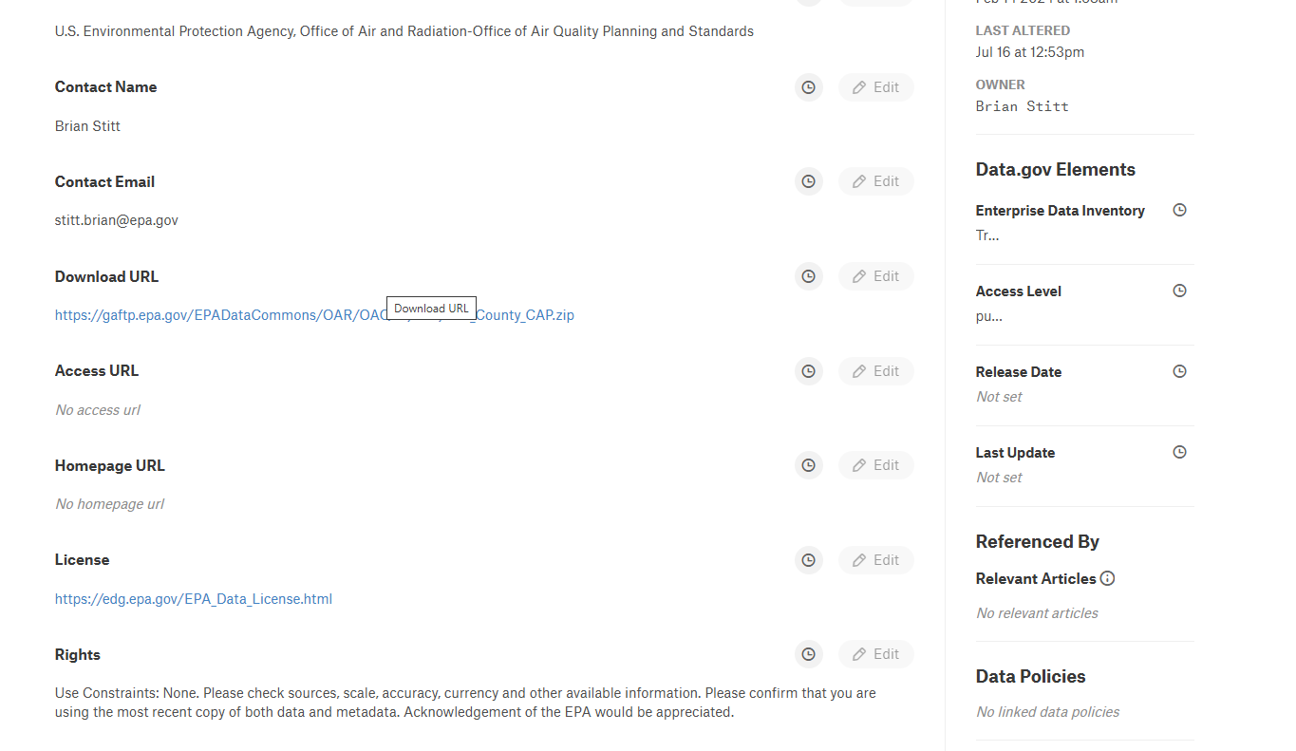
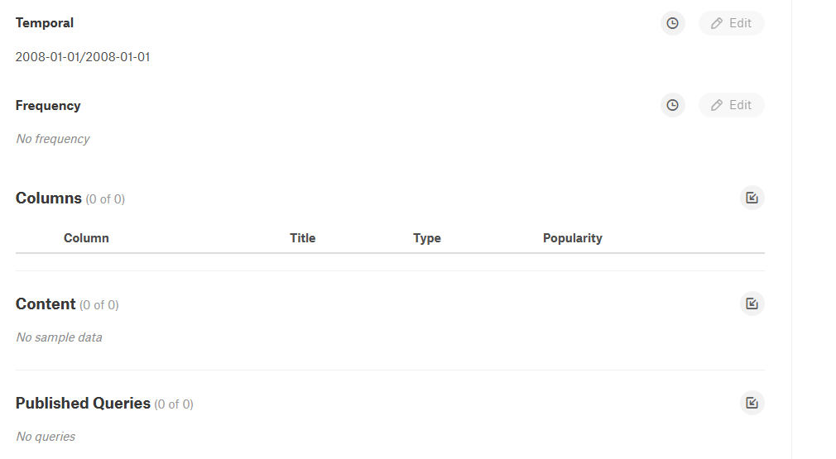

Background:
From: Ibarra, Michelle <Ibarra.Michelle@epa.gov>
Sent: Friday, February 28, 2025 10:29 AM
To: Mason, Rich <Mason.Rich@epa.gov>
Subject: RE: Seeking Confirmation FW: Follow- Up NEI Data - RE: Request - POC for Dataset

Hello Rich,

I am following up to get your confirmation on how the three NEI dataset below should be managed due to the EPA Go Anywhere FTP solution being decommissioned.

Could you please review the two NEI datasets and let me know if one or both the datasets should deleted or moved to the OMS Environmental Data Commons solution?

- Dataset #1: OAR\OAQPS\NEI\NEI_County_CAP.zip (VPN connection required)
- Dataset #2: OAR\OAQPS\NEI\NEI_Facility_HAPs_CAPs.zip (VPN connection required)

As background, OMS is asking the POCs to follow the steps (see attachment) to review your data assets and indicate list which require migration and which may be deleted in the EPA Data Commons Cleanup SharePoint

Thank you,

Michelle Ibarra
OAR Data Officer
Office of Air and Radiation, U.S. EPA
Office # 202-566-1005

From: Ibarra, Michelle
Sent: Wednesday, February 12, 2025 2:48 PM
To: Mason, Rich <Mason.Rich@epa.gov>
Subject: Seeking Confirmation FW: Follow- Up NEI Data - RE: Request - POC for Dataset

Hello Rich,

I am following up to get your confirmation on how the three NEI dataset below should be managed due to the EPA Go Anywhere FTP solution being decommissioned.

OMS is asking the POCs to follow the steps (see attachment) to review your data assets and indicate list which require migration and which may be deleted in the EPA Data Commons Cleanup SharePoint

Once complete, please let me know. If you have any trouble accessing or filling out the EPA Data Commons Cleanup SharePoint, please let me know.

Thank you,

Michelle Ibarra
OAR Data Officer
Office of Air and Radiation, U.S. EPA
Office # 202-566-1005

From: Ibarra, Michelle
Sent: Wednesday, February 12, 2025 2:43 PM
To: Rao, Venkatesh <Rao.Venkatesh@epa.gov>
Cc: Mason, Rich <Mason.Rich@epa.gov>
Subject: RE: Follow- Up NEI Data - RE: Request - POC for Dataset

Hello Tesh,

Thanks for confirming Rich Mason is the POC. I will work with Rich to resolve if the outstanding NEI datasets should be migrated. Please know, the decision on whether to move the datasets resides with your office. Myself and OMS are making sure we get the proper confirmation from Rich to manage the data properly.

Thank you,

Michelle Ibarra
OAR Data Officer
Office of Air and Radiation, U.S. EPA
Office # 202-566-1005

From: Rao, Venkatesh <Rao.Venkatesh@epa.gov>
Sent: Wednesday, February 12, 2025 1:42 PM
To: Ibarra, Michelle <Ibarra.Michelle@epa.gov>
Cc: Mason, Rich <Mason.Rich@epa.gov>
Subject: RE: Follow- Up NEI Data - RE: Request - POC for Dataset

Michelle,

I checked with my group and no one had seen nor heard of these datasets. This might have been worked on 6 or 7 years ago, when other people were in the group might have worked on this for ESRI applications.

You can probably move these datasets wherever you want to, I am not even sure if anyone is using them any more or will have any need for them.

The POC for this will be Rich Mason, our NEI (National Emissions Inventory) Team Lead, but I don’t expect him to do anything with any questions on this issue given all of the other high priority things we have going on right now.

Thank you.

--Tesh

-------------------

Tesh Rao
Temporary Acting Group Leader
Emissions Inventory and Analysis Group
OAQPS, EPA
RTP, NC 27111

From: Ibarra, Michelle <Ibarra.Michelle@epa.gov>
Sent: Wednesday, February 12, 2025 11:00 AM
To: Rao, Venkatesh <Rao.Venkatesh@epa.gov>
Subject: Follow- Up NEI Data - RE: Request - POC for Dataset

Hello Venkatesh,

I am following up on my email (see below). To recap, OMS is decommissioning the Go Anywhere FTP solution and will utilize EPA’s new Enterprise Data Catalog (EDC) solution. I need to track down the POC for the NEI data below, so the POC can determine whether the two datasets below should be moved to the EDC.

Could you please confirm if you are you the POC for the dataset below?
- Dataset #1: OAR\OAQPS\NEI\NEI_County_CAP.zip (VPN connection required)
- Dataset #2: OAR\OAQPS\NEI\NEI_Facility_HAPs_CAPs.zip (VPN connection required)

Thank you,

Michelle Ibarra
OAR Data Officer
Office of Air and Radiation, U.S. EPA
Office # 202-566-1005

From: Ibarra, Michelle
Sent: Thursday, January 23, 2025 6:22 PM
To: Rao, Venkatesh <Rao.Venkatesh@epa.gov>
Subject: Request - POC for Dataset

Hello Venkatesh,

My name is Michelle Ibarra, and I am the new OAR Data Officer. I am supporting OAR teams to make their data available and respond to other IT/IM needs. I am working with our OAR Information Management Officer, Paul Cusumano, to track down the Point of Contacts (POCs) for datasets that need to be moved out of the Go Anywhere server to either the EDC Data Commons solution or alternate path (see more background further below).

Could you please confirm if you are you the POC for the dataset below?
- Dataset #1: OAR\OAQPS\NEI\NEI_County_CAP.zip (VPN connection required)
- Dataset #2: OAR\OAQPS\NEI\NEI_Facility_HAPs_CAPs.zip (VPN connection required)

Background
EPA decommissioned the Environmental Dataset Gateway (EDG) in preparation for deploying the new Enterprise Data Catalog (EDC). The EDC was made available to all EPA staff in March of 2024. In addition to the EDC being the primary means to find data within the agency, the EDC will continue to maintain the offering of no cost data storage for program and regional offices who do not have storage options available to host small datasets (i.e., 250mb file, up to 20G per organization) for public consumption. Prior to migrating data, I need to track down the latest POC/Data Steward to review your data assets on the Go Anywhere server to determine that there remains an ongoing hosting need, and the assets continue meet Agency data management and EDC policies. Note, the EDC is not a records management system, therefore, all POCs/Data Stewards need to ensure they continue meeting their records management requirements for the respective datasets.

Please confirm if you are the POC/Data Steward and I can further assist you in migrating the dataset or determine alternate steps to managing the dataset (e.g., host in an alternate solution with unknown cost or not migrate the data).

Thank you,

Michelle Ibarra
Power Sector Data & Technology Branch
Clean Air & Power Division
Office of Air and Radiation, U.S. EPA
Office # 202-566-1005

