Main Improvements of FAST-CE 2.5
By SCUT, 2021-09-27

Main Improvements:
- Remove the “O3_ACE_MDA1.proj” and combine two “data.exe” files into one. The default directory is set to “/Documents/My FAST-CE Files/”.
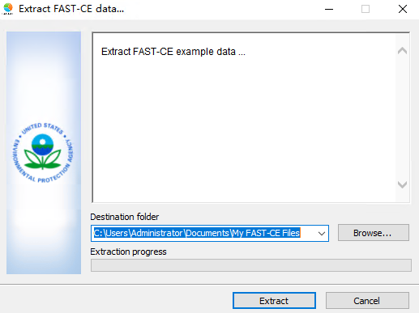
- Fix the bug when running the new “RCU monitor case” (by uploading the project file you created), there was an “error msg window” indicating it could not find the file.
- Remove the unnecessary “warning” windows.
- Display “model variables” information under the “Model Info” window.
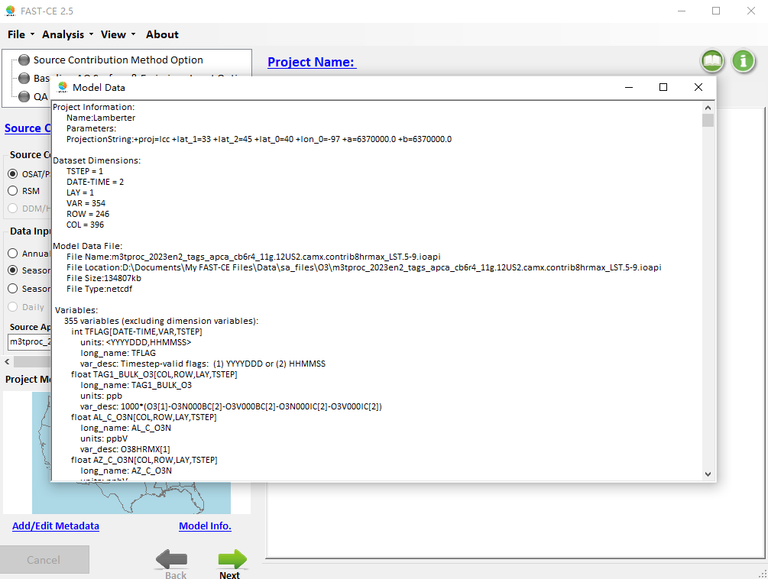
- Move “Back ->” “Next ->” to the bottom under the new “MAP”
- In “Add/Edit Metadata” (see window below too), allow to add new rows and add information if needed.
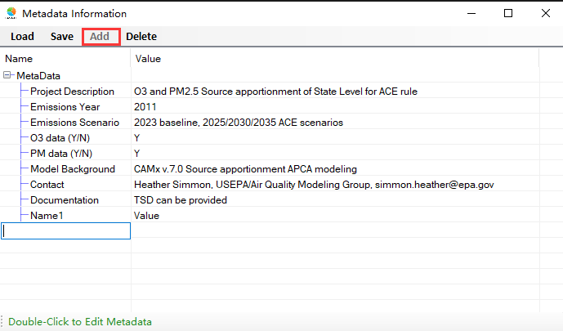
Also allow to delete rows:
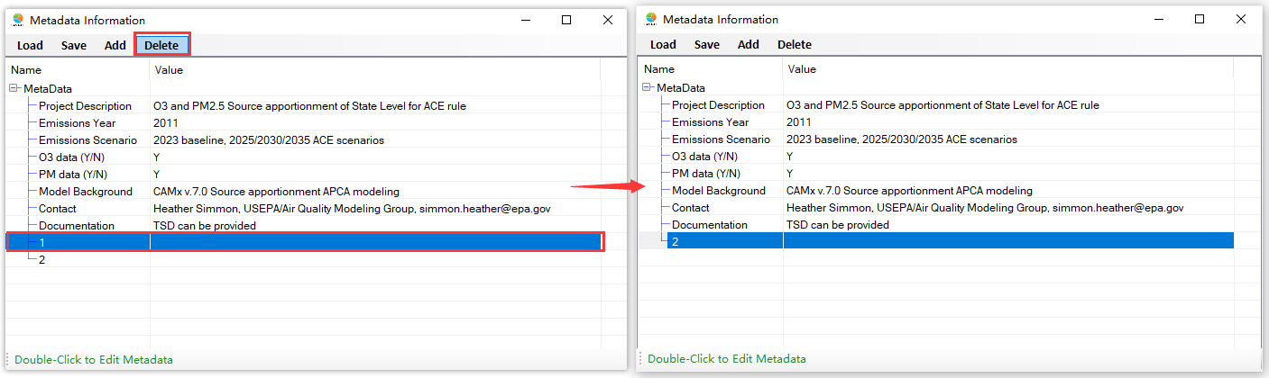
- Fix the bug that the metadata information from previous project was not copied to newly run project (& xml) file.
- Change the default case to “ACE O3”.
- Allow to set up the model domain through the “Map”.
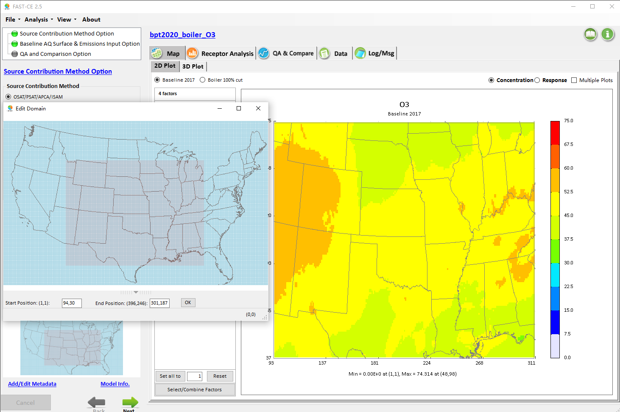
- For RCU monitor case, fix the output issues of “Save as SMAT-CE data”, “Save as Excel”. Disable the “Save as BenMAP-CE Data” function. We also fixed the error units when saving O3 BenMAP-CE data.
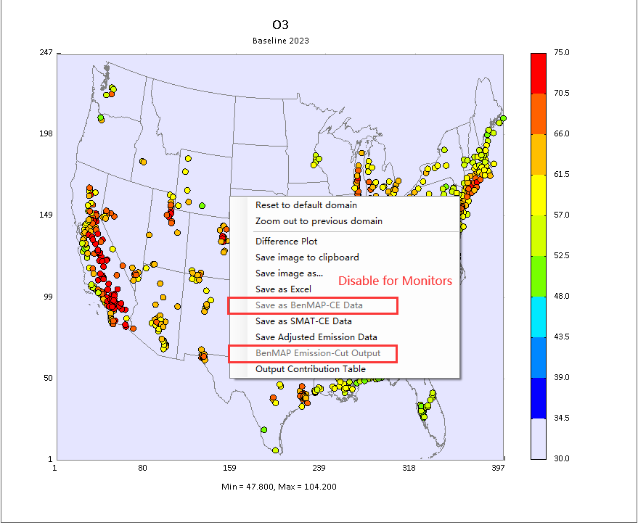
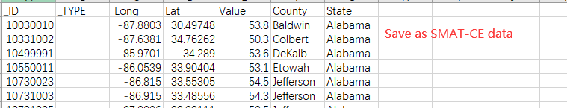
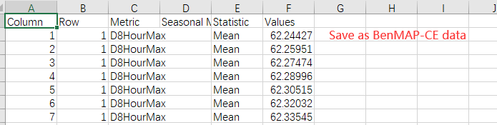
- Remove the 1.4 chapter of online user guide.

To Do List:
- Continue to develop the Monitor Point/DVs module for PM2.5 analysis.
- Provide more warn/error message.
- Provide more tips to prepare input files (mapping file/emission file/…).
- Update the online user guide with new functions.

