Main Improvements of NEXUS 2.5
By SCUT, 2021-4-06

Main Improvements:
- Develop a function named “Display Attribute Table” under “proximity analysis” module, so that users are allowed to view the information of “census tracts” which are displayed on the map;
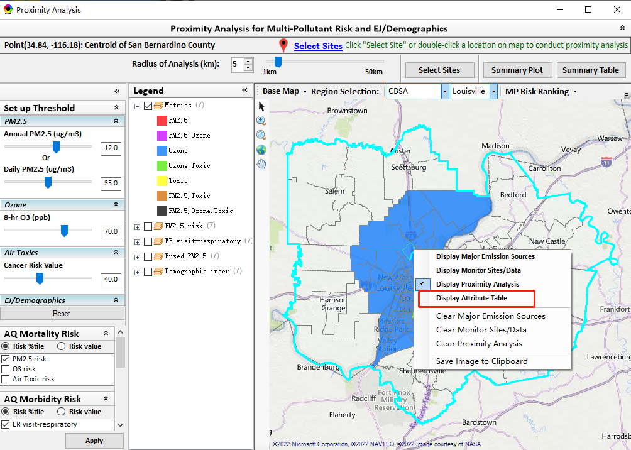
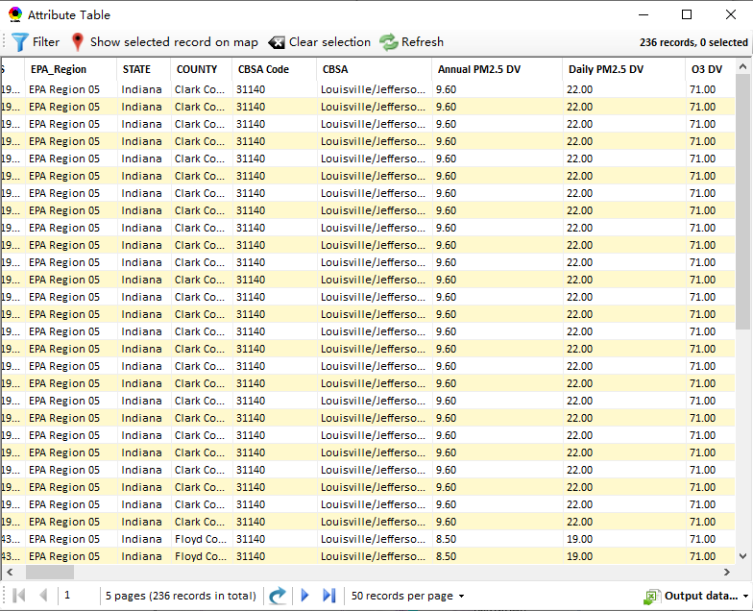
Fig. 1 A new option named “Display Attribute Table” under “proximity analysis” module
- Remove the “Data Query” module;
- Move “Cancer” & “Non-cancer” risk columns after PM & O3 mortality risks (before morbidity risks) under “Data” module;
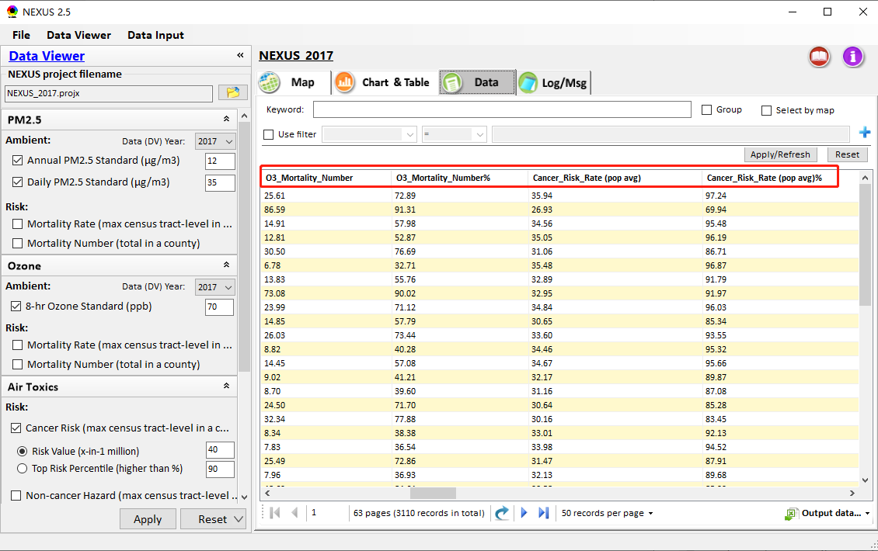
Fig. 2 The “data table” under “Data” module
- Add a button named “Select Sites” under “Proximity analysis” module;
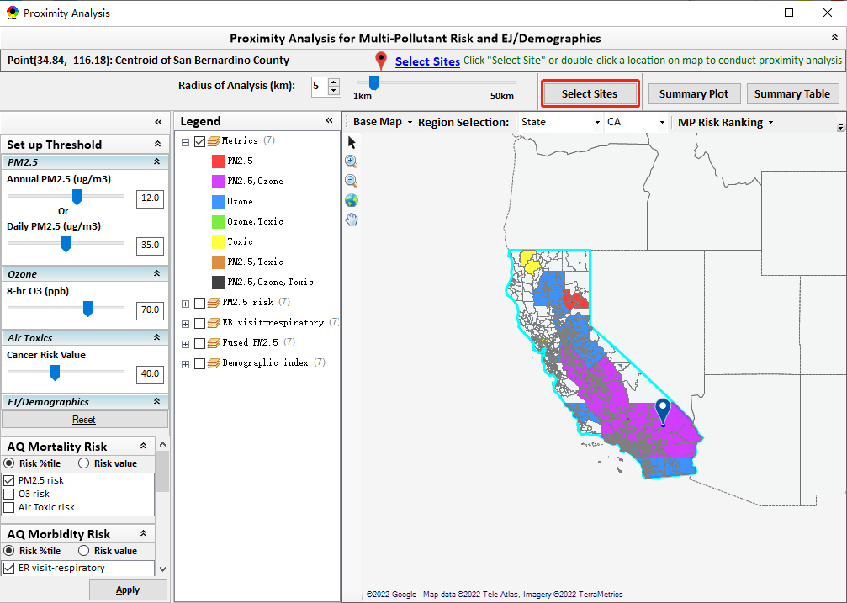
Fig. 3 Add a button named “Select Sites”
- Add a “Clear” button under “Select Sites” module, user can click it to clear all the selected sites;
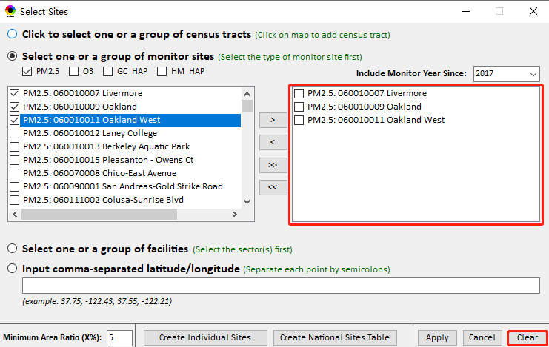
Fig. 4 The “Clear” button under “Select Sites” module
- Fix a bug for “Minimum Area Ratio (X%)” under “Select Site” window.
- Fix a bug that some monitor sites for Ozone are not filtered by “include monitor year since” option under “Monitoring Sites/Data Table” module;
- Fix a bug that the green dash icon disappears when "Save Image to Clipboard" together with the misspelling (“Demograohics” to “Demographics”);
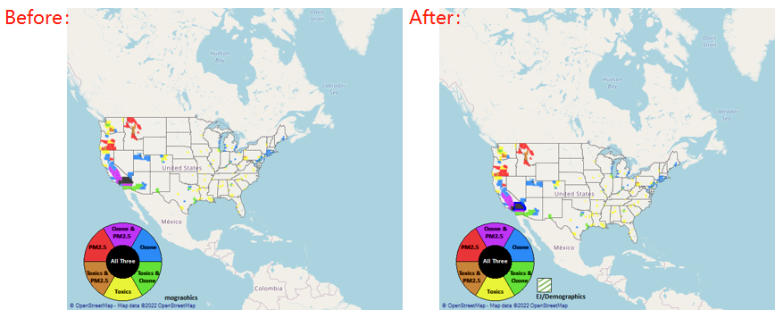
Fig. 5 Fix a bug that the green dash icon disappears
- Fix misspellings in the “Source/Sector Emissions” module (“Heacvy” to “Heavy”, “categor” to “category”)
- Fix misspelling in User’s Manual of NEXUS (“Dada” to “Data”);
- Change "Top risk percentile" to "Top hazard index percentile" under “Data Viewer” module;
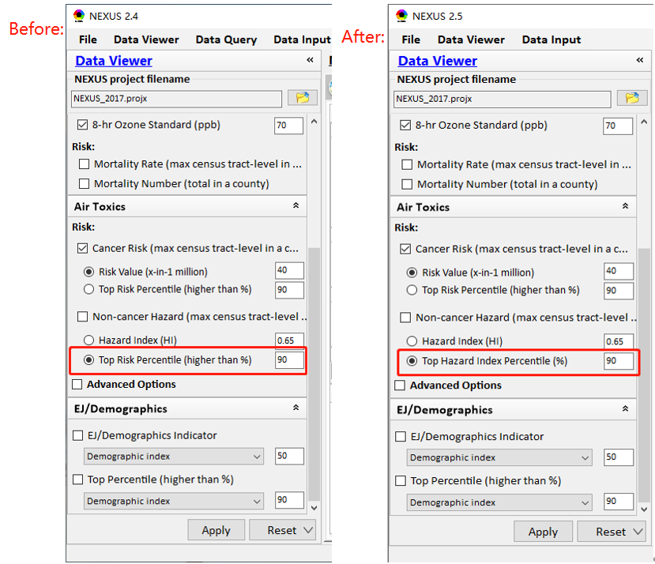
Fig. 6 Change "Top risk percentile" to "Top hazard index percentile"
- Keep the order of pollutants in "Source category emissions" to consistent with "Major point sources" under “Source/Sector Emissions” module;
- Remove the text like "as of 6/19/19" from the header under "EPA Regional Table Generator" table;
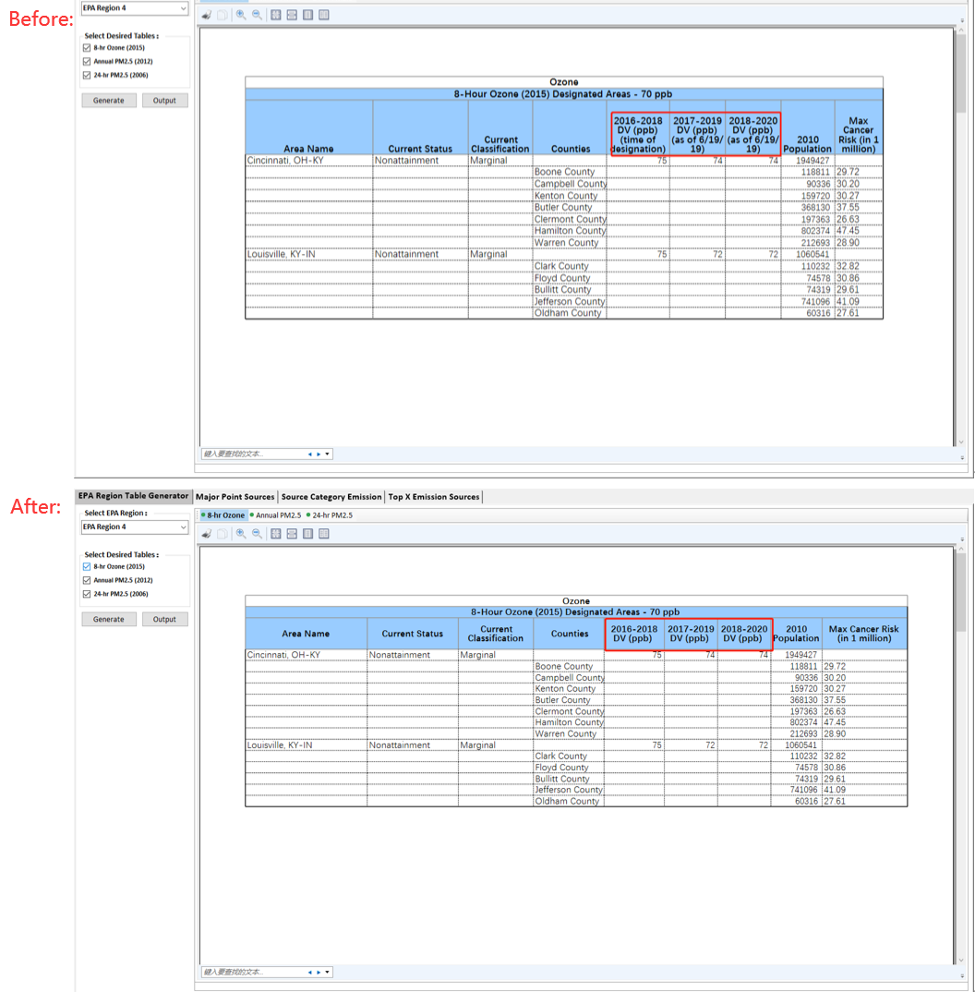
Fig. 7 Remove the text like "as of 6/19/19"
- Resume the “Monitor sites/data table” window default as top window (always on top). So are “Source/Sector Emissions” table window, and under “Proximity analysis module, “Select Sites” window, and “Summary Plot” & “summary Table” windows default as top windows.
- Develop two functions named “Create individual Sites” and “Create National Sites Table” under “Select Sites” module. These functions provide the capabilities to generate a new summary report/table for the individual sites (state-wide or CBSA-wide) selected in the grouping (monitors, sources/sectors, census tracts, locations) or national sites (nation-wide) under the “Select Sites” window.
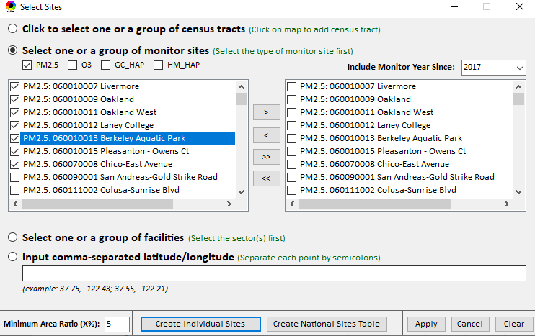
Fig. 8 “Create Individual Sites” and “Create National Sites Table” under “Select Sites” module
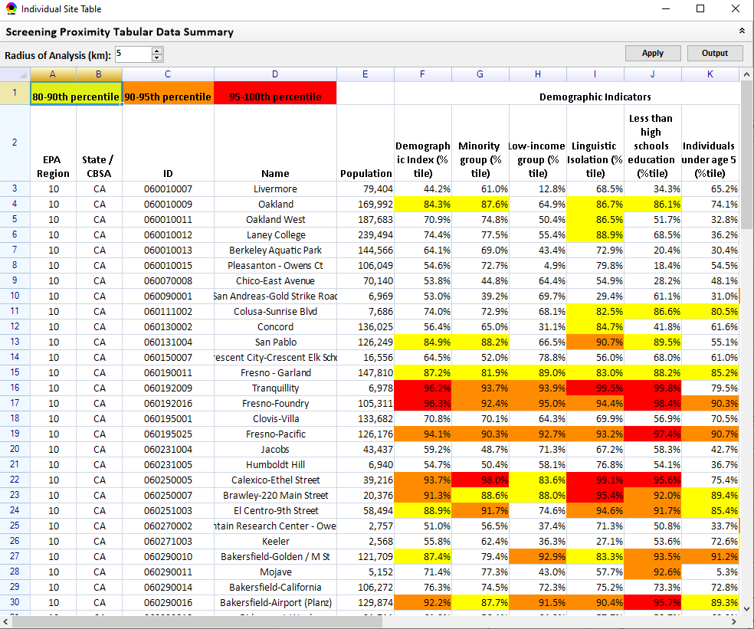
Fig. 9 Example of “Individual Site Table”
- Under “Site Table”, it allows users to define the highlighted %tile (e.g., use the default 80-100%tile, but give users the options to select the tiers of 3 color).
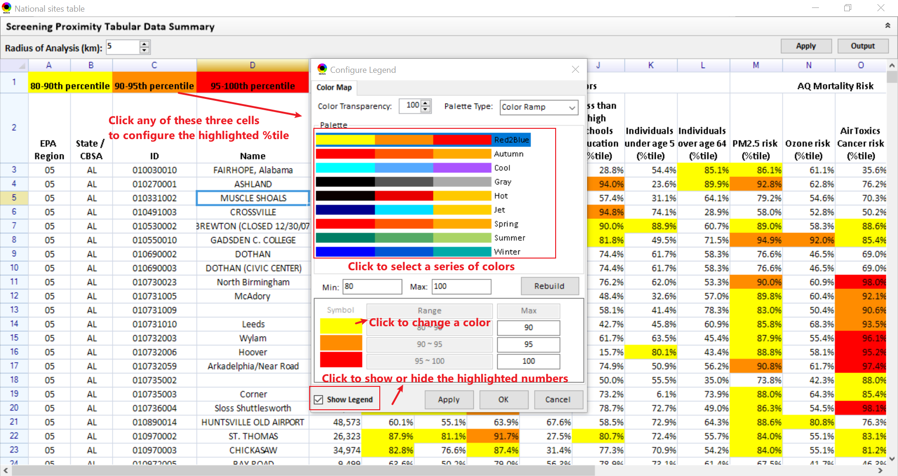
Fig. 10 Configure highlighted %tile for site table

To Do List:
- Include “morbidity risk” data into “summary table” & and “summary plot” under the “proximity analysis” module.
- Include top risk drivers into the “summary table” under the “proximity analysis” module and list the top 3 air toxic species of cancer risk.
- Add Air toxic concentration data in the “Data Input” module (currently blank and grayed).
- Need to speed up when loading a new project.
- Under Data Viewer → “Data Menu” Table: (1) Adjust all these columns (and the rest) to a narrower “reasonable” size (too wide for numbers) and list headers (titles) to two rows if needed;(2) If %tile is used, change all “%” to “%tile” ;(3) For number under “%tile” or “%”, add “%” to the numbers (e.g, “75.77” to “75.77%”);
- Gray out the HAPs species that have no data available when selecting “GAS & VOC HAPs” (15 species) or “Heavy mental HAPs” (7 species);
- Add “Sector Emissions Summary” under “Chart & Table”.
- Provide a clear base map for Proximity analysis.
- Provide a format validation for input files under Data Input module.
- Add “Tribal” options under Major Emission Source module for support to zoom-in to tribal areas (All & individual) and provide a Tribal Analysis module as given in the PPT sent previously;
- Include “Climate risk” layer data.
- Fix the bug for the “filter” function under Data Input module (see below figure).
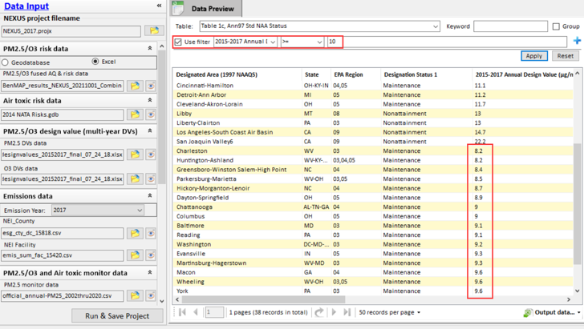
Fig. 11 Fix the bug for the “filter” function under Data Input module

