Air Quality Modeling Assessment Tools (AQMAT) Development
User’s Manual for NEXUS 3.6

Contract No: 68HERD21A0002
Task Order No: 68HERH21F0334
Version: 01

Prepared for: Carey Jang
Task Order Contracting Officer’s
Representative
U.S. EPA/OAR/OAQPS/AQAD/AQMG
(Mail Code: C439-01)
109 T.W. Alexander Drive
Research Triangle Park, NC 27711

Prepared by: Yun Zhu, Shicheng Long
College of Environment & Energy
South China University of Technology
Guangzhou, 510006, Guangdong, China

Sarav Arunachalam
Institute for the Environment
The University of North Carolina at Chapel Hill

Date: March 12, 2023
Acknowledgments
In cooperation with the U.S. EPA, the Institute for the Environment at the University of North Carolina at Chapel Hill (UNC-IE) along with the South China University of Technology (SCUT) developed the NEXUS software. This project was funded by the U.S. EPA under contract 68HERH21F0334 to UNC-IE.

Table of Contents
1 Introduction 1
1.1 Computer Requirements 1
1.2 Install/Uninstall NEXUS 1
1.2.1 Install NEXUS Software 1
1.2.2 Install NEXUS Data 4
1.2.3 Uninstall NEXUS 6
1.3 Contacts for Comments and Questions 7
2 File Types & Data Sources 8
3 Main Interface 10
4 Data Viewer Module 12
4.1 Data Viewer Settings 12
4.1.1 NEXUS Project 13
4.1.2 Set up threshold for PM_{2.5} 13
4.1.3 Set up threshold for Ozone 14
4.1.4 Set up threshold for Air Toxics 14
4.1.5 Set up threshold for EJ/Demographics 14
4.1.6 Set up threshold for Climate Risk 15
4.1.7 Apply and Reset 18
4.2 Map 20
4.2.1 MP Risk Ranking 25
4.2.2 Emission and Monitor Data 26
4.2.3 Proximity Analysis 37
4.2.4 Attribute Table 47
4.3 Chart & Table 48
4.3.1 EPA Region Table Generator 48
4.3.2 Major Points Sources 49
4.3.3 Source Category Emission 49
4.3.4 Top X Emission Sources 49
4.4 Data 49
5 Data Input Module 51

List of Tables
Table 1 Data Source Files 8
List of Figures
Figure 1-1 Setup Window 2
Figure 1-2 Choose Install Location 2
Figure 1-3 Ready to Install 3
Figure 1-4 Installation Processing 3
Figure 1-5 Installation Complete 4
Figure 1-6 Extract Window 5
Figure 1-7 Option and Destination Folder 5
Figure 1-8 Installation Window 6
Figure 1-9 Data Installation Success Tip 6
Figure 1-10 Confirm for Uninstallation 7
Figure 1-11 Removing NEXUS 7
Figure 3-1 Main Interface of NEXUS 10
Figure 4-1 Main Interface of Data Viewer 12
Figure 4-2 Setting Panel of Data Viewer 13
Figure 4-3 Example for Displaying EJ/Demographic Metric 15
Figure 4-4 Example for Displaying Climate Risk Metric 16
Figure 4-5 Example for Displaying Climate Risk Indicators 16
Figure 4-6 Example for Collapsing Setup Panel 17
Figure 4-7 The Default Checked Indicators for Four Options 18
Figure 4-8 GUI of Map Module 20
Figure 4-9 The Drop-down List of the MAP Module 22
Figure 4-10 Select EPA Region/State/CBSA 23
Figure 4-11 Configure Window of Circle Color Bar 23
Figure 4-12 The Interface of the MP Risk Ranking Module 24
Figure 4-13 The Drop-down List of the Emission & Monitor Data Module 26
Figure 4-14 Major Points Sources Option-1 27
Figure 4-15 Highlight Sources/Monitors in the Pop-up Window by Clicking on the Map 27
Figure 4-16 Major Points Sources Option-2 28
Figure 4-17 Source Category Emissions Option 29
Figure 4-18 Top X Emission Sources Option 29
Figure 4-19 The Function of Sector Emission Summary 30
Figure 4-20 The Summary Table 31
Figure 4-21 The Summary Plot-1 32
Figure 4-22 The Summary Plot-2 32
Figure 4-23 The “Monitor Sites/Data Table” Window 33
Figure 4-24 The Map and the Trend Plot of the Selected Monitor Site 35
Figure 4-25 Three Ways to Display Proximity Analysis Module 36
Figure 4-26 The Proximity Analysis Module 36
Figure 4-27 Map Layers Menu 38
Figure 4-28 Show Detailed Information by Clicking 38
Figure 4-29 Set the “Radius of Analysis” 40
Figure 4-30 The “Select Sites” Module 41
Figure 4-31 National Sites Table 42
Figure 4-32 Configure Legend for Tables 43
Figure 4-33 The Summary Table 44
Figure 4-34 The Summary Plot 45
Figure 4-35 Launch the Attribute Table 46
Figure 4-36 The Interface of the “EPA Region Table Generator” Module 47
Figure 4-37 GUI of Data Module 47
Figure 4-38 Grouping Tool in Data Window 48
Figure 5-1 Main Interface of Data Input 49
Figure 5-2 Load and Preview File/Dataset 50

Acronyms

AQ Air quality
CAP Criteria air pollutants
CBSA Core-based statistical areas
CEJST Climate and Economic Justice Screening Tool
CSV Comma-separated values
DV Design value
EJ Environmental justice
GHG Greenhouse gases
HAP Hazardous air pollutants
NATTS Non-Attainment areas
NEI National Emissions Inventory
OAQPS EPA’s Office of Air Quality Planning and Standards
ORD EPA's Office of Research and Development
VOC Volatile organic compound

Introduction
The NEXUS multi-pollutant analysis tool allows for the identification of areas with multipollutant air quality, environmental justice, and climate issues (e.g., ozone, PM_{2.5}, air toxics, EJ/Demographics, and climate risk) and screening of these areas to assist EPA and others to determine whether a multipollutant, risk-based approach might be of value for that area to pursue, using a user-friendly approach. It provides maps, charts and tables to display information about multipollutant issues for regions and identify/vet the list of areas to get to a small number of truly viable candidates for which users can discuss possible collaboration(s) with state/local agencies.

Computer Requirements
NEXUS requires a computer with:
- .Net Framework Version 4.0 or higher
- Microsoft Visual C++ 2013 Redistributable
- 64-bit Windows 7 and above
- 4GB RAM or greater
- 10 GB free disk space or greater

Install/Uninstall NEXUS

Install NEXUS Software
Contact the EPA to obtain a copy of the NEXUS Application Package (919 MB) and data files (see next subsection). The package installation process is given as follows:
- Double-click “NEXUS 3.6 setup.exe” to install the program, it will appear in the following windows:
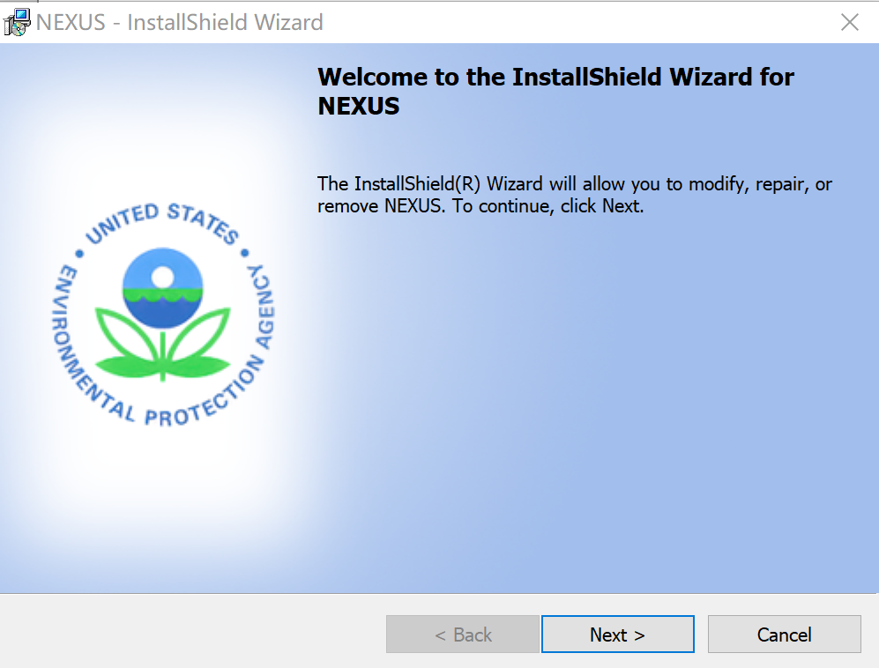
Figure 1-1 Setup Window
- Click the “Next” button, users can choose the install location in Figure 1-2.
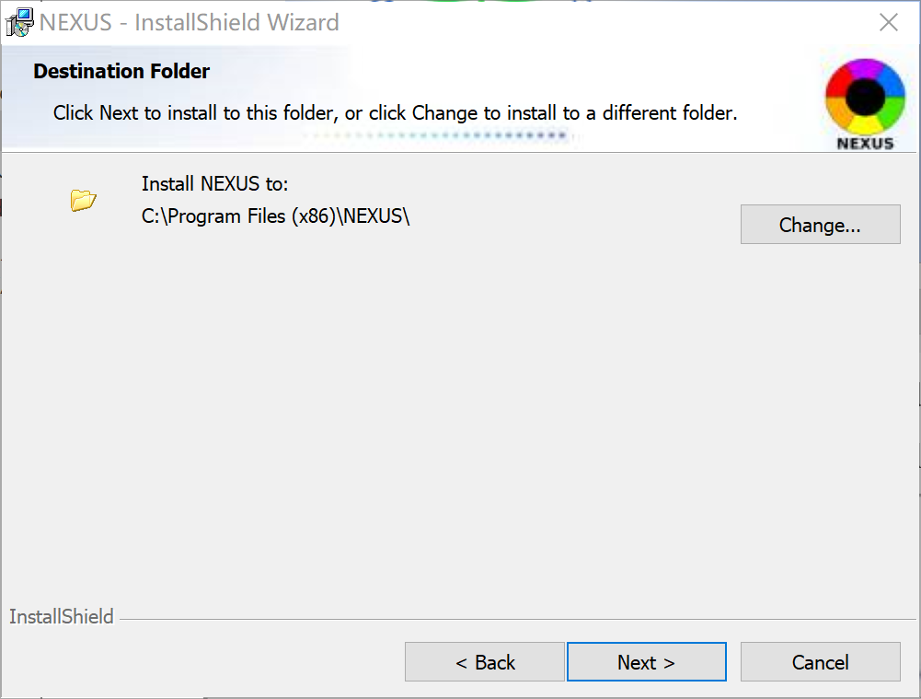
Figure 1-2 Choose Install Location
- Click the “Next” button, it will show the “Ready to Install” window as shown in Figure 1-3.
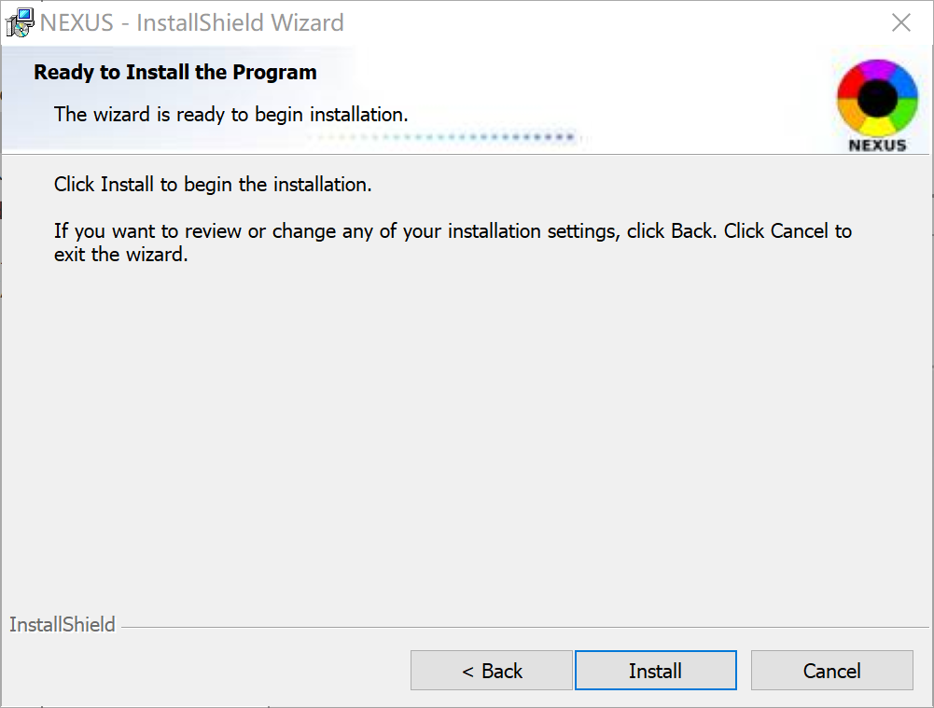
Figure 1-3 Ready to Install
- Click the “Install” button and NEXUS will be installed.
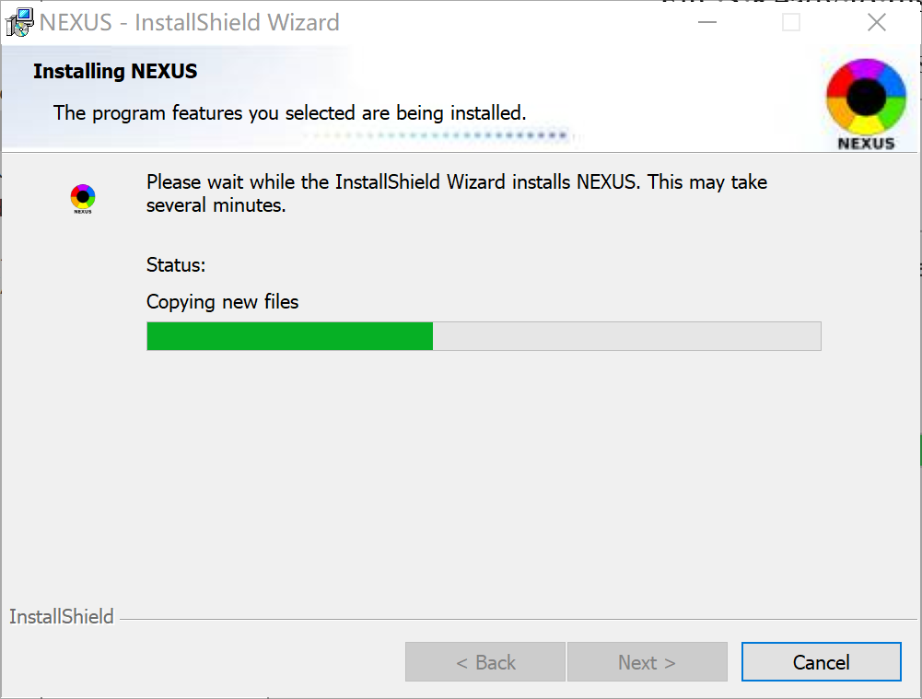
Figure 1-4 Installation Processing
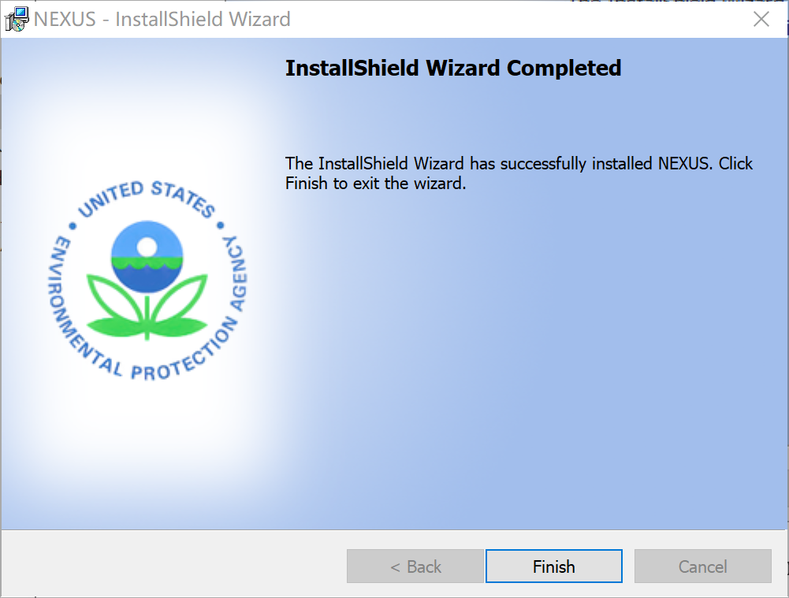
Figure 1-5 Installation Complete
- Click the “Finish” button and the installation is completed.

Install NEXUS Data
Contact the EPA to obtain a copy of the NEXUS Data Package (2.58 GB).

The data package installation process is given as follows:
- Double click “NEXUS 3.6 Data.exe” to install the data, it will appear in the following windows:
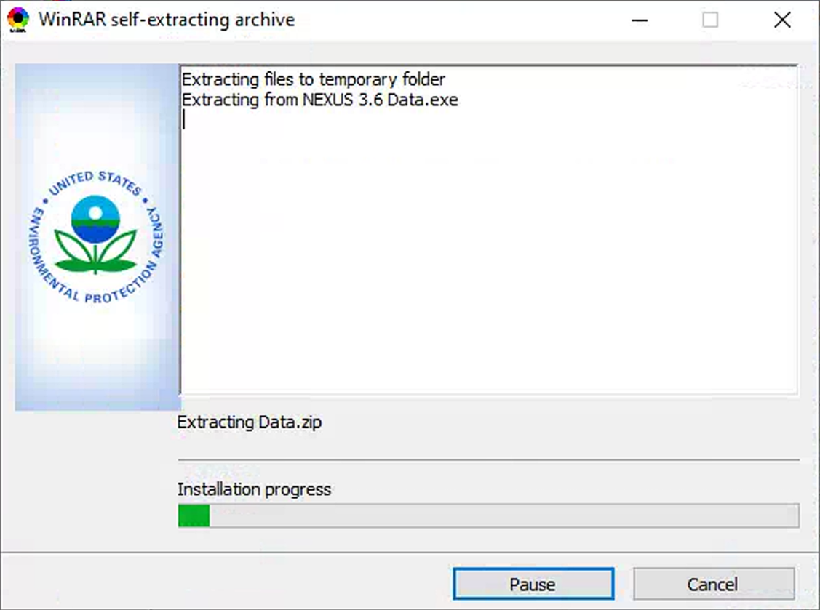
Figure 1-6 Extract Window
- After a while, the following window will pop up. Users can select installation options and specify folders as required. Note that the default destination folder points to users’ User Documents directory under "\My NEXUS Files\". It is recommended to use this default folder.
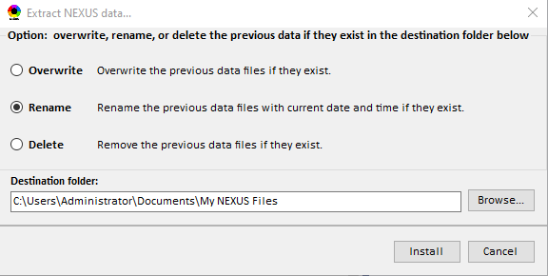
Figure 1-7 Option and Destination Folder
- Click the “Install” button, and the package starts installation and displays the installation progress in the lower-left corner as shown in Figure 1-8.
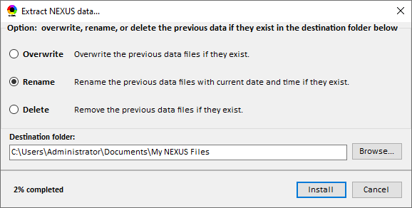
Figure 1-8 Installation Window
- The data installation is completed if the following page is displayed.
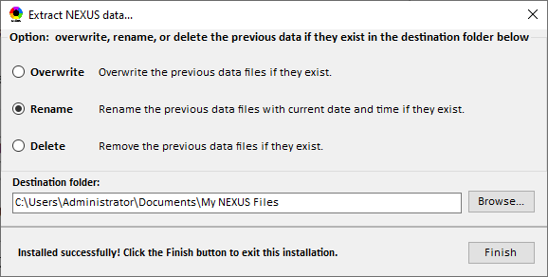
Figure 1-9 Data Installation Success Tip

Uninstall NEXUS
There are three ways to uninstall NEXUS, (1) uninstall from the PC “Start” menu. Click “Uninstall NEXUS” from the “NEXUS” fold at your PC “Start” menu; (2) Uninstall via Control Panel. Go to Control Panel, and input the path “Control Panel\Programs\Programs and Features” (or click in order) in the address bar on the top and then enter. A list of all installed apps appears in the right pane. Select “NEXUS” and right-click to choose “Uninstall”. Note that this method runs on a Windows PC but not a Mac. (3) Re-install the installed NEXUS version again, and it will navigate to a Program Maintenance window, and then select the Remove option to remove this installed NEXUS.
Below is the process of NEXUS uninstallation using the first method.
- Click “Uninstall NEXUS” from the start menu to uninstall the program, it will appear in the following Figure.
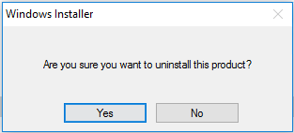
Figure 1-10 Confirm for Uninstallation
- Click the “Yes” button, and the system will start to remove the NEXUS program as shown in the next Figure.
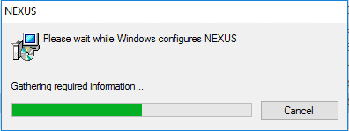
Figure 1-11 Removing NEXUS
- After a few seconds, uninstallation will finish.

Contacts for Comments and Questions
For comments and questions, please contact one of the following:
EPA OAQPS: Dr. Carey Jang jang.carey@epa.gov
EPA OAQPS: Ms. Beth Landis Landis.Elizabeth@epa.gov
UNC Institute for the Environment: Dr. Sarav Arunachalam sarav@email.unc.edu

File Types & Data Sources
This chapter describes the necessary format for data files that can be read into NEXUS in detail. Table 1 presents the names, format, data description, and data source of the different files.
- NEXUS Project File: An existing NEXUS project file (*.projx).
- Data Source Files: A set of source files providing the input data for NEXUS.
Table 1 Data Source Files
Data Input  File Names | Data  Format | Data  Description | Data  Source | Data  Period
“O₃ & PM_{2.5}  Ambient and Risk” | Excel or Geodataset | O₃/PM_{2.5} fused ambient & risk data at county/census tract level | From OAQPS MP & BenMAP team | 2017 to 2019
“Air Toxic  Ambient and Risk” | Excel or Geodataset | Air toxics fused ambient & risk data at county/census tract level | From OAQPS MP & Air Toxic team | 2017 to 2018
“O₃ & PM_{2.5}  Design Values” | Excel | O₃ & PM_{2.5} design values at  County-level | From EPA public website:  https://www.epa.gov/air-trends/air-quality-design-values | 2012 to 2020
“NEI County Emissions”  “NEI Facility Emissions” | Excel | County-level and facility source emissions of CAPs, HAPs & GHGs | From OAQPS public website: https://www.epa.gov/air-emissions-inventories/2017-national-emissions-inventory-nei-data | 2017
“O₃ & PM_{2.5}  monitoring data | Excel | O₃ & PM_{2.5} monitoring data (DVs) | From OAQPS public website:  https://gispub.epa.gov/arcgis/rest/services/OAR_OAQPS | 2002 to 2020
“Air Toxic  monitoring data” | Excel | Air toxics monitoring data  (22 HAPs) | From OAQPS public website: https://www.epa.gov/amtic/amtic-air-toxics-data-ambient-monitoring-archive | 2003 to 2020
EJ/Demographics data | Geodataset | Demographic indicators (7)  from EJSCREEN | From EJSCREEN:  https://www.epa.gov/ejscreen/download-ejscreen-data | 2021
“Advance areas“ | Geodataset | O₃ & PM_{2.5} Advance Areas | From OAQPS MP team | 2021
“Class 1_Areas” | Geodataset | EPA Class 1 Federal Areas | From EPA Class 1 Federal Areas Website: https://edg.epa.gov/data/public/OAR/OAQPS/Class1/Class1Areas.zip | 2016
“Tribal Areas” | Geodataset | EPA Tribal Areas | From EPA public website:  https://edg.epa.gov/data/Public/OEI/OIAA/Tribes/EPAtribes.zip | 2018
CEJST data | Excel | Climate and Economic Justice Screening Tool Data | From the official website of the United States government:  https://screeningtool.geoplatform.gov | 2022
NO₂ Satellite data | Excel | NO₂ Satellite data at county/census tract level | From OAQPS team | 2019
Heat Index | Excel | The heat index, also known as the apparent temperature, is what the temperature feels like to the human body when relative humidity is combined with the air temperature. | From ORD & OAQPS team | 2022
Wildfire hazard potential | Map  Server | It can help to inform evaluations of wildfire risk | https://apps.fs.usda.gov/arcx/rest/services/RDW_Wildfire/RMRS_WildfireHazardPotential_2018/MapServer/ | 2018
Drought | Map  Server | This map shows how drought conditions have changed across the contiguous 48 states from 1900 to 2020 | https://geodata.epa.gov/arcgis/rest/services/OAR_OAP/Drought/MapServer/ | 2020
Coastal flood hazard | Map  Server | This map depicts areas in coastal counties in the United States along the Gulf of Mexico and the Atlantic Ocean that are most prone to coastal flood hazards. | https://coast.noaa.gov/arcgis/rest/services/FloodExposureMapper/CFEM_CoastalFloodHazardComposite/MapServer/ | 2022
100-year floodplain | Image  Server | This map depicts the estimated 100-year floodplains for the Conterminous US for 2016. | https://enviroatlas.epa.gov/arcgis/rest/services/Supplemental/Estimated_floodplain_CONUS_WM/ImageServer/ | 2016
Sea level rise (NOAA) | Map  Server | This dataset depicts land at risk of permanent flooding when the sea level rises. Six map layers show the area inundated at one, two, three, four, five and six feet of sea level rise. | https://www.coast.noaa.gov/arcgis/rest/services/dc_slr/slr_1ft/MapServer/ | 2017

Main Interface
The main interface of NEXUS is shown in Figure 3-1. NEXUS consists of two modules, including Data Viewer and Data Input.
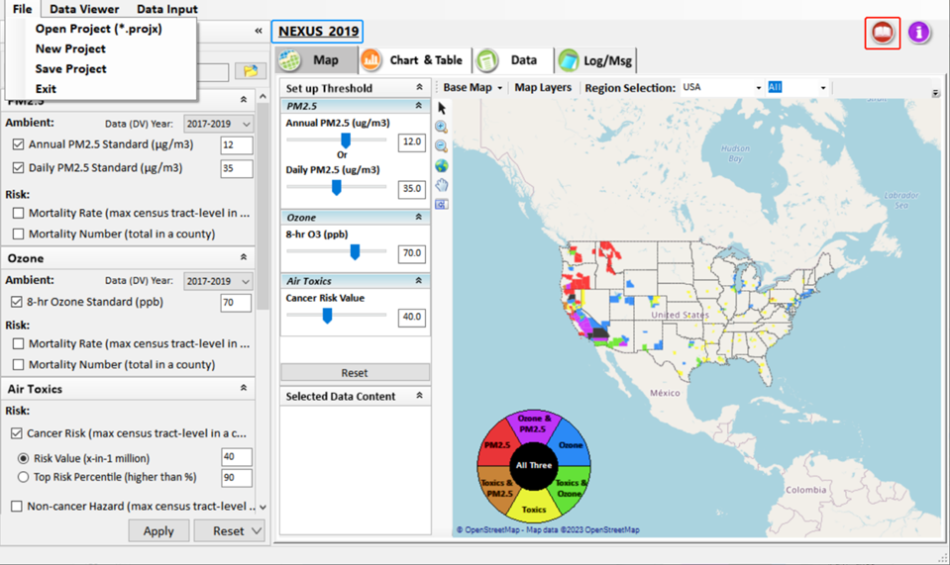
Figure 3-1 Main Interface of NEXUS
- Click the File button on the menu of the main interface, there are four options that users can choose.
- Click the Open Project(*.projx) button, locate the *. projx file and open it.
- Click the New Project button to create a new project.
- Click the Save Project button to save a created project.
- Click the Exit button to exit the NEXUS.
- As shown in the blue box in Figure 3-1 this is the NEXUS project file name, and it can open the project folder.
- Click the Data Viewer button on the menu of the main interface to enter the Data Viewer module, which allows users to display data in different kinds of ways, including maps, charts, and tables.
- Click the Data Input button on the menu of the main interface to enter the Data Input module, which allows users to edit the data sources of a NEXUS project.
- Click the “book” icon to launch “User’s Manual”, as shown in the red box in Figure 3-1.

Data Viewer Module
In this module, users can visualize those data from data sources defined by the Data Input module. Data Viewer Module includes four submodules: (1) Map, (2) Chart & Table, (3) Data, and (4) Log/Msg. As shown in Figure 4-1, there are two panels at the interface of the Data Viewer Module, the setting panel is on the left while the viewer panel is on the right. The hyperlink supports navigating to the User’s manual’s “Data Viewer” chapter (same for the “Data Input” module).
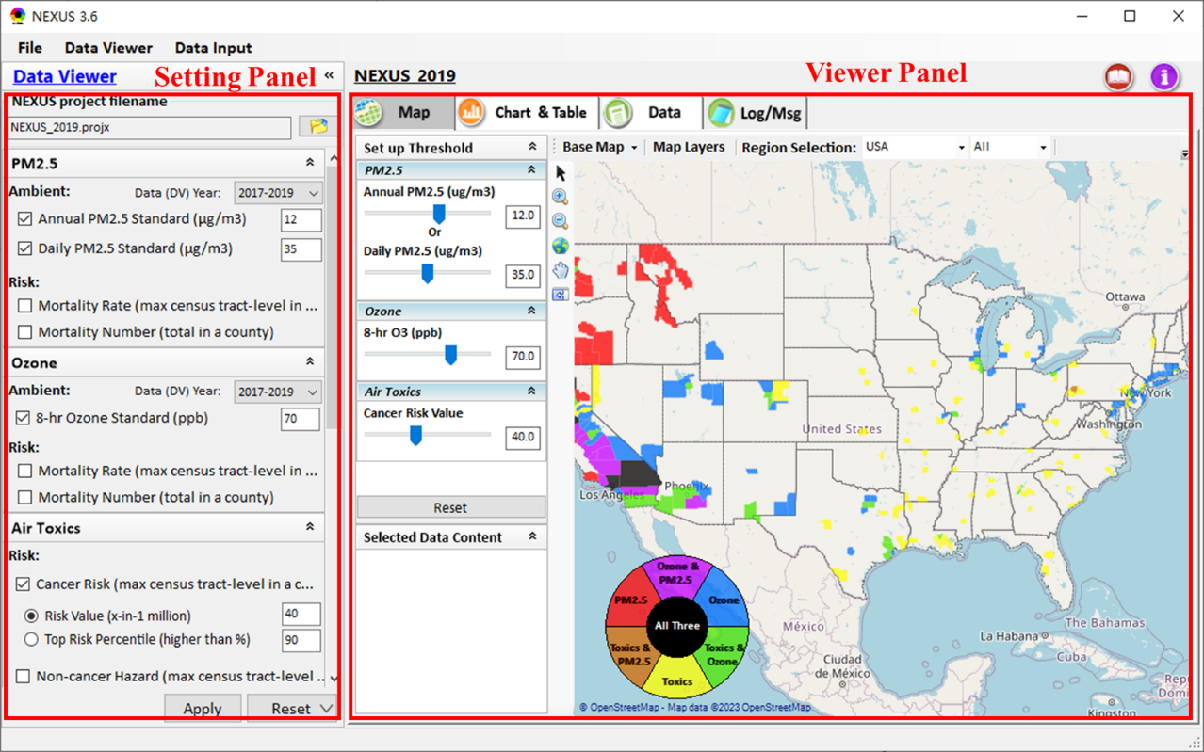
Figure 4-1 Main Interface of Data Viewer

Data Viewer Settings
Under this module, users can choose and set up standard values of concentrations and risks for the selected pollutants, which will be applied to the viewer panel. There are serval different options in the setting panel of Data Viewer, including NEXUS Project, PM_{2.5}, Ozone, Air Toxics, EJ/Demographics, Climate Risk, Apply and Reset, as shown in Figure 4-2.
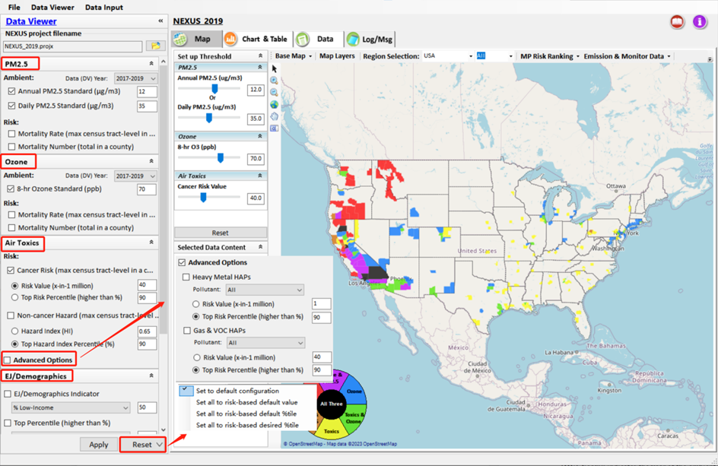
Figure 4-2 Setting Panel of Data Viewer

NEXUS Project
It allows users to directly open a case that has been successfully run and saved to user’s computer based on the input data in the Data Input module. This means that users no longer need to run again if the input data in the Data Input module have not changed. By default, it will load a saved project named "NEXUS_2019" when launching NEXUS. The year of the project means that the risk (mortality/morbidity) and “PM_{2.5}/O₃ Nonattainment Areas” data together with the “DV Year” are from the specified year, e.g., 2019. And that other data is the latest available.

Set up threshold for PM_{2.5}
This section allows users to provide standard settings for PM_{2.5}. Ambient and Risk options are available. For the Ambient option, it provides Annual PM_{2.5} Standard and Daily PM_{2.5} Standard two sub-options to check if desired. The “Data (DV) Year:” indicates the year of the ambient PM_{2.5} data to be used. The Risk option includes Mortality Rate and Mortality Number two sub-options. The Mortality Rate option consists of “Risk Value (person per 10k per year)” and “Top Risk Percentile (higher than %)”. Both are calculated from the maximum census tract-level data in a county. The Mortality Number consists of “Risk Value (person per year)” and “Top Risk Percentile (higher than %)”. These two options are calculated from those census tract-level data in a county via population-weighted. The checked items will be applied to display on the map in the viewer panel if they are exceeding the selected threshold.

Set up threshold for Ozone
This section allows users to provide standard settings for ozone. Ambient and Risk options are available for ozone, too. The Ambient option for ozone is an 8-hr ozone standard. The Risk option includes Mortality Rate and Mortality Number two sub-options. Both sub-options consist of “Risk Value” and “Top Risk Percentile (higher than %)”. These options are like those of PM_{2.5.} The checked items will be applied to display on the map in the viewer panel if they are exceeding the selected threshold.

Set up threshold for Air Toxics
This section allows users to provide standard settings for air toxics. Risk option consists of Cancer Risk and Non-cancer Hazard sub-options. The Cancer Risk includes “Risk Value” and “Top Risk Percentile”, while Non-cancer Hazard consists of “Hazard Index” and “Top Hazard Index Percentile”. The calculation of these options is similar to that in PM_{2.5}. The checked items will be applied to display on the map in the viewer panel if they are exceeding the selected threshold. Users also can check the Advanced Option to include more settings for air toxics.
- Advanced Option: This option allows users to set up standard values for more air toxic pollutants, including heavy-metal HAPs top percentile, gas & VOC HAPs top percentile, heavy-metal HAPs risk value, and Gas & VOC HAPs risk value. Users can choose a specific pollutant via the drop-down list and the selected items will be joined to display on the map in the viewer panel if they are exceeding the selected threshold.

Set up threshold for EJ/Demographics
This section allows users to provide standard settings for EJ/Demographics. EJ/Demographics Indicator and Top Percentile options are available. Both these two options provide seven indicators for analysis, including “Demographic index”, “% Low-Income”, “% People of Color”, “Less than high school education”, “Linguistic isolation”, “Individuals under age 5” and “Individuals over age 64”. The checked items will join to display on the viewer panel. EJ/Demographic metric is displayed with a “green dash” for counties exceeding the selected threshold as shown in Figure 4-3.
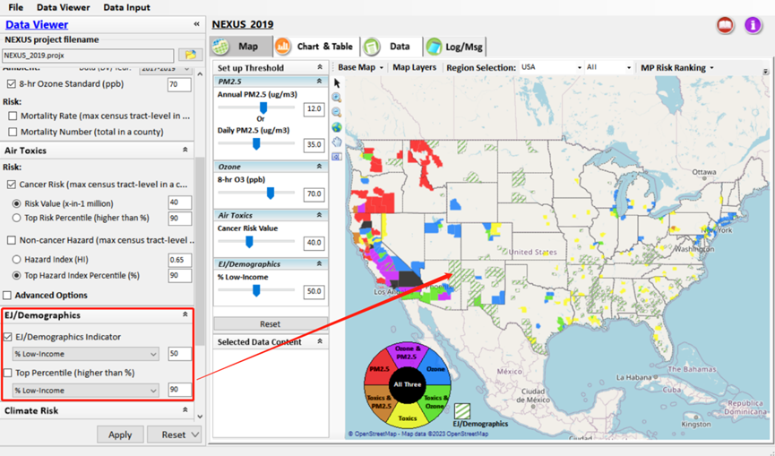
Figure 4-3 Example for Displaying EJ/Demographic Metric

Set up threshold for Climate Risk
This section allows users to provide standard settings for Climate Risk. Heat Index Value (℉) and Heat Index Top Percentile (higher than %) options are available. Both these two options provide three indicators for analysis, including “Heat Index Present”, “Heat Index 2050” and “Heat Index 2100”. And the items that have been checked will be displayed on the viewer panel. Heat Index is displayed with a “red dash” for counties exceeding the selected threshold as shown in Figure 4-4. Besides, Climate risk indicators (EJScreen) option is also available.
- Climate risk indicators (EJScreen): This option allows users to overlay the climate risk map, including wildfire hazard potential, drought, coastal flood hazard, 100-year flood plain, and 1~6ft sea level rise (NOAA). Users can choose a specific indicator via the drop-down list as shown in the green box in Figure 4-5 and the selected items will be joined to display on the map in the viewer panel. Meanwhile, Climate Legend will display on the right part of the viewer panel as shown in the blue box in Figure 4-5. And Users can change the standard value of transparency in the Climate Legend and view the screening results as shown in Figure 4-5.

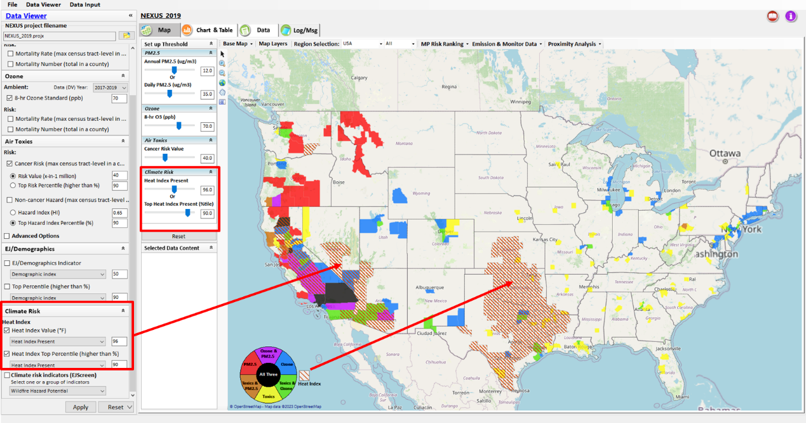
Figure 4-4 Example for Displaying Climate Risk Metric
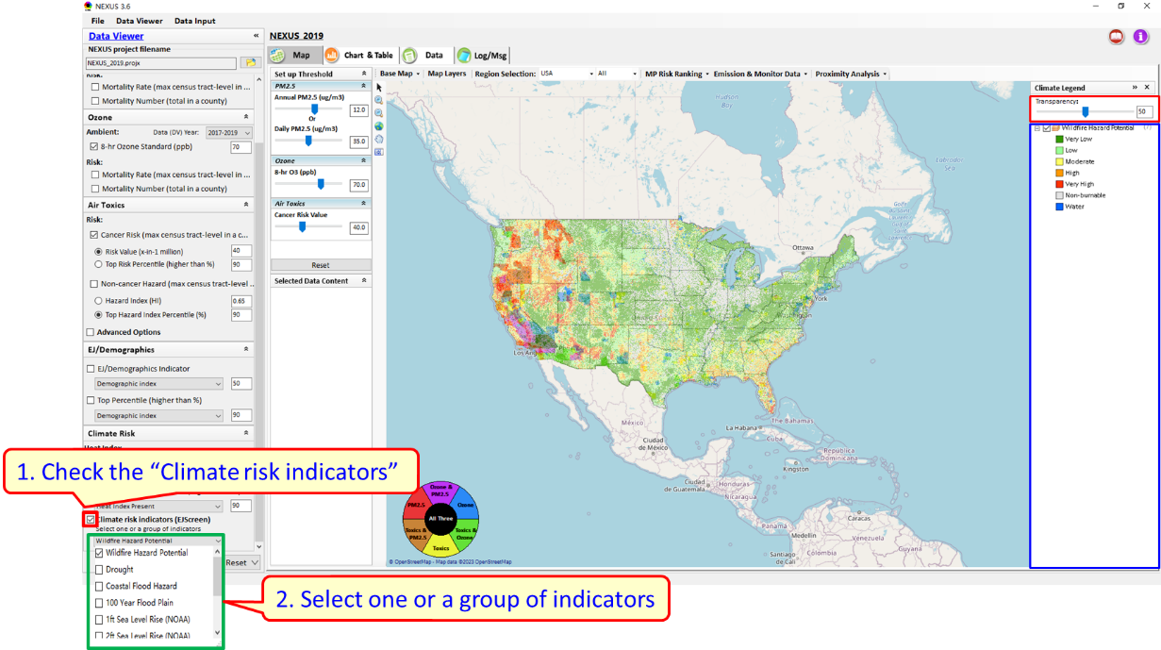
Figure 4-5 Example for Displaying Climate Risk Indicators

Note that all setup panels with a collapse icon mentioned above can be collapsed or expanded.
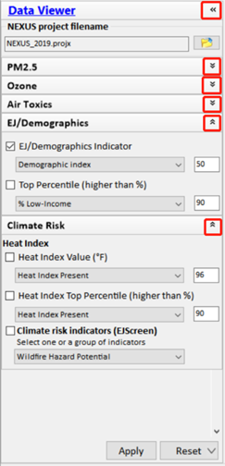
Figure 4-6 Example for Collapsing Setup Panel

Apply and Reset
After the input settings are completed, users can click the “Apply” button to apply the current settings and view the results immediately on the viewer panel. New settings will appear in the “Slider bars” panel and map display. “Slider bars” allows users to select & adjust “Ambient” and/or “Risk” threshold levels and display the color map. Users can also click the “Reset” button to reset all selected options to default. There are four options that users can choose to reset quickly if desired: (1) Set to default configuration; (2) Set all to risk-based default value; (3) Set all to risk-based default percentile; (4) Set all to risk-based desired percentile.
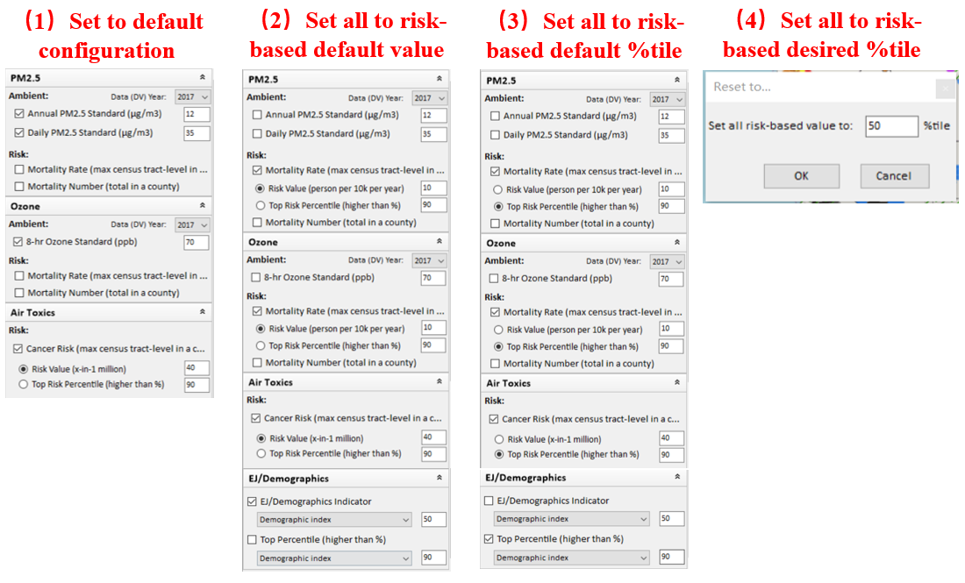
Figure 4-7 The Default Checked Indicators for Four Options
Figure 4-7 shows the default checked indicators for these four options, respectively.
“Set to default configuration” refers to the Ambient default value of PM_{2.5} and Ozone, and the Risk default value of air toxics;
- Annual PM_{2.5} Standard (μg/m³): 12
- Daily PM_{2.5} Standard (μg/m³): 35
- 8-hr Ozone Standard (ppb): 70
- Cancer Risk (Max census tract-level in a county) – Risk Value (x-in-1 million): 40
“Set all to risk-based default value” refers to the Risk default value of PM_{2.5}, ozone, and air toxic, and EJ/Demographics indicator default;
- PM_{2.5} Mortality Rate (Max census tract-level in a county) – Risk Value (person per 10k per year): 15
- Ozone Mortality Rate (Max census tract-level in a county) – Risk Value (person per 10k per year): 10
- Cancer Risk (Max census tract-level in a county) – Risk Value (x-in-1 million): 40
- EJ/Demographics - EJ/Demographics Indicator –Demographic Index: 50
- Climate Risk - Heat Index Value (℉) – Heat Index Present: 96
“Set all to risk-based default percentile” refers to the top 90% percentile for PM_{2.5}, ozone, and air toxic, and EJ/Demographics indicator;
- PM_{2.5} Mortality Rate (Max census tract-level in a county) – Top Risk Percentile (higher than %): 90
- Ozone Mortality Rate (Max census tract-level in a county) – Top Risk Percentile (higher than %): 90
- Cancer Risk (Max census tract-level in a county) – Top Risk Percentile (higher than %): 90
- EJ/Demographics – Top Percentile (higher than %) - Demographic Index: 90
- Climate Risk - Heat Index Top Percentile (higher than %) – Heat Index Present: 90
“Set all to risk-based desired percentile” refers the top X percentile for PM_{2.5}, ozone, and air toxic, and EJ/Demographics indicator, where X is a user-custom value (0~100).
- PM_{2.5} Mortality Rate (Max census tract-level in a county) – Top Risk Percentile (higher than %): X
- Ozone Mortality Rate (Max census tract-level in a county) – Top Risk Percentile (higher than %): X
- Cancer Risk (Max census tract-level in a county) – Top Risk Percentile (higher than %): X
- EJ/Demographics – Top Percentile (higher than %) - Demographic Index: X
- Climate Risk - Heat Index Top Percentile (higher than %) – Heat Index Present: X

Map
Under this module, users can identify areas with different air pollutant issues, based on the standard values setting. An area could have one of the issues — Air toxics, Ozone, PM_{2.5} (daily and/or annual), EJ, or Climate Risk, two of each, three of each, four of each, or all five. Areas with different kinds of issues will be displayed in unique colors, as the legend shows. Users can also perform different operations on a map (e.g., size-maximize or size-restore). When moving the mouse over a colored region on the map, a tip containing the county name and air pollutant issue associated with each county will be displayed as shown in Figure 4-8.

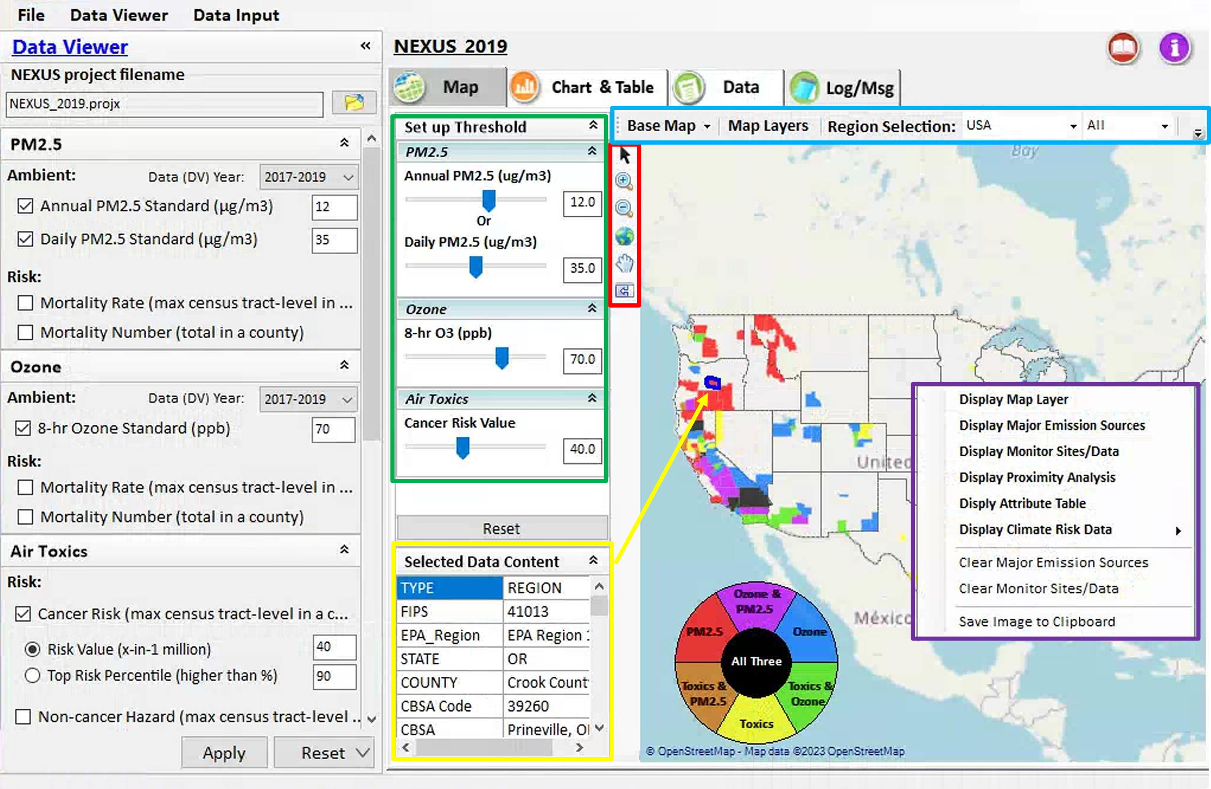
Figure 4-8 GUI of Map Module
- Setup Threshold: As shown in the green box in Figure 4-8, this module shows all the selected indicators that are set in the Data Viewer Settings. Users can change the standard value of pollutants and view the screening results.
- Selected Data Content: As shown in the yellow box in Figure 4-8, select a region by clicking on the map, the details of this region will be shown on this panel.
- Zoom and Map Control: As shown in the red box in Figure 4-8, this toolbox provides a series of map operation functions, including zooming in/out and panning the map display. For example, click the sign and then click a location of interest on the map to zoom in, or drag a rectangle to the area of interest on the map to zoom in to the selected area. Of course, you can also navigate by clicking and dragging the map to pan or using your mouse wheel to zoom.
- Right-click Menu: As shown in the purple box in Figure 4-8, right-click the map and it will pop up. It includes “Display Map Layer”, “Display Major Emission Sources”, “Display Monitor Sites/Data”, “Display Proximity Analysis”, “Display Attribute Table”, “Display Climate Risk Data”, and “Clear Major Emission Sources”, “Clear Monitor Sites/Data”, and “Save Image to Clipboard” options. Click “Display Map Layer” to show or hide the map layer panel, the checked layer will be added to the map. Click “Display Major Emission Sources” to open a “Source/Sector Emissions” window and load the facilities to the map. Click it again or click “Clear Major Emission Sources”, the window and those drawings from the map for facilities will be removed. The “Display Monitor Sites/Data” function is similar to “Display Major Emission Sources”. The difference is that “Display Monitor Sites/Data” shows the monitoring data. Select a county on the map, and then click “Display Proximity Analysis”, it will navigate to the proximity analysis module. “Display Attribute Table” to open an “Attribute Table” window. “Display Climate Risk Data” to view one or more climate risks (the functionality of this option is detailed in 4.1.6 Set up threshold for Climate Risk). More details about the first five modules will be also given in the following sections. Click “Save Image to Clipboard” to save the current map to the clipboard.
- Map Screening Analysis: As shown in the blue box in Figure 4-8, it provides a series of functions for map screening analysis, including Base Map, Map Layers, Region Selection, MP Risk Ranking, Emission & Monitor Data, and Proximity Analysis. Note that the last three functions will be folded in the drop-down list when the width of the main window is not wide enough to show these menus, as shown in Figure 4-9.
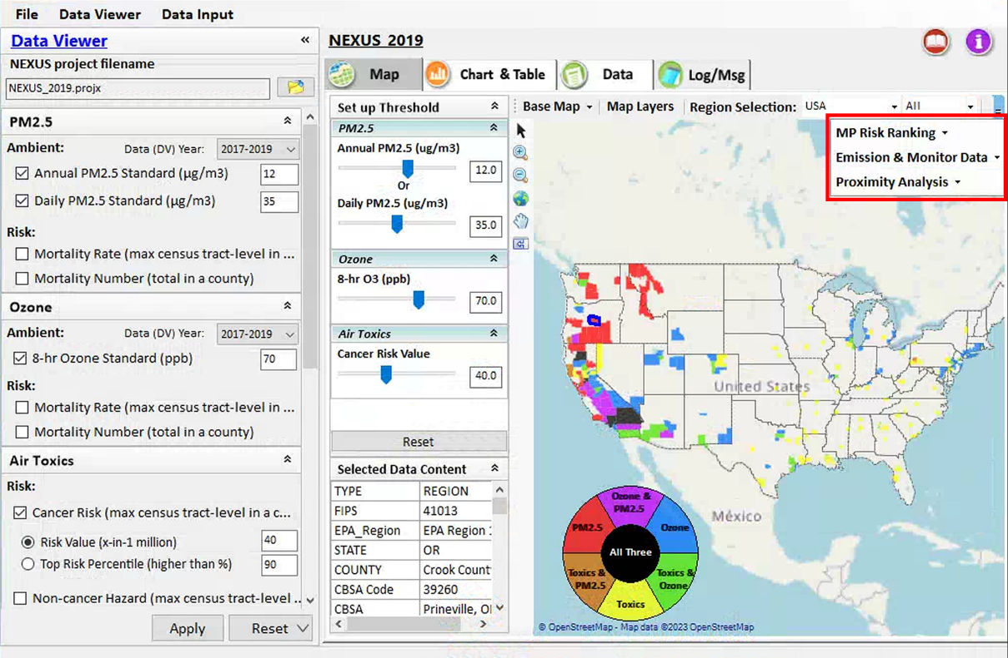
Figure 4-9 The Drop-down List of the MAP Module
- Base Map: The base map is the map that is beneath all the other layers in the app. Users are allowed to select online base maps or boundary lines for map display from the drop-down list. “State” boundary lines and “OpenStreetMap” online map are the default display.
- Map Layers: Users can click on different nodes to show/hide layers of boundary lines (e.g., EPA Region, State, CBSA, and County), various areas (e.g., non-attainment areas, advance areas, tribal areas, etc.), and AQ metrics (including PM_{2.5}, Ozone, Air Toxic, EJ/Demographic, and Climate/Heat Index).
- Region Selection: Users are allowed to select a region (“EPA regions”, “States”, or “CBSA” as shown in Figure 4-10) to zoom through the drop-down list.
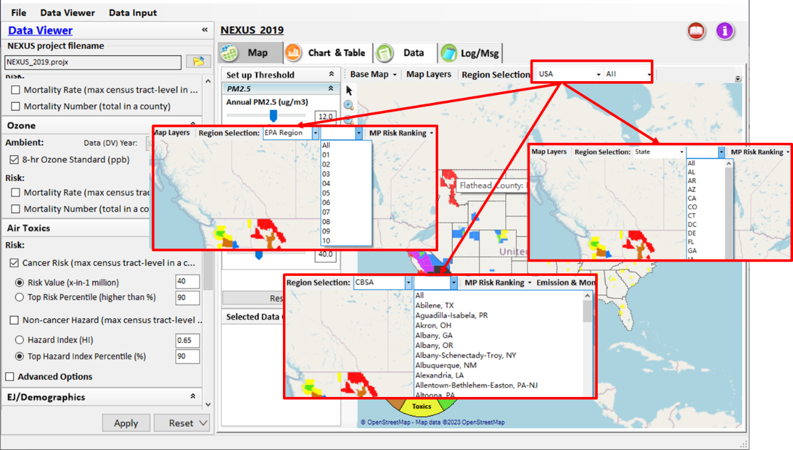
Figure 4-10 Select EPA Region/State/CBSA
- Legend Controls: The colored circle bar in the lower-left corner of the map identifies the air quality or EJ issues or Heat Index in different colors. More detailed customization of the map display legend is available in the configure window by clicking on the legend. As shown in Figure 4-11, users can both select the color series for display and customize the color and transparency for a single piece in the configure window.
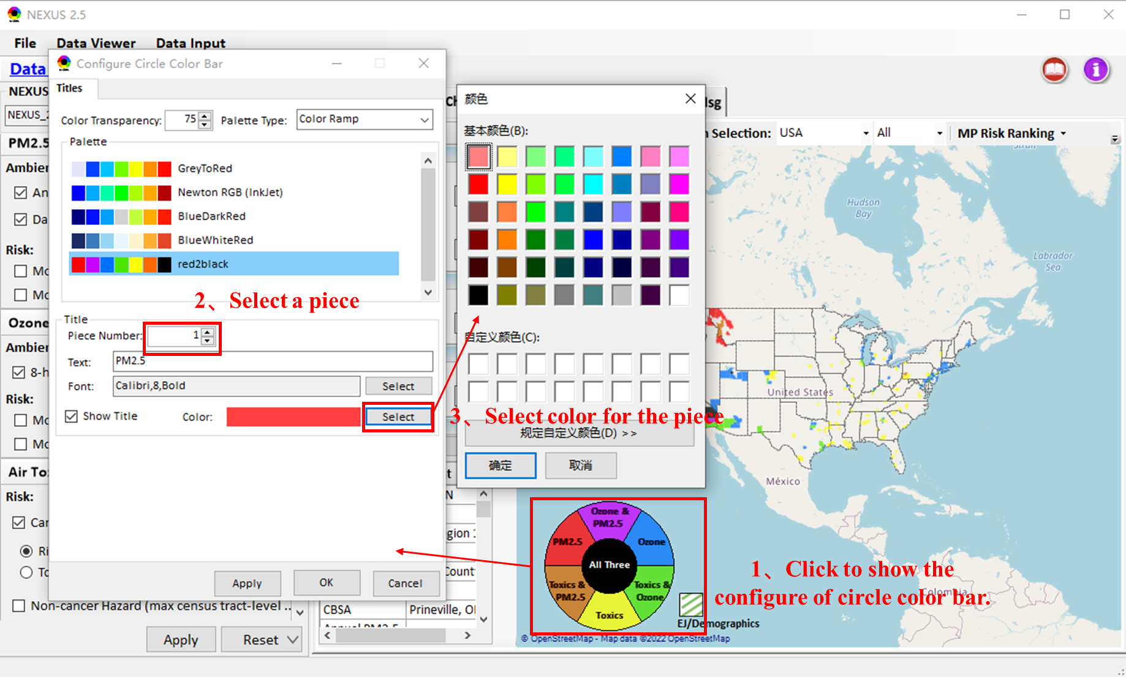
Figure 4-11 Configure Window of Circle Color Bar

MP Risk Ranking
As shown in Figure 4-12, under the drop-down list of "MP Risk Ranking", it provides functions of “CBSA Risk Ranking”, “Top Risk Percentile based on Nation” and “Top Risk Percentile based on Selected Region”.
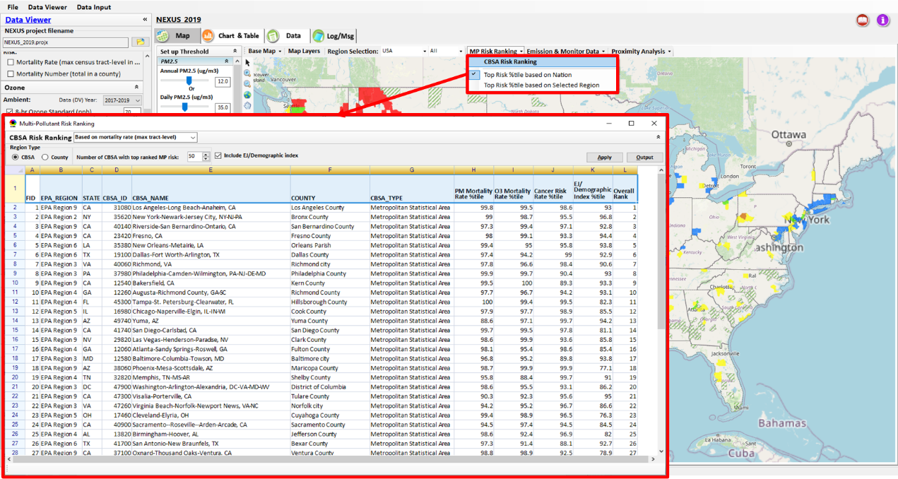
Figure 4-12 The Interface of the MP Risk Ranking Module

CBSA Risk Ranking
Click the “CBSA Risk Ranking” button to show the multi-pollutant risk ranking window, as shown in Figure 4-12. The details of this function are given as follows:
- CBSA Risk Ranking: In the drop-down list, there are two options to rank: “Based on mortality rate (max tract-level)” and “Based on mortality number”. “Based on mortality rate (max tract-level)” means that “Risk Ranking” is calculated by mortality rate based on max tract-level. “Based on mortality number” means that “Risk Ranking” is calculated by mortality number based on max tract level.
- Region Type: “CBSA” and “County” options are available. If the user checks “County”, the data in the worksheet will be ranked from highest to lowest risk for each county. If the user checks “CBSA”, duplicate CBSA will be filtered out, showing only the highest-risk counties in each CBSA.
- Number of CSBA/County with Top-ranked MP Risk: Users can set a specified number of CSBA/County (these are arranged in ascending order of MP risk) by clicking the up and down arrow or inputting a number. The default value is 50, which means that the top 50 regions with the largest MP risk will be listed.
- Include EJ Index: Check this if you want to include the EJ index (percentile).
- Apply: After the above settings are completed, users can click the “Apply” button to apply the current settings and view the results immediately on the panel.
- Output: Click the “Output” button to export the current pager record as an excel file (*.xlsx).

Top Risk Percentile Based on Nation
This menu indicates those top risk percentile metrics under the “Setup Threshold” are calculated based on “Nation” (the whole US). This option is checked by default.

Top Risk Percentile Based on the Selected Region
This menu indicates those top risk percentile metrics under the “Setup Threshold” are calculated based on the selected region specified in “Region Selection”. Note that if no top risk percentile metrics are used under the “Setup Threshold”, the results shown on the map are the same as “Top Risk Percentile based on Nation”.

Emission and Monitor Data
As shown in Figure 4-13, users can click the “Emission & Monitor Data” button, there are four options in the drop-down list, including “Display Emission Sources”, “Display Monitor Sites/Data”, “Clear Emission Sources” and “Clear Monitor Sites/Data” (Similar to “Right-click” menu on map).

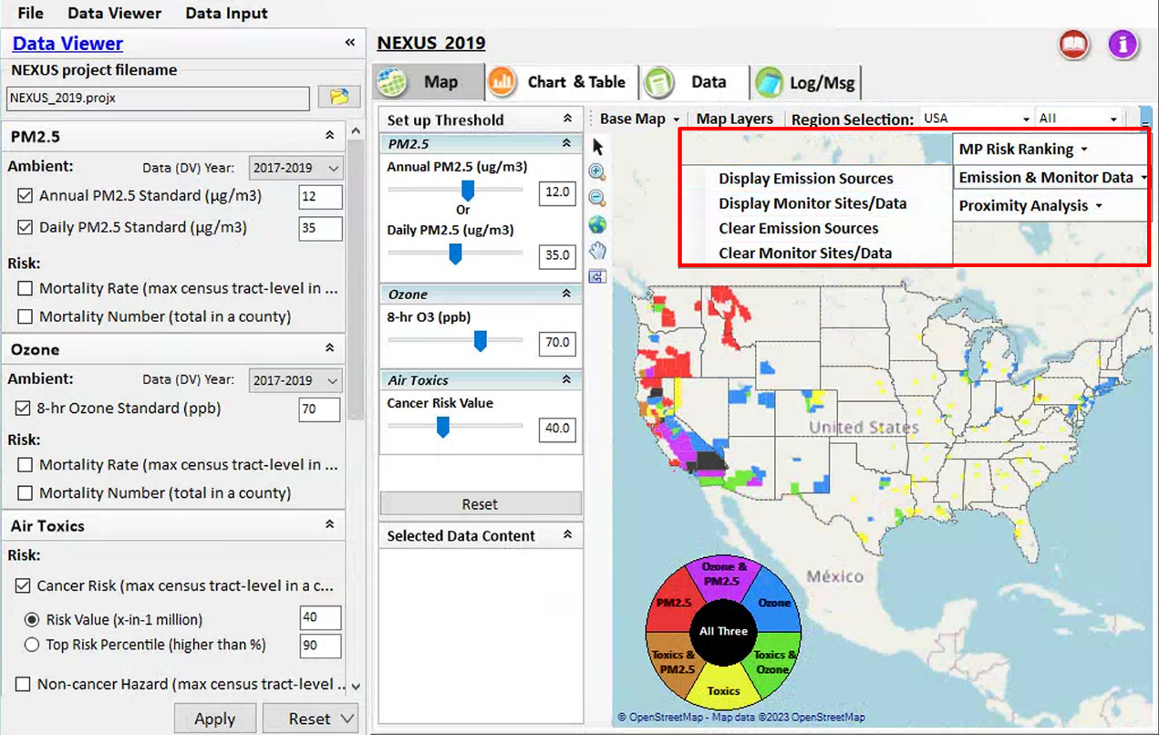
Figure 4-13 The Drop-down List of the Emission & Monitor Data Module

Display Emission Sources
Users can launch a new window by clicking the “Display Emission Sources” button. It includes the functions of “Major Point Sources”, “Source Category Emissions”, “Top X Emission Sources” and “Sector Emission Summary”.

Major Points Sources
This module provides a function to list the top x facilities ordered by emission of pollutants and supports overlaying the selected facility on the map. As shown in Figure 4-14, the same facility can be easily identified with the highlighted color under the checked pollutant lists when the mouse moves over the facility information panel. And users can click any “facility” to link and display source location and emission information on the map. Users can also click on the sources/monitors on the map to highlight them in the pop-up window.

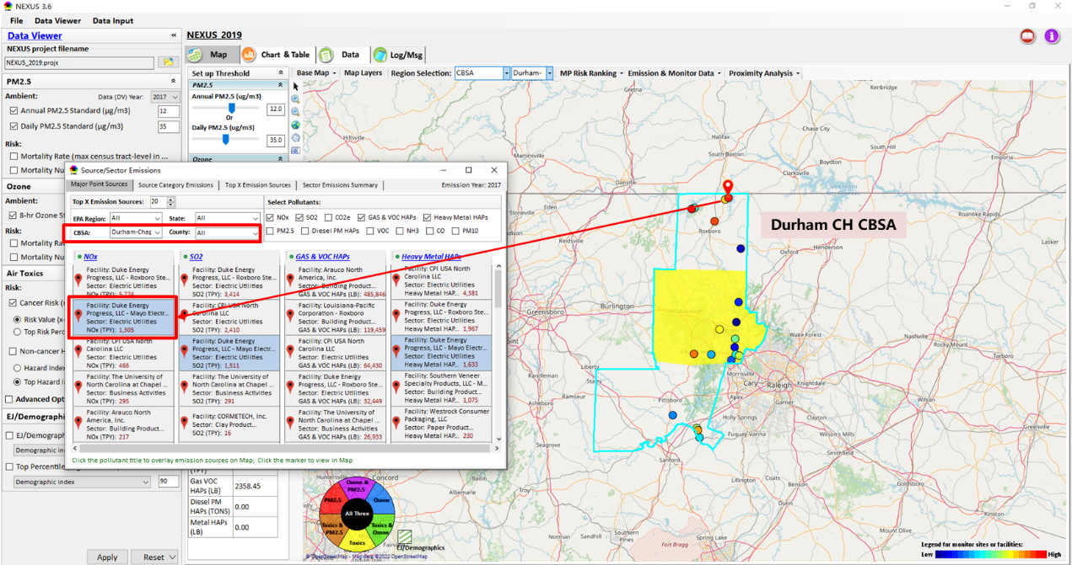
Figure 4-14 Major Points Sources Option-1
Click on the sources/monitors on the map will highlight them in the pop-up window
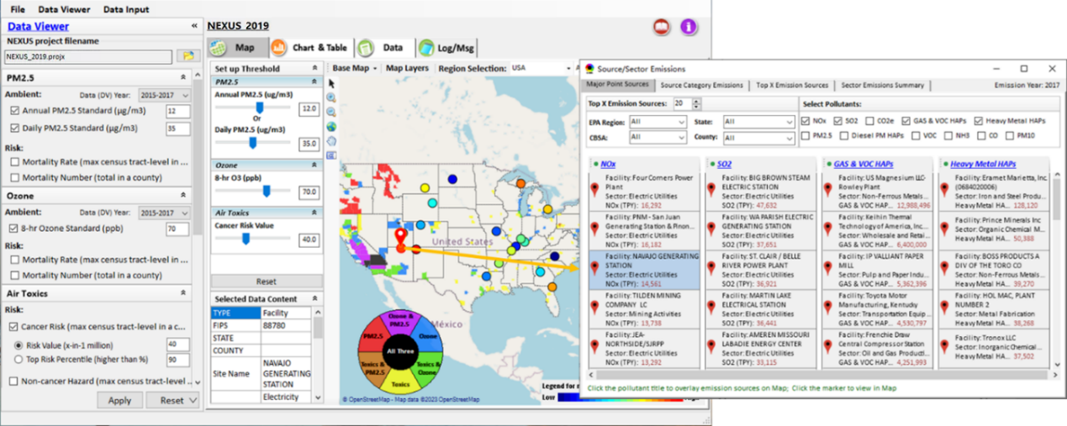
Figure 4-15 Highlight Sources/Monitors in the Pop-up Window by Clicking on the Map

- Top X Emission Sources: As shown in the green box in Figure 4-16, users can select a specified number of point emission sources (these are arranged in ascending order of emissions) by clicking the up and down arrow or inputting a number. The default value is 20, which is to screen the top 20 emission sources with the largest emissions.
- Region Selection: As shown in the red box in Figure 4-16, it supports filtering the facilities by specifying EPA Region, State, CBSA, or County.
- Select Pollutants: As shown in the blue box in Figure 4-16, it supports filtering the facilities by selecting the contaminants of different species.
- Hyperlink for Pollutants: As shown in the purple box in Figure 4-16, users can click the pollutant title to overlay emission sources on Map.
- Legend for Emission Sources on Map: The Legend (lower right, Figure 4-16) shows what the colors mean. Darker red indicates higher emissions, and darker blue indicates lower emissions.
- Tooltip for Facility Details: Move the mouse pointer to the Facility panel and pause for about 1 second, then the hover box with facility details appears.
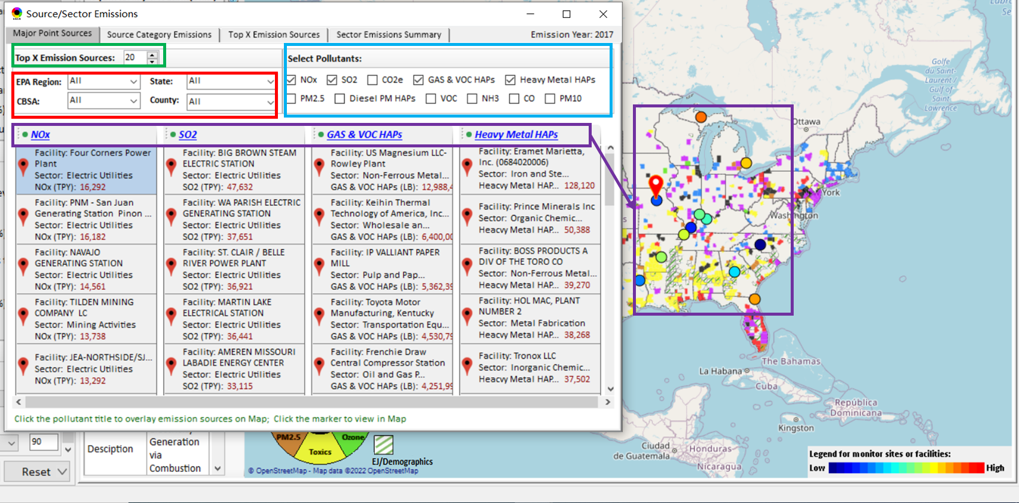
Figure 4-16 Major Points Sources Option-2

Source Category Emissions
As shown in Figure 4-17, this module provides emission data from five source categories, including “Point”, “Non-Point”, “On-Road”, “Non-Road”, and “Event” emissions for the selected region. The region selection supports to select by EPA Region, State, CBSA, and County. Note that “Resident Wood Combustion” will be listed separately below “Non-Point”.

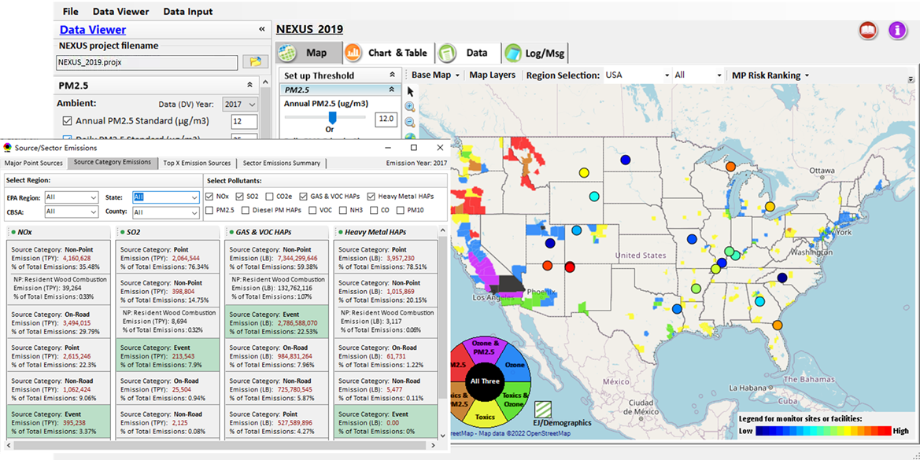
Figure 4-17 Source Category Emissions Option

Top X Emission Sources
As shown in Figure 4-18, this module filters the pollutant emission sources by providing selections of pollutant, facility or source category, and region, and displays the filtering results in the chart. Users can also click on a specified emission source marker in the result list to view it on the map.
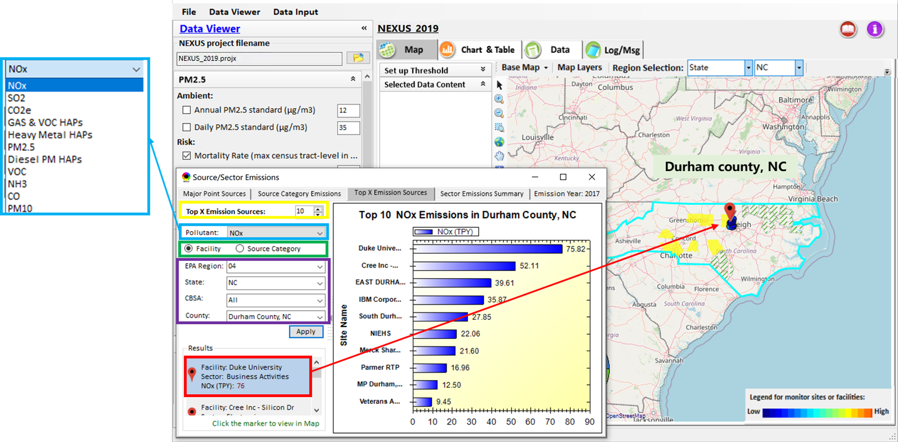
Figure 4-18 Top X Emission Sources Option
- Top X Emission Sources: As shown in the yellow box in Figure 4-18, users can set a specified number of pollutant emission sources (these are arranged in ascending order of emissions) by clicking the up and down arrow or inputting a number. The default value is 10, which is to screen the top 10 pollutant emission sources with the largest emissions.
- Pollutant Selection: As shown in the blue box in Figure 4-18, users can select a pollutant (NO_{x}, SO₂, CO₂e, GAS&VOC HAPs, Heavy Metal HAPs, PM_{2.5}, Diesel PM HAPs, VOC, NH₃, CO, PM₁₀) to view the emission sources of the pollutant.
- Facility or Source Category: As shown in the green box in Figure 4-18, it provides a selection of “facility” or “source category”. Users can choose to filter pollutant emission sources by facility or source category.
- Region Selection: As shown in the purple box in Figure 4-18, it supports filtering the pollutant emission sources by specifying EPA Region, State, CBSA, or County.

Sector Emission Summary
As shown in Figure 4-19, this module provides source and sector emissions summary for selected EPA Region, State, CBSA, or County regions to support OAQPS’s “Sector Prioritization” project effort. It also allows users to generate summary tables and summary plots based on selected regions.
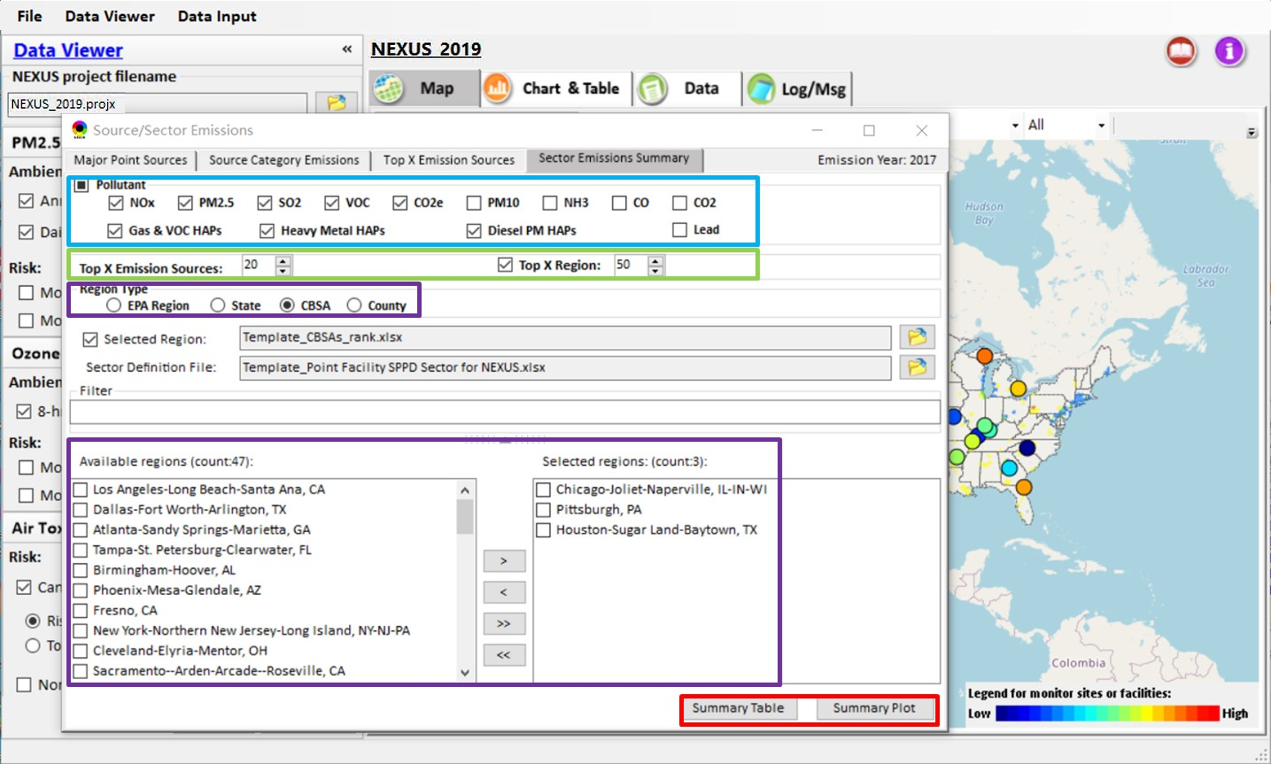
Figure 4-19 The Function of Sector Emission Summary
- Pollutant: As shown in the blue box in Figure 4-19, users can select one or more pollutants (NO_{x}, PM_{2.5}, SO₂, VOC, CO₂e, PM₁₀, NH₃, CO, CO₂, GAS&VOC HAPs, Heavy Metal HAPs, Diesel PM HAPs, Lead) to output sector emissions summary.
- Top X Emission Sources/Region: As shown in the green box in Figure 4-19, users can select a specified number of emission sources and regions (these are arranged in ascending order of emissions) by clicking the up and down arrow or inputting a number. The default value is 20 and 50, respectively. Note that “Top X Regions” option only works for the “Selected Region” option.
- Region Selection: As shown in the purple box in Figure 4-19, this selection specifies the region type (EPA Region, State, CBSA, or County). If users check the “Selected Region” option and input a risk ranking region file, the available regions panel will list the top x regions (the number is set in Top X Emission Regions) from the input file. This input file can be output from “CBSA Risk Ranking” module.
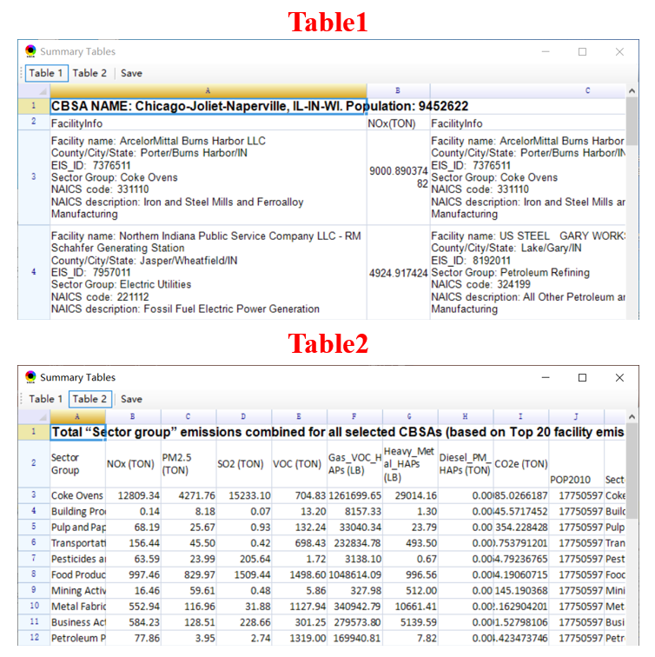
Figure 4-20 The Summary Table
- Summary Table: As shown in Figure 4-20, the “Summary Table” supports to display of emissions by specified sectors at selected regions first and then provides a function to output these data to Excel format tables. Table 1 shows detailed information and emissions for the top X facilities in the selected regions. Table 2 shows the emissions of the top X sectors in each selected region, calculating the frequency of occurrence of facilities belonging to that sector and their evaluation indicators: “score” (calculated by frequency and rank of the sector).
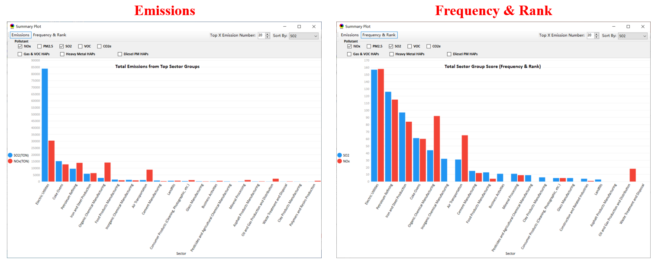
Figure 4-21 The Summary Plot-1
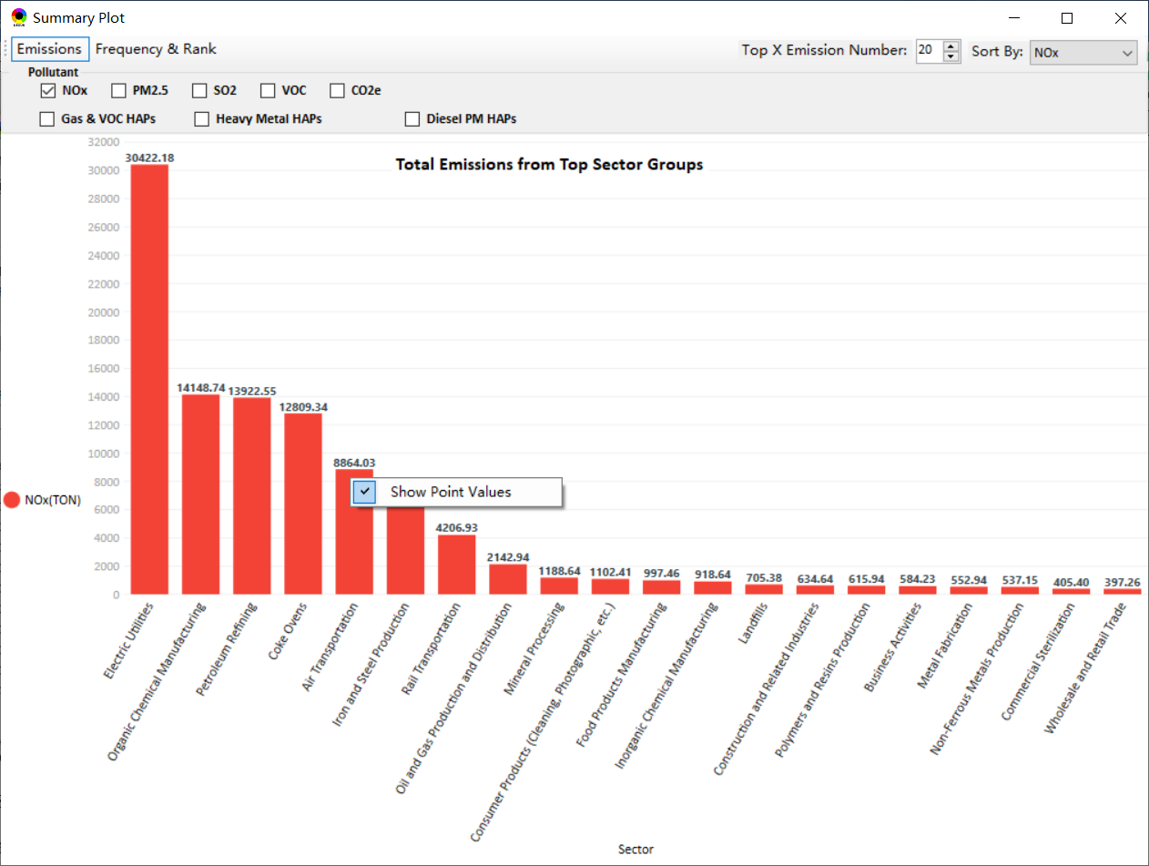
Figure 4-22 The Summary Plot-2
- Summary Plot: As shown in Figure 4-21, the “Summary Plot” allows users to display a plotting window for the top X sector group's total emissions and score. As shown in Figure 4-22, users can select one or more pollutants and the number of the sector to plot. In the drop-down list of “Sort by:”, users can select a pollutant and the bar will sort by the emission of the selected pollutant in descending order of emissions. And click “Show Point Values” through the right menu, data labels will be displayed on the plot.

Display Monitor Sites/Data
As shown in Figure 4-13, users can click the “Emission & Monitor Data” button, then click the “Display Monitor Sites/Data” menu in the drop-down list to open the “Monitor Sites/Data Table” window as shown in Figure 4-23. This module displays monitor sites on a map and displays monitor data on the window, and allows users to view the trend plot of pollutants for the selected monitor site.
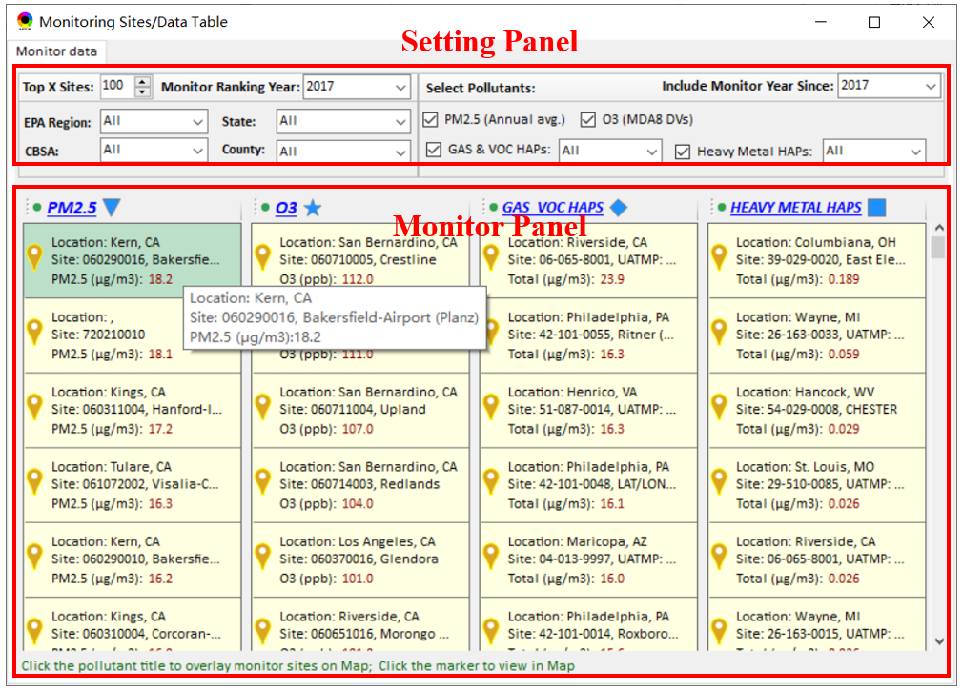
Figure 4-23 The “Monitor Sites/Data Table” Window
The Setting Panel as shown in Figure 4-23 supports the following functions:
- Top X Sites: Users can set the X value by clicking the up and down arrow or inputting a number, to display the top X sites in concentration rank. The default value is 100.
- Monitor Ranking Year: Users can select a year in the drop-down box, and the species concentration in the Display Panel will be sorted according to the data from the current year of selection.
- Include Monitor Year Since: Users can select a year in the drop-down box, it supports filtering the monitoring points that have data for the current year of selection and subsequent years.
- Region Selection: It supports filtering sites by specifying EPA Region, State, CBSA, or County.
- Pollutant Selection: Users can select one or more pollutants (PM_{2.5}, O₃, GAS&VOC HAPs, Heavy Metal HAPs) to be displayed. At the same time, specific species of GAS&VOC HAPs and heavy metal HAPs can be selected.
In Monitor Panel as shown in Figure 4-23, the explanations are as follows:
- Tooltip for Monitor Details: Move the mouse pointer to the Monitor Panel and pause for about 1s, then the hover box with monitor site details appears.
- Symbol for Pollutants: In the Monitor Panel, the symbol next to the pollutant name indicates the symbol displayed on the map. The inverted triangle represents PM_{2.5}, the five-pointed star represents O₃, the diamond represents GAS VOC HAPS, and the square represents Heavy Metal. Users can click on the pollutant name to show the concentration of the pollutant at the monitoring site on the map.

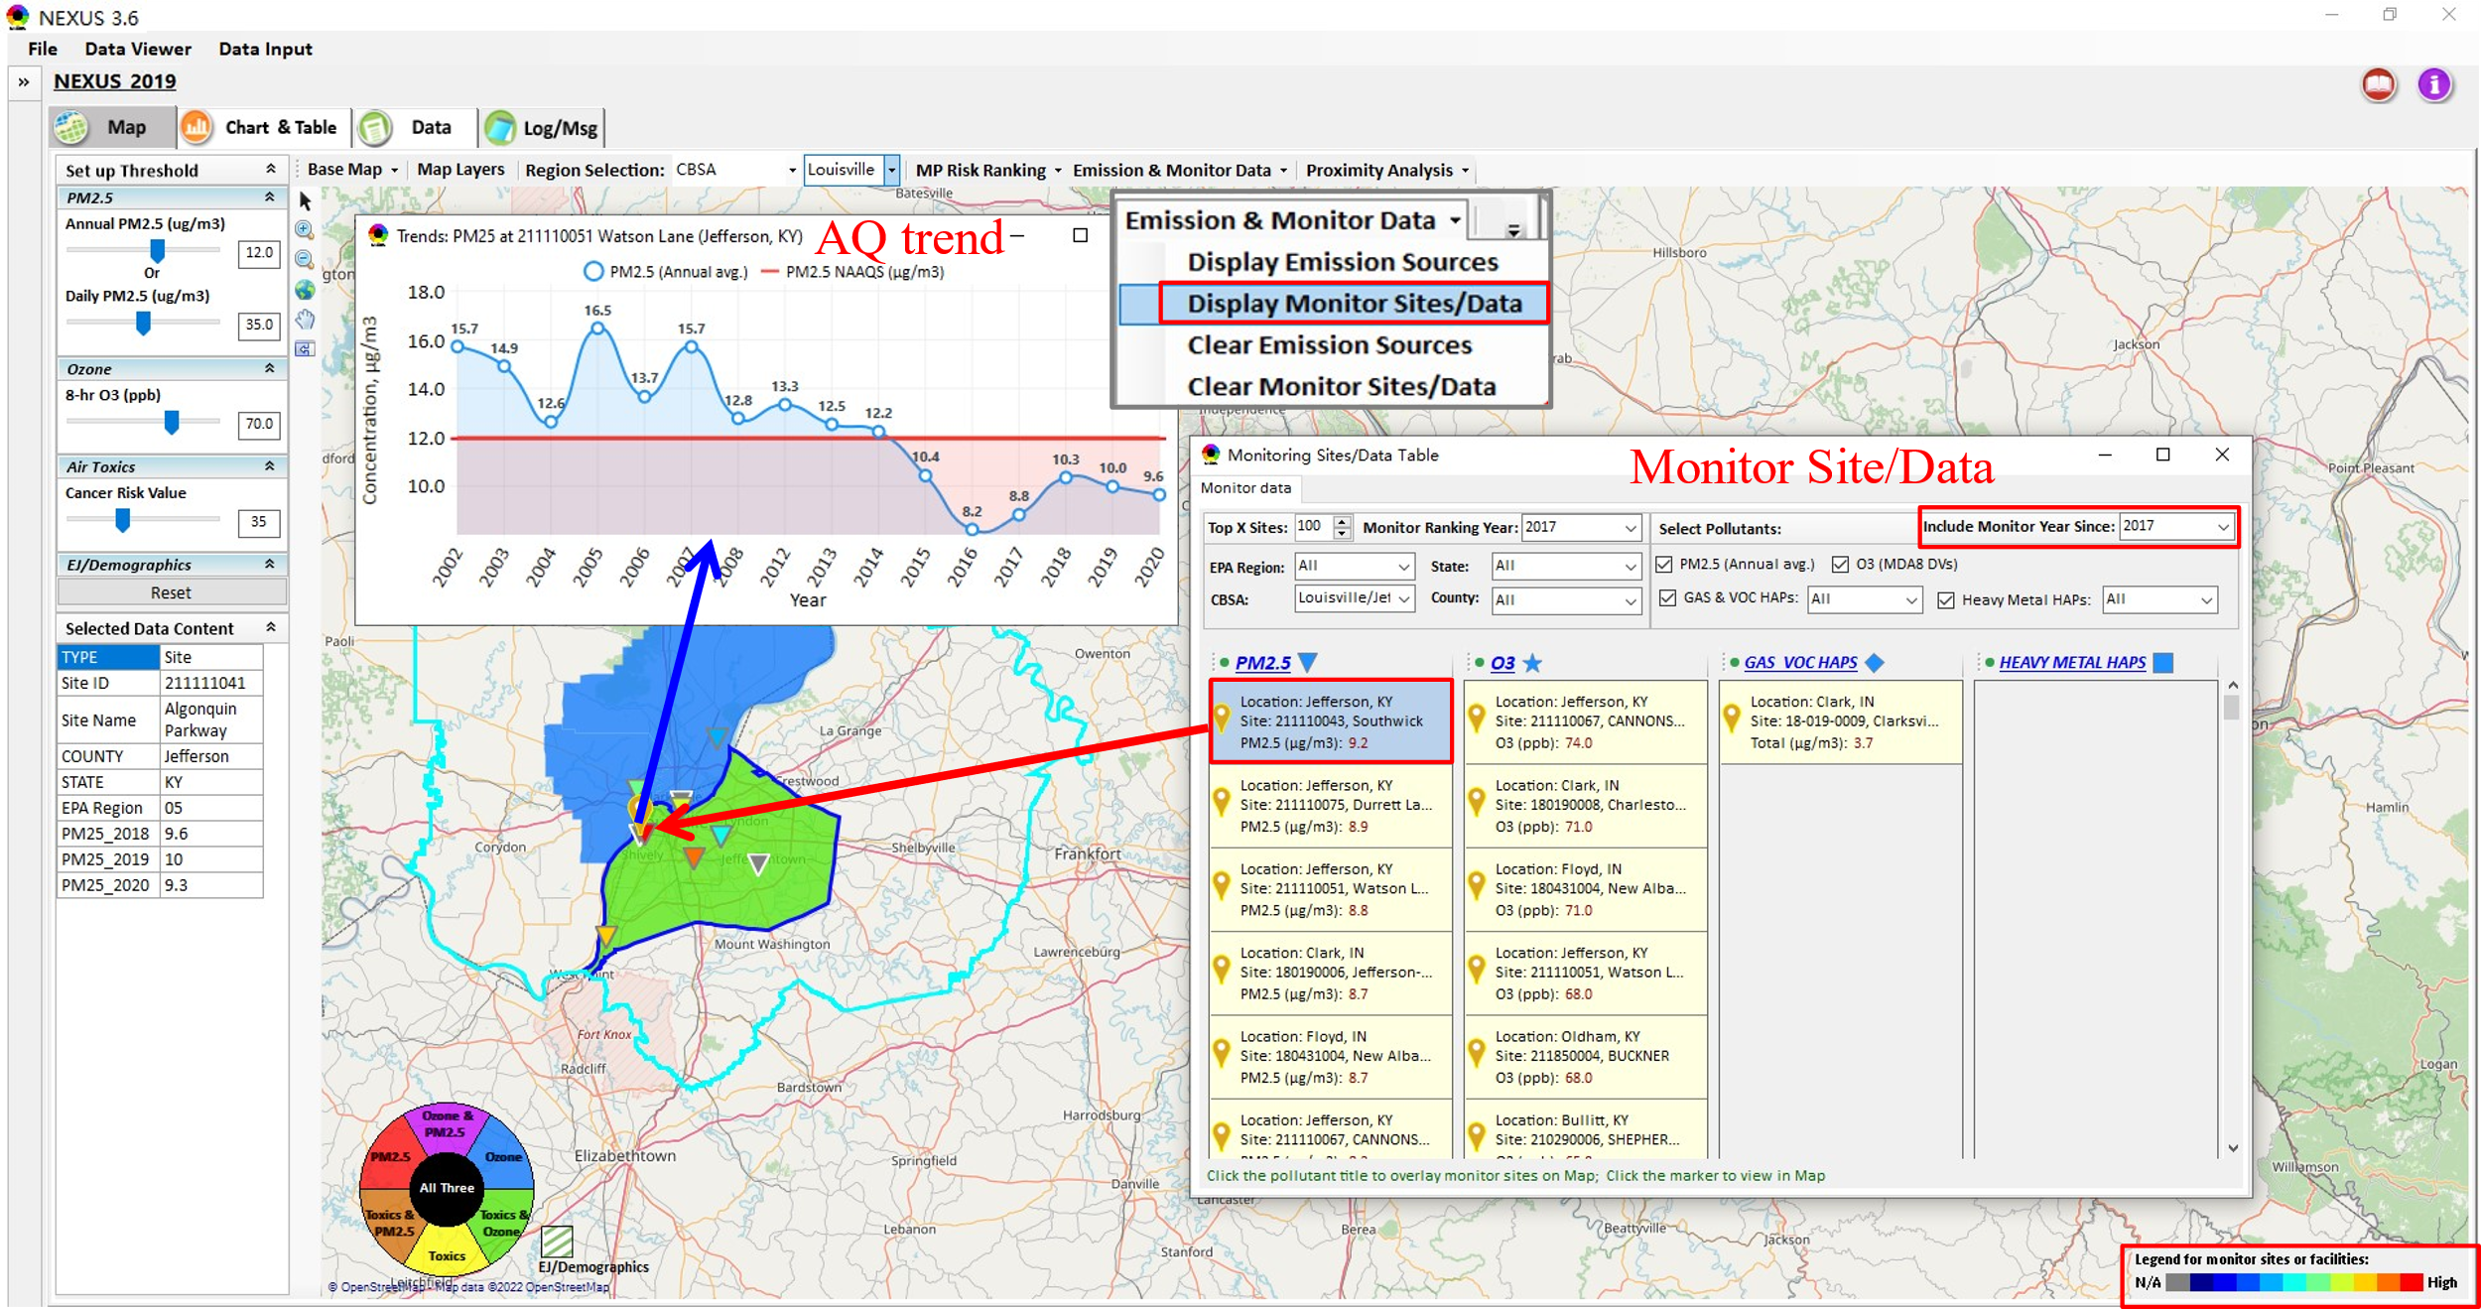
Figure 4-24 The Map and the Trend Plot of the Selected Monitor Site
- Legend for Monitor on Map: The Legend (lower right, Figure 4-24) shows what the colors mean. Darker red indicates higher concentration, darker blue indicates lower concentration, and gray indicates N/A (without value).
- Trend Plot for Monitor Sites: As shown in Figure 4-24, when clicking on one site on the Monitor Panel, a gold marker will be displayed on the map. Then users can click the monitor site (the golden marker) on the map to display the concentration trend plot of the selected pollutant.

Clear Emission Sources
As shown in Figure 4-13, users can click the “Emission & Monitor Data” button, then click the “Clear Major Emission Sources” tab in the drop-down list to clear emission sources from the map.

Clear Monitor Sites/Data
As shown in Figure 4-13, users can click the “Emission & Monitor Data” button, then click the “Clear Monitor Sites/Data” tab in the drop-down list to clear monitor sites from the map.

Proximity Analysis
This module provides proximity and spatial analysis capabilities with a higher resolution (census tract level). A census tract is a small subdivision of a county. Census tracts usually have around 4,000 people. As shown in Figure 4-25, there are three ways to navigate to this module, (a) double-click the marker icon of a facility or monitor site; (b) click a facility, monitor site, or a polygon with filled color, and then right-click on the map and select “Display Proximity Analysis”, and (c) click the “Display Proximity Analysis” button in the drop-down list of “Proximity Analysis” when selecting a facility, monitor site or a polygon with filled color on the map.
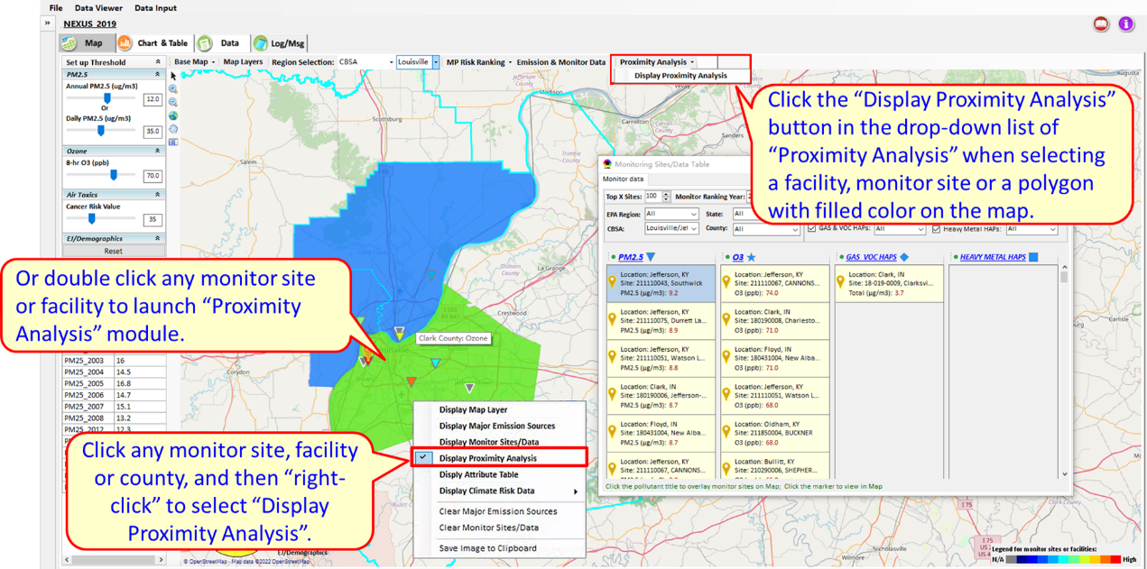
Figure 4-25 Three Ways to Display Proximity Analysis Module

Basic functions of Proximity Analysis
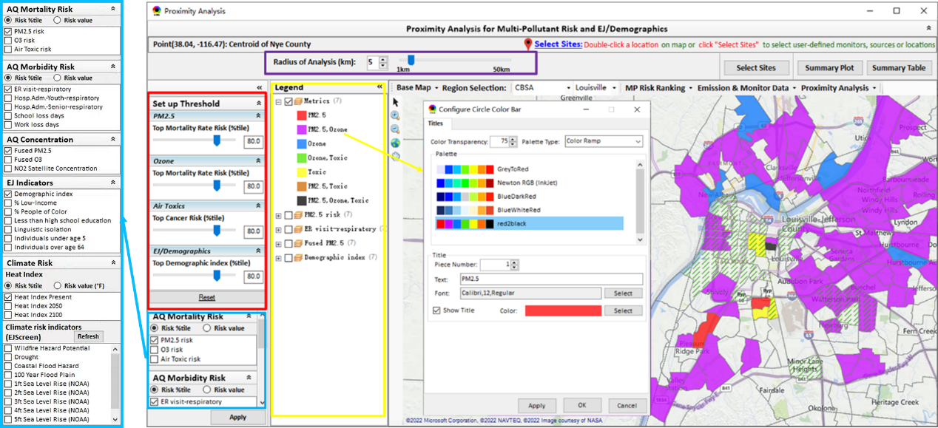
Figure 4-26 The Proximity Analysis Module
- Setup Threshold: As shown in the red box in Figure 4-26, the “Setup Threshold” panel allows users to identify those geographic areas exceeding the selected thresholds. This is similar to the Data Viewer module, but the difference is that this module is screening for census tract data. Click the “Reset” button to reset all values to default (or to a specified percentile if all indicators are selected in percentile).
- Overlaying Map: As shown in the blue box in Figure 4-26, the AQ Mortality Risk, AQ Morbidity Risk, AQ Concentration, EJ indicators, and Climate Risk configurations provide metric selections to overlay the MP, EJ analysis map, and/or Heat Index map, and it provides a “toggle” choice to select “Risk percentile” or “Risk value”.
- Legend: As shown in the yellow box in Figure 4-26, users can check (uncheck) to show (hide) an overlaying map. Click the color block icon, and open the “Configure Circle Color Bar” to configure the legend color & transparency.
- Radius of Analysis: As shown in the purple box in Figure 4-26, users can click the up and down arrows or slide the pointer to adjust the analysis radius.
- Region Selection: Users are allowed to select a region (“EPA regions”, “States”, or “CBSA” as shown in Figure 4-26) to zoom through the drop-down list.
- Map Layers menu: As shown in Figure 4-27, users can show/hide map overlays of “CEJST-Disadvantaged Areas”, “PM2.5 Non-attainment Areas”, etc.
Show Detailed Information: As shown in Figure 4-28, click a facility or monitoring site or a census tract to show the detailed information.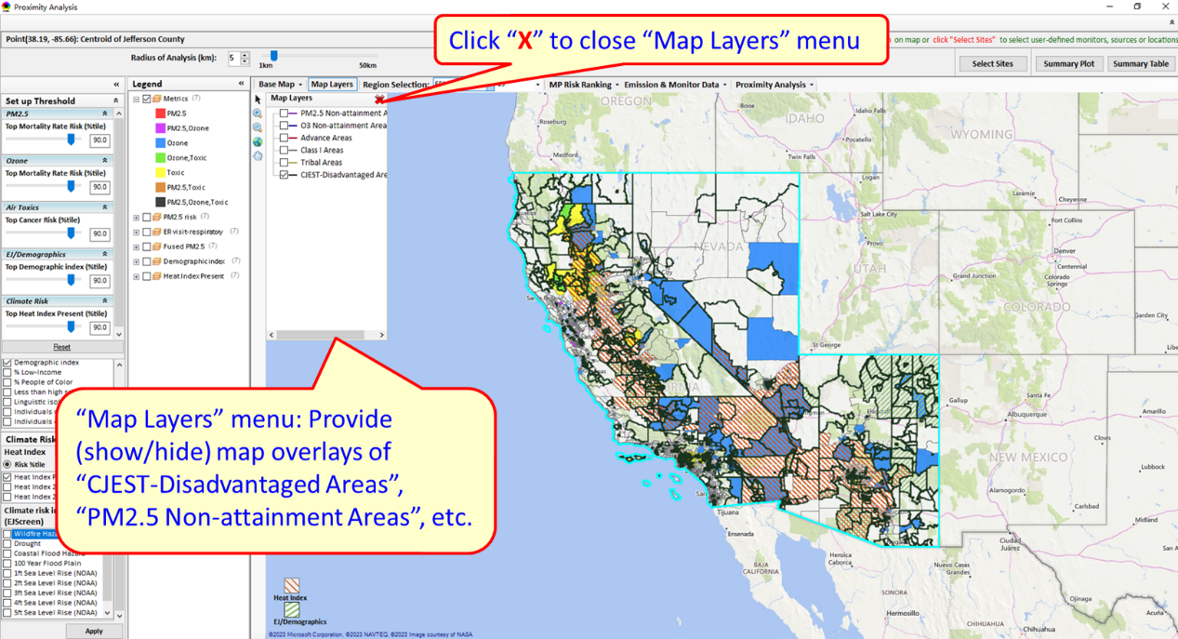
Figure 4-27 Map Layers Menu
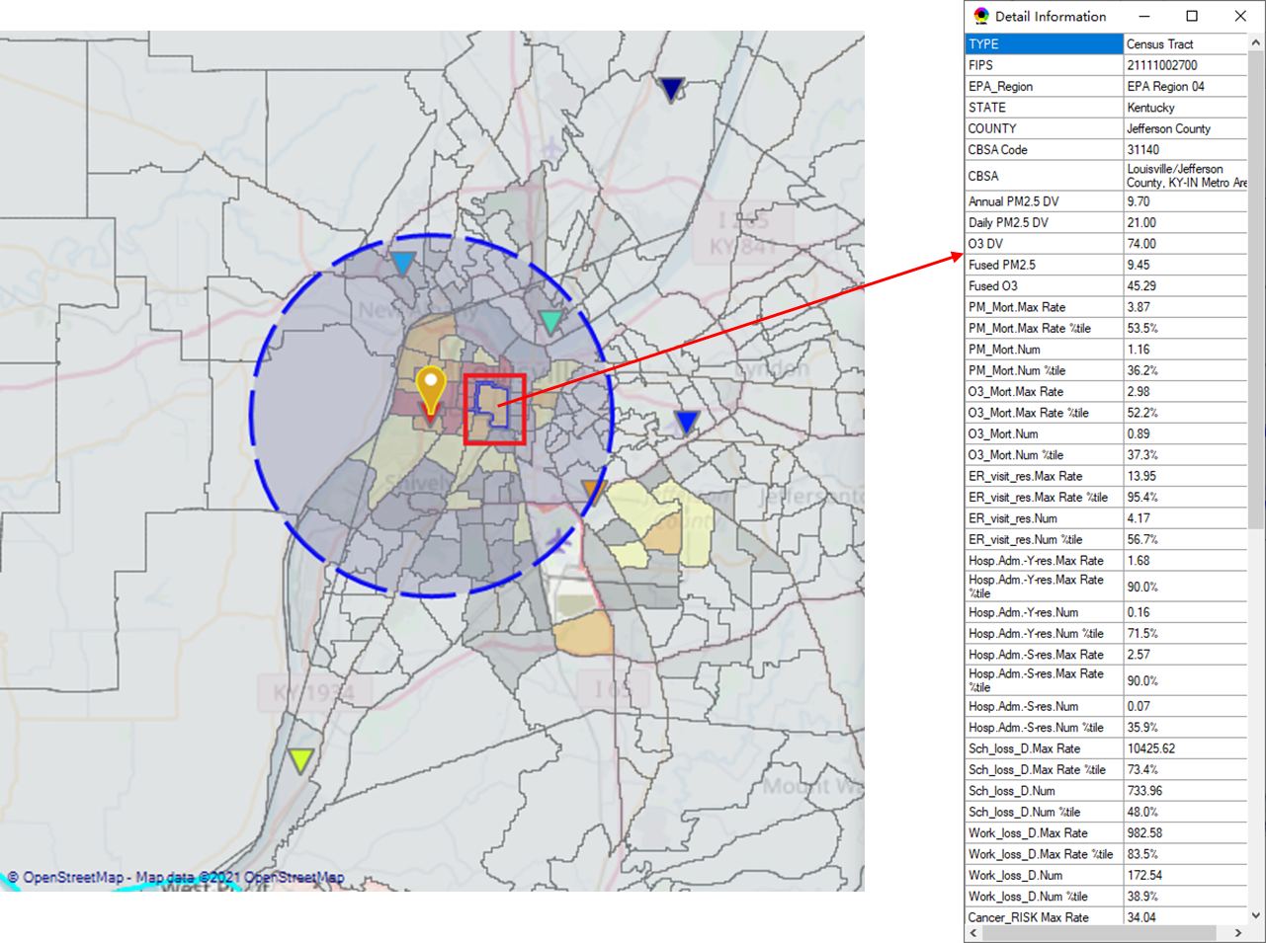
Figure 4-28 Show Detailed Information by Clicking

Select Sites
As shown in the red box in Figure 4-29, users are allowed to double-click a facility or a monitor site or a census tract to select a point for proximity analysis. To conduct proximity analysis for one or more locations, users can also click “Select Sites” to navigate to the “Select Sites” window for more custom settings. There are four options for “Select Sites”, (1) Select one or a group of monitor sites, (2) Select one or a group of sources/facilities, (3) Select one or a group of CEJST-Disadvantaged communities, (4) Select user-defined locations.
- “Select one or a group of monitor sites” option:
- Select the type of monitor sites;
- Check those monitor sites of interest from the left panel;
- Click the “>” button or “>>” to move those monitor sites of interest to the right panel;
- Click “Apply”.
- “Select one or a group of sources/facilities” option:
- Select one or more sector groups of facilities;
- Check those facilities of interest from the left panel;
- Click the “>” button or “>>” to move those facilities of interest to the right panel;
- Click “Apply”.
- “Select one or a group of CEJST-Disadvantaged communities:
- Select CEJST census tracts via the “Filter” function;
- Check those communities of interest from the left panel;
- Click the “>” button or “>>” to move those communities of interest to the right panel;
- Click “Apply”.
- “Select user-defined locations” option:
This option includes “Census tracts” and “Latitude/Longitude” options.
- “Census tracts” option:
- Select those census tracts of interest into the left list panel by clicking them on the map;
- Choose one or a group of census tracts to the right panel by clicking “>” or “>>”; Note that, “>” will move those checked items in the left panel to the right panel, while “>>” will move all sites from the left to the right panel; “<” will clear those checked items from the right panel, while “<<” will clear all sites from the right panel;
- Click the “Apply” button to conduct proximity analysis.
- “Latitude/Longitude” option:
- Input one or a group of Latitude/Longitude of interest in the textbox. Note that the input latitude/longitude should be separated by commas and each point should be separated by semicolons, e.g., 30.01, -90.61; 30.26, -90.95; 30.51, -91.23.
- Click “Apply”.
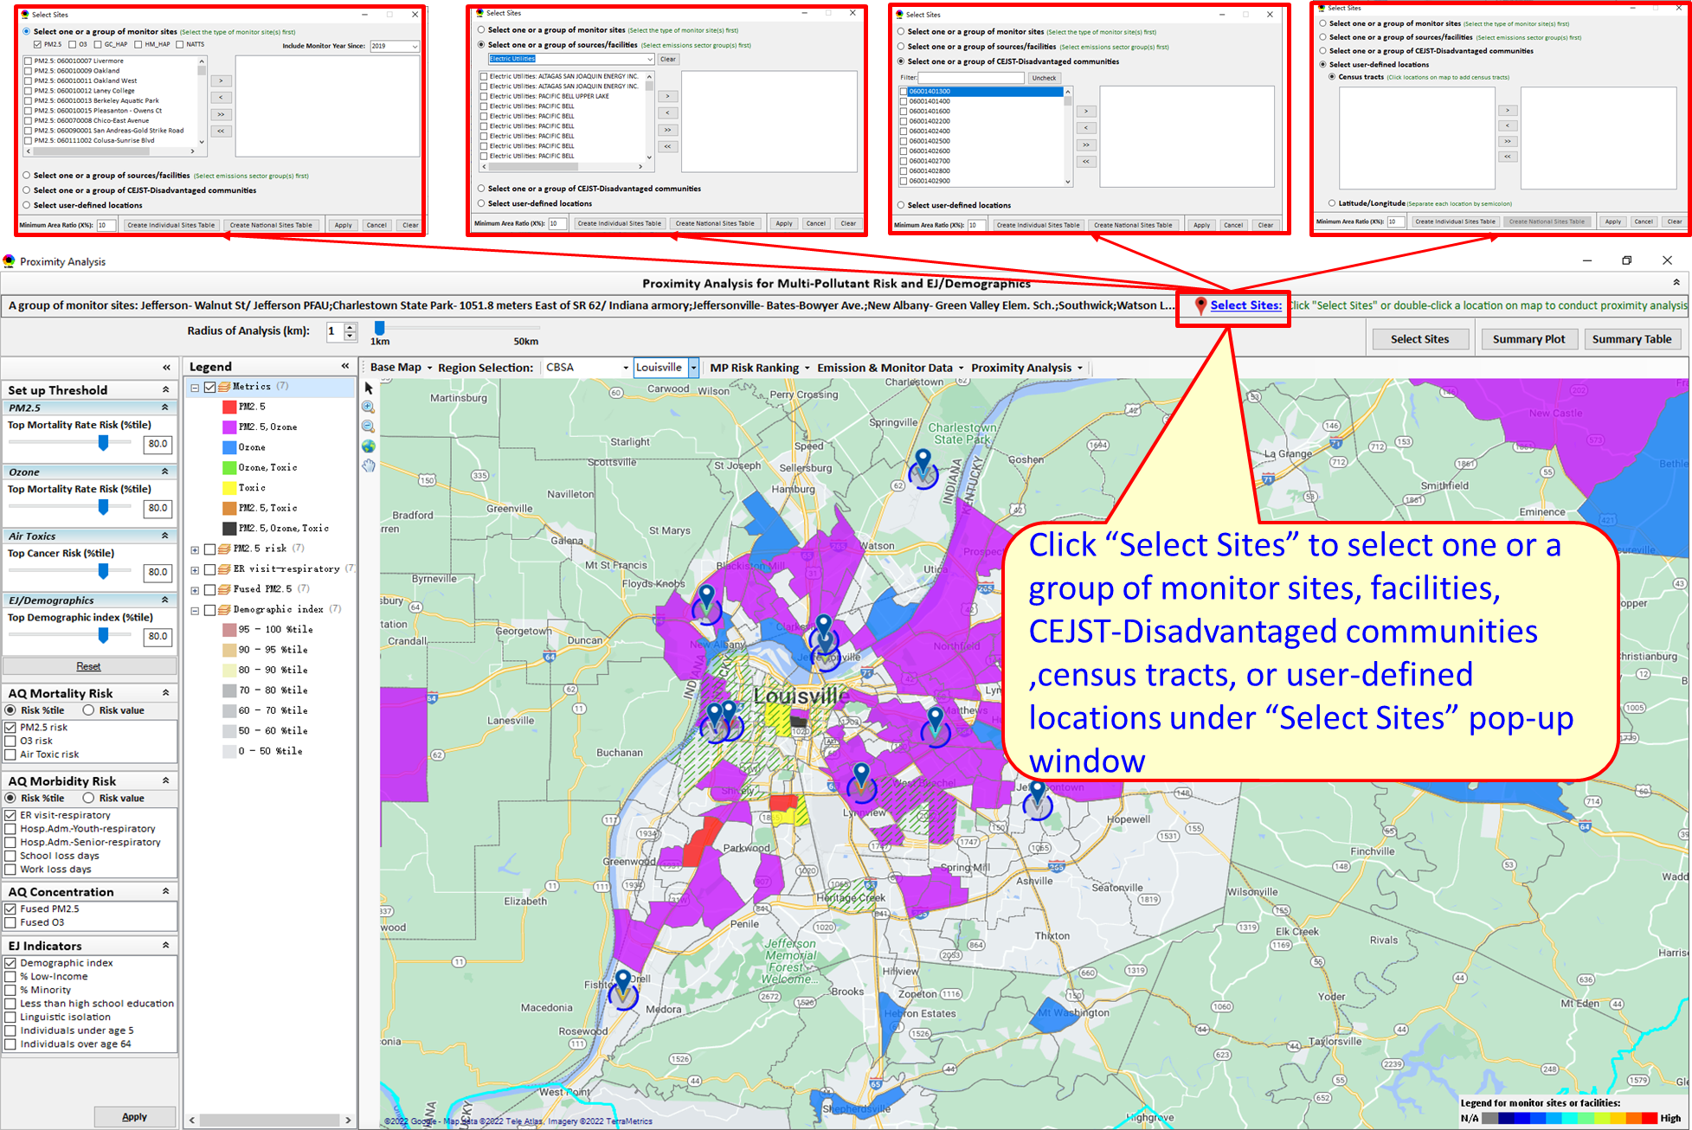
Figure 4-29 Set the “Radius of Analysis”

“Create individual Sites” Option
There are two functions named “Create individual Sites” and “Create National Sites Table” as shown in the red box in Figure 4-30. “Create individual Sites” option provides the capabilities to generate a new summary report/table for the individual sites (state-wide or CBSA-wide) selected in the grouping (monitors, sources/sectors, CEJST-Disadvantaged communities, census tracts, locations).
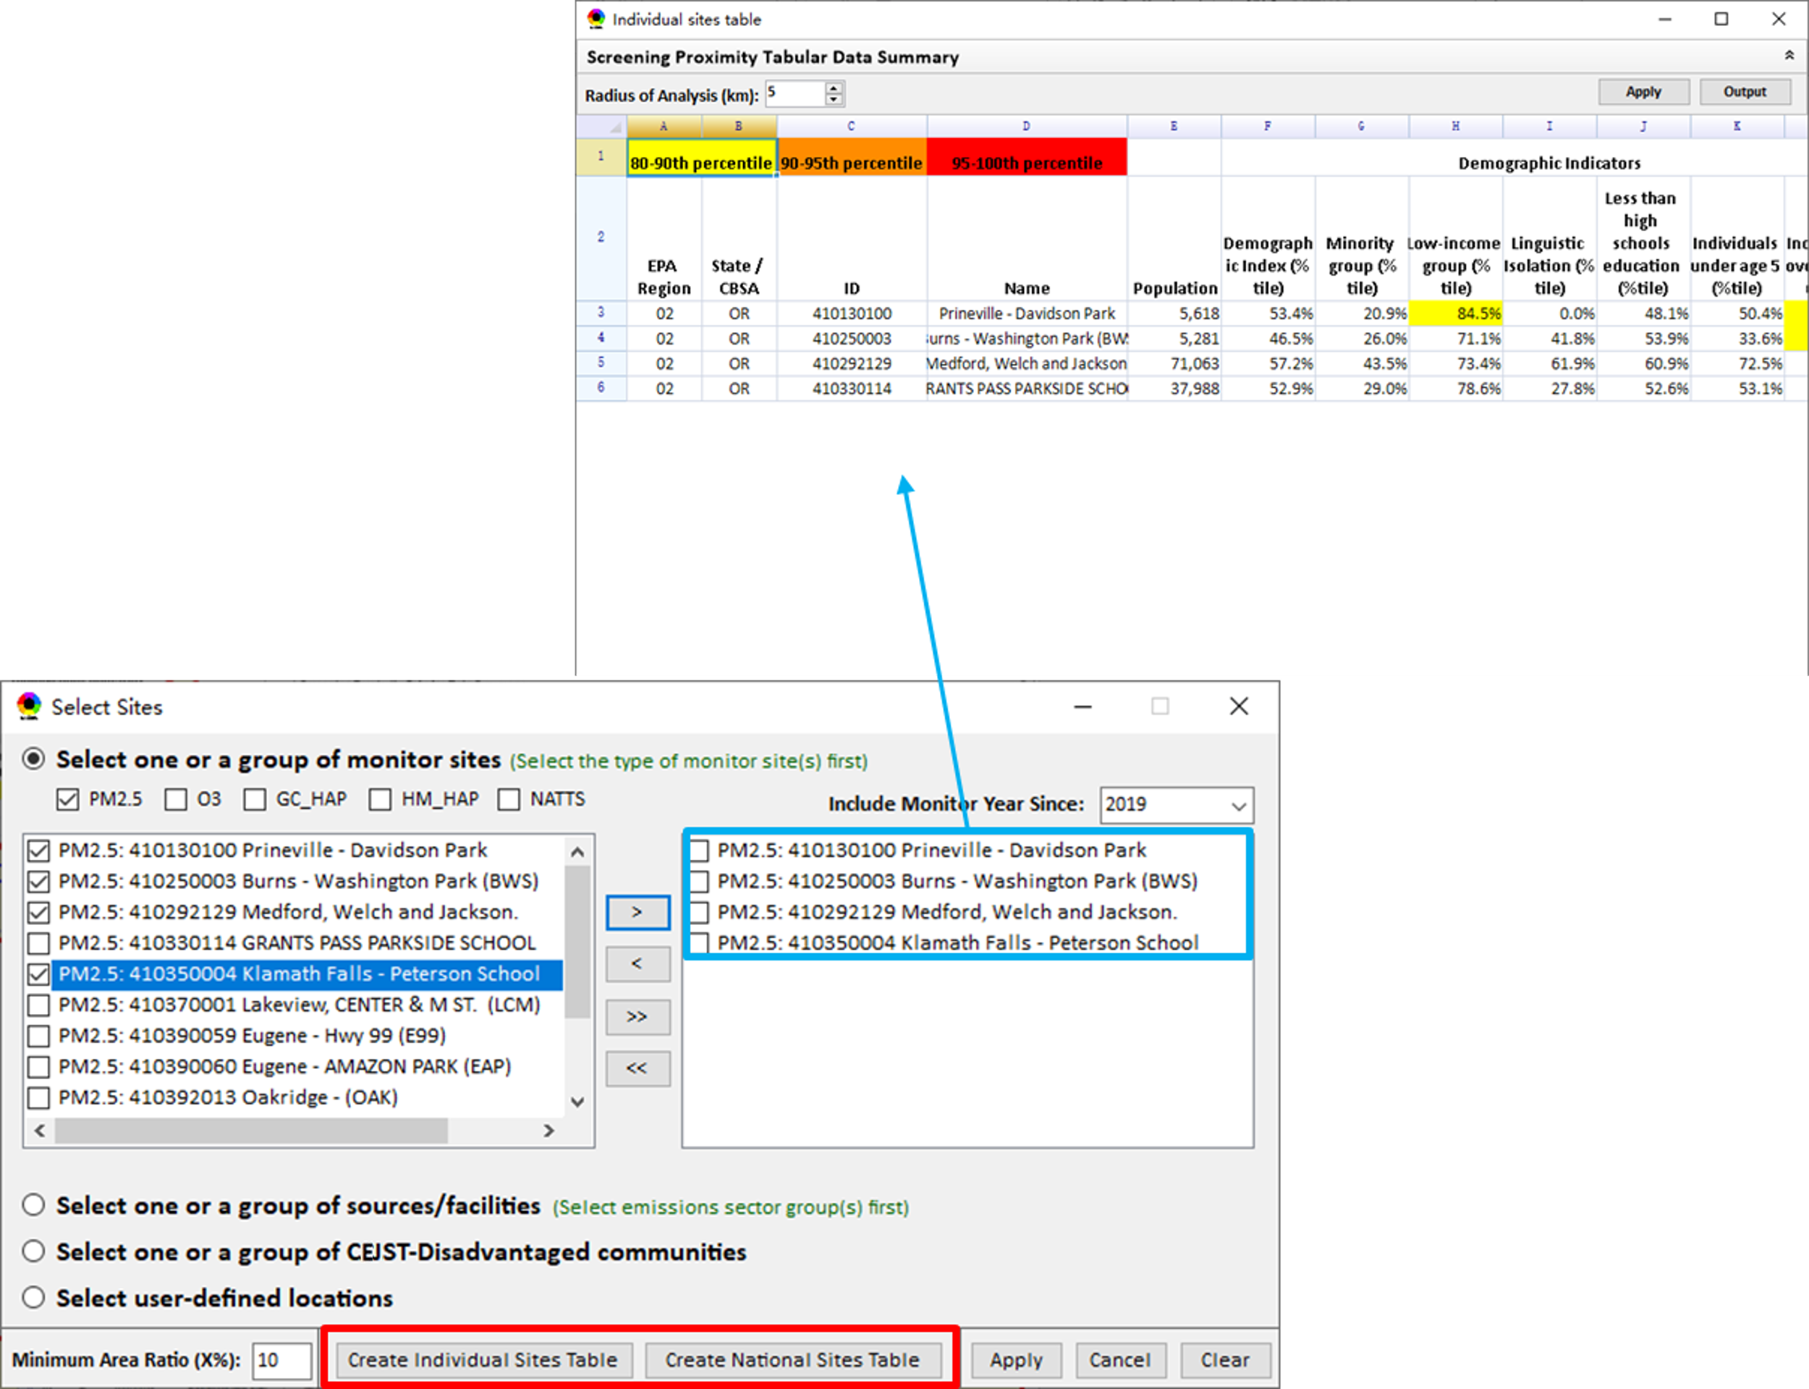
Figure 4-30 The “Select Sites” Module

“Create National Sites Table” Option
This function provides the capabilities to generate a new summary report/table for the individual sites (nation-wide) and “National & State avg. Table” (as shown in the red box in Figure 4-31). The individual sites table in this option provides “summary report/table” for all sites in the continental United States, which is the same as that in the “Create individual Sites” option. “National & State avg. Table” will list national and state average for demographic indicators (e.g., People of Color, Low-income, Linguistic Isolation, etc.), AQ mortality/morbidity risk, and AQ fused concentration. Users can click the “color legend” cells (as shown in the green box in Figure 4-31) to set the scale of highlighted numbers.
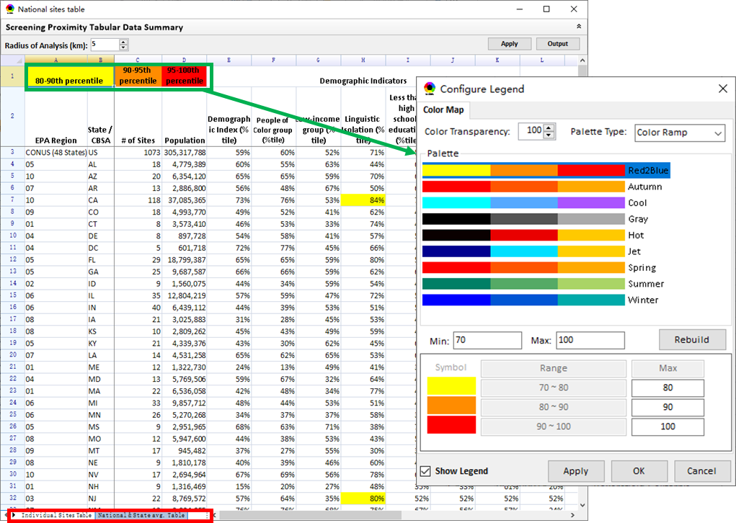
Figure 4-31 National Sites Table
- Configure Legend: With this function, users can define the highlighted percentile in the table (such as “National sites table”, “Individual sites table” or “Summary Table”). As shown in the red box in Figure 4-32, users can set max. & min. values and click the “Rebuild” button to rebuild the color legend or customize the numerical range for each color legend (as shown in the green box), and then click the “Apply” or “OK” button to apply the setting to the table. Users can also check or uncheck the “Show Legend” option (as shown in the orange box in Figure 4-32) to display/hide the color legend in the table.
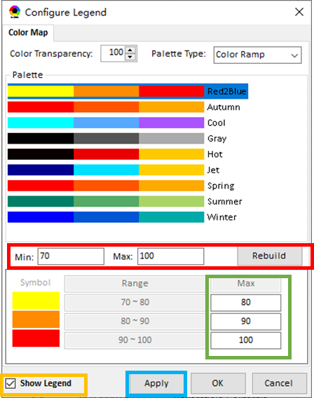
Figure 4-32 Configure Legend for Tables

Summary Table/Plot
The summary table/plot will help to cross-examine the potential linkages of multi-pollutant ambient concentration and risks (PM_{2.5}, Ozone, and Air toxics), demographic and socio-economic data (population, people of color\, low income, etc.), and climate risks. This summary table/plot calculates summaries of multi-pollutant risks and EJ data by population-weighting the values of those census tracts within the specified radius. Ambient concentrations are summarized by equal-weighting the tract values.
- Summary Table: As shown in Figure 4-33, users can set the radius of analysis and the threshold of air toxics to show the summary results for the selected point within the radius, and comparisons showing how a selected area compares to the relevant county, CBSA, State, EPA region, or the nation as a whole. Click the “Output” button to export the summary table as an excel file (*.xlsx).
- As shown in the green box in Figure 4-33, the “color legend” function is detailed in 4.2.3.2.2.
- As shown in the red box in Figure 4-33, the “top air toxic risk drivers” within the radius for the selected point(s) are displayed in the summary table.
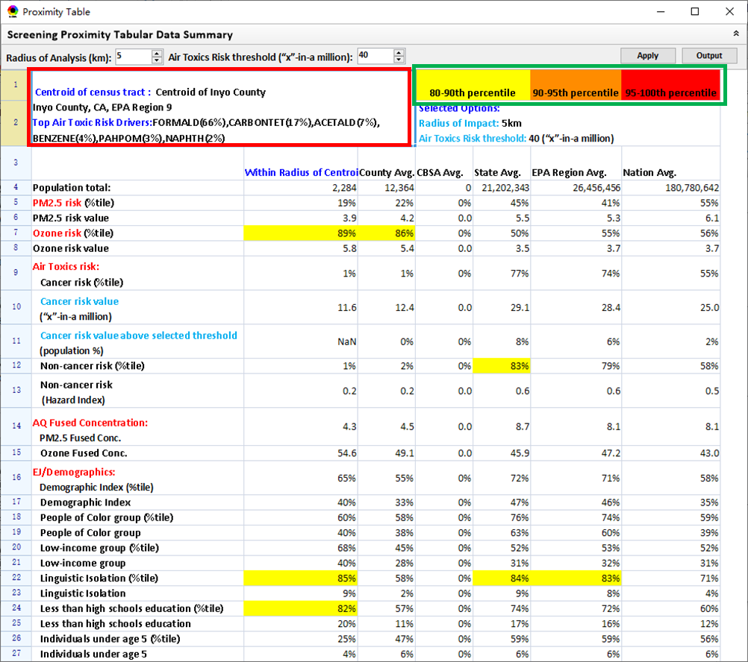
Figure 4-33 The Summary Table
- Summary Plot: In the summary plot, users can select one or more indicators to plot the summary results for the selected point within a radius, county/CBSA/State/EPA Region, and Nation average as shown in the red box in Figure 4-34.
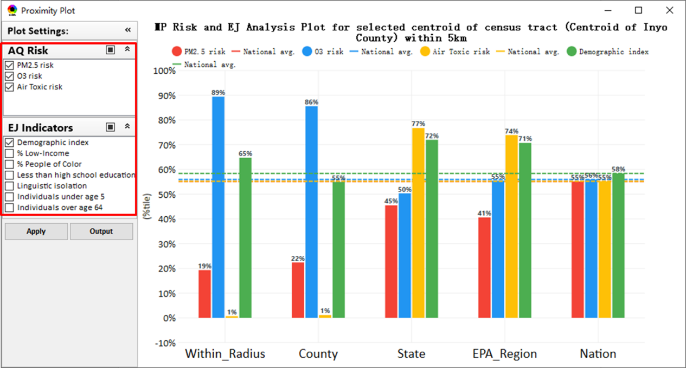
Figure 4-34 The Summary Plot

Attribute Table
Under Attribute Table, county or census tract data, which are displayed on the map, will be listed in this table. The data of counties will be shown on the Map in Data Viewer module, while that of census tracts will be shown in the proximity analysis module. Users can right-click on the map to launch the table (as shown in Figure 4-35). In this attribute table, you can filter data based on multiple criteria, select features, zoom to them, and download features to a CSV file that can be opened with spreadsheet software. Note that by default the table includes only those features that are showing in the current map.
- Filter: Users can check the option to filter/search/export data according to the field condition. Below is an example to filter out those data in “NC” state:
              - Click on “Filter” in the table header and then check “Use filter”. You can also click the “Add” icon on the right to add a set of filter criteria or click the “Remove” icon to remove the filter criteria in the current row.
              - In the first expression, use the dropdown to choose “STATE”, leave the criteria as “=” and input “NC” for North Carolina.
              - click “Apply” and then the attribute table will show those data in North Carolina based on the current set up thresholds.
              - Click “Reset” to remove all filters you applied.
- Show selected record on map: Users are supported to select one or more records to show on the map. Double-clicking anywhere in the row of interest will highlight that county or census tract on the map.
- Output data: Click  “Output data” menu at the right bottom of this attribute table, a menu will pop up, and then users can choose “Save current page records to *.csv” or “Save all records to *.csv” to output the data of current page or all pages.
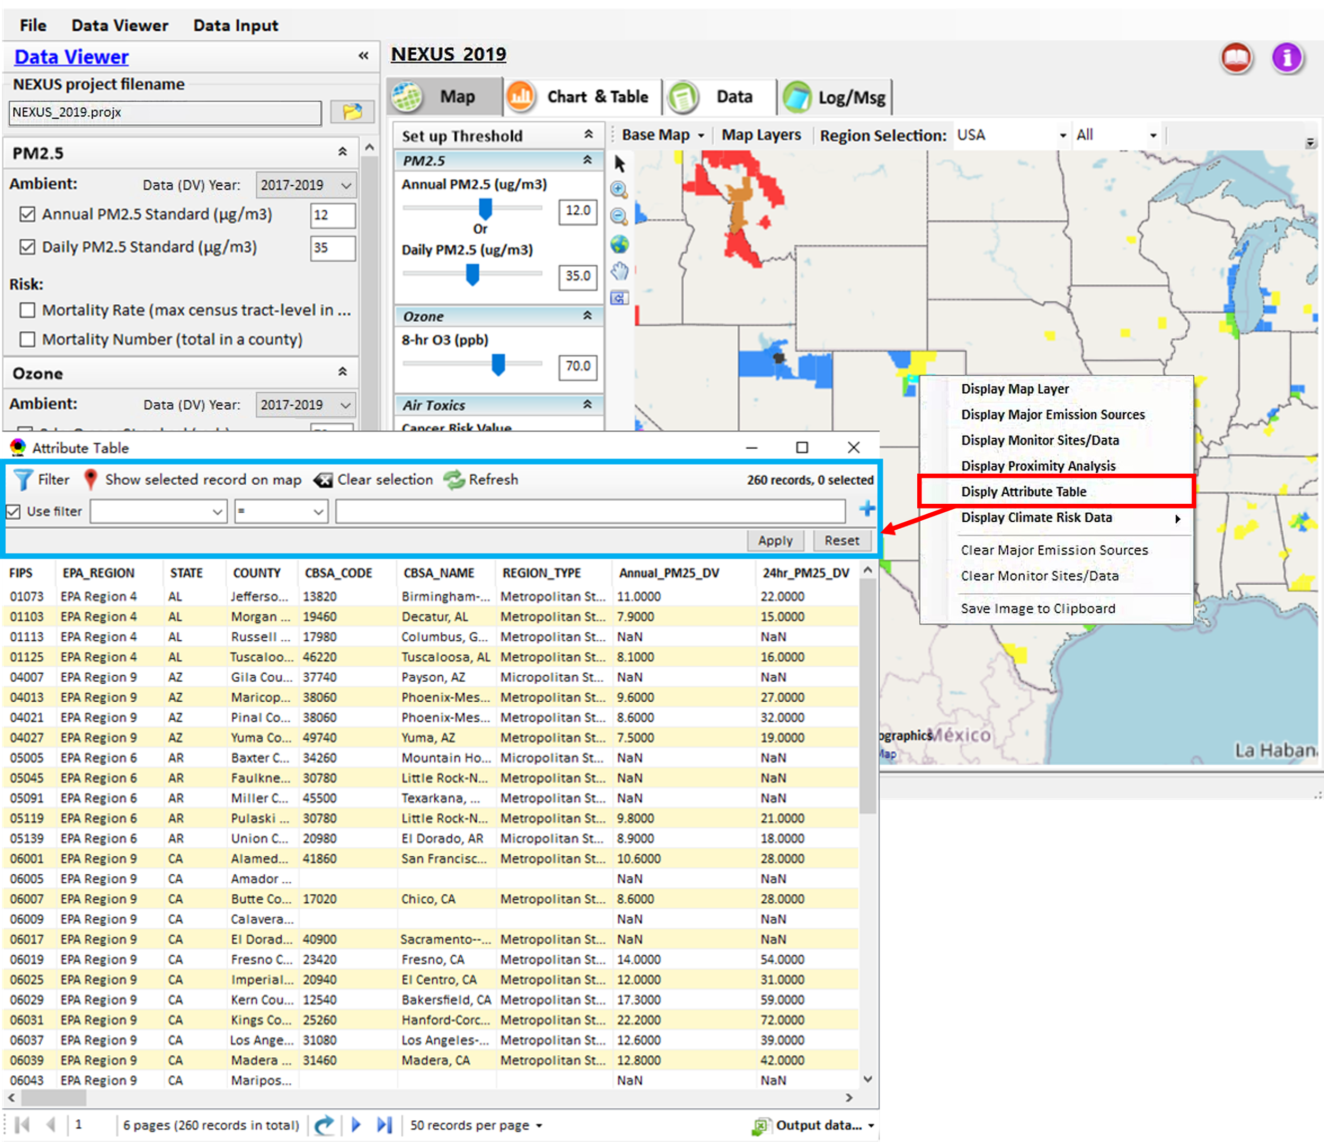
Figure 4-35 Launch the Attribute Table

Chart & Table

EPA Region Table Generator
In this module, as shown in Figure 4-36, users are allowed to export or print the selected standard data table. In addition, this module also provides search, copy, zoom in, zoom out, and other functions as well as a variety of browsing modes. It also provides the attainment status of ozone and PM_{2.5} and their DVs; also allows users to select of any EPA region based on data updated to 2020.
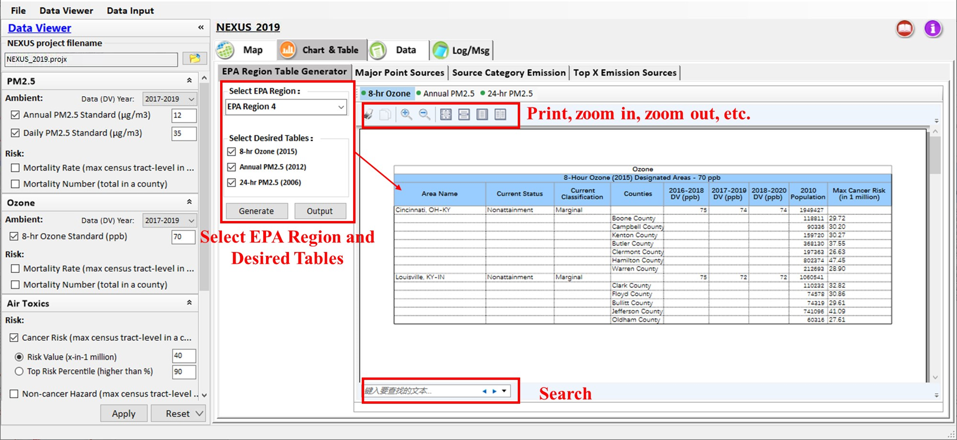
Figure 4-36 The Interface of the “EPA Region Table Generator” Module

Major Points Sources
The functionality of this module is detailed in 4.2.2.1.1 Major Points Sources.

Source Category Emission
The functionality of this module is detailed in 4.2.2.1.2 Source Category Emissions.

Top X Emission Sources
The functionality of this module is detailed in 4.2.2.1.3 Top X Emission Sources.

Data
This module provides more tabulated detailed information about each county, as shown in Figure 4-37. It also provides a filter and group tool for data viewing and allows users to export data for further study.
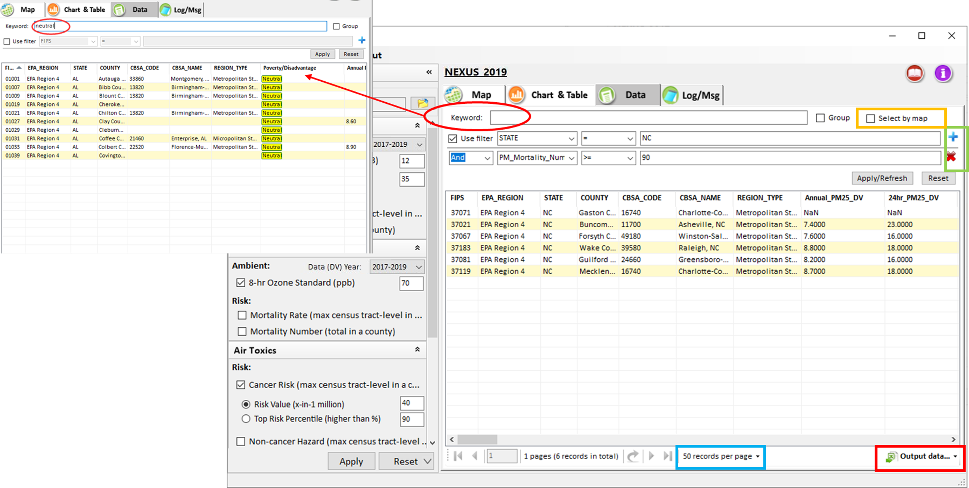
Figure 4-37 GUI of Data Module
- Output data (red box in Figure 4-37): There is an output icon that will allow the user to output data as a text file. This functionality will save the tabular data (current page record or all records) to a comma-separated value (CSV) file at a location of the user's choice. The data can be imported into a spreadsheet program or opened as a text file for archiving or future analysis.
- Add/Remove Filter (green box in Figure 4-37): Users are allowed to click “” to add filters and click “” to remove the current filter.
- Keyword: Users are allowed to filter the data with self-defined keywords.
- Select by map (orange box in Figure 4-37): Check to get the information of counties that are displayed on “Map” module. By default, this option is unchecked, and the table shows all counties’ data.
- Group: As shown in Figure 4-38, users are allowed to group the data on the current page according to a selected column. To group the data, users should click on an item of the chart header first for selecting the grouping basis, then check the “Group” box to get the grouping results. The user can adjust column widths, scroll through the table, and sort the table by clicking on the column heading.
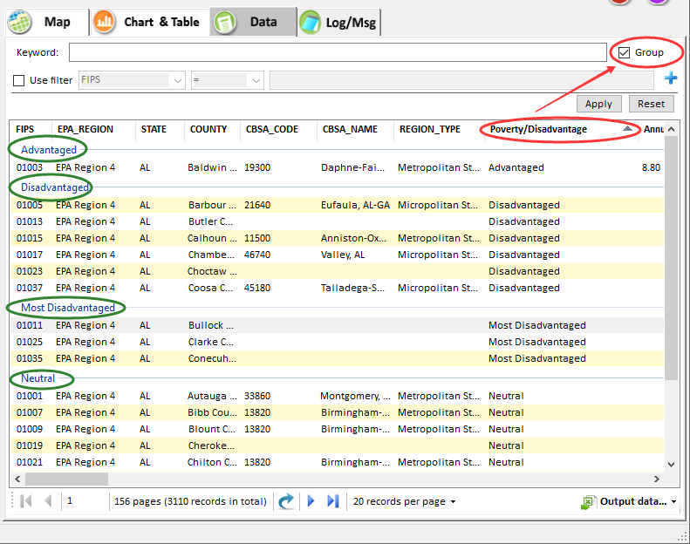
Figure 4-38 Grouping Tool in Data Window

Data Input Module
This module provides functions for users to input data sources for NEXUS. As shown in Figure 5-1, the left panel is for data input and the right panel is for data preview. The supported files and data in this module can be found in chapter 2. All NEXUS Input/Output data files are available in the user documents directory, e.g., “C:\Users\xx\Documents\My NEXUS files\Data (\Result)”, xx stands for user computer user.
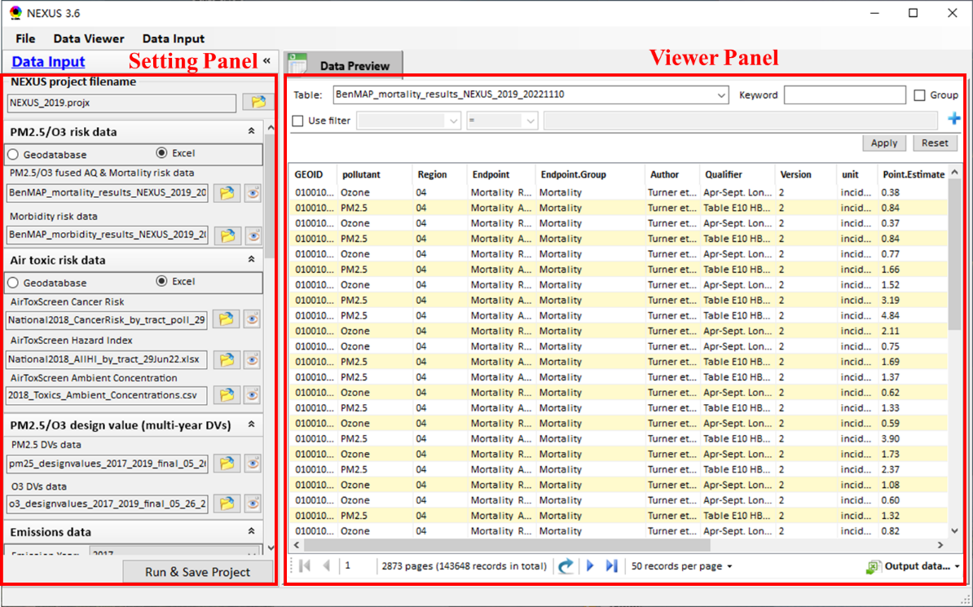
Figure 5-1 Main Interface of Data Input
- NEXUS Project: A project file that has been successfully run and saved to the user’s computer based on the below input data. This means that users no longer need to run again if the input data below have not changed.
- Run & Save Project: Users can click the “Run & Save Project” button to run and save the current settings as a NEXUS *. projx file. This calculation will take a few minutes depending on the user’s computer.
- Load File/Dataset: As shown in the red box in Figure 5-2, users can click the 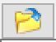 button to load input files for NEXUS. Users are allowed to input data sources for NEXUS geodatabase, air toxic geodatabase, ozone & PM_{2.5} DV (multiple years DV data), advanced area, Socio-economic/Demographic data, major emission, sources, NATA emission sources, class l areas, and tribal areas, CEJST data, NO₂ satellite concentration, climate risk data and so on. Both serial and CSV files can be edited/updated with recent DV data from EPA.
- File/Dataset Preview: As shown in the green box in Figure 5-2, users can click the  button to preview files or datasets in the data preview area.
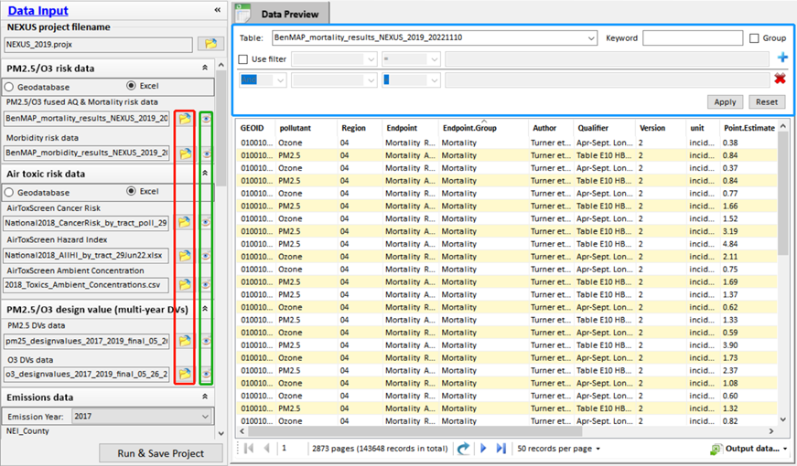
Figure 5-2 Load and Preview File/Dataset
As shown in the blue box in Figure 5-2, the data preview module supports several operations for the data viewer, including keyword filter, group filter, and output records to *.csv.
- Keyword: Users can filter the data on the current page with self-defined keywords.
- Group: Users can group the data on the current page according to a selected attribute. To group the data, users should click on an item of the chart header first for selecting the grouping basis, then check the “Group” box to get the grouping results.
- Use Filter: Users can check the option to filter data according to the field condition. Select a table to view if there are multiple tables in the selected data source file.
- Output data: Users can save the current pager record or all records to a *.csv file by clicking the button.

