RSM-VAT 2.8:
User Guide for DeepRSM module

Catalogue
1 RSM-VAT Improvements: GUI comparison with RSM-VAT 2.7 1
1.1 Create/Input RSM Option 1
1.2 Model Data Input Option 2
1.3 Use DeepRSM algorithm 3
1.4 Model Data Input Option 6
1.5 Validation and QA Option 9
1.6 Visualization Analysis Option 11
2 DeepRSM: Create RSM File 12
2.1 Create/Input RSM Option 12
2.2 Model Data Input Option 12
2.2.1 Base Case CMAQ File 12
2.2.2 Deep Training Model File 14
2.2.3 Species Names Mapping File 14
2.2.4 Time period and Target Pollutant 15
2.3 Validation and QA Option 16
2.4 Visualization Analysis Option 17
3 Results 19
3.1 Visualization Analysis 21
3.1.1 Map 21
3.1.2 Receptor Analysis 23
3.1.3 Data 24
3.2 QA and Validation 25

RSM-VAT Improvements: GUI comparison with RSM-VAT 2.7
RSM-VAT 2.8 has included the DeepRSM option compared to version 2.7, as well as an upgrade to the GUI for DeepRSM option. See Fig. 1 and Fig. 2.

Create/Input RSM Option
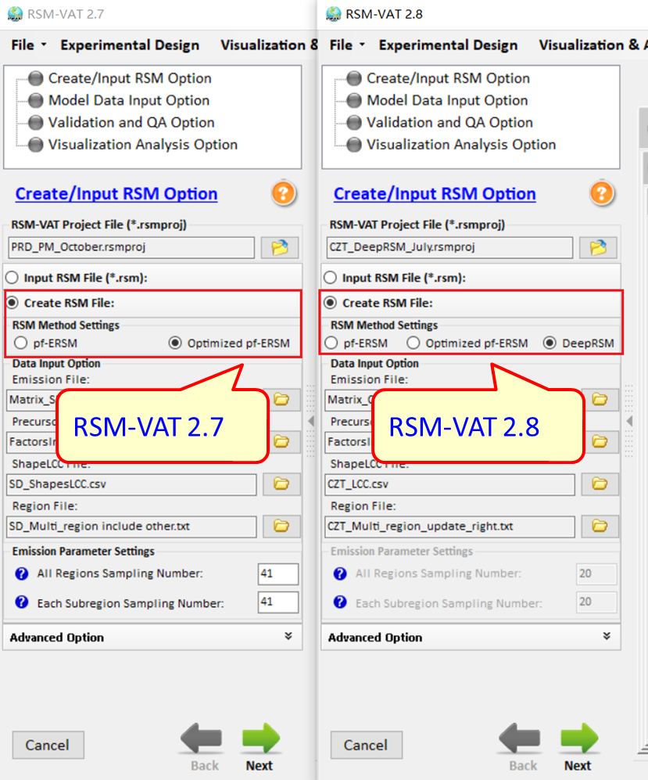
Fig. 1 Comparison for Create/Input RSM Option

Model Data Input Option
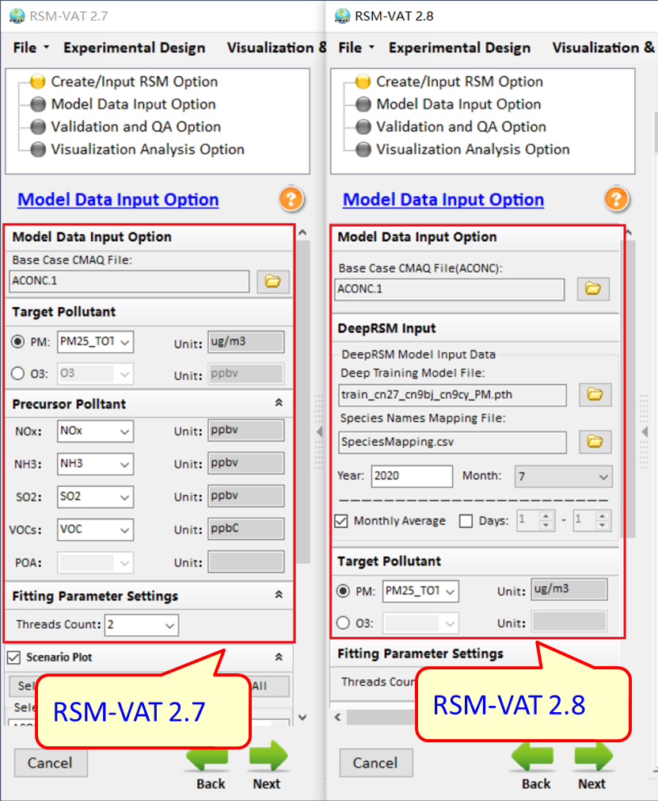
Fig. 2 Comparison for Model Data Input Option

Use DeepRSM algorithm
Select the DeepRSM option. The files you need to enter include Emission File、 Precursor Factors File、ShapeLCC File、Region File, the four files are shown in Fig. 3.
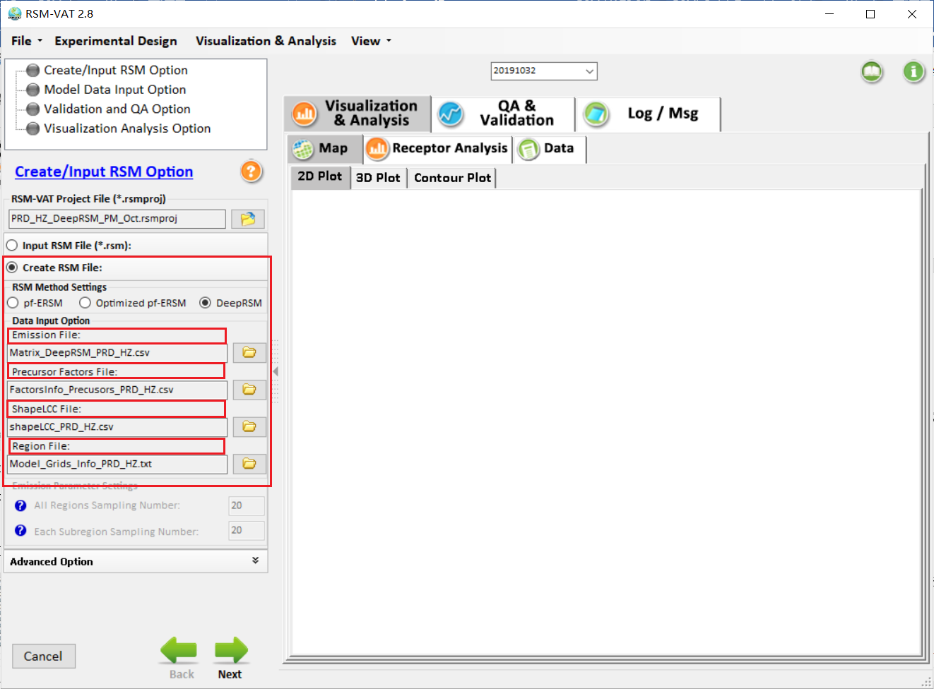
Fig. 3 GUI DeepRSM input files option
Emission File: Emission case files contain emission factors for each species in each region.
Here take the “Matrix_DeepRSM_PRD_HZ.csv” as an example.
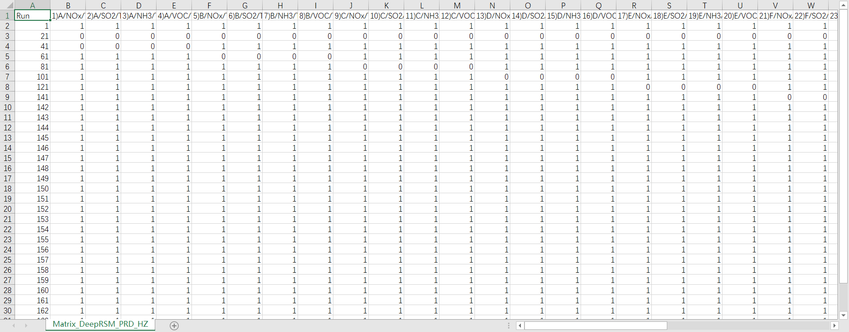
Fig. 4 Example for DeepRSM Emission control matrix file
Precursor Factors File: Here take the “FactorsInfo_Precusors_PRD_HZ.csv” as an example.
There are 24 control factors in this case (4 precursors factors for each region). The emission control factor ranges from 0 to 150%. The zero control factor means that the emission is reduced to zero, and the 150% factor means that the emission increases by 50% compared with the baseline emission.

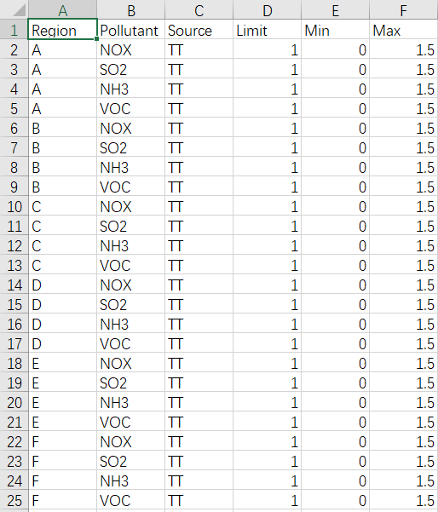
Fig. 5 Example for DeepRSM Factors file
ShapeLCC File: This file records the geographic location information of the control area.
Here take the “shapeLCC_PRD_HZ.csv” as an example.
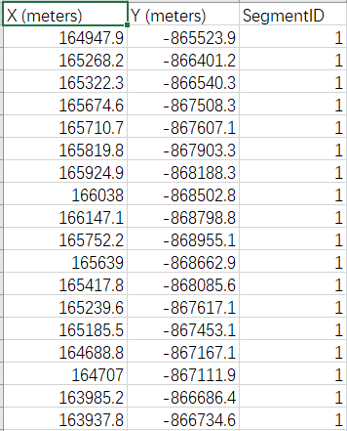
Fig. 6 Example for deepRSM shape file
Region File: This file records region information.
Here take the “Model_Grids_Info_PRD_HZ.txt” as an example.
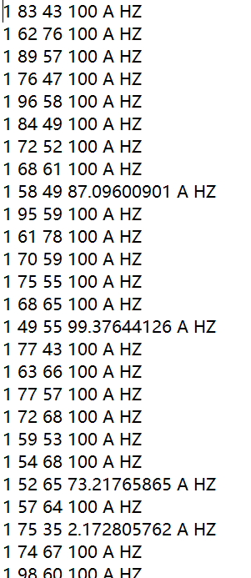
Fig. 7 Example for DeepRSM model grid file
Advanced Option: Uncheck the “Advanced Option”, including “ Use the BC Factor ” and “ Sectoral Fitting Input Option ”. As shown in the Fig. 8.
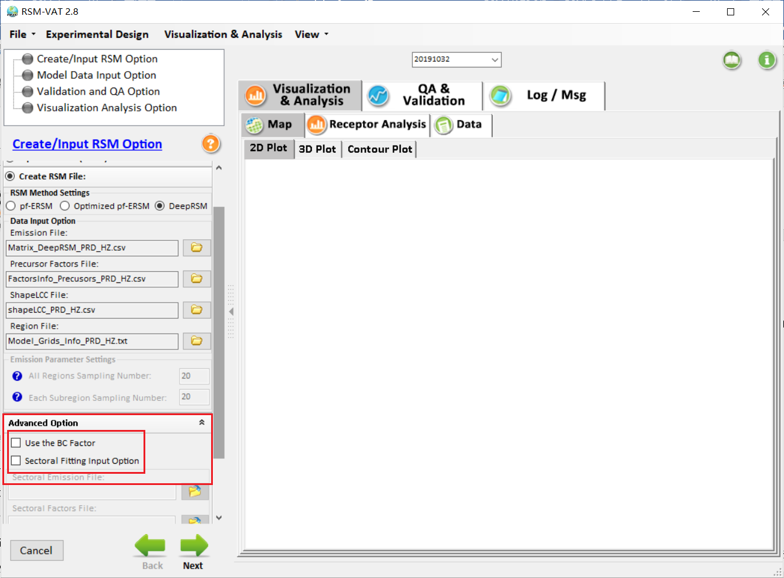
Fig. 8 GUI of Advanced Option

Model Data Input Option
Once DeepRSM is selected, a number of model parameters need to be set, including model training files, pollutant species mapping information and time of interest. Its interface is shown in the figure below.
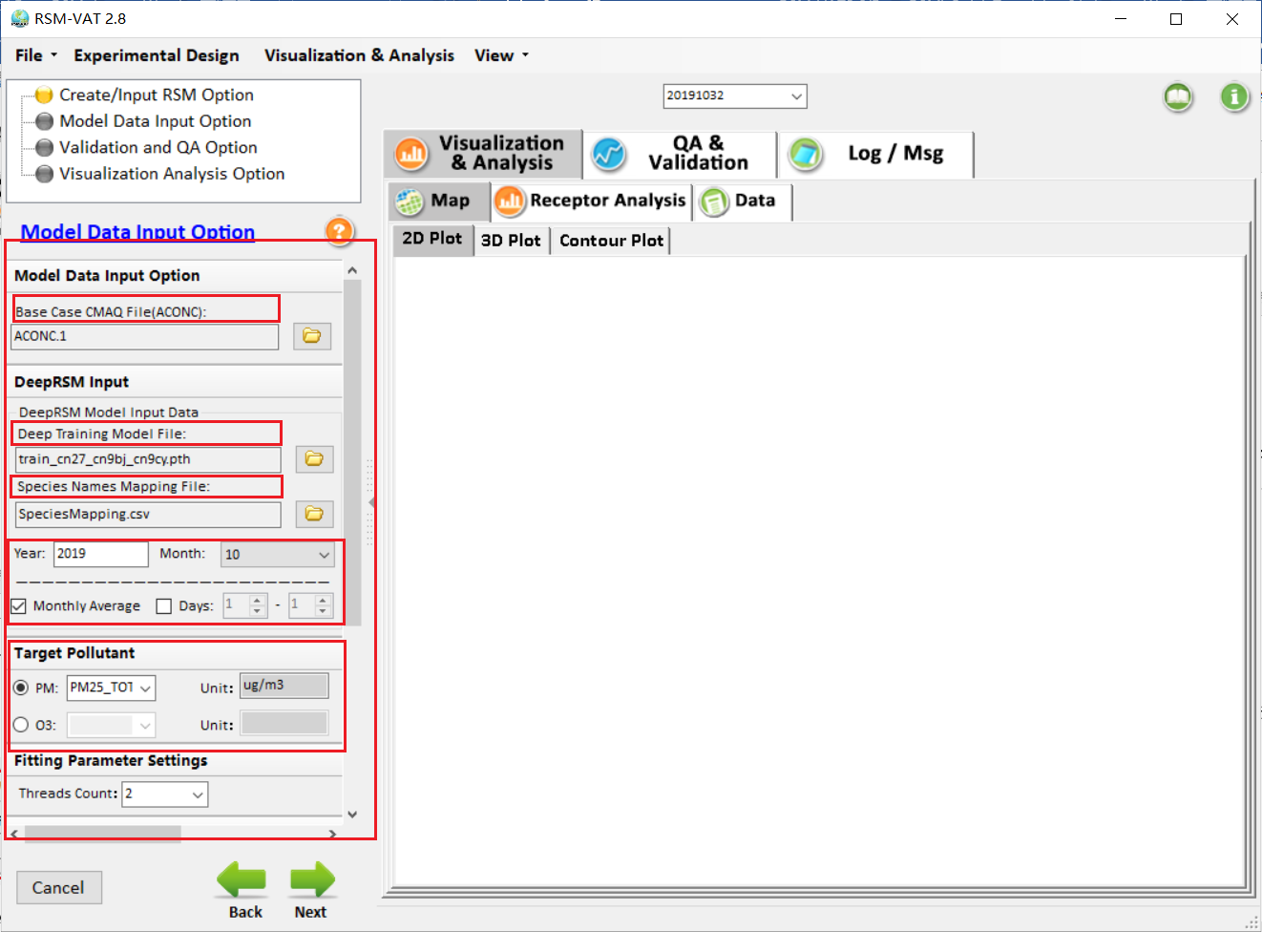
Fig. 9 GUI for DeepRSM Model Data Input Option
Base Case CMAQ File(ACONC): Base case file, generated by CMAQ model.( Note: Users need to include all the cases listed in the Emmission file from the previous step)
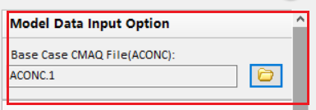
Fig. 10 GUI for DeepRSM Base Case CMAQ File(ACONC)
Deep Training Model File: Deep learning model, selected based on pollutants.
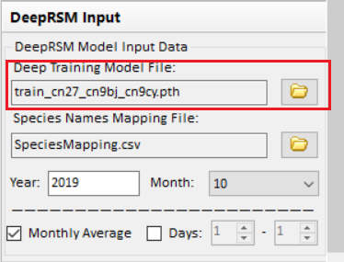
Fig. 11 GUI for Deep Training Model File
Species Names Mapping File: This file records mapping information for species, ensuring that species names in the CMAQ model file match those in the deep learning model. AS shown in the Fig. 13. (Note: The first column listed below are those species names built in deep learning model, and the second column are those species names set by users according to the CMAQ model file.)
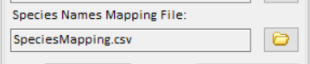
Fig. 12 Choose Species Names Mapping File
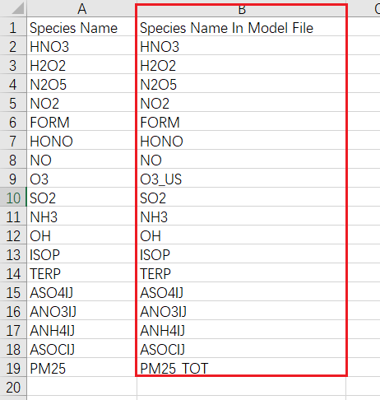
Fig. 13 Example for Species Names Mapping File
Year: Model run year. When the base file (Base Case Model File) is selected, it can be read automatically according to the base file.
Month: Model run month. It also can be read automatically according to the base file.
Monthly Average \ Days: Users can choose to calculate monthly average data as well as daily average data according to their own needs. Both of them can be chosen at the same time. (Note: Only continuous days are supported.)
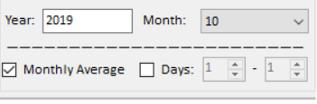
Fig. 14 GUI for Time parameter setting
Target Pollutant: Select the target pollutant to be predicited
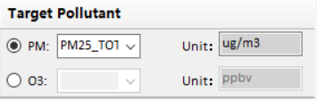
Fig. 15 GUI for setting Target Pollutant

Validation and QA Option
DeepRSM supports out of sample validation to verify the "real-time" response between precursor reductions and target pollutant concentrations. ( Note: Users need to ensure that the cases referred to in the Emission Control Matrix document exist in the step 2 “Base Case CMAQ File(ACONC)”, otherwise it will show the prompts as Fig. 16)
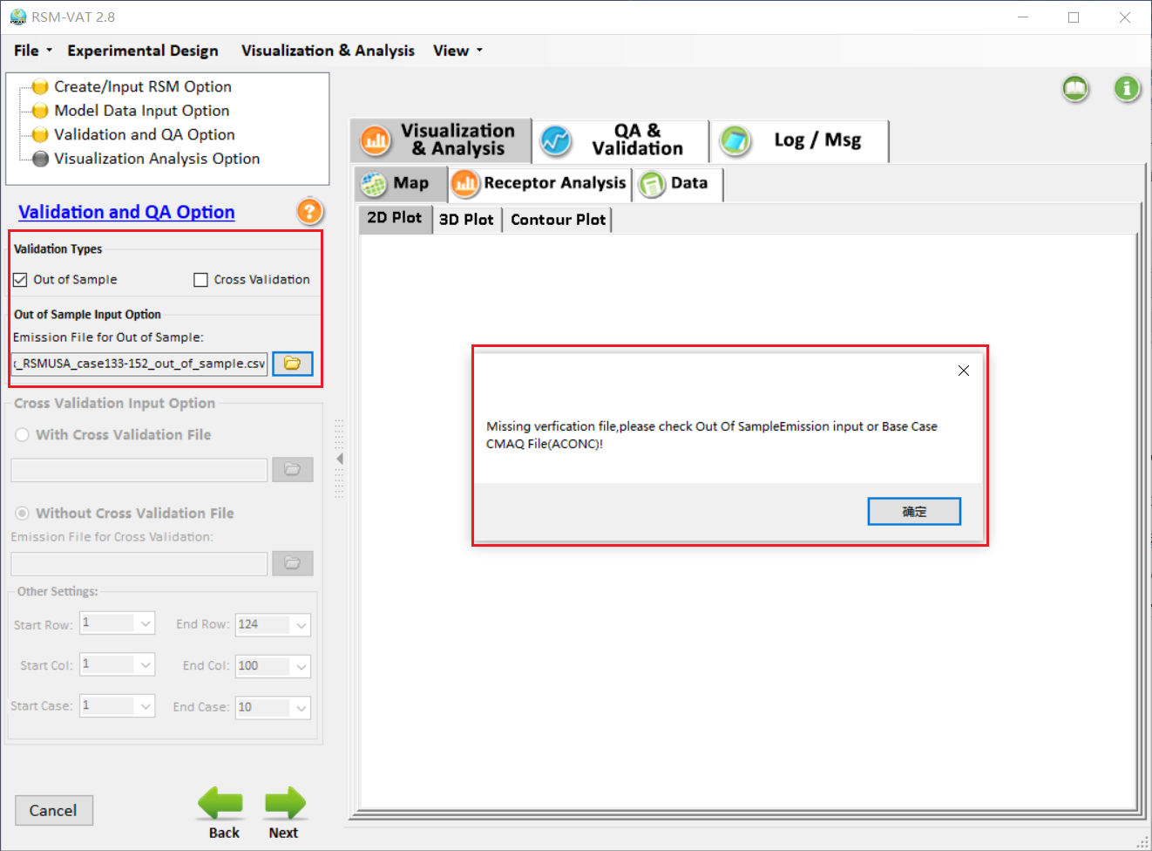
Fig. 16 Validation prompt for out of sample validation
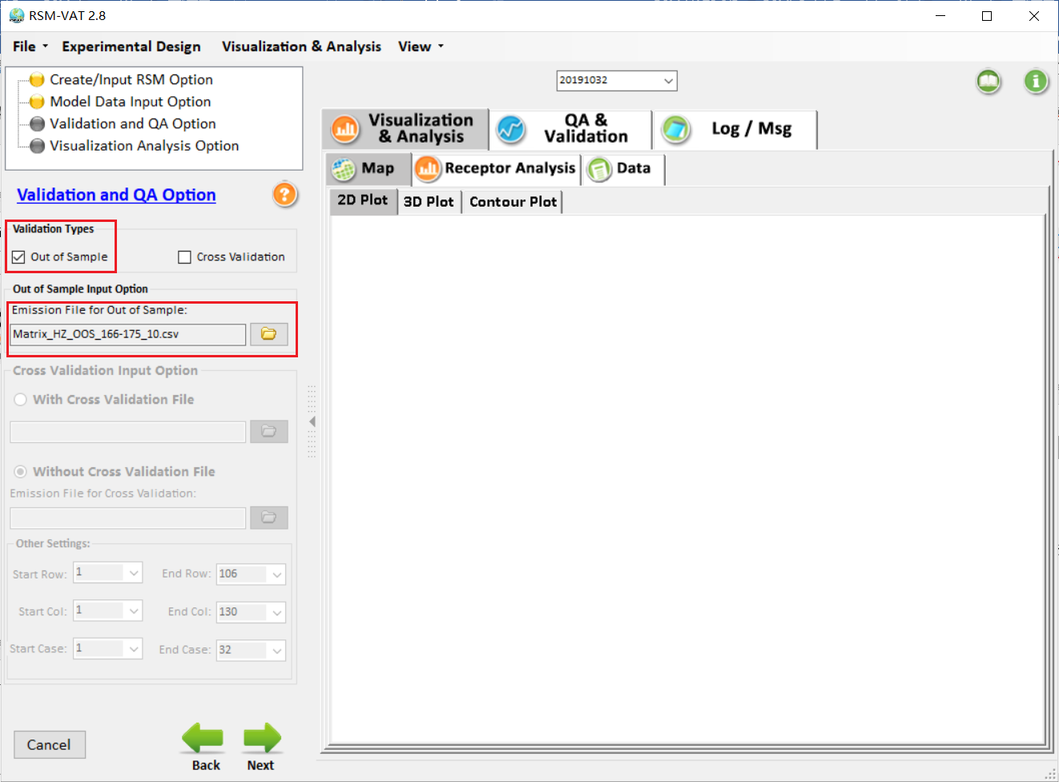
Fig. 17 GUI for Validation and QA Option module

Visualization Analysis Option
The visualization analysis option allows the user to set the receptor file and contour plot, as shown in Fig. 18.
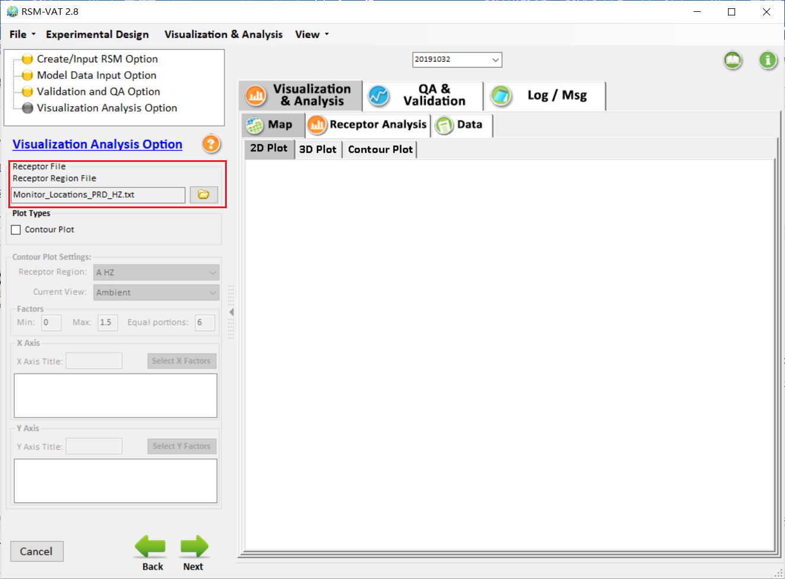
Fig. 18 GUI for Visualization Analysis Option

DeepRSM: Create RSM File
Take the data of the Pearl River Delta (PRD) region as an example.

Create/Input RSM Option
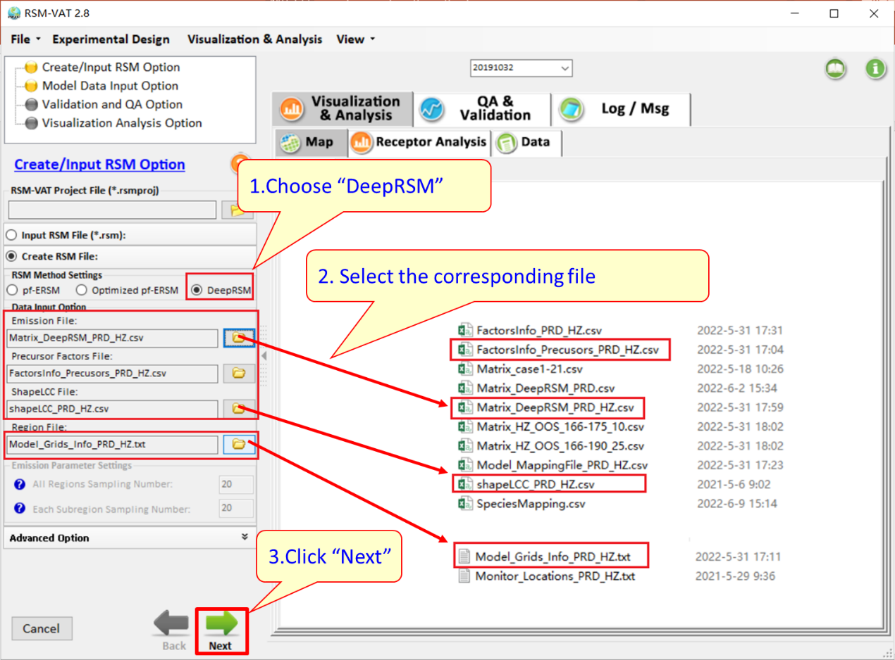
Fig. 19 Steps for setting Input RSM Option

Model Data Input Option

Base Case CMAQ File
The model directory contains all the model files for January, including those needed to create RSM and out of sample validation, as shown in Fig. 20.
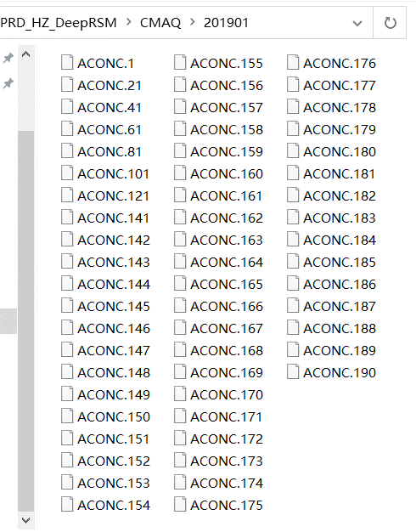
Fig. 20 Example for CMAQ files(2019-1)
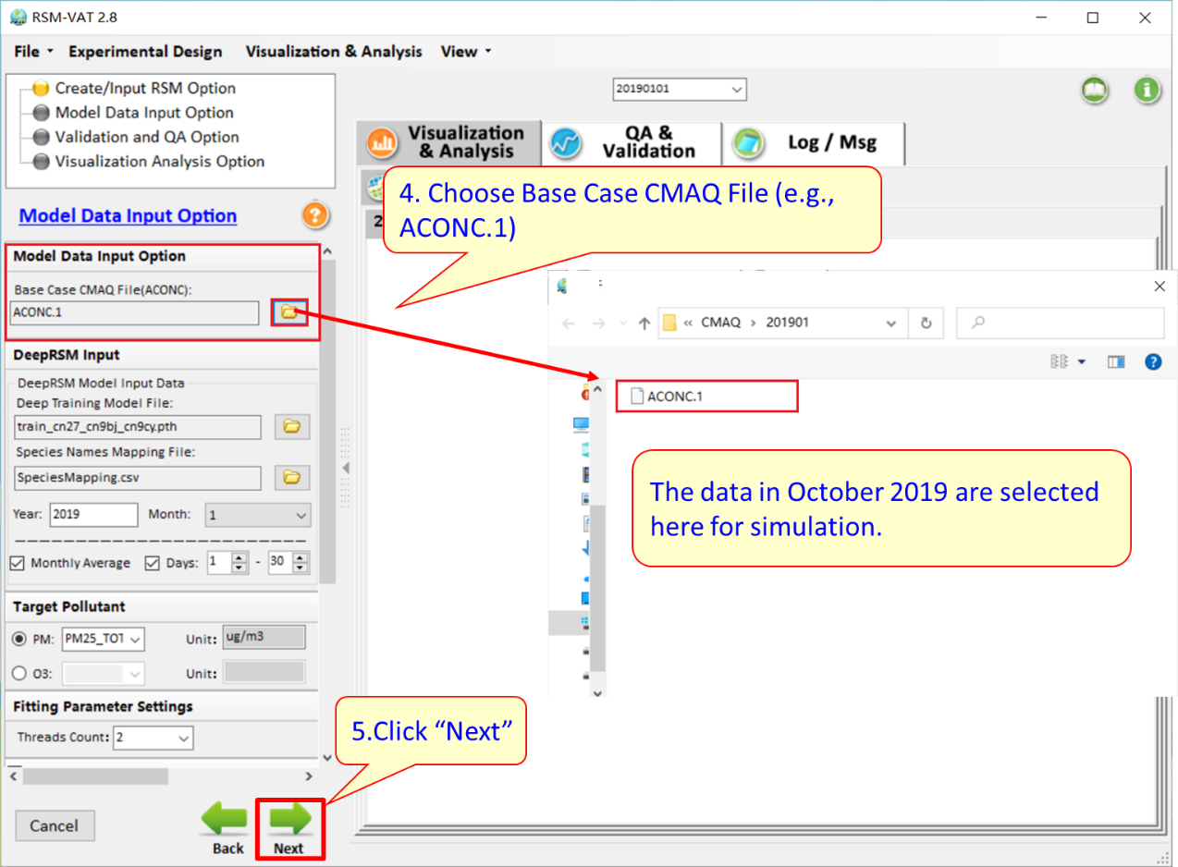
Fig. 21 Steps for setting Model Data Input Option

Deep Training Model File
RSM-VAT has built in several deep training model files created by THU or SCUT. Here users are allowed to select the Deep training model file according to the target pollutant, e.g, select “train_cn27_cn9bj_cn9cy_pm.pth” for PM.
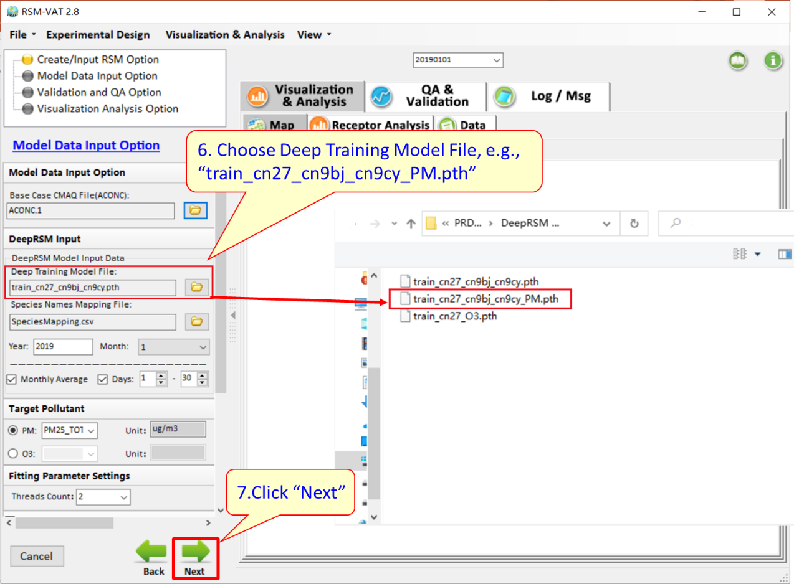
Fig. 22 Steps for setting Deep Training Model File

Species Names Mapping File
Select species names mapping file, e.g., “SpeciesMapping.csv”, shown in Fig. 23.
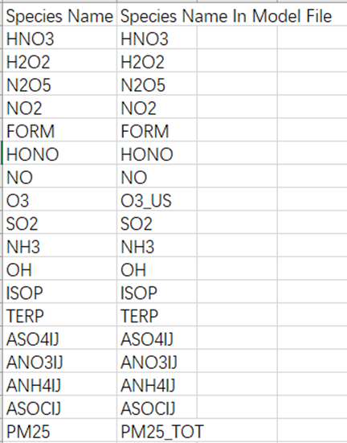
Fig. 23 Example for specific file for PRD case.
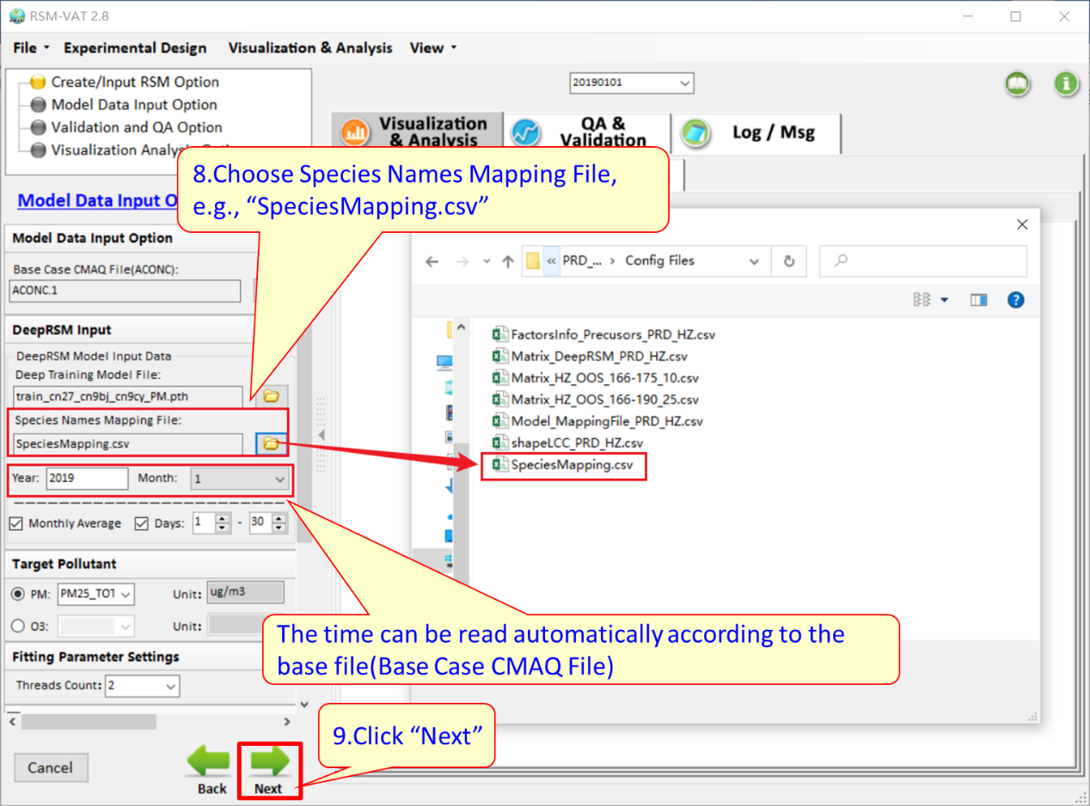
Fig. 24 Steps for setting Species Names Mapping File

Time period and Target Pollutant
Set calculation time period and target pollutant as needed. Here check "Monthly Average" , “Days: 1-30” option and select PM2.5 as target pollutant as an example.
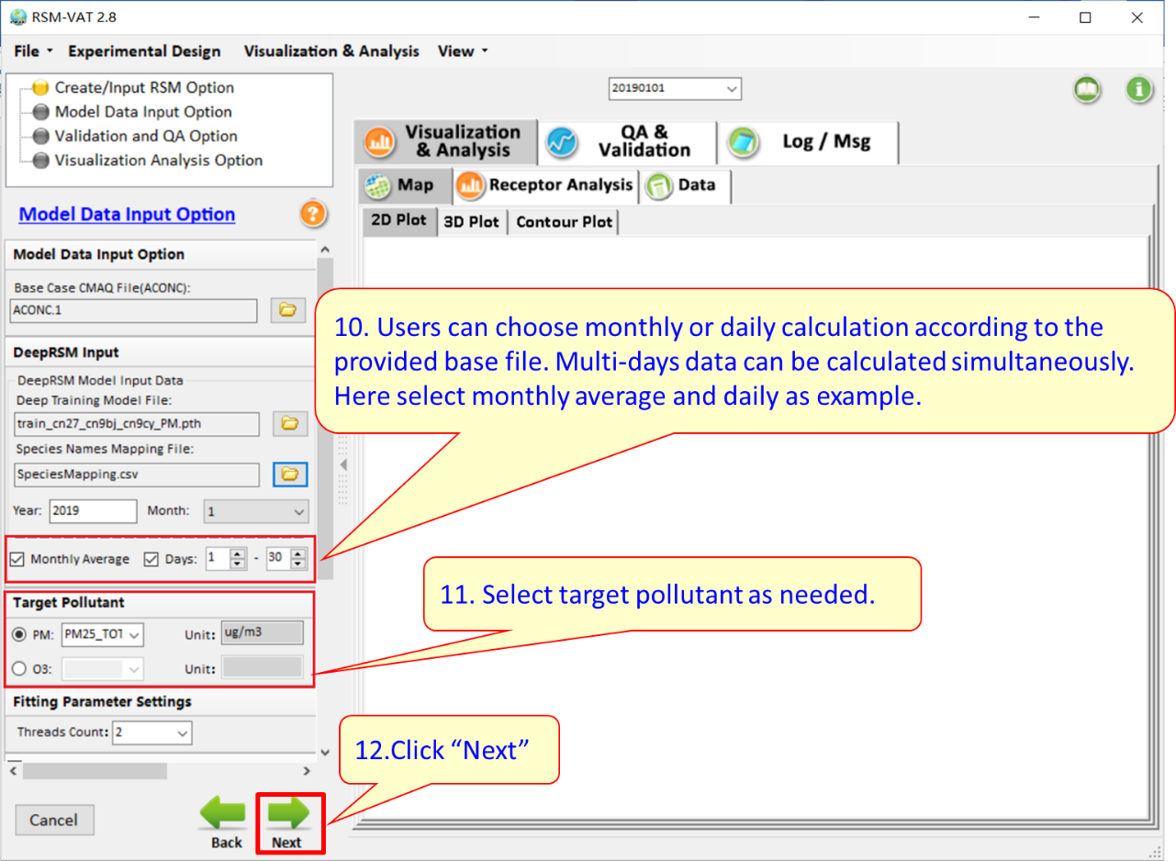
Fig. 25 Steps for setting Time period and Target Pollutant

Validation and QA Option
Check “Out of Sample” option. And then select “Matrix_HZ_OOS_166-175_10.csv” for out of sample validation file as an example.
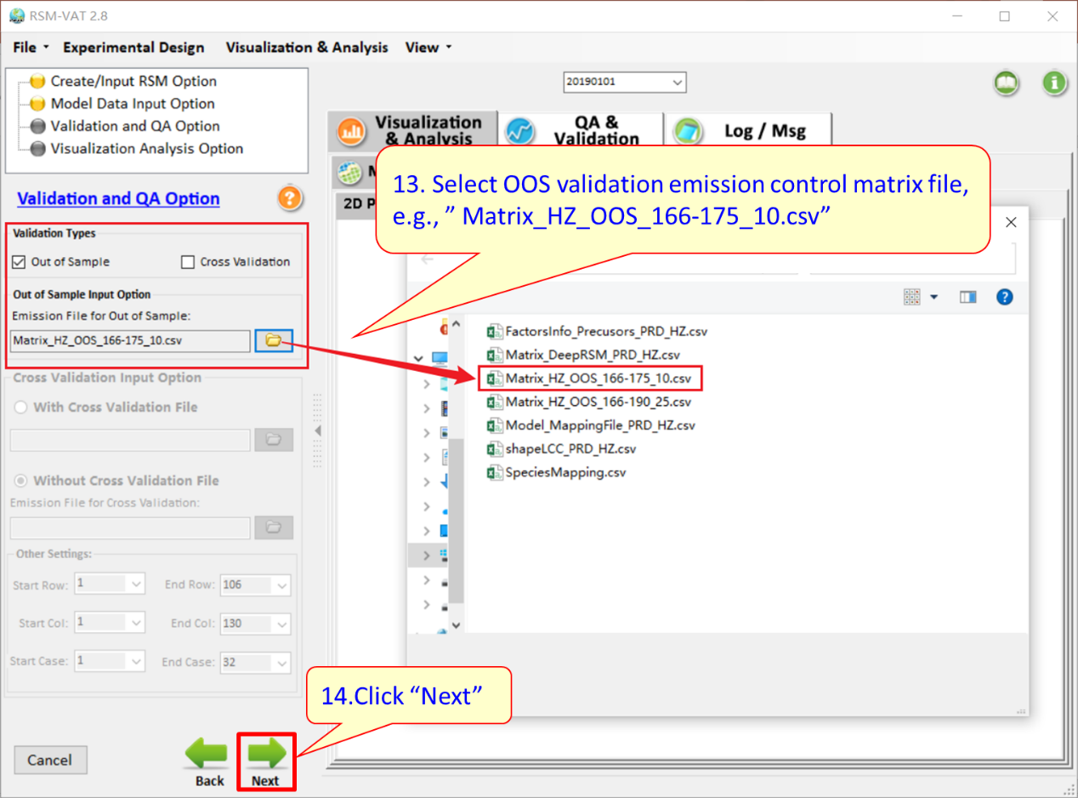
Fig. 26 Steps for setting Validation and QA Option

Visualization Analysis Option
Set receptor file and select “Monitor_Locations_PRD_HZ.txt” as an example.

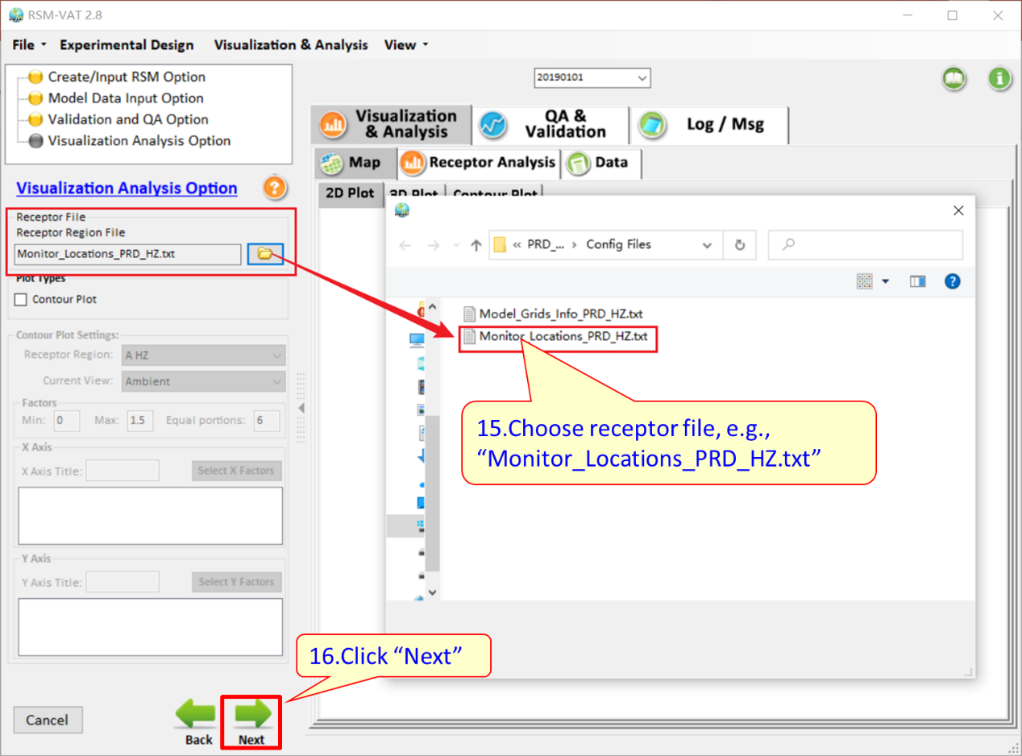
Fig. 27 Steps for setting Visualization Analysis Option
After all steps above are configured, click “Next” to save the files and start running, as shown below.
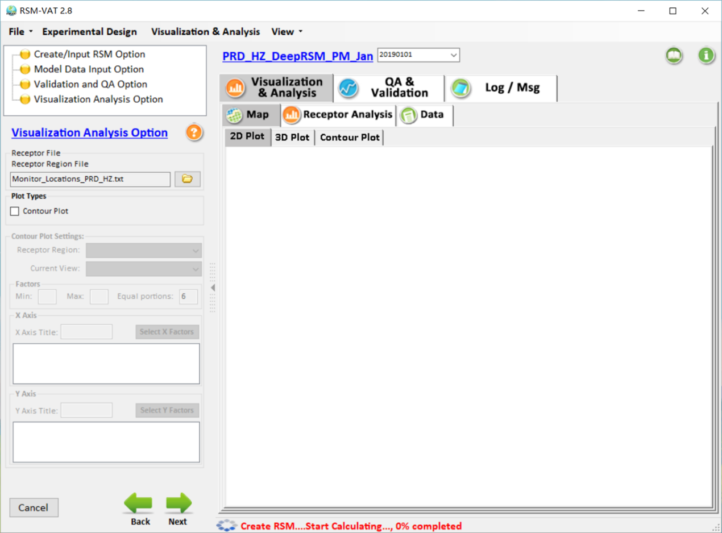
Fig. 28 Example of running RSM

Results
After completing running, the result will be shown in right side of home page, as shown below.
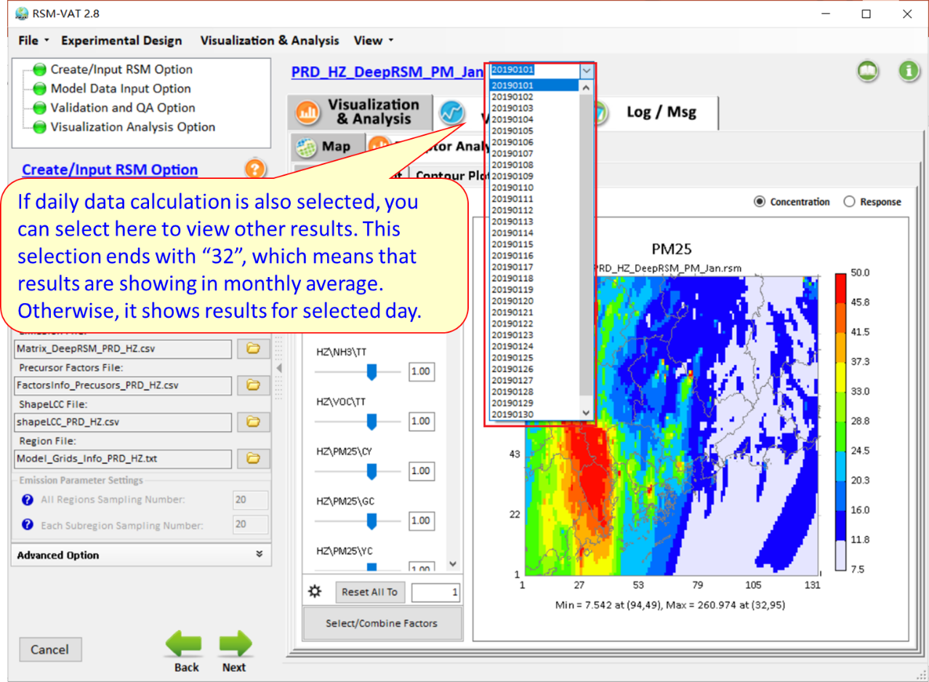
Fig. 29 Results for PRD_HZ_DeepRSM_PM_Jan case
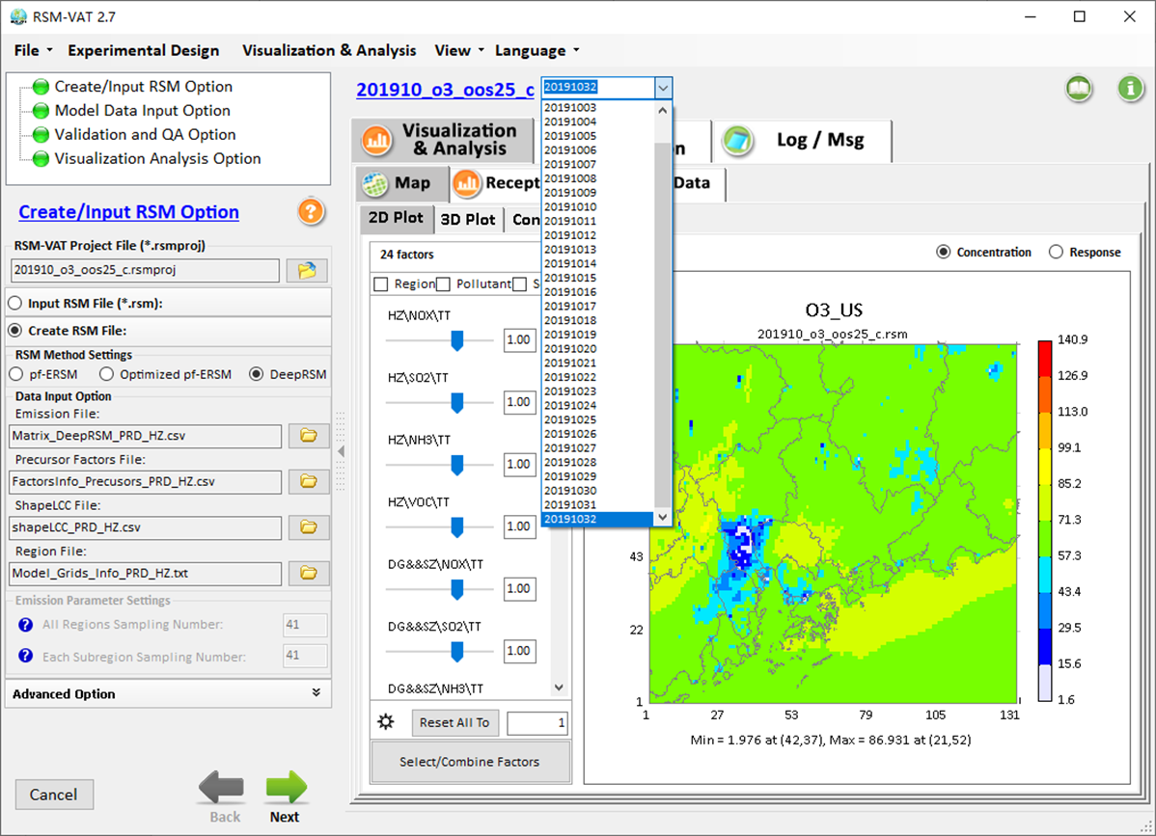
Fig. 30 Example for RSM in multiple days

Visualization Analysis

Map
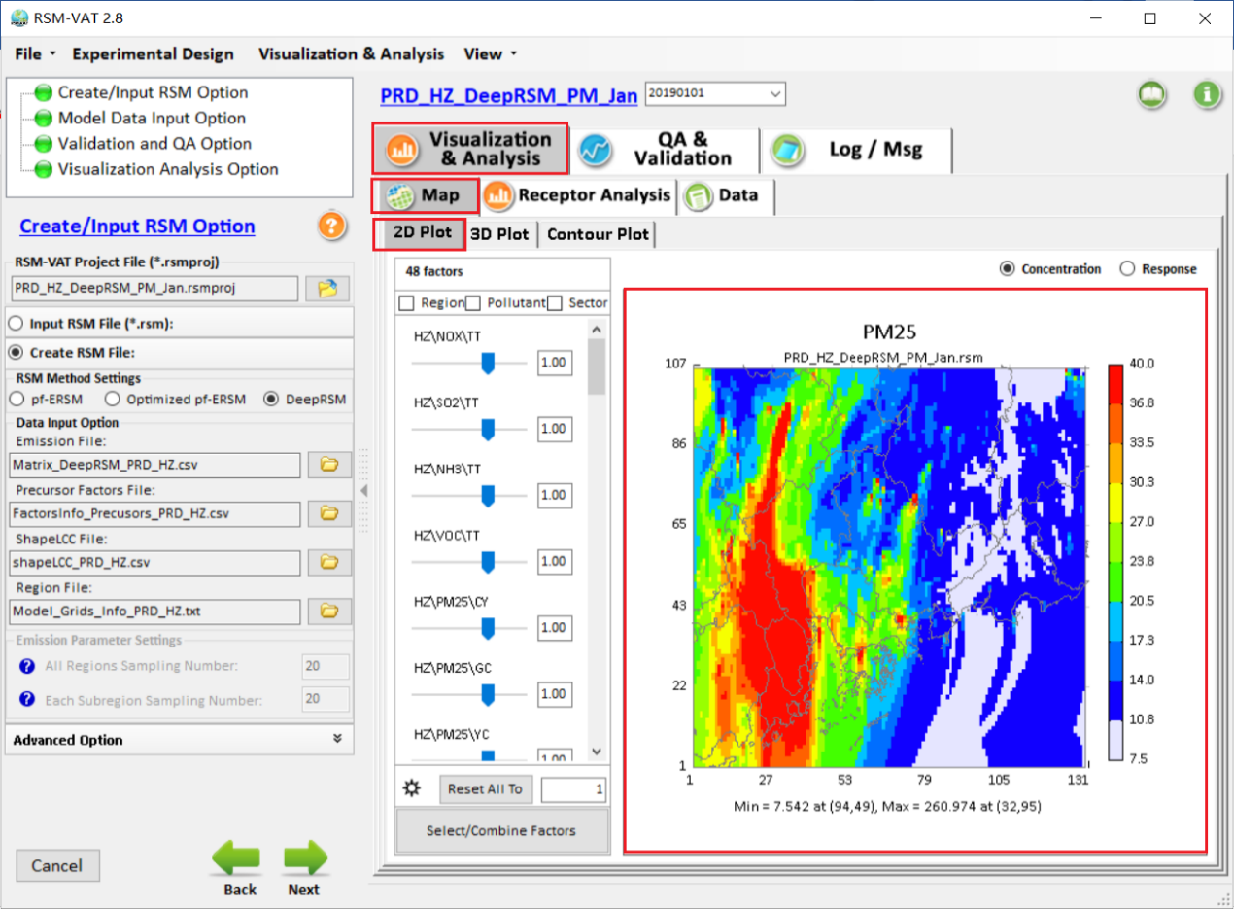
Fig. 31 Example of 2D Plot
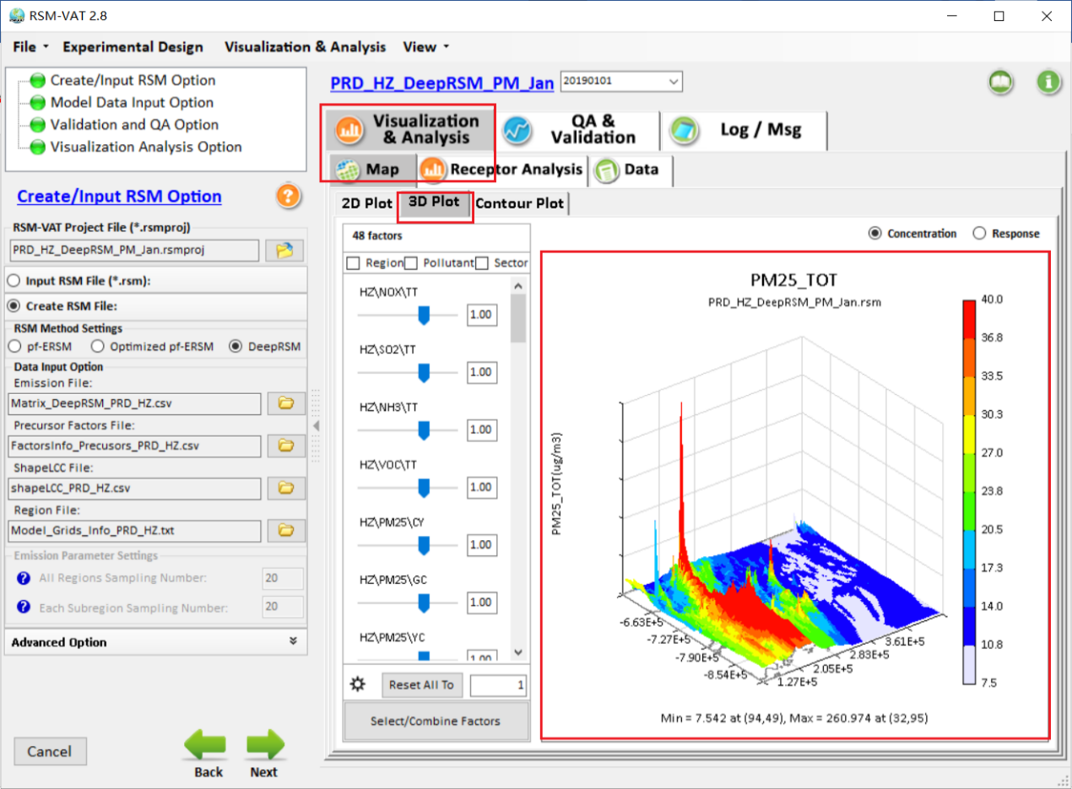
Fig. 32 Example of 3D Plot

Receptor Analysis
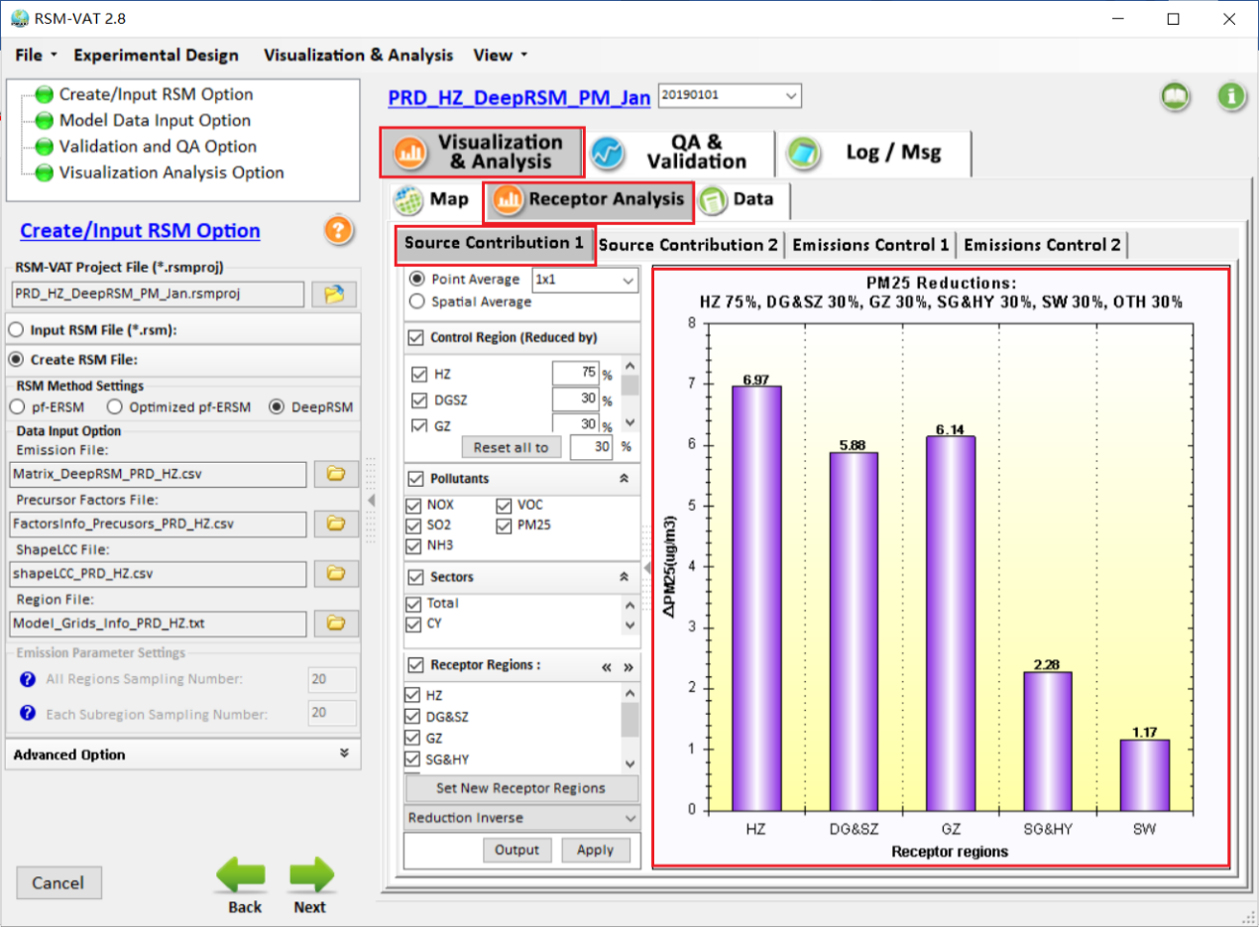
Fig. 33 Example of Source Contribution 1

Data
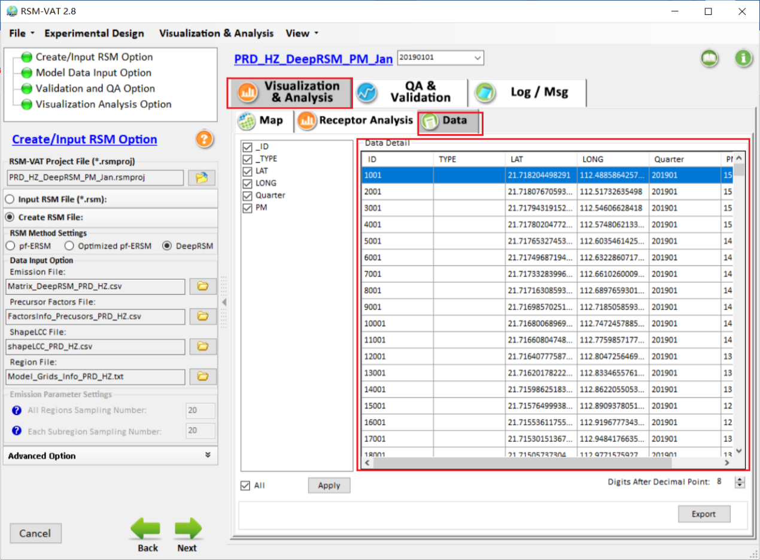
Fig. 34 Example of Data module.

QA and Validation
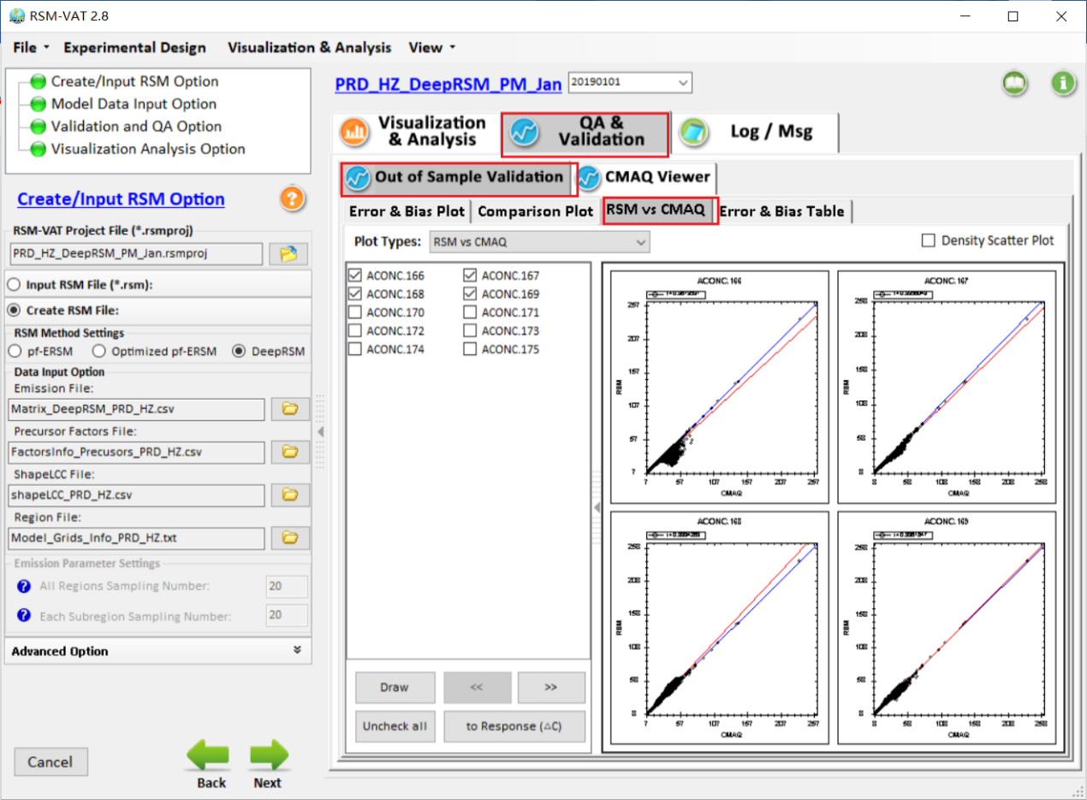
Fig. 35 Example of “Out of Sample Validation” module.

