Main Improvements of RSM-VAT 2.9
By SCUT, 2023-4-23

Main Improvements:
- Include “primary PM” control factor in whole US PM_{2.5} case (“Whole_US_PM25_July_Avg.rsmproj”);
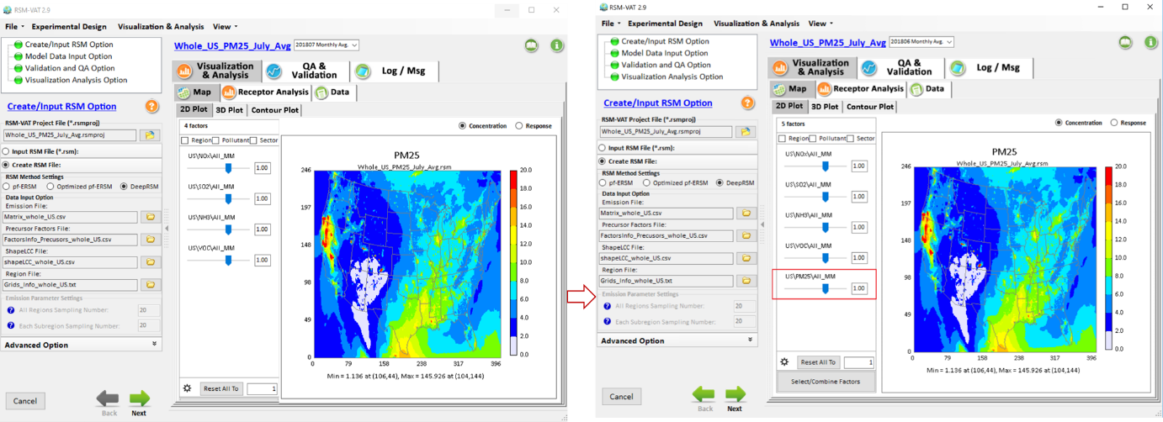
Fig. 1 Include “primary PM” control factor in whole US PM_{2.5} case
- Fix a screen frozen bug when loading RSM projects;
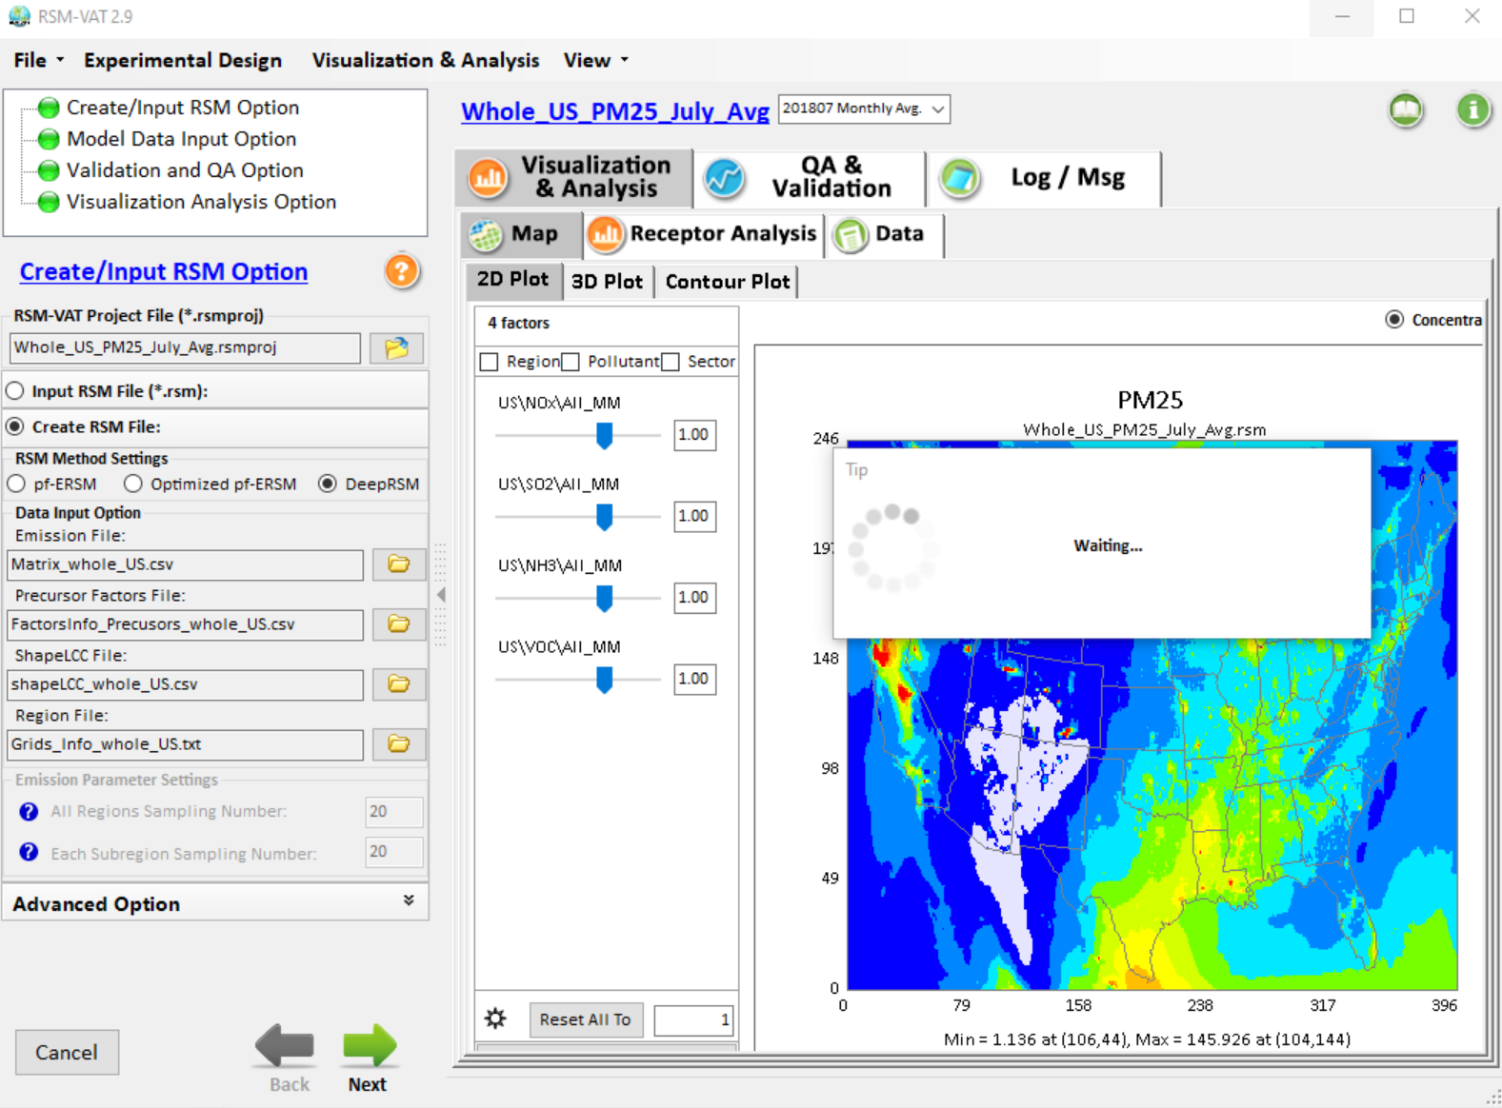
Fig. 2 Bug for loading RSM projects
- Fix a bug for climate region cases where the region name of “OTHER” displayed as “J” (Fig. 2).
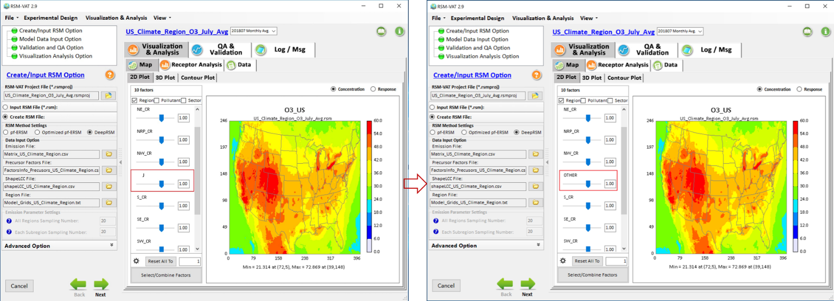
Fig. 3 Bug for displaying “OTHER” region
- Adjust the display name for the Monthly average case from “32” to “Monthly Avg” (Fig.3);
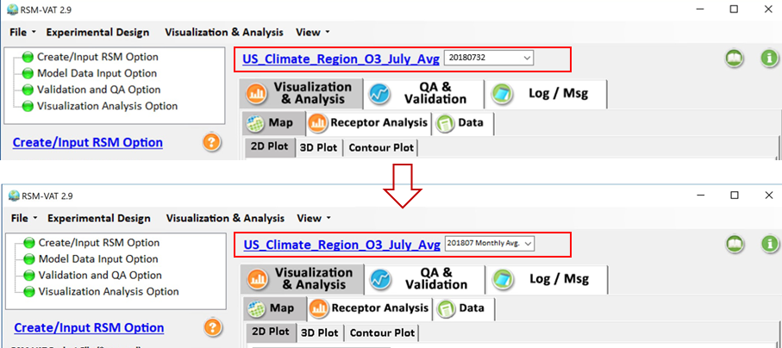
Fig. 4 Adjust the display name for the Monthly average case

To do list:
- Include “primary PM” factor for US climate regions case.
- Fix the concentration response bug in western climate region when controlling precursor emissions in center or eastern climate region.

