Main Improvements of NEXUS 0.4

Preparing for NEXUS 0.4
- Uninstall previous version of NEXUS;
- Double click “NEXUS Data.exe” to extract data to “My NEXUS Files”;
- Double click “NEXUS 0.4.exe” to install NEXUS 0.4.
- Double click the “NEXUS 0.4” icon on the desktop, it will load the pre-run “example” project, and show as below.
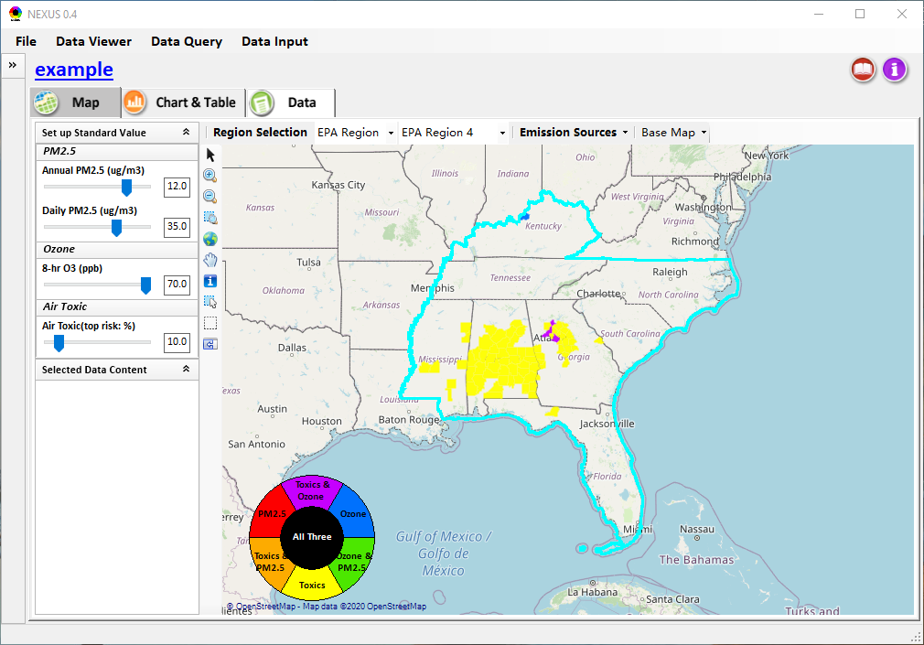
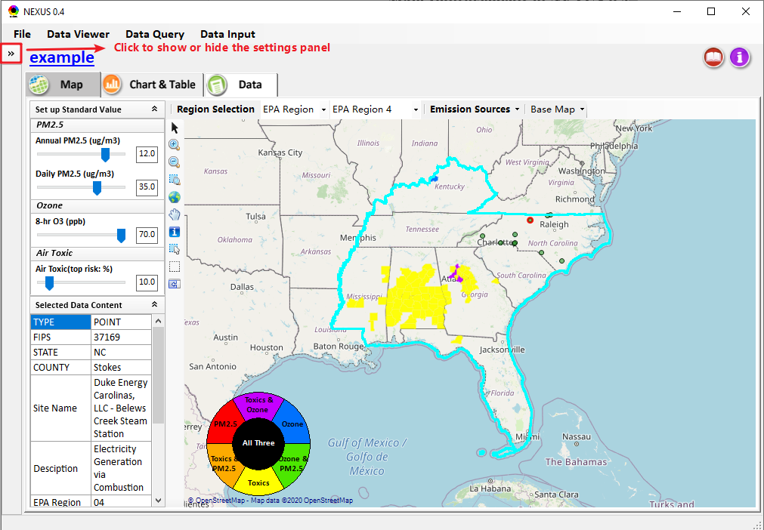

Improvements for Data Viewer
  - Implement the functions for all newly included options (e.g., PM_{2.5} Mortality/per million, Ozone Mortality/per million, Cancer/Non-Cancer risk top percentile, etc.);
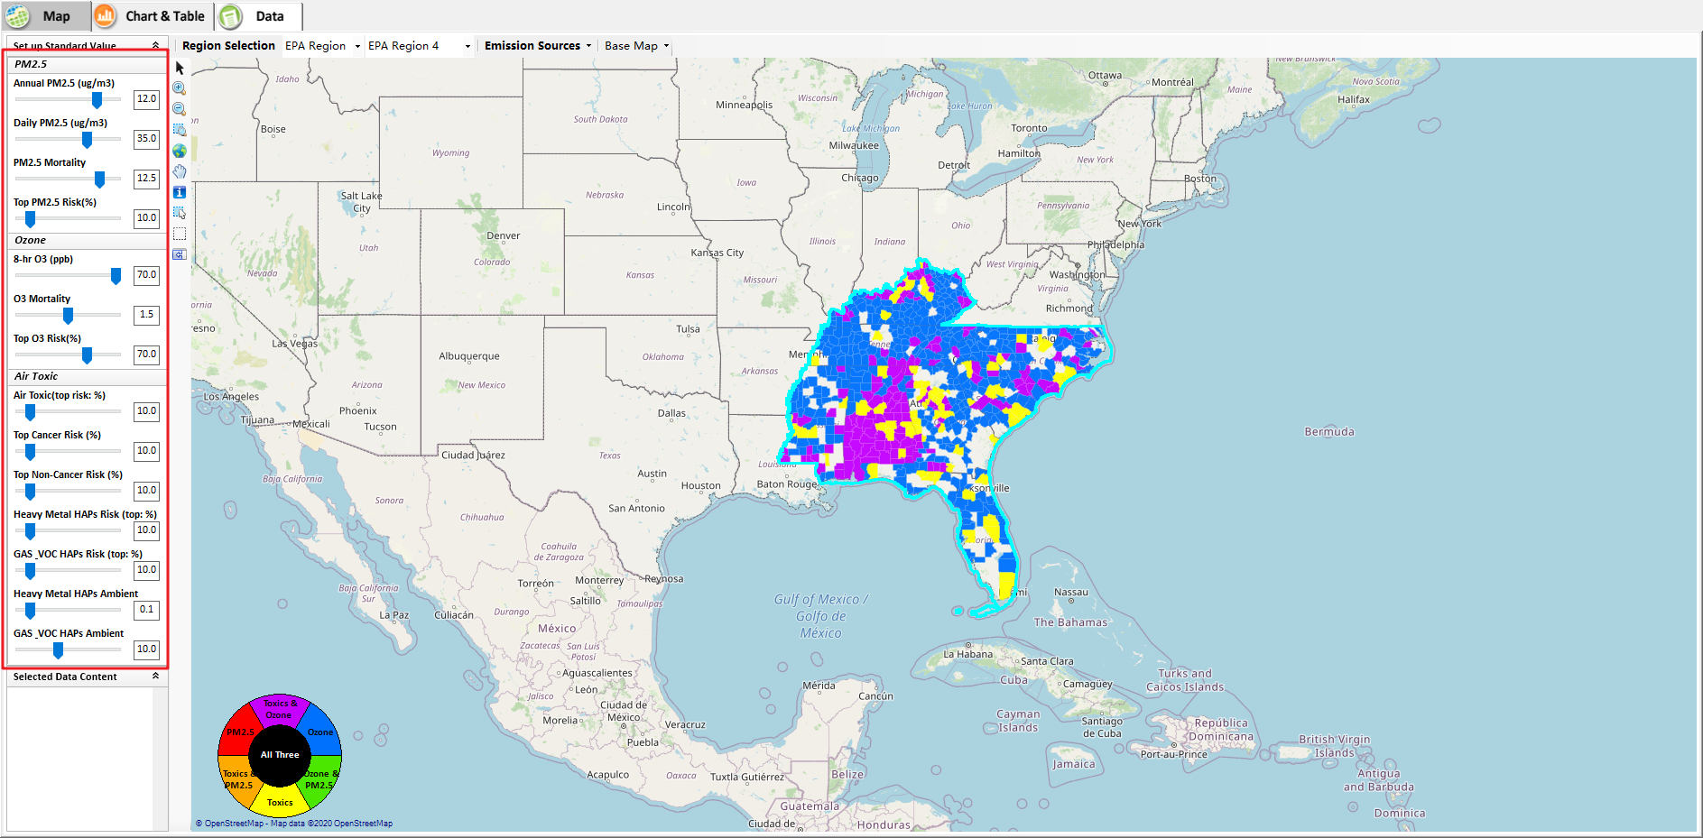
  - Use the design values from the files downloaded from EPA website instead of “NEXUS for Yarnell.gdb” for PM2.5 and Ozone.
  - Include Heavy Metal & VOC HAPs option.
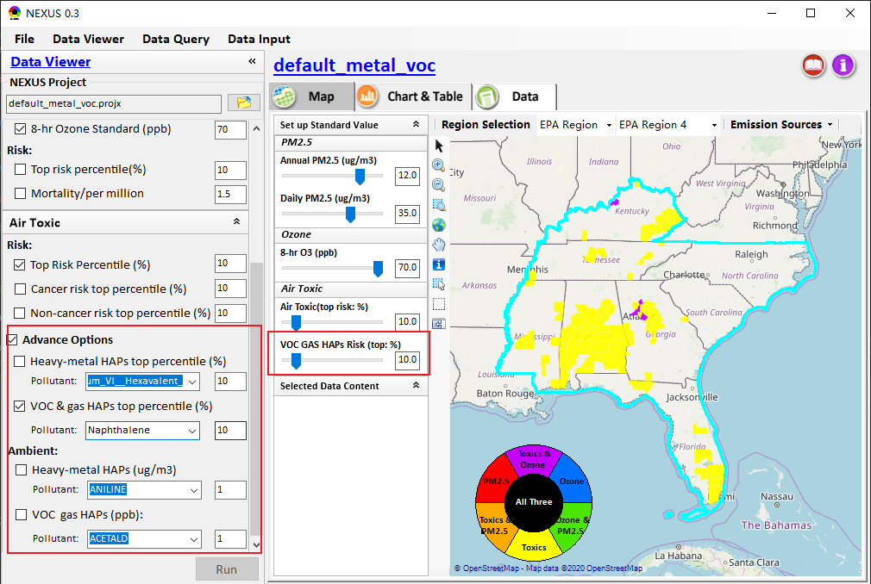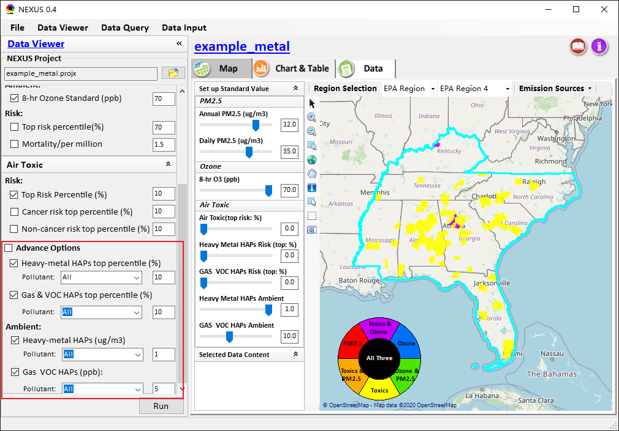

  - Develop the “Emission Sources” module.
- Click Emission Sources – Top X Emission Sources/Major Emission Sources, the Emission Sources Option window will show.
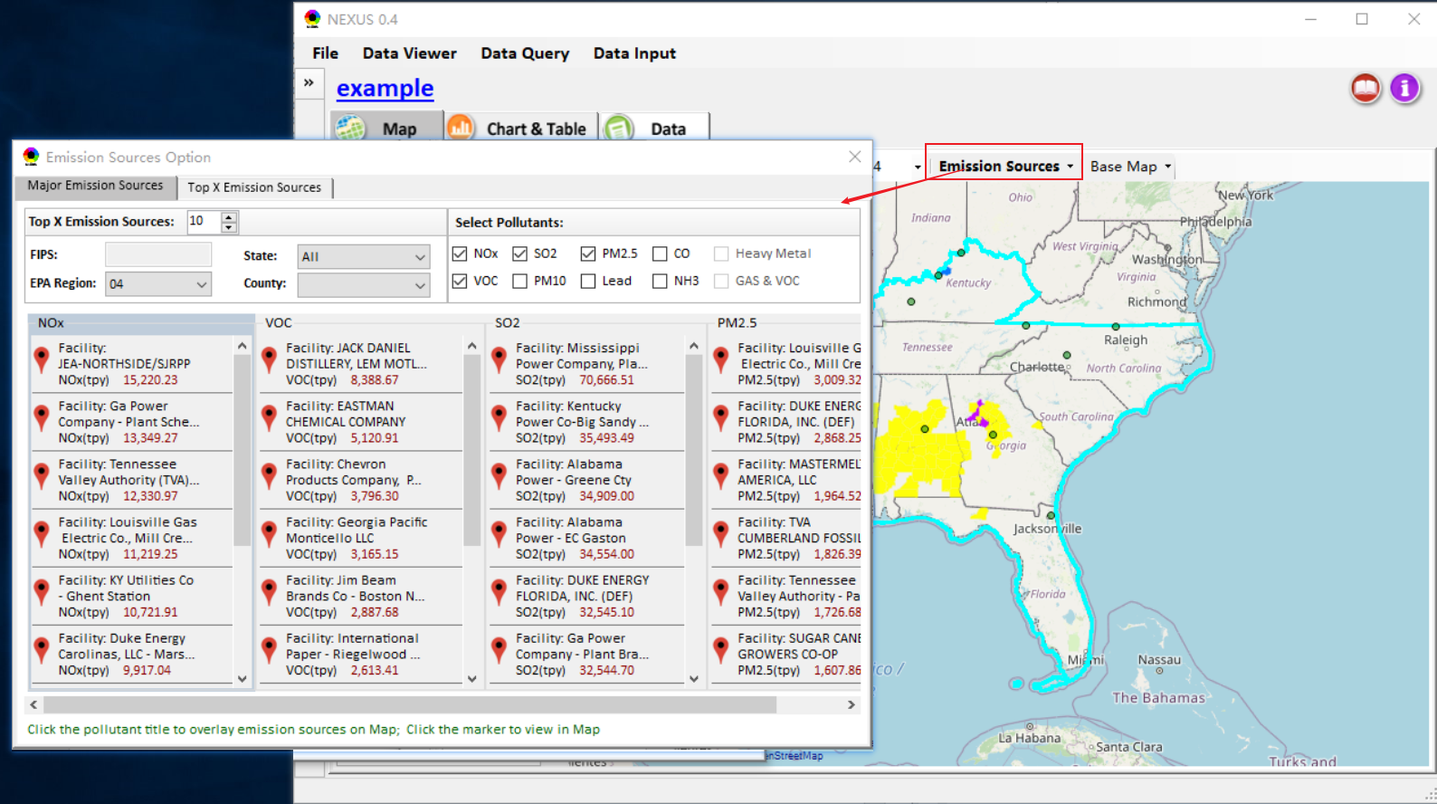

- Under the Major Emission Sources, user can click the pollutant label to overlay “top x emission” of desired pollutants on the map.
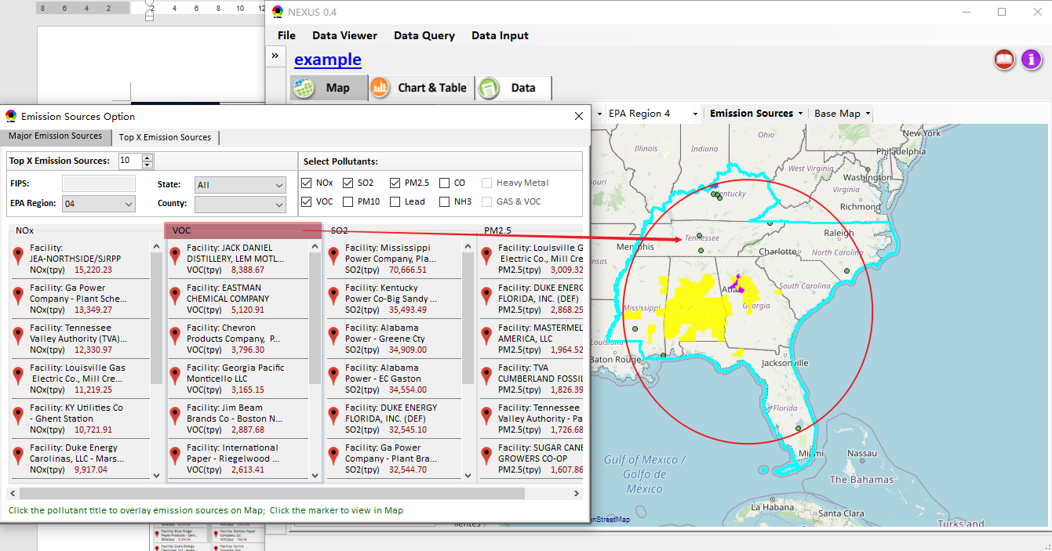

- user can click the “point marker” to overlay the emission point on the map.
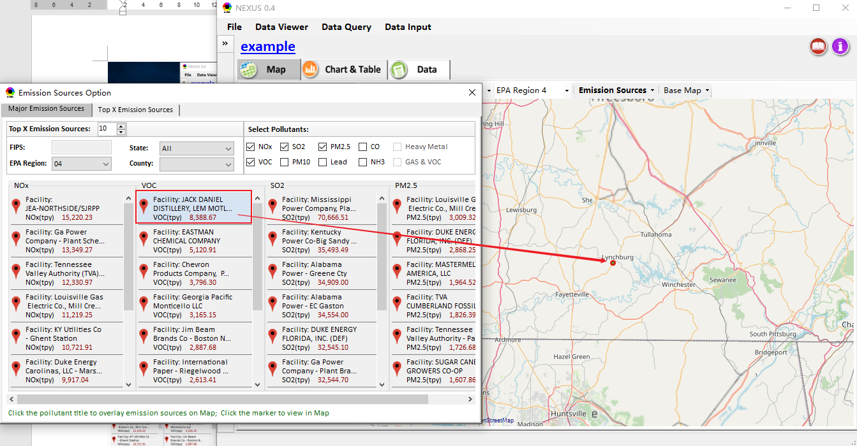

Improvements for “Data Query”
- Draft design of “Data Query”;
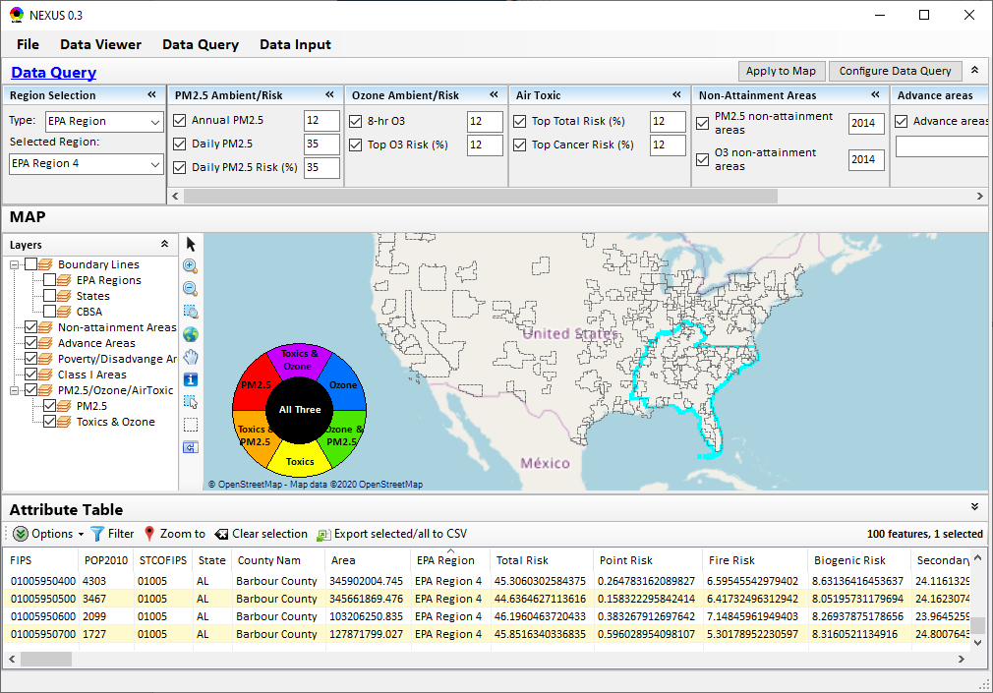
- Draft design of “Configure Data Query”
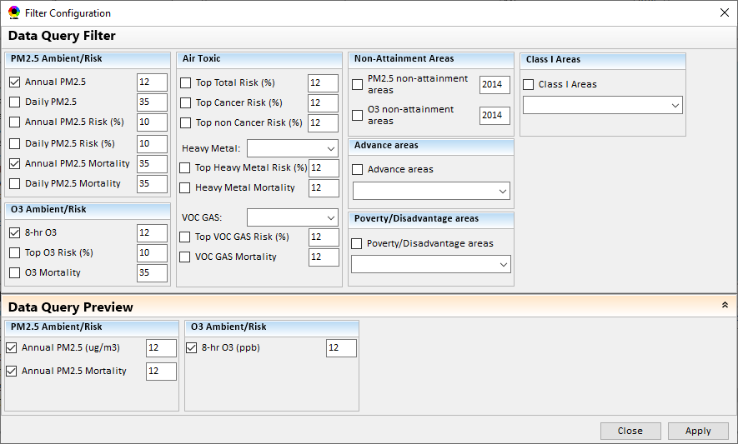

Improvements for “Data Input”
- Support to input and preview data under “Data Input” module.
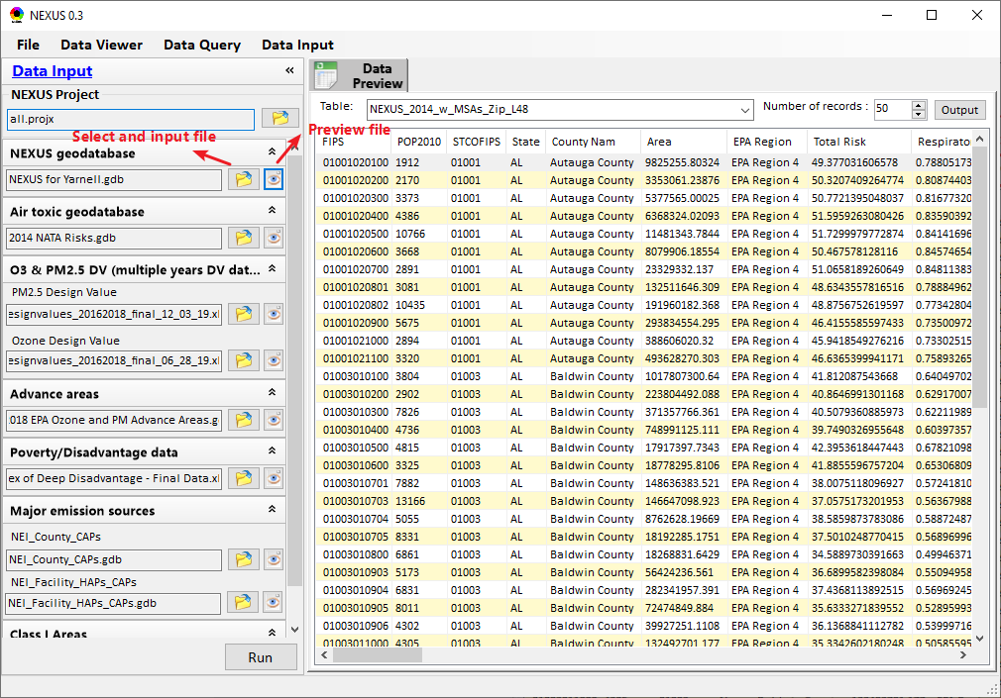
- Support to output the previewing data to “*.csv” file.
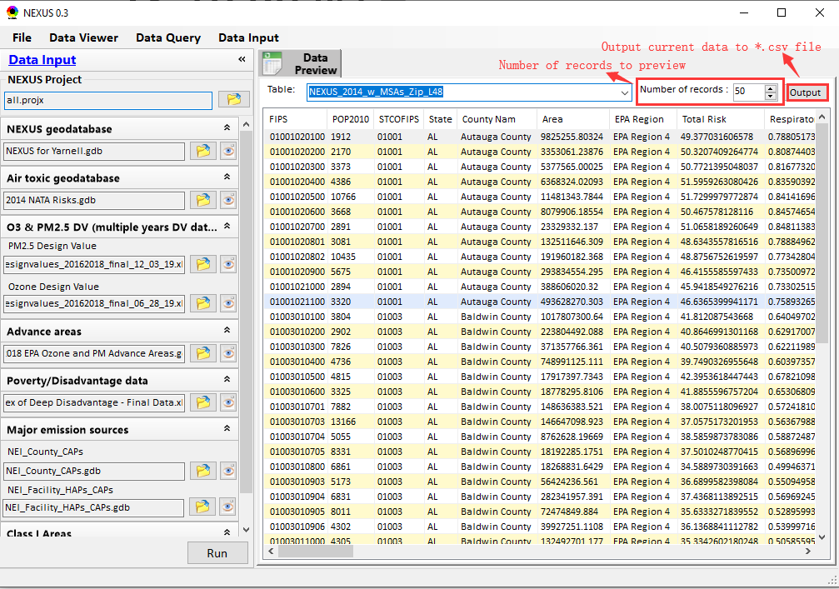

To do list:
  - Include “All” option for Heavy Metal & VOC HAPs;
  - Support to multi-select regions to combine the data (e.g., emission, mortality) to conduct multi-pollutant “Region Analysis”.
  - Integrate “Heavy Metal Air Toxic” and “Gas & VOC Air Toxic” into “Major Emission Sources” module
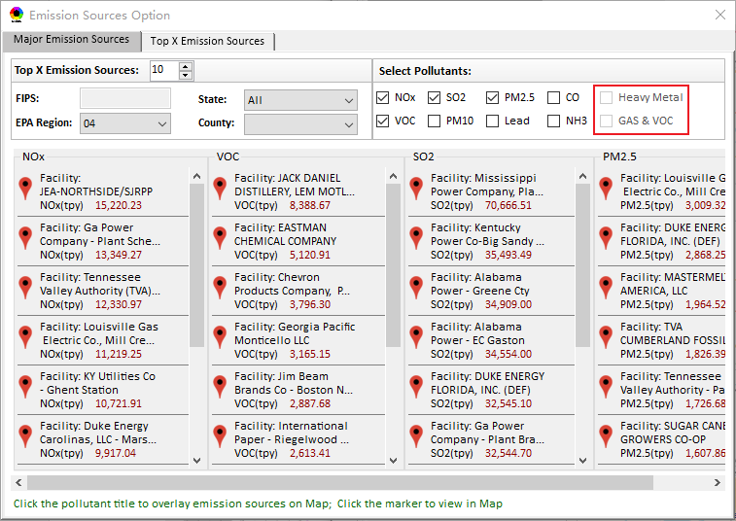
  - Under the Data module, provide a “Summary Table” that includes all kinds of data from “Data Input” module, e.g., join in the current data with Poverty/Disadvantage data.

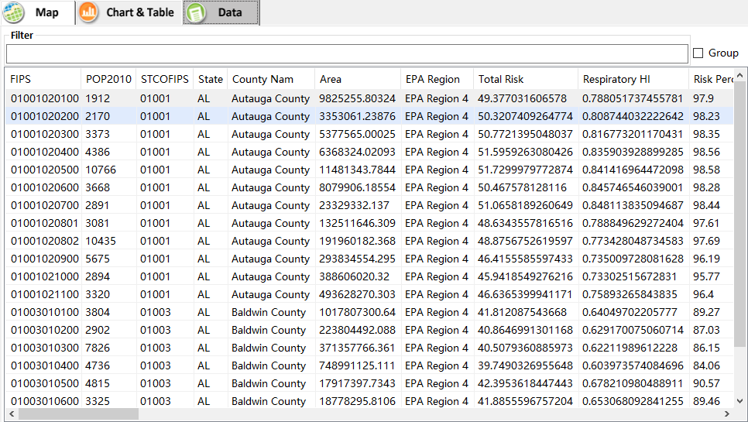
  - Develop similar function like “EPA Regions” & “States” for “CBSA” under “Region Selection”
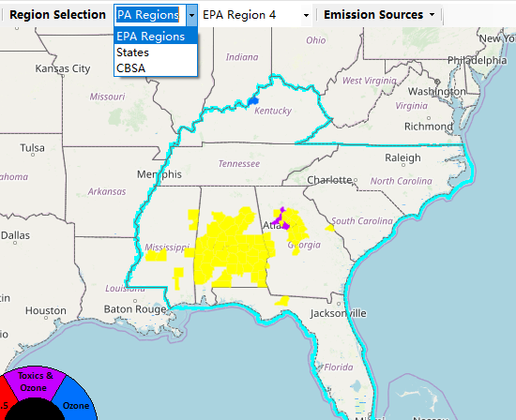
  - Continue to develop the Data Query module
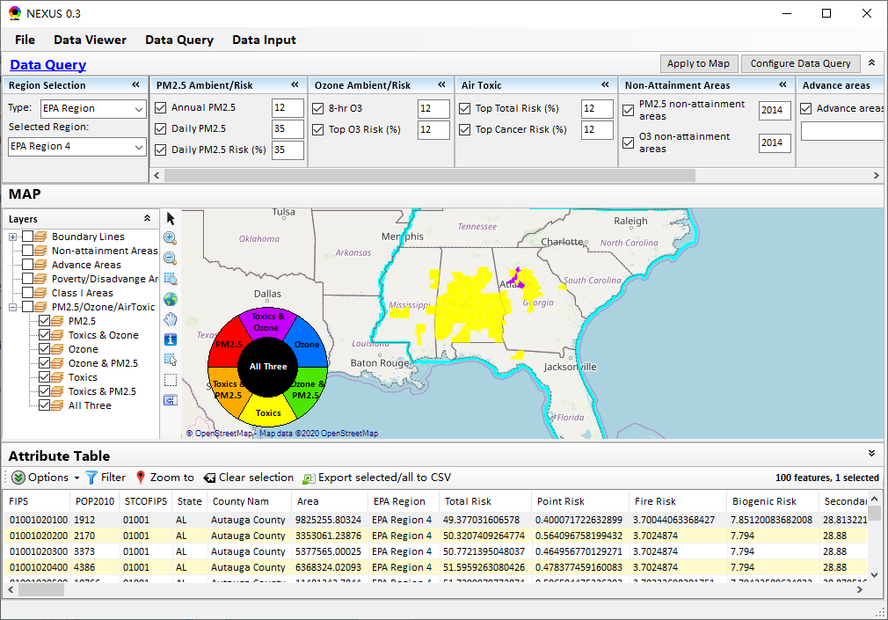
  - Develop the Table Generator module
