Supplement Appendix A

Tables and Figures

Table A.1. Number of EU sites in each trend type category which had decreasing (Dec), no significant trend (NT) or incomplete (NA) trends in the four health O₃ metrics impacted predominantly by high-end O₃ concentrations.

A4MDA8 AmaxMDA8 AmaxMDA1 A4W90
Trend Type Dec NT Inc NA Dec NT Inc NA Dec NT Inc NA Dec NT Inc NA

0 (No trend) 0 12 0 1 0 12 0 1 0 13 0 0 0 11 0 2
1a 59 57 0 2 52 64 0 2 62 55 0 1 48 39 0 31
1b 31 17 0 0 31 17 0 0 33 15 0 0 27 16 0 5
1c 1 0 0 0 1 0 0 0 1 0 0 0 1 0 0 0
2 0 52 2 2 0 54 1 1 3 51 1 1 0 47 2 7
3 7 14 0 1 11 10 0 1 13 9 0 0 5 10 0 7
4 5 0 0 0 3 2 0 0 5 0 0 0 4 1 0 0

Total 103 152 2 6 98 159 1 5 117 143 1 2 85 124 2 52

Table A.2. Number of US sites in each trend type category which had decreasing (Dec), no significant trend (NT) or incomplete (NA) trends in the four health O₃ metrics impacted predominantly by high-end O₃ concentrations. No monitors had increasing trends in any of these four metrics.

A4MDA8 AmaxMDA8 AmaxMDA1 A4W90
Trend Type Dec NT NA Dec NT NA Dec NT NA Dec NT NA

0 (No trend) 0 5 0 0 5 0 0 5 0 0 5 0
1a 99 19 1 105 13 1 115 4 0 91 15 13
1b 41 1 0 42 0 0 42 0 0 32 0 10
1c 3 0 1 3 0 1 3 0 1 3 0 1
2 1 6 0 2 5 0 3 4 0 2 5 0
3 8 0 0 7 1 0 7 1 0 8 0 0
4 10 0 0 10 0 0 10 0 0 9 0 1
7 0 1 0 0 1 0 0 1 0 0 1 0

Total 162 32 2 169 25 2 180 15 1 145 26 25

Table A.3. Sites in mainland China and Hong Kong, China exhibiting decreasing no significant trend (NT) or increasing (Inc) trends in the four health O₃ metrics impacted predominantly by high-end O₃ concentrations.

Site A4MDA8 AmaxMDA8 AmaxMDA1 A4W90

Mainland
Mt. Waliguan NT NT NT NT
Shangdianzi Inc Inc NT NT
Longfengshan NT NT NT NT

Hong Kong
Central/Western Inc Inc Inc Inc
Kwai Chung Inc Inc Inc Inc
Tap Mun NT NT NT NT
Tai Po Inc Inc Inc Inc
Yuen Long Inc Inc Inc Inc
Hok Tsui Inc Inc Inc Inc

Table A.4. Number of EU sites in each trend type category which had decreasing (Dec), no significant trend (NT), increasing (Inc), or incomplete (NA) trends in two human health O₃ metrics.

SOMO10 SOMO35
Trend Type Dec NT Inc NA Dec NT Inc NA

0 (No trend) 0 12 0 1 0 12 0 1
1a 1 72 43 2 18 96 2 2
1b 6 42 0 0 19 29 0 0
1c 1 0 0 0 1 0 0 0
2 0 29 25 2 0 44 10 2
3 4 17 0 1 9 12 0 1
4 4 1 0 0 4 1 0 0

Total 16 173 68 6 51 194 12 6

Table A.5. Number of US sites in each trend type category which had decreasing (Dec), no significant trend (NT), increasing (Inc), or incomplete (NA) trends in two human health O₃ metrics.

SOMO10 SOMO35
Trend Type Dec NT Inc NA Dec NT Inc NA

0 (No trend) 0 5 0 0 0 5 0 0
1a 34 62 22 1 53 56 9 1
1b 32 10 0 0 38 4 0 0
1c 3 0 0 1 3 0 0 1
2 0 4 3 0 0 4 3 0
3 7 1 0 0 7 1 0 0
4 10 0 0 0 10 0 0 0
7 0 1 0 0 0 1 0 0

Total 86 83 25 2 111 71 12 2

Table A.6. Number of EU sites in each trend type category which had decreasing (Dec), no significant trend (NT), increasing (Inc), or incomplete (NA) trends in four W126 vegetation O₃ metrics.

3-month 12-h W126 6-month 12-h W126 3-month 24-h W126 6-month 24-h W126
Trend Type Dec NT Inc NA Dec NT Inc NA Dec NT Inc NA Dec NT Inc NA

0 (No trend) 1 12 0 0 2 11 0 0 0 13 0 0 1 12 0 0
1a 15 101 1 1 44 73 0 1 13 103 1 1 38 79 0 1
1b 15 33 0 0 30 18 0 0 15 32 1 0 28 20 0 0
1c 1 0 0 0 1 0 0 0 1 0 0 0 1 0 0 0
2 1 43 10 2 0 51 5 0 0 46 9 1 0 53 3 0
3 3 17 0 2 12 10 0 0 5 15 0 2 12 10 0 0
4 4 1 0 0 5 0 0 0 4 1 0 0 5 0 0 0

Total 40 207 11 5 94 163 5 1 38 210 11 4 85 174 3 1

Table A.7. Number of US sites in each trend type category which had decreasing (Dec), no significant trend (NT), increasing (Inc), or incomplete (NA) trends in four W126 vegetation O₃ metrics.

3-month 12-h W126 6-month 12-h W126 3-month 24-h W126 6-month 24-h W126
Trend Type Dec NT Inc NA Dec NT Inc NA Dec NT Inc NA Dec NT Inc NA

0 (No trend) 0 5 0 0 0 5 0 0 0 5 0 0 0 5 0 0
1a 46 61 11 1 88 25 4 2 43 63 12 1 81 31 5 2
1b 30 11 0 1 40 2 0 0 29 12 0 1 40 2 0 0
1c 4 0 0 0 3 0 0 1 4 0 0 0 3 0 0 1
2 0 5 2 0 0 5 2 0 0 5 2 0 0 4 3 0
3 6 2 0 0 7 1 0 0 5 3 0 0 7 1 0 0
4 10 0 0 0 10 0 0 0 10 0 0 0 9 0 0 1
7 0 0 1 0 0 1 0 0 0 0 1 0 0 1 0 0

Total 96 84 14 2 148 39 6 3 91 88 15 2 140 44 8 4

Table A.8. Number of EU sites in each trend type category which had decreasing (Dec), no significant trend (NT), increasing (Inc), or incomplete (NA) trends in four vegetation O₃ metrics.

3-month AOT40 6-month AOT40 3-month 12-h avg. 6-month 12-h avg.
Trend Type Dec NT Inc NA Dec NT Inc NA Dec NT Inc NA Dec NT Inc NA

0 (No trend) 0 13 0 0 2 12 0 0 0 13 0 0 0 13 0 0
1a 4 110 3 1 25 90 1 1 0 76 42 0 2 82 34 0
1b 5 43 0 0 25 23 0 0 2 44 2 0 11 36 1 0
1c 1 0 0 0 1 0 0 0 1 0 0 0 1 0 0 0
2 0 42 12 2 0 50 6 0 0 27 29 0 0 28 28 0
3 3 17 0 2 11 11 0 0 2 20 0 0 7 15 0 0
4 4 1 0 0 4 1 0 0 4 1 0 0 4 1 0 0

Total 17 226 15 5 68 187 7 1 9 181 73 0 25 175 63 0

Table A.9. Number of US sites in each trend type category which had decreasing (Dec), no significant trend (NT), increasing (Inc), or incomplete (NA) trends in four vegetation O₃ metrics.

3-month AOT40 6-month AOT40 3-month 12-h avg. 6-month 12-h avg.
Trend Type Dec NT Inc NA Dec NT Inc NA Dec NT Inc NA Dec NT Inc NA

0 (No trend) 0 5 0 0 0 5 0 0 0 5 0 0 0 5 0 0
1a 30 70 18 1 70 41 6 2 14 50 58 0 40 64 15 0
1b 27 14 0 1 38 4 0 0 15 26 0 0 33 9 0 0
1c 4 0 0 0 3 0 0 1 1 1 0 0 4 0 0 0
2 0 2 5 0 0 5 2 0 0 2 5 0 0 3 4 0
3 4 4 0 0 7 1 0 0 3 5 0 0 6 2 0 0
4 9 1 0 0 10 0 0 0 7 3 0 0 9 1 0 0
7 0 0 1 0 0 1 0 0 0 0 1 0 0 1 0 0

Total 74 96 24 2 128 57 8 3 40 92 64 0 92 85 19 0

Table A.10. Sites in mainland China and Hong Kong, China exhibiting no significant trend (NT) or increasing (Inc) trend in two human health O₃ metrics.

Site SOMO10 SOMO35

Mainland
Mt. Waliguan Inc Inc
Shangdianzi Inc Inc
Longfengshan NT NT

Hong Kong
Central/Western Inc Inc
Kwai Chung Inc Inc
Tap Mun Inc Inc
Tai Po Inc Inc
Yuen Long Inc Inc
Hok Tsui Inc Inc

Table A.11. Sites in mainland China and Hong Kong, China which had decreasing (Dec), no significant trend (NT), or increasing (Inc) trends in four W126 vegetation O₃ metrics.

Site 3-month 12-h W126 6-month 12-h W126 3-month 24-h W126 6-month 24-h W126

Mainland
Mt. Waliguan NT NT NT NT
Shangdianzi Inc Inc Inc Inc
Longfengshan Dec NT Dec NT

Hong Kong
Central/Western Inc Inc Inc Inc
Kwai Chung Inc Inc Inc Inc
Tap Mun NT NT NT NT
Tai Po NT Inc NT Inc
Yuen Long Inc Inc Inc Inc
Hok Tsui Inc Inc Inc Inc

Table A.12. Sites in mainland China and Hong Kong, China which had decreasing (Dec), no significant trend (NT), or increasing (Inc) trends in four vegetation O₃ metrics.

Site 3-month AOT40 6-month AOT40 3-month 12-h avg. 6-month 12-h avg.

Mainland
Mt. Waliguan NT NT NT NT
Shangdianzi Inc Inc NT Inc
Longfengshan Dec NT Dec NT

Hong Kong
Central/Western Inc Inc Inc Inc
Kwai Chung Inc Inc Inc Inc
Tap Mun NT NT NT NT
Tai Po Inc Inc NT NT
Yuen Long Inc Inc Inc Inc
Hok Tsui Inc Inc Inc Inc

Table A.13. Proportion of US and EU sites assigned to Trend Types 1a and 1b with significant trends in high percentile O_{3.}
 |  | Sites with no decreasing trend | Sites with decreasing trend in:
Trend Type | Total Number of sites | 95th, 98th, 99th and 100th percentile | 95th, 98th, 99th and 100th percentile | 98th, 99th, and 100th percentile | 99th, and 100th percentile | 100th percentile
EU – 1a | 118 | 23% | 13% | 28% | 41% | 49%
US – 1a | 112 | 2% | 65% | 81% | 85% | 97%
EU – 1b | 48 | 13% | 38% | 46% | 50% | 67%
US – 1b | 48 | 0% | 92% | 100% | 100% | 100%

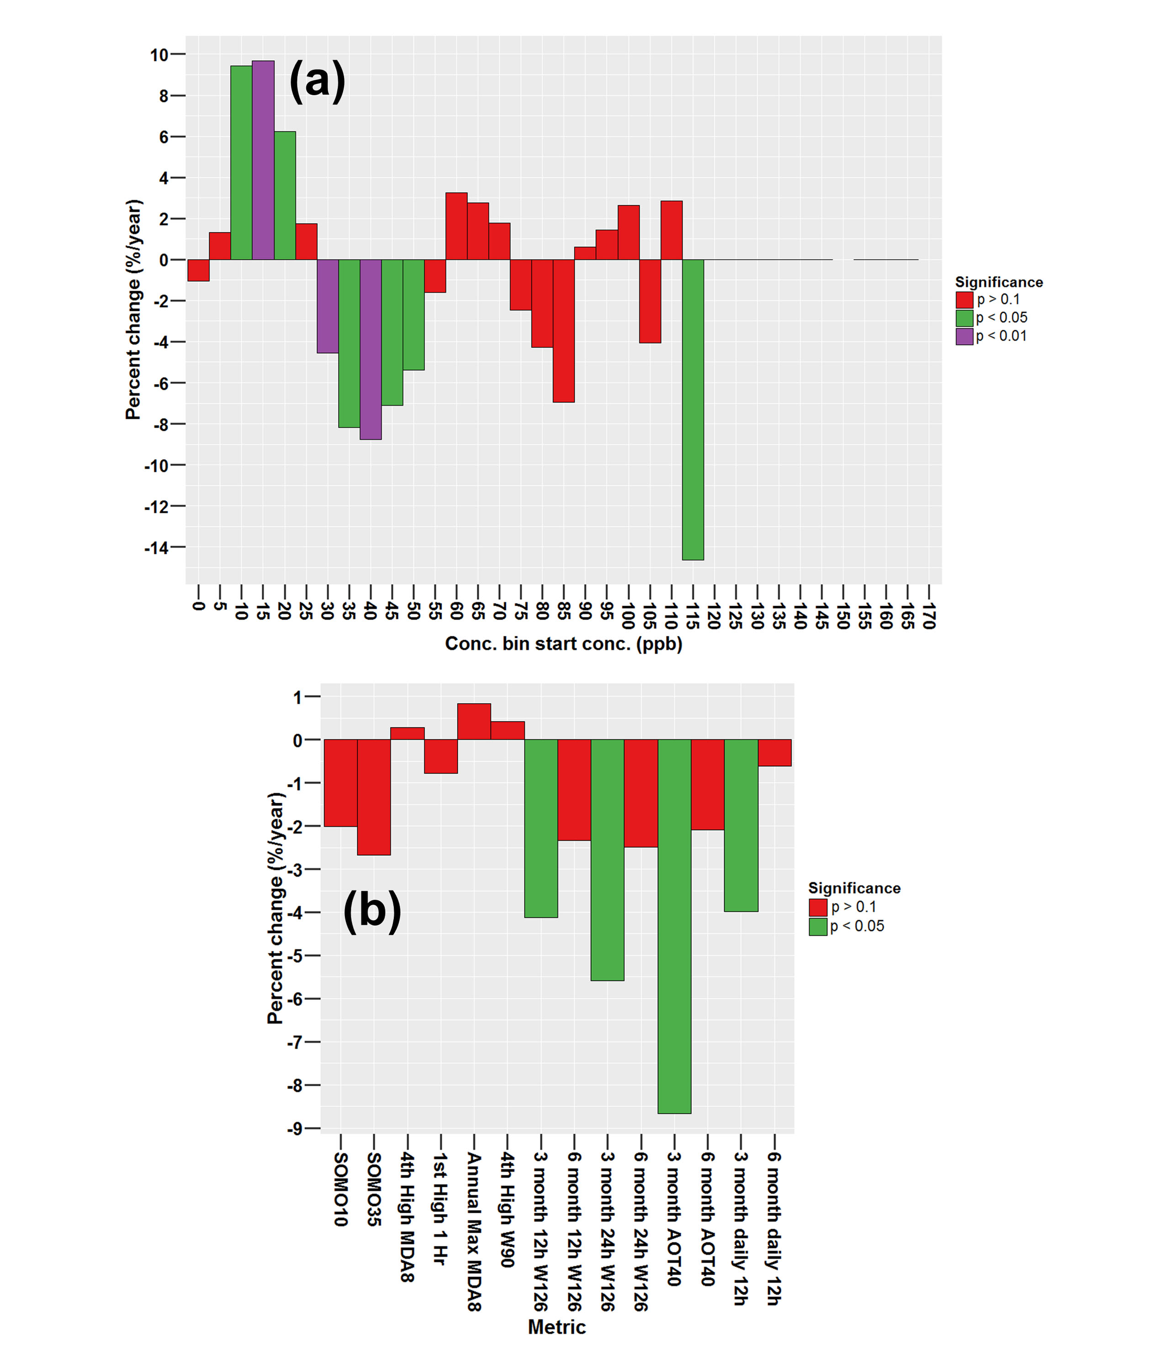

Figure A.1. Theil-Sen trend (%/year) (2006-2015) at Longfengshan, China, (a) O₃ concentrations in each bin and (b) 6 human health and 8 vegetation O₃ metrics. For this study, p < 0.05 is used to determine significance using the Mann-Kendall test. Trend type at this site was characterized as not matching the algorithm described in Supplement Appendix B (i.e., Trend Type X).

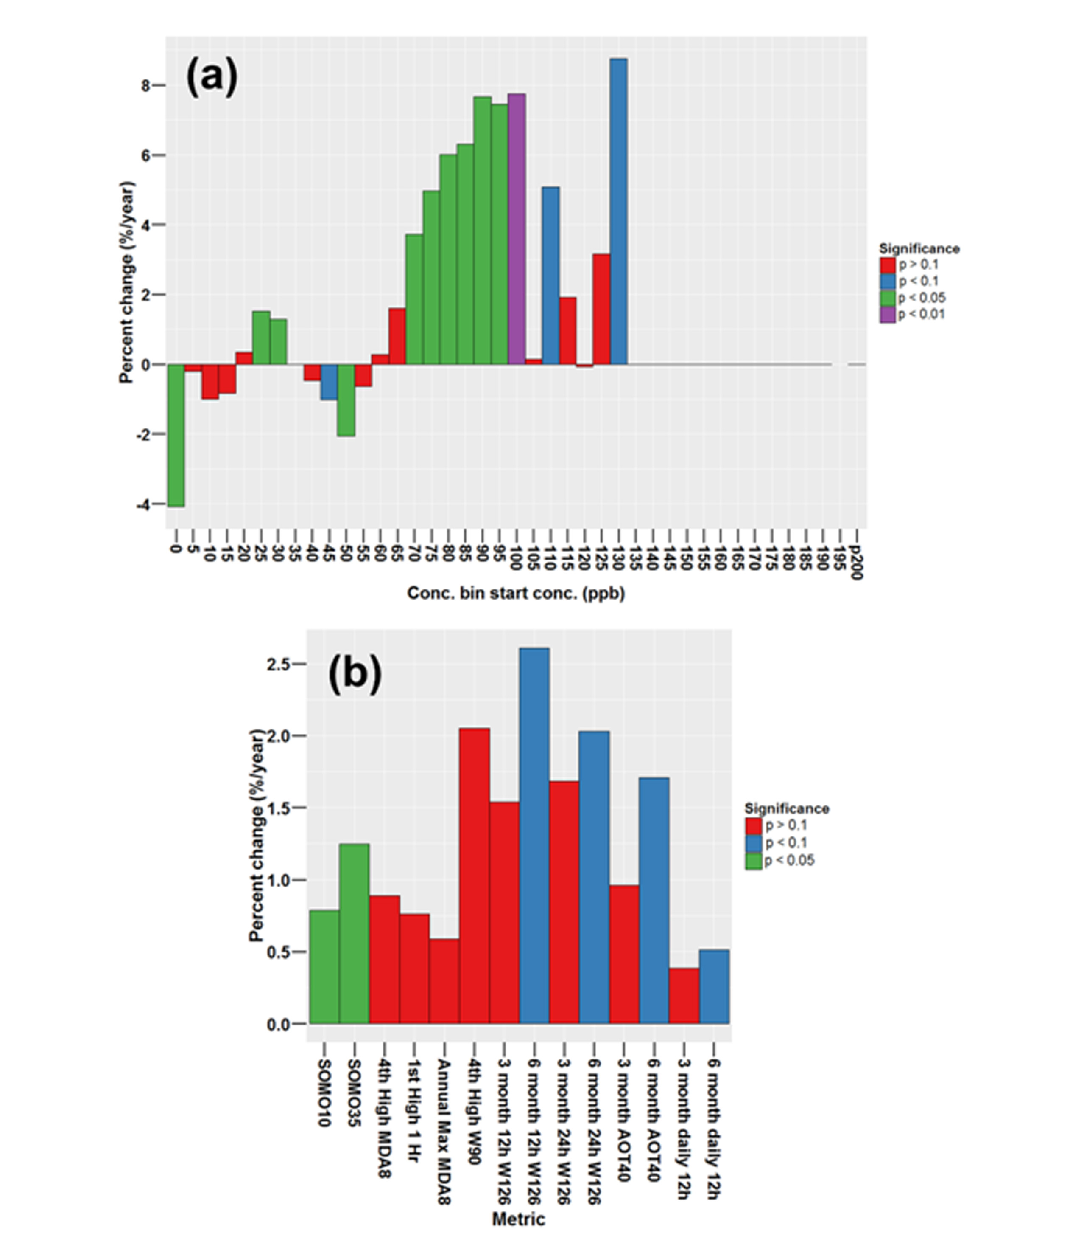
Figure A.2. Theil-Sen trend (%/year) (2004-2015) at Tap Mun, China, (a) O₃ concentrations in each bin and (b) 6 human health and 8 vegetation O₃ metrics. For this study, p < 0.05 is used to determine significance using the Mann-Kendall test. Trend type at this site was characterized as not matching the algorithm described in Supplement Appendix B, (i.e., Trend Type X).

Supplement Appendix B

Procedures Used for Identifying Trend Types Based on Distribution Changes

For each site, the T-S slope and p-value for each concentration bin was calculated as described above. The slopes were translated into a function, where X = concentration bin and F(X) = T-S slope for bin X. The 'zeros' of this function (i.e. the concentration bin where the magnitude of the T-S trend estimate transitioned from positive to negative or vice versa) were identified. In most cases, there were 1 or 2 zeros. However, in some cases F(X) was noisy and there were three or more zeros. Several of these cases at US sites were caused by 1/2 MDL substitution or other data reporting anomalies causing irregular trends in the lowest bin. Therefore, the lowest bin (i.e., 0-5 ppb) was ignored if there were three or more zeros. Most of the remaining cases involved bins where trends were not significant and/or data were sparse, causing F(X) to be noisy. These cases were resolved by smoothing F(X) using a weighted moving average, with weights based on the standard normal density. The smoothing resulted in F(X) with 1 or 2 zeros for each site.
The trend types were categorized as follows:
- If there were fewer than two concentration bins with significant p-values, then the site received Trend Type 0, or no trend.

The remaining Trend Types were determined using the positions of the bins with significant p-values relative to the zeros of F(X).
- For Trend Type 1, where the high and low ends of the distribution are compressed toward the middle, F(X) was required to have exactly two zeros, with at least one bin below the first zero having a decreasing trend and at least one bin above the second zero having a decreasing trend. To further categorize the Trend Type 1 sites, 3 sub-categories were created based on the trend in the median: Trend Type 1a sites, where the median increased; Trend Type 1b sites, where no change in the median occurred; and Trend Type 1c sites, where the median decreased.

Trend type classifications 2, 3, and 4 each had two possible criteria, one for cases where F(X) had one zero and one for cases where F(X) had two zeros.
- Trend Type 2 represents sites where low concentrations shift toward the middle of the distribution, but the frequency of high concentrations does not change. For Trend Type 2, if F(X) exhibited one zero, at least one of the four lowest bins (0-5, 5-10, 10-15, or 15-20 ppb) was required to exhibit a decreasing trend below the zero, and that no bins with significant trends occurred more than 4 bins (20 ppb) above the zero. If F(X) had two zeros, at least one bin below the first zero was required to exhibit a decreasing trend, and that there must be no bins with significant trends above the second zero.

- Trend Type 3 represents sites where the high concentrations shift towards the middle of the distribution, but the frequency of low concentrations does not change. For Trend Type 3, if F(X) exhibited one zero, all bins with decreasing trends were required to be above the zero, and none of the lowest four bins (0 – 20 ppb) could exhibit a significant trend. If F(X) had two zeros, at least one bin above the second zero was required have a decreasing trend, and none of the lowest four bins could have a significant trend.

- Trend Type 4 represents sites where the entire distribution shifts toward lower concentrations. The criteria for Trend Type 4 was the same as that for Trend Type 3 except there had to be an increasing trend in one of the bottom four bins (0 – 20 ppb).

- Trend Type 5 represents sites where the high and low concentrations increase in frequency (i.e. the opposite to Trend Type 1 behavior). Hence F(X) was required to have exactly 2 zeros, with at least one bin above the second zero, and one bin below the first zero having increasing trends.

- Trend Type 6 represents sites where the middle of the distribution shifts downwards, but the frequency of high concentrations does not change (i.e. the opposite of Trend Type 2 behavior). For Trend Type 6, if F(X) exhibited one zero, all bins with significant increasing trends were required to be below the zero, and that no bins with significant trends occurred more than 4 bins (20 ppb) above the zero. If F(X) had two zeros, at least one bin below the first zero was required to exhibit a significantly increasing trend, and that there must be no bins with significant trends above the second zero.

- Trend Type 7 represents sites where the middle of the distribution shifts upwards, but the frequency of low concentrations does not change (i.e. the opposite of Trend Type 3 behavior). For Trend Type 7, if F(X) exhibited one zero, all bins with increasing trends were required to be above the zero, and none of the lowest four bins (0 – 20 ppb) could exhibit a significant trend. If F(X) had two zeros, at least one bin above the second zero was required have an increasing trend, and none of the lowest four bins could have a significant trend.

- Trend Type 8 represents sites where the entire distribution shifts upwards (i.e. the opposite of Trend Type 4 behavior). The criteria for Trend Type 8 was the same as that for Trend Type 7 except there had to be a decreasing trend in one of the bottom four bins (0 – 20 ppb).

- Trend Type X represents complex trends that do not fall into any of the categories listed above. It is not possible to categorize portions of the O₃ distribution into “low”, “middle”, and “high” for this trend type because the directions of the trends shift more than two times in the distribution.

Supplement Appendix C

Data Capture Used for Exposure Metrics

SOMO10 and SOMO35: For each day, 24 8-h running means were calculated as the average concentration during that hour and the following 7 hours. An 8-h running mean was valid if there were 6 or more valid O₃ measurements during the 8 hour period. A valid daily maximum 8-h concentration was calculated if there were at least 18 valid 8-h running means during that day. The sum of positive differences between each daily maximum 8-h concentration and 10 ppb (SOMO10) and 35 ppb (SOMO35) were calculated when there were at least 75% valid daily maximum 8-h concentrations in a given year. This sum was then multiplied by the fraction of total days in the year over the number of days with a valid daily maximum 8-h concentration to produce annual SOMO10 and SOMO35 estimates.

4th highest daily max 8-h O₃ and Annual max daily 8-h (A4MDA8; AmaxMDA8): For each day, 24 8-h running means were calculated as the average concentration during that hour and the preceding 7 hours. An 8-h running mean was valid if a least 6 hours had valid O₃ measurements during the 8 hour period. A valid daily maximum 8-h concentration was calculated if there were at least 18 valid 8-h running means during that day. The 4th highest daily maximum, and annual maximum 8-h values were computed if there was a valid daily maximum 8-h concentration on at least 75% days during the year.

Annual 1st max daily 1-h (AmaxMDA1): The maximum hourly O₃ concentration on each calendar day was calculated when there were at least 18 valid hourly O₃ measurements during that day. The annual maximum daily 1-h concentration was calculated if there were at least 75% valid daily maximum 1-h O₃ concentrations during a year.

4th highest W90 (A4W90): For each day, 24 5-h sums of hourly W90 (calculated as outlined in Lefohn et al. (2010a)) were calculated, requiring that all 5 hours had valid O₃ data. The daily maximum 5-h W90 was calculated if there were at least 18 valid 5-h W90 values during the particular day. The 4th highest daily maximum W90 was calculated if there were at least 75% valid daily max 5-h W90 values in a given year.

12-h W126 3-month and 12-h W126 6-month: W126 was calculated for all hours between 08:00 and 19:59 during the relevant 3-month and 6-month period respectively. The sum of all hourly W126 values was calculated if at least 75% of hours during the accumulation period had valid O₃ data. The unadjusted W126 value was multiplied by the fraction of total hours over the number of valid hours in the accumulation period to produce the 12-h W126 3-month and 12-h W126 6-month estimates. The 3-month period for wheat was identified at (http://www.igacproject.org/sites/all/themes/bluemasters/images/TOAR_ListOf_Metrics.pdf) using information about the climate zone (http://eusoils.jrc.ec.europa.eu/projects/RenewableEnergy/) in which the monitoring site was located. The 6-month period was April-September.

24-h W126 3-month and 24-h W126 6-month: Data capture criteria as for 12-h W126 values except that the accumulation period was expanded to all hours across a day. The 3-month period for wheat was identified at (http://www.igacproject.org/sites/all/themes/bluemasters/images/TOAR_ListOf_Metrics.pdf) using information about the climate zone (http://eusoils.jrc.ec.europa.eu/projects/RenewableEnergy/) in which the monitoring site was located. The 6-month period was April-September.

12-h AOT40 3-month and 12-h AOT40 6-month: The sum of the positive differences between hourly O₃ and 40 ppb was calculated for the relevant 3-month and 6-month period, assessing only hours between 08:00 and 19:59, if at least 75% of hours during the accumulation period had valid O₃ data. The unadjusted AOT40 value was multiplied by the fraction of total hours over the number of valid hours in the accumulation period to produce the 12-h AOT40 3-month and 12-h AOT40 6-month estimates. The 3-month period for wheat was identified at (http://www.igacproject.org/sites/all/themes/bluemasters/images/TOAR_ListOf_Metrics.pdf) using information about the climate zone (http://eusoils.jrc.ec.europa.eu/projects/RenewableEnergy/) in which the monitoring site was located. The 6-month period was April-September.

Daily 12-h average averaged over 3-months and Daily 12-h average averaged over 6-months: During the relevant 3-month or 6-month period, the average O₃ concentration between 08:00 and 19:59 on each day was calculated if at least 9 hours had valid O₃ data on a particular day. The average of these daily averages was calculated if at least 75% of days during the 3-month or 6-month period had valid O₃ data. The 3-month period for wheat was identified at (http://www.igacproject.org/sites/all/themes/bluemasters/images/TOAR_ListOf_Metrics.pdf) using information about the climate zone (http://eusoils.jrc.ec.europa.eu/projects/RenewableEnergy/) in which the monitoring site was located. The 6-month period was April-September.

Supplement Appendix D

Change in Precision Analysis (US Sites)
A large fraction of US monitoring sites that were established in the early 1980s reported O₃ data with 10 ppb precision. These sites were mostly located in California and Texas, with a few sites located in the Northeastern US. All but one of these sites switched to reporting with 1 ppb precision in the early to mid-1990s (e.g., Fig. D.1). For the purpose of characterizing the change in the overall distribution using 5 ppb bins, random scatter was added to the early data at these sites. We performed an analysis to better understand the impact of both a one-time discrete shift from low precision to higher precision data and the impact of adding scatter to the low precision data on the exposure metrics examined in this article.
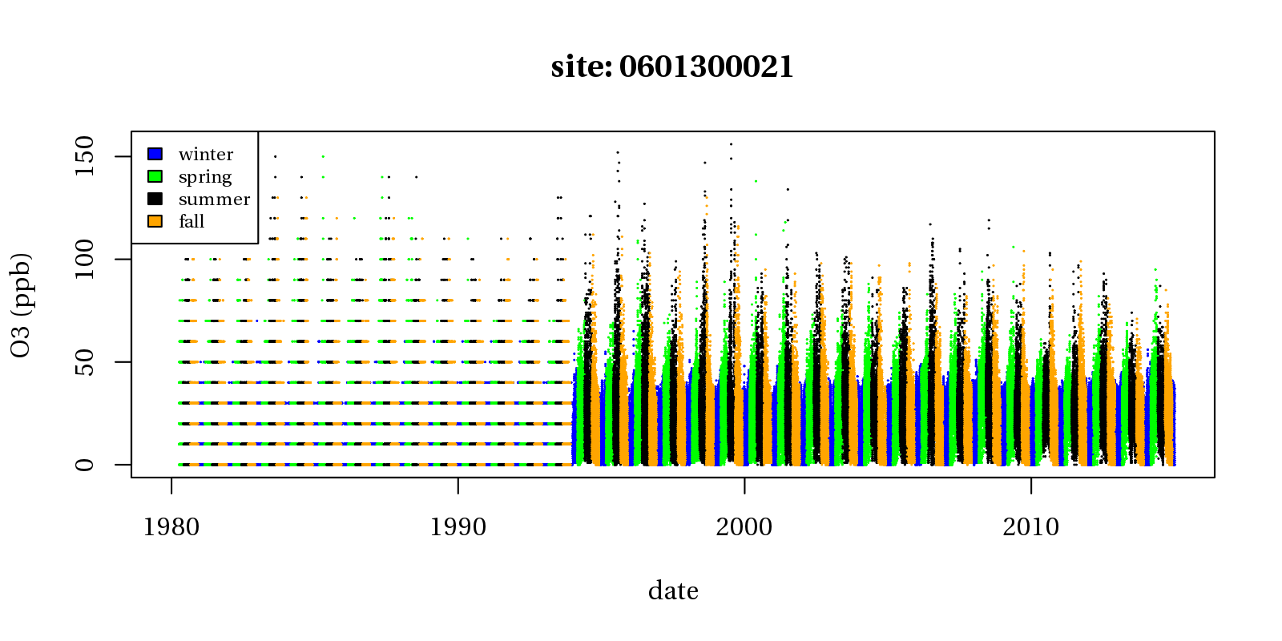
Figure D.1. Example of data at monitoring site in California which switched from 10 ppb to 1 ppb precision in reported data in 1993.

This analysis was performed for 5 sites that had 1 ppb precision data from 1980 to 2015: Little Rock, AR (051191002-1), Tampa, FL (121030018-1), Peoria, IL (171430024-1), Baton Rouge, LA (220330003-1), and Oklahoma City, OK (4010900331). For each site, we created three sets of data. The first data set consisted of the original reported data. In the second dataset, “rounded data”, all O₃ values from 1980 to 1989 were rounded to the nearest 10 ppb. For the third dataset, “scatter data”, random scatter within 10 ppb bins was added to rounded data from 1980 to 1989. The 14 exposure metrics were then calculated for each year at each site and with each dataset. These annual metrics were then used to calculate trends in each metric for each site and dataset pair. Trends results for the five sites are shown in Figs. D.2 through D.6. These figures show that across most sites and metrics, differences in trends (i.e., direction, magnitude, and significance) were small between datasets. There were some small differences which appear to be directionally consistent across metrics and sites. In general, when trends were decreasing in the original dataset, the rounded datasets showed a slightly larger magnitude of decreasing trends and a slightly smaller p-value for these trends. Also, when these trends were increasing, in the original dataset, the rounded dataset generally showed a slightly smaller magnitude of increasing trends and slightly larger p-value for these trends. There were two cases in which a slightly increasing trend in the original dataset became an insignificant decreasing trend in the rounded datasets, but neither of the trends was significant. The trends from the rounded and the scatter datasets looked almost identical. Based on this analysis, we can conclude that exposure metric trends calculated at sites with 10 ppb precision in the early part of the trend period may be very slightly biased but that adding scatter to those 10 ppb data do not impact the exposure metrics trends.

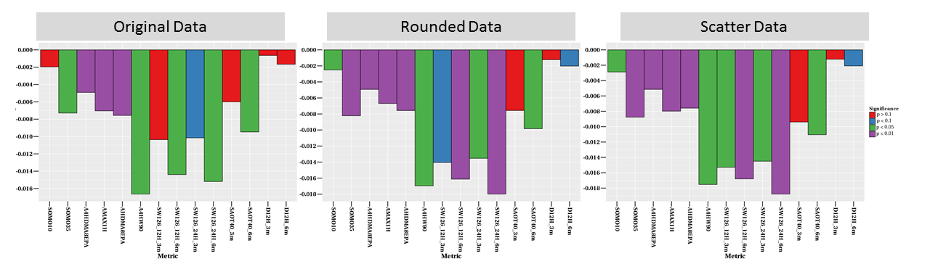
Figure D.2. 35-year exposure metrics trends (fraction/year) for three data sets at a Little Rock, AR site (051191002-1).

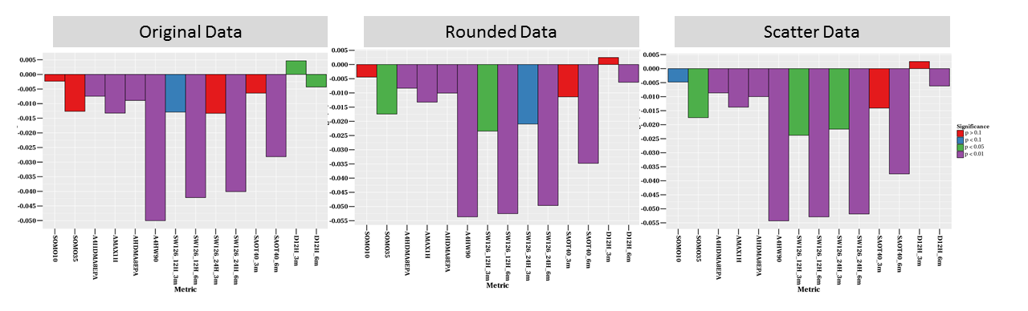
Figure D.3. 35-year exposure metrics trends (fraction/year) for three data sets at a Tampa, FL site (121030018-1).

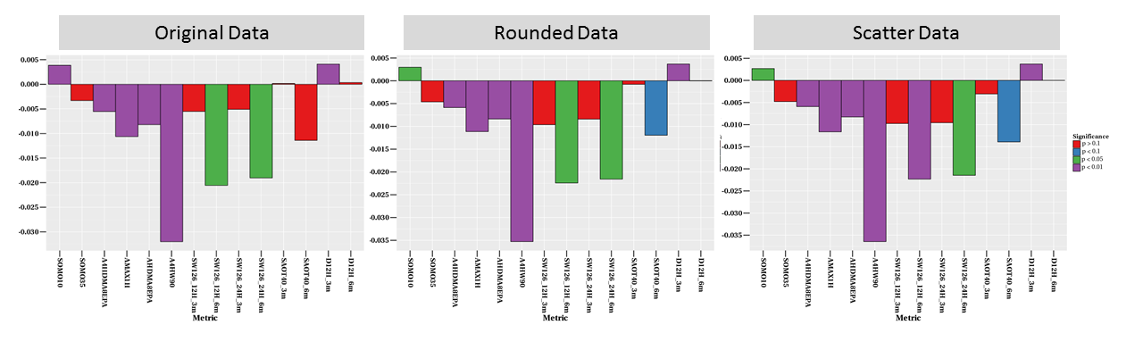
Figure D.4. 35-year exposure metrics trends (fraction/year) for three data sets at a Peoria, IL site (171430024-1).
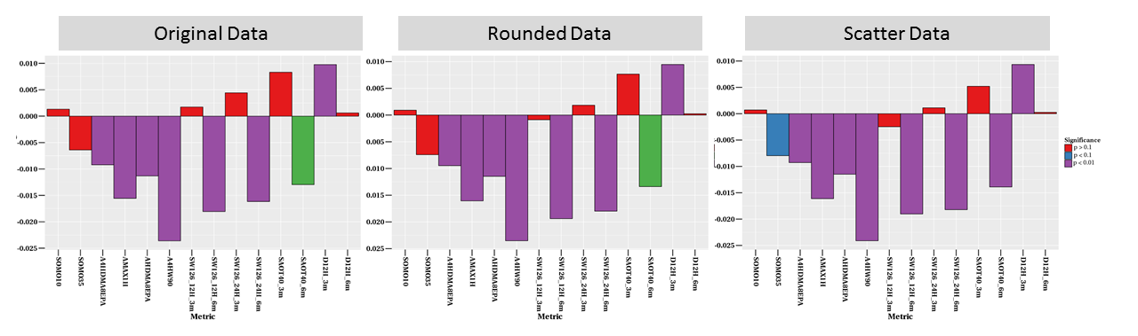
Figure D.5. 35-year exposure metrics trends (fraction/year) for three data sets at a Baton Rouge, LA site (220330003-1).

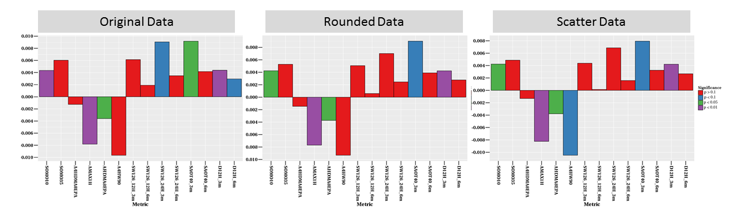
Figure D.6. 35-year exposure metrics trends (fraction/year) for three data sets at an Oklahoma City, OK site (401090033-1).

Supplement Appendix E

Calculation of the Theil-Sen Estimator

The Theil-Sen (T-S) estimator is calculated by first determining the slope between every possible pair of data points within the dataset and then taking the median slope from that set. To demonstrate this, we have created a hypothetical dataset of 4th high MDA8 O₃ values for four years in Table E.1. Among those four years, there are 6 possible pair of data: 2000-2001, 2000-2002, 2000-2004, 2001-2002, 2001-2004, and 2002-2004. Figure E.1 shows these data and the associated line representing the change in O₃ for each pair of data points. Since there are an even number of pairings, the median slope (shown as the dashed blue line) is not represented by a single line, but is the mean of the 3rd and 4th largest slopes (shown as solid blue lines).
Table E.1. Hypothetical data used to demonstrate the calculation of the T-S estimator. 3rd and 4th highest slopes used to calculate the median slope are shown in bold.

Year | 4th high MDA8 | Slope to 2001 | Slope to 2002 | Slope to 2004
2000 | 100 | -11 | -4.5 | -6.25
2001 | 89 | N/A | +2 | -4.67
2002 | 91 | N/A | N/A | -8
2004 | 75 | N/A | N/A | N/A

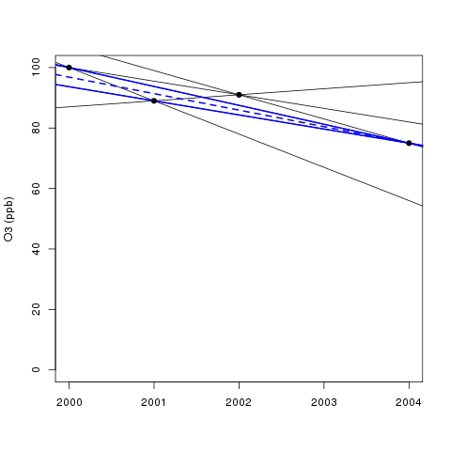
Figure E.1. Example demonstrating the calculation of the T-S estimator. Solid lines show all 6 pairwise slopes; 3rd and 4th highest slopes used to calculate the median slope are shown as blue solid lines; median value is shown as blue dashed line.

Explanation of the Weighted Moving Average Calculation when T-S Estimate is Zero

Here we provide an in-depth explanation of the weighted moving average calculation employed when the original T-S estimate for a trend is equal to zero. The moving average value for a particular year is calculated by constructing weights based on the proximity of each other year in the trend period to that year. The weighting function is the standard Normal density (i.e., a Normal density with mean equal to 0 and standard deviation equal to 1). For example, suppose we have a trend covering years 1990-2010. The moving average value for the year 2000 would be calculated using the following equation:
$$MA\left(2000\right)=\sum_{y=1990}^{2010}{\frac{1}{\sqrt{2π}}exp\left\{-\frac{{(y-2000)}^{2}}{2}\right\}C_{y}}$$

where C_{y} is the observed value for year y.

Figure E.2 below shows an example of the results of this calculation for the frequency of O₃ concentrations > 200 ppb at an ambient monitoring site in Los Angeles for years 1980-2014. The blue line represents the observed frequency, and the green line represents the moving average.

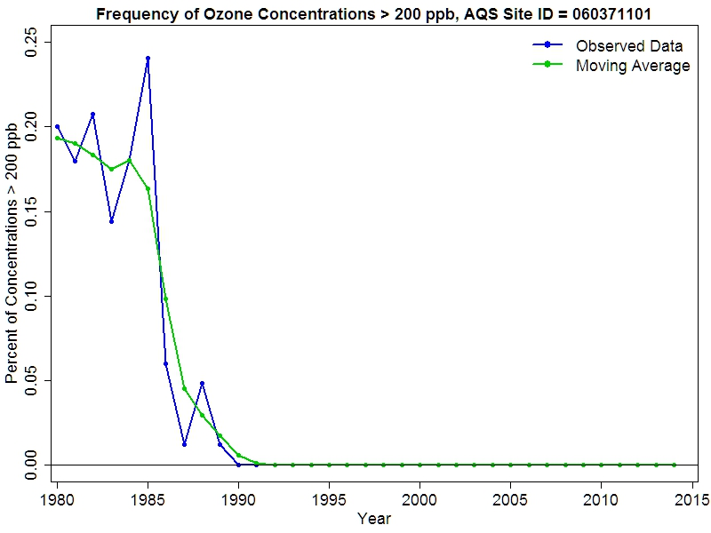
Figure E.2. Example showing the result of applying the weighted moving average calculation for the frequency of O₃ concentrations > 200 ppb at a monitoring site in Los Angeles, CA.

The observed frequency of concentrations > 200 ppb is zero for every year starting in 1990. Since over 70% of the individual year values are zero, by definition the T-S estimate must be zero. Applying the weighted moving average results in a non-zero value for every year, however the plot indicates that the moving average values are infinitesimal after 1991. This is because the weighting function places about 99% of the total weight within 2 years of the center year (e.g., 99% of the weight for year 1992 falls between 1990 and 1994). Effectively, applying the weighted moving average results in a sequence, which approaches (but never reaches) zero. By calculating the T-S estimator based on this moving average, we may now correctly identify that these data show a decreasing trend over time.

