Main Improvements of FAST-CE 3.6
By SCUT, 2023-09-05

Main Improvements:
- Include a new case for ISAM (US_ISAM_JUL_O3.proj) in FAST-CE 3.6 data package.
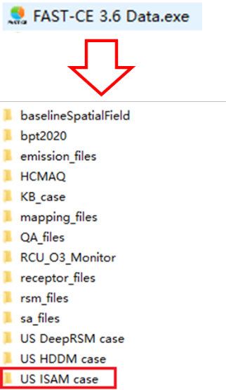
Fig. 1 Data for July 2018 US ISAM Case
- Correct the HDDM calculation method and update the “US_HDDM_JUL_O3” case in FAST-CE 3.6 data package. Note that HDDM results in previous version need to be re-run in order to fix the results.
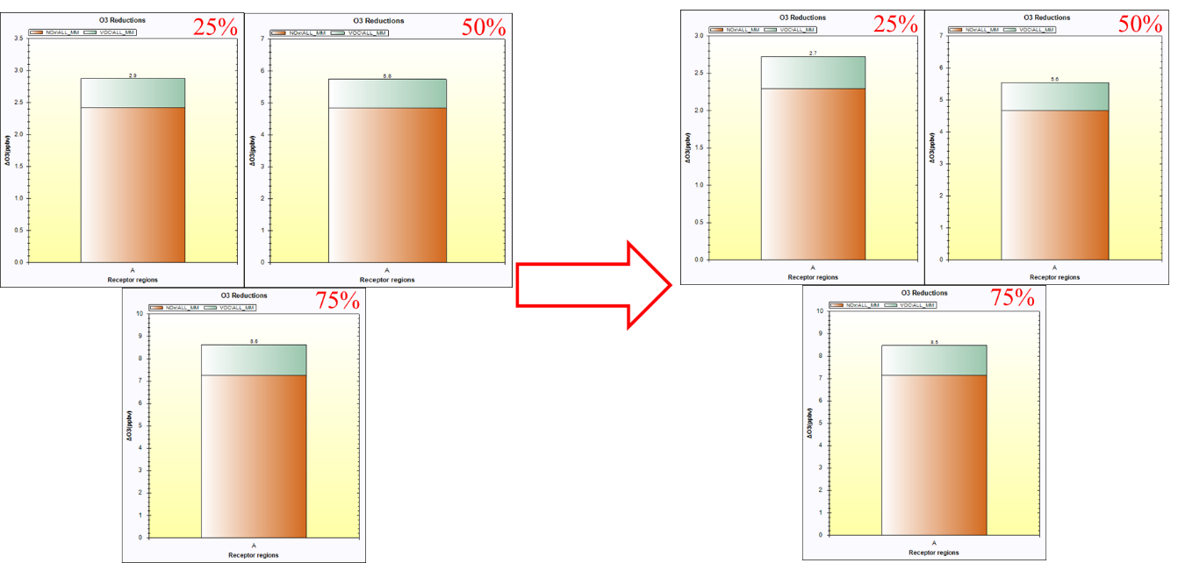
Fig. 2 FAST-CE 3.5 vs FAST-CE 3.6 results in “US_HDDM_JUL_O3”
To Do List:
- Develop a multi-method (DeepRSM, ISAM & HDDM) comparison under “QA&Compare” module.

