Main Improvements of FAST-CE 4.0
By SCUT, 2024-04-02

Main Improvements:
- Develop a function to output the scaling factors to csv format file when clicking the “Output Factors” button under the factors control panel.
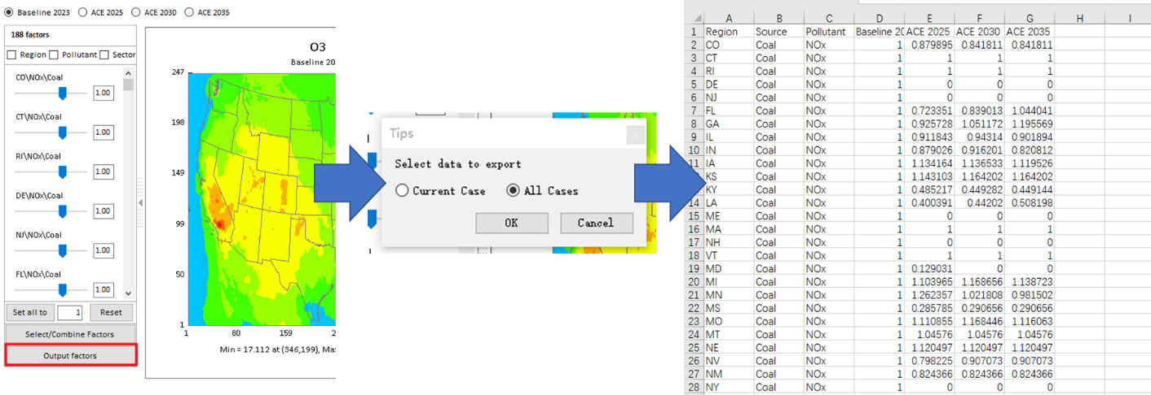
Fig. 1 Export Scaling factors to *.csv file
- Develop a function to save data as NetCDF format file under the right-click menu.
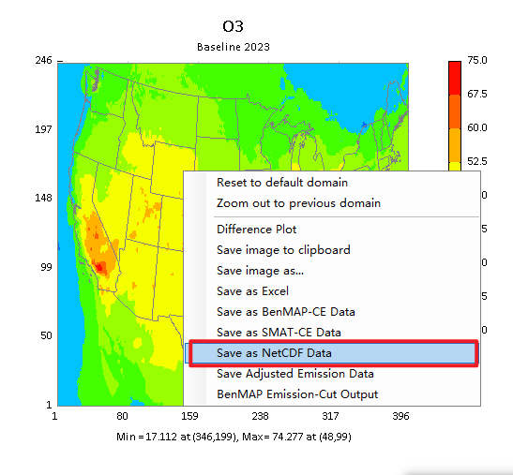
Fig. 2 Export NetCDF File function
- Develop a function to support to save all images to clipboard instead of saving only the selected image in previous version under the right-click menu when the "Multiple Plots" checkbox is selected.
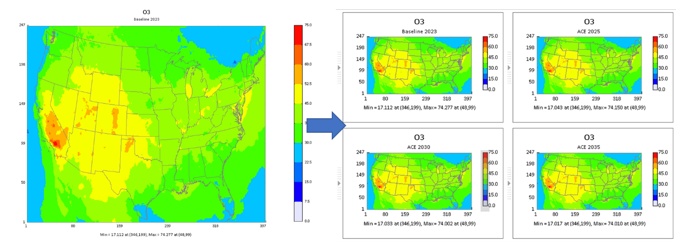
Fig. 3 Save image function
- Display the combined factors from the combined factors module under factors control panel instead of the original uncombined factors. Note that the merged factors will be calculated separately if any checkbox option (i.e., Region, Pollutant, Sector) is checked above the factors control panel.
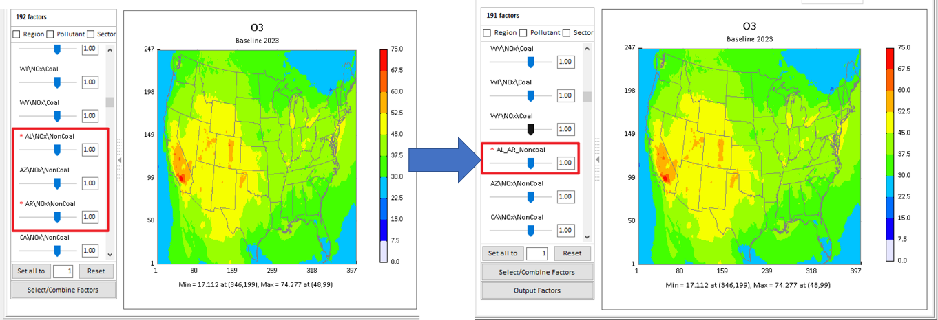
Fig. 4 Adjust factor combine module
- Remove the “Concentration” and “Response” options in the Project Comparison Plot module.
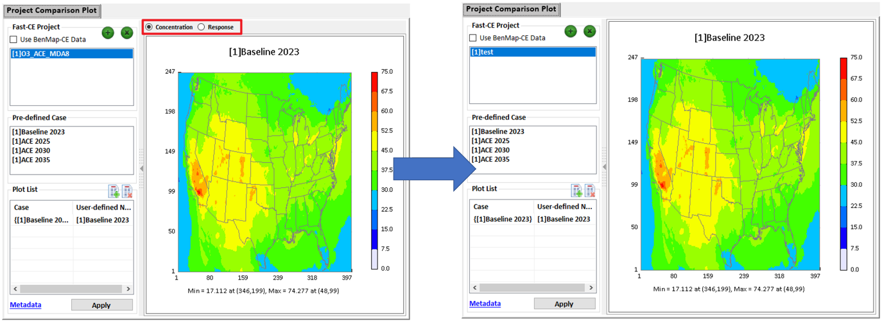
Fig. 5 Project Comparison Plot

