

- Home
- About

- Firewood

- Cooking Wood

- Mulch

- Contact

- Blog

How Much Firewood is in a Cord? And Other Important Firewood Questions
You are here:
- Home
- Firewood
- How Much Firewood is in…
Jan12
Firewood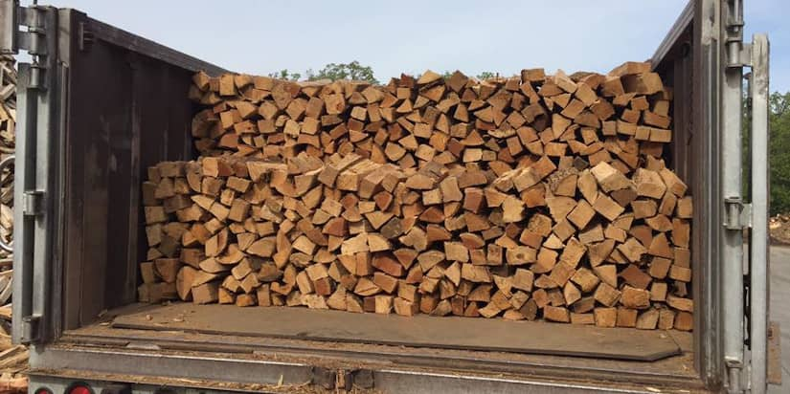
Firewood isn’t meant to be complicated. You set it ablaze, relax and enjoy the warmth. So, why does buying the right amount of firewood have to be complicated by confusing terms like cord and rick? How much firewood is in a cord, anyway?
We understand your frustration. Unfortunately, like any other industry, the firewood business has its jargon, too. Understanding that industry lingo can take the frustration and confusion out of your firewood purchasing… and we want to help!
That’s why we’ve put together this guide to help you understand how much firewood is in a cord, rick, face cord and bundle.
(Plus, stick around to the end because we have helpful tips for determining how much firewood you need!)

How is Firewood Measured?
The standard way to measure firewood is by volume, meaning length multiplied by width multiplied by height. So, you’ll usually see companies format their measurements in one of two ways:
- By the length, width and height, OR
- In cubic feet
Because lumberjacks don’t like throwing numbers around, we’ve devised shorthand ways to represent our firewood measurements. These standard terms include:
- Cord
- Face Cord
- Rick
- Bundle
But how much wood do each of these terms represent? We’ll look at each below.

How Many Cubic Feet of Wood Is in a Cord?
Most people in the firewood industry agree that a cord of firewood measures 4 feet high by 4 feet wide by 8 feet long, or 128 cubic feet.

Be Careful! Cord Measurements Can Vary
We say “most people” agree because the regulations for measuring cords vary from state to state. Verify that a company is talking about a standard cord before purchasing. If not, ask for their specific dimensions. Otherwise, you could end up with less wood than you thought you’d get!

How Many Pieces of Wood A Cord Contains
This may vary more wildly than you think because it depends on how long vendors cut their logs. Some vendors cut their logs into pieces as short as 12 inches or as long as 24 inches.
The standard 128 cubic feet of wood will usually contain:
- Four rows of 12-inch logs
- Three rows of 16-inch logs, OR
- Two rows of 24-inch logs
All these measurements add up to the same bulk amount of firewood, but this can feel confusing. After all, the first option will contain more firewood logs than the last. This is why it’s essential to understand log length when answering the question, “How much firewood is in a cord?”

How Much Wood You’ll Be Getting
So, how many pieces of firewood are in a cord? Unfortunately, there’s no way to say precisely how many pieces you’ll get. It depends on how long the company cuts logs.
Lengths can vary wildly, but the golden standard is 16 inches. However, some companies use 14-inch pieces, and others use 18 inches. At Lumberjacks, we always cut our kiln-dried firewood to 16 inches.
Typically, a full cord will contain between 600 and 800 pieces of firewood. If the company you purchase from shortens its logs, you will probably get closer to 800 pieces. And if the pieces are longer, you will probably get around 600 pieces. For the standard length of 16 inches, a full cord likely contains about 700 units of firewood.
You should also be aware of how tightly the company has stacked its cord. If the company stacks its firewood loosely, the 128 cubic feet will include a lot of air space. As a result, you’ll get less wood than if you’d gone with a company that stacks more tightly.

How Much a Cord of Wood Weighs
Depending on dryness and species, a cord of wood can weigh anywhere from 2,000 to 3,000 pounds. In other words, if you’re carrying it up a set of stairs, you’ll need to make more than one trip!
Generally, dry wood is lighter than moist wood, and softwoods are lighter than hardwoods. Hardwoods are heavier because they’re denser, which means they yield the hottest flames for the longest time.

Stack for Yourself to Make Sure
Do you want to ensure you’re getting the full cord you paid for? Then make sure you stack the wood for yourself! The company you purchase from should be fine with you stacking your wood and shouldn’t insist on doing it themselves. The most trustworthy companies will only stack wood for you if requested.
Bottom line: If the company isn’t okay with you stacking the wood before completing the sale, they’re probably not an honest business.

Terms Related to a Cord
If you hang around lumberjacks long enough, you’ll probably hear them use other phrases like bush cord and stove cord. Here are some definitions for these and other cord-related terms:
- Bush Cord –Another way of saying a full cord.
- Running Cord –Describes a full cord of firewood with all pieces stacked parallel.
- Sheldon Cord –Frequently used to describe an order of firewood that measures more than a full cord. There is no exact measurement for a Sheldon cord.
- Stove Cord –Used when purchasing wood for a stove. The wood in a stove cord is often shorter. So, a stove cord may measure 4 feet high by 8 feet long by 12 inches deep, but there is no official measurement.
These are just a few of the many terms for firewood volume out there. While all this industry slang can be daunting, the most important thing to remember is that a full cord measures 128 cubic feet. Once you know that, figuring out these other terms is as simple as understanding how they relate to a full cord.
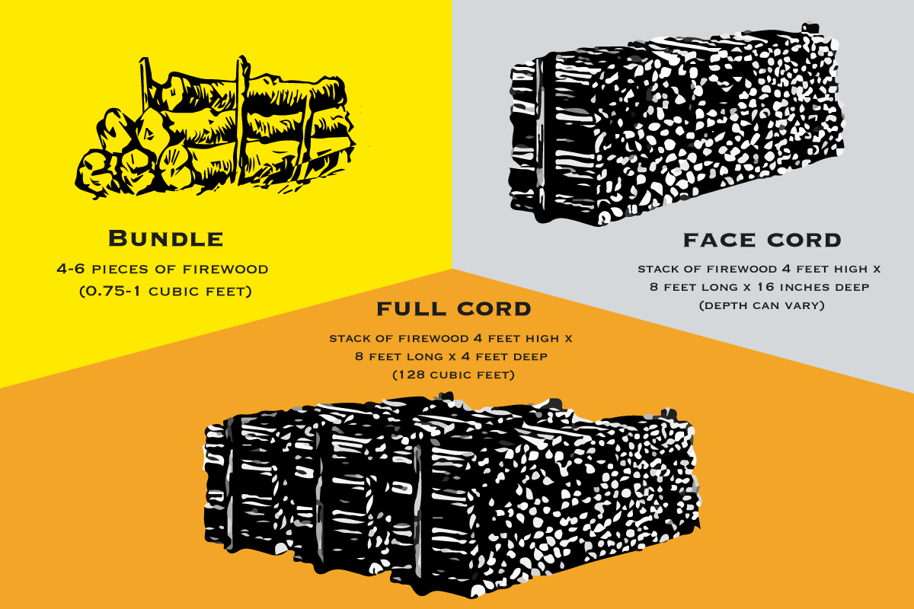
Bundle, Face Cord and Full Cord are standard terms for firewood volume.

How Many Face Cords Are in a Cord?
A face cord is smaller than a full cord. A face cord shares the 4-foot height and 8-foot length with the full cord. The difference is the width.
A standard full cord is 4 feet deep and usually consists of three stacks of 16-inch-long wood. However, the face cord is only one stack deep, making it approximately 1/3 the size of a full cord.

Not An Exact Measurement
The problem with a face cord as a measurement is there’s no standard definition for it. How much wood you get will depend on how long each piece is cut. Some face cords will measure 4 feet x 8 feet x 12 inches, while others will be 4 feet x 8 feet x 18 inches. So, the total volume of wood can vary.

Purchase Face Cords with Caution
With so much variation in total wood volume, you should be careful when buying from a company that sells wood by the face cord. Be sure to ask how long they cut their wood because that will determine the value you’re getting for your cost.
At Lumberjacks, we always cut our wood to the standard length of 16 inches. So, when you purchase a face cord from us, you know the stack will be 4 feet x 8 feet x 16 inches. We always hand stack each order before sending it out for delivery to ensure this.

How Much Firewood is in a Rick?
Another common firewood measurement term is a rick. The problem with this term is it gives no hints as to how it relates to a full cord. The truth is when people use the term “rick,” they mean the same thing as a face cord, which is why we prefer to use that term instead.

How Much Firewood Is in a Bundle?
Many firewood companies also sell wood by the bundle. Like with face cords and ricks, there’s no standard for how much wood a bundle will contain. However, there are some general guidelines most companies tend to follow.
A typical bundle contains 4-6 pieces of firewood. So, the total volume of wood you’ll receive will be between 0.75 and 1 cubic foot of wood.
Bundles usually come either wrapped in plastic or net bags. They are convenient to purchase and transport for one-time use.

How Much Firewood Do I Need?
Of course, understanding firewood measurements is only half the battle. Next, we need to determine what those measurements mean for us practically.

For a Campfire or Bonfire
How much firewood will you need to enjoy a fire in the great outdoors? In this situation, you will probably be best off purchasing firewood bundles.
How many bundles you’ll need will depend on how long you want the fire to last. You should probably be okay with a couple of bundles for a two-hour fire. But if you need the flames to rage for six or more hours, you’ll likely need at least five bundles. Of course, this amount will vary depending on several factors.

For a Fireplace
The firewood you need for your fireplace will depend on how often you use it. A fireplace can only burn two to three logs at a time. So, if you only occasionally use it, a face cord of firewood should last you a few months.
However, if you frequently use your fireplace or rely on it to heat your home, you may want to purchase a cord of wood or multiple cords.

For the Winter
So, how many cords of firewood will last a whole winter? The answer to this question will depend on several variables, including the size of the space you need to heat and how well-insulated it is. But generally, a cord of wood can last as long as ten weeks. So, one to two cords may get you through the winter.
However, the extra cold winters we experience here in Northern Illinois and Southern Wisconsin may require three to four cords for long-term warmth and comfort.

Transporting Your Firewood Order
Regardless of your order size, any local vendor will likely be able to deliver firewood in three business days or fewer. Naturally, we recommend leaving the largest deliveries up to professionals like us.
If you’re considering picking up an order, be aware that most standard vehicles won’t hold that much firewood. Even if you have a pickup truck, space is limited.
At most, a standard pickup truck can store a half cord of wood if logs are stacked tightly. This is pretty respectable, considering the popularity of face cords, but a full cord isn’t going anywhere without a more industrial vehicle.
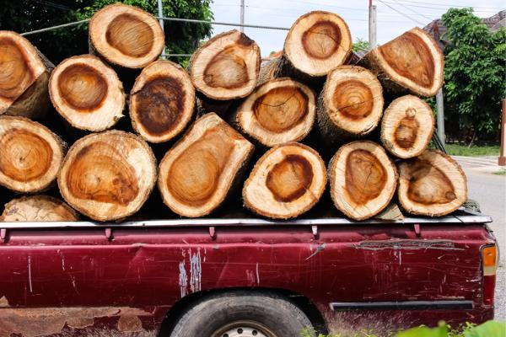
Feel free to pick up your face cord with your pickup truck.

How to Store the Firewood You Buy
If you want to know how to store the firewood you purchase, you may stack it in a convenient place. But remember that your storage location must be dry enough to maintain the dryness of your firewood.
Also, if you’ve settled for fresh or green wood, you’ll have to season it yourself. After splitting your fresh logs, you must leave them out to dry in a place that enjoys a lot of airflow and exposure to the sun. Summer is the ideal time to season wood in preparation for winter.
Generally, a good way to season fresh wood doubles as an excellent way to store kiln-dried firewood. In both cases, you should leave a lot of space among the logs to prioritize airflow. Firewood is also likely to hang onto its dryness if you leave it outside but remember to leave it under an awning or a loose tarp to shelter it from the elements.
If you can help it, keep the driest firewood on top of the stack for easy access to the good stuff. Always use the oldest firewood first to avoid rotting, as well.
Plenty of firewood racks are available for housing firewood indoors, but seasoned firewood can bring in unwanted pests, dirt, mold and debris.
You shouldn’t have more than two days’ worth of seasoned firewood in your home at any time. Of course, this is all the more reason to buy kiln-dried firewood, which can be present in any amount without inviting unwanted guests!
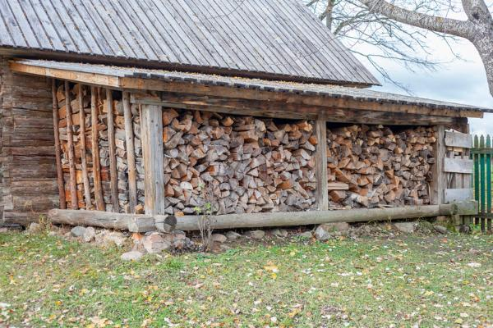
Awnings like these are perfect for leaving wood to dry.

Looking for Firewood in Northern Illinois?
Now that you know how much firewood is in a cord, the next step is to order the right amount of wood for you! But, of course, it doesn’t matter how much you get if the wood is low quality.
At Lumberjacks, we sell high-quality kiln-dried firewood with a moisture content below 20%. This means it’s incredibly easy to ignite for brighter, longer, and cleaner burns. It is also 100% free of insects and mold!
If you’re interested, please call us at 815-337-1451 or stop by our farm in Woodstock, IL, to view our inventory. You can also view our complete guide to kiln-dried firewood to learn more.
Call 815-337-1451 to Order Your Firewood Today
Editor’s Note: This blog was originally published in July 2021 and updated in January 2024.
Category: FirewoodBy LumberjacksJanuary 12, 2024
Tags: Cord of FirewoodFace CordFirewood EducationFirewood MeasurementsKiln-Dried Firewood

Author: Lumberjacks
Lumberjacks is the premier provider of kiln-dried firewood and hardwood mulch in Chicagoland and Southern Wisconsin. We offer delivery or pickup.

Post navigation
PreviousPrevious post:What are the Benefits of Kiln-Dried Firewood?NextNext post:Fire Pit Safety Checklist: 9 Simple Rules for a Safe and Fun Evening

Related posts
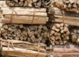
Firewood Bundles: A Helpful List of Your Most Common Questions
August 5, 2024
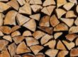
4 Fantastic Reasons You Should Buy a Full Cord of Firewood
July 7, 2024
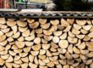
What’s a Face Cord of Wood? A Nice and Simple Guide
May 6, 2024
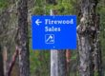
5 Reasons to Avoid Cheap Firewood in Chicago (and 1 Better Option)
May 6, 2024
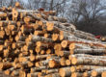
How Much Firewood Do I Need for Different Situations?
March 26, 2024

Firewood Won’t Burn? Here are Some Tips for the Best Fires
March 26, 2024
Email Signup

Name(Required)
First
Email Address(Required)

Testimonials
Video Player
00:00
01:01
Recent Posts
- Firewood Bundles: A Helpful List of Your Most Common Questions
August 5, 2024
- 4 Fantastic Reasons You Should Buy a Full Cord of Firewood
July 7, 2024
- Garden Mulch: A Simple, Helpful Step-by-Step Usage Guide
May 6, 2024
- What’s a Face Cord of Wood? A Nice and Simple Guide
May 6, 2024
- 5 Reasons to Avoid Cheap Firewood in Chicago (and 1 Better Option)
May 6, 2024
Categories
- Cooking Wood(7)
- Firewood(26)
- Mulch(18)
Contact Info
Lumberjacks, Inc.
5013 Sunnyside Rd
Woodstock, Illinois 60098
(815) 337-1451
- Business Hours
Monday – Friday: 8am to 4pm
Saturday: 8am to 4pm
- We Proudly Refer To

Find us on:
Facebook page opens in new windowX page opens in new windowYouTube page opens in new windowLinkedin page opens in new windowInstagram page opens in new window
Jack’s Blog
- 
Firewood Bundles: A Helpful List of Your Most Common Questions
August 5, 2024
- 
4 Fantastic Reasons You Should Buy a Full Cord of Firewood
July 7, 2024
- 
Garden Mulch: A Simple, Helpful Step-by-Step Usage Guide
May 6, 2024
Email Signup

Click To Subscribe
City Pages
- Local Firewood Delivery
  - Algonquin
  - Arlington Heights
  - Aurora
  - Barrington
  - Batavia
  - Chicago
  - Crystal Lake
  - Elgin
  - Geneva
  - Hoffman Estates
  - Joliet
  - Lake Forest
  - Mount Prospect
  - Naperville
  - Palatine
  - Rockford
  - Schaumburg
  - South Elgin
  - St. Charles
  - Vernon Hills
  - Wayne
©2024 Lumberjacks, Inc.

