BenMap VirtualBox Setup

- Download VirtualBox - https://www.virtualbox.org/wiki/Downloads ; we recommend you download the most recent version listed for your operating system. (Note that Mac computers using Apple’s M1 or M2 chips are not officially supported yet by VirtualBox, though you may download a Beta application.)
- Install VirtualBox
  - If installing on Windows, you may also be asked to install “Microsoft Visual C++ 2019 Redistributable package” available at https://learn.microsoft.com/en-us/cpp/windows/latest-supported-vc-redist
  - If installing on Mac you may be shown the following
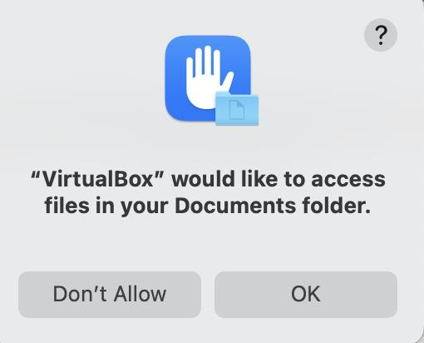
Click OK

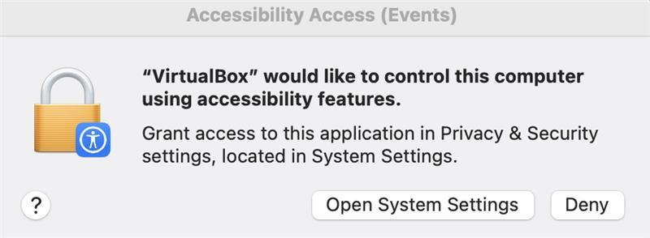
Open System Settings, and Allow (need screenshots here possibly)

- Download BenMap VirtualBox Machine (not sure from where yet)
- Keep track of where you downloaded the file to.
  - The download file will be about 6 GB
  - Uncompress the file using a tool that will unzip the file (e.g. 7-zip, WinZip, Mac Archive Utility
  - The uncompressed file will be about 25GB, so make sure you have at least 35 GB of free space.
  - Once uncompressed, you will have a folder with two files in it
    - BenMap Prod 2022-12.vdi
    - BenMap Prod 2022-12.vbox
  - You can now delete the original .zip file
- Start VirtualBox
  - You may see a screen like below. You can just click Switch
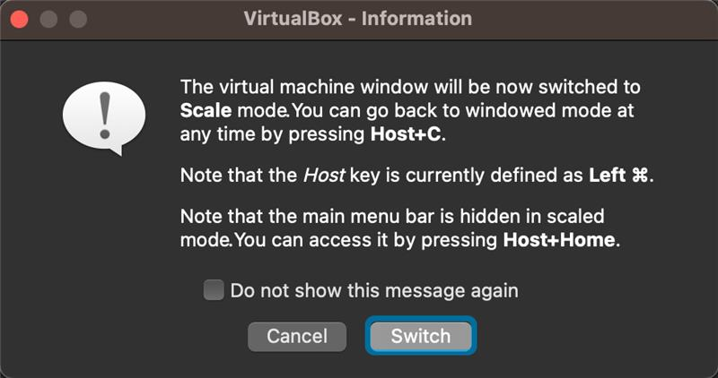
- You should see a screen like below
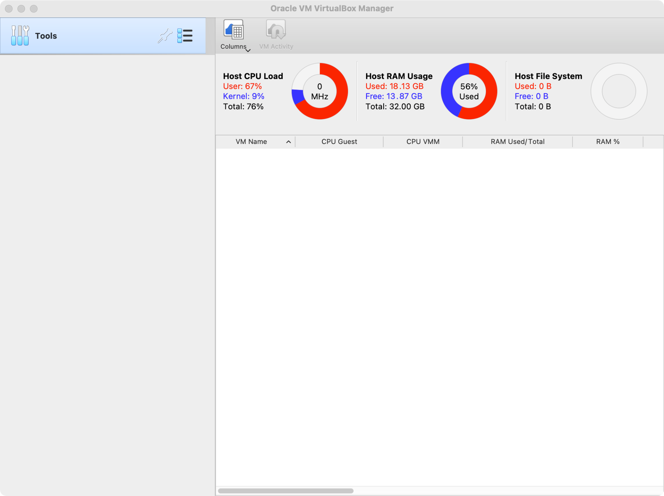
- Use the VirtualBox menu Machine and select Add
- Find the place you unzip the file BenMap file to and select the BenMap Prod 2022-12.vbox file
- You will see a screen as below
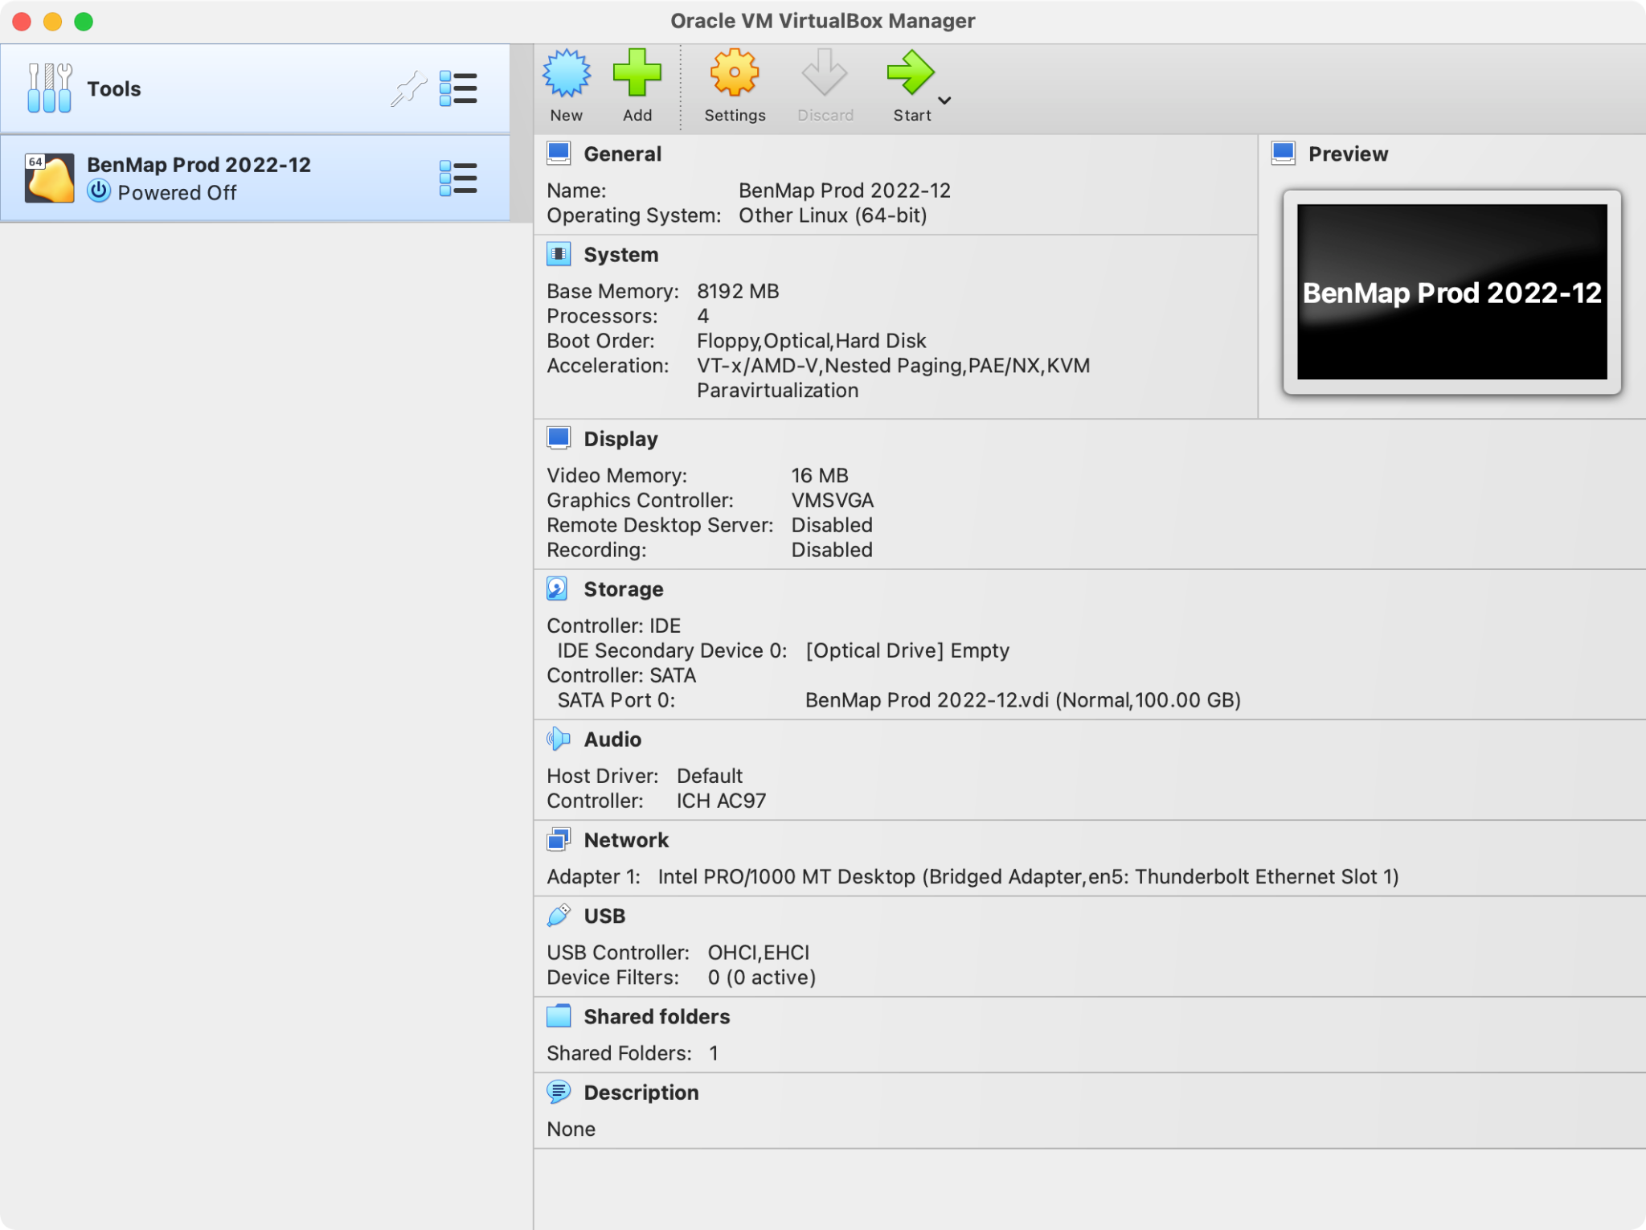
- To start the Virtual Machine, click the green Start Arrow
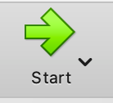
- You may see a warning regarding the network interface (see below). If so, click Change Network Settings and select the appropriate settings for your environment.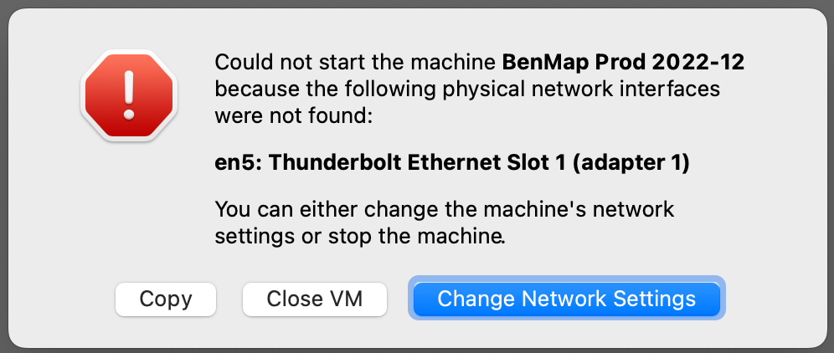
- If you see the above, do the following:
  - Click the Change Network Settings button. If you don’t see the Network Settings, you can get there by doing the following:

    - Click the Setting gear 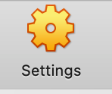
    - Select the Network tab 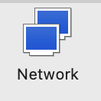

  - DO NOT CHANGE the Bridged Adapter setting, only select a different interface name

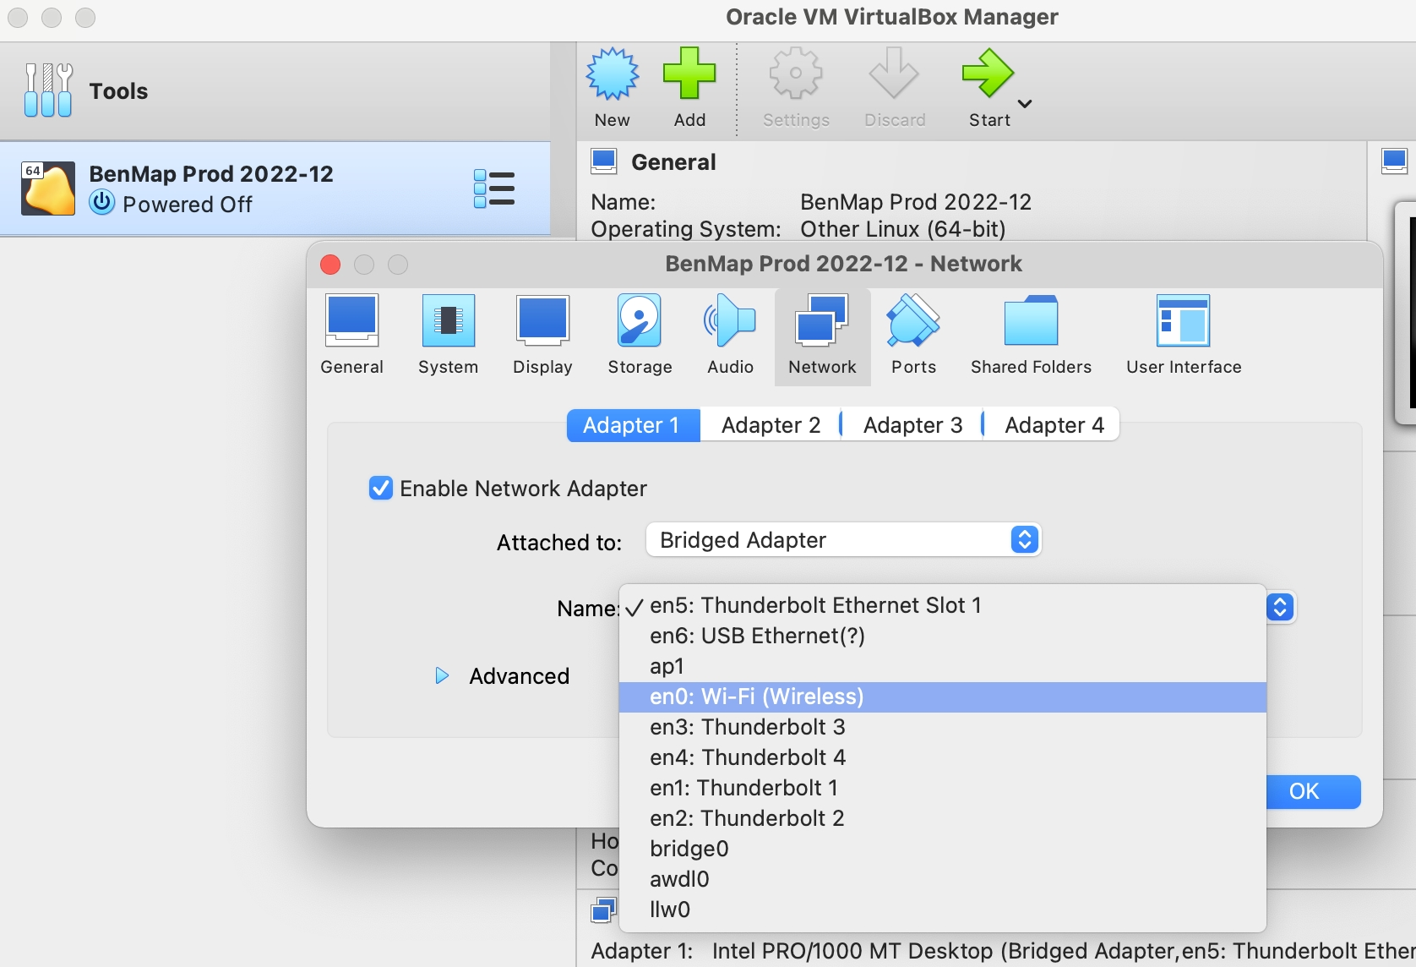

- You will see VirtualBox starting up and loading the BenMap Image
- When it is complete, you will see the below. You do not need to log in or do anything else with VirtualBox
- The address you see may be different based on your network.
- Please wait about 30 seconds to make sure all applications in VirtualBox are running.
- Switch to your web browser.
- In your browser, type the address shown (e.g. 192.168.0.108:8080)
- You should now see the below in your browser. You are ready to run BenMap
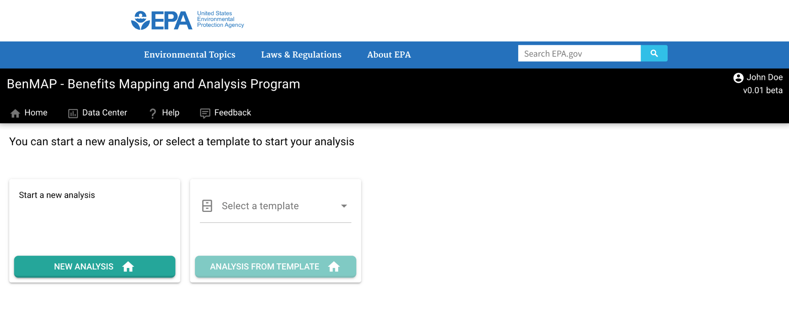
- When you are done using BenMap follow the steps below

Make sure there are no BenMap tasks running before exiting VirtualBox

- Once you are done using BenMap, go back to the VirtualBox application
- Right click on the “Running” BenMap
  - Select “Close” -> “ACPI Power Off”
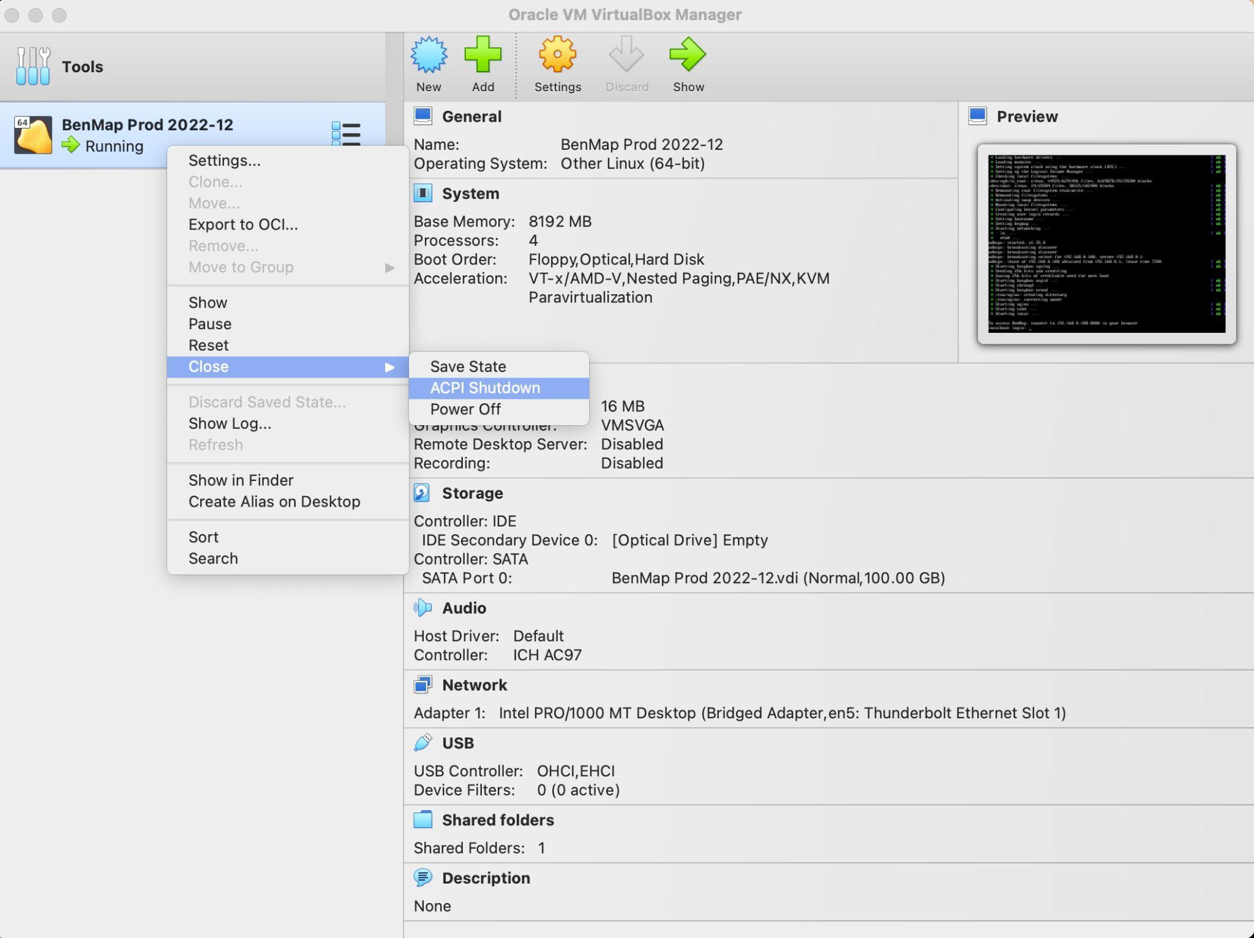

- You will be asked to verify with the box below

Again, make sure there are no running tasks before exiting VirtualBox

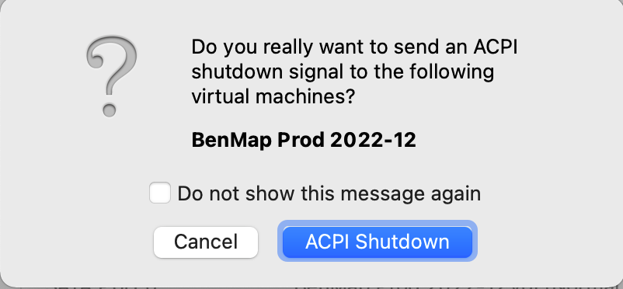
- You can now quit VirtualBox

OPTIONAL

- You can adjust the Base Memory and/or Processors by clicking on the Gear Icon for settings
- Click on the System Icon and you will be able to change your Base Memory
- Click on the Processor sub menu, and you will be able to select the number of processors

NOTE:

The size of the BenMap VirtualBox image will grow over time and consume more disk space as you run more scenarios. If it gets too large, you can always just start fresh with a new BenMap VirtualBox image.

