On Selecting a Minimal Set of In Vitro Assays to Reliably Determine Estrogen Agonist Activity

Richard Judson [1], Keith Houck [1], Eric Watt [1], Russell S. Thomas [1]
[1] U.S. Environmental Protection Agency, RTP NC

Abstract
The US EPA is charged with screening chemicals for their ability to be endocrine disruptors through interaction with the estrogen, androgen and thyroid axes. The agency is starting to explore the use of high-throughput in vitro assays to use in the Endocrine Disruptor Screening Program (EDSP), potentially as replacements for lower-throughput in vitro and in vivo tests. The first replacement is an integrated computational and experimental model for estrogen receptor (ER) pathway activity, to be used in lieu of the Tier 1 in vitro ER binding and transactivation assays and the in vivo uterotrophic bioassay. The experimental component of the ER agonist model uses a set of 16 in vitro assays that incorporate a variety of technologies and cell lines and probe multiple points in the ER pathway. Here, we demonstrate that it is possible to achieve the same level of performance against both in vitro and in vivo reference chemical sets as the full ER agonist model using various subsets of assays. The simplest “subset” model that achieves maximum accuracy against multiple metrics uses only 4 assays. There are multiple accurate subsets, allowing flexibility in the construction of a multiplexed assay battery. We also discuss the issue of challenging chemicals, i.e. those that tend to give false positive results in certain assays, and could hence be more problematic when only a few assays are being used.
Disclaimer: The views expressed in this article are those of the authors and do not necessarily reflect the views of policies of the U.S. Environmental Protection Agency. Mention of trade names or commercial products does not constitute endorsement or recommendation for use.

Introduction
There are tens of thousands of man-made chemicals in the environment, and some fraction of these are known or suspected to be xenoestrogens, i.e. they mimic the activity of natural estrogens by binding the estrogen receptor (ER) and triggering downstream gene activation (Safe 1995). Such chemicals are considered potential endocrine disruptors which, at high enough exposures at specific life stages, could lead to a variety of adverse outcomes ranging from birth defects to increased rates of cancer progression. We have developed a computational network model (Judson, Magpantay et al. 2015) based on a large set of in vitro ER assays (18 in total), that probe a variety of points in the ER pathway, using both cell-free and cell based assays and a range of detection technologies. The agonist model, which uses data from 16 of the in vitro assays, was validated against in vitro reference chemical activity, as well as data from guideline-like in vivo uterotrophic studies (Browne, Judson et al. 2015, Kleinstreuer, Ceger et al. 2015). The performance of the ER agonist model was deemed accurate enough that the US EPA has proposed accepting the model results in lieu of the Endocrine Disruptor Screening Program (EDSP) Tier 1 in vitro ER binding and transactivation assays, and the in vivo uterotrophic test (EPA 2015).
One limitation of the full ER model is the large number of assays used in it, and an obvious question is whether one could achieve equivalent performance with only a subset of the 16 in vitro assays. Within this set of 16 in vitro assays, there are 3 cell-free binding assays, 6 receptor dimerization assays, 2 transactivation assays measuring reporter RNA levels, 2 measuring reporter protein levels, and a cell proliferation assay. The main reason for exploring the use of many in vitro assays, and developing the full ER network model, is that we recognized that all in vitro assays have false positive and false negative results (Judson, Houck et al. 2016). Additionally, these false activities are not random, but are often due to technology-dependent assay interference (Baell and Holloway 2010, Bruns and Watson 2012). A major cause of false positives is activity triggered by cell stress at concentrations approaching where cytotoxicity occurs (Judson, Houck et al. 2016). The full ER network model was developed to help distinguish true activity from false. The key output of the model for a chemical was a value referred to as the ER Agonist Area Under the Curve (AUC) score, which is a value from zero to one. A chemical with a score close to 1 is likely to be a strong agonist and one with a score close to zero is unlikely to have any ER agonist activity. The computational model additionally assigned scores to a variety of in vitro assay interference modes. An important point about the full model is that it is a so-called ab initio model, meaning that it makes predictions about pathway activity based on measured activity in individual components of the pathway and on the structure of the pathway. In particular, the model did not result from “fitting” data to some simple mathematical form.
Here we explore two issues important to the screening and identification of environmental estrogens: 1) identifying predictive combinations of a minimum number of in vitro assays that perform almost equivalently to the full 16-assay model; and 2) identifying chemicals that are not true ER agonists, but are active in a subset of assays. Using these chemicals in addition to the standard reference chemicals can allow more robust characterization of assay and model performance. We demonstrate that a variety of subsets of in vitro assays perform as well as the full set of 16 assays measuring ER agonist activity. In addition, we find that the reference chemicals typically used in ER validation studies are relatively easy to classify and tend to inflate the performance of a given in vitro assay subset.
Methods
The full ER computational network model and its validation are described elsewhere (Browne, Judson et al. 2015, Judson, Magpantay et al. 2015, Kleinstreuer, Ceger et al. 2015). We developed “subset models” for all combinations of 1 to 16 in vitro assays. The in vitro assays are listed in Table 1, and are further described elsewhere (Judson, Magpantay et al. 2015). (Note that the Tox21_ERa_LUC_VM7_Agonist assay has previously been annotated as being run in BG1 cells, but this cell line has recently been shown to be of MCF7 origin and renamed VM7Luc4E2 ER TA [BG1-VM7].) The total database consisted of concentration-response data for the 16 ER in vitro assays (only focusing on agonist activity) for a total of 1811 chemicals. The concentration response data were fit to a Hill model to yield a hit call (yes or no), an AC50 (concentration at half maximum activity) and a maximum activity (top or T). Here T values >1 were set to 1 (just as in the full model). Assay-chemical pair AUC values were calculated, equal to
$AUC\left(chemical,{assay}_{i}\right)=-\log_{10}\left({AC50}_{i}\right)×T (i ∈\left[1,16\right])$ (1)
Chemical-assay AUC values were scaled so that the median value for the non-zero values for each assay were set to 1.0, and then all values were divided by the maximum value across all assay-chemical combinations, so that all individual values were in the range [0,1], just like the full ER model agonist AUC values. The process of fitting a Hill model to each curve was repeated 1000 times using the bootstrapping method of Watt et al. (Watt et al. in preparation) which yields a distribution of AUC values. The chemical-assay AUC matrices (median, upper and lower 95% confidence interval values) are given in Supplemental files S1a, S1b and S1c.
For each in vitro assay combination (subset model), we then fit a linear model with zero intercept of the form
${AUC}_{subset}(chemical)=\sum_{i=1}^{N}{c_{i}×AUC(chemical,{assay}_{i})}$ (2)
The values of the scaling coefficients ($c_{i}$) are optimized to minimize the root mean square error (RMSE) between the subset AUC values and the AUC values from the full model, for chemicals with the full model AUC>cutoff (see below). The subset AUC values were separately calculated with the median values for the assay AUCs, from the bootstrapping process, and the lower and upper 95% confidence level AUCs, which provides a confidence interval around the subset AUC value. Based on the knowledge that significant in vitro assay interference will often be manifested as activity in only one or two assays, we set the subset model value to zero if only one assay is active. The only exception to this is if we are testing models with only a single in vitro assay. For each of the 65535 combinations of in vitro assays, we recorded the RMSE and R2 for the complete set of chemicals with activity in least one assay, and separately for the reference chemicals (see below). Additionally, we dichotomized the data, calling the chemical “active” if the value of ${AUC}_{subset}(chemical)$ was greater than a specified cutoff, and “inactive” otherwise. The value of the cutoff was determined by performing a scan for the 16-assay subset model vs. the full model, and maximizing the balanced accuracy (average of sensitivity and specificity). This yielded a cutoff value of 0.1, which was the same threshold used in the full model. Based on the dichotomized calls, we then calculated sensitivity, specificity and balanced accuracy for each subset model. No separate class of “equivocal” response was used as in Browne et al.(Browne, Judson et al. 2015) Chemicals are classified as “hard to predict” when the difference between the assay AUC (normalized to be in the range of 0 to 1) and full AUC values is large. For certain analyses, we calculate the average difference between the full AUC and the median assay-chemical AUC.
All computations were carried out using the R programming language, version 3.6.1 (Ihaka and Gentleman 1996). All code and input files are available from the authors at the web address: ftp://newftp.epa.gov/COMPTOX/STAFF/rjudson/publications/ER_assay_select/ .

Table 1: Summary of the in vitro ER agonist assays used in the analysis. Further details are provided in the primary reference for the ER network model.

Assay ID | Assay Name | Source [1] | Gene Target | Normalized Data Type | Assay Design Type | Biological Process Target | Detection Technology | Detection Technology Subtype | Measurement Time Point (hr) | Organism | Tissue | Cell Format | Cell Line Name | Assay Footprint
A1 | NVS_NR_bER | NVS | ESR1 | percent activity | radioligand binding | receptor binding | Lysate-based radiodetection | Scintillation counting | 18 | bovine | uterus | tissuebased cell-free | NA | microplate: 96-well plate
A2 | NVS_NR_hER | NVS | ESR1 | percent activity | radioligand binding | receptor binding | Lysate-based radiodetection | Scintillation counting | 18 | human | NA | cell-free | NA | microplate: 96-well plate
A3 | NVS_NR_mERa | NVS | Esr1 | percent activity | radioligand binding | receptor binding | Filter-based radiodetection | Scintillation counting | 18 | mouse | NA | cell-free | NA | microplate: 96-well plate
A4 | OT_ER_ERaERa_0480 | OT | ESR1 | percent activity | protein fragment complementation assay | protein stabilization | Protein-fragment Complementation | Fluorescence intensity | 8 | human | kidney | cell line | HEK293T | microplate: 384-well plate
A5 | OT_ER_ERaERa_1440 | OT | ESR1 | percent activity | protein fragment complementation assay | protein stabilization | Protein-fragment Complementation | Fluorescence intensity | 24 | human | kidney | cell line | HEK293T | microplate: 384-well plate
A6 | OT_ER_ERaERb_0480 | OT | ESR1 | percent activity | protein fragment complementation assay | protein stabilization | Protein-fragment Complementation | Fluorescence intensity | 8 | human | kidney | cell line | HEK293T | microplate: 384-well plate
A7 | OT_ER_ERaERb_1440 | OT | ESR1 ESR2 | percent activity | protein fragment complementation assay | protein stabilization | Protein-fragment Complementation | Fluorescence intensity | 24 | human | kidney | cell line | HEK293T | microplate: 384-well plate
A8 | OT_ER_ERbERb_0480 | OT | ESR2 | percent activity | protein fragment complementation assay | protein stabilization | Protein-fragment Complementation | Fluorescence intensity | 8 | human | kidney | cell line | HEK293T | microplate: 384-well plate
A9 | OT_ER_ERbERb_1440 | OT | ESR2 | percent activity | protein fragment complementation assay | protein stabilization | Protein-fragment Complementation | Fluorescence intensity | 24 | human | kidney | cell line | HEK293T | microplate: 384-well plate
A10 | OT_ERa_EREGFP_0120 | OT | ESR1 | percent activity | fluorescent protein induction | regulation of gene expression | Microscopy | Optical microscopy: Fluorescence microscopy | 2 | human | cervix | cell line | HeLa | microplate: 384-well plate
A11 | OT_ERa_EREGFP_0480 | OT | ESR1 | percent activity | fluorescent protein induction | regulation of gene expression | Microscopy | Optical microscopy: Fluorescence microscopy | 8 | human | cervix | cell line | HeLa | microplate: 384-well plate
A12 | ATG_ERa_TRANS_up | ATG | ESR1 | log2 fold induction | mRNA induction | regulation of transcription factor activity | RT-PCR and Capillary electrophoresis | Fluorescence intensity | 24 | human | liver | cell line | HepG2 | microplate: 24-well plate
A13 | ATG_ERE_CIS_up | ATG | ESR1 | log2 fold induction | mRNA induction | regulation of transcription factor activity | RT-PCR and Capillary electrophoresis | Fluorescence intensity | 24 | human | liver | cell line | HepG2 | microplate: 24-well plate
A14 | Tox21_ERa_BLA_Agonist_ratio | Tox21 | ESR1 | percent activity | beta lactamase induction | regulation of gene expression | GAL4 b-lactamase reporter gene | Fluorescence intensity | 18 | human | kidney | cell line | HEK293T | microplate: 1536-well plate
A15 | Tox21_ERa_LUC_VM7_Agonist | Tox21 | ESR1 | percent activity | luciferase induction | regulation of gene expression | Luciferase-coupled ATP quantitation | Bioluminescence | 22-24 | human | ovary | cell line | VM7 | microplate: 1536-well plate
A16 | ACEA_T47D_80hr_Positive | ACEA | ESR1 | percent activity | real-time cell-growth kinetics | cell proliferation | RT-CES | Electrical Sensor: Impedance | 80 | human | breast | cell line | T47D | microplate: 96-well plate

[1] NVS=Novascreen; OT=Odyssey Thera; ATG=Attagene; Tox21=assays run by the National Institutes of Health’s National Center for Advancing Translational Sciences (NCATS) as part of the Federal Tox21 program.

For this study, we used a slightly different set of reference chemicals relative to what was used in the full model paper. We eliminated the in vitro antagonist reference chemicals, because the current analysis focused only on agonist activity, and we included a set of in vivo reference chemicals used in evaluating the full model against the in vivo uterotrophic test (Browne, Judson et al. 2015, Kleinstreuer, Ceger et al. 2015). The full set of reference chemicals are given in Table 2 with their in vitro and in vivo calls. These lists are publicly available on the NTP Interagency Center for the Evaluation of Alternative Toxicological Methods (NICEATM) web site (http://ntp.niehs.nih.gov/pubhealth/evalatm/test-method-evaluations/refchem/index.html).
As subset models were tested, we performed three separate evaluations against the reference chemicals. In the first, we calculated the sensitivity, specificity and balanced accuracy of the subset model relative to the specific classification calls of the full model. Then we calculated the same performance metrics of the subset model relative to the in vitro and in vivo reference chemical classifications in Table 2. These can be different because the predictions of the full model were not always in perfect agreement with the reference chemical classifications. In particular, some of the “very weak” in vitro positive reference chemicals were classified as inactive by the full model. In the original paper, we hypothesized that this was due to the maximum testing concentration (100 μM) not being high enough to see activity in these very weak xenoestrogens (Judson, Magpantay et al. 2015).
Table 2: Reference chemicals from NICEATM
CASRN | Name | In Vitro Agonist Activity Class | In Vivo Agonist Activity Class
57-91-0 | 17alpha-Estradiol | Moderate | Active
131-56-6 | 2,4-Dihydroxybenzophenone |  | Active
140-66-9 | 4-(1,1,3,3-Tetramethylbutyl)phenol | Moderate | Active
80-46-6 | 4-(1,1-Dimethylpropyl)phenol |  | Active
104-43-8 | 4-Dodecylphenol |  | Active
99-96-7 | 4-Hydroxybenzoic acid |  | Inactive
521-18-6 | 5alpha-Dihydrotestosterone | Weak | Active
61-82-5 | Amitrole |  | Inactive
520-36-5 | Apigenin | Very Weak
5153-25-3 | Benzoic acid, 4-hydroxy-, 2-ethylhexyl ester |  | Active
131-55-5 | Benzophenone-2 |  | Active
103-23-1 | Bis(2-ethylhexyl)hexanedioate |  | Inactive
80-05-7 | Bisphenol A | Weak | Active
1478-61-1 | Bisphenol AF |  | Active
77-40-7 | Bisphenol B | Weak | Active
80-09-1 | Bisphenol S |  | Active
85-68-7 | Butylbenzyl phthalate | Very Weak
94-26-8 | Butylparaben |  | Active
480-40-0 | Chrysin | Very Weak
50-22-6 | Corticosterone | Inactive
486-66-8 | Daidzein | Weak
115-32-2 | Dicofol | Very Weak
84-61-7 | Dicyclohexyl phthalate |  | Inactive
84-66-2 | Diethyl phthalate |  | Inactive
117-81-7 | Diethylhexyl phthalate | Very Weak | Inactive
56-53-1 | Diethylstilbestrol (DES) | Strong | Active
84-75-3 | Dihexyl phthalate |  | Inactive
84-74-2 | Di-n-butyl phthalate | Very Weak | Inactive
474-86-2 | Equilin |  | Active
50-28-2 | Estradiol | Strong | Active
50-27-1 | Estriol |  | Active
53-16-7 | Estrone | Moderate | Active
57-63-6 | Ethinyl Estradiol | Strong | Active
120-47-8 | Ethylparaben | Very Weak
60168-88-9 | Fenarimol | Very Weak
51630-58-1 | Fenvalerate |  | Inactive
446-72-0 | Genistein | Weak | Active
52-86-8 | Haloperidol | Inactive
520-18-3 | Kaempferol | Very Weak | Inactive
143-50-0 | Kepone | Weak
65277-42-1 | Ketoconazole | Inactive
330-55-2 | Linuron | Inactive
84-16-2 | meso-Hexestrol | Strong
72-33-3 | Mestranol |  | Active
72-43-5 | Methoxychlor | Very Weak | Active
58-18-4 | Methyltestosterone | Very Weak | Active
104-40-5 | Nonylphenol | Very Weak | Active
68-22-4 | Norethindrone |  | Active
789-02-6 | o,p'-DDT | Weak | Active
556-67-2 | Octamethylcyclotetrasiloxane |  | Active
72-55-9 | p,p'-DDE | Very Weak
599-64-4 | p-Cumylphenol | Weak | Active
87-86-5 | Pentachlorophenol |  | Inactive
57-30-7 | Phenobarbital Sodium | Inactive
32809-16-8 | Procymidone | Inactive
98-54-4 | p-tert-Butylphenol |  | Active
50-55-5 | Reserpine | Inactive
52-01-7 | Spironolactone | Inactive
17924-92-4 | Zearalenone |  | Active

Results
Using all 16 in vitro assays, the performance of the subset model across all chemicals is R²=0.96 with an RMSE of 0.071 (Figure 1). The sensitivity, specificity and balanced accuracy (BA) are 0.95, 0.95 and 0.95, respectively. At the low end (AUC close to zero), all of the subset models tend to over-predict the AUC values of the full ER network model because the full model moves the score into specific pseudo-receptor modes, and out of the agonist (or antagonist) mode (Judson, Magpantay et al. 2015). For chemicals with a full model AUC above the cutoff, the confidence intervals around the full and subset models mostly overlap with the diagonal (red points). Confidence intervals are calculated using a bootstrap approach described elsewhere (Watt et al. in preparation). This supports the use of a simple additive linear approach (Eq. 2) to explore multiple variations of subset models in a computationally efficient way.
The performance metrics for all subset models (combinations of assays) with a minimum BA >0.92 are given in Supplemental File S2. The “minimum BA” is the minimum value for the BA (all chemicals vs. the full model), BA (all reference chemicals vs. full model), BA (in vitro literature-based reference chemicals(Judson, Magpantay et al. 2015)), and BA (in vivo literature-based reference chemicals (Kleinstreuer, Ceger et al. 2015)). The threshold of 0.92 was selected because it is only slightly below the maximum “minimum BA” (0.94), but allows for an exploration of a diverse set of models with a range of assay subsets. There are 518 such models (out of a total of 65535), with the number of assays ranging from 3 to 12.
Figure 2 shows the BA for all models as a function of the number of in vitro assays used. From examining the top panel for BA for all chemicals, one can see that it is possible to achieve 96% BA (all chemicals vs. the full model) for certain combinations of 7 or more in vitro assays. This performance is above that for the model with all 16 assays. By looking at the bottom panel, one can see that the performance for just the reference chemicals is better on average, and in fact shows that there are sets of as few as 4 assays that correctly classify all of the reference chemicals, relative to their classification in the full model. However, as we explore below, subset models that optimize one metric (e.g. classification of the reference chemicals vs. the full model), may have suboptimal (and potentially very poor) performance on other metrics, such as classification of non-reference chemicals, or classification of reference chemicals against the literature results (Browne, Judson et al. 2015, Kleinstreuer, Ceger et al. 2015).
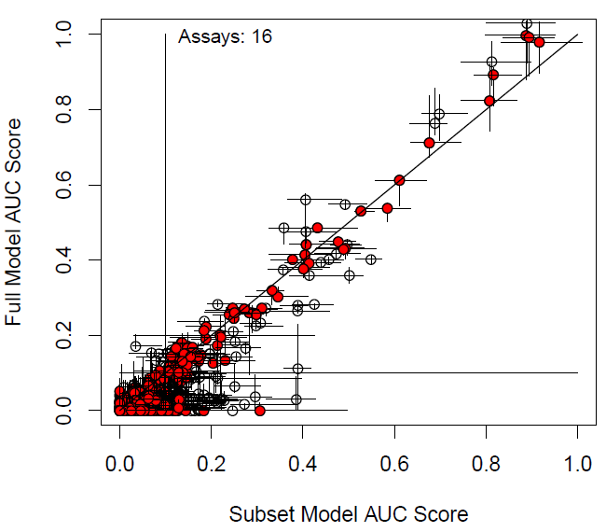
Figure 1: Comparison of the ER agonist AUC scores for the full network model and the subset model with all 16 in vitro assays for 1811 chemicals. Confidence intervals calculated using the method described in Watt et al. (Watt et al. in preparation). Red circles indicate that the subset model is within the confidence intervals of the full network model. Sensitivity, specificity and BA for the 16 assay model are 0.95, 0.95 and 0.95 for all chemicals, and 0.97, 0.95 and 0.96 for the reference chemicals. R2 values are 0.96 for all chemicals and 0.98 for the reference chemicals.

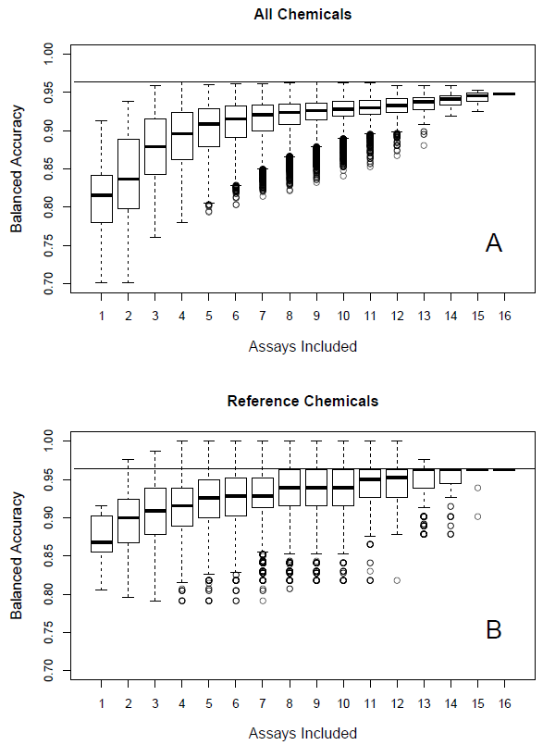
Figure 2: Boxplots of balanced accuracy (vs. the full model, using a cutoff of 0.1) for all subset models as a function of the number of in vitro assays used, (A) all chemicals and (B) reference chemicals. The bar in the middle of the box is the median value, the box indicates the middle two quantiles, the whiskers the 95% level, and points outliers beyond 95% of the distribution. The horizontal line is set at 0.96, the maximum BA seen for any model across all chemicals.

Table 3 gives the performance metrics for the best model for each number of assays from 1 to 16, where “best” means the subset model with the highest minimum-BA, as defined above. We see subset models reaching the highest value of 0.94 with as few as 4 assays (in this case the human cell free binding assay NVS_NR_hER, the Odyssey Thera protein dimerization assay OT_ER_ERaERb_1440, the Attagene TRANS reporter assay ATG_ERa_TRANS, and the proliferation assay, ACEA_T47D_80hr_Positive). Other combinations with more assays achieve the same level of accuracy, but these typically add to this first set of 4 assays, although the selection of which protein complementation assay(s) are used can vary. Optimal performance drops off as more than 12 assays are used. Notice that the weights of certain assays (usually from Odyssey Thera) are negative, indicating that they are being used to pull down the predictive AUC values, and essentially to compensate for over-sensitivity in other assays. Figure 3 graphically shows this increase and then decrease in performance with the number of assays included. By comparing Figures 2 and 3, we see that some subset models can achieve high BA against the full model, but these models are not as good overall at simultaneously achieving high accuracy against all of the performance metrics.
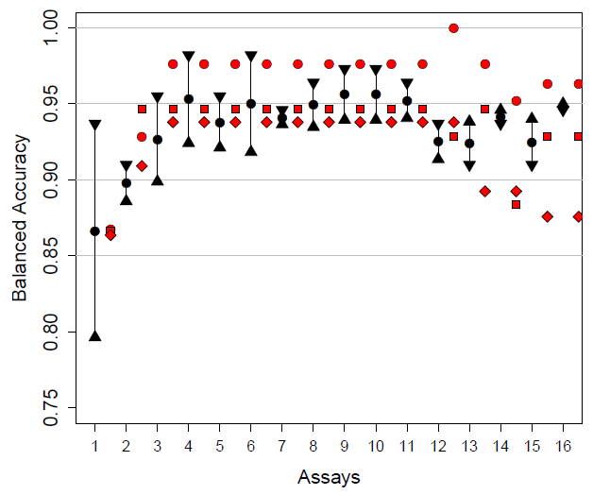
Figure 3: Performance for the best models for each number of in vitro assays from 1 to 16. The black symbols indicate data for the best all-chemical model, corresponding to Table 3. The black circle is the BA, the down triangle is the sensitivity, and the up-triangle is the specificity. The red symbols are for reference chemical BA values: circle (classification vs. the full model), square (classification vs in vitro reference chemicals), and diamond (classification vs. in vivo reference chemicals). The red symbols are shifted to the right slightly for ease of visualization.

Table 3: Best models for each number of assays
Assays | 1 | 2 | 3 | 4 | 5 | 6 | 7 | 8 | 9 | 10 | 11 | 12 | 13 | 14 | 15 | 16
Sensitivity (all chemicals) | 0.94 | 0.91 | 0.95 | 0.98 | 0.95 | 0.98 | 0.95 | 0.96 | 0.97 | 0.97 | 0.96 | 0.94 | 0.91 | 0.94 | 0.91 | 0.95
Specificity (all chemicals) | 0.80 | 0.89 | 0.90 | 0.92 | 0.92 | 0.92 | 0.94 | 0.93 | 0.94 | 0.94 | 0.94 | 0.91 | 0.94 | 0.95 | 0.94 | 0.95
BA (all chemicals) | 0.87 | 0.90 | 0.93 | 0.95 | 0.94 | 0.95 | 0.94 | 0.95 | 0.96 | 0.96 | 0.95 | 0.93 | 0.92 | 0.94 | 0.92 | 0.95
BA (in vitro reference chemicals) | 0.87 | 0.95 | 0.95 | 0.95 | 0.95 | 0.95 | 0.95 | 0.95 | 0.95 | 0.95 | 0.95 | 0.93 | 0.95 | 0.88 | 0.93 | 0.93
BA (in vivo reference chemicals) | 0.86 | 0.91 | 0.94 | 0.94 | 0.94 | 0.94 | 0.94 | 0.94 | 0.94 | 0.94 | 0.94 | 0.94 | 0.89 | 0.89 | 0.88 | 0.88
BA (minimum) | 0.86 | 0.90 | 0.93 | 0.94 | 0.94 | 0.94 | 0.94 | 0.94 | 0.94 | 0.94 | 0.94 | 0.93 | 0.89 | 0.88 | 0.88 | 0.88
Assay Selection
NVS_NR_bER | 0 | 0 | 0 | 0 | 0 | 0 | 0 | 1 | 1 | 1 | 1 | 1 | 1 | 1 | 1 | 1
NVS_NR_hER | 0 | 0 | 1 | 1 | 1 | 1 | 1 | 1 | 1 | 1 | 1 | 1 | 1 | 1 | 1 | 1
NVS_NR_mERa | 0 | 0 | 0 | 0 | 1 | 1 | 0 | 1 | 1 | 1 | 1 | 1 | 1 | 1 | 1 | 1
OT_ER_ERaERa_0480 | 0 | 0 | 0 | 0 | 0 | 0 | 1 | 1 | 1 | 1 | 1 | 1 | 1 | 1 | 1 | 1
OT_ER_ERaERa_1440 | 0 | 0 | 0 | 0 | 1 | 0 | 1 | 1 | 1 | 0 | 0 | 1 | 1 | 1 | 1 | 1
OT_ER_ERaERb_0480 | 0 | 0 | 0 | 0 | 0 | 1 | 1 | 0 | 1 | 1 | 1 | 1 | 1 | 1 | 1 | 1
OT_ER_ERaERb_1440 | 0 | 0 | 1 | 1 | 0 | 1 | 0 | 0 | 0 | 1 | 1 | 1 | 1 | 1 | 1 | 1
OT_ER_ERbERb_0480 | 0 | 0 | 0 | 0 | 0 | 0 | 1 | 0 | 0 | 1 | 1 | 1 | 1 | 1 | 1 | 1
OT_ER_ERbERb_1440 | 0 | 1 | 0 | 0 | 0 | 0 | 0 | 0 | 0 | 0 | 1 | 1 | 1 | 1 | 1 | 1
OT_ERa_EREGFP_0120 | 0 | 0 | 0 | 0 | 0 | 0 | 0 | 0 | 0 | 0 | 0 | 0 | 0 | 0 | 1 | 1
OT_ERa_EREGFP_0480 | 0 | 0 | 0 | 0 | 0 | 0 | 0 | 1 | 1 | 1 | 1 | 0 | 0 | 0 | 1 | 1
ATG_ERa_TRANS_up | 1 | 1 | 1 | 1 | 1 | 1 | 1 | 1 | 1 | 1 | 1 | 1 | 1 | 1 | 1 | 1
ATG_ERE_CIS_up | 0 | 0 | 0 | 0 | 0 | 0 | 0 | 0 | 0 | 0 | 0 | 0 | 1 | 1 | 1 | 1
TOX21_ERa_BLA_Agonist_ratio | 0 | 0 | 0 | 0 | 0 | 0 | 0 | 0 | 0 | 0 | 0 | 0 | 1 | 1 | 1 | 1
TOX21_ERa_LUC_BG1_Agonist | 0 | 0 | 0 | 0 | 0 | 0 | 0 | 0 | 0 | 0 | 0 | 1 | 1 | 1 | 1 | 1
ACEA_T47D_80hr_Positive | 0 | 0 | 0 | 1 | 1 | 1 | 1 | 1 | 1 | 1 | 1 | 1 | 0 | 1 | 0 | 1
Assay Weights
NVS_NR_bER | 0 | 0 | 0 | 0 | 0 | 0 | 0 | 0.23 | 0.22 | 0.24 | 0.22 | 0.28 | 0.22 | 0.24 | 0.18 | 0.19
NVS_NR_hER | 0 | 0 | 0.35 | 0.26 | 0.18 | 0.2 | 0.23 | 0.04 | 0.04 | 0.05 | 0.06 | 0 | 0.01 | -0.05 | 0.02 | -0.02
NVS_NR_mERa | 0 | 0 | 0 | 0 | 0.08 | 0.09 | 0 | 0.01 | 0.01 | 0.01 | 0.01 | 0.02 | 0.02 | 0.02 | 0.01 | 0.01
OT_ER_ERaERa_0480 | 0 | 0 | 0 | 0 | 0 | 0 | 0.11 | -0.02 | 0.01 | 0.06 | 0.06 | 0.09 | 0.06 | 0.04 | 0.03 | 0.02
OT_ER_ERaERa_1440 | 0 | 0 | 0 | 0 | 0.16 | 0 | 0.14 | 0.07 | 0.06 | 0 | 0 | 0.07 | 0.05 | 0.05 | 0.07 | 0.07
OT_ER_ERaERb_0480 | 0 | 0 | 0 | 0 | 0 | 0.03 | -0.02 | 0 | -0.03 | 0.02 | 0.04 | -0.1 | -0.09 | -0.07 | -0.1 | -0.09
OT_ER_ERaERb_1440 | 0 | 0 | 0.15 | 0.13 | 0 | 0.08 | 0 | 0 | 0 | 0.02 | -0.03 | 0.06 | 0.1 | 0.1 | 0.02 | 0.03
OT_ER_ERbERb_0480 | 0 | 0 | 0 | 0 | 0 | 0 | -0.05 | 0 | 0 | -0.08 | -0.11 | -0.02 | 0.05 | 0.05 | 0.02 | 0.03
OT_ER_ERbERb_1440 | 0 | 0.37 | 0 | 0 | 0 | 0 | 0 | 0 | 0 | 0 | 0.06 | -0.08 | -0.1 | -0.13 | -0.06 | -0.09
OT_ERa_EREGFP_0120 | 0 | 0 | 0 | 0 | 0 | 0 | 0 | 0 | 0 | 0 | 0 | 0 | 0 | 0 | 0.07 | 0.08
OT_ERa_EREGFP_0480 | 0 | 0 | 0 | 0 | 0 | 0 | 0 | 0.16 | 0.17 | 0.17 | 0.18 | 0 | 0 | 0 | 0.11 | 0.08
ATG_ERa_TRANS_up | 0.67 | 0.34 | 0.29 | 0.23 | 0.25 | 0.23 | 0.23 | 0.24 | 0.25 | 0.24 | 0.23 | 0.11 | 0.05 | 0.03 | 0.06 | 0.05
ATG_ERE_CIS_up | 0 | 0 | 0 | 0 | 0 | 0 | 0 | 0 | 0 | 0 | 0 | 0 | 0.17 | 0.12 | 0.14 | 0.1
TOX21_ERa_BLA_Agonist_ratio | 0 | 0 | 0 | 0 | 0 | 0 | 0 | 0 | 0 | 0 | 0 | 0 | 0.23 | 0.25 | 0.19 | 0.21
TOX21_ERa_LUC_BG1_Agonist | 0 | 0 | 0 | 0 | 0 | 0 | 0 | 0 | 0 | 0 | 0 | 0.34 | 0.19 | 0.18 | 0.22 | 0.2

Table 4 gives the frequency for selection of the assays in the 512 subset models with minimum BA >0.92. The Attagene TRANS assays is selected in almost all models (as it is selected in all of the models in Table 3). This assay tends to have a high sensitivity with a lower specificity (Judson, Magpantay et al. 2015), but is likely included in the subset models to maximize the combined sensitivity. The inclusion of other less sensitive but more specific assays then helps to compensate by bringing the model’s overall rate of false positives and false negatives down. The corresponding Attagene CIS assay is rarely used, likely because it has similarly high sensitivity and low specificity characteristics, but to a lesser extent. The ACEA cell proliferation assay is the second most often used. As with the Attagene assays, it tends to be highly sensitive, with a low specificity. The next three assays in order are the human, mouse and bovine cell-free binding assays. These typically have a lower sensitivity, missing many weak compounds, but are very specific (few false positives). The Odyssey Thera protein complementation assays are all used at intermediate frequencies. These assays are highly correlated, so that subset models with one of these assays will demonstrate similar performance as with any of the others. The two-hour Odyssey Thera chromatin binding assay (OT_ERa_EREGFP_0120) is almost never selected, perhaps because activity has not stabilized at this short time point. The Tox21 beta lactamase transactivation assay is one of the less frequently selected assays, while the Tox21 VM7 luciferase assay is more frequently used. This reflects the increased sensitivity of the latter over the former.

Table 4: Frequency of use of assays in models with minimum BA>0.92
Assay | Frequency
ATG_ERa_TRANS_up | 0.98
ACEA_T47D_80hr_Positive | 0.82
NVS_NR_hER | 0.77
NVS_NR_mERa | 0.57
NVS_NR_bER | 0.53
OT_ER_ERaERb_0480 | 0.51
TOX21_ERa_LUC_VM7_Agonist | 0.47
OT_ER_ERaERb_1440 | 0.46
OT_ER_ERbERb_1440 | 0.42
OT_ER_ERbERb_0480 | 0.42
OT_ERa_EREGFP_0480 | 0.37
OT_ER_ERaERa_1440 | 0.32
OT_ER_ERaERa_0480 | 0.31
TOX21_ERa_BLA_Agonist_ratio | 0.23
ATG_ERE_CIS_up | 0.13
OT_ERa_EREGFP_0120 | 0.01

The principal take-home message from the proceeding analysis is that there are a variety of in vitro assay subsets that can be used to accurately classify chemicals for ER agonist activity. However, none of the models gives perfect classification, so it is worth exploring the issue of what types of chemicals yield false positive results in these assays and models. Note that the false negative reference chemicals in the full model (and in the subset models) are almost all due to the limited upper testing concentration (~100 μM). Here, we focus on “subset false positive chemicals”, which are ones where the subset model indicates that the chemical is positive for estrogenicity, while the full model indicates that it is negative. As fewer and fewer assays are included in a model, a strong false positive signal in one assay can lead to a positive overall call, one that would be diluted if more (presumably negative) assays were included. Here, we calculate a metric which is the difference between the largest individual assay AUC (Eq. 1) and the full model AUC. Figure 4 shows a heatmap of all chemicals with a difference of 0.35 or greater, as an illustration. The top three chemicals are selective estrogen receptor modulators that are usually functionally classified as ER antagonists. These have large full-model antagonist AUC scores (Judson, Magpantay et al. 2015), and are expected to have significant activity in the upstream assays in the pathway (binding, protein dimerization, chromatin binding), but limited to no activity in the downstream assays (transactivation, proliferation) (Judson, Magpantay et al. 2015), which is what is seen here. In the second block are several progesterone or glucocorticoid-activating chemicals, active mostly in the ACEA cell proliferation assay. This assay, run in T47D cells, is known to be sensitive to these classes of chemicals independent of the estrogen receptor. A number of the remaining chemicals are detergents or solvents which may be activating the in vitro assays through a cell-stress or technology interference pathways. Most of these “false positive” chemicals are principally active in the Attagene assays, as observed previously (Judson, Magpantay et al. 2015). One hypothesis about these chemicals is that they are actually estrogenic, but only after bioactivation. These assays are run in a substrain of HepG2 cells that was selected for increased CYP activity.

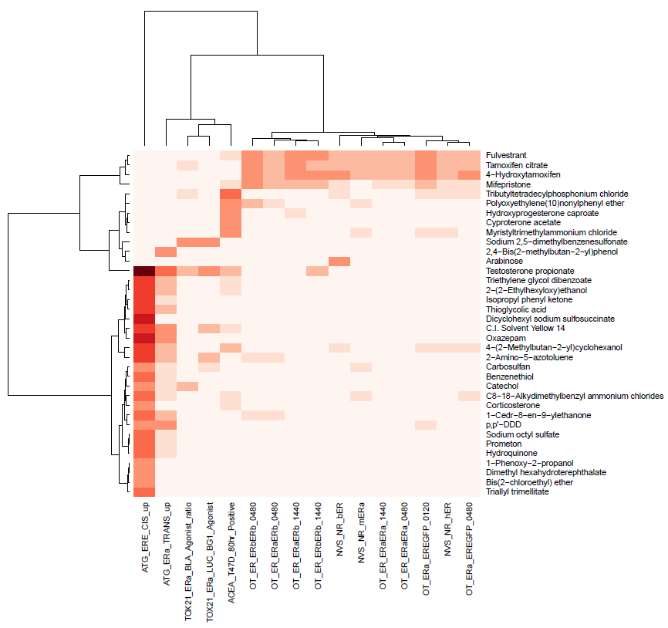
Figure 4: Heatmap of the maximum assay subset AUC values for chemicals with absolute difference between the maximum assay subset AUC and the full model AUC of >0.35. The color scale ranges from white (0.0) to dark red (1.0). The AUC could be for any subset with fewer than 16 assays.

Discussion
In this paper, we have described an approach for selecting a minimum battery of ER assays to use in classifying the estrogenic agonist activity of a chemical. We started with a validated set of 16 assays covering multiple points in the estrogen signaling pathway, which had been combined using a mathematical model that was used to distinguish true agonist or antagonist activity from assay or technology-specific assay interference activity (Judson, Magpantay et al. 2015). Here, we showed that one can use a simple linear model, one that combines individual chemical-assay AUC values, to achieve comparable performance for agonist activity. The chemical-assay AUC value is a combination of potency and efficacy (Equation 1). Using this simple linear model, we evaluated the accuracy of all combinations of 1 to 16 assays (65535 in total) against the results of the full model, and well-studied in vitro and in vivo reference chemicals.
From this analysis, we found that there were many combinations of subsets of assays that performed at levels comparable to the full 16-assay model. Interestingly, the performance against just the in vitro reference chemicals was often (but not always) higher than against either the in vivo reference chemicals, or against the complete set of ~1800 chemicals evaluated in the full model. This indicates that a battery evaluated (or validated) against only the standard reference chemicals may overstate the true accuracy of the model. This is due to the fact that there are certain chemicals that will be positive in only one assay or technology, either through assay interference (Baell and Holloway 2010, Bruns and Watson 2012), or through true activity that is only captured by that assay (e.g. through metabolic activation which does not occur in most of the current in vitro assays). The assay-specific false positive activity is a key factor determining the domain of applicability of the assay, which is one aspect of standard assay validation practice (ICCVAM 1997, Hartung, Bremer et al. 2004, Judson, Kavlock et al. 2013). In general, the narrower the set of chemicals used to evaluate an assay, the narrower will be the domain of applicability. We analyze the types of chemicals that show significant differences between the full model AUC and the AUC for individual assays. This analysis showed that such chemicals include antagonists (which are appropriately active in a subset of the agonist assays), chemicals such as detergents, which are likely causing false activity through cell stress in certain cell types (Judson, Houck et al. 2016), and chemicals only active in metabolically competent cells.
Note that some of the false positive (and false negative) activity in the data set used here is not “true”, i.e. some of it is due to experimental variability at the time the assays were run. However, by using data from such a large set of chemicals, such noise should be swamped by the larger signal.
Based on these results, we can conclude that one could use any one of multiple subset models to accurately predict the estrogenic potential of a chemical. There are subsets that include as few as 4 of the original 16 assays that simultaneously have acceptable performance against the full model, and the in vitro and in vivo reference chemicals. There are other subsets that have good performance against just the in vitro reference chemicals, but perform poorly against the full set, and these subsets would not be acceptable substitutes. The acceptable subsets all have assays that probe diverse points in the ER pathway, and use diverse assay reporting technology and cell types. Note that there are subsets of assays that are more or less sensitive or specific, so that one could tune a battery, for instance to be more sensitive and less specific, and then follow-up actives with other more specific tests.
Because we have tested a large and diverse library of chemicals in this set of 16 assays, we can characterize the types of chemicals that give false positive results, and hence can help characterize the domain of applicability for the assays. One could construct similar batteries using assays that are not included in the 16 used here, but our results suggest that to evaluate performance, one would need to test more chemicals than just the standard reference set. There is not a universal set of assay interference chemicals, but there are likely ones that yield false positive results in many assays using the same cell type or readout. Therefore, by mining available data for assays similar to a new one that is proposed for inclusion in an ER battery, one could develop a set of chemicals to help characterize that assays domain of applicability.

Supplemental Files:
S1a, S1b, S1c: Matrices (chemicals by assays) containing median, maximum, minimum assay-chemical AUC values normalized so that the maximum value of the median for each assay is 1.0.
S2: Listing of all models with a minimum AIUC>0.92, including performance statistics, assay selection and assay weights.

References
To be added:
Watt: ER uncertainty manuscript
BG1-VM7: change of cell type

Baell, J. B. and G. A. Holloway (2010). "New substructure filters for removal of pan assay interference compounds (PAINS) from screening libraries and for their exclusion in bioassays." J Med Chem 53(7): 2719-2740.
Browne, P., R. S. Judson, W. M. Casey, N. C. Kleinstreuer and R. S. Thomas (2015). "Screening Chemicals for Estrogen Receptor Bioactivity Using a Computational Model." Environ Sci Technol.
Bruns, R. F. and I. A. Watson (2012). "Rules for identifying potentially reactive or promiscuous compounds." J Med Chem 55(22): 9763-9772.
EPA, U. S. (2015). Use of High Throughput Assays and Computational Tools; Endocrine Disruptor Screening Program; Notice of Availability and Opportunity for Comment. E. P. Agency. Washington DC, Environmental Protection Agency.
Hartung, T., S. Bremer, S. Casati, S. Coecke, R. Corvi, S. Fortaner, L. Gribaldo, M. Halder, S. Hoffmann, A. J. Roi, P. Prieto, E. Sabbioni, L. Scott, A. Worth and V. Zuang (2004). "A modular approach to the ECVAM principles on test validity." Altern Lab Anim 32(5): 467-472.
ICCVAM (1997). Validation and Regulatory Acceptance of Toxicological Test Methods: A Report of the ad hoc Interagency Coordinating Committee on the Validation of Alternative Methods (ICCVAM). Research Triangle Park, NC, USA. , NIEHS.
Ihaka, R. and R. Gentleman (1996). "R: A language for data analysis and graphics." J.Comput and Graphical Statistics 5 299-314.
Judson, R., K. Houck, M. Martin, A. M. Richard, T. B. Knudsen, I. Shah, S. Little, J. Wambaugh, R. Woodrow Setzer, P. Kothya, J. Phuong, D. Filer, D. Smith, D. Reif, D. Rotroff, N. Kleinstreuer, N. Sipes, M. Xia, R. Huang, K. Crofton and R. S. Thomas (2016). "Analysis of the Effects of Cell Stress and Cytotoxicity on In Vitro Assay Activity Across a Diverse Chemical and Assay Space." Toxicol Sci 152(2): 323-339.
Judson, R., R. Kavlock, M. Martin, D. Reif, K. Houck, T. Knudsen, A. Richard, R. R. Tice, M. Whelan, M. Xia, R. Huang, C. Austin, G. Daston, T. Hartung, J. R. Fowle, 3rd, W. Wooge, W. Tong and D. Dix (2013). "Perspectives on validation of high-throughput assays supporting 21st century toxicity testing." ALTEX 30(1): 51-56.
Judson, R. S., F. M. Magpantay, V. Chickarmane, C. Haskell, N. Tania, J. Taylor, M. Xia, R. Huang, D. M. Rotroff, D. L. Filer, K. A. Houck, M. T. Martin, N. Sipes, A. M. Richard, K. Mansouri, R. W. Setzer, T. B. Knudsen, K. M. Crofton and R. S. Thomas (2015). "Integrated Model of Chemical Perturbations of a Biological Pathway Using 18 In Vitro High-Throughput Screening Assays for the Estrogen Receptor." Toxicol Sci 148(1): 137-154.
Kleinstreuer, N. C., P. C. Ceger, D. G. Allen, J. Strickland, X. Chang, J. T. Hamm and W. M. Casey (2015). "A Curated Database of Rodent Uterotrophic Bioactivity." Environ Health Perspect.
Safe, S. H. (1995). "Environmental and dietary estrogens and human health: is there a problem?" Environ Health Perspect 103(4): 346-351.

