Background - What does the teacher need to know before teaching this lesson?
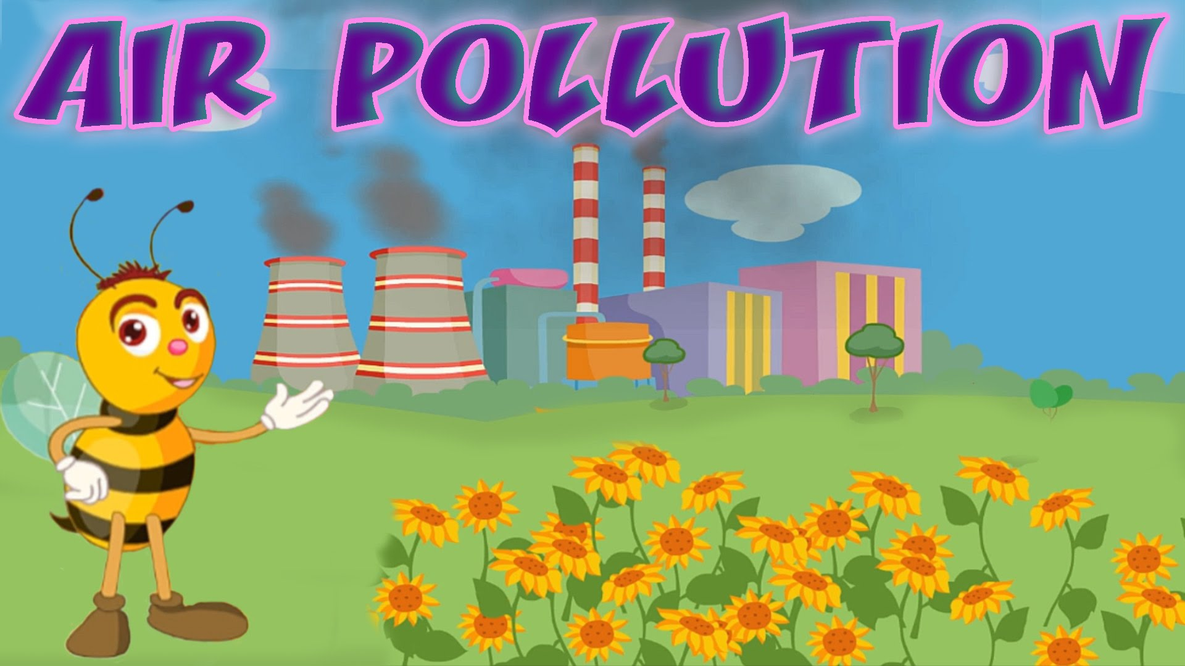
What is air?
Air is a mixture of different gases that covers the Earth in a layer over 400 miles high. This layer is called the atmosphere. It contains roughly 78% nitrogen, 21% oxygen, and smaller amounts of argon, hydrogen, carbon dioxide, and others.

Why is air important?
Air is needed by almost all the living things living on Earth. Most plants and animals take in air, use the oxygen in it and give out another gas, carbon dioxide. This process is called respiration. Air also protects life on Earth by absorbing harmful ultraviolet solar radiation and reducing temperature extremes between day and night

What is air pollution?
Air pollution is caused by the accumulation of one or more chemicals or substances in the air in high enough concentrations to harm humans, other animals, vegetation, or materials. Air pollution consists of chemicals or particles in the air that can harm the health of humans, animals, and plants. It also damages buildings. Pollutants in the air take many forms. They can be gases, solid particles, or liquid droplets. (National Geographic)

What causes air pollution?
Air pollution can result from both human and natural actions. Natural events that pollute the air include forest fires, volcanic eruptions, wind erosion, pollen dispersal, evaporation of organic compounds and natural radioactivity. Pollution from natural occurrences is not very often. Human activities that result in air pollution include emissions from industries and manufacturing activities, burning fossil fuels, and household and farming chemicals. For instance, common causes of air pollution are emissions from industrial facilities and electric utilities, motor vehicle exhaust, gasoline vapors, chemical solvents, roadway dust, and smoke.

Why is air pollution such a serious problem?
Air pollution can cause many health problems such as burning eyes, cancer, birth defects, brain damage, or even death. Air pollution can also damage the environment and property such as food crops, trees, lakes and buildings.

What Can I Do to Help Reduce Air Pollution?
Every time we drive to school, use our heater or air conditioner, clean our windows, or even style our hair, we make choices that affect air pollution. These steps, as well as many others, are things we all can do to help reduce air pollution.
- Conserve energy – remember to turn off lights, computers, and electric appliances when not in use.
- Use energy efficient light bulbs and appliances.
- Participate in your local utility’s energy conservation programs.
- Limit driving by carpooling, using public transportation, biking and walking.
- Combine errands for fewer trips, etc.
- Turn off your ignition if you’re waiting more than 10 seconds. Do not idle.

Further readings
Air pollution: https://www3.epa.gov/airnow/aqikids/games/aqi/Games.htm
Ways to reduce air pollution: http://www.vcapcd.org/pubs/Factsheets/50WaysfactSheet.pdf, Ventura County

Standards - What standards are being met by teaching this lesson?
- K-12 Integrated Environmental and Sustainability Learning Standards (See Appendix Table 1)
- California Education and the Environment Initiative (See Appendix Table 2)
- Next Generation Science Standards (See Appendix Table 3)
- Common Core State Standards (See Appendix Table 4)

Necessary supplies - What supplies will you need to teach the class?
- Paper for each student
- Coloring sheet for each student (provided in appendix)
- Five pictures (blowing up a balloon, flying a kite, paper airplane, bubbles, blowing out candles) from this site posted physically or electronically where the class can observe them (provided in appendix): http://www.kidsparkz.com/air.html
- These images queued for presentation (provided in appendix):
http://upload.wikimedia.org/wikipedia/commons/a/aa/AlfedPalmersmokestacks.jpg
http://upload.wikimedia.org/wikipedia/commons/c/cb/Automobile_exhaust_gas.jpg
http://upload.wikimedia.org/wikipedia/commons/4/47/Hong_kong_haze_comparison.jpg
- Optional: A banner or printed sign that says “Clean air allows me to…” – This will hang above an area that the students will hang drawings on.

Do Now - (Written on board/projector) What quick independent activity will students engage in as soon as they arrive in class that will review past learning or preview the day’s learning? (5 min)
Post the five pictures from Kidzsparkz (provided in appendix) and ask the children to look at them when they come in.

What do all five of these pictures have in common?

The answer is, they all focus on the use of air!

Objective for the Day – (Written on board/projector) What skill are you going to teach and what should the students be able to do by the end of the class to demonstrate what they have learned?
Today, you will gain an understanding of the importance of air and why we need to keep it clean.

Keywords:
Air
Air Pollution
Reducing pollution

Purpose – Why is it important for students to learn this skill? Explain why today’s lesson matters.
A grasp of the value of air is essential to an understanding of air pollution and the many problems it creates for all living things.

Teaching the Skill – How will you teach this skill to students? What will the examples and the modeling look like? How will you ensure that all students are actively participating in the lesson?
Step 1: | What is Air? (5-10 minutes)  After the students have had a chance to try answering the “Do Now” question, ask them the following questions:  What is air? – This is a very abstract question for kids this age. The answers given may be things like, “It’s what we breathe!” or “It’s all around us!” These are all valid answers. Air is the invisible gas that surrounds the Earth and allows for animals and plants to breathe.  Can we see air? – The answer is, of course, no. But we can see wind in the trees and smoke from a fire, which moves through the air.  Can we smell air? – There isn’t really a wrong answer here. We think of air as being scentless, but when we smell a pie baking, that smell is traveling to us through the air!  Can we feel air? – We can certainly feel movement of air. After one or two students offer answers to this question, ask everyone to blow on their palms. Sometimes, we can feel air!
Step 2: | Clean Air Allows Me To… (10 minutes)  Transition: Let’s talk about what air allows us to do! All living things require air in order to do things. I require air to teach you this lesson just like you require air to learn! Air helps you ride your bike, blow out your birthday candles, and sing your favorite songs! If air becomes dirty with pollution, it can cause illnesses like asthma that make it difficult for people to breathe, so it’s harder for people with asthma to do these wonderful things. Air pollution comes from things like cars, factories, and landfills.  Watch the video “Air Pollution for Kids” by Smart Learning for All until (2:45): https://www.youtube.com/watch?v=sAKyhfxxr7s  Pass out a piece of paper to each student and make sure everyone has access to crayons. Ask the students to draw something that they love to do. The theme of this activity is “Air allows me to…”  Give a personal example. Clean air allows me to swim! Clean air allows me to dance! Clean air allows me to laugh!  Give the kids time to finish their drawings and hang them all in an area where they can be seen and appreciated.

Practice - What will it look like when you give the students the chance to practice on their own? What activity will students complete? Remember, you are gradually releasing responsibility to the students over the course of the lesson. Students should ultimately be practicing the day’s objective independently. They might start by working in pairs or groups or with some helpful resources before working on their own. (5-10 min)
Begin a discussion with the class that focuses on the students’ own ideas. Here, you will give them the opportunity to brainstorm about what air pollution might look like or come from. Some questions you can ask include:

What could air pollution look like? Where does air pollution come from? How might we reduce air pollution?

Hold up the printed photos (found in appendix) to help the kids visualize each concept. Ask if the air is clean or polluted, and after they answer, provide an explanation of what can be done to mitigate the impact. Give the students time to really think about their answers. They will likely need some guidance. Air pollution can look like smoke, smog, dust, or gas. It can even be invisible! It comes from places like cars and factories, but can also come from natural things like wildfires and volcanoes. One way we can reduce air pollution is to ride a bike or take a bus or train rather than drive a car. You can also reduce your electricity use (because the production of electricity requires the burning of dirty fuels) by turning off lights when they are not being used.

End this thought exercise by displaying the pictures of air pollution that are provided in the supplies list. Let the kids look at pictures of dirty air and sources of air pollution to conclude the discussion.

Take Home/Homework – An activity for the students to take home and perform. Optional: Have the students return the next day with proof of completion of the activity.
Provide each student with one of the attached coloring sheets.

Appendix of Tables

Appendix Table 1: K-12 Integrated Environmental and Sustainability Learning Standards

Standard 2: The Natural and Build Environment
- Students engage in inquiry and systems thinking and use information gained through learning experiences in, about, and for the environment to understand the structure, components, and processes of natural and human-built environments.
Standard 3: Sustainability and Civic Responsibility
- Students develop and apply the knowledge, perspective, vision, skills, and habits of mind necessary to make personal and collective decisions and take actions that promote sustainability.

Appendix Table 2: California Education and the Environment Initiative

Principle II: People Influence Natural Systems
- The long-term functioning and health of terrestrial, freshwater, coastal, and marine ecosystems are influenced by their relationships with human societies.
Concept B: Students need to know that methods used to extract, harvest, transport, and consume natural resources influence the geographic extent, composition, biological diversity, and viability of natural systems.
Principle IV: There are no Permanent or Impermeable Boundaries that Prevent Matter from Flowing Between Systems
- The exchange of matter between natural systems and human societies affects the long-term functioning of both.
Concept B: Students need to know that the byproducts of human activity are not readily prevented from entering natural systems and may be beneficial, neutral, or detrimental in their effect.

Appendix Table 3: Next Generation Science Standards

From Molecules to Organisms: Structures and Processes
- K-LS1-1: Use observations to describe patterns of what plants and animals (including humans) need to survive.
Science and Engineering Practices | Disciplinary Core Ideas | Crosscutting Concepts
Analyzing and Interpreting Data: Analyzing data in K–2 builds on prior experiences and progresses to collecting, recording, and sharing observations.  Use observations (firsthand or from media) to describe patterns in the natural world in order to answer scientific questions.  Connections to Nature of Science: Scientific Knowledge is Based on Empirical Evidence: Scientists look for patterns and order when making observations about the world. | LS1.C: Organization for Matter and Energy Flow in Organisms: All animals need food in order to live and grow. They obtain their food from plants or from other animals. Plants need water and light to live and grow. | Patterns: Patterns in the natural and human designed world can be observed and used as evidence.
Earth and Human Activity
- K-ESS3-1: Use a model to represent the relationship between the needs of different plants and animals (including humans) and the places they live.
Science and Engineering Practices | Disciplinary Core Ideas | Crosscutting Concepts
Developing and Using Models: Modeling in K–2 builds on prior experiences and progresses to include using and developing models (i.e., diagram, drawing, physical replica, diorama, dramatization, storyboard) that represent concrete events or design solutions.  Use a model to represent relationships in the natural world. | ESS3.A: Natural Resources: Living things need water, air, and resources from the land, and they live in places that have the things they need. Humans use natural resources for everything they do. | Systems and System Models: Systems in the natural and designed world have parts that work together.

Appendix Table 4: Common Core State Standards

Mathematics
Mathematical Practices
Reason abstractly and quantitatively
- CCSS.Math.Practice.MP2: Mathematically proficient students make sense of quantities and their relationships in problem situations.
Measurement and Data
Describe and compare measurable attributes
- CCSS.Math.Content.K.MD.A.2: Directly compare two objects with a measurable attribute in common, to see which object has "more of"/"less of" the attribute, and describe the difference.
English Language Arts
Speaking and Listening
Comprehension and Collaboration
- CCSS.ELA-Literacy.SL.K.2: Confirm understanding of a text read aloud or information presented orally or through other media by asking and answering questions about key details and requesting clarification if something is not understood.
- CCSS.ELA-Literacy.SL.K.3: Ask and answer questions in order to seek help, get information, or clarify something that is not understood.
Presentation of Knowledge and Ideas
- CCSS.ELA-Literacy.SL.K.5: Add drawings or other visual displays to descriptions as desired to provide additional detail.

1 https://eo.ucar.edu/kids/sky/air1.htm
2 https://eschooltoday.com/pollution/air-pollution/what-is-air-pollution.html
3 http://des.nh.gov/organization/divisions/air/tsb/ams/aqmdp/share.htm
http://dnr.wi.gov/org/caer/ce/eek/teacher/aireverywhere/Where's_the_air.pdf

