What in This Picture Doesn’t Belong?
Kindergarten

1) 2) 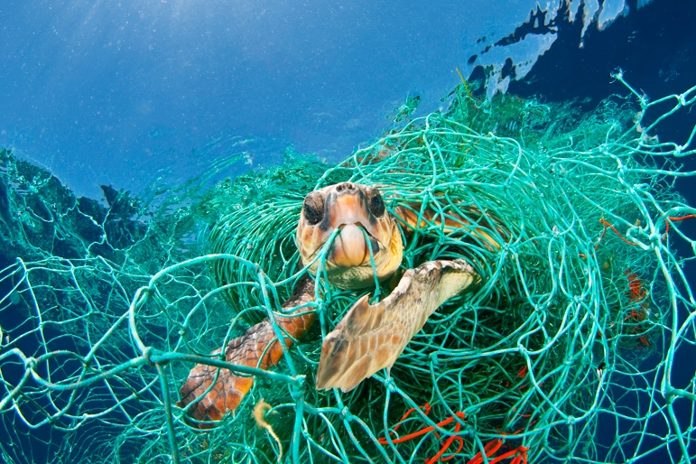

3) 

4) 