Source: The Yellowstone Coloring Book - http://www.nps.gov

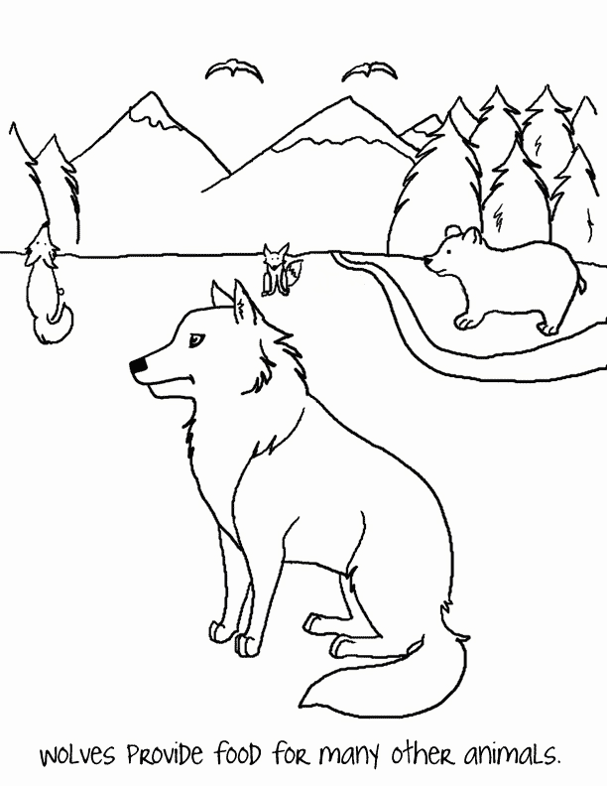

Source: California Wolf Center Coloring Page - http://www.californiawolfcenter.org/
Source: EPA.gov

