Traffic Jam! What can we do to prevent these energy wasters?

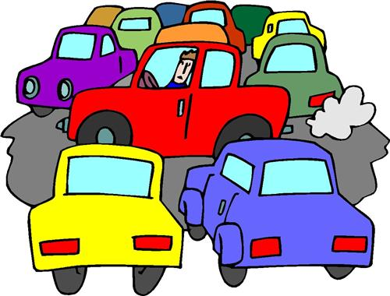
Source: Sheldonisd.com

Long Hot Shower! What can we do to prevent this energy waster?
Tip: Shower to your #1 favorite song, when it’s over, so is your shower!

Cartoon Picture

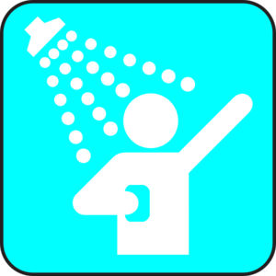
Source: clker.com

No one’s home! What can we do to prevent this energy waster?
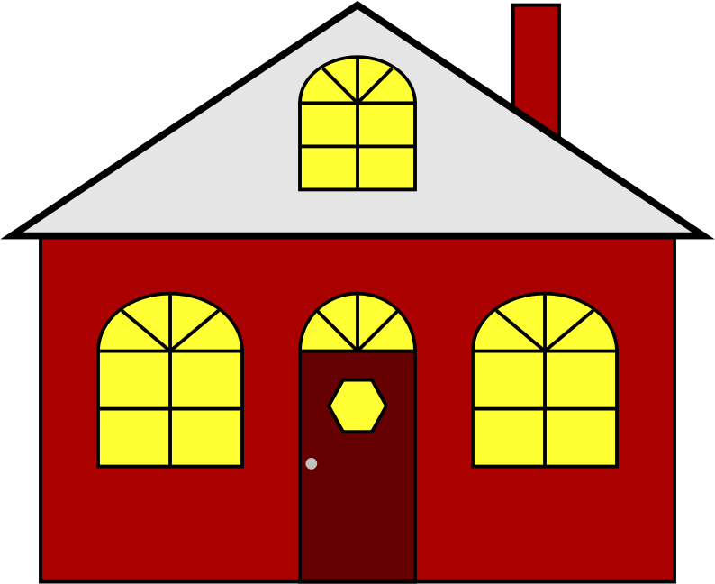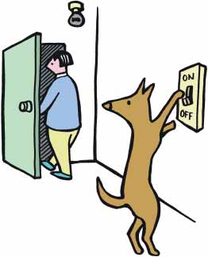
Source: Openclipart.org

Who left the TV on? What can we do to prevent this energy waster?



