Background- What does the teacher need to know before teaching this lesson?
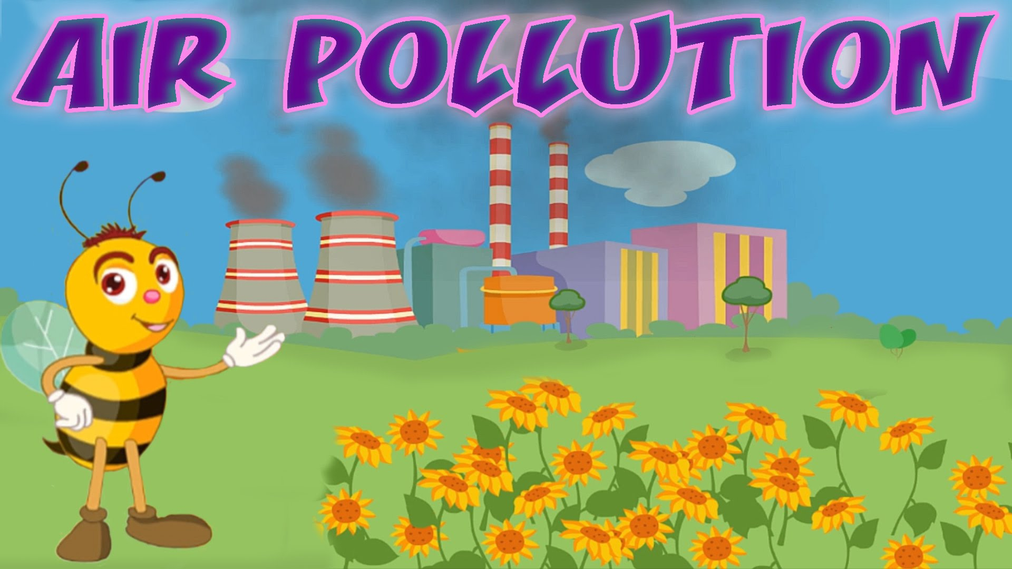
What is air?
Air is a mixture of different gases that covers the Earth in a layer called the atmosphere. It contains roughly 78% nitrogen, 21% oxygen, and small amounts of other gases like carbon dioxide.

Why is air important?
Air is needed by almost all the living things living on Earth. Animals take in air, use the oxygen in it and give out another gas, carbon dioxide. This process is called respiration. Plants take in the carbon dioxide in order to help them grow and they give out oxygen. This process is called photosynthesis. This cycle continues this way indefinitely, and is called the exchange of gases. Air also protects life on Earth by absorbing harmful ultraviolet (UV) solar radiation and reducing temperature extremes between day and night

What is air pollution?
Air pollution is caused by the accumulation of one or more chemicals or substances in the air in high enough concentrations to harm humans, other animals, vegetation, or materials. Air pollution consists of chemicals or particles in the air that can harm the health of humans, animals, and plants. It also damages buildings. Pollutants in the air take many forms. They can be gases, solid particles, or liquid droplets. (National Geographic)

What causes air pollution?
Air pollution can result from both human and natural actions. Natural events that pollute the air include forest fires, volcanic eruptions, wind erosion, pollen dispersal, evaporation of organic compounds and natural radioactivity. Pollution from natural occurrences are not very often. Human activities that result in air pollution include emissions from industries and manufacturing activities, burning fossil fuels, and household and farming chemicals. For instance, common causes of air pollution are emissions from industrial facilities and electric utilities, motor vehicle exhaust, gasoline vapors, chemical solvents, roadway dust, and smoke.

What are pollutants and emissions?
Pollutants are unwanted chemicals or other materials found in the air, at high enough concentrations to endanger the environment and people’s health. Emissions are discharges of a pollutant from a particular source (e.g., a factory) or group of sources (e.g., vehicles) into the air. Processes such as fossil fuel burning in industry, motor vehicles and buildings emit pollutants that cause local and regional pollution.

What is smog?
Smoke and fog together create smog. The term smog was first coined during the 1950s when it was used to describe a mixture of smoke and fog experienced in London. Smog occurs when emissions from industry, motor vehicles, incinerators, open burning and other sources accumulate under certain climatic conditions.

Why is air pollution such a serious problem?
Air pollution can cause many health problems such as burning eyes, cancer, birth defects, brain damage, or even death. Air pollution can also damage the environment and property such as food crops, trees, lakes and buildings.

What is the difference between weather and climate?
Weather is the short-term changes we see in temperature, clouds, precipitation, humidity and wind in a region or a city. Weather can vary greatly from one day to the next, or even within the same day. In the morning, the weather may be cloudy and cool. But by afternoon it may be sunny and warm. The climate of a region or city is its weather averaged over many years. This is usually different for different seasons. For example, a region or city may tend to be warm and humid during summer. But it may tend to be cold and snowy during winter. The climate of a city, region or the entire planet changes very slowly. These changes take place on the scale of tens, hundreds and thousands of years.

What is the difference between "climate change" and "global warming"?
"Global warming" refers to the long-term increase in Earth's average temperature. It can also refer to the man-made, or anthropogenic, causes of warming. "Climate change" refers to any long-term change in Earth's climate, or in the climate of a region or city. This includes warming, cooling and changes besides temperature.

What causes climate change?
Global warming occurs when carbon dioxide (CO2) and other air pollutants collect in the atmosphere and absorb sunlight and solar radiation that have bounced off the earth’s surface. Normally, this radiation would escape into space—but these pollutants, which can last from years to centuries in the atmosphere, trap the heat and cause the planet to get hotter.

What are some of the impacts of climate change?
- Melting glaciers, early snowmelt, and severe droughts will cause more dramatic water shortages and increase the risk of wildfires in the American West.
- Rising sea levels will lead to coastal flooding on the Eastern Seaboard, especially in Florida, and in other areas such as the Gulf of Mexico.
- Forests, farms, and cities will face troublesome new pests, heat waves, heavy downpours, and increased flooding. All those factors will damage or destroy agriculture and fisheries.
- Disruption of habitats such as coral reefs and Alpine meadows could drive many plant and animal species to extinction.
- Allergies, asthma, and infectious disease outbreaks will become more common due to increased growth of pollen-producing ragweed, higher levels of air pollution, and the spread of conditions favorable to pathogens and mosquitoes.

What can I do to help reduce air pollution and greenhouse gas emissions?
Every time we drive to school, use our heater or air conditioner, clean our windows, or even style our hair, we make choices that affect air pollution. These steps, as well as many others, are things we all can do to help reduce both air pollution and greenhouse gas emissions:
- Conserve energy – remember to turn off lights, computers, and electric appliances when not in use.
- Use energy efficient light bulbs and appliances.
- Participate in your local utility’s energy conservation programs.
- Limit driving by carpooling, using public transportation, biking and walking.
- Combine errands for fewer trips, etc.
- Turn off your ignition if you’re waiting more than 10 seconds. Do not idle.

Further readings
Air pollution: http://www.nrdc.org/air/
Ways to reduce air pollution: http://www.vcapcd.org/pubs/Factsheets/50WaysfactSheet.pdf
Today's climate change: https://19january2017snapshot.epa.gov/climatechange_.html
The carbon cycle: http://earthobservatory.nasa.gov/Features/CarbonCycle/

Standards - What standards are being met by teaching this lesson?
- K-12 Integrated Environmental and Sustainability Learning Standards (See Appendix Table 1)
- California Education and the Environment Initiative (See Appendix Table 2)
- Next Generation Science Standards (See Appendix Table 3)
- Common Core State Standards (See Appendix Table 4)

Necessary supplies - What supplies will you need to teach the class?
- Printouts of storybook (or a projector to display the storybook)
For the activity:
- Blue, green, red, & yellow food coloring
- Transparent cups or beakers
- Pipets
- Larger printouts of the graphics in the lesson plan below to display.

Do Now - (Written on board/projector) What quick independent activity will students engage in as soon as they arrive in class that will review past learning or preview the day’s learning? (10 min)
Ask students to list all the sources of air pollution they can think of. Discuss as a class. Compare the answers to the information provided on page 128 of "In the Air" background materials (attached).
Put Key Words on the board.

Objective for the Day – (Written on board/projector) What skill are you going to teach and what should the students be able to do by the end of the class to demonstrate what they have learned?
Today you will learn about
- Global climate change and air pollution
- Different kinds of air pollution
- What you can do to help keep our air clean

Key words:
atmosphere climate
greenhouse effect weather
greenhouse gas photosynthesis
global warming smog
climate change respiration
pollution emissions

Purpose – Why is it important for students to learn this skill? Explain why today’s lesson matters.
It is important we all know what we can do to help keep the air clean and reduce our emissions of greenhouse gases.

Teaching the Skill – How will you teach this skill to students? What will the examples and the modeling look like? How will you ensure that all students are actively participating in the lesson?
Step 1: | Does what we do matter? (5min)  Everything that happens here affects something over there.  Earth has its own control system. The oceans, the land, the air, the plants and animals, and the energy from the Sun all affect each other to make everything work in harmony. Nothing changes in one place without changing something in another place. The overall effect gives us our global climate.  From NASA’s Climate Kids http://climatekids.nasa.gov/climate-change-meaning/
Step 2: | Read “The Air We Breathe” (10 min)  http://www.nasa.gov/audience/foreducators/k-4/features/F_Air_We_Breathe.html  http://www.nasa.gov/pdf/62452main_The_Air_We_Breathe.pdf  Explain how the atmosphere serves as a protective layer for life on earth to function.  Discuss how what’s in the air affects people, plants, and animals.
Step 3: | Carbon Dioxide is a Greenhouse Gas (10-15 min)  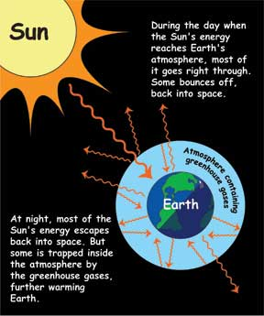  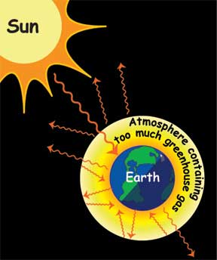  Explain the greenhouse effect.  From NASA’s Climate Kids  http://climatekids.nasa.gov/review/greenhouse-effect/  Earth's atmosphere does the same thing as a greenhouse. Gases in the atmosphere act like the roof of a greenhouse. During the day, the Sun shines through the atmosphere. Earth's surface warms up in the sunlight. At night, Earth's surface cools, releasing the heat back into the air. But the energy doesn't all leak back into space; some of the heat is trapped by greenhouse gases in the atmosphere, like carbon dioxide. This is known as the greenhouse effect. This is a good thing, because it means the Earth is warm enough that people, plants, and animals can live here. If it weren't for the greenhouse effect, Earth's oceans would be frozen solid, and Earth would not be the beautiful blue and green planet that it is.  The greenhouse effect keeps some of the Sun's energy from escaping back into space at night.  However, if the concentration of greenhouse gases is too great, too much heat gets trapped in the atmosphere and the Earth gets too hot. That's what's happening today. This is known as climate change.
Step 4: | Air Quality Activity (20 min)  When we burn fossil fuels, we create more than carbon dioxide. We also create air pollution. Air pollution is caused by chemicals that mix in the air and then make it dirty. It can get so dirty that it makes people sick. For some people, it can become hard to breathe. It can damage plants and animals, rivers and streams, even buildings. Common air pollutants include particulates, nitrogen dioxide, sulfur dioxide, carbon monoxide, and volatile organic compounds. Let's learn about those in the next exercise.  Hand out the Air Quality Activity (attached) and the materials necessary to complete it.  Discuss as a class students’ observations. Ask the students what we could do to reduce the number of pollutants released each day.

Practice - What will it look like when you give the students the chance to practice on their own? What activity will students complete? Remember, you are gradually releasing responsibility to the students over the course of the lesson. Students should ultimately be practicing the day’s objective independently. They might start by working in pairs or groups or with some helpful resources before working on their own. (5-10 min)
Hand out the clean air recommendations from the New York State Department of Environmental Conservation for students (“Clean Air in 10 Easy Step” is attached). If there is time, discuss the steps as a class. It is important to note that many of the steps we can take to reduce air pollution (like riding a bicycle instead of driving) can also reduce our emissions of greenhouse gases because they reduce our use of fossil fuels. If there isn't time for a class discussion, ask students to review the recommendations with their parents or guardians.

Closure - What will you do to wrap up the class and check one more time for student understanding of the objective?
The Air Quality Activity above will likely use up all the available time.

Take Home/Homework – An activity for the students to take home and perform. Optional: Have the students return the next day with proof of completion of the activity.
Ask students to write a reflection for homework on what they learned about air pollution, using key terms, and steps they and their families think they can take to help keep the air clean and reduce their emissions of greenhouse gases.

Additional Resources
For more activities, see the following links:
http://www.airnow.gov/index.cfm?action=aqikids.index
http://toxtown.nlm.nih.gov/text_version/resources/Unit2_ToxtownBook_final_508_5-10-2012.pdf
http://www.dec.ny.gov/education/52185.html

Appendix of Tables

Appendix Table 1: K-12 Integrated Environmental and Sustainability Learning Standards

Standard 1: Ecological, Social, and Economic Systems
- Students develop knowledge of the interconnections and interdependency of ecological, social and economic systems. They demonstrate understanding of how the health of these systems determines the sustainability of natural and human communities at local, regional, national, and global levels.
Standard 2: The Natural and Build Environment
- Students engage in inquiry and systems thinking and use information gained through learning experiences in, about, and for the environment to understand the structure, components, and processes of natural and human-built environments.
Standard 3: Sustainability and Civic Responsibility
- Students develop and apply the knowledge, perspective, vision, skills, and habits of mind necessary to make personal and collective decisions and take actions that promote sustainability.

Appendix Table 2: California Education and the Environment Initiative

Principle I: People Depend on Natural Systems
- The continuation and health of individual human lives and of human communities and societies depend on the health of the natural systems that provide essential goods and ecosystem services.
Concept C: Students need to know that the quality, quantity, and reliability of the goods and ecosystem services provided by natural systems are directly affected by the health of those systems.
Principle II: People Influence Natural Systems
- The long-term functioning and health of terrestrial, freshwater, coastal, and marine ecosystems are influenced by their relationships with human societies.
Concept B: Students need to know that methods used to extract, harvest, transport, and consume natural resources influence the geographic extent, composition, biological diversity, and viability of natural systems.
Principle III: Natural Systems Change in Ways that People Benefit from and can Influence
- Natural systems proceed through cycles that humans depend upon, benefit from, and can alter.
Concept C: Students need to know that human practices can alter the cycles and processes that operate within natural systems.
Principle IV: There are no Permanent or Impermeable Boundaries that Prevent Matter from Flowing Between Systems
- The exchange of matter between natural systems and human societies affects the long-term functioning of both.
Concept B: Students need to know that the byproducts of human activity are not readily prevented from entering natural systems and may be beneficial, neutral, or detrimental in their effect.

Appendix Table 3: Next Generation Science Standards

Biological Evolution: Unity and Diversity
- 3-LS4-4: Make a claim about the merit of a solution to a problem caused when the environment changes and the types of plants and animals that live there may change.
Science and Engineering Practices | Disciplinary Core Ideas | Crosscutting Concepts
Engaging in Argument from Evidence: Engaging in argument from evidence in 3–5 builds on K–2 experiences and progresses to critiquing the scientific explanations or solutions proposed by peers by citing relevant evidence about the natural and designed world(s).  Make a claim about the merit of a solution to a problem by citing relevant evidence about how it meets the criteria and constraints of the problem. | LS2.C: Ecosystem Dynamics, Functioning, and Resilience: When the environment changes in ways that affect a place’s physical characteristics, temperature, or availability of resources, some organisms survive and reproduce, others move to new locations, yet others move into the transformed environment, and some die. (secondary)  LS4.D: Biodiversity and Humans: Populations live in a variety of habitats, and change in those habitats affects the organisms living there. | Cause and Effect: Cause and effect relationships are routinely identified and used to explain change.
Earth and Human Activity
- 4-ESS3-1: Obtain and combine information to describe that energy and fuels are derived from natural resources and their uses affect the environment.
Science and Engineering Practices | Disciplinary Core Ideas | Crosscutting Concepts
Obtaining, Evaluating, and Communicating Information:  Obtaining, evaluating, and communicating information in 3–5 builds on K–2 experiences and progresses to evaluate the merit and accuracy of ideas and methods. Obtain and combine information from books and other reliable media to explain phenomena. | ESS3.A: Natural Resources: Energy and fuels that humans use are derived from natural sources, and their use affects the environment in multiple ways. Some resources are renewable over time, and others are not. | Cause and Effect: Cause and effect relationships are routinely identified and used to explain change.  Interdependence of Science, Engineering, and Technology: Knowledge of relevant scientific concepts and research findings is important in engineering.  Influence of Engineering, Technology, and Science on Society and the Natural World: Over time, people’s needs and wants change, as do their demands for new and improved technologies.
Engineering Design
- K-2-ETS1-1: Ask questions, make observations, and gather information about a situation people want to change to define a simple problem that can be solved through the development of a new or improved object or tool.
Science and Engineering Practices | Disciplinary Core Ideas | Crosscutting Concepts
Asking Questions and Defining Problems: Asking questions and defining problems in K–2 builds on prior experiences and progresses to simple descriptive questions.  Ask questions based on observations to find more information about the natural and/or designed world(s).  Define a simple problem that can be solved through the development of a new or improved object or tool. | ETS1.A: Defining and Delimiting Engineering Problems: A situation that people want to change or create can be approached as a problem to be solved through engineering.  Asking questions, making observations, and gathering information are helpful in thinking about problems.  Before beginning to design a solution, it is important to clearly understand the problem. | n/a

Appendix Table 4: Common Core State Standards

Mathematics
Mathematical Practices
Reason abstractly and quantitatively
- CCSS.Math.Practice.MP2: Mathematically proficient students make sense of quantities and their relationships in problem situations.
Model with mathematics
- CCSS.Math.Practice.MP4: Mathematically proficient students can apply the mathematics they know to solve problems arising in everyday life, society, and the workplace.
English Language Arts
Reading: Informational Text
Integration of Knowledge and Ideas
- CCSS.ELA-Literacy.RI.3.7: Use information gained from illustrations (e.g., maps, photographs) and the words in a text to demonstrate understanding of the text (e.g., where, when, why, and how key events occur).
Writing
Text Types and Purposes
- CCSS.ELA-Literacy.W.3.2: Write informative/explanatory texts to examine a topic and convey ideas and information clearly.
Research to Build and Present Knowledge
- CCSS.ELA-Literacy.W.3.8: Recall information from experiences or gather information from print and digital sources; take brief notes on sources and sort evidence into provided categories.
Speaking and Listening
Comprehension and Collaboration
- CCSS.ELA-Literacy.SL.3.1: Engage effectively in a range of collaborative discussions (one-on-one, in groups, and teacher-led) with diverse partners on grade 3 topics and texts, building on others' ideas and expressing their own clearly.
Presentation of Knowledge and Ideas
- CCSS.ELA-Literacy.SL.3.6: Speak in complete sentences when appropriate to task and situation in order to provide requested detail or clarification.

http://eo.ucar.edu/kids/sky/air1.htm
http://eschooltoday.com/pollution/air-pollution/what-is-air-pollution.html
https://www3.epa.gov/airquality/emissns.html
http://www.epa.vic.gov.au/air/aq4kids/smog.asp
http://www.nasa.gov/audience/forstudents/5-8/features/nasa-knows/what-is-climate-change-58.html
https://www.climate.gov/news-features/climate-qa/whats-difference-between-global-warming-and-climate-change
https://www.nrdc.org/stories/global-warming-101

