Introduction: Pollution that comes from our waterways more often than not travels into the ocean. In order to observe this, we will be replicating the outdoor activity “Trash Tracking” that sought to observe and examine the sources and damages of this waste. Instead of going outside to observe and collect trash, we will be scavenging for them indoors. The goal is to help students identify primary sources of trash that can be found in one’s community that has not made it into the trash can, and can in turn, become aquatic trash or marine debris.

Instructions: Print these images in black and white, single sided. Cut out the objects and place them around the room in places that are relatively obvious, but will force the children to scale the perimeter of the classroom and do some searching. Split the students up into groups of 4-5 and tell them that around the classroom are pieces of trash commonly found outside at your local park, on your recess field, and in the streets. Before they start the activity, ask them to make predictions about: 1) Where will they find the most trash? And 2) What types of trash will they find most?

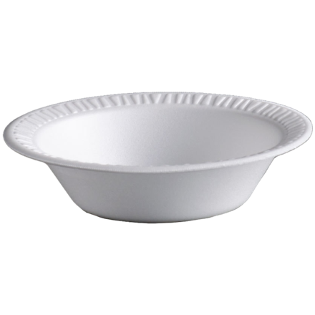

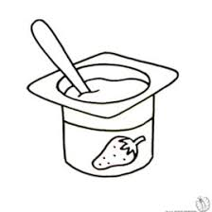

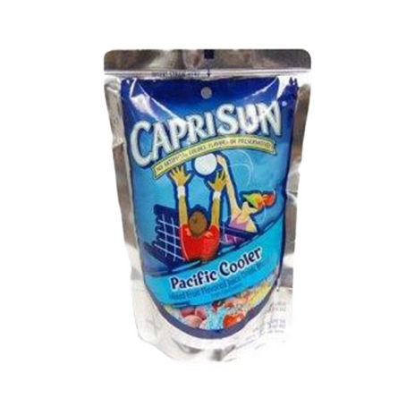

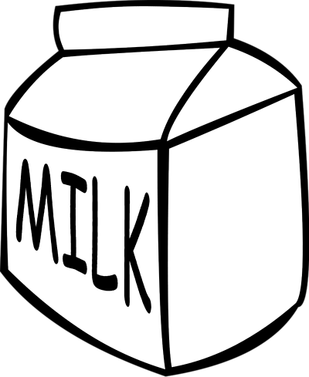
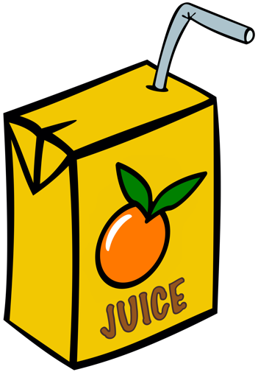
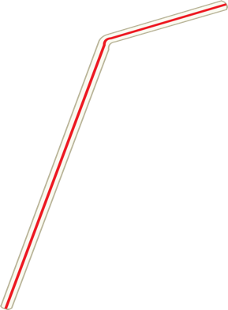

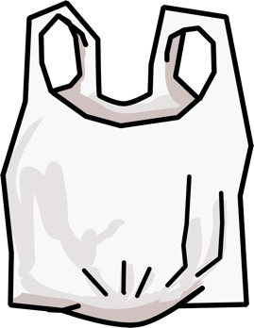

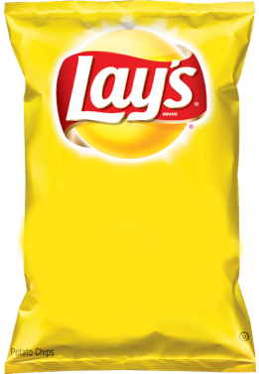

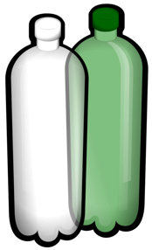

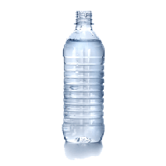

Sources:
Styrofoam Bowl: http://www.pak-man.com/3-1-2-oz-white-foam-bowls.html
Plastic Bottle: https://www.kisscc0.com/clipart/plastic-bag-fizzy-drinks-plastic-bottle-water-bott-3v81ct/
Plastic Bag: https://openclipart.org/detail/303136/plastic-shopping-bag
Capris Sun: https://yocartdelivery.com/products/capri-sun-pacific-cooler-6oz
Milk Carton: http://worldartsme.com/milk-carton-clipart.html#gal_post_15960_milk-carton-clipart-1.jpg
Yogurt: http://clipartmag.com/yogurt-clipart-black-and-white
Straw: https://unixtitan.net/explore/straw-clipart-png/
Water Bottle: http://pluspng.com/plastic-bottles-png-170.html
Orange Juice: https://openclipart.org/detail/303164/orange-juice-box-drink

