Background - What does the teacher need to know before teaching this lesson?
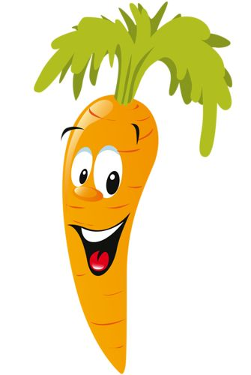
What is food and why do we need food?
Food is any substance consumed to provide nutritional support for the body. It usually comes from plants or animals and contains essential nutrients, such as vitamins, minerals, water, fat, carbohydrates, fiber, and protein. The substance is ingested by an organism and assimilated by the organism's cells to provide energy, maintain life, or stimulate growth. Simply put, food fuels the human body.

Where does food come from?
In general food comes from farms, but most of the food people eat today has been processed in factories. The only way we can know what there is in our food is to look at the list of ingredients placed on the label.

What is a healthy diet?
A healthy diet is a diet based on bread, rice, potatoes, pasta and other starchy foods and is rich in fruits and vegetables. A healthy diet will include moderate amounts of milk and dairy foods, meat, fish, eggs, beans and other non-dairy sources of protein, and limited amounts of foods and drinks high in fat and/or sugar. No single food can provide all the essential nutrients that the body needs. Therefore, it is important to consume a wide variety of foods to provide adequate intakes of vitamins, minerals and dietary fiber, which are important for health.

What are honeybees?
All honeybees are social and cooperative insects. A hive's inhabitants are generally divided into three types.
- Workers are the only bees that most people ever see. These bees are females that are not sexually developed. Workers forage for food (pollen and nectar from flowers), build and protect the hive, clean, circulate air by beating their wings, and perform many other societal functions.
- The queen's job is simple—laying the eggs that will spawn the hive's next generation of bees. There is usually only a single queen in a hive. If the queen dies, workers will create a new queen by feeding one of the worker females a special diet of a food called "royal jelly." This elixir enables the worker to develop into a fertile queen. Queens also regulate the hive's activities by producing chemicals that guide the behavior of the other bees.
- Male bees are called drones—the third class of honeybee. Several hundred drones live in each hive during the spring and summer, but they are expelled for the winter months when the hive goes into a lean survival mode.
Bees live on stored honey and pollen all winter, and cluster into a ball to conserve warmth. Larvae are fed from the stores during this season and, by spring, the hive is swarming with a new generation of bees

Why are honeybees important?,7
Bees pollinate a third of everything we eat and play a vital role in sustaining the planet’s ecosystems. Some 80% of the crops grown for human consumption – around 400 different types of plants – need bees and other insects to pollinate them to increase their yields and quality. These include most fruits and vegetables, many nuts, and plants such as rapeseed and sunflowers that are turned into oil, as well as cocoa beans, coffee and tea. Crops grown as fodder for dairy cows and other livestock are also pollinated by bees. And it’s not only food crops that rely on bee pollination, cotton does as well. As a result, annual US crop pollination by bees is estimated to be worth $15bn.

But beyond their monetary value for maintaining our fragile food supply, bees also make an invaluable contribution to ecosystems around the world. Seeds, fruits and berries eaten by birds and small mammals are all from plants that are pollinated by bees, making them guardians of the food chain and the biodiversity of our species.

Bees are industrious pollinators because they have co-evolved with flowering plants over millions of years. The bees need the flowers for food, while the flower needs the bee to reproduce. Unlike other insects, nectar and pollen from flowering plants are bees’ only food source; the sweet nectar drink gives adult bees energy. Pollen is protein-rich baby food.

In the process of foraging for food, bees are designed to pollinate. If you watch a female honeybee or bumblebee on a flower, you will see she has balls of pollen on her back legs. These are collected in her pollen baskets which she takes back to the nest to feed the young after fertilizing the flowers. For solitary bees, the pollen collects on the hairs on their abdomen.

What is pollination?
Pollination is the act of transferring pollen grains from the male anther of a flower to the female stigma. The goal of every living organism, including plants, is to create offspring for the next generation. One of the ways that plants can produce offspring is by making seeds. Seeds contain the genetic information to produce a new plant.

How do bees pollinate?
Quite simply, the bee gets covered in pollen, from the male part of the flower (the stamen), and deposit the grains on the female part (the stigma) of the next flower that they visit. Luckily for the plant, bees tend to visit flowers from the same plant when they are flowering rather than flit from one plant to another, so the plant is able to have sex. Once the pollen is on the stigma it moves down into the ovary where it fertilizes and forms a seed. A few months later the seed grows into a fruit or vegetable. Think of an apple tree; it blossoms, is visited by bees, produces apples later in the summer containing pips (the seeds), which if planted could slowly grow into a new apple tree.

Are honeybees in trouble?
Many countries around the world have documented a great decline in the number of bee populations including China, Brazil, North America, and Europe. The reasons of such troubling decline is not really known but pesticides (e.g.,Imidacloprid), poor nutrition, viruses, parasite varroa mite, and stress are often mentioned as the likely causes.

How can we help save the bees?
- Consider beekeeping as a worthwhile hobby and seek information to get started. The more beekeepers there are, translates into more voices being heard.
- Support local beekeepers by buying locally produced honey and other beehive products. Honey is the best "green" sweetener you can buy.
- Attend and support beekeeper association events held in places throughout the year in most communities such as environmental centers, schools, and state parks.
- Educate yourself on the dangers and risks with homeowner pesticides and chemicals. Whenever possible, choose non-damaging and non-chemical treatments in and around the home. Most garden and backyard pests can be dealt with without harsh chemicals, which many times are nit healthy for the pets, the kids, or the environment.
- Get to know the honey bee. Unlike other stinging insects, honey bees are manageable, and are non-aggressive. Don't blame every stinging event on the honey bees. Many times, stinging events are from hornets, yellow jackets, and wasps.
- Plant a bee friendly garden with native and nectar producing flowers. Use plants that can grow without extra water and chemicals. Native plants are the best to grow in any region. Backyard gardens benefit from the neighborhood beehive.
- Understand that backyard plants such as dandelions and clover are pollen and nectar sources for a wide variety of beneficial insects, including the honey bee. Dandelions and clover are a unwarranted nuisance for many homeowners. The desire to rid yards of these unwanted plants and have the "perfect" yard, are sources for chemical runoff and environmental damage from lawn treatments. A perfect lawn is not worth poisoning the earth.

Further readings
From the Farm to Your Table: Where Does Our Food Come From?: http://www.yale.edu/ynhti/curriculum/units/1997/7/97.07.07.x.html
Teaching the food system: http://foodspanlearning.org/
About Honeybees: http://www.honeybeecentre.com/learn-about-honeybees#.Vzl08eTmDIU

Standards - What standards are being met by teaching this lesson?
- K-12 Integrated Environmental and Sustainability Learning Standards (See Appendix Table 1)
- California Education and the Environment Initiative (See Appendix Table 2)
- Next Generation Science Standards (See Appendix Table 3)
- Common Core State Standards (See Appendix Table 4)

Necessary Supplies- What supplies will you need to teach the class?
- Handouts [attached]
- Whiteboard/Chalkboard with writing implement
- Pollination Activity Handouts (1 bee and 1 flower per student)
- Markers, crayons, scissors
- Colored chalk
- Q-tips or cotton swabs
- Masking tape
- Projector
- PowerPoint
- Internet/YouTube video

Do It Now - (Written on board/projector) What quick independent activity will students engage in as soon as they arrive in class that will review past learning or preview the day’s learning? (5-10 minutes)
Give “Do It Now: Food dependent on pollination from honeybees” activity handout to each of the students. Ask the students to circle the foods they think depend on bees to grow. Project images of the products (PowerPoint slides attached)

Objective for the Day– (Written on board/projector) What skill are you going to teach and what should the students be able to do by the end of the class to demonstrate what they have learned?
Today you will learn …
- What pollination is and why plants need it
- The anatomy of honey bee
- Why bees are very important to the foods we eat

Keywords:
Honey Bee
Plant
Pollen
Pollination

Purpose – Why is it important for students to learn this skill? Explain why today’s lesson matters.
The purpose of this lesson is to learn the importance of bees in our every day life and for the food we eat!

Teaching the Skill – How will you teach this skill to students? What will the examples and the modeling look like? How will you ensure that all students are actively participating in the lesson?
Step 1: | WHAT’S THE BUZZ ON BEES?  Which food depends on bees? (5-10 minutes)  Go over the “Do It Now” activity handout as a class. Ask the students which foods they think are affected by bees and which are not. What products are the students certain are affected by bees? Why are they certain?  Also ask which products the students are sure are not affected by bees. Why are they certain?  After the discussion, tell the students that all of the foods/products listed are directly affected by honeybees! In fact, 1/3 of all the food we eat is affected by honeybees!
Step 2: | How do bees affect all of that food? (5 minutes)  Bees are part of an important process called pollination. Pollination occurs when the pollen from flowers is moved within flowers or is exchanged between different flowers. Pollination allows flowers to be fertilized, develop seeds and produce fruits.  Bees help move the pollen between different flowers, allowing our food to grow!
Step 3: | Bee’s body parts and pollination (5-10 minutes)  Bees are specially equipped to take part in pollination. Bees, and all insects, have three main body sections: head, thorax, and abdomen, as well as 6 legs!  Draw a sketch of a bee on the board and label the parts as you discuss them. Ideally, you would draw the parts as you go: draw three circles attached to each other, representing the head, thorax, and abdomen. Then add 6 feet coming off the thorax. (Or you could display the attached image)  What other body parts do honeybees have that humans also have? They have eyes! Honeybees have eyes that are special so that they can find flowers. They have both simple eyes and complex eyes. Their simple eyes are just like ours, but their complex eyes work differently. Bees use sensors in their complex eyes to sense changes in light and color. Their eyes are specialized to find flowers that are ready for pollination.  Bees also have two sets of wings on their thorax, which help them fly around to find flowers! Bees eat the nectar from the flowers using a special tongue called a proboscis. When the bee is eating the nectar from the flower, pollination happens! Pollen sticks to the bee while it is eating. Then, the bee "combs" or cleans itself. When the bee does this, it puts the pollen into pollen baskets on their back legs! When it goes to the next flower, some of this pollen come off onto the new flower, allowing pollination to occur!  Bees also have stingers that they use to protect themselves when they feel threatened.  You could give the handout to the students so they can write in the anatomy of bee as you draw a bee on the board.
Step 4: | Plants and pollination (5-10 minutes)  Plants also have specialized parts to assist in pollination – they contain the pollen needed for pollination. What else do you think that plants have that help the process of pollination?  Their bright, beautiful colors and their nice smell attract honey bees.  Plants also have specialized organs to help with pollination. On the board, draw a flower. (Or you could display the attached image) There is a large rounded bulb at the top of the flower that is called the stigma. The stigma is sticky so that when a honeybee lands near it, the pollen stuck to the bee sticks to the stigma, causing pollination to occur! At the bottom of the flower is the ovary. The ovary protects the ovule, which is what is fertilized through pollination and will become the fruit from the plant. Around the stigma is the stamen. The stamen has two parts: the filaments and the anthers. The filaments are tall stalks that hold up the anthers around the stigma. The anthers are the part of the stamen that contains the pollen.  You could give the handout to the students so they can write in the anatomy as you draw it on the board.  **Do the Pollination Activity – Instructions in the Handout (from https://www.slideshare.net/fldpi/buzz-on-bees-lesson-plan)
Step 5: | Are honeybees the only insects that pollinate? (5 minutes)  No! Actually, there are many different types of bees, butterflies, and bats that can partake in pollination. Even birds can help pollinate plants. All of these different organisms contribute to the ecosystem and to how our food grows! However, many plants need honey bees in order to be pollinated - these other pollinators can't do the job because of the way the flower is shaped!
Step 6: | Why are bees in danger? (5 minutes)  Right now, bees are in trouble! The population of bees has been declining over the past decade and scientists are trying to find out why this is happening. Some scientists think it is because plants from different places are being brought around the world; the bees don’t know these plants and can’t get food from them!
Step 7: | How we can do to help honey bees? (5-10 minutes)  As a class, brainstorm ideas of how to promote bee populations and pollination! Some ideas could be: Grow plants that bees like, be courteous to bees, etc.
Step 8: | “Why do we Need Bees?” by Earth Rangers (3:32 min)  Watch the video https://www.youtube.com/watch?v=6CxCTyxRFh0  *Optional  If it is the proper season, go outside with the students to observe bees pollinating flowers.  Check for bee allergies before doing this!! Remind students to be courteous to bees and that if they feel threatened, they can sting – even though they don't want to sting you! Ask the students to look for the pollen baskets on the bees' back legs and look at the flowers themselves to see where the pollen is on the anthers of the flower.

Closure – Discuss the day’s activity and lesson plan with the class. (5-10 minutes)
Ask students to complete the Bee anatomy worksheet and Flower anatomy worksheet. (Attached)

*Optional
As a class, plant a native plant that requires pollination in an area that is close to your classroom (maybe outside your window if possible), but not near the playground. Talk to your local gardening store for plant suggestions. Then, have the students monitor when bees come - this way they can see pollination in action!

Homework– An activity for the students to take home and perform. Optional: Have the students return the next day with proof of completion of the activity.
Have the students keep a food journal for a week. At the end of the week, ask them to research which of the foods they ate came from plants that were pollinated by bees! For one of the foods, have the students find a picture of the flower that was pollinated in order to create that food.

Appendix of Tables

Appendix Table 1: K-12 Integrated Environmental and Sustainability Learning Standards

Standard 1: Ecological, Social, and Economic Systems
- Students develop knowledge of the interconnections and interdependency of ecological, social and economic systems. They demonstrate understanding of how the health of these systems determines the sustainability of natural and human communities at local, regional, national, and global levels.
Standard 2: The Natural and Build Environment
- Students engage in inquiry and systems thinking and use information gained through learning experiences in, about, and for the environment to understand the structure, components, and processes of natural and human-built environments.
Standard 3: Sustainability and Civic Responsibility
- Students develop and apply the knowledge, perspective, vision, skills, and habits of mind necessary to make personal and collective decisions and take actions that promote sustainability.

Appendix Table 2: California Education and the Environment Initiative

Principle I: People Depend on Natural Systems
- The continuation and health of individual human lives and of human communities and societies depend on the health of the natural systems that provide essential goods and ecosystem services.
Concept A: Students need to know that the goods produced by natural systems are essential to human life and to the functioning of our economies and cultures. | Concept C: Students need to know that the quality, quantity, and reliability of the goods and ecosystem services provided by natural systems are directly affected by the health of those systems.
Principle II: People Influence Natural Systems
- The long-term functioning and health of terrestrial, freshwater, coastal, and marine ecosystems are influenced by their relationships with human societies.
Concept B: Students need to know that methods used to extract, harvest, transport, and consume natural resources influence the geographic extent, composition, biological diversity, and viability of natural systems.
Principle III: Natural Systems Change in Ways that People Benefit from and can Influence
- Natural systems proceed through cycles that humans depend upon, benefit from, and can alter.
Concept C: Students need to know that human practices can alter the cycles and processes that operate within natural systems.
Principle IV: There are no Permanent or Impermeable Boundaries that Prevent Matter from Flowing Between Systems
- The exchange of matter between natural systems and human societies affects the long-term functioning of both.
Concept A: Students need to know that the effects of human activities on natural systems are directly related to the quantities of resources consumed and to the quantity and characteristics of the resulting byproducts.

Appendix Table 3: Next Generation Science Standards

Biological Evolution: Unity and Diversity
- 3-LS4-4: Make a claim about the merit of a solution to a problem caused when the environment changes and the types of plants and animals that live there may change
Science and Engineering Practices | Disciplinary Core Ideas | Crosscutting Concepts
Engaging in Argument from Evidence: Engaging in argument from evidence in 3–5 builds on K–2 experiences and progresses to critiquing the scientific explanations or solutions proposed by peers by citing relevant evidence about the natural and designed world(s).  Make a claim about the merit of a solution to a problem by citing relevant evidence about how it meets the criteria and constraints of the problem. | LS2.C: Ecosystem Dynamics, Functioning, and Resilience: When the environment changes in ways that affect a place’s physical characteristics, temperature, or availability of resources, some organisms survive and reproduce, others move to new locations, yet others move into the transformed environment, and some die. (secondary)  LS4.D: Biodiversity and Humans: Populations live in a variety of habitats, and change in those habitats affects the organisms living there. | Systems and System Models: A system can be described in terms of its components and their interactions.  Interdependence of Engineering, Technology, and Science on Society and the Natural World: Knowledge of relevant scientific concepts and research findings is important in engineering.
Ecosystems: Interactions, Energy, and Dynamics
- 3-LS2-1: Construct an argument that some animals form groups that help members survive.
Science and Engineering Practices | Disciplinary Core Ideas | Crosscutting Concepts
Engaging in Argument from Evidence: Engaging in argument from evidence in 3–5 builds on K–2 experiences and progresses to critiquing the scientific explanations or solutions proposed by peers by citing relevant evidence about the natural and designed world(s).  Construct an argument with evidence, data, and/or a model. | LS2.D: Social Interactions and Group Behavior: Being part of a group helps animals obtain food, defend themselves, and cope with changes. Groups may serve different functions and vary dramatically in size (Note: Moved from K–2). | Cause and Effect: Cause and effect relationships are routinely identified and used to explain change.
Earth and Human Activity
- 5-ESS3-1: Obtain and combine information about ways individual communities use science ideas to protect the Earth’s resources and environment.
Science and Engineering Practices | Disciplinary Core Ideas | Crosscutting Concepts
Obtaining, Evaluating, and Communicating Information: Obtain and combine information from books and other reliable media to explain phenomena. | ESS3.C: Human Impacts on Earth Systems: Human activities in agriculture, industry, and everyday life have had major effects on the land, vegetation, streams, ocean, air, and even outer space. But individuals and communities are doing things to help protect Earth’s resources and environments. | Systems and System Models: A system can be described in terms of its components and their interactions.  Connections to Nature of Science: Science findings are limited to questions that can be answered with empirical evidence.

Appendix Table 4: Common Core State Standards

Mathematics
Mathematical Practices
Reason abstractly and quantitatively
- CCSS.Math.Practice.MP2: Mathematically proficient students make sense of quantities and their relationships in problem situations.
Model with mathematics
- CCSS.Math.Practice.MP4: Mathematically proficient students can apply the mathematics they know to solve problems arising in everyday life, society, and the workplace.
English Language Arts
Reading: Informational Text
Key Ideas and Details
- CCSS.ELA-Literacy.RI.4.3: Explain events, procedures, ideas, or concepts in a historical, scientific, or technical text, including what happened and why, based on specific information in the text.
Writing
Text Types and Purposes
- CCSS.ELA-Literacy.W.4.2: Write informative/explanatory texts to examine a topic and convey ideas and information clearly.
Research to Build and Present Knowledge
- CCSS.ELA-Literacy.W.4.7: Conduct short research projects that build knowledge through investigation of different aspects of a topic.
Speaking and Listening
Comprehension and Collaboration
- CCSS.ELA-Literacy.SL.4.3: Identify the reasons and evidence a speaker provides to support particular points.
Presentation of Knowledge and Ideas
- CCSS.ELA-Literacy.SL.4.4: Report on a topic or text, tell a story, or recount an experience in an organized manner, using appropriate facts and relevant, descriptive details to support main ideas or themes; speak clearly at an understandable pace.

Do It Now: Food dependent on pollination from honeybees

Circle which of these foods and other agricultural products depend on honey bees?

Kiwi
Onion
Celery
Beet
Broccoli
Cauliflower
Cabbage
Papaya
Honey
Watermelon
Coconut
Cucumber
Cantaloupe
Lemon
Strawberry
Cotton
Apple
Mango
Avocado
Kidney beans
Apricot
Almond
Plum
Peach
Raspberry
Blueberry

Pollination Activity Page 1 of 3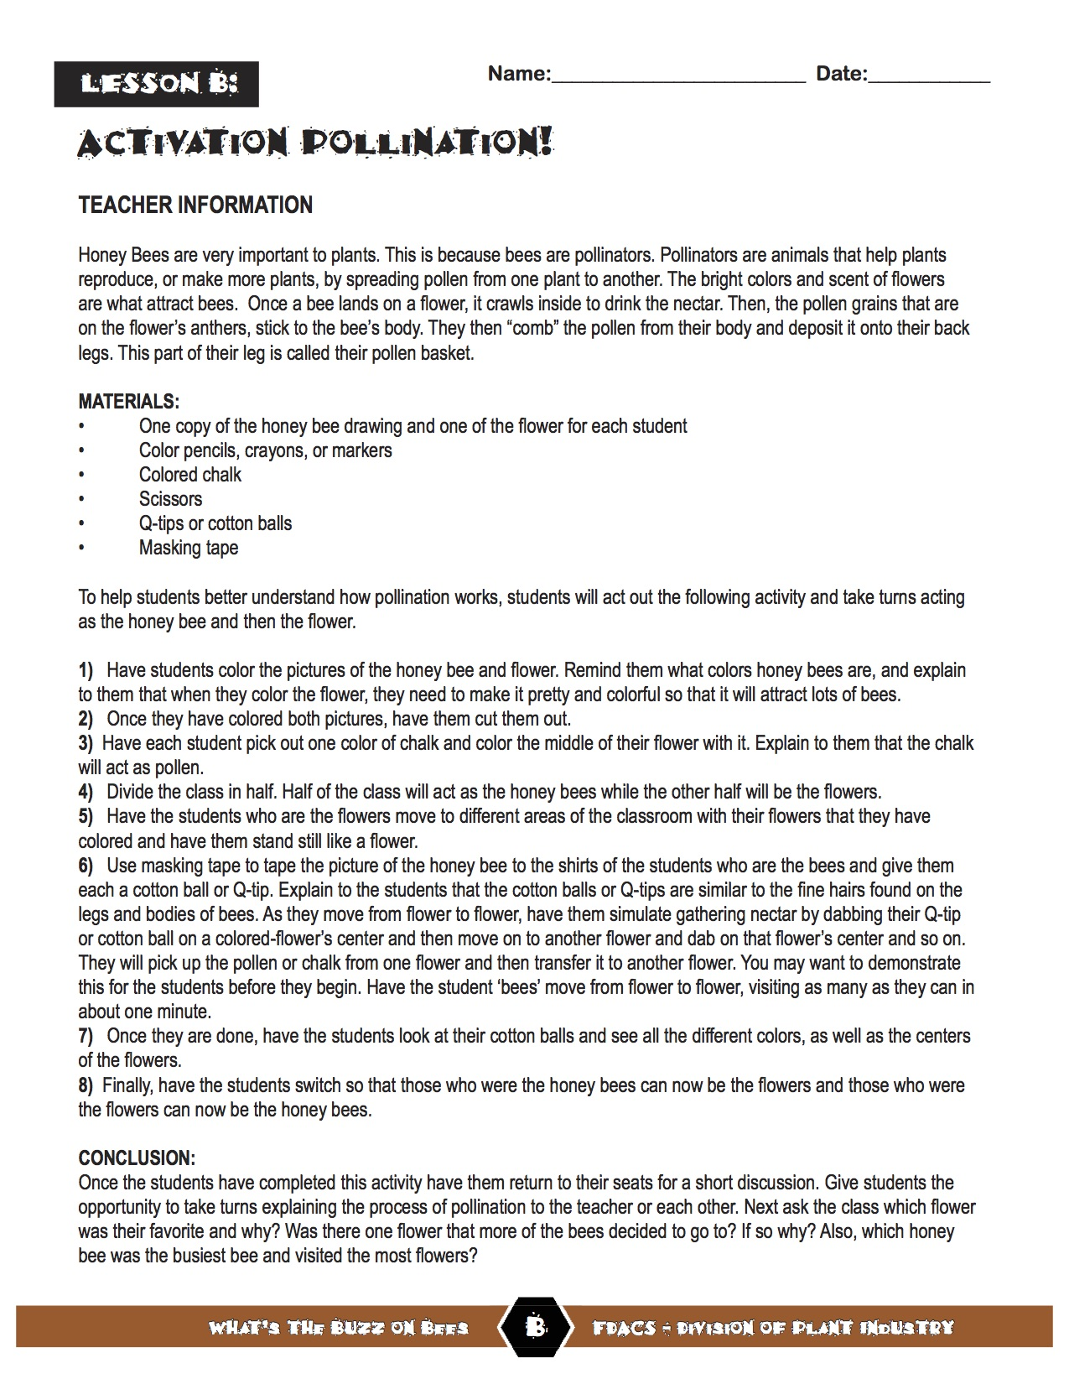
Pollination Activity Page 2 of 3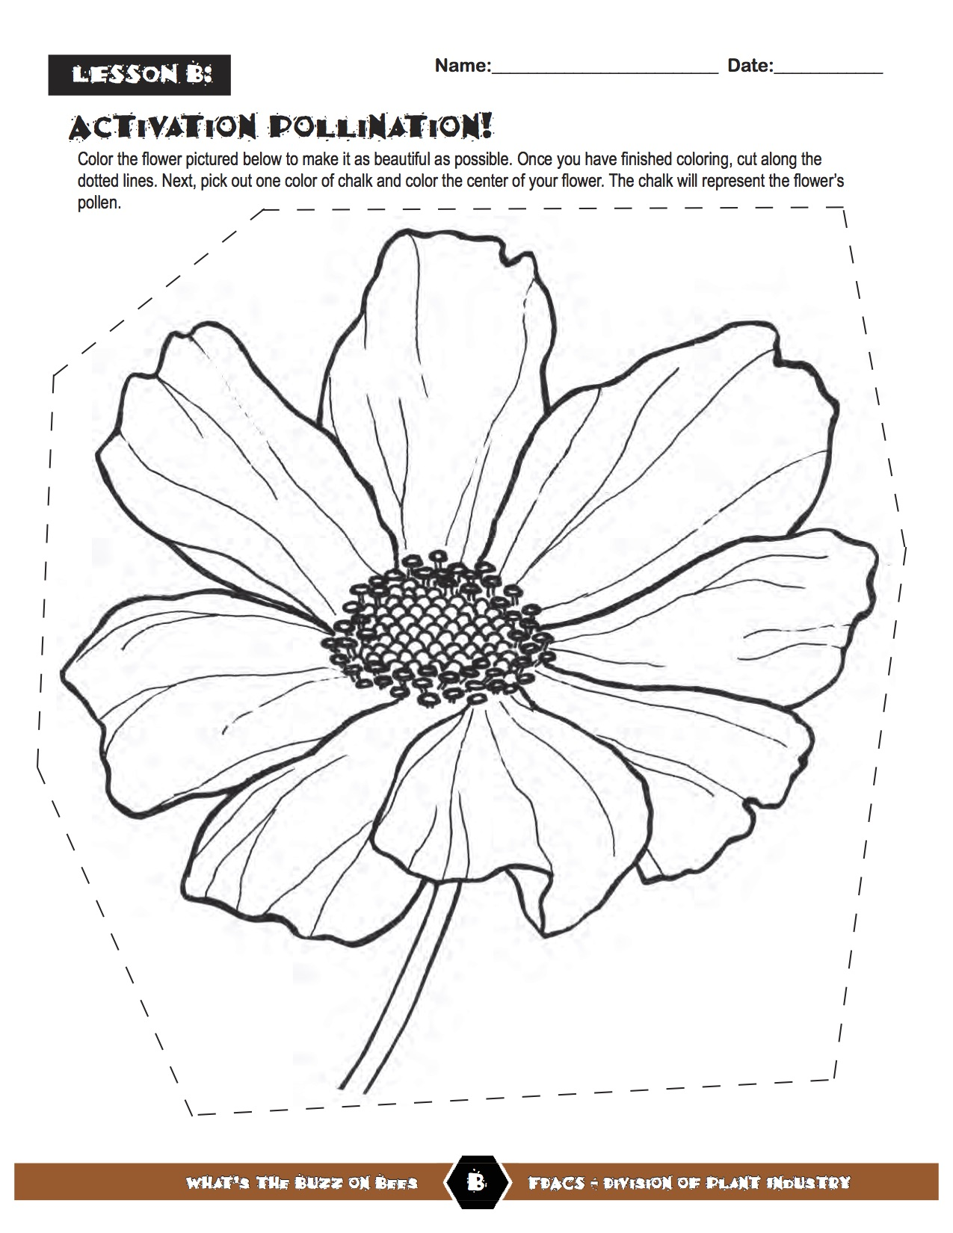
Pollination Activity Page 3 of 3
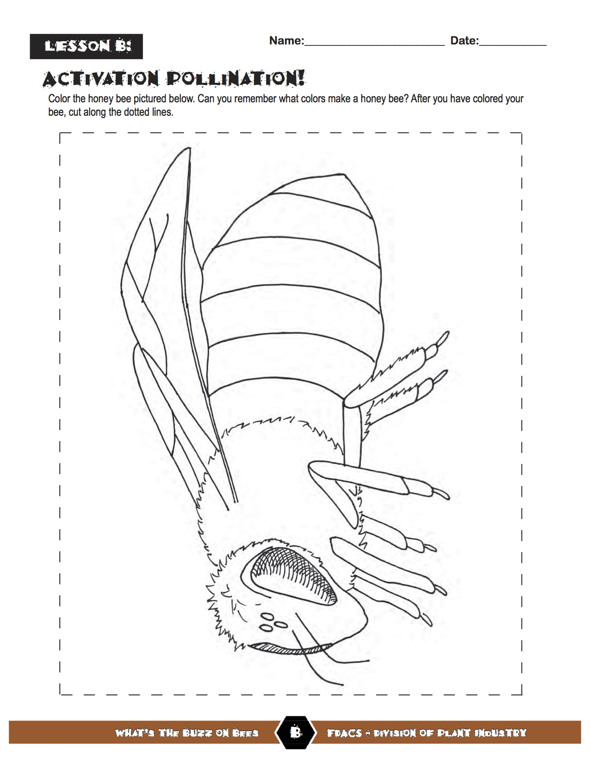
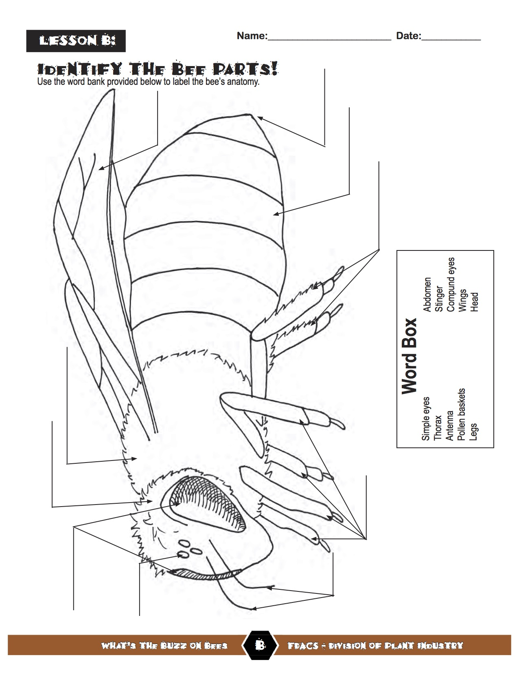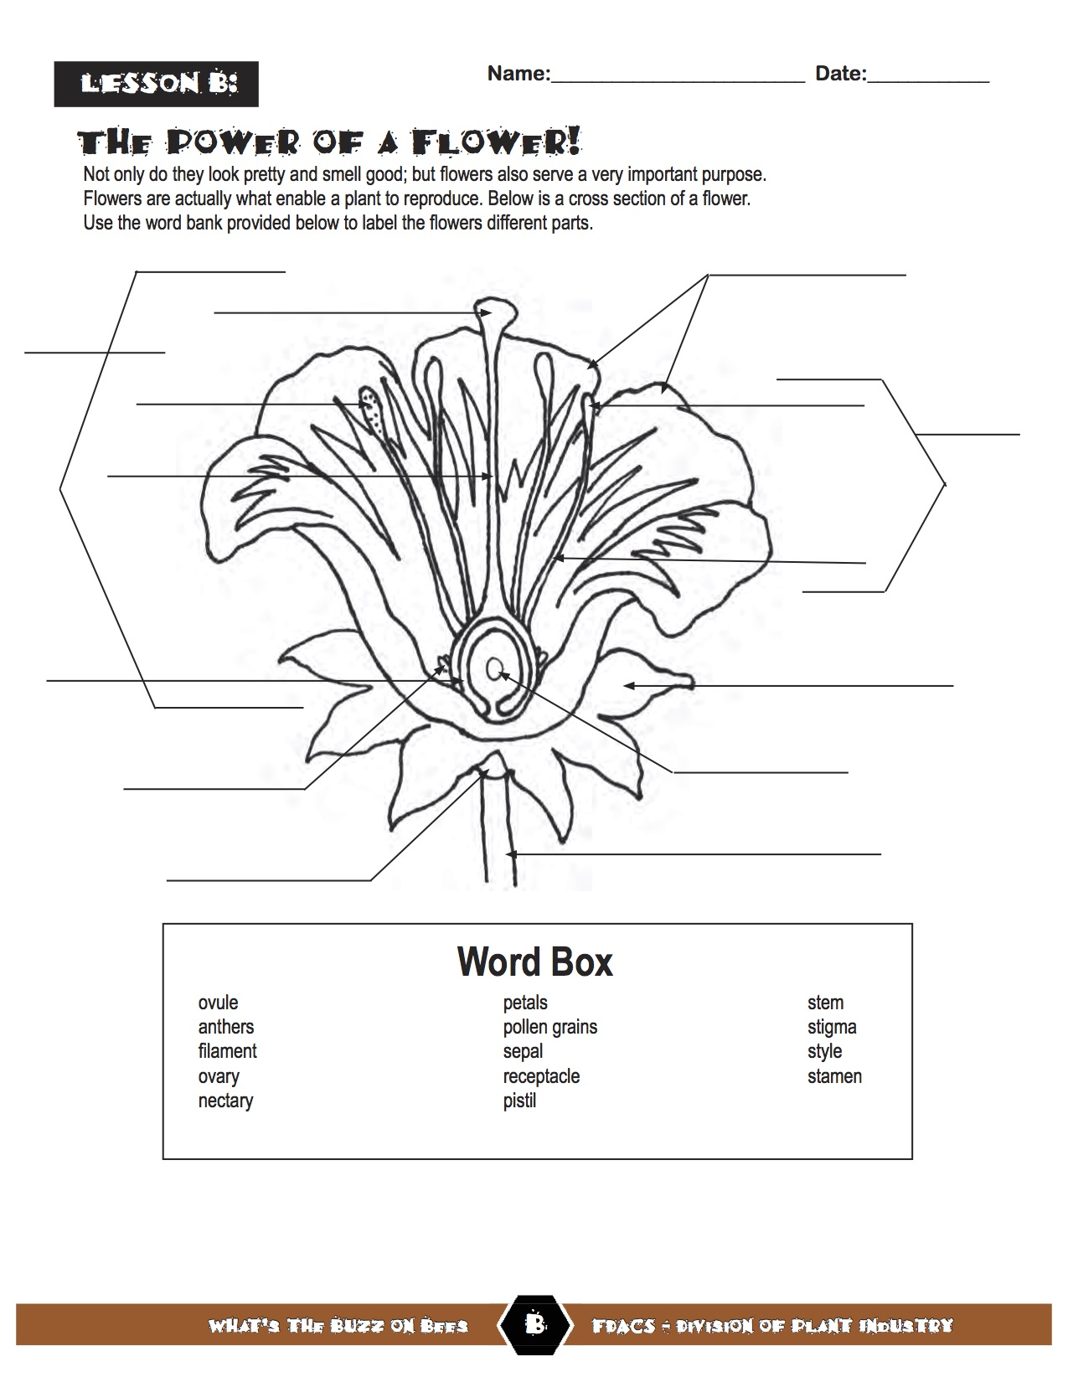
Answer Key: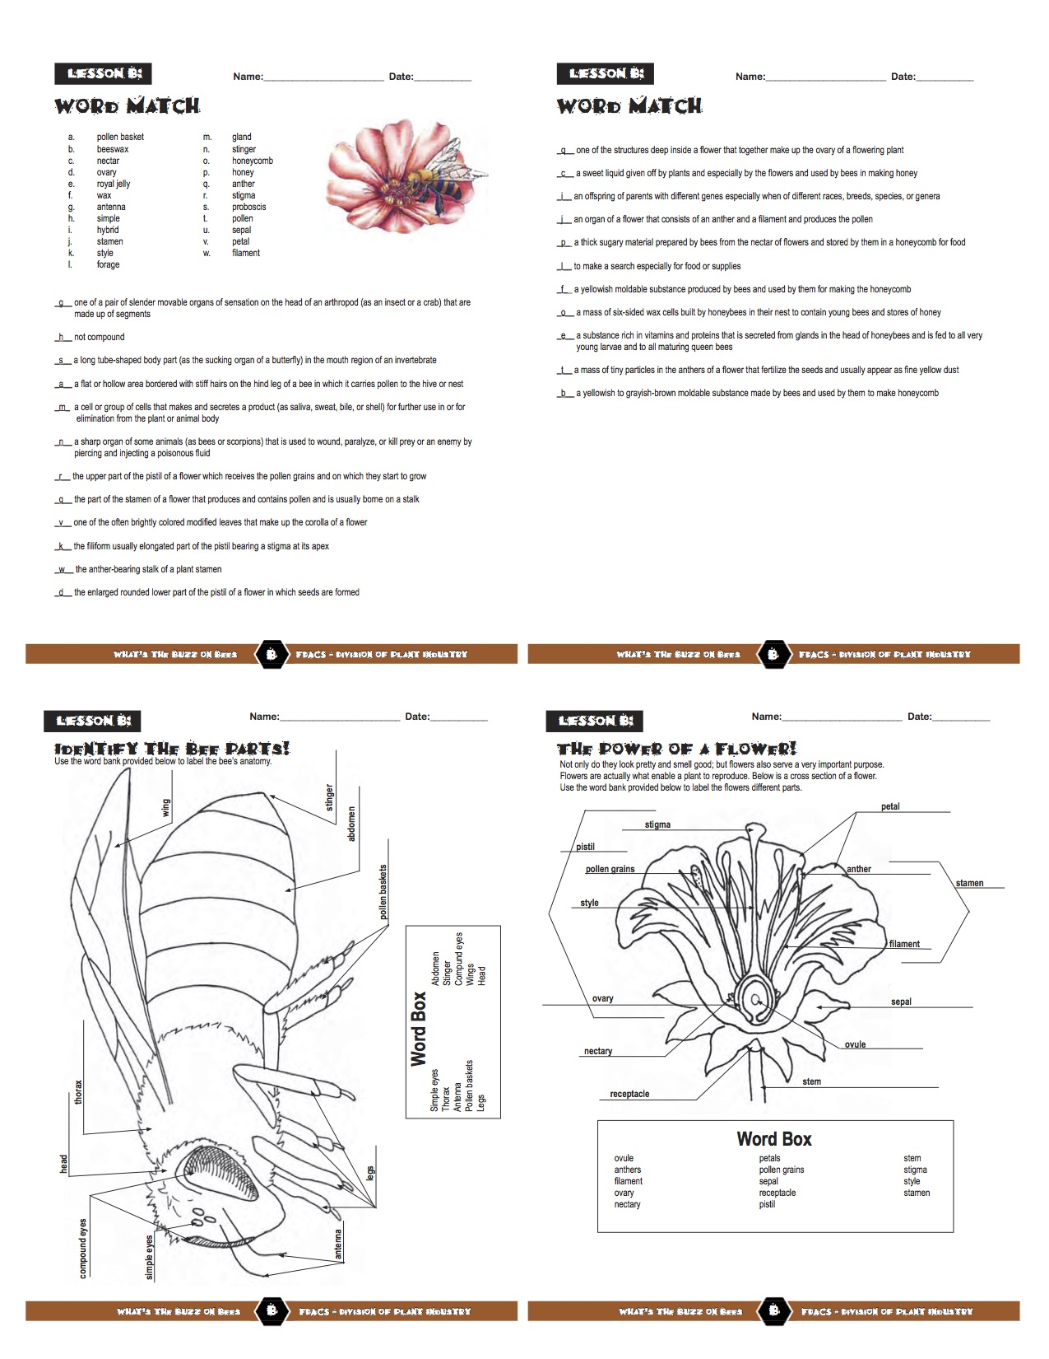

http://apjcn.nhri.org.tw/server/info/books-phds/books/foodfacts/html/maintext/main2a.html
http://teachersinstitute.yale.edu/curriculum/units/1997/7/97.07.07.x.html
http://www.who.int/mediacentre/factsheets/fs394/en/
http://animals.nationalgeographic.com/animals/bugs/honeybee/
https://www.nature.org/ourinitiatives/regions/northamerica/unitedstates/indiana/journeywithnature/bees-agriculture.xml
http://www.fs.fed.us/wildflowers/pollinators/What_is_Pollination/
https://www.canr.msu.edu/nativeplants/pollination/
http://www.endangeredspeciesinternational.org/insects6.ht
http://www.nationalhoneybeeday.com/helpthebees.html
Florida Department of Agriculture and Consumer Services http://faitc.org/whats-the-buzz-on-bees/
Adopted from Busy Bee lesson plans from the Florida Department of Agriculture and Consumer Services http://faitc.org/wp-content/uploads/2013/09/Bissy-Bee-Lesson-Plan-Appendices-updated-2013.pdf

