

Air Quality Modeling Assessment Tools (AQMAT) Development
User’s Manual for Software for Model Attainment Test – Community Edition (SMAT-CE) 2.1

Contract No: 68HERD21A0002
Task Order No: 68HERH21F0334
Version: 01

Prepared for: Carey Jang
Task Order Contracting Officer’s Representative
U.S. EPA/OAR/OAQPS/AQAD/AQMG
(Mail Code: C439-01)
109 T.W. Alexander Drive
Research Triangle Park, NC 27711

Prepared by: Yun Zhu, Shicheng Long
College of Environment & Energy
South China University of Technology
Guangzhou, 510006, Guangdong, China

Sarav Arunachalam
Institute for the Environment
The University of North Carolina at Chapel Hill

Date: December 31, 2022
Acknowledgements
User’s Manual for SMAT-CE 2.1 EPA Task Order: 68HERH21F0334

In cooperation with the U.S. EPA, the Institute for the Environment at the University of North Carolina at Chapel Hill (UNC-IE) along with the South China University of Technology (SCUT) developed the FAST-CE software. This project was funded by the U.S. EPA under contract 68HERH21F0334 to UNC-IE.

UNC Institute for the Environment i December 31, 2022

SMAT-CE User’s Guide Contents
List of Figures iv
List of Tables vi
1 Introduction 1
2 Quick Start 2
2.1 Install Software 2
2.2 Start SMAT-CE 2
2.3 Load a Previous Project 3
2.4 Annual PM Analysis Quick Start 3
2.5 Daily PM Analysis Quick Start 7
2.6 Ozone Analysis Quick Start 10
2.7 Visibility Analysis Quick Start 13
3 SMAT-CE Installation 17
4 SMAT-CE Start Page 19
5 Running SMAT-CE 22
5.1 Load Previous SMAT-CE Project 22
5.2 New SMAT-CE Analysis 22
5.3 Running SMAT-CE in Batch Mode 23
6 Annual PM Analysis 25
6.1 Choose Desired Output 27
6.2 Output Choices-Advanced 30
6.3 Data Input 33
6.4 Species Fraction Options 36
6.5 PM_{2.5} Calculation Options 40
6.6 Model Data Options 43
7 Daily PM Analysis 46
7.1 Choose Desired Output 48
7.2 Output Choices–Advanced 51
7.3 Data Input 53
7.4 Species Fraction Options 56
7.5 PM_{2.5} Calculation Options 61
7.6 Model Data Options 63
8 Ozone Analysis 67
8.1 Desired Output 69
8.2 Data Input 74
8.3 Filtering/Interpolation 78
8.4 RRF/Spatial Gradient 80
9 Visibility Analysis 86
9.1 Choose Desired Output 88
9.2 Data Input 102
9.3 Filtering 110
10 The SMAT-CE Data Viewer 114
10.1 Starting the Data Viewer 114
10.2 Starting an Analysis Session 115
10.3 Creating Data Displays 117
10.4 GIS Window 119
10.5 Map Window 122
10.6 Data Table Display 125
10.7 Chart Display 127
10.8 The SMAT-CE Configuration File 130
10.9 Exporting Data from SMAT-CE 131
11 Getting Help 133
12 References 134

List of Figures
Figure 3-1 . SMAT-CE installation window 18
Figure 4-1 . SMAT-CE start page window 20
Figure 4-2 . SMAT-CE About window 20
Figure 4-3 . SMAT-CE development log window 21
Figure 5-1 . SMAT-CE batch script 24
Figure 6-1 . Annual PM Analysis initial window 26
Figure 6-2 . Choose Desired Output for Annual PM_{2.5} Analysis 27
Figure 6-3 . Output Choices-Advanced for Annual PM_{2.5} Analysis 30
Figure 6-4 . Data Input for Annual PM_{2.5} Analysis 33
Figure 6-5 . Species Fraction Options for Annual PM_{2.5} Analysis 36
Figure 6-6 . PM_{2.5} Calculation Options for Annual PM_{2.5} Analysis 40
Figure 6-7 . Model Data Options for Annual PM_{2.5} Analysis 43
Figure 6-8 . Annual PM_{2.5} Analysis run status 44
Figure 6-9 . Annual PM Analysis Data Viewer 45
Figure 7-1 . Daily PM Analysis initial window 47
Figure 7-2 . Choose Desired Output for Daily PM_{2.5} Analysis 48
Figure 7-3 .Output Choices-Advanced for Daily PM_{2.5} Analysis 51
Figure 7-4 . Data Input for Daily PM_{2.5} Analysis 53
Figure 7-5 . Species Fraction Options for Daily PM_{2.5} Analysis 56
Figure 7-6 . PM_{2.5} Calculation Options for Daily PM_{2.5} Analysis 61
Figure 7-7 . Model Data Options for Daily PM_{2.5} Analysis 63
Figure 7-8 . Daily PM2.5 Analysis run status 65
Figure 7-9 . Daily PM Analysis Data Viewer 66
Figure 8-1 . Ozone Analysis initial window 68
Figure 8-2 . Choose Desired Output for Ozone Analysis 69
Figure 8-3 . Data Input for Ozone Analysis 74
Figure 8-4 . Filtering/Interpolation for Ozone Analysis 78
Figure 8-5 . Ozone Analysis run status 84
Figure 8-6 .Ozone Analysis data viewer 85
Figure 9-1 . Visibility Analysis initial window 87
Figure 9-2 . Choose Desired Output for Visibility Analysis 88
Figure 9-2 . Calculation Data Example 93
Figure 9-3 . Data Input for Visibility Analysis 102
Figure 9-4 Format for Daily PM Model Data 105
Figure 9-5 Example for forecast IMPROVE daily visibility file 107
Figure 9-6 . Example for File Linking IMPROVE Monitors and Class I Areas 109
Figure 9-7 . Filtering for Visibility Analysis 110
Figure 9-8 . Visibility Analysis run status 112
Figure 9-9 . Visibility Analysis data viewer 113
Figure 10-1 . SMAT-CE Data Viewer 114
Figure 10-2 . Data Viewer window with a completed project 115
Figure 10-3 . Log & Msg display window 116
Figure 10-4 . Configuration & Batch File display window. 117
Figure 10-5 . Output files right-click menu 118
Figure 10-6 . Output files GIS map view 118
Figure 10-7 . SMAT-CE GIS window 120
Figure 10-8 . GIS map right-click menu 121
Figure 10-9 . GIS window with highlighted map controls 122
Figure 10-10 . SMAT-CE map window 123
Figure 10-11 . Map window with right click menu 124
Figure 10-12 . Map window with highlighted map controls 125
Figure 10-13 . SMAT-CE Data table window 126
Figure 10-14 . Data window with highlighted configuration options 127
Figure 10-15 . SMAT-CE chart window 128
Figure 10-16 . Chart window with highlighted configuration options 129
Figure 10-17 . Viewing a SMAT-CE configuration file 130
Figure 10-18 . SMAT-CE Configuration File view 131

List of Tables
Table 3-1. SMAT-CE computing system recommendations. 17
Table 8-1. Ozone monitor data format 75
Table 8-2. Ozone modeling data format 76
Table 9-1 Variables and descriptions for Forecasted Visibility Data file 94
Table 9-2 Variables and descriptions for Class 1 Area and IMPROVE Monitor Identifiers and Locations 100
Table 9-3 Variables and descriptions for Base/Future/Delta Data 100
Table 9-5 Variables and descriptions for Daily PM Model Data file 106
Table 9-6 Variables and descriptions for forecast IMPROVE daily visibility file 107
Table 9-7 Variables and descriptions for File Linking IMPROVE Monitors and Class I Areas 109

Introduction
The Software of Model Attainment Test – Community Edition (SMAT-CE) is the next generation of Modeled Attainment Test Software (MATS). SMAT-CE implements modeled attainment tests for particulate matter (PM_{2.5}) and ozone (O₃) and performs the uniform rate of progress analysis for regional haze (visibility). The results from SMAT-CE can be used to provide scientific support for air pollution control strategies and decision making. Details of the modeled attainment tests formulated by the U.S. EPA and implemented in SMAT-CE are available in the Draft Modeling Guidance for Attainment of Air Quality Goals for Ozone, PM_{2.5}, and Regional Haze (US EPA, 2014).
This document provides instructions on how to use SMAT-CE to conduct modeled attainment tests for PM_{2.5} and ozone, and to perform the uniform rate of progress analysis for regional haze (visibility). In addition to a quick start guide, this document includes a description of the SMAT-CE interface, configuration options, and a step-by-step tutorial for using SMAT-CE, with sample data from the Eastern U.S.
This manual includes the following sections:
- Chapter 2. Quick Start Guide to quickly get users up and running
- Chapter 3. SMAT-CE installation
- Chapter 4. SMAT-CE User Interface
- Chapter 5. Start new analyses and load previously saved analyses
- Chapter 6. Annual PM_{2.5} attainment test details
- Chapter 7. Daily PM_{2.5} attainment test details
- Chapter 8. ozone attainment test details
- Chapter 9. Uniform rate of progress analysis for regional haze details
- Chapter 10. Using the SMAT-CE Data Viewer for analyzing results
- Chapter 11. Where to get help for using SMAT-CE

Quick Start
This chapter provides the steps required to install SMAT-CE and run it for various analyses. The Quick Start will use a pre-loaded Community Multiscale Air Quality (CMAQ) model tutorial data set to demonstrate how to run each of the SMAT-CE analysis modules. These steps will use the default SMAT-CE settings and do not describe the configuration settings for each analysis. For details of the configuration settings for the individual SMET-CE modules, refer to the User’s Guide chapter for each module.

Install Software
Details: User’s Guide Chapter 3
- Download the SMAT-CE Windows Setup.exe file from the ABaCAS website (http://abacas.see.scut.edu.cn/tools/). SMAT-CE runs on 32-bit and 64-bit Windows Operating Systems.
- Uninstall all previous versions of SMAT-CE.
- Install SMAT-CE by double-clicking the Setup.exe file. Follow the instructions to install the program to the default location on your computer.

Start SMAT-CE
Details: User’s Guide Chapter 4
- Double-click the SMAT-CE desktop icon or SMAT-CE.exe file to start the program.
- The SMAT-CE Start Page window will appear on your screen. There are five main modules available on the Start page: Process Data, Analyze/Visualize Data, Single Source Impact Analysis, BenMAP Benefit Module, and Support & Help. Note that the Single Source Impact Analysis and BenMAP Benefit Module functions are hidden by default. Users are allowed to enable these two modules from ‘Options’ under the ‘File’ drop-down list on the main screen.
- The Process Data module is on the left-hand panel of the SMAT-CE Start Page. This module allows users to either load a previous project or start a new model attainment test for annual PM_{2.5}, daily PM_{2.5}, ozone, or visibility.
- The Data Viewer is available through the Analyze/Visualize Data module on the lower left section of the SMAT-CE Start Page. The Data Viewer allows users to load results files (i.e., *.proj files) from completed SMAT-CE analyses and view these data in maps, tables, and charts; or export the data.
- The Single Source Impact Analysis is on the top of the right-hand panel of the SMAT-CE Start Page. This module is used to conduct single source PM_{2.5} and ozone air quality impact analyses using output from gridded, dispersion, or fused model data.
- The BenMAP Benefit Module is on the middle of the right-hand panel of the SMAT-CE Start Page. This module is used to estimate the health and economic benefits that result from changes in modeled concentrations of PM_{2.5} and ozone.
- The Support & Help links to this User’s Guide and the About button displays information about the current version of the software.

Load a Previous Project
Details: Chapter 5
- Click Load a Previous Project on the SMAT-CE Start Page to launch a Windows Explorer window. Use this window to navigate to the directory where SMAT-CE project (*.proj) files are saved to load a previous project.

Annual PM Analysis Quick Start
Details: Chapter 6
The steps below describe how to use SMAT-CE to compute monitor RRFs and design values for the NAAQS annual PM_{2.5} standard.
Step 1. Click Annual PM Analysis on the SMAT-CE Start Page to launch the Annual PM Analysis module window.
Step 2. The Choose Desired Output window displays first. This window sets the output that SMAT-CE will generate for the Annual PM Analysis. SMAT-CE can conduct a Standard Analysis (i.e., forecast point estimates at ambient monitors), output quarterly model data, and output a species fractions file.
  - Click on the Choose Desired Output hyperlink to display an electronic version of the User’s Manual for this window.
  - Type a Project Name in the dialog box. For example, type “Annual_PM_Tutorial” in the Project Name box.
  - Standard Analysis: Leave the box checked next to "Interpolate monitor data to FRM monitor sites. Temporally-adjust." SMAT-CE will create forecasts for each monitor in the monitor file.
  - Quarterly Model Data: Uncheck these options. (If checked, SMAT-CE generates quarterly model files from daily input data). SMAT-CE will run faster if it can skip the step of creating quarterly data from daily data.
  - Species Fraction: Check the box next to the Output species fractions file.
  - Actions on run completion: Check the box next to “Automatically Extract All Selected Output Files”. Upon completing its calculations, SMAT-CE will extract the results into a folder with the name of your scenario.
  - Click the Next arrow at the bottom right of the Choose Desired Output window to proceed to the next step.
Step 3. With the advanced options in the Output Choices - Advanced window, you can generate spatial fields and a variety of files useful for quality assurance. Simply review these options and then uncheck them all.
  - Click on the Output Choices-Advanced hyperlink to display an electronic version of the User’s Manual for this window.
  - Click the Next arrow at the bottom right of the Output Choices-Advanced window to proceed to the next step.
Step 4. The Data Input window sets the species and PM_{2.5} monitor data and the model data to use for the PM attainment test. SMAT-CE calculates the ratio of the base and future year model data to calculate a relative response factor (RRF) for each PM species. SMAT-CE uses the PM_{2.5} monitor data and interpolated species monitor data to estimate species values at each FRM site, multiplies the species values from the monitor data with the species-specific RRFs, and then estimates a future-year design value.
Use the default settings in the Data Input window.
  - Click on the Data Input hyperlink to display an electronic version of the User’s Manual for this window.
  - Click the Next arrow at the bottom right of the Data Input window to proceed to the next step.
Step 5. The Species Fraction Options window has several functions related to the IMPROVE-STN (species) monitor data and the (unofficial) PM_{2.5} monitor data. These functions include identifying the years of monitor data to use, deleting any specific data values, and choosing the minimum data requirements of monitors to use in the PM analysis.
Use the default settings in the Species Fraction Options window.
  - Click on the Species Fraction Options hyperlink to display an electronic version of the User’s Manual for this window.
  - Monitor Data Years: Sets the years of monitor data to use for the PM attainment test. The default is to use the 3-year period 2010-2012. The default period is based on a modeling year of 2011. The start and end years should be changed to applicable time periods, depending on the base modeling year.
  - Delete Specified Data Values: The default is to delete the observations specified by EPA. Valid data are flagged with a value of "0" and observations that should be deleted are flagged with values of "1" to "10". (Leave unchecked the option for the user to flag data.)
  - Minimum Data Requirements: There are three sets of minimum data requirements for the PM attainment test:
1. Minimum number of valid days per valid quarter. This sets the minimum number of site-days per valid quarter. The default is 11 days, which corresponds to >75% completeness for monitors on a 1-in-6-day monitoring schedule. This is the minimum number of samples that is routinely used in calculations of quarterly average concentrations.
2. Minimum number of valid quarters required for valid season. This sets the number of years of data (within the start year and end year specified) for which valid quarters for a given season are available. The default value is 1 year. If the value is set = 2, then there will need to be 2 years of valid data from quarter1 in order for quarter one to be considered complete (and the same for the other 3 quarters).
3. Minimum number of valid seasons required for valid monitor. This sets the number of valid seasons that are needed in order for a particular monitor's data to be considered valid. The default is 1 for IMPROVE-STN monitor data and the range is 1-4. For example, if the value is = 1, then a monitor's data will be used in the species fractions calculations if it has at least one valid season. If the value = 4, then the site must have all 4 seasons of valid data to be used. The default for PM_{2.5} depends on whether the data are used in point calculations (default = 4) or spatial field calculations (default = 1).
- Species Fraction Options–Advanced. Sets additional advanced options for the PM attainment test. Generally speaking, the default options settings are consistent with the EPA modeling guidance. One set of options sets the interpolation weighting to use and whether the interpolation involves a maximum distance or not. The second set of options involves choices regarding ammonium, blank mass, and organic carbon.
  - Click the Next arrow at the bottom right of the Species Fraction Options window to proceed to the next step.
Step 6. The PM_{2.5} Calculation Options window sets the particular years of monitor data to use from the input file specified in the Data Input Window.
Keep the default settings:
  - PM_{2.5} Monitor Data Years: Start Year = 2009 and End Year = 2013.
  - Official vs. Custom Values: Set to “Official Design Values”.
  - Valid FRM Monitors: Keep the minimum number of design values equal to the default value of 1, and do not specify any particular design values for inclusion in the calculations.
  - NH₄ Future Calculation: Sets how to forecast NH₄ values. Use the default approach, which is to use baseline DON values.
  - Click the Next arrow at the bottom right of the PM_{2.5} Calculation Options window to proceed to the next step.
Step 7. The Model Data Options window sets how to perform temporal adjustments on the monitoring data. This option sets how many model grid cells to use in the calculation of RRFs for point estimates and for spatial estimates. Use the default option: 3x3 set of grid cells. Note that for PM analyses, SMAT-CE calculates mean concentrations across the grid cell array (as compared to maximum concentrations used for ozone analyses).
Use the default settings in the Model Data Options window:
  - Click on the Model Data Options hyperlink to display an electronic version of the User’s Manual for this window.
  - Click the Next arrow at the bottom right of the Model Data Options window to complete the Annual PM Analysis configuration and run the attainment test.
  - Click Save & Run Project in the pop-up window. Click Save to create a project (*.proj) file for this tutorial exercise. The Filename should reflect the text entered in the Project Name box from Step 2 above.
The Annual PM Analysis will complete after a few minutes and the SMAT-CE Data Viewer will present the results of the analysis. See Chapter 10 for details on how to use the Data Viewer to analyze the results.

Daily PM Analysis Quick Start
Details: Chapter 7
The steps below describe how to use SMAT-CE to compute monitor RRFs and design values for the NAAQS daily PM_{2.5} standard.
Step 1. Click Daily PM Analysis on the SMAT-CE Start Page to launch the Daily PM Analysis module window.
Step 2. The Choose Desired Output window display first. This window sets the output that SMAT-CE will generate for the Daily PM Analysis. SMAT-CE can conduct a Standard Analysis (i.e., forecast point estimates at ambient monitors), output quarterly model data, and output a species fractions file.
  - Click on the Choose Desired Output hyperlink to display an electronic version of the User’s Manual for this window.
  - Type a Project Name in the dialog box. For example, type “Daily_PM_Tutorial” in the Project Name box.
  - Standard Analysis: Leave the box checked next to "Interpolate monitor data to FRM monitor sites. Temporally-adjust." SMAT-CE will create forecasts for each monitor in the monitor file.
  - Quarterly Peak Model Data: Check this option. SMAT-CE will generate quarterly model files from daily input data.
  - Species Fraction: Check the box next to the Output species fractions file.
  - Actions on run completion: Check the box next to “Automatically Extract All Selected Output Files”. Upon completing its calculations, SMAT-CE will extract the results into a folder with the name of your scenario.
  - Click the Next arrow at the bottom right of the Choose Desired Output window to proceed to the next step.
Step 3. With the advanced options in the Output Choices - Advanced window, you can generate spatial fields and a variety of files useful for quality assurance. Simply review these options and then uncheck them all.
  - Click on the Output Choices-Advanced hyperlink to display an electronic version of the User’s Manual for this window.
  - Click the Next arrow at the bottom right of the Output Choices-Advanced window to proceed to the next step.
Step 4. The Data Input window sets the species and PM_{2.5} monitor data and the model data to use for the PM attainment test. SMAT-CE calculates the ratio of the base and future year model data to calculate a relative response factor (RRF) for each PM species. SMAT-CE uses the PM_{2.5} monitor data and interpolated species monitor data to estimate species values at each FRM site, multiplies the species values from the monitor data with the species-specific RRFs, and then estimates a future-year design value.
Use the default settings in the Data Input window.
  - Click on the Data Input hyperlink to display an electronic version of the User’s Manual for this window.
  - Click the Next arrow at the bottom right of the Data Input window to proceed to the next step.
Step 5. This step is the same as Step 5 in Section 2.4.
Step 6. The PM_{2.5} Calculation Options window sets the particular years of monitor data to use from the input file specified in the Data Input Window
Keep the default settings:
  - PM_{2.5} Monitor Data Years: Start Year = 2009 and End Year = 2013.
  - Valid FRM Monitors: Keep the minimum number of design values equal to the default value of 1, and do not specify any particular design values for inclusion in the calculations.
  - NH₄ Future Calculation: Sets how to forecast NH₄ values. Use the default approach, which is to use baseline DON values.
  - Click the Next arrow at the bottom right of the PM_{2.5} Calculation Options window to proceed to the next step.
Step 7. The Model Data Options window sets how to perform temporal adjustments on the monitoring data. This option sets how many model grid cells to use in the calculation of RRFs for point estimates and for spatial estimates. Use the default option: 3x3 set of grid cells. Note that for PM analyses, SMAT-CE calculates mean concentrations across the grid cell array (as compared to maximum concentrations used for ozone analyses).
Use the default settings in the Model Data Options window:
  - Click on the Model Data Options hyperlink to display an electronic version of the User’s Manual for this window.
  - Temporal Adjustment at Monitor. Sets how many model grid cells to use in the calculation of RRFs for point and spatial estimates. Use the default option for both: 1x1 set of grid cells. Note that for PM analyses, SMAT-CE should be set to calculate mean concentrations across the grid cell array.
  - Advanced Options: RRF Model Values Used sets that monitor data to use to characterize peak values (e.g., top 10%of daily model days).
  - Click the Next arrow at the bottom right of the Model Data Options window to complete the Daily PM Analysis configuration and run the attainment test.
  - Click Save & Run Project in the pop-up window. Click Save to create a project (*.proj) file for this tutorial exercise. The Filename should reflect the text entered in the Project Name box from Step 2 above.
The Daily PM Analysis will complete after a few minutes and the SMAT-CE Data Viewer will present the results of the analysis. See Chapter 10 for details on how to use the Data Viewer to analyze the results.

Ozone Analysis Quick Start
Details: Chapter 8
The steps below describe how to use SMAT-CE to compute monitor RRFs and design values for the NAAQS ozone standard.
Step 1. Click Ozone Analysis on the SMAT-CE Start Page to launch the Ozone Analysis module window.
Step 2. The Desired Output window displays first. This window sets the ozone analysis output that SMAT-CE will generate. SMAT-CE can output the quarterly model data used in the calculations, use different approaches to interpolate the monitor data, and selectively output data for all of the design value periods.
  - Click on the Desired Output hyperlink to display an electronic version of the User’s Manual for this window.
  - Type a Project Name in the dialog box. For example, type “ozone_Tutorial” in the Project Name box.
  - Point Estimates: Leave the box checked next to "Forecast ozone design values at monitors." SMAT-CE will create forecasts for each monitor in the monitor file.
  - Quarterly Model Data: Check this option. SMAT-CE will generate quarterly model files from daily input data.
  - Spatial Field: Leave unchecked. If checked, SMAT-CE would interpolate from the monitor data to calculate design values for the entire modeling domain.
  - Actions on run completion: Check the box next to “Automatically Extract All Selected Output Files”. Upon completing its calculations, SMAT-CE will extract the results into a folder with the name of your scenario.
  - Click the Next arrow at the bottom right of the Desired Output window to proceed to the next step.
Step 3. The Data Input window sets the monitor and model data to use for the ozone attainment test. SMAT-CE calculates the ratio of the base and future year model data to calculate a relative response factor (RRF) for ozone. SMAT-CE multiplies the ozone monitor data by the RRFs and then estimates a future-year design value.
SMAT-CE includes options to use model data in different ways when calculating forecasts at each monitor. Options include selecting results from the single grid cell that contains the monitor or selecting a grid cell array of 3x3, 5x5, or 7x7 model cells around each monitor. The tutorial dataset contained in SMAT-CE is at 12km resolution and should use a 3x3 grid cell array. The default for ozone analysis is to choose the maximum daily concentration in the array for the RRF calculation.
Use the default settings in the Data Input window.
  - Click on the Data Input hyperlink to display an electronic version of the User’s Manual for this window.
  - Click the Next arrow at the bottom right of the Data Input window to proceed to the next step.
Step 5. The Filtering/Interpolation window has several functions related to interpolating monitoring data. These functions include identifying the years of monitor data to use in the RRF calculations, choosing the particular monitors to use in the analysis, and (when calculating spatial fields) specifying the interpolation method.
Use the default settings in the Filtering/Interpolation window.
- Click on the Filtering/Interpolation hyperlink to display an electronic version of the User’s Manual for this window.
  - Choose Ozone Design Values: Sets the years of monitor data to use for the ozone attainment test. The default is to use a 5-year period (covering three 3-year design value periods) centered on the modeling year. The default modeling year in SMAT-CE is 2011, so the Start Year is 2009-2011 and the End Year is 2011-2013. The start and end years should be changed to applicable time periods, depending on the base modeling year.
  - Valid Ozone Monitors: Identifies the "valid" monitors to include in the analysis. The default settings are to use monitors with at least one valid design value period and that are within 25 kilometers of a model grid cell. SMAT-CE includes a setting to force that a particular design value isavailable (e.g., 2005-2007) for the data to be valid. The default is to require none in particular.
  - Default Interpolation Method: Sets the method to combine the design values from different monitors into a single estimated design value. This option is only used when generating estimates for a Spatial Field. Since we are only generating Point Estimates, this set of options is not active in SMAT-CE.
  - Click the Next arrow at the bottom right of the Filtering/Interpolation Options window to proceed to the next step.
Step 6. The RRF/Spatial Gradient window sets the days to be used in the RRF calculation and the model values to use in the calculation of a Spatial Field.
Keep the default settings:
- RRF Setup: Sets the days to be used in the calculation of RRFs. By default, SMAT will select the top 10 highest days for the calculation. Each monitor must meet the minimum allowable threshold value and the minimum number of days at, or above, minimum allowable threshold value specified in this screen, or it is dropped from the calculation. The default values are 60 and 5, respectively.
- Spatial Gradient Setup: Sets the model values that will be used in the calculation of a Spatial Field. Since we are only generating Point Estimates, this set of options is not active in SMAT-CE.
  - Click the Next arrow at the bottom right of the RRF/Spatial Gradient Options window to complete the Ozone Analysis configuration and run the attainment test.
  - Click Save & Run Project in the pop-up window. Click Save to create a project (*.proj) file for this tutorial exercise. The Filename should reflect the text entered in the Project Name box from Step 2 above.
The Ozone Analysis will complete after a few seconds and the SMAT-CE Data Viewer will present the results of the analysis. See Chapter 10 for details on how to use the Data Viewer to analyze the results.

Visibility Analysis Quick Start
Details: Chapter 9
The steps below describe how to use SMAT-CE to forecast visibility at U.S. Class I Areas.
Step 1. Click Visibility Analysis on the SMAT-CE Start Page to launch the Visibility Analysis module window.
Step 2. The Choose Desired Output window displays first. This window sets the visibility analysis output that SMAT-CE will generate.
  - Click on the Choose Desired Output hyperlink to display an electronic version of the User’s Manual for this window.
  - Type a Project Name in the dialog box. For example, type “Visibility_Tutorial” in the Project Name box.
  - Forecast: Leave the box checked next to “Temporally adjust visibility levels at Class I Areas”. SMAT-CE will create forecasts for each Class I Area in the modeling domain. SMAT-CE includes two IMPROVE equations for calculating visibility from speciated PM_{2.5}. Use the new version of the equation.
  - Use model grid cell at monitor: A single IMPROVE monitor is associated with each Class I Area. SMAT-CE multiplies the monitor value by an RRF, which is the modeled future-year visibility divided by the modeled current-year visibility, to calculate future year visibility in the Class I Area. SMAT-CE provides the option to use either the model values in the grid cell at the IMPROVE monitor or to use the model values in the grid cell at the Class I Area centroid. Select the default option of using model values in the grid cell at the monitor.
  - Actions on run completion: Check the box next to “Automatically Extract All Selected Output Files” to direct SMAT-CE to export .CSV files with the results of this analysis.
  - Click the Next arrow at the bottom right of the Choose Desired Output window to proceed to the next step.
Step 3. The Data Input window sets the monitor and model data to use in the visibility forecasts. SMAT-CE calculates the ratio of the future to base year model data to calculate RRFs for the 20% best (B20) and 20% worst (W20) visibility days of the year. SMAT-CE then multiplies the calculated observed visibility at the monitor B20 days by the B20 RRF to calculate a future-year estimate for visibility on the best visibility days. SMAT-CE performs an analogous calculation for the worst visibility days.
SMAT-CE installs with IMPROVE visibility monitor values from 2000 through 2020. It also comes loaded with an example model output dataset for visibility for 2011 and 2017.
SMAT-CE includes options to use model data in different ways when calculating forecasts at each Class I Area monitor. Options include selecting results from the single grid cell that contains the monitor or selecting a grid cell array of 3x3, 5x5, or 7x7 model cells around each monitor. The tutorial dataset contained in SMAT-CE is at 12km resolution and should use a 3x3 grid cell array.
Use the default settings in the Data Input window.
  - Click on the Data Input hyperlink to display an electronic version of the User’s Manual for this window.
  - Click the Next arrow at the bottom right of the Data Input window to proceed to the next step.
Step 5. The Filtering window has several functions related to interpolating monitoring data. These functions include identifying the years of monitor data to use in the RRF calculations, choosing the particular monitors to use in the analysis, and (when calculating spatial fields) specifying the interpolation method.
Use the default settings in the Filtering window.
- Click on the Filtering hyperlink to display an electronic version of the User’s Manual for this window.
  - Choose Visibility Data Years: Sets the years of monitor data to use for the visibility forecast. The default is to use a 5-year period (covering three 3-year design value periods) centered on the modeling year. The default modeling year in SMAT-CE is 2011, so the Start Monitor Year is 2009 and the End Monitor Year is 2013. The Base Model Year is 2011.
  - Valid Visibility Monitors: Identifies the "valid" monitors to include in the analysis. The default setting, which is consistent with the EPA Modeling Guidance, is to exclude monitors with less than three years of data.
  - Click the Next arrow at the bottom right of the Filtering Options window to complete the Visibility Analysis configuration and run the attainment test.
  - Click Save & Run Project in the pop-up window. Click Save to create a project (*.proj) file for this tutorial exercise. The Filename should reflect the text entered in the Project Name box from Step 2 above.
The Visibility Analysis will complete after a few minutes and the SMAT-CE Data Viewer will present the results of the analysis. See Chapter 10 for details on how to use the Data Viewer to analyze the results.

SMAT-CE Installation
This section of the SMAT-CE User’s Manual describes how to install the software on a PC running Windows; SMAT-CE is currently not available for other operating systems. Before installing SMAT-CE, uninstall any previous versions of the software. See Table 3-1 for a description of the recommended PC configuration for running SMAT-CE.
Table 3-1. SMAT-CE computing system recommendations.
System  Component | Best  Recommendation | Minimum Recommendation
CPU | Intel, Quad-Core, 3 GHz | Intel, Duo-Core, 1.6 GHz
Memory (RAM) | 6 Gb | 2 Gb
Free Disk Space | 10 Gb | 10 Gb
Operating System | 64-bit Windows 10 | 32-Bit Windows XP
Screen Resolution | 1024 x 768 pixels
Font Size | normal

After downloading SMAT-CE from the ABaCAS website (http://abacas.see.scut.edu.cn/tools/), double-click on the SMAT-CE Setup.exe binary file to initiate the SMAT-CE – InstallShield Wizard (Figure 3-1). Click the Next button, and follow the tips in the window until the installation is finished.
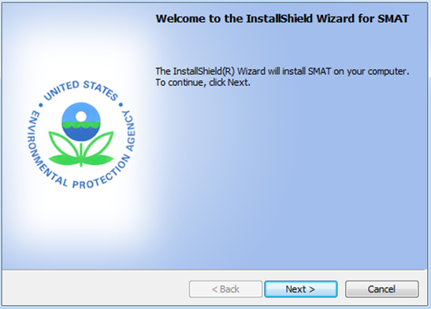
Figure 3-1. SMAT-CE installation window
A successful installation will result in a SMAT-CE desktop icon: .

SMAT-CE Start Page
Double-click the SMAT-CE desktop icon to start the program. The SMAT-CE Start Page (Figure 4-1) will appear on your screen. This window provides access to the following SMAT-CE modules:
- The Process Data module is the interface for loading air quality data into the software for conducting attainment tests. Users can select data from a project that had been loaded previously, or load new data for conducting PM, ozone, or visibility analysis. The Annual PM, Daily PM, Ozone, and Visibility Analysis options each open new windows to configure and run attainment tests for the applicable pollutant.
- The Analyze/Visualize Data module links to the SMAT-CE Data Viewer. The Data Viewer provides an interface to load previously generated results files (*.proj files), and view the data as maps, tables, and charts; or to export the results as a text file.
- The Support & Help module links to the SMAT-CE User’s Guide and information about the current version of the software. The “About” option under this module (Figure 4-2) provides the software version number, a suggested citation for SMAT-CE, and a Development Log (Figure 4-3) listing release notes for current and previous versions of the software.
Additional details about configuring and running the different SMAT-CE processing and analysis modules are included in the following sections.
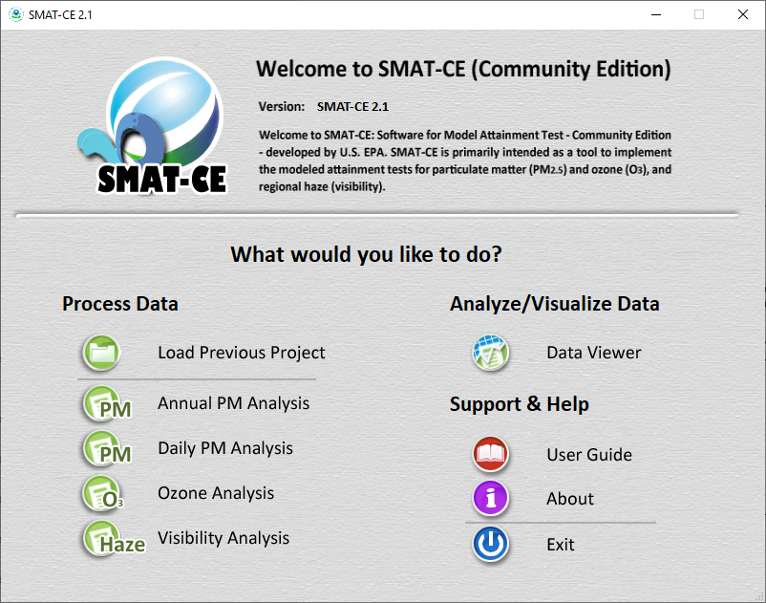
Figure 4-1. SMAT-CE start page window

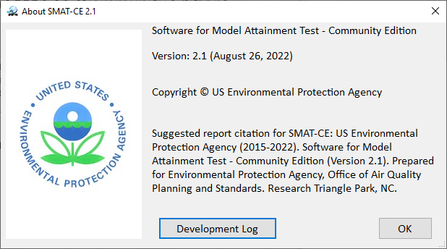
Figure 4-2. SMAT-CE About window
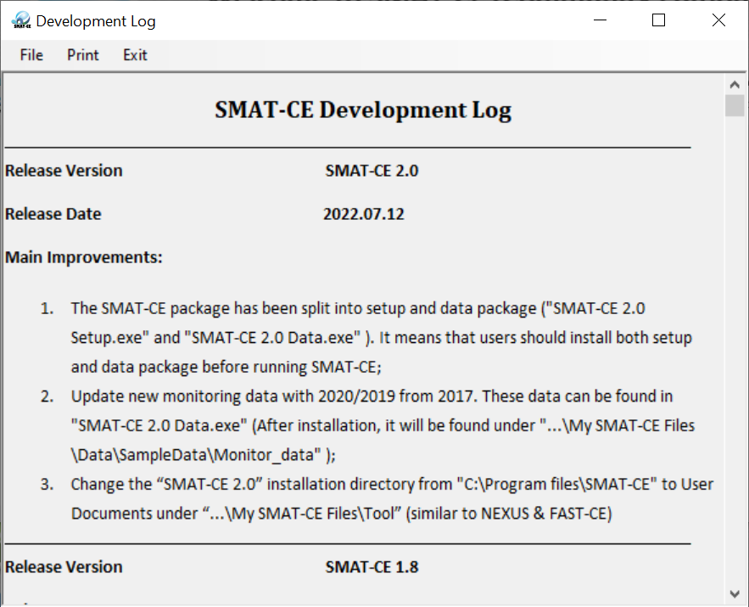
Figure 4-3. SMAT-CE development log window

Running SMAT-CE
Using SMAT-CE to conduct model attainment tests begins with the Process Data module on the Start Page. From this module, users may load a previous project or conduct a new model attainment test for Annual PM, Daily PM, Ozone, and Visibility. One of the key features of SMAT-CE is the project (*.proj) file. This file stores configuration information from a previous SMAT-CE analysis to facilitate recreating or continuing the analysis at a later time. Users may also choose to modify an existing project file to generate a new set of results, avoiding the need to rerun an entire SMAT-CE analysis from the beginning.
To conduct an attainment test with SMAT-CE, either select Load Previous Project or one of the pollutant Analysis options in the Process Data module on the Start Page.

Load Previous SMAT-CE Project
SMAT-CE projects that were run previously may be accessed through the Load Previous Project menu on the Start Page. When this option is selected a Windows file explorer opens to the default directory (C:/Users/[user ID]/My Documents/My SMAT-CE Files/Result/Project) containing SMAT-CE project files. It is recommended that all project files be saved to this directory. Upon selecting one of the existing projects, SMAT-CE will open to the Analysis module (i.e., Annual PM, Daily PM, Ozone, or Visibility) associated with the project.
Once a previous project is loaded, you will begin from the point where the loaded project was last saved. Refer to the following relevant sections for the details of how to continue the analysis of a previous project.

New SMAT-CE Analysis
A new SMAT-CE attainment test is initiated by selecting one of the four Analysis options under the Process Data section on the Start Page:
- Annual PM Analysis (Chapter 6): SMAT-CE will forecast annual PM_{2.5} design values at monitor locations. The software will also optionally calculate quarterly model data files and a species fractions file.
- Daily PM Analysis (Chapter 7): SMAT-CE will forecast daily PM_{2.5} design values at monitor locations. The software will also optionally calculate quarterly model data files and a species fractions file.
- Ozone Analysis (Chapter 8): SMAT-CE will forecast ozone design values at explicit (point) monitor locations. Options are also available for a variety of approaches to calculate design values for a spatial field, such as a matrix of model grid cell surrounding each monitor.
- Visibility Analysis (Chapter 9): SMAT-CE will forecast visibility at specific point locations (centroid) in Class I Areas. Different versions of the IMPROVE light extinction algorithm may be selected along with the option to use either model data at the monitor linked to each Class I Area or model data closest to the Class I Area centroid.
- Analyze/Visualize Data (Chapter 10): The Data Viewer provides a graphical and tabular interface to the input/output data from the attainment test analyses produced by SMAT-CE.

Running SMAT-CE in Batch Mode
SMAT-CE Configuration Files can be concatenated in a Windows batch script to automatically run multiple SMAT-CE analyses in sequence. A SMAT-CE Configuration File stores the configuration options for one SMAT Analysis (i.e., Annual PM, Daily PM, Ozone, or Visibility). Multiple Configuration Files can be used to define a suite of analyses to run at once through a batch script. The Configuration Files are created and saved automatically when setting up an attainment test analysis in SMAT-CE. They can be edited either through the Data Viewer or using a text editor outside of SMAT-CE.(Figure 5-1). New configuration files can be added to the batch script to run additional analyses.
An example batch script (batsmat.bat) and configuration files (*.cfg) are included in User Documents under “\My SMAT-CE Files\Data\BatchExample” (e.g., C:\Users\administrator\Documents\My SMAT-CE Files\Data\BatchExample). The script "batchsmat.bat" includes a list of configuration files for the four types of analyses supported by SMAT-CE (Figure 5-1). Please make sure the paths in .cfg files exist before running the batch script.
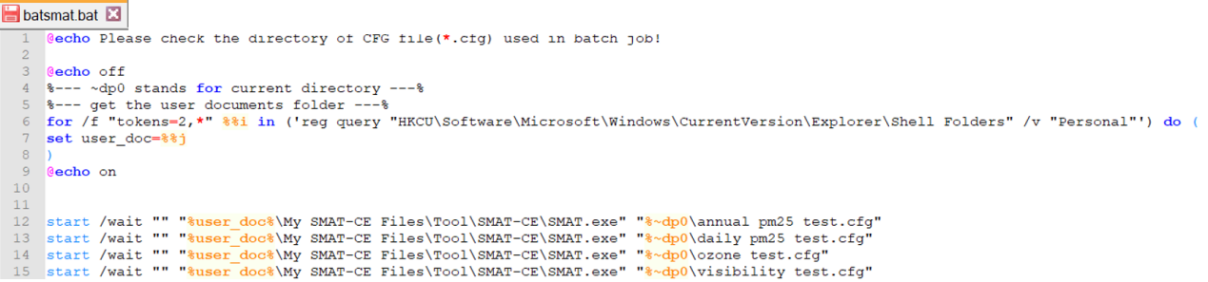
Figure 5-1. SMAT-CE batch script
After editing the SMAT-CE batch script, save it and double-click on the file to run the analyses. A Windows command window will display the status of the different SMAT-CE analysis runs. SMAT-CE will start and run in the background and when the runs are complete, the command window will shut down automatically. The results of the SMAT-CE batch runs are output to the User Documents under “\My SMAT-CE Files\Result\” directory. The *.proj files from these runs can be loaded into the SMAT-CE Data Viewer to probe the results from these runs.
Details of the SMAT-CE Analysis options are provided in the following Chapters. A Continental U.S. (CONUS) example project is used in each of the analysis chapters to demonstrate the options available for each attainment test.

Annual PM Analysis
SMAT-CE can forecast annual design values at PM_{2.5} monitor locations, these forecasts are referred to as Point Estimates. SMAT-CE can also use a variety of approaches to calculate design values for a Spatial Field. A Spatial Field refers to a set of values comprising calculations for each grid cell in a modeling domain from Eulerian grid models such as CMAQ and CAMx.
The Annual PM Design Value Analysis in SMAT-CE is organized into seven steps. The steps include the input/output and configuration options for computing PM_{2.5} design values. The following configuration steps correspond to different SMAT-CE windows and are described in detail in this chapter:
- Output Choice: Select whether to run the Standard Analysis, and whether to output a species fractions file and/or quarterly model data.
- Output Choice – Advanced: Configure miscellaneous Point Estimate output files for quality assurance of the PM design value calculations.
- Data Input: Specify the species monitoring data, species fractions file, PM_{2.5} ambient monitoring data, and the modeling data to use for the design value calculations.
- Species Fractions Calculation Options: Select the years of daily STN-IMPROVE and FRM monitoring data and identify valid monitors. Define data filtering specifications.
- Species Fractions Calculation Options – Advanced: Select the method to identify peak monitor values. Choose interpolation options for PM_{2.5} and species monitoring data. Choose assumptions for the ammonium calculation, default blank mass, and organic carbon.
- PM_{2.5} Calculation Options - FRM Monitor Data: Select the years of quarterly FRM monitoring data and identify valid monitors. Select the approach for calculating future year ammonium.
- Model Data Options: Specify the maximum distance of monitors from the modeling domain. Choose method to identify peak model values. Specify which model grid cells will be used when calculating RRFs at monitor locations.
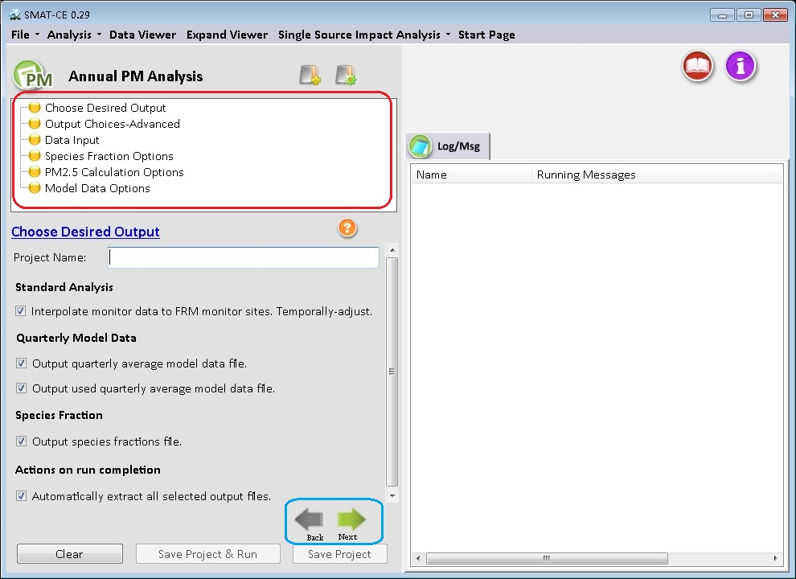
Figure 6-1. Annual PM Analysis initial window
To conduct an attainment test for the annual PM_{2.5} NAAQS, select Annual PM Analysis from the Process Data module on the SMAT-CE Start Page. Figure 6-1 shows the initial window that is displayed when Annual PM Analysis is selected. The box in the upper left of the window (highlighted in red in Figure 6-1) lists the configuration steps of the Annual PM Analysis. Each step listed in this box has a different set of configuration options that are displayed in the Annual PM Analysis window. Once each step is successfully configured, the yellow buttons in the box will change from yellow to green. In general, the configuration steps must be followed in order, from top to bottom, as they are listed in the box. Previously completed steps may be accessed and modified by double-clicking on the step name in the box. Once the configuration for a step is complete, you may move to the next step by either clicking on it or by selecting the Next button (shown in the blue box in Figure 6-1).
A previous project may be loaded, or a new project may be initiated at any time, in the Annual PM Analysis window by selecting one of the icons to the right of the “Annual PM Analysis” text above the red box in Figure 6-1.
Each of the Annual PM Analysis configuration steps are described in the following sections.

Choose Desired Output
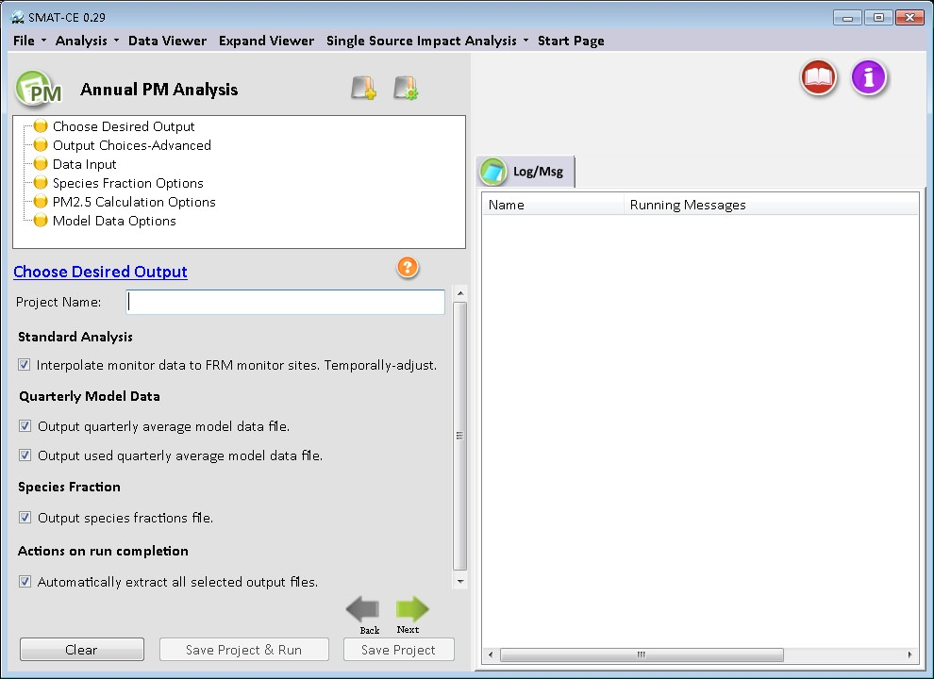
Figure 6-2. Choose Desired Output for Annual PM_{2.5} Analysis
Choose Desired Output is the first configuration step that is displayed when the Annual PM Analysis module is selected (Figure 6-2). The blue hyperlinked text in this window brings up the documentation for this configuration step. The settings in this step include:
Project Name
Text string to identify this analysis and set the name of the project file
Standard Analysis
Since most Federal Reference Method (FRM) PM_{2.5} monitoring sites do not have collocated chemical speciation monitors, spatial interpolation is used to estimate species data at FRM PM_{2.5} monitor locations. SMAT-CE provides options to use different methods for spatially interpolating chemical speciation information to the FRM monitors. These options are available from the Output Choices-Advanced configuration window. Complete details of the Standard Analysis approach, including the formula used to calculate species concentrations, are available in the U.S. EPA Draft Modeling Guidance for Attainment of Air Quality Goals for Ozone, PM_{2.5}, and Regional Haze (U.S. EPA, 2014) and in Section 5.1.2 of the MATS User’s Manual (Abt, 2014).
Most SMAT-CE users will run the standard analysis and it is checked by default.
Quarterly Model Data
Directs SMAT-CE to calculate and output quarterly averaged modeled PM_{2.5} data from daily model data input to the system. SMAT-CE requires two types of data input: ambient monitor data and gridded model output data. For the annual PM_{2.5} calculations, SMAT-CE will accept either SMAT-CE formatted daily average gridded model files or quarterly average files. If daily average model files are used as inputs, SMAT-CE will calculate quarterly averages from the daily averages and optionally output the quarterly average concentrations into text files (CSV files). The quarterly average text files can then be re-used in subsequent SMAT-CE analyses. Quarterly average input files are smaller and run faster than daily average files.
There are two options to output quarterly average model concentration CSV files:
- Selecting the Output quarterly average model data file box creates quarterly average CSV for all grid cells in the modeling domain. SMAT-CE will create one baseline year file and one future year file. This will create relatively large files, but they will still be ~90 times smaller than daily average files (assuming a full year of model data).
- Selecting the Output used quarterly average model data file causes SMAT-CE to output only the grid cells that are subsequently used in the particular SMAT-CE configuration. For example, if SMAT-CE calculates future year design values at 20 FRM sites using a 1 X 1 grid array, then SMAT-CE will output base and future model values for only 20 grid cells (assuming each monitor is in a unique grid cell). The advantage of these files is that they are extremely small. But if subsequent SMAT-CE runs use a different set of monitors or grid arrays, then the files may not contain all of the necessary data to complete the analysis. This option is recommended as a QA tool to examine the grid cells and the model concentrations that SMAT-CE is using in the analysis.
Additional details of the Quarterly Model Data option are available in Section 5.1.3 of the MATS User’s Manual (Abt, 2014).
Species Fractions
After calculating the ambient level of SO₄, NO₃, OC, EC, PBW, NH₄, and crustal, SMAT-CE then divides these ambient levels by the non-blank mass of PM_{2.5} to calculate species fractions. Select this box to output a text file of species fractions at each FRM monitor. This species fraction file can be re-used in MATS as an input file. The species fraction file can be useful for several reasons. One, using a species fraction file saves time because MATS won’t have to interpolate species data and calculate fractions each time it is run. Two, it can provide consistency between MATS runs by ensuring that the same species fractions are used each time. And for the same reason, the species fraction file can be used interchangeably between different users to ensure that multiple groups are using the same species fractions (if that is a goal). And finally, the fractions file can serve as a template for creating a custom species fractions file using whatever data and techniques (e.g., alternative interpolation techniques) are desired by any particular user.
Additional details of the Species Fractions calculation are available in Section 5.1.4 of the MATS User’s Manual (Abt, 2014).
Actions on run completion
Checking the “Automatically Extract All Selected Output Files” box will export CSV files of all selected output to a separate folder named with the Project Name in the SMAT "\Result\Output" folder. The results may also be exported later from the Data Viewer.

Run the Eastern U.S. Example
The default settings for these options, and the configuration to use for the Eastern U.S. example project, is to check all of the boxes in the SMAT-CE Choose Desired Output window. After setting a Project Name and selecting all of the boxes in the window either click Next or double-click the Output Choices-Advanced button in the upper left-hand panel of Annual PM Analysis window. The icon next to Choose Desired Output will turn from yellow to green, indicating that this step is complete.

Output Choices-Advanced
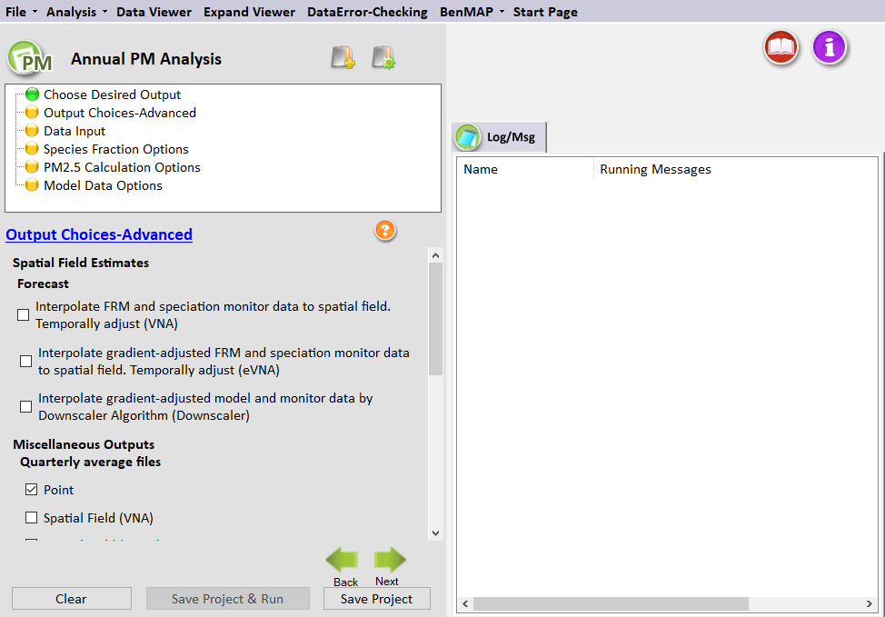
Figure 6-3. Output Choices-Advanced for Annual PM_{2.5} Analysis
The Output Choices–Advanced configuration step provides detailed control over the calculations, output, and quality assurance fields used by SMAT-CE (Figure 6-3). The blue hyperlinked text in this window brings up the documentation for this configuration step. The settings in this step include the following:
Spatial Field Estimates
This option provides PM_{2.5} forecasts for each grid cell in the modeling domain (e.g., CMAQ 36 km). The Interpolate FRM & speciation monitor data to spatial field. Temporally-adjust (VNA) option calculates interpolated spatial fields that are temporally adjusted using the Voronoi Neighbor Averaging (VNA) technique. This option creates gridded spatial fields of future year PM_{2.5} data. To create PM_{2.5} spatial fields, SMAT-CE interpolates both speciation data and PM_{2.5} data (FRM and IMPROVE).
The Interpolate gradient-adjusted FRM & speciation monitor data to spatial field. Temporally-adjust (eVNA) option calculates interpolated spatial fields that are temporally adjusted and gradient adjusted. Check this option to create gridded spatial fields of gradient adjusted future year PM_{2.5} data. To create PM_{2.5} spatial fields, SMAT-CE interpolates both gradient adjusted speciation data and PM_{2.5} data (FRM and IMPROVE). This option creates the recommended spatial fields for the “Unmonitored Area Analysis” from the PM_{2.5} modeling guidance.
The Interpolate gradient-adjusted model and monitor data by Downscaler Algorithm (DS) option calculates interpolated spatial fields by using Markov chain Monte Carlo (MCMC) methods with Gibbs sampling to develop a relationship between observed and modeled concentrations, and then predicting concentrations at points in the spatial domain.
The configuration options in this step provide a variety of output files that can be used in the quality assurance of the SMAT-CE calculations. The options are organized under the “Miscellaneous Outputs” heading and include the following.
Quarterly Average Files
Augments the SMAT-CE default of outputting annual average results for all analyses (point, spatial fields). Checking any one of these boxes will direct SMAT-CE to output more detailed quarterly average data, which are the basis of all of the SMAT-CE annual PM_{2.5} calculations.
High County Sites
Augments the SMAT-CE default of outputting the point results for all FRM sites. Checking this box will also produce a file that contains the single highest monitor in each county, based on the highest future year value. This dataset is a subset of the all-sites file.
Species Fractions Spatial Field
Produces the same result as the species fraction file created from the Standard Analysis except it outputs the species fractions file created from a spatial field. The file will contain species fraction data for each quarter for each grid cell.
Quarterly Average Speciated Monitors
Directs SMAT-CE to produce a file with the raw quarterly average speciated data that were used to interpolate species fractions to the FRM monitors. These data are derived from the “species for fractions” input file.
Design Value Periods
Directs SMAT-CE to produce a file with the standard SMAT-CE output for each design period within the period covered by the analysis. By default, SMAT-CE outputs one set of files covering the entire analysis period specified by the user. The outputs represent the averages of the values for each 3-year design value period. If the "Output design value periods" option is checked, SMAT-CE will produce discrete outputs for each design value period. The output files will be the same as a standard analysis, but with "Period 1", "Period 2", etc., attached at the end of the name. Selecting this option will increase the SMAT-CE run time.
Neighbor files
Directs SMAT-CE to produce files of “nearest neighbor” data for the VNA interpolation scheme. The data include the distance to neighbor monitors and weights used to do the interpolations. There is information for each FRM monitor (for point analyses) or each grid cell (for spatial fields) for each quarter and for each species.
Additional details of the Output Choices–Advanced options, including the formats of the output files from this step, are available in Section 5.2 of the MATS User’s Manual (Abt, 2014).

Run the Eastern U.S. Example
Use the default settings for these options for the Eastern U.S. example project. Either click Next or double-click the Data Input button in the upper left-hand panel of Annual PM Analysis window. The button next to Output Choices-Advanced will turn from yellow to green, indicating that this step is complete.

Data Input
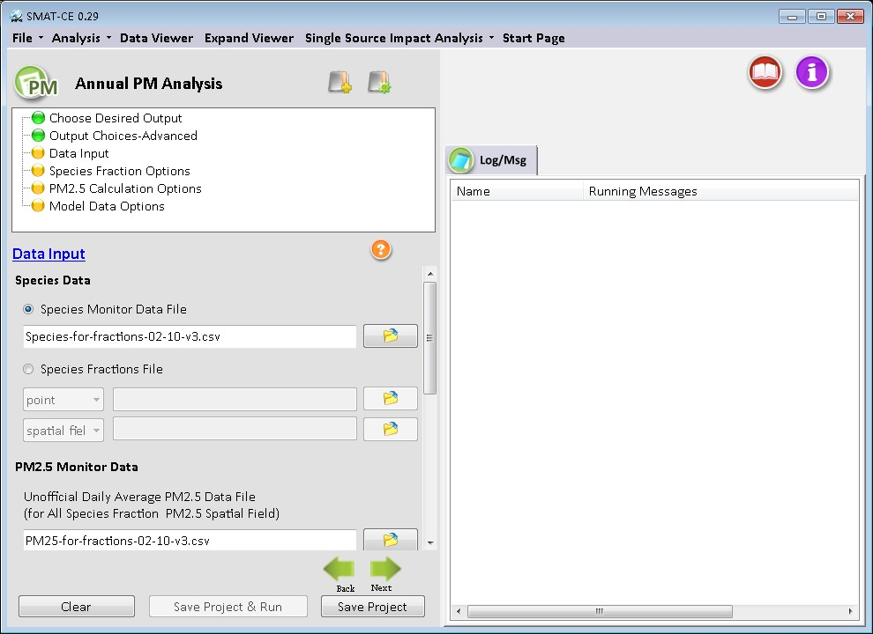
Figure 6-4. Data Input for Annual PM_{2.5} Analysis
The Data Input configuration step sets the ambient PM_{2.5} species data, PM_{2.5} monitor data (FRM and IMPROVE), and the gridded model output data to use for the SMAT-CE project (Figure 6-4).
There is specific terminology that is used on the Data Input page. "Official" data refers to PM_{2.5} FRM data that can be used to determine official design values for compliance purposes (comparison to the NAAQS). Other datasets which may not have rigid regulatory significance are sometimes referred to as "unofficial" data. The blue hyperlinked text in this window brings up the documentation for this configuration step. The settings in this step include:
Species Data
SMAT-CE uses ambient PM_{2.5} species data to calculate species concentrations at FRM monitoring sites and spatial fields. Users have a choice of supplying a “Species Monitor Data File” or a “Species Fractions File”.
- Species Monitor Data File: This is the SMAT-CE default of daily average species data from STN and IMPROVE sites across the country. Users can also provide their own ambient data files. MATS uses the daily average species data to calculate species fractions at each FRM monitor (or at each grid cell, in the case of spatial fields). The species fraction data is combined with the “unofficial daily average PM_{2.5} data” to calculate species concentrations. The default SMAT-CE species data file contains all available data. However, there is a data flag to indicate site days that are recommended to be removed from the species fractions calculations. SMAT-CE has incorporated flagging routines that remove data that are considered to be outliers and/or incomplete data. Section 5.4.2 of the MATS User’s Manual (Abt, 2014) describes the flags used in the species fractions calculations.
- Species Fraction File: An alternative to the Species Monitor Data File. This file contains pre-calculated species fractions with quarterly species information for the FRM monitors of interest. SMAT-CE can use a species fractions file (either "point" or "spatial fields") generated by a previous project. To use an existing fractions file, enter the correct path to the file in the Data Input window. When using spatial fields for existing species fractions files, select either "spatial field" or gradient adjusted spatial fields" from the drop-down box.
PM_{2.5} Monitor Data
SMAT-CE uses both "official" and "unofficial" data in its calculations.
- Unofficial Daily Average PM_{2.5} Data File: PM_{2.5} data that are needed to calculate species fractions. These data are used in combination with the Species Monitor Data File. This file is not needed if the user supplies a pre-calculated species fractions file.
Similar to the Species Monitor Data File, the Unofficial Daily Average PM_{2.5} Data File contains a data flag to indicate site days that are recommended to be removed from the species fractions calculations. The flagged data is matched between the species file and the PM_{2.5} file so that the same site days are removed. The PM_{2.5} data file contains additional data (sites that don’t contain speciation measurements) and therefore has additional flagged site days. These are not the same data flags that have been identified by State agencies. SMAT-CE has incorporated flagging routines that remove data that are considered to be outliers and/or incomplete data. SMAT-CE users are free to alter the flags as needed for their applications.
- Official Quarterly Average FRM Data File. The EPA-approved quarterly average FRM data that have been used to calculate PM_{2.5} design values. These data are used to calculate design values and 5-year weighted average design values as part of the attainment test.
The default data file in SMAT-CE was created by EPA OAQPS. In most cases, the data should not be altered, however, in some cases (e.g., sensitivity analyses) there may be a need to add or remove data.
A detailed description of the formats of the input data files used in this step, are available in Section 5.3.2 of the MATS User’s Manual (Abt, 2014).
Model Data
These are gridded model output from models such as CMAQ or CAMx. The user can choose either daily model data input or quarterly model data input (which is just a quarterly average of the daily model data). Either will work for the Annual PM_{2.5} Analysis. The default setting is daily average data. Model data must be selected for all SMAT-CE projects. The size of the modeling grid defines the outputs for point estimates and for spatial fields. For point estimates, SMAT-CE will output the results for all specified monitors within the domain. For spatial fields, SMAT-CE will create spatial fields that match the size of the gridded model domain.
SMAT-CE requires both a Baseline File and a Forecast File. The baseline file should be consistent with the historical monitor data used for the project, and the forecast year is the future-year of interest.

Run the Eastern U.S. Example
Use the default settings for the Data Input options for the Eastern U.S. example project. Either click Next or double-click the Species Fraction Options button in the upper left-hand panel of Annual PM Analysis window. The button next to Data Input will turn from yellow to green, indicating that this step is complete.

Species Fraction Options
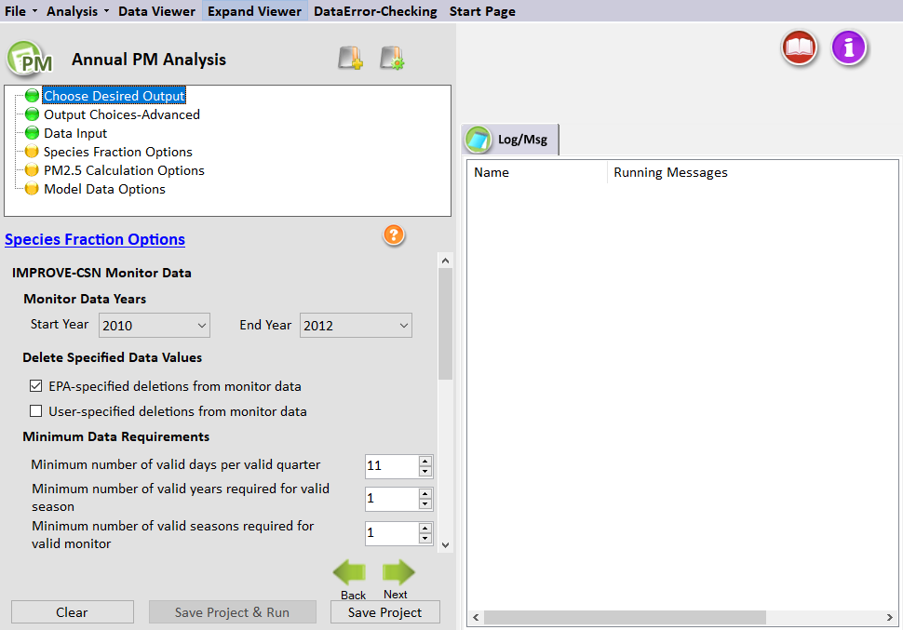
Figure 6-5. Species Fraction Options for Annual PM_{2.5} Analysis
The Species Fraction Calculation Options configuration step shown in Figure 6-5 has several options related to the speciated monitor data (IMPROVE and STN) monitor data and the total PM_{2.5} monitor data (FRM and IMPROVE). These functions include identifying the years of monitor data to use in the attainment test, deleting any specific data values, and choosing the minimum data requirements of monitors to use in the analysis. These options are listed below:
- IMPROVE-STN Monitor Data: The speciation data from STN and IMPROVE monitors are interpolated by SMAT-CE in order to provide species data for any point in a modeling domain. The interpolated species data is used to calculate species fractions at FRM monitors (point estimates) and/or species fractions at all grid cells (spatial fields). Note that you do not need to have values for all species for a monitor to be considered valid, as each species is considered individually. However, the "EPA_Flag" variable in the default "species for fractions" file has been set so that all monitor days that do not have complete species data are not used in the calculations (flag = 1). If the user wants to use the incomplete species data, the flag should be set to "0".
- PM_{2.5} Monitor Data: The total PM_{2.5} data from FRM are used by SMAT-CE to calculate species fractions for point estimates (in conjunction with the interpolated speciation data from STN and IMPROVE monitors). The interpolated species data is used to calculate species fractions at FRM monitors (point estimates) and/or species fractions at all grid cells (spatial fields).
Monitor Data Years
Use the drop-down menus to choose the three years of monitor data for the Annual PM_{2.5} Analysis. The SMAT-CE default is to use the 3-year period 2010 to 2012. (That is, for both IMPROVE-STN and PM_{2.5} monitor data, the Start Year is 2010 and the End Year is 2012.) The default period is based on a modeling year of 2011. The start and end years should be changed to applicable time periods, depending on the base modeling year.
SMAT-CE handles multiple years of data by calculating averages for each species by quarter and year. SMAT-CE then averages the quarterly values across the years (e.g., average quarter 1 values of SO₄ across two years to get a single "quarter 1" estimate). After completing this step, SMAT-CE will have four quarterly estimates for each species at each monitor. These quarterly values are then ready to be interpolated to FRM sites or to grid cell centroids in spatial fields.
Delete Specified Data Values
The default is to delete the observations specified by EPA. Valid data are given a value of "0" and observations that should be deleted are given a value of "1" to "10". There is also an option for the user to flag data, using the same convention of "0" for valid data and "1" to "10" for data marked for deletion. If both the EPA-specified and User-specified flags are checked, then SMAT-CE deletes any observations that are marked for deletion by either the EPA or the user. These settings make it easy for the user to flag additional data for removal from the calculations (without deleting the actual record from the ambient data file). See Section 5.4.2 of the MATS User’s Manual (Abt, 2014) for a description of the observational data flags.
Minimum Data Requirements
There are three sets of minimum data requirements for calculating design values:
- Minimum number of valid days per valid quarter. This is the minimum number of site-days per valid quarter. The default is 11 days, which corresponds to > 75% completeness for monitors on a 1-in-6-day monitoring schedule. This is the minimum number of samples that is routinely used in calculations of quarterly average concentrations.
- Minimum number of valid quarters required for valid season. This is the number of years of data (within the start year and end year specified) for which there are valid quarters for a given season. The default value is 1 year. If the value is set = 2, then there will need to be 2 years of valid data from quarter 1 in order for quarter one to be considered complete (and the same for the other 3 quarters).
- Minimum number of valid seasons required for valid monitor (point and spatial fields calculation). This is the number of valid seasons that are needed in order for a particular monitor's data to be considered valid. The default is 1 for IMPROVE-STN monitor data and the range is 1-4. For example, if the value is = 1, then a monitor's data will be used in the species fractions calculations if it has at least one valid season. If the value = 4, then the site must have all 4 seasons of valid data to be used. The default for PM_{2.5} depends on whether the data are used in point calculations (default = 4) or spatial field calculations (default = 1).
Section 5.4.3 of the MATS User’s Manual (Abt, 2014) shows an example of how the minimum data requirements are used in calculating averages for monitoring data.
Clicking the Advanced box displays additional Species Fractions Calculations Options. The Species Fractions Calculation Options–Advanced screen allows you to make relatively advanced choices for your analysis. Generally speaking, the default options settings are consistent with the EPA modeling guidance document. One set of options allows you to specify the interpolation weighting that you want to use and whether the interpolation involves a maximum distance or not. The second set of options involves choices regarding ammonium, blank mass, and organic carbon. These options are described below.
Interpolation Options
The selections in this section set how SMAT-CE will interpolate, or combine, the values from different monitors. One approach is to use Inverse Distance Weights, which assigns a weight to any particular monitor that is inversely proportional to its distance from the point of interest. A second approach is Inverse Distance Squared Weights, which means that the weights are inversely proportional to the square of the distance. And the third approach is Equal Weighting of Monitors. The default approach for PM is Inverse Distance Squared Weights.
When interpolating monitor values, SMAT-CE identifies monitors based on their distance away from the point of interest (e.g., the center of a grid cell). The first step in the interpolation process is to identify the monitors that are nearby, or neighbors, for each point of interest. The next step is to determine the distance (in kilometers) from the nearby monitors to the point of interest. The default approach is to include all valid monitors (i.e., those that satisfy the three criteria in the Species Fractions Calculation Options panel), regardless of distance. To limit the use of monitors based on distance, type in the distance in km (e.g., 100) next to the pollutant of interest. Note that a distance of 100 kilometers means that any monitors further than 100 kilometers can no longer be used in the interpolation. If a point of interest has no monitors within the specified distance, then no value is calculated.
The Miscellaneous Options panel sets the following options for SMAT-CE:
Ammonium
Specify whether to use degree of neutralization (DON) values to calculate ammonium (NH₄) or to use measured ammonium in conjunction with an assumption about the percentage of NH₄ that evaporates. The default option is to use DON values. To use measured ammonium, click the button and choose an NH₄ percentage evaporating (e.g., 50 means that the evaporation of NH₄ in PM is 50% of the original NH₄. Note that the PM particles are dissolved in water and evaporated in the evaporating pan until the water disappears, and the reduction of NH₄ is the evaporation amount). The default is "0", which assumes that no ammonium evaporates from the FRM filters.
Default Blank Mass
The Default Blank Mass option sets default blank mass to the desired level. The default is 0.5. Either type in or use the arrows to increase or decrease the value.
Organic Carbon
Set the "floor" and the "ceiling" for the mass balance calculation for organic carbon.

Run the Eastern U.S. Example
Use the default settings for the Species Fraction Options for the Eastern U.S. example project. Either click Next or double-click the PM_{2.5} Calculation Options button in the upper left-hand panel of Annual PM Analysis window. The button next to Species Fraction Options will turn from yellow to green, indicating that this step is complete.

PM_{2.5} Calculation Options
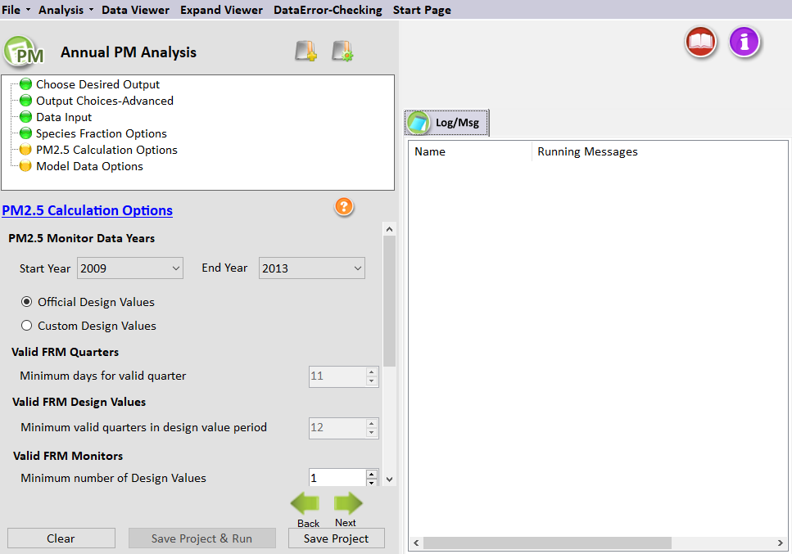
Figure 6-6. PM_{2.5} Calculation Options for Annual PM_{2.5} Analysis
The PM_{2.5} Calculation Options window shown in Figure 6-6 sets the particular years of monitor data to use from the input file specified in the Data Input window. The following options are available in this window.
PM_{2.5} Monitor Data Years
The Start Year and End Year drop-down menu options list the years of available official PM monitor data to use in the calculation of future PM_{2.5} design values. The default approach in SMAT-CE is to use five years of data.
SMAT-CE provides the option to use "official" design values, which are generally recommended, or to choose "custom" design values. The custom design values option requires the specification of the minimum number of observation days in each quarter and the minimum number of quarters to produce valid design values.
Valid FRM Quarters
Set the minimum number of site-days per valid quarter. The default is 11 days, which corresponds to > 75% completeness for monitors on a 1-in-6-day monitoring schedule. This is a minimum number of samples that is routinely used in calculations of quarterly average concentrations.
Valid FRM Design Values
Set the minimum number of quarters for which there are data within three consecutive design value periods. The default value is 12 quarters. If the value is set to 11, then there will need to be at least 11 valid quarters (i.e., two years must have four valid quarters and one year must have at least three valid quarters.)
Completion Code
Use this variable from the official quarterly PM_{2.5} monitor database to identify valid data. As noted above in Section 6.4, the completion code has values of 1, 2, 3, 4, or 5; and the codes are valid for the end year of each 3-year design value period. SMAT-CE uses the completion code variable somewhat differently when using official design values and when using custom design values:
- When using official data, SMAT-CE will only use completion codes: 1 and 2.
- When using custom data, SMAT-CE will potentially use completion codes: 1, 2, 3, and 4 (if the user specified completion criteria are met).
The following is an explanation of the official EPA completion codes:
- Code "1"- complete data and violates the NAAQS
- Code "2"- complete data that is below the NAAQS
- Code "3"- incomplete data and violates the NAAQS
- Code "4" - incomplete data that is below the NAAQS
- Code "5" - data that is not comparable to the NAAQS and should not be used. For example, FRM data collected at a micro-scale site cannot be compared to the annual PM_{2.5} NAAQS.
Valid FRM Monitors
By default, SMAT-CE assumes that there only needs to be one design value for a monitor to be considered valid. In addition, SMAT-CE assumes that no particular design value is required, so different monitors with different years of data could be used.
For example, a start year and end year as 2005 and 2009 gives potential 3-year design values of 2005-2007, 2006-2008, and 2007-2009. When the Minimum Number of Design Values is set to 1, one monitor could have data for, say, 2005-2007 and another monitor data for 2006-2008, and both monitors would be used. A Minimum Number of Design Values setting of 2 would only use monitors that have design values for two of the three design value periods, ignoring monitors that only have design values for a single period.
NH₄ Future Calculation
SMAT-CE can forecast NH₄ in two different ways. The default approach uses base year DON values. See Section 5.1.2.3 of the MATS User’s Manual for details on the forms of the two equations that are available to forecast NH₄.

Run the Eastern U.S. Example
Use the default settings for the PM_{2.5} Calculation Options for the Eastern U.S. example project. Either click Next or double-click the Model Data Options button in the upper left-hand panel of Annual PM Analysis window. The button next to PM_{2.5} Calculation Options will turn from yellow to green, indicating that this step is complete.

Model Data Options
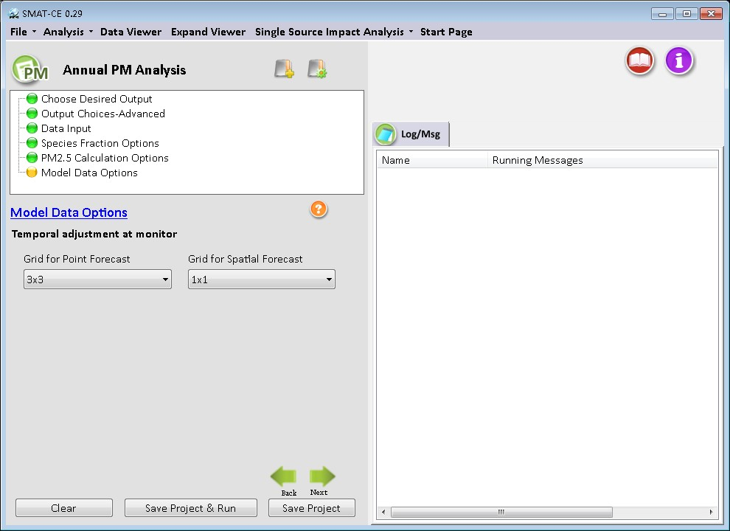
Figure 6-7. Model Data Options for Annual PM_{2.5} Analysis
The Model Data Options window shown in Figure 6-7. This window sets the temporal adjustments for each monitor:
Temporal Adjustment at Monitor
This option specifies how many model grid cells to use in the calculation of RRFs for point estimates and for spatial estimates. A drop-down menu provides options to use 1x1, 3x3, 5x5, and 7x7 arrays of model grid cells. The default for a 12 kilometer by 12-kilometer grid is to use a 3x3 array of grid cells. The U.S. EPA Draft Modeling Guidance for Attainment of Air Quality Goals for Ozone, PM_{2.5}, and Regional Haze (U.S. EPA, 2014) includes discussion on selecting the appropriate grid call array size for different model resolutions.
Note that for PM analyses, SMAT-CE calculates mean concentrations across the grid cell array (as compared to maximum concentrations used for ozone analyses).

Run the Eastern U.S. Example
Use the default settings for the Model Data Options for the Eastern U.S. example project. Either click Next, which will bring up a window prompting to “Save & Run Project” or click the Save Project & Run button at the bottom of the SMAT-CE window.
The Annual PM_{2.5} Analysis project may also be saved without running SMAT-CE by clicking the Save Project button. A file explorer window will request a filename to which the project settings will be saved to a *.proj file. This file can be loaded later to restart the analysis.
For the Eastern U.S. example, select save and run for the Annual PM_{2.5} Analysis project. A file explorer window will request a filename (*.proj) to which to save the project settings. While the Analysis is running, the icon next to Model Data Options will turn to a running status and status messages will be displayed in the Log & Msg tab on the right panel of the SMAT-CE main window (Figure 6-8).
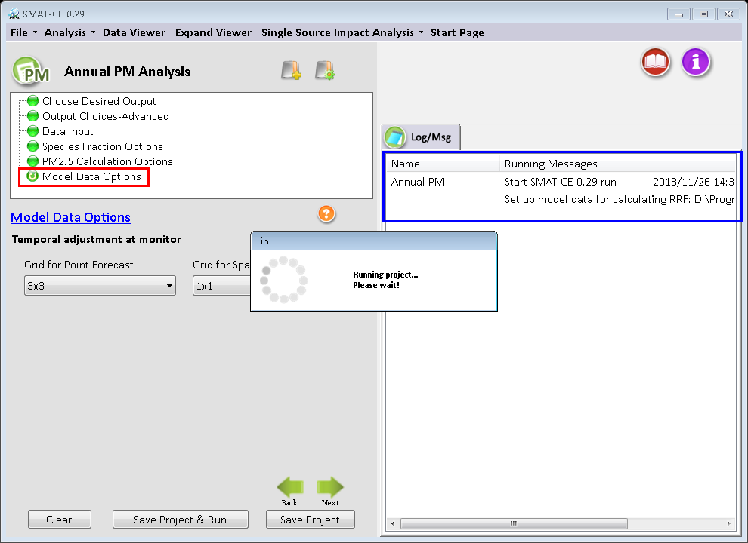
Figure 6-8. Annual PM_{2.5} Analysis run status
When the Annual PM_{2.5} Analysis is completed, the Data Viewer will automatically display in the SMAT-CE main window (Figure 6-9). The Output Files section of the Data Viewer left panel will display all of output files selected in the Choose Desired Output and Output Choices-Advanced Annual PM_{2.5} Analysis windows.
The Data Viewer provides options to display the Annual PM_{2.5} Analysis results as maps, bar charts, and tables. Chapter 10 describes how to load and analyze data using the SMAT-CE Data Viewer.
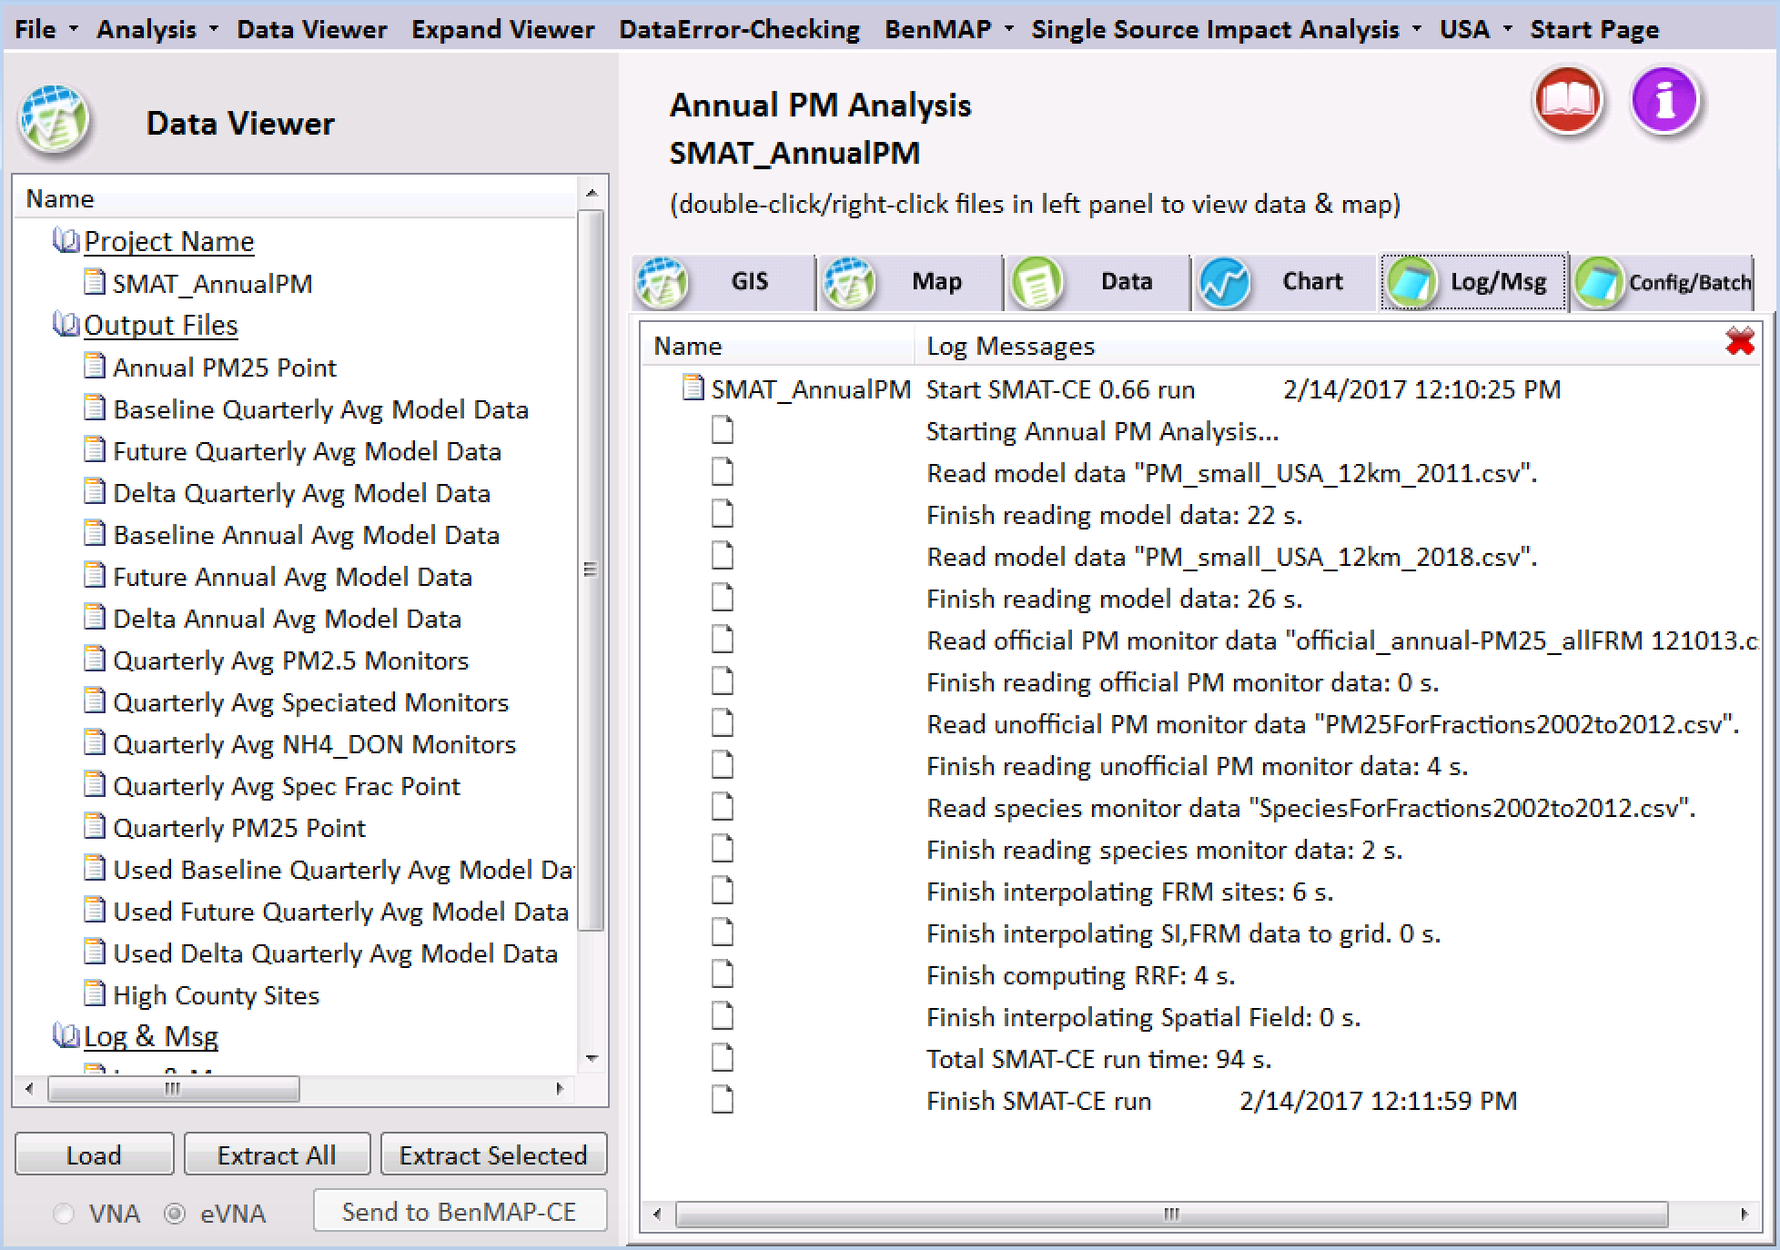
Figure 6-9. Annual PM Analysis Data Viewer
This concludes the chapter on the SMAT-CE Annual PM_{2.5} Analysis. As described in this section, details of the calculations and settings used in this analysis are available in the U.S. EPA Draft Modeling Guidance for Attainment of Air Quality Goals for Ozone, PM_{2.5}, and Regional Haze (U.S. EPA, 2014) and in Chapter 5 of the MATS User’s Manual (Abt, 2014).

Daily PM Analysis
SMAT-CE can forecast daily (24-hour) design values at PM_{2.5} monitor locations – these forecasts are referred to as Point Estimates. SMAT-CE can also use a variety of approaches to calculate design values for a Spatial Field. A Spatial Field refers to a set of values comprising calculations for each grid cell in a modeling domain from Eulerian grid models such as CMAQ and CAMx.
The Daily PM Design Value Analysis in SMAT-CE is organized into seven steps. The steps include the input/output and configuration options for computing ozone design values. The following configuration steps correspond to different SMAT-CE windows and are described in detail in this chapter:
- Output Choice: Select whether to run the Standard Analysis, and whether to output a species fractions file and/or quarterly model data.
- Output Choice–Advanced: Configure miscellaneous Point Estimate output files for quality assurance of the PM design value calculations.
- Data Input: Specify the species monitoring data, species fractions file, PM_{2.5} ambient monitoring data, and the modeling data to use for the design value calculations.
- Species Fractions Calculation Options: Select the years of daily STN-IMPROVE and FRM monitoring data and identify valid monitors. Define data filtering specifications.
- Species Fractions Calculation Options–Advanced: Select the method to identify peak monitor values. Choose interpolation options for PM_{2.5} and species monitoring data. Choose assumptions for the ammonium calculation, default blank mass, and organic carbon.
- PM_{2.5} Calculation Options - FRM Monitor Data: Select the years of quarterly FRM monitoring data and identify valid monitors. Select the approach for calculating future year ammonium.
- Model Data Options: Specify the maximum distance of monitors from modeling domain. Choose method to identify peak model values. Specify which model grid cells will be used when calculating RRFs at monitor locations.
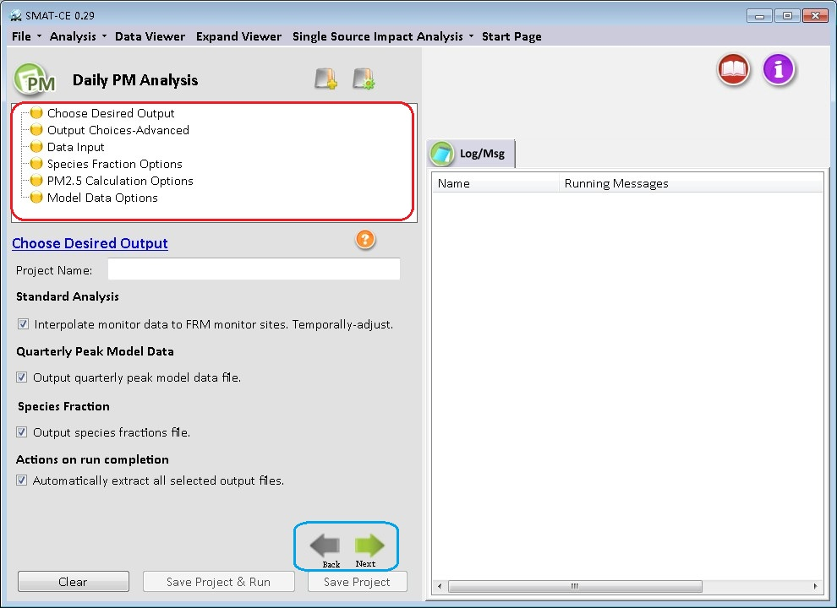
Figure 7-1. Daily PM Analysis initial window
To conduct an attainment test for the daily PM_{2.5} NAAQS, select Daily PM Analysis from the Process Data module on the SMAT-CE Start Page. Figure 7-1 shows the initial window that is displayed when Daily PM Analysis is selected. The box in the upper left of the window (highlighted in red in Figure 7-1) lists the configuration steps of the Daily PM Analysis. Each step listed in this box has a different set of configuration options that are displayed in the Daily PM Analysis window. Once each step is successfully configured, the icons next to each step in the box will change from yellow to green. In general, the configuration steps must be followed in order, from top to bottom, as they are listed in the box. Previously completed steps may be accessed and modified by double-clicking on the step name in the box. Once the configuration for a step is complete, you may move to the next step by either clicking on it or by selecting the Next button (shown in the blue box in Figure 7-1).
A previous project may be loaded, or a new project may be initiated, at any time in the Daily PM Analysis window by selecting one of the icons to the right of the “Daily PM Analysis” text above the red box in Figure 7-1.
Each of the Daily PM Analysis configuration steps are described in the following sections.

Choose Desired Output
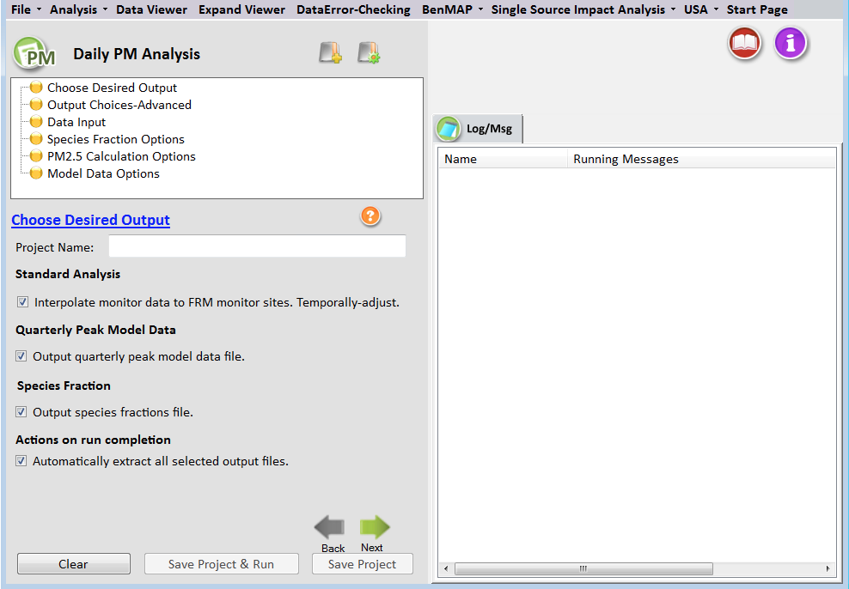
Figure 7-2. Choose Desired Output for Daily PM_{2.5} Analysis
Choose Desired Output is the first configuration step that is displayed when the Daily PM Analysis module is selected (Figure 7-2). The blue hyperlinked text in this window brings up the documentation for this configuration step. The settings in this step include:
Project Name
Text string to identify this analysis and set the name of the project file.
Standard Analysis
Since most Federal Reference Method (FRM) PM_{2.5} monitoring sites do not have collocated chemical speciation monitors, spatial interpolation is used to estimate species data at FRM PM_{2.5} monitor locations. SMAT-CE provides options to use different methods for spatially interpolating chemical speciation information to the FRM monitors. These options are available from the PM_{2.5} Calculation Options configuration window. Complete details of the Standard Analysis approach, including the formula used to calculate species concentrations, are available in the U.S. EPA Draft Modeling Guidance for Attainment of Air Quality Goals for Ozone, PM_{2.5}, and Regional Haze (U.S. EPA, 2014) and in Section 7.1.2 of the MATS User’s Manual (Abt, 2014).
Most SMAT-CE users will run the standard analysis and it is checked by default.
Quarterly Peak Model Data
SMAT-CE requires two types of data input: ambient monitor data and gridded model output data. For the daily PM_{2.5} calculations, SMAT-CE will accept either SMAT-CE formatted daily average gridded model files or quarterly peak average files.
If daily average model files are used as inputs, SMAT-CE will calculate quarterly peak averages from the daily averages and optionally output the quarterly peak average concentrations into text files (CSV files). The quarterly average text files can then be re-used in subsequent SMAT-CE analyses. Quarterly average input files are smaller and run faster than daily average files. Choosing this option will direct SMAT-CE to generate two types of quarterly peak average model concentration CSV files:
- All Data. SMAT-CE outputs quarterly peak data for all grid cells in the modeling domain. SMAT-CE will create one baseline year file and one future year file. This will create relatively large files, but they will still be much smaller than daily average files.
- Used Data. SMAT-CE outputs quarterly peak data for the grid cells that are subsequently used in the particular SMAT-CE configuration. For example, if SMAT-CE calculates future year design values at 20 FRM sites using a 1x1 grid array, then SMAT-CE will output base and future model values for only 20 grid cells (assuming each monitor is in a unique grid cell). The advantage of these files is that they are extremely small. But if subsequent SMAT-CE runs use a different set of monitors or grid arrays, then the files may not contain all of the necessary data to complete the analysis. This option is recommended as a QA tool to examine the grid cells and the model concentrations that MATS is using in the analysis.
Additional details of the Quarterly Peak Model Data option are available in Section 7.1.3 of the MATS User’s Manual (Abt, 2014).
Species Fraction
Checking the “Output species fraction file” box will create an output file containing the calculated PM_{2.5} species fractions at each FRM site used by SMAT-CE. Species fractions are simply the fraction of quarterly average PM_{2.5} at a given monitor attributable to seven (and potentially eight) species: nitrate (NO₃), sulfate (SO₄), organic carbon (OC), crustal, elemental carbon (EC), ammonium (NH₄), and particle-bound water (PBW). And pending data availability, sea salt can be included as well. While the default SMAT-CE species files include sea salt data, it is an optional species in the model files. If base and future year modeled sea salt data are available, a sea salt RRF will be calculated by SMAT-CE. If the salt data are not available in the model files, then the sea salt RRF will be set to 1.
This species fraction file can be re-used in SMAT-CE as an input file. The species fraction file can be useful for several reasons. Using a species fraction file saves time because SMAT-CE won’t have to interpolate species data and calculate fractions each time it is run. This file can provide consistency between SMAT-CE runs by ensuring that the same species fractions are used each time. And for the same reason, the species fraction file can be used interchangeably between different users to ensure that multiple groups are using the same species fractions (if that is a goal). And finally, the fractions file can serve as a template for creating a custom species fractions file using whatever data and techniques (e.g., alternative interpolation techniques) are desired by any particular user.
Additional details of the Species Fractions calculation are available in Section 7.1.4 of the MATS User’s Manual (Abt, 2014).
Actions on Run Completion
Checking the “Automatically Extract All Selected Output Files” box will export CSV files of all selected output to a separate folder named with the Project Name in the SMAT "\Result\Output" folder. The results may also be exported later from the Data Viewer.

Run the Eastern U.S. Example
The default settings for these options, and the configuration to use for the Eastern U.S. example project, is to check all of the boxes in the SMAT-CE Choose Desired Output window. After setting a Project Name and selecting all of the boxes in the window either click Next or double-click the Output Choices-Advanced button in the upper left-hand panel of Daily PM Analysis window. The icon next to Choose Desired Output will turn from yellow to green, indicating that this step is complete.

Output Choices–Advanced
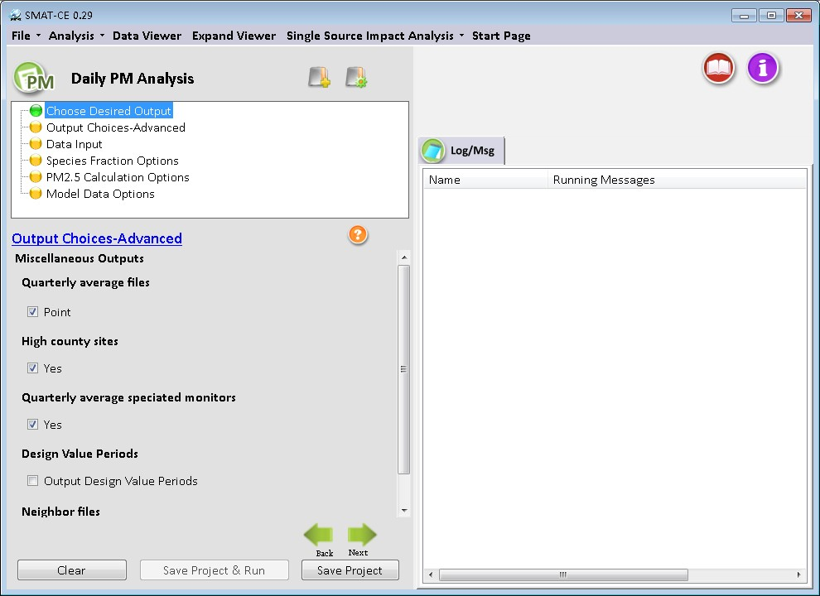
Figure 7-3.Output Choices-Advanced for Daily PM_{2.5} Analysis
The Output Choices–Advanced configuration step provides detailed control over the calculations, output, and quality assurance fields used by SMAT-CE (Figure 7-3). The blue hyperlinked text in this window brings up the documentation for this configuration step. All of the settings in this step are organized under the “Miscellaneous Outputs” heading and include the following.
Quarterly Average Files
SMAT-CE outputs by default the 98th percentile design values, which are based on a weighted average of five years of data. Checking the Point box under Quarterly average files will direct SMAT-CE to output detailed parameters from the peak calculations that are the basis of all of the PM design value calculations. Two additional files are output by SMAT-CE when this option is selected:
- Daily All Years All Days PM_{2.5} Point. This file has baseline and future values for the Top 32 ranked PM_{2.5} values and constituent species. In addition, it gives the speciated RRFs.
- Daily All Years High Days PM_{2.5} Point. This file identifies the 98th percentile PM_{2.5} value in the baseline and future for each year at each monitor. Note that the baseline and future quarters and days may differ.
High County Sites
Augments the SMAT-CE default of outputting the point results for all FRM sites. Checking this box will also produce a file that contains the single highest monitor in each county, based on the highest future year value. This dataset is a subset of the all-sites file.
Quarterly Average Speciated Monitors
Directs SMAT-CE to produce a file with the raw quarterly average speciated data that were used to interpolate species fractions to the FRM monitors. These data are derived from the “species for fractions” input file.
Design Values Periods
Directs SMAT-CE to produce a file with the standard SMAT-CE output for each design period within the period covered by the analysis. By default, SMAT-CE outputs one set of files covering the entire analysis period specified by the user. The outputs represent the averages of the values for each 3-year design value period. If the "Output design value periods" option is checked, SMAT-CE will produce discrete outputs for each design value period. The output files will be the same as a standard analysis, but with "Period 1", "Period 2", etc., attached at the end of the name. Selecting this option will increase the SMAT-CE run time.
Neighbor Files
Directs SMAT-CE to produce files of “nearest neighbor” data for the VNA interpolation scheme. The data include the distance to neighbor monitors and weights used to do the interpolations. This option will generate information for each FRM monitor (for point analyses) or each grid cell (for spatial fields) for each quarter and for each species.
Additional details of the Output Choices – Advanced options, including the formats of the output files from this step, are available in Section 7.2 of the MATS User’s Manual (Abt, 2014).

Run the Eastern U.S. Example
Use the default settings for these options for the Eastern U.S. example project. Either click Next or double-click the Data Input button in the upper left-hand panel of the Daily PM Analysis window. The button next to Output Choices-Advanced will turn from yellow to green, indicating that this step is complete.

Data Input
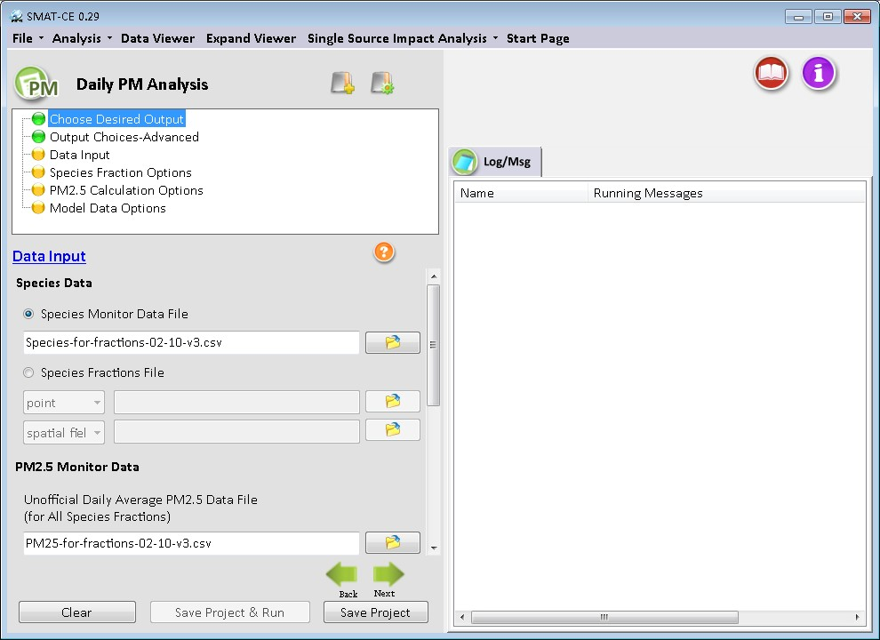
Figure 7-4. Data Input for Daily PM_{2.5} Analysis
The Data Input configuration step sets the ambient PM_{2.5} species data, PM_{2.5} monitor data (FRM and IMPROVE), and the gridded model output data to use for the SMAT-CE project (Figure 7-4).
There is specific terminology that is used on the Data Input page. "Official" data refers to PM_{2.5} FRM data that can be used to determine official design values for compliance purposes (comparison to the NAAQS). Other datasets which may not have rigid regulatory significance are sometimes referred to as "unofficial" data. The blue hyperlinked text in this window brings up the documentation for this configuration step. The settings in this step include:
Species Data
SMAT-CE uses ambient PM_{2.5} species data to calculate species concentrations at FRM monitoring sites and spatial fields. Users have a choice of supplying a “Species Monitor Data File” or a “Species Fractions File”.
- Species Monitor Data File. This is the SMAT-CE default of daily average species data from STN and IMPROVE sites across the country. Users can also provide their own ambient data file. MATS uses the daily average species data to calculate species fractions at each FRM monitor (or at each grid cell, in the case of spatial fields). The species fraction data is combined with the “unofficial daily average PM2.5 data” to calculate species concentrations. However, there is a data flag to indicate site days that are recommended to be removed from the species fractions calculations. SMAT-CE has incorporated flagging routines that remove data that are considered to be outliers and/or incomplete data. Section 7.4.2 of the MATS User’s Manual (Abt, 2014) describes the flags used in the species fractions calculations.
- Species Fraction File. Alternative to the Species Monitor Data File. This file contains pre-calculated species fractions with quarterly species information for the FRM monitors of interest. SMAT-CE can use a species fractions file (either "point" or "spatial fields") generated by a previous project. To use an existing fractions file, enter the correct path to the file in the Data Input window. When using spatial fields for existing species fractions files, select either "spatial field" or gradient adjusted spatial fields" from the drop-down box.
PM_{2.5} Monitor Data
SMAT-CE requires model data in the form of a text file. SMAT-CE uses both "official" and "unofficial" data in its calculations.
- Unofficial Daily Average PM_{2.5} Data File. PM_{2.5} data that are needed to calculate species fractions. These data are used in combination with the Species Monitor Data File. This file is not needed if the user supplies a pre-calculated species fractions file.
Similar to the Species Monitor Data File, the Unofficial Daily Average PM_{2.5} Data File contains a data flag to indicate site days that are recommended to be removed from the species fractions calculations. The flagged data is matched between the species file and the PM_{2.5} file so that the same site days are removed. The PM_{2.5} data file contains additional data (sites that don’t contain speciation measurements) and therefore has additional flagged site days. These are not the same data flags that have been identified by State agencies. SMAT-CE has incorporated flagging routines that remove data that are considered to be outliers and/or incomplete data. SMAT-CE users are free to alter the flags as needed for their applications.
- Official Quarterly Average FRM Data File. The EPA-approved quarterly average FRM data that have been used to calculate PM_{2.5} design values. These data are used to calculate design values and 5-year weighted average design values as part of the attainment test.
The default data file in SMAT-CE was created by EPA OAQPS. In most cases, the data should not be altered, however, in some cases (e.g., sensitivity analyses) there may be a need to add or remove data.
A detailed description of the formats of the input data files used in this step, are available in Section 7.3.2 of the MATS User’s Manual (Abt, 2014).
Model Data
These are gridded model output from models such as CMAQ or CAMx. The user can choose either daily model data input or quarterly model data input (which is just a quarterly average of the daily model data). Either will work for the Daily PM_{2.5} Analysis. The default setting is daily average data. Model data must be selected for all SMAT-CE projects. The size of the modeling grid defines the outputs for point estimates and for spatial fields. For point estimates, SMAT-CE will output the results for all specified monitors within the domain. For spatial fields, SMAT-CE will create spatial fields that match the size of the gridded model domain.
Subsequent versions of SMAT-CE will support reading directly from CMAQ data files. This option is currently greyed out in SMAT-CE.
SMAT-CE requires both a Baseline File and a Forecast File. The baseline file should be consistent with the historical monitor data used for the project, and the forecast year is the future-year of interest.

Run the Eastern U.S. Example
Use the default settings for the Data Input options for the Eastern U.S. example project. Either click Next or double-click the Species Fraction Options button in the upper left-hand panel of Daily PM Analysis window. The button next to Data Input will turn from yellow to green, indicating that this step is complete.

Species Fraction Options
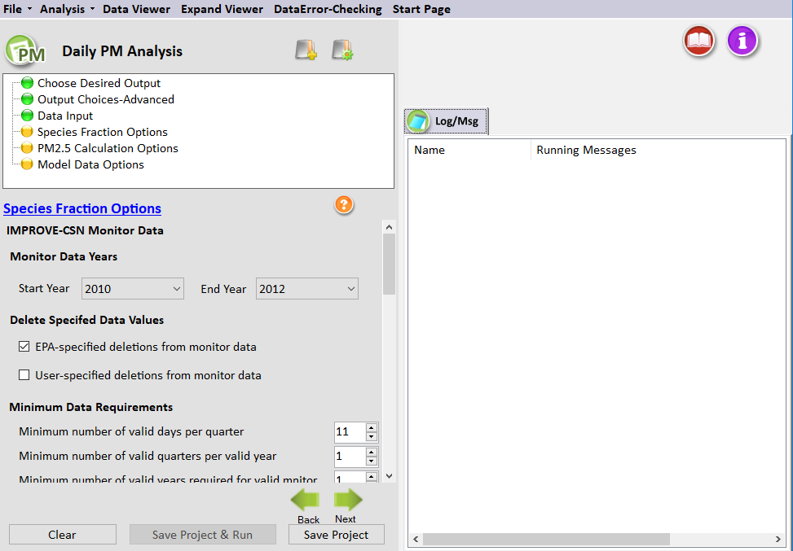
Figure 7-5. Species Fraction Options for Daily PM_{2.5} Analysis
The Species Fraction Calculation Options configuration step shown in Figure 7-5 has several options related to the speciated monitor data (IMPROVE and STN) monitor data and the total PM_{2.5} monitor data (FRM and IMPROVE). These functions include identifying the years of monitor data to use in the attainment test, deleting any specific data values, and choosing the minimum data requirements of monitors to use in the analysis. These options are listed below:
- IMPROVE-CSN Monitor Data. The speciation data from CSN and IMPROVE monitors are interpolated by SMAT-CE in order to provide species data for any point in a modeling domain. The interpolated species data is used to calculate species fractions at FRM monitors (point estimates) and/or species fractions at all grid cells (spatial fields). Note that you do not need to have values for all species for a monitor to be considered valid, as each species is considered individually. However, the "EPA_Flag" variable in the default "species for fractions" file has been set so that all monitor days that do not have complete species data are not used in the calculations (flag = 1). If the user wants to use the incomplete species data, the flag should be set to "0".
- PM_{2.5} Monitor Data. The total PM_{2.5} data from FRM are used by SMAT-CE to calculate species fractions for point estimates (in conjunction with the interpolated speciation data from CSN and IMPROVE monitors). The interpolated species data is used to calculate species fractions at FRM monitors (point estimates) and/or species fractions at all grid cells (spatial fields).
Monitor Data Years
Use the drop-down menus to choose the three years of monitor data for the Annual PM_{2.5} Analysis. The SMAT-CE default is to use the 3-year period 2010 to 2012. (That is, for both IMPROVE-CSN and PM_{2.5} monitor data, the Start Year is 2010 and the End Year is 2012.) The default period is based on a modeling year of 2011. The start and end years should be changed to applicable time periods, depending on the base modeling year.
SMAT-CE handles multiple years of data by calculating averages for each species by quarter and year. SMAT-CE then averages the quarterly values across the years (e.g., average quarter 1 values of SO₄ across two years to get a single "quarter 1" estimate). After completing this step, SMAT-CE will have four quarterly estimates for each species at each monitor. These quarterly values are then ready to be interpolated to FRM sites or to grid cell centroids in spatial fields.
Delete Specified Data Values
The default is to delete the observations specified by EPA. Valid data are given a value of "0" and observations that should be deleted are given a value of "1" to "10". There is also an option for the user to flag data, using the same convention of "0" for valid data and "1" to "10" for data marked for deletion. If both the EPA-specified and User-specified flags are checked, then SMAT-CE deletes any observations that are marked for deletion by either the EPA or the user. These settings make it easy for the user to flag additional data for removal from the calculations (without deleting the actual record from the ambient data file). See Section 7.4.2 of the MATS User’s Manual (Abt, 2014) for a description of the observational data flags.
Minimum Data Requirements
There are three sets of minimum data requirements for calculating design values:
- Minimum number of valid days per valid quarter. This is the minimum number of site-days per valid quarter. The default is 11 days, which corresponds to > 75% completeness for monitors on a 1-in-6-day monitoring schedule. This is the minimum number of samples that is routinely used in calculations of quarterly average concentrations.
- Minimum number of valid quarters required for valid season. This is the number of years of data (within the start year and end year specified) for which there are valid quarters for a given season. The default value is 1 year. If the value is set = 2, then there will need to be two years of valid data from quarter 1 in order for quarter one to be considered complete (and the same for the other three quarters).
- Minimum number of valid seasons required for valid monitor (point and spatial fields calculation). This is the number of valid seasons that are needed in order for a particular monitor's data to be considered valid. The default is 1 for IMPROVE-STN monitor data and the range is 1-4. For example, if the value is = 1, then a monitor's data will be used in the species fractions calculations if it has at least one valid season. If the value = 4, then the site must have all four seasons of valid data to be used. The default for PM_{2.5} depends on whether the data are used in point calculations (default = 4) or spatial field calculations (default = 1).
Section 7.4.3 of the MATS User’s Manual (Abt, 2014) shows an example of how the minimum data requirements are used in calculating averages for monitoring data.
Clicking the Advanced box displays additional Species Fractions Calculations Options. The Species Fractions Calculation Options–Advanced screen allows you to make relatively advanced choices for your analysis. Generally speaking, the default options settings are consistent with the EPA modeling guidance document. One set of options allows you to specify the interpolation weighting that you want to use and whether the interpolation involves a maximum distance or not. The second set of options involves choices regarding ammonium, blank mass, and organic carbon. These options are described below.
Using Monitor Data to Calculate Species Fractions
The Using Monitor Data to Calculate Species Fractions panel sets how IMPROVE and STN speciated monitor data and ("unofficial") PM_{2.5} monitor data will be used to calculate quarterly peak values. Three data filtering options are available to apply to the averaging calculations:
- Use Top X Percent of Daily Monitor Days. SMAT-CE uses the top "X" percent of days per quarter to calculate the quarterly peak values. Set the percent cutoff to use for this option.
- Use All Daily Monitor Values Greater than Fixed Amount (ug/m3). SMAT-CE averages all monitor values greater than or equal to a concentration cutoff. Set the concentration cutoff and the minimum number of days greater than or equal to the cutoff concentration. If there is an insufficient number of days, SMAT-CE will drop the data for that particular quarter.
- Use Top X Number of Daily Monitor Days. SMAT-CE averages the concentrations for the top "X" number of days per quarter. Set the number of days to use for this option.
These three filtering options work in essentially the same way for IMPROVE and CSN speciated monitor data and for ("unofficial") PM_{2.5} monitor data. Section 7.5.1 of the MATS User’s Manual (Abt, 2014) shows examples of how the data filters are used in calculating averages for monitoring data.
Note that the IMPROVE and STN speciated monitor data uses the "measured_FM" variable to identify peak days. Note also that it is possible that the option used to identify peak days (e.g., Use Top X Percent of Daily Monitor Days) does not give a unique set of days because a number of days may have the same value.
Interpolation Options
The selections in this section set how SMAT-CE will interpolate, or combine, the values from different monitors. One approach is to use Inverse Distance Weights, which assigns a weight to any particular monitor that is inversely proportional to its distance from the point of interest. A second approach is Inverse Distance Squared Weights, which means that the weights are inversely proportional to the square of the distance. And the third approach is Equal Weighting of Monitors. The default approach for PM is Inverse Distance Squared Weights.
When interpolating monitor values, SMAT-CE identifies monitors based on their distance away from the point of interest (e.g., the center of a grid cell). The first step in the interpolation process is to identify the monitors that are nearby, or neighbors, for each point of interest. The next step is to determine the distance (in kilometers) from the nearby monitors to the point of interest. The default approach is to include all valid monitors (i.e., those that satisfy the three criteria in the Species Fractions Calculation Options panel), regardless of distance. To limit the use of monitors based on distance, type in the distance in km (e.g., 100) next to the pollutant of interest. Note that a distance of 100 kilometers means that any monitors further than 100 kilometers can no longer be used in the interpolation. If a point of interest has no monitors within the specified distance, then no value is calculated.
The Miscellaneous Options panel sets the following options for SMAT-CE:
Ammonium
Specify whether to use degree of neutralization (DON) values to calculate ammonium (NH₄) or to use measured ammonium in conjunction with an assumption about the percentage of NH₄ that evaporates. The default option is to use DON values. To use measured ammonium, click the button and choose an NH₄ percentage evaporating (e.g., 50). The default is "0", which assumes that no ammonium evaporates from the FRM filters.
Default Blank Mass
The Default Blank Mass option sets default blank mass to the desired level. The default is 0.5. Either type in or use the arrows to increase or decrease the value.
Organic Carbon
Set the "floor" and the "ceiling" for the mass balance calculation for organic carbon.

Run the Eastern U.S. Example
Use the default settings for the Species Fraction Options for the Eastern U.S. example project. Either click Next or double-click the PM_{2.5} Calculation Options button in the upper left-hand panel of Daily PM Analysis window. The button next to Species Fraction Options will turn from yellow to green, indicating that this step is complete.

PM_{2.5} Calculation Options
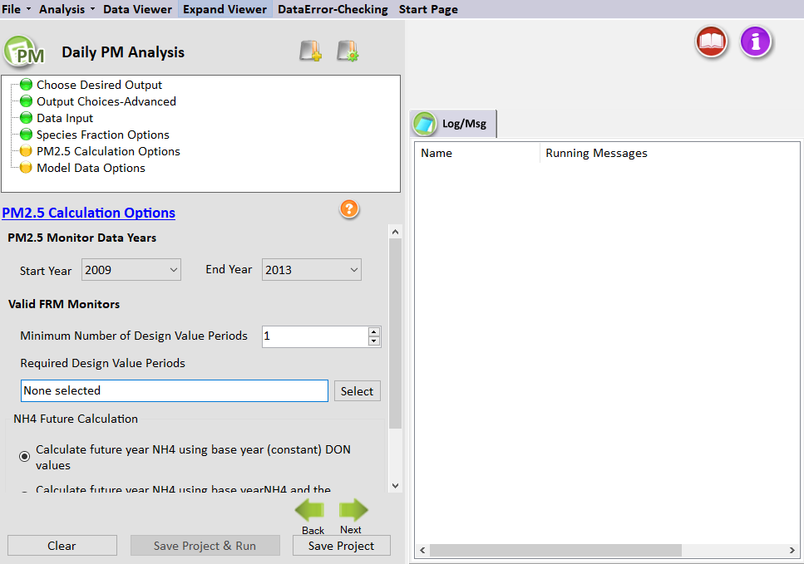
Figure 7-6. PM_{2.5} Calculation Options for Daily PM_{2.5} Analysis
The PM_{2.5} Calculation Options window shown in Figure 7-6 sets the particular years of monitor data to use from the input file specified in the Data Input window. The following options are available in this window.
PM_{2.5} Monitor Data Years
The Start Year and End Year drop-down menu options list the years of available official PM monitor data to use in the calculation of future PM_{2.5} design values. The default approach in SMAT-CE is to use five years of data.
SMAT-CE provides the option to use "official" design values, which are generally recommended, or to choose "custom" design values. The custom design values option requires the specification of the minimum number of observation days in each quarter and the minimum number of quarters to produce valid design values.
Valid FRM Monitors
By default, SMAT-CE assumes that there only needs to be one design value for a monitor to be considered valid. In addition, SMAT-CE assumes that no particular design value is required, so different monitors with different years of data could be used.
For example, a start year and end year as 2005 and 2009 gives potential 3-year design values of 2005-2007, 2006-2008, and 2007-2009. When the Minimum Number of Design Values is set to 1, one monitor could have data for, say, 2005-2007 and another monitor data for 2006-2008, and both monitors would be used. A Minimum Number of Design Values setting of 2 would only use monitors that have design values for two of the three design value periods, ignoring monitors that only have design values for a single period.
NH₄ Future Calculation
SMAT-CE can forecast NH₄ in two different ways. The default approach uses base year DON values. See Section 7.1.2.4 of the MATS User’s Manual for details on the forms of the two equations that are available to forecast NH₄.

Run the Eastern U.S. Example
Use the default settings for the PM_{2.5} Calculation Options for the Eastern U.S. example project. Either click Next or double-click the Model Data Options button in the upper left-hand panel of Daily PM Analysis window. The button next to PM_{2.5} Calculation Options will turn from yellow to green, indicating that this step is complete.

Model Data Options
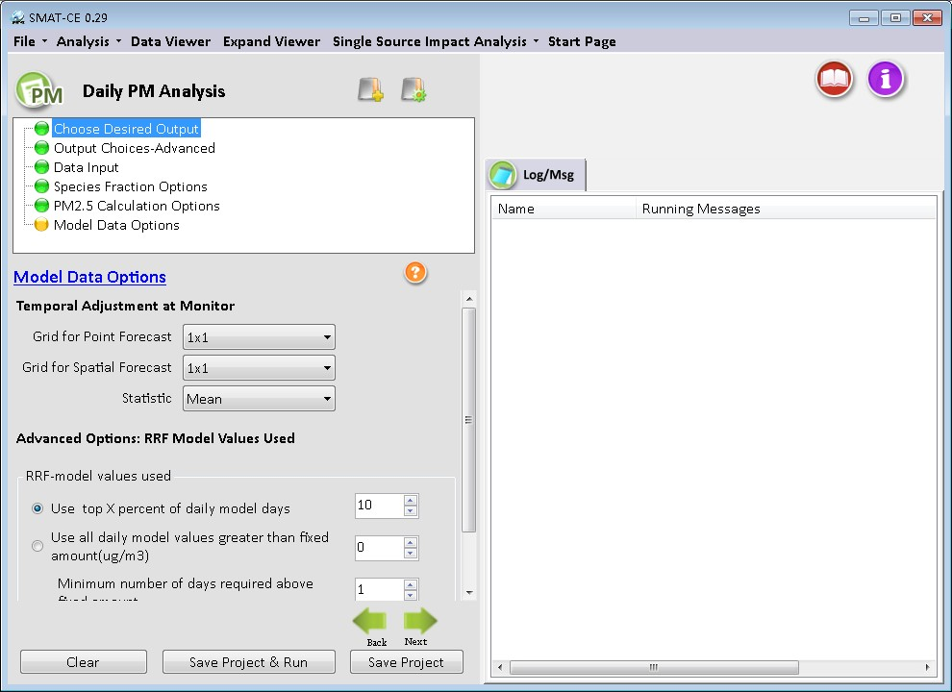
Figure 7-7. Model Data Options for Daily PM_{2.5} Analysis
The Model Data Options window shown in Figure 7-7. This window sets the temporal adjustments for each monitor:
Temporal Adjustment at Monitor
This option specifies how many model grid cells to use in the calculation of RRFs for point estimates and for spatial estimates. A drop-down menu provides options to use 1x1, 3x3, 5x5, and 7x7 arrays of model grid cells. The default for a 12-kilometer by 12-kilometer grid is to use a 3x3 array of grid cells. The U.S. EPA Draft Modeling Guidance for Attainment of Air Quality Goals for Ozone, PM_{2.5}, and Regional Haze (U.S. EPA, 2014) includes discussion on selecting the appropriate grid call array size for different model resolutions.
Note that for PM analyses, SMAT-CE calculates mean concentrations across the grid cell array (as compared to maximum concentrations used for ozone analyses).
Advanced Options: RRF Model Values Used
This option allows presents three different ways to calculate quarterly peak modeled values: (1) the top X percent of daily model days, (2) all daily model values greater than or equal to a specified amount, and (3) the top X number of model days. The three options are described in Section 7.4: Species Fractions Calculation Options–Advanced. SMAT-CE determines the peak modeled days by sorting the PM_{2.5} concentrations in the baseline model data input file.

Run the Eastern U.S. Example
Use the default settings for the Model Data Options for the Eastern U.S. example project. Either click Next, which will bring up a window prompting to “Save & Run Project” or click the Save Project & Run button at the bottom of the SMAT-CE window.
The Daily PM_{2.5} Analysis project may also be saved without running SMAT-CE by clicking the Save Project button. A file explorer window will request a filename to which the project settings will be saved to a *.proj file. This file can be loaded later to restart the analysis.
For the Eastern U.S. example, choosing to save and run the Daily PM_{2.5} Analysis project. A file explorer window will request a filename (*.proj) to which to save the project settings. While the Analysis is running, the icon next to Model Data Options will turn to a running status and status messages will be displayed in the Log & Msg tab on the right panel of the SMAT-CE main window (Figure 7-8 ).
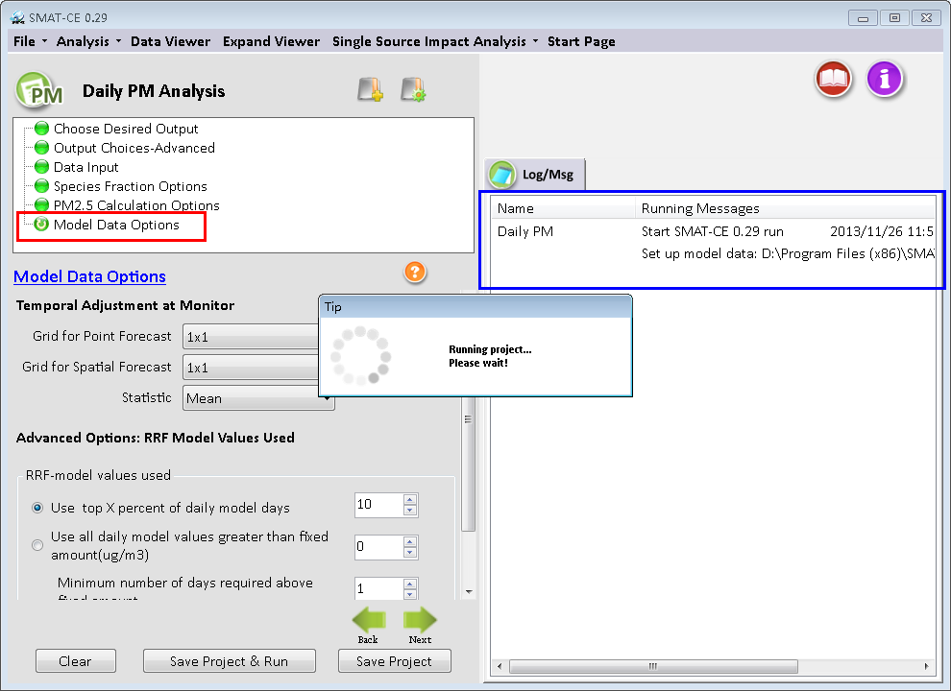
Figure 7-8. Daily PM2.5 Analysis run status
When the Daily PM_{2.5} Analysis is completed, the Data Viewer will automatically display in the SMAT-CE main window (Figure 7-9). The Output Files section of the Data Viewer left panel will display all of output files selected in the Choose Desired Output and Output Choices-Advanced Daily PM_{2.5} Analysis windows.
The Data Viewer provides options to display the Daily PM_{2.5} Analysis results as maps, bar charts, and tables. Chapter 10 describes how to load and analyze data using the SMAT-CE Data Viewer.
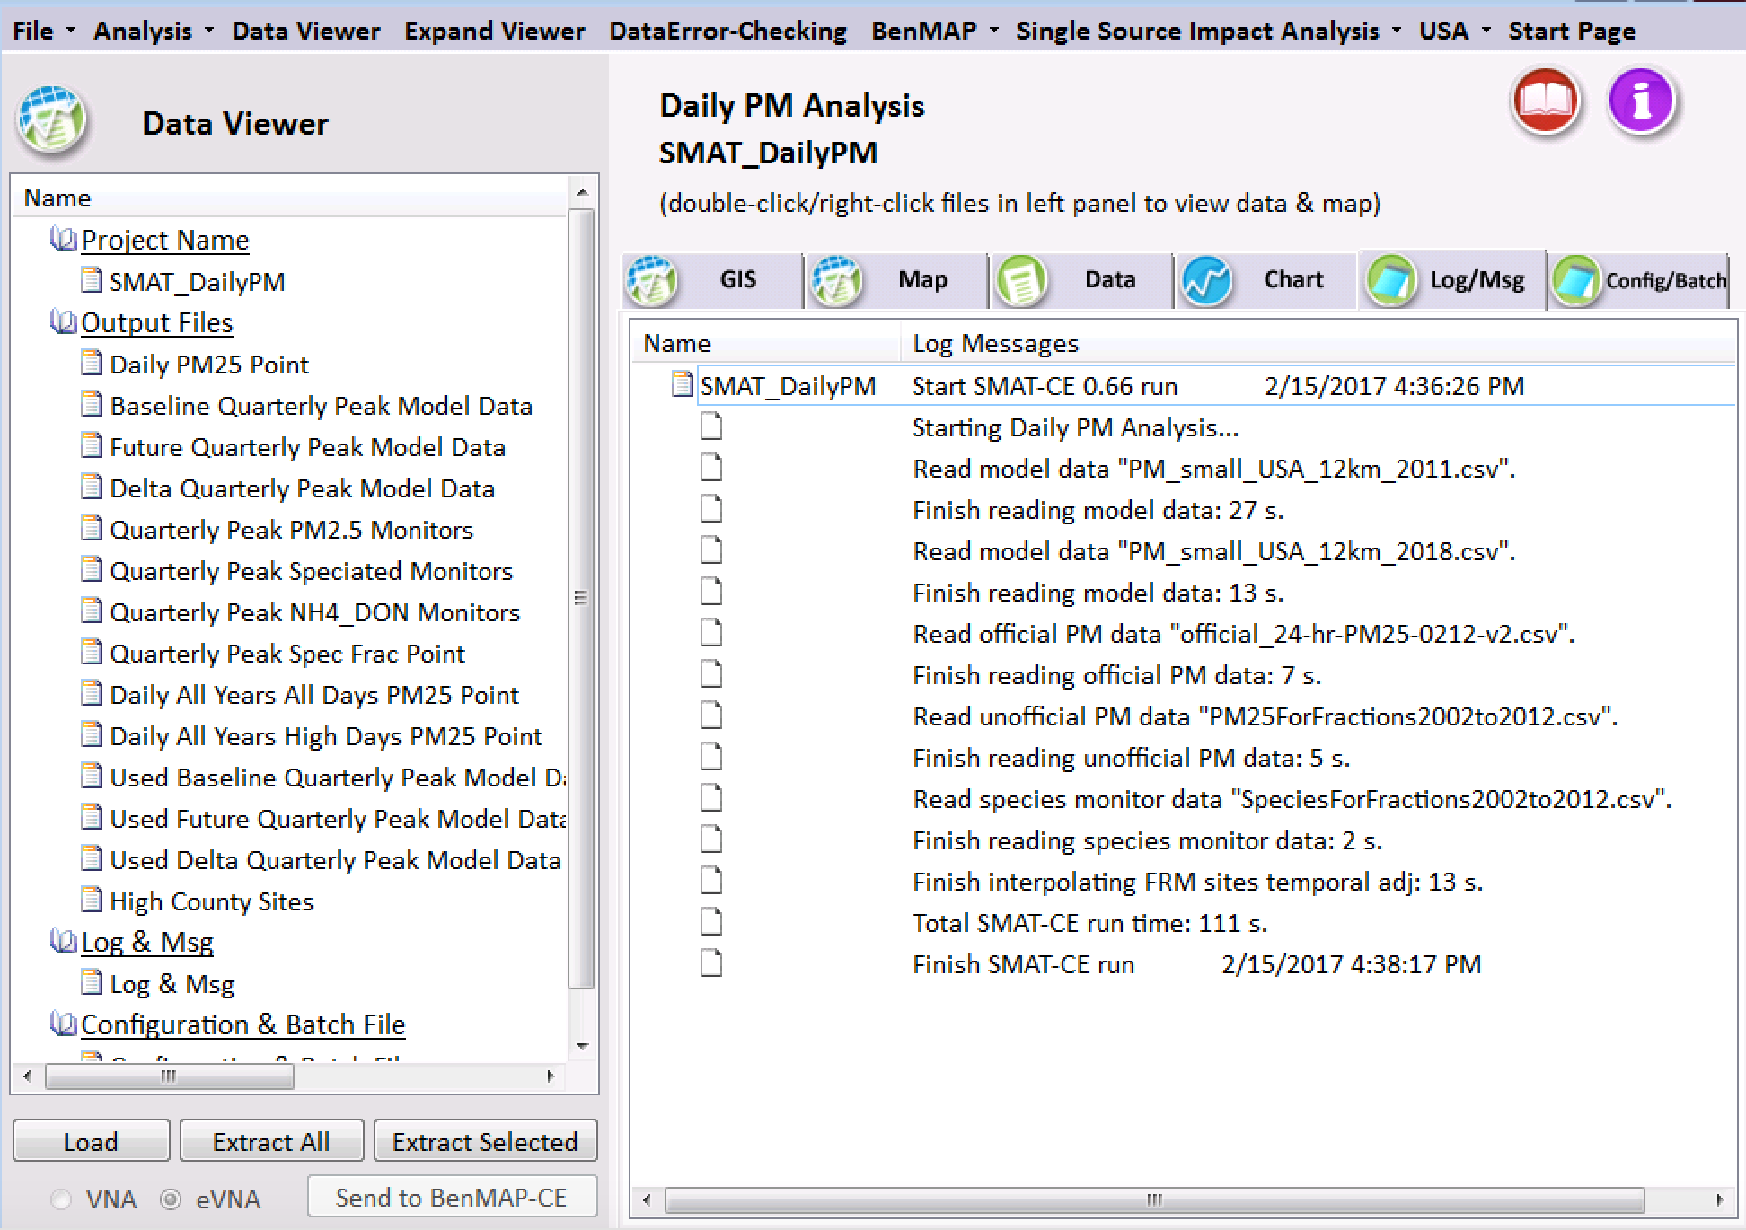
Figure 7-9. Daily PM Analysis Data Viewer
This concludes the chapter on the SMAT-CE Daily PM_{2.5} Analysis. As described in this section, details of the calculations and settings used in this analysis are available in the U.S. EPA Draft Modeling Guidance for Attainment of Air Quality Goals for Ozone, PM_{2.5}, and Regional Haze (U.S. EPA, 2014) and in Section 7 of the MATS User’s Manual (Abt, 2014).

Ozone Analysis
SMAT-CE can forecast design values at ozone monitor locations – these forecasts are referred to as Point Estimates. SMAT-CE can also use a variety of approaches to calculate design values for a Spatial Field. A Spatial Field refers to a set of values comprising calculations for each grid cell in a modeling domain from Eulerian grid models such as CMAQ and CAMx.
The Ozone Design Value Analysis in SMAT-CE is organized into four steps. The steps include the input/output and configuration options for computing ozone design values. The following four configuration steps correspond to different SMAT-CE windows and are described in detail in this chapter:
- Choose Desired Output: Select point estimates, spatial field estimates, or both.
- Data Input: Specify the air quality modeling and ambient monitoring data to use for the design value calculations. Specify which model grid cells will be used when calculating RRFs at monitor locations.
- Filtering Interpolation: Select the monitoring data years, identify valid monitors, and define the interpolation approach to use when calculating a Spatial Field.
- RRF and Spatial Gradient: Specify the daily ozone values to use in the calculation of RRFs and Spatial Gradients.
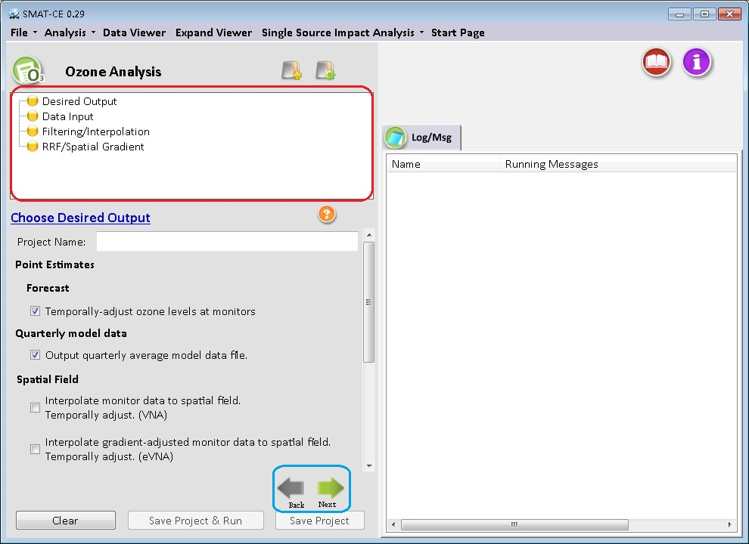
Figure 8-1. Ozone Analysis initial window
To conduct an attainment test for the ozone (O₃) NAAQS, select Ozone Analysis from the Process Data module on the SMAT-CE Start Page. Figure 8-1 shows the initial window that is displayed when Ozone Analysis is selected. The box in the upper left of the window (highlighted in red in Figure 8-1) lists the configuration steps of the Ozone Analysis. Each step listed in this box has a different set of configuration options that are displayed in the Ozone Analysis window. Once each step is successfully configured, the yellow icons next to each step in the box will change from yellow to green. In general, the configuration steps must be followed in order, from top to bottom, as they are listed in the box. Previously completed steps may be accessed and modified by double-clicking on the step name in the box. Once the configuration for a step is complete, you may move to the next step by either clicking on it or by selecting the Next button (shown in the blue box in Figure 8-1).
A previous project may be loaded, or a new project may be initiated, at any time in the Ozone Analysis window by selecting one of the icons to the right of the “Ozone Analysis” text above the red box in Figure 8-1.
Each of the Ozone Analysis configuration steps are described in the following sections.

Desired Output
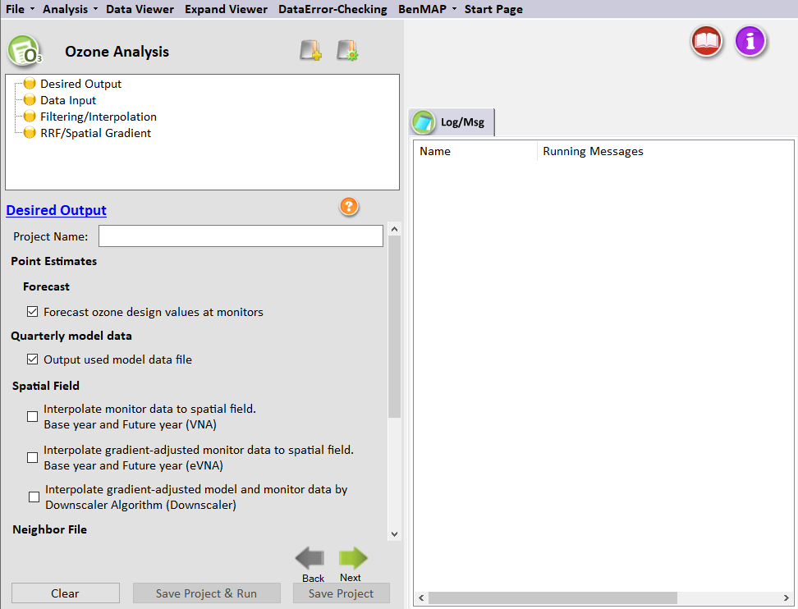
Figure 8-2. Choose Desired Output for Ozone Analysis
Choose Desired Output is the first configuration step that is displayed when the Ozone Analysis module is selected (Figure 8-2). The blue hyperlinked text in this window brings up the documentation for this configuration step. SMAT-CE supports design value calculations as Point Estimates, which refer to forecasts made at fixed
locations, such as monitors. SMAT-CE can also generate Spatial Fields, which refer to air pollution estimates made at the center of each grid cell in a specified model domain. The Spatial Field estimates can be baseline estimates or forecasts, generated with or without a gradient adjustment.
The settings in this step include:
Project Name
Text string to identify this analysis and set the name of the project file.
Point Estimates
The calculation of Point Estimates, or future-year ozone levels at monitors, has several steps. The first step is to calculate the baseline value as a function of up to three design values. The second step is to use model data to temporally adjust the baseline value. For details of these calculations see the U.S. EPA Draft Modeling Guidance for Attainment of Air Quality Goals for Ozone, PM_{2.5}, and Regional Haze (U.S. EPA, 2014).
- Baseline Ozone. The baseline ozone design value is the simple average of design values, where the average carries one significant figure to the right of the decimal point. Generally, design value years should match the modeling data being used. The EPA modeling guidance recommends using an average of the 3 design values periods which straddle the emissions base year. For example, if the modeled emissions base year is 2007, then design values from 2005-2007, 2006-2008, and 2007-2009 should be used to compute the baseline ozone. An average of design values is, in effect, a weighted average of annual averages -- 2007 is “weighted” three times, 2006 and 2008 are weighted twice, and 2005 and 2009 are weighted once. This creates a 5-year weighted average design value which is used to project future air quality levels.
The default design value years in SMAT-CE are the periods 2009-2013, which assumes a model base year of 2011.
- Temporally Adjusted Ozone. The first step in temporally adjusting baseline ozone involves identifying the model grid cells near the monitor site. Next, SMAT-CE calculates the average of daily 8-hour average maximum model values for both the baseline and future-year model runs, and then takes the ratio of the two to calculate the RRF. Finally, SMAT-CE calculates the future-year design value by multiplying the RRF with the baseline design value measured at the monitor.
The equation for temporally adjusting baseline ozone is as follows:
Monitor_{i,future} = Monitor_{i} * RRF_{i}
where:
Monitori, future = future-year ozone design value at monitor site i, measured in parts per billion (ppb)
Monitori = baseline ozone design value at monitor site i, measured in ppb
RRFi = relative response factor at monitor site i. The RRF is the ratio of the future 8-hour daily maximum concentration predicted near a monitor (averaged over multiple days) to the baseline 8-hour daily maximum concentration predicted near the monitor (averaged over the same days).
Selecting Forecast ozone design values at monitors configures SMAT-CE to generate future year design values at each monitor in the modeling domain.
Quarterly Model Data
SMAT-CE calculates and outputs quarterly averaged modeled Ozone data from daily model data input to the system. SMAT-CE requires two types of data input: ambient monitor data and gridded model output data. For the annual Ozone calculations, SMAT-CE will accept either SMAT-CE formatted daily average gridded model files or quarterly average files. If daily average model files are used as inputs, SMAT-CE will calculate quarterly averages from the daily averages and optionally output the quarterly average concentrations into text files (CSV files). The quarterly average text files can then be re-used in subsequent SMAT-CE analyses. Quarterly average input files are smaller and run faster than daily average files.
Spatial Field
A Spatial Field refers to air pollution estimates made at the center of each grid cell in a specified model domain. For example, SMAT-CE may be configured to calculate ozone design values for each grid cell in a modeling domain.
SMAT-CE calculates three types of ozone-related Spatial Fields:
- Interpolate monitor data to spatial field. Base year and Future year (VNA). This is an interpolation of baseline monitor values at each grid cell, including temporal adjustments to a specified future year. SMAT-CE identifies the "neighbor" monitors for each grid cell and then calculates an inverse-distance-weighted average of the monitor values at each grid cell. The future year forecasts are derived by multiplying the baseline spatial fields with RRFs at each monitor.
Checking this option will interpolate the data for both the base and future years. Upon selecting this option, additional selections become available to interpolate the monitor values for either the “Base only” or “Future only”.
- Interpolate gradient-adjusted monitor data to spatial field. Base year and Future year (eVNA). This is an interpolation of model-adjusted baseline monitor values at each grid cell, including temporal adjustments to a specified future year. SMAT-CE identifies the "neighbor" monitors for each grid cell, it adjusts the monitor values to account for the modeled spatial gradient, and then calculates an inverse-distance weighted average of the monitor values. The future year forecasts are derived by multiplying the gradient-adjusted baseline spatial fields with RRFs at each monitor.
Checking this option will interpolate the data for both the base and future years. Upon selecting this option, additional selections become available to interpolate the monitor values for either the “Base only” or “Future only”.
- Interpolate gradient-adjusted model and monitor data by Downscaler Algorithm (DS). The DS interpolation method is a relatively complex statistical prediction method, but DS resembles a simple linear regression model with spatially varying coefficients at a high level. DS uses Markov chain Monte Carlo (MCMC) methods with Gibbs sampling to develop a relationship between observed and modeled concentrations, and then use the relationship to predict concentrations at points in the spatial domain.
Checking this option will interpolate the data for both the base and future years. Upon selecting this option, additional selections become available to interpolate the monitor values for either the “Base only” or “Future only”.
Selecting each of the interpolation options to produce additional configure
Details of the interpolation calculations are available in Section 9.1.3 of the MATS User’s Manual (Abt, 2014).
Neighbor File
Selecting “Spatial Field” directs SMAT-CE to produce files of “nearest neighbor” data for the VNA interpolation scheme. The data include the distance to neighbor monitors and weights used to do the interpolations. This option will generate information for each monitor (for point analyses) or each grid cell (for spatial fields) for each quarter and for each species.
Actions on Run Completion
Checking the “Automatically Extract All Selected Output Files” box will export CSV files of all selected output to a separate folder named with the Project Name in the SMAT "\Result\Output" folder. The results may also be exported later from the Data Viewer.
Design Value Periods
Normally, SMAT-CE will output one set of files covering the entire analysis period specified by the user. The outputs represent the averages of the values for each 3-year design value period. If the "Output all design value periods" option is checked, SMAT-CE will produce discrete outputs for each design value period. The output files will include a period identifier (e.g., "Period 1", "Period 2") inserted into the file name. Checking this option will increase the SMAT-CE run time by up to four times.
Base & Future Design Values
The maximum design values are based on the highest future year value from the three design value periods. These values can be output by checking the "Output Max Design Values" option. The output file will include “maximum forecast” inserted into the file name.

Run the Eastern U.S. Example
Use the default settings for these options for the Eastern U.S. example project. Either click Next or double-click the Data Input button in the upper left-hand panel of the Ozone Analysis window. The button next to Desired Output will turn from yellow to green, indicating that this step is complete.

Data Input
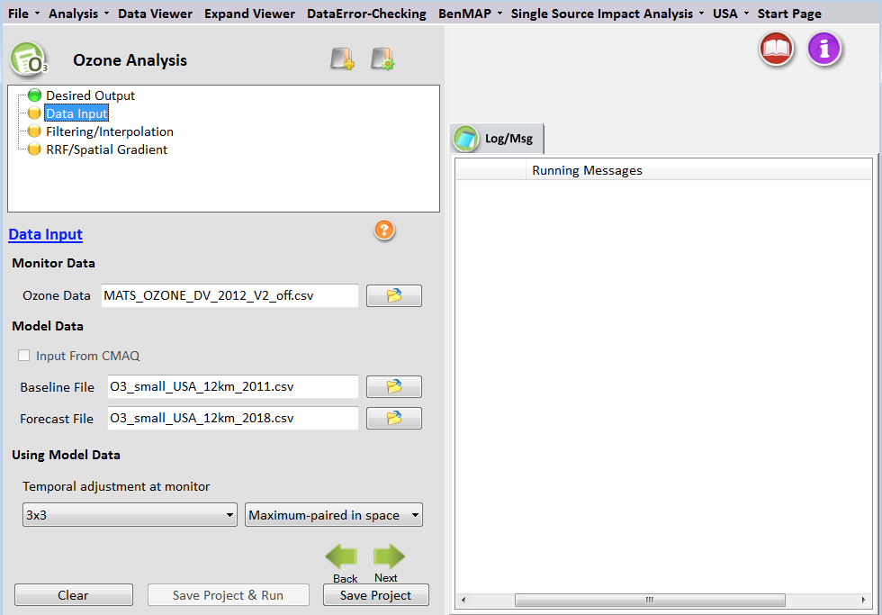
Figure 8-3. Data Input for Ozone Analysis
The Data Input configuration step sets the ambient ozone monitor data and the gridded model output data to use for the SMAT-CE project (Figure 8-3). This step also sets the model grid cells to use for calculating RRFs at the monitor locations.
SMAT-CE is pre-loaded with ozone design values at U.S. monitors for the period from 2002-2020. It is also distributed with example ozone model data for 2001 and 2018.
The blue hyperlinked text in this window brings up the documentation for this configuration step. The settings in this step include:
Monitor Data
Monitor data should be in the form of a simple text file. The first row specifies the nature or frequency of the data (e.g., Design Value or Day). The second row presents comma-separated variable names. The third row begins the data values. The table below shows the format of the ozone monitor data for input to SMAT-CE.

Table 8-1. Ozone monitor data format
Variable | Description
_ID | The ID is a unique name for each monitor in a particular location. The default value is the AIRS ID. (This is a character variable.)
_TYPE | Leave this blank.
LAT | Latitude in decimal degrees. Values in the northern hemisphere are positive, and those in the southern hemisphere are negative
LONG | Longitude in decimal degrees. Values in the eastern hemisphere are positive, and those in the western hemisphere (e.g., United States) are negative.
DATE | The time period of the monitor observation. As a convention, the date represents the last year of the 3-year design value period (e.g., 2001 represents the 1999-2001 design value).
O3 | Observed monitor value. Note that missing values are represented by a minus nine (-9).
_STATE_NAME | State name. (This is a character variable.)
_COUNTY_NAME | County name. (This is a character variable.)

Model Data
SMAT-CE requires model data in the form of a text file. A forthcoming feature will support reading CMAQ output files directly; the Input from CMAQ option is currently greyed out in SMAT-CE. To compute RRFs and future year design values, SMAT-CE requires text files of Baseline and Forecast (future) ozone concentrations. The first row of these text files specifies the frequency of the data (e.g., Day or Hour). The second row presents comma-separated variable names. The third row begins with the data values. For design value calculations, the ozone model data must be daily 8-hour average maximum concentrations in each grid cell. lists the file format and descriptions of the variables in the ozone model data file.
Table 8-2. Ozone modeling data format
Variable | Description
_ID | The ID is a unique number for each model grid cell in the air quality model domain. It is generally based on the column and row identifiers from the air quality modeling domain. The default convention is to calculate the ID by multiplying the column identifier by one thousand (1000) and adding the row identifier. (This is a character variable.)
_TYPE | Leave this blank.
LAT | Latitude in decimal degrees. Values in the northern hemisphere are positive, and those in the southern hemisphere are negative.
LONG | Longitude in decimal degrees. Values in the eastern hemisphere are positive, and those in the western hemisphere (e.g., United States) are negative.
DATE | The time period of the monitor observation. As a convention, the date represents the last year of the 3-year design value period (e.g., 2001 represents the 1999-2001 design value).
O3 | Modeled ozone concentration in the form of an 8-hour average daily maximum. Note that missing values are represented by a minus nine (-9).

Using Model Data
The RRF for a monitor is calculated from "nearby" model grid cells. For purposes of this calculation, a monitor is assumed to be at the center of the cell in which it is located, and this cell is at the center of an array of “nearby” cells. The number of cells considered “nearby” a monitor is a function of the size of the grid cells used in the modeling. In the example case of a 12-kilometer grid, EPA uses a default 3x3 array of grid cells. See the U.S. EPA Draft Modeling Guidance for Attainment of Air Quality Goals for Ozone, PM_{2.5}, and Regional Haze (U.S. EPA, 2014) for details on how model data arrays are used in the design value calculation.
With the array size determined, SMAT-CE provides three options for how the modeling data are extracted from array:
- Maximum. For each day of modeling data, SMAT-CE will identify the highest 8-hour daily maximum among the grid cells in the chosen array. In the case of a 3x3 array, SMAT-CE will identify the highest daily 8-hour average maximum from among the nine “nearby” grid cells for each day and for each monitor site.
- Mean. For each day of modeling data, SMAT-CE will average the 8-hour daily values for the grid cells in the chosen array. In the case of a 3x3 array, SMAT-CE will average nine values.
- Maximum-paired in space. For each day of modeling data, SMAT-CE will identify the grid cell with the highest 8-hour daily maximum in the chosen array in the baseline file and calculate the RRF using the same grid cell in the control file.
The default choice for the ozone analysis in SMAT-CE is to use the maximum-paired in space option to calculate temporally-adjusted ozone concentrations at each monitor.
For monitors located on the border of a modeling domain where it may not be possible to have a full array of grid cells, SMAT-CE uses as much available modeling data as possible to fill the array.
See section 9.2.3.1 of the SMAT-CE User’s Manual (Abt, 2014) for examples of how the matrix of grid cells are used to compute RRFs and ozone design values.

Run the Eastern U.S. Example
Use the default settings for these options for the Eastern U.S. example project. Either click Next or double-click the Filtering/Interpolation button in the upper left-hand panel of the Ozone Analysis window. The button next to Data Input will turn from yellow to green, indicating that this step is complete.

Filtering/Interpolation
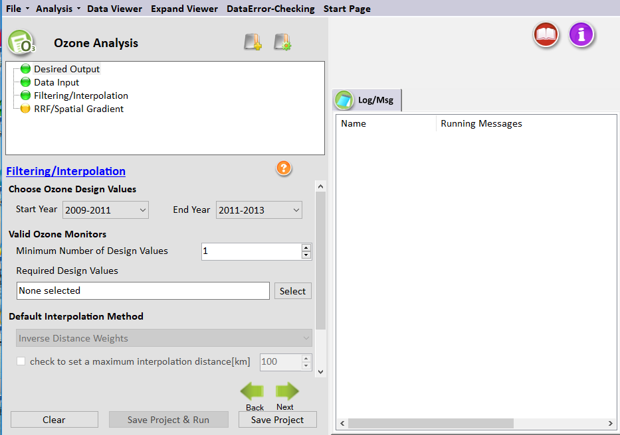
Figure 8-4. Filtering/Interpolation for Ozone Analysis
The Filtering and Interpolation window (Figure 8-4) identifies the years of monitor data to use for calculating RRFs, sets the monitors to use in the analysis, and specifies the interpolation method to use when calculating spatial fields.
The blue hyperlinked text in this window brings up the documentation for this configuration step. The settings in this step include:
Choose Ozone Design Values
Setting the Start Year and the End Year defines the range of the ozone design values that will be used in the calculation of the baseline ozone level. You can vary the number of design values used in this calculation. The default in SMAT-CE is to use a 5-year design value period (three design values) centered on the 2011 base year. A base year of 2011 uses the following design value periods: 2009-2011, 2010-2012, and 2011-2013. The Start Year is set to 2009-2011 and the End Year is set to 2011-2013.
Valid Ozone Monitors
MATS provides two choices for identifying monitors that are "valid" and thus included in your analysis:
- Minimum Number of Design Values. Specifies the minimum number of design value periods that need to be included in the calculation of the baseline ozone design value (1, 2, or 3). The default option is to require the one design value be available in the specified range of dates.
- Required Design Values. Specifies whether a particular design value period needs to be valid for the calculations to be performed at that monitor. The default option is None Selected.
Default Interpolation Method
The Default Interpolation Method sets the interpolation method to use for combining the values from different monitors. One approach is to use Inverse Distance Weights such that the weight given to any particular monitor is inversely proportional to its distance from the point of interest. A second approach is Inverse Distance Squared Weights, in which the weights are inversely proportional to the square of the distance. And the third approach is Equal Weighting of Monitors. The default approach for ozone is Inverse Distance Weights.
The first step in the interpolation process is to identify the monitors that are nearby, or neighbors, for each point of interest. The next step is to determine the distance from the nearby monitors to the point of interest. The default approach in SMAT-CE is to include all valid monitors (i.e., those that satisfy the two criteria under Valid Ozone Monitors), regardless of distance. If you want to limit the use of monitors based on distance, select “Check to Set a Maximum Interpolation Distance,” and then specify a distance (in kilometers). A distance of 100 kilometers means that any monitors more than 100 kilometers from the point of interest can no longer be used in the interpolation. If a point of interest has no monitors within the specified distance, then no value is calculated. The default is to leave this box unchecked.
The interpolation method option is only used when generating estimates for Spatial Field. Since the ozone analysis only uses point estimates, the interpolation method is not active.

Run the Eastern U.S. Example
Use the default settings for these options for the Eastern U.S. example project. Either click Next or double-click the RRF/Spatial Gradient button in the upper left-hand panel of the Ozone Analysis window. The button next to Data Input will turn from yellow to green, indicating that this step is complete.

RRF/Spatial Gradient
In calculating an ozone RRF or a Spatial Gradient not all of the model data are typically used. In the case of RRFs, daily values falling below specified thresholds can be excluded from the calculation. In the case of a spatial gradient, SMAT-CE may be setup to follow the same thresholds as used for point estimates. If a valid result is needed in all grid cells a Backstop minimum threshold can be used. A sub-range of days to be included in the RRF calculation may also be specified along with whether to pair the days by high concentration rather than by date. SMAT-CE can also average a user-specified range of values to calculate gradient adjustments.
The blue hyperlinked text in this window brings up the documentation for this configuration step. The settings in this step include:
RRF Setup
The RRF Setup involves four variables that specify the thresholds and the numbers of days above the thresholds – Initial threshold value; Minimum number of days in baseline at or above threshold; Minimum allowable threshold value; and Min number of days at or above minimum allowable threshold.
The first step in calculating the RRF is to determine the days to use in the RRF calculation. Select to either use the highest concentration days (i.e., a specified number of highest ozone days) or the number of days above a concentration threshold. If the number of days is above the Minimum number of days in baseline at or above threshold, then SMAT-CE averages the 8-hour values for those grid cells with at least this concentration.
SMAT-CE performs the following steps in calculating RRFs:
- In the case of a 3x3 array, SMAT-CE identifies the highest daily 8-hour average maximum from among the nine “nearby” grid cells for each day and for each monitor site. In the case where there are 90 days of model outputs, SMAT-CE generates 90 daily values.
SMAT-CE can do this calculation separately for the baseline and future-year scenarios. If you chose an option other than “Maximum – paired in space” under the Data Input menu, two different grid cells in the baseline and future-year might be used to represent a given day.
- If the Top X modeled ozone days option is selected, SMAT-CE will select the specified number of days based on their ranking by value and date. If there are fewer days above the minimum allowable threshold than specified, then the monitor site will be dropped. Otherwise, the selected days will be used in computing the RRF.
- If the Initial threshold value option is selected, SMAT-CE will find the days with concentrations above the specified threshold and average the concentrations across all of the selected days. The Minimum number of days in baseline at or above threshold setting is used to set the minimum number days required for a valid calculation. If SMAT-CE does not find the minimum number of days above the specified threshold, it will lower the threshold concentration by 1 ppb to try to meet the minimum number of day criterion. SMAT-CE will iterate on this approach until the minimum number of days is met.
- The default Minimum allowable threshold value in SMAT-CE is 60 ppb. If there are fewer days with concentrations above this threshold value than is set by the Min number of days at or above minimum allowable threshold, then the monitor site will be dropped from the RRF calculations. The SMAT-CE default setting for the Min number of days at or above minimum allowable threshold is 5.
SMAT-CE checks the daily 8-hour maxima calculated for the baseline scenario and sets to missing any daily value falling below the minimum allowable concentration threshold. For all days set to missing in the baseline scenario, SMAT-CE also sets the corresponding day in the future-year scenario to missing.
- By enabling the Backstop minimum threshold for spatial fields, a lower bound concentration is set for the iterative lowering of the minimum concentration when SMAT-CE is trying to meet the minimum number of days criteria in the RRF calculation. The backstop threshold is only used for grid cells which do not have enough days above the minimum allowable threshold concentration to meet the minimum number of days criteria. The backstop threshold does not change the calculation for grid cells that already meet the minimum number of days.
- SMAT-CE also supports using date ranges to define an ozone season to use for RRF calculations. The Subrange first day of ozone season used in RRF and Subrange last day of ozone season used in RRF set the start day and end day of the subrange based on a count of the number of days from the first day in the modeled ozone concentration file. For example, if the model files contained data for June 1 through August 30, a subrange start and end day of "31" and "61" respectively would specify the period for July 1 through July 31.
- The Pair days based on high concentration instead of date option is available for simulations in which the future year meteorology is different than the base year (such as climate modeling). SMAT-CE will pair the future year highest concentrations with the highest concentrations in the base year file, regardless of date. The number of days in the RRF will continue to be based on the threshold variables. For example, if eleven days are greater than the selected threshold in the base year, then the RRF will be calculated based on the eleven highest base and future year concentration days.
- For each monitor site, SMAT-CE averages the non-missing daily values for the baseline and future-year scenarios, and then calculates the RRF as the ratio of the future-year average concentration to the baseline average concentration.
Spatial Gradient Setup
In using a spatial gradient to estimate ozone levels, SMAT-CE estimates ozone levels in unmonitored locations by using the values of nearby monitored data scaled by a ratio of model values. The ratio, or spatial gradient, is a mean of model values at the unmonitored location over the mean of the model values at a monitor.
Note that several "nearby" monitors (and their associated model values) are used in the calculation of ozone values at an unmonitored location. SMAT-CE uses a process called Voronoi Neighbor Averaging (VNA) to identify these neighbors, and then takes an inverse distance-weighted average of these monitors.
SMAT-CE sorts the daily 8-hour maximum ozone values from high to low, averages a certain number of these values (by default the top five), and then uses these averages in the calculation of the spatial gradient. Note that the highest days for Cell A and Cell E are determined independently of each other.
To select a different set of days for the gradient adjustment, set the Start Value and End Value. SMAT-CE assigns an index value of 1 to the highest daily 8-hour maximum ozone value in each grid cell, the second highest an index value of 2, etc. Use the Start Value and the End Value to identify the values to average by using these indices.
Since point estimates are currently only available for ozone design values in SMAT-CE, the Spatial Gradient Setup option is not active.
Detailed examples of the RRF calculations are available in Section 9.4.1 of the MATS User’s Manual (Abt, 2014).

Run the Eastern U.S. Example
Use the default settings for the RRF/Spatial Gradient options for the Eastern U.S. example project. Either click Next, which will bring up a window prompting to “Save & Run Project” or click the Save Project & Run button at the bottom of the SMAT-CE window.
The Ozone Analysis project may also be saved without running SMAT-CE by clicking the Save Project button. A file explorer window will request a filename to which the project settings will be saved to a *.proj file. This file can be loaded later to restart the analysis.
For the Eastern U.S. example, select save and run for the Ozone Analysis project. A file explorer window will request a filename (*.proj) to which to save the project settings. While the Analysis is running, the icon next to Model Data Options will turn to a running status and status messages will be displayed in the Log & Msg tab on the right panel of the SMAT-CE main window (Figure 8-5).

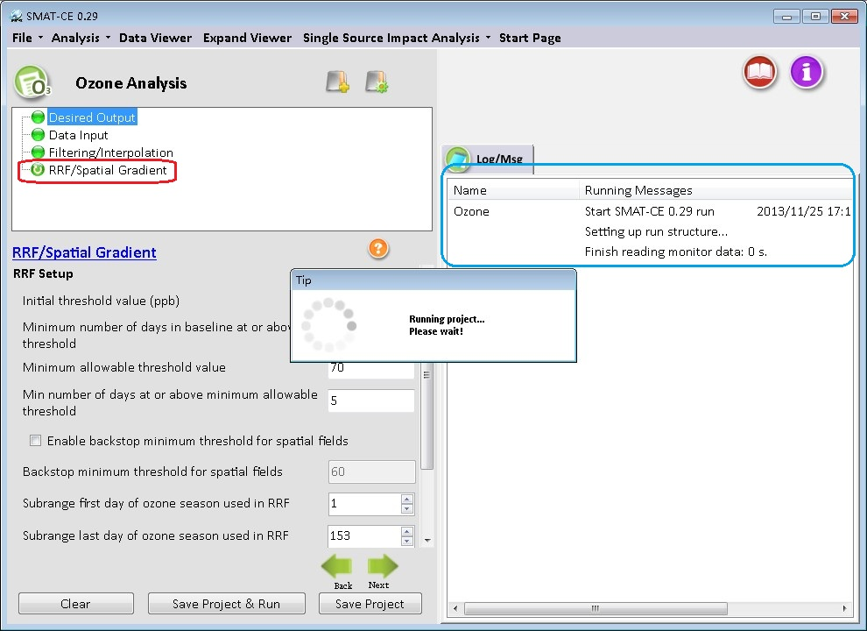
Figure 8-5. Ozone Analysis run status
When the Ozone Analysis is completed, the Data Viewer will automatically display in the SMAT-CE main window (Figure 8-6). The Output Files section of the Data Viewer left panel will display all of output files selected in the Desired Output Ozone Analysis window.
The Data Viewer provides options to display the Ozone Analysis results as maps, bar charts, and tables. Chapter 10 describes how to load and analyze data using the SMAT-CE Data Viewer.
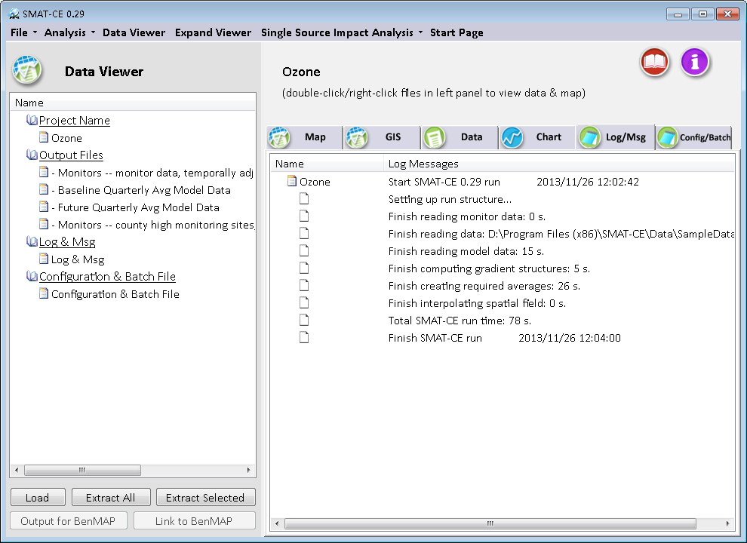
Figure 8-6.Ozone Analysis data viewer
This concludes the chapter on the SMAT-CE Ozone Analysis. As described in this section, details of the calculations and settings used in this analysis are available in the U.S. EPA Draft Modeling Guidance for Attainment of Air Quality Goals for Ozone, PM_{2.5}, and Regional Haze (U.S. EPA, 2014) and in Chapter 9 of the MATS User’s Manual (Abt, 2014).

Visibility Analysis
SMAT-CE can calculate baseline and future-year visibility levels for the best and worst days for Class I Areas – these estimates are referred to as Point Estimates, as they refer to particular locations.
The Visibility Analysis in SMAT-CE is organized into three steps. The steps include the input/output and configuration options for conducting visibility analysis. The following configuration steps correspond to different SMAT-CE windows and are described in detail in this chapter:
- Choose Desired Output: Select whether to calculate Point Estimates at IMPROVE monitors or at Class I Area centroids and whether to use the old or new version of the IMPROVE visibility equation.
- Data Input: Specify the air modeling and monitoring data that you want to use. Specify which model grid cells will be used when calculating RRFs at monitor locations.
- Filtering: Choose the years of monitoring data. Identify valid monitors.

Refer to the EPA Visibility and Regional Haze webpage for the latest guidance and data related to Visibility Analysis.

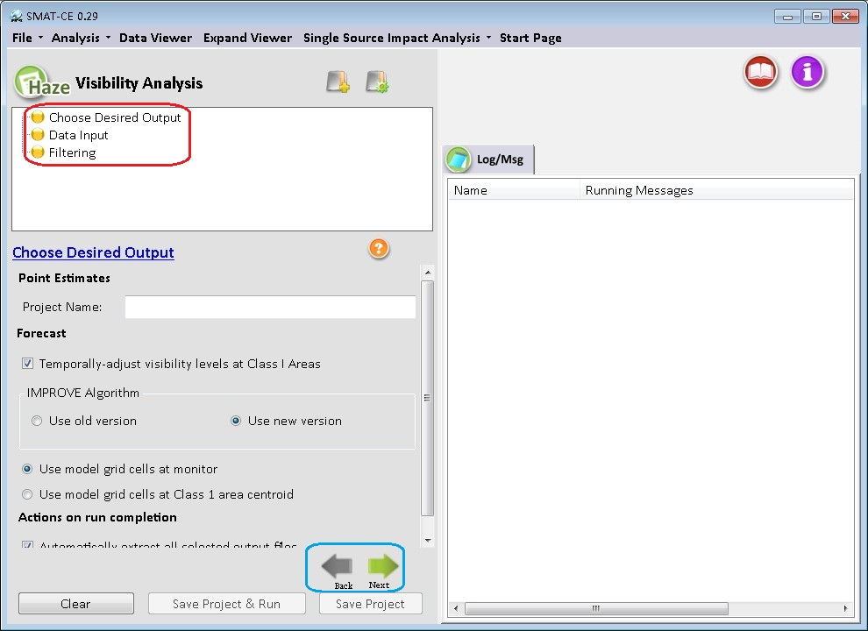
Figure 9-1. Visibility Analysis initial window
To conduct a visibility analysis, select Visibility Analysis from the Process Data module on the SMAT-CE Start Page. Figure 9-1 shows the initial window that is displayed when Visibility Analysis is selected. The box in the upper left of the window lists the configuration steps of the Visibility Analysis. Each step listed in this box has a different set of configuration options that are displayed in the Visibility Analysis window. Once each step is successfully configured, the icons next to each step in the box will change from yellow to green. In general, the configuration steps must be followed in order, from top to bottom, as they are listed in the box. Previously completed steps may be accessed and modified by double-clicking on the step name in the box. Once the configuration for a step is complete, you may move to the next step by either clicking on it or by selecting the Next button.
A previous project may be loaded, or a new project may be initiated, at any time in the Visibility Analysis window by selecting one of the icons to the right of the “Visibility Analysis” text shown in Figure 9-1.
Each of the Visibility Analysis configuration steps are described in the following sections.

Choose Desired Output
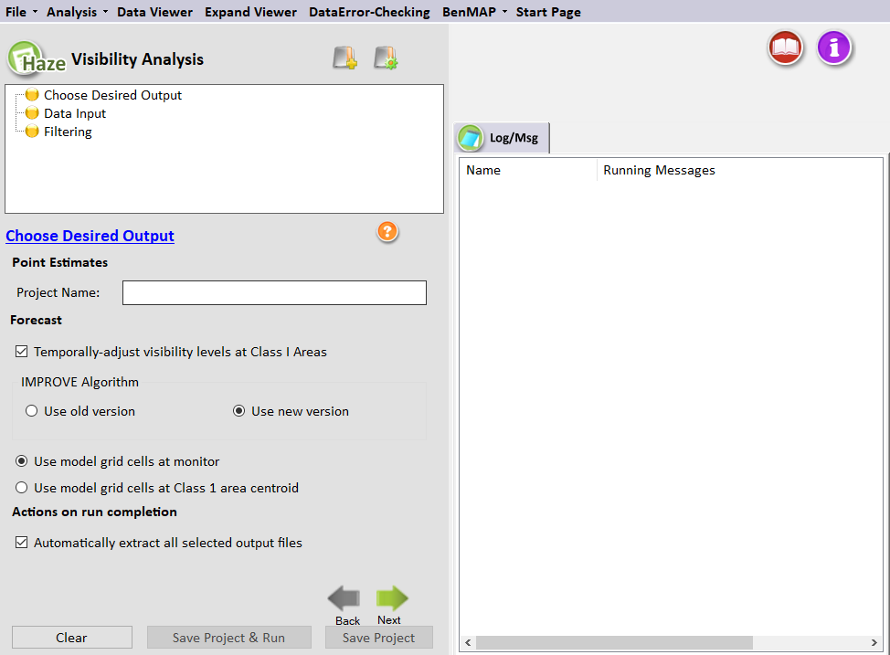
Figure 9-2. Choose Desired Output for Visibility Analysis
Choose Desired Output is the first configuration step that is displayed when the Visibility Analysis module is selected (Figure 9-2). The blue hyperlinked text in this window brings up the documentation for this configuration step. The settings in this step include:

Project Name
Text string to identify this analysis and set the name of the project file.

Forecast
SMAT-CE supports to use the "Use old version" or "Use new version" of the IMPROVE Algorithm (IMPROVE,2006), which SMAT uses to translate PM levels (measured in ug/m3) to visibility levels (measured in extinction or deciviews). Note that "Use old version" of the IMPROVE Algorithm is still under development.
SMAT-CE includes two options for how model data are selected for the visibility RRF calculation. When forecasting visibility, SMAT-CE can calculate RRFs from model data at either the grid cell containing the monitor or at the centroid of the Class I Area.
Monitors assigned to represent a Class I Area are generally close to the Class I Area. However, in some cases, this distance can be substantial. For example, the YELL2 monitor in Wyoming (44.5653 latitude, -110.4002 longitude) is located more than a degree longitude away from the Red Rocks Lake Class I Area (44.64 latitude, -111.78 longitude). By default, SMAT-CE uses model data at the monitor.
SMAT-CE produces a forecast of visibility in Class I Areas through the following steps:
- Identify best & worst visibility monitor days in Base Model Year. Use monitored total extinction data from a user-specified year to identify the 20% best (B20) and 20% worst (W20) visibility days at each Class I area. At this stage SMAT-CE is using extinction values (measured in Mm⁻¹). By the end of this series of calculations, SMAT-CE will convert these extinction visibility measures to deciviews.
Note that you specify the particular year, the Base Model Year, from the available monitoring data in the Filtering window. SMAT-CE labels the year of monitoring data as the Base Model Year because this particular year of monitor data matches the baseline model data, specified in the Data Input window.
- Average best & worst baseline model days. Using baseline speciated model data (specified in the Data Input window), average the B20 visibility days and then average the W20 visibility days at each Class I areas (matched with the ambient data). The model data comes into SMAT-CE as speciated values with units in ug/m³. These data are averaged to produce speciated baseline concentrations for the B20 and W20 days with units of ug/m³.
- Average best & worst forecast model days. Calculate these same averages for the forecast model data (specified in the Data Input window). Identify the same B20 and W20 days from the model results and then average the speciated model data (reported in ug/m³). These data are averaged to produce speciated forecast (future) concentrations for the B20 and W20 days with units of ug/m³.
- Calculate RRFs. Use the speciated B20 and W20 averages from the baseline and forecast model data to calculate B20 and W20 RRFs for each species at each Class I area. The B20 RRF is simply the ratio of the baseline B20 average to the forecast B20 average. The result of this step will be two unitless RRFs for each species at each Class I area.
- Identify best & worst visibility days in other monitored years. Using the monitored total extinction, identify the B20 visibility days and the W20 visibility days from the other available years of monitoring data. The default in SMAT-CE is that there should be at least three valid years and one of those years should be the base modeling year (the base meteorological year). (Monitor validity is discussed further in the section on the Visibility Analysis Filtering window.)
Note that the B20 days will occur on a different set of days for each year; similarly, the W20 days will occur on a different set of days for each year.
- Multiply RRFs with speciated monitor data from each year. Multiply the species specific B20 RRF (unitless) with the B20 daily speciated monitor values (measured in ug/m³) from each of the available years. Do analogous calculations for the W20 days.
Note that the RRF is based on best/worst days identified from the base model year. This same "Base Model Year" RRF is used with all of the valid monitor years. For example, if the Base Model Year is 2001, then the RRF developed from 2001 modeling data will be applied to all valid monitoring data in the 5-year period surrounding the model year.
- Convert ug/m³ values to daily extinction values and sum to get total extinction. For each day in each valid monitor year (for both the baseline and forecast), use either the new or old IMPROVE equation to estimate daily total extinction (measured in Mm⁻¹). After this calculation, there will be a set of total extinction values for B20 and W20 days in each valid year for both the baseline and the forecast.
- Convert extinction to deciviews. For each valid year in both the baseline and forecast, convert the B20 and W20 daily averages from Mm⁻¹ to deciviews. The formula for this conversion is as follows:
Deciviews = 10*ln(extinction/10)
- Average daily B20 days and W20 days. For each valid year, average the daily deciview values from the B20 visibility days and calculate the same average for the W20 visibility days. There will be up to five “best” averages and “worst” total visibility measures (measured in deciviews) for both the baseline and the forecast.
- Calculate final average. Average the valid B20 and W20 yearly visibility measures. The final result will be a single “best” value and a single “worst” deciview estimate at each Class I Area for both the baseline and forecast.

"Use new version" of the IMPROVE Algorithm:
The "Use new version" of the IMPROVE algorithm has a number of additional terms, in relation to the Old IMPROVE equation. In particular, it considers the different effects of small and large sulfate, nitrate, and organic carbon particles. A separate equation defining small and large is given below:
bext = 2.2*fs(RH)*[SMALL_AMM_SO4] + 4.8*fl(RH)*[LARGE_AMM_SO4]
+ 2.4*fs(RH)*[SMALL_AMM_NO3] + 5.1*fl(RH)*[LARGE_AMM_NO3]
+ 2.8*[SMALL_OMC] + 6.1*[LARGE_OMC]
+ 10*EC
+ CRUSTAL
+ 0.6*CM
+ SS_RAYLEIGH
+ 1.7*fss(RH)*SEA_SALT
+ 0.33*NO2.
where:
bext = total extinction (measured in inverse megameters)
fs(RH) = term to account for enhancement of light scattering due to hydroscopic growth of small ammonium nitrate and ammonium sulfate (unitless)
fl(RH) = term to account for enhancement of light scattering due to hydroscopic growth of large ammonium nitrate and ammonium sulfate (unitless)
SMALL_AMM_SO4 = small ammonium sulfate (ug/m3)
LARGE_AMM_SO4 = large ammonium sulfate (ug/m3)
SMALL_AMM_NO3 = small ammonium nitrate (ug/m3)
LARGE_AMM_NO3 = large ammonium nitrate (ug/m3)
SMALL_OMC = small organic carbon mass (ug/m3) (OC*1.8)
LARGE_OMC = large organic carbon mass (ug/m3) (OC*1.8)
EC = elemental carbon (ug/m3)
CRUSTAL = fine soil (ug/m3)
CM = coarse particulate matter (ug/m3)
SS_RAYLEIGH = Site-specific Rayleigh scattering (inverse megameters)
fss(RH) = term to account for enhancement of light scattering due to hydroscopic growth of sea salt (unitless)
SEA_SALT = Sea salt (ug/m3)
NO2 = Nitrogen dioxide levels (parts per billion). This term is assumed to be zero.
The apportionment of the total concentration of sulfate compounds into the concentrations of the small and large size fractions is accomplished using the following equations:
[Large Sulfate] = [Total Sulfate]/20ug/m³ x [Total Sulfate], for [Total Sulfate] < 20
ug/m³
[Large Sulfate] = [Total Sulfate], for [Total Sulfate] >= 20 ug/m³
[Small Sulfate] = [Total Sulfate] - [Large Sulfate]
The same equations are used to apportion total nitrate and total organic mass concentrations into the small and large size fractions.

Example Calculation New IMPROVE Algorithm
The first column "bext" presents the calculated value given the following data.
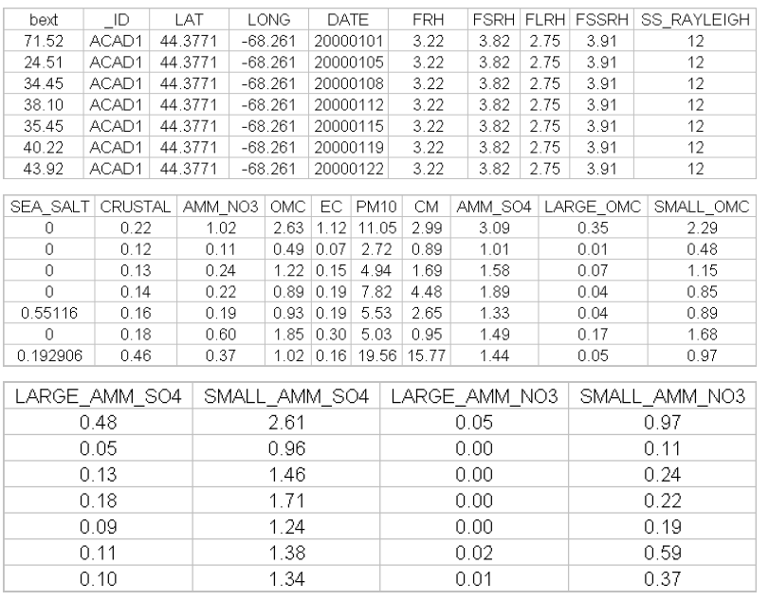
Figure 9-3. Calculation Data Example
Additional details of the visibility forecasting approach using by SMAT-CE, including the forms of the new and old IMPROVE equations, are available in the U.S. EPA Draft Modeling Guidance for Attainment of Air Quality Goals for Ozone, PM_{2.5}, and Regional Haze (U.S. EPA, 2014) and in Section 11.1.2 of the MATS User’s Manual (Abt, 2014).

Actions on Run Completion
By checking “Automatically Extract All Selected Output Files,” SMAT-CE will generate the following five output files:
- Visibility forecast (average of design values). (Up to) 5-year average of forecasted and base-year average visibility. When Use model grid cells at monitor is selected, the name of this output file is "Forecasted Visibility Data.csv" with the Scenario Name appended at the beginning. When Use model grid cells at Class 1 area centroid is selected the name of this output file is "Forecasted Visibility Data for Class 1 Areas.csv" plus the Scenario Name.
- Visibility forecast (all design values). Forecasted and base-year values for individual years. The name of this file is "Forecasted Visibility – all design values.csv" plus the Scenario Name.
- Class I areas and the monitors. The list of all of the Class I areas and the monitors assigned to each. The name of this file is "Class 1 Area and IMPROVE Monitor Identifiers and Locations.csv" plus the Scenario Name.
- Base-year model data. The base year model values for PM species for the grid cells and days used in the RRF calculations. The name of this file is: "Used Model Grid Cells – Base Data.csv" plus the Scenario Name.
- Future-year model data. This future year model values for PM species for the grid cells and days used in the RRF calculations. The name of this file is: "Used Model Grid Cells - Future Data.csv" plus the Scenario Name.

Visibility Output Variable Description

Forecasted Visibility Data.csv (average of design values)
The table below describes the variables in the output file. The first row specifies the frequency of the data (e.g., Year). The second row presents comma-separated variable names. The third row begins the data values. Note that the output data includes a large number of variables, so in the sample output below we have divided the variables into two blocks. In a file actually generated by SMAT-CE, these two blocks would be combined. Note also that the variables output by SMAT-CE depend on whether you have specified using model data at the monitor or model data at the center of the Class I Area. This is detailed in the description table below.
Table 9-1 Variables and descriptions for Forecasted Visibility Data file
Var Name | Description
site_id | IMPROVE monitor identification code (text)
type | Leave blank
date | Meteorological modeling year (used to identify the 20% best and worst  days from the ambient data)
monitor_gridcell | Identifier for grid cell closest to monitor. (This variable only appears if you specified the Use model grid cell at monitor option.)
class_i_gridcell | Identifier for grid cell closest to Class 1 area. (This variable only appears if you specified the Use model grid cell at Class 1 area centroid option.)
gridcell_lat | Centroid latitude in decimal degrees of grid cell used in calculation. Values in the northern hemisphere are positive, and those in the southern hemisphere are negative.
gridcell_long | Centroid longitude in decimal degrees of grid cell used in calculation. Values in the eastern hemisphere are positive, and those in the western hemisphere (e.g., United States) are negative.
monitor_lat | Monitor latitude. (This variable only appears if you specified the Use model grid cell at monitor option.)
monitor_long | Monitor longitude. (This variable only appears if you specified the Use model grid cell at monitor option.)
class_i_lat | Class 1 area centroid latitude. (This variable only appears if you specified the Use model grid cell at Class 1 area centroid option.)
class_i_long | Class 1 area centroid longitude. (This variable only appears if you  specified the Use model grid cell at Class 1 area centroid option.)
dv_best_b | Base-year best visibility [up to 5-year average] (in deciviews)
dv_best_f | Forecasted (future-year) best visibility [up to 5-year average](in deciviews)
dv_worst_b | Base-year worst visibility [up to 5-year average] (in deciviews)
dv_worst_f | Forecasted (future-year) worst visibility [up to 5-year average] (in deciviews)
amm_so4_g10_b | Base-year total ammonium sulfate for 20% best days
s_amm_so4_g10_b | Base-year small ammonium sulfate for 20% best days
l_amm_so4_g10_b | Base-year large ammonium sulfate for 20% best days
amm_no3_g10_b | Base-year total ammonium nitrate for 20% best days
s_amm_no3_g10_b | Base-year small ammonium nitrate for 20% best days
l_amm_no3_g10_b | Base-year large ammonium nitrate for 20% best days
omc_g10_b | Base-year total organic mass for 20% best days
s_omc_g10_b | Base-year small organic mass for 20% best days
l_omc_g10_b | Base-year large organic mass for 20% best days
ec_g10_b | Base-year elemental carbon for 20% best days
crustal_g10_b | Base-year crustal for 20% best days
cm_g10_b | Base-year coarse mass (PM₁₀ minus PM_{2.5}) for 20% best days
sea_salt_g10_b | Base-year sea salt for 20% best days
amm_so4_g90_b | Base-year total ammonium sulfate for 20% worst days
s_amm_so4_g90_b | Base-year small ammonium sulfate for 20% worst days
l_amm_so4_g90_b | Base-year large ammonium sulfate for 20% worst days
amm_no3_g90_b | Base-year total ammonium nitrate for 20% worst days
s_amm_no3_g90_b | Base-year small ammonium nitrate for 20% worst days
l_amm_no3_g90_b | Base-year large ammonium nitrate for 20% worst days
omc_g90_b | Base-year total organic mass for 20% worst days
s_omc_g90_b | Base-year small organic mass for 20% worst days
l_omc_g90_b | Base-year large organic mass for 20% worst days
ec_g90_b | Base-year elemental carbon for 20% worst days
crustal_g90_b | Base-year crustal for 20% worst days
cm_g90_b | Base-year coarse mass (PM₁₀ minus PM_{2.5}) for 20% worst days
sea_salt_g90_b | Base-year sea salt for 20% worst days
ss_Rayleigh | Site-specific Rayleigh scattering (Mm-1)
E_amm_so4_g10_b | Base-year ammonium sulfate extinction (Mm-1) for 20% best days
E_amm_no3_g10_b | Base-year ammonium nitrate extinction (Mm-1) for 20% best days
E_omc_g10_b | Base-year organic mass extinction (Mm-1) for 20% best days
E_ec_g10_b | Base-year elemental carbon extinction (Mm-1) for 20% best days
E_crustal_g10_b | Base-year crustal extinction (Mm-1) for 20% best days
E_cm_g10_b | Base-year coarse mass extinction (Mm-1) for 20% best days
E_sea_salt_g10_b | Base-year sea salt extinction for 20% best days
tbext_g10_b | Base-year total bext (includes site specific Rayleigh scattering) for 20% best days
E_amm_so4_g90_b | Base-year ammonium sulfate extinction (Mm-1) for 20% worst days
E_amm_no3_g90_b | Base-year ammonium nitrate extinction (Mm-1) for 20% worst days
E_omc_g90_b | Base-year organic mass extinction (Mm-1) for 20% worst days
E_ec_g90_b | Base-year elemental carbon extinction (Mm-1) for 20% worst days
E_crustal_g90_b | Base-year crustal extinction (Mm-1) for 20% worst days
E_cm_g90_b | Base-year coarse mass extinction (Mm-1) for 20% worst days
E_sea_salt_g90_b | Base-year sea salt extinction for 20% worst days
tbext_g90_b | Base-year total bext (includes site specific Rayleigh scattering) for 20% worst days
amm_so4_g10_f | Forecasted (future-year) total ammonium sulfate for 20% best days
s_amm_so4_g10_f | Forecasted (future-year) small ammonium sulfate for 20% best days
l_amm_so4_g10_f | Forecasted (future-year) large ammonium sulfate for 20% best days
amm_no3_g10_f | Forecasted (future-year) total ammonium nitrate for 20% best days
s_amm_no3_g10_f | Forecasted (future-year) small ammonium nitrate for 20% best days
l_amm_no3_g10_f | Forecasted (future-year) large ammonium nitrate for 20% best days
omc_g10_f | Forecasted (future-year) total organic mass for 20% best days
s_omc_g10_f | Forecasted (future-year) small organic mass for 20% best days
l_omc_g10_f | Forecasted (future-year) large organic mass for 20% best days
ec_g10_f | Forecasted (future-year) elemental carbon for 20% best days
crustal_g10_f | Forecasted (future-year) crustal for 20% best days
cm_g10_f | Forecasted (future-year) coarse mass (PM₁₀ minus PM_{2.5}) for 20% best days
sea_salt_g10_f | Forecasted (future-year) sea salt for 20% best days
amm_so4_g90_f | Forecasted (future-year) total ammonium sulfate for 20% worst days
s_amm_so4_g90_f | Forecasted (future-year) small ammonium sulfate for 20% worst days
l_amm_so4_g90_f | Forecasted (future-year) large ammonium sulfate for 20% worst days
amm_no3_g90_f | Forecasted (future-year) total ammonium nitrate for 20% worst days
s_amm_no3_g90_f | Forecasted (future-year) small ammonium nitrate for 20% worst days
l_amm_no3_g90_f | Forecasted (future-year) large ammonium nitrate for 20% worst days
omc_g90_f | Forecasted (future-year) total organic mass for 20% worst days
s_omc_g90_f | Forecasted (future-year) small organic mass for 20% worst days
l_omc_g90_f | Forecasted (future-year) large organic mass for 20% worst days
ec_g90_f | Forecasted (future-year) elemental carbon for 20% worst days
crustal_g90_f | Forecasted (future-year) crustal for 20% worst days
cm_g90_f | Forecasted (future-year) coarse mass (PM₁₀ minus PM_{2.5}) for 20% worst days
sea_salt_g90_f | Forecasted (future-year) sea salt for 20% worst days
E_amm_so4_g10_f | Forecasted (future-year) ammonium sulfate extinction (Mm-1) for 20% best days
E_amm_no3_g10_f | Forecasted (future-year) ammonium nitrate extinction (Mm-1) for 20% best days
E_omc_g10_f | Forecasted (future-year) organic mass extinction (Mm-1) for 20% best days
E_ec_g10_f | Forecasted (future-year) elemental carbon extinction (Mm-1) for 20% best days
E_crustal_g10_f | Forecasted (future-year) crustal extinction (Mm-1) for 20% best days
E_cm_g10_f | Forecasted (future-year) coarse mass extinction (Mm-1) for 20% best days
E_sea_salt_g10_f | Forecasted (future-year) sea salt extinction for 20% best days
tbext_g10_f | Forecasted (future-year) total bext (includes site specific Rayleigh scattering) for 20% best days
E_amm_so4_g90_f | Forecasted (future-year) ammonium sulfate extinction (Mm-1) for 20% worst days
E_amm_no3_g90_f | Forecasted (future-year) ammonium nitrate extinction (Mm-1) for 20% worst days
E_omc_g90_f | Forecasted (future-year) organic mass extinction (Mm-1) for 20% worst days
E_ec_g90_f | Forecasted (future-year) elemental carbon extinction (Mm-1) for 20% worst days
E_crustal_g90_f | Forecasted (future-year) crustal extinction (Mm-1) for 20% worst days
E_cm_g90_f | Forecasted (future-year) coarse mass extinction (Mm-1) for 20% worst days
E_sea_salt_g90_f | Forecasted (future-year) sea salt extinction for 20% worst days
tbext_g90_f | Forecasted (future-year) total bext (includes site specific Rayleigh scattering) for 20% worst days
rrf_g10_crustal | Relative response factor (RRF) for crustal matter on the best visibility days
rrf_g10_no3 | RRF for nitrate on the best visibility days
rrf_g10_oc | RRF for organic mass on the best visibility days
rrf_g10_ec | RRF for elemental carbon on the best visibility days
rrf_g10_cm | RRF for coarse matter (PM₁₀ minus PM_{2.5}) on the best visibility days
rrf_g10_so4 | RRF for sulfate on the best visibility days
rrf_g90_crustal | RRF for crustal matter on the worst visibility days
rrf_g90_no3 | RRF for nitrate on the worst visibility days
rrf_g90_oc | RRF for organic mass on the worst visibility days
rrf_g90_ec | RRF for elemental carbon on the worst visibility days
rrf_g90_cm | RRF for coarse matter (PM₁₀ minus PM_{2.5}) on the worst visibility days
rrf_g90_so4 | RRF for sulfate on the worst visibility days

Forecasted Visibility - all design values.csv
This format of this file is same as the “Forecasted Visibility Data.csv”. The first row specifies the frequency of the data (e.g., Year). The second row presents comma-separated variable names. The third row begins the data values. The difference is that each row (from third row) in this file is the forecasted visibility data for a specified year instead of 5-year average in “Forecasted Visibility Data.csv”.

Class 1 Area and IMPROVE Monitor Identifiers and Locations.csv
The table below describes the variables in the output file. Note that the output data
includes a number of variables, so in the sample output below we have divided the
variables into two blocks. In a file actually generated by SMAT-CE, these two blocks would be combined.
Table 9-2 Variables and descriptions for Class 1 Area and IMPROVE Monitor Identifiers and Locations
Var Name | Description (variable type)
_id | Class I Area identification code (text)
_type | Leave blank.
_class_i_name | Name of Class I Area (text)
_class_i_state | State in which Class I Area is located (text)
class_i_lat | Class I Area centroid latitude (numeric)
class_i_long | Class I Area centroid longitude (numeric)
class_i_gridcell | Identifier of grid cell closest to the Class 1 area centroid
date | Meteorological modeling year
_monitor_id | IMPROVE monitor identification code (text)
monitor_lat | IMPROVE monitor latitude (numeric)
monitor_long | IMPROVE monitor longitude (numeric)
monitor_gridcell | Identifier of grid cell closest to the monitor

Used Model Reference Cells - Base/Future/Delta Data.csv
The table below describes the variables in the output file.
Table 9-3 Variables and descriptions for Base/Future/Delta Data
Var Name | Description
_id | The ID is a unique name for each monitor in a particular location. The default value is the column identifier multiplied by 1000 plus the row. (This is a character variable.)
_type | Leave blank.
gridcell_lat | Latitude at the grid cell centroid in decimal degrees. Values in the northern hemisphere are positive, and those in the southern hemisphere are negative.
gridcell_long | Longitude at the grid cell centroid in decimal degrees. Values in the eastern  hemisphere are positive, and those in the western hemisphere (e.g., United States) are negative.
date | Date of daily average model value with YYYYMMDD format (This is a numeric variable)
crustal | Coarse PM (ug/m3)
so4 | Sulfate PM
ec | Elemental Carbon
no3 | Nitrate PM
oc | Organic carbon PM
cm | Crustal PM
_visibility_rank | worst = 20% worst days used in rrf calculation; best = 20% best days used in RRF calculation

Run the Eastern U.S. Example
Use the default settings for these options for the Eastern U.S. example project. Either click Next or double-click the Data Input button in the upper left-hand panel of the Visibility Analysis window. The button next to Choose Desired Output will turn from yellow to green, indicating that this step is complete.

Data Input
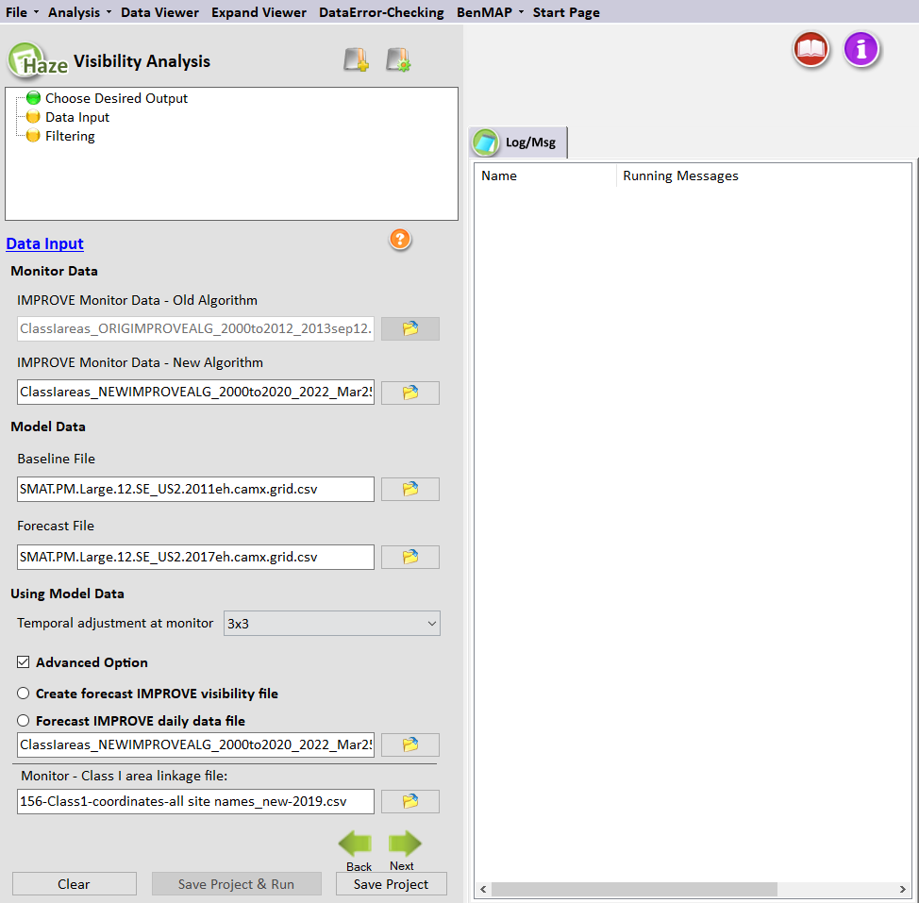
Figure 9-4. Data Input for Visibility Analysis
The Data Input window (Figure 9-4) sets the monitor and model data files to use for the SMAT-CE visibility forecasts. It also includes a specification for how SMAT-CE will average the model data for the RRF calculation. The blue hyperlinked text in this window brings up the documentation for this configuration step. The settings in this step include:

Monitor Data
Daily monitor data of speciated aerosol concentrations (ug/m³) and visibility (Mm⁻¹) measures are available from the Federal Land Manager Environmental Database website. These monitor data are used to: (1) identify the B20 and W20 visibility days for a given year; and (2) calculate the 5-year baseline conditions.
Note that one IMPROVE monitor is associated with each Class I site, and the calculated visibility for the IMPROVE site is assumed to representative of the Class I site. SMAT-CE comes with a default cross-walk that it uses for IMPROVE monitors and Class I Areas.
SMAT-CE is distributed with monitored species concentrations (ug/m³) along with extinction (Mm⁻¹) and deciview estimates for the period 2000 to 2012. SMAT-CE uses these data to project concentrations and extinctions for the observed species AMM_SO4, AMM_NO3, OMC, EC, CRUSTAL, and CM. The monitored data files include the variable GOOD_YEAR, which indicates whether a particular monitor should be used for a given year. A value of “1" means the monitor can be used, and a value of “0" means that the monitor should be dropped for the year.
The monitor data variable GROUP identifies the percentile for the overall visibility level for a particular day. A value of “90" means that the particular day is among the 20%worst days for the year. A value of “10" means that the particular day is among the 20%best days for that year. (Days with other GROUP values are not needed)
There are a number of extra variables in the ambient data input file that are not directly used by SMAT-CE (such as extinction values). These additional data can be used to QA the SMAT-CE output or for additional data analysis.
SMAT-CE can use two different types of IMPROVE monitor data:
- IMPROVE Monitor Data – Old Algorithm. Monitor data needed for calculating extinction with the old IMPROVE algorithm. Section 11.2.1.1 of the MATS User’s Manual (Abt, 2014) includes a description of the file format.
- IMPROVE Monitor Data – New Algorithm. The monitor data for the new IMPROVE algorithm includes a large number of variables. The table below has a complete listing of the variables. The variables in bold are required variables on the input file. The additional variables are provided for QA purposes and are optional. Note that sea salt mass is optional but is used in the visibility calculations if provided.
Table 9-4 Variables and descriptions for Monitor Data file
Var Name | Description
_ID | IMPROVE site code
_TYPE | Leave blank.
LAT | Latitude in decimal degrees. Values in the northern hemisphere are positive,  and those in the southern hemisphere are negative.
LONG | Longitude in decimal degrees. Values in the eastern hemisphere are positive,  and those in the western hemisphere (e.g., United States) are negative.
DATE | Date of daily average ambient data with YYYYMMDD format (This is a  numeric variable)
FRH | Monthly climatological relative humidity adjustment factor
FSRH | Monthly climatological relative humidity adjustment factor - small sulfate and  nitrate particles
FLRH | Monthly climatological relative humidity adjustment factor - large sulfate and  nitrate particles
FSSRH | Monthly climatological relative humidity adjustment factor - sea salt  SS_RAYLEIGH Site-specific Rayleigh scattering (Mm-1)
PM25 | Measured PM_{2.5} mass (ug/m3)
SEA_SALT | Sea salt mass
CRUSTAL | Crustal mass ( 2.2 × [Al] + 2.49 × [Si] + 1.63 × [Ca] + 2.42 × [Fe] + 1.94 × [Ti]) AMM_NO₃ Ammonium nitrate mass (NO₃*1.29)
AMM_NO3 | Ammonium nitrate mass (NO₃*1.29)
OMC | Organic carbon mass (OC*1.8)
EC | Elemental carbon
PM10 | PM₁₀ mass
CM | Coarse mass (PM₁₀ minus PM_{2.5})
AMM_SO4 | Ammonium sulfate (S*4.125)
LARGE_OMC | Large organic mass
SMALL_OMC | Small organic mass
LARGE_AMM_SO4 | Large ammonium sulfate
SMALL_AMM_SO4 | Small ammonium sulfate
LARGE_AMM_NO3 | Large ammonium nitrate
SMALL_AMM_NO3 | Small ammonium nitrate
E_AMM_SO4 | Ammonium sulfate extinction (Mm-1)
E_AMM_NO3 | Ammonium nitrate extinction
E_OMC | Organic mass extinction
E_EC | Elemental carbon extinction
E_CRUSTAL | Crustal extinction
E_CM | Coarse mass (PM₁₀ minus PM_{2.5}) extinction
E_SEA_SALT | Sea salt extinction
TBEXT | Total bext (includes site specific Rayleigh scattering)
DV | Deciviews (calculated from Total bext)
GOOD_YEAR | Denotes complete data for the year (1= all quarters >75% completeness, 0=  incomplete)
GROUP | 90= 20% worst days and 10= 20% best days for each year (if good_year=1)
POSSIBLE_NDAYS | Possible samples in quarter
NDAYS | Actual complete samples per quarter
OMPLETE_QUARTER | Quarter completeness (1= complete, 0= incomplete)
SF | Sulfur concentration (used to calculate ammonium sulfate)
SO4F | Sulfate concentration (may be used as a backup in case S is missing)

Model Data
Model data for the B20 and W20 visibility days are used to calculate RRFs, which provide an estimate of the relative change in visibility from the baseline conditions to a future year. The monitor data are used to identify the B20 and W20 days. SMAT-CE will match the best and worst measured days to the correct modeled days, by date. The model data input to SMAT-CE are PM species concentrations (ug/m³).
The following exhibits provide an example of the model data format and a description of the variables. Note that the first line of the data file gives the frequency of the data. In this case, daily data. The second line gives the variables names. The data begins on the third line. Each data line represents a daily observation.
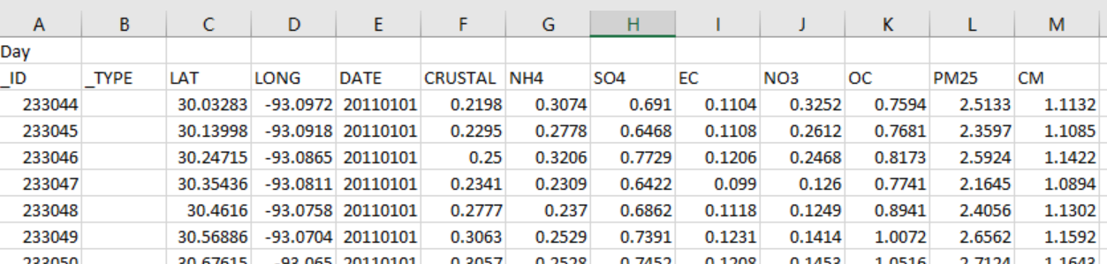
Figure 9-5 Format for Daily PM Model Data

Table 9-5 Variables and descriptions for Daily PM Model Data file
Var Name | Description
_ID | The ID is a unique number for each model grid cell in the air quality model domain. It is generally based on the column and row identifiers from the air quality modeling domain. The default convention is to calculate the ID by multiplying the column identifier by one thousand (1000) and adding the row identifier. (This is a character variable)
_TYPE | Leave blank.
LAT | Latitude at the grid cell centroid in decimal degrees. Values in the northern hemisphere are positive, and those in the southern hemisphere are negative.
LONG | Longitude at the grid cell centroid in decimal degrees. Values in the eastern  hemisphere are positive, and those in the western hemisphere (e.g., United States) are negative.
DATE | Date of daily average model value with YYYYMMDD format (This is a numeric variable)
CRUSTAL | Crustal PM
NH₄ | Ammonium mass
SO₄ | Sulfate PM
EC | Elemental Carbon
NO₃ | Nitrate PM
OC | Organic mass PM
PM_{2.5} | PM_{2.5} mass
CM | Coarse PM (ug/m3)

Using Model Data
For the Temporal adjustment at monitor setting select the matrix of model grid cells to use in the RRF calculation (1x1 matrix, 3x3 matrix, etc.). SMAT-CE will average the concentrations in the selected matrix to use for the RRF calculation.
RRFs are then calculated for the species sulfate, nitrate, EC, OMC, Crustal, and Coarse Matter (CM) by taking the ratio of the average of the B20 or W20 days in the future to the average corresponding B20 or W20 days in the baseline. For example, when calculating the sulfate RRF for the B20 days, SMAT-CE does the following calculation:
$${RRF}_{Sulfate,j}=\frac{\frac{1}{n}\sum_{i=1}^{n}{{Sulfate}_{future, j,i}}}{\frac{1}{n}\sum_{i=1}^{n}{{Sulfate}_{baseline, j,i}}}$$
where,
j = Class I area
i = day
n = number of B20 days
Sulfate = modeled sulfate concentration (ug/m³) on B20 days
When identifying the model data for this calculation, SMAT-CE first selects the model values located at either the monitor or at the centroid of the Class I Area, based on the setting in the Choose Desired Output window.

Advanced Option
Create forecast IMPROVE visibility file:
This option will create a forecast IMPROVE daily visibility file. The name of this file is "Forecast IMPROVE Daily Data.csv" plus the Project Name (e.g., "Tutorial Visibility - Forecast IMPROVE Daily Data.csv "). This file can be used as the new baseline monitor data and should be in the form of a simple text file (Figure 9-6). The first row specifies the frequency of the data (e.g., day). The second row presents comma-separated variable names. The third row begins the data values. Below is an example of the monitor data file format and descriptions of the variables in the file. The table below describes the variables in the output file.
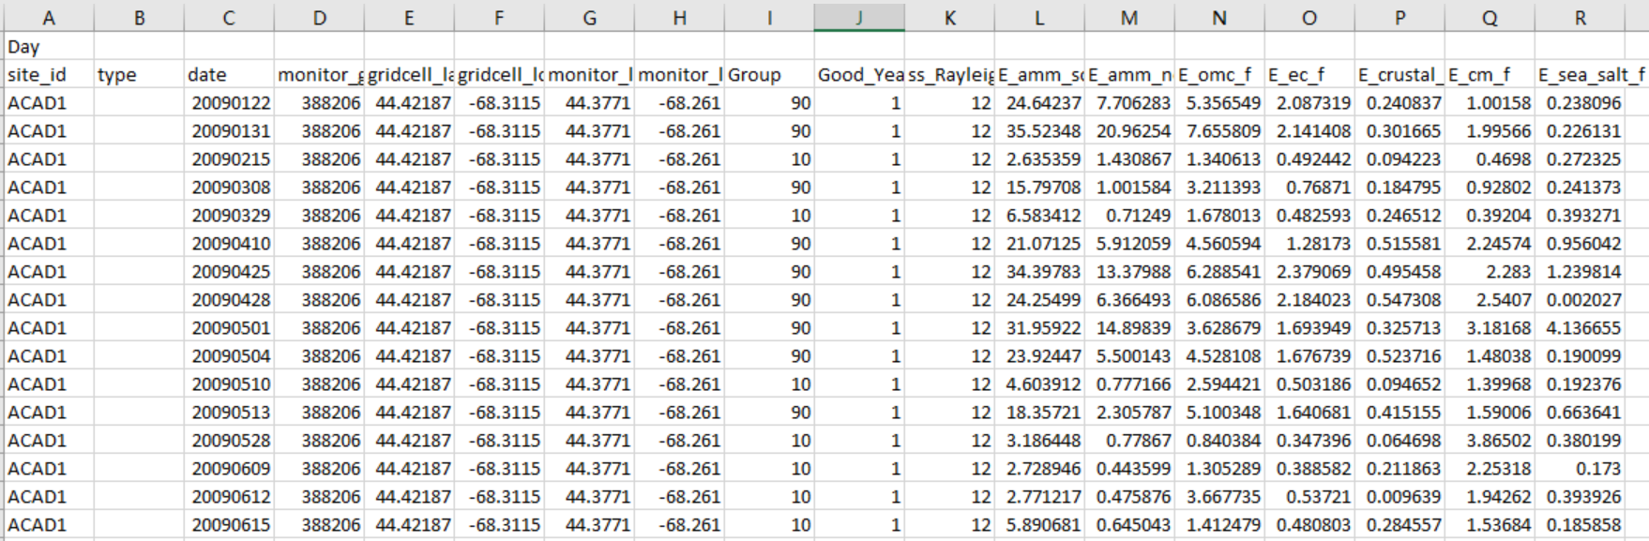
Figure 9-6 Example for forecast IMPROVE daily visibility file
Table 9-6 Variables and descriptions for forecast IMPROVE daily visibility file
Var Name | Description (variable type)
site_id | IMPROVE monitor identification code (text)
type | Leave blank
date | Date of daily average ambient data with YYYYMMDD format (This is a numeric variable)
monitor_gridcell | Identifier for grid cell closest to monitor. (This variable only appears if you specified the Use model grid cell at monitor option.)
gridcell_lat | Centroid latitude in decimal degrees of grid cell used in calculation. Values in the northern hemisphere are positive, and those in the southern hemisphere are negative.
gridcell_long | Centroid longitude in decimal degrees of grid cell used in calculation. Values in the eastern hemisphere are positive, and those in the western hemisphere (e.g., United States) are negative.
monitor_lat | Monitor latitude. (This variable only appears if you specified the Use model grid cell at monitor option.)
monitor_long | Monitor longitude. (This variable only appears if you specified the Use model grid cell at monitor option.)
Group | 90= 20% worst days and 10= 20% best days for each year (if good_year= 1)
Good_Year | Denotes complete data for the year (1= all quarters >75% completeness, 0= incomplete)
ss_Rayleigh | Site-specific Rayleigh scattering (Mm-1)
E_amm_so4_f | Ammonium sulfate extinction (Mm-1)
E_amm_no3_f | Ammonium nitrate extinction
E_omc_f | Organic mass extinction
E_ec_f | Elemental carbon extinction
E_crustal_f | Crustal extinction
E_cm_f | Coarse mass (PM₁₀ minus PM_{2.5}) extinction
E_sea_salt_f | Sea salt extinction

Forecast IMPROVE daily data file:
This option can use the forecast IMPROVE daily data file created from the “Create forecast IMPROVE visibility file” option as baseline monitor data to forecast the new visibility data.
Monitor -Class I area linkage file:
This file provides the linkage between IMPROVE monitors and Class I Areas. The format of the file and the variable descriptions are as follows:
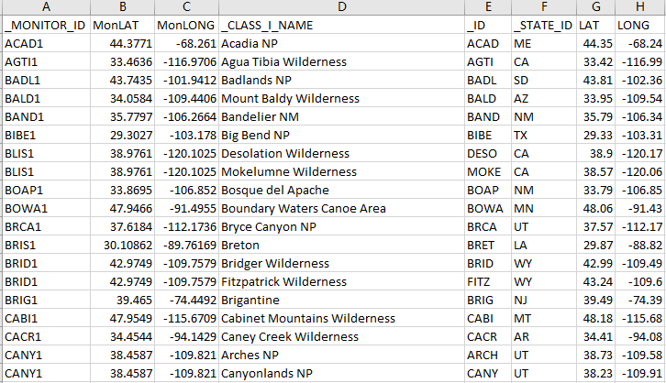
Figure 9-7. Example for File Linking IMPROVE Monitors and Class I Areas
Table 9-7 Variables and descriptions for File Linking IMPROVE Monitors and Class I Areas
Var Name | Description (variable type)
_MONITOR_ID | IMPROVE monitor identification code (text)
MonLAT | IMPROVE monitor latitude (numeric)
MonLONG | IMPROVE monitor longitude (numeric)
_CLASS_I_NAME | Name of Class I Area (text)
_ID | Class I Area identification code (text)
_STATE_ID | State in which Class I Area is located (text)
LAT | Class I Area centroid latitude (numeric)
LONG | Class I Area centroid longitude (numeric)
Note: Character variables have names that begin with an underscore (i.e., "_"), and the
character values used can be kept with or without quotes. (If a character variable has an
embedded space, such as might occur with the name of a location, then use quotes.)

Run the Eastern U.S. Example
Use the default settings for these options for the Eastern U.S. example project. Either click Next or double-click the Filtering button in the upper left-hand panel of the Visibility Analysis window. The button next to Data Input will turn from yellow to green, indicating that this step is complete.

Filtering
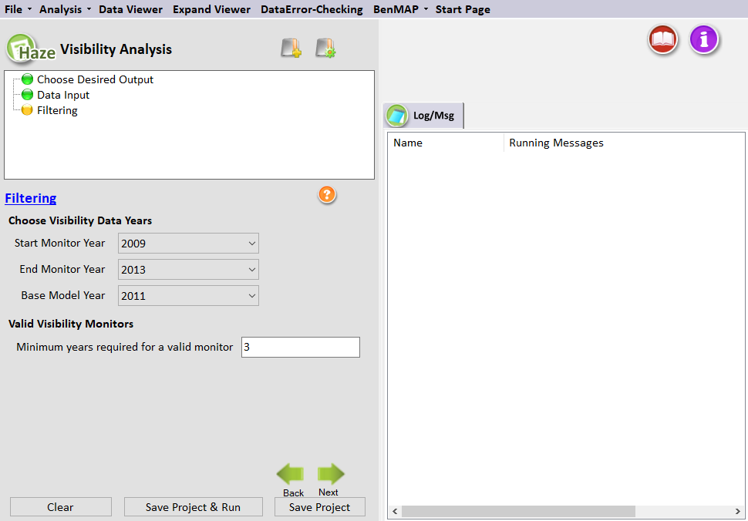
Figure 9-8. Filtering for Visibility Analysis
The Filtering window (Figure 9-8) sets the years of monitor and model data to use in the visibility forecasts. It also sets criteria for a monitor to be included in the analysis. The blue hyperlinked text in this window brings up the documentation for this configuration step. The settings in this step include:

Choose Visibility Data Years
SMAT-CE presents as a series of drop-down menus the available years of monitor data that were loaded through the Data Input window. The Start Monitor Year and End Monitor Year drop-down menus set the range of years to use for the visibility calculations.
The Base Model Year drop-down menu sets the year to use in determining the B20 and W20 monitor days. The Base Model Year should correspond to the year of the model data and must fall within the range specified by the Start Monitor Year and End Monitor Year. After setting the Base Model Year, SMAT-CE identifies and saves for each monitor the particular dates during this year that registered the best and worst visibility days. These dates are then used to identify the model values used in the calculation of RRFs for the temporal adjustment.

Valid Visibility Monitors
The Minimum years required for a valid monitor sets the minimum number of years of data that a monitor must have to be included in the visibility analysis. SMAT-CE excludes from the analysis any monitors with fewer than the minimum years set here. The SMAT-CE default value is three years.

Run the Eastern U.S. Example
Use the default settings for the Filtering options for the Eastern U.S. example project. Either click Next, which will bring up a window prompting to “Save & Run Project” or click the Save Project & Run button at the bottom of the SMAT-CE window.
The Visibility Analysis project may also be saved without running SMAT-CE by clicking the Save Project button. A file explorer window will request a filename to which the project settings will be saved to a *.proj file. This file can be loaded later to restart the analysis.
For the Eastern U.S. example, select save and run for the Visibility Analysis project. A file explorer window will request a filename (*.proj) to which to save the project settings. While the Analysis is running, the icon next to Filtering will turn to a running status and status messages will be displayed in the Log & Msg tab on the right panel of the SMAT-CE main window (Figure 9-9).

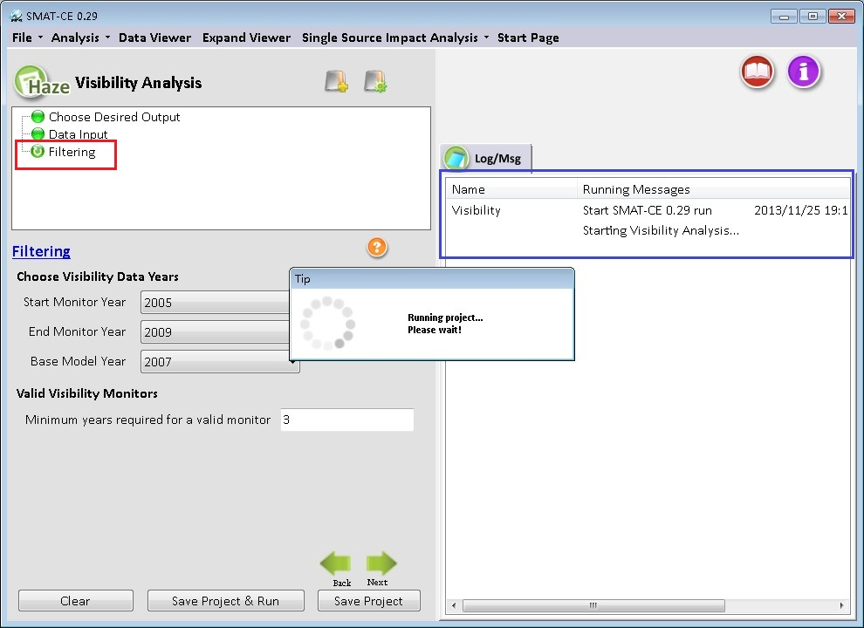
Figure 9-9. Visibility Analysis run status
When the Visibility Analysis is completed, the Data Viewer will automatically display in the SMAT-CE main window (Figure 9-10). The Output Files section of the Data Viewer left panel will display all of output files selected in the Choose Desired Output Visibility Analysis window.
The Data Viewer provides options to display the Visibility Analysis results as maps, bar charts, and tables. Chapter 10 describes how to load and analyze data using the SMAT-CE Data Viewer.
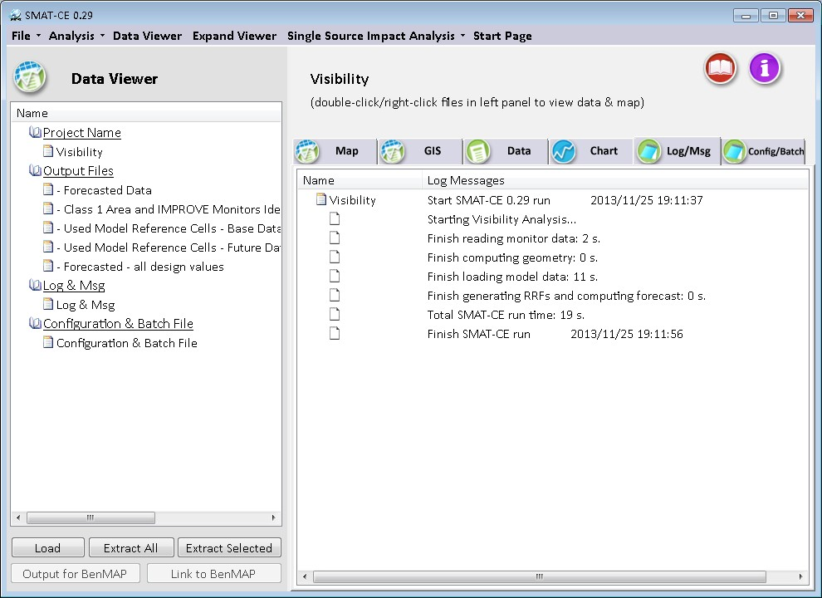
Figure 9-10. Visibility Analysis data viewer
This concludes the chapter on the SMAT-CE Visibility Analysis. As described in this section, details of the calculations and settings used in this analysis are available in the U.S. EPA Draft Modeling Guidance for Attainment of Air Quality Goals for Ozone, PM_{2.5}, and Regional Haze (U.S. EPA, 2014) and in Chapter 11 of the MATS User’s Manual (Abt, 2014).

The SMAT-CE Data Viewer
The SMAT-CE Data Viewer displays the results from completed attainment test analyses. The results may be displayed as maps, tables, and charts; or they may be exported to text files for use in external data processing programs. This section describes how to use and configure the Data Viewer for the different analyses supported by SMAT-CE.

Starting the Data Viewer
The SMAT-CE Data Viewer (Figure 10-1) can be started in the following ways.
- From the SMAT-CE Start Page, click on Data Viewer in the Analyze/Visualize Data section of the window.
- From any of the SMET-CE analysis windows, click on Data Viewer in the menu bar along the top of the window.
- When a SMAT-CE analysis finishes, the Data Viewer window displays automatically.

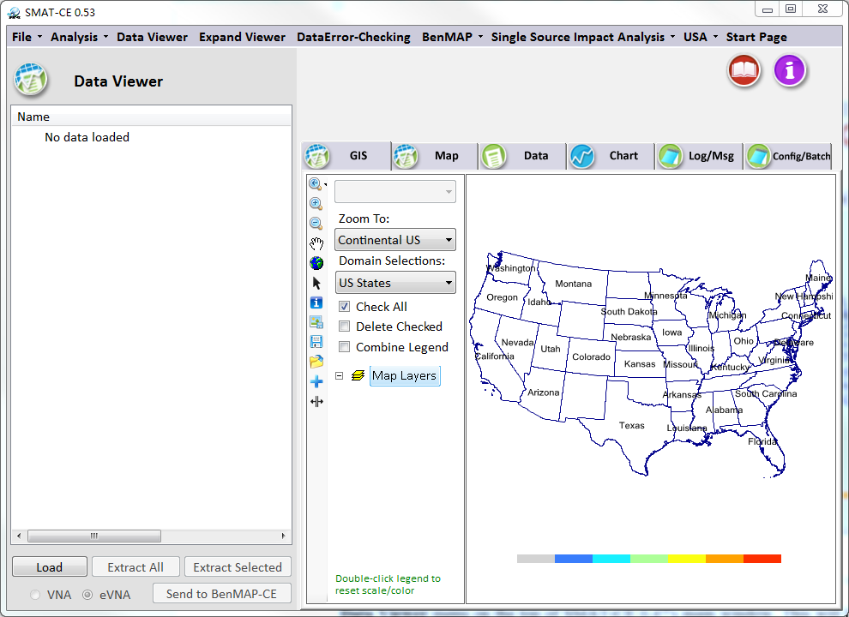
Figure 10-1. SMAT-CE Data Viewer

Starting an Analysis Session
To load results from a saved project, click on the Load button on the bottom left of the Data Viewer window and select a SMAT-CE project (*.proj) file to load. The Data Viewer will then display the following selections in the left-hand filename window pane (Figure 10-2).
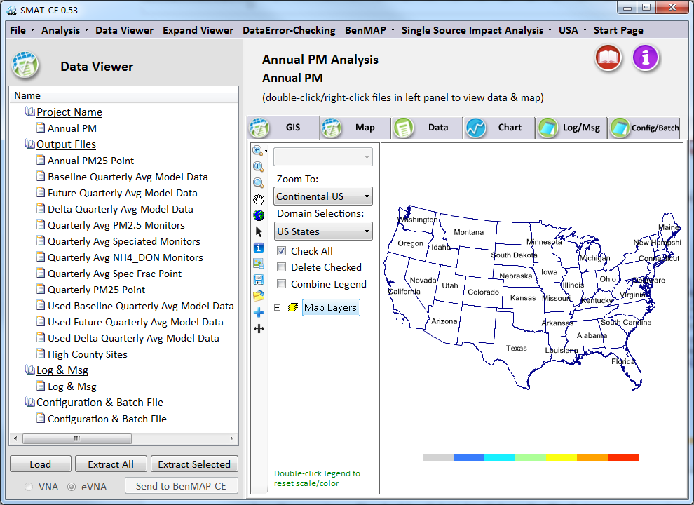
Figure 10-2. Data Viewer window with a completed project
Project Name: The name of the currently loaded project. Clicking on the project name will open the completed analysis window for the project. For example, if the loaded project is for an ozone attainment test, the Ozone Analysis window for that project will open upon clicking the project name in the Data Viewer filename menu.
Output Files: The list of the output files specified during configuration of the SMAT-CE analysis. The types of Output Files available depend on the type of analysis (PM, Ozone, or Visibility) and the output choices set in the Configuration File. Clicking on any of the output files will load the data into the Data Viewer graphical and tabular analysis modules.
Log & Msg: The SMAT-CE logging information generated during the currently loaded project. Clicking on the Log & Msg menu item displays the steps used to create the SMAT-CE results and the time that the run completed (Figure 10-3).
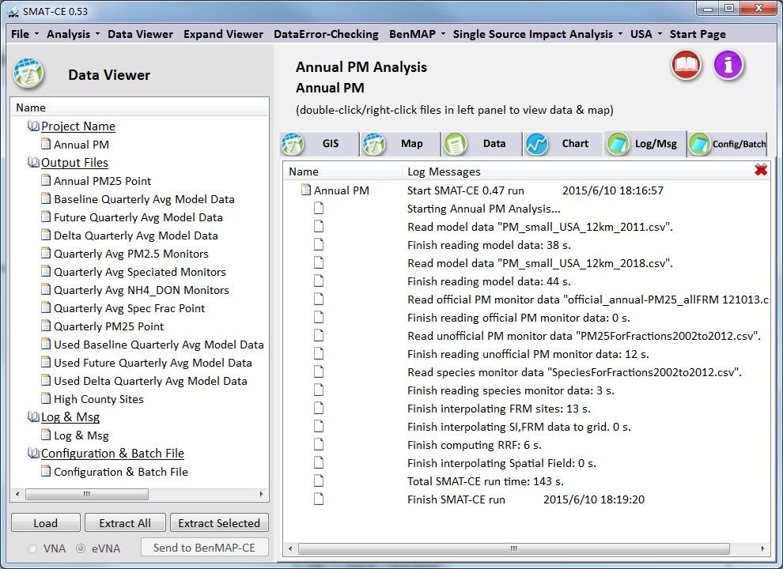
Figure 10-3. Log & Msg display window
Configuration & Batch File: The SMAT-CE batch script commands used to generate the results for the current project. Clicking on the Configuration & Batch File menu item displays the configuration settings for the project (Figure 10-4).
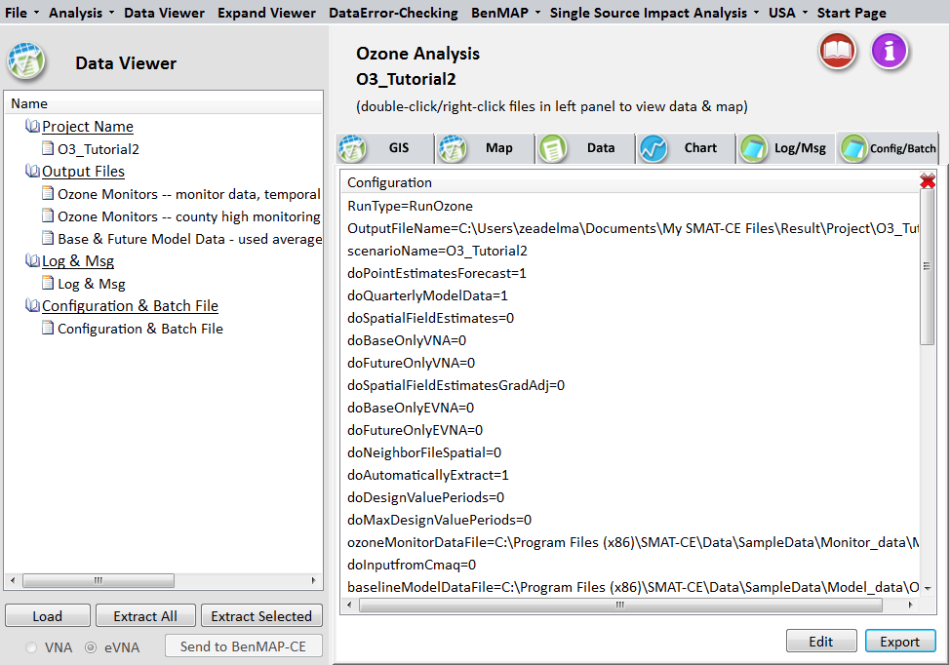
Figure 10-4. Configuration & Batch File display window.

Creating Data Displays
To examine the results from a completed SMAT-CE analysis, select one of the project Output Files in the left-hand pane of the Data Viewer window. Either double-click or right-click on one of the filenames to select for analysis. Different types of output files are displayed in the Data Viewer file list. The attainment test results will be named according to the form of the test: Annual PM_{2.5} Point, Daily PM_{2.5} Point, etc. The model data used in the attainment test will have file names that end in “Model Data”. The monitoring data used in the attainment test will have file names that end in “Monitors”.
A right-click on a file name will display a pop-up menu with different analysis choices. For everything but model data, the menu will show: Add to GIS, View, and Extract (Figure 10-5). For the model data results, the right-click pop-up menu will show: Add to Map, Add to GIS, View, and Extract. Double-clicking on any data file will display the file data on the SMAT-CE GIS map and data table viewer (Figure 10-6).
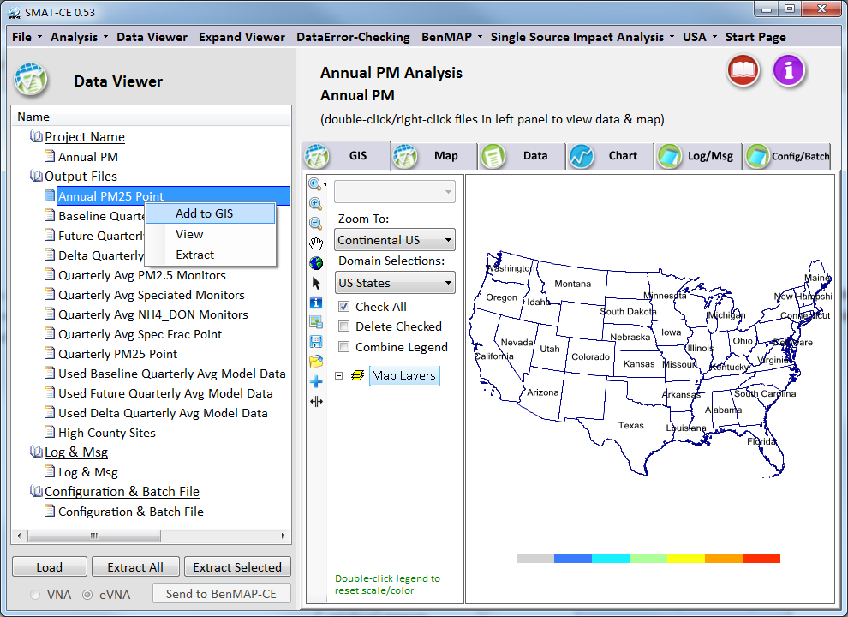
Figure 10-5. Output files right-click menu

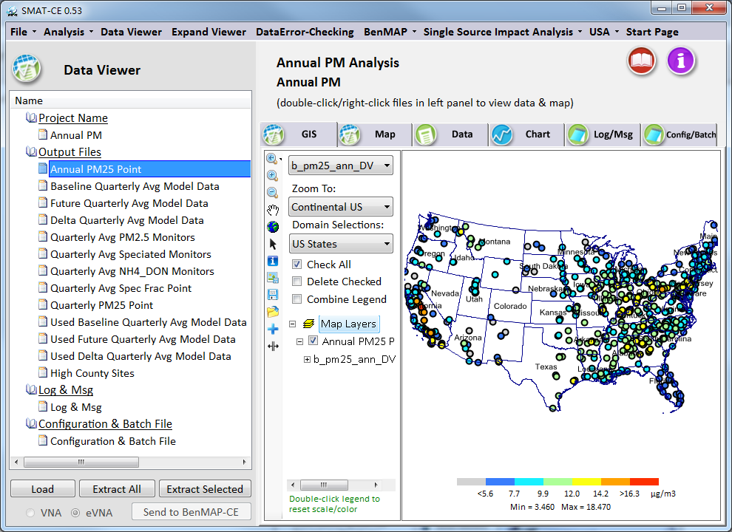
Figure 10-6. Output files GIS map view

The Data Viewer window right-hand analysis pane includes the following six tabs that display different analysis and configuration settings for the current SMAT-CE project:
GIS: Open-source geographic information system (GIS) graphical interface for displaying SMAT-CE point analysis results at monitor locations. Multiple data layers may be added to the map and different attributes within each layer can be plotting in the GIS tab.
Map: Spatial tile plots of model output data used for estimating relative response factors.
Data: Tabulated display of the SMAT-CE input and output data.
Chart: Bar chart display of the SMAT-CE input and output data.
Log/Msg: Logging information generated during the currently loaded project
Config/Batch: Batch script commands used to generate the results for the current project
Details of how to display data in the analysis tabs and how to configure the plots in each tab are included in the following sections.

GIS Window
The SMAT-CE GIS window displays the results of point analyses at monitor locations in the selected modeling domain. Example results available to view in the GIS window include base and future year design values, RRFs, and input monitor data.
To plot results in the GIS window either right-click on an output file name in the Data Viewer file list and select Add to GIS (Figure 10-5); or click on the GIS tab of the Data Viewer right-hand panel and then double-click an output file on the file list. Alternatively, click on the on the GIS and Map Controls toolbar to load a saved data file into the GIS viewer. The GIS view will display the analysis results or input monitor data as a thematic map with a colored legend that uses a legend and color scale that are set according the minimum and maximum values of the loaded dataset (Figure 10-7).
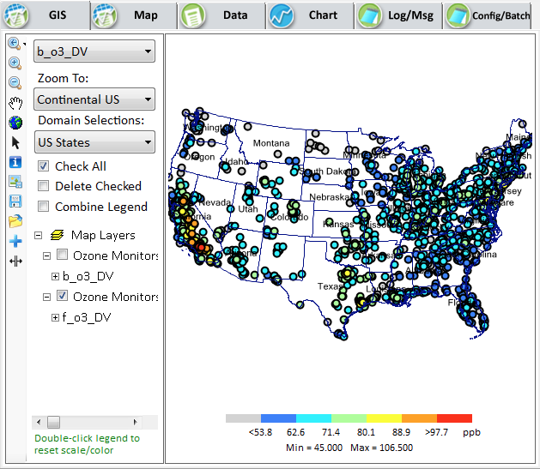
Figure 10-7. SMAT-CE GIS window
The GIS map can be saved quickly by right-clicking anywhere in the map window and selecting one of the three options (Figure 10-8).
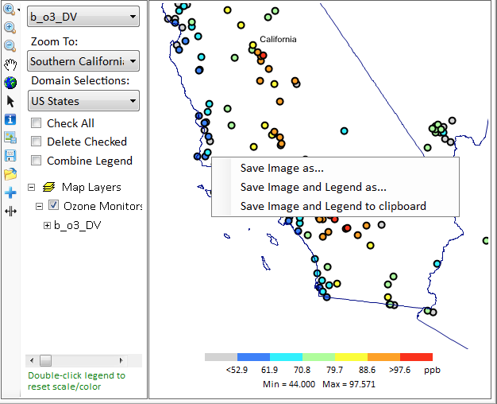
Figure 10-8. GIS map right-click menu
The configuration options available in the GIS window include:
Zoom and Map Controls: Shown in the red box in Figure 10-9, these options control zooming in/out and panning the map display, probing monitor values, exporting the map image, saving a shapefile of the results, and adding external shapefile data to the GIS map.
Layer Controls: Shown in the yellow box in Figure 10-9, these options control the SMAT-CE result layer attributes to display on the map, quick zooms to selected sub-regions (Zoom To), and boundary layer attributes to display on the map (Domain Selections). The Map Layers section of this area displays the different GIS layers shown on them. Right-clicking on any of the layers provides advanced configuration controls for the layer.
Legend Controls: Shown in the blue box in Figure 10-9, this option provides a quick adjustment of the GIS map legend levels. Double-click the color bar to display the legend controls. The legend controls set the minimum and maximum values of the legend and the individual colors on the scale. More detailed customization of the map display legend is available by double-clicking a map layer in the Layer Controls section of the GIS window.
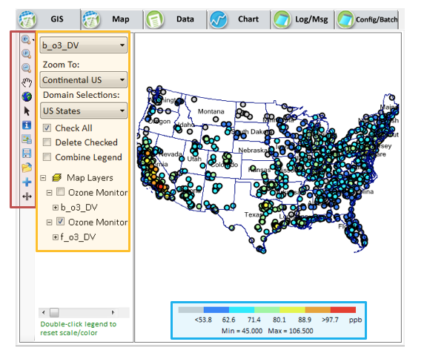
Figure 10-9. GIS window with highlighted map controls

Map Window
The SMAT-CE Map window displays the results of model results at monitor locations in the modeling domain. Example results available to view in the Map window include base and future year model result used in the calculation of RRFs.
To plot results in the Map window either right-click on a model data output file name in the Data Viewer file list and select Add to Map (Figure 10-5); or click on the Map tab of the Data Viewer right-hand panel and then double-click a model data output file on the file list. Note that if there is no option to view the data on the map (i.e., only Add to GIS is displayed) then the selected data are not compatible with the Map view. The Map view will display the analysis results as a tile plot map with a colored legend that uses a legend and color scale that are set according the minimum and maximum values of the loaded dataset (Figure 10-10).
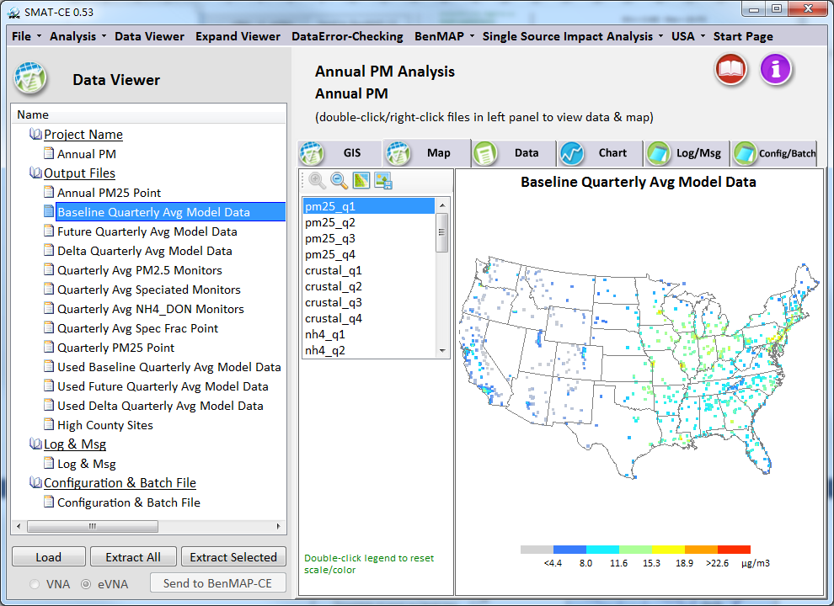
Figure 10-10. SMAT-CE map window
The Map display can be saved quickly by right-clicking anywhere in the map and selecting one of the three options (Figure 10-11).
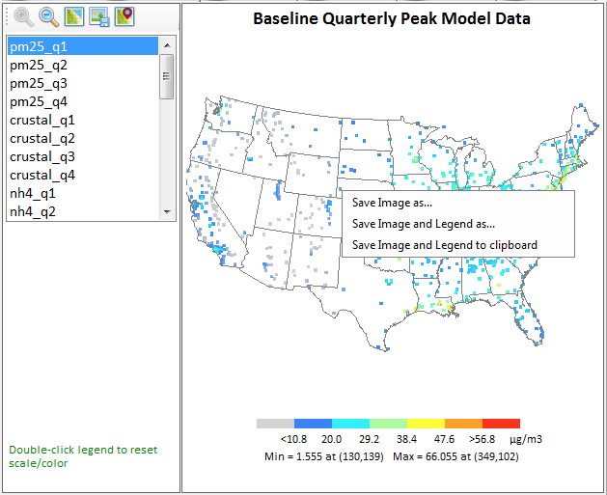
Figure 10-11. Map window with right click menu
The configuration options available in the GIS window include:
Zoom and Map Controls: Shown in the red box in Figure 10-12, these options control zooming in/out, adding county lines, exporting the map image, and overlaying monitor data on the map image.
Legend Controls: Shown in the blue box in Figure 10-12, this option adjusts the map legend levels. Double-click the color bar to display the legend controls. The legend controls set the minimum and maximum values of the legend and the individual colors on the scale.
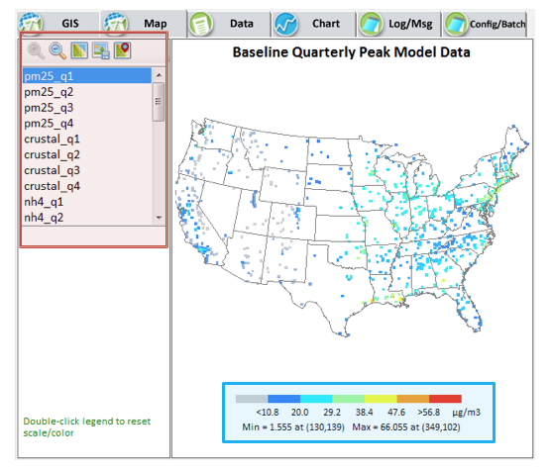
Figure 10-12. Map window with highlighted map controls

Data Table Display
The SMAT-CE Data Table window displays the SMAT-CE input and output data in a tabulated format.
To plot results in the Data Table window either right-click on a file name in the Data Viewer file list and select View (Figure 10-5); or click on the Data tab of the Data Viewer right-hand panel and then double-click a file on the file list. The Data view will display the analysis results as a table on the right-hand panel of the Data Viewer window (Figure 10-13).
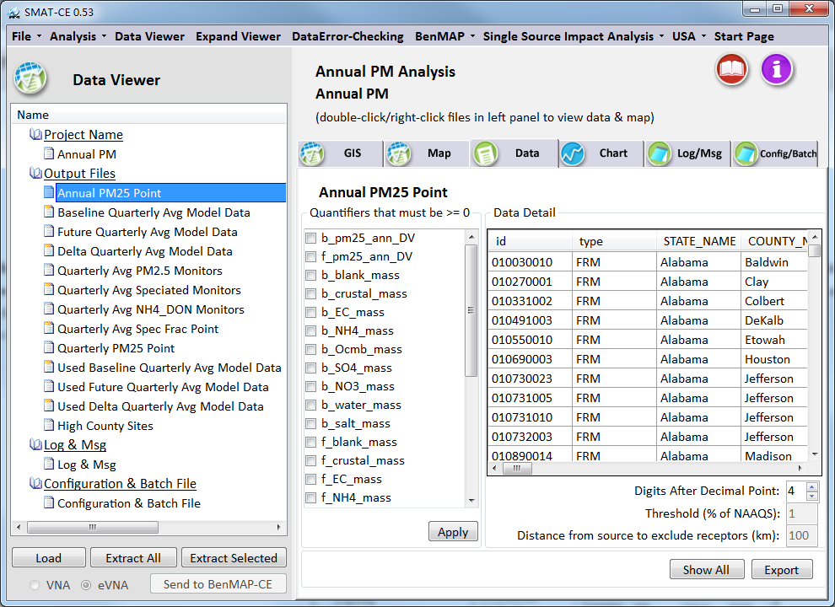
Figure 10-13. SMAT-CE Data table window
The configuration and viewing options available in the Data window include:
Variable Filtering: Shown in the red box in Figure 10-14, the list shows the variables in the data table. Checking the boxes next to the variables and clicking “Apply” will filter out rows in the table where the values of the selected variable(s) are null (-9).
Data Table: Shown in the yellow box in Figure 10-14, the data table shows the tabulated results from the selected SMAT-CE data file. The table can be sorted by any of the columns by left clicking on the column header.
Data Precision and Export: Shown in the blue box in Figure 10-14, this section of the data window sets the precision of the values in the table, exports the data to a CSV file, and removes the filtering selections.

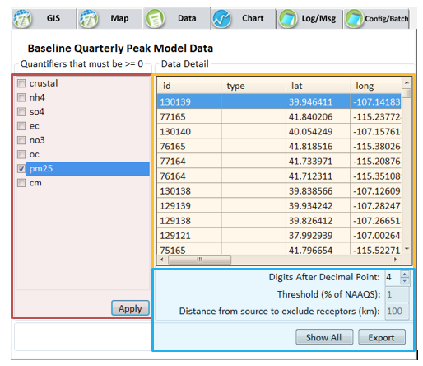
Figure 10-14. Data window with highlighted configuration options

Chart Display
The SMAT-CE Chart window displays the SMAT-CE input and output data as bar charts. This type of display is useful for comparing data values, such as design values or observations, between monitors.
To plot results in the Chart window or click on the Chart tab of the Data Viewer right-hand panel and then double-click a file on the file list on the left-hand panel. The Chart view will display the analysis results as bars on the right-hand panel of the Data Viewer window (Figure 10-15).
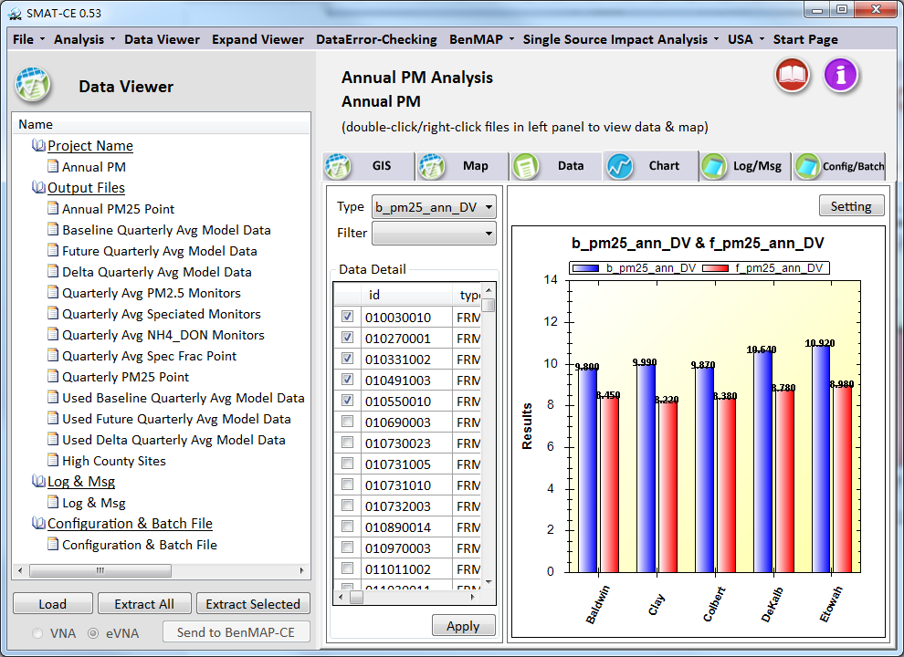
Figure 10-15. SMAT-CE chart window
The configuration and viewing options available in the Chart window include:
Type and Filter Selection: Shown in the red box in Figure 10-16, two drop boxes include data variables and regions to include in the chart. Selecting from the Type menu will both display the selected variable in the Chart and filter the Data Detail list by the selected variable. Selecting from the Filter menu will display the selected region in the Chart and filter the Data Detail list by the selected region. One or both of the variables may be selected to filter the chart data. Note that the Filter (region) selection is not available for model data.
Data Detail: Shown in the yellow box in Figure 10-16, the Data Detail shows the tabulated results from the selected SMAT-CE data file. The table can be sorted by any of the columns by left clicking on the column header. The check boxes in the first column may be used to select individual data rows to include in the Chart. After checking the rows to be plotted, use the “Apply” button to plot the selected rows in the Chart. The “Select All” box can be used to select/unselect all of the rows with one click. Use the Type menu (described above) to select the variable (column) to include in the Chart.
Chart: Shown in the blue box in Figure 10-16, this section of the Chart window displays the bar chart and includes options to configure the chart. The “Setting” button displays a window for configuring the chart title and axes, including axis titles and min/max ranges. Right-clicking on the chart will display a selection box with options to Copy the chart to the clipboard, export (Save Image As) an image of the chart, Print the chart, and zoom out (Un-Zoom) from the chart. The Show Point Values right-click option enables the values of a bar to be displayed when the mouse hovers over the bar. The Change Title and Legend right-click option enables customization of the variable names, title, and axes.
Zoom into sections of the chart by left clicking and dragging a box over the chart region to highlight. Use the right-click menu to un-zoom.

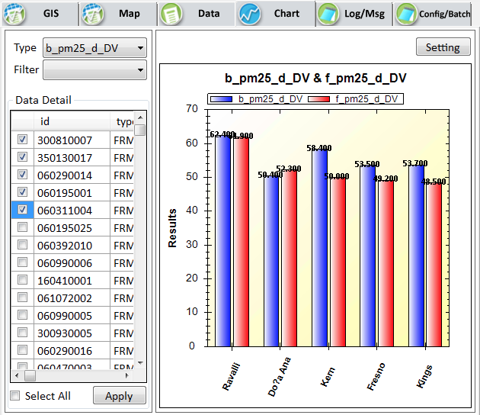
Figure 10-16. Chart window with highlighted configuration options

The SMAT-CE Configuration File
Windows batch scripts can be used to run several SMAT-CE analyses in sequence. The batch script can string together a list of SMAT-CE Configuration Files to define the settings for each analysis. The SMAT-CE Configuration File stores the configuration options for a completed SMAT Analysis. A Configuration File can be used to duplicate (re-run) a previously completed analysis or in a batch script to run in sequence with other analyses. The SMAT-CE Configuration Files (*.cfg) files are saved in the \My SMAT-CE Files\Result\CFG directory.
An existing Configuration File can also be edited to generate a new set of results, without having to explicitly set each of the choices made in the previous Configuration. Stored Configuration Files can be used to run SMAT-CE in batch mode, for example to run several attainment test analyses using a single batch script.
To view a Configuration file from the Data Viewer, either double-click/right-click on the Configuration & Batch File name in the left-hand window pane (Figure 10-17) or left-click on the Config/Batch tab in the right-hand window pane.

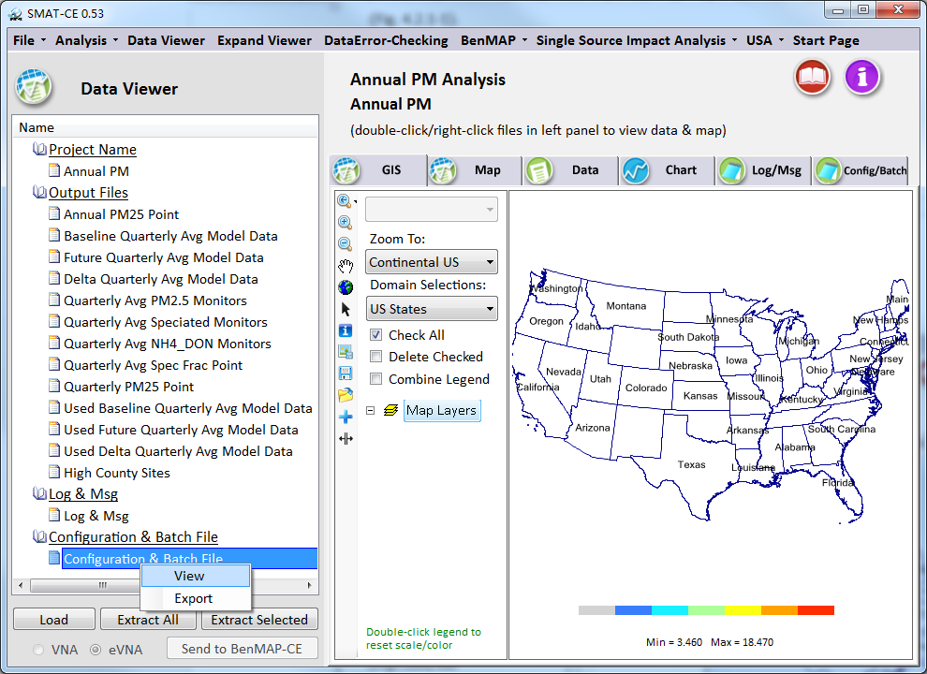
Figure 10-17. Viewing a SMAT-CE configuration file
The Configuration file contents will be displayed in the Config/Batch window (Figure 10-18). Clicking the Edit button in the lower-right corner of this window enables editing of the configuration file contents. Click three times on the configuration line to make some changes to the file. After editing the Configuration File, click the Export button to save it as a new configuration file. The *.cfg file can also be edited outside of SMAT-CE using a text editor.
Section 5.3 describes how to use Configuration Files in a batch script to run several SMAT-CE analyses in sequence.
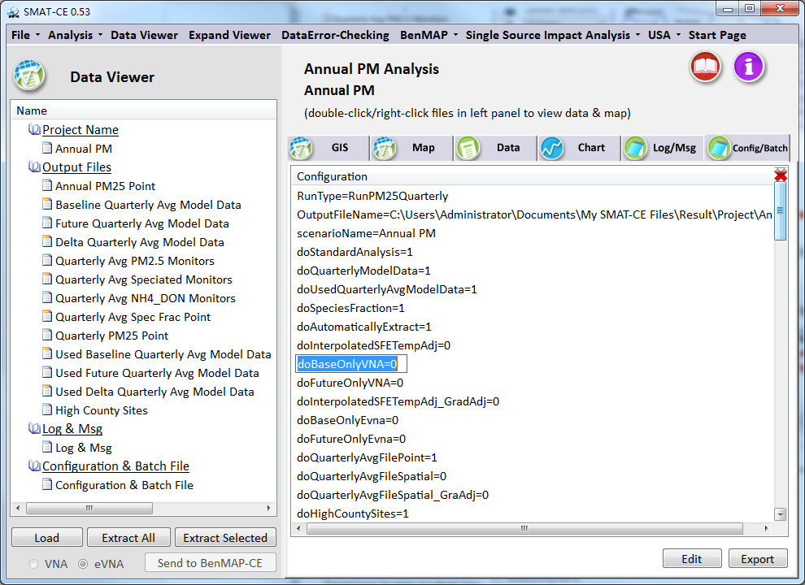
Figure 10-18. SMAT-CE Configuration File view

Exporting Data from SMAT-CE
Output data from the SMAT-CE analyses can be exported to text files. Data export is most relevant to the Output Files (as opposed to the Configuration & Batch/Log & Msg Files), which can be viewed and manipulated in external data analysis programs such as Excel. SMAT-CE generates .CSV files that import cleanly into spreadsheets and database programs.
The easiest way to export data from SMAT-CE is in the analysis windows. By checking the box "Automatically Extract All Selected Output Files" on the initial window of a SMAT-CE analysis (the same window where the Project Name is set), SMAT-CE will automatically output the result to .CSV files. Alternatively, the Data Viewer includes options to export the SMAT-CE results.
The Extract All button at the bottom of the left-hand window pane in the Data Viewer will initiate an export of the SMAT-CE results. A pop-up window will display for setting a root output filename and directory path.
To export an individual file, right click on the filename, and choose the Extract option, or click the Extract Selected button on the bottom left panel of the main window. A pop-up window will display for setting the output filename and directory path.

Getting Help
Support for SMAT-CE is available from the CMAS Center

References
Abt, Associates, Inc. 2014. “Modeled Attainment Test Software: User’s Manual”. Prepared for Office of Air Quality Planning and Standards, U.S. EPA. Research Triangle Park, NC.
U.S. EPA. 2014. “Memorandum: Draft Modeling Guidance for Demonstrating Attainment of Air Quality Goals for Ozone, PM_{2.5}, and Regional Haze”. From Richard Wayland, Division Director – Air Quality Assessment Division, U.S. EPA. Research Triangle Park, NC.

https://www.epa.gov/visibility
http://views.cira.colostate.edu/fed/

