Air Quality Modeling Assessment Tools (AQMAT) Development
User’s Manual for Response Surface Model-Visualization Analysis Tool (RSM-VAT) 2.8

Contract No: 68HERD21A0002
Task Order No: 68HERH21F0334
Version: 01

Prepared for: Carey Jang
Task Order Contracting Officer’s Representative
U.S. EPA/OAR/OAQPS/AQAD/AQMG
(Mail Code: C439-01)
109 T.W. Alexander Drive
Research Triangle Park, NC 27711

Prepared by: Yun Zhu, Shicheng Long
College of Environment & Energy
South China University of Technology
Guangzhou, 510006, Guangdong, China

Sarav Arunachalam
Institute for the Environment
The University of North Carolina at Chapel Hill

Date: December 31, 2022
Acknowledgements
In cooperation with the U.S. EPA, the Institute for the Environment at the University of North Carolina at Chapel Hill (UNC-IE) along with the South China University of Technology (SCUT) developed the FAST-CE software. This project was funded by the U.S. EPA under contract 68HERH21F0334 to UNC-IE.

Table of Contents
1 Introduction 1
1.1 Evaluation Process of RSM-VAT 1
1.2 Who Can Use RSM-VAT? 1
1.3 Computer Requirements 2
1.4 Installing/Uninstalling RSM-VAT 3
1.4.1 Installing RSM-VAT 3
1.4.2 RSM-VAT Data Extraction 5
1.4.3 Uninstalling RSM-VAT 7
1.5 Contacts for Comments and Questions 7
1.6 Sources for More Information 7
2 Terminology and File Types 8
2.1 Common Terms 8
2.2 File Types 10
3 Quick Start 12
3.1 Experimental Design 12
3.1.1 Create Emission Control Matrix 13
3.1.2 Create NetCDF File and Namelist Files for CMAQ 15
3.2 Create a New RSM Project 18
3.2.1 Run a New RSM Project 18
3.2.2 Set Input Parameters 19
3.3 View Results 23
3.3.1 QA & Validation 23
3.3.2 Visualization & Analysis 25
4 Main Interface 27
5 Experimental Design 28
5.1 Control Matrix 29
5.1.1 pf-RSM Matrix 29
5.1.2 Traditional RSM Matrix 30
5.1.3 Add-on pf-RSM Matrix Sampling 30
5.1.4 Add-on Traditional RSM Matrix Sampling 31
5.2 CMAQ Preparation 32
5.2.1 Create Region Control NetCDF File 33
5.2.2 Merge/Subtract Region Operation 36
5.2.3 Export Emission Control Namelist File 37
6 Create RSM Project 40
6.1 Create/ Input RSM Option 40
6.1.1 pf-ERSM/Optimized pf-ERSM Algorithm option 40
6.1.2 DeepRSM algorithm option 42
6.2 Model Data Input Option 46
6.2.1 pf-ERSM/Optimized pf-ERSM Algorithm option 46
6.2.2 DeepRSM algorithm option 47
6.3 Validation and QA Option 51
6.4 Visualization Analysis Option 52
7 Visualization & Analysis for RSM Results 53
7.1 QA & Validation 55
7.1.1 Out of Sample Validation 58
7.1.2 Cross Validation 61
7.1.3 CMAQ Viewer 61
7.2 Visualization & Analysis 62
7.2.1 Map 62
7.2.2 Chart 67
7.2.3 Data 74

List of Tables
Table 1. Types of RSM Input files 12
Table 2. File Types Generated by RSM 12
Table 3. Performance Metrics used in RSM-VAT 59

List of Figures
Figure 1.4.1-1. Setup Window 3
Figure 1.4.1-2. Choose Install Location 4
Figure 1.4.1-3. Ready to Install 4
Figure 1.4.1-4. Installation Process 5
Figure 1.4.1-5. Complete Installation 5
Figure 1.4.2-1. Ready to Unzip Data Package 6
Figure 1.4.2-2. Unzip Processing 6
Figure 1.4.3-1. Uninstallation Processing 7
Figure 3.1.1-1. Enter the Experimental Design Module 13
Figure 3.1.1-2. Factors File 14
Figure 3.1.1-3. pf-RSM Matrix Sampling 15
Figure 3.1.2-1. Create Region Control NetCDF File 16
Figure 3.1.2-2. Merge/Subtract Region Operation 17
Figure 3.1.2-3. Export Emission Control Namelist File 18
Figure 3.2.1-1. Create a New Project 19
Figure 3.2.2-1. Create/ Input RSM Option 20
Figure 3.2.2-2. Model Data Input Option 21
Figure 3.2.2-3. Validation and QA Option 22
Figure 3.2.2-4. Visualization Analysis Option 22
Figure 3.2.2-5. Receptor Region File 23
Figure 3.2.2-6. Save Project and Run 23
Figure 3.3.1-1. Out of Sample Validation Results 24
Figure 3.3.1-2. Results of CMAQ simulations 25
Figure 3.3.2-1. Map Results 26
Figure 3.3.2-2. Chart Results 26
Figure 3.3.2-3. Data Results 27
Figure 4-1. Main Interface of RSM-VAT 27
Figure 5-1. GUI of Experimental Design Module 29
Figure 5.1.1-1. pf-RSM Sampling Module 29
Figure 5.1.2-1. Traditional RSM Matrix Sampling 30
Figure 5.1.3-1. Add-on pf-RSM Matrix Sampling 31
Figure 5.1.4-1. Add-on Traditional RSM Matrix Sampling 32
Figure 5.1.4-2. Main Functions in CMAQ Preparation Module 33
Figure 5.2.1-1. GUI of Create Region Control NetCDF File 34
Figure 5.2.1-2. Operation for Manage Selected Regions 35
Figure 5.2.1-3. Example for Load NetCDF File 35
Figure 5.2.2-1. GUI of Merge/Subtract Region Operation 36
Figure 5.2.2-2. Example for Using Merge/Subtract Region Operation Module 37
Figure 5.2.3-1. Namelist Template File Example 38
Figure 5.2.3-2. Mapping File Example 38
Figure 5.2.3-3. Example for Using Export Emission Control Namelist File 39
Figure 5.2.3-4. Results for Output Namelist Files 40
Figure 6.1.1-1. Create/ Input RSM Option 41
Figure 6.1.2-1. The GUI of DeepRSM 42
Figure 6.1.2-2. DeepRSM input files 43
Figure 6.1.2-3. Example of emission file for deepRSM option 43
Figure 6.1.2-4. Example of factors file for DeepRSM option 44
Figure 6.1.2-5. Example of ShapeLCC file for DeepRSM option 44
Figure 6.1.2-6. Example of receptor region file for DeepRSM option 45
Figure 6.1.2-7. Advanced Option 46
Figure 6.2.1-1. Model Data Input Option 47
Figure 6.2.2-1. Model Data Input Option of DeepRSM 48
Figure 6.2.2-2. Base Case CMAQ File(ACONC) 48
Figure 6.2.2-3. Deep Training Model File 49
Figure 6.2.2-4. Choose Species Names Mapping File 49
Figure 6.2.2-5. Species Names Mapping File 49
Figure 6.2.2-6. Time parameter setting 50
Figure 6.2.2-7. Target Pollutant 50
Figure 6.2.2-8. Next-Model Data Input Option 50
Figure 6.3-1. Validation and QA Option 51
Figure 6.4-1. Visualization Analysis Option 52
Figure 6.4-2. Running Messages 53
Figure 7-1. The results of different days 54
Figure 7-2. Data Viewer of RSM-VAT Results 55
Figure 7.1-1. QA & Validation 56
Figure 7.1.1-1. Error & Bias Plot of Out of Sample Validation 58
Figure 7.1.1-2. Comparison Plot 59
Figure 7.1.1-3. RSM vs CMAQ of Out of Sample Validation 60
Figure 7.1.1-4. Error & Bias Table of Out of Sample Validation 61
Figure 7.1.3-1. CMAQ Viewer 62
Figure 7.2.1-1. Right-click menu on Map 63
Figure 7.2.1-2. 2D Plot Viewer in the Map Module 63
Figure 7.2.1-3. Pre-defined control filter 64
Figure 7.2.1-4. User-defined control method 65
Figure 7.2.1-5. 3D Plot Viewer in the Map Module 66
Figure 7.2.1-6. Contour Plot Viewer in the Map Module 66
Figure 7.2.2-1. Example of Source Contribution 1 67
Figure 7.2.2-2. Set up a new receptors regions 68
Figure 7.2.2-3. Load a receptor region file 69
Figure 7.2.2-4. Extract selected regions to text file. 69
Figure 7.2.2-6. Example of Source Contribution 2 71
Figure 7.2.2-7. Cluster chart in Source Contribution 2 72
Figure 7.2.2-8. Pie chart in Source Contribution 2 72
Figure 7.2.2-9. Example of Emission Control 1 73
Figure 7.2.2-10. Example of Emission Control 2 74
Figure 7.2.2-11. Right-click menu on Chart 74
Figure 7.2.3-1. Data Detail Results and Configuration 75

Introduction
RSM-VAT is a tool that takes the CMAQ modeling results as input data, then builds up a “real-time” response between air pollution emission reductions and air pollutant concentrations using statistical techniques (e.g., polynomial fitting method or a maximum likelihood estimation – experimental best linear unbiased predictors). It allows for an instantaneous calculation of the change in ambient concentration resulting from the changes of emissions within a predefined set of sources, locations, and precursor emission types. This response is helpful for policymakers to decide on the best scenario alternative to achieve the attainment of air quality standards.

Evaluation Process of RSM-VAT
The definition of the CMAQ-based Response Surface Model, its process is listed as:
- A set of control factors are selected based on the decision requirement.
- An emission control matrix design is delivered through a Hammersley quasi-random Sequence Sampling (HSS) or a Latin Hypercube Sampling (LHS) method.
- A base-year emission inventory is scaled with the emission control matrix and forming emission control scenarios for CMAQ model runs. These emission inventory factors, together with the identical meteorology and other model input, are applied in CMAQ model to finally get CMAQ simulations.
- A great amount of CMAQ simulations are used for non-linear statistics with Polynomial Functions.
- The reliability of the created RSM is validated through Cross Validation and Out-of-sample Validation.

Who Can Use RSM-VAT?
RSM-VAT can be used by a wide range of persons, including scientists, policy analysts, and decision-makers. Less experienced users apply RSM to better understand and analyze the established statistical relationship between air pollution emission reductions and air pollutant concentrations. Most end users (policymakers) would directly use the RSM data analysis module for policy decisions. Advanced users can explore a wide range of advanced options. For example, performing a series of advanced visualization and analysis functions for validating RSM prediction results; examining the nonlinear interactions among multiple air pollutant precursors and instantly generating the air pollutant concentration surface response to air pollutant emission changes.
In a word, RSM-VAT can be used in the following aspects:
- Strategy design and assessment screening tool
- Comparison of urban vs. regional emission controls
- Comparison across emission controls of different sectors (e.g., industry, transportation, and civil sources)
- Comparison across emission controls of different pollutants (e.g., NOx, SO₂, NH₃, VOCs, PM_{2.5})
Optimization
- Can be used to identity the key emission factors and develop optimal combinations of controls to attain standards at minimum cost
“What If?” Analyses
Provide real-time predictions of air quality model responses to emission and inputs.
- Quickly provide insights into questions for policy design, e.g., does it matter if regional controls are put in place before local controls?
- What emission reduction is more effective for achieving the targeted air quality?
- Which emission source has a greater impact on air quality?
- What is the most effective emission reduction strategy for improving air quality?
Model Sensitivity
- Can be used to systematically evaluate the relative sensitivity of modeled ozone and PM concentrations to changes in emissions/meteorology inputs

Computer Requirements
RSM-VAT requires a computer with:
.Net Framework Version 4.0 or higher.
32-bit or 64-bit Windows 7/Windows 8/Windows 10.
GB RAM or greater.
10 GB free disk space or greater.

Installing/Uninstalling RSM-VAT

Installing RSM-VAT
Download RSM-VAT Software Package (e.g., RSM-VAT 2.8.exe) and corresponding example data (e.g., RSM-VAT 2.8 Data.exe) from the ABaCAS.
- ABaCAS website:
http://abacas.see.scut.edu.cn/tools/
Double click the package to start the installation.
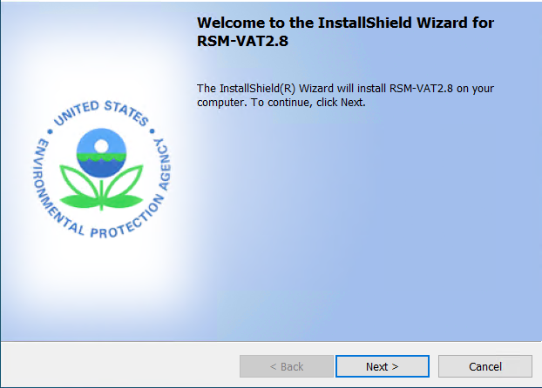
Figure 1.4.1-1. Setup Window
Click the “Next” button, to use the default install location as shown in Figure 1.4.1-2.

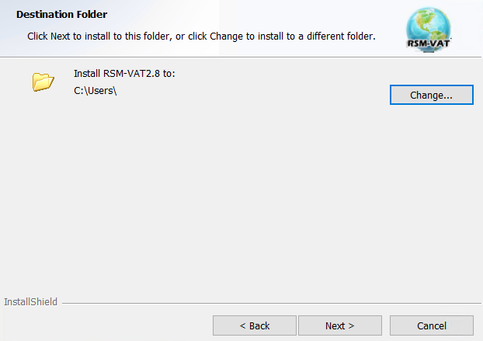
Figure 1.4.1-2. Choose Install Location
Click the “Next” button, it will show the “Ready to Install” window as shown in Figure 1.4.1-3.
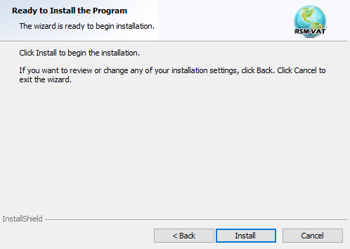
Figure 1.4.1-3. Ready to Install
Click the “Install” button, Figure 1.4.1-4 shows the installation process of RSM-VAT.

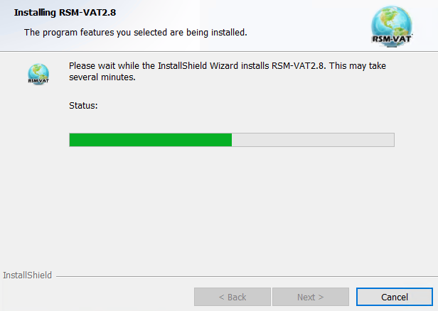
Figure 1.4.1-4. Installation Process
Click the “Finish” button and complete installation.
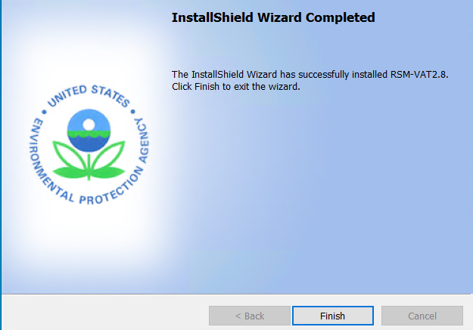
Figure 1.4.1-5. Complete Installation

RSM-VAT Data Extraction
After finished installation, please extract the RSM-VAT self-extracting example data executable file. Double click the self-extracting executable file to unzip it to User Documents directory under \Documents\My RSM-VAT Files\Data\* to replace the old Data folder, as shown in the following figure:

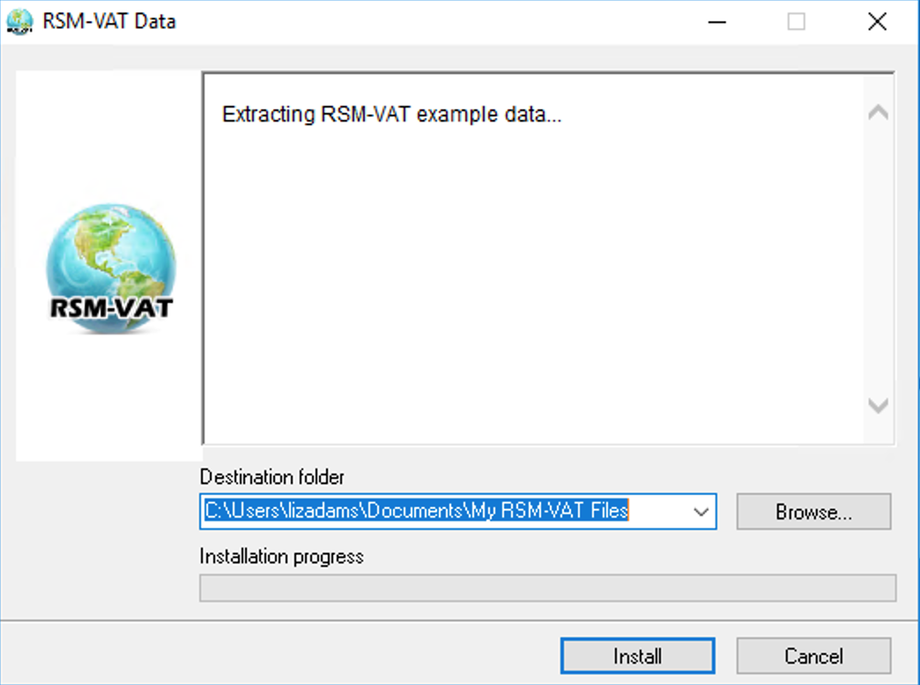
Figure 1.4.2-1. Ready to Unzip Data Package
Click the “Install” button. Figure 1.4.2-2 shows the unzipping process of the example data.
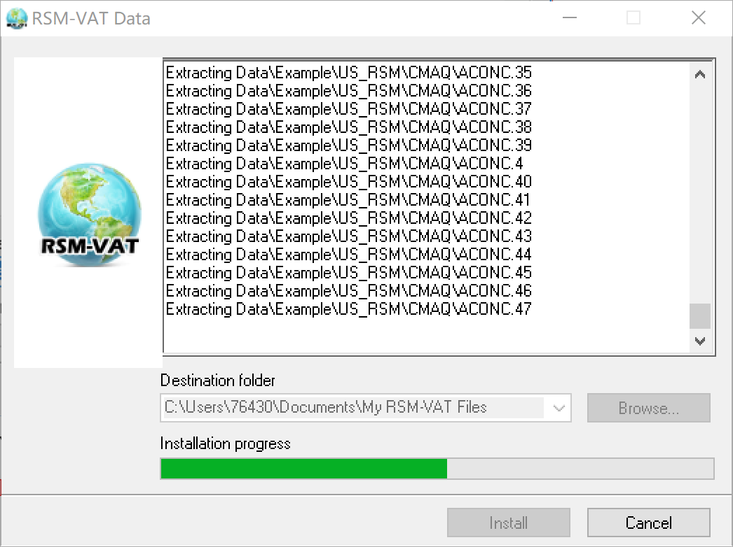
Figure 1.4.2-2. Unzip Processing

Uninstalling RSM-VAT
Go to Control Panel.
Select RSM-VAT and click Change/Remove, the following figure will appear:
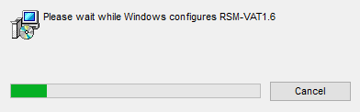
Figure 1.4.3-1. Uninstallation Processing
After a few seconds, uninstallation will finish.

Contacts for Comments and Questions
For comments and questions, please contact：
- The Center for Community Modeling and Analyses System (CMAS) at the University of North Carolina at Chapel Hill via e-mail at cmas@unc.edu.

Sources for More Information
For supplemental information on RSM-VAT, see the following papers:
Jia Xing. (2011) Study on the Nonlinear Responses of Air Quality to Primary Pollutant Emissions (in Chinese) [D], Tsinghua University.
Jia Xing, Shuxiao Wang, Carey J. Jang, Yun Zhu, Jiming Hao. (2011) Nonlinear Response of Ozone to Precursor Emission Changes in China: A Modeling Study using Response Surface Methodology. Atmospheric Chemistry and Physics, 11(10), 5027-5044.
Yunwen Lao, Yu Zhu, Carey J. Jang, et al. (2012) Research and development of regional air pollution control decision support tool based on response surface model (in Chinese) [J]. Acta Scientiae Circumstantiae, 32:1913-1922.
Bin Zhao, ShuXiao Wang, Jia Xing, Joshua S.Fu, Carey J.Jang, Yun Zhu, Xinyi Dong, Yang Gao, Jiandong Wang, Jiming Hao, et al.(2015) Assessing the nonlinear response of fine particles to precursor emissions: development and application of an extended response surface modeling technique v1.0. Geoscientific Model Development, 8(1), 115-128.
Yun Zhu, Yuanwen Lao, Carey J.Jang, Chen-Jen Lin, Jia Xing, Shuxiao Wang, Joshua S.Fu, Shuang Deng, Junping Xie, Shicheng Long.(2015) Development and case study of a science-based software platform to support policy making on air quality. Journal of Environmental Sciences, 27, 97–107.
Shicheng Long, Yun Zhu, Carey J.Jang, Che-Jen Lin, Shuxiao Wang, Bin Zhao, Jian Gao, Shuang Deng, Junping Xie, Xuezhen Qiu.(2016) A case study of development and application of a streamlined control and response modeling system for PM_{2.5} attainment assessment in China. Journal of Environmental Sciences, 41, 69-80.
Yuzhou Pan, Yun Zhu, Jicheng Jang, Shuxiao Wang, Jia Xing, Pen-Chi Chiang, Xuetao Zhao, Zhiqiang You, and Yingzhi Yuan.(2020) Source and sectoral contribution analysis of PM_{2.5} based on efficient response surface modeling technique over Pearl River Delta Region of China. Science of The Total Environment 737:139655.
Tingting Fang, Yun Zhu, Jicheng Jang, Shuxiao Wang, Jia Xing, Pen-Chi Chiang, Shaojia Fan, Zhiqiang You, and Jinying Li.(2020) Real-time source contribution analysis of ambient ozone using an enhanced meta-modeling approach over the Pearl River Delta Region of China. J Environ Manage 268:110650.
Jia Xing, Shuxin Zheng, Dian Ding, James T. Kelly, Shuxiao Wang, Siwei Li, Tao Qin, Mingyuan Ma, Zhaoxin Dong, Carey Jang, Yun Zhu, Haotian Zheng, Lu Ren, Tie-Yan Liu, and Jiming Hao.(2020) Deep learning for prediction of the air quality response to emission changes. Environmental science & technology.

Terminology and File Types
The first section of this chapter explains common terms used in this user manual, and references to other sections (e.g., 5.1, 6.1, and 7.1 section) in this manual to find more detailed information. Section 2.2 describes the necessary format for externally generated model and monitor data files that can be read into RAM-VAT in detail.

Common Terms
CMAQ (Community Multi-Scale Air Quality). A state-of-the-art air quality model able to model secondary ambient particulate levels, as well as other pollutants, including ozone.
Response Surface Model (RSM). RSM is a “reduced form” model of a complex air quality model (e.g., CMAQ) – “meta-model”, based on a systematically selected set of model runs. Statistical techniques are used to represent the relationship between model inputs and outputs (e.g., emissions control and concentrations of PM & ozone). Once the “response surface” has been generated, it can be used to simulate the functions of the more computationally expensive photochemical air quality model. It can also be used to derive analytical representations of model sensitivities to changes in the model inputs.
Latin Hypercube Sampling (LHS). LHS is often applied to generate the experimental design for a Kriging model. It is a statistical method for generating a sample of plausible collections of parameter values from a multidimensional distribution which is more efficient than random sampling from many factors.
Hammersley quasi-random Sequence Sampling (HSS). HSS uses low-discrepancy sequences (quasi-random points) which have the better uniformity or evenness in their domain of definition. This sampling technique provides a generalized approach for increasing simulation efficiency by systematically replacing the pseudo-random numbers used in Monte Carlo (MC) simulations with quasi-random numbers.
Control Factor: It means the emission of a specified precursor pollutant from a particular source and location.
Control Matrix. An experimental design that specifies the type of emission control factors used in a matrix as inputs to the CMAQ air quality model. The matrix is created by sampling the control factors in the design space (e.g., from 0.00 to 1.50) using Latin Hypercube Sampling (LHS) or Hammersley quasi-random Sequence Sampling (HSS).
High-dimensional Kriging Interpolation. Kriging is a geostatistical method based on an exponentially weighted sum of the sample run results. A high-dimensional Kriging approach is applied for the response surface regression of the CMAQ simulation results. RSM adopted and recoded the Parametric Empirical Kriging algorithm and accelerated the calculation efficiency using multi-threading technology.
Add-on Sampling. A sampling method that generates additional runs for CMAQ simulations if the RSM prediction bias does not meet the desired tolerance.
Out of Sample Validation (OOS). OOS is a validation method to evaluate the RSM performance. It compares RSM-predicted values to those of CMAQ for a set of model runs not used in created the RSM.
Cross Validation (CV). CV is another validation method to evaluate the RSM performance. During each CV routine, one of the experimental runs is left out for creating the RSM. The RSM predicted data are then verified against the CMAQ results that are left out.

File Types
RSM-VAT Project File: A pre-run RSM project file, which contains those inputs data and RSM fitting parameters.
RSM File: A *.rsm file created by RSM-VAT, which contains RSM fitting parameters.
Emission File: A *.csv file that contains a series of emission runs created by Control Matrix module, it is an essential input for RSM creation (Config Files/ Matrix_RSMUSA_case1-132.csv),
ShapeLCC File: A *.csv file defines a sequence of points for each state or county, or any other contour, in terms of X and Y coordinates, this file can be created by Model-VAT or ArcGIS (Config Files/USA_whole_StateShapesLCClamberter.csv).
Region File: A separate *.txt file that defines the grids’ information of each region of interest, and it can be created by ArcGIS (Config Files/ US_Multi_region include other.txt).
CMAQ File: These files are CMAQ simulation result files (ACONC) which are NetCDF format, containing the grid data at a single layer and single period. Each emission run in Emission File has a corresponding simulation result file. The filename can be customized, but the filename extension must correspond to the sample serial number of experimental scenes. Therefore, the file can be named using the convention: (CMAQ/Jan/ACONC1, ACONC2, ACONC3, …).
Receptor Region File: A separate *.txt file that defines the grids’ information of each region of interest. Generally, this file defines those grids’ information that contains monitor sites in selected regions. The format of this file is the same as Region File (Config Files/US_Multi_Monitor.txt).
Experimental Configuration File: A *. expproj file that records the settings in Experimental Design module.
Factors File: A *.csv file for emission factor information. It contains each factor’s region, pollutant, source, minimum/maximum emission reduction (Config Files/FactorsInfo_US_Precursor.csv).
Grid Definition File: A GRDCRO2D file that defines the model domain when generating NetCDF files. It usually comes from the CMAQ model (Config Files/RegCtrlNCFfiles/GRIDCRO2D.12EUS2.35L.160101).
Region Control File: A *.shp that contains shape, location, and other related properties of regions (Config Files/RegCtrlNCFfiles/Shapefiles/USA.shp).
Region Control NetCDF File: It is a NetCDF file that contains the grids’ information of selected regions, which is created by CMAQ Preparation module.
Namelist Template File: A *.nml file that contains information about how to scale emissions to model species (Config Files/RegCtrlNCFfiles/ EmissCtrl_RSMUSA.nml).
Control Matrix File: It is the same as the above Emission File that created by Control Matrix module (Config Files/RegCtrlNCFfiles/ Matrix_RSMUSA.csv).
Mapping File: An *.csv file that matches the regions and sectors in the emission control matrix and NetCDF file with the namelist template file (Config Files/RegCtrlN
CFfiles/Mapping_Factors.csv).
Table 1 and Table 2 present the above the different file types, their name, and their file extension.
Table 1. Types of RSM Input files
Module | Filename | File Extension
Visualization & Analysis | RSM-VAT Project File  RSM File  Emission File  Precursor Factors File  ShapeLCC File  Region File  CMAQ File  Receptor Region File | *. rsmproj  *.rsm  *.csv  *.csv  *.csv  *.txt  NetCDF  *.txt
Experimental Design | Experimental Configuration File  Factors File  Grid Definition File  Region Control File  Namelist Template File  Region Control NetCDF File  Control Matrix File  Mapping File | *. expproj  *.csv  NetCDF file  *.shp  *.nml  *.ncf  *.csv  *.csv

Table 2. File Types Generated by RSM
Module | Filename | File Extension
Visualization & Analysis | RSM-VAT Project File  RSM File | *. rsmproj  *.rsm
Experimental Design | Experimental Configuration File  Control Matrix File  Region Control NetCDF File  Namelist File | *. expproj  *.csv  *.ncf  *.nml

Quick Start
This chapter provides the steps required to run RSM-VAT. The Quick Start will use a combined U.S. Case to demonstrate how to run each of the RSM-VAT modules. These steps will use the default RSM-VAT settings and do not describe the configuration settings for each analysis. For details of the configuration settings for the individual RSM-VAT modules, refer to the User’s Manual chapter for each module. The steps below describe how to use RSM-VAT to create a RSM for U.S. PM_{2.5}.
Step 1. Create an emission control matrix, region control NetCDF file and Namelist files for the CMAQ model under Experimental Design module.
Step 2. Create a RSM project under Visualization & Analysis module.
Step 3. View Results under Visualization & Analysis module.

Experimental Design
Click Experimental Design on the top of RSM-VAT home page to switch to the Experimental Design module. The step below describes how to use RSM-VAT to create an emission control matrix, region control NetCDF file, and Namelist files for the CMAQ model. For more details, please refer to Chapter 7.

Create Emission Control Matrix
Click the Experimental Design in the menu bar to enter the Experimental Design module. As shown in Figure 3.1.1-1, the submodule of the Control Matrix displays in default.

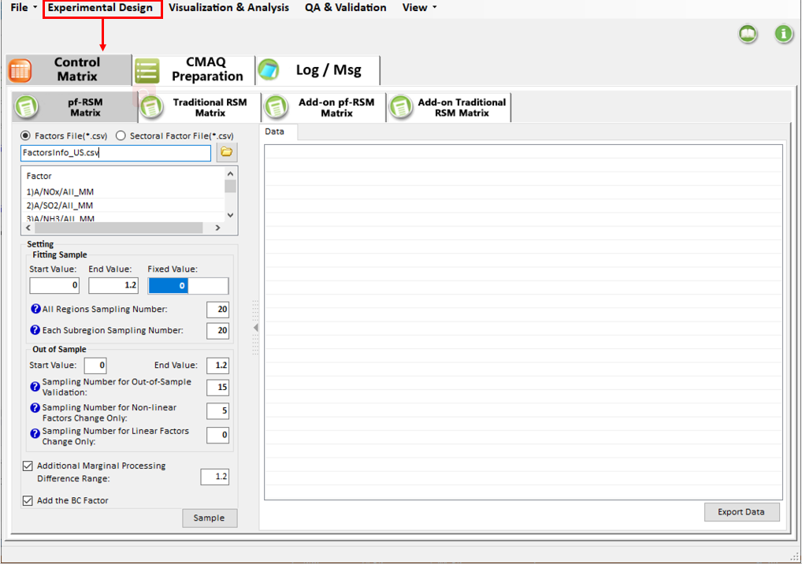
Figure 3.1.1-1. Enter the Experimental Design Module
Click the pf-RSM Matrix and then click the file button 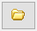 to select a Factors File and open it. The details of Factors File are shown in Figure 3.1.1-2, this case has a total of 25 control factors (5 different factors for each single region). The Emission control factors range from 0 to 120%, a zero-control factor means that the emission of interest is reduced to zero while a 120% factor indicates that the emission is increased by 20% compared to baseline emission.

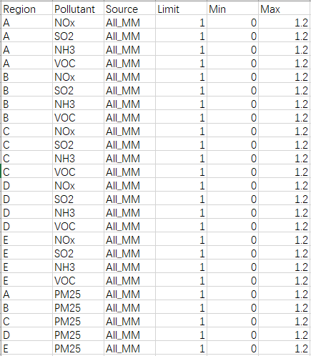
Figure 3.1.1-2. Factors File
After setting sampling parameters, click the Sample to start sampling. As shown in Figure 3.1.1-3, it will create a series of emission runs, a row stands for a emission run, a column (except the 1st column) represents the emission control value for current factor. For example, all the result information of case 1 is displayed as 1, which indicates the sampling result without the implementation of control measures.

Click the Export Data to export the sampling result to a local path.
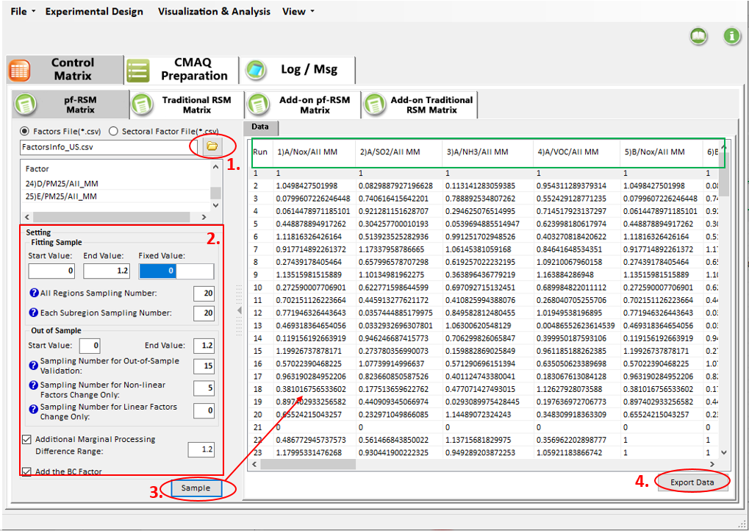
Figure 3.1.1-3. pf-RSM Matrix Sampling

Create NetCDF File and Namelist Files for CMAQ
Click the CMAQ Preparation in the tab bar to enter the CMAQ Preparation submodule.
Create a region control NetCDF file based on region control shapefile as shown in Figure 3.1.2-1.
- Check the Create Region Control NetCDF File option to view the setting panel.
- Click the file button to select a grid definition file.
- Click the plus button 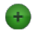 to add a region control shapefile.
- Click the Manage Selected Region button to select control regions from the loaded region control shapefiles and the list of selected regions below will be updated.
- Click the Output button to generate the NetCDF file, and the result file will then be loaded in the right panel under the NetCDF tab page.
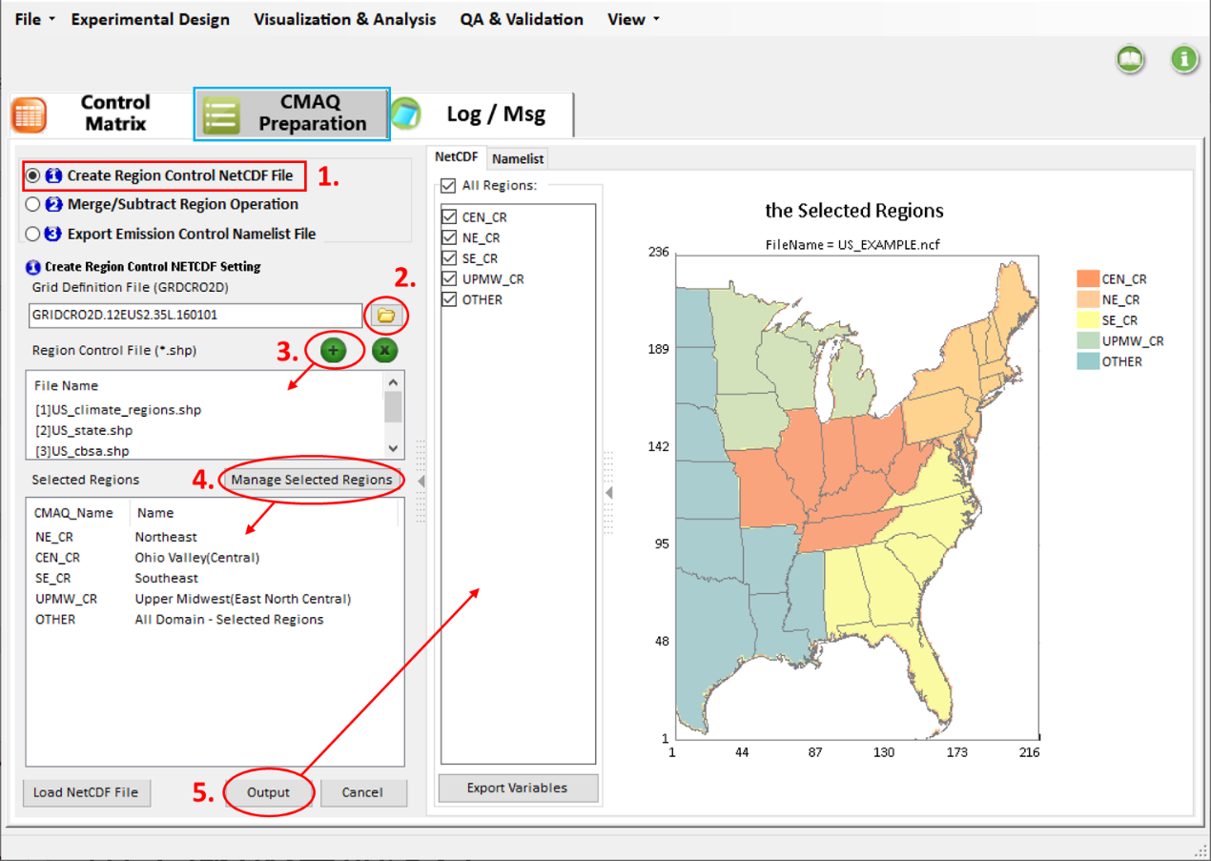
Figure 3.1.2-1. Create Region Control NetCDF File
Additionally, users can get a new region control NetCDF file through merge operation on the file obtained in the previous step if necessary, as shown in Figure 3.1.2-2, which is available for a single region case study.
- Check the Merge/Subtract Region Operation option to view the setting panel.
- Click the file button to load the region control NetCDF file attained in the previous step.
- Check the Create Region with Formula option, then click the Add/Remove button to add an expression to merge regions.
- Click the Output button to generate a new region control NetCDF file by the merge operation, and the result file will then be loaded in the right panel under the NetCDF tab page.
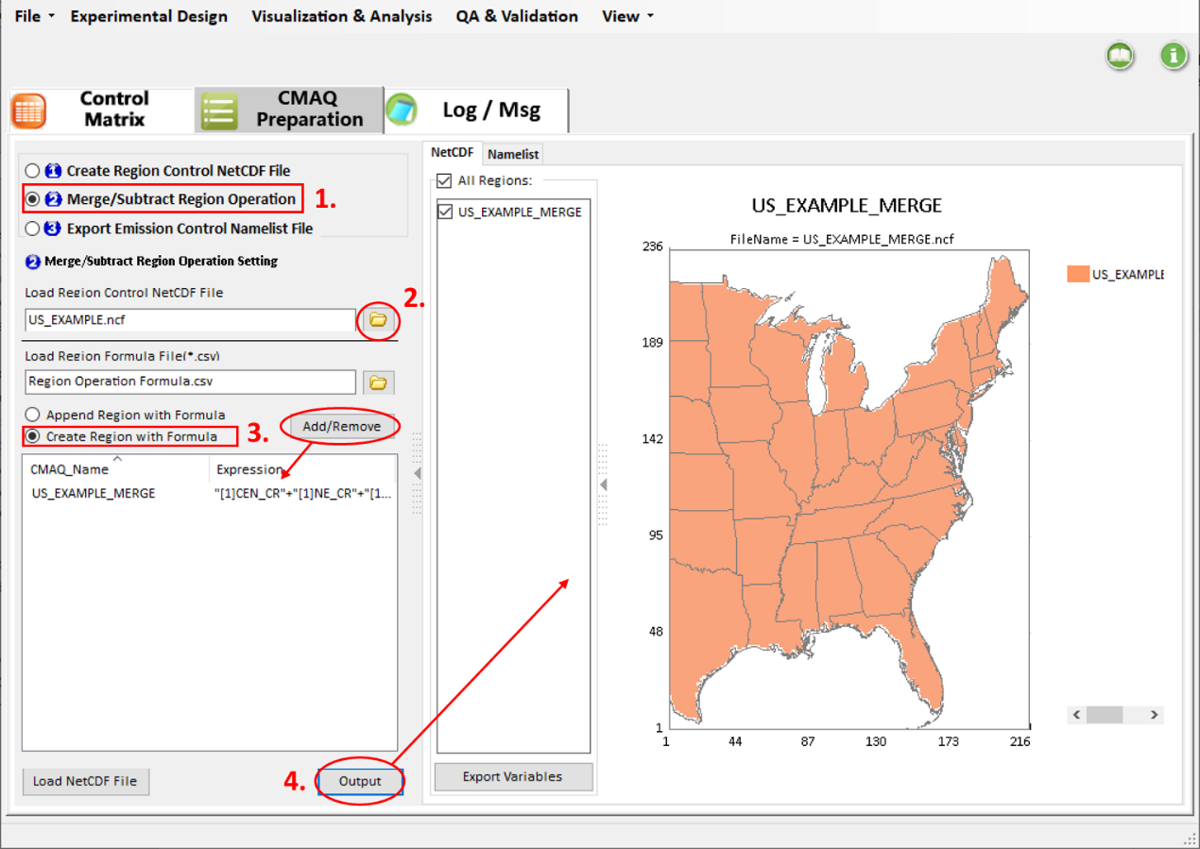
Figure 3.1.2-2. Merge/Subtract Region Operation
Export emission control namelist files for CMAQ based on the control matrix and NetCDF file obtained in previous steps, as shown in Figure 3.1.2-3.
- Check the Export Emission Control Namelist File option to view the setting panel.
- Click the file button to select a namelist template file.
- Click the file button to select the region control NetCDF file generated in previous steps.
- Click the file button to select the control matrix file generated in the Control Matrix submodule.
- Click the file button to select the mapping file corresponding to the input NetCDF file and control matrix file.
- Click the Output button to generate the Namelist files for CMAQ, and the result files will then be loaded in the right panel under the Namelist tab page.
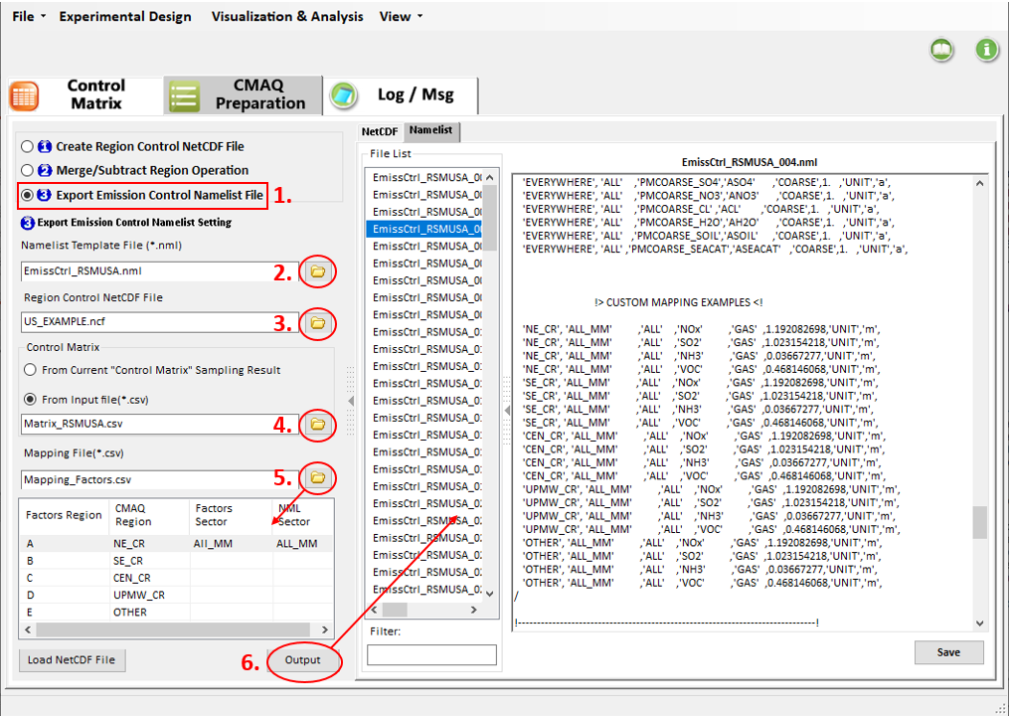
Figure 3.1.2-3. Export Emission Control Namelist File

Create a New RSM Project
The steps below describe how to create and run a new RSM project:

Run a New RSM Project
Click the Visualization & Analysis in the menu bar to enter the module. As shown in Figure 3.2.1-1, the interface of Create/Input RSM Option displays on the left.
Click the File button and choose the New Project option to create a new RSM project.
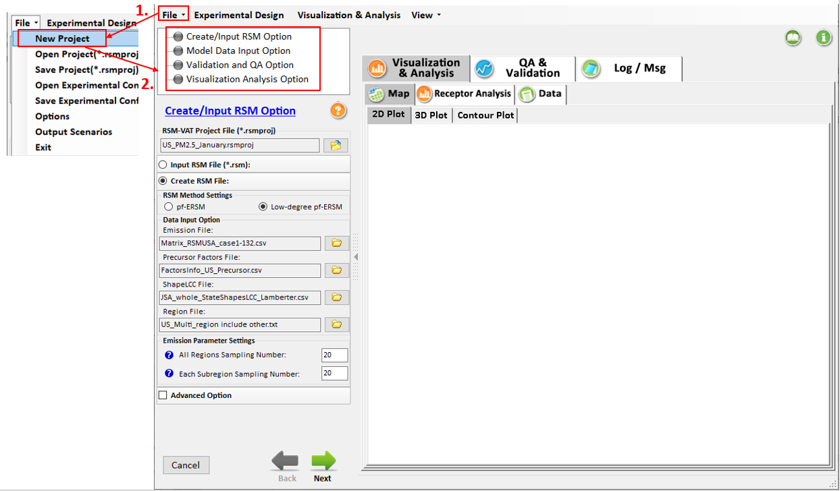
Figure 3.2.1-1. Create a New Project

Set Input Parameters
The parameter setting for Create/Input RSM Option is shown in Figure 3.2.2-1.
- Choose the Create RSM File option and then click the file button to select the input files for creating RSM, including the Emission File, Precursor Factors File, ShapeLCC File, Region File. After selecting the input files, the All Regions Sampling Number and Each Subregion Sampling Number are needed to set based on the Emission File.
- Click the Next button to proceed to the configuration of the Model Data Input Option.
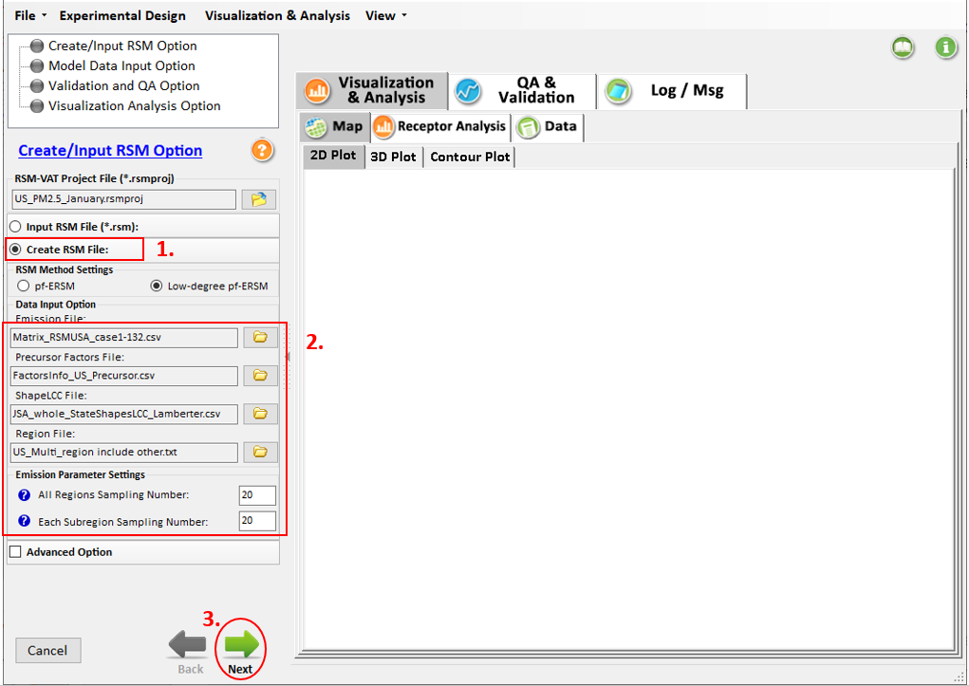
Figure 3.2.2-1. Create/ Input RSM Option
The parameter setting for Model Data Input Option is shown in Figure 3.2.2-2.
- Click the file button which is in the upper-right of the main interface to select a Base Case CMAQ File and open it.
- Check the Scenario Plot and then select cases, this operation is optional.
- Click the Next button to proceed to the configuration of the Validation and QA Option, as shown in Figure 3.2.2-2.
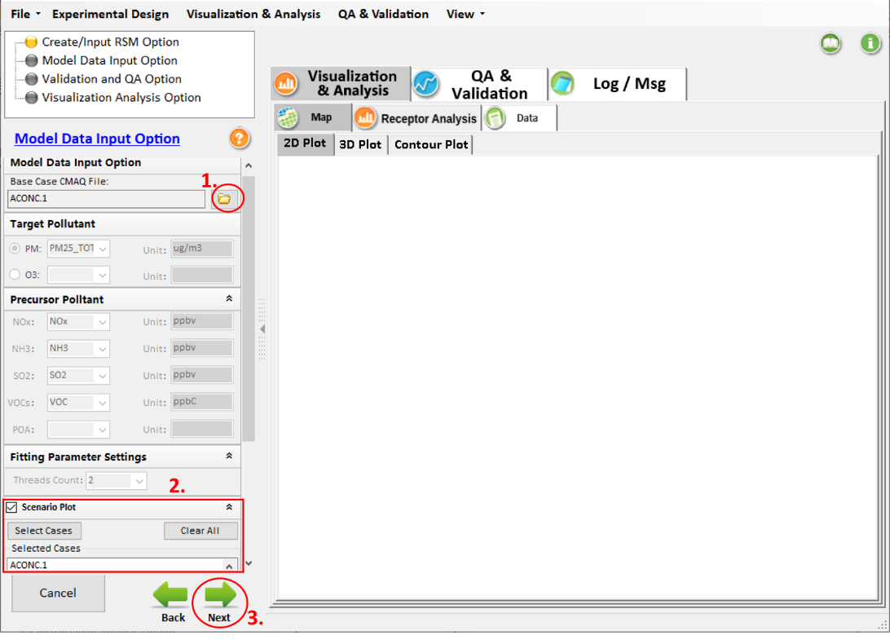
Figure 3.2.2-2. Model Data Input Option
The parameter setting for Validation and QA Option is shown in Figure 3.2.2-3.
- Click the file button to select an Emission File for Out of Sample, as shown in Figure 3.2.2-3.
- Click the Next button to proceed to the configuration of the Validation and QA Option.
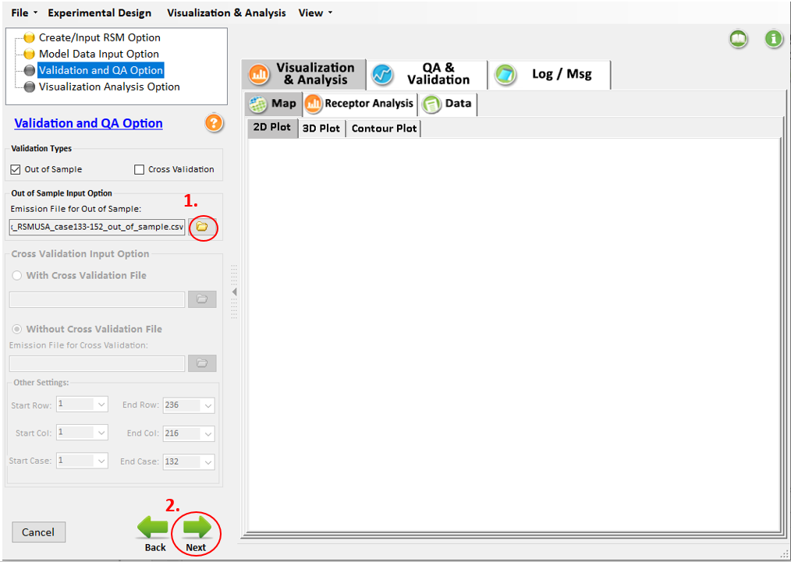
Figure 3.2.2-3. Validation and QA Option
The parameter setting for Validation and QA Option is shown in Figure 3.2.2-4.
- Click the file button to select a Receptor Region File and the details of the Receptor Region File are shown in Figure 3.2.2-5.

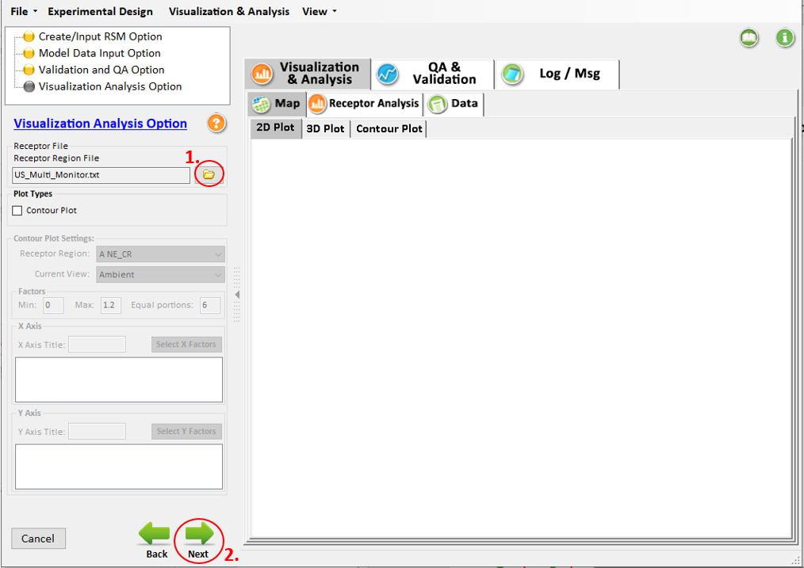
Figure 3.2.2-4. Visualization Analysis Option
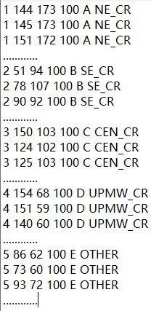
Figure 3.2.2-5. Receptor Region File
- Click the Next button and Figure 3.2.2-6 will appear, choose yes to run the program.
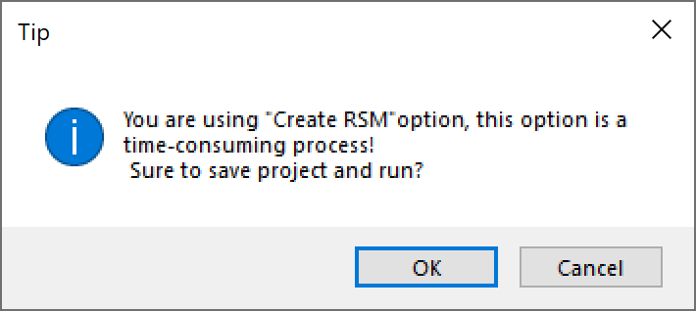
Figure 3.2.2-6. Save Project and Run

View Results
The steps below describe how to view the result of an RSM project. More details refer to Chapter 7.

QA & Validation

Out of Sample Validation
As shown in Figure 3.3.1-1, it shows the Out of Sample Validation results of RSM, in which the predicted values derived from the RSM are compared with the actual CMAQ simulations of a set of model runs that are not included creating RSM, and the comparison results are displayed in Error & Bias Plot, Comparison Plot, RSM .vs CMAQ and Error & Bias Table.
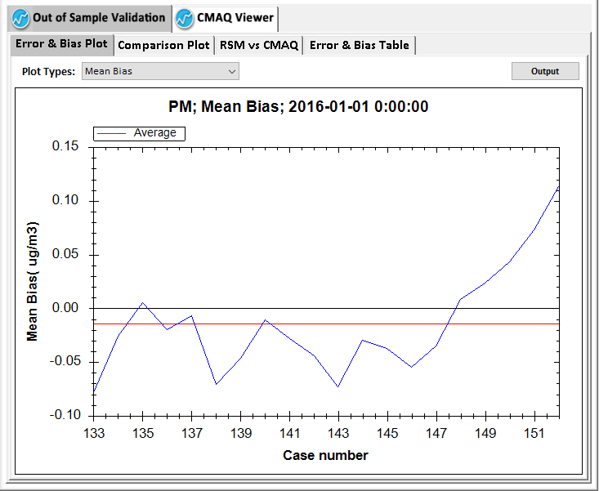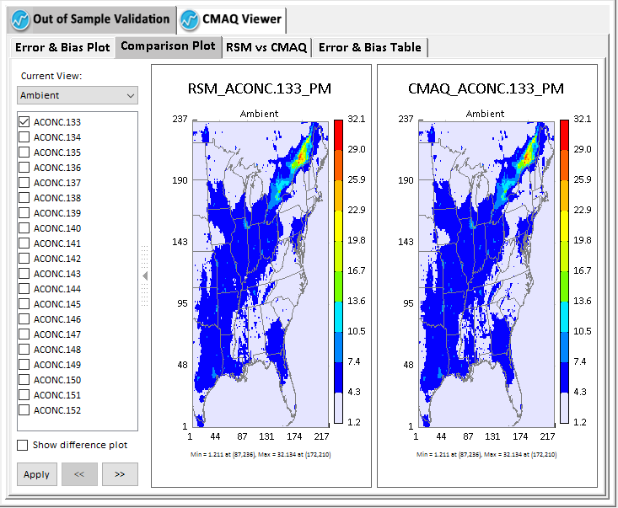
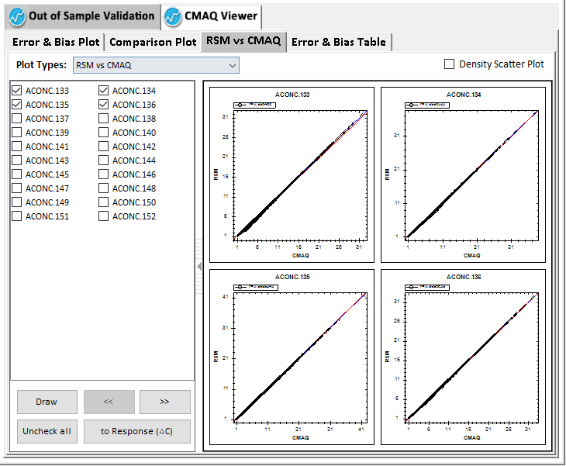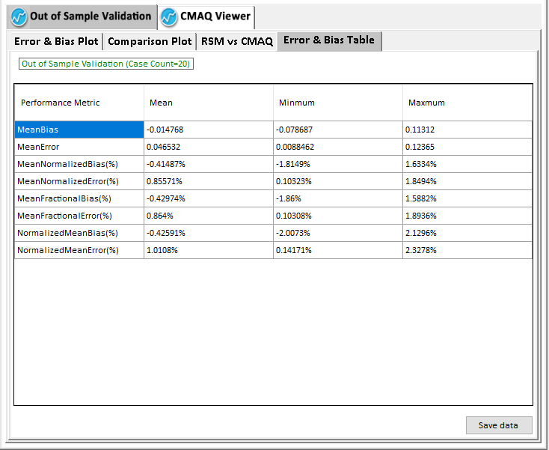
Figure 3.3.1-1. Out of Sample Validation Results

CMAQ Viewer
Figure 3.3.1-2 shows the distribution of the PM_{2.5} concentration under different emission runs from emission control matrix file. This module can help users check the results of CMAQ simulations under different emission runs.
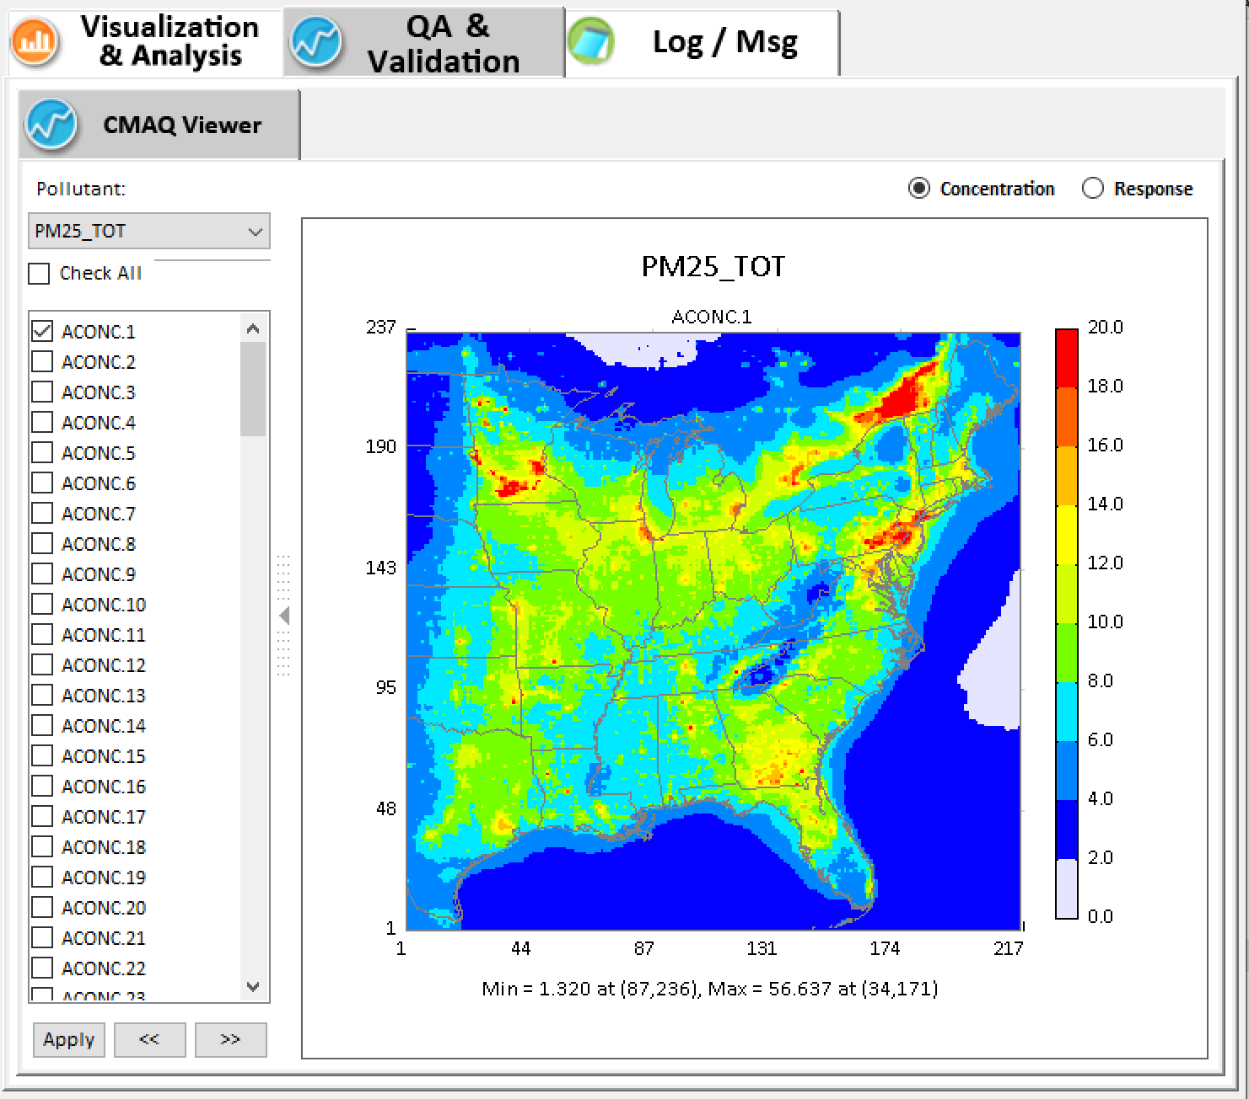
Figure 3.3.1-2. Results of CMAQ simulations

Visualization & Analysis

Map Results
As shown in Figure 3.3.2-1, the maps show the ambient levels of PM_{2.5} simulated by RSM through 2D&3D Plot. The values of 1 in Figure 3.3.2-1 represent the PM_{2.5} concentration without the implementation of control measures compared to baseline, users can change the value of the control factors and check the Response to view air quality changes compared to baseline.

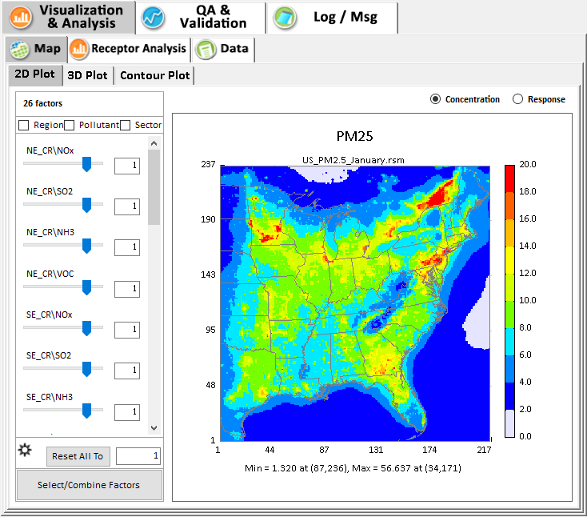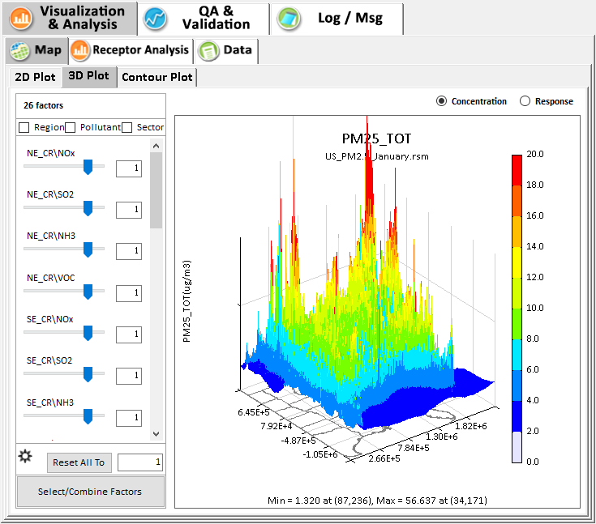
Figure 3.3.2-1. Map Results

Chart Results
Figure 3.3.2-2 shows source contributions for air quality (PM_{2.5}) in each receptor region under different emission control by various charts. For more details, refer to Chapter 7.

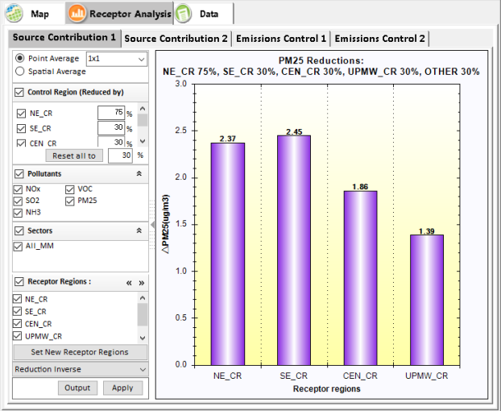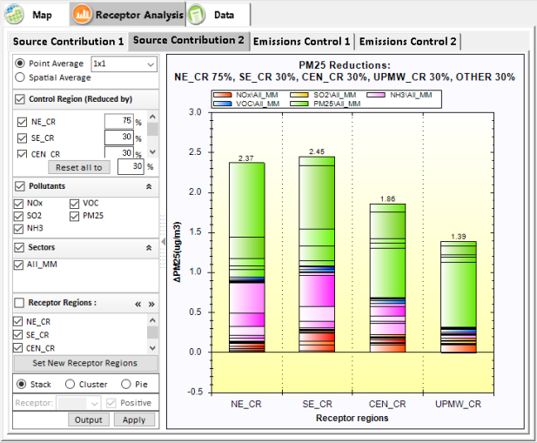
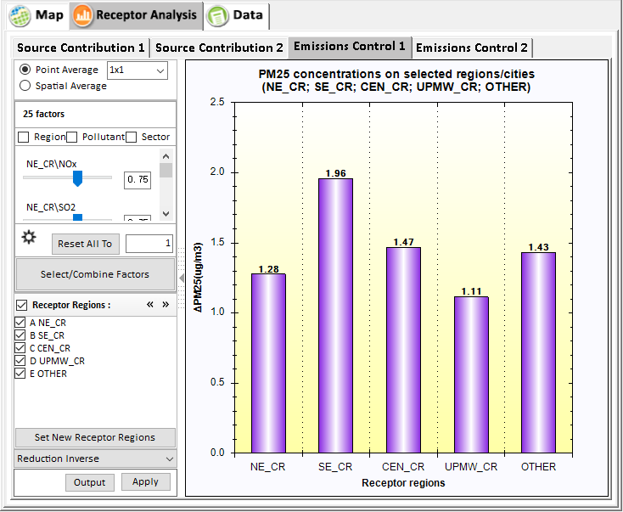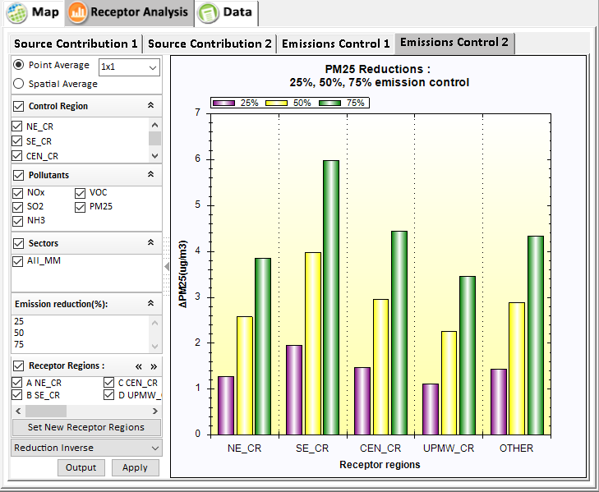
Figure 3.3.2-2. Chart Results

Data Results
Figure 3.3.2-3 shows the PM_{2.5} concentration of each grid in the simulation domain. Users can output it for further study, e.g., as input for SMAT-CE.
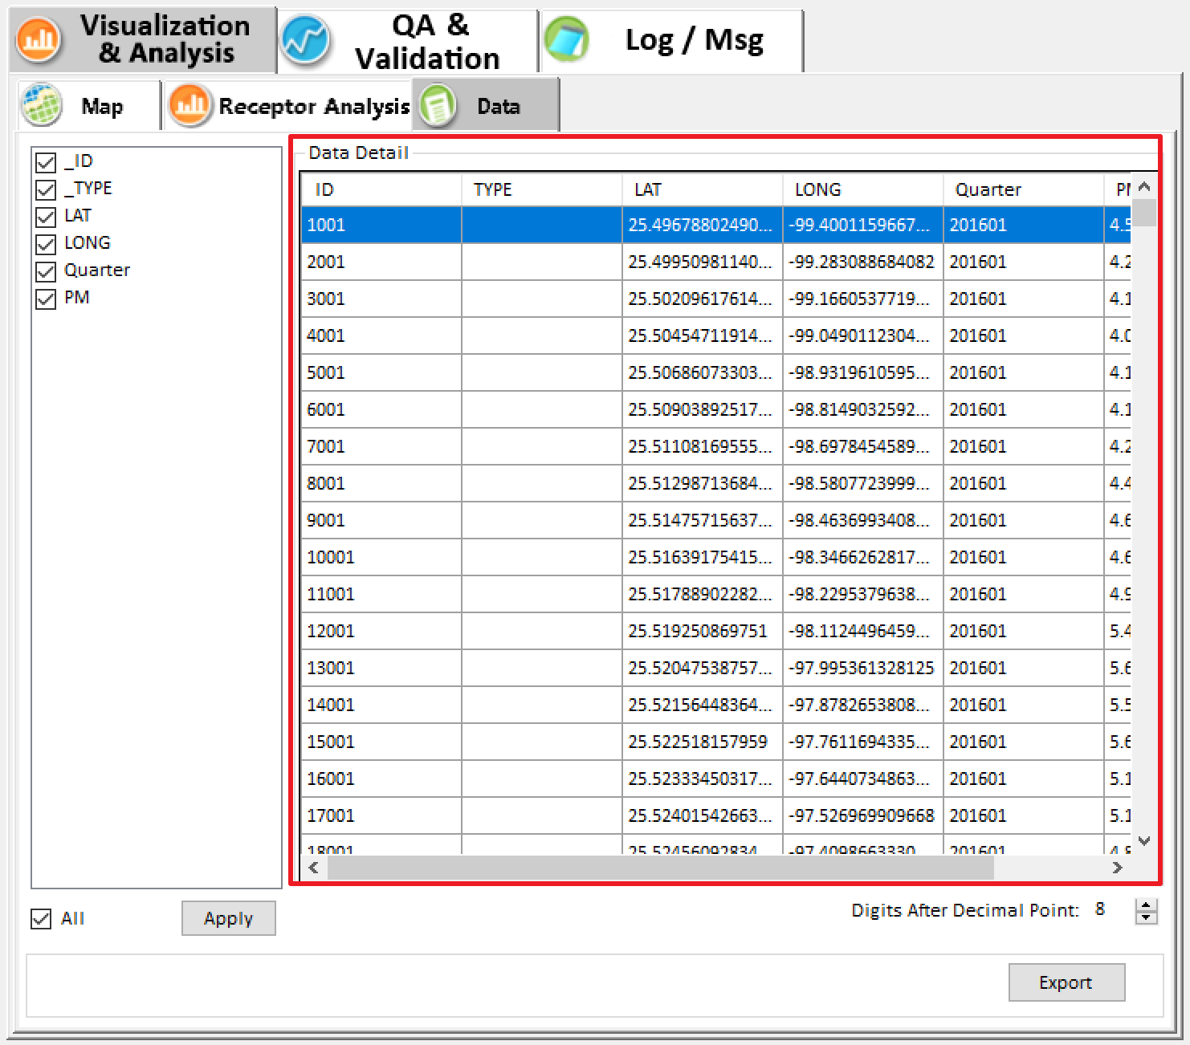
Figure 3.3.2-3. Data Results

Main Interface
The main interface of RSM-VAT can be shown in Fig 4-1.
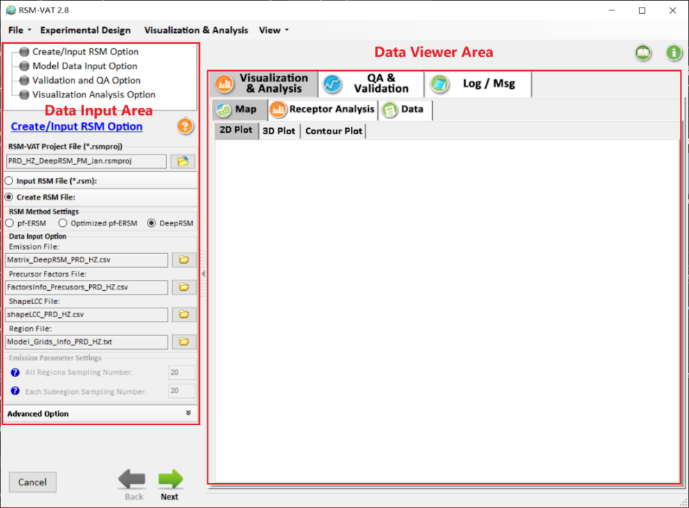
Figure 4-1. Main Interface of RSM-VAT
Click File button on the top of RSM-VAT main page, there are five options that users can choose.
- Go to File, click Open Project button, locate the *. rsmproj file and open it.
- Click the New Project button to create a new project.
- Click the Save Project button to save a created project.
- Click the Options button to set the default configuration, show language menu, and show start page menu.
- Click the Exit button to exit the RSM-VAT.
Click the Experimental Design button on the top of RSM-VAT main page to switch to Experimental Design module.
Click the Visualization & Analysis button on the top of RSM-VAT main page to switch to Visualization & Analysis module.
Click the View button on the top of RSM-VAT main page, there are two options that users can choose.
- Click the Setting Viewer button to show the setting panel.
- Click the Data Viewer button to collapse the Setting Viewer panel and show the Visualization & Analysis panel.

Experimental Design
Under “Experimental Design” module, it includes two submodules: (1) Control Matrix and (2) CMAQ Preparation. Control matrix module is used to create emission control matrix based on the selected control factors, while CMAQ preparation module provides region control NetCDF file and Namelist files for CMAQ model.
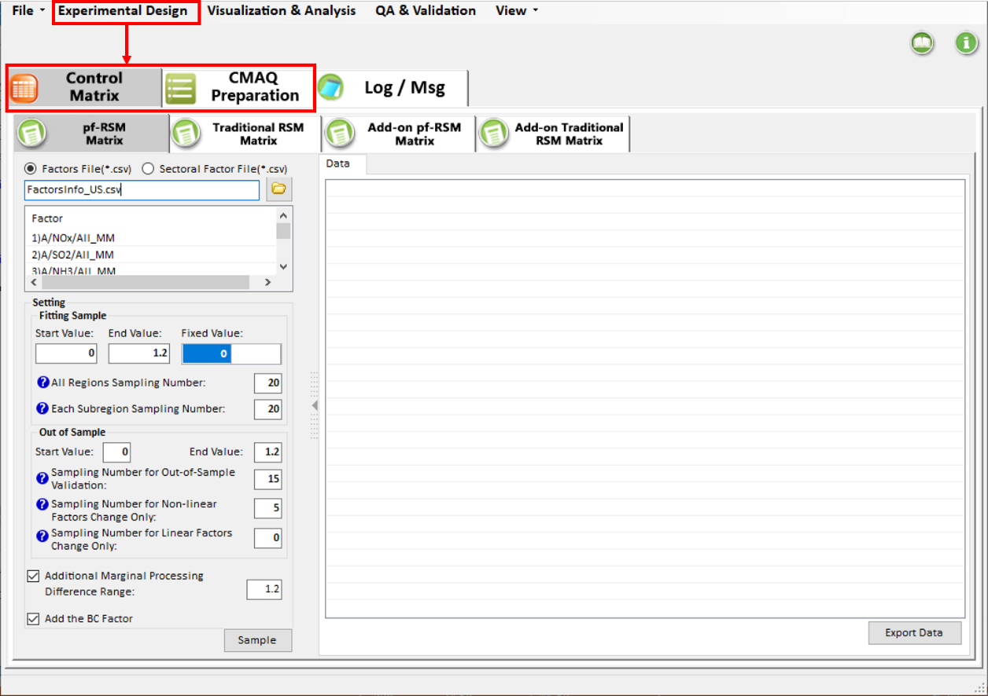
Figure 5-1. GUI of Experimental Design Module

Control Matrix

pf-RSM Matrix
In the pf-RSM Matrix sampling module, users can create an emission control matrix for the pf-RSM model based on various pollutants in different regions/cities using the HSS method. Users can also export data for further study, as shown in Figure 5.1.1-1.
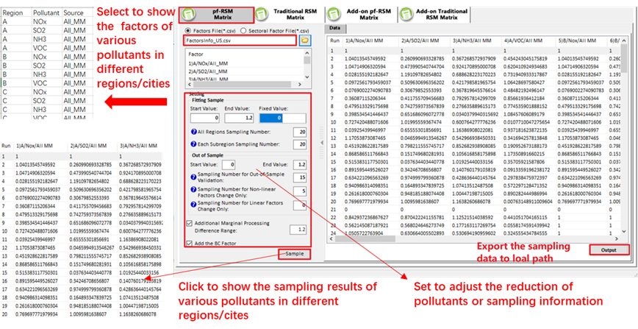
Figure 5.1.1-1. pf-RSM Sampling Module

Traditional RSM Matrix
In the traditional RSM sampling matrix module, users can create the emission control matrix for traditional RSM (e.g., RSM using High-dimensional Kriging interpolation technique) based on selected pollutants in different regions/cities using LHS method. Users can also export data for further study, as shown in Figure 5.1.2-1.

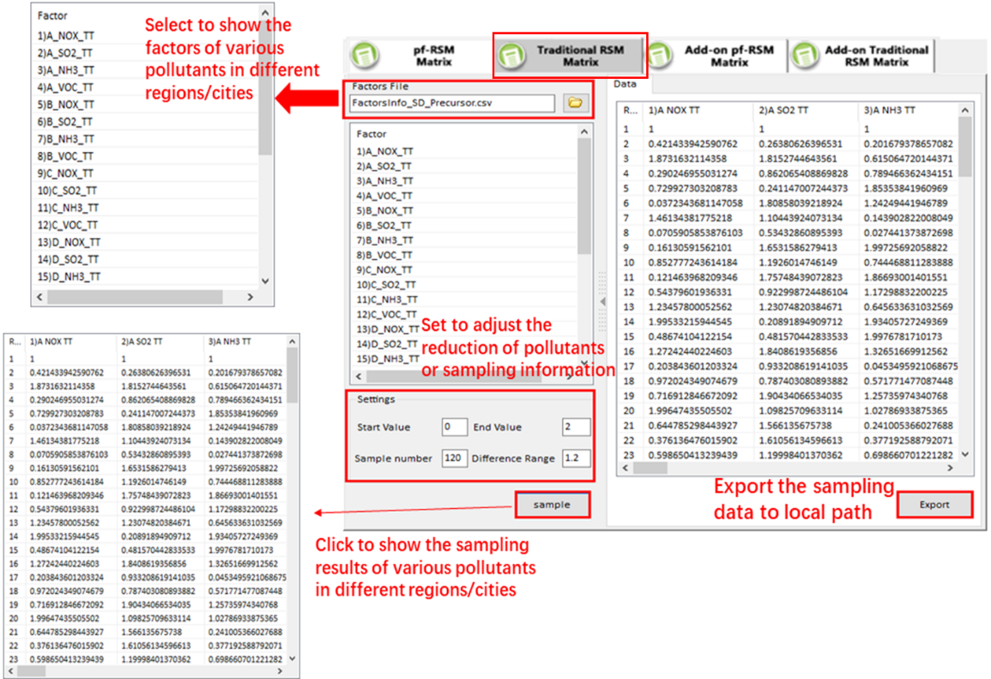
Figure 5.1.2-1. Traditional RSM Matrix Sampling

Add-on pf-RSM Matrix Sampling
In the Add-on pf-RSM matrix sampling module, it is also for appending a certain amount of samples when the pf-RSM prediction error or bias exceeds acceptable ranges, as shown in Figure 5.1.3-1. Increasing the sampling density will further improve the RSM prediction accuracy (Xing et al., 2011). The add-on sampling function allows users to choose the factors, and to set the number of samples and the factor range. The module uses HSS methods to generate a sub-matrix supplementing the existing matrix for additional sampling runs. For example, to further reduce the difference between RSM and CMAQ results, one can use the function of this module to generate additional 20 experiment runs. The CMAQ simulation results of the 20 additional runs together are then used to recreate the RSM.
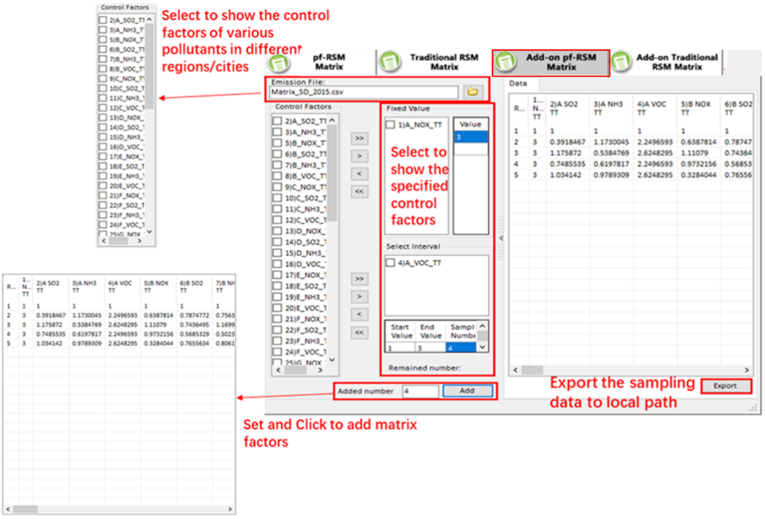
Figure 5.1.3-1. Add-on pf-RSM Matrix Sampling

Add-on Traditional RSM Matrix Sampling
In Add-on traditional RSM matrix sampling module, it is for appending a certain amount of samples when the traditional RSM prediction error or bias exceeds acceptable ranges, as shown in Figure 5.1.4-1.

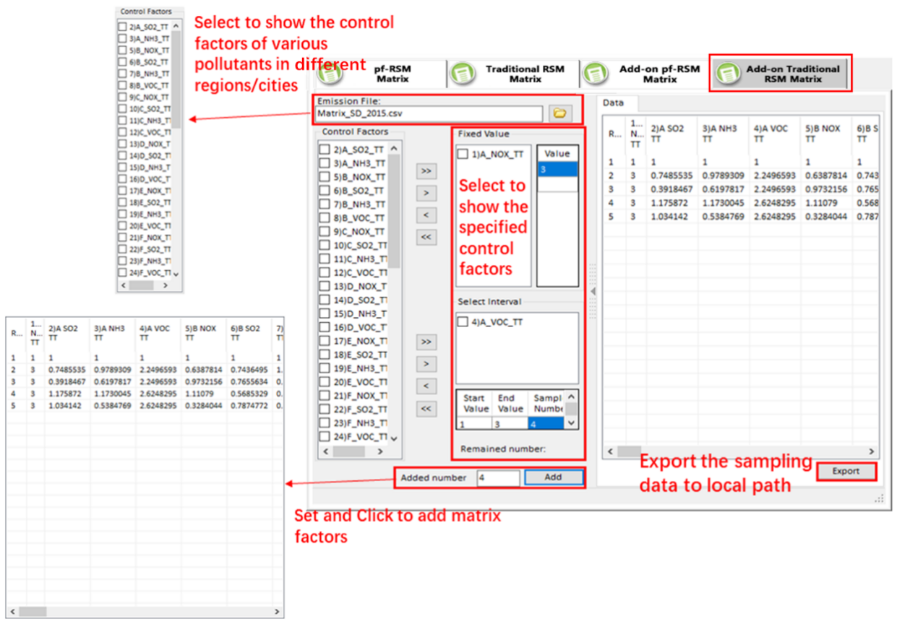
Figure 5.1.4-1. Add-on Traditional RSM Matrix Sampling

CMAQ Preparation
Under the CMAQ preparation modules, it provides three kinds of functions for users to create region control NetCDF file and export emission control Namelist files that are needed in CMAQ 5.3 or later. There are: (1) Create Region Control NetCDF File, (2) Merge/Subtract Region Operation, and (3) Export Emission Control Namelist File.

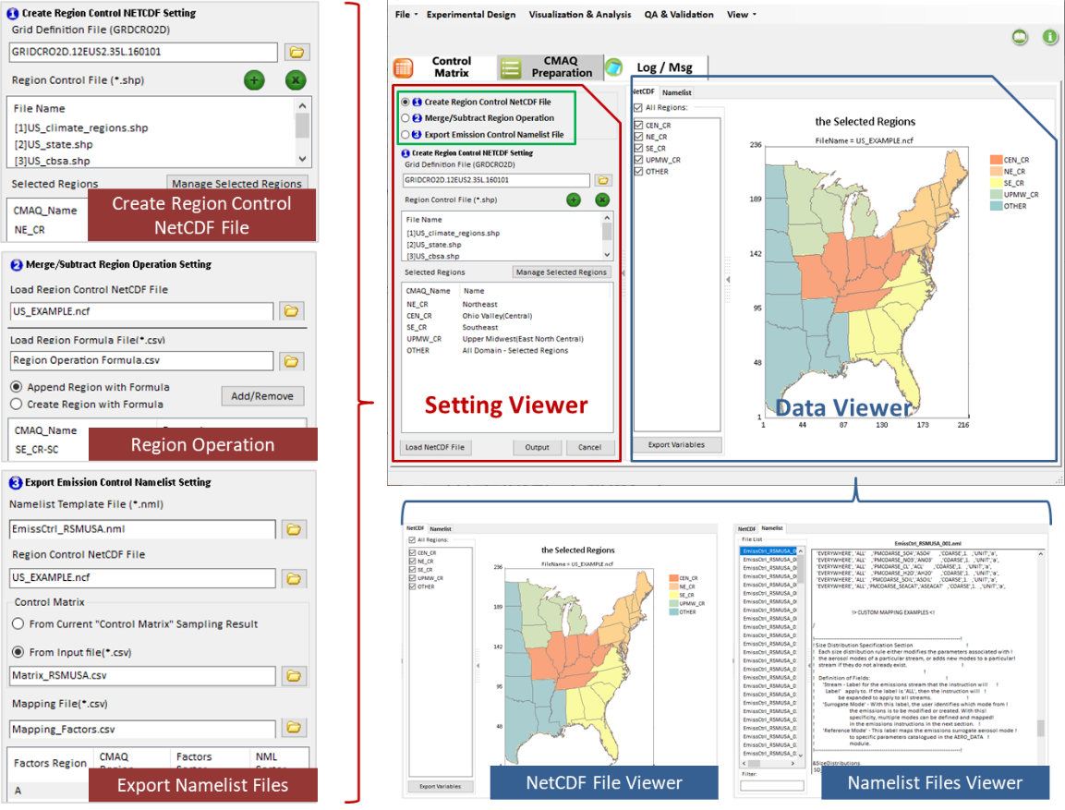
Figure 5.1.4-2. Main Functions in CMAQ Preparation Module

Create Region Control NetCDF File
The Create Region Control NetCDF File module is used to create region control NetCDF files for the CMAQ module. To create a region control NetCDF file, the following operations are needed:
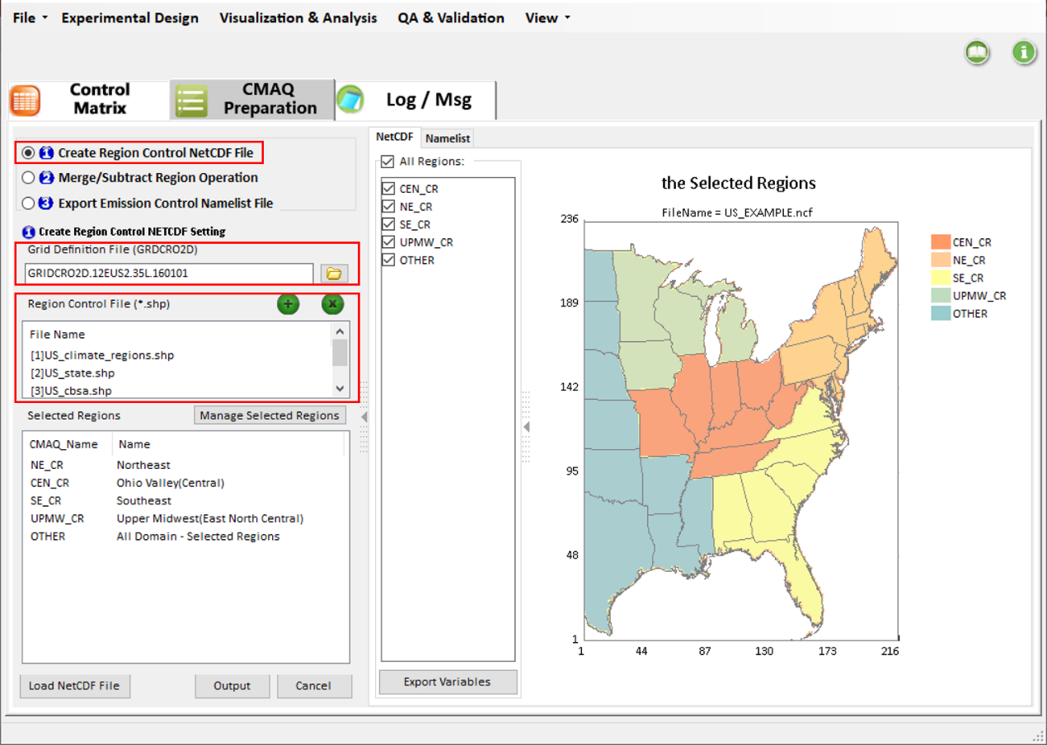
Figure 5.2.1-1. GUI of Create Region Control NetCDF File
Load Grid Definition File (GRDCRO2D): Click the browse file icon to select the grid definition file. This file usually comes from the CMAQ model.
Load region control ESRI Shapefile (*.shp): Click the “+” icon to add a region control shapefile or click the “X” icon to remove loaded region control shapefile.
Manage Selected Regions: Click this button to open the region management dialog. Under this dialog, users can select regions of interest and drag into the selected regions panel on the right. If the selected regions are not needed already, users can select them and click the “Delete” key on the keyboard. User’s interested regions once set up, click the “OK” button to return the main page, and the selected regions will be listed in the “Selected Regions” panel. Note that users can also define a special region called “Other” by clicking the “Define Other” button. This region usually is defined as those regions that are outside the selected regions but inside the model domain (All Domain – the selected regions).
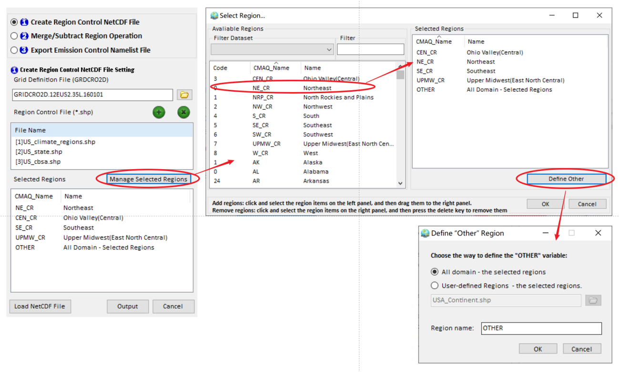
Figure 5.2.1-2. Operation for Manage Selected Regions
Create region control NetCDF File: All settings mentioned are done, click the Output button, and a region control NetCDF file will be created, and the result will be visualized in the right panel under “NetCDF” tab page. Note that users can also load previously created region control NetCDF files by clicking the Load NetCDF File button.

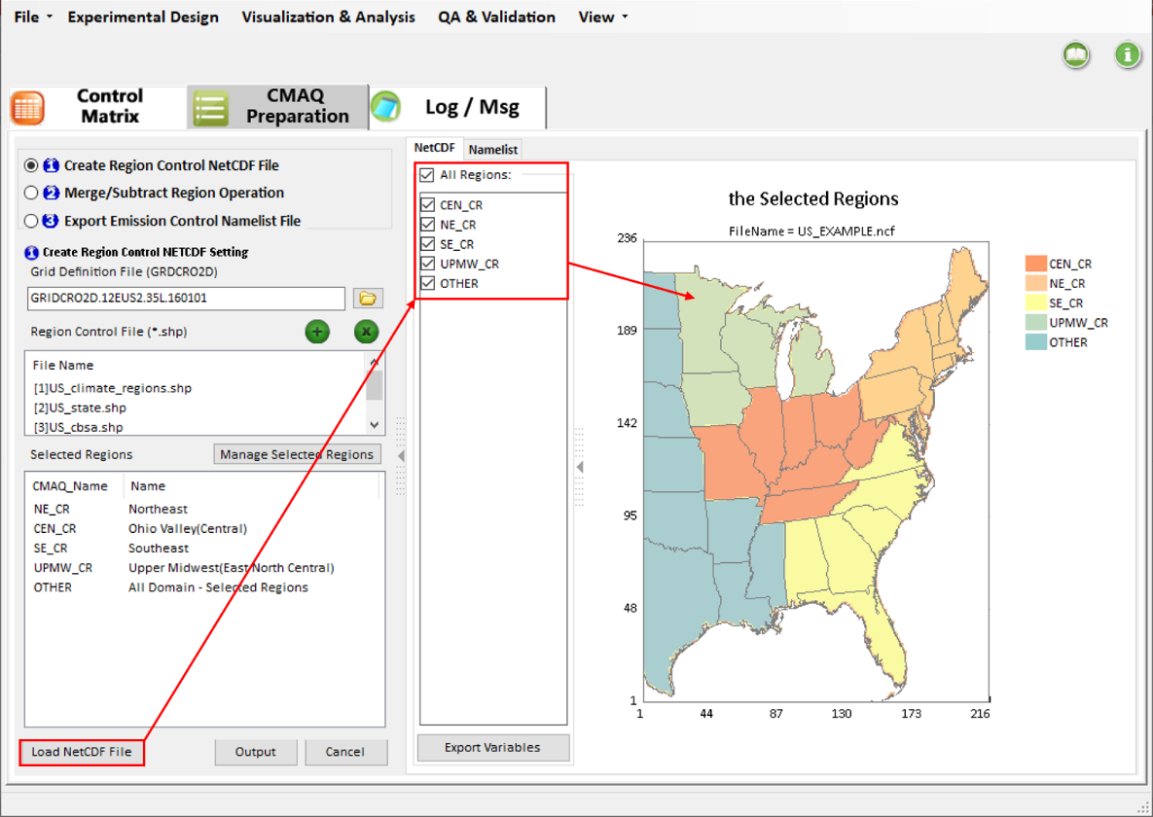
Figure 5.2.1-3. Example for Load NetCDF File

Merge/Subtract Region Operation
The Merge/Subtract Region Operation module allows users to merge or subtract those regions created in the last module (“Create Region Control NetCDF File”). Under this module, it includes the following operations: (1) Load Region Control NetCDF File, (2) Load Region Formula File (*.csv), and (3)Add/Remove Regions.

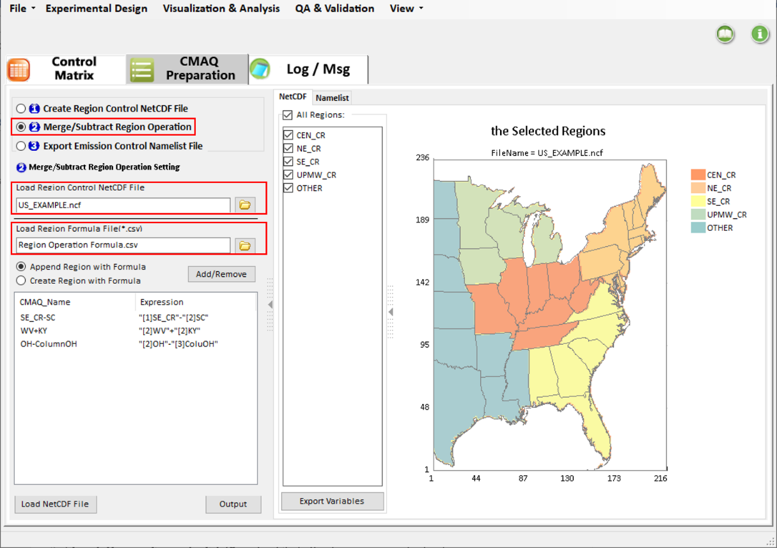
Figure 5.2.2-1. GUI of Merge/Subtract Region Operation
Load Region Control NetCDF File: Click the browser icon to load the NetCDF file created in the last module.
Load Region Formula File(*.csv): Click the browser icon to load a region formula file. This file defines some regions with formula.
Add/Remove Regions: Click the “Add/Remove” button to open a dialog to define the region with formula. In this dialog, users can define a region by using an expression under “Formula Editor”. Double-click the regions on the left panel to add them into “Formula Editor” on right. While the edit finished, click the “Add” button to commit the formula to the “Selected Regions” panel.
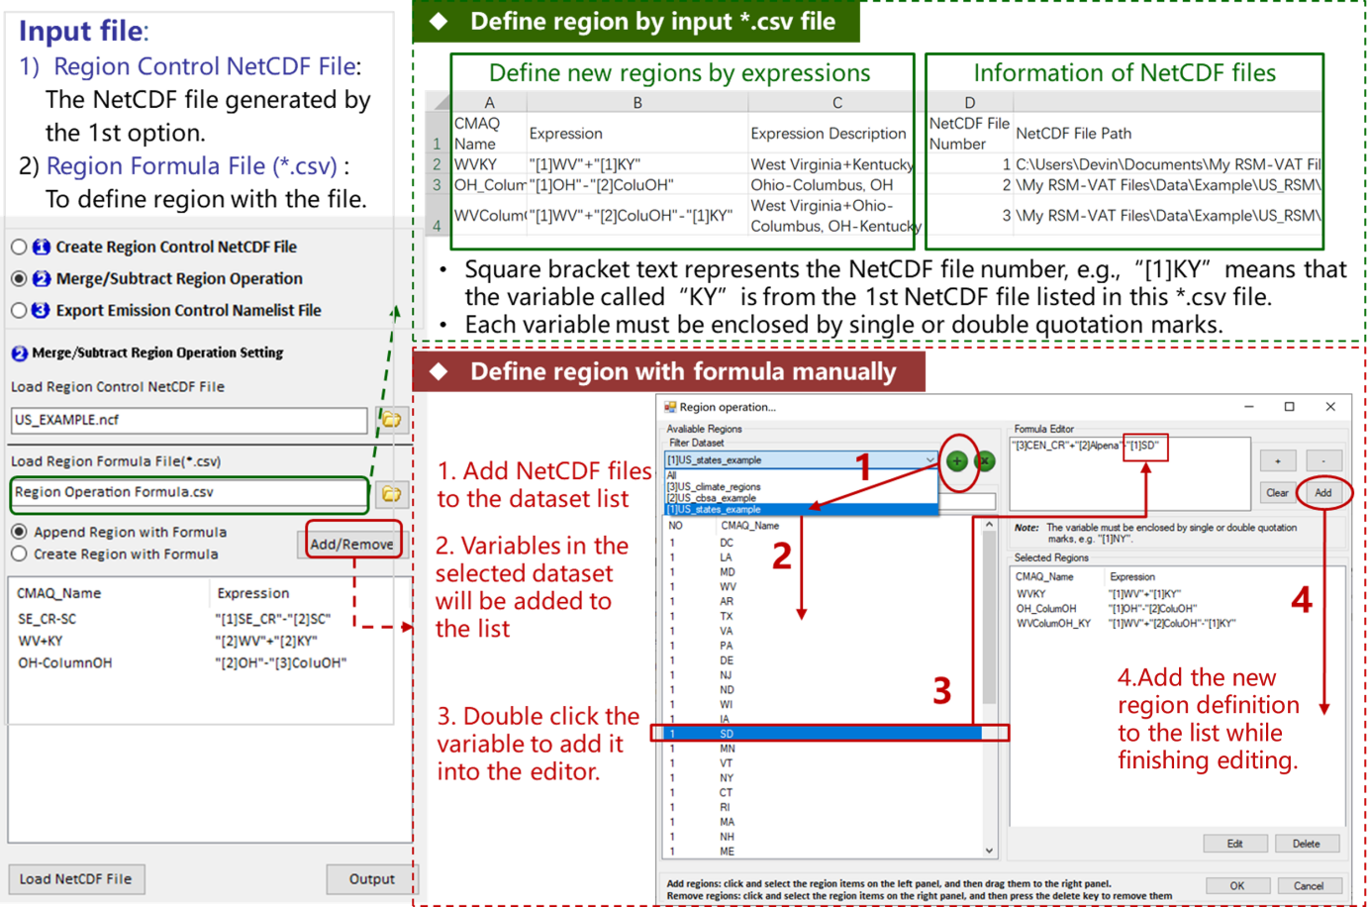
Figure 5.2.2-2. Example for Using Merge/Subtract Region Operation Module
Create Region Control NetCDF File: Once the above settings are finished, click the “Output” button to create the new region control NetCDF file, and the file will be visualized in the right panel under “NetCDF” tab page. Note that users can also load previously created region control NetCDF files by clicking the “Load NetCDF File” button.

Export Emission Control Namelist File
Under the “Export Emission Control Namelist File” module, it provides users a function to output a series of Namelist files based on the emission control matrix, and these Namelist files will be used as input for CMAQ 5.3 or later. In this module, the following steps are needed. There are (1) Set Namelist Template File, (2) Set Region Control NetCDF File, (3) Set Control Matrix, and (4) Set Mapping File.
Set Namelist Template File: This file will be used as a template to output a series of new Namelist files based on the input emission control matrix, as shown in Figure 5.2.3-1. This file is available at:
https://github.com/USEPA/CMAQ/blob/master/DOCS/Users_Guide/Tutorials/CMAQ_UG_tutorial_emissions.md.
Set Region Control NetCDF File: This file is created from the first or second module mentioned above. The region variables in the final output Namelist file will be obtained from this file.
Set Control matrix: It provides two options for users, one is using the control matrix created in the Control Matrix module, and the other is coming from the user’s input.
Set Mapping File: This file is used to make the region, sector, and pollutant variables in the emission control matrix to be consistent with those in the Namelist template file, as shown in Figure 5.2.3-2.

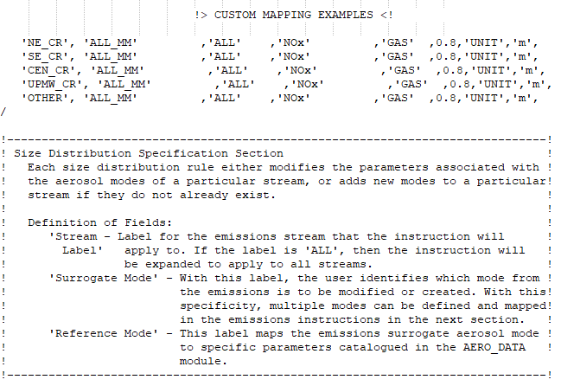
Figure 5.2.3-1. Namelist Template File Example

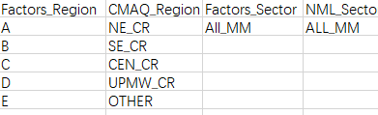
Figure 5.2.3-2. Mapping File Example
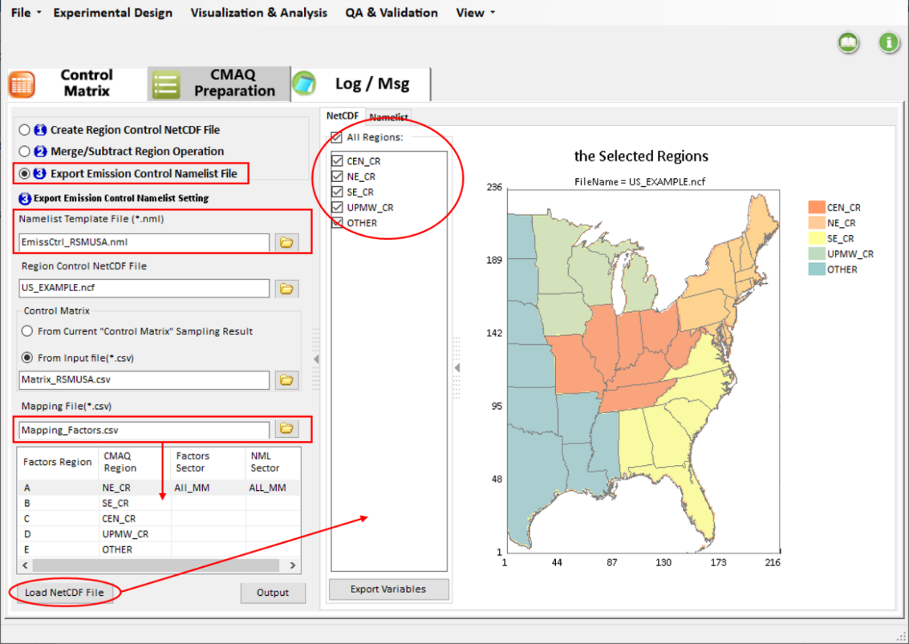
Figure 5.2.3-3. Example for Using Export Emission Control Namelist File
Create Emission Control Namelist File: Once all settings above are done, click the “Output” button, and a series of emission control Namelist files will be exported to the user-specified directory and listed in the Namelist tab page. Under Namelist tab page，users can click any of Namelist files to view or edit it.
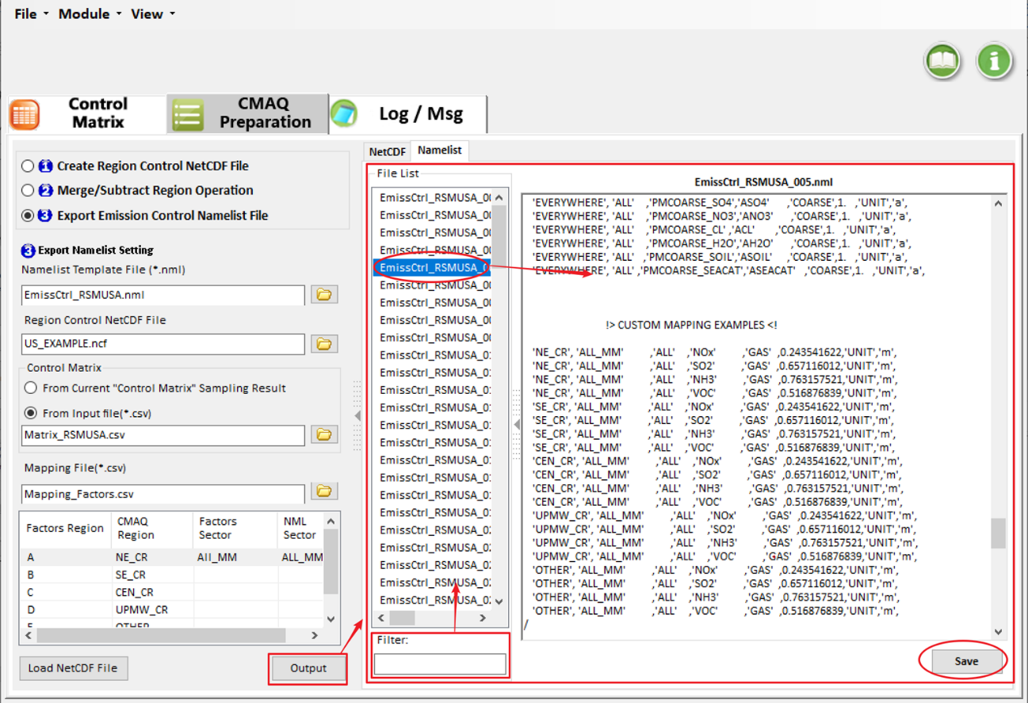
Figure 5.2.3-4. Results for Output Namelist Files

Create RSM Project
There are four steps of input options for inputting different data or configuring the calculation parameters, including Create/ Input RSM Option, Model Data Input Option, Validation and QA Option, and Visualization Analysis Option. The GUI of these options depends on the algorithm of user selection in RSM method settings under “Create/Input RSM option”.

Create/ Input RSM Option

pf-ERSM/Optimized pf-ERSM Algorithm option
Firstly, select Optimized pf-ERSM option in RSM Method Settings. (Pf-ERSM is consistent with Optimized pf-ERSM input, here Optimized pf-ERSM is used as an example).
The Create/ Input RSM Option includes RSM-VAT Project File, Input RSM File, Create RSM File, and Advanced Option, as shown in Figure 6.1.1-1.
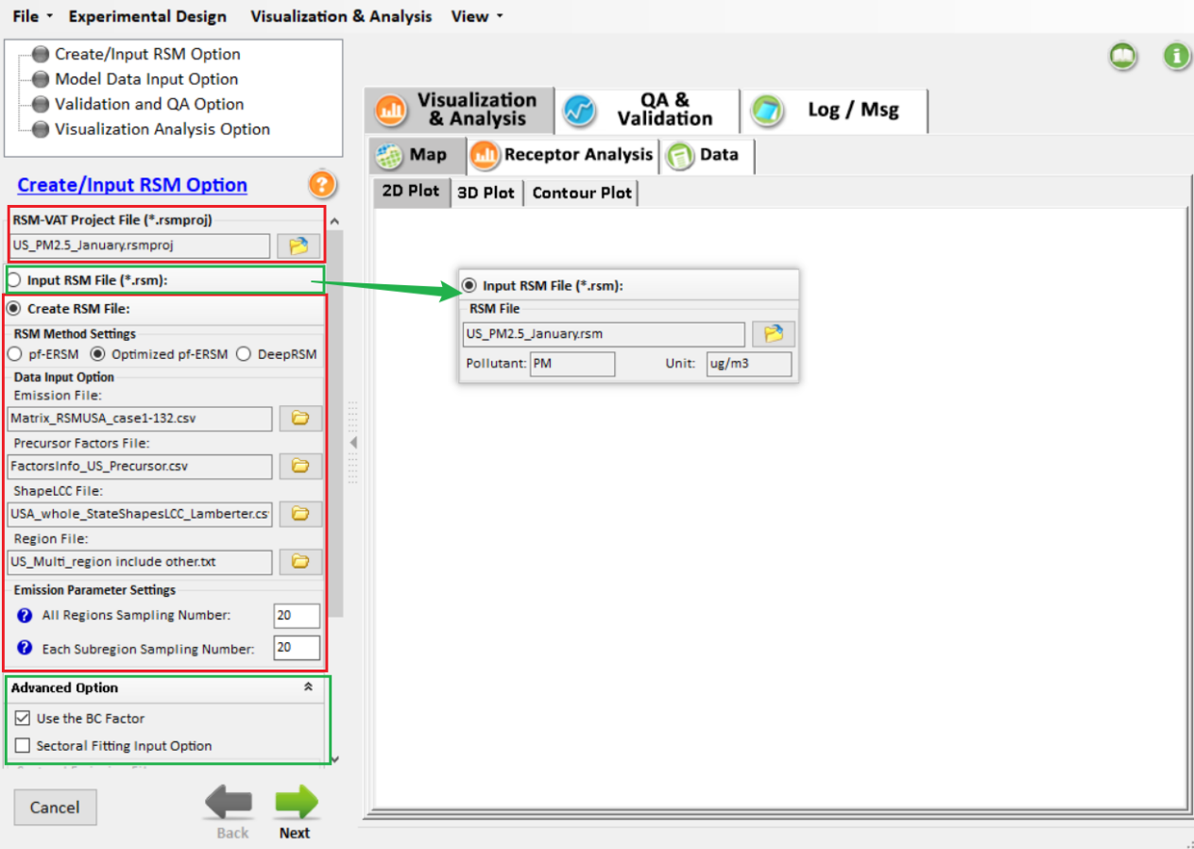
Figure 6.1.1-1. Create/ Input RSM Option
RSM-VAT Project File: Allows users to directly open a RSM project that has been successfully run without having to run again (US_PM2.5_January.rsmproj).
Input RSM File: Allows users to directly open an already fitted RSM file. Also, the Create RSM File option will be unavailable if the Input RSM File option is chosen. This option will be timesaving because it does not need to create RSM again.
Create RSM File: Allows users to select RSM methods according to their needs and then set related files that need to be fitted, including Emission File, Precursor Factors File, ShapeLCC File, and Region File. This option for RSM run is a little time-consuming compared with the Input RSM File option because the fitting process for creating the RSM file is computational.
Emission Parameter Settings: Allows users to set the sampling number for the regions and subregions. The values of All Regions Sampling Number and Each Subregion Sampling Number should correspond to the input Emission File.
Advanced Option: Allows users to perform source contribution analysis by using related sectoral files. For example, it allows users to identify which emission sources contributes the most to the target pollutant concentration and then make control strategies.

DeepRSM algorithm option
If the DeepRSM option in RSM Method Settings is selected, its interface is as shown in Figure 6.1.2-1. Unlike with pf-ERSM and Optimized pf-ERSM, when DeepRSM is selected, Emission Parameter Settings will not be available.
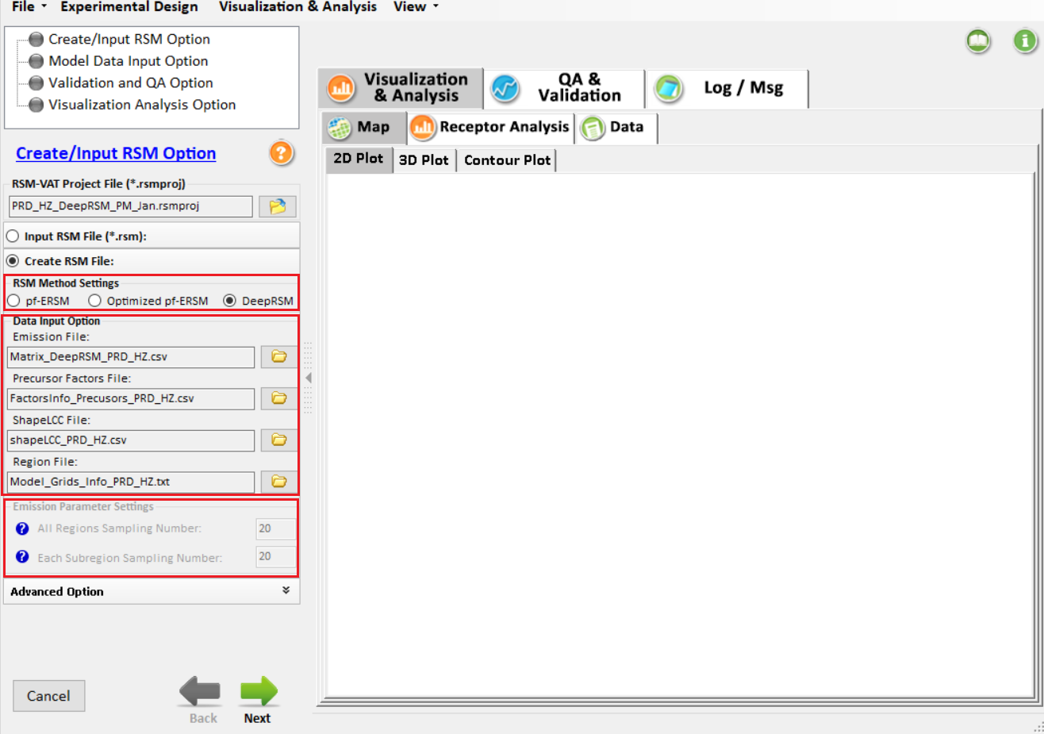
Figure 6.1.2-1. The GUI of DeepRSM
Select the DeepRSM option. The files you need to enter include the Emission File, Precursor Factors File,、ShapeLCC File,、and Region File. The four files are shown in:
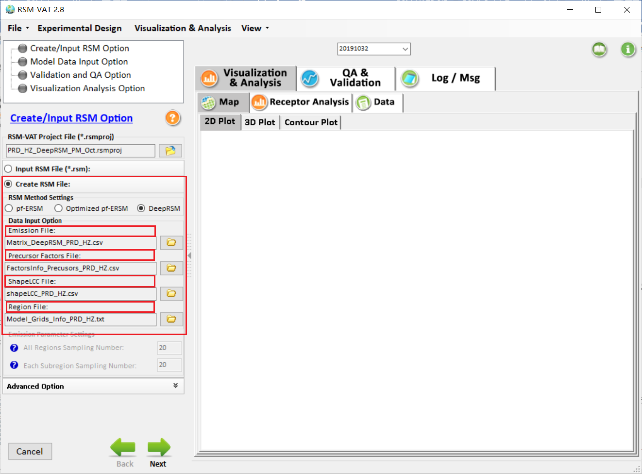
Figure 6.1.2-2. DeepRSM input files
Emission File: Emission case files containing emission factors for each species in each region. Here take the “Matrix_DeepRSM_PRD_HZ.csv” as an example.
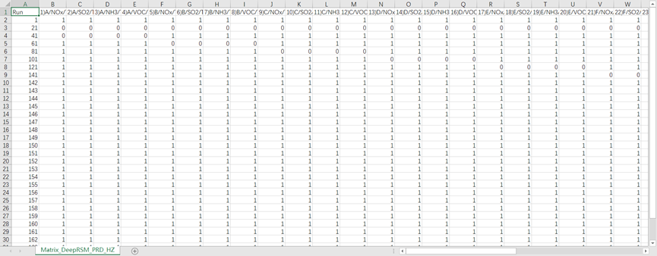
Figure 6.1.2-3. Example of emission file for deepRSM option
Precursor Factors File: Here, take the “FactorsInfo_Precusors_PRD_HZ.csv” as an example.
There were 24 control factors in this case (four different factors for each region). The emission control factor ranges from 0 to 150%. The zero-control factor means that the benefit emission is reduced to zero, and the 150% factor means that the emission increases by 50% compared with the baseline emission.
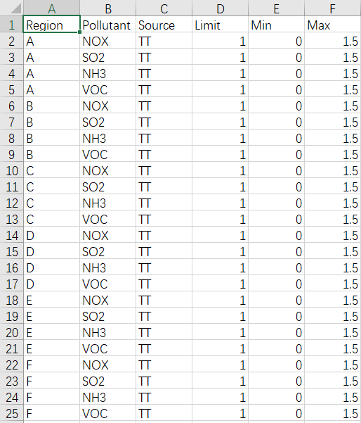
Figure 6.1.2-4. Example of factors file for DeepRSM option
ShapeLCC File: This file records the geographic location information of the control area.
Here, take the “shapeLCC_PRD_HZ.csv” as an example:

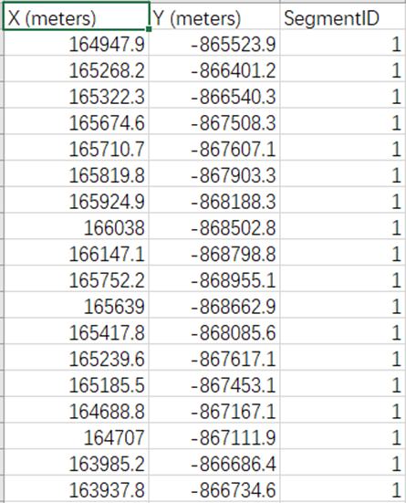
Figure 6.1.2-5. Example of ShapeLCC file for DeepRSM option
Region File: This file records region information.
Here take the “Model_Grids_Info_PRD_HZ.txt” as an example:
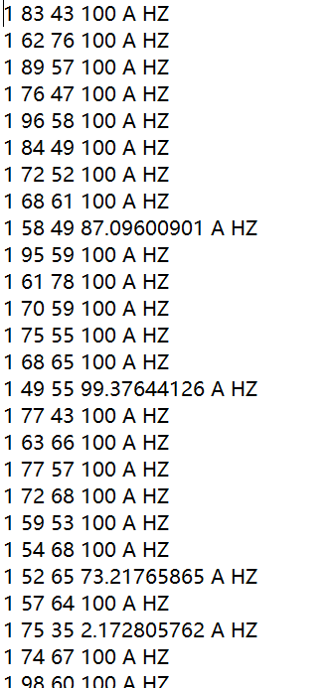
Figure 6.1.2-6. Example of receptor region file for DeepRSM option
Advanced Option: Uncheck the “Advanced Option”, including “ Use the BC Factor ” and “ Sectoral Fitting Input Option ”. As shown in the Figure 6.1.2-7 Advanced Option.
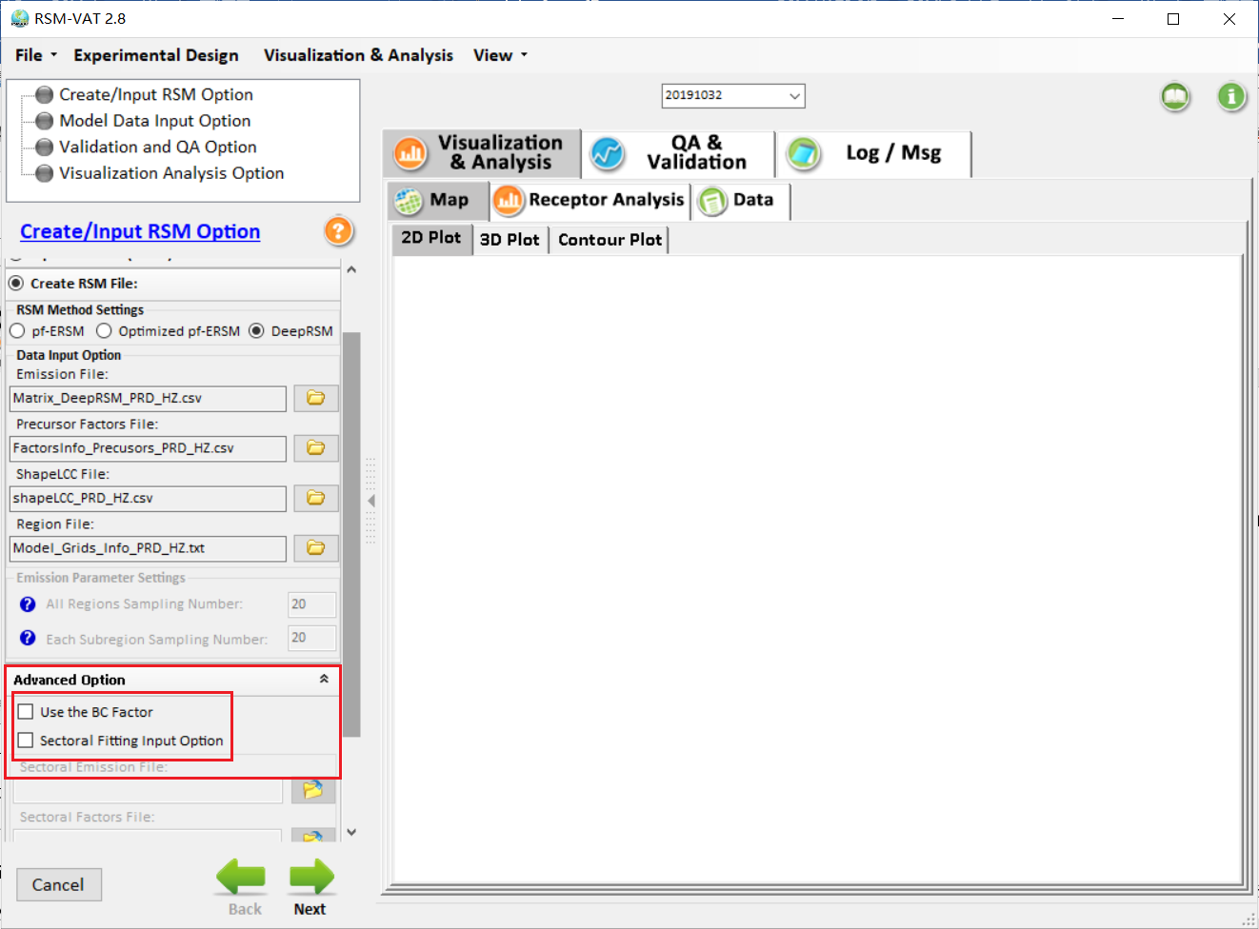
Figure 6.1.2-7. Advanced Option
Click on the “Next” green arrow at the bottom right of Data Input setting window to the next option.

Model Data Input Option

pf-ERSM/Optimized pf-ERSM Algorithm option
If pf-ERSM/Optimized pf-ERSM is selected, Model Data Input Option will contain the following options: Model Data Input Option, Target Pollutant, Precursor Pollutant, Fitting Parameter Setting, and Plot Type, as shown in Figure 6.2.1-1.
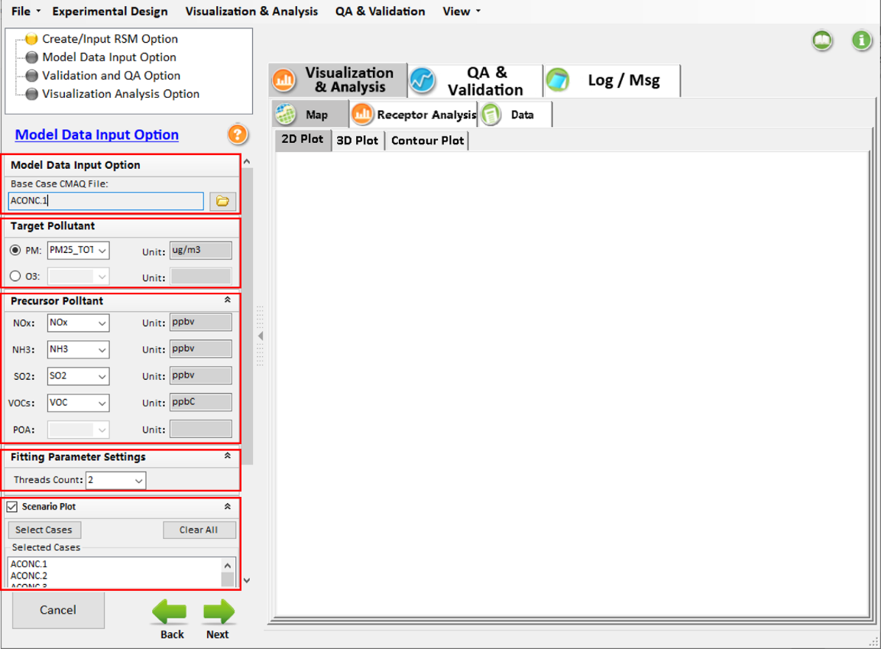
Figure 6.2.1-1. Model Data Input Option
Model Data Input Option: Allow users to set the file path of the Base Case CMAQ File, where all CMAQ simulation files are located.
Target Pollutant: Allows the user to set the pollutant that will be modeled, e.g., PM_{2.5} or O_{3.}
Precursor Pollutant: Allows the user to specify the precursor species.
Fitting Parameter Settings: Allows the user to set the number of threads called during the fitting process.
Scenario Plot: Allow the user to select CMAQ cases to check the CMAQ simulations by checking the Scenario Plot option.

DeepRSM algorithm option
If the DeepRSM option is selected, the interface in Model Data Input Option is different from the pf-ERSM and Optimized pf-ERSM option, its interface is shown in the figure below. And a number of model parameters need to be set, including model training files, pollutant species, mapping information, and time information.
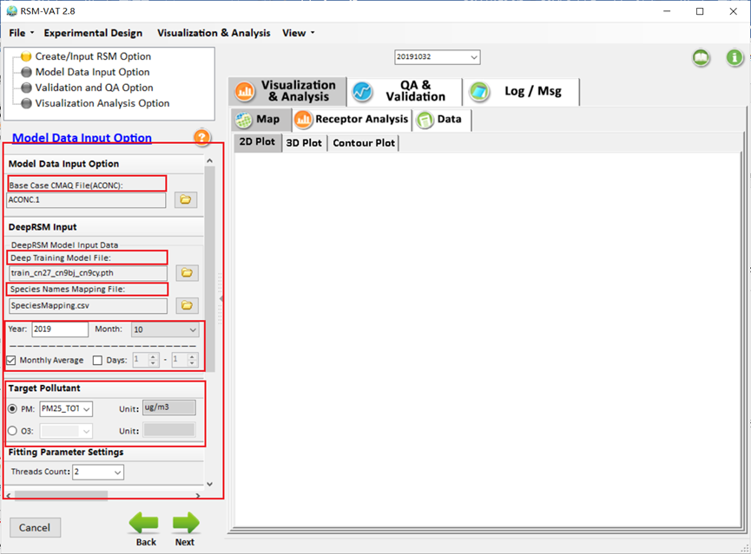
Figure 6.2.2-1. Model Data Input Option of DeepRSM
Base Case CMAQ File(ACONC): Base case file, generated by CMAQ model. (Note: User needs to include all the cases listed in the Emission file from the previous step.)
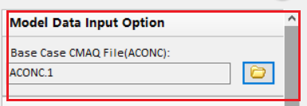
Figure 6.2.2-2. Base Case CMAQ File(ACONC)
Deep Training Model File: Deep learning model, selected based on pollutants.
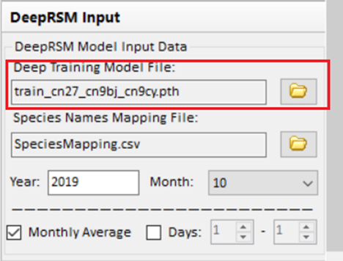
Figure 6.2.2-3. Deep Training Model File
Species Names Mapping File: This file records mapping information for species, ensuring that species names in the CMAQ benchmark file match those in the deep learning model. As shown in the figure below: ‘
(Note: User can only change the name in the column “Species Name In Model File”, and all names are in uppercase letters.)
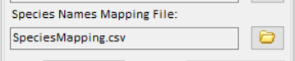
Figure 6.2.2-4. Choose Species Names Mapping File
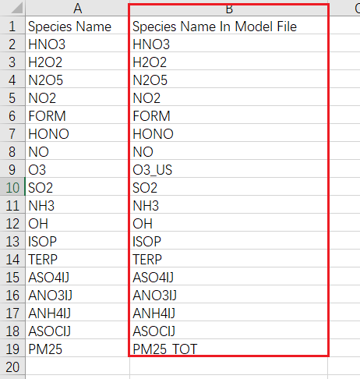
Figure 6.2.2-5. Species Names Mapping File
Year: Model run year. When the base file(Base Case Model File) is selected, it can be read automatically according to the base file.
Month: Model run month. It also can be read automatically according to the base file.
Monthly Average/Days: Users can choose to calculate monthly average data or daily average data according to their own needs. Both of them can be chosen at the same time. ( Note: Only consecutive days are supported.)
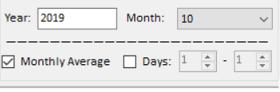
Figure 6.2.2-6. Time parameter setting
Target Pollutant: Select the target contaminant species to be simulated. (Note: Need to be consistent with species in CMAQ benchmark documents (Base Case CMAQ File).)
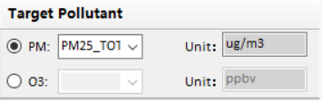
Figure 6.2.2-7. Target Pollutant
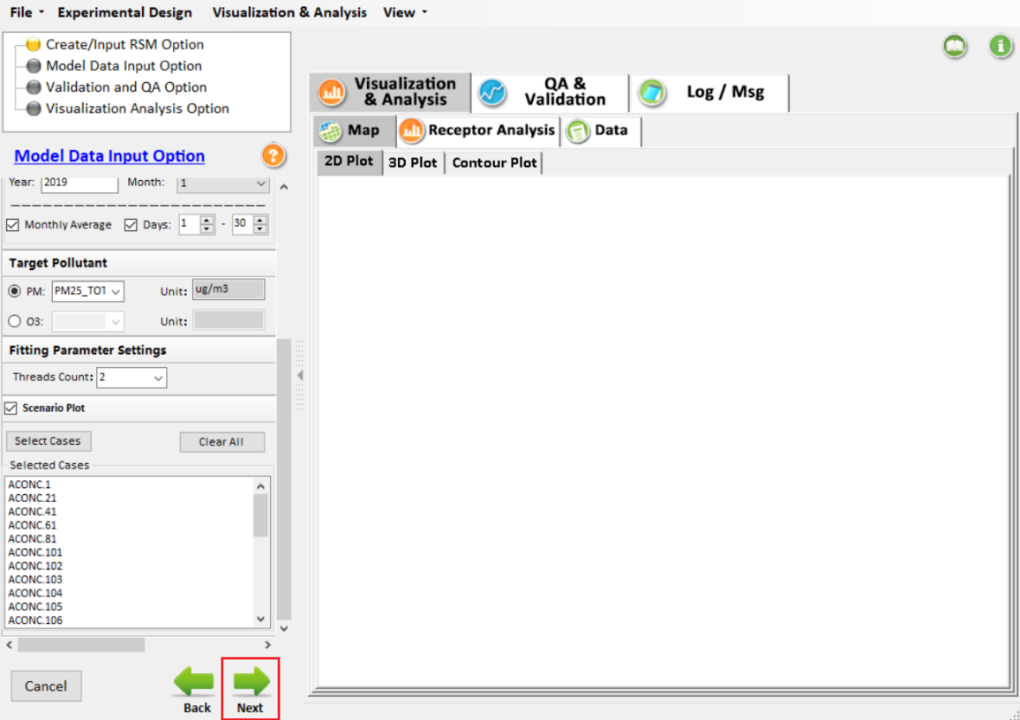
Figure 6.2.2-8. Next-Model Data Input Option
Click on the “Next” green arrow at the bottom right of Data Input setting window to proceed to the next option.

Validation and QA Option
In Validation and QA Option, the GUI of pf-ERSM/Optimized pf-ERSM and DeepRSM is the same. The user needs to input Out of Sample File as needed.
The Validation and QA Option includes Validation Types, Out of Sample Input Option, and Cross Validation Input Option, as shown in Figure 6.3-1. This option is used to validate the reliability and rationality of created RSM.
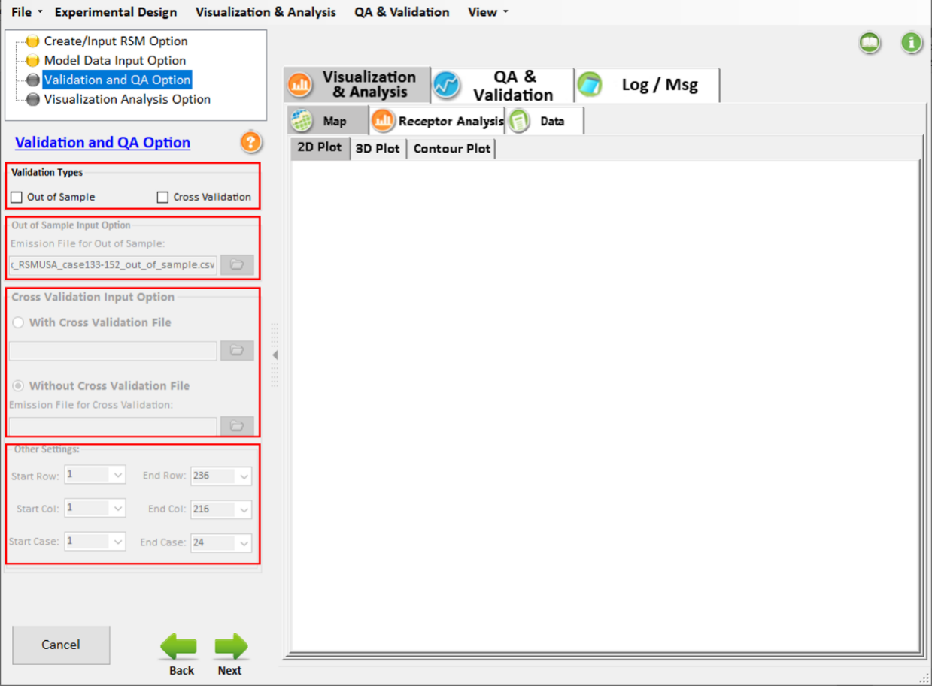
Figure 6.3-1. Validation and QA Option
Validation Types: Allows users to choose the ways of validation, including Out of Sample and Cross Validation. These two choices are optional for users.
Out of Sample Input Option: Once this option is checked, users should prepare and input an out of sample emission file. Note that the CMAQ runs in this emission file are not included in the RSM creation.
Cross Validation Input Option: Once this option is checked, users should input an emission file for Cross Validation. Note that one of the CMAQ runs in this emission file is left out for creating the RSM and the RSM predicted data are then verified against the CMAQ results that are left out. This comparison process is sequentially carried out for all CMAQ runs in this emission file.
Click on the “Next” green arrow at the bottom right of Data Input setting window to proceed to the next option.

Visualization Analysis Option
The Visualization Analysis Option allows users to set Receptor File and Plot Types, as shown in Figure 6.4-1(Note: the GUI of pf-ERSM/Optimized pf-ERSM is the same as DeepRSM). Once the Contour Plot option is checked under the Plot Types, users should set up control factors for the X-axis and Y-axis, respectively. And the results will be shown in “Contour Plot” once it is selected under Visualization & Analysis →Map.
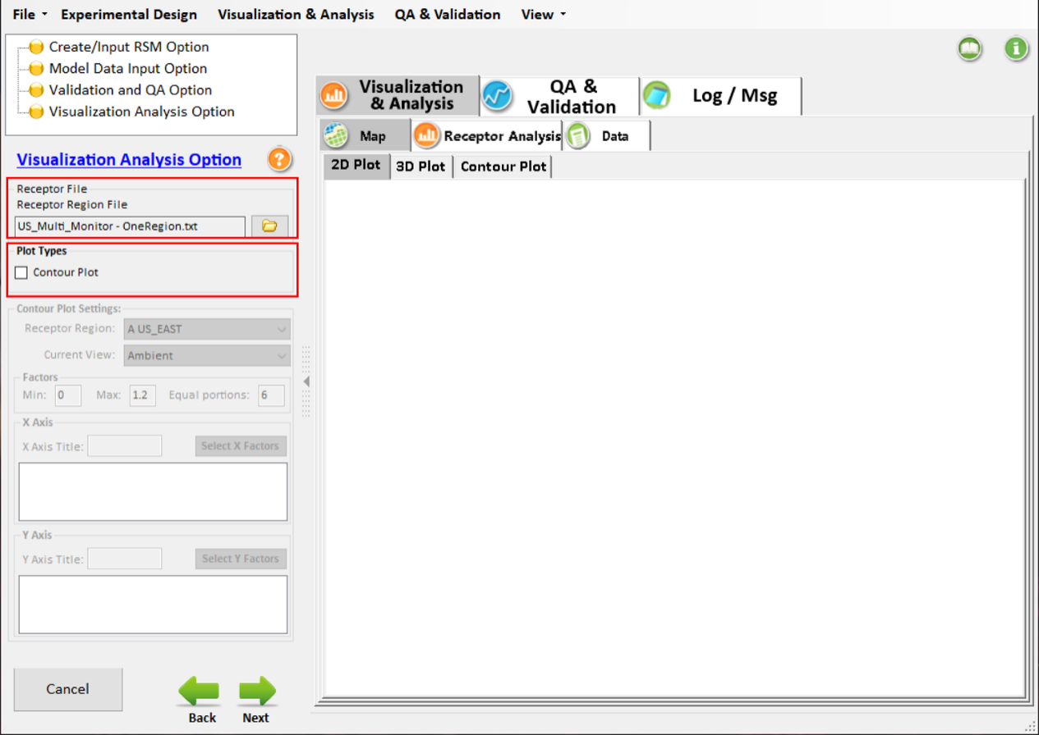
Figure 6.4-1. Visualization Analysis Option
Click on the green “Next” arrow at the bottom right of Data Input setting window to proceed to save and run RSM-VAT. Users can view the running messages through “Log/Msg”, as shown in Figure 6.4-2.

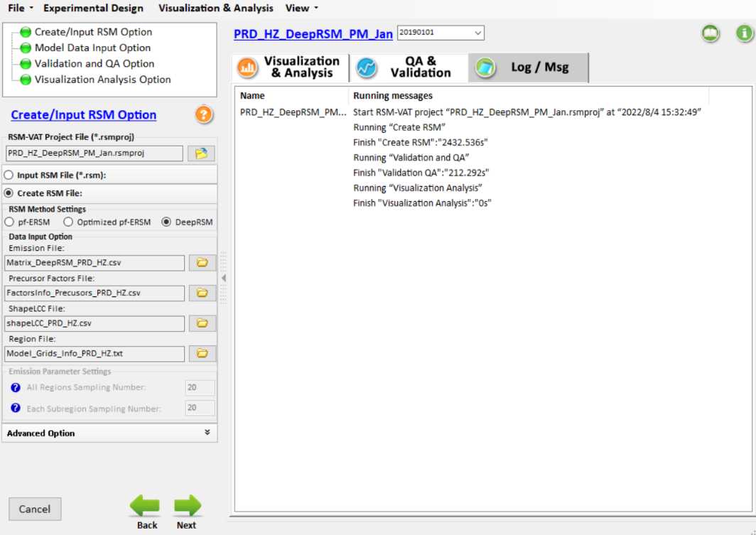
Figure 6.4-2. Running Messages

Visualization & Analysis for RSM Results
When RSM project is created, the QA & Validation of Created RSM will be shown in “QA & Validation” module, and the RSM results will be shown in Visualization & Analysis module by multiple visualization types, including MAP, Chart, or Data, as shown in Figure 7-2.
Note: If the DeepRSM algorithm is used and data for multiple days is run, the results of different days can be selected through the drop-down box, as shown in Figure 7-1, and the results are consistent with other algorithms.
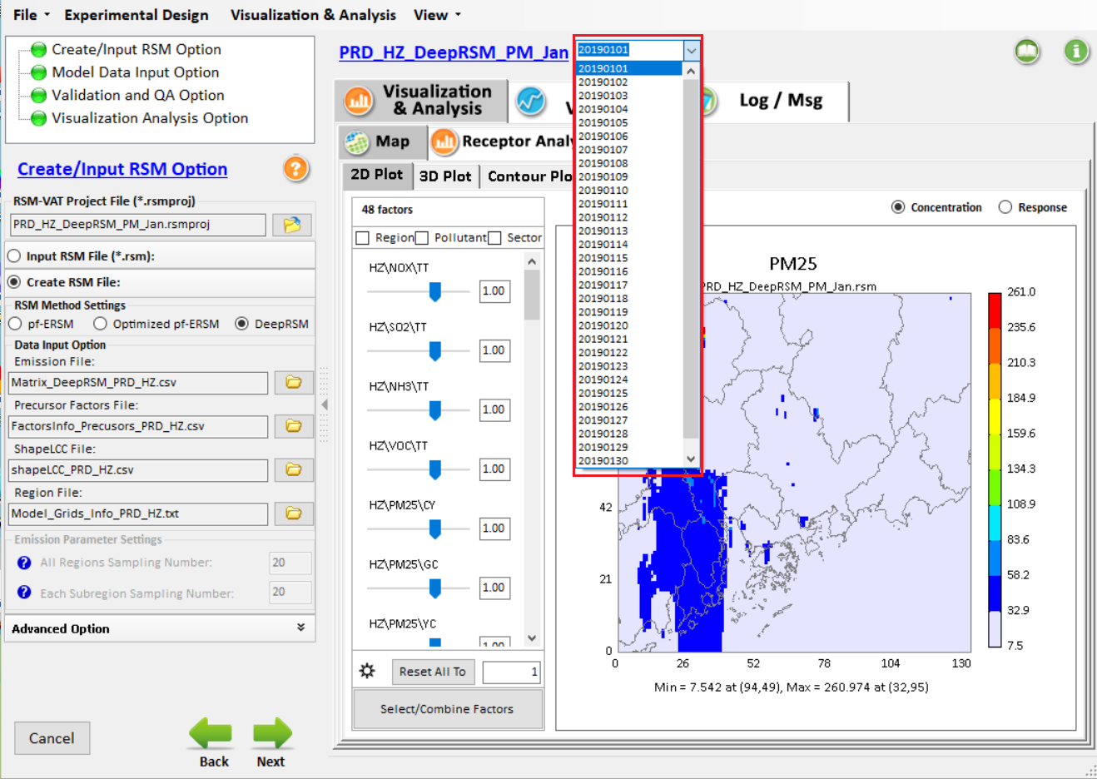
Figure 7-1. The results of different days

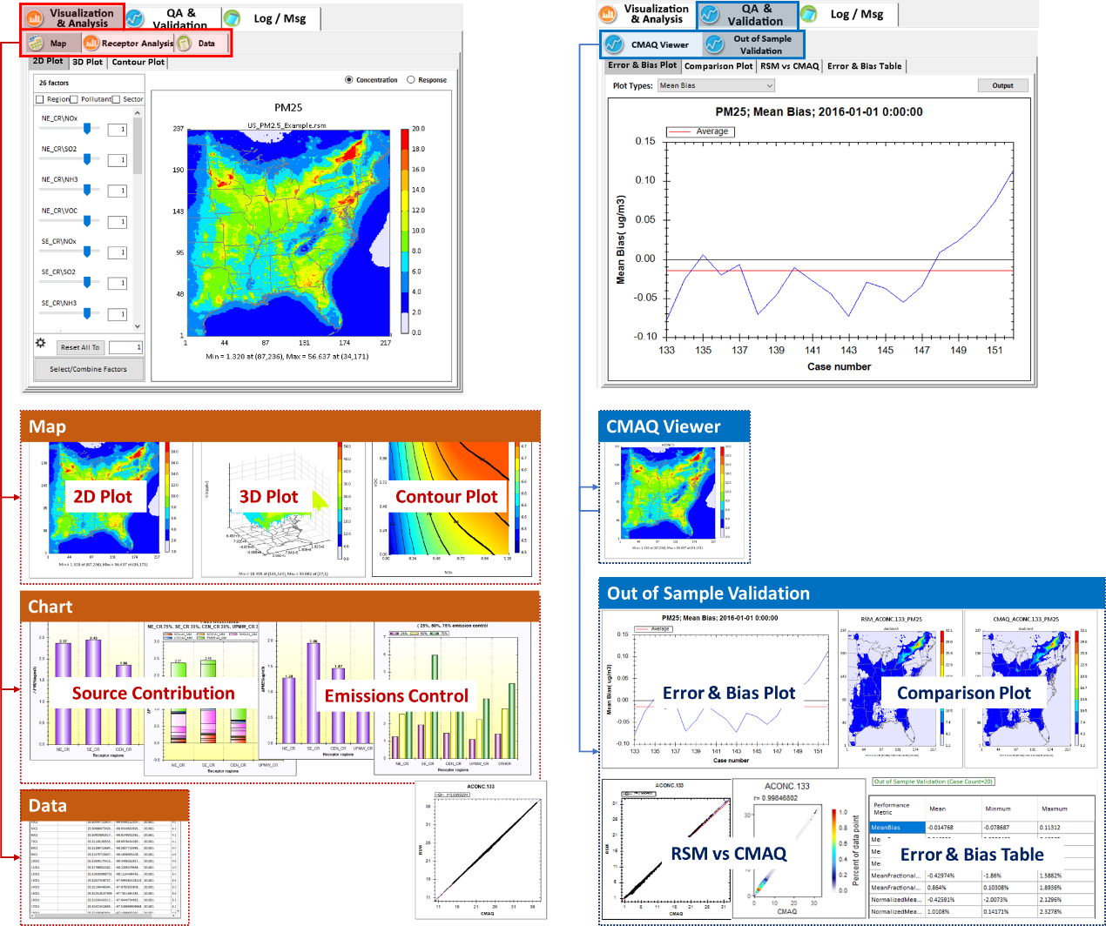
Figure 7-2. Data Viewer of RSM-VAT Results

QA & Validation
Uncertainties associated with RSM come from two key areas: (1) inherent uncertainties from the air quality model (CMAQ) due to uncertainties of modeling sciences and formulation, computational approximation, and input data, including both emission and meteorological data; and (2) statistical representation of RSM model to simulate the responses of the air quality model (CMAQ) due to preset control scenarios. The model was validated using several techniques (e.g., OOS, CV), while recognizing and acknowledging these uncertainties associated with the application of the RSM.

The QA & Validation module includes Out of Sample Validation, Cross Validation and CMAQ Viewer, as shown in Figure 7.1-1. This module is mainly used to examine and validate the RSM model performance. Among them, Out of Sample Validation is conducted to evaluate the performance of RSM, which compares the predicted values derived from the response surface models with the CMAQ simulations of a set of model runs that are outside of the experimental design and are not used in developing the predictive model. The same evaluation metrics (Table 3) were used for both Out of Sample Validation and Cross Validation methods. CMAQ Viewer is a tool for displaying and comparing the RSM predicted results to the CMAQ simulations.

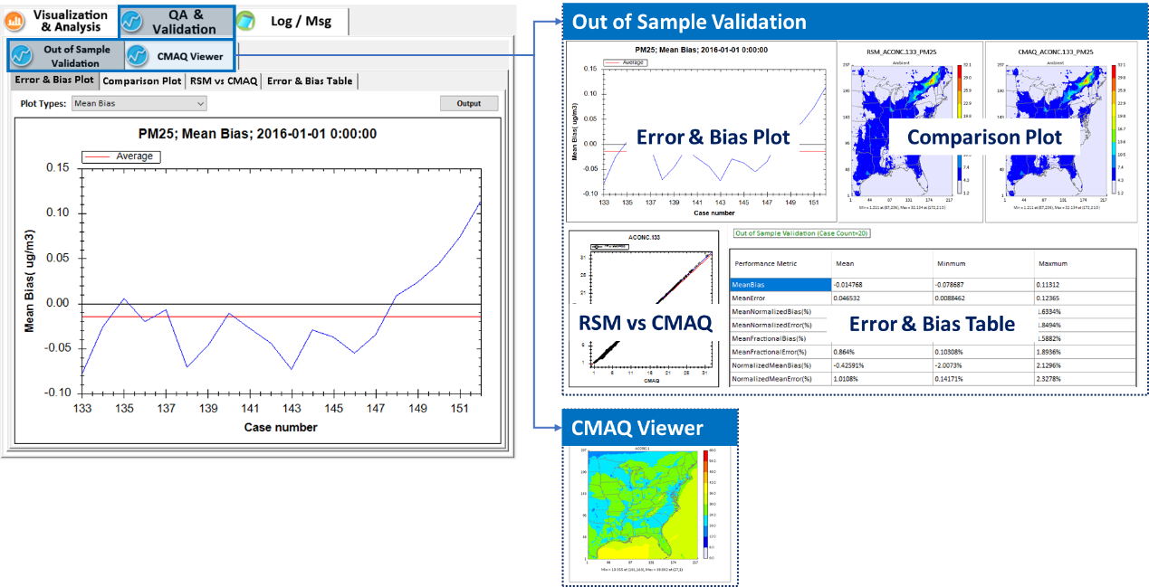
Figure 7.1-1. QA & Validation

Table 3. Performance Metrics used in RSM-VAT
Performance Metric Equation
Mean Bias
(MB, )
Mean Error
(ME, )
Mean Normalized Bias
(MNB, )
Mean Normalized Error
(MNE, )
Mean Fractional Bias
(MFB, -200% to +200%)
Mean Fractional Error
(MFE, 0% to +200%)
Normalized Mean Bias
(NMB, )
Normalized Mean Error
(NME, )
N is the number of grid cells, Cri is the RSM predicted value in grid i, and Cci is the CMAQ value in grid i.

Out of Sample Validation

Error & Bias Plot
Under Error & Bias Plot module, it provides multiple statistical plots (e.g., MB, ME, MNB, MNE, MFB, MFE, etc.) for validating the RSM performance in different aspects. Users can also configure the plot according to their preferences, as shown in Figure 7.1.1-1.(Note: If the DeepRSM algorithm is selected, the results of different days can be selected through the drop-down box , as shown in Figure 6.2.2-1)
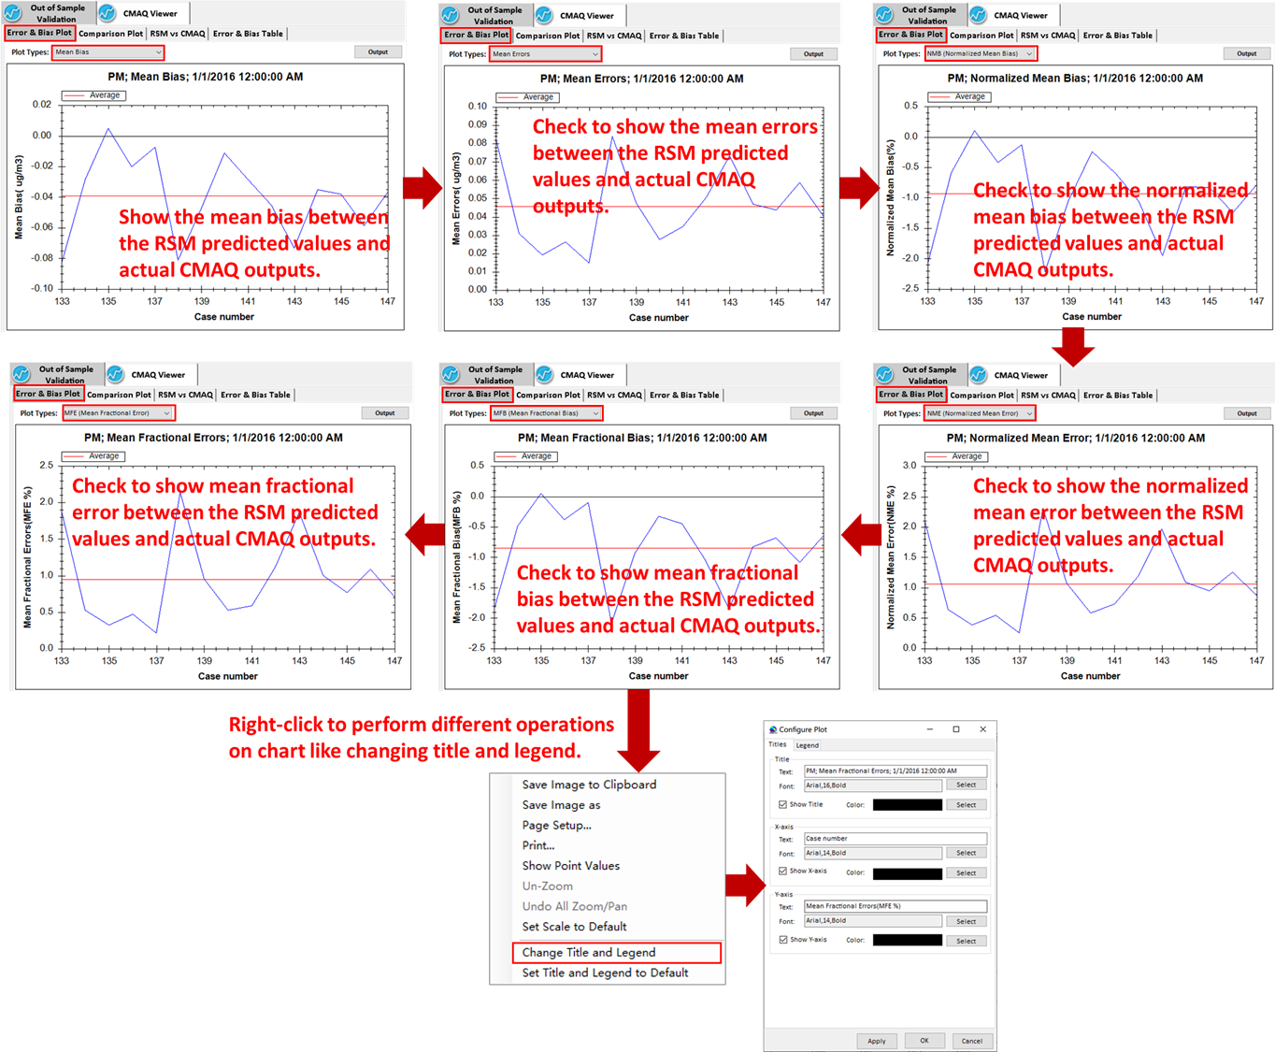
Figure 7.1.1-1. Error & Bias Plot of Out of Sample Validation

Comparison Plot
Under the Comparison Plot module, visual inspection of prediction maps was conducted to confirm overall spatial comparability in the predicted versus modeled outputs for each of the CMAQ experimental design runs. Users can also set specific plot types and perform different operations on map (e.g., zoom in or zoom out domain), as shown in Figure 7.1.1-2.
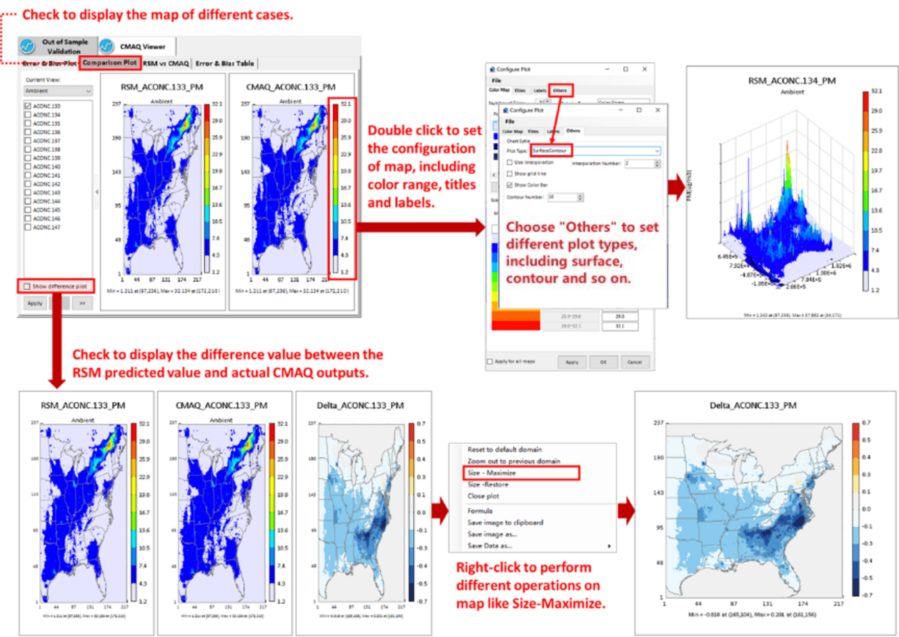
Figure 7.1.1-2. Comparison Plot

RSM vs CMAQ
In RSM vs CMAQ module, it shows the correlation between RSM and CMAQ by scatter plots, density scatter plots. Users can also configure the plots according to their preferences, as shown in Figure 7.1.1-3.
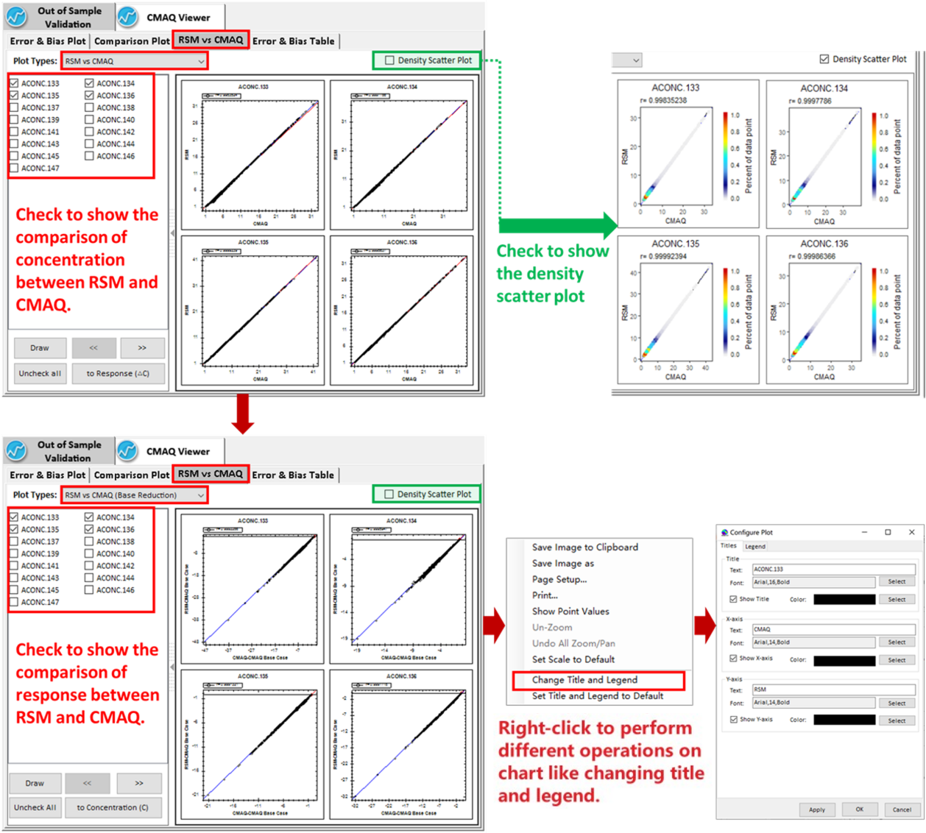
Figure 7.1.1-3. RSM vs CMAQ of Out of Sample Validation
This module provides two kinds of plot types for users to view the comparison of the results between RSM and CMAQ. RSM vs CMAQ shows the comparison of the concentration between RSM and CMAQ, while RSM vs CMAQ (Base Reduction) shows the comparison of the response between RSM and CMAQ, where CMAQ-CMAQ Base Case and RSM-CMAQ Base Case are plotted as abscissa and ordinate respectively.

Error & Bias Table
The Error & Bias Table module summarizes the values of those statistical metrics listed in Table 3 to characterize the performance of created RSM, e.g., mean bias, mean normalized bias, and normalized mean bias, and so on. Users can export data for further study, as shown in Figure 7.1.1-4.
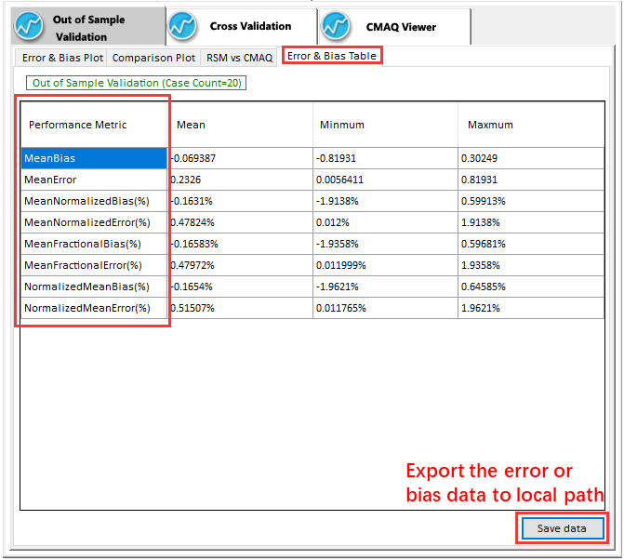
Figure 7.1.1-4. Error & Bias Table of Out of Sample Validation

Cross Validation
Cross Validation is used to evaluate overall RSM performance. For each iterative run, one of the experimental model runs is left out of the model estimation, and the RSM is then computed and used to predict the omitted run. If Cross Validation option is checked in the “Validation and QA Option”, Cross Validation tab will be listed under “QA & Validation” module. The predictive performance of the RSM is also evaluated using a standard set of model performance statistical indices over all grid cells, e.g., MB, ME, MNB, MNE, etc. It also provides Error & Bias Plot, Comparison Plot, RSM vs CMAQ scatter plot, and Error & Bias Table functions, which are like that of Out of Sample validation. We will not elaborate on it again here.

CMAQ Viewer
Under CMAQ Viewer module, it provides functions for users to visualize and examine the CMAQ simulations. Users can also set specific plot types and perform different operations on map (e.g., zoom in or zoom out domain), as shown in Figure 7.1.3-1.
(Note: If the DeepRSM algorithm is selected, the results of different days can be selected through the drop-down box , as shown in Figure 6.2.2-1)
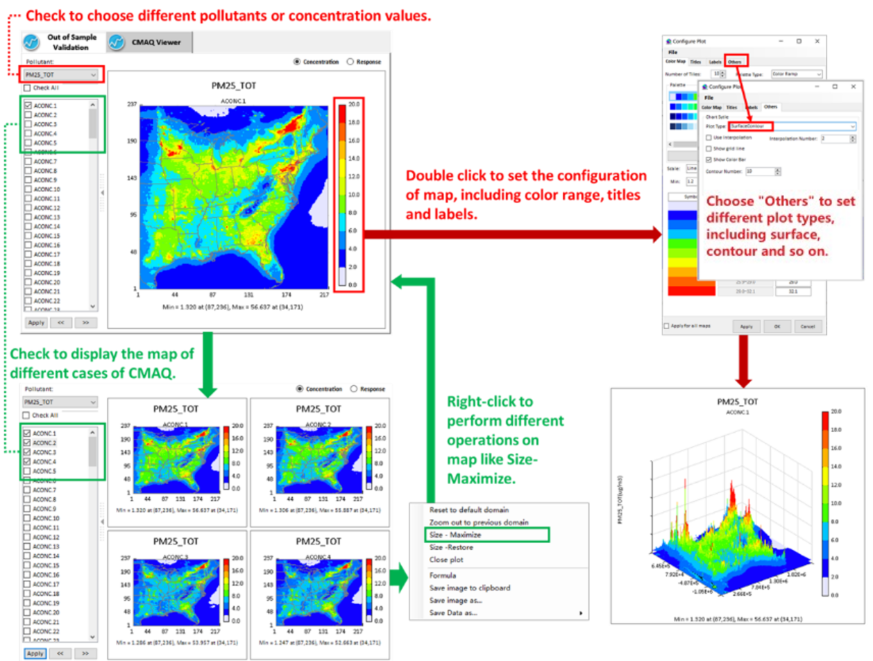
Figure 7.1.3-1. CMAQ Viewer

Visualization & Analysis
RSM-VAT provides a series of visualization and analysis functions for supporting decision making, including 2D and 3D maps for instant overview of air quality response, bar/pie charts for quantitatively analyzing and comparing the effectiveness of emission reduction, and contour plots for dynamically description of the nonlinear or linear relationship between two single/groups of emission control factors.

Map
Under the Map module, users can show the concentration that responds in real time to the emission reduction control with a specific plot type. The 2D map can identify these changes in different administrative regions intuitively, while the 3D map has an instant three-dimensional visual effect for the air quality changes. Users can also perform different operations on the map (e.g., size-maximize or size-restore), using the menu brought up by right-clicking on the map, as shown in Figure 7.2.1-1. (Note: If the DeepRSM algorithm is selected, the results of different days can be selected through the drop-down box , as shown in Figure 6.2.2-1)
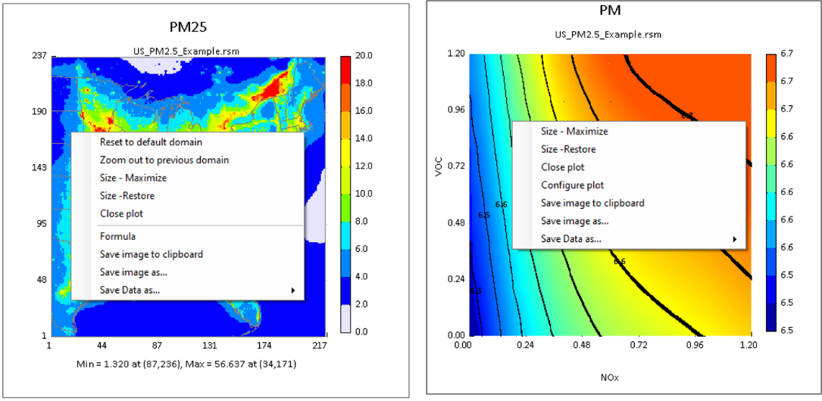
Figure 7.2.1-1. Right-click menu on Map

2D Plot
Users can click the 2D Plot tab to view the 2D distribution of pollutant concentration in real time. In this module, users are allowed to set the value of emission control factors and get the corresponding 2D concentration in response to the set emission controls as shown in Figure 7.2.1-2. For example, the user will be able to change any control factor (e.g., NE_CR NOx levels) and see the impacts on PM_{2.5}.

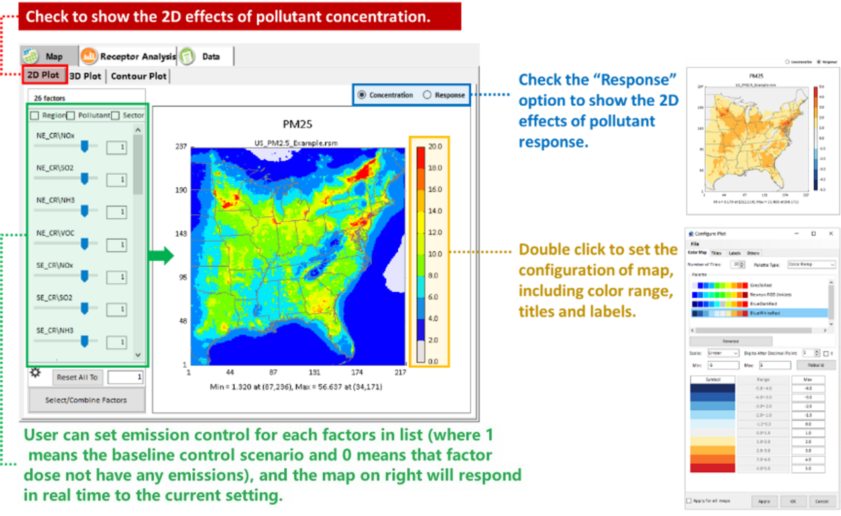
Figure 7.2.1-2. 2D Plot Viewer in the Map Module
Change emissions of control factors: The panel (green line) on the left lists all control factors. Users are able to change any control factor (e.g., NE_CR NOx levels) and see the impacts on air quality changes (e.g., PM_{2.5} or O₃) by dragging the slide bar or inputting value in the text box. Besides, users can also set all control factors to a same control level, e.g., 0.5 by clicking “Reset All To” button.

Customize control factors: It allows users to flexibly group/combine specific factors by checking Region/Pollutant/Sector in the top of the control factors panel. Users are also allowed to customize these control factors by clicking “Select/Combine Factors” button. When “Select/Combine Factors” is clicked, it will show a “Select/Combine Factors” window and provide two ways to customize control factors in this window.
- Using pre-defined control filters: all existing control factors can be classified by pre-defined filters, including “Region”, “Pollutant” and “Sector”. Users can select interested filter to re-organized control factors and get the corresponding air quality surfaces by changing these new defined factors, as shown in Figure 7.2.1-3.

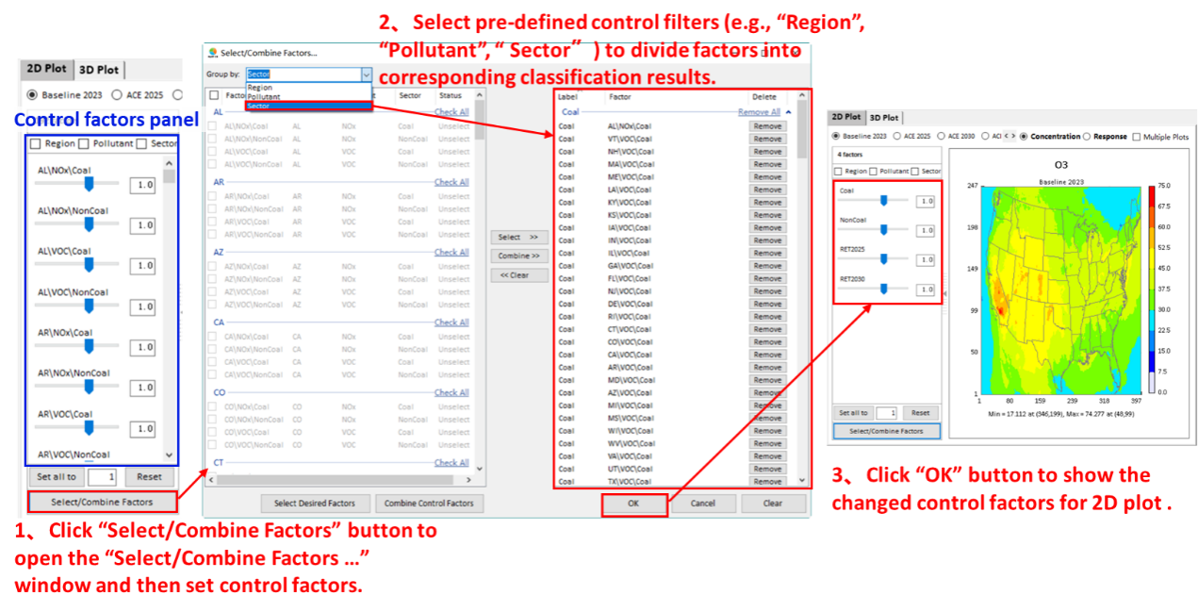
Figure 7.2.1-3. Pre-defined control filter
- User-defined control method: it provides two kinds of ways to define control factors as needed. a) Select interested factors only. This means that those factors you want to control will be selected and listed in control factors panel while those unselected factors will be kept as baseline (equal to 1). To do this, users just need to check the interested factors from the left panel of Figure 7.2.1-4(a), and then click “Select Desired Factors” to move these factors to right panel and finally click “OK” to return control factors panel. b) Select any combination of factors. This means that you can combine one or more factors to form a new factor by using “Combine Control Factors”, as shown in Figure 7.2.1-4(b).

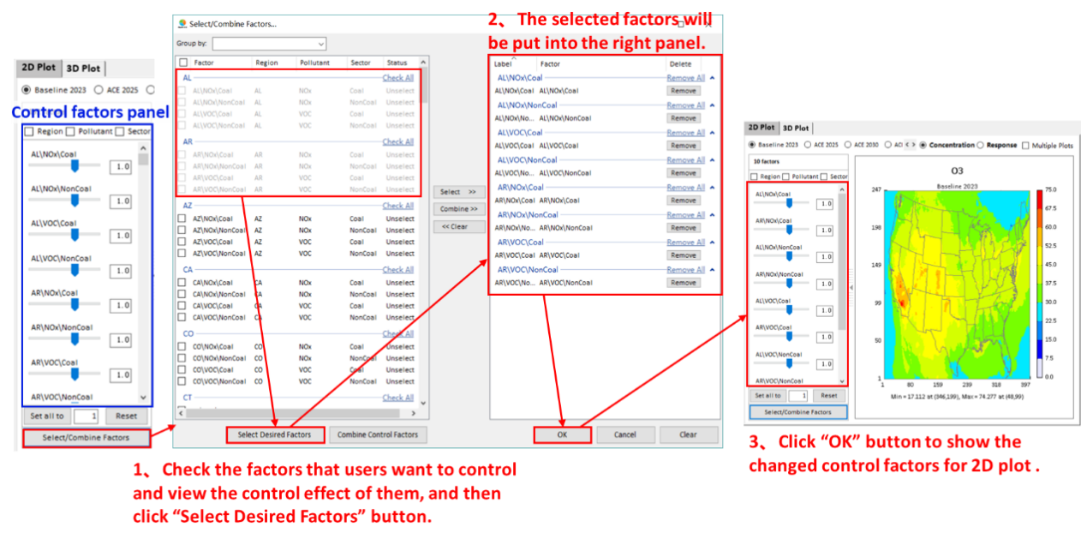
- Select interested factors only
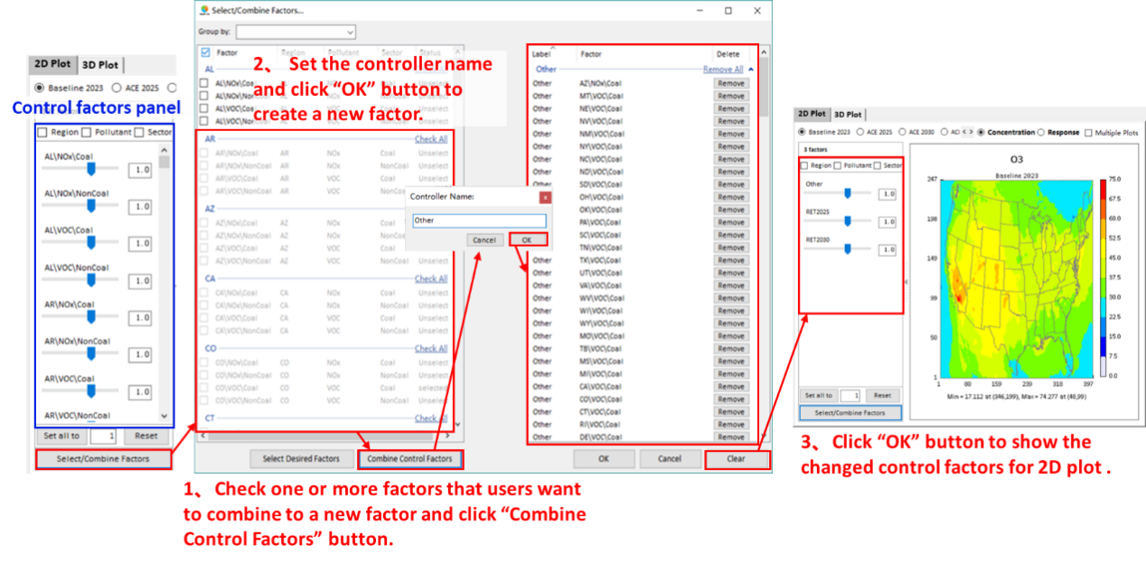
- Select any combination of factors
Figure 7.2.1-4. User-defined control method

3D Plot
User can click the 3D Plot tab to view the 3D distribution of pollutant concentration in real time. In this module, users are allowed to set the value of emission factors and get the corresponding 2D concentration in response to the set emissions as shown in Figure 7.2.1-5.

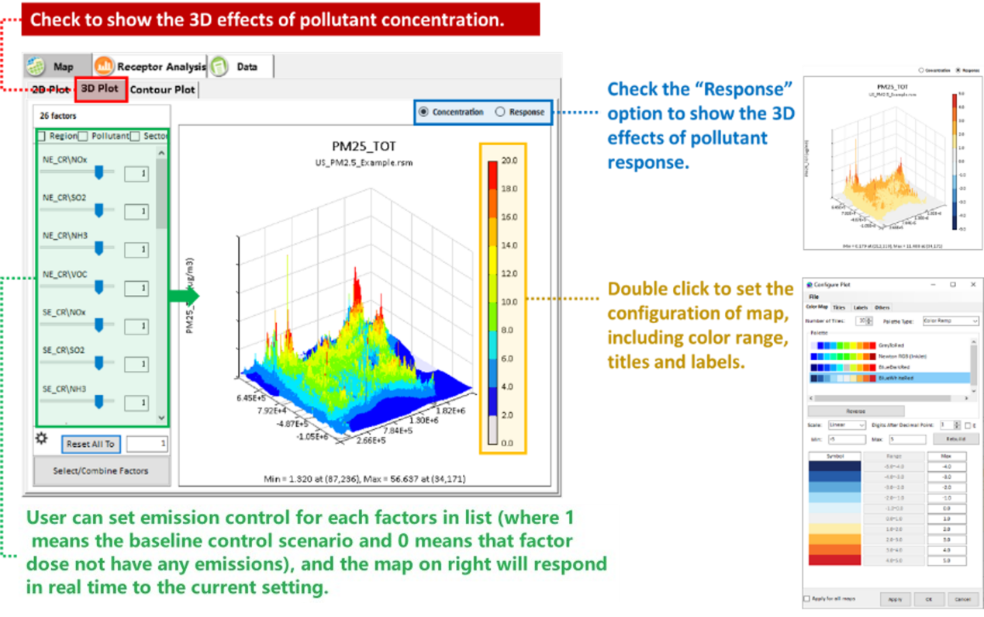
Figure 7.2.1-5. 3D Plot Viewer in the Map Module

Contour Plot
User can click the Contour Plot tab to view the 2D contour plot of pollutant concentration. This module can help users study the sensitivity among different precursors, e.g., O₃ response of NOx and VOCs emissions control. In this module, users can draw the contour plot of pollutant concentration based on the specified emission factors as shown in Figure 7.2.1-6.

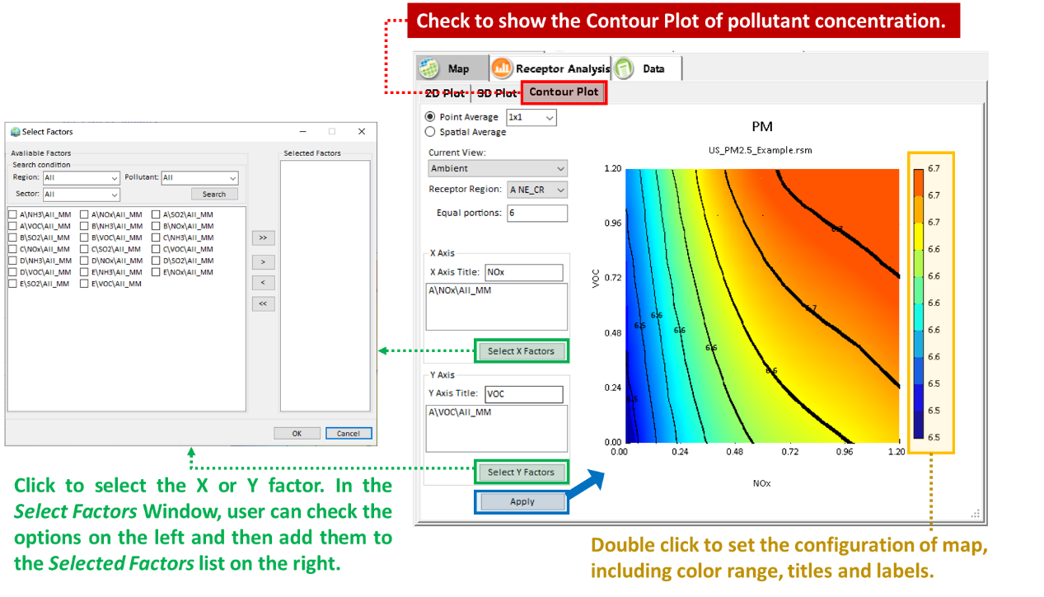
Figure 7.2.1-6. Contour Plot Viewer in the Map Module

Chart
The Chart module provides four kinds of charts for users to analyze the response to different emission controls. There are (1) Source Contribution 1, (2) Source Contribution 2, (3) Emission Control 1, and (4) Emission Control 2. (Note: If the DeepRSM algorithm is selected, the results of different days can be selected through the drop-down box, as shown in Figure 6.2.2-1.)

Source Contribution 1
Under the Source Contribution 1 module, the module provides functions for users to analyze the source contribution to the target pollutant (e.g., PM_{2.5}, O₃) in selected receptors from the different emission controls. As shown in Figure 7.2.2-1, the left panel is the configuration options of Source Contribution 1, while the right panel shows the pollutant reductions under the current configuration of emissions control.

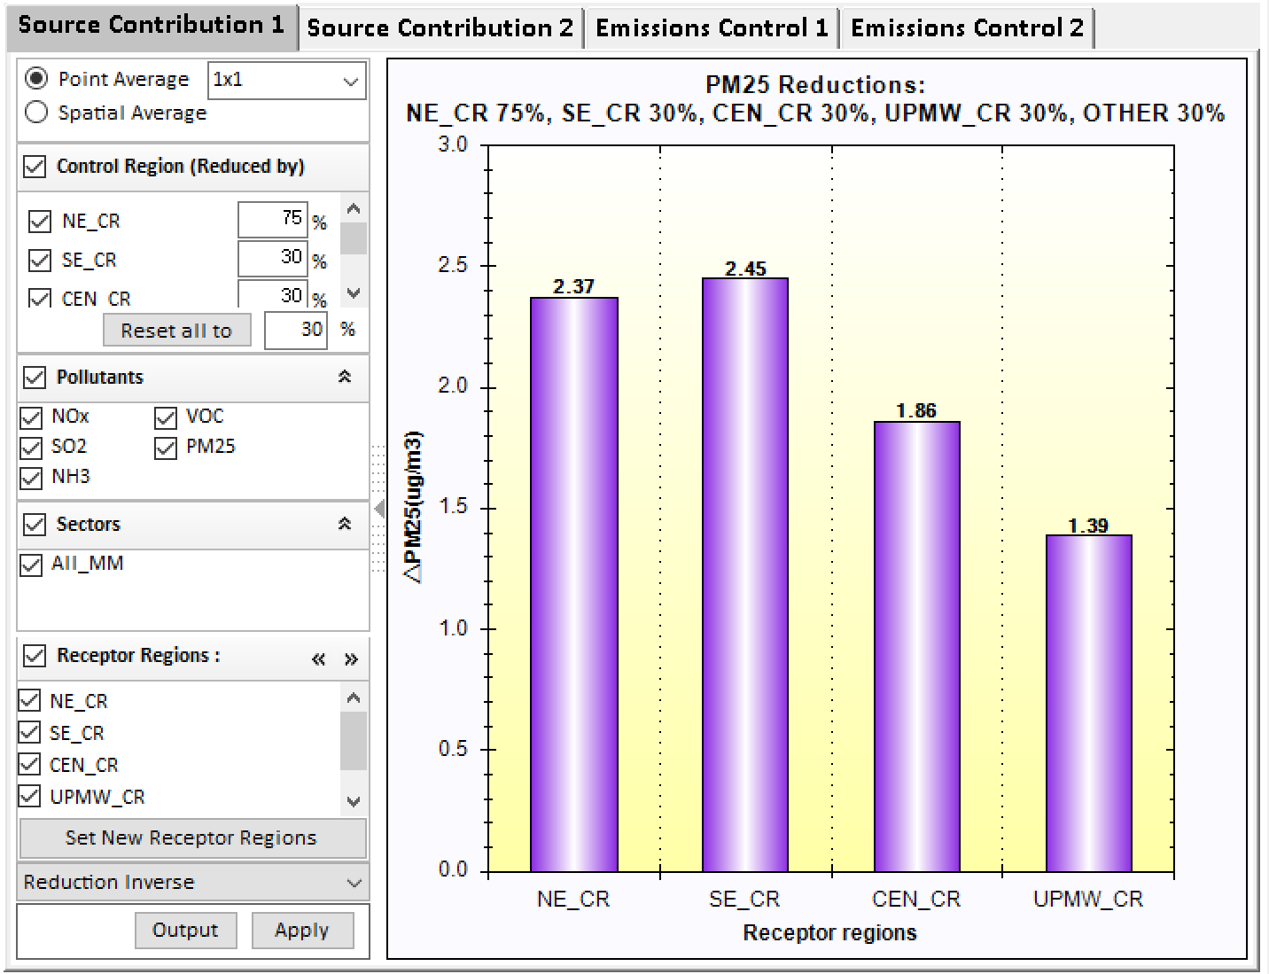
Figure 7.2.2-1. Example of Source Contribution 1

The configuration options available in this module include:

Point Average: This option specifies how many model grid cells at the monitor locations to use in the calculation of mean concentration for specified receptor regions. A drop-down menu provides options to use 1x1, 3x3, 5x5, and 7x7 arrays of model grid cells. The default is to use a 1x1 array of grid cells at the monitor locations.
Spatial Average: This option averages pollutant concentration in those grid cells that are located in specified receptor regions, respectively.
Control Region (Reduced by): This option lists all control regions and supports to set emission reductions for each control region. The “Reset all to” button allows users to reset a same emission reduction for all control region.
Pollutants: This option lists all precursors (including primary PM for PM_{2.5}) that come from emission control matrix.
Sectors: This option lists all sectors (e.g., Points, Mobiles, etc.) that come from the emission control matrix.
Receptor Regions: This option lists all receptor regions that come from the “Receptor Region File” in “Visualization Analysis Option” module by default. Under this option, it also provides an option for users to set up new receptor regions. For example, users can click the “Set New Receptor Regions” to open a receptor region configuration window to select desired states or CBSA regions by selecting the default file “US_STATE.txt” or “US_CBSA.txt” and then checking the regions of interest on the right panel, and then click “OK” or “Apply to All Charts” to show the corresponding response results of new receptor regions (Figure 7.2.2-2). Note that “OK” button only takes effect in current chart, but “Apply to All Charts” button applies to all charts under the Receptor Analysis module. Users can also add new receptor regions by importing receptor region files in the specified format according to their needs (Figure 7.2.2-3). Also, users can extract the desired regions for further study (Figure 7.2.2-4).

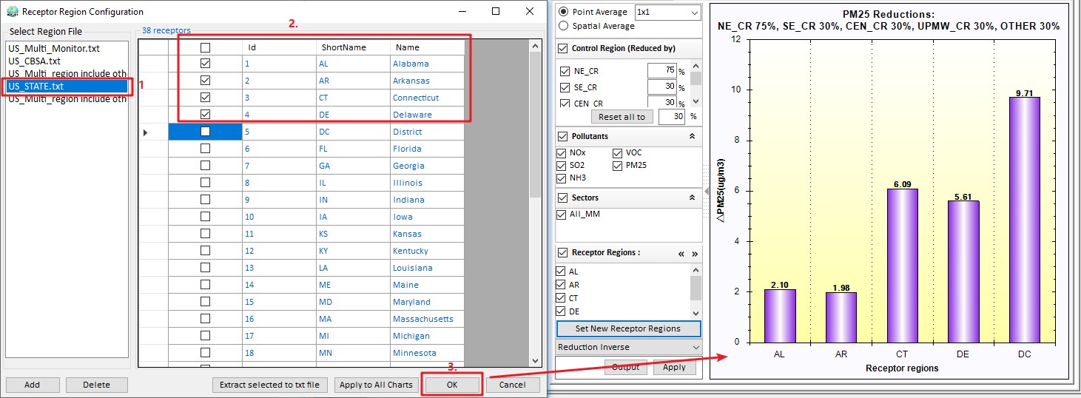
Figure 7.2.2-2. Set up a new receptors regions
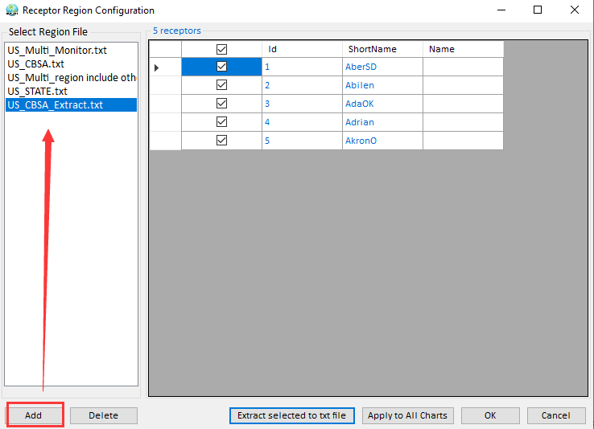
Figure 7.2.2-3. Load a receptor region file

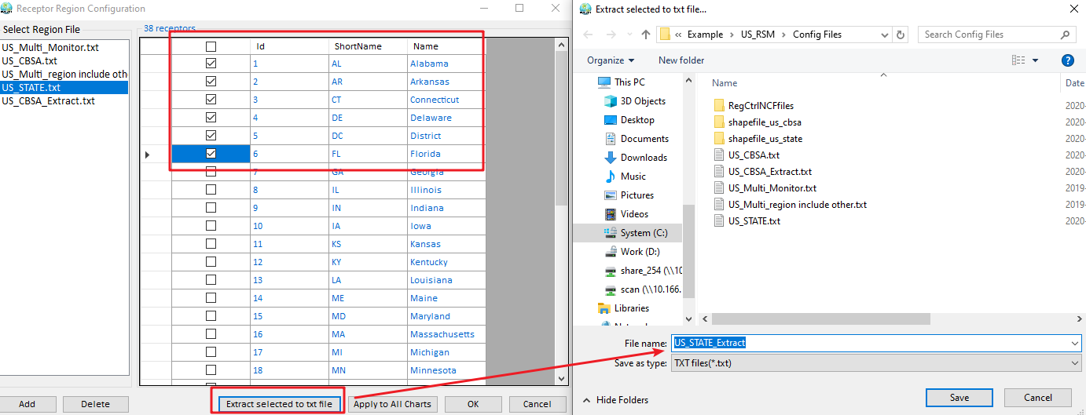
Figure 7.2.2-4. Extract selected regions to text file.

Response type: A drop-down menu on the bottom of this module configuration panel provides three response types: Ambient, Reduction, and Reduction Inverse. The Ambient option means the chart on the right will show as absolute concentration of each receptor. The Reduction option means that the chart on the right will show as “RSM Prediction” – “Baseline CMAQ concentration”, while the Reduction Inverse option is the reverse of Reduction.

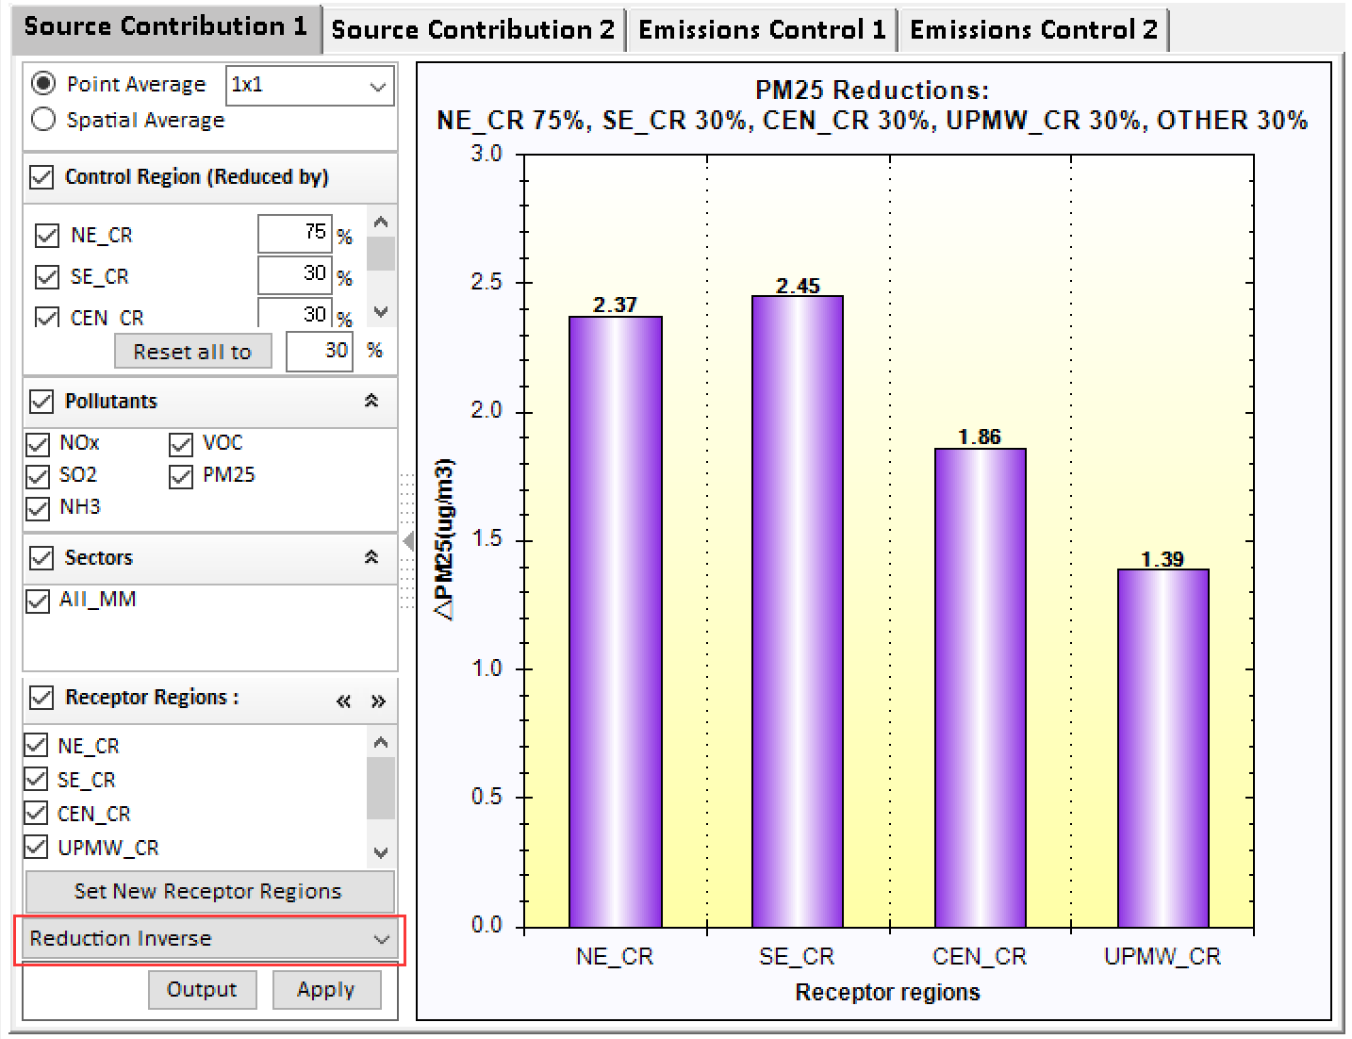
Figure 7.2.2-5. Response Type in Source Contribution 1

Output: Click this button to output current results to “*.csv” file for further study.
Apply: Click this button to make the settings effective and draw chart.

Source Contribution 2
Under this module, users are able to compare the cumulative/cluster impacts and the different source contributions to PM_{2.5} or O₃ decrease caused by control factors (a control factor means a combination of region, pollutant, sector, e.g., NE_CR/NOx/All_MM) emission reductions under different emission control scenarios. As shown in Figure 7.2.2-1, the configuration options in the left panel are similar to that of Source Contribution 1. The difference is that it provides three types of charts for visualization on the bottom of the configuration options: (1) Stack chart, (2) Cluster chart, and (3) Pie chart.

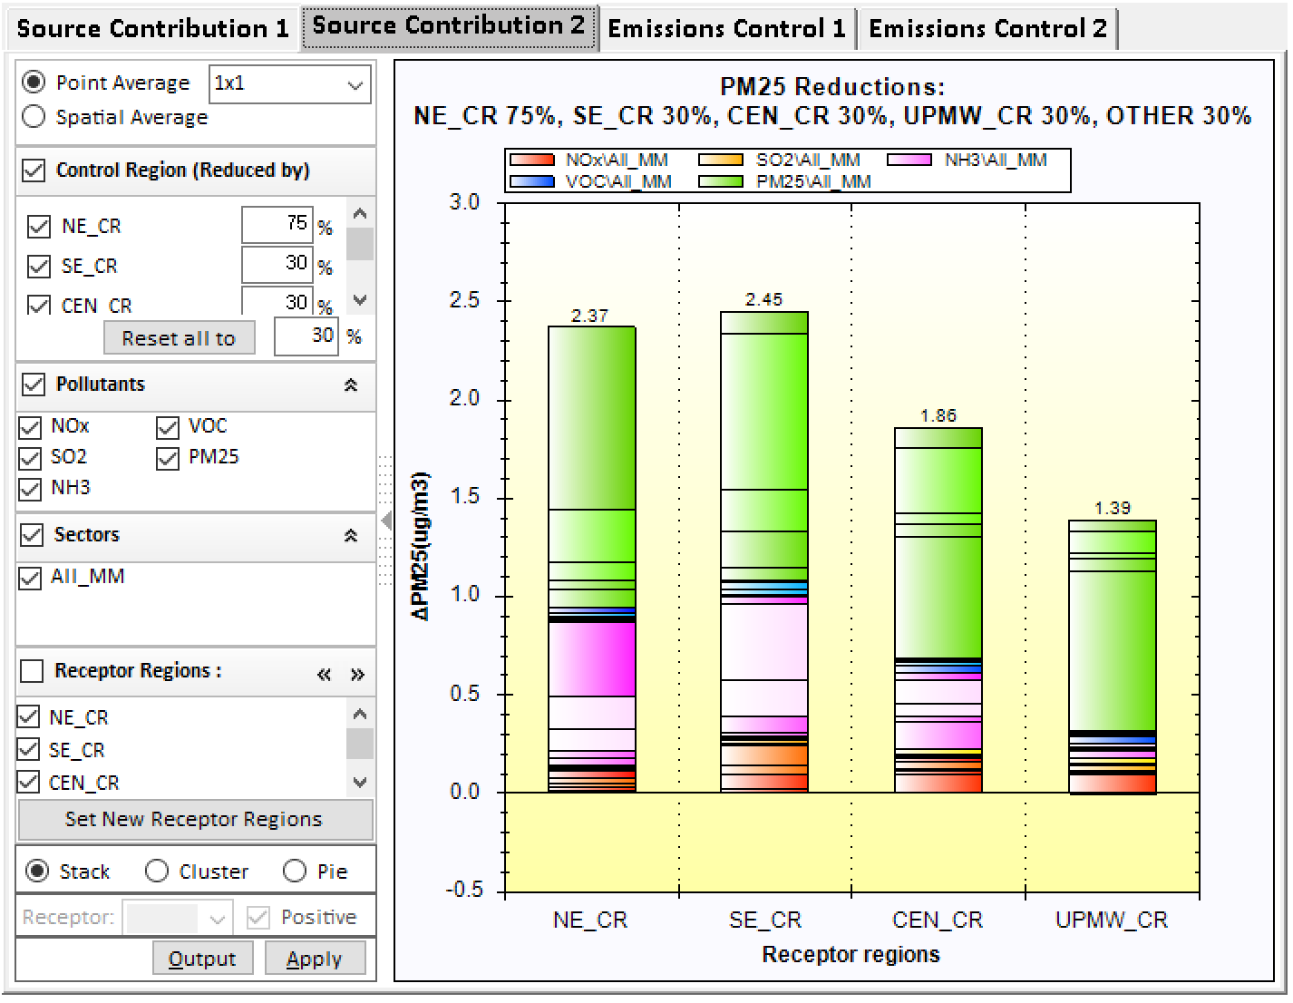
Figure 7.2.2-6. Example of Source Contribution 2

Stack chart: This option shows the cumulative impacts of PM_{2.5} or O₃ decrease (Air quality improvements) caused by the emission control scenario from current configuration options. For example, Figure 7.2.2-1 shows the ambient PM_{2.5} concentration of the Northeast climate region (NE_CR) could be reduced by 2.37μg/m³ under the emission control scenario of NE_CR 75%, SE_CR 30%, CEN_CR 30%, UPMW_CR 30% and OTHER 30%. And the emission sources from primary PM_{2.5} (PM2.5/All_MM) contributes almost 60% to PM_{2.5} Reduction in NE_CR receptor.
Cluster chart: This option shows the cluster impacts of PM_{2.5} or O₃ decrease (Air quality improvements) caused by the emission control scenario from current configuration options as shown in Figure 7.2.2-7.

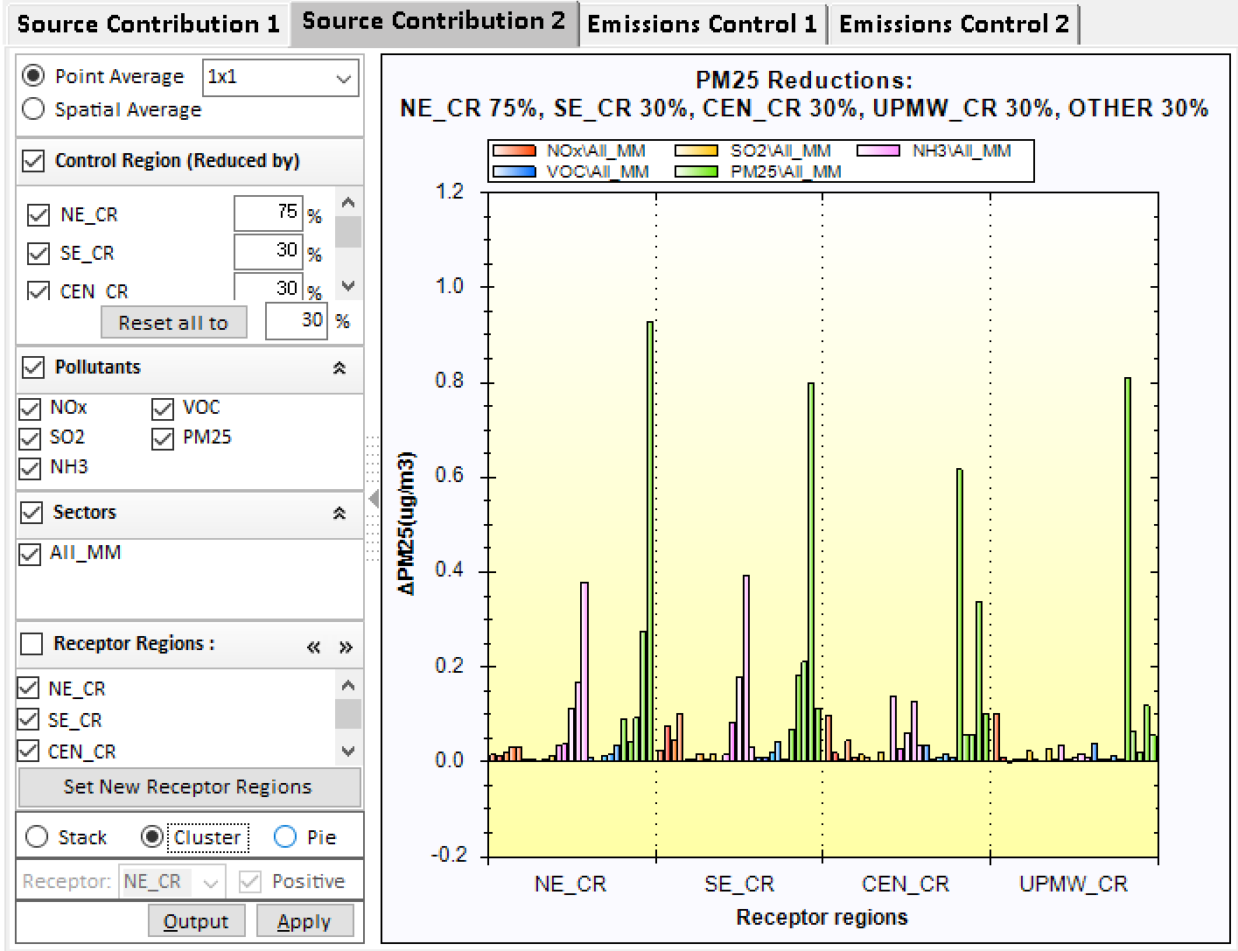
Figure 7.2.2-7. Cluster chart in Source Contribution 2
Pie chart: This option shows the source contributions to PM_{2.5} or O₃ in a selected receptor region caused by the emission control scenario from current configuration options. As shown in Figure 7.2.2-8, the drop-down menu of the Receptor option on the bottom of configuration panel only takes effect in the checked Pie option. It lists all receptor regions from the Receptor Regions list panel and uses the first item as default. Figure 7.2.2-8 shows that the emission sources from NE_CR primary PM_{2.5} (A,PM25,All_MM) have a greater impact (~23.04%) on PM_{2.5} Reduction of NE_CR compared to other control factors.

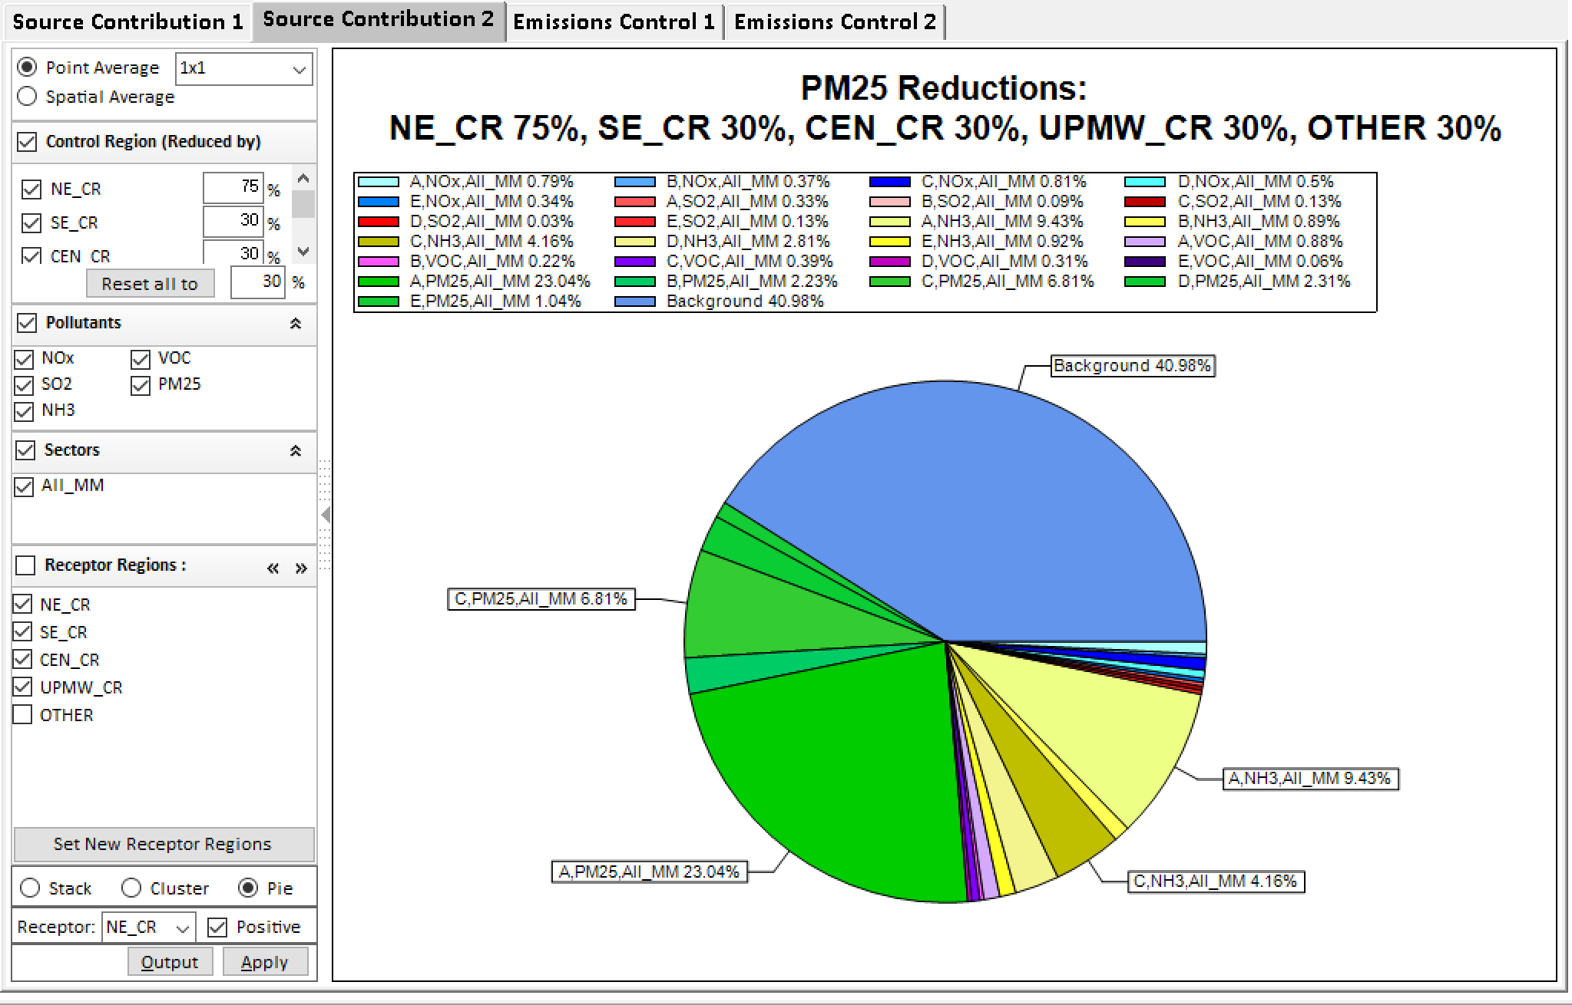
Figure 7.2.2-8. Pie chart in Source Contribution 2

Emission Control 1
Under this module, the user is able to compare the emission source contributions to PM_{2.5} or O₃ decrease caused by changing each control factor emissions. As shown in Figure 7.2.2-9, the configuration options in the left panel are similar to that of Source Contribution 1. The difference is that user are allowed to control changing each control factor emission under the control factors panel. Under the control factors panel, users can flexibly change the input control factor emission and show the corresponding response value of concentrations in real time. The panel lists all control factors. The sliders could be dragged to change the emission of each control factor. Users can also group/combine specific factors by checking Region/Pollutant/Sector on the top of the control factors panel or by clicking the Select/Combine Factors button to customize control factors of interest.

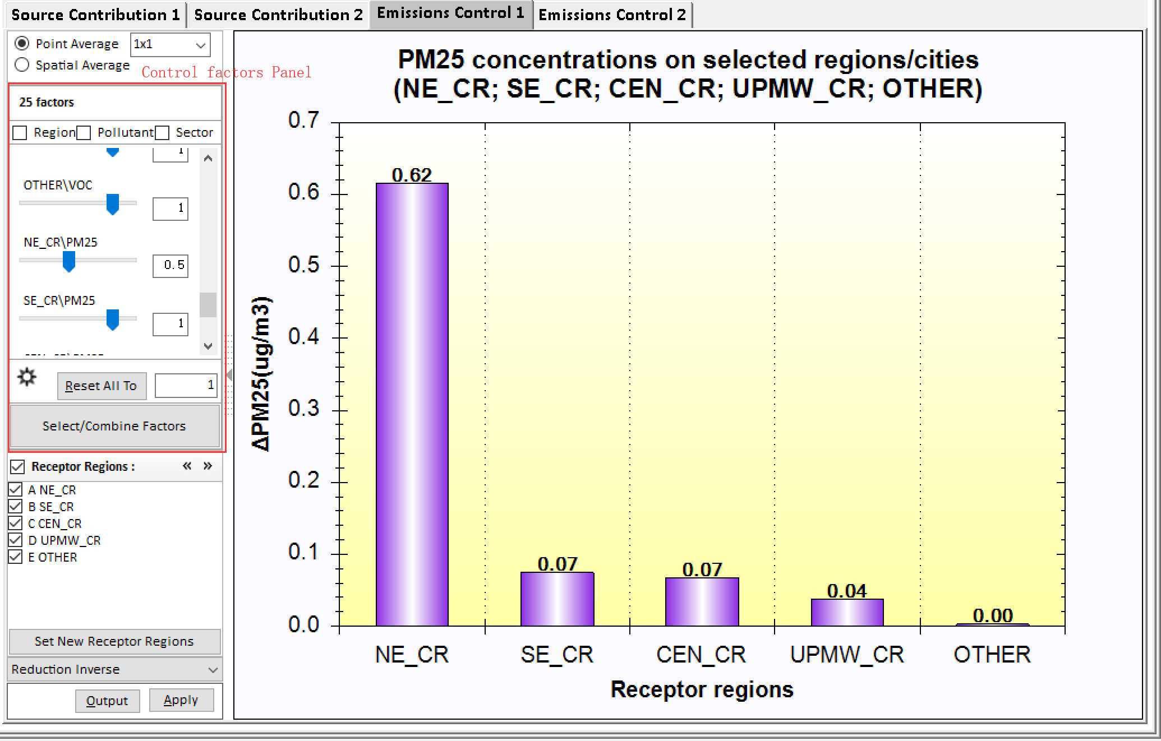
Figure 7.2.2-9. Example of Emission Control 1

Emission Control 2
Under this module, to the user can compare the emission source contributions to PM_{2.5} or O₃ decrease under various emission reductions at a time. As shown in Figure 7.2.2-10, the configuration options in the left panel are similar to that of Source Contribution 1. The difference is that this allows users to input multiple emission reductions at a time under the Emission Reduction panel. Figure 7.2.2-10 shows PM_{2.5} NH₃ reductions of NE_CR, SE_CR, CEN_CR, UPMW_CR and OTHER receptor regions under 25%, 50%, and 75% emission controls.

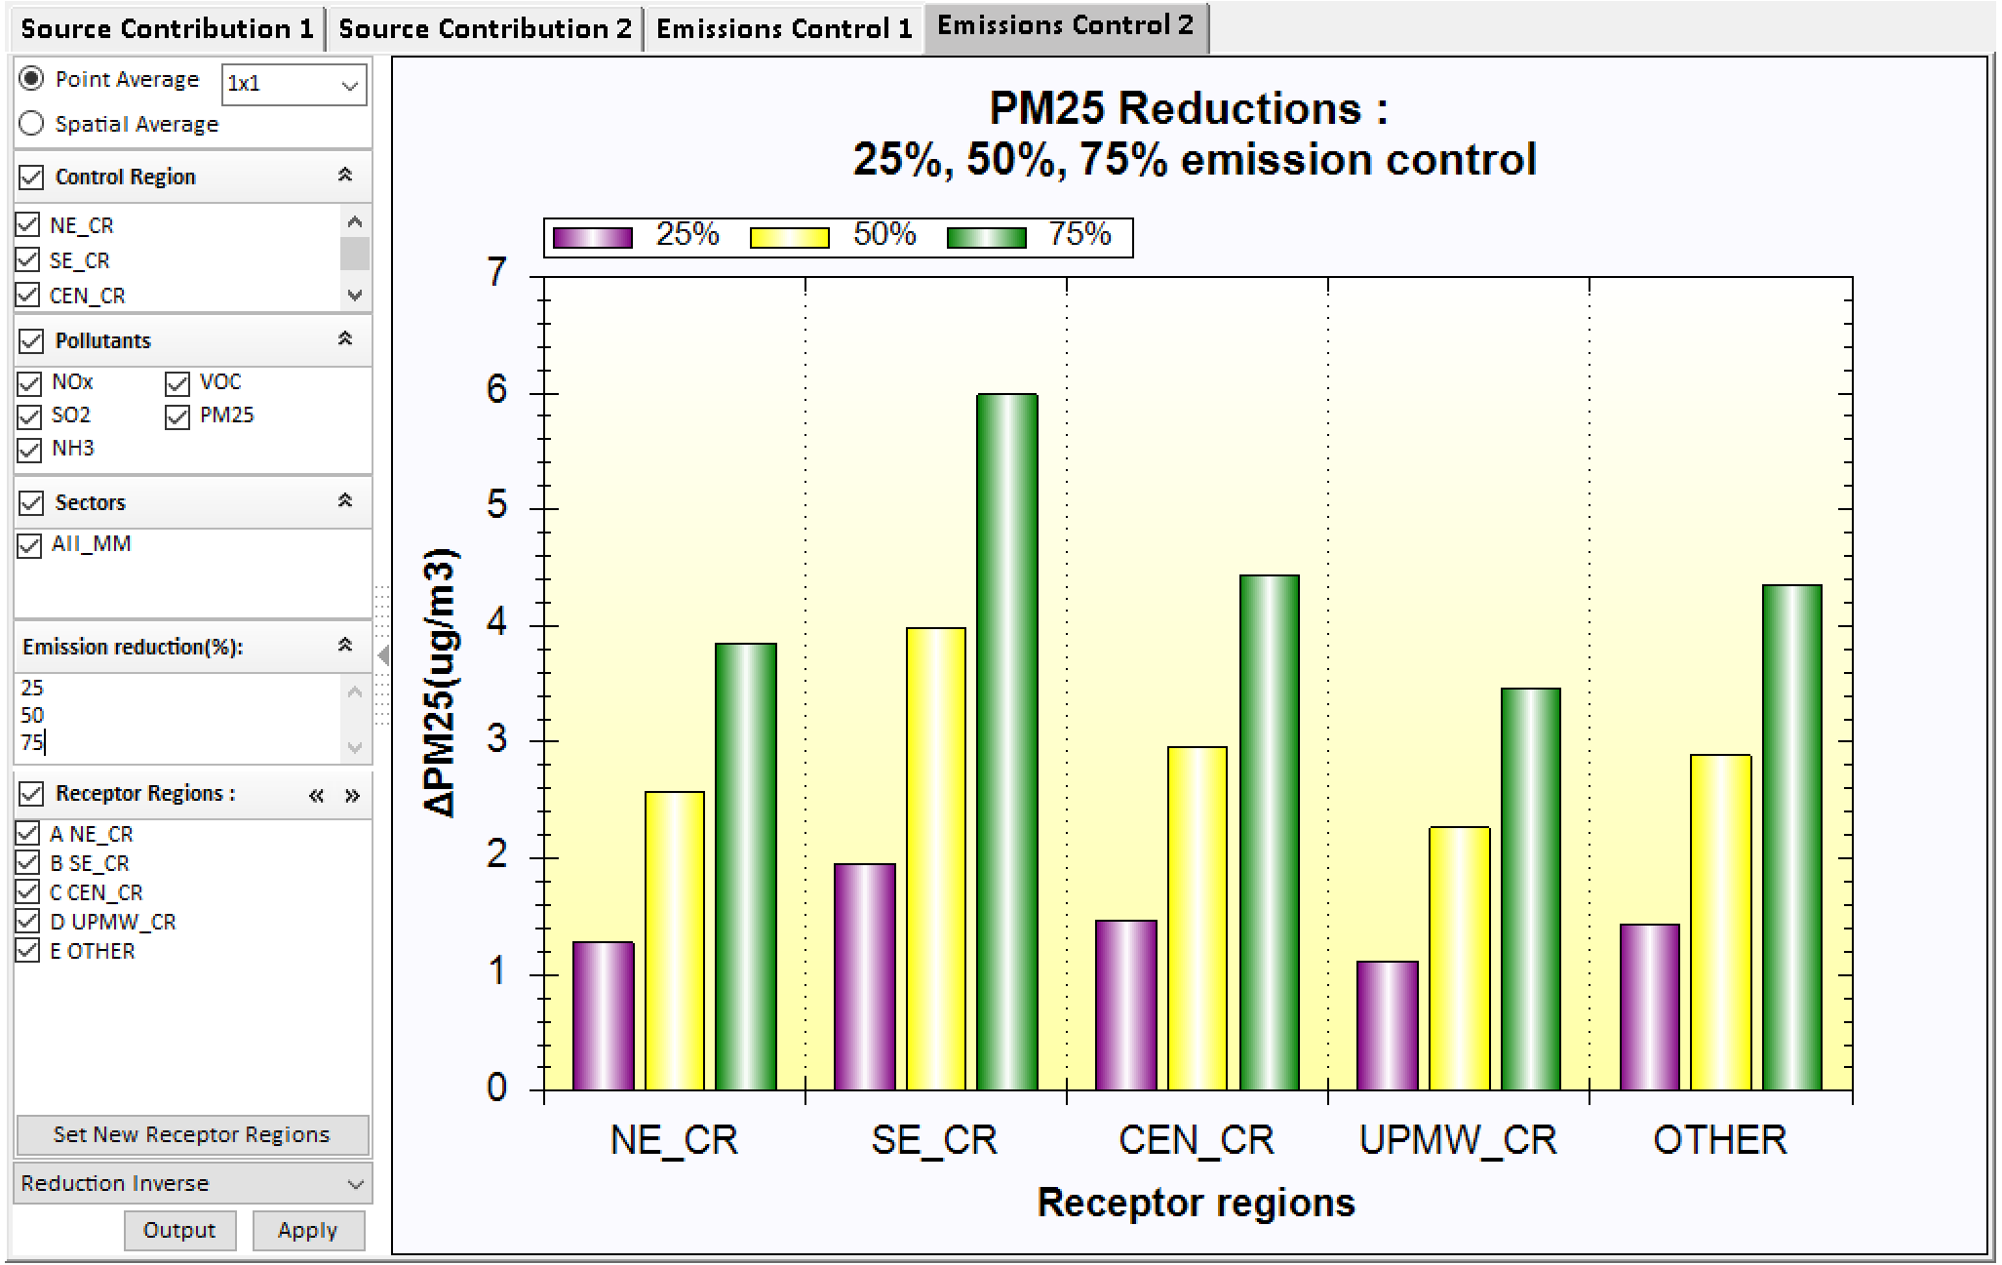
Figure 7.2.2-10. Example of Emission Control 2

Note that in the above charts under Chart module, RSM-VAT provides a right-click menu on charts which allow users to right-click to perform different operations on the chart, like changing title and legend, as shown in Figure 7.2.1-1.

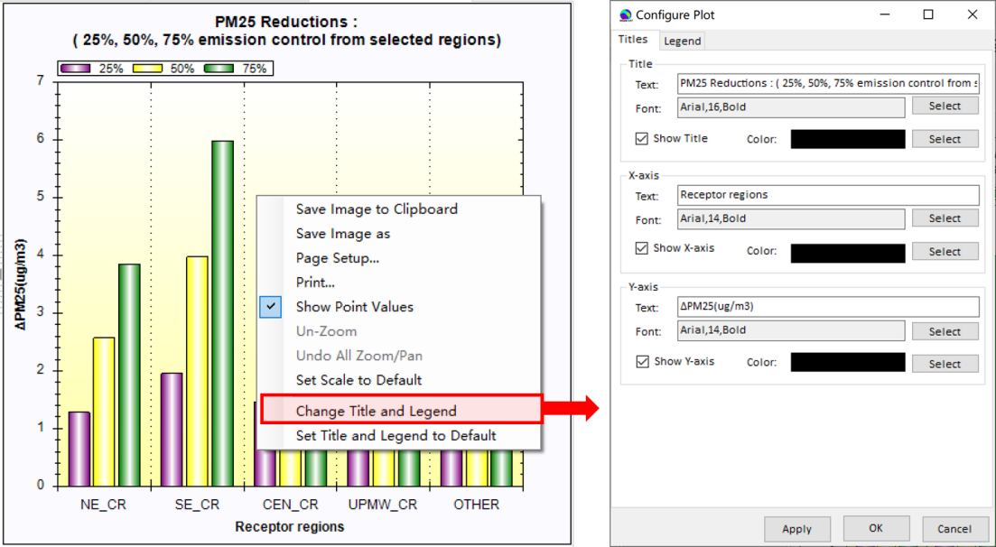
Figure 7.2.2-11. Right-click menu on Chart

Data
The Data module provides detailed information (e.g., Latitude, Longitude, ambient concentration) of all grid cells in the model domain. Users can check the fields of interest to show or export data for further study, e.g., as input for SMAT-CE, as shown in Figure 7.2.3-1. (Note: If the DeepRSM algorithm is selected, the results of different days can be selected through the drop-down box , as shown in Figure 6.2.2-1).

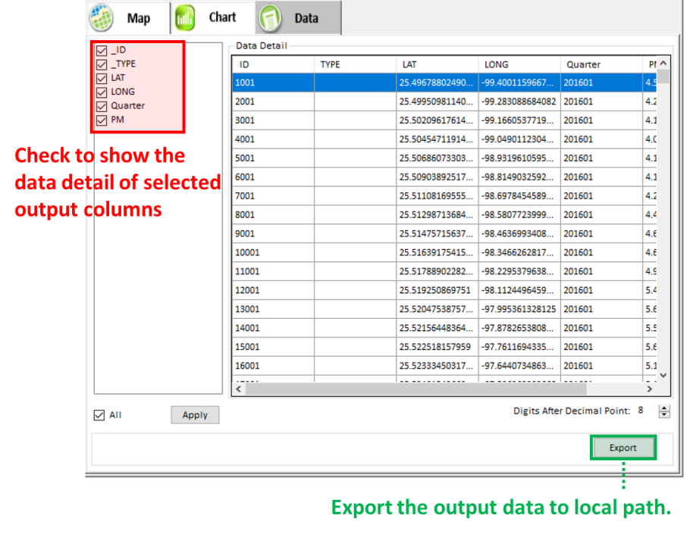
Figure 7.2.3-1. Data Detail Results and Configuration

