Main Improvements/Upgrades of FAST-CE 2.3
1/07/2021

Include the “H-CMAQ” test case.
Users may click “File” –> “Open Project” and select “HCMAQ_O3.proj” to open the example H-CMAQ case.
(Note: The “H-CMAQ” case dataset is included in “FAST-CE Data 2.3.exe” (~4 Gb); however, the smaller dataset (~10MB) can be downloaded from ftp://newftp.epa.gov/aqmg/cjang/FAST-CE/HCMAQ/* and then copied under “C:\Documents\My FAST-CE Files\Data\HCMAQ\*” after “FAST_CE 2.3.exe” is installed. The Project file: “HCMAQ_O3.proj” or Configuration file: “HCMAQ_O3.xml” can then be opened and run)

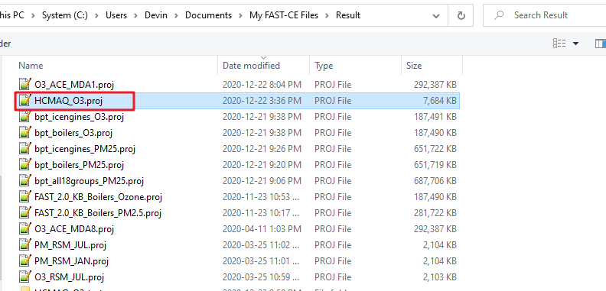
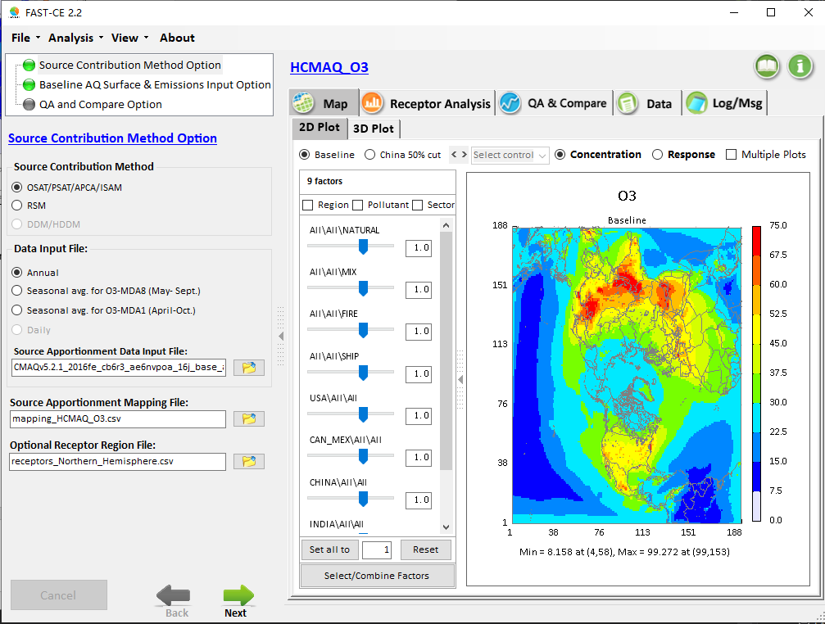

Two receptor files are available for the H-CMAQ case:
The “receptors_Northern_Hemisphere.csv” uses “USA, China, Canada&Mexico, India and rest_world” as the receptor regions.
The “receptors_Northern_Hemisphere_all counties.csv” uses all countries in the Northern hemisphere as receptor regions.
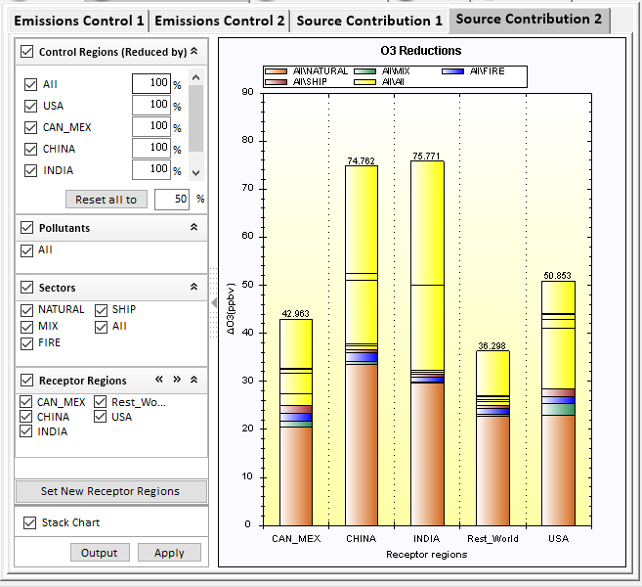

Include three new “bpt2020” cases
Double-click the “FAST-CE Data_bpt2020.exe” to unzip the bpt2020 boiler data package. After that, user can open the bpt boiler cases by clicking “File” – “Open Project” and select a bpt boiler case listed below.
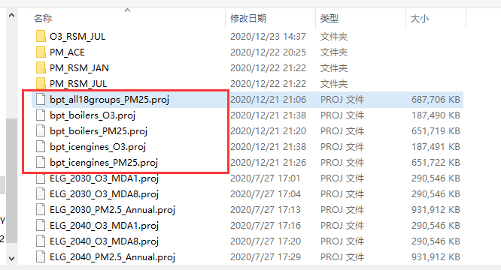
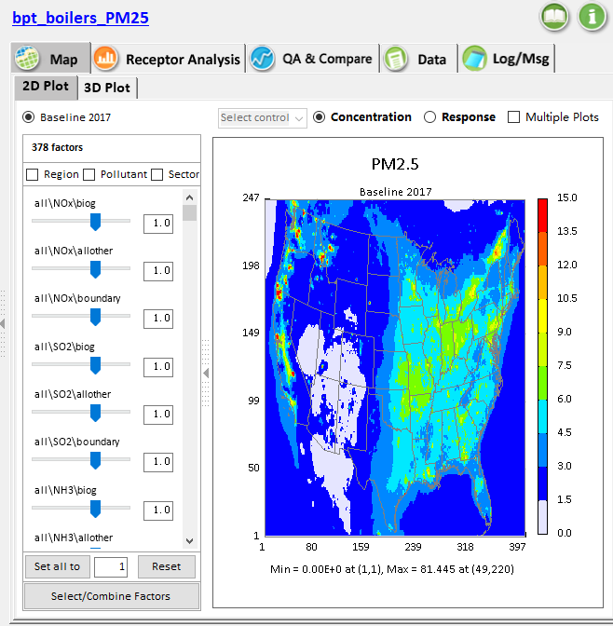
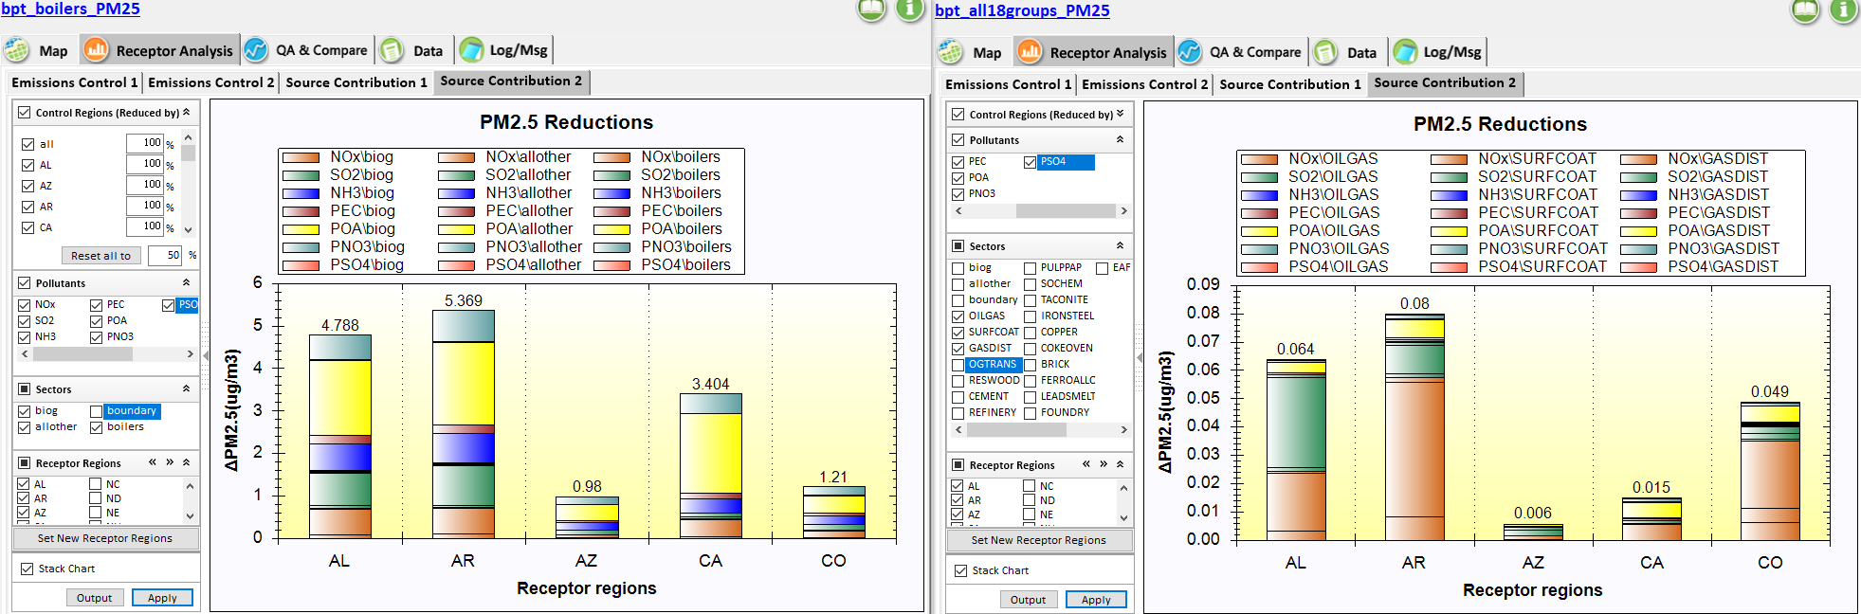

Add a function “Save adjusted emissions data” in "right-click" menu for users to output a set of adjusted emission files under a self-defined sub-directory.
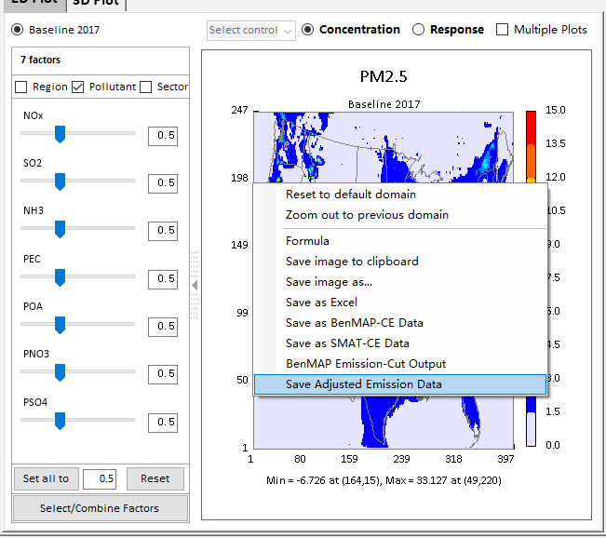
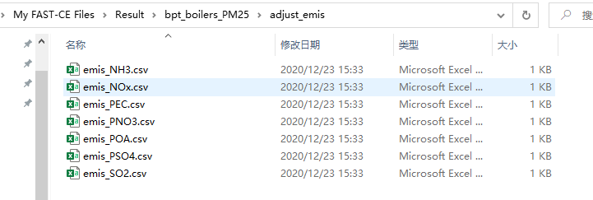

Include a function (“Load Configuration” & “Save Configuration”) under File menu for users to load a configuration file (*.xml) as a project input file or save it.
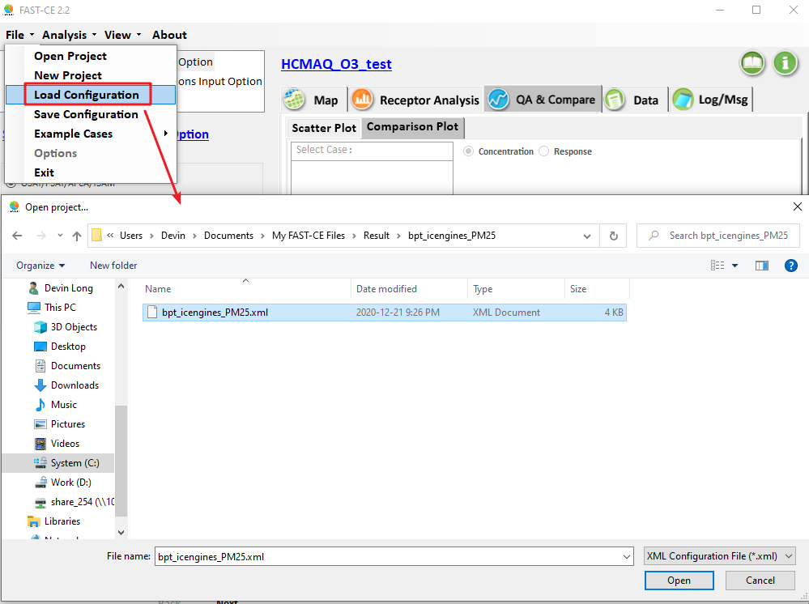

Add a function (“Options”) under File menu for user to set a default configuration file (*.xml), so it will serve as the default input data configuration next time the program is opened.
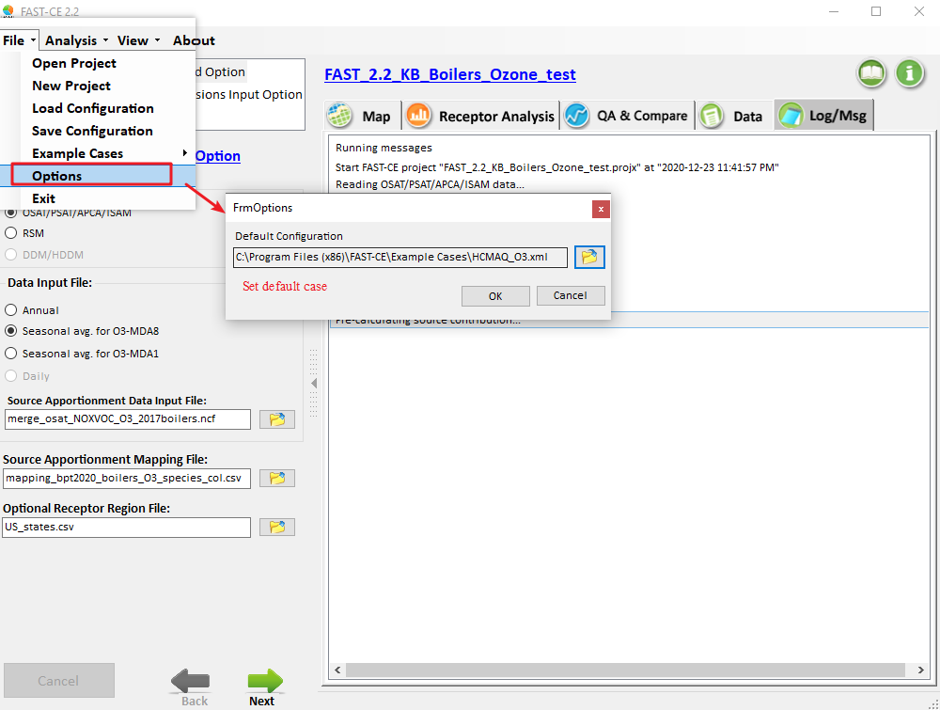

Add the “BenMAP emission-cut output” function in the “right-click” menu.
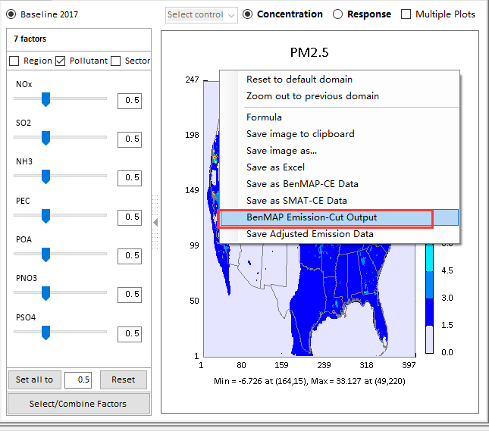
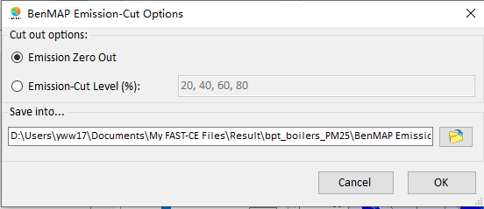
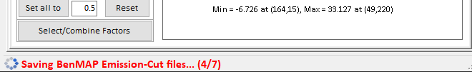
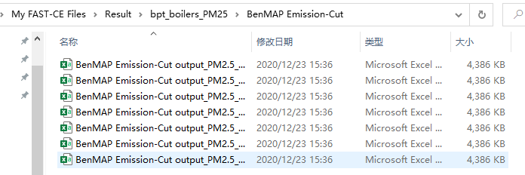

Add a 2nd "species" column for O3 mapping file to Make O3 and PM mapping files consistent.
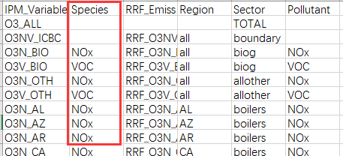
The “Species” Column for O3 is to keep consistent with PM2.5 mapping file, it is optional and not actually used.
Note: The “RRF” Column is still required for current version.

Add the “Annual” option in O3 analysis, and remove “(May-Sept.)” and “(April-Oct.)” from “Seasonal avg. for MDA8” and “Seasonal avg. for MDA1” option, respectively.
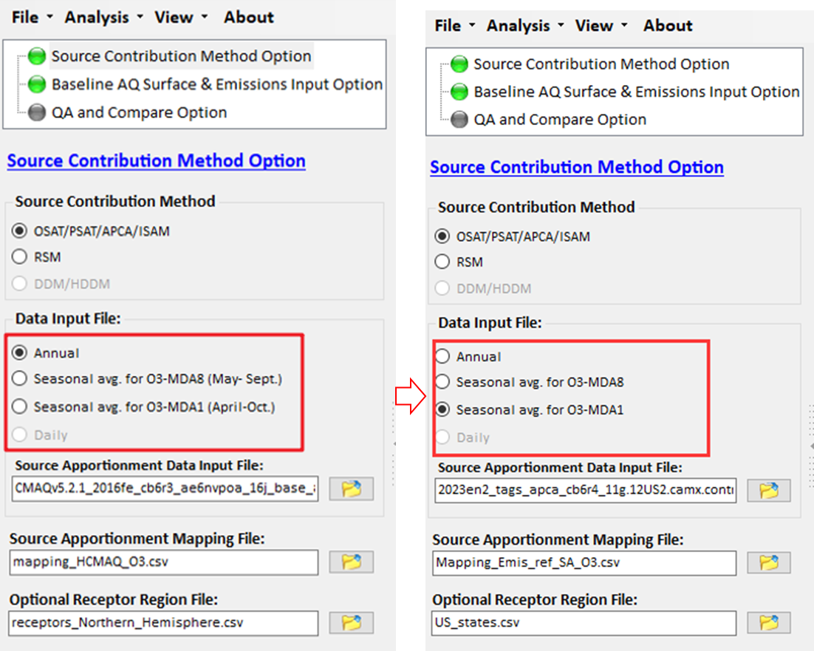

Change the module name: "QA/Validation Input Option" to "QA and Compare Option". Change the menu bar name "QA/Validate" to "QA & Compare" (next to "Receptor Analysis").
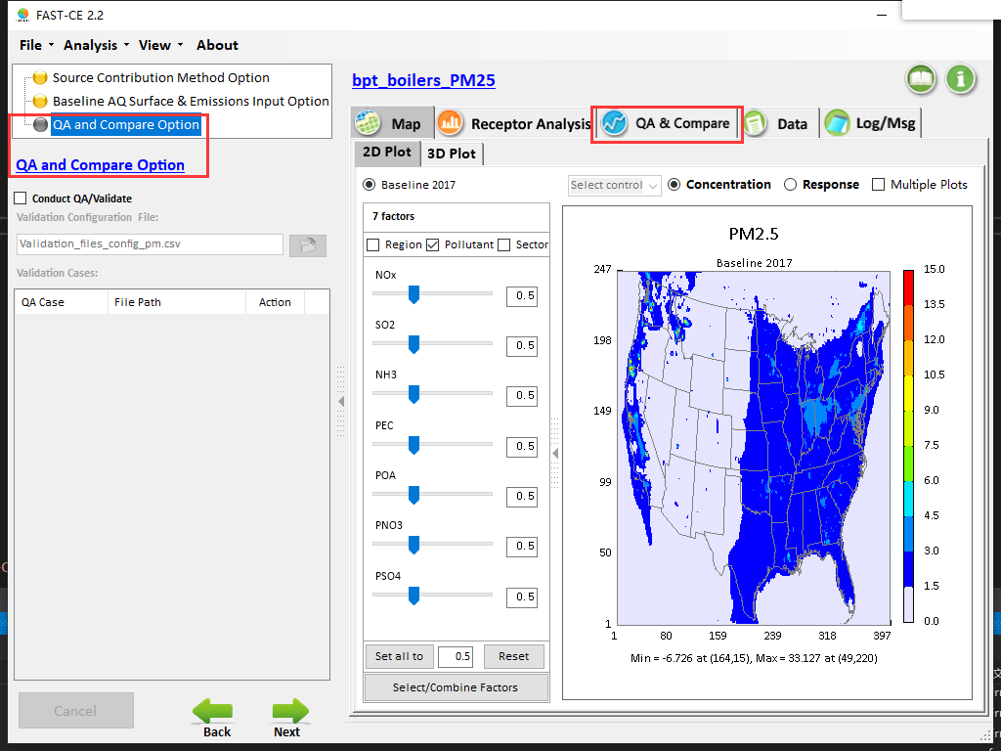

Follow the "Pollutant" order in the mapping file when listing the "Pollutant" under 2D Plot or 3D Plot.
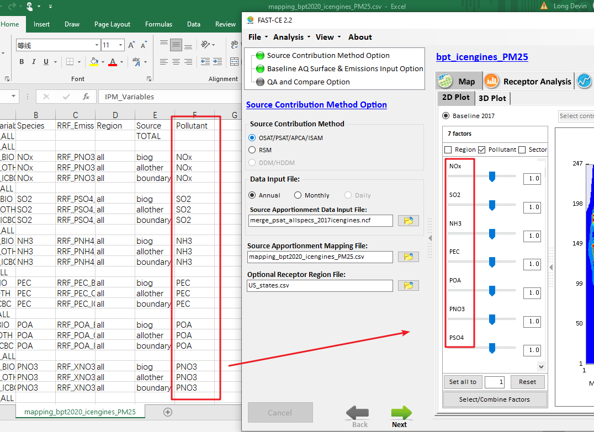

For ACE cases, "RET2025" and "RET2030" is listed only under "Sector" (do not show these RET variables when checking “Region” or “Pollutant”)
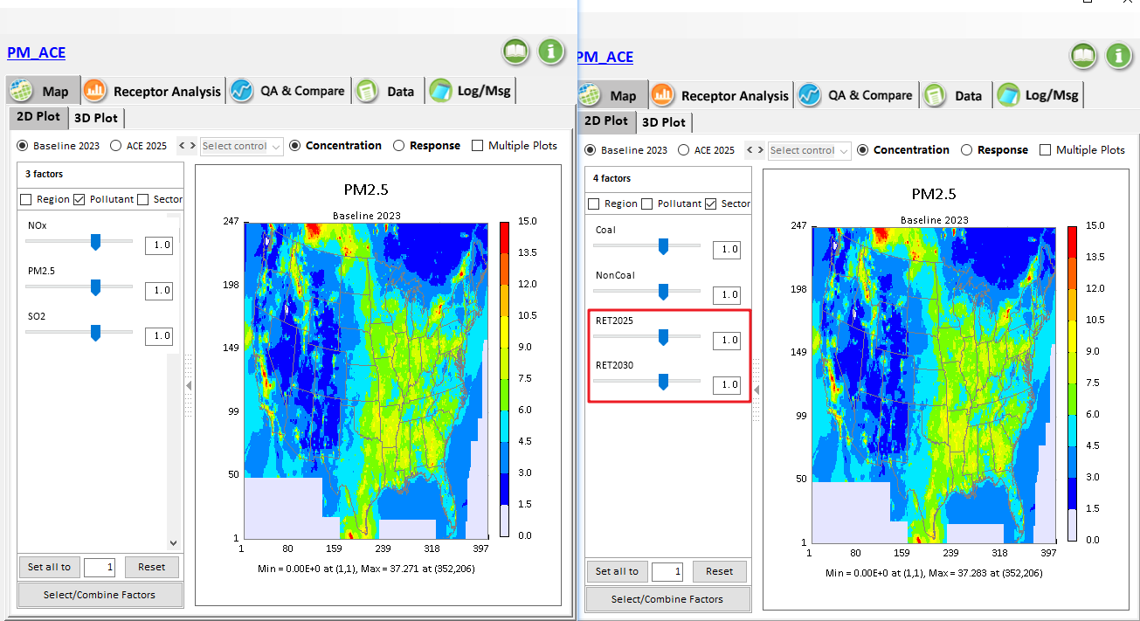

Fix the bug that previous version only shows 3 “Pollutants” in the “radio” button. Now all defined emitted "Pollutants" from the emission files will be listed out.
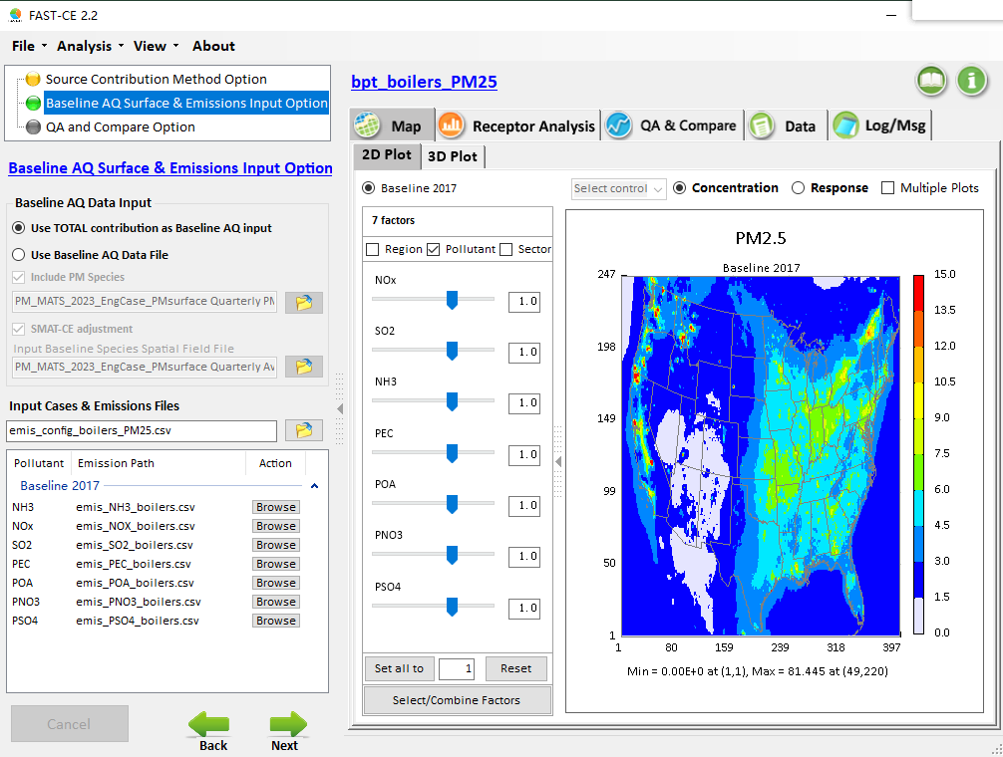

Fix the bug when top box "Control Region" unchecked, all Regions still checked.

Fix the bug when "Region" and "Pollutant" are checked, but showing "Region" and "Sector".

Fix the bug when either "Region" or "Pollutant" or "Sector" is checked, the default "RET2025" and "RET2030" were not be set to "no reduction" which wrongly caused the "positive response".
